Quick writes

Activity
Choose one of the 3 people below. You will have 5 minutes to write as many sentences as you can about your chosen person, for example their name, age, siblings, home town, favourite foods and so on. After the 5 minutes is up, swap your sentences with a partner for feedback and marking. Check each other’s work for grammatical accuracy and the variety of language structures and vocabulary used in each sentence. Suggestions for providing feedback:
- Correct the error(s) yourself or indicate where you have found an error. Your partner can then rewrite the sentence correctly.
- Suggest additional or alternative language structures and vocabulary from the unit that your partner could have used.
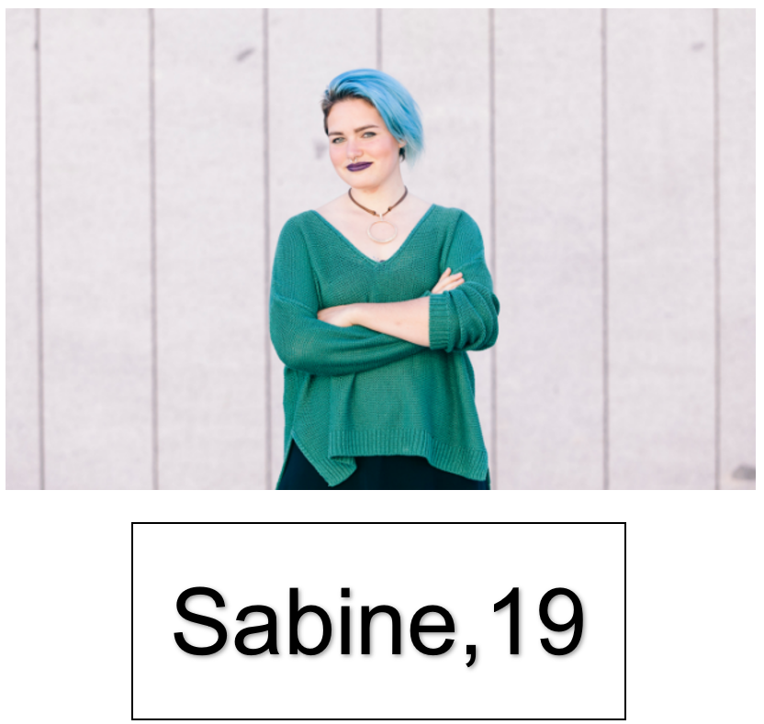

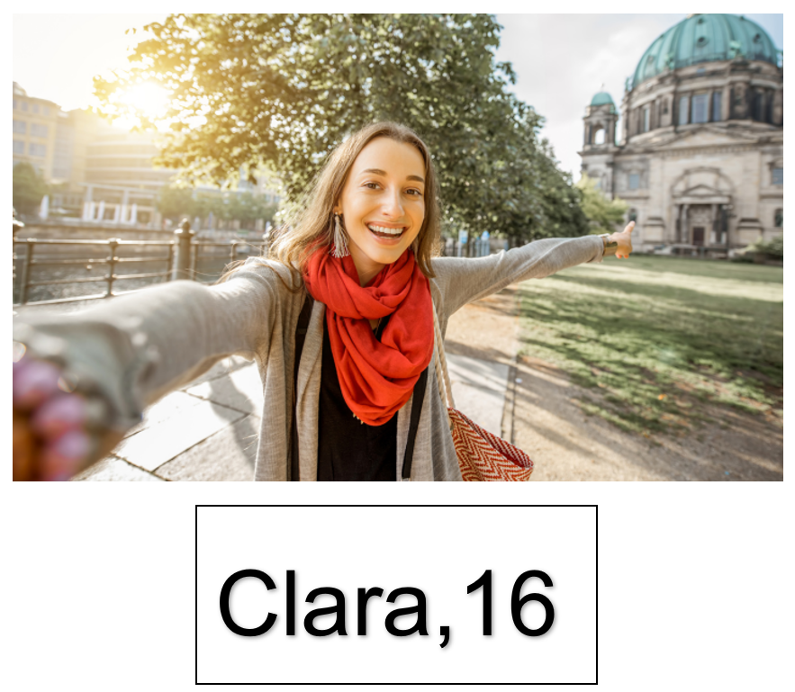

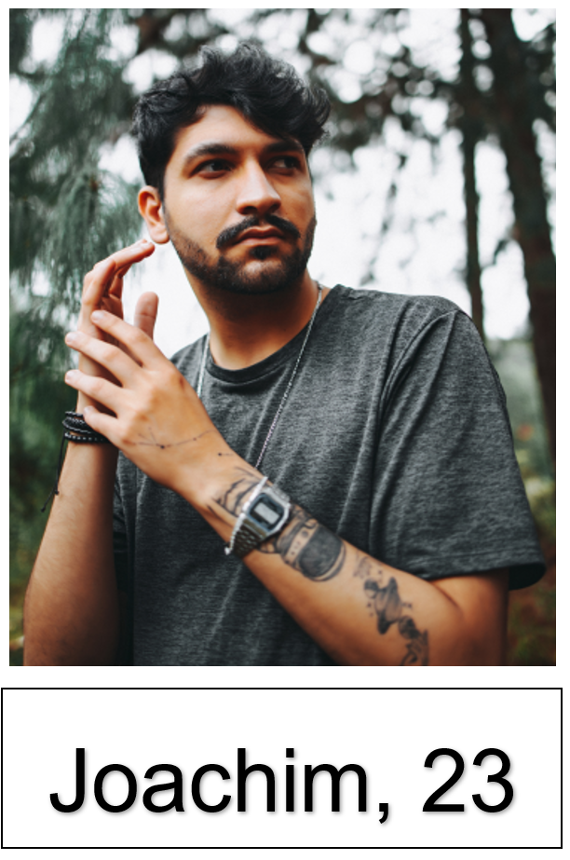

For the teacher
Remove this section before sharing this resource with students.

Sample response for Sabine (to use as a model, if required)
Ich heiße Sabine.
Ich komme aus Deutschland.
Ich wohne in Düsseldorf.
Ich bin neunzehn Jahre alt.
Ich habe einen Bruder und eine Schwester.
Ich habe einen Hund und zwei Fische.
Mein Lieblingssport ist Tennis.
Ich esse gern Schnitzel.
Ich esse nicht gern Fisch.
Mein Lieblingsessen ist Kartoffelsalat.
Mein Lieblingsgetränk ist Apfelsaft.
Ich esse Schnitzel zum Abendessen.
Ich trinke Tee zum Frühstück.
Ich esse Currywurst zum Mittagessen.

© State of New South Wales (Department of Education), 2024
The copyright material published in this resource is subject to the Copyright Act 1968 (Cth) and is owned by the NSW Department of Education or, where indicated, by a party other than the NSW Department of Education (third-party material).
Copyright material available in this resource and owned by the NSW Department of Education is licensed under a Creative Commons Attribution 4.0 International (CC BY 4.0) license.
This license allows you to share and adapt the material for any purpose, even commercially.
Attribution should be given to © State of New South Wales (Department of Education), 2024.
Material in this resource not available under a Creative Commons license:
- the NSW Department of Education logo, other logos and trademark-protected material
- material owned by a third party that has been reproduced with permission. You will need to obtain permission from the third party to reuse its material.
Links to third-party material and websites
Please note that the provided (reading/viewing material/list/links/texts) are a suggestion only and implies no endorsement, by the New South Wales Department of Education, of any author, publisher, or book title. School principals and teachers are best placed to assess the suitability of resources that would complement the curriculum and reflect the needs and interests of their students.
If you use the links provided in this document to access a third-party's website, you acknowledge that the terms of use, including licence terms set out on the third-party's website apply to the use which may be made of the materials on that third-party website or where permitted by the Copyright Act 1968 (Cth). The department accepts no responsibility for content on third-party websites.

