Mini task 3 – email activity

Activity 1
You have just received the email below from your future host student. Read the email and then answer the questions below:
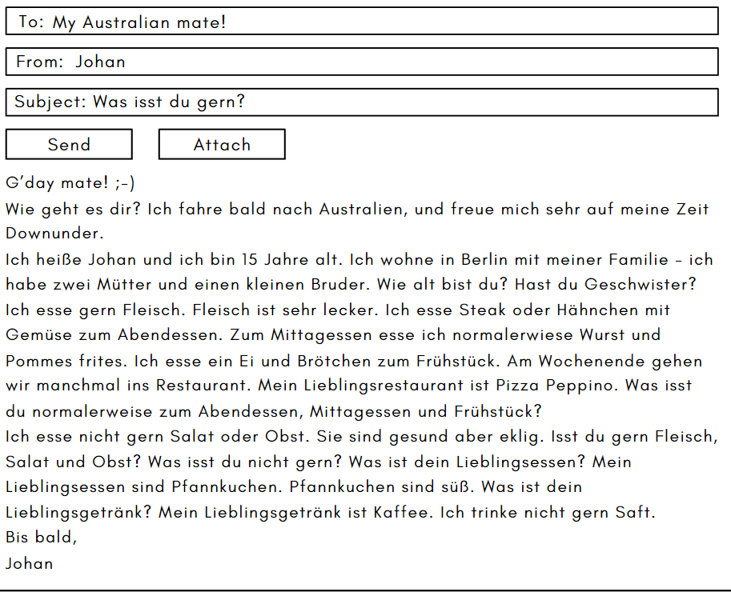
- Describe Johan’s family.
- What does Johan eat for dinner, lunch and breakfast?
- Outline his food and drink likes and dislikes, including reasons for his preferences.
- Do you think Johan would be a good fit for your family as a host student? Give 3 reasons from the text.
- Challenge question. What does Johan say about Pizza Peppino?

Activity 2
Write back to Johan, in German. In your reply, make sure you respond to any questions he has asked and include any other information or questions you think relevant.

For the teacher
Remove this section before sharing this resource with students.

Activity 1 – email script
G’day mate! ;-)
Wie geht es dir? Ich fahre bald nach Australien, und freue mich sehr auf meine Zeit Downunder.
Ich heiße Johan und ich bin 15 Jahre alt. Ich wohne in Berlin mit meiner Familie - ich habe zwei Mütter und einen kleinen Bruder. Wie alt bist du? Hast du Geschwister?
Ich esse gern Fleisch. Fleisch ist sehr lecker. Ich esse Steak oder Hähnchen mit Gemüse zum Abendessen. Zum Mittagessen esse ich normalerwiese Wurst und Pommes frites. Ich esse ein Ei und Brötchen zum Frühstück. Am Wochenende gehen wir manchmal ins Restaurant. Mein Lieblingsrestaurant ist Pizza Peppino. Was isst du normalerweise zum Abendessen, Mittagessen und Frühstück?
Ich esse nicht gern Salat oder Obst. Sie sind gesund aber eklig. Isst du gern Fleisch, Salat und Obst? Was isst du nicht gern? Was ist dein Lieblingsessen? Mein Lieblingsessen sind Pfannkuchen. Pfannkuchen sind süß. Was ist dein Lieblingsgetränk? Mein Lieblingsgetränk ist Kaffee. Ich trinke nicht gern Saft.
Bis bald,
Johan

Questions about email
- Johan has 2 mothers and a (little) brother.
- He has steak or chicken with vegetables for dinner, sausage and fries for lunch and an egg and bread roll for breakfast.
- He likes meat as it is delicious. He doesn’t like salad and vegetables as they are healthy but disgusting. His favourite food is pancakes as they are sweet. His favourite drink is coffee. He doesn’t like to drink juice.
- Sample answer – Johan would fit in with my family as a host student as he likes to eat meat and so does our family. We often eat steak and vegetables as he does. He doesn’t like fruit and salad. My family do like salad and fruit, but I don’t like them so that matches with me.
- Challenge question. He says it’s his favourite restaurant.

© State of New South Wales (Department of Education), 2024
The copyright material published in this resource is subject to the Copyright Act 1968 (Cth) and is owned by the NSW Department of Education or, where indicated, by a party other than the NSW Department of Education (third-party material).
Copyright material available in this resource and owned by the NSW Department of Education is licensed under a Creative Commons Attribution 4.0 International (CC BY 4.0) license.
This licence allows you to share and adapt the material for any purpose, even commercially. Attribution should be given to © State of New South Wales (Department of Education), 2024.
Material in this resource not available under a Creative Commons licence:
- the NSW Department of Education logo, other logos and trademark-protected material
- material owned by a third party that has been reproduced with permission. You will need to obtain permission from the third party to reuse its material.
Links to third-party material and websites
Please note that the provided (reading/viewing material/list/links/texts) are a suggestion only and implies no endorsement, by the New South Wales Department of Education, of any author, publisher, or book title. School principals and teachers are best placed to assess the suitability of resources that would complement the curriculum and reflect the needs and interests of their students.
If you use the links provided in this document to access a third-party's website, you acknowledge that the terms of use, including licence terms set out on the third-party's website apply to the use which may be made of the materials on that third-party website or where permitted by the Copyright Act 1968 (Cth). The department accepts no responsibility for content on third-party websites.

