Modern Greek Stage 3
Οικογενειακό ταξίδι στην Ελλάδα (Family trip to Greece)
Contents
Unit overview 5
Stage 3 outcomes and content to be addressed 6
Learning map 10
Assessment 13
Assessment opportunities 14
Teaching and learning activities 15
Week 1 – things to do on holidays 15
Vocabulary 1 – days of the week 16
Vocabulary 2 – verbs 17
Activity 1 – Learning map 17
Activity 2 – Kosta’s Family Trip to Greece 18
Activity 3 – pre-assessment of vocabulary – days of the week 18
Activity 4 – things to do on holidays 19
Week 2 – when to go on holiday 20
Vocabulary 3 – nouns 20
Vocabulary 4 – seasons 21
Vocabulary 5 – months of the year 22
Activity 1 – pre-assessment of vocabulary – seasons 24
Activity 2 – months of the year pre-assessment 25
Activity 3 – when to visit Greece 25
Week 3 – Kosta’s Family Trip to Greece 27
Activity 1 – I would like to visit … 27
Activity 2 – sentence scramble 28
Activity 3 – sentence builders 29
Week 4 – creating your itinerary 31
Vocabulary 6 – conversation phrases for travel agent 31
Activity 1 – conversation with travel agent 32
Activity 2 – order the sentences 33
Activity 3 – complete your itinerary 34
Week 5 – assessment criteria and practice task 35
Activity 1 – assessment task 35
Activity 2 – success criteria 35
Activity 3 – discuss the rubric 36
Activity 4 – peer assessment 37
Activity 5 – practice task 37
Week 6 – communicative task – Family trip to Greece 38
Activity 1 – warm-up activity – Bingo 39
Activity 2 – task set-up 39
Activity 3 – communicative task – create an itinerary with a travel agent 40
Activity 4 – peer assessment 41
Week 7 – feedback and goal setting 43
Activity 1 – warm-up activity – Hotseat 44
Activity 2 – self-assessment 44
Activity 3 – set learning goals 44
Week 8 – language review 46
Activity 1 – student questions 47
Activity 2 – teacher identified 47
Activity 3 – language review 47
Activity 4 – grammar review 48
Student resources 49
Resource 1 – jumbled days of the week 49
Resource 2 – find the verbs 51
Resource 3 – months flashcards 52
Resource 4 – sentence scramble 55
Resource 5 – conversation with travel agent 56
Resource 6 – order the sentences 57
Resource 7 – assessment task – Family trip to Greece 58
Outcomes 58
Task 58
Learning intention 59
Success criteria 59
Task instructions 60
Resource 8 – rubric – Family trip to Greece 61
Resource 9 – peer feedback strategy – Two stars and a wish 64
Resource 10 – dialogue cards 65
Support and alignment 67
References 70

Unit overview
Stage: 3
Title: Οικογενειακό ταξίδι στην Ελλάδα (Family trip to Greece)
Description: In this unit, students plan an itinerary to Greece that includes places to visit and duration of stay in each place. They book the trip to Greece with a travel agent.
Duration: This lesson sequence is designed to be completed over approximately 8 weeks.
Student proficiency levels:
It is assumed that most Stage 3 students have been learning Modern Greek since Kindergarten and their proficiency level will be Intermediate. This unit is aimed at Intermediate students. Every classroom will be different and teachers will need to adapt to their context. Many classes may include a combination of Beginner, Intermediate and Advanced students. Assessment tasks and opportunities in this unit can be differentiated using the ‘Too hard?’ and ‘Too easy?’ suggestions.

Stage 3 outcomes and content to be addressed
The table below outlines the focus area, outcomes and content points for Stage 3 students.
Focus area and outcome | Content points
Interacting  A student:  - exchanges information and opinions in familiar contexts by using culturally appropriate rehearsed language ML3-INT-01 | Exchanging meaning in oral interactions in the target language  - Understand and share information about themselves and their personal world  - Ask and answer questions with familiar structures  - Express and describe emotions and personal preferences  - Address a new acquaintance and introduce themselves  - Ask for clarification or repeat information to facilitate understanding in familiar interactions  Applying knowledge of language systems to interact in the target language  - Use key features of the sound system including pronunciation, intonation patterns, stress and/or rhythms to interact  - Use familiar vocabulary to interact  - Use modelled grammatical structures to interact  Applying knowledge of the target language culture(s) to interact  - Use language and nonverbal communication that are appropriate to cultural practices
Understanding texts  A student:  - identifies and responds to information and opinions in texts to demonstrate understanding ML3-UND-01 | Understanding and responding to target language texts  - Listen to, read and view information and opinions in a range of texts on familiar themes  - Use comprehension strategies to process information and opinions in texts  - Respond in the target language and/or English to main points and specific information in familiar texts to explain understanding and express opinions  Applying knowledge of language systems to understand and respond to target language texts  - Identify and use the sounds of the target language to understand and respond to texts  - Identify and use sound–symbol correspondences to understand and respond to texts  - Use knowledge of vocabulary and phrases from familiar themes to understand and respond to texts  - Use modelled sentence structures and grammar patterns to understand and respond to texts  - Use familiar metalanguage to compare some target language structures and features with English  - Recognise and use familiar structures and features of the target language writing system to understand and respond to texts  Developing intercultural understanding through target language texts  - Respond to texts and consider how language is connected with cultural practices and compare how this is evident in their own language(s), culture(s) and identity
Creating texts  A student:  - creates a range of texts for familiar communicative purposes by using culturally appropriate rehearsed language ML3-CRT-01 | Creating spoken, written and multimodal texts in the target language  - Create informative texts appropriate to context, purpose and audience, sharing information about familiar themes  - Create imaginative texts appropriate to context, purpose and audience using a series of sequenced sentences and visuals to express ideas on familiar themes  Applying knowledge of language systems to create texts in the target language  - Use pronunciation, intonation patterns, stress and/or rhythms to create spoken texts  - Use sound–symbol correspondences to create written texts  - Use relevant vocabulary, formulaic expressions or modelled phrases from familiar themes to create texts  - Use a range of modelled sentence and grammatical structures to create texts  - Select structures and features of the target language writing system to create written texts  Applying knowledge of the target language culture(s) to create texts  - Use language appropriate to cultural practices to create texts
Modern Languages K–10 Syllabus © NSW Education Standards Authority (NESA) for and on behalf of the Crown in right of the State of New South Wales, 2022.

Learning map
The creation of maps for learning is a planning process that incorporates Aboriginal intellectual tradition. Learning maps are a visual pathway of what students will learn.
Share the learning map with your students, briefly explaining the learning that will happen in each lesson. Provide students with a copy of the learning map or display the learning map in the classroom. This learning map can be adapted to Modern Greek by accessing a copy of Learning map – Οικογενειακό ταξίδι στην Ελλάδα (Family trip to Greece) (Stage 3).
Figure 1 – Family trip to Greece learning map
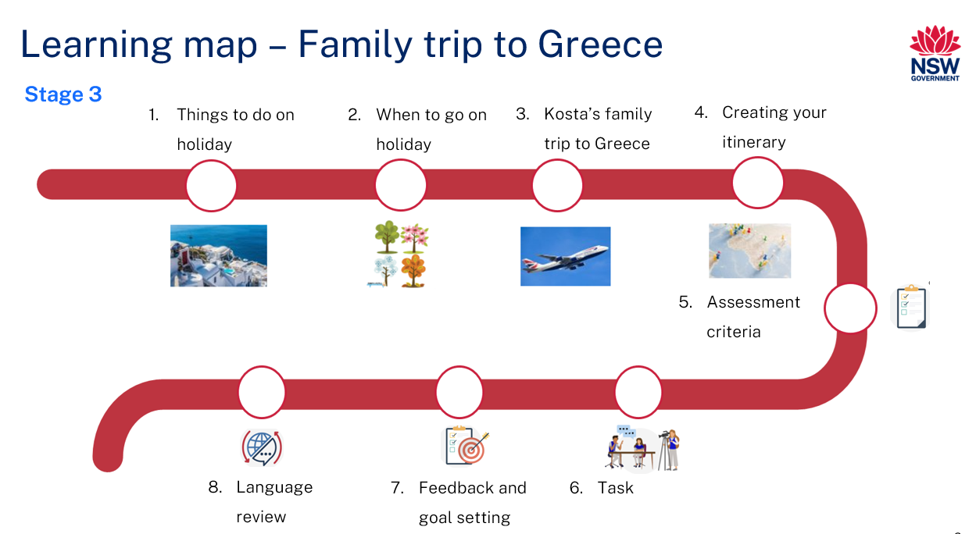
Figure 2 – Οικογενειακό ταξίδι στην Ελλάδα learning map
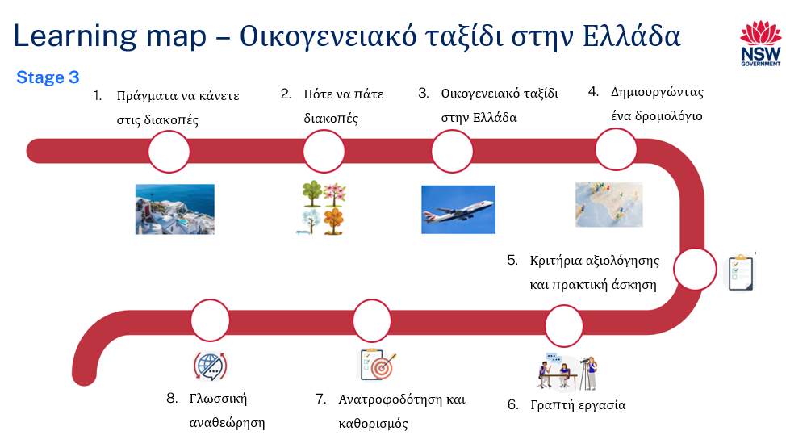

Assessment
Stage 3 communicative task: Create a 7-day itinerary for a family trip to Greece. Book your trip with a travel agent, including places to visit and things to do.
Too hard?
Create a 3-day itinerary for a visit to Greece by visiting a travel agent and telling them about the places you would like to visit.
Too easy?
Create an itinerary for a 10-day visit to Greece by visiting a travel agent and having a conversation about the places you would like to visit, things you will do at each place and how many nights you will spend.
Context: booking a holiday
Audience: travel agent
Purpose: to book a trip to Greece

Assessment opportunities
The table below details assessment opportunities and differentiation ideas.
Assessment opportunities | Too hard? | Too easy?
Week 3 – sentence scramble  Students are given 6 sentences where the words are out of order. They rearrange the words in the correct order to form sentences. | Sentence scramble  Students are given the unjumbled version of the sentences which they can use as a guide to complete the activity. | Sentence scramble  Students write additional sentences of their own on where they would like visit when in Greece.
Week 3 – sentence builders  Students are provided with a sentence builder. They use it to create sentences about activities they plan to do on a certain day of their holiday. | Sentence builders  Students can complete one sentence using the sentence builder with support from a peer or teacher. | Sentence builders  Students add information about activities they’ll do to the sentences made using the sentence builder.
Week 4 – order the sentences  Students are given a jumbled-up conversation between a traveller and their travel agent which they cut out and place in the correct order. | Order the sentences  Students are given the conversation put in the right order which they can use as a guide to complete the activity. | Order the sentences  Students write an additional 2 to 4 sentences to add to the conversation.

Teaching and learning activities

Week 1 – things to do on holidays
The table below outlines the learning intention and success criteria of the lesson, and materials that the teacher and students will need to complete the teaching and learning activities.
Learning intention and success criteria | Materials
Students will identify and use verbs in Modern Greek.  Students can:  - locate verbs in a story  - talk about things to do on holiday. | - Resource 1 – jumbled days of the week  - Resource 2 – find the verbs  - Kosta’s Family Trip to Greece PowerPoint book (Modern Greek)  - Kosta’s Family Trip to Greece PowerPoint book (English)  - Learning map  - Modern Greek workbooks  - Writing materials

Vocabulary 1 – days of the week
The table below outlines suggested vocabulary for ‘days of the week’. It includes the original Modern Greek script, a Romanised version of the Modern Greek script and the corresponding English translations.
English | Romanised Modern Greek | Modern Greek
Monday | Theftera | Δευτέρα
Tuesday | Triti | Τρíτη
Wednesday | Tetarti | Τετάρτη
Thursday | Penmpti | Πέμπτη
Friday | Paraskevi | Παρασκευή
Saturday | Savvato | Σάββατο
Sunday | Kiriaki | Κυριακή

Vocabulary 2 – verbs
The table below outlines suggested vocabulary for ‘verbs’. It includes the original Modern Greek script, a Romanised version of the Modern Greek script and the corresponding English translations.
English | Romanised Modern Greek | Modern Greek
I will go | tha pao | θα πάω
I will visit | tha episkeftho | Θα επισκεφθώ
I will see | tha tho | Θα δω
I will watch | tha parakoloutho | Θα παρακολουθήσω
I will eat | tha fao | Θα φάω
I will swim | tha kolimbiso | Θα κολυμπήσω

Activity 1 – Learning map
Display and distribute the Learning map to students and have them paste it in their workbooks for easy reference. Explain that the Learning map is to give students a more detailed breakdown of lessons during the unit. Point out that the Learning map is a plan that may need to change.

Activity 2 – Kosta’s Family Trip to Greece
- Display the front cover of the story Kosta’s Family Trip to Greece and ask students what they think it may be about.
- Read the story and have students listen for any words they may already be familiar with.
- Stop at every page and ask students if they recognise any words. Particular attention should be paid to days of the week, verbs and nouns.
- Ask students if they know what an itinerary is. Explain that Kosta has made an itinerary.
- Have students Think-Pair-Share why it is so important to have an itinerary when going on an overseas holiday and what factors need to be considered when creating one.
- Students share their answers and a word wall is created and displayed.
Itinerary: a detailed plan for a journey which includes a list of places to visit, as well as the dates and times for the visits.
Word wall: a collection of words that are displayed on the wall or bulletin board in a classroom and can be used by students during writing and reading.

Activity 3 – pre-assessment of vocabulary – days of the week
- Discuss with students that when creating an itinerary, it is important to know the days of the week.
- Write the days of the week on the board and go through them by saying them out aloud and having the students repeat each day.
- Randomly pick different students to come to the board and write the English word for each day of the week until all 7 days have been written.
- Once the days of the week have been rubbed off the board, display Resource 1 – jumbled days of the week and have students cut out each day and stick them in order in their student workbooks.

Activity 4 – things to do on holidays
- Discuss the things that Kosta will do on his holiday. Some examples include: he will swim, he will watch the sunset, he will visit family.
- Ask students what the grammatical term for ‘doing’ words is. Students should respond with ‘verbs’.
- Explain to students that the book and the itinerary are about things people will do in the future, so the verbs are written in the future tense. In English, ‘I will’ shows that the verb refers to the future. In Modern Greek, ‘θα’ is placed in front of the verb to refer to the future.
- Ask students how to say these verbs in Modern Greek in the present tense. For example, ‘I swim’ is ‘κολυμπάω’.
- If students have been introduced to the past tense, ask how to say, for example, ‘I swam’ (κολύμπησα).
- Ask students what other activities could be done on a holiday to Greece. Add them to a word wall.
- Re-read Kosta’s Family Trip to Greece in English and find all the verbs in the book (see Vocabulary 2 – verbs).
- In pairs, have students read Kosta’s Family Trip to Greece in Modern Greek and have them find all the matching verbs in Modern Greek.
- Students fill out Resource 2 – find the verbs and have their peers check their work for accuracy.

Week 2 – when to go on holiday
The table below outlines the learning intention and success criteria of the lesson, and materials that the teacher and students will need to complete the teaching and learning activities.
Learning intention and success criteria | Materials
Students will learn about the best times to visit Greece for a holiday.  Students can:  - ask and answer questions about when they would like to visit Greece in Modern Greek. | - Resource 3 – months flashcards  - Modern Greek workbooks  - Writing materials

Vocabulary 3 – nouns
The table below outlines suggested vocabulary for ‘nouns’. It includes the original Modern Greek script, a Romanised version of the Modern Greek script and the corresponding English translations.
English | Romanised Modern Greek | Modern Greek
sunset | iliovasilema | ηλιοβασíλεμα
dinner | vrathino | βραδινό
restaurant | estiatorio | εστιατόριο
island | nisi | νησí
grandparents | pappous ke giagia | παππούς και γιαγιά
evening | upogevma | απόγευμα
swim | bunio | μπάνιο
beach | paralia | παραλíα
city | poli | πόλη

Vocabulary 4 – seasons
The table below outlines suggested vocabulary for ‘seasons’. It includes the original Modern Greek script, a Romanised version of the Modern Greek script and the corresponding English translations.
English | Romanised Modern Greek | Modern Greek
seasons | epohes | εποχές
summer | kalokeri | καλοκαίρι
winter | himonas | χειμώνας
spring | anixi | άνοιξη
autumn | fthinoporo | φθινόπωρο

Vocabulary 5 – months of the year
The table below outlines suggested vocabulary for ‘months of the year’. It includes the original Modern Greek script, a Romanised version of the Modern Greek script and the corresponding English translations.
English | Romanised Modern Greek | Modern Greek
months of the year | mines tou hronou | μήνες του χρόνου
January | Ianouarios | Ιανουάριος
February | Fevrouarios | Φεβρουάριος
March | Martios | Μάρτιος
April | Aprilios | Απρίλιος
May | Maios | Μάιος
June | Iounios | Ιούνιος
July | Ioulios | Ιούλιος
August | Avgoustos | Αύγουστος
September | Septemvrios | Σεπτέμβριος
October | Oktovrios | Οκτώβριος
November | Noemvrios | Νοέμβριος
December | Dekemvrios | Δεκέμβριος

Activity 1 – pre-assessment of vocabulary – seasons
- Discuss seasons and the best times to travel. Ask:
- When is the best time to travel if you want to visit Greece?
- When do you think Kosta is travelling?
- Explain to students that, when planning a holiday, it is important to remember that Greece is in the Northern hemisphere and their seasons are opposite to Australia’s. For example, when it is winter in Australia, it is summer in Greece, so if you like hot weather, the best time to travel to Greece is from May through to September. What are the benefits of travelling in each season?
- Have students draw Table 1 below in their workbooks and write the corresponding name for each season in Modern Greek.
Table 1– seasons
Summer | Winter | Spring | Autumn
καλοκαíρι | χειμώνας | άνοιξη | φθινόπωρο
- Play a game with students where each season is allocated a body movement. For example:
- hands on head for winter
- sitting cross-legged on the floor for summer
- hopping on one leg for spring
- clapping hands for autumn.
- Call out a season at a time in Modern Greek and students must perform the corresponding action.
- Students who do not perform the action must sit down in their seats.

Activity 2 – months of the year pre-assessment
- Play a communicative language learning game, such as Concentration, using the flashcards to practise months of the year.
- Hand out Resource 3 – months flashcards and have students pair up.
- Students place the flashcards face down and take turns turning cards over to find the matching pair of words for each month in English and Modern Greek. To keep the cards, students must name the month correctly in Modern Greek.
- The winner is the student that collects the most pairs of cards.
- Add months of the year to the relevant columns in the seasons table from Activity 1.

Activity 3 – when to visit Greece
Introduce the question and answer:
- question: «Πότε θέλεις να πας στην Ελλάδα;» (When would you like to go to Greece?)
- answer: «Θέλω να πάο το καλοκαíρι, Ιούνιος η Ιούλιος, όταν κάνει ζέστη.» (I want to go in summer, June or July, when it is hot.)
Have students write this in their workbooks and in pairs, they can practise the conversation. They do this several times and when ready, they can showcase to the class.
Note: Advanced students may also swap around the seasons, months and conditions. For example, «Θέλω να πάο το χειμώνα, Δεκέμβριος η Ιανουάριος, όταν κάνει κρύο.» (I want to go in winter, December or January when it is cold.)

Week 3 – Kosta’s Family Trip to Greece
The table below outlines the learning intention and success criteria of the lesson, and materials that the teacher and students will need to complete the teaching and learning activities.
Learning intention and success criteria | Materials
Students will create sentences about where they want to visit and for how long.  Students can:  - create a portion of their itinerary, stating the days, locations and amount of time  - form sentences using a sentence builder. | - Resource 4 – sentence scramble  - Kosta’s Family Trip to Greece PowerPoint book (Modern Greek)  - Glue  - Information and communications technology (ICT) devices  - Modern Greek workbooks  - Scissors  - Writing materials

Activity 1 – I would like to visit …
- We say ‘I would like to…’ as a polite or formal way to say ‘I want’. We use polite or formal language when speaking to people we don’t know.
- Read Kosta’s Family Trip to Greece. Talk about all the places that Kosta will visit. Ask students the following:
- Have you been to any of the places that Kosta will visit?
- Which places in the book would you also like to visit with your family?
- Are there any other places you have heard about that you would like to visit in Greece?
- Using ICT devices, students research places in Greece and decide on where they would like to visit. Things to research include:
- things to do and see
- how to get there
- historical attractions.
- Have students pick at least 5 places they would like to visit in Greece.
- Students compile a list of these places in both Modern Greek and English in their workbooks.
- Teach students the phrase «Θα ήθελα να επισκεφτώ ...» (I would like to visit …). Students practise saying the phrase and add where they would like to visit. For example, «Θα ήθελα να επισκεφτώ το νησί της Μύκονου» (I would like to visit the island of Mykonos).
- Students write sentences in Modern Greek in their workbooks about the places they would like to visit. They read all the sentences to a partner.

Activity 2 – sentence scramble
- Display and provide Resource 4 – sentence scramble to all students. Have students work in pairs to cut out all the words and form sentences.
- Sentences in order are:
- Θα ήθελα να επισκεφτώ την Αθήνα. (I would like to visit Athens.)
- Θα ήθελα να επισκεφτώ το νησί της Μύκονου. (I would like to visit Mykonos.)
- Θα ήθελα να επισκεφτώ τη Θεσσαλονίκη. (I would like to visit Thessaloniki.)
- Θα ήθελα να επισκεφτώ τους Δελφούς. (I would like to visit Delphi.)
- Θα ήθελα να επισκεφτώ τον Παρθενώνα. (I would like to visit the Parthenon.)
- Once the sentences have been checked by their peer partners, students stick the sentences in their workbooks.

Activity 3 – sentence builders
- Explain that, when planning an itinerary, it is important to add the number of days you would like to visit each destination. For example, « Θα ήθελα να επισκεφτώ την Αθήνα για 3 μέρες» (I would like to visit Athens for 2 days).
- Say the above example out loud and have students repeat after you. Include your own examples, changing the places and how many days in each sentence.
- Have students build sentences from the Table 2. They may use the examples in the table or add places from the list they compiled in Activity 1.
- Students consider how long they would like to stay in each place and on what days of the trip they will be visiting those places.
Table 2 – sentence builders
θα ήθελα να (I would like to) | επισκεφτώ (visit)  δω (see) | την Αθήνα (Athens)  την Ακρόπολη (the Acropolis)  τη Σαντορίνη (Santorini)  το Παρθενώνα (the Parthenon)  τη Βουλή (Parliament house)  το Μοναστηράκι (Monastiraki)  την Πλάκα (Plaka)  τη Θεσσαλονίκη (Thessalonika)  το Λευκό Πύργο (the White Tower) | για μια μέρα (for one day)  για δύο μέρες (for 2 days)  για τρις μέρες (for 3 days)  για τέσσερες μέρες (for 4 days)  για πέντε μέρες (for 5 days)  για έξι μέρες (for 6 days)  για επτά μέρες (for 7 days)  για οκτώ μέρες (for 8 days)  για εννέα μέρες (for 9 days)  για δέκα μέρες (for 10 days)

Week 4 – creating your itinerary
The table below outlines the learning intentions and success criteria of the lesson, and materials that the teacher and students will need to complete the teaching and learning activities.
Learning intentions and success criteria | Materials
Students will:  - greet another person in Modern Greek  - ask a travel agent for help when organising their Modern Greek trip.  Students can:  - greet another person in Modern Greek  - ask a travel agent for help when planning an itinerary. | - Resource 5 – conversation with travel agent  - Resource 6 – order the sentences  - Glue  - Map of Greece  - Modern Greek workbooks  - Scissors  - Writing materials

Vocabulary 6 – conversation phrases for travel agent
The table below outlines suggested vocabulary for the activities below. It includes the original Modern Greek script, a Romanised version of the Modern Greek script and the corresponding English translations.
English | Romanised Modern Greek | Modern Greek
Good morning | Kalimera | Καλημέρα
Good afternoon | Kalo apogevma | Καλό απόγευμα
How are you? | Ti kanis? | Τι κάνεις;
Good thank you | Kala efharisto | Καλά ευχαριστό
How can I help you? | Pos boro na se voithiso | Πως μπορώ να σε βοηθήσω;
I would like to book a trip to Greece for my family. | Thelo na kliso ena taxidi stin Ellatha gia tin ikogenia mou. | Θέλω να κλείσω ένα ταξίδι στην Ελλάδα για την οικογένειά μου.
Great | Iperoho | Υπέροχο
Where would you like to visit in Greece? | Pou thelis na episkeftis stin Ellatha? | Που θέλεις να επισκεφτείς στην Ελλάδα;

Activity 1 – conversation with travel agent
- Ask students what they think they would say when starting a conversation with a travel agent. Answers may include:
- The traveller begins with a greeting and asks the other person how they are.
- The travel agent will ask what they can help with.
- The traveller expresses what they need from the travel agent.
- Display Resource 5 – conversation with travel agent and go through it one sentence at a time, focusing on the pronunciation and meaning of each word.
- Provide each student with a copy of Resource 5 – conversations with travel agent. Students pair up and go through the script. Each student will have a turn at being the traveller and the travel agent.
- Each pair has a turn at performing the script in front of classmates.
Note: students with Advanced proficiency levels can perform the conversation without the script or even add some of their own words as an improvisation.

Activity 2 – order the sentences
- Provide each student with a copy of Resource 6 – order the sentences. Students cut out all the sentences and put them in the correct order.
- Once the sentences have been placed in the correct order, students have their work checked by a peer.
- Students take a photo or glue the sentences into their workbooks in the correct order.
Note: students with Beginner proficiency levels can refer to Resource 5 – conversation with travel agent when putting the sentences in order.

Activity 3 – complete your itinerary
Students complete the itineraries by:
- marking 5 places they would like to visit on a map of Greece
- writing and the names of each place in Modern Greek and in English
- ordering the places they will visit by writing 1 at the first place and 5 at the last place
- combine them with Resource 5: Conversation with travel agent to produce a conversation script.
- Students write this script in their workbooks.
Students pair up and provide their partner with a copy of their conversation script. The partners read through each conversation script together and practise several times before presenting to their peers.

Week 5 – assessment criteria and practice task
The table below outlines the learning intention and success criteria of the lesson, and materials that the teacher and students will need to complete the teaching and learning activities.
Learning intention and success criteria | Materials
Students will develop a clear understanding of the requirements of the assessment task.  Students can:  - suggest appropriate success criteria  - explain what they need to do to be successful in the task. | - Resource 7 – assessment task – Family trip to Greece  - Resource 8 – rubric – Family trip to Greece  - Resource 9 – peer feedback strategy – Two stars and a wish  - Writing materials

Activity 1 – assessment task
Share Resource 7 – assessment task – Family trip to Greece with the students and lead the class in reading it.

Activity 2 – success criteria
After looking at the assessment task, students Think-Pair-Share and suggest appropriate success criteria, such as:
I will be successful if I can:
- plan an itinerary with a travel agent
- tell the travel agent the places I want to visit, the day I would like to visit and the duration of each visit
- use correct sentences with correct grammar
- pronounce the words correctly
- speak in a well-paced manner without long pauses
- start and end the conversation in an appropriate way, for example, Καλημέρα, καλησπέρα, ευχαριστώ πολύ, αντíο, σε παρακαλώ. (Good morning, good afternoon, thank you very much, goodbye, please).

Activity 3 – discuss the rubric
- Show students an unmarked rubric (please see Resource 8 – rubric – Family trip to Greece). This may need to be adapted if the class has decided on different success criteria.
- Explain metalanguage, such as fluency, accuracy, pronunciation and vocabulary.
- In pairs, students read and discuss the ‘excellent’ column of the rubric. Students then share their understanding of what they need to do to be successful.
- Point out and provide examples of what ‘excellent’ and ‘sound’ samples of task completion, fluency, accuracy, pronunciation and vocabulary look and sound like.

Activity 4 – peer assessment
Peer feedback will be incorporated into the task (see Resource 9 – peer feedback strategy – Two stars and a wish). Confirm which peer feedback strategy will be used, for example, ‘Two stars and a wish’, and discuss with students.
Evaluation: students give examples of what stars and wishes would look like for this task.

Activity 5 – practice task
In pairs, students take turns role-playing the ‘traveller’ and ‘travel agent’. Using the itinerary they have created, students practise asking and responding to questions related to their family trip to Greece. Conversation is to include places they would like to visit, what they will do and for how long they would like to stay in each place. Students must also include appropriate greetings.

Week 6 – communicative task – Family trip to Greece
The table below outlines the learning intention and success criteria of the lesson, and materials that the teacher and students will need to complete the teaching and learning activities.
Learning intention and success criteria | Materials
Students will participate in a role-play at a travel agent to create an itinerary of where they would like to visit in Greece.  Students can:  - plan an itinerary with a travel agent  - tell the travel agent the places they want to visit, the day they would like to visit and the duration of each visit  - use correct sentences with correct grammar  - pronounce the words correctly  - speak in a well-paced manner without long pauses  - start and end the conversation in an appropriate way, for example, Καλημέρα, καλησπέρα, ευχαριστώ πολύ, αντíο, σε παρακαλώ. (Good morning, good afternoon, thank you very much, goodbye, please). | - Resource 8 – rubric – Family trip to Greece  - Resource 9 – peer feedback strategy – Two stars and a wish  - Tablets or other recording devices  - Writing materials

Activity 1 – warm-up activity – Bingo
In groups of 4 or 5, students create their own bingo cards featuring various words and phrases that have been taught throughout the unit.
Once the cards have been created, students play a game where they write down 5 of these words or phrases. One student calls the words or phrases out one at a time. The student who has all their words or phrases called out first wins the game. Play this until every student has a chance at calling out the phrases.

Activity 2 – task set-up
Students split into groups of 3. Give students a few minutes to ensure everybody knows the order in which they will be performing each role. ‘You’ is the student who is completing the assessed communicative task.
Hand out Resource 8 – rubric – Family trip to Greece and Resource 9 – peer feedback strategy – Two stars and a wish to each student.
Suggested rotations:
- Role-play/Presentation 1: Student 1 – ‘You’, Student 2 – Peer assessor/Camera operator, Student 3 – Travel agent
- Role-play/Presentation 2: Student 1 – Travel agent, Student 2 – ‘You’, Student 3 – Peer assessor/Camera operator
- Role-play/Presentation 3: Student 1 – Peer assessor/Camera operator, Student 2 – Travel agent, Student 3 – ‘You’.

Activity 3 – communicative task – create an itinerary with a travel agent
Note: make sure to space students apart when filming. Demonstrate how to film using a recording device. Use microphones, if possible, to maximise sound quality. Highlight the importance of holding the recording device still by using a tripod or resting it on a table.
You are planning a trip to Greece and need to create an itinerary. You need to visit a travel agent so that they can help you plan your itinerary.
Example interaction:
- You: Καλημέρα/καλό απόγευμα. (Good morning/afternoon.)
- Travel agent: Καλημέρα/καλό απόγευμα. (Good morning/afternoon.)
- You: Τι κάνεις; (How are you?)
- Travel agent: Καλά ευχαριστό, πως μπορώ να σε βοηθήσω; (Good, thank you, how can I help you?)
- You: Θα ήθελα να κλείσω ένα ταξίδι στην Ελλάδα για την οικογένειά μου. (I would like to book a trip to Greece for my family.)
- Travel agent: Υπέροχο. Πότε θέλεις να πας; (Great! When would you like to go?)
- You: Το καλοκαíρι, Ιούνιος η Ιούλιος, όταν κάνει ζέστη. (In summer, June or July, when it is hot.)
- Travel agent: Υπέροχο. Που θέλεις να επισκεφτείς στην Ελλάδα; (That’s great. Where would you like visit in Greece?)
- You: Θα ήθελα να επισκεφτώ την Αθήνα για δύο μέρες. Θα δω την Ακρόπολη. (I would like to visit Athens for two days. I will see the Acropolis.)
- Travel agent: Και μετά; (And then?)
- You: Θα ήθελα να επισκεφτώ το νησí της Μυκόνου για τέσσερες μέρες. Θα κολυμπήσω στη θάλλασα. (I would like to visit an island like Mykonos for 4 days. I will swim in the sea.)
- Travel agent: Εντάξι και που μετά; (Ok, and where to next?)
- You: Θέλω να πάω στον Όλυμπο για 2 μέρες. Θα δω το αρχαíο Ολυμπιακό στάδιο. (I want to go to Olympus for 2 days. I will see the ancient Olympic Stadium.)
- Travel agent: Θα περάσετε υπέροχες διακοπές. (Sounds like a great holiday.)
- You: Ευχαριστό. (Thank you.)
Note: before recording the interactions/presentation, check if any students do not have permission to be filmed. Alternatives to video recording include audio recording or the teacher watching the interactions while taking notes and marking the rubric.

Activity 4 – peer assessment
One student records the interaction between the shopkeeper and the buyer. The friend will provide peer assessment to the buyer after the interaction using Resource 9 – peer feedback strategy – Two stars and a wish.
Students provide peer feedback verbally and follow up by completing the peer feedback slip.

Week 7 – feedback and goal setting
Note: if there is insufficient time to mark the videos before Week 8, Weeks 7 and 8 can be swapped.
The table below outlines the learning intention and success criteria of the lesson, and materials that the teacher and students will need to complete the teaching and learning activities.
Learning intention and success criteria | Materials
Students will reflect on their task recordings to assess performance and set learning goals.  Students can:  - accurately self-assess how they completed the task  - set appropriate learning goals based on previous learning goals as well as teacher, peer and self-assessment. | - Resource 8 – rubric – Family trip to Greece! (one per student)  - Modern Greek workbooks  - Tablets or other recording devices  - Writing materials
Note: prior to the lesson, view all material and mark rubric for each student.

Activity 1 – warm-up activity – Hotseat
- Play a communicative language learning game, such as ‘Hotseat’, with the whole class to practise the vocabulary of Modern Greek verbs.
- Divide the class into 2 teams. Select one player from each team to sit with their back to the board.
- Write a Modern Greek verb on the board. Examples include: eat, see, visit, play, swim.
- Students from each team take turns giving clues in English to their teammate in the hotseat, without using the Modern Greek word written on the board, for example, ‘We need to wear a swimsuit for this activity.’ The first student in the hotseat to correctly say the word for 'swimming' in Modern Greek earns a point for their team.
Note: for Beginner-level students, provide a bilingual list of verbs to assist them in calling out names. Advanced or Intermediate students can give clues in Modern Greek.

Activity 2 – self-assessment
Students watch the video of themselves completing the task and mark themselves using Resource 8 – rubric – Family trip to Greece!. They then compare both the teacher completed rubric and the one they completed.

Activity 3 – set learning goals
Students reflect on the teacher, peer- and self-evaluation to set learning goals for the next phase of learning. Example learning goals could be ‘I will not be worried about making a mistake when speaking Modern Greek’. Learning goals are written in language notebooks.
Evaluation: students set appropriate learning goals based on previous learning goals and teacher, peer- and self-assessment.

Week 8 – language review
Note: if there is insufficient time to mark the videos before Week 8, Weeks 7 and 8 can be swapped.
The table below outlines the learning intention and success criteria of the lesson, and materials that the teacher and students will need to complete the teaching and learning activities.
Learning intention and success criteria | Materials
Students will reflect on and ask questions about the language taught in this unit.  Students can:  - ask questions about vocabulary, grammar or pronunciation they have used in this unit  - use the language they have learned to communicate with classmates in Modern Greek. | - Resource 6 – order the sentences  - Resource 10 – dialogue cards  - Kosta's Family Trip to Greece PowerPoint book  - Student workbooks or ICT devices
Note: over the course of the unit, gaps in student knowledge, misconceptions and misuse of language will have been identified. These observations are addressed using engaging and interactive activities and strategies.

Activity 1 – student questions
Remind students of the activities and tasks they have completed over the course of the unit. Give students time to Think-Pair-Share any questions they may have about any aspect of the language taught.

Activity 2 – teacher identified
Identify a number of gaps in student knowledge, misconceptions and misuse of language over the unit.
Address these observations using engaging and interactive activities and strategies.

Activity 3 – language review
- Revisit the phrase ‘I would like to visit’ – ‘Θα ήθελα να επισκεφτώ’. Write it on the board and model and drill with students to ensure correct pronunciation.
- For example, ‘I would like to visit Paros for three days’ – ‘Θα ήθελα να επισκεφτώ την Πάρο για τρις μέρες’.
- Students form circles in groups of 5–7. The first student says ‘I would like to visit (place) for (number) days’ and gently tosses a bean bag to a student in the circle. The student with the bean bag says ‘I would like to visit (different place) for (different number) days’ before gently tossing the bean bag to a classmate.
- The activity can be repeated with different groups.
- Bingo: Students record 6 words in their workbooks. Call out words from suggested vocabulary. Students cross out words on their list. The first student to cross all words on the list calls out ‘Bingo!’ and is the winner.
- Reading corner: Make copies of Kosta's Family Trip to Greece. Students sit in a circle and read one line each until complete.

Activity 4 – grammar review
- Sentence re-ordering: Use sentences students have learned in this unit (see Resource 6 – order the sentences). The words in a sentence are randomly and incorrectly arranged. Students rearrange the words to make a sentence with the correct sentence structure and write it in their workbooks or type using a device.
- Dialogue cards: Prepare a set of cards with English sentences to be translated to Modern Greek (see Resource 10 – dialogue cards). Students take turns in picking a card and translating. Students keep the card if they get it correct. The winner is the student with the most cards.

Student resources

Resource 1 – jumbled days of the week
Κυριακή |  | Τρίτη
Πέμπτη |  | Τετάρτη
Δευτέρα |  | Σάββατο
Παρασκευή

Sunday |  | Tuesday
Thursday |  | Wednesday
Monday |  | Saturday
Friday

Resource 2 – find the verbs
Verbs (English) | Verbs (Modern Greek)

Resource 3 – months flashcards
1 |  | 2 |  | 3 |  | 4
Ιανουάριος |  | Φεβρουάριος |  | Μάρτιος |  | Απρίλιος
5 |  | 6 |  | 7 |  | 8
Μάιος |  | Ιούνιος |  | Ιούλιος |  | Αύγουστος

9 |  | 10 |  | 11 |  | 12
Σεπτέμβριος |  | Οκτώβριος |  | Νοέμβριος |  | Δεκέμβριος
1 |  | 2 |  | 3 |  | 4
January |  | February |  | March |  | April

5 |  | 6 |  | 7 |  | 8
May |  | June |  | July |  | August
9 |  | 10 |  | 11 |  | 12
September |  | October |  | November |  | December
This resource can be adapted by replacing the text to suit your [Language].

Resource 4 – sentence scramble
1. | να Αθήνα επισκεφτώ Θα ήθελα την. | to Athens visit I would like.
2. | ήθελα της Μύκονου επισκεφτώ το Θα να νησί. | I would like of Mykonos the visit to island.
3. | επισκεφτώ Θα τη Θεσσαλονίκη ήθελα να. | visit I would Thessaloniki like to.
4. | Δελφούς επισκεφτώ να ήθελα τους Θα. | Delphi to visit I would like.
5. | τον Θα να ήθελα Παρθενώνα επισκεφτώ. | the I would like to Parthenon visit.

Resource 5 – conversation with travel agent
Traveller: Καλημέρα/καλό απόγευμα. (Good morning/afternoon.)
Travel agent: Καλημέρα/καλό απόγευμα. (Good morning/afternoon.)
Traveller: Τι κάνεις; (How are you?)
Travel agent: Καλά ευχαριστό, πως μπορώ να σε βοηθήσω; (Good, thank you, how can I help you?)
Traveller: Θέλω να κλείσω ένα ταξίδι στην Ελλάδα για την οικογένειά μου. (I would like to book a trip to Greece for my family.)
Travel agent: Υπέροχο. Που θέλεις να επισκεφτείς στην Ελλάδα; (That’s great. Where would you like visit in Greece?)

Resource 6 – order the sentences
Travel agent: Καλά ευχαριστό, πως μπορώ να σε βοηθήσω; (Good, thank you, how can I help you?)
Travel agent: Καλημέρα/καλό απόγευμα. (Good morning/afternoon).
Traveller: Θέλω να κλείσω ένα ταξίδι στην Ελλάδα για την οικογένειά μου. (I would like to book a trip to Greece for my family.)
Traveller: Καλημέρα/καλό απόγευμα. (Good morning/afternoon).
Travel agent: Υπέροχο. Που θέλεις να επισκεφτείς στην Ελλάδα; (That’s great. Where would you like visit in Greece?)
Traveller: Τι κάνεις; (How are you?)

Resource 7 – assessment task – Family trip to Greece

Outcomes
You will be assessed on how well you:
- ask and answer modelled questions in a guided conversation
- select familiar vocabulary and formulaic phrases to interact
- recognise and use modelled sounds, including pronunciation and intonation patterns and/or rhythms to interact.

Task
You are at the travel agent and want to book a trip to Greece with your family. You will be interacting with the travel agent using familiar vocabulary, formulaic phrases and questions, adjectives and nouns to create an itinerary for your trip to Greece. This includes the places you would like to visit, what day of the trip you will be visiting and how long you would like to stay in each place for.
The table below outlines the communicative task students will need to complete.
Too hard? | Too easy?
Create a 3-day itinerary for a visit to Greece by visiting a travel agent and having a conversation about the places you would like to visit. This can be in English or Modern Greek. | Create an itinerary for a 10-day visit to Greece by visiting a travel agent and having a conversation about the places you would like to visit.

Learning intention
Students will be able to interact with a travel agent to create an itinerary for a family trip to Greece.
Advanced learners
Students will create a 10-day itinerary.

Success criteria
You will record a video of yourself interacting with a travel agent.
You will be successful if you can:
- plan an itinerary with a travel agent
- tell the travel agent the places you want to visit, the day you would like to visit and the duration of each visit
- use correct sentences with correct grammar
- pronounce the words correctly
- speak in a well-paced manner without long pauses
- start and end the conversation in an appropriate way, for example, Καλημέρα, καλησπέρα, ευχαριστώ πολύ, αντíο, σε παρακαλώ. (Good morning, good afternoon, thank you very much, goodbye, please)

Task instructions
- This task will be completed in groups of 3. Each student will take turns at all 3 roles:
- the person travelling
- the travel agent (peer feedback)
- camera operator.
- The person travelling is completing the communicative task, so you will only be assessed for task completion while performing this role. You will be assessed on all other criteria in the rubric while performing all roles except for camera operator.
- Intermediate or Advanced students should create a 10-day itinerary using a variety of phrases.
- The travel agent will provide feedback to the person travelling. This feedback will take the form of ‘Two stars and a wish’.
- Following the task, you will watch a recording of yourself completing the task. You can self-assess by marking yourself on the ‘Family trip to Greece assessment rubric’. Then compare the self-assessed rubric and the teacher-marked rubric.
- Reflect on your performance and identify areas for improvement. Use this information to set a learning goal for the next stage of learning.

Resource 8 – rubric – Family trip to Greece
Name:
Table 3 – rubric for Family holiday to Greece
Criteria | Excellent | Got it | Sort of | Not yet | Limited
Communication | Your audience, the travel agent, clearly understands what you want to communicate.  Successfully and thoroughly complete all of the following aspects of the task:  - start the conversation in an appropriate way, for example, καλημέρα (good morning)  - tell the travel agent at least 10 places in Greece you would like to visit  - use correct language to explain what day you would like to be in each place and for how long  - end the conversation in an appropriate way, for example, ευχαριστώ, αντίο (thank you, goodbye). | Your audience, the travel agent, can understand what you want to communicate.  Successfully complete all of the following aspects of the task:  - start the conversation in an appropriate way  - tell the travel agent what places in Greece you would like to visit  - use correct language to explain what day you would like to be in each place and for how long  - end the conversation in an appropriate way, for example, ευχαριστώ, αντίο (thank you, goodbye). | Your audience, the travel agent, can mostly understand what you want to communicate.  Successfully complete most of the following aspects of the task:  - tell the travel agent what places in Greece you would like to visit  - use mostly correct language to explain what day you would like to be in each place and for how long. | Your audience, the travel agent, struggles to understand what you want to communicate. However, communication is successful.  Do not complete all aspects of the task. | Your audience, the travel agent, is unable to understand what you want to communicate.  Unable to complete any aspect of the task.
Fluency | Speak with ease in a well-paced manner without long pauses | Speak confidently with appropriate speed and expression | Usually speak confidently with appropriate speed and expression | Don’t speak confidently | Unable to be understood
Grammar | Always say words in the correct order when speaking | Usually say words in the correct order when speaking | Make some grammar mistakes when speaking | Rarely make sense when speaking | Unable to be understood
Pronunciation | Pronounce all words correctly | Pronounce most words correctly | Consistently make pronunciation errors | Pronounce only a few words correctly | Unable to be understood
Vocabulary | Use expected vocabulary correctly and add interesting vocabulary to dialogue | Use expected vocabulary in dialogue correctly | Make some mistakes when trying to use expected vocabulary | Make many mistakes when trying to use expected vocabulary | Unable to use vocabulary in appropriate context

Resource 9 – peer feedback strategy – Two stars and a wish
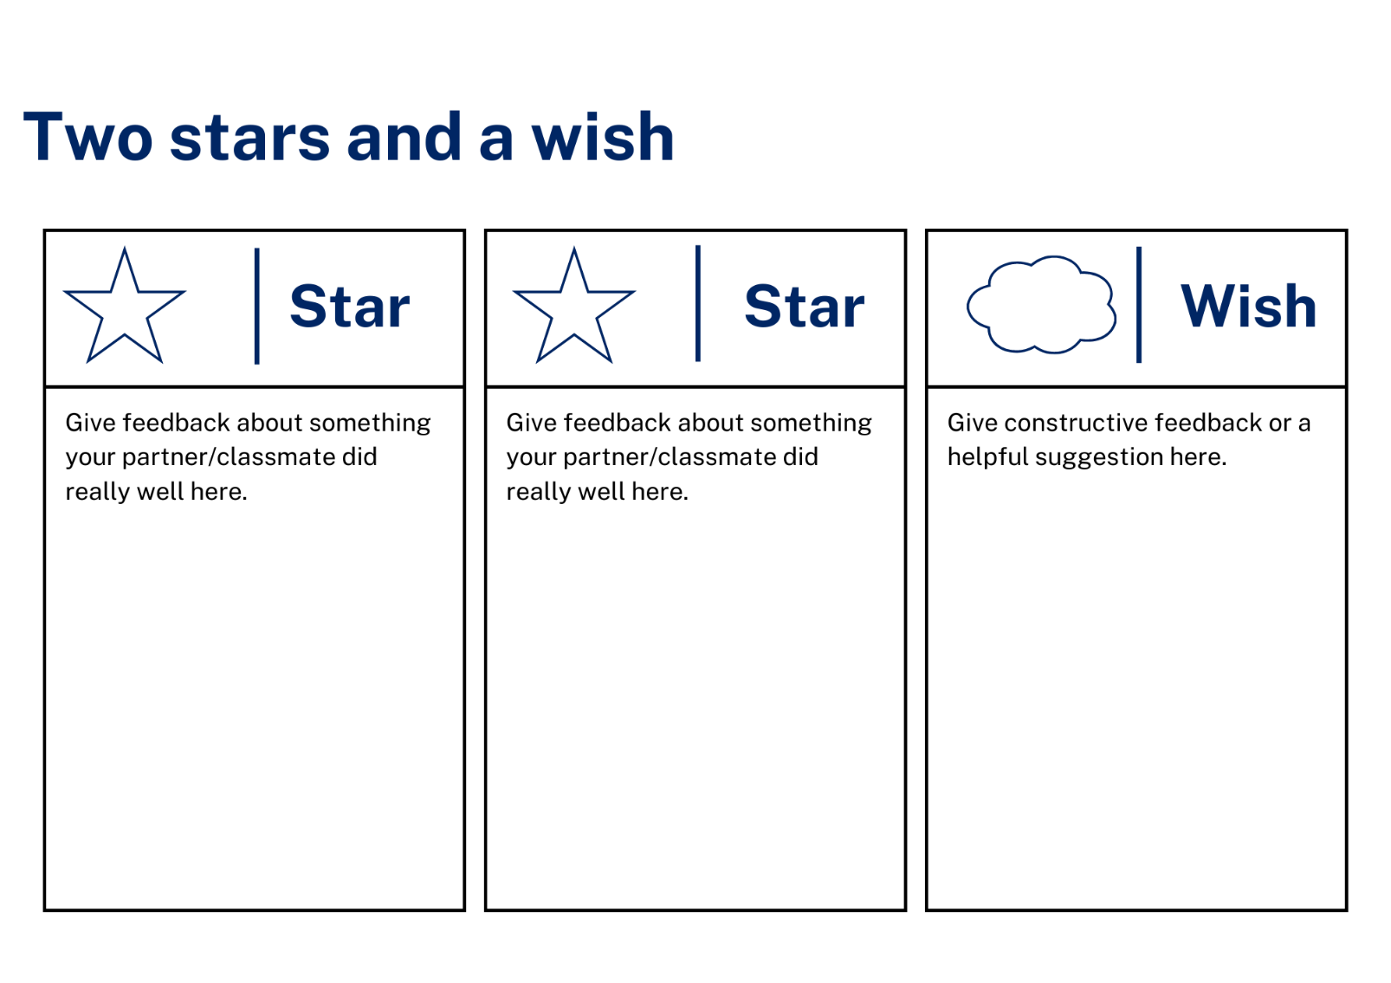

Resource 10 – dialogue cards
Modern Greek
Θα ήθελα να επισκεφτώ την Αθήνα για δύο μέρες. |  | Καλημέρα/καλό απόγευμα. |  | Το καλοκαíρι, Ιούνιος η Ιούλιος, όταν κάνει ζέστη. |  | Θα ήθελα να κλείσω ένα ταξίδι στην Ελλάδα για την οικογένειά μου. |  | Θέλω να πάω στον Όλυμπο για 2 μέρες και να δω το αρχαíο Ολυμπιακό στάδιο.
Εντάξι και που μετά; |  | Υπέροχο. Που θέλεις να επισκεφτείς στην Ελλάδα; |  | Υπέροχο. Πότε θέλεις να πας; |  | Θα ήθελα να επισκεφτώ το νησí της Μυκόνου για τέσσερες μέρες και να κολυμπήσω στη θάλλασα. |  | Καλά ευχαριστό, πως μπορώ να σε βοηθήσω;

English
I would like to visit Athens for two days. |  | Good morning/Good afternoon. |  | In summer, June or July, when it is hot. |  | I would like to book a holiday to Greece for my family. |  | I want to go to Olympus for 2 days and see the ancient Olympic Stadium.
Ok. And where to next? |  | Great! Which places in Greece would you like to visit? |  | Great! When would you like to go? |  | I would like to visit the island of Mykonos for four days and swim in the sea. |  | Good, thank you, how may I help you?

Support and alignment
Resource evaluation and support: all curriculum resources are prepared through a rigorous process. Resources are periodically reviewed as part of our ongoing evaluation plan to ensure currency, relevance and effectiveness. For additional support or advice, contact the Primary Languages team by emailing primlang@det.nsw.edu.au.
Alignment to system priorities and/or needs: School Excellence Policy, School Success Model
Alignment to the School Excellence Framework: this resource supports the School Excellence Framework elements of curriculum (curriculum provision, teaching and learning programs) and effective classroom practice (lesson planning).
Alignment to Australian Professional Teaching Standards: this resource supports teachers to address Australian Professional Teaching Standards 2.2.2, 3.2.2.
Consulted with: Curriculum, Secondary Learners, school-based staff and NESA subject matter experts. Advice from Aboriginal Outcomes and Partnerships, EAL/D, HPGE and Inclusive Education for Modern Languages Stage 3 Italian Mangiare in Ristorante has been considered in preparing this document.
NSW syllabus: Modern Languages K–10 Syllabus
Syllabus outcomes: ML3-INT-01, ML3-UND-01, ML2-CRT-01
Author: Primary Curriculum
Publisher: State of NSW, Department of Education
Resource: unit
Related resources: further resources to support Stage 3 Modern Languages can be found on the Languages K-6 curriculum page.
Professional learning: relevant professional learning is available through Primary Languages Networks on Teams (staff only).
Universal Design for Learning: support the diverse learning needs of students using inclusive teaching and learning strategies. Some students may require more specific adjustments to allow them to participate on the same basis as their peers. For further advice see Inclusive practice resources for primary school.
Differentiation: when using these resources in the classroom, it is important for teachers to consider the needs of all students in their class, including:
- Aboriginal and Torres Strait Islander students. Targeted strategies can be used to achieve outcomes for Aboriginal students in K-12 and increase knowledge and understanding of Aboriginal histories and cultures. Teachers should use students’ Personalised Learning Pathways to support individual student needs and goals.
- EAL/D learners. EAL/D learners may require scaffolding to support them to gain content knowledge, while providing extra time and assistance to master the English language required to engage with texts or complete classroom tasks. View some samples of differentiating through scaffolding.
- Students with additional learning needs. Learning adjustments enable students with disability and additional learning and support needs to access syllabus outcomes and content on the same basis as their peers. Teachers can use a range of adjustments to ensure a personalised approach to student learning.
- High potential and gifted learners. Assessing and identifying high potential and gifted learners will help teachers decide which students may benefit from extension and additional challenge. In addition, the Differentiation Adjustment Tool can be used to support the specific learning needs of high potential and gifted students.
Creation date: 25 October 2023
Rights: © State of New South Wales, Department of Education

References
This resource contains NSW Curriculum and syllabus content. The NSW Curriculum is developed by the NSW Education Standards Authority. This content is prepared by NESA for and on behalf of the Crown in right of the State of New South Wales. The material is protected by Crown copyright.
Please refer to the NESA Copyright Disclaimer for more information https://educationstandards.nsw.edu.au/wps/portal/nesa/mini-footer/copyright.
NESA holds the only official and up-to-date versions of the NSW Curriculum and syllabus documents. Please visit the NSW Education Standards Authority (NESA) website https://educationstandards.nsw.edu.au/ and the NSW Curriculum website https://curriculum.nsw.edu.au.
Modern Languages K–10 Syllabus © NSW Education Standards Authority (NESA) for and on behalf of the Crown in right of the State of New South Wales, 2022.
8 Ways (n.d.) 8 Aboriginal Ways of Learning [website], accessed 25 October 2023.
AITSL (Australian Institute for Teaching and School Leadership) (2017) ‘Feedback Factsheet’, AITSL, accessed 25 October 2023.
Brookhart SM (2011) How to Assess Higher-Order Thinking Skills in Your Classroom, Hawker Brownlow Education, Victoria.
CESE (Centre for Education Statistics and Evaluation) (2020a) What works best: 2020 update, NSW Department of Education, accessed 25 October 2023.
CESE (Centre for Education Statistics and Evaluation) (2020b) What works best in practice, NSW Department of Education, accessed 25 October 2023.
Conti G (28 September 2015) ‘16 tips for effective grammar teaching in the foreign language classroom’, The Language Gym, accessed 25 October 2023.
Conti G (28 May 2017) ‘From Target Language to Model Language – the mind shift that has transformed my teaching’, The Language Gym, accessed 25 October 2023.
Henshaw FG and Hawkins MD (2022) Common Ground: Second Language Acquisition Theory Goes to the Classroom, Focus, Indianapolis..
Jones J and Wiliam D (2014) Modern Foreign Languages Inside the Black Box: Assessment for Learning in the Modern Foreign Languages Classroom (Black P, Harrison C, Marshall B and Wiliam D, eds), Learning Sciences International, United States.
NESA (NSW Education Standards Authority) (2020) NSW Curriculum Review – final report, NESA, NSW Government, accessed 25 October 2023.
Rosenshine B (2012) ‘Principles of Instruction: Research-Based Strategies That All Teachers Should Know’, American Educator, 36(1):12–19, 39, accessed 25 October 2023.
Smith S (2022) Becoming an Outstanding Languages Teacher, 2nd edn, Routledge, United Kingdom.
Wisniewski B, Zierer K and Hattie J (2020) ‘The Power of Feedback Revisited: A Meta-Analysis of Educational Feedback Research’, Frontiers In Psychology, 10(3087), doi:10.3389/fpsyg.2019.03087, accessed 25 October 2023.
Wiliam D (2013) ‘Assessment: The Bridge between Teaching and Learning’, Voices from the Middle, 21(2):15–20, accessed 25 October 2023.
Wiliam D and Leahy S (2015) Embedding Formative Assessment: Practical Techniques for K–12 Classrooms, Learning Sciences International, United States.

© State of New South Wales (Department of Education), 2023
The copyright material published in this resource is subject to the Copyright Act 1968 (Cth) and is owned by the NSW Department of Education or, where indicated, by a party other than the NSW Department of Education (third-party material).
Copyright material available in this resource and owned by the NSW Department of Education is licensed under a Creative Commons Attribution 4.0 International (CC BY 4.0) license.
This license allows you to share and adapt the material for any purpose, even commercially.
Attribution should be given to © State of New South Wales (Department of Education), 2023.
Material in this resource not available under a Creative Commons license:
- the NSW Department of Education logo, other logos and trademark-protected material
- material owned by a third party that has been reproduced with permission. You will need to obtain permission from the third party to reuse its material.
Links to third-party material and websites
Please note that the provided (reading/viewing material/list/links/texts) are a suggestion only and implies no endorsement, by the New South Wales Department of Education, of any author, publisher, or book title. School principals and teachers are best placed to assess the suitability of resources that would complement the curriculum and reflect the needs and interests of their students.
If you use the links provided in this document to access a third-party's website, you acknowledge that the terms of use, including licence terms set out on the third-party's website apply to the use which may be made of the materials on that third-party website or where permitted by the Copyright Act 1968 (Cth). The department accepts no responsibility for content on third-party websites.

