Hindi Stage 3
विद्यालय का भ्रमण (School tour)

Contents
Unit overview 5
Stage 3 outcomes and content to be addressed 6
Learning map 10
Assessment 13
Assessment opportunities 14
Teaching and learning activities 15
Week 1 – school 15
Activity 1 – Learning map 16
Vocabulary 1 – school 16
Vocabulary 2 – verbs 17
Activity 2 – school vocabulary – pre-assessment 19
Activity 3 – clap it out! 20
Activity 4 – mime time 21
Activity 5 – verbs 21
Activity 6 – recording new language 22
Week 2 – bilingual map of a school 24
Vocabulary 3 – location and directions 24
Activity 1 – features of a map 26
Activity 2 – make a bilingual map 27
Activity 3 – Where is…? 27
Activity 4 – How do I get to…? 29
Week 3 – things I do at school 31
Activity 1 – days of the week 31
Activity 2 – things I do at school 32
Activity 3 – recording new language 33
Activity 4 – roll and bol (say) 33
Week 4 – questions and answers 35
Activity 1 – questions 35
Activity 2 – suggested answers 36
Activity 3 – questions and answers – mingling activity 36
Activity 4 – face off 37
Week 5 – assessment criteria and practice task 38
Activity 1 – discuss the assessment task 38
Activity 2 – success criteria 39
Activity 3 – discuss the rubric 40
Activity 4 – peer assessment 40
Activity 5 – practice task – question and answer 41
Week 6 – communicative task – show a new family around the school and answer their questions 42
Activity 1 – communicative task – show a new family around the school and answer their questions 43
Activity 2 – set up 43
Activity 3 – peer feedback 44
Week 7 – feedback and goal setting 45
Activity 1 – scavenger hunt 46
Activity 2 – self-assessment 46
Activity 3 – set learning goals 46
Week 8 – language review 47
Activity 1 – student questions 48
Activity 2 – Hotseat 48
Activity 3 – rolling sentences 48
Activity 4 – Show me around 49
Student resources 50
Resource 1 – school flashcards 50
Resource 2 – school vocabulary worksheet 54
Resource 3 – verbs flashcards 56
Resource 4 – location and direction flashcards 60
Resource 5 – sentence builders – questions and answers 64
Resource 6 – assessment task – school tour 72
Outcomes 72
Task 72
Learning intention 72
Success criteria 73
Task instructions 74
Resource 7 – rubric – school tour 75
Resource 8 – peer feedback strategy – Two stars and a wish 79
Support and alignment 80
References 83

Unit overview
Stage: 3
Title: विद्यालय का भ्रमण (School tour)
Description: In this unit, students create and label a bilingual map of the school to support new language speaking families. They practise giving directions using modelled language. Students use the bilingual map to interact in a role-play asking and responding to questions about the different parts of the school.
Duration: This lesson sequence is designed to be completed over approximately 8 weeks.
Student proficiency levels:
It is assumed that most Stage 3 students have been learning Hindi since Kindergarten and their proficiency level will be Intermediate. This unit is aimed at Intermediate students. Every classroom will be different and teachers will need to adapt to their context. Many classes may include a combination of Beginner, Intermediate and Advanced students. Assessment tasks and opportunities in this unit can be differentiated using the ‘Too hard?’ and ‘Too easy?’ suggestions.

Stage 3 outcomes and content to be addressed
The table below outlines the focus area, outcomes and content points for Stage 3 students.
Focus area and outcome | Content points
Interacting  A student:  - exchanges information and opinions in familiar contexts by using culturally appropriate rehearsed language ML3-INT-01 | Exchanging meaning in oral interactions in the target language  - Understand and share information about themselves and their personal world  - Ask and answer questions with familiar structures  - Express and describe emotions and personal preferences  - Address a new acquaintance and introduce themselves  - Ask for clarification or repeat information to facilitate understanding in familiar interactions  Applying knowledge of language systems to interact in the target language  - Use key features of the sound system including pronunciation, intonation patterns, stress and/or rhythms to interact  - Use familiar vocabulary to interact  - Use modelled grammatical structures to interact  Applying knowledge of the target language culture(s) to interact  - Use language and nonverbal communication that are appropriate to cultural practices
Understanding texts  A student:  - identifies and responds to information and opinions in texts to demonstrate understanding ML3-UND-01 | Understanding and responding to target language texts  - Listen to, read and view information and opinions in a range of texts on familiar themes  - Use comprehension strategies to process information and opinions in texts  - Respond in the target language and/or English to main points and specific information in familiar texts to explain understanding and express opinions  Applying knowledge of language systems to understand and respond to target language texts  - Identify and use the sounds of the target language to understand and respond to texts  - Identify and use sound–symbol correspondences to understand and respond to texts  - Use knowledge of vocabulary and phrases from familiar themes to understand and respond to texts  - Use modelled sentence structures and grammar patterns to understand and respond to texts  - Use familiar metalanguage to compare some target language structures and features with English  - Recognise and use familiar structures and features of the target language writing system to understand and respond to texts  Developing intercultural understanding through target language texts  - Respond to texts and consider how language is connected with cultural practices and compare how this is evident in their own language(s), culture(s) and identity
Creating texts  A student:  - creates a range of texts for familiar communicative purposes by using culturally appropriate rehearsed language ML3-CRT-01 | Creating spoken, written and multimodal texts in the target language  - Create informative texts appropriate to context, purpose and audience, sharing information about familiar themes  - Create imaginative texts appropriate to context, purpose and audience using a series of sequenced sentences and visuals to express ideas on familiar themes  Applying knowledge of language systems to create texts in the target language  - Use pronunciation, intonation patterns, stress and/or rhythms to create spoken texts  - Use sound–symbol correspondences to create written texts  - Use relevant vocabulary, formulaic expressions or modelled phrases from familiar themes to create texts  - Use a range of modelled sentence and grammatical structures to create texts  - Select structures and features of the target language writing system to create written texts  Applying knowledge of the target language culture(s) to create texts  - Use language appropriate to cultural practices to create texts
Modern Languages K–10 Syllabus © NSW Education Standards Authority (NESA) for and on behalf of the Crown in right of the State of New South Wales, 2022.

Learning map
The creation of maps for learning is a planning process that incorporates Aboriginal intellectual tradition. Learning maps are a visual pathway of what students will learn.
Share the learning map with your students, briefly explaining the learning that will happen in each lesson. Provide students with a copy of the learning map or display the learning map in the classroom. This learning map can be adapted to Hindi by accessing a copy of Learning map – School tour (Stage 3).

Figure 1 – School tour learning map
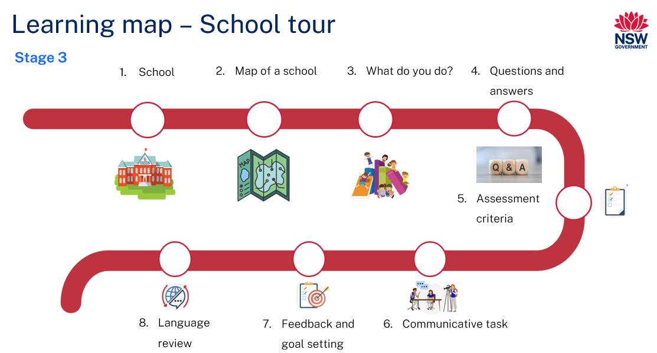
Figure 2 – विद्यालय का भ्रमण learning map
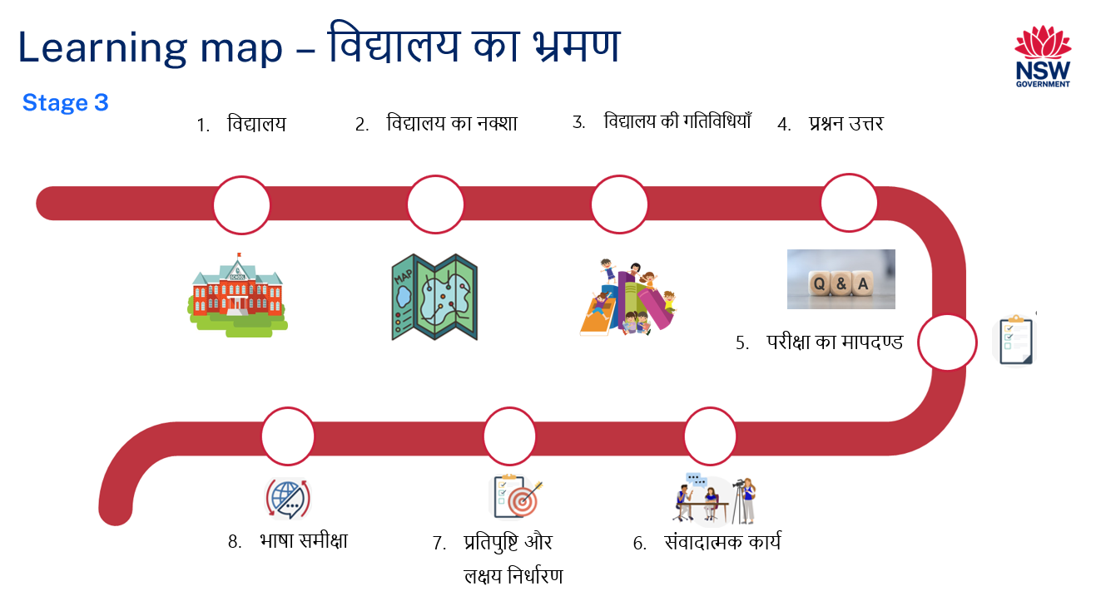

Assessment
Stage 3 communicative task: Using a map of the school, show a new Hindi-speaking family around selected parts of the school and answer their questions.
Too hard?
Students answer questions for one area of the school using the map.
Too easy?
Students engage in conversation giving the new Hindi-speaking family a complete tour of the school.
Context: showing a new family around the school
Audience: Hindi-speaking parents
Purpose: to show new language speaking parents the school

Assessment opportunities
The table below details assessment opportunities and differentiation ideas.
Assessment opportunities | Too hard? | Too easy?
Week 2 – make a bilingual map  Students draw and label an aerial view of any 3 areas of their school. | Make a bilingual map  Students draw and label any one area of their choice in English and Hindi. | Make a bilingual map  Students draw and label the map of the whole school in English and Hindi.
Week 3 – roll and bol (say)  Students make silly sentences using 3 dice with location/directional words, verbs, and places in a school. | Roll and bol (say)  Students make sentences using 2 dice with a focus on verbs and places in a school. | Roll and bol (say)  Students say silly sentences using the words on dice under a set timer.
Week 4 – face off  Students ask and respond to questions about an area of the school with their peers. | Face off  Students ask and respond to questions related to one topic at a time. | Face off  Students use questions as a conversation starter. The conversation continues after the question has been answered.

Teaching and learning activities

Week 1 – school
The table below outlines the learning intention and success criteria of the lesson, and materials that the teacher and students will need to complete the teaching and learning activities.
Learning intention and success criteria | Materials
Students will communicate using words and phrases related to school in Hindi.  Students can:  - say and write vocabulary related to people and places in a school in Hindi  - say and write verbs in Hindi. | - Resource 1 – school flashcards  - Resource 2 – school vocabulary worksheet  - Resource 3 – verbs flashcards  - Writing and drawing materials  - Butcher’s paper  - Sticky notes  - Hindi exercise books

Activity 1 – Learning map
Explain and display the Learning map to give students a more detailed breakdown of lessons during the unit. Point out that the Learning map is a plan that may need to change.

Vocabulary 1 – school
The table below outlines suggested vocabulary for the below activities. It includes the original Hindi script, a Romanised version of the Hindi script, and the corresponding English translations.
English | Romanised Hindi | Hindi
school | vidyaalay | विद्यालय
library | pustakaalay | पुस्तकालय
toilet | shauchaalay | शौचालय
school office | karyaalay | कार्यालय
playground | khel ka maidan | खेल का मैदान
school hall | haal/ sabha bhavan | हॉल / सभा भवन
canteen | kanteen | कंटीन
uniform shop | vardee ki dukaan | वर्दी की दुकान
classroom | kakshaa | कक्षा
students | chhaatr/ vidyaarthi | छात्र / विद्यार्थी
teachers | adhyaapak/adhyaapika | अध्यापक / अध्यापिका
principal | pradhaan aachaarya | प्रधानाचार्य

Vocabulary 2 – verbs
The table below outlines suggested vocabulary for the below activities. It includes the original Hindi script, a Romanised version of the Hindi script, and the corresponding English translations.
English | Romanised Hindi | Hindi
write | likh | लिख
read/study | parh | पढ़
play | khel | खेल
eat | khaa | खा
run | daud | दौड़
learn | seekh | सीख
buy | khareed | खरीद
ask | poonch | पूछ
go | jaa | जा
walk | chal | चल
borrow | udhaar | उधार
return | lautaana | लौटना
find | doondh | डूँढ़

Activity 2 – school vocabulary – pre-assessment
- Brainstorm different areas of a school in English. Show the images in Resource 1 – school flashcards. Ask the following questions to assess students’ prior knowledge. Students answer by showing thumbs up at their chests.
- How many different areas of your school can you identify from the pictures?
- Do you know the names of all areas of a school in Hindi?
- Do you know the names of some of them?
- Do you know the names of any of them?
- Students Think-Pair-Share the words they know.
- Display images in Resource 1 – school flashcards on one side of the board. As a whole class, match words to pictures one at a time. After each match, model and drill the correct pronunciation of vocabulary.
Note: display vocabulary on the wall. Add new and known words in Hindi as required.

Activity 3 – clap it out!
- Display Vocabulary 1 – school and model the correct pronunciation by asking students the following questions.
- How many syllables in the word छात्र (Chhatr)? There are 2 syllables (छा-त्र Chha-tr). Clap twice as you say each syllable loudly and clearly.
- Ask students to clap out the syllables with you.
- Repeat with:
- पुस्तकालय (pustakaalay) = has 5 syllables पु-स्त-का-ल-य (pu-sta-kaa-la-y),
- कक्षा (kakshaa) = has 2 syllables क-क्षा (ka-kshaa)
- Ask students to repeat this for other vocabulary words.
- Students write the words from Vocabulary 1 – school with a few letters missing. Another student completes the word by filling in the gaps.
- Hand out Resource 2 – school vocabulary worksheet and label the pictures.

Activity 4 – mime time
- Display images from Resource 3 – verbs flashcards one at a time and model saying the vocabulary words in Hindi. Students repeat the words. Model and drill the correct pronunciation of vocabulary. Display pictures and words for infinitive verbs on a piece of butcher’s paper.
- As a whole class, brainstorm actions that students can mime for different verbs. Suggested actions include:
- Read: palms together and moving head left to right
- Write: holding a pen/pencil and scribbling
- Ask: raising your hand and waiting.
- Say a verb and have students mime the action. Repeat the activity with all the other verbs. Flip the activity with you miming the action and students guessing the verb in Hindi.

Activity 5 – verbs
- Display images from Resource 3 – verbs flashcards. Ask students what verbs are and if they can identify verbs in the flashcards. In pairs, students Think-Pair-Share and tell their partners the words they know and report back to class.
- Display a flashcard of any one part of a school from Resource 1 – school flashcards. Brainstorm verbs that are associated with that place either in English or Hindi, for example verbs that are associated with the library may include सीख (learn), पढ़ (read), पढ़ा (teach), लिख (write), उधार (borrow), लौटाना (return) or डूँढ़ (find). Write the response on the board or butchers’ paper.
- Split the class in small groups and have each group complete the table below. Set a timer for 5 minutes and ask students to write down as many verbs they can think of that are associated with location(s) in the table. Students may use a dictionary or an online dictionary to find the Hindi translation for unknown words. Explain that some verbs may be used more than once depending on the places in the school.
Table 1 – location verbs
Playground | Library | Classroom | Hall | Canteen
- After 5 minutes, have each group present their verb list and create a word cloud using their words.
Note: display the word cloud for each location in the classroom. Add verbs suggested by the students to the word wall. Refer to the verbs in the word cloud for future lessons.

Activity 6 – recording new language
Students record vocabulary of school and infinitive verbs in their Hindi exercise books.
Evaluation: students accurately use the correct pronunciation to say the vocabulary words.

Week 2 – bilingual map of a school
The table below outlines the learning intention and success criteria of the lesson, and materials that the teacher and students will need to complete the teaching and learning activities.
Learning intention and success criteria | Materials
Students will create a bilingual map of their school.  Students can:  - label the map in English and Hindi  - describe the location of a place in school. | - Resource 4 – location and direction flashcards  - Hindi exercise books  - writing and drawing materials  - glue stick  - access to an online map

Vocabulary 3 – location and directions
The table below outlines suggested vocabulary for the below activities. It includes the original Hindi script, a Romanised version of the Hindi script, and the corresponding English translations.
English | Romanised Hindi | Hindi
direction | dishaa | दिशा
up | upar | ऊपर
down | neeche | नीचे
between | beech mein | बीच में
straight ahead | seedhe | सीधे
in front of | saamne | सामने
back/behind | peechay | पीछे
to the left side | baaen oar | बाएं ओर
to the right side | daaen oar | दाएं ओर
next to/ beside | saath mein | साथ में
near | paas mein | पास में
Where is…? | kahaan hai…? | कहाँ है… ?

Activity 1 – features of a map
- To pre-assess students' understanding of features of a map, ask students to turn to a partner and tell them the features of a map using the Think-Pair-Share strategy.
- Display maps of a park, school, hospital and zoo on the walls of the classroom. Have students walk around the classroom and note down the things that are common to all maps. Students Think-Pair-Share their observations and report back to the class in English. Possible responses include legend, scale, title, orientation and compass.
- As a whole class, discuss the meaning for each feature of the map.
Note: this activity is to assess students’ general understanding of what the key features of a map are. Students are not expected to learn the vocabulary for the features in Hindi, however there might be some students with prior knowledge.

Activity 2 – make a bilingual map
- Tell students that there can be different views of the same object. These include a bird’s eye view or aerial view, a front view and a side view. Display an online map and show different views of the same object.
- Ask students to draw a map of the whole school with an aerial view.
- Discuss things to be included on a map, for example landmarks or important features of the area, the distance between 2 places, key and compass. Once they have finalised the draft in their Hindi exercise books, students draw the map on A4 paper.
- Ask them to label the map in English and Hindi using the places in Vocabulary 1 – school. Students may plan the map in their Hindi exercise books.

Activity 3 – Where is…?
Note: have an enlarged map of your school ready for Activity 3 and Activity 4.
Pre-assessment: explain to students that prepositions are words that describe the position of objects. Elicit different prepositions by placing a book in different places and asking students to describe its position. For example, next to, in, between, on and behind. Place a book on a table and ask students where it is. Students respond by saying ‘मेज़ पर’ (on the table). Then, place the book next to a chair and ask students where it is now. Students respond by saying, ‘कुर्सी के साथ’ (next to the chair). Include different prepositions or directional vocabulary, for example ऊपर (up), नीचे (down), बाएं (left), दाएं (right), साथ में (next to), बीच में (between). Students record the prepositions in their language exercise books.
Note: use of articles
Explain that the use of articles in English and Hindi languages differs in several ways. English uses ‘the’ as the definite article before nouns to refer to something that is already known or previously mentioned. For example: The book is on the table. Hindi does not have a direct equivalent of the definite article ‘the’. Instead, the context and word order often serve to specify definiteness. For example: पुस्तकालय शौचालय के बाएं ओर है। (The library is to the left of the toilets). It is assumed both speakers know which library.
Also, Hindi does not have indefinite articles such as ‘a’ and ‘an’. Instead, the absence of an article or the use of the numeral ‘एक (one)’ implies an indefinite context. For example: ‘मेरे पास एक आम है। (I have a mango).
- Introduce new words from Vocabulary 3 – location and directions using Resource 4 – location and direction flashcards. Have students sit in a circle with an enlarged map of your school in the centre. Introduce the कहाँ है? (where is…?) phrase. Explain to students that in Hindi, the phrase, (where is…) follows the name of a part of the school. For example, कंटीन कहाँ है? (canteen where is?). Explain to the students that a sentence in Hindi always ends in a verb. Demonstrate the order of words in Hindi using the above examples. The order of words to form a sentence in Hindi is Subject (S) + Object (O) + Verb (V). Suggested acronym to remember the order is SOV. Explain how it is different in English where the usual order of words is Subject (S) + Verb (V) + Object (O). When the subject in a sentence is ‘I’, the sentence ends in ‘हूँ’ (hoon). Ask students if their home language is more similar to Hindi or English.
- Demonstrate asking questions. Suggested questions:
- पुस्तकालय कहाँ है ? (Where is the library?)
- शौचालय कहाँ है ? (Where are the toilets?)
- हिन्दी की कक्षा कहाँ है ? (Where is the Hindi classroom?)
- कंटीन कहाँ है? (Where is the canteen?)
- Have students use Vocabulary 3 – location and directions and the map of the school they created in Activity 2 to respond to the questions. Suggested student responses:
- कंटीन हॉल के साथ में है । (The canteen is next to the school hall).
- पुस्तकालय शौचालय के बाएं ओर है। (The library is to the left of the toilets).
- शौचालय खेल के मैदान के बीच में है। (The toilets are in the middle of the playground).
- हिन्दी की कक्षा year 1 की कक्षा के साथ है । (The Hindi classroom is next to the Year 1 classroom).

Activity 4 – How do I get to…?
Display an enlarged map of your school on the board. Select a few locations on the map and model how to give directions to get from one place to another in a school. For example: Ask ‘मैं पुस्तकालय तक कैसे पहुँचूँ ? (how do I get to the library?) Suggested response may be: कार्यालय से सीधा जाओ और सामने पुस्तकालय है। (Start at the office, go straight and you’ll reach the library).
Hand out Resource 1 – school flashcards and ask students to use the map they created in Activity 2. In pairs, students take 2 flashcards that could be a destination or a starting point. They take turns asking questions and giving directions to each other using Vocabulary 3 – location and directions.
Sample interaction:
- Student 1: मैं कार्यालय कैसे जाऊँ? (How do I get to the school office?)
- Student 2: पुस्तकालय से दाएं मुड़ो, फिर सीधे जाओ। कार्यालय year 1 के बाएं ओर है। (Turn right from the library, then go straight. The school office is to the left of the Year 1 classrooms).

Week 3 – things I do at school
The table below outlines the learning intentions and success criteria of the lesson, and materials that the teacher and students will need to complete the teaching and learning activities.
Learning intention and success criteria | Materials
Students will say and write simple sentences to describe the location of a place in the school in Hindi.  Students can:  - say and write things they do in school  - give directions to go from one place to another  - say and write sentences in Hindi using the correct word order. | - Resource 1 – school flashcards  - Map of the school created by the students  - Editable dice (3 per group)  - Hindi exercise books  - Writing and drawing materials
Note: introduced vocabulary in this lesson includes: बोल (say).

Activity 1 – days of the week
Pre-assessment: ask students if they know the days of the week in Hindi by showing a thumbs up at their chests when days of the week are called out in English. Ask the following questions:
- Do you know the names of all days of the week in Hindi?
- Do you know some of them?
- Do you know any of them?
In pairs, students Think-Pair-Share the words they know and report back to class. Model and drill the correct pronunciation of the days of the week.

Activity 2 – things I do at school
- Revise directional vocabulary and ‘Where is…?’ from Activity 3 – Where is…?
- Introduce the phrase ‘यह (this is a…)’. Show the images from Resource 1 – school flashcards one at a time. Show the image of the library and ask students to repeat ‘यह कंटीन है।‘ (This is a library) after you. Repeat with the other flashcards one at a time.
- Using the same flashcard, ask students where it is located and one thing they do at the place. Explain that, in Hindi, when you’re the subject in a sentence, there are 2 variations of the response. This is dependent on the gender of the subject – the masculine form (add the suffix -आ vowel, खरीदता) and the feminine form (add the suffix -ई vowel, खरीदती). For example, the library flashcard is displayed on the board. Ask students one thing they do in the library.
- The sample response for:
- Boys: मैं पुस्तकालय में किताबें पढ़ता हूँ। (I read books in the library).
- Girls: मैं पुस्तकालय में किताबें पढ़ती हूँ। (I read books in the library).
- Hand out Resource 1 – school flashcards to students and a map of a school. In pairs, students take turns to pick a card and respond to the following:
- What is it? using यह (‘this is a …’) phrase
- its location
- one thing they do at the selected place using the appropriate gender variation.
For example: If a student picks a library flashcard, the sample response may be: यह पुस्तकालय है। यह Year 1 की कक्षा के सामने है । मैं पुस्तकालय में किताबें पढ़ता (masculine)/ पढ़ती (feminine) हूँ। (This is a library. It is opposite the Year 1 classroom. I read books in the library).

Activity 3 – recording new language
Students record the sentences practiced above in their Hindi exercise books using Vocabulary 1 – school, Vocabulary 2 – verbs and Vocabulary 3 – location and directions.

Activity 4 – roll and bol (say)
Note: have 3 editable dice ready prior to this activity. Write any 6 directional words on die 1, verbs on die 2 and places in a school on die 3. The number of dice will depend on the number of groups formed. Ensure that every group has 3 dice.
- Split the class into groups of 3. Hand out 3 dice to each group. Students roll the 3 dice and make silly sentences using the words on the dice. For example:
- Dice 1 – library
- Dice 2 – play
- Dice 3 – next to.
- Based on the words rolled on the 3 dice, the sentences may be: यह पुस्तकालय है। मैं पुस्तकालय में खेलता हूँ। पुस्तकालय कंटीन के साथ में है। (This is a library. I play in the library. The library is next to the canteen).
- Students take turns until each one has had a few turns responding.

Week 4 – questions and answers
The table below outlines the learning intention and success criteria of the lesson, and materials that the teacher and students will need to complete the teaching and learning activities.
Learning intention and success criteria | Materials
Students will answer questions about school in Hindi.  Students can:  - answer questions about the school  - respond to questions using correct word order in Hindi. | - Resource 5 – sentence builders  - Questions written on cards  - Timer

Activity 1 – questions
Introduce questions that could be asked by a Hindi-speaking family in Resource 5 – sentence builders. Explain that they may ask questions related to the location, directions, days of the week and activity.
- Location: revise the कहाँ (‘Where is…?’) phrase from the previous lesson. Explain to students that in Hindi, the phrase, ‘Where is…?’ follows the name of a part of the school. For example, विद्यालय का कार्यालय (school office) कहाँ (where) है (is)? (Where is the school office)?
- Day of the week: introduce the कौन से दिन…(what day…) phrase. Demonstrate the use of the phrase by asking questions, for example: आपका sports day कौन से दिन होता है? (What day is your sports day?)
- Activity: revise saying sentences in Hindi telling one thing students do at the school. Ask students कोई एक चीज बताइए जो आप … में करते है (Tell me one thing you do at the canteen.)
Model and drill the questions, then display the questions on one side of the board. In pairs, students discuss the questions and use their knowledge of Hindi to decide on the best translations for each. Pairs share their translations with the class. Highlight that there may be several acceptable translations for some of the questions. Display the translations on the board.

Activity 2 – suggested answers
Display answers to the questions in Activity 1 at random on the board. In pairs, students match the questions to the answers in Resource 5 – sentence builders. One question at a time, pairs share their answers with the class. Again, highlight that there may be several acceptable answers for some of the questions.

Activity 3 – questions and answers – mingling activity
Note: write questions on cards prior to this activity.
Split the class in 2. Students in one half of the class hold a card with the questions on it. The other half of the class has nothing. Give students a time limit to ask as many classmates as possible the question on their card and students respond to the questions. When the time is up, the 2 groups swap roles.

Activity 4 – face off
Students choose one area of the school, for example the library, to talk about. Have students stand in 2 rows facing each other, with one row asking questions and the other row of students responding. Set a timer for one minute. Students have a conversation asking and responding to the questions about the library. When the timer is up, students move to the next person in line. In their conversation, include questions and answers related to what part of the school it is, its location, directions and one activity you do at the selected place and when.
Suggested interaction:
- Student A: मैं पुस्तकालय कैसे पहुँचूँ? (How do I get to the library?)
- Student B: कार्यालय से सीधे जाओ और फिर बाएं मुड़ो । पुस्तकालय आपके दाएं ओर है। (Walk straight from the office and turn left. The library is on your right).
- Student A: आप पुस्तकालय में क्या करते हो? (What do you do in the library?)
- Student B: मैं पुस्तकालय में किताबें पढ़ता/ पढ़ती हूँ। (I read books in the library).
- Student A: आपका library day कौन से दिन होता है? (What day is your library day)?
- Student B: मेरा library day गुरुवार को होता है। (My library day is Thursday).
The student who answered the questions about the library, now asks questions about a different part of the school, for example, the canteen. Students then talk to a new partner about other places in the school.

Week 5 – assessment criteria and practice task
The table below outlines the learning intention and success criteria of the lesson, and materials that the teacher and students will need to complete the teaching and learning activities.
Learning intention and success criteria | Materials
Students will develop an understanding of the requirements of the assessment task.  Students can:  - say what they need to do to be successful in the task  - ask questions if they don't understand the requirements of the assessment task. | - Learning map  - Resource 6 – assessment task – school tour  - Resource 7 – rubric – school tour  - Resource 8 – peer feedback strategy – Two stars and a wish  - Paper  - Writing materials

Activity 1 – discuss the assessment task
To prepare students for the final task, review the Learning map and discuss the language that has been taught each week. Point out that, according to the learning map, the final task will be completed in Week 6. Explain to students they will role-play having a conversation with a new Hindi speaking family. Students use the bilingual map of the school created in Week 2 to ask and respond to the questions regarding different parts of the school on the map.
Hand out Resource 6 – assessment task – school tour and lead the class in reading it.

Activity 2 – success criteria
After looking at the assessment task, students Think-Pair-Share and suggest appropriate success criteria, such as:
I will be successful if I can:
- respond to questions from the Hindi speaking family about
- the different parts of the school on the map
- the location of 2 selected parts of the school
- direction to and from the selected parts of the school
- one thing I do at the selected places and when.
- use correct sentences with correct grammar
- use verbs in the correct person and tense
- use nouns with the correct gender
- subject agrees with the correct gender.
- pronounce the words correctly
- speak in a well-paced manner without long pauses
- end the conversation in an appropriate way, for example, ‘धन्यवाद’ (Thank you).

Activity 3 – discuss the rubric
- Show students an unmarked rubric Resource 7 – rubric – school tour. This may need to be adapted if the class has decided on different success criteria.
- Explain the metalanguage, such as fluency, accuracy, pronunciation and vocabulary.
- Point out and provide examples of ‘excellent’ and ‘sort of’ task completion, fluency, accuracy, pronunciation and vocabulary.
- Students read and then discuss the ‘excellent’ column of the rubric in pairs. They then share their understanding of what is needed to be successful.

Activity 4 – peer assessment
Peer feedback will be incorporated into the task. Confirm which peer feedback strategy will be used, for example, Resource 8 – peer feedback strategy – Two stars and a wish and discuss with students.
Evaluation: students give examples of what stars and wishes would sound like for this task.

Activity 5 – practice task – question and answer
Students get in pairs and take turns at role-playing you and the new family at school. Using the map created in Week 2 and the questions and answers practised in Week 4, students ask and respond to questions related to what part of the school it is, its location, directions to and from the selected places, one thing you do at the selected places and when.

Week 6 – communicative task – show a new family around the school and answer their questions
The table below outlines the learning intention and success criteria of the lesson, and materials that the teacher and students will need to complete the teaching and learning activities.
Learning intention and success criteria | Materials
Students will participate in a role-play showing a new Hindi-speaking family around the school, using a map of the school, and answering their questions.  Students can:  - respond to questions from Hindi speaking family about  - the different parts of the school on the map  - the location of 2 selected parts of the school  - direction and from the selected parts of the school  - one thing I do at the selected places and when.  - use sentences with correct grammar  - use verbs in the correct person and tense  - use nouns with the correct gender  - subject agrees with the correct gender.  - pronounce the words correctly  - speak in a well-paced manner without long pauses  - end the conversation in an appropriate way, for example, ‘धन्यवाद’ (Thank you). | - Resource 6 – assessment task – school tour  - Resource 7 – rubric – school tour  - Resource 8 – peer feedback strategy – Two stars and a wish

Activity 1 – communicative task – show a new family around the school and answer their questions
Ensure students have at least one more opportunity to role-play using the map of the school before they complete their assessment.

Activity 2 – set up
Note: make sure to space students apart when filming. Demonstrate how to film using a recording device. Use microphones, if possible, to maximise sound quality. Highlight the importance of holding the recording device still by using a tripod or resting it on a table.
Students get in groups of 3. Give students a few minutes to ensure everybody knows the order in which they will be performing each role. The Hindi student is the student who is completing the assessed communicative task.
Suggested rotations:
- Role-play 1: Student 1 – Hindi student, Student 2 – Peer assessor/Camera operator, Student 3 – New family
- Role-play 2: Student 1 – New family, Student 2 – Hindi student, Student 3 – Peer assessor/Camera operator
- Role-play 3: Student 1 – Peer assessor/Camera operator, Student 2 – New family, Student 3 – Hindi student.

Activity 3 – peer feedback
- Hand out Resource 6 – assessment task – school tour and Resource 7 – rubric – school tour.
- Divide students into pairs. Students take turns providing peer assessment to the presenter using the ‘Two stars and a wish’ strategy.
- Students provide peer feedback verbally and follow up with the completed Resource 8 – peer feedback strategy – Two stars and a wish.

Week 7 – feedback and goal setting
Note: if there is insufficient time to mark the videos before Week 8, Weeks 7 and 8 can be swapped.
The table below outlines the learning intention and success criteria of the lesson, and materials that the teacher and students will need to complete the teaching and learning activities.
Learning intention and success criteria | Materials
Students will reflect on their task recordings to assess performance and set learning goals.  Students can:  - self-assess their completion of the task  - set suitable learning goals based on previous learning goals and teacher, peer- and self-assessment. | - Blank Resource 7 – rubric – school tour for self-assessment (one per student)  - Teacher completed copy of Resource 7 – rubric – school tour (one per student)  - Hindi exercise books  - Tablets or other recording devices
Note: prior to this lesson, view each video and mark each student according to the criteria on Resource 7 – rubric – school tour.

Activity 1 – scavenger hunt
Hand out a map of the school to students. In pairs, students take turns being the ‘navigator’ and the ‘explorer.’ The navigator looks at the map and uses Vocabulary 3 – location and directions to guide their explorer partner to find specific locations on the map from Vocabulary 1 – school, by giving instructions in Hindi. The explorer must follow the directions provided by the navigator.
Set a time limit of 5 minutes for each round. After each round, have the pairs switch roles. Ask the pair to keep a track of the number of locations each pair finds correctly within the time limit.

Activity 2 – self-assessment
Students watch the video of themselves completing the task and mark themselves using the rubric. Students then compare both the teacher completed rubric and the one they completed.

Activity 3 – set learning goals
Students reflect on the teacher, peer- and self-evaluation to set learning goals for the next phase of learning. For example, ‘I will not be worried about making a mistake when speaking Hindi’ or ‘I will try to say (a particular sound) correctly.’ Students write their learning goals in their language notebooks.
Evaluation: students set appropriate learning goals based on previous learning goals and teacher, peer- and self-assessment.

Week 8 – language review
Note: if there is insufficient time to mark the videos before Week 8, Weeks 7 and 8 can be swapped.
The table below outlines the learning intention and success criteria of the lesson, and materials that the teacher and students will need to complete the teaching and learning activities.
Learning intention and success criteria | Materials
Students will reflect on and ask questions about the language taught in this unit.  Students can:  - ask questions about vocabulary, grammar, or pronunciation they have used in this unit  - use Hindi words and phrases they have learned to communicate with classmates. | - Editable dice  - Map of school created by students  - Hindi exercise books  - Writing materials
Note: over the course of the unit, gaps in student knowledge, misconceptions and misuse of language will have been identified. These observations are addressed using engaging and interactive activities and strategies. The activities below are examples and will need to be supplemented with activities to address your observations.

Activity 1 – student questions
Remind students of the activities and tasks they have completed over the course of the unit. Give students time to Think-Pair-Share any questions they may have about any aspect of the language taught.

Activity 2 – Hotseat
- Divide the class in 2 or 3 teams, depending on the class size. One player per team has their back to the board. Write a word from Vocabulary 1 – school, Vocabulary 2 – verbs or Vocabulary 3 – location and directions in Hindi on the board.
- Students give clues in Hindi or in English to their teammate without saying the word, for example, यहाँ से खाना खरीदते है । (You buy food from here). The first student on the chair to say कंटीन (canteen) earns a point for their team.
- After each round, model and drill how to correctly pronounce the vocabulary, displaying the words and supporting images on the board or wall.

Activity 3 – rolling sentences
Note: write any 6 directional words in Vocabulary 3 – location and directions on editable dice for this activity. The number of dice will depend on the number of groups formed. Ensure that every group has the editable dice.
Split the class into groups of 3. Hand out Resource 1 – school flashcards and an editable die to each group. Ask students to place the flashcards face down in a pile. Student 1 flips 2 flashcards and places them face up. Student 2 rolls the die. Student 3 phrases a sentence using the cue on the die. Example:
- Student 1 flips पुस्तकालय library and खेल का मैदान (playground)
- Student 2 rolls the word दाएं (right)
- Student 3 responds – पुस्तकालय खेल के मैदान के दाएं में है । (The library is to the right of the playground).
Students take turns until each one has had a few turns responding.

Activity 4 – Show me around
In pairs, students have a conversation asking and responding to the questions about the chosen school area using Resource 5 – sentence builders and a map of the school. In their conversation, include questions and answers related to what part of the school it is, its location, directions to the selected place and one activity you do at the selected place and when. Students take turns asking and responding to the questions.

Student resources

Resource 1 – school flashcards
 |  |  |  | This Photo by Unknown Author is licensed under CC BY-SA |  | 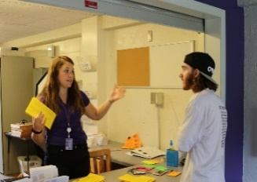  This Photo by Unknown Author is licensed under CC BY-SA-NC |  | 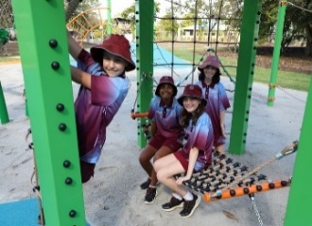  This Photo by Unknown Author is licensed under CC BY
विद्यालय |  | पुस्तकालय |  | शौचालय |  | कार्यालय |  | खेल का मैदान
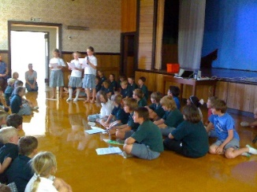 |  | This Photo by Unknown Author is licensed under CC BY-SA |  | 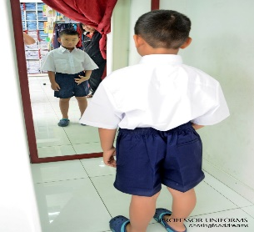  This Photo by Unknown Author is licensed under CC BY-SA-NC |  | 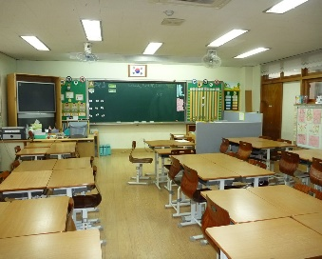  This Photo by Unknown Author is licensed under CC BY-SA |  | 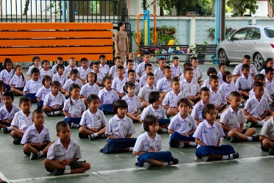
हॉल |  | कंटीन |  | वर्दी की दुकान |  | कक्षा |  | छात्र / विद्यार्थी
 |  | 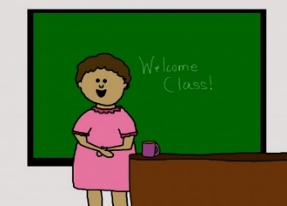
अध्यापक |  | अध्यापिका |  | प्रधानाचार्य

 |  |  |  |  |  | 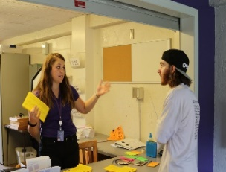 |  | 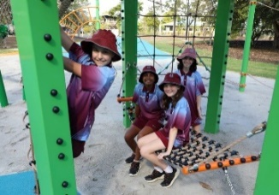
school |  | library |  | toilets |  | office |  | playground
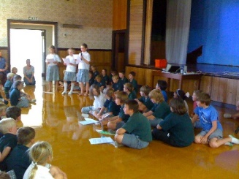 |  |  |  | 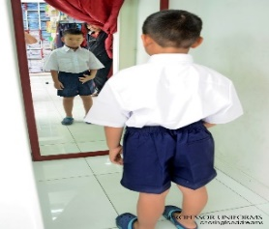  This Photo by Unknown Author is licensed under CC BY-SA-NC |  | 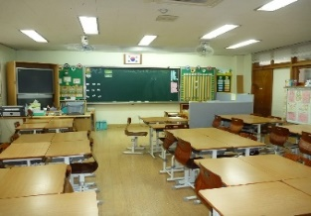 |  | 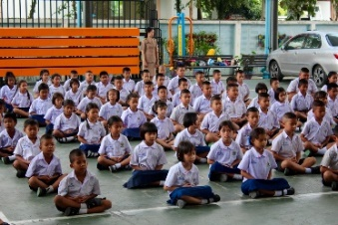
hall |  | canteen |  | uniform shop |  | classroom |  | student

male teacher |  | female teacher |  | Principal

Resource 2 – school vocabulary worksheet
Write the word matching the picture.
विद्यालय (school) | शौचालय (toilets) | पुस्तकालय (library) | अध्यापक  (male teacher)
कार्यालय (office) | कक्षा (classroom) | खेल का मैदान (playground)
अध्यापिका  (female teacher) | छात्र (student) | प्रधानाचार्य (Principal)

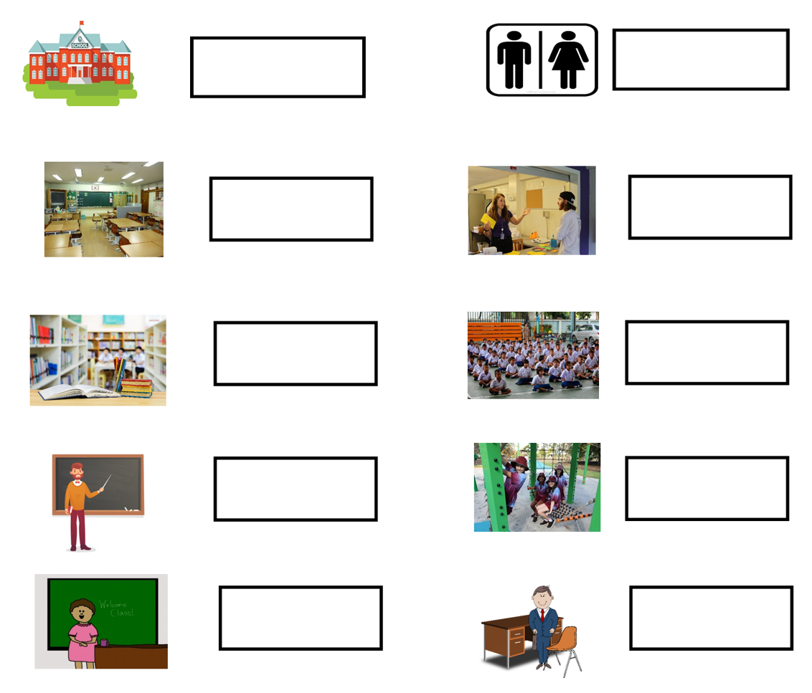

Resource 3 – verbs flashcards
लिख |  | पढ़ |  | खेल |  | खा |  | दौड़
 |  |  |  |  |  | This Photo by Unknown Author is licensed under CC BY-NC |  | 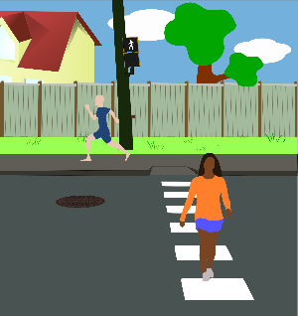
सीख |  | खरीद |  | पूछ |  | जा |  | चल

This Photo by Unknown Author is licensed under CC BY-SA
उधार ले |  | वापिस कर |  | डूँढ़

write |  | read/study |  | play |  | eat |  | run
 |  |  |  |  |  | This Photo by Unknown Author is licensed under CC BY-NC
learn |  | buy |  | ask |  | go |  | walk
This Photo by Unknown Author is licensed under CC BY-SA
borrow |  | return |  | find

Resource 4 – location and direction flashcards
 |  | 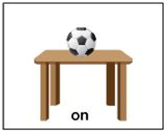 |  | 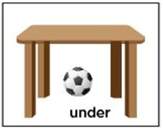 |  | 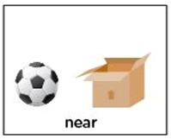
दिशा |  | ऊपर |  | नीचे |  | पास में
साथ में |  | बीच में |  | पीछे |  | सामने

सीधे |  | दायें ओर |  | बाएं ओर

direction |  | on |  | under |  | near
next to |  | between |  | behind |  | in front of
straight |  | to the left of |  | to the right of

Resource 5 – sentence builders – questions and answers
Questions | Places in a school
…कहाँ है? (Where is the…?)  मैं…कैसे पहुँचूँ? (How do I get to the…?)  कोई एक चीज बताइए जो आप … में करते है (Tell me one thing you do at the…?) | पुस्तकालय (library)  शौचालय (toilets)  कार्यालय (office)  खेल का मैदान (playground)  हॉल / सभा भवन (hall)  कंटीन (canteen)  वर्दी की दुकान (uniform shop)  कक्षा (classroom)
आपका … कौन से दिन होता है? (What day is your…?) | sports day  library day  Hindi class

Answers | Place in a school
यह… (This is the…)  ये (These are the…) | पुस्तकालय है । (library)  कार्यालय है । (office)  खेल का मैदान है । (playground)  हॉल / सभा भवन है । (hall)  कंटीन है । (canteen)  वर्दी की दुकान है । (uniform shop)  कक्षा है । (classroom)  शौचालय हैं । (toilets)
यह… (It…) | पुस्तकालय के (library)  शौचालय के (toilets)  कार्यालय के (office)  खेल का मैदान के (playground)  हॉल / सभा भवन के (hall)  कंटीन के (canteen)  वर्दी की दुकान के (uniform shop)  कक्षा के (classroom) | Location/direction  ऊपर (up)  नीचे (down)  बीच में (between)  सीधे (straight)  सामने (in front of)  पीछे (behind)  बाएं ओर (to the right of)  दाएं ओर (to the left of)  साथ में (next to)  पास में (near) | है । (is)
मैं /हम … (I/we…) | पुस्तकालय में (library)  शौचालय में (toilets)  कार्यालय में (office)  खेल का मैदान में (playground)  हॉल / सभा भवन में (hall)  कंटीन में (canteen)  वर्दी की दुकान में (uniform shop)  कक्षा में (classroom) | Verbs  लिख (write)  पढ़ (read)  खेल (play)  खा (eat)  दौड़ (run)  सीख (learn)  खरीद (buy)  पूछ (ask)  जा (go)  चल (walk)  उधार (borrow)  वापिस कर (return)  डूँढ़ (find)  Add suffix -ता (masculine) ओर -ती (feminine) to the verb based on the gender of the subject. | हूँ /हैं ।
Sports day  library day  Hindi class | सोमवार (Monday)  मगलवार (Tuesday)  बुधवार (Wednesday)  वीरवार (Thursday)  शुक्रवार (Friday) | को होता है । (happens on- masculine)  को होती है । (happens on- feminine)

Resource 6 – assessment task – school tour

Outcomes
You will be assessed on how well you exchange information and opinions in familiar contexts by using culturally appropriate rehearsed language.

Task
Show a new Hindi-speaking family around the school using a map of the school and answer their questions.
The table below outlines the communicative task students will need to complete.
Too hard? | Too easy?
Student answers questions for one area of the school using the map. | Students engage in conversation giving the new Hindi-speaking family a complete tour of the school.

Learning intention
Students will be able to show a new Hindi-speaking family around the school using a map of the school and answer their questions.

Success criteria
You will be successful if you can:
- respond to questions from Hindi speaking family about
- the different parts of the school on the map
- the location of 2 selected parts of the school
- direction to and from the selected parts of the school
- one thing I do at the selected places and when
- use correct sentences with correct grammar
- use verbs in the correct person and tense
- use nouns with the correct gender
- subject agrees with the correct gender.
- pronounce the words correctly
- speak in a well-paced manner without long pauses
- end the conversation in an appropriate way, for example, ‘धन्यवाद’ (Thank you).

Task instructions
- This task will be completed in groups of 3. Each student will take turns at all 3 roles:
- Hindi student
- New family
- Camera operator/Peer-assessor.
- The person responding to the questions from the new family is completing the communicative task, so you will only be assessed for task completion while performing this role. You will be assessed on all other criteria in the rubric while performing all roles except for camera operator.
- When you are the camera operator, you will record the interaction between the other members of your group. The camera operator will also provide feedback to the Hindi student. This feedback will take the form of ‘Two stars and a wish’.
- Reflect on your performance and identify areas for improvement. Use this information to set a learning goal for the next stage of learning.

Resource 7 – rubric – school tour
Name:
Table 2 – rubric for School tour
Criteria | Excellent | Got it | Sort of | Getting there | Not yet
Communication | Your audience, the family, clearly understands what you want to communicate.  Successfully and thoroughly complete all the following aspects of the task:  - respond to questions from Hindi-speaking family about  - the different parts of the school on the map  - the location of 2 selected parts of the school  - direction to and from the selected parts of the school  - one thing I do at the selected places and when  - use correct sentences with correct grammar  - use verbs in the correct person and tense  - use nouns with the correct gender  - subject agrees with the correct gender  - pronounce the words correctly  - speak in a well-paced manner without long pauses  - end the conversation in an appropriate way, for example, ‘धन्यवाद.’ | Your audience, the family, can understand what you want to communicate.  Successfully complete most of the following aspects of the task:  - respond to questions from Hindi-speaking family about  - the different parts of the school on the map  - the location of 2 selected parts of the school  - direction to and from the selected parts of the school  - one thing I do at the selected places and when  - use correct sentences with correct grammar  - use verbs in the correct person and tense  - use nouns with the correct gender  - subject agrees with the correct gender  - pronounce the words correctly  - speak in a well-paced manner without long pauses  - end the conversation in an appropriate way, for example, ‘धन्यवाद’ | Your audience, the family, can mostly understand what you want to communicate.  Complete most of the following aspects of the task:  - respond to questions from Hindi-speaking family about  - the different parts of the school on the map  - the location of one selected part of the school  - direction to the selected part of the school  - one thing I do at the selected place and when  - use correct sentences with correct grammar  - use verbs in the correct person and tense  - use nouns with the correct gender  - subject agrees with the correct gender  - pronounce the words correctly  - speak in a well-paced manner without long pauses  - end the conversation in an appropriate way, for example, ‘धन्यवाद’ | Your audience, the family, struggles to understand what you want to communicate. However, communication is successful.  Rely on non-linguistic resources such as images, gesture and facial expression to communicate. | Your audience, the family, is unable to understand what you want to communicate.  Unable to complete any aspect of the task.
Grammar | Always say Hindi words in the correct order. | Usually say Hindi words in the correct order. | Make some grammar mistakes when speaking. | Rarely make sense when speaking. | Unable to be understood.
Pronunciation | Pronounce the words correctly. | Pronounce most words correctly. | Consistently make pronunciation errors. | Pronounce only a few words correctly. | Unable to be understood.
Fluency | Speak Hindi with ease, in a well-paced manner without long pauses. | Speak confidently with appropriate speed and expression. | Usually speak confidently with appropriate speed and expression. | Don’t speak confidently. | Unable to be understood.
Vocabulary | Use full range of vocabulary correctly and use relevant words to expand on the topic. | Use expected vocabulary correctly to complete the task. | Make some mistakes when trying to use expected vocabulary. | Make many mistakes when trying to use expected vocabulary. | Unable to use vocabulary in appropriate context.

Resource 8 – peer feedback strategy – Two stars and a wish
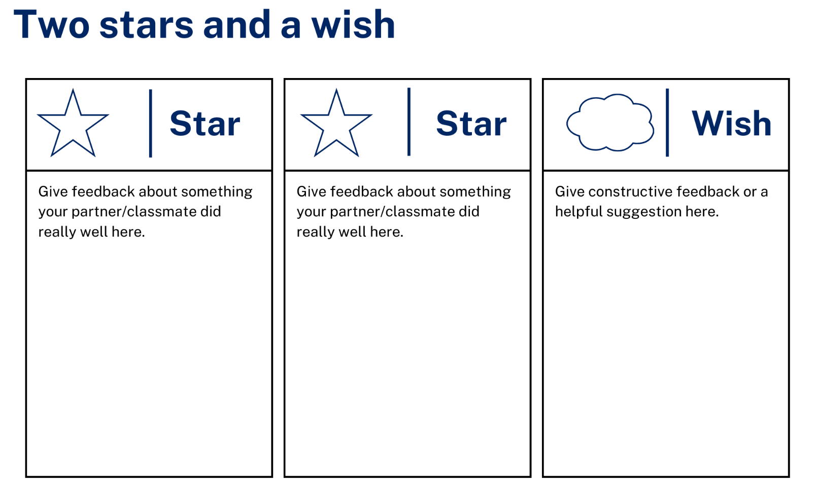

Support and alignment
Resource evaluation and support: all curriculum resources are prepared through a rigorous process. Resources are periodically reviewed as part of our ongoing evaluation plan to ensure currency, relevance, and effectiveness. For additional support or advice, contact the Primary Languages team by emailing primlang@det.nsw.edu.au.
Alignment to system priorities and/or needs: School Excellence Policy, School Success Model
Alignment to the School Excellence Framework: this resource supports the School Excellence Framework elements of curriculum (curriculum provision, teaching and learning programs) and effective classroom practice (lesson planning).
Alignment to Australian Professional Teaching Standards: this resource supports teachers to address Australian Professional Teaching Standards 2.2.2, 3.2.2.
Consulted with: Curriculum, Secondary Learners, school-based staff and NESA subject matter experts. Advice from Aboriginal Outcomes and Partnerships, EAL/D, HPGE and Inclusive Education for Modern Languages Stage 3 Italian Mangiare in Ristorante has been considered in preparing this document.
NSW syllabus: Modern Languages K–10 Syllabus
Syllabus outcomes: ML3-INT-01, ML3-UND-01, ML3-CRT-01
Author: Primary Curriculum
Publisher: State of NSW, Department of Education
Resource: Unit
Related resources: further resources to support Stage 3 Modern Languages can be found on the Languages K–6 curriculum page.
Professional learning: relevant professional learning is available through Primary Languages Statewide Staffroom on Teams (staff only).
Universal Design for Learning: support the diverse learning needs of students using inclusive teaching and learning strategies. Some students may require more specific adjustments to allow them to participate on the same basis as their peers. For further advice see Inclusive practice resources for primary school.
Differentiation: when using these resources in the classroom, it is important for teachers to consider the needs of all students in their class, including:
- Aboriginal and Torres Strait Islander students. Targeted strategies can be used to achieve outcomes for Aboriginal students in K-12 and increase knowledge and understanding of Aboriginal histories and cultures. Teachers should use students’ Personalised Learning Pathways to support individual student needs and goals.
- EAL/D learners. EAL/D learners may require scaffolding to support them to gain content knowledge, while providing extra time and assistance to master the English language required to engage with texts or complete classroom tasks. View some samples of differentiating through scaffolding.
- Students with additional learning needs. Learning adjustments enable students with disability and additional learning and support needs to access syllabus outcomes and content on the same basis as their peers. Teachers can use a range of adjustments to ensure a personalised approach to student learning.
- High potential and gifted learners. Assessing and identifying high potential and gifted learners will help teachers decide which students may benefit from extension and additional challenge. In addition, the Differentiation Adjustment Tool can be used to support the specific learning needs of high potential and gifted students.
Creation date: 15 November 2023
Rights: © State of New South Wales, Department of Education

References
This resource contains NSW Curriculum and syllabus content. The NSW Curriculum is developed by the NSW Education Standards Authority. This content is prepared by NESA for and on behalf of the Crown in right of the State of New South Wales. The material is protected by Crown copyright.
Please refer to the NESA Copyright Disclaimer for more information https://educationstandards.nsw.edu.au/wps/portal/nesa/mini-footer/copyright.
NESA holds the only official and up-to-date versions of the NSW Curriculum and syllabus documents. Please visit the NSW Education Standards Authority (NESA) website https://educationstandards.nsw.edu.au/ and the NSW Curriculum website https://curriculum.nsw.edu.au.
Modern Languages K–10 Syllabus © NSW Education Standards Authority (NESA) for and on behalf of the Crown in right of the State of New South Wales, 2022.
8 Ways (n.d.) 8 Aboriginal Ways of Learning [website], accessed 13 December 2022.
AITSL (Australian Institute for Teaching and School Leadership (2017) ‘Feedback Factsheet’, AITSL, accessed 26 September 2023.
Brookhart SM (2011) How to Assess Higher-Order Thinking Skills in Your Classroom, Hawker Brownlow Education, Victoria.
CESE (Centre for Education Statistics and Evaluation) (2020a) What works best: 2020 update, NSW Department of Education, accessed 26 September 2023.
CESE (Centre for Education Statistics and Evaluation) (2020b) What works best in practice, NSW Department of Education, accessed 26 September 2023.
Conti G (28 September 2015) ‘16 tips for effective grammar teaching in the foreign language classroom’, The Language Gym, accessed 26 September 2023.
Conti G (28 May 2017) From Target Language to Model Language – the mind shift that has transformed my teaching, The Language Gym, accessed 26 September 2023.
Henshaw FG and Hawkins MD (2022) Common Ground: Second Language Acquisition Theory Goes to the Classroom, Focus, Indianapolis, accessed 26 September 2023.
Jones J and Wiliam D (2014) Modern Foreign Languages Inside the Black Box: Assessment for Learning in the Modern Foreign Languages Classroom (Black P, Harrison C, Marshall B and Wiliam D, eds), Learning Sciences International, United States.
Rosenshine B (2012) ‘Principles of Instruction: Research-Based Strategies That All Teachers Should Know’, American Educator, 36(1):12–19, 39, accessed 26 September 2023.
Smith S (2022) Becoming an Outstanding Languages Teacher, 2nd edn, Routledge, United Kingdom.
Wisniewski B, Zierer K and Hattie J (2020) ‘The Power of Feedback Revisited: A Meta-Analysis of Educational Feedback Research’, Frontiers In Psychology, 10(3087), doi:10.3389/fpsyg.2019.03087, accessed 26 September 2023.
Wiliam D (2013) ‘Assessment: The Bridge between Teaching and Learning’, Voices from the Middle, 21(2):15–20, accessed 26 September 2023.
Wiliam D and Leahy S (2015) Embedding Formative Assessment: Practical Techniques for K–12 Classrooms, Learning Sciences International, United States.

© State of New South Wales (Department of Education), 2023
The copyright material published in this resource is subject to the Copyright Act 1968 (Cth) and is owned by the NSW Department of Education or, where indicated, by a party other than the NSW Department of Education (third-party material).
Copyright material available in this resource and owned by the NSW Department of Education is licensed under a Creative Commons Attribution 4.0 International (CC BY 4.0) license.
This licence allows you to share and adapt the material for any purpose, even commercially. Attribution should be given to © State of New South Wales (Department of Education), 2023.
Material in this resource not available under a Creative Commons licence:
- the NSW Department of Education logo, other logos and trademark-protected material
- material owned by a third party that has been reproduced with permission. You will need to obtain permission from the third party to reuse its material.
Links to third-party material and websites
Please note that the provided (reading/viewing material/list/links/texts) are a suggestion only and implies no endorsement, by the New South Wales Department of Education, of any author, publisher, or book title. School principals and teachers are best placed to assess the suitability of resources that would complement the curriculum and reflect the needs and interests of their students.
If you use the links provided in this document to access a third-party's website, you acknowledge that the terms of use, including licence terms set out on the third-party's website apply to the use which may be made of the materials on that third-party website or where permitted by the Copyright Act 1968 (Cth). The department accepts no responsibility for content on third-party websites.

