Italian Stage 2
Sono malato (I’m sick)
Contents
Unit overview 6
Stage 2 outcomes and content to be addressed 7
Learning map 11
Assessment 14
Assessment opportunities 15
Teaching and learning activities 16
Week 1 – il corpo (the body) 16
Vocabulary 1 – il corpo (the body) 17
Activity 1 – learning map 18
Activity 2 – il corpo (the body) 19
Activity 3 – Sono malato (I’m sick) 20
Activity 4 – tombola – il corpo (bingo – the body) 20
Activity 5 – ‘the’ 21
Activity 6 – which ‘the’? 22
Week 2 – Sono malato (I’m sick) 24
Vocabulary 2 – Sto male (I’m not well) 25
Activity 1 – ho mal di pancia (I have a sore tummy) 26
Activity 2 – concentration 27
Activity 3 – illness and injury sentence builder 27
Activity 4 – recording new language 29
Week 3 – consigli – ecco un cerotto (advice – here’s a plaster) 30
Vocabulary 3 – consigli (advice) 30
Activity 1 – ecco un cerotto (here’s a plaster) 31
Activity 2 – vai a letto (go to bed) 32
Activity 3 – Simone dice (Simon says) 33
Activity 4 – advice sentence builder 34
Activity 5 – recording new language 35
Week 4 – Cosa é successo? (What happened?) 36
Vocabulary 4 – Cosa é successo? (What happened?) 36
Activity 1 – ho mangiato tropppo (I ate too much) 37
Activity 2 – Cosa é successo? (What happened?) 38
Activity 3 – la passeggiata 39
Activity 4 – dictation 40
Activity 5 – recording new language 40
Week 5 – assessment criteria and practice task 41
Activity 1 – mime – illness and injury 41
Activity 2 – introduce assessment task 42
Activity 3 – success criteria 43
Activity 4 – discuss the rubric 43
Activity 5 – practice task 44
Week 6 – communicative task – tell a teacher about an illness or injury you have 46
Activity 1 – snowman 46
Activity 2 – task set-up 48
Activity 3 – communicative task – tell a teacher about an illness or injury 48
Activity 4 – peer assessment 49
Week 7 – feedback and goal setting 51
Activity 1 – hotseat 52
Activity 2 – reflection questions 52
Activity 3 – self-assessment 52
Activity 4 – set learning goals 53
Week 8 – language review 54
Activity 1 – student questions 55
Activity 2 – lie detector 55
Activity 3 – phrases from Sono malato – labelling activity 55
Activity 4 – create your own comic strip 57
Student resources 58
Resource 1 – il corpo (the body) flashcards 58
Resource 2 – Italian ‘the’ 62
Resource 3 – Which ‘the’? 63
Resource 4 – Sto male (I’m not well) flashcards 64
Resource 5 – sentence builder – illness and injury 66
Resource 6 – advice flashcards 69
Resource 7 – Cosa é successo? (What happened?) flashcards 71
Resource 8 – Cosa é successo? (What happened?) sentence builder 73
Resource 9 – assessment task – tell a teacher about an illness or injury 75
Outcomes 75
Task 75
Learning intention 76
Success criteria 76
Task instructions 76
Resource 10 – rubric – Sono malato (I’m sick) 78
Resource 11 – TAG (Tell, Ask, Give) peer feedback strategy 81
Resource 12 – learning goal form 82
Resource 13 – Sono malato – labelling activity 83
Support and alignment 84
References 87

Unit overview
Stage: 2
Title: Sono malato (I’m sick)
Description: In this unit, students use new and known vocabulary related to the body. They describe common ailments and give basic medical advice. Students create a scaffold to practise the task before telling a teacher about their ailment and listening to their advice in a role-play.
Duration: This lesson sequence is designed to be completed over approximately 8 weeks.
Student proficiency levels:
It is assumed that many Stage 2 students have been learning Italian since Kindergarten and for many, their proficiency level will be Intermediate although some students will still be at the Beginner level. This unit is aimed at Intermediate students. Every classroom will be different, and teachers will need to adapt to their context. Many Stage 2 classes may include a combination of Beginner, Intermediate and Advanced students. Assessment tasks and opportunities in this unit can be differentiated using the ‘Too hard?’ and ‘Too easy?’ suggestions.

Stage 2 outcomes and content to be addressed
The table below outlines the focus area, outcomes and content points for Stage 2 students.
Focus area and outcome | Content points
Interacting  A student:  - exchanges information in familiar contexts by selecting culturally appropriate modelled language ML2-INT-01 | Exchanging meaning in oral interactions in the target language  - Share information about themselves to describe their personal world  - Ask and answer modelled questions in a guided conversation  - Express emotions and preferences  - Interact in conversation with teacher and peers in familiar social contexts  Applying knowledge of language systems to interact in the target language  - Recognise and use modelled sounds, including pronunciation and intonation patterns and/or rhythms to interact  - Select familiar vocabulary and formulaic phrases to interact  - Use modelled sentence structures to interact  Applying knowledge of the target language culture(s) to interact  - Use modelled language structures and nonverbal communication that are appropriate to cultural practices
Understanding texts  A student:  - identifies and responds to information in texts to demonstrate understanding ML2-UND-01 | Understanding and responding to target language texts  - Listen to, read and view information in texts on familiar themes  - Use strategies to locate, organise, classify and sort information in texts for a range of purposes  - Respond to questions about specific information in texts on familiar themes, using modelled target language sentence structures and/or English  - Respond to texts through actions, visuals, written or spoken responses in the target language and/or English to demonstrate understanding and convey meaning  Applying knowledge of language systems to understand and respond to target language texts  - Identify and use the sounds of familiar vocabulary and phrases in the target language to understand and respond to texts  - Recognise and use sound–symbol correspondences to understand and respond to texts  - Identify and use knowledge of vocabulary and formulaic phrases from familiar themes to understand and respond to texts  - Identify and use elements of grammar in familiar language patterns  - Recognise modelled target language features and compare them with English features  - Recognise and use modelled structures and features of the target language writing system to understand and respond to texts  Developing intercultural understanding through target language texts  - Respond to texts and identify connections between language and cultural practices and reflect on their own language(s) and culture(s)
Creating texts  A student:  - creates texts for familiar communicative purposes by selecting culturally appropriate modelled language ML2-CRT-01 | Creating spoken, written and multimodal texts in the target language  - Create imaginative texts appropriate to context, purpose and audience using a series of modelled sentence structures and visuals to add meaning  Applying knowledge of language systems to create texts in the target language  - Use pronunciation and intonation patterns to create spoken texts  - Use sound–symbol correspondence to create written texts  - Use vocabulary, formulaic expressions or modelled phrases from familiar themes to create texts  - Use elements of simple grammar patterns in modelled sentence structures to create texts  - Use modelled structures and features of the target language writing system to create written texts  Applying knowledge of the target language culture(s) to create texts  - Select language appropriate to cultural practices to create texts
Modern Languages K–10 Syllabus © NSW Education Standards Authority (NESA) for and on behalf of the Crown in right of the State of New South Wales, 2022.

Learning map
The creation of maps for learning is a planning process that incorporates Aboriginal intellectual tradition. Learning maps are a visual pathway of what students will learn.
Share the learning map with your students, briefly explaining the learning that will happen in each lesson. Provide students with a copy of the learning map or display the learning map in the classroom. This learning map can be adapted to Italian by accessing a copy of Learning map – Sono malato (I’m sick) (Stage 2).
Figure 1 – I’m sick learning map
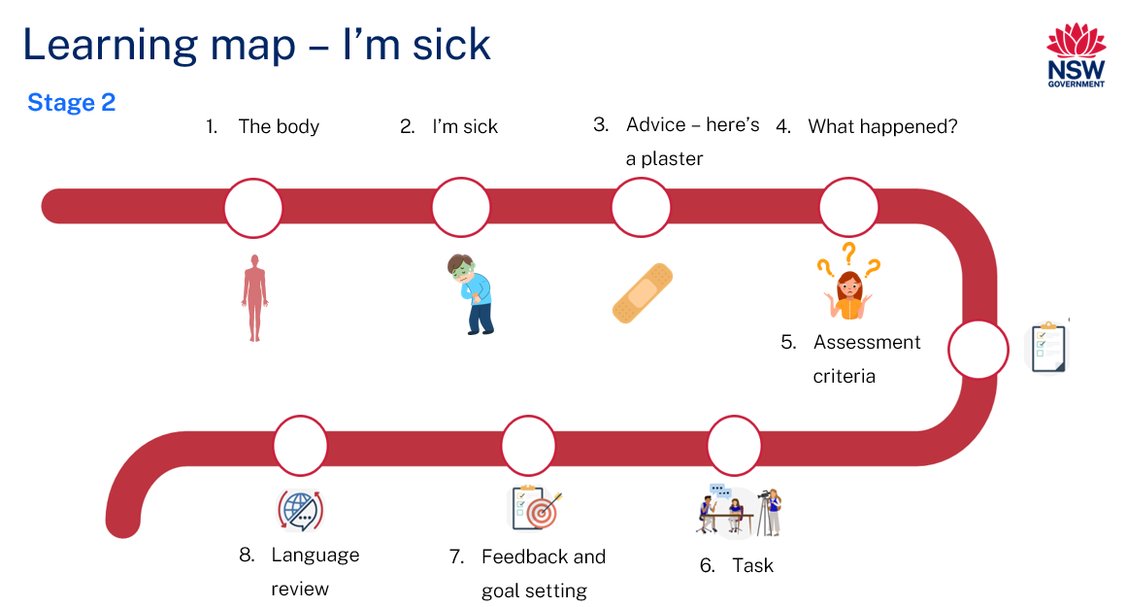
Figure 2 – Sono malato learning map
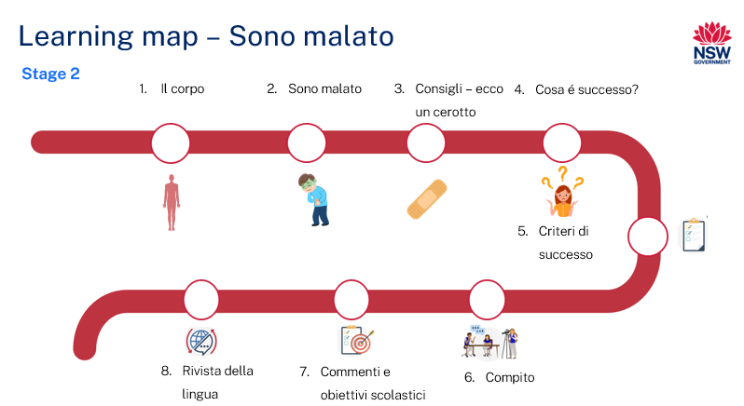

Assessment
Stage 2 communicative task: You have an illness or injury. Tell your teacher what is wrong with you and what happened. Listen to them and follow their advice.
Too hard?
Tell your teacher what is wrong with you. Listen to them and follow their advice.
Too easy?
Tell your teacher what is wrong with you and what happened. Listen to them and ask a clarifying question about their advice.
Context: you have an illness or injury
Audience: teacher
Purpose: to help you get better

Assessment opportunities
The table below details assessment opportunities and differentiation ideas.
Assessment opportunities | Too hard? | Too easy?
Week 1 – il corpo (the body)  Pre-assessment of vocabulary knowledge. | Il corpo (the body)  If most of the students know only a few of the words, reduce the number of words taught. | Il corpo (the body)  If most of the students know all the words, include additional vocabulary, such as, dita (finger), denti (teeth), viso (face) and schiena (back).
Week 2 – illness and injury sentence builder  Students use Resource 5 – sentence builder – illness and injury to practise short conversations with a partner in Italian. | Illness and injury sentence builder  Students use the sentence builder to say sentences to their partner. | Illness and injury sentence builder  Students extend the conversation to include more than one illness or injury.
Week 8 – create your own comic strip  Students create their own comic strip based on their task or on a similar scenario involving a student with an illness or injury and a teacher. | Create your own comic strip  Students omit the section saying how they got the illness or injury. | Create your own comic strip  Students include an additional section where the student asks a clarifying question about the teacher’s advice.

Teaching and learning activities

Week 1 – il corpo (the body)
The table below outlines the learning intentions and success criteria of the lesson, and materials that the teacher and students will need to complete the teaching and learning activities.
Learning intentions and success criteria | Materials
Students will:  - use vocabulary related to the body parts  - use the appropriate word for ‘the’ with Italian nouns.  Students can:  - say and write the words for body parts in Italian.  - match nouns with the correct word for ‘the’. | - Learning map  - Sono malato (I’m sick) Quirky Comics recording (or I’m sick PowerPoint book)  - Resource 1 – il corpo (the body) flashcards  - Resource 2 – Italian ‘the’  - Resource 3 – Which ‘the’?  - Intentional observation checklist for communicative activities  - Glue  - Italian exercise books  - Writing and drawing materials

Vocabulary 1 – il corpo (the body)
The table below outlines the suggested vocabulary used throughout this learning sequence. It includes the Italian words and phrases and their corresponding English translations.
Italian | English
il corpo | body
la testa | head
le spalle | shoulders
il ginocchio | knee
i piedi | feet
gli occhi | eyes
le orecchie | ears
il naso | nose
la bocca | mouth
la gola | throat
la pancia | tummy
la gamba | leg
il braccio | arm
la mano | hand

Activity 1 – learning map
Explain and display the Learning map to give students a more detailed breakdown of lessons during the unit. Point out that the learning map is a plan that may need to change.

Activity 2 – il corpo (the body)
Note: if students are not familiar with ‘Heads, shoulders, knees and toes’ in Italian, replace this activity with the singing of the song with accompanying actions to introduce vocabulary related to the body. Point out that the Italian version is not a direct translation of the English song, with piedi (feet) used instead of toes.
- To pre-assess students’ knowledge of Italian vocabulary related to the body, put students into small groups and give them 3 minutes to brainstorm Italian words related to the body.
- After one minute, remind students in English of the song ‘Heads, shoulders, knees and toes’ and associated actions to help jog their memories of the Italian vocabulary if they sang this song in Stage 1 Italian lessons.
- When the time is up, ask each group how many words they have recorded. The team with the most correct words will be the winner.
- Display the recorded words from Resource 1 – il corpo (the body) flashcards on a word wall along with additional suggested words. Model the correct pronunciation of each word for students to repeat.
- Display the words from Resource 1 – il corpo (the body) flashcards that haven’t been recorded yet on one side of the board alongside the images on the other. Model the correct pronunciation of each word for students to repeat.
- Students look at the pictures of body parts and cards with corresponding Italian words. First, ask them to identify how many they think they know by answering the following questions through showing thumbs up at their chests: Do you know all the words? Most of them? Any of them?
- The teacher asks students to match words to the pictures one at a time. After each match, the teacher models and drills the correct pronunciation of vocabulary.

Activity 3 – Sono malato (I’m sick)
Note: this unit is based on the levelled Italian Quirky Comics video text Sono malato (I’m sick). If it is more appropriate for your class, most of the activities in this unit can be used for a more challenging version of that text, Mal di scuola (Sick of school). You can choose to use both versions in the unit to highlight the changes in language. If the videos are not available in the language you teach, convert the I’m sick PowerPoint book to your language and use that as the basis of this unit.
- Show Sono malato (2:10) to the class one frame at a time. Pause after each frame and ask the following questions:
- Who are the characters in this story?
- What is happening in the story?
- Why do you think the girl is feeling sick?
- After watching the video for the first time, students work in small groups to record Italian words they heard in the text.
- As students view the recording again, ask them to identify any words related to the body that they can hear in the text. Answers may include: piede (foot), gola (throat), pancia (tummy), orecchio (ear), testa (head).
- Add any additional words to the word wall.

Activity 4 – tombola – il corpo (bingo – the body)
- Play a communicative language learning game such as ‘Bingo!’ to practise using vocabulary related to the body.
- Each student will create a bingo card by choosing approximately 6 words related to the body from Resource 1 – il corpo (the body) flashcards or the word wall. Students write the Italian word and draw a corresponding image.
- One student is nominated to lead a whole class game to demonstrate before students play in groups.
- All students take turns at being the bingo caller drawing the language words from a hat or a bowl. They read the words aloud to their group of 5 or 6 students.
- The students playing the game listen to the words being called. If the word called is on their bingo card, they cover or mark the word. The winner of each round is the student who marks or covers all their words and pictures first.
Note: as students are playing the game, use the Intentional observation checklist for communicative activities to record your observations of students' pronunciation and their use of vocabulary.

Activity 5 – ‘the’
Note: in Italian, there are 7 words for ‘the’. The correct word depends on the noun that follows. The choice of word for ‘the’ depends on the gender of the noun (Italian nouns are either masculine or feminine); whether it is singular or plural; and the starting letters of the noun.
- Explain to students that the first word on Resource 1 – il corpo (the body) flashcards means ‘the’. This is different to English, where ‘the’ is not required. If the flashcards were in English, they would read, for example, ‘head’ and not ‘the head’.
- Ask students to list the words for ‘the’ they can see on the flashcards – il, la, le, i, gli. Model and drill the pronunciation of each word, particularly gli. Tell students that gli can be called the smile sound because you smile when you say it.
- Ask students if they know or can work out when to use each word for ‘the’. It is possible that Stage 2 students may know that il is used with masculine nouns and la is used with feminine nouns.
- Point out to students that if a singular noun ends in -o, it will likely be masculine and if it ends in -a, it will likely be feminine. There are a small number of exceptions to this, including la mano (hand), which is a feminine noun that ends in -o. Similarly, plural nouns that end in -i, will likely be masculine, and plural nouns that end in -e, will likely be feminine.
- Share Resource 2 – Italian ‘the’ with students, one row at a time, introducing l’ and lo. Display the table in the classroom.
Note: for students with Beginner proficiency, focus only on the most common forms of ‘the’: il, la, i and le.

Activity 6 – which ‘the’?
- Display Resource 3 – Which ‘the’? where the following words with the Italian word for ‘the’ removed or hidden: il gatto (cat), i gatti (cats), la casa (house), le case (houses), l’orso (bear), l’arancia (orange), gli spaghetti (spaghetti), lo zoo (zoo).
- Ask students the meaning of each word, using the images for support.
- Students Think-Pair-Share whether each word is masculine or feminine, singular or plural.
- Provide each student with a printed copy of Resource 3 – Which ‘the’? and give them a few minutes to write the appropriate word for ‘the’ beside each image. Display Resource 2 – Italian ‘the’ for reference.
- Mark the activity as a class, discussing common errors. Students glue the activity in their books or save in their portfolio.
- Add the words from Resource 3 – Which ‘the’? to the example column of Resource 2 – Italian ‘the’.
Note: this activity can be taught independently of this unit.

Week 2 – Sono malato (I’m sick)
The table below outlines the learning intention and success criteria of the lesson, and materials that the teacher and students will need to complete the teaching and learning activities.
Learning intention and success criteria | Materials
Students will talk about their illness and/or injury in Italian.  Students can:  - use the appropriate verb when talking about an illness or injury  - say sentences using the correct word order. | - Sono malato (I’m sick) Quirky Comics recording (or I’m sick PowerPoint book)  - Resource 1 – il corpo (the body) flashcards  - Resource 4 – Sto male (I’m not well) flash cards (For display and for each group)  - Resource 5 – sentence builder – illness and injury  - Glue  - Italian exercise books  - Writing and drawing materials

Vocabulary 2 – Sto male (I’m not well)
The table below outlines the suggested vocabulary used throughout this learning sequence. It includes the Italian words and phrases and their corresponding English translations.
Italian | English
Sono malato | I’m sick
Ho mal di pancia | I have a sore tummy
Lei ha mal d’orecchio | She has an earache
Lui ha mal di testa | He has a headache
Ho il piede gonfio | I have a swollen foot
Ho il raffreddore | I have a cold
Ho fame | I’m hungry
Ho freddo | I’m cold
Ho un taglio | I have a cut
Ho la gamba rotta | I have a broken leg

Activity 1 – ho mal di pancia (I have a sore tummy)
- Ask students if they can remember what illnesses and injuries they saw when watching the video. Suggested answers include sore tummy, earache, headache and a swollen foot.
- View the video again. How do the characters say these illnesses and injuries in Italian?
- Ho mal di pancia (I have a sore tummy)
- Lei ha mal d’orecchio (She has a sore ear)
- Lui ha mal di testa (He has a headache)
- Ho il piede gonfio (I have a swollen foot).
- Have students repeat each sentence after you, in chunks and as a whole.
- Remind or explain to students that ho means ‘I have’, while lei ha means ‘she has’ and lui ha means ‘he has’. Explain that subject pronouns, such as lei (she) and lui (he) are optional in Italian, unlike in English. This is because the ending of each verb indicates the person. Subject pronouns are often used to provide emphasis.
- Point out that ho can also be used for feelings and emotions. In the recording, the characters say ho fame (I’m hungry, literally ‘I have hunger’) and ho freddo (I’m cold). Use gesture and tone of voice to help students work out the meaning of these Italian phrases in English. Explain that if someone wants to say how they feel in Italian, they will use ho (I have), with some words, for example ho caldo (I’m hot). With other words, they will use sono (I am), for example – Sono malato (I’m sick).
- Split the class into small groups of 3 or in pairs. Tell students they will pretend to have an illness or injury. Using the vocabulary in Resource 1 – il corpo (the body) flashcards, students tell their small group where they are sore, for example, ho mal di gola (I have a sore throat). Continue until each student has had at least 2 chances to speak.

Activity 2 – concentration
- Cut the words from the images and stick the cards on the board back to front so the images and words can’t be seen.
- Choose a student to turn over a picture card and a label card. Ask the class to name the picture and read the label. If the cards match, the student keeps the cards and displays them face up.
- If the cards don’t match the student turns the cards over and another student has a turn. Keep playing until all cards are matched.
- When all the cards are matched, read the labels as a class.
- Students then play the game in small groups.

Activity 3 – illness and injury sentence builder
- Show or remind students of the scene where the boy falls off his bike. His friend asks ‘Come stai Roberto?’ (‘How are you, Robert?’) He answers ‘Male’ (Bad). The friend asks ‘Perché?’ (Why?) Ask students to Think-Pair-Share what these words and phrases mean. They should know that ‘Come stai?’ means ‘How are you?’ and ‘male’ means ‘bad’. If it hasn’t been taught previously, some students should be able to work out that perché? means ‘why?’
- Ask a few students ‘Come stai?’ and encourage them to answer ‘male’. Then ask ‘Perché?’ and ask them to give an answer they used in their small groups in Activity 1. Students repeat this interaction with their partner.
Note: perché also means ‘because’ when used in a statement. It means ‘Why?’ when used in a question.
- Display Resource 5 – sentence builder – illness and injury. Point out the new vocabulary including un raffreddore (a cold) and rotta (broken). Model and drill the pronunciation of the new language, including in sentences, such as Ho il raffreddore (I have a cold) and Ho la gamba rotta (I have a broken leg).
- Explain to students how to use the resource. To make a sentence, they will start in the left column. Each sentence will start with ho (I have). Students will then choose the appropriate article or word for ‘the’ or ‘a’, if required. They can then finish their sentence with raffreddore or continue with the phrase mal di, before choosing the part of the body that is making them sick. They can skip the third column and then choose a limb or a joint that can be gonfio (swollen) or rotto/rotta (broken). Demonstrate with an example sentence.
- Give each student a copy of Resource 5 – sentence builder – illness and injury and tell them they will have approximately 10 minutes to talk to as many classmates as possible. Remind them to start each conversation with:
- Come stai? (How are you?)
- Male (Bad)
- Perché? (Why?)

Activity 4 – recording new language
- New vocabulary introduced in the lesson is added to the word wall.
- Students paste the sentence builder in their books or store in their portfolio.
- Students record any additional new language in their books.

Week 3 – consigli – ecco un cerotto (advice – here’s a plaster)
The table below outlines the learning intention and success criteria of the lesson, and materials that the teacher and students will need to complete the teaching and learning activities.
Learning intention and success criteria | Materials
Students will give advice to someone who has an illness and/or injury in Italian.  Students can:  - use verbs to give advice in Italian | - Sono malato (I’m sick) Quirky Comics recording (or I’m sick PowerPoint book)  - Resource 5 – sentence builder – illness and injury  - Resource 6 – advice flashcards  - Italian exercise books  - Writing and drawing materials

Vocabulary 3 – consigli (advice)
The table below outlines the suggested vocabulary used throughout this learning sequence. It includes the Italian words and phrases and their corresponding English translations.
Italian | English
Dormi | Sleep
Prendi la medicina | Take some medicine
Bevi un po’ d’acqua | Drink some water
Siediti qui | Sit down here
Riposa la gamba | Rest your leg
Vai dal dottore | Go to the doctor
Metti un cerotto | Put on a plaster
Non mangiare niente | Don’t eat anything

Activity 1 – ecco un cerotto (here’s a plaster)
- View the recording again, if required. Ask students ‘What does the school nurse do to help the students that are injured or sick?’ Answer: say ‘Here’s a plaster’ for every ailment. Ask how you say this in Italian. Answer: Ecco un cerotto.
- Ask students when un cerotto or plaster is appropriate. The expected answer is when you have a cut. Teach the phrase ho un taglio (I have a cut) and add it to the word wall.
- Ask students what they would do to help the students in the text. Students suggest answers in English.

Activity 2 – vai a letto (go to bed)
- Show the first 20 seconds of the video again. Ask what instruction or advice the teacher gives the students. The answer is Andate in infermeria (Go to sick bay). Explain to students that Andate means ‘go’ or ‘you go’ when talking to 2 or more people. In this activity, students will give advice to one person. Vai means ‘go’ or ‘you go’ when talking to one person.
- Ask students what type of word is ‘go’ and remind them of the common options when answering this question: noun, adjective or verb and that ‘go’ is a verb. Students Think-Pair-Share with a partner to brainstorm any Italian verbs they know. Verbs suggested by students are recorded on the board.
- Display the images in Resource 6 – advice flashcards on one side of the board and the words and phrases from Vocabulary 3 – consigli (advice) on the other side.
- Students Think-Pair-Share the words and phrases they think they know and report back to class. As a class, ask students to match the words and phrases to pictures one at a time. After each match, model and drill how to correctly pronounce the vocabulary.
- Ask students what letter all the verbs end in (answer: ‘i’). Explain that in Italian, second person singular (you) verbs, usually end in ‘-i’. Ask students if they know what letter first person singular (‘I’) verbs usually end in. Answer: ‘o’. Examples include ho (I have) and sono (I am).

Activity 3 – Simone dice (Simon says)
- As a class, agree on actions for each of the commands in Resource 6 – advice flashcards. Suggestions include:
- sleep – head tilted using hands with palms together as a pillow
- take some medicine – open mouth, pretend to put a tablet in and swallow
- drink some water – open mouth and raise imaginary glass to drink
- sit down – bend knees and make sitting action
- rest your leg – put leg on a chair
- go to the doctor – pretend to use a stethoscope
- put a plaster on it – pretend to unpeel the wrapping on a plaster and place on arm
- don’t eat anything – cover mouth.
- Lead the class in a game of Simone dice (Simon says) to demonstrate how to play. All students stand up and when you say Simone dice followed by a word or phrase from Resource 6 – advice flashcards, students will perform the action agreed to in the previous step. If they perform the wrong action or do nothing, they are out and have to sit down. If you say a word or phrase without saying Simone dice (Simon says), students are to do nothing. Students that perform an action are out. The winners are those students still standing at the end of the game.
- Split the class into groups. In each group, every student will take a turn at being Simon and give their group instructions using words and phrases from Resource 6 – advice flashcards. After each student in the group has had a turn being Simon, the game is complete.
Note: as students are playing the game, use the Intentional observation checklist for communicative activities to record your observations of students pronunciation and their use and understanding of vocabulary.

Activity 4 – advice sentence builder
- Demonstrate an extended conversation with a student using Resource 5 – sentence builder – illness and injury.
- Ask a student Come stai? (How are you?) and encourage them to say Male (bad). Ask them Perché? (Why?) and encourage them to provide an answer from the sentence builder. Respond by suggesting advice for their illness or injury from Resource 6 – advice flashcards. Sample interaction:
- Student A: Come stai? (How are you?)
- Student B: Male (bad)
- Student A: Perché? (Why?)
- Student B: Ho mal di testa (I have a headache)
- Student A: Bevi un po d’acqua (Drink some water)
- Students take turns at asking and answering questions in the conversation with a partner.

Activity 5 – recording new language
New vocabulary introduced in the lesson is added to the word wall. Students record any additional new language in their books.

Week 4 – Cosa é successo? (What happened?)
The table below outlines the learning intention and success criteria of the lesson, and materials that the teacher and students will need to complete the teaching and learning activities.
Learning intention and success criteria | Materials
Students will say what happened using the past tense in Italian.  Students can:  - say and write past tense sentences in Italian | - Mal di scuola (Sick of school) (2:48) Quirky Comics recording (or I’m sick PowerPoint book)  - Resource 7 – Cosa é successo? (What happened?) flashcards  - Resource 8 – Cosa é successo? (What happened?) sentence builder  - Butcher’s paper  - Italian exercise books  - Writing and drawing materials

Vocabulary 4 – Cosa é successo? (What happened?)
The table below outlines the suggested vocabulary used throughout this learning sequence. It includes the Italian words and phrases and their corresponding English translations.
Italian | English
Non lo so! | I don’t know.
Ho mangiato troppo. | I ate too much.
Ho ascoltato la musica forte. | I listened to loud music.
Ho giocato al sole. | I played in the sun.
Sono caduto dalla bicicletta. | I fell off my bike.
Sono andato all’infermeria. | I went to sickbay.
Ho saltato. | I jumped.
Sono uscita nella pioggia. | I went out in the rain.

Activity 1 – ho mangiato tropppo (I ate too much)
- Ask students why the girl at the beginning of the video Sono malato (2:10) had a sore tummy and how the boy ended up with a swollen foot. Expected answers are she ate too much pasta and he fell off his bike.
- View the recording of Mal di scuola (Sick of school) (2:48), which tells the same story using more advanced language. Ask students to listen carefully for how to say, ‘I ate too much’ (Ho mangiato troppo) and ‘I fell’ in Italian (Sono caduto). After viewing, students Think-Pair-Share their responses. Model and drill the pronunciation and intonation of both phrases and ask students to repeat after you. Explain that troppo means ‘too’ or ‘too much’.
- Point out the question before sono caduto in the video, Cosa é successo Roberto? (What happened Robert?) Model and drill the pronunciation of this question. Add Cosa é successo...? to the word wall.
- Remind students of the meaning of ho (I have) and sono (I am). Explain that if you want to say ‘I did something’ in the past in Italian, you need to say 2 words. The first word will either be ho (I have) or sono (I am), which are auxiliary or ‘helping’ verbs. The second word will be the past of the verb, which usually ends in -to. Most verbs use ho, but many common verbs use sono. Students need to learn or check which helping verb to use each time.

Activity 2 – Cosa é successo? (What happened?)
- Write Ho mangiato (I ate) on one piece of butcher’s paper and write Sono caduto (I fell) on another piece. Stick the butcher’s paper to the wall.
- Display the images in Resource 7 – Cosa é successo? (What happened?) flashcards on the board and ask students in English what is happening in each picture. Students suggest illnesses or injuries that could come from the actions in the images.
- Read each word and phrase one at a time and stick these to the other side of the board. Use gestures and actions to support the meaning of each word and phrase.
- Students Think-Pair-Share the words and phrases they think they know and report back to the class. As a class, ask students to match words and phrases to pictures one at a time. After each match, model and drill how to correctly pronounce the vocabulary.
- On the butchers’ paper, list the ‘have’ verbs under ho mangiato (I ate): Ho ascoltato (la musica forte) – I listened (to loud music), Ho saltato – I jumped, Ho giocato (al sole) – I played (in the sun). This will help clarify for students which helping verb to use.
- Point out that verbs that use sono as an auxiliary follow gender agreement. This means that for boys will say ‘sono andato’ for ‘I went’ and girls will say ‘sono andata’. This can be written as sono andato/a.
- Add the ‘am’ verbs under sono caduto/a (I fell) Sono andato/a (all’infermeria) – I went (to sickbay), Sono uscito/a (nella pioggia) – I went out (in the rain).
- Point out that sometimes you are ill or injured and you don’t know why. In these cases, you’ll say Non lo so! (I don’t know). Use appropriate gestures and facial expressions when modelling the pronunciation of Non lo so! (I don’t know) for students to repeat.

Activity 3 – la passeggiata
- Remind students of the Italian concept of la passeggiata, where people take a walk or stroll through their town or city, usually in the late afternoon or early evening.
- Ensure each student has a copy of Resource 8 – Cosa é successo? (What happened?) sentence builder. Tell students to stroll around the classroom greeting each other in Italian. When you say aspetta (wait), students ask the person they’re closest to Cosa é successo? (What happened?). Students refer to the sentence builder and use appropriate gesture and facial expression when responding.
- Students must use a different answer each time. Say aspetta (wait) at least 8 times to ensure students practise each phrase.
Note: as students are playing the game, use the Intentional observation checklist for communicative activities to record your observations of students’ Italian use, particularly, their use of the past tense. Address any common errors at the conclusion of the activity.

Activity 4 – dictation
- Students sit with a partner, each person facing one of 2 walls. Display sentences in Italian on each wall. Each row can see an Italian sentence displayed in front of them on a wall but can’t see the sentence behind them. Students aren’t allowed to look at the sentence behind them. Example sentences include:
- Sono uscito nella pioggia – I went out in the rain.
- Ho ascoltato la musica forte – I listened to loud music.
- All students facing one wall read aloud the sentence they can see. Their partner writes the sentence. The writer can ask the reader to slow down, repeat words or to check their pronunciation. When the reader is finished, the writer can check their work and suggest changes needed to spelling and punctuation.

Activity 5 – recording new language
New vocabulary introduced in the lesson is added to the word wall. Students record new language in their books.

Week 5 – assessment criteria and practice task
The table below outlines the learning intention and success criteria of the lesson, and materials that the teacher and students will need to complete the teaching and learning activities.
Learning intention and success criteria | Materials
Students will develop a clear understanding of the requirements of the assessment task.  Students can:  - suggest appropriate success criteria  - explain what they need to do to be successful in the task. | - Resource 1 – il corpo (the body) flashcards  - Resource 4 – Sto male (I’m not well) flash cards  - Resource 9 – assessment task – tell a teacher about an illness or injury  - Resource 10 – rubric – Sono malato (I’m sick)  - Intentional observation checklist for communicative activities

Activity 1 – mime – illness and injury
- Pretend to have an illness or injury, for example, a sore tummy and ask students to guess what is wrong with you by calling out the appropriate phrase in Italian, for example, mal di pancia.
- Put the class into groups and ask them to take turns at miming illnesses or injuries and other students in the group guess what they are miming by saying the Italian word or phrase. Students can refer to Resource 1 – il corpo (the body) flashcards and Resource 4 – Sto male (I’m not well) flash cards.
- Ensure all students have an opportunity to mime.
Note: students with Advanced proficiency can provide advice to the person miming the illness or injury. If time permits, students with Intermediate proficiency can be supported to provide advice.

Activity 2 – introduce assessment task
- Hand out Resource 9 – assessment task – tell a teacher about an illness or injury.
- Tell students that their communicative task is: You have an illness or injury. Tell your teacher what is wrong with you and follow their advice.
- Point out that:
- the context of the task is that you have an illness or injury
- the audience of the communication will be your teacher
- the communicative purpose is to help you get better.

Activity 3 – success criteria
After looking at the assessment task, students Think-Pair-Share and suggest appropriate success criteria, such as:
I will be successful if I can:
- use appropriate greetings.
- say why I’m not feeling well.
- say what happened to cause my illness or injury.
- say words in the right order
- speak loudly and clearly.

Activity 4 – discuss the rubric
- Show students an unmarked copy of Resource 10 – rubric – Sono malato (I’m sick). This may need to be adapted if the class has decided on different success criteria.
- Explain metalanguage such as fluency, accuracy, pronunciation and vocabulary.
- Students read and then discuss the ‘excellent’ column of the rubric in pairs. They then share their understanding of what is needed to be successful.
- Point out and provide examples of what ‘excellent’ and ‘sound’ samples of task completion, fluency, accuracy, pronunciation and vocabulary look and sound like.

Activity 5 – practice task
Choose students to model the example interaction:
- Teacher: Come stai Marco? (How are you, Marco?)
- You: Sto male (I’m not okay.)
- Teacher: Perché? (Why?)
- You: Ho mal di piede (I have a sore foot)
- Teacher: Cosa é successo? (What happened?)
- You: Ho giocato a calcio e sono caduto. (I played football and I fell.)
- Teacher: Mmm, siediti qui e riposi. (Mmm, sit down here and rest.)
- You: Grazie. (Thank you.)
In pairs, students practise the example interaction. They then each choose a different illness or injury and use the example interaction to plan and have conversations based on each student’s chosen illness or injury.
Note: as students are completing the practise task, use the Intentional observation checklist for communicative activities to record your observations of students' pronunciation and their use of grammar and vocabulary.

Week 6 – communicative task – tell a teacher about an illness or injury you have
The table below outlines the learning intention and success criteria of the lesson, and materials that the teacher and students will need to complete the teaching and learning activities.
Learning intention and success criteria | Materials
Students will tell a teacher about an illness or injury they have.  Students can:  - use appropriate greetings  - say why they are not feeling well  - say what happened to cause their illness or injury  - say words in the right order  - speak loudly and clearly. | - Intentional observation checklist for communicative activities  - Paper or individual whiteboards  - Recording devices for each group  - Resource 11 – TAG (Tell, Ask, Give) peer feedback strategy  - Writing materials

Activity 1 – snowman
- Choose a word or phrase from the word wall and set up the board with gaps marked out for the letters in the words.
- Display the 21 letters of the Italian alphabet.
- Students are invited to guess a letter in the word or phrase. When a letter is guessed, it is crossed out from the displayed alphabet.
- If a letter is guessed correctly it is written in the appropriate gap(s). When letters are incorrectly guessed, a picture of a snowman is slowly drawn with each incorrect guess.
- The class can have 7 incorrect guesses:
- one large circle for the base
- a smaller circle for the body
- one small circle for the head
- 2 guesses for the eyes
- 1 guess for a carrot nose
- 1 smile to finish.
- Additional guesses can be allowed by adding arms and hands.
- The class will win if they can fill all the gaps, say the Italian word and it’s English meaning before the body is drawn.
- Students then split into pairs. Each student chooses a word or phrase and sets up the snowman game on paper or individual whiteboards.
Note: remind students to use the correct pronunciation of Italian letters. Record observations on the Intentional observation checklist for communicative activities.

Activity 2 – task set-up
Students split into groups of 3. Groups are given a few minutes to ensure everybody knows the order in which they will perform each role. ‘You’ is the student who will be completing the assessed communicative task.
Suggested rotations:
- Role-play/Presentation 1: Student 1 – ‘You’, Student 2 – Peer assessor/Camera operator, Student 3 – Teacher
- Role-play/Presentation 2: Student 1 – Teacher, Student 2 – ‘You’, Student 3 – Peer assessor/Camera operator
- Role-play/Presentation 3: Student 1 – Peer assessor/Camera operator, Student 2 – Teacher, Student 3 – ‘You’.

Activity 3 – communicative task – tell a teacher about an illness or injury
Note: make sure to space students apart when filming. Demonstrate how to film using a recording device. Use microphones if possible to maximise sound quality. Highlight the importance of holding the recording device still by using a tripod or resting it on a table.
Students split into groups of 3 and complete the task. Students are asked to choose a different illness or injury from those in the example interaction and the ones used in their practice task.
Example interaction:
- Teacher: Come stai Maria? (How are you, Maria?)
- You: Sto male (I’m not okay.)
- Teacher: Perché? (Why?)
- You: Ho mal di piedi (I have a sore foot)
- Teacher: Cosa é successo? (What happened?)
- You: Ho giocato a calcio e sono caduto. (I played football and I fell.)
- Teacher: Mmm, siedi qui e riposi. (Mmm, sit down here and rest.)
- You: Grazie. (Thank you.)
Note: before recording interactions/presentation, check if any students do not have permission to be filmed. Alternatives to video recording include audio recording or the teacher watching the interactions while taking notes and marking the rubric.

Activity 4 – peer assessment
Confirm which peer feedback strategy will be used after the task, for example Resource 11 – TAG (Tell, Ask, Give) peer feedback slip. Explain what is required with this strategy and provide example feedback.
- Tell them something they really liked and explain why.
- Example: I like how you pronounced all the words correctly and kept the conversation going.
- Ask a question to clarify or confirm something from the role-play.
- Example: Did you use the correct helping verb when saying what happened?
- Give a suggestion to make their classmates’ use of language even better.
- Example: use more facial expression and gesture when saying what’s wrong with you.

Week 7 – feedback and goal setting
Note: if there is insufficient time to mark the videos before Week 8, Weeks 7 and 8 can be swapped.
The table below outlines the learning intention and success criteria of the lesson, and materials that the teacher and students will need to complete the teaching and learning activities.
Learning intention and success criteria | Materials
Students will reflect on recordings of themselves completing the task to assess how well they completed the task and to set learning goals.  Students can:  - accurately self-assess their completion of the task  - set appropriate learning goals based on previous learning goals and teacher, peer and self-assessment. | - Resource 10 – rubric – Sono malato (I’m sick)  - Resource 12 – learning goal form  - Italian exercise books  - Recording devices  - Writing and drawing materials
Note: prior to this lesson, view each video and mark each student according to the criteria on the rubric for communicative language tasks.

Activity 1 – hotseat
- Divide the class into 2 teams. One player per team has their back to the board. Write a word or phrase from the word wall on the board.
- Students give clues to their teammate without saying the word, for example, it has 5 fingers at the end of your arm. The first student on the chairs to say mano (hand) earns a point for their team. Advanced students can give clues in Italian.
- After each round, model and drill correct pronunciation of vocabulary.

Activity 2 – reflection questions
Provide sentence starters and example prompts, such as the following, to guide students’ thinking:
- I now feel confident when… reading and saying words related to the body in Italian.
- I always/sometimes feel confused when… choosing the correct word for ‘the’ in Italian.
- A next step for me is to… say and write more past tense sentences in Italian.

Activity 3 – self-assessment
Students watch the video of themselves completing the task and mark themselves using the rubric. Students then compare both the teacher completed rubric and the one they completed.

Activity 4 – set learning goals
Note: learning goals should be SMART: Specific, Measurable, Achievable, Realistic, Timely.
Students reflect on the teacher, peer and self-evaluation to set goals for the next phase of learning. Example learning goals include:
- I will use the correct word for ‘the’ when saying and writing words in Italian.
- I will not worry about making small mistakes when having a conversation in Italian.
- I will say tricky sounds in Italian correctly, for example gli.
Students record their learning goals using a copy of Resource 12 – learning goal form.

Week 8 – language review
Note: if there is insufficient time to mark the videos before Week 8, Weeks 7 and 8 can be swapped.
The table below outlines the learning intention and success criteria of the lesson, and materials that the teacher and students will need to complete the teaching and learning activities.
Learning intention and success criteria | Materials
Students will reflect on and ask questions about the language taught in this unit.  Students can:  - ask questions about vocabulary, grammar, or pronunciation they have used in this unit  - use Italian they have learned to communicate with classmates. | - Resource 5 – sentence builder – illness and injury  - Resource 13 – Sono malato – labelling activity  - Paper  - Writing and drawing materials
Note: over the course of the unit, gaps in student knowledge, misconceptions and misuse of language will have been identified. These observations are addressed using engaging and interactive activities and strategies.

Activity 1 – student questions
Remind students of the activities and tasks they have completed over the course of the unit. Give students time to Think-Pair-Share any questions they may have about any aspect of the language taught or the language in the text.

Activity 2 – lie detector
Students write 3 sentences from Resource 5 – sentence builder – illness and injury. They secretly mark one sentence as true and the other 2 as false. They read each sentence to their partner who guesses which one is true and which are lies before swapping roles.

Activity 3 – phrases from Sono malato – labelling activity
- Share Resource 13 – Sono malato – labelling activity with the class. Tell them that in this activity, they will learn some more useful language from the text that wasn’t used in the task. Discuss the useful English words and phrases. Does anyone already know some of these in Italian?
- Model and drill each of the Italian words and phrases before students view the recording of Sono malato (2:10) again. While watching, students complete the activity and match the Italian and English phrases.
- Mark the activity as a class, discussing each word and phrase as relevant. The table below displays the answers to the activity.
Italian | English
che fame! | I’m so hungry
andiamo | let’s go
ecco | here is
vediamo | let’s see
ci sono | there are
va bene | okay
ragazzi | kids
pronto? | hello?
Note: if time permits, go deeper with some of the words and phrases. For example, compare ci sono (there are) with c’é (there is) and/or discuss the suffix -iamo (let’s/we) and use it with other known verbs.

Activity 4 – create your own comic strip
Note: if time permits, ask students to complete this activity prior to the communicative task. Students create their own comic strip. This can be based on their task or on a similar scenario involving a student with an illness or injury and a teacher. Remind students of the importance of spelling Italian words correctly, including the use of accents and of putting the words in the correct order.
Students divide an A4 page in 4 quadrants. The teacher will speak first in each quadrant, asking Come stai? (How are you?) Perché? (Why?) and Cosa é successo? (What happened?) The teacher will give advice in the final quadrant.
Collect and display the completed comic strips. Record observations of students’ writing strengths and weaknesses.
Note: this activity may be completed digitally. Ensure the device or app is compatible with Italian.

Student resources

Resource 1 – il corpo (the body) flashcards
This resource can be adapted by replacing the text to suit your language.
 |  | 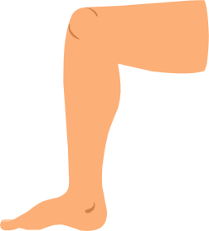
il corpo |  | il ginocchio |  | il naso |  | la testa
la bocca |  | la gola |  | la pancia |  | le gambe
il braccio |  | la mano |  | le spalle |  | gli occhi
i piedi |  | le orecchie

This resource can be adapted by replacing the text to suit your language.
body |  | knees |  | nose |  | head
mouth |  | throat |  | tummy |  | legs

arm |  | hand |  | shoulders |  | eyes
feet |  | ears

Resource 2 – Italian ‘the’
The | When to use | Example
il | With most singular, masculine nouns – usually end in -o | il corpo (body)
la | With most singular, feminine nouns – usually end in -a | la testa (head)
le | With plural, feminine nouns – usually end in -e | le spalle (shoulders)
i | With most plural, masculine nouns – usually end in -i | i piedi (feet)
gli | With plural, masculine nouns that begin with a vowel, z, gn, ps and s + consonant. | gli occhi (eyes)
l’ | With singular nouns, masculine and feminine, that begin with a vowel | l’orecchio (ear) - masculine  l’unghia del dito (fingernail) - feminine
lo | With singular, masculine nouns that begin with z, gn, ps and s + consonant. | lo stomaco (stomach)

Resource 3 – Which ‘the’?
This resource can be used to teach multiple languages. Use the resource link to tailor it to your preferred language.
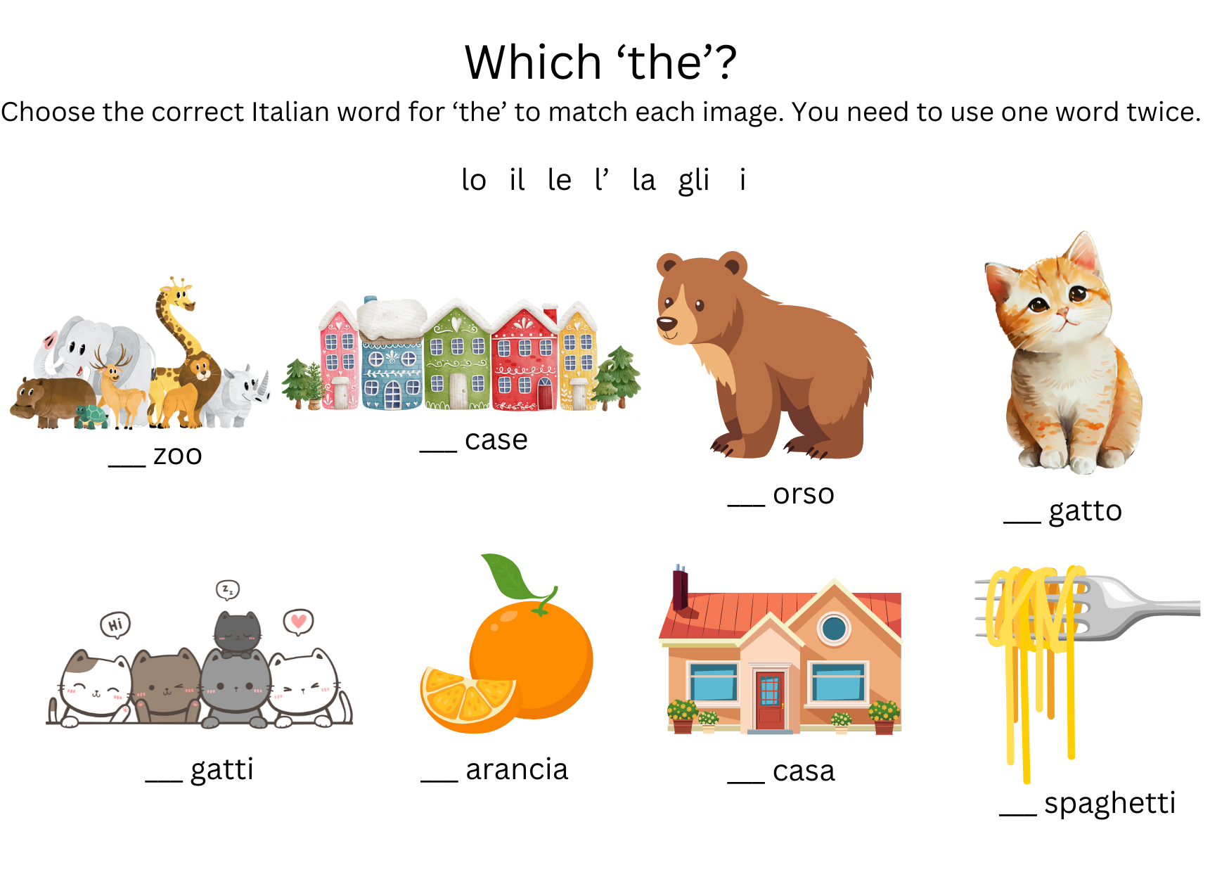

Resource 4 – Sto male (I’m not well) flashcards
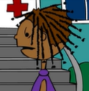 |  | 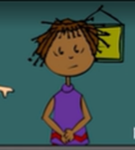 |  | 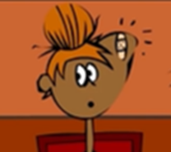 |  |  |  | 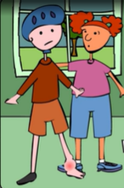
Sono malato |  | Ho mal di pancia |  | Lei ha mal d’orecchio |  | Lui ha mal di testa |  | Ho il piede gonfio
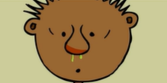 |  | 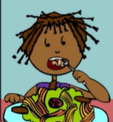 |  | 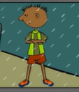 |  |  |  | 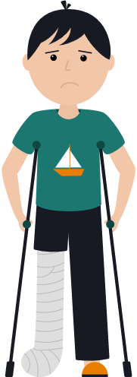
Ho il raffreddore |  | Ho fame |  | Ho freddo |  | Ho un taglio |  | Ho la gamba rotta
This resource can be adapted by replacing the text to suit your language.
I’m sick |  | I have a sore tummy |  | She has an earache |  | He has a headache |  | I have a swollen foot
I have a cold |  | I’m hungry |  | I’m cold |  | I have a cut |  | I have a broken leg
This resource can be adapted by replacing the text to suit your language.

Resource 5 – sentence builder – illness and injury
Come stai? (How are you?)
Sto male. (I'm not well)
Perché? (Why?)

I have | article | illness/sore | body part | adjective
Ho | il  un  - | raffredore.  taglio.  mal di | pancia  gola  testa  bocca  naso  orecchie  occhi  ginocchio  spalle  braccio  mano  piede  gamba | gonfio  rotta

I have | article | illness/sore | body part
I have | the  a  an | cold.  cut  sore  swollen  broken | tummy  throat  head  mouth  nose  ears  eyes  knee  shoulders  arm  hand  foot  leg

Resource 6 – advice flashcards
Dormi |  | Prendi la medicina |  | Bevi l’acqua |  | Siediti qui
Riposa la gamba |  | Vai dal dottore |  | Metti un cerotto |  | Non mangiare niente
This resource can be adapted by replacing the text to suit your Language.
Sleep |  | Take some medicine |  | Drink water |  | Sit down here
Rest your leg |  | Go to the doctor |  | Put on a plaster |  | Don’t eat anything
This resource can be adapted by replacing the text to suit your language.

Resource 7 – Cosa é successo? (What happened?) flashcards
 |  |  |  |  |  | 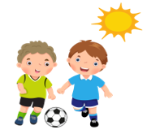
Non lo so! |  | Ho mangiato troppo |  | Ho ascoltato la musica forte |  | Ho giocato al sole
Sono caduto dalla bicicletta |  | Sono andato all’infermeria |  | Ho saltato |  | Sono uscito nella pioggia
This resource can be adapted by replacing the text to suit your language.
I don’t know! |  | I ate too much |  | I listened to loud music |  | I played in the sun
I fell off my bike |  | I went to sickbay |  | I jumped |  | I went out in the rain
This resource can be adapted by replacing the text to suit your language.

Resource 8 – Cosa é successo? (What happened?) sentence builder
I | verb | verbal phrase
Ho  Sono | mangiato  ascoltato  giocato  saltato  caduto/a  andato/a  uscito/a | troppo  la musica forte  al sole  dalla bicicletta  all’infermeria  nella pioggia

I | verb | verbal phrase
I | ate  listened  played  jumped  fell  went  went | too much  to loud music  in the sun  off my bike  to sick bay  out in the rain

Resource 9 – assessment task – tell a teacher about an illness or injury

Outcomes
You will be assessed on how well you:
- exchange information in familiar contexts by selecting culturally appropriate modelled language

Task
You have an illness or injury. Tell your teacher what is wrong with you and what happened. Listen to them and follow their advice.
- Context: You have an illness or injury
- Audience: Teacher
- Purpose: To help you get better.
The table below outlines the communicative task students will need to complete.
Too hard? | Too easy?
Tell your teacher what is wrong with you. Listen to them and follow their advice. | Tell your teacher what is wrong with you and what happened. Listen to them and ask a clarifying question about their advice.

Learning intention
You will tell a teacher about an illness or injury you have.

Success criteria
You will be successful if you can:
- use appropriate greetings.
- say why you’re not feeling well.
- say what happened to cause your illness or injury.
- say words in the right order
- speak loudly and clearly

Task instructions
- You have an illness or injury. Tell your teacher what is wrong with you and follow their advice.
- the context of the task is that you have an illness or injury.
- the audience of the communication will be your teacher.
- the communicative purpose is to help you get better.
- This task will be completed in groups of 3. Each student will take turns at all 4 roles:
- you (the student with an illness or injury)
- the teacher
- camera operator/peer assessor.
- The student with an illness or injury is completing the communicative task, so you will only be assessed for task completion while performing this role. You will be assessed on all other criteria in the rubric while performing all roles except for camera operator/peer assessor.
- Following the task, you will watch a recording of yourself completing the task. You can self-assess by marking yourself on the Resource 10 – rubric – Sono malato (I’m sick). Then compare the self-assessed rubric and the teacher marked rubric.
- Reflect on your performance and identify areas for improvement. Use this information to set a learning goal for the next stage of learning using Resource 12 – learning goal form.

Resource 10 – rubric – Sono malato (I’m sick)
Name:________________________
Table 1 – rubric for Sono malato (I’m sick)
Criteria | Excellent | Got it | Sort of | Not yet | Limited
Communication | Your audience, the teacher, clearly understands what you want to communicate.  Successfully and thoroughly complete all of the following aspects of the task:  - use appropriate greetings  - say why you’re not feeling well  - say what happened to cause your illness or injury  - say words in the right order  - speak loudly and clearly | Your audience, the teacher, can understand what you want to communicate.  Successfully complete all of the following aspects of the task:  - use appropriate greetings  - say why you’re not feeling well  - say what happened to cause your illness or injury  - say words in the right order  - speak loudly and clearly. | Your audience, the teacher, can mostly understand what you want to communicate.  Successfully complete most of the following aspects of the task:  - use appropriate greetings  - say why you’re not feeling well  - say what happened to cause your illness or injury  - say words in the right order  - speak loudly and clearly. | Your audience, the teacher, struggles to understand what you want to communicate. However, communication is successful.  Do not complete all aspects of the task. | Your audience, the teacher, is unable to understand what you want to communicate.  Unable to complete any aspect of the task.
Fluency | Always speak with appropriate speed and expression confidently. | Speak confidently with appropriate speed and expression most of the time. | Speak confidently with appropriate speed and expression some of the time. | Don’t speak confidently. | Unable to be understood.
Grammar | Always say words in the correct order when speaking. | Usually say words in the correct order when speaking. | Make some grammar mistakes when speaking. | Rarely make sense when speaking. | Unable to be understood.
Pronunciation | Pronounce all words correctly. | Pronounce most words correctly. | Consistently make pronunciation errors. | Pronounce only a few words correctly. | Unable to pronounce any words correctly.
Vocabulary | Use expected vocabulary correctly and add interesting vocabulary to dialogue. | Use expected vocabulary in dialogue correctly. | Make some mistakes when trying to use expected vocabulary. | Make many mistakes when trying to use expected vocabulary. | Unable to use vocabulary in appropriate context.

Resource 11 – TAG (Tell, Ask, Give) peer feedback strategy
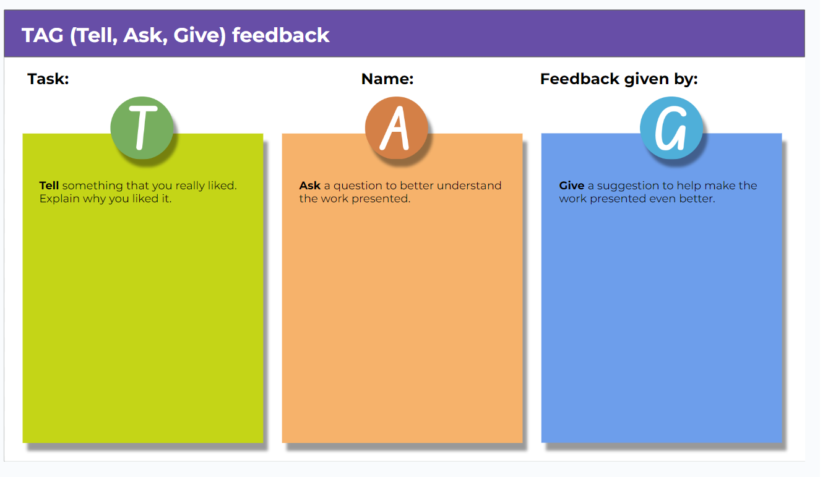

Resource 12 – learning goal form
Learning goal | Notes
My learning goal | I will pronounce [X] sound correctly in Italian words and sentences.
The steps I will take | I will:  - say 5 different Italian words with [X] sound every day  - practise pronouncing words correctly by playing tongue twister games  - record and listen to myself saying the sound in Italian  - practise the sound with my friends and ask for their feedback  - listen and act on my teacher’s feedback.
Target date | Term [X], Week 8
Target achieved | Term [X], Week ….

Resource 13 – Sono malato – labelling activity
Write the relevant Italian word or phrase under each picture.
okay  ____________ |  | let’s see  ____________ |  | let’s go  ____________ |  | here is  ____________
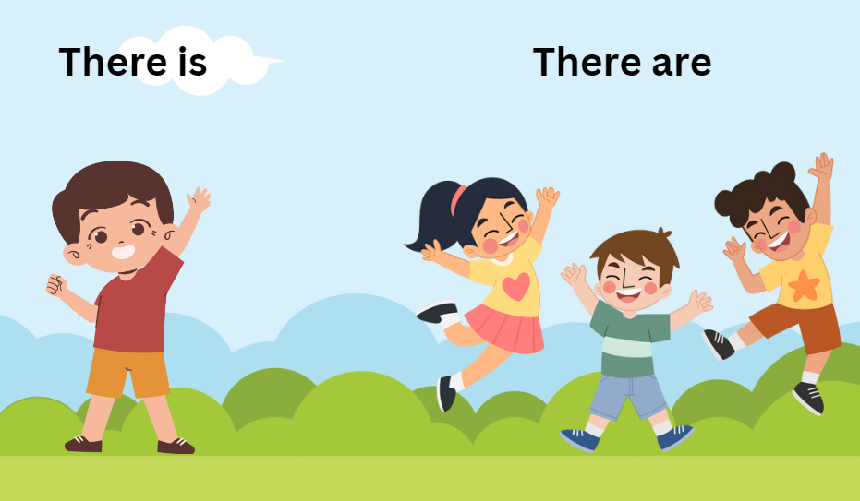
there are  ____________ |  | I’m so hungry  ____________ |  | Hello?  ____________ |  | kids  ____________

andiamo | va bene | che fame | ragazzi | pronto? | ecco | ci sono | vediamo

Support and alignment
Resource evaluation and support: all curriculum resources are prepared through a rigorous process. Resources are periodically reviewed as part of our ongoing evaluation plan to ensure currency, relevance, and effectiveness. For additional support or advice, contact the Primary Languages team by emailing primlang@det.nsw.edu.au.
Alignment to system priorities and/or needs: School Excellence Policy
Alignment to the School Excellence Framework: this resource supports the School Excellence Framework elements of curriculum (curriculum provision, teaching and learning programs) and effective classroom practice (lesson planning).
Alignment to Australian Professional Teaching Standards: this resource supports teachers to address Australian Professional Teaching Standards 2.2.2, 3.2.2.
Consulted with: Curriculum, Secondary Learners, school-based staff and NESA subject matter experts. Advice from Aboriginal Outcomes and Partnerships, EAL/D, HPGE and Inclusive Education for Modern Languages Stage 3 Italian Mangiare in Ristorante has been considered in preparing this document.
NSW syllabus: Modern Languages K–10 Syllabus
Syllabus outcomes: ML2-INT-01, ML2-UND-01, ML2-CRT-01
Author: Primary Curriculum
Publisher: State of NSW, Department of Education
Resource: unit
Related resources: further resources to support Stage 2 Modern Languages can be found on the Languages K–6 curriculum page.
Professional learning: relevant professional learning is available through Primary Languages Networks on Teams (staff only).
Universal Design for Learning: support the diverse learning needs of students using inclusive teaching and learning strategies. Some students may require more specific adjustments to allow them to participate on the same basis as their peers. For further advice see Inclusive practice resources for primary school.
Differentiation: when using these resources in the classroom, it is important for teachers to consider the needs of all students in their class, including:
Aboriginal and Torres Strait Islander students. Targeted strategies can be used to achieve outcomes for Aboriginal students in K-12 and increase knowledge and understanding of Aboriginal histories and cultures. Teachers should use students’ Personalised Learning Pathways to support individual student needs and goals.
EAL/D learners. EAL/D learners may require scaffolding to support them to gain content knowledge, while providing extra time and assistance to master the English language required to engage with texts or complete classroom tasks. View some samples of differentiating through scaffolding.
Students with additional learning needs. Learning adjustments enable students with disability and additional learning and support needs to access syllabus outcomes and content on the same basis as their peers. Teachers can use a range of adjustments to ensure a personalised approach to student learning.
High potential and gifted learners. Assessing and identifying high potential and gifted learners will help teachers decide which students may benefit from extension and additional challenge. In addition, the Differentiation Adjustment Tool can be used to support the specific learning needs of high potential and gifted students.
Creation date: 25 January 2024
Rights: © State of New South Wales, Department of Education

References
This resource contains NSW Curriculum and syllabus content. The NSW Curriculum is developed by the NSW Education Standards Authority. This content is prepared by NESA for and on behalf of the Crown in right of the State of New South Wales. The material is protected by Crown copyright.
Please refer to the NESA Copyright Disclaimer for more information https://educationstandards.nsw.edu.au/wps/portal/nesa/mini-footer/copyright.
NESA holds the only official and up-to-date versions of the NSW Curriculum and syllabus documents. Please visit the NSW Education Standards Authority (NESA) website https://educationstandards.nsw.edu.au/wps/portal/nesa/home and the NSW Curriculum website https://curriculum.nsw.edu.au.
Modern Languages K–10 Syllabus © NSW Education Standards Authority (NESA) for and on behalf of the Crown in right of the State of New South Wales, 2022.
8 Ways (n.d.) 8 Aboriginal Ways of Learning [website], accessed 13 December 2022.
AITSL (Australian Institute for Teaching and School Leadership (2017) ‘Feedback Factsheet’, AITSL, accessed 13 December 2022.
CESE (Centre for Education Statistics and Evaluation) (2020a) What works best: 2020 update, NSW Department of Education, accessed 13 December 2022.
CESE (Centre for Education Statistics and Evaluation) (2020b) What works best in practice, NSW Department of Education, accessed 13 December 2022.
Conti G (28 September 2015) ‘16 tips for effective grammar teaching in the foreign language classroom’, The Language Gym, accessed 13 December 2022.
Conti G (28 May 2017) From Target Language to Model Language – the mind shift that has transformed my teaching, The Language Gym, accessed 13 December 2022.
Henshaw FG and Hawkins MD (2022) Common Ground: Second Language Acquisition Theory Goes to the Classroom, Focus, Indianapolis, accessed 13 December 2022.
Jones J and Wiliam D (2014) Modern Foreign Languages Inside the Black Box: Assessment for Learning in the Modern Foreign Languages Classroom (Black P, Harrison C, Marshall B and Wiliam D, eds), Learning Sciences International, United States, accessed13 December 2022.
NESA (NSW Education Standards Authority) (2020) NSW Curriculum Review – final report, NESA, NSW Government, accessed 13 December 2022.
Rosenshine B (2012) ‘Principles of Instruction: Research-Based Strategies That All Teachers Should Know’, American Educator, 36(1):12–19, 39, accessed 13 December 2022.
Smith S (2022) Becoming an Outstanding Languages Teacher, 2nd edn, Routledge, United Kingdom, accessed13 December 2022.
Wisniewski B, Zierer K and Hattie J (2020) ‘The Power of Feedback Revisited: A Meta-Analysis of Educational Feedback Research’, Frontiers In Psychology, 10(3087), doi:10.3389/fpsyg.2019.03087, accessed 13 December 2022.
Wiliam D (2013) ‘Assessment: The bridge between teaching and learning’, Voices from the Middle, 21(2):15–20, accessed 13 December 2022.
Wiliam D and Leahy S (2015) Embedding Formative Assessment: Practical Techniques for K–12 Classrooms, Learning Sciences International, United States accessed 13 December 2022.

© State of New South Wales (Department of Education), 2024
The copyright material published in this resource is subject to the Copyright Act 1968 (Cth) and is owned by the NSW Department of Education or, where indicated, by a party other than the NSW Department of Education (third-party material).
Copyright material available in this resource and owned by the NSW Department of Education is licensed under a Creative Commons Attribution 4.0 International (CC BY 4.0) license.
This license allows you to share and adapt the material for any purpose, even commercially. Attribution should be given to © State of New South Wales (Department of Education), 2024.
Material in this resource not available under a Creative Commons license:
the NSW Department of Education logo, other logos and trademark-protected material
material owned by a third party that has been reproduced with permission. You will need to obtain permission from the third party to reuse its material.
Links to third-party material and websites
Please note that the provided (reading/viewing material/list/links/texts) are a suggestion only and implies no endorsement, by the New South Wales Department of Education, of any author, publisher, or book title. School principals and teachers are best placed to assess the suitability of resources that would complement the curriculum and reflect the needs and interests of their students.
If you use the links provided in this document to access a third-party's website, you acknowledge that the terms of use, including licence terms set out on the third-party's website apply to the use which may be made of the materials on that third-party website or where permitted by the Copyright Act 1968 (Cth). The department accepts no responsibility for content on third-party websites.

