Arabic Stage 1
(We are family) نحن عائلة

Contents
Unit overview 5
Stage 1 outcomes and content to be addressed 6
Learning map 10
Assessment 13
Assessment opportunities 14
Teaching and learning activities 15
Week 1 – family 15
Vocabulary 1 – family members 16
Activity 1 – Learning map 17
Activity 2 – introduce family vocabulary 17
Activity 3 – labelling family members 18
Activity 4 – hotseat 19
Week 2 – story time 20
Vocabulary 2 – my family 21
Activity 1 – story time 22
Activity 2 – understanding possession 22
Activity 3 – demonstrative pronouns 23
Activity 4 – Maze muncher 24
Activity 5 – family traditions 25
Week 3 – names 26
Vocabulary 3 – What’s your name? 27
Activity 1 – asking and responding to questions 28
Activity 2 – Face off 28
Activity 3 – puppet talk – name game 29
Week 4 – make a poster 30
Activity 1 – sentence builder 31
Activity 2 – make a poster 32
Activity 3 – gallery walk 33
Activity 4 – exit ticket 33
Week 5 – assessment criteria and practice task 35
Activity 1 – family bingo 35
Activity 2 – discuss the assessment task 36
Activity 3 – success criteria 36
Activity 4 – practice task 37
Week 6 – communicative task – introducing your family 38
Activity 1 – family basket 39
Activity 2 – task set-up 39
Activity 3 – communicative task – introducing your family 40
Activity 4 – peer assessment 41
Week 7 – feedback and goal setting 42
Activity 1 – silent relay 43
Activity 2 – self-assessment 43
Activity 3 – set learning goals 43
Week 8 – language review 45
Activity 1 – student questions 46
Activity 2 – word work 46
Activity 3 – grammar 47
Activity 4 – listening and responding 47
Student resources 48
Resource 1 – family flashcards 48
Resource 2 – labelling activity 49
Resource 3 – ‘This is’ cards 51
Resource 4 – my family flashcards 52
Resource 5 – question cards 53
Resource 6 – sentence builder 55
Resource 7 – bingo card 56
Resource 8 – student rubric – We are family 57
Resource 9 – peer feedback strategy – two stars and a wish 58
Support and alignment 59
References 62

Unit overview
Stage: 1
Title: (We are family) نحن عائلة
Description: In this unit, students introduce members of their families in Arabic. Students use simple greetings, rehearsed phrases, nouns and pronouns to exchange information about their family members with their peers.
Duration: This lesson sequence is designed to be completed over approximately 8 weeks.
Student proficiency levels:
Stage 1
It is assumed that most Stage 1 students have been learning Arabic since Kindergarten and their proficiency level will still be Beginner. The assessment tasks in this scope and sequence are aimed at Beginner students. Every classroom will be different and teachers will need to adapt to their context. Many classes may include a combination of Beginner, Intermediate and Advanced students with varying skills and abilities within these proficiency levels. Assessment tasks and opportunities in this unit can be differentiated using the ‘Too hard?’ and ‘Too easy?’ suggestions.
Note: Arabic is read from right to left, unlike English which is read from left to right. As a result, there are some samples of English and Arabic text in this document where punctuation may appear incorrect in both. Please keep this in mind when using this document.

Stage 1 outcomes and content to be addressed
The table below outlines the focus area, outcomes and content points for Stage 1 students.
Focus area and outcome | Content points
Interacting  A student:  - exchanges meaning by selecting culturally appropriate modelled language ML1-INT-01 | Exchanging meaning in oral interactions in the target language  - Exchange greetings, farewells and simple information to describe people or objects  - Answer common questions about themselves and their personal world in a guided conversation  - Express simple emotions and preferences  - Interact in classroom routines using familiar language  - Interact by selecting modelled language in games or scenarios using imagination  Reproducing oral language to interact in the target language  - Recognise and reproduce modelled sounds, including pronunciation and intonation patterns to interact  - Reproduce familiar vocabulary and short formulaic phrases to interact  Applying knowledge of the target language culture(s) to interact  - Use familiar verbal and nonverbal communication that is appropriate to cultural practices
Understanding texts  A student:  - recognises and responds to information in simple texts to demonstrate understanding ML1-UND-01 | Understanding and responding to target language texts  - Listen to, read and/or view simple texts, such as stories, songs, charts, rhymes or lists on familiar themes  - Use auditory cues, gestures, visuals and other forms of nonverbal communication to support comprehension  - Associate vocabulary on familiar themes with known actions, people, places, objects and ideas  - Recognise information in simple texts and respond to simple questions in the target language and/or English to show understanding of texts  - Demonstrate understanding when responding to texts using actions, drawing, singing or simple exchanges in the target language and/or English  Applying knowledge of language systems to understand and respond to target language texts  - Recognise and use sounds of modelled vocabulary and phrases to understand and respond to texts  - Recognise sound–symbol correspondences in modelled words and phrases to understand and respond to texts  - Recognise and use knowledge of modelled vocabulary, high-frequency words and formulaic phrases on familiar themes to understand and respond to texts  - Use simple grammar patterns to understand and respond to texts  - Recognise that the target language has features that may be similar to or different from English  - Recognise and reproduce symbols or modelled vocabulary and phrases of the writing system to understand and respond to texts  Developing intercultural understanding through target language texts  - Notice that language is used in ways that reflect cultural practices and reflect on their own language and cultural practices
Creating texts  A student:  - creates simple texts by selecting culturally appropriate modelled language ML1-CRT-01 | Creating spoken, written and multimodal texts in the target language  - Create texts using familiar vocabulary, phrases and visuals to express meaning  - Create a simple sentence about themselves and their personal world to express ideas and/or give descriptive information  - Label or describe objects and images  Applying knowledge of language systems to create texts in the target language  - Use pronunciation patterns to create spoken texts  - Use familiar sound–symbol correspondences to create written texts  - Use familiar vocabulary and formulaic phrases to create texts  - Use simple modelled sentence structures to create texts  - Reproduce modelled features of the target language writing system to create written texts  Reproducing how target language speakers communicate to create texts  - Reproduce language appropriate to cultural practices to create texts
Modern Languages K–10 Syllabus © NSW Education Standards Authority (NESA) for and on behalf of the Crown in right of the State of New South Wales, 2022.

Learning map
The creation of maps for learning is a planning process that incorporates Aboriginal intellectual tradition. Learning maps are a visual pathway of what students will learn.
Share the learning map with your students, briefly explaining the learning that will happen in each lesson. Provide students with a copy of the learning map or display the learning map in the classroom. This learning map can be adapted to Arabic by accessing a copy of Learning map – (We are family) نحن عائلة! (Stage 1).
Figure 1 – We are family learning map
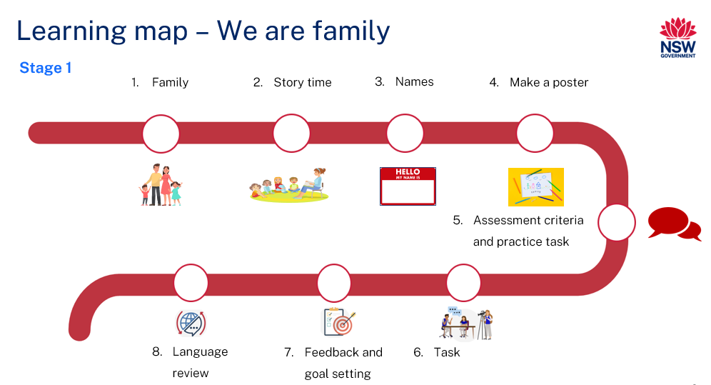
Figure 2 –نحن عائلة learning map
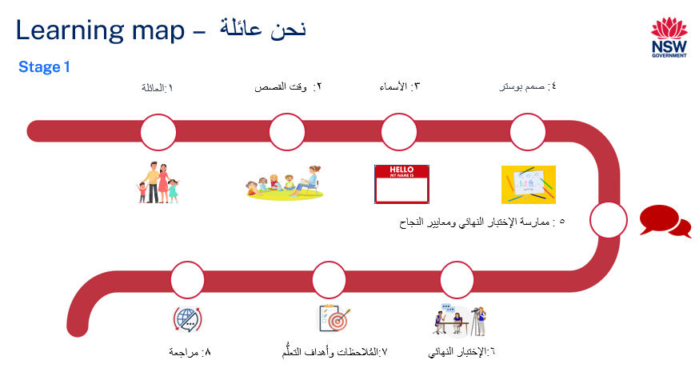

Assessment
Stage 1 communicative task: A friend from an Arabic-speaking country introduced you to their parents. Now it is your turn to tell your friend’s parents about your family. Use a photograph to introduce them to members of your family. Include family members’ names and relationship to you.
Too hard?
Students use a photograph to introduce their family to the friend's parents.
Too easy?
Students use a photograph to introduce members of their family to the friend’s parents. Students include their family members’ names, their relationship to the student and one activity the student enjoys doing with each of them.
Context: responding to a request from a friend’s parent
Audience: your friend and their family
Purpose: to tell your friend’s parents about your family

Assessment opportunities
The table below details assessment opportunities and differentiation ideas.
Assessment opportunities | Too hard? | Too easy?
Week 1 – labelling family members  Students label the corresponding pictures of family members with the correct Arabic words. | Labelling family members  Provide students with a set of Resource 1 – family flashcards to assist them with vocabulary. | Labelling family members  Students draw and label extended family members, including aunts, uncles and cousins, in Arabic.
Week 3 – asking and responding to questions  Pre-assessment of students' understanding and their ability to respond to questions correctly. | Asking and responding to questions  For students who know only one question and response, reduce the number of questions taught. | Asking and responding to questions  For students who know all the questions and responses, introduce more complex questions.
Week 4 – make a poster  Students create a poster by drawing their family members and labelling each one in Arabic. | Make a poster  Students refer to Resource 6 – sentence builder for vocabulary assistance and grammatical structure. | Make a poster  In addition to labelling family members, students will write a sentence about something each family member likes to do.

Teaching and learning activities

Week 1 – family
The table below outlines the learning intention and success criteria of the lesson, and materials that the teacher and students will need to complete the teaching and learning activities.
Learning intention and success criteria | Materials
Students will identify and say family members’ names in Arabic.  Students can:  - say family members’ names correctly in Arabic. | - Resource 1 – family flashcards  - Resource 2 – labelling activity (copies for students and an A3-sized version for the teacher)  - Learning map  - Writing materials

Vocabulary 1 – family members
The table below outlines suggested vocabulary for family members. It includes the original Arabic script, a Romanised version of the Arabic script and the corresponding English translations.
English | Romanised Arabic | الترجمة الى اللغة العربية
father | ab | أب
mother | um | أم
sister | ukht | أخت
brother | akh | أخ
grandfather | jidd | جد
grandmother | jiddah | جدة
uncle (father’s side) | amm | عم
aunt (father’s side) | ammah | عمة
uncle (mother’s side) | khaal | خال
aunt (mother’s side) | khaalah | خالة
family | a'ilah | عائلة

Activity 1 – Learning map
Explain and display the Learning map to give students a more detailed breakdown of lessons during the unit. Point out that the Learning map is a plan that may need to change.

Activity 2 – introduce family vocabulary
Note: remind students who speak Arabic at home that everyday terms for family members, such as 'mum' and 'dad', will differ in the classroom because they are using Modern Standard Arabic. Unlike English, in Arabic, there are 2 words each for 'aunt' and 'uncle', based on whether they are from the mother's or father's side. Ask students who speak neither English or Arabic at home if their background language is more like English or Arabic.
- Show students the images in Resource 1 – family flashcards. Ask them to identify how many words they think they know when answering the following questions by showing a thumbs up at their chests. Ask:
- Do you know all the words for these pictures in Arabic?
- Do you know most of them?
- Do you know some of them?
- Do you know none of them?
- In pairs, students Think-Pair-Share the words they know.
- Model and drill the correct pronunciation of Resource 1 – family flashcards vocabulary with students until most students are pronouncing the words correctly.

Activity 3 – labelling family members
- Show the whole class a large, A3-sized version of Resource 2 – labelling activity. Use this to demonstrate the correct way to label each picture with the appropriate Arabic word.
- Point to the images on the labelling activity and ask students who each person is.
- Distribute a copy of Resource 2 – labelling activity to each student to complete.
Note: students with Advanced proficiency levels can draw and label additional family members not included in the worksheet.

Activity 4 – hotseat
- Play a communicative language learning game, ‘Hotseat’ with the whole class to practise the vocabulary of family names.
- Divide the class into 2 teams. Select one player from each team to sit with their back to the board.
- Write a family member's name in Arabic on the board, such as (mother)أم .
- Students from each team will take turns giving clues in English to their teammate in the hotseat. Students can’t use the Arabic word written on the board when giving clues. For example, ‘An adult female member of your family’. The first student in the hotseat to correctly say the word for 'mother' earns a point for their team.
Note: for Beginner-level students, provide a bilingual list of family names to assist them in calling out names. Advanced or Intermediate students can give clues in Arabic.
Evaluation: students label the pictures with the correct Arabic words.

Week 2 – story time
The table below outlines the learning intentions and success criteria of the lesson, and materials that the teacher and students will need to complete the teaching and learning activities.
Learning intentions and success criteria | Materials
Students will:  - identify and say Arabic phrases related to family members  - understand the use of possessive and demonstrative pronouns in Arabic.  Students can:  - identify Arabic vocabulary words related to family using pictures  - apply the correct way of saying ‘this is’ based on the gender of the noun  - apply the Arabic grammar rule for possession. | - Resource 3 – ‘This is’ cards  - Resource 4 – my family flashcards  - My Family PowerPoint book (Arabic)  - My Family PowerPoint book (English)  - Arabic exercise books  - Individual whiteboards  - Whiteboard markers  - Writing materials

Vocabulary 2 – my family
The table below outlines suggested vocabulary for ‘my family’. It includes the original Arabic script, a Romanised version of the Arabic script and the corresponding English translations.
English | Romanised Arabic | الترجمة الى اللغة العربية
My family | Aa’ilati | عائلتي
This is my father. | Hādhā abī | هذا أبي.
This is my mother. | Hādhihi ummī | هذه أمي.
This is my brother. | Hādhā akhī | هذا أخي.
This is my sister. | Hādhihi ukhtī | هذه أختي.
This is my grandfather. | Hādhā jaddī | هذا جدي.
This is my grandmother. | Hādhihi jaddatī | هذه جدتي.
This is me. | Hādhā ana | هذا أنا.

Activity 1 – story time
Note: when reading the My Family PowerPoint book to the class, emphasise how family member words end in the letter ي to indicate possession. Also, highlight the gender-specific changes in the demonstrative pronouns (this is – masculine) هذا and (this is – feminine) هذه.
- Assess students' prior knowledge and display the cover page of the My Family PowerPoint book, ensuring the title is hidden. Ask students to whisper to their partner what they think the book could be about.
- Point to each picture in the book, covering the text, and ask students to whisper to a partner the Arabic word for each family member you are pointing to.
- Read the My Family PowerPoint book to the class.

Activity 2 – understanding possession
Note: to show possession in Arabic, add the letter (Yaa) 'ي' to the end of a noun. This concept is like adding s' to a noun in English to indicate ownership.
- Ask students how possession is shown in English. For example, ask them about the words used to indicate that something belongs to someone. Discuss examples like ‘my’, ‘your’, ‘his’, or ‘her’ to establish the concept of possessive pronouns.
- Introduce students to the concept of possessive pronouns in Arabic. Illustrate, for instance, how adding (Yaa) 'ي' to a noun indicates possession, changing (family)عائلة to (my family) عائلتي and applying similar alterations to other words in the story such as (mother) أم to (my mother)أمي and (father) أب to (my father) أبي .
- Demonstrate on the board how possession is formed in Arabic. For example:
Figure 3 – addingي to a word to form possession (text translates to my mother = my + mother)
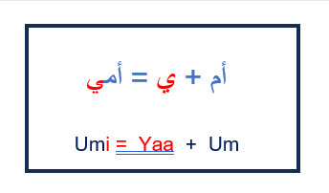
- Write a list of nouns from the book in Arabic on the board. In pairs, students use individual whiteboards and markers, taking turns to show possession by adding the letter 'ي' to nouns.

Activity 3 – demonstrative pronouns
Note: inform students that, unlike English, Arabic has different terms for 'this is', selecting between هذا and هذه, based on whether the corresponding person is male or female, or the noun is masculine or feminine.
- Introduce Resource 3 – ‘This is’ cards. Explain that in Arabic, (this is – masculine) هذا is used for masculine nouns, while (this is – feminine) هذه is used for feminine nouns. Articulate هذا and هذه clearly, pointing to the respective cards, and have the students repeat after you to ensure correct pronunciation and understanding.
- Position the (this is – masculine) هذا card on the left and the (this is – feminine)هذه card on the right on the whiteboard. Clearly label هذا as masculine and هذه as feminine beside each card.
- Select students at random to choose a card from Resource 4 – my family flashcards. Students place the selected family member card under the correct هذا or هذه card.
- For example, if a student places the card (my mother) أمي under (this is – feminine) ,هذه the student reads aloud the sentence, saying (‘This is my mother.’) 'هذه أمي' . Repeat the sentence, or recast if required to ensure it is correct, and ask the class to repeat.
- Students record these pronoun-noun combinations into their Arabic exercise books.
Note: encourage students to say the sentences aloud with you when matching the demonstrative pronoun, ‘this is’, to the noun.

Activity 4 – Maze muncher
- Play a communicative language learning game, ‘Maze muncher’ with the whole class to practise grammar and vocabulary.
- Have students stand in a large, open area, spaced apart.
- Call out sentences using Resource 3 – ‘This is’ cards and Resource 4 – my family flashcards such as (‘This is my mother.’) 'هذه أمي'
- The first student to correctly translate the sentence can take a step to 'tap' another student, who will then be 'out'.
- Continue playing until you have called out a variety of sentences.

Activity 5 – family traditions
- Start a class discussion about family traditions and culture in Arabic-speaking countries. Have students sit in a circle and ask them questions, such as:
- How do families celebrate events?
- What traditions do families in Arabic speaking countries have?
- How does this compare with families in Australia or from your home country?
- Have students share their family traditions with the class, go around the circle until everyone has had the chance to talk about their family here or about their family back home.

Week 3 – names
The table below outlines the learning intention and success criteria of the lesson, and materials that the teacher and students will need to complete the teaching and learning activities.
Learning intention and success criteria | Materials
Students will learn to ask and answer questions to identify names in Arabic.  Students can:  - ask others what their names are and respond with their own names when asked. | - Resource 5 – question cards  - Arabic exercise books  - Hand puppets  - Writing materials

Vocabulary 3 – What’s your name?
The table below outlines suggested vocabulary for ‘What’s your name’? It includes the original Arabic script, a Romanised version of the Arabic script and the corresponding English translations.
English | Romanised Arabic/transliterated Arabic | الترجمة الى اللغة العربية
Who is this? | Man hādhā? | من هذا؟
What's your name? (masculine) | Ma ismuka? | ما اسمكَ؟
What's your name? (feminine) | Ma ismuki? | ما اسمكِ؟
My name is … | Ismee | اسمي
What is his name? | Ma ismuhu? | ما اسمه؟
His name is … | Ismuhu | اسمه
What is her name? | Ma ismuha? | ما اسمها؟
Her name is … | Ismuha | اسمها

Activity 1 – asking and responding to questions
- To pre-assess students’ vocabulary before teaching new words, have students Think-Pair-Share to discuss any Arabic words they might use when asking about a name.
- Display Resource 5 – question cards on the board. Read each question aloud. After reading, ask students to show a thumbs up near their chest if they know the question well, a thumb sideways if they somewhat understand it and a thumbs down if they have never heard the question.
- Read aloud the Arabic questions using Resource 5 – question cards and have students repeat each word after you call them out.
- Have students record the new language into their Arabic exercise books.

Activity 2 – Face off
- Play a communicative language game called 'Face off' to help students practice listening and responding to recently taught questions.
- Divide the class into 2 teams. The students at the front of each line start the game.
- Ask students questions using Resource 5 – question cards, such as (What's her name?) ما اسمها؟ while indicating to a female student on one team.
- The first student to correctly name the student scores a point and moves to the back of their line.
- Demonstrate ‘What's her name?’ ما اسمها؟and ‘What's his name?’ ما اسمه؟a few more times, then nominate students to continue asking alternating questions until everyone has had a turn.

Activity 3 – puppet talk – name game
Note: make multiple copies of Resource 5 – question cards.
- Divide students into groups of 3. Give each group a hand puppet and a copy of Resource 5 – question cards. Every student in the group chooses a card from the set.
- Each student takes a turn using the hand puppet to ask the question from their selected card to another group member.
- After each student in the group has asked and answered a question, they exchange cards within their group.
- Continue the process until every student has had the chance to ask and respond to each question in the set.
Evaluation: use Intentional observation checklist for communicative activities to make notes about student understanding of the target language, their pronunciation and use of gesture, facial expression and tone to support communication.

Week 4 – make a poster
The table below outlines the learning intentions and success criteria of the lesson, and materials that the teacher and students will need to complete the teaching and learning activities.
Learning intentions and success criteria | Materials
Students will:  - draw and label images of their family members in Arabic  - communicate the names of their family members using Arabic  - use masculine and feminine demonstratives in Arabic correctly.  Students can:  - correctly label and say the names of family members in Arabic  - use the appropriate masculine or feminine version of ‘this is’ for the person they are talking about. | - Resource 6 – sentence builder  - A3 white paper  - Arabic exercise books  - Coloured stickers  - Coloured sticky notes  - Colourful markers  - Writing materials

Activity 1 – sentence builder
Note: revisit Vocabulary 1 – family members, Vocabulary 2 – my family and Vocabulary 3 – What’s your name? to review the words and phrases taught in the past few weeks.
- Explain to students that they will use a sentence builder to assist them in practicing how to introduce their family members.
- In pairs, students will use Resource 6 – sentence builder to create sentences introducing various family members.
- Review the sentence structure with the class. The sentence should follow this pattern:
- This is my [family member]. هذا/هذه [عضو العائلة].
- His/her name is [Name]. اسمه/اسمها [الاسم].
- Students take turns sharing their sentences with each other introducing their family members.
- Students write their sentences in their Arabic exercise books.
Note: sample names have been provided for teacher demonstrations. You may choose to change the names to suit the context of your class.

Activity 2 – make a poster
- Students create a family poster where they will draw and then label each family member in Arabic. Draw an example of a family, with a variety of members, such as parents, grandparents and siblings, on the board or on a large sheet of paper to provide a visual guide (see Figure 4).
Figure 4 – family poster example
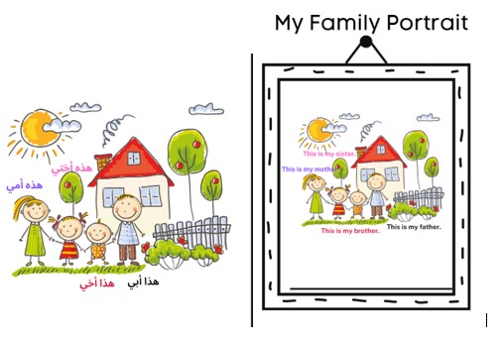
- After the demonstration, provide students with the A3-sized drawing paper and colourful markers to begin their family posters.
Note: provide a copy of Resource 6 – sentence builder to assist students at Beginner proficiency levels with vocabulary and grammatical structure. Those at Advanced proficiency levels should label family members, pets and extended family members, such as grandparents or cousins. Additionally, they can write a sentence describing an activity they enjoy with a chosen family member.

Activity 3 – gallery walk
Once students have completed their family posters, organise a gallery walk in the classroom. Distribute stickers to each student for peer feedback. As they walk around and view their classmates' work, students can place a sticker on or near parts of the posters where they identify correctly labelled family members or appropriately ways of saying ‘this is’.

Activity 4 – exit ticket
Note: students may not know how to spell the names of people in their families in Arabic. They can write this in English or use Romanised Arabic and say it verbally as they leave the class.
- To assess students’ understanding of sentence structure, divide the board into 4 sections and ask students to write ‘This is my [family member]. Her name/His name is [Name]’ on 4 different coloured sticky notes.
- As students leave the class, have them stick their notes in the correct order to make a simple sentence on the board. For example (This is my mother. Her name is Layla.) هذه أمي. اسمها ليلى. (See Figure 5).
Figure 5 – exit ticket example
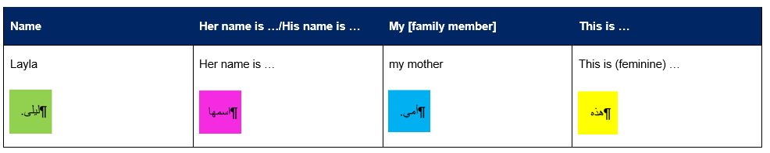

Week 5 – assessment criteria and practice task
The table below outlines the learning intention and success criteria of the lesson, and materials that the teacher and students will need to complete the teaching and learning activities.
Learning intention and success criteria | Materials
Students will develop a clear understanding of the requirements of the assessment task.  Students can:  - suggest appropriate success criteria  - explain what they need to do to be successful in the task. | - Resource 1 – family flashcards  - Resource 7 – bingo card  - Learning map  - Family poster  - Counters  - Family photographs

Activity 1 – family bingo
- Play a whole class communicative language learning game, such as Bingo, to reinforce family names in Arabic. Show students the flashcards from Resource 1 – family flashcards. Ask them to make a bingo card by either writing or drawing 6 family members in Arabic on Resource 7 – bingo card.
- Lead a whole-class game by calling out the names of family members in Arabic, ensuring to model the correct pronunciation.
- Provide a handful of counters to each student. Each time the name of a family member is called out in Arabic, a counter must be placed on that member's name on the bingo card. The winner is the first student to get a whole row of counters.

Activity 2 – discuss the assessment task
To prepare students for the final task, review the Learning map and discuss the language that has been taught each week. Point out that, according to the learning map, the final task will be completed in Week 6. Explain to students that they will role-play presenting a photograph of their family to their friend’s parent and will introduce each family member from the photo and their relationship to them.

Activity 3 – success criteria
After looking at the assessment task, students Think-Pair-Share and suggest appropriate success criteria, such as:
I will be successful if I can:
- use appropriate greetings at the start and end of the conversation
- show my family photo and tell my friend's parents the name of each person in it and how they are related to me
- use the correct gendered word for 'this is' with each family member
- say the words in the correct order
- speak in a well-paced manner without long pauses.

Activity 4 – practice task
Note: prior to completing this task, remind students they will need a family photo. If a student is unable to bring a family photo, they may use the family poster created in Week 4.
- Explain to students that they will participate in a role-play activity.
- Divide students into pairs. In each pair, assign roles: one student will pretend to be a parent's friend and the other will play themselves. Using a family photo or a family poster as a reference, students will introduce their family members and specify the relationships. For example, ‘This is my dad, his name is [Dad’s name]. هذا أبي، اسمه [اسم الأب].
- After each student has had a turn, have them switch roles.

Week 6 – communicative task – introducing your family
The table below outlines the learning intention and success criteria of the lesson, and materials that the teacher and students will need to complete the teaching and learning activities.
Learning intention and success criteria | Materials
Students will introduce each of their family members, stating the relationship with each, by using a family photograph as reference.  Students can:  - use appropriate greetings at the start and end of the conversation  - show their family photo and tell their friend's parents the name of each person in it and how they are related to them  - use the correct gendered word for 'this is' with each family member  - say the words in the correct order  - speak in a well-paced manner without long pauses. | - Resource 1 – family flashcards  - Resource 4 – my family flashcards  - Resource 9 – peer feedback strategy – Two stars and a wish  - Chairs  - Recording device  - Tripod and microphones (if possible)

Activity 1 – family basket
- Seat students in a circle and distribute flashcards from Resource 1 – family flashcards or Resource 4 – my family flashcards.
- One person (for example, the teacher) stands in the centre of the circle and calls out a word from either resources’ flashcards.
- Students with matching flashcards stand and must find a new spot in the circle.
- The person in the middle also takes a seat, leaving one student standing. The standing student takes the flashcards to then call out the next word.
- Continue playing until all flashcards have been called out.
Note: students with Beginner proficiency levels may need pronunciation support.

Activity 2 – task set-up
Students split into the groups decided in the previous lesson. Groups are given a few minutes to ensure everybody knows the order in which they will perform each role. ‘You’ is the student who will be completing the assessed communicative task.
Suggested rotations:
- Role-play/Presentation 1: Student 1 – ‘You’, Student 2 – Peer assessor/Camera operator, Student 3 – Friend’s parent
- Role-play/Presentation 2: Student 1 – Friend’s parent, Student 2 – ‘You’, Student 3 – Peer assessor/Camera operator
- Role-play/Presentation 3: Student 1 – Peer assessor/Camera operator, Student 2 – Parent’s friends, Student 3 – ‘You’

Activity 3 – communicative task – introducing your family
Note: make sure to space students apart when filming. Demonstrate how to film using a recording device. Use microphones, if possible, to maximise sound quality. Highlight the importance of holding the recording device still by using a tripod or resting it on a table.
Students get into groups of 3 and complete the task.
Example interaction:
- Friend’s parent: (Hi) مرحباً
- You: (Hi, this is my family.) مرحباً، هذه عائلتي.
- Friend’s parent: (What’s your name? – masculine) ما اسمكَ؟
- You: (My name is Ali. This is my dad and his name is [Dad’s name].). اسمي علي.. هذا أبي، اسمه [اسم الأب]
- Friend’s parent: Who is this? ؟ من هذا
- You: This is my mum and her name is [Mum’s name] and this is my brother his name is [Brother’s name].
هذه أمي واسمها [اسم الأم] وهذا أخي اسمه[اسم الأخ].
- Friend’s parent: (Thank you and goodbye.). شكراً ومع السلامة
- You: (Goodbye.) مع السلامة
Note: before recording interactions, check if any students do not have permission to be filmed. Alternatives to video recording include audio recording or the teacher watching the interactions while taking notes and marking the rubric.

Activity 4 – peer assessment
Note: this may be the first time students have engaged in peer assessment. As a result, you may need to provide further explanations about why this is important and what students should and shouldn't do while giving and receiving peer assessment. Remind students that they need to be respectful to each other when giving and receiving feedback. Co-construct ‘ground rules’ for peer feedback. Providing sentence starters, for example:
- ‘I like the way…’
- ‘You did an excellent job of…’
- ‘My favourite part was…’
- ‘I didn’t understand…’
may be helpful to prompt them. Emphasise that the peer feedback should only be related to the visual rubric provided in this task.
Each student will provide and receive feedback to the student who was ‘you’ when they had the role of peer assessor/camera operator. Peer feedback is provided verbally and may be followed up with a completed Resource 9 – peer feedback strategy – Two stars and a wish slip.

Week 7 – feedback and goal setting
Note: if there is insufficient time to mark the videos before Week 8, Weeks 7 and 8 can be swapped.
The table below outlines the learning intention and success criteria of the lesson, and materials that the teacher and students will need to complete the teaching and learning activities.
Learning intention and success criteria | Materials
Students will reflect on feedback to set suitable learning goals.  Students can:  - reflect on the feedback provided to establish new learning goals. | - Resource 8 – student rubric – We are family  - Individual whiteboards  - Recorded student videos  - Whiteboard markers  - Writing materials
Note: prior to this lesson, the teacher views each video and marks each student according to the criteria in Resource 8 – student rubric – We are family.

Activity 1 – silent relay
Students form equal lines, each with an individual whiteboard at the front. All students except the last one close their eyes. Show the last student a word from Vocabulary 1 – family members or Vocabulary 2 – my family. After seeing the word, they stand and trace it on the next player's back. The student in the front writes the word on the whiteboard. Rotate positions until everyone has a turn.

Activity 2 – self-assessment
Students watch the video of themselves completing the task and mark themselves using Resource 8 – student rubric – We are family. Students then compare both the teacher-completed rubric and the one they completed.

Activity 3 – set learning goals
To foster student ownership of their learning, facilitate a class discussion to help students reflect on their marked rubric, peer- and self-assessment and set their own personalised learning goals for the next phase. Use simplified language to ensure that the students can understand and engage with the discussion effectively.
Suggest learning goals, such as:
- I will be confident when saying words in Arabic
- I will try to say Arabic words in the correct order
- I will practise saying tricky sounds in Arabic, for example, the pronunciation of the initial sound ‘ع’ in the word (family) عائلتي
Present suggestions like the above and others appropriate to the context of your class. Encourage students to raise their hands when they hear a goal that resonates with them. By doing so, students will understand their options and select a learning goal that is most relevant and suitable for their needs. Students record their learning goals.
Evaluation: students set appropriate learning goals based on previous learning goals and teacher-, peer- and self-assessment.

Week 8 – language review
Note: if there is insufficient time to mark the videos before Week 8, Weeks 7 and 8 can be swapped.
The table below outlines the learning intention and success criteria of the lesson, and materials that the teacher and students will need to complete the teaching and learning activities.
Learning intention and success criteria | Materials
Students will review the language learned during this unit to name all family members and relationship with them.  Students can:  - ask questions about vocabulary, grammar or pronunciation they have used in this unit  - use the Arabic they have learned to communicate with classmates. | - Resource 1 – family flashcards  - Resource 5 – question cards  - Resource 6 – sentence builder  - Hand puppets  - Individual whiteboards  - Writing materials
Note: over the course of the unit, gaps in student knowledge, misconceptions and misuse of language will have been identified. These observations are addressed using engaging and interactive activities and strategies. The activities below are examples and will need to be supplemented with activities to address your observations.

Activity 1 – student questions
Remind students of the activities and tasks they have completed over the course of the unit. Give students time to Think-Pair-Share any questions they may have about any aspect of the language taught.
Note: set up different language stations for activities 2 to 4 that focus on reinforcing word work, grammar, listening and responding. These activities can be adapted to suit students’ needs. After a set time, students rotate in groups to a new station to complete activities with a different focus.

Activity 2 – word work
This station will focus on reviewing learned vocabulary.
Suggested activities:
- Word match: provide 2 sets of Resource 1 – family flashcards. In pairs, each student takes a turn drawing a card and naming the family member on the card. If a student draws a card that matches the top card of the pile, for example, 2 identical family members, the first student to call out ‘Match!’ wins the pile.
- Lie detector: in pairs, students take turns writing a sentence from Resource 6 – sentence builder on an individual whiteboard. Their partner reads and translates the sentence, then guesses whether it's true or a lie.

Activity 3 – grammar
This station will focus on grammar taught during the unit.
Suggested activities:
- Hand puppets: in pairs, students play 'Who Am I?' using hand puppets. One student gives clues in English about a family member and the other guesses the family member in Arabic.
- Ask me a question: provide students with Resource 5 – question cards. Students take turns asking a classmate in Arabic, (‘What is her/his name?’) ‘ما اسمها/اسمه؟’ The responding student uses the correct pronoun in Arabic: (‘Her/His name is [Name]’) 'اسمها/اسمه‘ [الاسم]' Students swap roles and repeat.

Activity 4 – listening and responding
This station will focus on strengthening and reviewing listening and responding to texts skills.
Suggested activity:
- Delayed dictation: in pairs, one student says a word from Resource 1 – family flashcards and counts down from 5. After the countdown, the other student writes the word down. Then switch roles until all words have been called out.

Student resources

Resource 1 – family flashcards
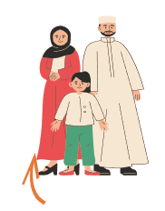 |  | 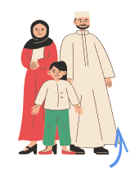
أم  mother |  | أب  father |  | أخ  brother |  | أخت  sister |  | جد  grandfather
 |  |  |  |  |  | 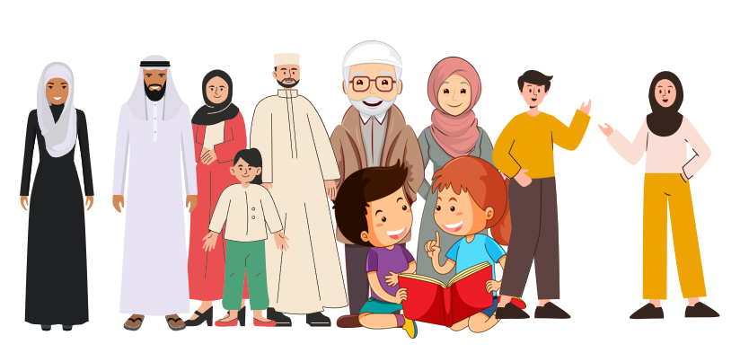
جدة  grandmother |  | عم و عمة  uncle and aunt |  | خال و خالة  uncle and aunt |  | عائلة  family

Resource 2 – labelling activity
عائلة
قم بتسمية كل صورة باستخدام الكلمة العربية الصحيحة.

جد |  | جدة |  | أب
أم |  | أخ |  | أخت

Family
Label each picture using the correct Arabic word.

grandfather |  | grandmother |  | father
mother |  | brother |  | sister

Resource 3 – ‘This is’ cards
This is  هذا |  | This is  هذه

Resource 4 – my family flashcards
أمي  my mother |  | أبي  my father |  | أخي  my brother |  | أختي  my sister
 |  | جدتي و جدي  my grandmother and grandfather |  | عائلتي  my family |  | أنا  me

Resource 5 – question cards
This resource can be used to teach multiple languages. Use the resource link to tailor it to your preferred language.
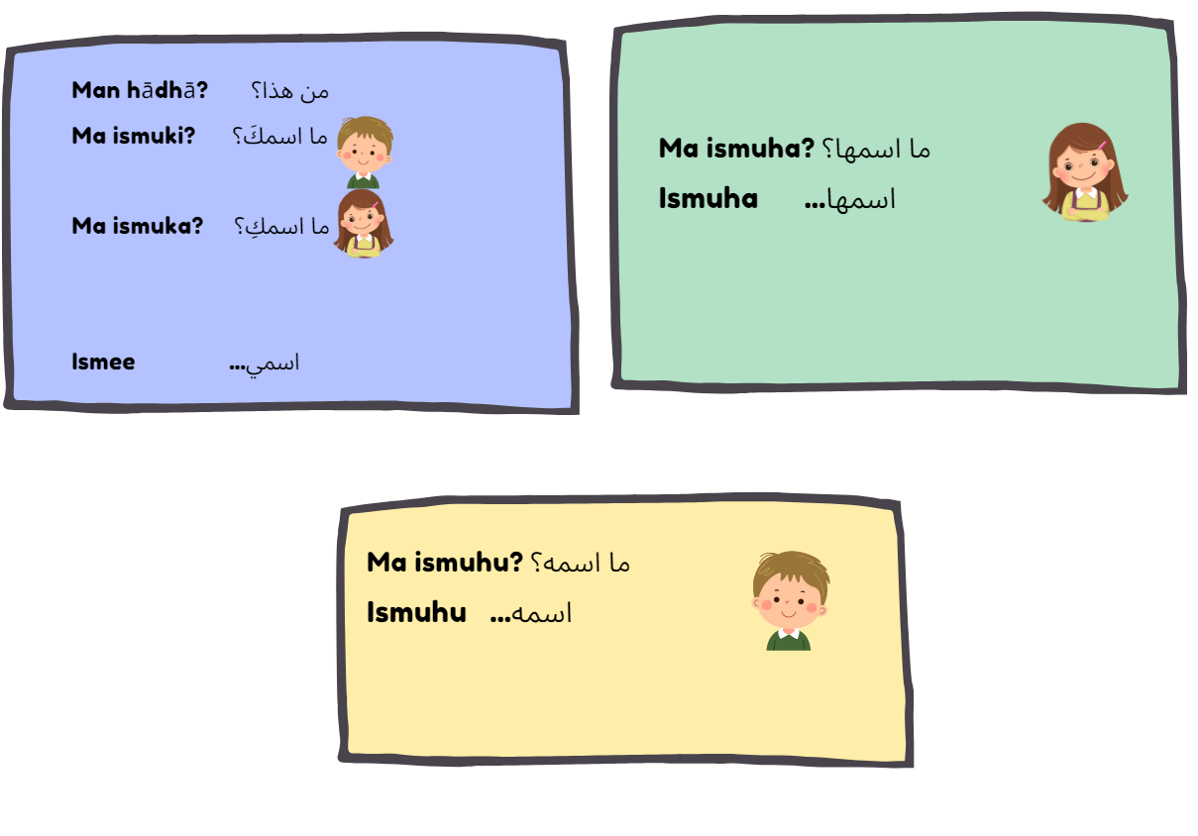
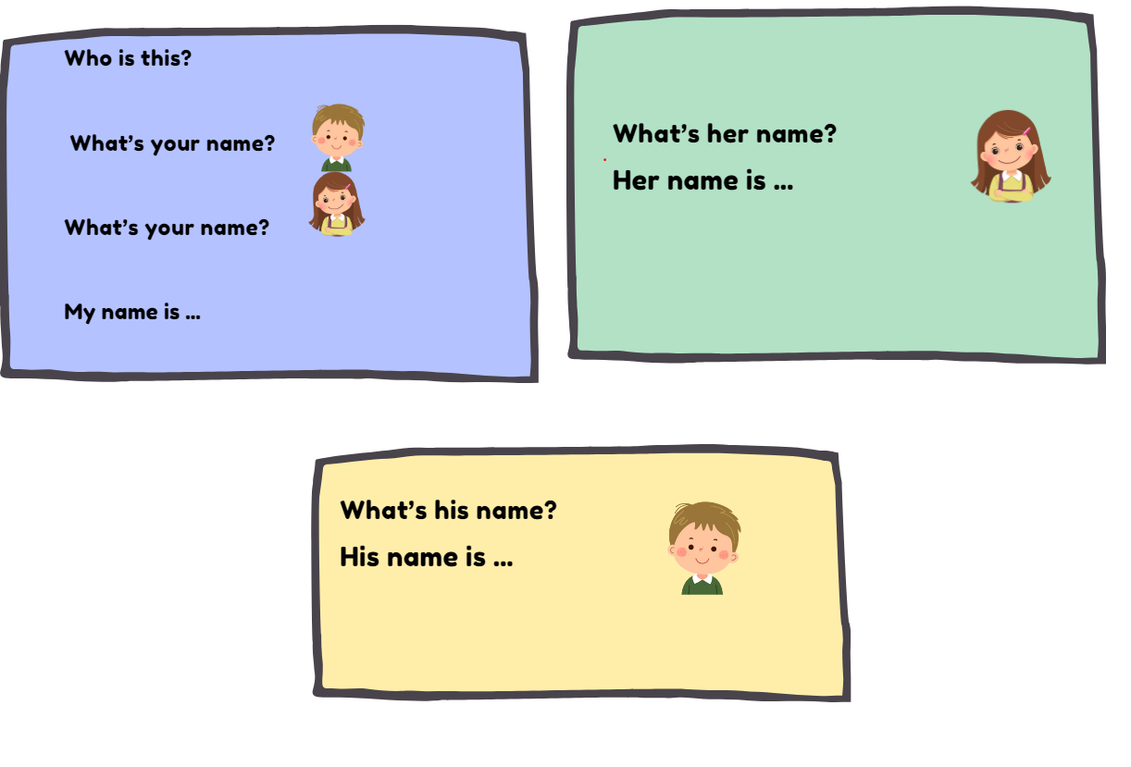

Resource 6 – sentence builder
[Name of person] | Her name is …/ His name is … | My [family member] | This is …
(Ali) علي  (Layla) ليلى | (His name is) اسمه...  (Her name is) اسمها... | (my father) أبي  (my brother) أخي  (my mother) أمي  (my sister)أختي | This is (masculine) هذا  This is (feminine) هذه

Resource 7 – bingo card

Resource 8 – student rubric – We are family
I can use appropriate greetings at the beginning and end of the conversation.
I can show my family photo and tell my friend's parents the name of each person in it and how they are related to me.
I can match the correct gendered word for 'this' with the family member I am talking about.
I can say the words in the correct order.
I can speak in a well-paced manner without long pauses.

Resource 9 – peer feedback strategy – two stars and a wish
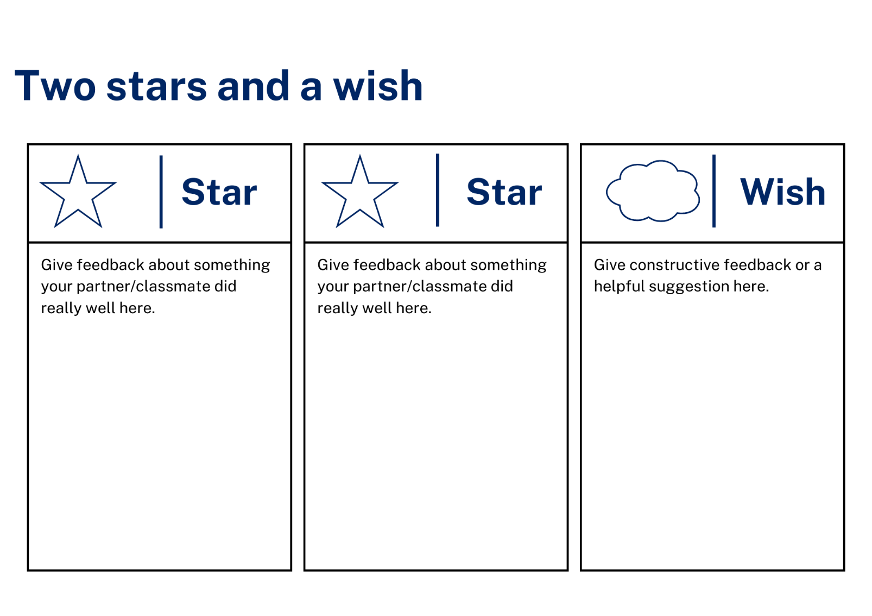

Support and alignment
Resource evaluation and support: all curriculum resources are prepared through a rigorous process. Resources are periodically reviewed as part of our ongoing evaluation plan to ensure currency, relevance, and effectiveness. For additional support or advice, contact the Primary Languages team by emailing primlang@det.nsw.edu.au.
Alignment to system priorities and/or needs: School Excellence Policy, School Success Model
Alignment to the School Excellence Framework: this resource supports the School Excellence Framework elements of curriculum (curriculum provision, teaching and learning programs) and effective classroom practice (lesson planning).
Alignment to Australian Professional Teaching Standards: this resource supports teachers to address Australian Professional Teaching Standards 2.2.2, 3.2.2.
Consulted with: Curriculum, Secondary Learners, school-based staff and NESA subject matter experts. Advice from Aboriginal Outcomes and Partnerships, EAL/D, HPGE and Inclusive Education for Modern Languages Stage 3 Italian Mangiare in Ristorante has been considered in preparing this document.
NSW syllabus: Modern Languages K–10 Syllabus
Syllabus outcomes: ML1-INT-01, ML1-UND-01, ML1-CRT-01
Author: Primary Curriculum
Publisher: State of NSW, Department of Education
Resource: unit
Related resources: further resources to support Stage 1 Modern Languages can be found on the Languages K-6 curriculum page.
Professional learning: relevant professional learning is available through Primary Languages Networks on Teams (staff only).
Universal Design for Learning: support the diverse learning needs of students using inclusive teaching and learning strategies. Some students may require more specific adjustments to allow them to participate on the same basis as their peers. For further advice see Inclusive practice resources for primary school.
Differentiation: when using these resources in the classroom, it is important for teachers to consider the needs of all students in their class, including:
- Aboriginal and Torres Strait Islander students. Targeted strategies can be used to achieve outcomes for Aboriginal students in K-12 and increase knowledge and understanding of Aboriginal histories and cultures. Teachers should use students’ Personalised Learning Pathways to support individual student needs and goals.
- EAL/D learners. EAL/D learners may require scaffolding to support them to gain content knowledge, while providing extra time and assistance to master the English language required to engage with texts or complete classroom tasks. View some samples of differentiating through scaffolding.
- Students with additional learning needs. Learning adjustments enable students with disability and additional learning and support needs to access syllabus outcomes and content on the same basis as their peers. Teachers can use a range of adjustments to ensure a personalised approach to student learning.
- High potential and gifted learners. Assessing and identifying high potential and gifted learners will help teachers decide which students may benefit from extension and additional challenge. In addition, the Differentiation Adjustment Tool can be used to support the specific learning needs of high potential and gifted students.
Creation date: 9 October 2023
Rights: © State of New South Wales, Department of Education

References
This resource contains NSW Curriculum and syllabus content. The NSW Curriculum is developed by the NSW Education Standards Authority. This content is prepared by NESA for and on behalf of the Crown in right of the State of New South Wales. The material is protected by Crown copyright.
Please refer to the NESA Copyright Disclaimer for more information https://educationstandards.nsw.edu.au/wps/portal/nesa/mini-footer/copyright.
NESA holds the only official and up-to-date versions of the NSW Curriculum and syllabus documents. Please visit the NSW Education Standards Authority (NESA) website https://educationstandards.nsw.edu.au/wps/portal/nesa/home and the NSW Curriculum website https://curriculum.nsw.edu.au/.
Modern Languages K–10 Syllabus © NSW Education Standards Authority (NESA) for and on behalf of the Crown in right of the State of New South Wales, 2022.
8 Ways (n.d.) 8 Aboriginal Ways of Learning [website], accessed 9 October 2023.
AITSL (Australian Institute for Teaching and School Leadership) (2017) ‘Feedback Factsheet’, AITSL, accessed 9 October 2023.
Brookhart SM (2011) How to Assess Higher-Order Thinking Skills in Your Classroom, Hawker Brownlow Education, Victoria.
CESE (Centre for Education Statistics and Evaluation) (2020a) What works best: 2020 update, NSW Department of Education, accessed 9 October 2023.
CESE (Centre for Education Statistics and Evaluation) (2020b) What works best in practice, NSW Department of Education, accessed 9 October 2023.
Conti G (28 September 2015) ‘16 tips for effective grammar teaching in the foreign language classroom’, The Language Gym, accessed 9 October 2023.
Conti G (28 May 2017) ‘From Target Language to Model Language – the mind shift that has transformed my teaching’, The Language Gym, accessed 9 October 2023.
Henshaw FG and Hawkins MD (2022) Common Ground: Second Language Acquisition Theory Goes to the Classroom, Focus, Indianapolis.
Jones J and Wiliam D (2014) Modern Foreign Languages Inside the Black Box: Assessment for Learning in the Modern Foreign Languages Classroom (Black P, Harrison C, Marshall B and Wiliam D eds), Learning Sciences International, United States.
NESA (NSW Education Standards Authority) (2020) NSW Curriculum Review – final report, NESA, NSW Government, accessed 9 October 2023.
Rosenshine B (2012) ‘Principles of Instruction: Research-Based Strategies That All Teachers Should Know’, American Educator, 36(1):12–19, 39, accessed 9 October 2023.
Smith S (2022) Becoming an Outstanding Languages Teacher, 2nd edn, Routledge, United Kingdom.
Wisniewski B, Zierer K and Hattie J (2020) ‘The Power of Feedback Revisited: A Meta-Analysis of Educational Feedback Research’, Frontiers In Psychology, 10(3087), doi:10.3389/fpsyg.2019.03087, accessed 9 October 2023.
Wiliam D (2013) ‘Assessment: The Bridge between Teaching and Learning’, Voices from the Middle, 21(2):15–20, accessed 9 October 2023.
Wiliam D and Leahy S (2015) Embedding Formative Assessment: Practical Techniques for K–12 Classrooms, Learning Sciences International, United States.

© State of New South Wales (Department of Education), 2023
The copyright material published in this resource is subject to the Copyright Act 1968 (Cth) and is owned by the NSW Department of Education or, where indicated, by a party other than the NSW Department of Education (third-party material).
Copyright material available in this resource and owned by the NSW Department of Education is licensed under a Creative Commons Attribution 4.0 International (CC BY 4.0) license.
This license allows you to share and adapt the material for any purpose, even commercially.
Attribution should be given to © State of New South Wales (Department of Education), 2023.
Material in this resource not available under a Creative Commons license:
- the NSW Department of Education logo, other logos and trademark-protected material
- material owned by a third party that has been reproduced with permission. You will need to obtain permission from the third party to reuse its material.
Links to third-party material and websites
Please note that the provided (reading/viewing material/list/links/texts) are a suggestion only and implies no endorsement, by the New South Wales Department of Education, of any author, publisher, or book title. School principals and teachers are best placed to assess the suitability of resources that would complement the curriculum and reflect the needs and interests of their students.
If you use the links provided in this document to access a third-party's website, you acknowledge that the terms of use, including licence terms set out on the third-party's website apply to the use which may be made of the materials on that third-party website or where permitted by the Copyright Act 1968 (Cth). The department accepts no responsibility for content on third-party websites.

