# Modern Languages 7–10

Participant workbook

Contents

About this workbook 2

Presentation overview 3

Learning intentions and success criteria 3

Alignment to the Australian Professional Standards for Teachers 4

Part 1 – Introduction 5

Part 1 activity – self-reflection 6

Part 2 – ‘Interacting’ in action 9

Interacting 10

Part 2 activity – interacting in your classroom 10

Part 3 – Q&A 12

Ongoing actions 13

Transforming classrooms through the Modern Languages K–10 Syllabus 13

Pulse check 14

Growth – making a concrete plan 23

Quick links 26

Where to next? 27

Website 27

Statewide staffroom 28

Evaluation 29

References 30

## About this workbook

This workbook is designed to guide your thinking, reflections and plans for future action. In the workbook, you will find **note-taking** **pages** that complement the presentations and **activities** to help you engage with the content.

The note-taking pages feature focus questions specific to the content of the presentation. They also provide you with the opportunity to record your key take-aways and ideas.

The activity pages support you to work individually or collaborate with colleagues to consider how you can apply the content in your school context.

This workbook can be printed double-sided or used digitally. If you have questions about the presentation, please connect with the Languages and Culture team via the [Languages statewide staffroom](https://forms.office.com/Pages/ResponsePage.aspx?id=muagBYpBwUecJZOHJhv5kSNaKRC4ClVDiPgZI5jjt3lUQ1pMWVRSU0kzWExaMEIyVFg5VlJPVkRVRyQlQCN0PWcu) or via email at [languagesnsw@det.nsw.edu.au](mailto:languagesnsw@det.nsw.edu.au).

## Presentation overview

This presentation will provide purposeful and guided planning and reflection for the Modern Languages K–10 Syllabus, and will focus on **engaging students through reinvigorated pedagogy and meaningful content**.

The presentation consists of a video and this workbook. Included in the video are 3 main sections:

1. **Introduction**

This animation provides background information about curriculum reform and why change is important.

1. **‘Interacting’ in action**

This recording unpacks interacting in the context of the syllabus and provides sample activities.

1. **Q&A**

This question-and-answer session, with members of the Languages and Culture team, addresses questions submitted by language teachers from a range of contexts in NSW public schools.

The presentation also includes opportunities for you to reflect and plan.

### Learning intentions and success criteria

By the end of the presentation, participants will:

* enhance their understanding of the Modern Languages K–10 Syllabus
* explore various ways that interacting can be embedded in the classroom
* reflect on their teaching practices.

To demonstrate learning, participants will:

* strengthen their teaching practices to align with the aim of the syllabus
* identify one interacting activity from the presentation that they would like to adapt to their context and try in Term 2
* set achievable goals for Term 2.

### Alignment to the Australian Professional Standards for Teachers

This presentation aligns with the following standards:

* 2.1 Content and teaching strategies of the teaching area
* 3.2 Plan, structure and sequence learning programs
* 3.6 Evaluate and improve teaching programs
* 6.2 Engage in professional learning and improve practice

## Part 1 – Introduction

**Focus questions**

* What is the aim of curriculum reform and how is it embedded in the Modern Languages K–10 Syllabus?
* How can shifts in pedagogy make meaningful changes to teaching and learning?
* What impact do you want the syllabus to have on the students in your classroom?

| **Key points** | **Notes** |
| --- | --- |

### Part 1 activity – self-reflection

Now that you have watched the animation for Part 1, complete the self-reflection below. You can complete this at any time.

|  |  |
| --- | --- |
| Self-reflection | Check |
| Did you teach to the new [Modern Languages K–10 Syllabus](https://curriculum.nsw.edu.au/learning-areas/languages/modern-languages-k-10-2022/overview) in Term 1? | Yes  No |
| Did you include formative assessment opportunities? | Yes  No |
| Did you include summative (for example, end-of-term) assessment? | Yes  No |
| On reflection, were your students more engaged in Term 1 than previously? | Yes  No |
| What was the biggest impact on student engagement, that you were able to influence? |  |
| How did you change your pedagogy to align with the new syllabus? |  |
| Did you reduce content compared to previous years? | Yes  No |
| Did you apply explicit teaching? | Yes  No |
| Did you use learning intentions and success criteria? | Yes  No |
| Did you backward map from the summative assessment task? | Yes  No |
| Did you get students to use the target language more in the classroom, for example, to initiate conversation or converse with peers? | Yes  No |
| If yes, add details of techniques you used to get students to use the target language more in the classroom. | |
| The central goal of the syllabus is communication. Did you see an increase in communication in your classes in Term 1? | Yes  No |

**Considering your preparation to implement the syllabus in Term 1, what support did you access in 2023?**

|  |  |
| --- | --- |
| Resource | Check |
| Term 1 statewide staff meeting – [*Interacting in the Modern Languages K–12 Syllabus*](https://www.youtube.com/watch?v=Yu-Ye4rXjwY&t=2138s&pp=ygUMbGFuZ3VhZ2VzbnN3)(1:08:24) | Yes  No |
| Term 2 statewide staff meeting – [*An introduction to the syllabus and our support*](https://www.youtube.com/watch?v=-TfYw_r9l94&pp=ygUMbGFuZ3VhZ2VzbnN3) (40:07) | Yes  No |
| Term 3 statewide staff meeting – [*Assessment and the Modern Languages K–10 Syllabus*](https://www.youtube.com/watch?v=UFUhmNQk31I&pp=ygUMbGFuZ3VhZ2VzbnN3) (44:15) | Yes  No |
| Term 4 statewide staff meeting – [*Deep dive into a learning sequence from a unit of work for the new Modern Languages K–10 Syllabus*](https://www.youtube.com/watch?v=Dsr07iGdkC0&pp=ygUMbGFuZ3VhZ2VzbnN3)(40:49) | Yes  No |
| Language-specific resource launches | Yes  No |
| Microlearning – [*Modern Languages K–10 Syllabus – from planning to practice in Years 7–10*](https://myplsso.education.nsw.gov.au/mylearning/catalogue/details/1def470e-42f5-ed11-ba76-0003ffd06f24) (3 modules) | Yes  No |
| Network meetings – how many did you attend? (0–4) | 0 1 2 3 4  (circle the number of meetings you attended) |
| Engaging with the new resources and/or support documents |  |

**Summary**

The 3 key ideas that I would like to apply to my practice:

1.

2.

3.

## Part 2 – ‘Interacting’ in action

**Focus questions**

* What is ‘Interacting’?
* How is ‘Interacting’ different in the Modern Languages K–10 Syllabus?
* What is ‘negotiating meaning’?

| **Key points** | **Notes** |
| --- | --- |

### Interacting

The central goal of the Modern Languages Syllabus K–10 (2022) is communicating in the target language. There are 3 focus areas – **Interacting**, Understanding texts and Creating texts.

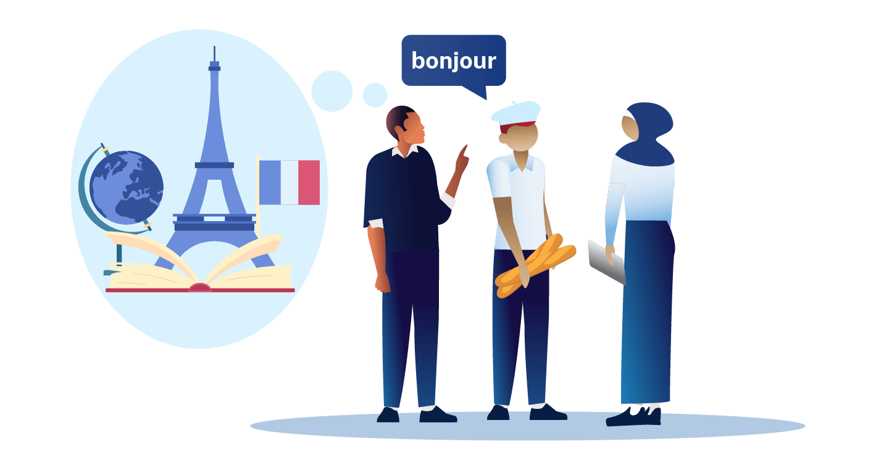

**Interacting**

* Requires students to communicate with each other
* Is primarily done through oral language
* Must be reciprocal
* Includes a degree of 'unknown' to support spontaneity
* Includes socialising with peers

### Part 2 activity – ‘Interacting’ in your classroom

What was your favourite ‘Interacting’ activity you did with students in Term 1?

|  |
| --- |
|  |

Identify one ‘Interacting’ activity from the presentation that you like the most and explain why.

|  |
| --- |
|  |

Identify one ‘Interacting’ activity from the presentation that you would like to adapt to your context and try in Term 2.

|  |
| --- |
|  |

Check out our [statewide staffroom post](https://teams.microsoft.com/l/message/19:02ee3e41ec164d27b513da7c46d169d7@thread.tacv2/1707864625865?tenantId=05a0e69a-418a-47c1-9c25-9387261bf991&groupId=10295a23-0ab8-4355-88f8-192398e3b779&parentMessageId=1707864625865&teamName=Languages%20statewide%20staffroom&channelName=Community%20noticeboard&createdTime=1707864625865&allowXTenantAccess=false) for more ‘Interacting’ ideas. Feel free to share an idea as well. We welcome ideas from all teachers across the state.

**Summary**

The 3 key ideas that I would like to apply to my practice:

1.

2.

3.

## Part 3 – Q&A

**Focus questions**

* What new information did you learn from listening to the Q&A session that can assist you with teaching languages?
* Is there anything you’d like to find out more about?
* Is there something you would like to ask the Languages and Culture team, not covered in the session?

| **Key points** | **Notes** |
| --- | --- |

**Summary**

The 3 key ideas that I would like to apply to my practice:

1.

2.

3.

## Ongoing actions

Learning to use a new syllabus is a different journey for every language teacher in NSW. What’s important is that we all get to the same destination – **engaging students in language learning and empowering them to communicate in the target language**.

### Transforming classrooms through the Modern Languages K–10 Syllabus

We have created [2 downloadable posters](https://education.nsw.gov.au/teaching-and-learning/curriculum/languages/planning-programming-and-assessing-languages-7-10#posters), for display in your staffroom or to include in your planning documents, which summarise what is happening in classrooms when the intentions of curriculum reform and the new syllabus are being met.

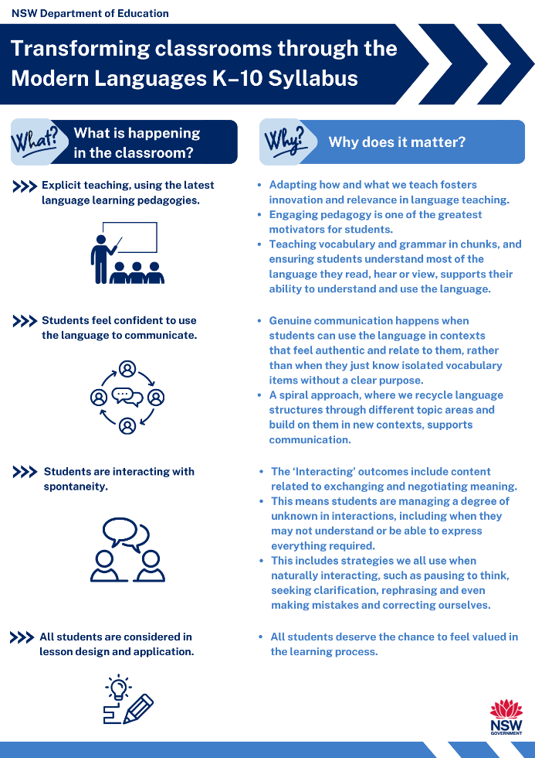 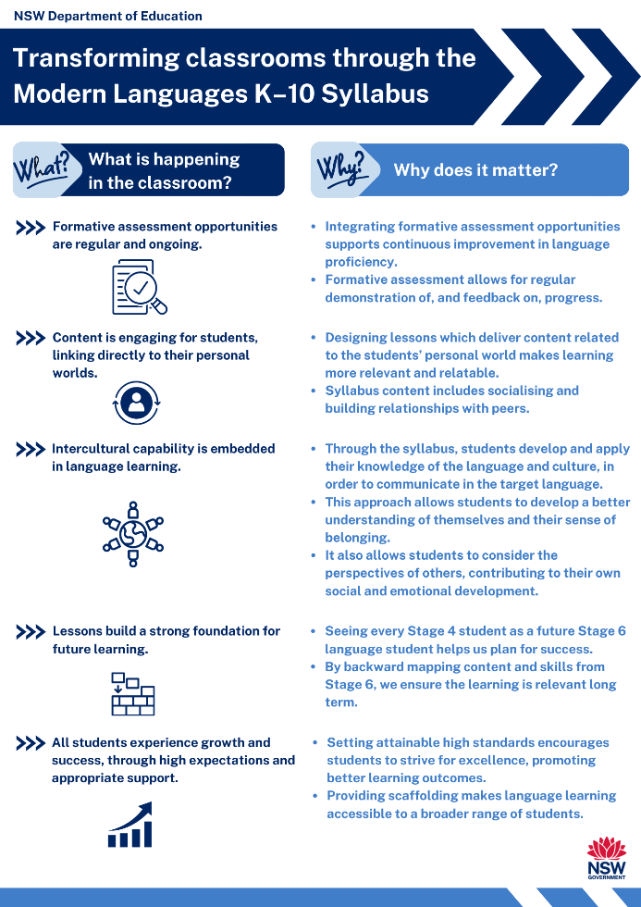

### Pulse check

If you feel you need some more time and/or support to fully engage with the syllabus and understand its intentions, we have also created a **pulse check –** **where am I now and where do I want to go?**

Expanding on the information in the posters, we have included an easy ‘first step’ for you to deepen your understanding.

Table 1 – Transforming classrooms through the Modern Languages K–10 Syllabus

|  |  |  |  |
| --- | --- | --- | --- |
| **What is happening in the classroom?**  **Checkmark with solid fill** | **Why does it matter?**  **Comment Important with solid fill** | **Am I new to this? Is there room to grow?** | **What can I do to learn more?**  **Remote learning language with solid fill** |
| Explicit teaching, using the latest language learning pedagogies. | * Adapting how and what we teach fosters innovation and relevance in language teaching. * Engaging pedagogy is one of the greatest motivators for students. * Teaching vocabulary and grammar in chunks, and ensuring students understand most of the language they read, hear or view, supports their ability to understand and use the language. | Arrow: Slight curve with solid fill | Explore our sample units to see the latest pedagogies in action. Then identify one activity you’ve never used before and try with students in the next week. Don’t forget to ask for their feedback! |
| Students feel confident to use the language to communicate. | * Genuine communication happens when students can **use** the language in contexts that feel authentic and relate to them, rather than when they just know isolated vocabulary items without a clear purpose. * A spiral approach, where we recycle language structures through different topic areas and build on them in new contexts, supports communication. | Arrow: Slight curve with solid fill | View our sample scope and sequence documents to see the spiral approach in action. Consider whether your approach supports students to build their language skills within and across topics. Highlight a structure from your current unit of work and consider how you will revisit the structure in a new context next term. |
| Students are interacting with spontaneity. | * The ‘Interacting’ outcomes include content related to exchanging and **negotiating** meaning. * This means students are managing a degree of unknown in interactions, including when they may not understand or be able to express everything required. * This includes strategies we all use when naturally interacting, such as pausing to think, seeking clarification, rephrasing and even making mistakes and correcting ourselves. | Arrow: Slight curve with solid fill | Look at the ‘Interacting’ activities and tasks in our sample units to find ideas for how to support students to move from rehearsed to scaffolded to spontaneous interactions. These will guide you in embedding a degree of unknown. And remember, it is still okay for students to create and then rote learn or read aloud role-plays, but this would meet the ‘Creating texts’ outcomes (not ‘Interacting’ outcomes). |
| All students are considered in lesson design and application. | * All students deserve the chance to feel valued in the learning process. | Arrow: Slight curve with solid fill | Review the grey ‘Differentiation’ boxes in our sample units of work – they show low and zero preparation examples of supporting all students. Then choose one of your planned teaching and learning activities and design adjustments to support the range of students in your class. Keep it simple. If you have to create a whole new activity, it won’t be sustainable. Design for inclusivity from the outset, tweaking where necessary. |
| Formative assessment opportunities are regular and ongoing. | * Integrating formative assessment opportunities supports continuous improvement in language proficiency. * Formative assessment allows for regular demonstration of, and feedback on, progress. | Arrow: Slight curve with solid fill | The exit tickets and mini tasks in our sample units showcase formative assessment and feedback opportunities. Try an exit ticket next week, and see if your students are doing as well as, or better than, you thought. |
| Content is engaging for students, linking directly to their personal worlds. | * Designing lessons which deliver content related to the students’ personal world makes learning more relevant and relatable. * Syllabus content includes socialising and building relationships with peers. | Arrow: Slight curve with solid fill | Choose 2 of our sample units and search for ‘personal world’ and/or ‘socialise’ and explore the activities aligned with this content. Run a scan of your upcoming unit, and identify how your units are meeting this content or how you may need to modify them. |
| Intercultural capability is embedded in language learning. | * Through the syllabus, students develop and apply their knowledge of the language and culture, in order to communicate in the target language. * This approach allows students to develop a better understanding of themselves and their sense of belonging. * It also allows students to consider the perspectives of others, contributing to their own social and emotional development. | Arrow: Slight curve with solid fill | Our sample units provide ideas for embedding culture authentically, in place of teaching culture as a standalone entity. For example, students don’t just learn about festivals, they invite a friend to attend one. Review one of your current units and identify any standalone culture content. Determine how you will link it to language learning. |
| Lessons build a strong foundation for future learning. | * Seeing every Stage 4 student as a future Stage 6 language student helps us plan for success. * By backward mapping content and skills from Stage 6, we ensure the learning is relevant long term. | Arrow: Slight curve with solid fill | Review an assessment task from one of our Stage 4 units, and one from Stage 5. Identify what skills and structures students could use in Stage 6. Identify similar skills and structures in your own units. |
| All students experience growth and success, through high expectations and appropriate support. | * Setting attainable high standards encourages students to strive for excellence, promoting better learning outcomes. * Providing scaffolding makes language learning accessible to a broader range of students. | Arrow: Slight curve with solid fill | Look at the activities in our units of work and see how we have scaffolded activities to set high expectations and provide support for students. Then, choose an activity you use often and design a more scaffolded approach. |

## Growth – making a concrete plan

After participating in this professional learning package for Modern Languages 7–10, it’s now time to make a concrete plan for action.

The aim of the Modern Languages K–10 Syllabus is to enable students to become **effective communicators in the target language**, to **develop intercultural capability** and to **develop enjoyment and interest in language learning**. Teachers have the greatest impact on how well the Modern Languages K–10 Syllabus achieves those goals. While change can be confronting and challenging, the concept of lifelong learning remains a cornerstone of our work.

*‘If we’re growing, we’re always going to be out of our comfort zone.’ John Maxwell*

Having reflected on where you are now in relation to understanding and using the syllabus to engage your students in language learning, it is time to evaluate and consider how you and your students will continue to grow and learn.

**Based on your self-reflection:**

* How can you bring the intentions of curriculum reform to life?
* What will it look like in your classroom?
* What is the first thing you need to do this week?
* What is your goal for the end of the term?

Use the guiding questions in the table below to establish a solid foundation for your plan for Term 2.

**The plan does not have to be big; growth is growth.**

|  |  |  |
| --- | --- | --- |
| Questions | Consider | Notes |
| Goal  What do you want to achieve in terms of enabling effective communication and developing enjoyment and interest in language learning for your students? | * What would you like to have happen that is not happening now? * Is your goal realistic? If not, revise it. * What will be the benefits of achieving this goal? * What will be the cost of not achieving this goal? |  |
| Reality  Is the focus of your teaching program effective communication?  Are your students engaged and enjoying language learning in the classroom? | * On a scale of 1–10, where 10 is the ideal outcome and 1 is the worst outcome, where are you now? * How do you know this is accurate? * What are you already doing that will help you to achieve your goal? * What is not working, that is within your area of control? |  |
| Options  What could you do to further enhance communication and interest in learning in your classroom? | * What are new options for achieving this goal? * What are the benefits and pitfalls of these options? * What approaches have you used yourself, or seen others use, in similar circumstances? * What advice would you give someone else who was in a similar position to you? * Who can you ask? |  |
| Will  What will you do next? | * Which option(s) do you like the most for action during the coming week? * What will you do specifically? |  |
| Tactics  How and when will you do it? | * What is the next small step to progress this option? * Precisely when will you take the next step? * Do you need to log the step in your diary or on a notepad? |  |
| Habits  How will you sustain your success? | * What needs to be different about your thoughts, feelings, behaviours or environment to ensure you carry out these actions? * What might get in the way and how can you address that? * What support or structures are needed to maintain this? * What sort of person do you need to be to achieve the results you desire? |  |

The questions have been adapted from [Growth Coaching International’s principles](https://www.growthcoaching.com.au/).

## Quick links

Not a member of the Languages Statewide staffroom? Scan the QR code or select this [link](https://forms.office.com/Pages/ResponsePage.aspx?id=muagBYpBwUecJZOHJhv5kSNaKRC4ClVDiPgZI5jjt3lUQ1pMWVRSU0kzWExaMEIyVFg5VlJPVkRVRyQlQCN0PWcu) to join.



Looking for the Modern Languages K–10 Syllabus? Scan the QR code or select this [link](https://curriculum.nsw.edu.au/learning-areas/languages/modern-languages-k-10-2022/overview) to take you there.



Want to take a deeper look at the new resources available on our website? Scan the QR code or select this [link](https://education.nsw.gov.au/teaching-and-learning/curriculum/languages/planning-programming-and-assessing-languages-7-10) to see programming resources, generic resources and languages specific resources.



Join your local network, for opportunities to share ideas and grow your knowledge in a small, collegial group. Scan the QR code or select this [link](https://education.nsw.gov.au/teaching-and-learning/curriculum/languages/language-teacher-network#Language1) to find out which network is best for you and the network leader’s details.



## Where to next?

If you have not already engaged with our resources or professional learning, please consider the following options.

### Website

Have a look at our units of work. All units of work can be adapted to your own classroom context and are fully resourced. You can find these on our website – [Chinese](https://education.nsw.gov.au/teaching-and-learning/curriculum/languages/planning-programming-and-assessing-languages-7-10/chinese), [French](https://education.nsw.gov.au/teaching-and-learning/curriculum/languages/planning-programming-and-assessing-languages-7-10/french), [German](https://education.nsw.gov.au/teaching-and-learning/curriculum/languages/planning-programming-and-assessing-languages-7-10/german), [Italian](https://education.nsw.gov.au/teaching-and-learning/curriculum/languages/planning-programming-and-assessing-languages-7-10/italian), [Japanese](https://education.nsw.gov.au/teaching-and-learning/curriculum/languages/planning-programming-and-assessing-languages-7-10/japanese) and [Spanish](https://education.nsw.gov.au/teaching-and-learning/curriculum/languages/planning-programming-and-assessing-languages-7-10/spanish).

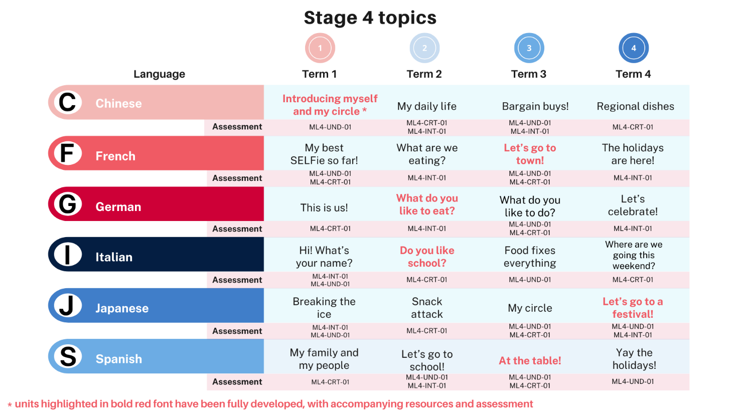

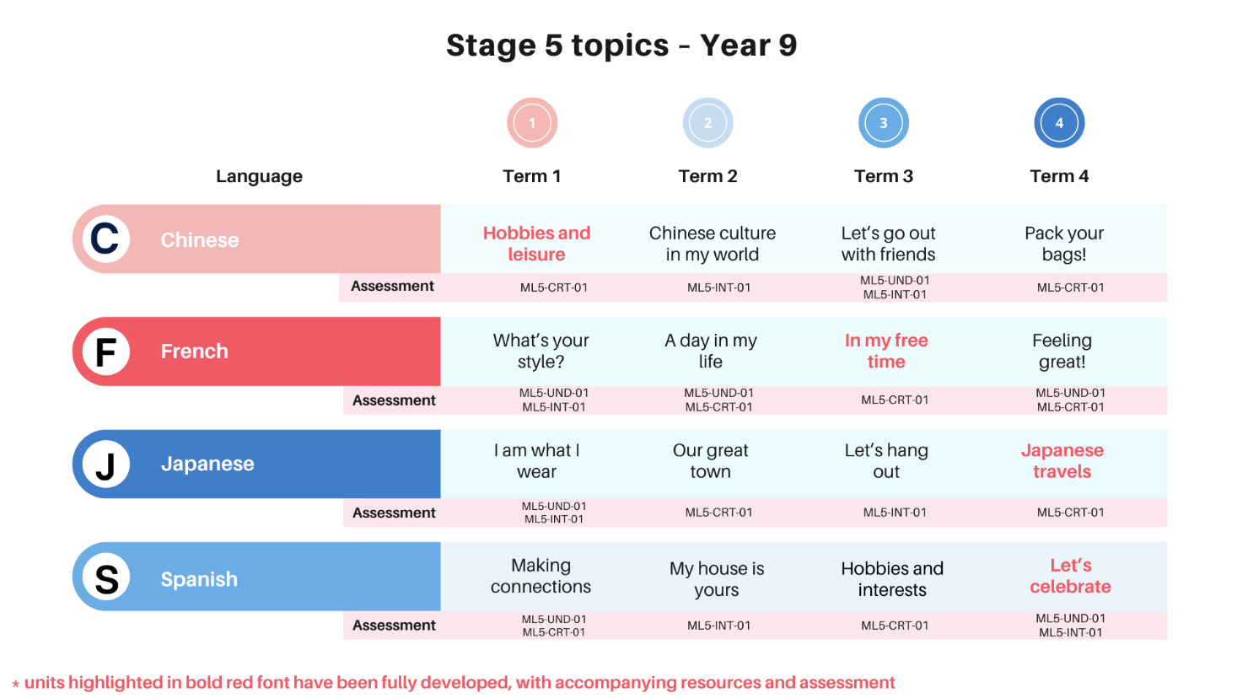

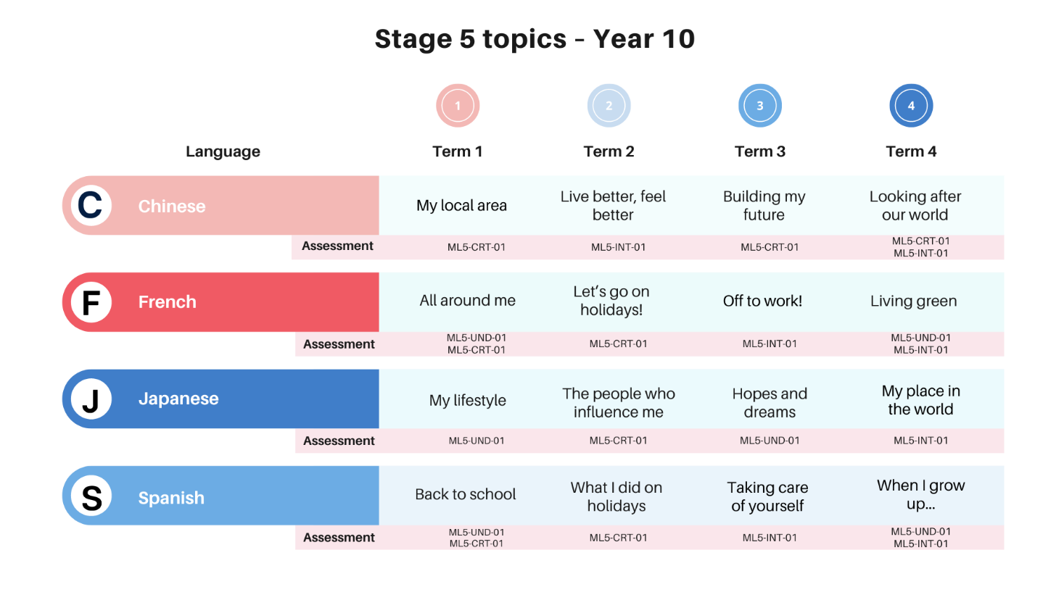

### Statewide staffroom

During Term 1, the Languages and Culture team posted regularly with ideas for Term 1 content for the Stage 4 mandatory 100 hours, aligned with our generic scope and sequence. Click on the links below to see some of these posts in Teams.

* [Link to post 1](https://teams.microsoft.com/l/message/19:16c99fb692554d9c94cd5617adb6d376@thread.tacv2/1706572160332?tenantId=05a0e69a-418a-47c1-9c25-9387261bf991&groupId=10295a23-0ab8-4355-88f8-192398e3b779&parentMessageId=1706572160332&teamName=Languages%20statewide%20staffroom&channelName=General&createdTime=1706572160332&allowXTenantAccess=false)
* [Link to post 2](https://teams.microsoft.com/l/message/19:16c99fb692554d9c94cd5617adb6d376@thread.tacv2/1707682813736?tenantId=05a0e69a-418a-47c1-9c25-9387261bf991&groupId=10295a23-0ab8-4355-88f8-192398e3b779&parentMessageId=1707682813736&teamName=Languages%20statewide%20staffroom&channelName=General&createdTime=1707682813736&allowXTenantAccess=false)

## Evaluation

We value your feedback. Please complete the [Modern Languages 7–10 evaluation](https://forms.office.com/pages/responsepage.aspx?id=muagBYpBwUecJZOHJhv5kQ9AEtJqKbhAgD099fZ5L3pURVdQOE42TVNGRExXQkZLSUs5S1EwRkRUWiQlQCN0PWcu) to help us provide further support.



## References

This resource contains NSW Curriculum and syllabus content. The NSW Curriculum is developed by the NSW Education Standards Authority. This content is prepared by NESA for and on behalf of the Crown in right of the State of New South Wales. The material is protected by Crown copyright.

Please refer to the NESA Copyright Disclaimer for more information <https://educationstandards.nsw.edu.au/wps/portal/nesa/mini-footer/copyright>.

NESA holds the only official and up-to-date versions of the NSW Curriculum and syllabus documents. Please visit the NSW Education Standards Authority (NESA) website <https://educationstandards.nsw.edu.au/> and the NSW Curriculum website [https://curriculum.nsw.edu.au](https://curriculum.nsw.edu.au/).

[Modern Languages K–10 Syllabus](https://curriculum.nsw.edu.au/learning-areas/languages/modern-languages-k-10-2022/overview) © NSW Education Standards Authority (NESA) for and on behalf of the Crown in right of the State of New South Wales, 2022.

Growth Coaching International (n.d.) [*Improving how we communicate & relate to one another*](https://www.growthcoaching.com.au/about/), Growth Coaching International website, accessed 20 November 2023.

**© State of New South Wales (Department of Education), 2023**

The copyright material published in this resource is subject to the *Copyright Act 1968* (Cth) and is owned by the NSW Department of Education or, where indicated, by a party other than the NSW Department of Education (third-party material).

Copyright material available in this resource and owned by the NSW Department of Education is licensed under a [Creative Commons Attribution 4.0 International (CC BY 4.0) license](https://creativecommons.org/licenses/by/4.0/).

[](https://creativecommons.org/licenses/by/4.0/)

This license allows you to share and adapt the material for any purpose, even commercially.

Attribution should be given to © State of New South Wales (Department of Education), 2023.

Material in this resource not available under a Creative Commons license:

* the NSW Department of Education logo, other logos and trademark-protected material
* material owned by a third party that has been reproduced with permission. You will need to obtain permission from the third party to reuse its material.

**Links to third-party material and websites**

Please note that the provided (reading/viewing material/list/links/texts) are a suggestion only and implies no endorsement, by the New South Wales Department of Education, of any author, publisher, or book title. School principals and teachers are best placed to assess the suitability of resources that would complement the curriculum and reflect the needs and interests of their students.

If you use the links provided in this document to access a third-party's website, you acknowledge that the terms of use, including licence terms set out on the third-party's website apply to the use which may be made of the materials on that third-party website or where permitted by the *Copyright Act 1968* (Cth). The department accepts no responsibility for content on third-party websites.