Exploring effective pedagogical approaches in English 3–6
Participant workbook
Contents
About this workbook 2
Presentation overview 3
Learning intentions and success criteria 3
Alignment to the Australian Professional Standards for Teachers 3
Alignment to the School Excellence Framework 4
Section 1 – reading in 3–6 – presentation notes 5
Activity 1 – pause and reflect 6
Section 2 – selecting and analysing a fluency passage – presentation notes 7
Activity 2 – selecting and analysing a fluency passage 8
Planning and programming for explicit instruction 10
Section 3 – planning and programming evidence-based strategies – presentation notes 13
Activity 3 – planning teaching and learning strategies 15
Where to next? 17
Evaluation 17
References 18

About this workbook
This workbook is designed to guide your thinking, reflections and plans for future action. In the workbook, you will find note-taking pages that complement the presentation and activity templates to help you engage with the content.
The note-taking pages feature focus questions specific to the content of the presentation. They also provide you with the opportunity to record your key take-aways and ideas.
The activity pages support you to collaborate with colleagues and consider how you can apply the content in your school context. Your facilitator will guide you through the activities.
This workbook can be printed double-sided or used digitally. If you have questions about the presentation, please connect with your Statewide staffroom or email englishk6@det.nsw.edu.au.

Presentation overview
This session will examine evidence-based approaches to the explicit teaching of reading. You will be guided through the intentional text selection process and unpack how to identify and analyse a fluency and close reading passage.
Practical advice regarding planning and programming parallel content, as part of Component A, will round out this exciting session.

Learning intentions and success criteria
Participants will:
- learn about explicit reading instruction.
To demonstrate learning, participants will:
- explore an overview of current reading research and understand how reading is positioned in the English K–10 syllabus
- examine key considerations for intentional text selection
- select and analyse a fluency and close reading passage
- identify parallel content and experiment with planning for explicit reading instruction.

Alignment to the Australian Professional Standards for Teachers
This presentation aligns with the following standards:
- 2.1.2 Apply knowledge of the content and teaching strategies of the teaching area to develop engaging teaching activities.
- 2.2.2 Organise content into coherent, well-sequenced learning and teaching programs.
- 2.3.2 Design and implement learning and teaching programs using knowledge of curriculum, assessment and reporting requirements.
- 2.5.2 Apply knowledge and understanding of effective teaching strategies to support students’ literacy and numeracy achievement.
- 3.2.2 Plan and implement well-structured learning and teaching programs or lesson sequences that engage students and promote learning.
- 3.3.2 Select and use relevant teaching strategies to develop knowledge, skills, problem solving and critical and creative thinking.
- 6.2.2 Participate in learning to update knowledge and practice, targeted to professional needs and school and/or system priorities.
- 6.3.2 Contribute to collegial discussions and apply constructive feedback from colleagues to improve professional knowledge and practice.
- 7.4.2 Participate in professional and community networks and forums to broaden knowledge and improve practice.

Alignment to the School Excellence Framework
This professional learning session aligns with the following elements of the School Excellence Framework:
- Curriculum
- Effective classroom practice
- Learning and development

Section 1 – reading in 3–6 – presentation notes
Evidence based reading instruction
- NSW English K–10 Syllabus text requirements
- An overview of reading instruction
- The components of reading
- The guided release of responsibility model for explicit reading instruction
- Intentional text selection
Key points | Notes

Activity 1 – pause and reflect
Duration: 5 minutes
- What were 3 key messages you took from this first session?
- In what ways might these messages be applied to your teaching practice?
- Consider further learning you would like to engage in to deepen your understanding of evidence-based reading approaches 3–6?

Section 2 – selecting and analysing a fluency passage – presentation notes
- Exploring explicit teaching
- Intentional selection of fluency and close reading passages
- Scenario: Selecting and analysing a close reading passage
Key points | Notes

Activity 2 – selecting and analysing a fluency passage
Materials:
- English K–10 Syllabus
- Sample unit
- Mentor and/or supporting texts
- Scope and sequence and instructional sequences
- Passage template (page 9)
Duration: 25 minutes
Instructions:
- Follow the modelled process for selecting a fluency and close reading passage for one week of a unit of work, completing steps 1, 2 and 3.
- Use the process and considerations on pages 10-12 to assist you in the process.
- You may wish to use the passage template provided below.

Passage analysis for text _______________________
Purpose:
Text structure | Excerpt from Chapter _ | Language features and author technique

Planning and programming for explicit instruction
Figure 1 – a process for planning for explicit instruction
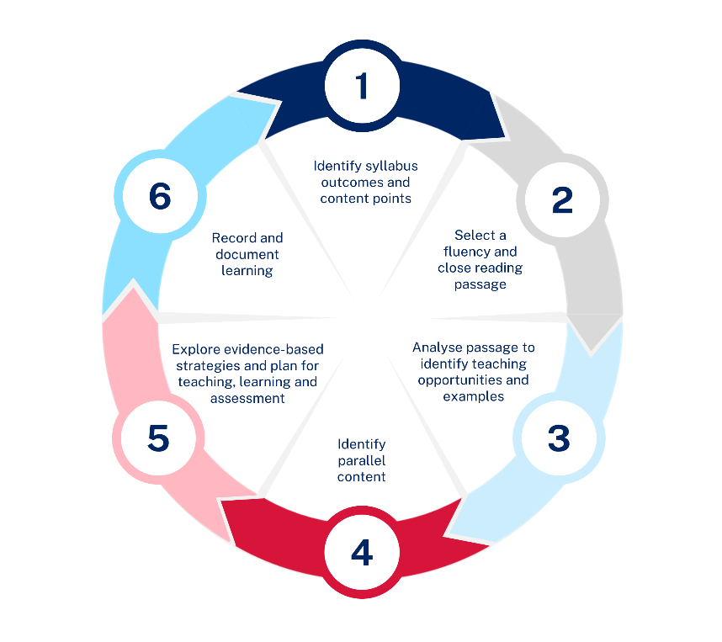
Steps | Considerations
- Identify syllabus outcomes and content points | - Identify syllabus outcomes and content points for explicit instruction.  - Distinguish between the new or repeated content using the department’s 3–6 Scope and sequence.  - Consult the necessary instructional sequences to create explicit, systematic, and cumulative learning sequences for Component A.  - Refer to the English K–10 Syllabus to identify other relevant outcomes and content points that will contribute to meeting student needs.
- Select a fluency and close reading passage | - Identify weekly reading from a sample unit (for example, Week 1 of Stage 3 Unit 11 explores Chapters 1 to 4).  - Prioritise the key factors that influence text selection including purpose, targeted outcomes and content, language features, level of challenge for students and length of the passage.  - Consider the learning that occurs in Component B to ensure that the passage is in line with the reading material for the week.  - Evaluate the context to identify which section of text best caters to students' learning needs while supporting the explicit teaching of the focus content points.
- Analyse passage to identify teaching opportunities and examples | - Identify the author’s purpose of the passage and analyse the structure of the passage.  - Identify examples of language features and author techniques using the extracted Component A content points.
- Identify parallel content | - Use the identified content points and consider opportunities to connect learning. Note: some content points have multiple elements and not all elements need to be taught in each lesson.  - Distribute learning to provide further opportunities to integrate other content points.
- Explore evidence-based strategies and plan for teaching, learning and assessment | - Use the syllabus to explore content examples and teaching advice. The glossary will also provide further clarity.  - Access additional resources such as the department’s Lesson advice guides.  - Plan the teaching strategies and learning activities that will target the identified content points.  - Consider a range of rich assessment strategies to monitor individual student progress and offer ongoing student feedback.
- Record and document learning | - Map content and align learning experiences.  - Use the department's syllabus mapping tool to track content points explicitly taught.

Section 3 – planning and programming evidence-based strategies – presentation notes
Planning and programming evidence-based strategies
- Planning and programming process
- Identifying parallel content
- Explore evidence-based strategies
- Plan for explicit teaching, learning and assessment
- Record and document learning
Key points | Notes
Summary
The 3 key ideas that I would like to apply to my practice:

Activity 3 – planning teaching and learning strategies
Use the remaining time to consider your next steps.
The information below may help you to continue the planning and programming process.
Materials:
- English K–10 Syllabus
- Fluency passage selected from Activity 2
- Sample unit that accompanies the fluency passage
- Reference guide – unpacking the English 3–6 Focus areas
Suggested next steps:
- Use the fluency passage to identify which content points from Component A could be explicitly taught in parallel during week 1.
- Select evidence-based instructional strategies that align with the identified content to distribute learning.
- You may wish to use the table template provided below.

Planning evidence-based approaches
Day 1 | Day 2 | Day 3 | Day 4
Content points | Content points | Content points | Content points
Strategies | Strategies | Strategies | Strategies

Where to next?
Would you like to learn more? The links below provide additional learning and resources:
- English K–10 Syllabus Teaching advice
- Planning, programming and assessing English K–6
- English K–6 scope and sequences
- English 3–6 microlearning modules
- Lesson advice guides
- Lead Learner suite
- Digital Learning Selector.

Evaluation
We value your feedback. Please complete the Exploring effective pedagogical approaches in English 3–6 evaluation to help us provide further support.

References
This resource contains NSW Curriculum and syllabus content. The NSW Curriculum is developed by the NSW Education Standards Authority. This content is prepared by NESA for and on behalf of the Crown in right of the State of New South Wales. The material is protected by Crown copyright.
Please refer to the NESA Copyright Disclaimer for more information https://educationstandards.nsw.edu.au/wps/portal/nesa/mini-footer/copyright.
NESA holds the only official and up-to-date versions of the NSW Curriculum and syllabus documents. Please visit the NSW Education Standards Authority (NESA) website https://educationstandards.nsw.edu.au and the NSW Curriculum website https://curriculum.nsw.edu.au.
English K–10 Syllabus © NSW Education Standards Authority (NESA) for and on behalf of the Crown in right of the State of New South Wales, 2022.
NESA (NSW Education Standards Authority) (2021) ‘Proficient Teacher: Standard descriptors’, The Standards, NESA website, accessed 09 November 2023.

© State of New South Wales (Department of Education), 2024
The copyright material published in this resource is subject to the Copyright Act 1968 (Cth) and is owned by the NSW Department of Education or, where indicated, by a party other than the NSW Department of Education (third-party material).
Copyright material available in this resource and owned by the NSW Department of Education is licensed under a Creative Commons Attribution 4.0 International (CC BY 4.0) license.
This license allows you to share and adapt the material for any purpose, even commercially.
Attribution should be given to © State of New South Wales (Department of Education), 2024.
Material in this resource not available under a Creative Commons license:
- the NSW Department of Education logo, other logos and trademark-protected material
- material owned by a third party that has been reproduced with permission. You will need to obtain permission from the third party to reuse its material.
Links to third-party material and websites
Please note that the provided (reading/viewing material/list/links/texts) are a suggestion only and implies no endorsement, by the New South Wales Department of Education, of any author, publisher, or book title. School principals and teachers are best placed to assess the suitability of resources that would complement the curriculum and reflect the needs and interests of their students.
If you use the links provided in this document to access a third-party's website, you acknowledge that the terms of use, including licence terms set out on the third-party's website apply to the use which may be made of the materials on that third-party website or where permitted by the Copyright Act 1968 (Cth). The department accepts no responsibility for content on third-party websites.

