English Stage 3 – Second year – Unit 12
Imagery, symbol and connotation – Rabbit, Soldier, Angel, Thief
Contents
Unit overview and instructions for use 6
Teacher notes 8
Outcomes and content 10
Resources 18
Week 1 20
Component A teaching and learning 20
Planning framework 20
Component B teaching and learning 20
Learning intentions and success criteria 20
Learning intention 21
Success criteria 21
Lesson 1 – symbols in text 21
Lesson 2 – genre 23
Lesson 3 – cohesive devices in texts 25
Lesson 4 – imagery in texts 28
Week 2 31
Component A teaching and learning 31
Planning framework 31
Component B teaching and learning 31
Learning intentions and success criteria 31
Learning intention 32
Success criteria 32
Lesson 5 – extended metaphor 32
Lesson 6 – analysing a picture book 36
Lesson 7 – achieving precision through verb choices 38
Lesson 8 – subjective and objective language 41
Week 3 45
Component A teaching and learning 45
Planning framework 45
Component B teaching and learning 45
Learning intentions and success criteria 45
Learning intention 46
Success criteria 46
Lesson 9 – creating and presenting a descriptive text 46
Lesson 10 – free verse poetry 49
Lesson 11 – non-finite verbs in adverbial clauses 53
Lesson 12 – developing a character 56
Week 4 60
Component A teaching and learning 60
Planning framework 60
Component B teaching and learning 60
Learning intentions and success criteria 60
Learning intention 61
Success criteria 61
Lesson 13 – using visual techniques 61
Lesson 14 – exploring symbolism 63
Lesson 15 – reflecting on Rabbit, Soldier, Angel, Thief 66
Lesson 16 – planning a picture book 68
Week 5 70
Component A teaching and learning 70
Planning framework 70
Component B teaching and learning 70
Learning intentions and success criteria 70
Learning intention 71
Success criteria 71
Lesson 17 – drafting a picture book 71
Lesson 18 – editing a picture book 72
Lesson 19 – illustrating a picture book 74
Lesson 20 – sharing a picture book 75
Resource 1 – poster exemplar 78
Resource 2 – genre comparison 79
Resource 3 – word associations, word repetition and synonyms 81
Resource 4 – multiple meanings 82
Resource 5 – Sasha 83
Resource 6 – newspaper teacher exemplar 84
Resource 7 – image table 85
Resource 8 – free verse poetry plan 86
Resource 9 – free verse poetry exemplar 87
Resource 10 – character profile 88
Resource 11 – claim – agree, disagree 89
References 90
Further reading 91

Unit overview and instructions for use
In this 5-week unit, students will explore the textual concepts of ‘imagery, symbol and connotation’ with the supporting concept of ‘genre’ using the mentor text Rabbit, Soldier, Angel, Thief by Katrina Nannestad and the supporting text The Feather by Margaret Wild. Students will discover that literature does not always follow the form and function of a single genre, and that symbols are used within both written texts and illustrations. Students will apply their knowledge of symbol, imagery and genre in the creation of a narrative picture book with poetic elements.
Outcomes and content in this unit are organised into Component A and Component B. The components are connected, with learning in Component A complementing learning in Component B.
Note: the duration of this unit can be adapted to suit individual school contexts. For example, learning could occur across 5 days rather than 4.
The table below highlights the focus areas and preparation required for Component A and Component B.
Teaching and learning | Component A | Component B
Suggested duration | 60 minutes × 4 days/week or equivalent | 60 minutes × 4 days/week or equivalent
Explicit teaching focus areas | Component A addresses content from the focus areas:  - Vocabulary  - Reading comprehension  - Creating written texts  - Spelling  - Handwriting and digital transcription  It centres on the development of foundational skills and knowledge through regular, systematic and repeated practice. | Component B addresses content from the focus areas:  - Oral language and communication  - Vocabulary  - Reading comprehension  - Creating written texts  - Understanding and responding to literature  It centres on the conceptual understandings of English and exemplifies the importance of learning about and enjoying literature through the study of quality texts.
Preparing for teaching and learning | - Specific teaching and learning activities need to be developed by the teacher. When planning for these activities, please refer to the Component A outcomes and content, teaching guides and planning frameworks.  - Plan and document how you will sequence teaching and learning in whole-class and targeted-groups across the 5-week cycle as required. This should be based on student needs identified through ongoing assessment data. | - Familiarise yourself with the mentor and supporting texts and textual concepts, and the teaching and learning sequence.  - Determine how you will support students in whole-class and targeted-groups across the 5-week cycle as required. This should be based on student needs identified through ongoing assessment data.
English K–10 Syllabus © NSW Education Standards Authority (NESA) for and on behalf of the Crown in right of the State of New South Wales, 2022.

Teacher notes
- ‘Imagery, symbol and connotation’ is the mentor concept of this unit, explored using the text Rabbit, Soldier, Angel, Thief by Katrina Nannestad.
- Imagery is the use of figurative language to represent objects, characters, actions or ideas in such a way that they appeal to the senses of the reader or viewer (NESA 2023).
- Symbol is an object, character or entity that can be understood to represent a larger idea, action or feeling. Depending on context, audience and purpose, symbols can have commonly agreed or reinforced associations, or they can be dynamic. Symbols can operate within texts, or they can serve as meaning-making devices of language in the real world (NESA 2023).
- Connotation is the nuances or implied meaning attached to language, beyond that of its literal or dictionary meanings. Connotations may be positive, negative, or neutral (NESA 2023).
- Understanding imagery, symbol and connotation can be supported through watching the department’s video: Understanding connotation, imagery and symbol (6:06).
- While ‘imagery, symbol and connotation’ is the mentor concept for the conceptual component of this unit, the supporting concept of ‘genre’ is also explored. Additional textual concepts may be included based on individual school context and student needs.
- For information on figurative language and poetic forms refer to the NESA Glossary.
- In addition to the resources listed, students will require access to short passages of the mentor and/or supporting texts. Teachers can copy extracts from texts in reliance on the Statutory Text and Artistic Works Licence. Teachers need to attribute the extracts and include the following notice: ‘This material has been copied [and communicated to you] in accordance with the statutory licence in section 113P of the Copyright Act. Any further reproduction or communication of this material by you may be the subject of copyright protection under the Act. Do not remove this notice’.
- This unit could enhance student learning towards the achievement of history or geography outcomes.
- Consider prior student knowledge of World War 2 (WW2). Sensitivity around the concept of war should be considered and adjustments and accommodations made where contextually appropriate. Access and provide support if needed.
- Determine students’ understanding of figurative language including metaphors, hyperbole, similes and personification.
- Reflect on student learning and engagement in activities and record differentiation and adjustments within the unit to inform future teaching and learning. One way of doing this could be to add comments to the digital file.
- In NSW classrooms there is a diverse range of students including Aboriginal and/or Torres Strait Islander students, students learning English as an additional language or dialect, high potential and gifted students and students with disability. Some students may identify with more than one of these groups, or possibly all of them. Refer to Curriculum planning for every student – advice for further information.
- Content points are linked to the National Literacy Learning Progression (version 3).
Levels and indicators sourced from National Literacy Learning Progression © Australian Curriculum, Assessment and Reporting Authority (ACARA), (accessed 10 November 2023) and was not modified. See references for more information.

Outcomes and content
The table below outlines the outcomes and content for this unit. The letters 'A' and 'B' in the header refer to Components A and B. The numbers 1 to 5 refer to weeks. The use of 'x' in these columns indicates where the content points are intended to be addressed and in which week.
Focus area and outcome, content points and National Literacy Learning Progression | A | B | 1 | 2 | 3 | 4 | 5
Oral language and communication
EN3-OLC-01 communicates to wide audiences with social and cultural awareness, by interacting and presenting, and by analysing and evaluating for understanding
- Initiate and contribute to sustained discussions, through questioning, building on and evaluating shared information (InT5) |  | x | x | x | x | x
- Respond to questions with elaboration and detail (InT5) |  | x | x | x | x | x
- Apply interactive listening strategies by responding to and providing feedback to the speaker (InT5) |  | x | x | x | x | x | x
- Apply active listening strategies by retelling or repeating what another person has expressed and by building on what has been said (InT5, InT6) |  | x | x | x | x | x
- Evaluate features of spoken texts that contribute to own or others’ enjoyment |  | x |  | x |  | x | x
- Deliver presentations suited to purpose and audience (SpK6) |  | x |  |  | x |  | x
- Experiment with volume, pace and intonation to enhance meaning when presenting and reciting, and recognise the effects these have on audience understanding (SpK6) |  | x | x | x | x |  | x
- Use expanded noun and verb groups to present planned, detailed descriptions (SpK6) |  | x |  | x | x |  | x
- Reflect on and monitor own and peer presentations according to given criteria |  | x |  |  | x |  | x
Vocabulary
EN3-VOCAB-01 extends Tier 2 and Tier 3 vocabulary through interacting, wide reading and writing, morphological analysis and generating precise definitions for specific contexts
- Identify and use words that convey subjective, emotive and persuasive meanings in texts | x | x |  | x | x
- Describe multiple meanings of words, including their metaphorical uses (UnT8) | x | x | x | x
- Compare nuances and subtleties between synonyms to discern the most appropriate word for a given context (UnT8) | x | x | x | x | x | x | x
Reading comprehension
EN3-RECOM-01 fluently reads and comprehends texts for wide purposes, analysing text structures and language, and by monitoring comprehension
- Syllabify, blend grapheme–phoneme correspondences and use morphemic knowledge as strategies for reading words accurately (SpG10, PKW9, FlY6) | x |  | x | x | x | x | x
- Adjust prosodic reading to enhance meaning and engage an audience (FlY6) | x |  | x | x | x | x | x
- Select, compare and reflect on texts read for personal interest | x |  |  |  | x | x | x
- Reflect on reading experiences and identify texts and language features that are enjoyable | x | x |  |  | x | x | x
- Adjust reading approach to suit the purpose for reading (UnT8) | x | x | x | x | x |  | x
- Bring subject vocabulary, technical vocabulary, background knowledge and conceptual knowledge to new reading tasks (UnT8) | x | x | x | x
- Analyse how the integration of persuasive, informative and/or narrative structures within a text can enhance effect |  | x | x | x
- Compare purposes for different texts and consider why authors and illustrators have structured texts in particular ways (UnT8) |  | x | x | x | x | x | x
- Describe how own mental model is adjusted as new words and information deepen understanding during reading |  | x | x | x | x | x
- Recognise that anaphors, such as pronouns and verb phrases, take their meanings from other parts of a text to support inference | x |  | x | x | x
- Recognise that personal narratives contain more subjective language, but factual accounts of events contain more objective language |  | x |  | x
- Analyse how language, background and vocabulary knowledge, and inferencing are used together to effectively build and adjust a mental model prior to and during reading | x | x | x | x | x | x | x
- Monitor and repair reading when meaning breaks down (UnT9) | x |  | x | x | x | x | x
- Ask questions to clarify thinking, and to provide reasons or evidence (LiS6) |  | x |  | x | x |  | x
- Reflect on personal connections with a text and identify how interests and experiences can influence understanding and appreciation of ideas presented |  | x |  |  | x | x
- Generate, monitor and adjust own goals for improving oral reading fluency and silent reading fluency | x |  | x | x | x | x | x
Creating written texts
EN3-CWT-01 plans, creates and revises written texts for multiple purposes and audiences through selection of text features, sentence-level grammar, punctuation and word-level language
- Make creative choices about temporal and spatial settings, character profiles and motives to enhance reader engagement (CrT9) |  | x |  | x | x | x | x
- Select and use poetic forms to descriptively express ideas |  | x |  |  | x | x | x
- Maintain correct noun–pronoun referencing, subject–verb agreement and use temporal, conditional and causal connectives to build cohesive links across a text (GrA5, CrT9, GrA6) | x | x |  | x | x | x | x
- Use word repetition and word associations as cohesive devices across texts (CrT8) |  | x | x | x | x | x | x
- Experiment with figurative language for effect and to engage the reader, including metaphor, hyperbole, oxymoron and allusion (CrT8) | x | x | x | x | x | x | x
- Experiment with the use of non-finite verbs in adverbial clauses | x | x |  |  | x | x | x
- Make choices about verbs and verb groups to achieve precision and add detail (GrA6) | x | x |  | x | x | x | x
- Experiment with the placement of adverbial clauses, to modify the meaning or to add detail to a verb or verb group (GrA6) | x | x |  | x | x | x | x
- Use capital letters at the beginning of a sentence, to indicate proper nouns, for headings and subheadings, to indicate the beginning of a poetry line, for emphasis, and when using acronyms (PuN7) | x | x | x | x
- Understand that texts, such as poetry, may include innovative use of punctuation, and experiment with punctuation to suit purpose and for effect | x | x | x | x | x | x | x
- Select and use a range of synonyms in a longer text, for precision and to create variety for reader engagement | x | x | x | x | x | x | x
- Use print or digital tools to plan, sequence, create, revise, edit and publish texts |  | x |  | x |  | x | x
- Create texts using digital technologies suited to a target audience and purpose, to support and enhance the development of ideas (CrT9) |  | x |  | x |  |  | x
Spelling
EN3-SPELL-01 automatically applies taught phonological, orthographic and morphological generalisations and strategies when spelling in a range of contexts, and justifies spelling strategies used to spell unfamiliar words
- Segment unfamiliar multisyllabic words into syllables and phonemes as a strategy when spelling | x |  | x | x | x | x | x
- Apply infrequently occurring graphemes and letter patterns when spelling base words in a range of writing contexts (SpG10, SpG11) | x |  | x | x |  |  | x
- Recognise that the same grapheme can represent different phonemes (SpG10) | x |  |  |  | x | x | x
- Proofread written texts to correct misspellings, making use of spelling reference tools where required | x |  |  | x |  |  | x
- Explain and use spelling conventions for assimilated prefixes such as in-, ad-, com- (SpG10) | x |  |  |  | x | x | x
- Explain the etymology of taught roots and apply this knowledge when creating written texts (SpG10) | x |  | x | x |  |  | x
Handwriting and digital transcription
EN3-HANDW-01 sustains a legible, fluent and automatic handwriting style
EN3-HANDW-02 selects digital technologies to suit audience and purpose to create texts
- Sustain writing with a legible, fluent and personal handwriting style across a text (HwK8) | x |  |  | x |  |  | x
- Adjust handwriting style to suit writing purpose (HwK8) | x |  |  |  | x | x | x
- Navigate the keyboard with efficiency and accuracy when typing words, numerals, punctuation and other symbols | x |  |  |  | x | x | x
- Reflect on and monitor typing accuracy and rate according to goals and given criteria | x |  | x |  | x | x | x
Understanding and responding to literature
EN3-UARL-01 analyses representations of ideas in literature through narrative, character, imagery, symbol and connotation, and adapts these representations when creating texts
EN3-UARL-02 analyses representations of ideas in literature through genre and theme that reflect perspective and context, argument and authority, and adapts these representations when creating texts
- Recognise recurring and universal symbols and imagery in literature, describe their meanings and experiment with symbol and imagery when creating texts |  | x | x | x | x | x | x
- Explain how genre can be recognised by established codes and conventions that govern content and construction of literature, and apply this knowledge when creating texts |  | x | x | x | x | x | x
- Examine and experiment with elements in literature that do not follow the form and function of a single genre |  | x | x |  | x | x | x
English K–10 Syllabus © NSW Education Standards Authority (NESA) for and on behalf of the Crown in right of the State of New South Wales, 2022.

Resources
The resources in the table below are referred to in this unit. Letters 'A' and 'B' in the header refer to Component A and B respectively, and the numbers 1 to 5 indicate weeks. The use of 'x' in these columns indicates whether the resources are required in Component A, B or both, and in which week.
Resource | A | B | 1 | 2 | 3 | 4 | 5
Nannestad K (2021) Rabbit, Soldier, Angel, Thief, HarperCollins Publishers, Sydney. ISBN13: 9780733341465 | x | x | x | x | x | x | x
Wild M (2018) The Feather (F Blackwood, illus), Little Hare Books, Australia. ISBN13: 9781760506353 | x | x | x | x | x | x | x
Resource 1 – poster exemplar |  | x | x
A3 paper |  | x | x
Resource 2 – genre comparison |  | x | x
Resource 3 – word associations, word repetition and word synonyms |  | x | x
Resource 4 – multiple meanings |  | x | x
Resource 5 – Sasha |  | x |  | x |  | x
Resource 6 – newspaper teacher exemplar |  | x |  | x
Resource 7 – image table |  | x |  |  | x | x
Resource 8 – free verse poetry plan |  | x |  |  | x
Resource 9 – free verse poetry exemplar |  | x |  |  | x
Resource 10 – character profile |  | x |  |  | x | x | x
Resource 11 – claim – agree, disagree |  | x |  |  |  | x
Sticky notes |  | x |  |  |  | x

Week 1

Component A teaching and learning
Component A focuses on the development of foundational skills and knowledge through regular, systematic and repeated practice. The mentor and supporting texts used in Component B of this unit can support the effective implementation of Component A teaching and learning.

Planning framework
To plan and document Component A teaching and learning, a planning scaffold [DOCX 228 KB] is provided. To support you in your planning, a link to a detailed example of a one-week teaching and learning cycle is included in the scaffold. Additional resources to support teaching and learning in each focus area can be found at Lesson advice guides.

Component B teaching and learning
The following teaching and learning sequence has been designed to address Component B outcomes and content and develops conceptual understandings of English through the study of quality texts. Adapt the sequence as required to best meet the needs of your students.

Learning intentions and success criteria
Learning intentions and success criteria are best co-constructed with students.

Learning intention
Students are learning to recognise the use of symbols and imagery in texts that do not follow the form and function of a single genre.

Success criteria
Students can:
- recognise symbols in texts and describe their meaning
- identify, compare and categorise the genre(s) of a text
- identify and experiment with word repetition, word associations and synonyms to create cohesion in written texts
- identify and analyse the effects of figurative language, including metaphor.

Lesson 1 – symbols in text
Note: prior to the lesson, locate and display images of a bouquet of flowers, an ushanka, a beetle and a pile of white feathers.
- Students complete a gallery walk to explore the images from Rabbit, Soldier, Angel, Thief, discussing the connection that each item has to Sasha and his story.
- Explain that Sasha’s collected items are symbols. Symbolism is a common technique used by writers in both fiction and non-fiction texts to emphasise a theme or make a point about the nature of a story. As a class, discuss what each of Sasha’s items symbolise. For example, the flowers are a symbol of Sasha’s love for his family, but also a symbol of survival as Doctor Orlova explains on page 121.
Symbol: an object, character or entity that can be understood to represent a larger idea, action or feeling. Depending on context, audience and purpose, symbols can have commonly agreed or reinforced associations, or they can be dynamic. Symbols can operate within texts, or they can serve as meaning-making devices of language in the real world. (NESA 2023).
- Read The Feather by Margaret Wild. Ask:
- What is the symbol of this text? How do you know?
- What do you think the symbol represents?
- What feelings or connotations does this symbol evoke for the reader?
- Discuss that the feather is a universal symbol of hope. Explore and define other known symbols of hope. For example, a rainbow, an angel, a butterfly, a dove, an olive branch, a sunrise.
- Display the front cover of The Feather and the images on page 57 in Rabbit, Soldier, Angel, Thief. Discuss the images and make connections between the feathers in both texts, using guiding questions. For example:
- Does the symbol of the feather represent hope in both texts? How do you know?
- What feelings, or connotations, do the feathers in Rabbit, Soldier, Angel, Thief evoke for the reader?
- What feelings, or connotations, does the feather in The Feather evoke for the reader?
- Are there any other connections between the texts?
- Revise some of the other items that Sasha has collected. For example, a knotted piece of rope, 12 matchboxes filled with ashes, a bunch of flowers and 8 buttons. Students turn and talk to discuss the symbolic meaning of Sasha’s collected items.
- Display Resource 1 – poster exemplar. Explain that students will create a poster that illustrates and describes the symbolic meaning of one of Sasha’s collected items. Students will write about the importance of the object and the larger idea, action or feeling associated with the object.
- Divide students into small groups and allocate each group one item that Sasha has collected. In their groups, student create their posters digitally or on A3 paper. Encourage students to use the responses recorded on their image tables from Unit 11, Lessons 8 and 20 as support.
- Revise the importance of interactive listening strategies when responding to and providing feedback to others. Students listen as each group presents their posters to the class.
- Students provide feedback on each group’s description of the symbol and the memories/emotions that it creates for Sasha, using TAG feedback.

Lesson 2 – genre
- To revise the concept of ‘genre’, ask students to recall their knowledge of genre and any common genre types. Explain that genre is a term used to group different types of texts according to similarities in form and function. Genre can vary according to form (literary forms include poetry, picture books, chapter books; factual forms include informative books, historical reports), function (the way the elements of a text, such as words, illustrations and sounds, contribute to meeting its overall purpose), mode (process of communication such as sounds, music, printed or spoken words, images and gestures) and medium (means of communication, such as publishing or the internet) of the text delivery. Explain that by identifying the genre of a text, readers will be able to:
- know what to expect before and during reading
- select texts based on need or interest (reading to research or for enjoyment)
- predict patterns (structure) and vocabulary they might encounter. For example, figurative language, grammatical features.
- Re-read The Feather. While reading, ask students to identify elements of the text that might reveal its genre. For example, it is a printed book with text and illustrations, and it fits the characteristics of a picture book (form) intended for entertainment (function).
- In pairs, students identify and compare the genres of Rabbit, Soldier, Angel, Thief and The Feather, using Resource 2 – genre comparison. As part of their analysis, students discuss the following questions:
- What similarities and differences do you notice between the texts?
- What is the genre of each text?
- Do either of the texts fall into more than one genre? How do you know?
- Revise strategies for active listening, including responding to, building on or repeating what another person has expressed before adding your thoughts to the discussion. Students share their responses with another pair of students, using sentence stems. For example:
- 'I agree with...because…'
- 'Can you explain more about …'
- As a class, discuss the genre of both texts. For example, they are both written to entertain the reader and follow the structure of a narrative. Rabbit, Soldier, Angel, Thief could be classified as a historical narrative as it contains historical information about WW2 within the dual narrative. The Feather is a narrative picture book that relies heavily on dialogue and poetic elements. Discuss how some aspects of genre are recognisable and familiar while others break conventions.

Lesson 3 – cohesive devices in texts
- Display the class story map of Rabbit, Soldier, Angel, Thief from Unit 11 and review the narrative so far.
- Display pages 128–129 of the text. Review that these items are symbols representing a larger idea, action or feeling for Sasha. Students turn and talk to predict what these items might symbolise and the emotions or memories these items evoke for Sasha.
- Read Chapters 18 and 19 of the text, unpacking unfamiliar vocabulary. Ask:
- How does the author's description of the characters heading across the river into Stalingrad shape your mental model?
- What language does the author use to create effect? For example, ‘...and rips into my ears...’ (p 132), ‘...German monsters...’ (p 143) and ‘... glistens on his fangs.’ (p 143)
- Why does Sasha love the village?
- Why does Papa Scruff remind Sasha of the beetle and the turnip?
- Why do you think Sasha pats the magic buttons?
- Discuss and add important details from Chapters 18 and 19 to the class story map.
- Read the description of Yelena and Sasha’s Stalingrad from ‘Yelena used to dream...’ to ‘...you’re made of stone.’ (pp 134–135). Students fold a piece of paper in half. On one side, students illustrate Yelena’s version of Stalingrad. On the other side, students illustrate Sasha’s version of Stalingrad.
- In pairs, students discuss how the language from the passage built their mental model of Stalingrad.
- Introduce that word associations, word repetition and synonyms are used to create cohesion in a text. Explain that Katrina Nannestad has deliberately used these devices to assist the reader to track meaning across sections of text. This helps the reader to build and adjust their mental model. This is seen in the passage from activity 5 when the author describes ‘Stalingrad’ from 2 very different points of view. Sasha recalls Yelena’s version of Stalingrad and then speaks of the Stalingrad he can see.
Note: word association, also known as collocation, describes words that typically occur together. For example, tree/branch. Word association makes a text predictable which supports understanding.
Word repetition describes when certain words are repeated. Word repetition is used to emphasise meaning and supports meaning as the reader can easily track content words across a text.
Using synonyms, or words that have a similar meaning, creates links or cohesion across a text. Using synonyms adds interest for the reader and enhances meaning (Derewianka 2022).
- Display the text excerpt from ‘Yelena used to dream…’ to ‘…named just for him!’ (pp 134–135). Model identifying word associations, word repetition and synonyms, discussing how they create cohesion across the text. Record ideas using Resource 3 – word associations, word repetition and word synonyms. For example:
- word associations: city, apartment blocks, factories, department store, railway station
- word repetition: the repetition of the word ‘world’ creates cohesion by repeatedly emphasising the comparison of Stalingrad to the rest of the world.
- synonyms: beautiful, best, amazing, wonderful. These words create cohesion by reinforcing Yelena’s opinion of Stalingrad in different ways.
- Provide students with the text excerpt starting at ‘But by the time...’ to ‘...singing amidst the ruins’ (p 135). Students locate the word repetition, word associations and synonyms used and identify how they create cohesion in describing Sasha’s Stalingrad. They record their answers on Resource 3 – word associations, word repetition and word synonyms. Students also identify and record other related words that could have been used by the author.
- Using the teacher copy of Resource 3 – word associations, word repetition and word synonyms, co-construct a descriptive passage to describe Yelena’s Stalingrad. For example:
Yelena’s Stalingrad
In the heart of Stalingrad, picture a beautiful city park, a green oasis amongst the wonderful towering apartment blocks rising, rising, rising to 5 or 6 stories high and bustling department stores where you can buy anything! A factory where they make the best tractors in the world. Winding… winding... paths make their way through the park, leading you to secret garden beds filled with breathtaking colourful flowers. The benches scattered around invite you to take a seat and enjoy the most amazing view in the whole wide world. Tipper-tapper, tipper-tapper, tipper-tapper you can hear the shoes of the people rushing to catch their trains at the nearby railway station with a statue of a crocodile that the kids dance the Khorovod around.
As the sun sets, the electric lights start to twinkle turning the park into a magical wonderland. The glorious trams glide smoothly along the streets nearby, their bells softly ringing as they pass by. The magnificent oak trees stand tall and proud, their leaves rustling in the gentle breeze. Time stands still and it feels like the most wonderful city in the whole wide world, moves around you.
When you arrive at the railway station you can see: a crocodile sculpture, a beautiful sandstone fountain and stone children statues dancing the Khorovod around them. The flowing water from the fountain cools the air, creating a wonderfully welcoming atmosphere. The gentle sounds of water splashing and the display of the dancing children bring a sense of joy to the surroundings.
- Review experimenting with the use of innovative punctuation as taught in Component A. Deconstruct the modelled writing using co-construct success criteria for writing. For example:
- use word associations, word repetition and synonyms for cohesion
- experiment with punctuation such as ellipses, colon, exclamation marks, quotation marks to suit purpose and for effect
- Using words from Resource 3 – word associations, word repetition and word synonyms, students write a descriptive passage to describe Sasha’s Stalingrad.
Too hard? Work with students to brainstorm ideas and co-construct the first paragraph.
Too easy? Students incorporate figurative language into their passage.
- In pairs, students share their writing and identify the different cohesive devices used in each other’s work.

Lesson 4 – imagery in texts
- Review the class story map, pointing out that Sasha coming to Stalingrad is a historical element of the narrative as Stalingrad was an important location in WW2.
- Read Chapters 20 and 21 of the text, unpacking unfamiliar vocabulary such as ‘Kalinka’. Ask:
- Why does Grumpy Boris ask for ‘a page that’s full of peace’? (p 145)
- Why do Sasha and his comrades ‘grab the happy moments’ (p 146) when they can?
- What is the significance of Sasha finding another Nina?
- Discuss and add important details from Chapters 20 and 21 to the class story map.
- Introduce the concept of ‘imagery’. As introduced in Component A, metaphor and hyperbole are examples of figurative language used by Katrina Nannestad to create imagery. This language helps to effectively build the reader’s mental model of the narrative. Imagery often has associated connotations. Connotations can be dependent on the cultural and personal experiences of the reader.
Note: Imagery is the use of figurative language to represent objects, characters, actions or ideas in such a way that they appeal to the senses of the reader or viewer.
Connotation: the nuances or implied meaning attached to language, beyond that of its literal or dictionary meanings. Connotations may be positive, negative, or neutral (NESA 2023).
- Display the text excerpt from ‘his grin is so wide....’ to ‘…Thank you!’ (p 144). Ask students what types of figurative language are used in this passage. For example, hyperbole such as ‘his grin is so wide that I think it will split his head in two’. Remind students that hyperbole is a form of exaggeration and is used for effect. It usually has an implied meaning or connotation. In this example, the implied meaning is that Cook is extremely happy to have a silver spoon.
- Provide students with the text excerpt from ‘I slip Papa’s knife…’ to ‘...in Red Star’ (pp 148–150). In small groups, students will annotate the text excerpt to identify and analyse figurative language. This includes hyperbole, personification, metaphor. Ask students to consider the connotations that the examples of figurative language have.
- As a class, review the figurative language identified in the passage and discuss the implied meanings or connotations.
- Draw students’ attention to the phrase ‘my cheeks burning with pride’ (p 148). Explain that the word ‘burning’ has multiple meanings. It can be used as an adjective to describe something that is very hot or on fire, it can be used as a noun to describe the process of being subjected to intense heat. In this example, the word ‘burning’ is being used metaphorically to describe that Sasha was blushing with pride. Repeat to discuss the multiple meanings of the word ‘swelling’ within the phrase ‘my heart swelling with Russian pride’ (p 149).
- Provide students with Resource 4 – multiple meanings. In pairs, students describe the multiple meanings of the bolded words including the metaphorical meaning drawn from each quote of Rabbit, Soldier, Angel, Thief. Students may use a dictionary as support.
- As a class, share responses to activity 9. Discuss why Katrina Nannestad has consistently used figurative language, including metaphors, throughout the text.

Week 2

Component A teaching and learning
Component A focuses on the development of foundational skills and knowledge through regular, systematic and repeated practice. The mentor and supporting texts used in Component B of this unit can support the effective implementation of Component A teaching and learning.

Planning framework
To plan and document Component A teaching and learning, a planning scaffold [DOCX 228 KB] is provided. To support you in your planning, a link to a detailed example of a one-week teaching and learning cycle is included in the scaffold. Additional resources to support teaching and learning in each focus area can be found at Lesson advice guides.

Component B teaching and learning
The following teaching and learning sequence has been designed to address Component B outcomes and content and develops conceptual understandings of English through the study of quality texts. Adapt the sequence as required to best meet the needs of your students.

Learning intentions and success criteria
Learning intentions and success criteria are best co-constructed with students.

Learning intention
Students are learning to make language choices, such as the inclusion of figurative language, subjective language and precise verbs, when creating texts.

Success criteria
Students can:
- use an extended metaphor to create imagery for the reader
- analyse the structure of a picture book and consider why authors and illustrators structure texts in particular ways
- use verbs and adverbial clauses in descriptive texts, and modify verbs to achieve precision and add detail
- identify subjective and objective language within texts and use subjective language when writing.

Lesson 5 – extended metaphor
- Read Chapters 22 and 23 of the text, unpacking unfamiliar vocabulary. Ask:
- What can be inferred from the journalist fainting?
- Why do you think the journalist is so interested in Sasha’s stories but will not show him what he is writing?
- How does Sasha’s description of the soldiers contribute to your changing mental model of these characters?
- Discuss and add important details from Chapters 22 and 23 to the class story map.
- Display the newspaper article, ‘The Angel of Stalingrad’ on pages 165–166. Discuss the purpose of a newspaper article, the intended audience and how an article is structured. Explore that the article is written using subjective language as it is a personal narrative written by Igor Turgenev.
- Provide students with an excerpt of the newspaper article. In small groups, students analyse why Sasha is referred to as an ‘angel’. For example, the use of ‘angel’ is symbolic as it reflects how others perceive the character of Sasha. Like an angel, Sasha is seen as a helper or protector, someone who is peaceful and innocent.
- Students record their thinking for the word ‘angel’ on Resource 5 – Sasha.
Note: this resource was also used in Unit 11.
- Explain that the use of ‘angel’ is also a metaphor. Explore how metaphors are another type of figurative language that authors use to describe something as being something else. Reinforce that figurative language creates imagery and influences meaning in texts.
- Discuss Katrina Nannestad’s use of an extended metaphor in the newspaper article to describe Sasha’s qualities and actions. This metaphor is sustained throughout the article, creating a vivid and symbolic representation of Sasha. Ask:
- How does the extended metaphor of an angel enhance your understanding of Sasha’s character?
- What words and phrases are used to describe Sasha with angelic qualities? For example, precious, hero, love and hope.
- If you created an extended metaphor for Sasha, what would it be and why?
- Discuss other synonyms that the author could have used instead of ‘angel’, using a thesaurus as support. As introduced in Component A, revise that the nuances and subtleties between synonyms help us to identify the most appropriate word for the given context. This creates precise meaning.
- Co-construct a word cline for the word ‘angel’ to order the words from the most precise to least precise way to describe Sasha. For example, the synonym ‘guardian’ is a precise representation of Sasha, however ‘holy being’ or ‘supernatural being’ would not be the best word choice to replace ‘angel’.
- Display Resource 6 – newspaper teacher exemplar. Explain that students will adopt the perspective of a newspaper reporter to write a newspaper article on a digital platform to describe Sasha, using an alternate metaphor for ‘angel’. For example, Hero of Stalingrad, Saviour of Stalingrad, Sunshine of Stalingrad. Discuss the metaphor used in the exemplar and why it is an appropriate representation of Sasha.
- Analyse the cohesion created in the exemplar using word associations, word repetition and synonyms. For example:
- word associations: sunlight, beacon, shine, dawn, hues, bright, lantern
- word repetition: brightens
- synonyms: shining, glowing, brilliance.
- Discuss the use of the figurative language device, allusion, in the exemplar. Draw attention to the allusions that are used to enhance a text and add depth and layers of meaning. For example: ‘his kindness made the whole room glow like a star’, ‘a real-life Peter Pan’.
Allusion: A deliberate and implicit reference to a person or event, or a work of art which draws on knowledge and experiences shared by the composer and responder (NESA 2023).
- Students brainstorm other allusions they may know. For example, ‘weight of the world on your shoulders’, ‘the smell of donuts is like kryptonite for me’.
- Students select an alternate metaphor for ‘angel’ and brainstorm the figurative language (extended metaphor and allusions), word associations, word repetition and synonyms they could use in their article.
- Students adopt the perspective of a newspaper reporter to construct a newspaper article to describe Sasha using their alternate metaphor. Students use a digital platform to describe Sasha, using their alternative metaphor for ‘angel’ using digital tools to create a conventional newspaper layout, including columns and a heading.
Too easy? Students incorporate other known forms of figurative language. For example, hyperbole.
- In pairs, students share their work. Students discuss the metaphors used and how they represent the character of Sasha.
Assessment task 1 – observations from this lesson allow students to demonstrate achievement towards the following syllabus outcomes and content points:
EN3-VOCAB-01 – extends Tier 2 and Tier 3 vocabulary through interacting, wide reading and writing, morphological analysis and generating precise definitions for specific contexts
- describe multiple meanings of words, including their metaphorical uses
- compare nuances and subtleties between synonyms to discern the most appropriate word for a given context.
EN3-CWT-01 – plans, creates and revises written texts for multiple purposes and audiences through selection of text features, sentence-level grammar, punctuation and word-level language
- ⁠use word repetition and word associations as cohesive devices across texts
- use capital letters at the beginning of a sentence, to indicate proper nouns, for headings and subheadings, to indicate the beginning of a poetry line, for emphasis, and when using acronyms
- select and use a range of synonyms in a longer text, for precision and to create variety for reader engagement.

Lesson 6 – analysing a picture book
- Display The Feather by Margaret Wild. Review the common codes and conventions of a narrative picture book. For example, combination of text and images, narrative structure, setting, characters, meaning drawn from both text and images.
- To highlight how visual images create meaning, read The Feather to students twice. Initially, read the text without the illustrations, and then read it again showing the illustrations. Discuss the meaning the illustrations bring to the text.
- Explain that authors and illustrators structure texts in particular ways. When writing narratives, authorial decisions may include the use of linear/non-linear structure, circular structure, flashbacks, multiple perspectives or parallel plotlines. Students turn and talk to discuss the narrative structure of The Feather. For example, orientation, complication, resolution and coda. Explain that when illustrating narrative picture books, illustrators make decisions about layout, text placement, salience, perspective (angle), gaze and colour.
- Display the first double-page spread of the text from ‘In the darkness…’ to ‘…Lies still’. Analyse the page using guiding questions:
- How is the text organised on the page and how does this layout contribute to the overall message? For example, the text is on the right-hand side and the arrangement of lines mirrors a shape poem, cleverly portraying the descent of the feather.
- What is the most salient feature of the page? Which object or person holds the most attention? For example, the feather is seen several times across the page and has a glow around it which attracts the reader’s attention.
- How does the use of colour contribute to the overall impact? For example, the presence of a white ring around the feather suggests its unique and significant nature. The use of white could symbolise peace or hope.
- Are there any additional aspects of this page that spark curiosity or questions in your mind?
- Display the next double-page spread of the text and analyse using the guiding questions from activity 4.
- Organise students into small groups and assign each group a double-page spread to analyse using the guiding questions from activity 4. Students record their responses.
- Students share their analysis of the questions with the class, including the questions they may have about the illustrations. Encourage peers to provide a response to the questions, incorporating evidence from the text. For example:
- Question: I wonder why the children are wearing red and orange while everyone else is illustrated in shades of grey.
- Response: The colours are bright and capture the reader’s attention. Perhaps the red is symbolic of love or strength, and the orange is symbolic of warmth or joy.
- Students complete a quick write to demonstrate their understanding of how images and colours can carry symbolic meaning in a text.
- Read Chapters 24 and 25 of Rabbit, Soldier, Angel, Thief, unpacking unfamiliar vocabulary. Ask:
- Why does Nina avoid answering Sasha’s question about the location of Nina’s mother?
- What memories do the violets create for Sasha?
- How does the cold wind chill Sasha’s heart?
- Discuss and add important details from Chapters 24 and 25 to the class story map.

Lesson 7 – achieving precision through verb choices
- Read Chapters 26 and 27 of the text, unpacking unfamiliar vocabulary. Ask:
- Why does Sasha compare ‘village rain’ and ‘Stalingrad rain’?
- What emotions does Sasha feel at losing his home again? What words describe these emotions?
- What could Sasha be implying when he says, ‘We'll share...our hearts’ (p 188)?
- Discuss and add important details from Chapters 26 and 27 to the class story map.
- As introduced in Component A, revise that verb choice in a narrative can achieve precision and add detail. Verbs play an important role in narratives as they create a more vivid picture in the reader's mind by helping to visual the precise action of the story and also reveal insights into characters' behaviours and attitudes.
- Display page 182. As a class, identify the verbs, verb groups and extended verb groups used by Katrina Nannestad. Discuss how her choice of verbs achieves precision and adds detail. For example: ‘German soldiers spew like...’. The verb ‘spew’ is used metaphorically to convey a rapid and forceful entry. It adds a sense of intensity and urgency to the description, contributing to the overall visual imagery of the scene.
- Model creating a descriptive passage using precise verbs and verb groups to describe the children’s journey in the text The Feather. For example:
Maria and Nico’s vision of hope
In a small, quiet town nestled between rolling hills, my brother Nico and I discovered a feather unlike any we had seen before. Its soft, delicate plumes shimmered with a heavenly glow, catching the sunlight as it gently drifted down to our feet. Instinctively, we sensed there was something special about this feather—something magical.
As Nico and I examined the feather, we felt a warmth flowing from it, as if it held a secret message of hope. The town had been going through tough times, and the feather seemed like a tiny beacon of light during the darkness. We decided to take it to the townspeople, our hearts filled with a new-found sense of optimism.
However, the townspeople applied too much pressure to the feather, and the once-vibrant plumes began to lose their lustre. The hope it symbolised seemed to fade away. Nico and I, refusing to let the magic die, tenderly cared for the feather. We created a cozy nest from soft fabrics, sang lullabies to it, and even whispered words of encouragement. Slowly, the feather began to regain its brilliance. As each day passed, we witnessed a remarkable transformation. The feather, once lifeless, now fluttered with life. It was a symbol of resilience and renewal—a testament to the power of hope and the nurturing care we provided.
One sunny morning, as the feather regained its strength, Nico and I decided it was time to set it free. With smiles on our faces and hearts full of joy, we released the feather into the open sky. As it soared higher and higher, we knew that our small act of kindness had played a part in restoring hope not just to the feather but to our entire town.
Nico and I stood together, watching the feather dance on the breeze, knowing we would be okay.
- Review adverbial clauses from Component A. Discuss the teacher model, identifying verbs and adverbial clauses used.
- Discuss the precision of the verbs and adverbial clauses. For example:
- ‘discovered’. Would using the verb ‘stumbled upon’ be more precise?
- ‘As each day passed, we witnessed a remarkable transformation’. Would changing the position of the clause increase the precision of the sentence?
- Students write a descriptive passage to describe the feather’s journey using first person narrative voice. For example, ‘I am floating down to the ground, landing softly and soundlessly at the feet of two small children’.
- In pairs, students identify the verbs and adverbial clauses used in their description. Students use a thesaurus to assist in selecting more precise verbs and change the position of adverbial clauses as needed.
- In small groups, students take turns presenting their descriptions whilst experimenting with volume, pace and intonation to suit the purpose and enhance meaning.
- Students reflect on the presentation using guiding questions to evaluate text and language features that made listening enjoyable. For example:
- Can you identify moments where the speaker uses strong verbs to convey excitement or feelings?
- Does the speaker use adverbial clauses to provide extra detail about the how, when, where or why an action takes place?

Lesson 8 – subjective and objective language
- Revisit that Rabbit, Soldier, Angel, Thief is a historical narrative. Read the author’s note at the back of the text and discuss how the text is fiction but is inspired by real events. Explain that the inclusion of informative structures within a narrative text enhances effect. For example, the reader is likely to develop an emotional response and personal connection knowing that the text is based on Sergey Aleshkov’s life.
- Read Chapters 28 and 29 of the text, unpacking unfamiliar vocabulary. Ask:
- What are the impacts of the Volga River freezing over?
- Why does Sasha only feel sorrow upon the surrender of the German soldiers?
- Why does Sasha think that remembering is a good thing even though it hurts?
- Discuss and add important details from Chapters 28 and 29 to the class story map.
- Revise that Katrina Nannestad has experimented with genre conventions by including a dual narrative. In Rabbit, Soldier, Angel, Thief the story shifts between the present (Sasha in the hospital) and the past (Sasha in the war). She has also integrated informative structures through the inclusion of historical events from WW2. As taught in Component A, revise that correct noun–pronoun referencing, subject–verb agreement and connectives contributes to a well-structured text. Discuss the structure of the text using the guiding questions:
- How do the 2 different narrative structures within the one text engage the reader?
- How do these 2 chapters cohesively link the dual narratives? What language is used to show this? For example, correct noun–pronoun referencing, subject–verb agreement and connectives.
- Why does the author use a dual narrative to tell this historical fiction?
- What pattern do you see in the text structure as part of the dual narrative? For example, the last chapter in each section is always in the present, which is in the hospital.
- Display and read the text excerpt from ‘What was the point…’ to ‘...doesn’t make sense!’ (p 195). Analyse the passage to determine whether it uses subjective or objective language and identify its purpose. For example, ‘What was the point of it all?’ is subjective language that shows Sasha's feelings and thoughts about the ruined beautiful city.
Subjective language: words used to communicate based on opinion, feelings or personal biases.
Objective language: language that is fact-based, measurable and observable, verifiable and unbiased. It does not include a speaker or writer’s point of view, interpretation or judgement (NESA 2023).
- Read and analyse the language used in article 1, ‘The threat of war’ from Growing Up In The Second World War. Compare to the language used in Rabbit, Soldier, Angel, Thief. For example, the article uses more objective language and is based on facts that include dates and limited personal opinions. The use of past tense and the absence of personal pronouns contribute to the overall objectivity of the language in this article.
- Explain that students will compare Rabbit, Soldier, Angel, Thief and Growing Up In The Second World War by identifying the objective and subjective language used in each text. Provide students with the text excerpt from ‘Doctor Orlova shrugs...’ to ‘...other pretty petals.’ (pp 200–201) and article 4 ‘Air raids’ from Growing Up In The Second World War. In pairs, students identify the subjective and objective language used in both text excerpts and record using a T-chart. For example:
- subjective: ‘I don’t like the way they look...’ (Rabbit, Soldier, Angel, Thief)
- objective: ‘From September 1940...’ (Growing Up In The Second World War)
- Using the following guiding questions, students join another pair to discuss the use of subjective and objective language in the texts:
- In which text do you see more words expressing personal opinions or emotions? Can you provide examples?
- Does one text provide more balanced and unbiased information compared to the other? Can you point out specific examples?
- How do the differences in subjective and objective language impact your understanding of the topics discussed in each text?
- Revise how subjective language can elicit personal opinions, feelings and reflections. Model using subjective language to describe the symbolism of the ‘straggly bunch of violets’ (p 129). For example:
The bunch of violets holds special significance for Sasha, taking him back to a cherished memory from his past spent with his family. These flowers remind him of the joy they brought to Mama every time she gathered and displayed a fresh bunch on the windowsill. Growing up in the village, the lush meadows full of life were a playground for Sasha and his friends to enjoy. The flowers serve as a constant reminder of the friendships and family he cherishes.
- Using subjective language, students write a response to describe the symbolism of the ‘eight buttons’ (p 57).
Too easy? Students incorporate other forms of figurative language into their written response.
- Share student responses, identifying the subjective language used.
Assessment task 2 – observations from this lesson allow students to demonstrate achievement towards the following syllabus outcome and content points:
EN3-RECOM-01 – fluently reads and comprehends texts for wide purposes, analysing text structures and language, and by monitoring comprehension
- bring subject vocabulary, technical vocabulary, background knowledge and conceptual knowledge to new reading tasks
- analyse how the integration of persuasive, informative and/or narrative structures within a text can enhance effect
- compare purposes for different texts and consider why authors and illustrators have structured texts in particular ways
- recognise that personal narratives contain more subjective language, but factual accounts of events contain more objective language.

Week 3

Component A teaching and learning
Component A focuses on the development of foundational skills and knowledge through regular, systematic and repeated practice. The mentor and supporting texts used in Component B of this unit can support the effective implementation of Component A teaching and learning.

Planning framework
To plan and document Component A teaching and learning, a planning scaffold [DOCX 228 KB] is provided. To support you in your planning, a link to a detailed example of a one-week teaching and learning cycle is included in the scaffold. Additional resources to support teaching and learning in each focus area can be found at Lesson advice guides.

Component B teaching and learning
The following teaching and learning sequence has been designed to address Component B outcomes and content and develops conceptual understandings of English through the study of quality texts. Adapt the sequence as required to best meet the needs of your students.

Learning intentions and success criteria
Learning intentions and success criteria are best co-constructed with students.

Learning intention
Students are learning to write descriptive texts and poems which incorporate symbolism and imagery.

Success criteria
Students can:
- experiment with symbolism in the creation of a descriptive text
- write a free verse poem about a symbolic item using figurative language and cohesive devices
- experiment with the use of non-finite verbs in adverbial clauses
- experiment with the codes and conventions of genre by developing a character for a picture book.

Lesson 9 – creating and presenting a descriptive text
- Display page 129 with the following images: the violets, a shovel, the pencils, a brick and a harmonica. Revise the use of symbols in texts. Students turn and talk to analyse these items for their symbolic significance. For example, the symbolism of the violets evokes a significant memory of Sasha’s village and family, reminding him of happier times and the connections he felt. They offer a glimmer of hope that peace will one day return.
- In pairs, students record the symbolic significance of these items using Resource 7 – image table.
Note: this resource will also be used in Lesson 12 and Lesson 14.
- Display page 205 with the following images: a bunch of flowers with all the red ones removed, 7 spoons, a ball of string, a family photo and a pair of underpants. Students predict how they believe these items will be symbolic for Sasha using sentence prompts. For example:
- Can you explain that further?
- Do you agree or disagree with ______ idea? Why?
- Read Chapters 30 and 31 of the text, unpacking unfamiliar vocabulary. Ask:
- Why is Sasha happy that the soldiers get mail?
- What does Grumpy Boris’ letter reveal about his character?
- Why does Sasha give Baby Barinov one of his buttons?
- Discuss and add important details from Chapters 30 and 31 to the class story map.
- Choose an item from activity 3 and model writing a short passage which highlights the symbolism of the item. For example:
The knitted jumper
In the hot garage of my grandparent's house, I discover my Grandma’s dusty old tin filled with colourful buttons. As I hold one in my hand, a wave of memories wash over me, and suddenly, I'm reminded of a beautiful, knitted jumper my Grandma gifted me.
‘Grandma!’ I exclaim. ‘This is the same as the button you used for my sweater!’ With a big smile, Grandma nods, her eyes looking all happy and sentimental. ‘Yes, that's the one!’ she says. ‘Remember that sweater? It was like wearing a cosy hug!’ I giggle, thinking about how comfy and cool that jumper was. ‘Yeah, and it had this magical power to make everything feel better.’
Grandma chuckles, ‘Well, you see, that button isn't just a regular button. It's like a superhero button! It holds together not just the jumper, but all the love and good times we shared while I was knitting it.’ As I run my fingers over the button, it's like I can feel the love from all those moments we spent together.
Now, as I hold this button again… it's not just a button. It's a reminder of the quality times with Grandma because of the warmth of her love stitched into every bit of that jumper. It's my own little piece of sentimental magic that brings back those sunny days and makes me smile. Every time I wear it, it’s like wrapping myself in a cosy cocoon of memories.
- Analyse the teacher model to co-construct success criteria for writing. For example:
- use expanded noun and verb groups to create detailed and vivid descriptions
- use word associations, word repetition and synonyms for cohesion
- experiment with punctuation such as ellipses, colon, exclamation marks, quotation marks to suit purpose and for effect
- use correct noun–pronoun referencing, subject–verb agreement and the use of temporal, conditional and causal connectives for cohesion.
- Students choose one of the items from activity 3 and write a short passage which highlights the symbolism of the object. Students review their writing using the success criteria.
Too hard? Work with students to brainstorm ideas and co-construct a plan for writing.
Too easy? Students include adverbial clauses.
- Revise the importance of interactive listening strategies when responding to and providing feedback to others. In small groups, students listen as each student presents their description.
- Students provide feedback on the description of the item and how it is symbolic using TAG feedback.

Lesson 10 – free verse poetry
- Read Chapters 32 and 33 of the text, unpacking unfamiliar vocabulary. Ask:
- What symbols does Sasha consider lucky?
- How does Sasha provide hope to the injured German soldier?
- How do Sasha’s perceptions of war change?
- Discuss and add important details from Chapters 32 and 33 to the class story map.
- Display and discuss the symbol of hope mentioned in the last 2 sentences of Chapter 33 in Rabbit, Soldier, Angel, Thief. For example, the dancing and music creates a glimmer of hope that the world may soon return to a normal way of life. Recall that universal symbols convey meaning and can be used to represent imagery when creating texts. Use guiding questions to reflect on the universal symbol of hope. For example:
- When we think of hope what symbols do we imagine? For example, dove with olive branch, rainbow, feather, angel.
- What symbol of hope do you personally connect to? Why?
- Revise that The Feather is a narrative picture book that relies heavily on dialogue and poetic elements. The dialogue used throughout draws attention to the symbolism of the feather and describes the feather using imagery.
- Re-read The Feather. While reading, have students identify the poetic elements they notice in the text. For example, short phrases, one-word sentences, placement of words on the page, alliteration and figurative language. As a class, discuss the impact of these techniques.
Free verse poetry: a poem that does not use traditional rhythm or rhyme. It often sounds like natural speech. It is popular with modern poets as there are no restrictions on expressing their thoughts and emotions. (English A to Z 2023)
- Emphasise that in free verse poetry there are no specific rules or structure like repetition and stanzas. Display the first double page of The Feather and ask:
- What free verse poetry conventions are included on these pages? For example, the playful yet purposeful placement of lines, innovative use of punctuation, no traditional use of rhyme or rhythm, emotive language.
- How do these devices create engagement and enjoyment for the reader?
- How is the feather represented as a symbol of hope on these pages?
- Display and read the last double page of the text. Discuss the emotions and vivid images that come to mind. Students turn and talk to highlight the free verse poetry techniques they can see and the effect created to enhance reader engagement using the guiding questions from activity 6.
- Revise known symbols of hope from Lesson 1. Explain that students will write a free verse poem on a symbol of hope.
- Model creating a free verse poem plan on a feather using Resource 8 – free verse poetry plan. For example:
Symbol of hope: a feather
Synonyms for the symbol: quill, plume
Word repetition: falling, dropping
Word associations for hope: faith, belief
Figurative language: The feather speaks gently to the heart that dreams/In the stillness of dawn, hope opens its wings, announcing a new day/mythical Pegasus
- Provide students with a copy of Resource 8 – free verse poetry plan. Students plan their free verse poem on their chosen symbol of hope.
Too hard? Students use the teacher model and add 2 more ideas.
Too easy? Students add other known figurative language to create imagery. For example, hyperbole.
- Display Resource 9 – free verse poetry exemplar. Discuss the poetry techniques used. For example:
- Structure: part 1 describes the feather, part 2 outlines the movement of the object and part 3 incorporates the symbolism.
- Text features: the placement of words to replicate the form or movement of the symbol, emotive language (‘whispers softly’) and figurative language techniques (metaphor, simile, allusion).
- Analyse the exemplar for the inclusion of expanded noun and verb groups. For example, ‘stillness of dawn’. Explore how these language techniques contribute to detailed and expressive description. For example, they evoke a vibrant mental image.
- Students create a free verse poem about hope, using their completed Resource 8 – free verse poetry plan.
Too hard? Complete Resource 8 – free verse poetry plan with teacher support.
- Revisit that when presenting, volume, pace and intonation are adjusted according to purpose and audience. Discuss different situations that may change presenting to others. For example, speaking formally when presenting to the principal or casually when presenting to a good friend.
- Co-create criteria for presentations. For example:
- pausing at an ellipses
- using expression when there is an exclamation mark
- placing emphasis on the word with dashes. For example, ‘lo–o–o–ong’
- placing emphasis or using intonation for particular words to create effect.
- In small groups, students present their poems. Students provide feedback to their peers, using TAG feedback.
Assessment task 3 – observations from this lesson allow students to demonstrate achievement towards the following syllabus outcomes and content points:
EN3-OLC-01 – communicates to wide audiences with social and cultural awareness, by interacting and presenting, and by analysing and evaluating for understanding apply active listening strategies by retelling or repeating what another person has expressed and by building on what has been said
- apply interactive listening strategies by responding to and providing feedback to the speaker
- use expanded noun and verb groups to present planned, detailed descriptions.
EN3-VOCAB-01 – extends Tier 2 and Tier 3 vocabulary through interacting, wide reading and writing, morphological analysis and generating precise definitions for specific contexts
- identify and use words that convey subjective, emotive and persuasive meanings in texts.
EN3-RECOM-01 – fluently reads and comprehends texts for wide purposes, analysing text structures and language, and by monitoring comprehension
- adjust reading approach to suit purpose for reading.

Lesson 11 – non-finite verbs in adverbial clauses
- Read Chapters 34 and 35 of the text, unpacking unfamiliar vocabulary. Ask:
- Why is Sasha worried about General Grenade coming to the camp?
- What is the significance of the string that comes in the letters?
- Why does Sasha have to stay with Cook in Chapter 35?
- What is the purpose of Sasha collecting the spoons?
- Discuss and add important details from Chapters 34 and 35 to the class story map.
- As introduced in Component A, revise adverbial clauses. Adverbial clauses can contain a non-finite verb. This is another way of creating dependent clauses within complex sentences. Discuss that the author uses non-finite verbs in adverbial clauses in Chapter 34 to describe the actions of the soldiers in the campsite while they are relaxed and busy doing ‘camp jobs.’ They are used within dialogue to demonstrate 2 things happening simultaneously. For example, ‘“Done!” I say, handing the scissors back.’ (p 230). ‘Say’ is the main verb of the sentence, ‘handing’ is the non-finite verb in the adverbial clause, ‘handing the scissors back’.
Adverbial clauses: a dependent clause that modifies a verb, adjective or another adverb. It includes words that provide information about the time, place, condition, reason, manner or purpose (NESA 2023).
Non-finite verb: a non-finite verb cannot stand alone as the main verb in a sentence. There are 2 kinds of non-finite verbs; infinitives and participles. The infinitive verb has no subject and is often preceded by the word ‘to’. For example, I want to dance. Participles are formed by combining an auxiliary verb with a verb ending in -ing or -ed. For example, I am dancing on the stage. (Winch 2022).
- Explain that students will analyse a text excerpt to identify:
- the main verb group in each sentence
- the adverbial clauses that use a non-finite verb, discussing the purpose for the use of the infinite verb.
- Provide students with the text excerpt from 'I sit by Grumpy Boris...’ to ‘...this letter.’ (p 230). In pairs, students complete the analysis. Share findings as a class.
- Discuss why students think the author has included letter writing in the text. For example, it is a historical detail. This was a common and practical method of communication during WW2.
- Model writing a letter home, posing as a soldier, describing how Sasha collected the spoons. Demonstrate how to include non-finite verbs in adverbial clauses. For example:
August 1945
Dear Jenny,
Thank you for your latest letter. I miss you like a fish misses the ocean. I cannot believe how big Simon is now! The piece of string is as long as my arm. I wish I was home to see baby Simon grow.
Life in the Red Army is busy, with soldiers around me always working hard. Striving to stay strong and ready for anything, we are always training day and night. Our days are filled with marching, cleaning rifles, and standing guard. During our limited free time, we find joy in playing cards, teasing each other and telling stories.
Sasha, The Angel of Stalingrad, is so delightful. He boosts our spirits every day. We would be lost without him. I won’t lie to you, some days are tough! Sasha wanted to come with us to the battlefront, but it was far too dangerous for a child. His mind is always busy, thinking of ways to help, so he asked us for all our spoons. He wanted to mind them to ensure we would return from fighting and collect them from him. What a sweet kid, he is certainly a lucky charm!
I miss you all very much and I'm counting the days until I can return home. I can’t wait to hug you, share stories, and enjoy a good meal with my lucky spoon, around our family table.
Please know that I'm thinking of you constantly and that your love and support keep me going. I'll be working hard, hoping for peace and praying for our safe return.
Give baby Simon a kiss from me.
With all my love,
Brian
- Students write a letter posing as a soldier in Sasha’s camp, responding to a letter they have received using the ‘string’ as a stimulus. In this letter students experiment with using non-finite verbs in adverbial clauses to add additional information to the main clause.
Too hard? Students use the teacher model to scaffold their writing.
Too easy? Students include innovative punctuation.
- Students share their work with a partner, identifying the adverbial clauses featuring non-finite verbs that have been included.

Lesson 12 – developing a character
- Read Chapters 36 and 37 of the text, unpacking unfamiliar vocabulary. Ask:
- Why do the characters have ‘...two holes in our hearts’? (p 244)
- Why do ‘...bits of winning feel more like losing’? (p 247)
- Why does Sasha say, ‘I don’t mind red...’? (p 255)
- Discuss and add important details from Chapters 36 and 37 to the class story map.
- Display page 203 with the following images: a bunch of flowers with all the red ones removed, 7 spoons, a ball of string, a family photo and a pair of underpants. Revise the use of symbols in texts. Students turn and talk to analyse these items for their symbolic significance. For example, the 7 remaining spoons represent the original group of comrades, symbolising their shared experiences at the battlefront. The 2 extra spoons that Sasha keeps symbolise the 2 soldiers who did not return from the battlefield. It triggers the memories and reminds Sasha of those who are no longer with him.
- In pairs, students record the symbolic significance of these items using Resource 8 – image table.
Note: this resource will also be used in Lesson 14.
- Explain that students will create a picture book that focuses on the symbolism of hope as their final task of the unit. Students will select one of the items that Sasha has collected and use it as a symbol of hope in their picture book. Explain that students will experiment with the codes and conventions that govern context and the construction of literature. Explore how the inclusion of free verse poetry in a narrative (picture book) does not follow the form and function of a single genre.
- Display and discuss the headings on Resource 10 – character profile and instruct students to create a character for their picture book, using this resource. Use the guiding questions to discuss why characters are important in a story. For example:
- Who is your favourite character in Rabbit, Soldier, Angel, Thief?
- What makes their character interesting?
- How does Sasha help tell the story?
- What personal connections do you make with the characters?
- Model creating a character profile using Resource 10 – character profile. Record a name for the character. For example, Rosa the Brave. Model brainstorming synonyms and word associations for the character. For example:
- synonyms: brave, fearless, daring, courageous
- word associations: heroine, adventurous.
- In pairs, students discuss what characteristics they will include for their character.
- Students complete Resource 10 – character profile.
- In small groups, students share their character profile. Students provide feedback to their peers using sentence prompts and asking questions to clarify thinking. For example:
- Can you tell me more about...?
- I was thinking about what you said...
- I was wondering, what if...?
- How does that support our work on...?
- Students apply peer feedback to their character profile.
- With a partner, students consider which of Sasha’s collected items they could choose as a symbol of hope for their picture book. The selected item should symbolise something significant to their character, like Sasha's collected items.
Too easy? Students choose an item that represents a personal symbol of hope.
- Students turn and talk to choose their symbol of hope and determine the symbolism of this item for their character.

Week 4

Component A teaching and learning
Component A focuses on the development of foundational skills and knowledge through regular, systematic and repeated practice. The mentor and supporting texts used in Component B of this unit can support the effective implementation of Component A teaching and learning.

Planning framework
To plan and document Component A teaching and learning, a planning scaffold [DOCX 228 KB] is provided. To support you in your planning, a link to a detailed example of a one-week teaching and learning cycle is included in the scaffold. Additional resources to support teaching and learning in each focus area can be found at Lesson advice guides.

Component B teaching and learning
The following teaching and learning sequence has been designed to address Component B outcomes and content and develops conceptual understandings of English through the study of quality texts. Adapt the sequence as required to best meet the needs of your students.

Learning intentions and success criteria
Learning intentions and success criteria are best co-constructed with students.

Learning intention
Students are learning to plan a written text that uses symbol and does not follow the form or function of a single genre.

Success criteria
Students can:
- use visual techniques to create illustrations
- participate in sustained discussions about symbolism
- reflect on reading experiences and recognise morals within a narrative
- use narrative codes and conventions to plan writing.

Lesson 13 – using visual techniques
- Display page 259 with the following images: a bunch of German flowers, a watch, 2 blocks of soap and a piece of chalk. Students turn and talk to predict how these items will be symbolic for Sasha.
- Read Chapters 38 and 39 of the text, unpacking unfamiliar vocabulary. Ask:
- Why does the author repeat ‘Here in the monsters’ lair!’ multiple times in Chapter 38? How does this shape your mental model?
- Why is Sasha sad when he speaks of Russia after the war?
- How does Sasha feel when he realises it was not the Germans that destroyed the village?
- Why does Sasha have feelings of remorse returning the stolen items?
- Discuss and add important details from Chapters 38 and 39 to the class story map.
- Revise that words, sounds, images, logos and colour can all have symbolic meaning in literature. Re-read The Feather. While reading, discuss and analyse the symbolism and visual techniques used in the text, identifying the drawing techniques, the use of colour and how the text is placed in relation to the images. Explain that when students create their picture book it will be important to include these visual techniques for their chosen symbol of hope and the character they created on Resource 10 – character profile in Lesson 12.
- Using paper or a digital platform, students illustrate their chosen symbol of hope and their character, referring to Resource 10 – character profile.
- Revise active listening as responding to and providing feedback to the speaker by retelling or repeating what another person has expressed. In pairs, students discuss the symbolism of their item and visual techniques applied to their illustrations. Students provide feedback to their partner using sentence prompts. For example:
- Are you saying that...?
- I think I could also explain your thinking by saying... Do I have that right?
- Students turn and talk to discuss how their chosen symbol represents hope and how it relates to their character using the completed image tables created throughout Unit 11 and 12.
- Students write a short passage to explain why their chosen symbol represents ‘hope’ and how it relates to the character they have developed. For example:
Rosa the Brave
In the heart of a city ravaged by war, Rosa the Brave emerged as a beacon of resilience. Her unwavering spirit reflected the collective determination to rebuild what had been shattered. Amongst the ruins, she discovered a weathered brick, its edges worn but unbroken—a symbol of hope rising from the rubble. As Rosa cradled the brick in her hands, she saw more than just one brick; she dreamed of a foundation for a future without war. With each layer of mortar, the brick became a testament to the strength that flourishes in adversity. Through Rosa's courage and the symbol of the brick, the city began to rebuild, casting its silhouette against the backdrop of a brighter horizon.

Lesson 14 – exploring symbolism
- Re-read the title of the text, Rabbit, Soldier, Angel, Thief. Remind students that these words help to shape our mental model for Sasha’s character. Explain that students will be analysing why Sasha is referred to as a ‘thief’. Provide students with an excerpt of the text from Chapter 39 ‘Two little boys...’ (p 274) to ‘…start this war.’ (p 275). In small groups, students identify and analyse why the text includes the word ‘thief’ in its title. For example, Sasha believes taking items from the Germans is his right.
- Students record their thinking for the word 'thief’ on Resource 5 – Sasha.
- Read Chapters 40, 41 and 42 of the text, unpacking unfamiliar vocabulary. Ask:
- Why do you think the characters can begin to talk about life after the war?
- What does the soap symbolise to Sasha and Lizebeta?
- What is the significance of the words Sasha writes on the wall?
- Why does Sasha vow to never speak again?
- Discuss and add important details from Chapters 40, 41 and 42 to the class story map.
- Display page 259 with the following images: a bunch of German flowers, a watch, 2 blocks of soap and a piece of chalk. Revise the use of symbols in texts. Students turn and talk to analyse these items for their symbolic significance. For example, the stolen watch symbolises a breach of moral values. Papa Scruff teaches Sasha the importance of integrity, turning the incident into a lesson for Sasha's deeper understanding of ethical principles. The stolen watch becomes a symbol of upholding moral values.
- In pairs, students record the symbolic significance of these items using Resource 7 – image table.
- In pairs, students review all the items that Sasha collected using the completed image tables from Unit 11 and 12 as a guide. Students identify any interesting connections they discovered when completing this task. For example, flowers appear on each of the pages with images.
- Discuss the recurring use of flowers as a symbol. Ask:
- Where else might we see flowers used as a symbol? For example, red roses are used as a symbol of love on Valentine’s Day.
- Why are the flowers a recurring symbol throughout the text? For example, they symbolise the love that Sasha has for the important people in his journey.
- Display an enlarged copy of Resource 11 – claim – agree, disagree. Ask students to identify whether they agree or disagree with the claim ‘Flowers are a universal symbol of positive emotions’. Provide each student with a sticky note and have them write a statement explaining why they agree or disagree with the claim. For example:
Agree: Flowers are positive because they are colourful; when you plant them in the garden, they add beauty and receiving flowers from someone brings joy.
Disagree: Flowers are used at funerals to express grief; when picked, they wither and lose their visual appeal. Additionally, giving flowers to sick people reminds me of challenging times.
- Revise that active listening strategies are applied when retelling or repeating what another person has expressed and then the discussion is added to through questioning, building on and evaluating shared information. Emphasise that students will apply active listening skills to engage respectfully in a sustained discussion. Organise students into small groups, providing each group with a copy of Resource 11 – claim – agree, disagree. Students identify their position on the claim, place a sticky note on the corresponding side of the resource and actively contribute to the discussion.
- Select one student from each group to present their group’s position on the claim. Encourage students to express any remaining insights or questions they may have after concluding the discussion.
Assessment task 4 – observations from this lesson allow students to demonstrate achievement towards the following syllabus outcome and content points:
EN3-OLC-01 – communicates to wide audiences with social and cultural awareness, by interacting and presenting, and by analysing and evaluating for understanding
- initiate and contribute to sustained discussions, through questioning, building on and evaluating shared information
- respond to questions with elaboration and detail
- apply active listening strategies by retelling or repeating what another person has expressed and by building on what has been said.

Lesson 15 – reflecting on Rabbit, Soldier, Angel, Thief
- Revise the class story map and explain that the final 2 chapters of Rabbit, Soldier, Angel, Thief are about to be read. Discuss how the mental model for Sasha’s character has changed throughout the text. Use guiding questions, for example:
- How have Sasha’s core values and beliefs developed throughout the text?
- How have his experiences shaped the way we view his character?
- Does Sasha have any role models to guide his actions, words and thoughts?
- What victories, challenges and/or conflicts has he overcome that influence the way we view him?
- Read Chapters 43 and 44 of the text, unpacking unfamiliar vocabulary. Ask:
- Why is it crucial for Sasha to remember his past?
- How does Katrina Nannestad bring the dual narratives together? What effect does this have?
- Discuss and add important details from Chapters 43 and 44 to the class story map.
- Display the front cover of the Rabbit, Soldier, Angel, Thief and read the text excerpt from ‘For years...’ to ‘...me Little Rabbit.’ (p 305). Ask:
- What is the significance of the title of the text? For example, Sasha assumes various roles. These different roles highlight his journey and illustrate the lessons learned by Sasha along the way.
- How are the items Sasha collects related to the book title? For example, all the items collected symbolise significant people or moments for Sasha. They demonstrate a shift in Sasha’s perspective and contribute to the enjoyment of the text when their purpose is revealed. This provides insight into the morals and lessons learned for Sasha and the other characters, offering a deeper understanding of the text for the reader.
- Why does Sasha ask Natasha and Invincible Ivan to call him ‘Little Rabbit’? For example, it reveals the innocent aspect of his identity, signifying new beginnings as he reclaims his true self after playing the different roles of soldier, angel and thief.
- In pairs, students turn and talk to reflect on Rabbit, Soldier, Angel, Thief. Students discuss the elements of the text that contribute to an enjoyable reading experience and any personal connections that they have with the text. For example, ‘I particularly enjoyed the part where Papa Scruff discussed the stolen watch, clock, and yellow toy truck with Sasha. It conveyed the importance of treating everyone kindly, mirroring the way one would want someone to treat their own family.’
- Remind students that narratives often communicate morals or values. Discuss the morals or lessons shared by Katrina Nannestad in Rabbit, Soldier, Angel, Thief.
- Students complete a quick write to identify the morals or lessons communicated in Rabbit, Soldier, Angel, Thief.
Assessment task 5 – observations from this lesson allow students to demonstrate achievement towards the following syllabus outcome and content points:
EN3-RECOM-01 – fluently reads and comprehends texts for wide purposes, analysing text structures and language, and by monitoring comprehension
- reflect on reading experiences and identify texts and language features that are enjoyable
- describe how our mental model is adjusted as new words and information deepen understanding during reading
- reflect on personal connections with a text and identify how interests and experiences can influence understanding and appreciation of ideas presented
- analyse how language, background and vocabulary knowledge, and inferencing are used together to effectively build and adjust a mental model prior to and during reading.

Lesson 16 – planning a picture book
- Remind students that they will create a picture book focused on their chosen symbol of hope. Students review their completed Resource 10 – character profile and the illustrations created in Lesson 13.
- Re-read The Feather by Margaret Wild, paying specific attention to narrative structures, the use of poetic forms, figurative language, visual effects and the overarching message of the text. Explore how students can use The Feather as a model for creating their picture book.
- Using Storyboarding 8 cells, model creating a digital plan for the writing component of a narrative picture book with poetic elements. The narrative should include one of the items collected by Sasha as a symbol of hope.
Too easy? Students choose an item that represents a personal symbol of hope.
- Review the modelled plan to discuss and add to co-constructed success criteria for writing. For example:
- integrate narrative structures and poetic forms
- select verbs, verb groups and expanded noun and verb groups to achieve precision and add detail
- experiment with the placement of adverbial clauses and the use of non-finite verbs to provide information about the time, place, condition, reason, manner or purpose
- use word associations, word repetition and synonyms for cohesion
- experiment with punctuation such as ellipses, colon, exclamation marks, quotation marks to suit purpose and for effect
- use correct noun–pronoun referencing, subject–verb agreement and the use of temporal, conditional and causal connectives for cohesion
- experiment with figurative language for effect.
- In pairs, students brainstorm ideas that could be included in each part of their Storyboarding 8 cells plan.
- Students begin planning the written component of their picture book, using Storyboarding 8 cells.
- Students share their plan with a partner, providing feedback to each other on the inclusion of visual techniques using TAG feedback, and asking questions to clarify thinking.
- Students apply feedback and reflections to their plan.

Week 5

Component A teaching and learning
Component A focuses on the development of foundational skills and knowledge through regular, systematic and repeated practice. The mentor and supporting texts used in Component B of this unit can support the effective implementation of Component A teaching and learning.

Planning framework
To plan and document Component A teaching and learning, a planning scaffold [DOCX 228 KB] is provided. To support you in your planning, a link to a detailed example of a one-week teaching and learning cycle is included in the scaffold. Additional resources to support teaching and learning in each focus area can be found at Lesson advice guides.

Component B teaching and learning
The following teaching and learning sequence has been designed to address Component B outcomes and content and develops conceptual understandings of English through the study of quality texts. Adapt the sequence as required to best meet the needs of your students.

Learning intentions and success criteria
Learning intentions and success criteria are best co-constructed with students.

Learning intention
Students are learning to apply their knowledge of genre, symbol and imagery to create a narrative picture book.

Success criteria
Students can:
- draft and revise writing to refine and ensure cohesion
- use illustrations to enhance writing
- use evidence from the text to demonstrate an understanding of symbolism, imagery and genre.

Lesson 17 – drafting a picture book
- Display the double-page spread in The Feather from ‘I dreamed I was flying…’ to ‘above the sea’. Examine the use of poetic forms, figurative language and visual effects.
- Discuss the importance of the drafting process. Highlight that even authors like Margaret Wild go through multiple drafts to refine and improve their work.
- Display and discuss the co-constructed success criteria from Lesson 16. Using the teacher’s modelled plan, model drafting the first 2 pages of the picture book using a digital platform. For example, Microsoft Word, Google Slides, Microsoft PowerPoint.
- Students use a digital platform to draft their picture book.
Too hard? Students use the teacher model to innovate and continue their picture book.
- In pairs, students begin the revising process by choosing 1–2 success criteria as a focus. Students read their draft to their partner, identifying how they have met the criteria selected and discussing improvements that could be made.
- Students apply feedback to their draft.

Lesson 18 – editing a picture book
- Students review their draft from Lesson 17 using the displayed co-constructed success criteria for writing. Students revise their work by looking over their writing as a whole and reworking the organisation and details. Grammatical features, text structure and vocabulary choices are considered during the revising stage. Model how to edit for spelling, punctuation and capitalisation when creating digital texts. For example, when using a word processing software, a red squiggly line under the word indicates a spelling error. Display the model from Lesson 17 to digitally demonstrate editing a text.
- Provide time for students to edit their writing using digital tools.
- In pairs, students read their picture books, explaining how they have met the success criteria. Students ask questions to clarify thinking and evaluate the features of their picture book that contribute to their own and others’ enjoyment.
- Students apply feedback to their writing.
Note: depending on the technology available for illustration, the students' stories may need to be printed for Lesson 19.
Assessment task 6 – observations and work samples from this lesson allow students to demonstrate achievement towards the following syllabus outcomes and content points:
EN3-RECOM-01 – fluently reads and comprehends texts for wide purposes, analysing text structures and language, and by monitoring comprehension
- ask questions to clarify thinking, and to provide reasons or evidence.
EN3-CWT-01 – plans, creates and revises written texts for multiple purposes and audiences through selection of text features, sentence-level grammar, punctuation and word-level language
- make creative choices about temporal and spatial settings, character profiles and motives to enhance reader engagement
- select and use poetic forms to descriptively express ideas
- maintain correct noun–pronoun referencing, subject–verb agreement and use temporal, conditional and causal connectives to build cohesive links across a text
- experiment with figurative language for effect and to engage the reader, including metaphor, hyperbole, oxymoron and allusion
- experiment with the use of non-finite verbs in adverbial clauses
- make choices about verbs and verb groups to achieve precision and add detail
- experiment with the placement of adverbial clauses, to modify the meaning or to add detail to a verb or verb group
- understand that texts, such as poetry, may include innovative use of punctuation, and experiment with punctuation to suit purpose and for effect.

Lesson 19 – illustrating a picture book
Note: depending on the technology available for illustration, the students' stories may need to be printed before this lesson and art supplies made available.
- Review the visual techniques used in The Feather. Explain that students will illustrate their picture book as the final part of its development. Remind students that they have already created an illustration of their character and symbol of hope.
- Model drawing a visual plan onto the Storyboarding 8 cells used in Lesson 16. Demonstrate drawing the images for the first 2 pages of the teacher modelled plan from Lesson 16. For example, the character, the symbol of hope and other important visual effects required for the page.
- Students create their visual plan using Storyboarding 8 cells.
- In pairs, review their plan explaining how their illustrations will add further meaning to their written text.
- Students illustrate their picture book using their plan as a guide.
Assessment task 7 – observations and work samples from this lesson allow students to demonstrate achievement towards the following syllabus outcome and content points:
EN3-CWT-01 – plans, creates and revises written texts for multiple purposes and audiences through selection of text features, sentence-level grammar, punctuation and word-level language
- use print or digital tools to plan, sequence, create, revise, edit and publish texts
- create texts using digital technologies suited to a target audience and purpose, to support and enhance the development of ideas.

Lesson 20 – sharing a picture book
Note: the teacher will need to coordinate a time for the students to read their story to other students.
- Explain that students will be reading their picture book to other students in the school. Revise the co-constructed success criteria for presentations from Lesson 10. Revisit that when presenting, we adjust volume, pace and intonation according to purpose and audience. Students read their picture book to a partner to practice adjusting for the audience, using the co-constructed success criteria for presentations as a guide.
- Students read their picture book to a younger student in the school.
- Students reflect on their reading and identify the features that contributed to the other students’ enjoyment of the text, using Plus, Minus, Interesting.
- Discuss the learning about the textual concepts imagery, symbol, connotation and genre. As a class, reflect on the unit. Ask:
- How have authors Katrina Nannestad and Margaret Wild taught you to experiment with symbolism and imagery when creating written texts? How have you incorporated similar techniques into your own writing? Share an example from your work.
- Can you give an example in Rabbit, Soldier, Angel, Thief where the author experiments with elements from various genres? How have you incorporated a similar style into your writing? Share an example from your work.
- Can you give an example of where the author(s) followed specific codes and conventions for genre? How do these elements contribute to the overall experience? How did you apply this to your writing? Share an example from your work.
- Students complete an exit slip as a method of reflection and assessment. Example questions may include:
- Why do authors use different writing techniques to suit the purpose(s) of a text?
- What have I learnt about imagery, symbolism, connotation and genre?
- How will I apply my new learning to future reading and writing tasks?
Assessment task 8 – observations and work samples from this lesson allow students to demonstrate achievement towards the following syllabus outcomes and content points:
EN3-OLC-01 – communicates to wide audiences with social and cultural awareness, by interacting and presenting, and by analysing and evaluating for understanding
- deliver presentations suited to purpose and audience
- evaluates features of spoken texts that contribute to own and others’ enjoyment
- experiment with volume, pace and intonation to enhance meaning when presenting and reciting, and recognise the effects these have on audience and understanding
- reflect on and monitor own and peer presentations according to given criteria.
EN3-UARL-01 – analyses representations of ideas in literature through narrative, character, imagery, symbol and connotation, and adapts these representations when creating texts
- recognise recurring and universal symbols and imagery in literature, describe their meanings and experiment with symbol and imagery when creating texts
EN3-UARL-02 – analyses representations of ideas in literature through genre and theme that reflect perspective and context, argument and authority, and adapts these representations when creating texts
- explain how genre can be recognised by established codes and conventions that govern content and construction of literature, and apply this knowledge when creating texts
- examine and experiment with elements in literature that do not follow the form and function of a single genre.

Resource 1 – poster exemplar
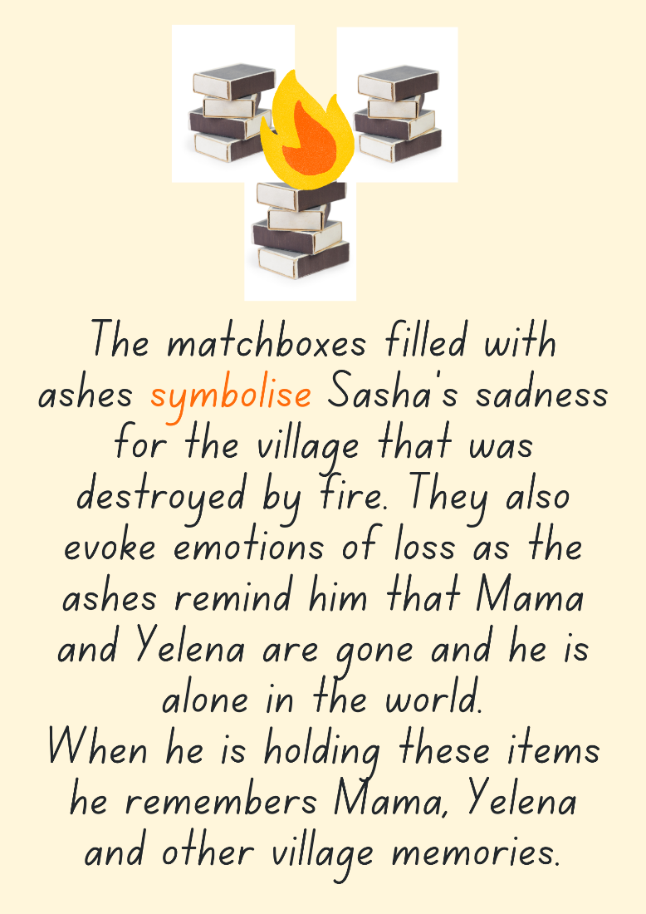

Resource 2 – genre comparison
Element | Rabbit, Soldier, Angel, Thief | The Feather
Form
Literary forms include poetry, picture books, chapter books.
Factual forms include informative books, historical reports.
Function
The way the elements of a text, such as words, illustrations and sounds, contribute to meeting its overall purpose. For example, to inform, to persuade, to entertain.
Mode
The process of communication such as sounds, music, printed or spoken words, images and gestures.
Medium
The means of communication, such as print based publishing, broadcasting, or the internet.

Resource 3 – word associations, word repetition and synonyms
Cohesive devices | Examples | Related words
Word associations
Word repetition
Synonyms

Resource 4 – multiple meanings
Quote from the text | Meaning of word | Metaphorical meaning
‘a murmur ripples across the room’ (p 121)
‘one of the fish springs to life’ (p 133)
‘the air is thick with black smoke’ (p 140)
‘my heart is racing’ (p141)

Resource 5 – Sasha
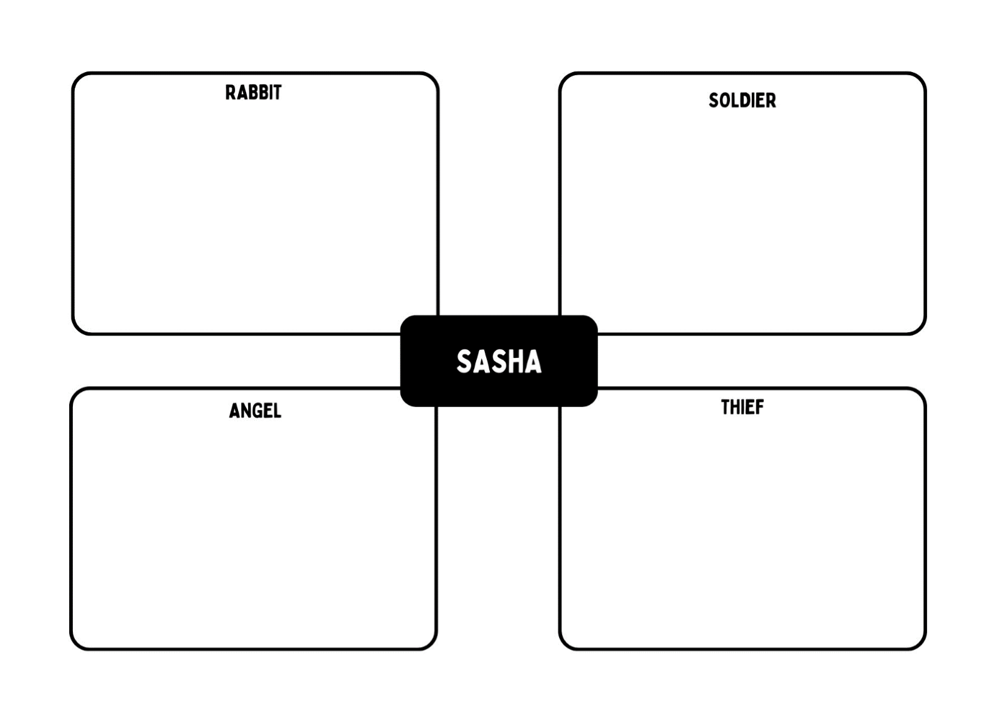

Resource 6 – newspaper teacher exemplar
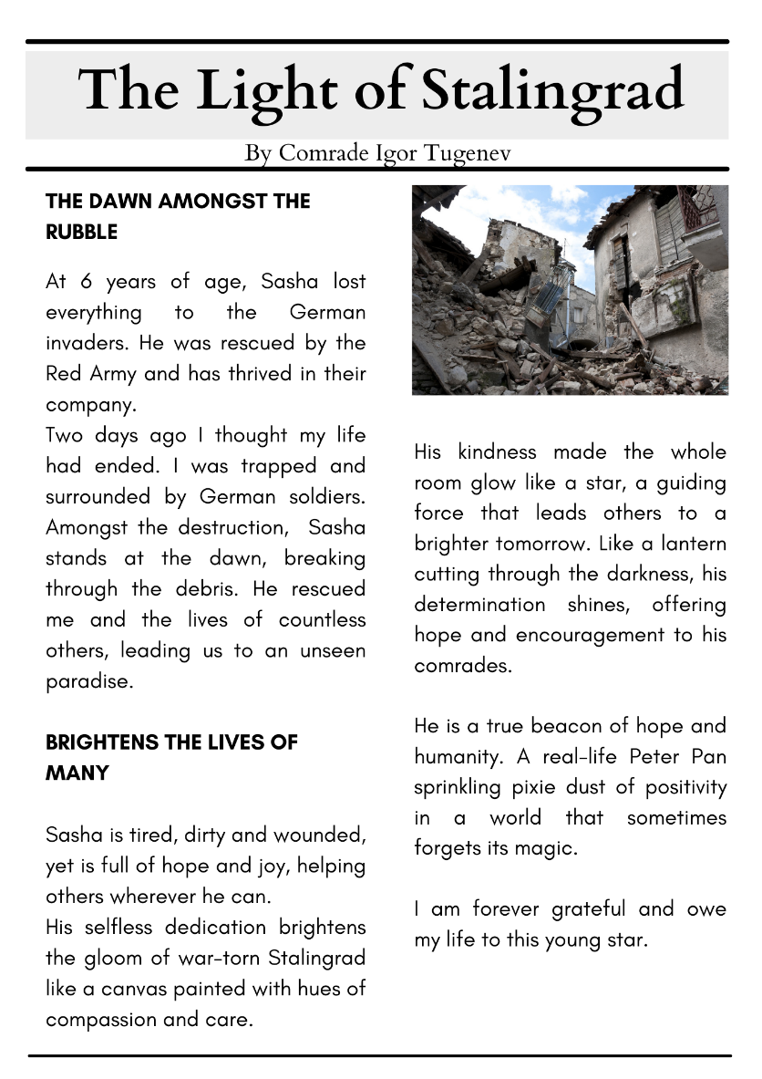

Resource 7 – image table
Collected item | What does this item symbolise for Sasha? | What does this item symbolise for the other characters?

Resource 8 – free verse poetry plan
Symbol of hope
Synonyms for the symbol
Word repetition
Word associations for hope
Figurative language

Resource 9 – free verse poetry exemplar
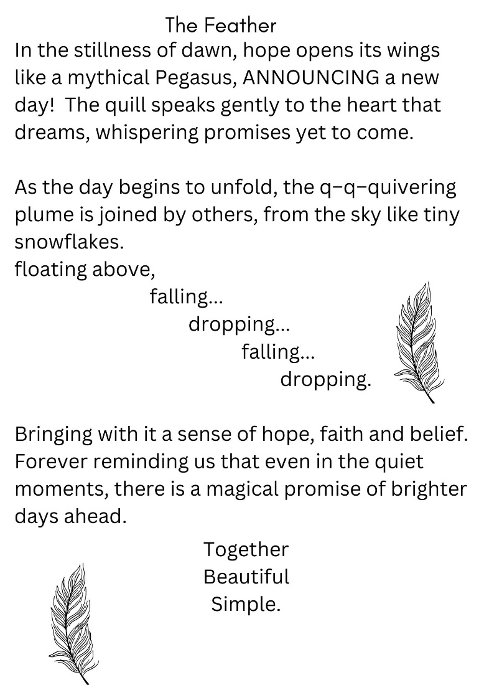

Resource 10 – character profile
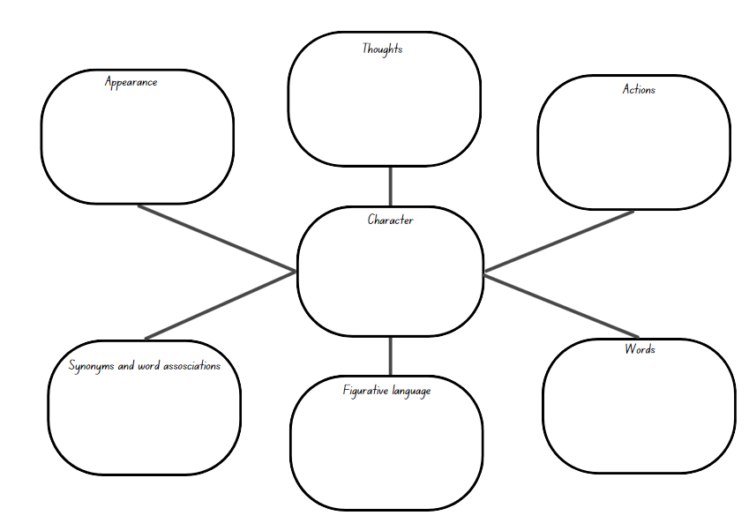

Resource 11 – claim – agree, disagree
Claim: Flowers are a universal symbol of positive emotions.
Agree | Disagree

References
This resource contains NSW Curriculum and syllabus content. The NSW Curriculum is developed by the NSW Education Standards Authority. This content is prepared by NESA for and on behalf of the Crown in right of the State of New South Wales. The material is protected by Crown copyright.
Please refer to the NESA Copyright Disclaimer for more information. https://educationstandards.nsw.edu.au/wps/portal/nesa/mini-footer/copyright
NESA holds the only official and up-to-date versions of the NSW Curriculum and syllabus documents. Please visit the NSW Education Standards Authority (NESA) website https://educationstandards.nsw.edu.au/wps/portal/nesa/home and the NSW Curriculum website https://curriculum.nsw.edu.au.
English K–10 Syllabus © NSW Education Standards Authority (NESA) for and on behalf of the Crown in right of the State of New South Wales, 2022.
National Literacy Learning Progression © Australian Curriculum, Assessment and Reporting Authority (ACARA) 2010 to present, unless otherwise indicated. This material was downloaded from the Australian Curriculum website (National Literacy Learning Progression) (accessed 7 November 2023 and was not modified).
Derewianka B (2022) A New Grammar Companion for Teachers, 3rd edn, PETAA (Primary English Teaching Association Australia), Newtown.
Imperial War Museums (2024) Growing Up In The Second World War, Imperial War Museums website, accessed 15 November 2023.
NESA (NSW Education Standards Authority) (2023) ‘Glossary’, Resources, NESA website, accessed 6 February 2024.
State of New South Wales (Department of Education) (2023) 'English A to Z', English help, NSW Department of Education website, accessed 8 November 2023.
Nannestad K (2021) Rabbit, Soldier, Angel, Thief, HarperCollins Publishers, Sydney.
Wild M (2018) The Feather (Blackwood F, illus), Little Hare Books, Australia.
Winch G (2022) Primary Grammar Book, 4th edn, Oxford University Press Australia and New Zealand.

Further reading
McDonald L (2023) A New literature companion for teachers, 3rd edition, PETAA, Newtown.

© State of New South Wales (Department of Education), 2024
The copyright material published in this resource is subject to the Copyright Act 1968 (Cth) and is owned by the NSW Department of Education or, where indicated, by a party other than the NSW Department of Education (third-party material).
Copyright material available in this resource and owned by the NSW Department of Education is licensed under a Creative Commons Attribution 4.0 International (CC BY 4.0) license.
This license allows you to share and adapt the material for any purpose, even commercially.
Attribution should be given to © State of New South Wales (Department of Education), 2024.
Material in this resource not available under a Creative Commons license:
- the NSW Department of Education logo, other logos and trademark-protected material
- material owned by a third party that has been reproduced with permission. You will need to obtain permission from the third party to reuse its material.
Links to third-party material and websites
Please note that the provided (reading/viewing material/list/links/texts) are a suggestion only and implies no endorsement, by the New South Wales Department of Education, of any author, publisher, or book title. School principals and teachers are best placed to assess the suitability of resources that would complement the curriculum and reflect the needs and interests of their students.
If you use the links provided in this document to access a third-party's website, you acknowledge that the terms of use, including licence terms set out on the third-party's website apply to the use which may be made of the materials on that third-party website or where permitted by the Copyright Act 1968 (Cth). The department accepts no responsibility for content on third-party websites.

