English Stage 3 Second year – Unit 11
Characterisation – Rabbit, Soldier, Angel, Thief
Contents
Unit overview and instructions for use 5
Teacher notes 7
Outcomes and content 9
Resources 16
Week 1 19
Component A teaching and learning 19
Planning framework 19
Component B teaching and learning 19
Learning intentions and success criteria 19
Lesson 1 – building background knowledge through discussion 20
Lesson 2 – cause and effect 23
Lesson 3 – characterisation 26
Lesson 4 – narrative voice 29
Week 2 32
Component A teaching and learning 32
Planning framework 32
Component B teaching and learning 32
Learning intentions and success criteria 32
Learning intention 33
Success criteria 33
Lesson 5 – character development 33
Lesson 6 – use of figurative language (metaphor) 35
Lesson 7 – use of modal words 38
Lesson 8 – understand and engage with characters 42
Week 3 45
Component A teaching and learning 45
Planning framework 45
Component B teaching and learning 45
Learning intentions and success criteria 45
Lesson 9 – structure and tense 46
Lesson 10 – use of figurative language (hyperbole and similes) 49
Lesson 11 – character profiles 51
Lesson 12 – experimenting with characterisation 53
Week 4 58
Component A teaching and learning 58
Planning framework 58
Component B teaching and learning 58
Learning intentions and success criteria 58
Lesson 13 – asking and responding to questions about literature. 59
Lesson 14 – cause and effect using a multimodal text 63
Lesson 15 – use of punctuation for meaning and effect 66
Lesson 16 – writing to suit purpose and effect 70
Week 5 73
Component A teaching and learning 73
Planning framework 73
Component B teaching and learning 73
Learning intentions and success criteria 73
Lesson 17 – planning a letter 74
Lesson 18 – drafting a letter 76
Lesson 19 – revise and edit a letter 78
Lesson 20 – characterisation – Rabbit, Soldier, Angel, Thief 80
Resource 1 – World War 2 fact cards 83
Resource 2 – discussion cards 86
Resource 3 – Sergey Aleshkov information report 87
Resource 4 – character profile 88
Resource 5 – Sasha’s important items 89
Resource 6 – Sasha 90
Resource 7 – modality words 91
Resource 8 – image table 92
Resource 9 – writing plan 93
References 94

Unit overview and instructions for use
In this 5-week unit, students will gain a deeper understanding of the textual concepts of ‘characterisation’ and ‘narrative’. Through the text Rabbit, Soldier, Angel, Thief, students will explore the development of characters as depicted through their appearance, words, thoughts and actions. They will explore the models of behaviour presented and how the relationship between characters enhances a reader’s engagement with the text. Students will create imaginative and informative texts, drawing on their knowledge of characterisation as well as historical knowledge gained.
Note: Rabbit, Soldier, Angel, Thief will also be used as the mentor text in Unit 12.
Outcomes and content in this unit are organised into Component A and Component B. The components are connected, with learning in Component A complementing learning in Component B.
Note: the duration of this unit can be adapted to suit individual school contexts. For example, learning could occur across 5 days rather than 4.
The table below highlights the focus areas and preparation required for Component A and Component B.
Teaching and learning | Component A | Component B
Suggested duration | 60 minutes × 4 days/week or equivalent | 60 minutes × 4 days/week or equivalent
Explicit teaching focus areas | Component A addresses content from the focus areas:  - Vocabulary  - Reading comprehension  - Creating written texts  - Spelling  - Handwriting and digital transcription  It centres on the development of foundational skills and knowledge through regular, systematic and repeated practice. | Component B addresses content from the focus areas:  - Oral language and communication  - Vocabulary  - Reading comprehension  - Creating written texts  - Understanding and responding to literature  It centres on the conceptual understandings of English and exemplifies the importance of learning about and enjoying literature through the study of quality texts.
Preparing for teaching and learning | - Specific teaching and learning activities need to be developed by the teacher. When planning for these activities, please refer to the Component A outcomes and content, teaching guides and planning frameworks.  - Plan and document how you will sequence teaching and learning in whole-class and targeted-groups across the 5-week cycle as required. This should be based on student needs identified through ongoing assessment data. | - Familiarise yourself with the mentor and supporting texts and textual concepts, and the teaching and learning sequence.  - Determine how you will support students in whole-class and targeted-groups across the 5-week cycle as required. This should be based on student needs identified through ongoing assessment data.
English K–10 Syllabus © NSW Education Standards Authority (NESA) for and on behalf of the Crown in right of the State of New South Wales, 2022.

Teacher notes
- ‘Characterisation’ is the mentor concept of this unit, explored using the text Rabbit, Soldier, Angel, Thief by Katrina Nannestad. Characterisation is the technical construction and representation of any personality or person-like figure in text, including features such as their appearance, actions, words or thoughts (NESA 2023).
- Understanding of characterisation can be supported through watching the department’s video: Character (2:31).
- While ‘characterisation’ is the mentor concept for the conceptual component of this unit, the supporting concept of ‘narrative’ can also be explored. Additional textual concepts may be included based on individual school context and student needs.
- For information on modality and figurative language techniques refer to the NESA Glossary.
- In addition to the resources listed, students will require access to short passages of the mentor text. Teachers can copy extracts from texts in reliance on the Statutory Text and Artistic Works Licence. Teachers need to attribute the extracts and include the following notice: ‘This material has been copied [and communicated to you] in accordance with the statutory licence in section 113P of the Copyright Act. Any further reproduction or communication of this material by you may be the subject of copyright protection under the Act. Do not remove this notice’.
- This unit could enhance student learning towards the achievement of history and geography outcomes.
- Consider prior student knowledge of World War 2 (WW2).
- Determine students understanding of figurative language including metaphors, hyperbole, similes and personification.
- Sensitivity around the concept of war should be considered and adjustments and accommodations made where contextually appropriate. Access and provide support if needed.
- Reflect on student learning and engagement in activities, and record differentiation and adjustments within the unit to inform future teaching and learning. One way of doing this could be to add comments to the digital file.
- In NSW classrooms there is a diverse range of students including Aboriginal and/or Torres Strait Islander students, students learning English as an additional language or dialect, high potential and gifted students and students with disability. Some students may identify with more than one of these groups, or possibly all of them. Refer to Curriculum planning for every student – advice for further information.
- Content points are linked to the National Literacy Learning Progression (version 3).
Levels and indicators sourced from National Literacy Learning Progression © Australian Curriculum, Assessment and Reporting Authority (ACARA), (accessed 24 October 2023) and was not modified. See references for more information.

Outcomes and content
The table below outlines the outcomes and content for this unit. The letters 'A' and 'B' in the header refer to Components A and B. The numbers 1 to 5 refer to weeks. The use of 'x' in these columns indicates where the content points are intended to be addressed and in which week.
Focus area and outcome, content points and National Literacy Learning Progression | A | B | 1 | 2 | 3 | 4 | 5
Oral language and communication
EN3-OLC-01 communicates to wide audiences with social and cultural awareness, by interacting and presenting, and by analysing and evaluating for understanding
- Follow agreed-upon protocols and define individual roles as needed for in-person or online interactions, establishing specific goals, criteria or timeframes (InT6) |  | x | x | x | x | x | x
- Interact in a range of contexts and deliberately adjust language and style (InT6) |  | x | x | x | x | x | x
- Ask and respond to analytical and evaluative questions about literature that contribute to own or others’ enjoyment and understanding (SpK5, UnT7) |  | x | x | x | x | x | x
- Apply interactive listening strategies by responding to and providing feedback to the speaker (InT5) |  | x | x | x |  | x | x
- Experiment with volume, pace and intonation to enhance meaning when presenting and reciting, and recognise the effects these have on audience understanding (SpK6) |  | x |  |  |  | x
- Reflect on and monitor own and peer presentations according to given criteria |  | x |  |  |  | x | x
Vocabulary
EN3-VOCAB-01 extends Tier 2 and Tier 3 vocabulary through interacting, wide reading and writing, morphological analysis and generating precise definitions for specific contexts
- Identify and use words that convey subjective, emotive and persuasive meanings in texts | x | x | x | x | x | x | x
- Extend knowledge of literal and non-literal word meanings through idiom or metaphor (UnT9, CrT9) | x | x |  | x | x | x | x
- Evaluate the effectiveness of modal words used in texts to intensify or soften emotional responses (CrT9) | x | x |  | x | x | x | x
Reading comprehension
EN3-RECOM-01 fluently reads and comprehends texts for wide purposes, analysing text structures and language, and by monitoring comprehension
- Syllabify, blend grapheme–phoneme correspondences and use morphemic knowledge as strategies for reading words accurately (SpG10, PKW9, FlY6) | x |  | x | x | x | x | x
- Adjust prosodic reading to enhance meaning and engage an audience (FlY6) | x |  | x | x | x | x | x
- Compare purposes for different texts and consider why authors and illustrators have structured texts in particular ways (UnT8) |  | x | x |  | x | x
- Describe how own mental model is adjusted as new words and information deepen understanding during reading | x | x |  | x | x | x | x
- Explain how language evokes responses when reading (UnT9) | x | x |  | x |  | x
- Identify cause and effect, using knowledge of causal connectives | x | x | x |  |  | x
- Recognise that a sequence of clauses may use different tenses but remains connected throughout a topic or section of text (GrA5) | x | x |  |  | x
- Analyse how language, background and vocabulary knowledge, and inferencing are used together to effectively build and adjust a mental model prior to and during reading | x | x | x | x | x | x | x
- Ask questions to clarify thinking, and to provide reasons or evidence (LiS6) | x | x | x | x | x | x | x
Creating written texts
EN3-CWT-01 plans, creates and revises written texts for multiple purposes and audiences through selection of text features, sentence-level grammar, punctuation and word-level language
- Make creative choices about temporal and spatial settings, character profiles and motives to enhance reader engagement |  | x |  | x | x | x | x
- Choose and control narrative voice across a text | x | x | x | x | x | x | x
- Choose text formats with appropriate text structures, features and language to inform target audiences (CrT9) |  | x | x |  |  | x | x
- Describe and/or explain ideas through logically sequenced paragraphs (CrT9) |  | x | x | x | x | x | x
- Experiment with characterisation (CrT9) |  | x |  | x | x | x | x
- Compare and contrast or discuss cause and effect through sequenced paragraphs (CrT9) |  | x | x |  |  | x
- Control tense across a text according to purpose, shifting between past, present and future tense if required (GrA6, CrT9) | x | x |  |  | x | x | x
- Maintain correct noun–pronoun referencing, subject–verb agreement and use temporal, conditional and causal connectives to build cohesive links across a text (GrA5, CrT9, GrA6) | x | x | x |  | x | x | x
- Experiment with figurative language for effect and to engage the reader, including metaphor, hyperbole, oxymoron and allusion (CrT9) | x | x |  | x | x | x | x
- Create written texts that include multiple paragraphs with clear, coherent transition of ideas (CrT9) |  | x | x | x | x | x | x
- Vary sentence structures or lengths when using simple, compound and complex sentences, with a focus on achieving clarity and effect suited to text purpose | x | x | x | x | x | x | x
- Use quotation marks consistently across a text to distinguish words that are spoken by characters in dialogue or words authored by others (PuN5, PuN7) | x | x |  |  |  | x | x
- Understand that texts, such as poetry, may include innovative use of punctuation, and experiment with punctuation to suit purpose and for effect | x | x |  |  |  | x | x
- Experiment with word choices to create humour, for clarity or emphasis, to suit audience and purpose (CrT8) | x | x |  |  |  | x | x
- Reflect on own writing by explaining and justifying authorial decisions regarding text-level features, sentence-level grammar, punctuation and word-level language |  | x | x | x | x | x | x
- Re-read, proofread and edit own and other’s writing, and use criteria and goals in response to feedback |  | x |  | x | x | x | x
Spelling
EN3-SPELL-01 automatically applies taught phonological, orthographic and morphological generalisations and strategies when spelling in a range of contexts, and justifies spelling strategies used to spell unfamiliar words
- Segment unfamiliar multisyllabic words into syllables and phonemes as a strategy when spelling | x |  | x | x | x | x | x
- Apply and explain graphemes identified by their etymology (SpG11) | x |  |  |  | x |  | x
- Apply infrequently occurring graphemes and letter patterns when spelling base words in a range of writing contexts (SpG10, SpG11) | x |  | x |  |  | x | x
- Recognise that the same grapheme can represent different phonemes (SpG10) | x |  |  | x |  |  | x
- Explain and use spelling conventions for assimilated prefixes such as in-, ad-, com- (SpG10) | x |  | x | x |  |  | x
- Correctly spell taught homophones when creating written texts across a range of writing topics and learning areas (SpG10) | x |  |  |  | x | x | x
Handwriting and digital transcription
EN3-HANDW-01 sustains a legible, fluent and automatic handwriting style
EN3-HANDW-02 selects digital technologies to suit audience and purpose to create texts
- Sustain writing with a legible, fluent and personal handwriting style across a text (HwK8) | x |  | x |  | x | x
- Adjust handwriting style to suit writing purpose (HwK8) | x |  |  |  |  | x
- Navigate the keyboard with efficiency and accuracy when typing words, numerals, punctuation and other symbols (HwK8) | x |  |  | x |  | x | x
Understanding and responding to literature
EN3-UARL-01 analyses representations of ideas in literature through narrative, character, imagery, symbol and connotation, and adapts these representations when creating texts
EN3-UARL-02 analyses representations of ideas in literature through genre and theme that reflect perspective and context, argument and authority, and adapts these representations when creating texts
- Analyse attributes of character and use similar attributes when creating texts |  | x | x | x | x | x | x
- Analyse how engagement with characters within and between texts invites enjoyment of literature |  | x |  | x | x | x | x
- Identify the ways different elements of a text contribute to character development and adapt these elements when creating texts |  | x | x | x | x | x | x
- Describe how narrative conventions engage the reader through models of behaviour, and apply narrative conventions when creating texts |  | x |  | x | x | x | x
- Recognise that narratives reflect both personal and common lived experiences and offer models of behaviour, which may be rejected or accepted |  | x | x | x | x | x | x
English K–10 Syllabus © NSW Education Standards Authority (NESA) for and on behalf of the Crown in right of the State of New South Wales, 2022.

Resources
The resources in the table below are referred to in this unit. Letters 'A' and 'B' in the header refer to Component A and B respectively, and the numbers 1 to 5 indicate weeks. The use of 'x' in these columns indicates whether the resources are required in Component A, B or both, and in which week.
Resource | A | B | 1 | 2 | 3 | 4 | 5
Nannestad K (2021) Rabbit, Soldier, Angel, Thief, HarperCollins Publishers, Sydney. ISBN13: 9780733341465 | x | x | x | x | x | x | x
Image: Polish infantrymen on alert in a trench in Tobruk |  | x | x
Video: BTN – History of WWII (4:20) |  | x | x
Resource 1 – World War 2 fact cards |  | x | x
Resource 2 – discussion cards | x | x | x
Article: The true story that inspired Katrinna Nannestad’s latest book, ‘Rabbit, Soldier, Angel, Thief’ |  | x | x
Resource 3 – Sergey Aleshkov information report |  | x | x
Coloured highlighters |  | x | x | x |  | x
Resource 4 – character profile |  | x | x |  | x |  | x
Resource 5 – Sasha’s important items |  | x | x
Resource 6 – Sasha |  | x |  | x | x | x
Resource 7 – modality words |  | x |  | x
A3 piece of paper |  | x |  | x | x
Resource 8 – image table |  | x |  | x |  |  | x
Website: Growing Up In The Second World War |  | x |  |  |  | x
Individual whiteboards |  | x |  |  |  | x
Resource 9 – writing plan |  | x |  |  |  |  | x

Week 1

Component A teaching and learning
Component A focuses on the development of foundational skills and knowledge through regular, systematic and repeated practice. The mentor and supporting texts used in Component B of this unit can support the effective implementation of Component A teaching and learning.

Planning framework
To plan and document Component A teaching and learning, a planning scaffold [DOCX 228 KB] is provided. To support you in your planning, a link to a detailed example of a one-week teaching and learning cycle is included in the scaffold. Additional resources to support teaching and learning in each focus area can be found at Lesson advice guides.

Component B teaching and learning
The following teaching and learning sequence has been designed to address Component B outcomes and content and develops conceptual understandings of English through the study of quality texts. Adapt the sequence as required to best meet the needs of your students.

Learning intentions and success criteria
Learning intentions and success criteria are best co-constructed with students.

Learning intention
Students are learning to identify the different elements of a text that contribute to character development, including the use of a character’s voice.

Success criteria
Students can:
- follow agreed-upon protocols using established criteria to interact in a range of contexts
- identify and use causal connectives to show cause and effect
- create a character profile using developing knowledge of a character
- use a character’s voice when creating written texts.

Lesson 1 – building background knowledge through discussion
Note: this lesson will build field knowledge and context required prior to reading the text, Rabbit, Soldier, Angel, Thief by Katrina Nannestad. Sensitivity around the concept of war should be considered and adjustments and accommodations made where contextually appropriate.
- Display the image Polish infantrymen on alert in a trench in Tobruk and ask students to respond to it with a quick write. Briefly discuss responses and what students know about WW2.
- Explain that the text, Rabbit, Soldier, Angel, Thief, by Australian author Katrina Nannestad will be explored over the term. However, before reading it, it is important to understand the time and place that it is set in. Watch BTN – History of WWII (4:20) to help ‘set the scene’.
- Develop a shared criteria for successful learning interactions, as a speaker, listener, for small groups and whole-class contexts. For example, establishing protocols such as assigning roles, turn-taking and listening. Discuss how interactions may change depending on the formality of context. For example:
- Formal context: minimal use of contractions may be appropriate when interacting in a formal context. (NESA 2023)
- Informal context: deliberate use of colloquialism, slang and jargon may be appropriate when interacting in an informal context. (NESA 2023)
Note: the criteria developed will be used to guide learning interactions throughout the unit.
- Divide students into small, mixed ability groups. Provide each group with a set of Resource 1 – World War 2 fact cards. Each group will read, analyse and interpret the information. Students engage in rich discussions about the subject matter, asking questions to clarify thinking, using the shared criteria for successful learning interactions and Resource 2 – discussion cards to prompt them.
Too hard? Modify the complexity of the activity by simplifying the resources.
Too easy? Students write responses to the discussion cards.
- Make connections to students' knowledge of WW2 in literature today. Use the following prompting questions:
- Why do you think stories about real life events in the past, like WW2, are important?
- Why might people find stories about WW2 interesting, even though they might be sad?
- Why are places like Germany or Russia interesting places to set a story?
- Read Chapter 1 of Rabbit, Soldier, Angel, Thief. Ask students:
- Where is the beginning of the story set? (Berlin) What do we know about this place? (It is the capital of Germany and the Red Army attacked it at the end of WW2)
- Why do you think there is a Red Army hospital in Berlin? What does this tell us about when the story is set? (It is the end of WW2, 1945 and Germany has been defeated)
- What characters have been introduced and what can we tell about them so far? (Sasha is the protagonist, it is written from his perspective).
Note: create a story map class display that is added to each time Rabbit, Soldier, Angel, Thief is read. This will support comprehension of the text and show the development of characters as the story unfolds. It can be used as a prompt for discussion.
- Students record their predictions about the text based on their background knowledge about WW2 in Russia and Germany, explored in activity 2 and 4, and the first Chapter read in activity 6.
Too hard? Students draw and label text predictions.
- Discuss student predictions about Rabbit, Soldier, Angel, Thief. Ask prompting questions to frame the textual concepts of characterisation and narrative that will be explored throughout the unit:
- Do your predictions relate to what you know about WW2? How and why?
- How do you think the setting (Europe during WW2) will influence what the characters do, say and feel? Why?
- Do you think the text will have a message or a lesson for readers to think and learn about?

Lesson 2 – cause and effect
- Revise learning from Component A about the use of causal connectives in texts to identify cause (what happened) and effect (why something happened). Brainstorm and record a range of causal connectives. For example: because, so, as a result, in consequence. Discuss how the inclusion of causal connectives creates cohesion across a text. For example, they signal to the reader that there is a cause and effect relationship between the preceding and succeeding information.
- Display an enlarged copy of Resource 1 – World War 2 fact cards. In pairs, students use information from the fact cards to practise using causal connectives. The first speaker begins with the first clause of the sentence (cause), the second speaker then selects an appropriate causal connective to complete the sentence (effect). Students actively listen to and respond to the first speaker. For example:
Student A: The Germans invaded Russia …
Student B: so the Red Army fought back.
Student B: The war was devastating...
Student A: as a result many children were left orphaned.
Too hard? Provide students with a sentence starter related to the images from Resource 1 (cause) and a limited number of causal connectives. Students select an appropriate causal connective and complete the sentence (effect).
- Use the class story map to re-orient students back to what has happened in Rabbit, Soldier, Angel, Thief so far. Discuss student predictions about the text from Lesson 1.
- Read the ‘Author’s Note’ at the back of Rabbit, Soldier, Angel, Thief that explains how the main character, Sasha, was inspired by a real-life person. Discuss that the text reflects both personal and common lived experiences. For example, the events that happen to Sasha are fictional but are based on true events from WW2 and were a common experience for children like Sergey Aleshkov who was a child of the Red Army.
- Display and read the blog article about Rabbit, Soldier, Angel, Thief. Discuss the significance of the author’s choice to develop a character based on a true story about a tiny boy soldier, reportedly the youngest child to have served during the Second World War. Discuss the extreme hardship of Sergey Aleshkov when he joined the Red Army at the age of between 6 and 8 years of age. Ask students how they think this character might shape the text.
- Explore the blog’s purpose (to inform). The blog has been written in sequenced paragraphs to show cause and effect. For example, the author’s research led to her developing the character, Sasha, for the text. Use a T-chart to unpack the paragraphs and record the cause (what happened) and effect (why something happened) across the text. For example:
- Cause: Author, Katrina Nannestad, was researching information for a different book.
- Effect: She found interesting information about a real-life person, Sergey Aleshkov.
- Use the information from the T-chart to model writing a short text showing cause and effect. Compose the ‘cause’ as the first sentence for the short text. Model writing the first section. Invite student responses to co-construct subsequent sections. For example:
Cause: Author Katrina Nannestad stumbled upon an article about Sergey Aleshkov, a boy soldier in World War 2.
Effect: as a result, her discovery made her curious and prompted her to delve deeper into research about Sergey.
Cause: she thought about her own children at that age and how their innocence and naivety were endearing.
Effect: this resulted in the author being inspired to develop a fictional character named Sasha, also a child soldier, whose traits uplifted those around him at a time of war.
Cause: the author's research led her to reading about the wartime experiences of women and children, recorded in books like Last Witnesses and The Unwomanly Face of War.
Effect: consequently, this helped the author write a historical narrative, with the character Sasha at the centre, telling the fictional stories of people of the past who lived through the devastation of war.
- Provide students with Resource 3 – Sergey Aleshkov information report. Using the models from activity 6 and 7 for support, students identify the cause and effect in the text using different coloured highlighters. Students write a short text with sequenced information that shows cause and effect, using causal connectives.
Too hard? Provide students with 2–3 causes from the information report and a limited number of causal connectives. Students select an appropriate causal connective and write the effect. This could be completed as an oral activity.
- To reflect on learning, ask:
- Why is it important to identify cause and effect when reading a text?
- What strategies will we use to identify the cause and effect when reading Rabbit, Soldier, Angel, Thief? For example, identify causal connectives, making connections to the events and their subsequent consequences.
- How do the causal connectives create cohesion?
- What cause and effect events do you predict in Rabbit, Soldier, Angel, Thief?

Lesson 3 – characterisation
- Display the front cover of Rabbit, Soldier, Angel, Thief and read the title. Students predict what impact these words may have on the text.
- Draw students’ attention to the character on the front cover. Ask:
- Who might this character be?
- What information do we currently have that is shaping our mental model of this character?
Mental model: a mental representation of the information in a real or an imaginary world. A student develops a mental model as the text progresses. It may include information derived from inferences and from background knowledge as well as from what is explicitly stated in the text itself. (NESA 2023)
- Read Chapter 2 of Rabbit, Soldier, Angel, Thief. Unpack unfamiliar vocabulary. For example, ‘Stalingrad’ (p 7) and ‘ushanka’ (p 12). Ask the following guiding questions to monitor comprehension:
- What further information have we gained about Sasha?
- Do you think it is important that the reader knows Sasha’s name and age? Why or why not?
- Why do you think Sasha does not speak? What makes you think that?
- Discuss and add important details from Chapter 2 of Rabbit, Soldier, Angel, Thief to the class story map.
- Introduce the concept of characterisation. Explain that appearance, actions, words and thoughts show the attributes of a character, and these features throughout a text contribute to character development.
Characterisation: the technical construction and representation of any personality or person-like figure in text, including features such as their appearance, actions, words or thoughts (NESA 2023)
- Display the excerpt from Rabbit, Soldier, Angel, Thief from ‘Doctor Orlova is sitting in my bed...’ (p 6) to ‘...blue, blue cornflowers’ (p 7). Model identifying and analysing the information gained about Dr Orlova’s appearance, actions, words and thoughts. For example:
- ‘...wrinkles around her eyes and mouth multiply.’ (p 6) indicates that she is someone who smiles regularly
- ‘...frazzled grey hair...’ (p 7) indicates she is an older lady.
- Explain that our knowledge of Dr Orlova comes from her actions, what she says and how she is described by Sasha.
- Provide students with an excerpt of Rabbit, Soldier, Angel, Thief from ‘I remain silent...’ (p 2) to ‘...Red army hospital in Berlin’ (p 4). In small groups, students identify and analyse the information gained about Sasha’s appearance, actions, words and thoughts. For example:
- ‘...tucks the end of my bandages... (p 3)’ indicates he is injured and in a hospital
- ‘What were you thinking boy?’ (p 3) indicates he did something silly and is in trouble.
- Display Resource 4 – character profile and explain that students will create a character profile for Sasha. Model creating Resource 4 – character profile for Dr Orlova to include details about her appearance, actions, words and thoughts. For example:
Appearance: she had frazzled grey hair. This tells us she is an older lady. She had wrinkles around her eyes, and this shows us she had smile lines from smiling all the time.
Actions: she was kind because she brought Sasha flowers.
Words: she cares because she touches Sasha’s knee and speaks affectionately to him.
Thoughts: she understands and is willing to be patient that Sasha cannot speak but would like to when she says, ‘I know, Sasha...’.
- Provide students with a copy of Resource 4 – character profile. Guide students to use the information from activity 8 to create a character profile for Sasha.
- In pairs, students share character profiles and compare information gained about Sasha.
- Re-read and draw students’ attention to a key moment in Chapter 2 of Rabbit, Soldier, Angel, Thief from ‘My skin creeps...’ (p 12) to the end of the Chapter. Ask:
- Why do you think Sasha says, 'I don’t know if I want to do this?’ For example, he is not sure if he is ready to share or speak.
- What does this reveal about his character? For example, he is vulnerable and has some sad memories that will help the reader empathise with him.
- What does ‘I nod again and I speak’ reveal about Sasha? For example, his character is already showing development.
- Explain that students will further explore how Sasha’s character develops as the text continues to be read.

Lesson 4 – narrative voice
- Display the images of the bouquet of flowers, piece of rope, matches and ushanka from page 15 of Rabbit, Soldier, Angel, Thief. Students turn and talk to predict how they think these items may be connected to Sasha’s memories.
- Review students’ knowledge of narrative conventions. For example, plot, real or imagined characters, real or imagined setting, dialogue, a moral or lesson. Explain that narrative voice is another convention and refers to the point of view from which a story is told. Authors use first, second or third-person voice, depending on the point of view they wish to show.
- Read Chapters 3 and 4 of Rabbit, Soldier, Angel, Thief with students listening to identify the narrative voice used. Unpack unfamiliar vocabulary while reading. For example, ‘partisans’ (p 26). Ask the following guiding questions to monitor comprehension:
- What narrative voice is used in the text? How do you know? For example, first-person voice as shown by the use of ‘I’ and ‘we’.
- What is the significance of the flowers? For example, they are Mama’s favourite and they have them through the house.
- How do we know the Germans are not welcome in the village? For example, the village is silent in fear and they ‘stomp’ on everything.
- Discuss and add important details from Chapters 3 and 4 of Rabbit, Soldier, Angel, Thief to the class story map.
- Review that Rabbit, Soldier, Angel, Thief is written in first-person voice from Sasha’s point of view. Discuss why the author might have chosen to write using Sasha’s voice. For example, it is a technique to provide more information about the character, the author wants to create empathy for the character and develop a close relationship between the reader and the character.
- Explain that students will write in first-person voice to describe items that are important to Sasha.
- Model identifying and discussing important items for Mama as described in the text. For example, flowers, family, headscarf and log cabin. As a class, jointly construct a passage from the point of view of Mama. Use first-person voice to describe the items of importance in logically sequenced paragraphs. For example:
When my son Sasha picks wildflowers, I put them in a clear glass vase on the windowsill so everyone who walks by the house can see them. Sometimes I wear my headscarf, which has beautiful flowers embroidered on it. It reminds me that we live in our wonderful village with breathtaking scenery and lovely log houses.
My favourite time of the day is when I’m telling Yelena and Sasha a fairytale at night. When Anna visits, I encourage her to read one of our books to the children as it reminds me of when my mum read to me. Sometimes I feel a little sad because Rosa and Papa have gone to join the Red Army, but we know it's for the greater good. I feel lucky to have such a wonderful family.
- Students identify the words that show first-person narrative voice in the modelled text. For example, my, we, our, I.
- Display and discuss the important items for Sasha on Resource 5 – Sasha’s important items.
- Students independently create a passage in first-person voice from Sasha’s point of view.
Too hard? Provide sentence stems and a word bank.
- Introduce the importance of reflecting and justifying authorial decisions when creating written texts. For example, the process ensures the writing has clear and coherent ideas, meets the intended purpose and uses literary devices to entertain the reader.
- In pairs, students share their passage from Sasha’s voice. Students reflect on the use of first-person narrative voice and discuss the impact it has on the reader.

Week 2

Component A teaching and learning
Component A focuses on the development of foundational skills and knowledge through regular, systematic and repeated practice. The mentor and supporting texts used in Component B of this unit can support the effective implementation of Component A teaching and learning.

Planning framework
To plan and document Component A teaching and learning, a planning scaffold [DOCX 228 KB] is provided. To support you in your planning, a link to a detailed example of a one-week teaching and learning cycle is included in the scaffold. Additional resources to support teaching and learning in each focus area can be found at Lesson advice guides.

Component B teaching and learning
The following teaching and learning sequence has been designed to address Component B outcomes and content and develops conceptual understandings of English through the study of quality texts. Adapt the sequence as required to best meet the needs of your students.

Learning intentions and success criteria
Learning intentions and success criteria are best co-constructed with students.

Learning intention
Students are learning to experiment with the use of language features for emotive effect in their writing.

Success criteria
Students can:
- analyse how the development of character relationships influences the enjoyment of literature
- use emotive and figurative language to evoke emotive responses
- use modal words to intensify or soften emotional responses of the reader
- understand and discuss the connections between characters.

Lesson 5 – character development
- Revise that background and vocabulary knowledge, language and inferencing are used together to build and adjust our mental model prior to and throughout reading the text. In small groups, students discuss how their mental model for Sasha is developing using the class story map. For example, through Sasha’s actions, thoughts and words we know that he loves his family and he is kind and thoughtful to others.
- Read Chapter 5 of Rabbit, Soldier, Angel, Thief, unpacking unfamiliar vocabulary. For example, ‘balalaika’ (p 32), ‘kasha’ (p35). Ask the following guiding questions:
- Why does Mama refer to Sasha as Little Rabbit? What does this show the reader about his character?
- What does Sasha’s understanding of ‘real’ and ‘not real’ reveal about the way Sasha thinks? How do you know this?
- Discuss and add important details from Chapter 5 of Rabbit, Soldier, Angel, Thief to the class story map.
- Read the word ‘Rabbit’ on the front cover of the text and remind students that this word helps shape our mental model for Sasha’s character. Highlight that the use of ‘rabbit’ to describe Sasha is a non-literal use of the word. Provide students with an excerpt of the text from ‘Mama turns and stares...’ (p 34) to ‘Yes, Little Rabbit.’ (p 35). In small groups, students identify and analyse why Sasha is referred to as a rabbit. For example, he is small and needs protection.
- Provide students with a copy of Resource 6 – Sasha to record their understanding about why Sasha is referred to as a ‘rabbit’.
Note: this resource will also be used in Lesson 12 and Unit 12.
- Explore the relationship between Sasha and Mama, including her use of the word ‘rabbit’ as a term of endearment. Explain that the relationships between characters is important as it helps the reader to identify and empathise with the character. Revise the shared criteria for successful learning interactions from Lesson 1. In small groups, students then use the Claim, Support, Question routine to analyse the relationship between Sasha and Mama and record their responses. For example:
Claim: Mama realises the war is causing Sasha to lose his child-like innocence and live in an adult world.
Support: he sees the guns, partisans and other items in the house. In the text it shows the reader that, ‘Mama laughs, with sadness around the edges’, which shows her realisation for what might happen to Sasha.
Question: How might this change the relationship between Mama and Sasha?
- As a class, reflect on how students’ mental model of Sasha changed when using the Claim, Support, Question routine.
- Students construct a passage that uses Sasha’s voice to describe the relationship between Mama and Sasha. Remind students to include the information from activity 4 and 6.
- Students update Sasha’s character profile created in Lesson 3, adding additional information gained about his character.

Lesson 6 – use of figurative language (metaphor)
- Use the class story map to review Chapter 5 of Rabbit, Soldier, Angel, Thief.
- Read Chapters 6 and 7 of Rabbit, Soldier, Angel, Thief. Unpack unfamiliar vocabulary. For example, ‘kolkhoz’ (p 47). Ask the following guiding questions to monitor comprehension:
- What words are used to describe the German soldiers? For example, ‘handsome princely faces’ (p 40), ‘monster’ (p 41), ‘prince-monster’ (p 43)
- What consequences do you think Sasha might be referring to?
- Discuss and add important details from Chapters 6 and 7 of Rabbit, Soldier, Angel, Thief to the class story map.
- Display the excerpt from Rabbit, Soldier, Angel, Thief from ‘Bye! I throw myself...’ (p 40) to ‘...into my belly’ (p 41). Highlight ‘...pulling them in so tightly that our heads crack.’ As introduced in Component A, explain that this is an example of figurative language (a metaphor) to create effect and engage the reader. Figurative language can contribute to character development as it provides a deeper understanding of characters’ thoughts, actions, words and attributes. In this example, the heads of Olga, Nina and Sasha do not literally break open when they hug. The author has used the word ‘crack’ in a metaphorical way to show the strength of the hug.
Metaphor: an object, entity or situation that can be regarded as representing something else. (NESA 2023)
- Provide students with the text excerpt starting at ‘Bye! I throw myself...’ (p 40) to ‘...into my belly.’ (p 41). In pairs, students locate and highlight the metaphors used. For example, ‘the monster’ and ‘a cold shiver runs...down my spine and into my belly’ (p 41). Students discuss and analyse the literal and non-literal meanings of these metaphors.
- Explain that students will create a 4-column table titled ‘Metaphor analysis’, with the headings: metaphor, literal meaning, non-literal meaning and reason. Students use the identified metaphors in activity 5 to record the metaphors, their literal and non-literal meanings under each heading, including reasons why the author has used metaphors to help identity and relate to Sasha’s actions, words and thoughts. For example:
Metaphor: ‘pulling them in so tightly that our heads crack’.
Literal meaning: their heads have collided and when their heads touch, they crack open.
Non-literal meaning: the hug is forceful and emotional emphasising the intensity of the situation.
Reason: by using this figurative language, the author helps the reader not only identify the emotions Sasha is experiencing but also highlights the significance of this moment in Sasha's character development. The phrase ‘heads crack’ paints a vivid picture of Sasha's emotional response, indicating a negative change in his feelings. This figurative language aids in creating a deeper connection between the reader and the character, and it signals a turning point in Sasha's character development, likely indicating a moment of dread and transformation.
- Students create and complete the 4-column table.
Too hard? Provide students with a word bank for the metaphors.
Too easy? Students are provided with a longer text extract to identify different forms of figurative language.
- As a class, students share their thinking and provide reasons justifying why the author included metaphors.
- Draw students’ attention to the use of ‘monster’ to depict the German soldiers. As a class, complete a ‘popcorn’ activity, where students are given the opportunity to speak freely, one at a time, providing examples of what they imagine when they hear the word ‘monster.’ Record student responses.
Popcorn activity: students will respond to the topic and ‘popcorn out’ their responses and ideas as it comes to them, waiting for the previous person to finish talking before responding.
- Referring to learning from Component A, discuss how the word ‘monster’ evokes an emotive response. Highlight that the use of the ‘monster’ metaphor develops with Sasha’s description of the soldiers changing from being ‘...like a hungry monster’ (p 41) to ‘...monster...’ (p 42) to '...prince-monster...' (p 43).
- Explain that students will create their own metaphor for the German soldiers. For example, the soldiers as wolves, vampires, zombies or giants. Provide students with a piece of paper, folded in thirds to create 3 separate images which describe the German soldiers over time, using Sketches and squiggles. For example:
- Image1 will look like a hungry giant
- Image 2 is of a giant
- Image 3 is a giant with princely features.
- Students record the metaphors underneath.
- Model using a metaphor of the soldiers as ‘giants’ to write a rich description. For example:
The Giant
The fearsome giant with his clean uniform, beamed with pride as he marched directly towards me. I felt like a tiny mouse facing a gigantic mountain as he stomped towards me. His gun was like a bommyknocker hanging at his side. I hid behind and clung to Mama's legs, where her comforting embrace became my shield against the intimidating giant with humungous limbs, as if her legs were the strong walls of a castle protecting me, her frightened child.
- Students use their metaphor to write a rich description to describe the German soldiers. Encourage students to include language that evokes an emotive response.
- Revise the importance of active listening strategies when responding and providing feedback to others. In pairs, students take turns reading their description to a partner, while their partner draws a mental model of the description.

Lesson 7 – use of modal words
- Display and re-read the excerpt from Chapter 6 of Rabbit, Soldier, Angel, Thief from ‘I run. I run like a rabbit...’ (p 44) to '...crawl into a hollow log and stop’ (p 45). Draw attention to the way the author has described Sasha as a rabbit more than once throughout the text. This metaphor has been carefully used to depict Sasha’s escape from the German soldiers, in contrast to the rabbit being an affectionate nickname for Sasha. Ask:
- Why has the author used the ‘rabbit’ to describe the way Sasha escapes?
- How does this shape your mental model of Sasha’s character? For example, Sasha is no longer a sweet innocent boy as he scrambles over the door and hides in a hollow log, showing a shift in his character’s development.
- Remind students that modal words are used in texts to intensify or soften emotional responses for the audience, as introduced in Component A. Modal words can indicate probability (might, perhaps), occurrence (regularly, rarely), obligation (must, ought) and inclination (desire).
- As a class, identify modal words from the text excerpt in activity 1. For example, ‘I don’t stop’, ‘I can’t take another step’. Consider how the reader’s emotional response could change if an alternate modal word was used. For example, can stop, might stop, should stop, may stop.
- Provide students with an excerpt of Chapter 7 from ‘I walk on through the grass...’ (p 47) to ‘...what consequences look like’ (p 48). In pairs, students identify examples of modal words. For example, should (p 47), maybe (p 47), need (p 47), is (p 48). Ask:
- Why do you think the author used words with low modality to initially describe the missing village?
- Do these words intensify or soften the emotions you feel for Sasha? Why?
- When the author uses the high modality statement of ‘...I know for certain’, do your emotions intensify or soften for Sasha? Why?
- Explain that students will work with a partner to explore the use of high and low modality words and the effect they can have on a reader’s emotional response. Provide each group with a set of Resource 7 – modality words. Model using a high and a low modality word from Resource 7 – modality words to orally describe Sasha’s emotions when he returned to where his village once was. For example:
- Low modality word: perhaps
- High modality word: absolutely
- Example: I absolutely will find Mama and Yelena, perhaps they are okay.
- Explain that students will write a diary entry to reflect on the day Sasha’s village was destroyed using Sasha’s voice. Students should be encouraged to reflect on learning so far to co-construct success criteria to support writing. For example:
- first-person narrative voice
- multiple logically sequenced paragraphs
- modal words, metaphors and emotive language to evoke emotional responses.
- Co-construct a diary entry from Yelena' s voice through first-person narrative voice. Demonstrate making creative choices about settings, motives and characters to influence reader engagement. For example:
May 12, 1942
Dear Diary,
Yesterday changed my life forever! I felt like my life was in slow motion and it was one big dream. I was helping Mama in the kitchen when the arrival of the beastly giants in their clean uniforms was a storm of activity. The door shivered and quaked under the forceful impact of the shiny, black boots of the German Soldiers. We were certainly afraid for what was to come. Thank goodness Sasha was playing in the sunflower field with Nina and Olga.
I thought Mama was disappointed when Sasha arrived home. He became a quivering mouse in the presence of the monsters. When they called him Little Rabbit, his chest swelled with bravery as he declared, ‘Mama is the only one who can call me that!’. I definitely thought he was going to give away our secrets. I rushed at him to stop him, and the German hit me so hard I fell over and scrambled under the table to safety.
Clever Little Rabbit knew how to play the game, he did not give away our secrets. I am so glad Mama taught him what ‘was ‘real’ and what ‘was ‘not real’. This was the perfect opportunity to use Sasha’s idea of tying the monster's legs together. The rope eagerly bound the legs together.
I shouted to Sasha to run and he scampered like a rabbit out of the house. I miss him so much. Perhaps I may see him again one day.
Signing off,
Yelena the Partisan
- As a class, read the co-constructed diary entry and analyse using the success criteria.
- Students independently write a diary entry using Sasha’s voice. Encourage students to make creative choices about settings, motives and characters to influence reader engagement. Remind students to refer to the co-constructed success criteria.
Too hard? Work with students to brainstorm ideas and co-construct a plan for writing.
- In pairs, students take turns to read their writing. They explain how they have met the success criteria, justifying their authorial decisions and applying feedback to their work.
Assessment task 1 – observations and work samples from this lesson allow students to demonstrate achievement towards the following syllabus outcome and content point:
EN3-CWT-01 – plans, creates and revises written texts for multiple purposes and audiences through selection of text features, sentence-level grammar, punctuation and word-level language
- experiment with characterisation
- make creative choices about temporal and spatial settings, character profiles and motives to enhance reader engagement
- create written texts that include multiple paragraphs with clear, coherent transition of ideas.

Lesson 8 – understand and engage with characters
- Display page 15 of Rabbit, Soldier, Angel, Thief with the 4 images: flowers, rope, matchbox and ushanka. Discuss possible connections Sasha may have with these 4 items.
Note: teacher may source props that represent the items Sasha has collected as an alternative to using the images.
- Read Chapter 8 of Rabbit, Soldier, Angel, Thief. Ask the following guiding questions:
- What do we now know about the collected items and their importance to Sasha?
- Why do you think the characters appear to be okay with Sasha stealing some of these items?
- Revise narrative conventions and explain that narratives present models of behaviour. Discuss that through narrative, readers explore actions, interactions, motivations and reactions. Discuss the behaviours the reader observes from Sasha and how this shapes the narrative. For example, Sasha has a compulsive urge to steal items from others that are a reminder of his past. This model of behaviour is accepted by the other characters even though stealing is a crime.
- Add important details from Chapter 8 of Rabbit, Soldier, Angel, Thief to the class story map.
- Display Resource 8 – image table. Explain that students will create a list of the items that Sasha has collected and will record the connection Sasha has with each item using Resource 8 – image table. Emphasise that each item is an element of the text that contributes to Sasha’s character development and drives the plot forward. This resource will link Sasha’s interactions with other characters throughout the text. For example, the bouquet of flowers helps Sasha to recall his home, family and village.
Note: this resource will also be used in Lesson 20 and Unit 12.
- Students draw and label each item from page 15 of Rabbit, Soldier, Angel, Thief under the heading ‘item’ on Resource 8 – image table. For example, students draw a bouquet of flowers.
- Re-read the passage from Rabbit, Soldier, Angel, Thief from ‘...please, I call out...’ (p 51) to ‘...in my sleep’ (p 52). As a class discuss the connection between the bouquet of flowers and Sasha. Co-construct and record sentences that reflect the significance and connection to other characters in the first row of Resource 8 – image table. For example:
Item: bouquet of flowers
Sasha’s connection: Sasha’s village was filled with flowers, his mother loved flowers and she embroidered them on her headscarf.
Sasha’s connection to other characters: The flowers remind Sasha of his beloved mother and the people of his village.
Too hard? Provide students with a template that has the pictures already included. Provide students with a word bank for the items.
Too easy? Students include metaphors and modal language to describe the interactions between characters.
- In small groups, students discuss Sasha’s connection to the items and other characters using Resource 8 – image table and the shared criteria for successful learning interactions.
- Students will participate in a Hot seat where they will take on the role of Sasha to develop their knowledge of the collected items. Co-construct and record a list of questions to ask Sasha about the items. For example:
- What does it look like?
- Where did you find it? (if not stated, you can be creative)
- What memories does it create for you?
- In small groups, students choose one of the items to describe. Students take turns being in the hot seat to answer the questions posed by their peers. Students provide feedback to the presenter by using the agreement, disagreement, clarify and extension parts of Peer discussion and conferencing protocol.
- Students update Resource 8 – image table using further information gained through the discussion.

Week 3

Component A teaching and learning
Component A focuses on the development of foundational skills and knowledge through regular, systematic and repeated practice. The mentor and supporting texts used in Component B of this unit can support the effective implementation of Component A teaching and learning.

Planning framework
To plan and document Component A teaching and learning, a planning scaffold [DOCX 228 KB] is provided. To support you in your planning, a link to a detailed example of a one-week teaching and learning cycle is included in the scaffold. Additional resources to support teaching and learning in each focus area can be found at Lesson advice guides.

Component B teaching and learning
The following teaching and learning sequence has been designed to address Component B outcomes and content and develops conceptual understandings of English through the study of quality texts. Adapt the sequence as required to best meet the needs of your students.

Learning intentions and success criteria
Learning intentions and success criteria are best co-constructed with students.

Learning intention
Students are learning to experiment with narrative conventions and elements of a text that contribute to character development.

Success criteria
Students can:
- identify narrative conventions and maintain present tense in writing
- create and use hyperbole statements and similes in writing
- experiment with characterisation to develop character profiles
- write a sustained piece of writing, referring to co-constructed success criteria.

Lesson 9 – structure and tense
- Display the class story map. In pairs, students turn and talk to explain their current mental model of Sasha. Remind students that their mental model of Sasha is shaped and adjusted by his appearance, actions, words or thoughts, as well as inferences made by the reader. Discuss how this information combines to effectively build a mental model.
- Review narrative conventions, as discussed in Lesson 4. Revise that a skilful plot or storyline uses a structure, with a common structure being orientation, complication, resolution.
- Ask students to consider how Rabbit, Soldier, Angel, Thief is organised up to this point. For example, there are 2 plots running side-by-side (one storyline is set after the war, one storyline is set during the war).
- Explain that the text is a dual narrative. This is a narrative structure where a story is told from 2 different points of view or told by the same person at different moments in time. In Rabbit, Soldier, Angel, Thief the author shifts the story between present (Sasha in the hospital) and the past (Sasha in the war).
- Use the class story map to think about the structure of Rabbit, Soldier, Angel, Thief so far:
- Chapters 1 and 2: Sasha is in the hospital and he decides to tell his story
- Chapters 3 to 7: Sasha is in his village and it is destroyed by German soldiers
- Chapter 8: Sasha is in hospital, reflecting on the loss of his village and looking at some items he has collected.
- Ask students why the author is moving between the past and the present. What effect does this have? For example, it makes the reader feel as though they are there with Sasha in that moment.
- Review learning about narrative voice from Lesson 4, recognising that use of first-person narrative voice is a convention used by the author to also engage the reader and help the reader connect with the main character. Explain that another way an author can engage and position the reader is through their choice of tense. Referring to learning from Component A, remind students that tense is shown through the form of the verb.
Tense: the form of the verb that indicates when something is happening in relation to the speaker’s time: past, present or future (NESA 2023).
- Provide students with 2 excerpts from the text, one from each part of the dual narrative:
- Excerpt 1: ‘I sleep...’ (p 46) to ‘...here and there.’ (p 47)
- Excerpt 2: ‘I try to sleep...’ (p 53) to ‘...I stare at them.’ (p 53)
- In pairs, compare the 2 excerpts by highlighting the language used to show the tense of the texts.
- As a class, discuss the tense used across both texts. Ask guiding questions to support students in their discussion. For example:
- What tense is used in the excerpts? How do you know?
- Why do you think the author told the dual narrative in the same tense? For example, it makes both narratives feel as if they are happening in real-time.
- What effect does this have on the reader? For example, it engages the reader as they feel as if they are ‘in the moment’ with Sasha.
- As introduced in Component A, review that a sequence of clauses may use a combination of words in present and past tense but remain connected on the one idea or topic. For example, the author mainly uses present tense but changes into past tense on occasion. This is seen in the use of dialogue on page 52 from ‘Sasha! Sasha!’ to ‘...told me your story.’
- Explain that students will use present tense to write about an adventure that Sasha has with the beetle before he was in the hospital. Model this text creation by co-constructing a creative piece of writing for an adventure Sasha has with the buttons before he was in hospital, maintaining present tense. For example:
I stroll through the blue, blue cornflowers with Olga and Nina when something surprising happens. Nina and Olga's buttons pop magically off their shirts, and they tumble out of their hands. Each button seems to wink at us mischievously, like little friends ready to join in the fun. They are like a glistening waterfall in the sunlight, and their joyous laughter fills the air. Our smiles grow wide, it is clear that today won’t be like any other day. I have a strong feeling about it deep in my bones.
Out of the blue, the buttons race away, just like butterflies darting through the wind, teasing us and playing hide-and-seek. We pursue them until we can’t run any longer. My heart races with excitement, as if it were on fire. I am sure I will encounter these buttons again soon, just as I hope to see Olga and Nina once more.
- Provide time for students to write about an adventure that Sasha has with the beetle.
Too easy? Students include figurative language in their writing.
- Remind students of the shared criteria for successful learning interactions. In pairs, students take turns to read their writing, justifying their authorial decisions and use of present tense.

Lesson 10 – use of figurative language (hyperbole and similes)
- Display the images on page 57: bunch of flowers, a beetle, 8 buttons and white feathers. Students discuss how they believe these items will be connected to Sasha’s memories using the reasoning protocol.
- Read Chapter 9 of Rabbit, Soldier, Angel, Thief, unpacking unfamiliar vocabulary. For example, Baba Yaga (p 65). Ask:
- Why do the soldiers stop chatting and laughing when they see Sasha enter the camp?
- Why do you think Sasha would like to be friends with Natasha?
- Add important details from Chapter 9 to the class story map.
- Revise the use of figurative language throughout the text, as taught in Component A. Identify that the author, Katrina Nannestad, has included the use of hyperbole throughout the text for effect and to engage the reader. For example, ‘I wish our house had chicken legs...’ to ‘... away from the Germans.’ (p 29)
Hyperbole: an exaggerated statement not intended to be taken literally; may be used as a rhetorical device or figure of speech (NESA 2023).
- Re-read the final paragraph of Chapter 9 from Rabbit, Soldier, Angel, Thief starting at ‘I wake during the...’ (p 65). Students identify the hyperbole used in this passage and describe the images it creates for the reader. For example, ‘Baba Yaga is...chewing on my heart, then dancing on my skull.’ Explain that this phrase has figurative meaning as it references a well-known character from Slavic folklore, Baba Yaga. Baba Yaga is often depicted as a fearsome and unpredictable witch-like figure. In this context, the use of this hyperbole symbolises the emotional distress Sasha is experiencing. Hyperbole is a vivid and imaginative way of expressing intense emotions.
- Explain that students will create statements to describe Sasha’s actions using hyperbole. As a class, brainstorm and record character attributes which describe Sasha. For example, brave, kind, smart, scared, soft, loving.
- Model creating a statement to describe Sasha using hyperbole. For example, he scampers faster than a rabbit escaping a giant monster.
- Students use the brainstormed words from activity 6 to create statements of hyperbole to describe Sasha’s actions, thoughts and words, recording their responses on sentence strips. Students share their responses with the class and display the sentence strips around the story map.
- Revise figurative language as introduced in Component A. Review that similes are a figure of speech that compare similar qualities of 2 different things. Explain that students will listen to an extract from Rabbit, Soldier, Angel, Thief to identify the similes used to describe the giant. Read the start of Chapter 10, finishing at ‘...and into my heart’ (p 67). While reading, students use a known note taking strategy to record the similes heard to describe ‘the giant’. As a class, students share the recorded similes. For example, ‘Your head is as big as a pumpkin...’ (p 66).
- Explain that students will create similes to describe Sasha using the words brainstormed in activity 6. Model writing and illustrating a simile to describe Sasha using Sketches and squiggles. For example, smart: ‘He was as smart as a detective solving a tricky case’.
- Provide time for students to create their similes and illustrate using Sketches and squiggles.
Too hard? Provide students with sentence stems.
Too easy? Students add a hyperbole statement to their illustrations.
- In pairs, students take turns to share their work. One student covers their simile while the other student guesses the simile from the illustration.
Note: the hyperbole and simile examples created will be referred to in Lesson 11.

Lesson 11 – character profiles
- Explain that students will update their character profile for Sasha, using their hyperbole statements and similes from Lesson 10. Students independently add their hyperbole statements and similes to the figurative language section of Resource 4 – character profile.
- In pairs, students look at their updated Resource 4 – character profile to discuss how their mental model of Sasha has adjusted and developed over time, using the shared criteria for successful learning interactions.
- Read Chapter 10 of Rabbit, Soldier, Angel, Thief, unpacking unfamiliar vocabulary. Ask the following guiding questions to monitor comprehension:
- Why did it mean so much for Sasha to be given a tin and spoon?
- Why does Major Scruff tell Sasha that he is the beetle?
- Add important details from Chapter 10 to the class story map.
- Explain that students will analyse the development of other characters from Rabbit, Soldier, Angel, Thief. Display an enlarged copy of Rabbit, Soldier, Angel, Thief from ‘Come, boy...’ (p 67) to ‘...Moscow’s finest restaurant!’ (p 68). Model analysing the text for Cook’s character by circling key words and statements that describe him. Model recording key words and phrases. For example, appearance: ‘he’s wearing a white apron, a white hat and a wide smile.’ (p 67)
- Explain that students will participate in a Jigsaw to analyse one of the characters – Natasha, Ivan or Major Scruff, using the information contained in Chapters 9 and 10. Divide students into groups, allocating each group a character and excerpts from the text. For example:
- Natasha: ‘I am Private Natalya... (p 64) to ‘...face with kisses.’ (p 65)
- Invincible Ivan: ‘The giant visits...’ to ‘...corners of my head.’ (p 66), ‘He pulls me onto his giant...’ (p 70) to ‘... call him Invincible Ivan.’ (p 71)
- Major Scruff: ‘Hello, he says...’ (p 63) to ‘...I will keep you safe’ (p 64), ‘Major Scruff! You’re back...’ to ‘...very good name.’ (p 72)
- Students participate in the jigsaw, locating key words and phrases about their allocated character.
- Model creating a character profile for Cook on an enlarged copy of Resource 4 – character profile, using the analysed section of text from activity 5.
- Students independently create character profiles, recording the appearance, thoughts, actions and words for Natasha, Invincible Ivan and Major Scruff, using Resource 4 – character profile and the jigsaw activity as a reference.
Too hard? Students use the teacher model to create one character profile.
- Explain that students will create a hyperbole statement and a simile to add to Resource 4 – character profile for Natasha, Invincible Ivan and Major Scruff. As a class, create one hyperbole statement and one simile to describe Cook. For example, ‘I think Cook is a superhero with a magical soup cauldron’ (hyperbole). ‘Cook is as funny as a stand-up comedian with a pantry full of food jokes’ (simile).
- Students create one hyperbole statement and one simile for Natasha, Invincible Ivan and Major Scruff and record them on Resource 4 – character profile.
Too hard? Students complete a simile or a hyperbole statement for one character profile.
- As a class, discuss the model of behaviour shown by each character and the relationship they have with Sasha. Consider the impact that each of their relationships has on the reader. For example, Natasha acts as a motherly figure to Sasha and as a reader, I’m relieved that he has found someone to care for him.

Lesson 12 – experimenting with characterisation
- Re-read the title of the text, Rabbit, Soldier, Angel, Thief. Remind students that these words help to shape our mental model for Sasha’s character. Explain that the students will be analysing why Sasha is referred to as a ‘soldier’. Provide students with an excerpt of the text from ‘When I finish eating...’ (p 68) to ‘...return the salute.’ (p 68). In small groups, students identify and analyse why Sasha is referred to as a ‘soldier’. For example, he has been adopted by the Red Army.
- Students record their thinking for the word ‘soldier’ on Resource 6 – Sasha.
- Review success criteria created in Lesson 7. Discuss learning from previous lessons and add to the success criteria to support students’ writing. For example:
- use first-person narrative voice maintaining appropriate noun-pronoun referencing
- use multiple logically sequenced paragraphs
- use modal words, figurative language and emotive language to evoke emotional responses
- maintain appropriate tense using correct subject-verb agreement
- use temporal, conditional and causal connectives for cohesion.
- Explain that students will experiment with characterisation to write a diary entry describing Sasha’s first impressions of the camp. The diary entry will highlight Sasha’s interactions with Ivan, Natasha and/or Major Scruff, using Sasha’s voice. In a diary entry, the author may move between past and present tense to retell significant events. For example, I can't believe it (present), he was (past) so mean to me, even though I had (past) always been kind to him. In this sequence of clauses, the tense shifts between present and past tense but remains connected on the one idea or topic.
- As a model, co-construct a diary entry using Sasha’s voice stating his first impressions of entering the camp. Model using the character attributes of Sasha, as recorded on Resource 4 – character profile to develop characterisation in the diary entry. For example:

May 14, 1942
Dear Diary,
I am devastated! My whole life has blown up in a puff of smoke. I walked through the unfamiliar forest weighed down by the sorrow of loss and the realisation that I may never see my family again. I try to find some comfort in the sight of the freshly grown flowers, springing up like colourful dreams filling the air with the sweet fragrance of hope. I imagine the tall trees in the forest as towering guardians, their branches like arms that hug me as I walk searching for the partisans. Next, I somehow weave my way through the maze of the forest and land in the clutches of Red Army soldiers beaming like shooting stars, lighting up my sorrow and dissolving my fear.
I have entered the camp of the Red Army soldiers, a place where comradery blooms like a thousand wildflowers in Spring. Suddenly I awake to an empty camp, feeling warmer and lighter than the day before, as if the tents themselves have embraced me, offering comfort like a cozy blanket on a chilly morning. A lone soldier is waving at me gleaming in an impossibly white apron and hat. His smile is as wide as sliced watermelon as he waves his spoon like a magic wand casting the mice out of his soup. We call him Cook because he is a kitchen wizard, conjuring up delicious dishes with the flair of a magician.
I devour a bowl of kasha made by the finest chef in all of Moscow. Cook reveals his wicked sense of humour by winking at me and begins to describe the complaints of the day. ‘There is as little pork in this stew as stars on a cloudy night!’ I was so entertained that I roared with laughter, even if Cook did not find it as funny as I did My chest swelled with pride as my heart danced with joy! Cook handed me a bowl and spoon and called me Private Sasha! I am a soldier of the Red Army.
Signing off,
Sasha the Soldier.
- As a class, read the co-constructed diary entry and analyse how it meets the success criteria.
- Students independently write their diary entry using Sasha’s voice. Remind students to refer to their character profiles as they write, incorporating their knowledge of characters. Encourage students to make additional creative choices about settings, motives and characters to influence reader engagement.
Too hard? Work with students to brainstorm ideas and co-construct a plan for writing.
- Students read their work to a partner and justify how they have met the success criteria. For example, highlighting the use of tense throughout their work, including where tense may change but remain connected throughout a section of text. Students explain and justify their authorial decisions and apply feedback received.
Assessment task 2 – observations and work samples from this lesson allow students to demonstrate achievement towards the following syllabus outcomes and content points:
EN3-VOCAB-01 – extends Tier 2 and Tier 3 vocabulary through interacting, wide reading and writing, morphological analysis and generating precise definitions for specific contexts
- evaluate the effectiveness of modal words used in texts to intensify or soften emotional responses
- extend knowledge of literal and non-literal word meanings through idiom or metaphor.
EN3-RECOM-01 – fluently reads and comprehends texts for wide purposes, analysing text structures and language, and by monitoring comprehension
- recognise that a sequence of clauses may use different tenses but remain connected throughout a topic or section of text.
EN3-CWT-01 – plans, creates and revises written texts for multiple purposes and audiences through selection of text features, sentence-level grammar, punctuation and word-level language
- choose and control narrative voice across a text
- experiment with figurative language for effect and to engage the reader, including metaphor, hyperbole, oxymoron and allusion
- reflect on own writing by explaining and justifying authorial decisions regarding text-level features, sentence-level grammar, punctuation and word-level language.

Week 4

Component A teaching and learning
Component A focuses on the development of foundational skills and knowledge through regular, systematic and repeated practice. The mentor and supporting texts used in Component B of this unit can support the effective implementation of Component A teaching and learning.

Planning framework
To plan and document Component A teaching and learning, a planning scaffold [DOCX 228 KB] is provided. To support you in your planning, a link to a detailed example of a one-week teaching and learning cycle is included in the scaffold. Additional resources to support teaching and learning in each focus area can be found at Lesson advice guides.

Component B teaching and learning
The following teaching and learning sequence has been designed to address Component B outcomes and content and develops conceptual understandings of English through the study of quality texts. Adapt the sequence as required to best meet the needs of your students.

Learning intentions and success criteria
Learning intentions and success criteria are best co-constructed with students.

Learning intention
Students are learning to make creative choices in the development of characters, using language features suited to purpose and for effect.

Success criteria
Students can:
- ask and respond to questions to deeply analyse the inferred meanings of the text
- identify and use causal connectives to show cause and effect
- use volume, pace and intonation to enhance meaning and engage the audience when reading a text
- use a variety of sentences to create effect.

Lesson 13 – asking and responding to questions about literature.
- Display the class story map. In pairs, students turn and talk to explain their current mental model of Sasha. Remind students that their mental model of Sasha is shaped and adjusted by his appearance, actions, words or thoughts, as well as inferences made by the reader. Discuss how this information combines to effectively build a mental model.
- Read Chapter 11 of Rabbit, Soldier, Angel, Thief, unpacking unfamiliar vocabulary. Ask the following guiding questions to support comprehension:
- How does Chapter 11 portray Sasha as a soldier? What model of behaviour does Sasha provide?
- When Sasha is singing what does it remind him of? Why is this important for his character development? For example, it reminds him of home and shows the reader the way he interacts with the soldiers is like that of family.
- Why does Invincible Ivan tell Sasha not to look as they are walking through the field? What does this reveal about Ivan’s character?
- Add important details from Chapter 11 to the class story map.
- Re-read the passage from Rabbit, Soldier, Angel, Thief ‘I wake as we march...’ (p 82) to the end of Chapter 11. Review learning from Lesson 6 to remind students that language used evokes a response when reading. Discuss the language used and the emotional response it creates for the ‘moving village’ metaphor. As a class, analyse the text and record the important items that make a village for Sasha and his people. For example, ‘Barns and an orchard...’ (p 83).
- Students participate in a Socratic seminar to analyse the following statement based on Sasha’s belief: ‘A village is not a village without the people’. The inner circle of the seminar will discuss whether they agree or disagree with this statement and justify their response. Students complete a Socratic seminar, using the shared criteria for successful learning interactions.
- Explain that students will create a descriptive passage using a metaphor for their personal village. Model recording important elements that make a class a ‘village’. For example:
- we speak only kind words
- we encourage each other
- our classroom is safe.
- Using the elements listed in activity 6, co-construct a descriptive passage using a metaphor to describe the class. For example:
Imagine a classroom as a magical garden where all the students are colourful flowers. In this garden, the sun represents kindness, and the rain represents encouragement. Just like flowers need sunshine and rain to grow and thrive, students in the classroom need kind words and encouragement to flourish.
The teacher is like the caring gardener who tends to the garden. They use the sun (kindness) to make sure each flower (student) feels warm and loved. They also use the rain (encouragement) to help each flower grow taller and stronger.
When students use kind words, they become like rays of sunshine, making their classmates feel happy and confident. Imagine that saying something nice to a classmate is like giving them a ray of sunshine. It brightens their day and helps them grow.
Encouragement, on the other hand, is like the rain that helps everyone's skills and confidence bloom. When you encourage a classmate, you're giving them the support they need to face challenges and grow just like the flowers in the garden.
But, just as the garden can be harmed if someone steps on the flowers or doesn't take care of them, using unkind words or not offering encouragement can hurt our classroom garden. So, let's make sure we are all like the sun and the rain, spreading kindness and encouragement to help our classmates bloom and thrive in this magical classroom garden!
- Students independently create a descriptive passage using a metaphor for their own personal village.
Too hard? Students draw their metaphor and label using key words.
Too easy? Students include similes and hyperbole statements in their writing.
- Students read their work to a partner, explaining and justifying their authorial decisions.
Assessment task 3 – observations from this lesson allow students to demonstrate achievement towards the following syllabus outcomes and content points:
EN3-OLC-01 – communicates to wide audiences with social and cultural awareness, by interacting and presenting, and by analysing and evaluating for understanding
- follow agreed-upon protocols and define individual roles as needed for in-person or online interactions, establishing specific goals, criteria or timeframes
- interact in a range of contexts and deliberately adjust language and style
- ask and respond to analytical and evaluative questions about literature that contribute to own or others’ enjoyment and understanding.
EN3-RECOM-01 – fluently reads and comprehends texts for wide purposes, analysing text structures and language, and by monitoring comprehension
- analyse how language, background and vocabulary knowledge, and inferencing are used together to effectively build and adjust a mental model prior to and during reading
- describe how our own mental model is adjusted as new words and information deepen understanding during reading
- ask questions to clarify thinking, and to provide reasons or evidence.

Lesson 14 – cause and effect using a multimodal text
- Use the class story map to review Rabbit, Soldier, Angel, Thief. Discuss the duties Sasha undertakes in his new role as a soldier. For example, fills canteens and/or fetches ammunition. In pairs, students discuss how this information helps to adjust their mental model of Sasha’s character. Students record additional thinking for the word ‘soldier’ on Resource 6 – Sasha. For example, he is excited to be called Private Sasha and be given a special job. This makes him feel important and like one of the other soldiers.
- Read Chapter 12, unpacking unfamiliar vocabulary. Ask the following guiding questions:
- How do the attacks by the German Soldiers affect the Red Army camp?
- How does Major Scruff treat the captured German soldier? For example, he shows him respect through his actions.
- Why is it important for Sasha to see the way Major Scruff treats the captured German soldier? For example, Sasha sees this model of behaviour and replicates Major Scruff’s behaviour by treating the German soldier with kindness and empathy.
- Add important details from Chapter 12 to the class story map.
- Review learning from Component A about causal connectives and refer to the list of causal connectives from Lesson 2. For example, because, so, as a result, in consequence. Explain that students will identify cause and effect, using causal connectives in a multimodal text.
- Display and read the article Growing Up In The Second World War. Discuss the article’s purpose and explain that it shows the experiences of British children during WW2. Use a T-chart to unpack the article and record the cause (what happened) and effect (why something happened) across the text. For example:
Cause: The war caused the evacuation of many children from the cities.
Effect: For this reason, the young children went to live in the country with foster families.
- Use the information from the article and the T-chart to model writing a short informative text showing cause and effect. Review the structure of a paragraph, including using the cause as the topic sentence. Co-construct writing the first paragraph utilising the factual events depicted in the article from activity 5 showing cause and effect. For example:
British children during World War 2
During World War 2, people in Britian feared invasion. As a result, boys who were 17 years and over joined the Home Guard to protect their country. The Home Guard’s job was to prepare the towns in the south and east of England in case German soldiers tried to invade. These boys had to step up since the adult men were already off fighting in the war.
- Students create an informative piece of writing to show cause and effect. Students write multiple sequenced paragraphs that use causal connectives.
Too hard? Provide students with a word bank of causal connectives.
Too easy? Students incorporate modal words in their passage.
- Ask:
- Why is it important to identify cause and effect when reading a text?
- What text features and strategies did we use to identify cause and effect? For example, identify causal connectives, making connections to the events and their subsequent consequences.
- What are some examples of causal connectives that can be used to identify cause and effect?
- How do the causal connectives create cohesion?
- Students identify and discuss events that show cause and effect in Rabbit, Soldier, Angel, Thief. In pairs, students take turns starting with the first clause of the sentence (cause), the second student then selects an appropriate causal connective and completes the sentence (effect). For example:
Cause: Major Ivan cuts the buttons off the German prisoner's pants.
Effect: so that it is hard for him to escape when his pants are around his ankles.
- In pairs, students turn and talk to identify other examples of cause and effect used throughout the text.
- Guide students to compare the purposes of the text and the article. Ask:
- What are the purposes of both texts?
- How are the 2 texts similar? Why is this important?
- How are they different? Why is this important?
- Is there anything else you wonder or have noticed?
Assessment task 4 – observations and work samples from this lesson allow students to demonstrate achievement towards the following syllabus outcomes and content points:
EN3-RECOM-01 – fluently reads and comprehends texts for wide purposes, analysing text structures and language, and by monitoring comprehension
- compare purposes for different texts and consider why authors and illustrators have structured texts in particular ways
- identify cause and effect, using knowledge of causal connectives
- choose text formats with appropriate text structures, features and language to inform target audiences.
EN3-CWT-01 – plans, creates and revises written texts for multiple purposes and audiences through selection of text features, sentence-level grammar, punctuation and word-level language
- describe and/or explain ideas through logically sequenced paragraphs
- compare and contrast or discuss cause and effect through sequenced paragraphs.

Lesson 15 – use of punctuation for meaning and effect
- Read Chapter 13 and 14 of Rabbit, Soldier, Angel, Thief, unpacking unfamiliar vocabulary. For example, dedushka (p 93). Ask the following guiding questions:
- Why did Cook light a fire in the middle of the trench?
- What is the effect of losing the kasha? For example, hungry soldiers (p 95).
- Why do you think Sleepy Bear went to sleep standing up?
- How do the characters contribute to our enjoyment of the text?
- Add important details from Chapter 13 and 14 to the class story map.
- Display and provide students with an excerpt from the text from ‘He helps me....’ to ‘...shake and crumble!’ (p 94). Remind students that punctuation is used for effect, as taught in Component A. Students identify and highlight the punctuation used in this excerpt of text. For example, exclamation marks, full stops, capital letters, hyphens, ellipses and quotation marks.
- As a class, discuss how the words used by the author are also chosen for effect. For example, in the excerpt from activity 3 the word ‘even’ emphasises the meticulous measurements made by the dedushka.
- Discuss how punctuation, word choice and dialogue influence the way a text can be read. Explain that using volume, pace and intonation when presenting or reciting a text enhances meaning. Model reading the passage, from activity 3, in a monotone voice. Re-read the passage again using intonation, varying volume and pace and observing punctuation marks to enhance meaning when reading aloud. Co-construct a success criteria for presentations. For example:
- pausing at an ellipses
- using expression when there is an exclamation mark
- placing emphasis on the word with dashes. For example, ‘lo–o–o–ong’
- placing emphasis or using intonation for particular words to create effect
- using a character voice for quotation marks.
- Discuss the differences between the 2 readings and how the second reading helps create meaning and engagement for the reader. Explain that when reading we can use the criteria to reflect on and monitor how we read.
- In pairs, students take turns reading the same passage using varying volume, pace and techniques discussed in activity 5.
- Students reflect and provide feedback to their partner using the co-constructed success criteria from activity 5.
- Provide students with the text excerpt from ‘I walk along the trenches...’ (p 99) to ‘warming my heart’ (p 100) and highlight the use of quotation marks. Explain that quotation marks are a narrative convention used to engage a reader as it reveals further detail about a character’s actions, thoughts and words.
Note: this text excerpt will be used again in Lesson 16.
- In pairs, students identify dialogue used in the excerpt from activity 9. Students highlight the passage to show when the characters are speaking, using a new colour for each character. Ask:
- What does this dialogue show the reader about the relationships between characters?
- How do these interactions help shape the reader’s mental model of the characters?
- Explore how quotation marks on page 99 of Rabbit, Soldier, Angel, Thief reveal Sasha’s opinion of how other characters speak. For example, Sasha is retelling what Grumpy Boris says using quotation marks to ensure the reader can distinguish the difference between Sasha’s and Boris’ voice. Discuss how the language Sasha uses for Grumpy Boris makes you feel about that character. For example, it is emotive because he is pretending that he doesn’t like Sasha. The other characters accept Grumpy Boris’ model of behaviour because they know that Grumpy Boris cares about them despite the way he acts.
- In pairs, students take turns reading the passage from activity 9 varying volume and pace as well as using the techniques discussed in activity 5.
- Explain that students will participate in a Snowball discussion to analyse the models of behaviour observed in the passage. Use a guiding question to facilitate discussion. For example, What are the key takeaways or lessons from Chapters 14 and 15 for the reader? For example, that someone small can make a difference by caring for others and having a positive attitude towards their situation.
- Students complete the snowball discussion.
- In small groups, students discuss how their mental model has changed for Sasha from the lessons learned.
Assessment task 5 – observations from this lesson allow students to demonstrate achievement towards the following syllabus outcomes and content points:
EN3-OLC-01 – communicates to wide audiences with social and cultural awareness, by interacting and presenting, and by analysing and evaluating for understanding
- apply interactive listening strategies by responding to and providing feedback to the speaker
- experiment with volume, pace and intonation to enhance meaning when presenting and reciting, and recognise the effects these have on audience understanding.
EN3-VOCAB-01 – extends Tier 2 and Tier 3 vocabulary through interacting, wide reading and writing, morphological analysis and generating precise definitions for specific contexts
- identify and use words that convey subjective, emotive and persuasive meanings in texts.
EN3-RECOM-01 – fluently reads and comprehends texts for wide purposes, analysing text structures and language, and by monitoring comprehension
- explain how language evokes responses when reading.

Lesson 16 – writing to suit purpose and effect
- Revise simple, compound and complex sentences taught in Component A and explain that authors use different sentence structures to suit audience and purpose. A series of short simple sentences may be used to create tension or humour, and compound and complex sentences may be used to elaborate, extend and explain ideas.
- Display the text excerpt from ‘All the days...’ to ‘...bandage-rolling and water-rolling’ on page 98. Read the passage as a class, identifying the different sentence structures used. For example, this passage uses predominately extended compound and complex sentences. Ask students why the author chose to use these sentence structures. For example, the purpose is to describe daily life in the trenches so the author uses extended sentences.
- Remind students that authors make deliberate word choices to create humour, clarity or emphasis to suit audience and purpose. Students consider the word choice in the excerpt from activity 2, discussing the purpose of the language used. For example, the author uses simple noun groups such as ‘magic buttons’ and ‘favourite songs’ to reflect the way Sasha would speak as a 10-year-old boy.
- Review punctuation in the excerpt from activity 2. Draw students’ attention to the use of the colon. Analyse and discuss the author’s purpose for the use of this punctuation. For example, to signal the beginning of a list of daily experiences in the trenches.
- Explain that students will create a diary entry, focusing on deliberate word choice, sentence structure and punctuation for purpose and effect. Review the success criteria created in Lesson 7 and updated in Lesson 12. Discuss what has been learned in the previous lessons that will support their writing and can be included in the success criteria. For example:
- use first-person narrative voice maintaining appropriate noun-pronoun referencing
- use multiple logically sequenced paragraphs
- use modal words, figurative language and emotive language to evoke emotional responses
- maintain appropriate tense using correct subject-verb agreement
- experiment with word choice to suit audience and purpose
- experiment with punctuation such as ellipses, colon, exclamation marks and quotation marks to suit purpose and for effect
- vary sentence structures or lengths when using simple, compound and complex sentences
- use temporal, conditional and causal connectives for cohesion.
- Co-construct a list of items that Natasha would take to the battlefield. For example, a spoon, a shovel, bandages, a medical kit, dressings, splints and medication for pain.
- Co-construct the beginning of a diary entry using Natasha’s voice for a day on the battlefield using the co-constructed success criteria as a model. For example:

May 21, 1942
Dear Diary,
Today’s the day! I’m all set for the battlefront! The first thing Sasha and I did this morning was check a – l –ll my gear was ready. I have: a spoon, a shovel, bandages, a medical kit, dressings, splints, and medicine for pain. I am glad that my magical medical bag can help fix and repair almost anything that needs fixing! Later, as I was getting ready, I heard Cook mumble under his breath, ‘That Natasha is one brave woman. Always there for the soldiers, bringing them back to safety, just like a real superhero.’ What a compliment! I hope I can live up to his expectations because the soldiers’ are relying on me to help them.
- As a class, re-read the co-constructed diary entry from activity 7 and analyse against the success criteria. Discuss the use of sentence structure, punctuation and word choice for purpose and effect.
- Students create a list of items that Sasha might need to take to the battlefront with him. Students plan and write a diary entry using Sasha’s voice (first-person narrative voice) to explain his use of items on the battlefield. Remind students to refer to the success criteria and other work samples created throughout the unit.
Too hard? Provide students with differentiated success criteria to suit learning needs.
- Students read their work to a partner and identify how they have met the success criteria. Students explain and justify their authorial decisions and apply feedback received.

Week 5

Component A teaching and learning
Component A focuses on the development of foundational skills and knowledge through regular, systematic and repeated practice. The mentor and supporting texts used in Component B of this unit can support the effective implementation of Component A teaching and learning.

Planning framework
To plan and document Component A teaching and learning, a planning scaffold [DOCX 228 KB] is provided. To support you in your planning, a link to a detailed example of a one-week teaching and learning cycle is included in the scaffold. Additional resources to support teaching and learning in each focus area can be found at Lesson advice guides.

Component B teaching and learning
The following teaching and learning sequence has been designed to address Component B outcomes and content and develops conceptual understandings of English through the study of quality texts. Adapt the sequence as required to best meet the needs of your students.

Learning intentions and success criteria
Learning intentions and success criteria are best co-constructed with students.

Learning intention
Students are learning to explore characterisation and narrative conventions to construct cohesive writing.

Success criteria
Students can:
- plan, draft, revise and edit writing to refine and ensure cohesion
- use interactive listening strategies to apply feedback to written texts
- understand the relationships between characters and how this invites emotional engagement
- use evidence from the text to demonstrate a changing mental model of the characters over time.

Lesson 17 – planning a letter
- Display the class story map. In pairs, students turn and talk to explain their current mental model of Sasha. Remind students that their mental model of Sasha is shaped and adjusted by his appearance, actions, words or thoughts, as well as inferences made by the reader. Discuss how this information combines to effectively build a mental model.
- Read Chapter 15 of Rabbit, Soldier, Angel, Thief and unpack unfamiliar vocabulary. Ask the following guiding questions:
- What emotions does Sasha portray in this Chapter? What language is used to identify his emotions?
- What triggers Sasha's memory of the big white hen?
- What character traits are revealed in this Chapter about Sasha?
- Add important details from Chapter 15 to the class story map.
- Analyse how the reader’s personal connections to the characters in the text help connect the reader and create enjoyment. Display guiding questions for the students to identify how they connect with the characters. Ask:
- What emotions do you feel towards the characters and how does this affect your interactions with the characters? For example, even though Invincible Ivan is a ‘giant’ we know he loves and wants to protect Sasha. This makes him a likeable character.
- Do you personally relate to any of the characters? For example, do they remind you of anyone you know?
- In pairs, review and update Resource 4 – character profile for Sasha, Natasha, Invincible Ivan and Major Scruff. Students discuss how their mental model has changed over time for each character.
- Explain that students will write a letter to one of the character’s family as their final writing task. Students will use the voice of Natasha, Invincible Ivan or Major Scruff to describe what has happened since they met Sasha.
- Co-construct a success criteria for writing by drawing on previous learning throughout the unit. For example:
- use first-person narrative voice maintaining appropriate noun–pronoun referencing
- include multiple logically sequenced paragraphs
- use modal words, figurative language and emotive language to evoke emotional responses
- maintain appropriate tense using correct subject-verb agreement
- experiment with word choice to suit audience and purpose
- experiment with punctuation such as ellipses, colon, exclamation marks, quotation marks to suit purpose and for effect
- vary sentence structures or lengths when using simple, compound and complex sentences
- use temporal, conditional and causal connectives for cohesion.
Note: the success criteria will be referred to in Lesson 18 and Lesson 19.
- Model selecting a character. Use Resource 4 – character profile to review character attributes and the development of this character throughout the text. Explain how this characterisation can be drawn upon in the planning of their letter. For example, the reader is aware that Natasha is someone who loves and nurtures Sasha, like a motherly figure. Model using Resource 9 – writing plan to plan a letter to the character’s family.
- Students select a character and use Resource 4 – character profile to review characterisation.
- Students begin planning their chosen character’s letter using Resource 9 – writing plan.
Too hard? Students plan a letter using the teacher model as an exemplar.

Lesson 18 – drafting a letter
- Display and revise the success criteria from Lesson 17.
- Students continue planning using Resource 9 – writing plan from Lesson 17.
- Remind students of the shared criteria for successful learning interactions. Students share their plan with a partner and provide feedback using TAG feedback.
- Students apply feedback and reflections to their plan.
- Discuss the importance of the drafting process. Co-construct the beginning of the letter to Sasha’s family, using the information recorded on the teacher’s modelled example of Resource 9 – writing plan from Lesson 17 and the success criteria.
- Students begin to draft a letter to the chosen character’s family using that character’s voice to describe what happened since Sasha’s arrival, developing their interactions with Sasha, Invincible Ivan, Natasha and/or Major Scruff.
Too easy? Students use digital technologies to draft and enhance their letter.
Assessment task 6 – observations and work samples from this lesson allow students to demonstrate achievement towards the following syllabus outcome and content points:
EN3-UARL-01 – analyses representations of ideas in literature through narrative, character, imagery, symbol and connotation, and adapts these representations when creating texts
- analyse attributes of character and use similar attributes when creating text
- identify the ways different elements of a text contribute to character development and adapt these elements when creating texts
- describe how narrative conventions engage the reader through models of behaviour and apply narrative conventions when creating texts.

Lesson 19 – revise and edit a letter
- Students continue to draft and complete their letter to the family from Lesson 18.
- Display co-constructed success criteria. Model how to revise and edit the text using the success criteria, referring to the teacher model.
- Display guiding questions for students to refer to when revising and editing. For example:
- How have you met the success criteria?
- Have you used your plan to guide your writing?
- Have you read your work aloud to check that it looks right and sounds right?
- In pairs, students revise, explaining and justifying authorial decisions to how they met the success criteria.
- Students apply feedback and reflections to their writing. Optional: Students publish their work.
- In pairs, students present their letter using the co-constructed success criteria for presentations developed in Lesson 15.
- Read Chapter 16 of Rabbit, Soldier, Angel, Thief and unpack unfamiliar vocabulary. Ask the following guiding questions:
- What is Sasha’s reaction to being told he cannot go back to Major Scruff?
- What does Sasha liken Major Scruff to? What does this tell us about Sasha and Major Scruff’s relationship?
- Add important details from Chapter 16 to the class story map.
Assessment task 7 – observations and work samples from this lesson allow students to demonstrate achievement towards the following syllabus outcome and content points:
EN3-CWT-01 – plans, creates and revises written texts for multiple purposes and audiences through selection of text features, sentence-level grammar, punctuation and word-level language
- control tense across a text according to purpose, shifting between past, present and future tense if required
- maintain correct noun–pronoun referencing, subject–verb agreement and use temporal, conditional and causal connectives to build cohesive links across a text
- vary sentence structures or lengths when using simple, compound and complex sentences, with a focus on achieving clarity and effect suited to text purpose
- use quotation marks consistently across a text to distinguish words that are spoken by characters in dialogue or words authored by others
- understand that texts, such as poetry, may include innovative use of punctuation, and experiment with punctuation to suit purpose and for effect
- experiment with word choices to create humour, for clarity or emphasis, to suit audience and purpose
- re-read, proofread and edit own and other’s writing, and use criteria and goals in response to feedback.
Note: to support teachers in assessing students for this focus area, a rubric may prove helpful.

Lesson 20 – characterisation – Rabbit, Soldier, Angel, Thief
- Review how the narrative conventions of Rabbit Solder Angel Thief have contributed to the character development of Sasha. For example, structure, plot, narrative voice, models of behaviour.
- Read Chapter 17 of Rabbit, Soldier, Angel, Thief and unpack unfamiliar vocabulary. Ask the following guiding questions:
- How does Sasha remember Papa Scruff? For example, he loves him and Papa Scruff deserves to be loved.
- What do you think the significance of Sasha being in Stalingrad has on the development of his character?
- Add important details from Chapter 17 to the class story map.
- Re-read the passage from ‘Flowers’, she says...’ (p 121) to ‘...my head and slips away’ (p 121) and discuss the models of behaviour presented by Dr Orlova and Sasha. Ask students what can be inferred from this section of text. For example, Dr Orlova is describing the flowers to Sasha as great survivors and how they squeeze their way back and reach for the sun. Sasha indicates that he is aware that she is talking about something more than flowers, inferencing that she is talking about Sasha.
- Display Resource 8 – image table from Lesson 8. Review the first 4 items of a bouquet of flowers, a knotted piece of rope, 12 matchboxes and a ushanka. Remind students of their significance to Sasha and the connections to other characters.
- Display page 57 with the following images: bunch of flowers, a beetle, 8 buttons and a pile of white feathers. Explain that students will be creating a list of the next set of items that Sasha has collected using a new copy of Resource 8 – image table to record the connection Sasha has with each item. These items are an element of the text that contributes to the character development of Sasha, driving the plot forward. This resource will link Sasha’s interactions with other characters throughout the text. For example, the beetle helps Sasha recall his relationship with Major Scruff and his work around the camp.
Too hard? Provide students with a template that has the pictures already included. Provide students with a word bank for the items.
Too easy? Students include metaphors and modal language to describe the interactions between characters.
- In small groups, students discuss Sasha’s connection to the items and other characters using Resource 8 – image table and the shared criteria for successful learning interactions to guide their conversation.
- Students will participate in a hot seat where they will take on the role of Sasha to learn more about the importance of the collected items. Co-construct and record a list of questions to ask Sasha about the items. For example:
- What does it look like?
- Where did you find it? (if not stated, you can be creative)
- What memories does it create for you?
- In small groups, students choose one of the items to describe. Students take turns being in the hot seat to answer the questions posed by their peers. Students provide feedback to the presenter by using the agreement, disagreement, clarify and extension parts of the Peer discussion and conferencing protocol.
- Students update the Resource 8 – image table using further information gained through the discussion.
- Students use exit tickets to demonstrate their knowledge of the textual concepts, characterisation and narrative conventions. For example:
- How has Katrina Nannestad used different elements of a text to develop characterisation?
- What models of behaviour are evident in the text?
- What models of behaviour did you accept because of Sasha’s circumstances? Would you accept these behaviours from your friends? Why or why not?
- How has the interaction between the characters added to your enjoyment of the text?
Assessment task 8 – observations from this lesson allow students to demonstrate achievement towards the following syllabus outcomes and content points:
EN3-OLC-01 – communicates to wide audiences with social and cultural awareness, by interacting and presenting, and by analysing and evaluating for understanding reflect on and monitor own and peer presentations according to given criteria
- reflect on and monitor own and peer presentations according to given criteria.
EN3-UARL-01 – analyses representations of ideas in literature through narrative, character, imagery, symbol and connotation, and adapts these representations when creating texts
- analyse attributes of character and use similar attributes when creating texts
- analyse how engagement with characters within and between texts invites enjoyment of literature.

Resource 1 – World War 2 fact cards
- Under Hitler’s rule, Germany invaded Poland on 1st September 1939. France and Britain declared war on Germany days later, this was the start of World War 2.
- Fighting across the world continued until Hitler’s death. The war in Europe ended on 7th May 1945.
- Japan did not surrender until 14th August 1945, with the bombing of Hiroshima which ended World War 2.
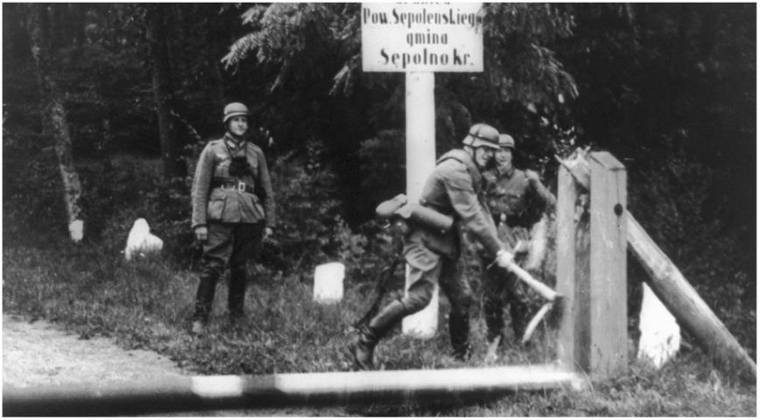 | - Adolf Hitler was the leader of the Nazi Party from 1918-1945 (his death and the end of World War 2).  - He ordered the German invasion of Russia on 22nd June 1941 after defeating France.  - Hitler wanted to expand his regime so invading Russia was a big win for Germany. It was also a further attack on the Jewish population in Europe.
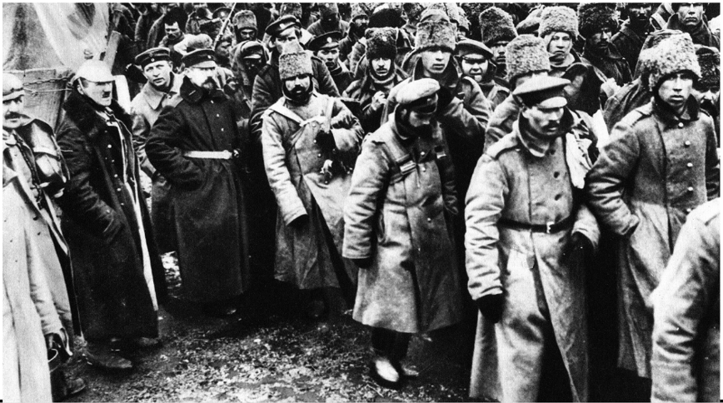 | - Russia’s ‘Red Army’, also known as the ‘Workers and Peasants’ army was established after World War 1 in 1918.  - During World War 2 many Russians, including women and children, joined the Red Army to fight against German occupation.  - During the war, many Russian civilians joined resistance movements, known as ‘partisans’. They helped the Red Army by giving them food and supplies and information about the whereabouts of German troops so they could be attacked.
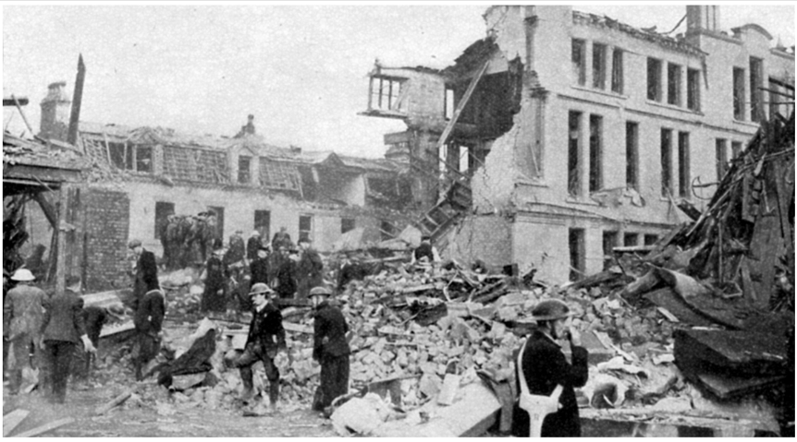 | - In the Russian city, Stalingrad, the Red Army fought the Germans from 23 August 1942 – 2 February 1943. This ended in German defeat and was a significant event that contributed to Germany losing the war.  - Berlin, the capital city of Germany, was attacked by the Red Army in April 1945. After a deadly battle, Berlin was defeated. This was the last major battle in World War 2 and was significant in ending the war.
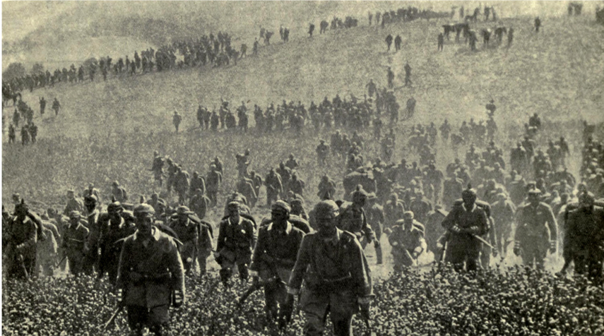 | - During World War 2, Germany, Italy and Japan were an alliance. They were known as the ‘Axis powers’. Their purpose was to have power and ownership of other countries.  - The rest of the world, including Australia, opposed these powers. These were known as the ‘Allies’ and were led by the United Kingdom (UK), United States of America (USA), Russia and China.
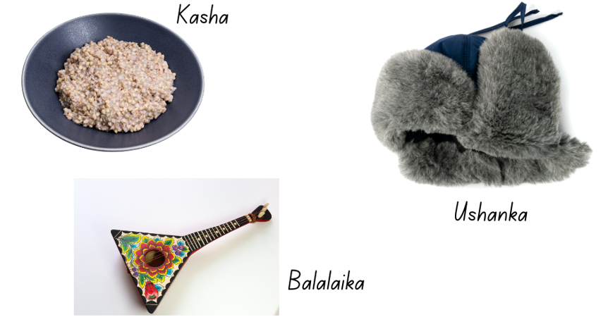 | - Kasha – Is a national dish of Russia. It is made from a grain called buckwheat and is similar to porridge.  - Balalaika – Is a Russian instrument. It is similar to a guitar, with a wooden triangular body and strings.  - Ushanka – Is a hat first worn by Russian troops during World War 2 to help keep them warm. It is now an iconic Russian symbol.

Resource 2 – discussion cards
Did you already know this information? Where did you learn about it? |  | Is this new information to you? |  | How does this information make you feel? |  | What does this information make you wonder or want to know more about?
Can you summarise this information? |  | What does this information make you think of? |  | How do you think these past events have shaped the world today? |  | What do you think it would be like to live in a time of war?

Resource 3 – Sergey Aleshkov information report
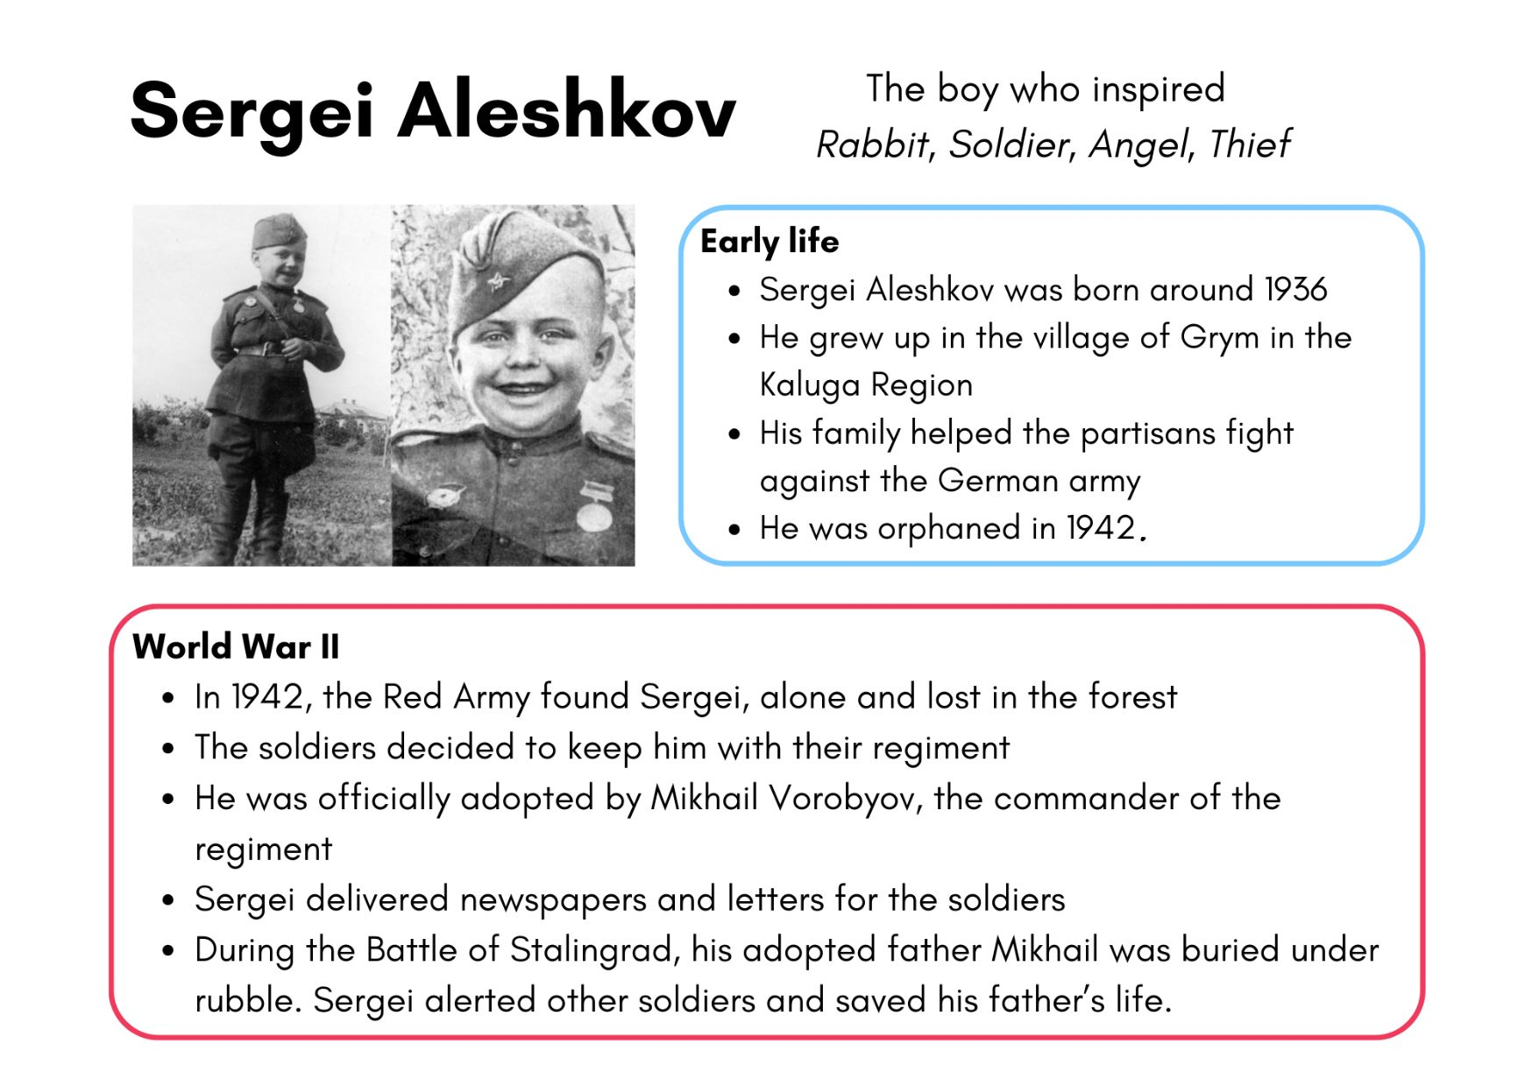
Source: Egorov B (2020)

Resource 4 – character profile
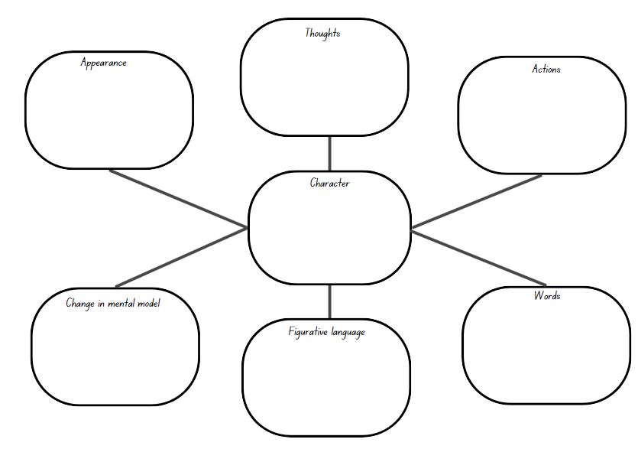

Resource 5 – Sasha’s important items
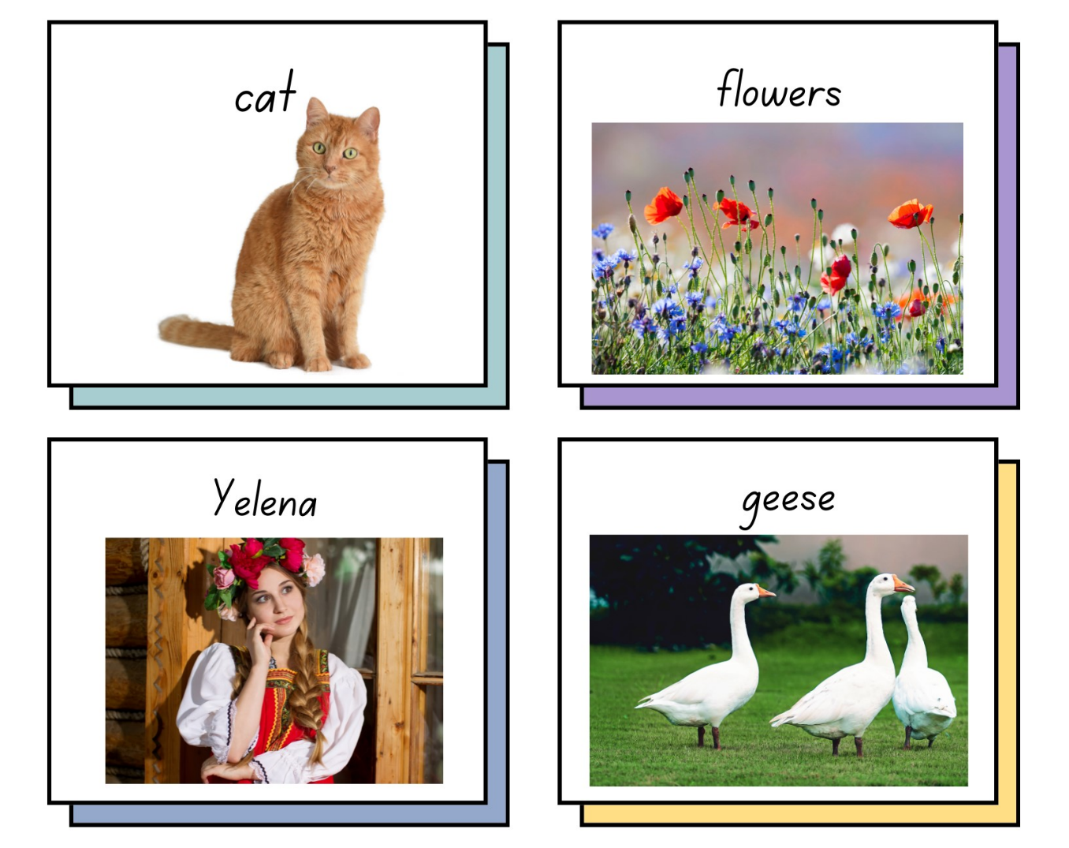

Resource 6 – Sasha
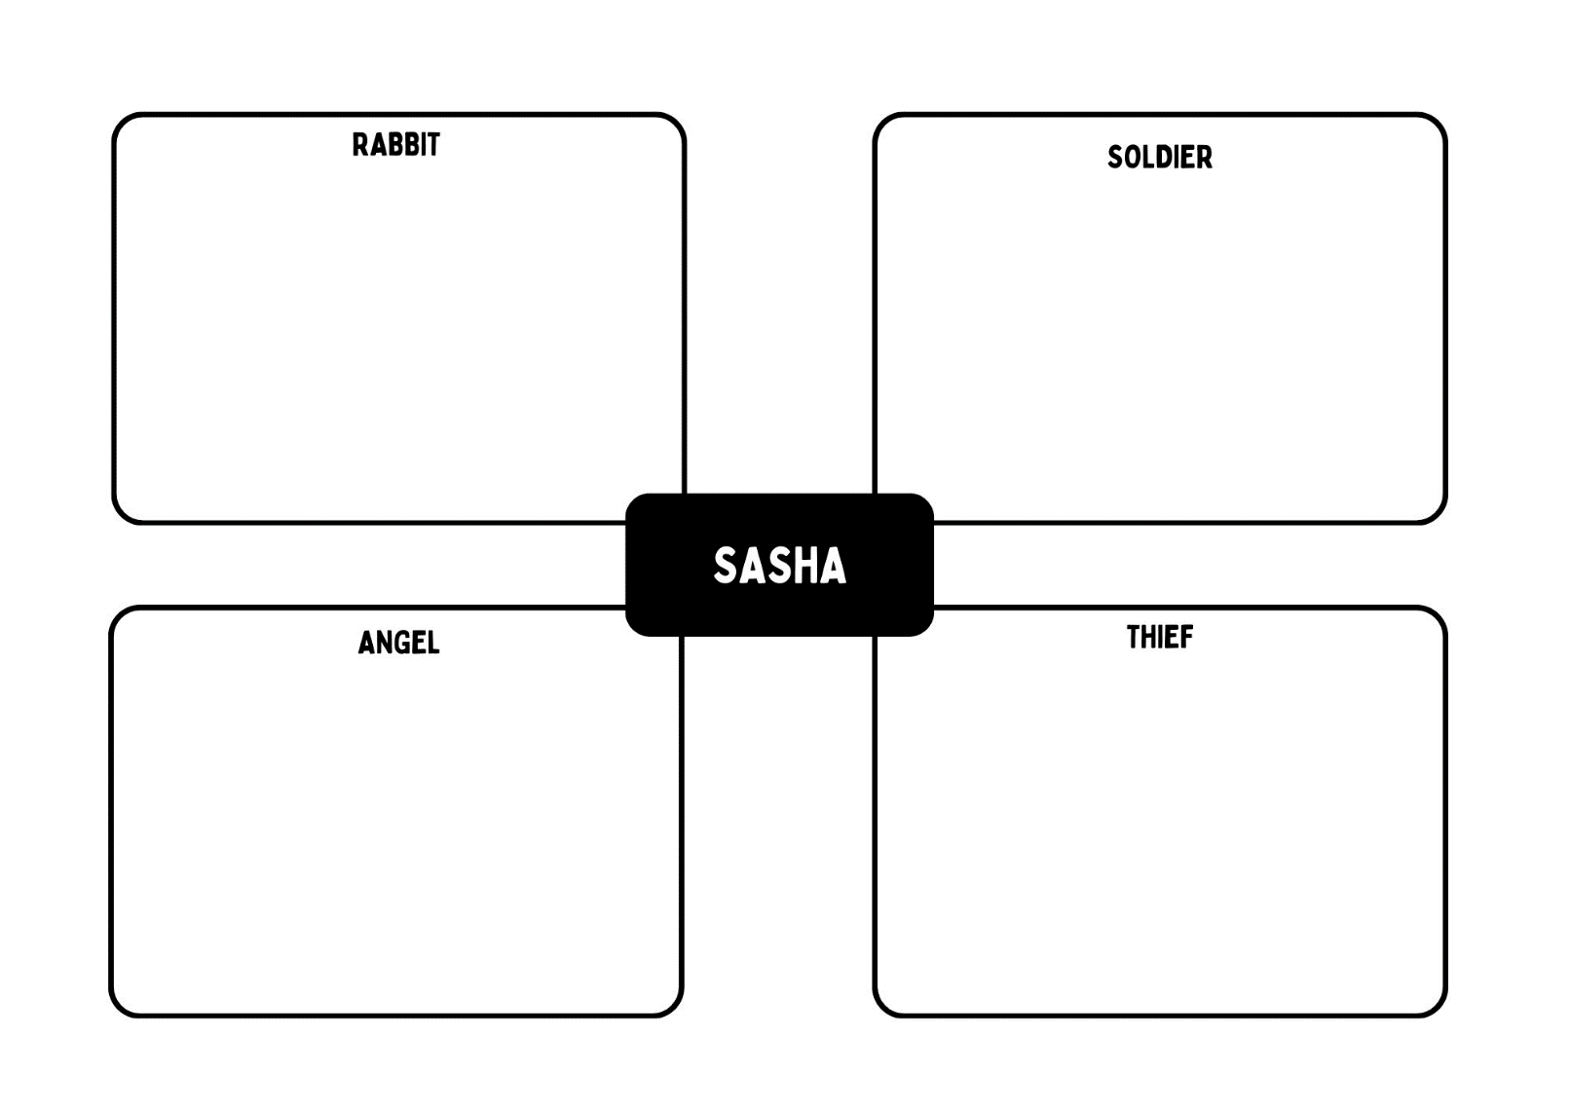

Resource 7 – modality words
Low modality | High modality
possibly | undoubtedly
perhaps | absolutely
potentially | ultimately

Resource 8 – image table
Collected item | Describe Sasha’s connection to the collected item | How does the collected item connect Sasha to other characters?

Resource 9 – writing plan
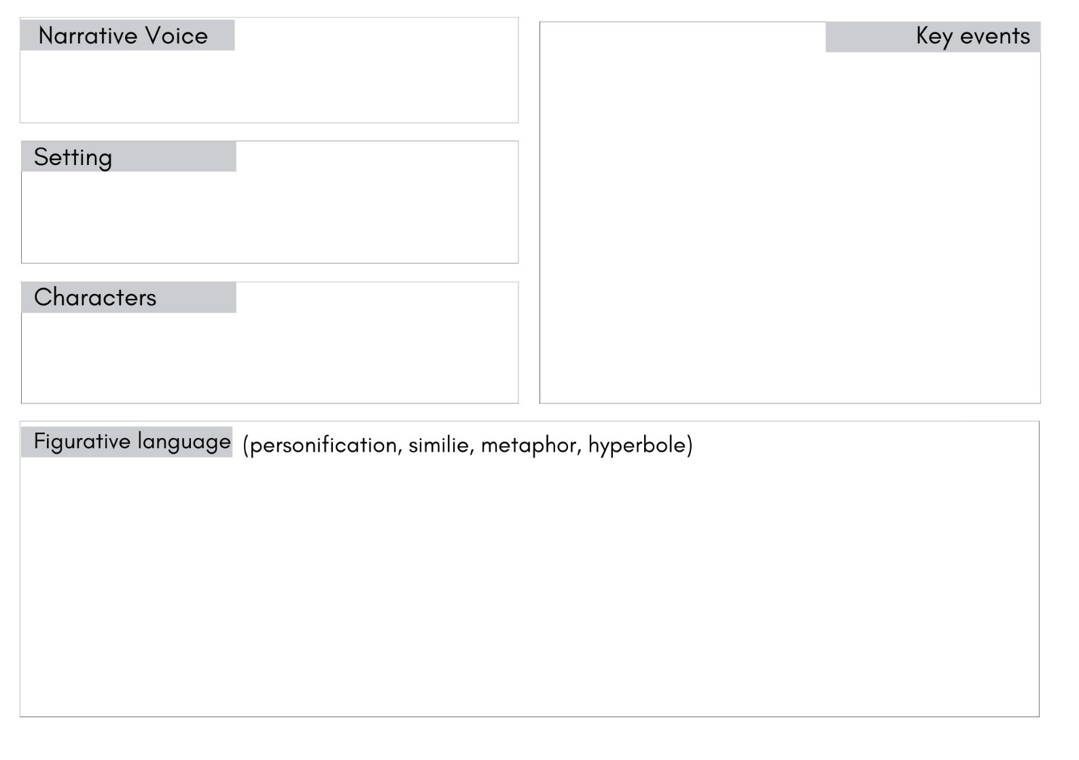

References
This resource contains NSW Curriculum and syllabus content. The NSW Curriculum is developed by the NSW Education Standards Authority. This content is prepared by NESA for and on behalf of the Crown in right of the State of New South Wales. The material is protected by Crown copyright.
Please refer to the NESA Copyright Disclaimer for more information. https://educationstandards.nsw.edu.au/wps/portal/nesa/mini-footer/copyright
NESA holds the only official and up-to-date versions of the NSW Curriculum and syllabus documents. Please visit the NSW Education Standards Authority (NESA) website https://educationstandards.nsw.edu.au/wps/portal/nesa/home and the NSW Curriculum website https://curriculum.nsw.edu.au.
English K–10 Syllabus © NSW Education Standards Authority (NESA) for and on behalf of the Crown in right of the State of New South Wales, 2022.
National Literacy Learning Progression © Australian Curriculum, Assessment and Reporting Authority (ACARA) 2010 to present, unless otherwise indicated. This material was downloaded from the Australian Curriculum website (National Literacy Learning Progression) (accessed 23 November 2023) and was not modified.
Egorov B (22 December 2020) ‘The six-year-old soldier who fought in WWII’, Russia Beyond, accessed 29 November 2023.
Fisher T (1941) Polish infantrymen on alert in a trench in Tobruk [photograph], Australian War Memorial website, accessed 27 October 2023.
HarperCollins Publishers (19 November 2021) ‘The true story that inspired Katrinna Nannestad's latest book, 'Rabbit, Soldier, Angel, Thief'’, HarperCollins Publishers Australia website, accessed 23 October 2023.
Imperial War Museums (2024) Growing Up In The Second World War, Imperial War Museums website, accessed 15 November 2023.
Moseley A (11 August 2020) ‘History of WWII’ [video], ABC, Behind the News website, accessed 23 October 2023.
NESA (NSW Education Standards Authority) (2023) ‘Glossary’, Resources, NESA website, accessed 23 October 2023.
Nannestad K (2021) Rabbit, Soldier, Angel, Thief, HarperCollins Publishers, Sydney.
President and Fellows of Harvard College and Harvard Graduate School of Education (2015) ‘Claim, Support, Question’, Resources: Thinking Routine Toolbox, Project Zero website, accessed 23 October 2023.

© State of New South Wales (Department of Education), 2023
The copyright material published in this resource is subject to the Copyright Act 1968 (Cth) and is owned by the NSW Department of Education or, where indicated, by a party other than the NSW Department of Education (third-party material).
Copyright material available in this resource and owned by the NSW Department of Education is licensed under a Creative Commons Attribution 4.0 International (CC BY 4.0) license.
This license allows you to share and adapt the material for any purpose, even commercially.
Attribution should be given to © State of New South Wales (Department of Education), 2023.
Material in this resource not available under a Creative Commons license:
- the NSW Department of Education logo, other logos and trademark-protected material
- material owned by a third party that has been reproduced with permission. You will need to obtain permission from the third party to reuse its material.
Links to third-party material and websites
Please note that the provided (reading/viewing material/list/links/texts) are a suggestion only and implies no endorsement, by the New South Wales Department of Education, of any author, publisher, or book title. School principals and teachers are best placed to assess the suitability of resources that would complement the curriculum and reflect the needs and interests of their students.
If you use the links provided in this document to access a third-party's website, you acknowledge that the terms of use, including licence terms set out on the third-party's website apply to the use which may be made of the materials on that third-party website or where permitted by the Copyright Act 1968 (Cth). The department accepts no responsibility for content on third-party websites.

