English Stage 2 – Unit 11

Contents
Unit overview and instructions for use 5
Teacher notes 7
Outcomes and content 9
Resources 17
Week 1 19
Component A teaching and learning 19
Planning framework 19
Component B teaching and learning 19
Learning intentions and success criteria 19
Learning intention 20
Success criteria 20
Lesson 1 – understanding authority 20
Lesson 2 – exploring argument and perspective 23
Lesson 3 – subjective and objective language and synonyms 26
Lesson 4 – understanding authorship and interrogative sentences 29
Week 2 33
Component A teaching and learning 33
Planning framework 33
Component B teaching and learning 33
Learning intentions and success criteria 33
Learning intention 34
Success criteria 34
Lesson 5 – investigating quoted and reported speech 34
Lesson 6 – using rhetorical questions for intentional effect 36
Lesson 7 – topic-specific vocabulary and subjective and objective language 39
Lesson 8 – point of view and mental models 43
Week 3 46
Component A teaching and learning 46
Planning framework 46
Component B teaching and learning 46
Learning intentions and success criteria 46
Learning intention 47
Success criteria 47
Lesson 9 – Ned Kelly’s point of view 47
Lesson 10 – Ned Kelly: hero or villain? 52
Lesson 11 – exploring modality in Ned Kelly and the Green Sash 54
Lesson 12 – sequencing argument points into paragraphs 56
Week 4 59
Component A teaching and learning 59
Planning framework 59
Component B teaching and learning 59
Learning intentions and success criteria 59
Learning intention 60
Success criteria 60
Lesson 13 – exploring salience through multimodal features 60
Lesson 14 – retrieving relevant information 63
Lesson 15 – planning a speech 66
Lesson 16 – drafting and composing 67
Week 5 69
Component A teaching and learning 69
Planning framework 69
Component B teaching and learning 69
Learning intentions and success criteria 69
Learning intention 70
Success criteria 70
Lesson 17 – finalising drafting and composing a script 70
Lesson 18 – editing 71
Lesson 19 – publishing and presenting a speech 73
Lesson 20 – reflecting on argument, authority, authorship and genre 75
Resource 1 – mental model boxes 78
Resource 2 – cards 79
Resource 3 – Venn diagram 82
Resource 4 – modality 83
Resource 5 – planning template 86
Resource 6 – writing process 87
References 88

Unit overview and instructions for use
In this 5-week unit, students will explore the mentor concept of ‘argument and authority’ as well as the supporting concept of ‘genre’ through a deep analysis of the text Ned Kelly and the Green Sash. Throughout the unit students will explore the difference between authority and authorship. They will develop a deeper understanding of rhetorical devices used to strengthen an argument to persuade an audience. Students will apply this knowledge when creating responses and written texts.
Outcomes and content in this unit are organised into Component A and Component B. The components are connected, with learning in Component A complementing learning in Component B.
Note: the duration of this unit can be adapted to suit individual school contexts. For example, learning could occur across 5 days rather than 4.
The table below highlights the focus areas and preparation required for Component A and Component B.
Teaching and learning | Component A | Component B
Suggested duration | 60 minutes × 4 days/week or equivalent | 60 minutes × 4 days/week or equivalent
Explicit teaching focus areas | Component A addresses content from the focus areas:  - Vocabulary  - Reading fluency  - Reading comprehension  - Creating written texts  - Spelling  - Handwriting and digital transcription  It centres on the development of foundational skills and knowledge through regular, systematic and repeated practice. | Component B addresses content from the focus areas:  - Oral language and communication  - Vocabulary  - Reading comprehension  - Creating written texts  - Understanding and responding to literature  It centres on the conceptual understandings of English and exemplifies the importance of learning about and enjoying literature through the study of quality texts.
Preparing for teaching and learning | - Specific teaching and learning activities need to be developed by the teacher. When planning for these activities, please refer to the Component A outcomes and content, teaching guides and planning frameworks.  - Plan and document how you will sequence teaching and learning in whole-class and targeted-groups across the 5-week cycle as required. This should be based on student needs identified through ongoing assessment data. | - Familiarise yourself with the mentor and supporting texts and textual concepts, and the teaching and learning sequence.  - Determine how you will support students in whole-class and targeted-groups across the 5-week cycle as required. This should be based on student needs identified through ongoing assessment data.
English K–10 Syllabus © NSW Education Standards Authority (NESA) for and on behalf of the Crown in right of the State of New South Wales, 2022.

Teacher notes
- Argument – a stated position about an idea. The way in which various dimensions of a text (such as theme, perspective and style) can be understood to represent a particular position on an issue.
- Authority – authority of a text: how trustworthy, authentic or valid an audience may find the representation of ideas, experiences, perspectives and arguments in a text. Authority over a text – The varying degrees to which the meaning of a text is controlled or constructed by its creator(s) and by its audience. (NESA 2023).
- Understanding of argument and authority can be supported through watching the department’s videos: Argument (3:17) and Authority (2:39).
- While ‘argument and authority’ is the mentor concept for the conceptual component of this unit, the supporting concept of ‘genre’ can be also be explored. Additional textual concepts may be included based on individual school context and student needs.
- For information on rhetorical questions, salience, quoted speech, reported speech, subjective language, objective language, rhetorical devices, interrogative sentences, modality refer to the NESA Glossary.
- In addition to the resources listed, students will require access to short passages of the mentor and/or supporting texts. Teachers can copy extracts from texts in reliance on the Statutory Text and Artistic Works Licence. Teachers need to attribute the extracts and include the following notice: ‘This material has been copied [and communicated to you] in accordance with the statutory licence in section 113P of the Copyright Act. Any further reproduction or communication of this material by you may be the subject of copyright protection under the Act. Do not remove this notice’.
- This unit could enhance student learning towards the achievement of history outcomes.
- Students may need prior knowledge on the purpose of a persuasive text, genre, Ned Kelly and bushrangers.
- Reflect on student learning and engagement in activities and record differentiation and adjustments within the unit to inform future teaching and learning. One way of doing this could be to add comments to the digital file.
- In NSW classrooms there is a diverse range of students including Aboriginal and Torres Strait Islander students, students learning English as an additional language or dialect, high potential and gifted students and students with disability. Some students may identify with more than one of these groups, or possibly all of them. Refer to Curriculum planning for every student – advice for further information.
- Content points are linked to the National Literacy Learning Progression version (3).
Levels and indicators sourced from National Literacy Learning Progression © Australian Curriculum, Assessment and Reporting Authority (ACARA), (accessed 11 September 2023) and was not modified. See references for more information.

Outcomes and content
The table below outlines the outcomes and content for this unit. The letters 'A' and 'B' in the header refer to Components A and B. The numbers 1 to 5 refer to weeks. The use of 'x' in these columns indicates where the content points are intended to be addressed and in which week.
Focus area and outcome, content points and National Literacy Learning Progression | A | B | 1 | 2 | 3 | 4 | 5
Oral language and communication
EN2-OLC-01 communicates with familiar audiences for social and learning purposes, by interacting, understanding and presenting
- Contribute to discussions with peers and stay on topic, build on others' ideas and express own ideas (InT4) |  | x | x | x | x | x | x
- Pose and respond to open-ended questions about literature that contribute to own or others’ enjoyment (InT5) |  | x | x | x
- Listen actively to identify spoken information, acknowledging the value of others’ contributions (LiS6) |  | x | x |  | x |  | x
- Understand that rhetorical questions can be used for intentional effect |  | x |  | x |  | x | x
- Identify the evidence a speaker provides to support a particular point of view |  | x |  |  | x
- State a reasoned argument in a presentation about learning area content, to a familiar audience (SpK5, SpK6) |  | x |  | x |  |  | x
Vocabulary
EN2-VOCAB-01 builds knowledge and use of Tier 1, Tier 2 and Tier 3 vocabulary through interacting, wide reading and writing, and by defining and analysing words
- Identify and explain the difference between synonyms and antonyms (SpK6) | x | x | x
- Recognise that words and phrases can have literal or implied meanings according to context (UnT7) | x | x | x | x | x | x | x
- Describe how modal words indicate degrees of probability, occurrence, obligation and inclination | x | x | x | x | x | x | x
- Understand and use language associated with digital texts | x | x |  | x | x
- Apply morphemic knowledge to change word meanings by adding different prefixes and suffixes to a base word or root | x |  | x |  | x | x
- Use word associations to build word knowledge |  | x |  |  |  | x
Reading fluency
EN2-REFLU-01 sustains independent reading with accuracy, automaticity, rate and prosody suited to purpose, audience and meaning
- Explain how effortless and accurate word reading, at a pace appropriate for text and purpose, can support reading fluency and comprehension | x |  |  | x | x
- Read multisyllabic words, phrases and continuous texts with accuracy and appropriate rate suited to reading purpose (FlY5, PKW8) | x |  | x | x | x | x | x
- Apply appropriate tone to represent characters’ emotions when reading text with dialogue (FlY5) | x |  | x | x | x | x | x
- Reflect on and compare differences between own oral reading fluency and silent reading fluency | x |  |  | x | x
- Monitor and adjust own goals for improving reading fluency | x |  | x |  |  | x | x
Reading comprehension
EN2-RECOM-01 reads and comprehends texts for wide purposes using knowledge of text structures and language, and by monitoring comprehension
- Select and read texts of personal interest and to gather information for learning (UnT7) | x |  | x |  | x
- Build topic knowledge, including key vocabulary, and activate background knowledge prior to and during reading (UnT7) | x | x | x | x
- Locate, select and retrieve relevant information from a print or digital text and consider accuracy of information presented | x | x | x | x | x | x | x
- Identify different structures and features of persuasive, informative and imaginative texts | x | x |  | x | x | x
- Identify and describe how text structure, features and language work together to achieve a text’s purpose | x | x |  | x | x | x
- Describe how multimodal features enhance meaning and salience in texts (UnT7) | x | x | x | x | x | x | x
- Identify the difference between quoted speech and reported speech | x | x | x | x | x | x | x
- Adjust own mental model as reading presents new words and understanding | x | x | x | x |  |  | x
- Link the meanings of words and phrases across consecutive sentences to support local inferencing | x |  |  | x | x
- Identify and describe the difference between subjective and objective language in texts (UnT7) | x | x | x | x
- Ask questions to clarify meaning and promote deeper understanding of a text (LiS6, UnT6) | x | x | x | x | x | x | x
Creating written texts
EN2-CWT-01 plans, creates and revises written texts for imaginative purposes, using text features, sentence-level grammar, punctuation and word-level language for a target audience
EN2-CWT-02 plans, creates and revises written texts for informative purposes, using text features, sentence-level grammar, punctuation and word-level language for a target audience
EN2-CWT-03 plans, creates and revises written texts for persuasive purposes, using text features, sentence-level grammar, punctuation and word-level language for a target audience
- Create written texts that argue a viewpoint using rhetorical devices to persuade an audience |  | x |  | x | x | x | x
- Use a structure that includes a statement of position, has sequenced paragraphs and a conclusion (CrT8) |  | x |  |  | x | x | x
- Sequence argument points in paragraphs that begin with a topic sentence and support the development of ideas (CrT8) |  | x |  |  | x | x | x
- Experiment with modality to modulate an argument for persuasive effect (CrT8) | x | x |  |  | x | x | x
- Use facts or opinions to reinforce a viewpoint (CrT8) |  | x | x | x | x | x | x
- Create cause-and-effect statements (CrT7) | x | x |  |  |  | x | x
- Use declarative sentences to provide facts or state a viewpoint | x | x |  | x | x
- Use interrogative sentences to ask a direct question, or for rhetorical effect to engage the reader with a viewpoint | x | x | x | x | x | x | x
- Understand and use quoted and reported text or speech in own writing | x | x | x | x | x | x | x
- Use topic-specific Tier 2 and Tier 3 vocabulary to demonstrate authority (CrT8) | x | x | x | x | x | x | x
- Experiment with modality to indicate probability, occurrence, obligation or inclination | x | x |  |  | x | x | x
- Create texts by drawing on personal and others’ experiences, and texts read, viewed and listened to for inspiration and ideas |  | x |  |  |  | x | x
- Reflect on and monitor texts according to given criteria, and respond to feedback from others |  | x |  | x | x | x | x
Spelling
EN2-SPELL-01 selects, applies and describes appropriate phonological, orthographic and morphological generalisations and strategies when spelling in a range of contexts
- Explain how to segment multisyllabic words into syllables and phonemes, and apply this knowledge when spelling (SpG7) | x |  | x | x | x | x | x
- Understand that some graphemes are dependent on their position in a word in English and apply this knowledge when spelling | x |  | x | x | x | x | x
- Understand that graphemes can be explained by their etymology | x |  |  | x |  |  | x
- Identify inflected suffixes, explaining when and how to treat base words when they are affixed, and apply this knowledge when spelling | x |  | x |  |  |  | x
- Identify derivational suffixes such as -able, -ness, -ian and -ment, explaining when and how to treat base words when they are affixed, and apply this knowledge when spelling (SpG9) | x |  |  |  | x | x | x
- Correctly spell irregular plural words across a range of written contexts | x |  |  | x
Handwriting and digital transcription
EN2-HANDW-01 forms legible joined letters to develop handwriting fluency
EN2-HANDW-02 uses digital technologies to create texts
- Sustain the NSW Foundation Style cursive to facilitate fluency and legibility across a text (HwK6) | x |  | x |  | x |  | x
- Position a chosen device in a way that facilitates efficient and sustained text creation | x |  |  | x |  | x
- Monitor goals that build on typing accuracy and rate | x |  |  | x |  | x
Understanding and responding to literature
EN2-UARL-01 identifies and describes how ideas are represented in literature and strategically uses similar representations when creating texts
- Recognise that an argument is not a dispute but can be a single perspective that is presented or defended (UnT7) |  | x | x | x | x | x | x
- Describe the difference between authorship and authority |  | x | x | x | x | x | x
- Understand that to control impact and effect authors make intentional choices about language, form and structure (UnT7) |  | x | x | x | x | x | x
- Identify different text genres when a text is characterised by more than a single genre |  | x | x | x |  |  | x
English K–10 Syllabus © NSW Education Standards Authority (NESA) for and on behalf of the Crown in right of the State of New South Wales, 2022.

Resources
The resources in the table below are referred to in this unit. Letters 'A' and 'B' in the header refer to Component A and B respectively, and the numbers 1 to 5 indicate weeks. The use of 'x' in these columns indicate whether the resources are required in Component A, B or both, and in which week.
Resource | A | B | 1 | 2 | 3 | 4 | 5
Greenwood M (2010) Ned Kelly and the Green Sash (F Lessac, illus) Walker Books, Australia. ISBN13: 9781922244598 | x | x | x | x | x | x | x
Resource 1 – mental model boxes (individual student copies) |  | x | x | x
Large strips of paper (4–6 strips per student) |  | x | x | x
A3 or large piece of paper |  | x | x | x | x
Large bag/container |  | x |  | x
Individual whiteboards |  | x |  |  | x
Resource 2 – cards (one copy for every 15 students) |  | x |  | x
Yellow, green and blue highlighter (for each student) |  | x |  | x
Resource 3 – Venn diagram (individual student copies) |  | x |  | x
Ned Kelly: Hero or murderer? Evidence files A-H (display copies digitally or in print) |  | x |  |  | x
Resource 4 – modality (enlarged copy and one copy for every 5 students) |  | x |  |  | x
Resource 5 – planning template (individual student copies) |  | x |  |  |  | x | x
Resource 6 – writing process (enlarged copy) |  | x |  |  |  | x | x

Week 1

Component A teaching and learning
Component A focuses on the development of foundational skills and knowledge through regular, systematic and repeated practice. The mentor and supporting texts used in Component B of this unit can support the effective implementation of Component A teaching and learning.

Planning framework
To plan and document Component A teaching and learning, a planning scaffold [DOCX 81 KB] is provided. To support you in your planning, a link to a detailed example of a one-week teaching and learning cycle is included in the scaffold. Additional resources to support teaching and learning in each focus area can be found at Lesson advice guides.

Component B teaching and learning
The following teaching and learning sequence has been designed to address Component B outcomes and content and develops conceptual understandings of English through the study of quality texts. Adapt the sequence as required to best meet the needs of your students.

Learning intentions and success criteria
Learning intentions and success criteria are best co-constructed with students.

Learning intention
Students are learning to understand and describe the difference between authorship and authority and to identify the genre of a text.

Success criteria
Students can:
- identify the purpose, authority and genre of a text
- explore the argument and perspective of a character
- describe and identify subjective and objective language in texts
- understand authorship and authority.

Lesson 1 – understanding authority
- Read the interesting facts about Ned Kelly and the Kelly Gang listed below. Students consider whether they are fact or fiction.
- A man wore a green sash every day until the day he died.
- As a young boy he saved a boy from drowning.
- This man wore armour that weighed over 40 kilograms.
- His father was deported from Ireland for stealing 2 pigs.
- He survived living in the bush.
- His favourite meal was lamb roast and green peas.
- Ask students if they think someone could have lived this life and what makes them say that. Explain that the facts are about Ned Kelly, who was one of 4 members of the Kelly Gang.
- Introduce Ned Kelly and the Green Sash. Keep the title concealed until Lesson 2. Read the first 2–3 sentences about each member of the Kelly gang, from the back of Ned Kelly and the Green Sash. Facilitate a discussion using the guiding questions:
- What is the purpose of these pages?
- What type of genre is this text? How do you know? (biographies)
- What genre conventions are used in the pages? For example, language choices, subject matter, form and purpose.
Genre: the categories into which texts are grouped are based on similarities in premise, structure and function. The ‘genre’ of a text describes larger recurring patterns of subject matter and textual structures observable between texts, such as typical plots, characters and setting. ‘Genre’ can also describe categories of form and structure in texts (NESA Glossary).
- Introduce the concept of ‘authority’ by explaining that authority of a text means how trustworthy and authentic the text is. Explain that, as a reader, it is important to ask questions such as whether the text was written by an expert or if it the text has been published by a reputable source. Authority over a text refers to who controls the meaning – the creator (author) and the reader or audience. A reader brings their own ideas and experiences that will have an impact on the meaning of the text. Explain that understanding authority is important as readers need to be critical thinkers. This will be revisited in Lesson 4.
- Display and read the final page of the text paying attention to the special thanks and sources sections. Discuss the types of texts that have been referenced. For example, ‘True History of the Kelly Gang’.
- Record examples that prove the text is a trustworthy and valid representation of information, using the final pages in the text. For example, the author has researched information from a variety of sources including the Benalla & District Historical Society and the Costume and Pioneer Museum.
- Explain that students will work in small groups to create a ‘biography analysis’ about one of the Kelly Gang members considering the following questions:
- Who is your Kelly Gang member?
- What information do you know about them?
- What key vocabulary describes their character?
- What questions do you have about the Kelly Gang member?
- In small groups, students complete a ‘biography analysis’ for one of the Kelly gang members using the Jigsaw strategy. Provide groups with a text excerpt from ‘The Kelly Gang’ from Ned Kelly and the Green Sash (back page).
- As groups present their biography analysis, guide students to ask questions to clarify meaning and understanding of authority such as:
- What information did the author need to write the biography?
- How does the author present the information?
- What do you think the author's intention was in writing the biographies?
- Are there parts of the biography where different readers might draw different conclusions about The Kelly Gang based on the available information?
- How did this task build your knowledge of the topic?

Lesson 2 – exploring argument and perspective
Optional activity: prepare a green sash to use whilst reading the narrative.
- Show students the image of Ned Kelly on the front cover of Ned Kelly and the Green Sash. Keep the title concealed with a piece of paper.
- Ask students to share their understanding of what a mental model is, remind students to draw on learning from Component A to elaborate on their thinking. Explain that a mental model is a mental representation of the information in a real or an imaginary world. Students will be provided with new information, that they will filter and store, as they read through the text. Model completing the prediction section of Resource 1 – mental model boxes. Explain that the ‘mental model 1’ section of the resource will be completed at the end of the lesson. The ‘mental model 2’ section of the resource will be completed in Lesson 8.
Since a coherent understanding of a text is built little by little, idea by idea, pedagogy should focus on supporting students to understand a portion of text at the point of reading and to assist them to see how ideas in previous text connect with current text. It involves the teacher reading aloud to the students and explicitly modelling the comprehension processes required to successfully build a mental model of the text – Reading Comprehension lesson advice guide (NSW Department of Education)
- Students complete the prediction section of Resource 1 – mental model boxes. Remove the piece of paper from the front cover to reveal the title of the text. Discuss:
- Why do you think the text has ‘the Green Sash’ in the title?
- What might Ned Kelly have to do with the green sash?
- What do you wonder about the green sash?
- Read the narrative section of Ned Kelly and the Green Sash. The newspaper articles will be read in Lesson 7.
- Pose questions, such as:
- Whose ‘side of the story’ is being told in the narrative?
- Do you think there could be another side to the story? How do you know?
- What emotions do you experience after reading this?
- What do you wonder about the text? What connections did you make with prior knowledge?
- Discuss that Ned Kelly’s ‘side of a story’ is called an argument.
Argument: a stated position about an idea. The way in which various dimensions of a text (such as theme, perspective and style) can be understood to represent a particular position on an issue (NESA Glossary).
- Students Think-Pair-Share how readers know that the author is betraying Ned Kelly’s perspective or ‘side of the story’. For example, the author intends to engage the readers’ empathy using personal pronouns such as I and my, to reveal the first-person narrative voice.
- Display and re-read the text on the 2 double-page spreads from ‘I was raised on the banks...’ to ‘…stealing from wealthy squatters.’ Ask how the author’s perspective helps readers connect with Ned’s story. For example, Ned Kelly and his family were poor and faced hardship. In the text, Ned Kelly said, ‘battled to scrape a living’, which tells the reader that life was not easy and they had to work hard. Ned Kelly believed the police did not care about him and his family and described them as ‘big-bellied unicorns’ that ‘showed no pity’. This shows that they were not wealthy and felt targeted by the police.
- Model writing a response to show that the narrative is based on Ned Kelly’s argument or ‘side of the story’. Include how the author uses personal pronouns and has written the narrative in first person voice to present Ned Kelly’s argument. For example:
The author of Ned Kelly and the Green Sash has written the text using first-person narrative voice and has written the text from Ned Kelly’s side of the argument. On these double pages, the author has used the personal pronouns I, my, and you. The pronouns help readers feel like Ned Kelly is talking directly to them, sharing his thoughts and feelings. Using first-person narrative helps readers understand how Ned Kelly sees the world and why he makes the choices he does.
- Display and re-read the 2 double-page spreads starting from ‘I turned twelve the following summer...’ to ‘... I’d give ‘em something to talk about.’ Ask students to consider the argument that Ned Kelly is presenting.
- Ask students to identify the argument that Ned Kelly presents to the reader. Students write a response to identify the argument identified. Responses should include examples from the text to support reasoning.
Too hard? Students provide an oral response to the question (this could be recorded).
Too easy? Students provide additional examples drawn from background knowledge or research.
- Discuss active listening skills and ways to value the contributions of others.
- In small groups, students share responses, staying on topic to discuss the argument that is shown throughout the text.
- Revisit Resource 1 – mental model boxes and ask students to consider how their mental model may have changed since the first prediction. Students complete the ‘mental model 1’ section of Resource 1 – mental model boxes.

Lesson 3 – subjective and objective language and synonyms
- Flick through the text Ned Kelly and the Green Sash and recall previous learning on argument and authority.
- Ask what Ned's opinion of the police was and how students know.
- Revisit the pages beginning with ‘My father was a convict…’ to ‘...blamed for stealing from wealthy squatters’ in the text and record examples of the language used to identify Ned’s feelings towards the police. For example, ‘brush with the law’, ‘traps’, ‘big-bellied unicorns’. Discuss:
- Why does Ned use this language to describe the police?
- What is the purpose of this language?
- What would be the impact on the reader if the author did not use this descriptive language?
- Revisit subjective and objective language, referring to Component A. Discuss whether the language Ned used to describe the police was subjective or objective. Ask how students know and what impact Ned’s language has on a reader. For example, Ned Kelly used subjective language to describe the police as he had a bias towards them. This language engages the reader and evokes emotions.
Subjective language: words used to communicate opinions, feelings and personal biases (NESA Glossary).
Objective language: language that is fact-based, measurable, observable, verifiable and unbiased. It does not include a speaker or writer’s point of view, interpretation or judgement (NESA Glossary).
- Select a subjective sentence from the double page. In pairs, students discuss why the language is subjective and how they know. For example, the author has used subjective language in the sentence, ‘...showed no pity...’, because this is Ned’s opinion of how the police see the Kelly family.
- Ask students to identify an objective sentence from the double page. For example, ‘... mare hidden among the river gums.’ This is a fact to describe where the mare was.
- Explain that the use of subjective language in the text requires the reader to consider whether it is literal or implied information. Draw students' attention to ‘big-bellied unicorns’, ‘fat-necked unicorns’, ‘wombat-headed, magpie legged, splay footed officers of justice’ and ‘snakes and toads’. Ask what these terms are referring to. Explain that these terms are not meant to be understood as literal meanings. Instead, the author’s purpose is for readers to understand the implied meaning and that Ned Kelly has a negative opinion towards the police. He is expressing this opinion by likening them to different mythical and real-life creatures.
Literal: having only the most direct meaning. For example, ‘It is raining very heavily’. (NESA Glossary)
Implied: additional information is drawn upon to decode what is being said. For example, ‘It is raining cats and dogs’. (NESA Glossary)
- Revise synonyms from Component A. Explain that the author chose to use synonyms to avoid repetition and to convey the emotions of Ned Kelly.
- Ask and discuss the following:
- Why does Ned call the police different names? What images do you see when you hear these words?
- What would the impact be if the author did not use synonyms?
- Is the language subjective or objective?
- What is the effect of the implied meaning of the language being used? How does this represent Ned Kelly’s relationship with the police?
- Identify and record synonyms the author has used in the text. For example, family – clan, misfortune – suffered, duffing – stealing, bushranger – fugitive.
- Explain that students will be writing sentences and then replacing some of the words with synonyms. These sentences will be written using subjective or objective language. Use images and language from the text to model writing sentences. Demonstrate rewriting the sentences using synonyms from activity 10. For example:
- Subjective: I was forced to become a bushranger. I was forced to become a fugitive.
- Objective: Dad was caught duffing a calf. Dad was caught stealing a calf.
- Students write subjective and objective sentences on individual strips of paper, using images and language from the text. Students rewrite their sentences using synonyms from activity 10, on separate strips of paper.
Too hard? Provide students with a scaffold to fill in the missing subjective and objective language.
- Revisit active listening skills and ways to value the contributions of others. In small groups, remind students to stay on topic as they share their sentences to express their understanding of subjective and objective sentences. Students group each sentence under the headings subjective and objective and circle the synonyms.
- Ask students to reflect on the impact synonyms have on the argument that the reader is presenting. For example, the author is engaging the reader by avoiding repetition and conveying the emotions of Ned Kelly. The author is trying to evoke emotion in the reader to sympathise and agree with Ned Kelly’s argument.
Assessment task 1 – observations from this lesson allow students to demonstrate achievement towards the following syllabus outcome and content points:
EN2-VOCAB-01 – builds knowledge and uses of Tier 1, Tier 2 and Tier 3 vocabulary through interacting, wide reading and writing, and by defining and analysing words.
- identify the difference between synonyms and antonyms.

Lesson 4 – understanding authorship and interrogative sentences
- Display an image of Mark Greenwood and introduce him as the author of Ned Kelly and the Green Sash. Share the following fun facts about Mark Greenwood:
- He is a ‘history hunter’.
- He loves writing history mysteries.
- When writing stories his inspirations are interesting characters, old photographs, places, times and events in history.
- He likes researching so he can present people with factual information and support it with his imagination.
- Introduce authorship. Explain to students that authorship is how a text is produced, it is the act of writing and creating. Authors use their language skills and creativity to write for others to read and enjoy. Authorship can also include others who contributed to a story.
- Revise authority. Draw attention to the concept of ‘authority’ by stating it includes how the meaning of the text is controlled or constructed by its creator(s) and by its audience. This is important to note as authors control the impact and effect a text has on its audience by making intentional choices about language, form and structure used. Remind students that understanding authority is important as readers need to be constructive and critical thinkers.
Authority of a text – How trustworthy, authentic or valid an audience may find the representation of ideas, experiences, perspectives and arguments in a text (NESA Glossary).
Authority over a text – The varying degrees to which the meaning of a text is controlled or constructed by its creator(s) and by its audience (NESA Glossary).
- Students explore how the author has controlled and constructed the meaning of the text using language and form. Students Think-Pair-Share using the following questions:
- What forms have been used in the text? (narrative, biographies)
- What language has the author used to develop the meaning of the text? (Language of police, language used in that time, descriptions of the Kelly Gang in biographies.)
Textual form: the conventions specific to a particular type of text, often signalling content, purpose and audience, for example letter form, drama script, blog (NSW DoE 2022).
- Explain that students will be writing a list of questions to ask the author to better understand how the ideas were crafted and created so that the text could be written.
- Revise that an interrogative sentence is a rhetorical device that asks a direct or indirect question, as taught in Component A. For example:
- to request information: What do you consider to be a bushranger's job?
- for rhetorical effect: How would you feel?
- for emphasis: How many more robberies do you need, really?
- As a class, co-construct 2 questions to ask the author, using an interrogative sentence. For example: Can you describe your creative process when you're working on a new text or story?
- Students create their own interrogative sentences to discover more from the author about creating and writing the text.
Too hard? Students orally construct their sentences.
- Students complete a question hunt by finding someone with a similar question to them. In pairs, students consider a relevant answer to the question.
- Explain that throughout this unit a success criteria will be developed that will be used to create a piece of writing that includes argument and authority based on a particular genre.
Note: display a piece of A3 or large piece of paper to co-construct a success criteria, throughout the unit.
- Discuss what has been learned in the previous 4 lessons that will support future writing. Add to the success criteria. For example:
- identify the difference between subjective and objective language
- use interrogative sentences to ask a direct question or for rhetorical effect.

Week 2

Component A teaching and learning
Component A focuses on the development of foundational skills and knowledge through regular, systematic and repeated practice. The mentor and supporting texts used in Component B of this unit can support the effective implementation of Component A teaching and learning.

Planning framework
To plan and document Component A teaching and learning, a planning scaffold [DOCX 81 KB] is provided. To support you in your planning, a link to a detailed example of a one-week teaching and learning cycle is included in the scaffold. Additional resources to support teaching and learning in each focus area can be found at Lesson advice guides.

Component B teaching and learning
The following teaching and learning sequence has been designed to address Component B outcomes and content and develops conceptual understandings of English through the study of quality texts. Adapt the sequence as required to best meet the needs of your students.

Learning intentions and success criteria
Learning intentions and success criteria are best co-constructed with students.

Learning intention
Students are learning to explore language features and how they impact different perspectives within a text.

Success criteria
Students can:
- understand and use quoted and reported speech
- use rhetorical devices for effect, in writing
- identify and use topic-specific vocabulary
- identify subjective and objective language
- compare different perspectives presented in a text.

Lesson 5 – investigating quoted and reported speech
- Read the pages with the heading ‘The Green Sash’ towards the end of Ned Kelly and the Green Sash. Provide time for students to ask any questions to clarify understanding. Reiterate that effective readers ask and respond to open-ended questions for enjoyment and to monitor comprehension, referring to Component A.
- Students turn and talk with a partner answering the following questions:
- Why has the author included ‘The Green Sash’ information?
- How does the information on the ‘The Green Sash’ page support the authority of the text?
- Ask if Ned Kelly is a hero or a villain. Allow thinking time and discuss. Ask students to explain their reasoning.
- Students write their opinion as to whether Ned Kelly is a hero or villain. Encourage students to explain their reasons to support their opinion.
Note: this will be used in Lesson 10.
- Explain that quoted speech is the exact words expressed by a person, referring to learning from Component A. For example, Ned Kelly said “Such is life.” Explain that reported speech is used in texts to communicate what someone said, without using the exact words. For example, Ned Kelly said he was seeking no mercy for himself but wanted justice for his mother.
- Explain that authors intentionally choose to use quoted and reported speech throughout a text to create atmosphere, help control the impact, and effect it has on the reader.
- Display the double page beginning with ‘That evening a buggy pulled up…’ and explain that the author has used quoted and reported speech to communicate what was being said. For example:
- “You’re a plucky lad for saving my son,” he said. (quoted)
- Ma said it was the grandest sash she’d ever seen. (reported)
- Model turning a reported speech sentence into quoted speech. For example, “It is the grandest sash I have seen,” said Ma.
- Explain that students will be writing dialogue between the siblings behind the curtain, using quoted and reported speech.
- In small groups students brainstorm and discuss what the siblings might be saying to each other as they watch Ned receive the green sash. Ask students to share their ideas.
- Co-construct the start of the dialogue between some of the siblings using quoted and reported speech.
- Students continue to write the remainder of the dialogue.
Too hard? Provide students with a word bank to write the dialogue.
Too easy? Students enhance their writing by using synonyms for ‘said’, considering the impact on the reader.
Optional: in small groups, students share and discuss their writing and select one to re-enact. Provide time to practise and present to the class.
- Refer to displayed co-constructed success criteria and discuss what will be useful for writing. Add to success criteria. For example:
- use quoted and reported speech in their writing.

Lesson 6 – using rhetorical questions for intentional effect
- Introduce rhetorical questions as ‘a question that is asked to provoke thoughts rather than an answer’. Explain that they are a rhetorical device used to convey a viewpoint. Read the sentence ‘I do not wish to win a word of pity, but I ask that my story be heard and considered.’ This sentence implies that Ned Kelly wants people to listen to his story. Model writing this as a rhetorical question. For example, ‘Will you listen and consider my story?’ Explain that this question does not need to be answered but provokes the readers thoughts.
- Explain that rhetorical devices are used to convey a viewpoint and make arguments clearer, more logical or convincing, or create atmosphere. Locate rhetorical devices used within the text, such as:
- Exaggeration (hyperbole): a statement making something seem more extreme or dramatic than it is. For example, ‘My character could not be painted blacker...’
- Imagery: language that represents objects, characters, actions or ideas in such a way that they appeal to the senses of the reader. For example, ‘...water so icy cold it stole my breath.’
- Irony: a clash between what words say and what they mean. For example, ‘Fire away. You can’t hurt us.’
- In small groups, students consider what rhetorical devices they could add to improve their rhetorical questions from activity 3. Using a different colour, students add one or 2 other rhetorical devices to their question.
- Display the image of the train approaching the station at Glenrowan and read the text on the double-page spread from ‘Beyond the station at Glenrowan...’ to ‘... and quickly surrounded the inn.’
- Discuss the characters on the double-page spread and how they were involved in the event that occurred at Glenrowan.
- In pairs, students create an oral statement based on the events that unfolded at Glenrowan Station, using Resource 2 – cards. Students will need:
- one yellow card (character)
- one blue card (rhetorical device) to demonstrate that rhetorical devices can be used intentionally to convey an argument
- one green card (for or against Ned Kelly).
- Each pair selects 3 cards. Provide time for students to develop their oral statement.
- Each pair presents their statement to the class and then ask their peers the following questions:
- Who was the character being portrayed?
- What rhetorical devices were used?
- Was the argument for or against Ned Kelly?
- Students write their oral statement to include the character’s argument, using the cards selected in activity 9. Use highlighters to show the character in yellow, the rhetorical device in blue and the argument in green. For example:
- Character: Ned Kelly
- Rhetorical device: rhetorical question and exaggeration
- Argument: for.
I am Ned Kelly, and I am without a doubt innocent. I am the best bushranger Australia has ever seen! Will you listen to my story?
Too hard? Co-construct the writing using sentence stems ‘I am (character name) and I believe...’
Too easy? Students use background knowledge or researched facts to strengthen the character's argument.
- Refer to displayed co-constructed success criteria and discuss what will be useful for writing. Add to success criteria. For example:
- use rhetorical devices.
Assessment task 2 – observations from this lesson allow students to demonstrate achievement towards the following syllabus outcome and content point:
EN2-OLC-01 – communicates with familiar audiences for social and learning purposes, by interacting, understanding and presenting
- understand that rhetorical questions can be used for intentional effect.

Lesson 7 – topic-specific vocabulary and subjective and objective language
- Read the first 2 newspaper articles in Ned Kelly and the Green Sash titled ‘Outlaws of the Wombat Ranges’ and ‘Murder of Police’. Facilitate a discussion using the following questions:
- What is the author's perspective in these articles? How do you know?
- Why do you think the newspaper articles used so many images?
- Why do you think the language of Ned’s narrative/story is different to the language in the newspaper article?
- Revisit the meaning of authority and inform students that the information presented in the ‘Murder of Police’ newspaper article is authentic information. Display the newspaper article Bushranging in Victoria: The Argus Monday October 28th and the transcript to highlight how the information in the text has been researched and is a valid representation of what was reported at the time of the events. Discuss the digital pathway followed to link to this information, using correct terminology. For example, follow the hyperlink which leads to a website that opens in an additional tab.
- Read the first few sentences of the online article.
Note: when reading the transcript online, click on the text and the lines in the newspaper article will be highlighted.
- Compare the language used in the online article to the newspaper articles in Ned Kelly and the Green Sash. Draw out the common vocabulary. For example, ruffians, intelligence. Categorise and record the vocabulary into Tier 2 and Tier 3 words. Display. For example:
- Tier 2: bushrangers, Stringybark, police, gunfight, offenders, criminal, intelligence, train, stealing, Kelly
- Tier 3: Constable, notorious, Sergeant, mounted patrol, revolver, mortally, imprisoned, warrant, ruffians.
Tier 2 words: general academic words that can be used across a variety of domains. They are of high utility for mature language users and are commonly used in written language. Tier 2 words add power and precision to written and spoken language but many Tier 2 words are most commonly found in written language (NESA Glossary).
Tier 3 words: words that are used rarely (low frequency) and only in highly specific situations (NESA Glossary).
- Remind students that topic specific vocabulary can be used to demonstrate authority. Ask how the author’s use of vocabulary adds to the authority of Ned Kelly and the Green Sash. For example, the use of vocabulary in the text adds to the validity and reliability of the information.
- Refer to the 2 articles already read in Ned Kelly and the Green Sash. Ask:
- What is the purpose of these articles? (To inform and persuade.)
- What type of genre are the articles and how do you know?
- Do you think the articles are a trustworthy and valid representation of information? Why or why not?
- What connections can be made between the narrative text and the newspaper articles?
- Identify and discuss the different structures and features between the narrative text and the newspaper articles. Draw attention to the features and language used in both. For example:
The narrative text is written from Ned Kelly’s point of view and is persuading you to believe his story. The language is less formal and there is dialogue. The newspaper articles are informative and are also being used to persuade the reader that the Kelly Gang are not who they say they are. The language is informative. There are headings and captioned pictures.
- Revise objective and subjective language from Lesson 3. Fold and display a large piece of paper in half, creating 2 columns with the headings objective language and subjective language.
- Re-read the newspaper articles. Identify and write examples of objective and subjective language in the correct columns on the paper.
- Model writing a sentence using subjective language and a sentence using objective language from the reporters’ perspective. For example, ‘The Kelly’s are wreaking havoc across the community and are a menace to society!’ (subjective). ‘Mrs Kelly was sentenced to three years in prison.’ (objective). Refer to displayed Tier 2 and Tier 3 vocabulary from activity 3 and the subjective and objective language.
- Divide the class into 2 groups and provide students with strips of paper. Each student in Group 1 records sentences from the reporter’s point of view that contain subjective language. Each student in Group 2 records sentences from the reporter’s perspective that contain objective language. Encourage students to include Tier 2 and Tier 3 vocabulary in their sentences. Refer to displayed Tier 2 and Tier 3 vocabulary from activity 3.
- Students place their sentences in a large bag or container.
- Explain that one side of the room represents subjective language, and the other side of the room represents objective language. Students listen to the sentence read and select whether it is subjective or objective language. Students move to the side of the room that represents their response. If students are unsure, they can stand in the middle of the room.
- Select and read some sentences from the bag or container. Students identify whether each sentence contains subjective or objective language by moving to the relevant side of the room. Discuss, sort and display sentences.
- Explore the impact of objective and subjective language choices made by the author. For example, subjective language allows authors to convey their emotions, feelings, and personal opinions about a subject. It helps create a connection with the reader by sharing the author's perspective, beliefs, and experiences. Objective language is used to present facts and information in a clear and unbiased manner. It helps authors maintain accuracy and credibility in their writing,
- Refer to displayed co-constructed success criteria and discuss what will be useful for writing. Add to success criteria. For example:
- use topic-specific vocabulary.
Assessment task 3 – observations and work samples from this lesson allow students to demonstrate achievement towards the following syllabus outcome and content point:
EN2-RECOM-01 – reads and comprehends texts for wide purposes using knowledge of text structures and language, and by monitoring comprehension
- build topic knowledge, including key vocabulary, and activate background knowledge prior to and during reading
- identify and describe the difference between subjective and objective language in texts.
EN2-CWT-03 – plans, creates and revises written texts for persuasive purposes, using text features, sentence-level grammar, punctuation and word-level language for a target audience
- use topic-specific Tier 2 and Tier 3 vocabulary to demonstrate authority.

Lesson 8 – point of view and mental models
- Read the newspaper articles in Ned Kelly and the Green Sash titled ‘The Kelly Gang at Euroa’ and ‘Another Outrage by The Kelly Gang’. Consider the accuracy of information and ask students to explain why they do or do not think the information in the newspaper articles is or is not accurate, referring to learning from Component A.
- Discuss and record the different points of view from the text. For example, the point of view of the reporters, the police, the community, the Kelly family. Ask:
- What perspectives does the author provide the reader?
- What devices does the author use to reiterate these perspectives? For example, the language, newspaper articles, illustrations.
- How does the author convey these perspectives? For example, through the characters point of view.
- Why can people at the same event have different points of view?
- Why is it important for the reader to understand the different points of view?
- Display Resource 3 – Venn diagram and explain that students will complete a comparison by recording similarities and differences of how Ned Kelly is viewed by himself and the newspaper reporters.
- Model writing one point in each section of Resource 3 – Venn diagram.
- Students complete Resource 3 – Venn diagram.
Too hard? Students write one word for each section of the Venn diagram and draw a picture to explain it.
- Revise and model writing a gist statement about the point of view of the reporters. For example, Ned Kelly is a daring thief and legendary outlaw.
Gist statements: succinct thoughts and information that capture the generalisations gleaned from what has been read, heard or viewed (NESA Glossary).
- Students record gist statements about the points of view of Ned Kelly and the reporters, referring to the Venn diagram. These will be used again in Lesson 9.
- Students share their Venn diagram and gist statements. Explain that once the Venn diagrams are shared, students can build on each other’s ideas and they may add more details to their Venn diagram.
- Ask students how their mental model of the text has changed and what made it do so.
- In pairs, students use facts from the text or their opinions to share if their ideas about the text have changed using I Used to Think... Now I Think... statements. Select groups to share ideas.
- Explain that good readers adjust their mental model as they develop a deeper understanding or different perspective of a text, as taught in Component A. Students complete final section of Resource 1 – mental model boxes.
Assessment task 4 – observations and work samples from this lesson allow students to demonstrate achievement towards the following syllabus outcome and content point:
EN2-RECOM-01 – reads and comprehends texts for wide purposes using knowledge of text structures and language, and by monitoring comprehension
- adjust own mental model as reading presents new words and understanding.

Week 3

Component A teaching and learning
Component A focuses on the development of foundational skills and knowledge through regular, systematic and repeated practice. The mentor and supporting texts used in Component B of this unit can support the effective implementation of Component A teaching and learning.

Planning framework
To plan and document Component A teaching and learning, a planning scaffold [DOCX 81 KB] is provided. To support you in your planning, a link to a detailed example of a one-week teaching and learning cycle is included in the scaffold. Additional resources to support teaching and learning in each focus area can be found at Lesson advice guides.

Component B teaching and learning
The following teaching and learning sequence has been designed to address Component B outcomes and content and develops conceptual understandings of English through the study of quality texts. Adapt the sequence as required to best meet the needs of your students.

Learning intentions and success criteria
Learning intentions and success criteria are best co-constructed with students.

Learning intention
Students are learning to identify and use facts or opinions to justify written arguments from a single perspective.

Success criteria
Students can:
- respond to Ned Kelly’s point of view
- write texts that argue a viewpoint from the author’s perspective
- use modality to enhance an argument
- sequence argument points into a paragraph.

Lesson 9 – Ned Kelly’s point of view
- Read the first ‘gaol cell’ page of Ned Kelly and the Green Sash. Ask students to explain why they think the author chose to start the text this way.
- Open the Behind the News interview: Ned Kelly (0:00-2:03). In pairs, students discuss the digital pathway followed to link to this information, using correct terminology. For example, follow the hyperlink which leads to a website that opens in an additional tab.
- Watch the Behind the News interview: Ned Kelly (0:00-2:03).
- Ask how Ned portrays his perspective in the interview. Revise that an argument is not always a dispute but is how someone can defend their point of view.
- Revise interrogative sentences, from Component A and Lesson 4. Explain that students will be reporters and that they will create interrogative sentences to ask Ned Kelly his point of view of events or actions. For example, students could ask if Kelly thinks being called a ruffian and scoundrel is fair and why/why not.
- Remind students that when readers ask open-ended questions, they can gain a deeper understanding of a character and/or text, referring to content taught in Component A.
- Students write interrogative sentences to ask Ned Kelly about his thoughts and point of view.
- In small groups, students share their interrogative sentences and discuss possible responses. Students choose one person to be Ned Kelly, while the remainder of the group act as reporters asking their questions, allowing time for Ned Kelly to respond to each question. The student acting as Ned draws on information from the text and the newspaper articles explored in previous lessons to answer questions. Students record key words and phrases from the responses. Students may swap roles after multiple questions.
- Discuss the different views that have been presented throughout the newspaper articles in the text. Students refer to Venn diagrams from Lesson 8.
- Display and revise the co-constructed success criteria from Lesson 4, Lesson 5 and Lesson 6. Explain that students will refer to this to complete the writing task.
- Students write a response to the newspaper articles from Ned Kelly’s point of view. Students choose a modern form of communication (for example, blog, email) to write this response justifying Ned Kelly’s point of view.
- Model writing a response to a newspaper article using a focus from the success criteria such as rhetorical devices and interrogative sentences. Refer to samples of recorded key words from activity 8. For example:

To the reporters at The Argus,
I have read your opinions of me in your newspaper articles, do you even know my side of the story? I think you need to understand my life some more. I offered to give myself up in return for my mother’s freedom. They could have had me! Those scoundrels ignored me! I tried my very best to please those big-bellied unicorns but that didn’t work now, did it?
‘Top ranking officers’ you say? I don’t think so, they didn’t catch me! You call me a menace, bloodthirsty offender, outlaw and a scoundrel but you don’t know my story and how hard my life has been! My family has weathered the storm of injustice countless times. I was like a knight using my armour to protect my family. I hope that someday you might soften the blow and tell my true story.
Such is Life.
Ned Kelly
Condemned Cell, Melbourne Gaol, 2023
- Students write a response from Ned Kelly’s point of view referring to the success criteria from Lesson 4, Lesson 5 and Lesson 6 as a guide. Refer to samples of recorded key words from activity 8.
Too hard? Students use a sentence starter or scaffold.
Too easy? Students write a response using language and structure, similar to the gaol cell pages in the text.
- Select students to present their response to the class.
Assessment task 5 – observations and work samples from this lesson allow students to demonstrate achievement towards the following syllabus outcomes and content points:
EN2-OLC-01 – communicates with familiar audiences for social and learning purposes, by interacting, understanding and presenting
- pose and respond to open-ended questions about literature that contribute to own or others’ enjoyment
- identify the evidence a speaker provides to support a particular point of view.
EN2-VOCAB-01 – builds knowledge and uses of Tier 1, Tier 2 and Tier 3 vocabulary through interacting, wide reading and writing, and by defining and analysing words.
- understand and use language associated with digital texts.
EN2-RECOM-01 – reads and comprehends texts for wide purposes using knowledge of text structures and language, and by monitoring comprehension
- ask questions to clarify meaning and promote deeper understanding of a text.
EN2-CWT-03 – plans, creates and revises written texts for persuasive purposes, using text features, sentence-level grammar, punctuation and word-level language for a target audience
- use interrogative sentences to ask a direct question, or for rhetorical effect to engage the reader with a viewpoint.

Lesson 10 – Ned Kelly: hero or villain?
- Ask if students think Ned Kelly is a hero or villain. Students use the Conscience alley technique to consider an argument for this statement. Students identify whether they think Ned Kelly was a hero or a villain, using evidence to support their opinion.
- Introduce Ned Kelly: Hero or criminal? and explore the information in the following sections:
- In a snapshot
- How was the Kelly Gang formed?
- What happened at Stringybark Creek?
- The Glenrowan siege: did the Kelly Gang survive?
- Hero or criminal?
- Discuss the following questions in relation to the website:
- What perspective is conveyed on the website?
- How does the reader’s knowledge of the events change their perspective of the website?
- What is the purpose of these articles?
- What type of genre is this text? How do you know?
- How do we know that the text is a trustworthy and valid representation of information? What examples can you identify?
- Identify and discuss the different structures and features between the narrative text, the newspaper articles and the website. Draw attention to the features and language used on the website and make comparisons with the narrative text and the newspaper articles from Lesson 7.
- Revise that a declarative sentence is a statement presented as a complete sentence to provide fact, evidence or detail, expanding on content taught in Component A. Identify examples of declarative sentences to provide fact or state a viewpoint from Ned Kelly: Hero or criminal?
- Explain that students will participate in a Hero or Villain detective task. They will form opinions based on the evidence that is presented to them. For example, Evidence file B – Ned Kelly is a villain as he served 3 years in prison and all the members of the Kelly Gang had criminal records.
- Display evidence sets from Ned Kelly: ‘Hero or murderer?’ Evidence files A–H in digital or print form around the classroom. Students' complete a gallery walk to read each set and record the title of the evidence set and key words to represent their thoughts and opinions.
- Students revisit their opinion about whether Ned Kelly is a hero or villain from activities 1 and 2. Ask students if their opinion has changed and, if so, how and why it has changed. Prompt students to use the evidence sets and/or information from Ned Kelly and the Green Sash to support their arguments.
- Model using evidence from the text and/or website (evidence sets) to support writing an argument, using declarative sentences. For example, Ned Kelly is a hero because he saved Richard Shelton from drowning in the rapids.
- Ask student to share their thinking for argument points and model building on ideas. Students write argument points in response to the question ‘Was Ned Kelly a hero or a villain?’ including declarative sentences and a reference to the evidence to support their argument. This will be used in Lesson 11 to write a paragraph.
Too hard? Provide students with 2 sentence starters such as ‘Ned Kelly was a hero because …’
- Students find a peer with a different opinion and compare supporting evidence, using active listening skills while valuing the opinions of others.
- Refer to displayed co-constructed success criteria and discuss what will be useful for writing. Add to the success criteria. For example:
- create written texts that use facts or opinions to reinforce a point of view.

Lesson 11 – exploring modality in Ned Kelly and the Green Sash
- Ask students to share what they know about modality from previous learning. Explain that the author of Ned Kelly and the Green Sash, Mark Greenwood, uses modality to add depth and complexity to writing, to express a particular point of view and engage readers. Modality forms a continuum from high modality (always, must) to low modality (might, could) and is used to enhance and strengthen arguments.
- Identify examples of sentences from the text that contain modality. For example, could, will, would. Display a 4-column chart with the headings ‘probability’, ‘occurrence’, ‘obligation’ and ‘inclination’, on a large piece of paper. This will be used to support future writing.
- Explain that good writers consider the impact that the choice of modality will have on their writing. Modal words can be categorised under 4 headings:
- Probability: helps convey the level of certainty or possibility associated with a particular statement, for example, certainly, definitely, surely
- Occurrence: indicates the occurrence or non-occurrence of an event, for example, always, never, consistently
- Obligation: expresses a sense of duty or something that is required, for example, must, have to, ought to, should
- Inclination: expresses a personal preference or willingness to do something, for example, want, wish, would like to.
- Distribute word cards from Resource 4 – modality. As a class, sort and place the words cards under the correct heading on the 4-column chart, see teacher resource in Resource 4 – modality. Ask students to consider and explain why it is important to understand and use different modal words. For example, to make an argument point stronger and to persuade an audience.
- The students select a modal word to write in a sentence, on individual whiteboards. For example, certainly – ‘I can certainly help you with your homework.’
- Model rewriting and building on the argument to persuade, using modal words. Referring to the argument points from Lesson 10, ‘Ned Kelly is a hero because he saved Richard Shelton...’ For example:
Ned Kelly must be remembered as a hero. He eagerly saved Richard Shelton from drowning in the rapids. Ned Kelly always showed courage and bravery.
- Underline and label the modal words used. Discuss how these words have strengthened the argument for persuasive effect. For example:
Ned Kelly must (obligation) be remembered as a hero. He eagerly (inclination) saved Richard Shelton from drowning in the rapids. Ned Kelly always (occurrence) showed courage and bravery.
Note: keep the modelled sentences for Lesson 12.
- Students revisit their argument points from Lesson 10. Students rewrite their argument points to include modal words in their writing. Remind students to refer to the class display created in activity 6 to strengthen their arguments for persuasive effect.
Too hard? Provide students with sentence strips and a word bank of modality words. Students insert the missing modality word into the sentence strip.
- In pairs, students share their arguments and underline and label the modal words used.
- Refer to the displayed co-constructed success criteria and discuss what will be useful for writing. Add to success criteria. For example:
- use modal words when writing to strengthen an argument for persuasive effect.

Lesson 12 – sequencing argument points into paragraphs
- Review the displayed 4-column modality chart. Remind students that these words are used to strengthen an argument for persuasive effect.
- Revise topic sentences by asking students to recall what they know. Remind students that topic sentences introduce the main subject or topic of the paragraph and provide a clear focus for the information that follows. Explain that when writing an argument, a statement of position needs to be written at the beginning and a conclusion needs to be written at the end.
Topic sentence: a sentence that usually occurs at the start of a paragraph and outlines the main idea of that paragraph (NESA Glossary).
- Display the newspaper article in Ned Kelly and the Green Sash titled ‘Another Outrage By The Kelly Gang’. Ask students to identify the topic sentence and justify their choice. If needed, read topic sentences from other articles and explain that a topic sentence tells the reader what this paragraph is going to be about.
- Explain that students will write a paragraph using their argument points from Lesson 11, starting with a topic sentence. Students will also include a statement of position and a conclusion.
- Model planning a paragraph. For example:
- Topic sentence/statement of position: Ned Kelly is a hero
- First argument point: Ned Kelly saving Richard Shelton
- Second argument point: Mr and Mrs Shelton awarding Ned Kelly the green sash
- Third argument point: Ned Kelly being supported by members of the public for standing up for the common person
- Concluding statement/conclusion: prove that Ned Kelly is a hero.
- Co-construct writing a statement of position and a paragraph, using the paragraph plan and argument points from Lesson 11. Encourage the use of declarative sentences and experiment with modality. For example:
Ned Kelly is a hero who risked his own life for the good of others.
Ned Kelly must be remembered as a hero. He bravely saved Richard Shelton from drowning in the rapids. Ned Kelly always showed courage and bravery. He risked his own life to save Richard. Mr Shelton gave Ned a special green sash as a hero’s reward. Mr and Mrs Shelton would absolutely agree that Ned is a hero. Ned was supported by members of the public for standing up for the rights of the common person.
The people of Australia believed that Ned Kelly was a hero. These actions certainly prove that Ned Kelly is unquestionably a hero.
- Draw students’ attention to the topic sentences, modality and evidence used to support arguments.
- Students plan a statement of position and a paragraph, using the argument points from Lesson 11.
- Students write a statement of position and a paragraph using the paragraph plan and argument points from Lesson 11. Encourage students to use declarative sentences and experiment with modality.
- Students share their paragraph with a partner identifying the topic sentence, modality and evidence used.
- Refer to the displayed co-constructed success criteria and discuss what will be useful for writing. Add to success criteria. For example:
- include a statement of position, sequenced paragraphs and a conclusion
- use topic sentences at the start of a written paragraph.
Assessment task 6 – observations and work samples from this lesson allow students to demonstrate achievement towards the following syllabus outcomes and content points:
EN2-CWT-03 – plans, creates and revises written texts for persuasive purposes, using text features, sentence-level grammar, punctuation and word-level language for a target audience
- sequence argument points in paragraphs that begin with a topic sentence and support the development of ideas
- use declarative sentences to provide facts or state a viewpoint.

Week 4

Component A teaching and learning
Component A focuses on the development of foundational skills and knowledge through regular, systematic and repeated practice. The mentor and supporting texts used in Component B of this unit can support the effective implementation of Component A teaching and learning.

Planning framework
To plan and document Component A teaching and learning, a planning scaffold [DOCX 81 KB] is provided. To support you in your planning, a link to a detailed example of a one-week teaching and learning cycle is included in the scaffold. Additional resources to support teaching and learning in each focus area can be found at Lesson advice guides.

Component B teaching and learning
The following teaching and learning sequence has been designed to address Component B outcomes and content and develops conceptual understandings of English through the study of quality texts. Adapt the sequence as required to best meet the needs of your students.

Learning intentions and success criteria
Learning intentions and success criteria are best co-constructed with students.

Learning intention
Students are learning to create texts that argue a point of view from a single perspective.

Success criteria
Students can:
- describe how salience contributes to the meaning of a text
- take notes and use facts or opinions to reinforce a point of view
- plan a speech to develop a single perspective
- draft and compose a speech to develop a single perspective.

Lesson 13 – exploring salience through multimodal features
- Explain that students will complete a visual literacy task to identify the first thing they see on the page. Explain that this is called the salient point.
Salience: a strategy used to highlight what is important in a text. In an image, salience may be created through framing an object in the foreground, and/or by its size or distinct colour. In written text, salience may be conveyed by positioning the most important idea at the beginning of a sentence, or through font styling such as the use of bold, underlined or italicised text (NESA Glossary).
- Ask students to close their eyes. Reveal the first ‘gaol cell’ page with Ned Kelly at the beginning of the text. Ask students to open their eyes and tell the person next to them the first thing they saw. Read the text on the first gaol cell page. Model a think-aloud. For example:
When I first looked at this picture, the salient point I noticed was a man in a gaol cell. I know this is Ned Kelly because of the content of the text and what I have previously read. I then noticed that Ned Kelly was looking at a small bird with a red chest. This is called a Red Robin and I think it is a sign that compliments the text on the page ‘the darkest life may have a bright side...’ this is important because it tells us Ned Kelly’s side of the story.
- Students turn and talk to discuss what they think the salience points are and why they are important for the reader. Share and record some responses.
- Identify and discuss the different structures and features between the narrative text, newspaper articles, website and the gaol cell pages. Draw attention to the features and language used and make comparisons, referring to Lesson 7 and Lesson 10. Discuss how these structures and features work together to achieve the text’s purpose.
- Revise literal and implied meaning. Ask students if they can identify literal or implied meanings from this page. For example, ‘...the darkest life may have a bright side...’ This implies that even though Ned’s life may have been ‘dark’ it still had positive or happy moments.
- Ask students to close their eyes. Display the final page of Ned Kelly in the gaol cell. Students open their eyes. Ask students what the first thing they saw was, when their opened their eyes. Ask what the salient points are.
- As a class, annotate the double-page spread using sticky notes, labelling the salience points. Ask how these points add meaning to the text. Explain that ‘Such is Life’ is considered the salient point as it is written in a larger font and is in bold. It is important because it is a famous phrase that Ned Kelly is known for. It means he was accepting of his unpredictable and challenging life, regardless of the outcome or circumstances.
- Re-read the text on the final gaol cell page. Ask students to identify the implied or literal meanings of this text and share with a partner. For example, the first sentence implies that he is referring to his own story and if someone would listen to him, they might change the way they see him.
- Ask students to close their eyes and visualise, while reading the following sentence to students ‘Ned Kelly sits on top of his horse wearing his armour. Ned Kelly is faced away from the world on his own in the bush.’
- Students draw a sketch of their visualisation (5 minutes). Repeat the sentence as required.
- Students annotate their sketch by labelling the salient points and describing how these features enhance meaning.
Optional: view Sidney Nolan’s Ned Kelly Series.
- Students write sentences describing how the salient points in their sketches enhance meaning.
- In pairs, students share their annotated sketch and writing and discuss and reflect on salience. Provide some questions to support a deeper understanding of salience. For example:
- What part of your sketch do you want people to notice first?
- Is there a specific part in your sketch that you think tells the main idea?
- What's the most important part of your writing? Why did you choose that as your focus?
- Is there something you want readers to remember most from your writing?
Assessment task 7 – observations and work samples from this lesson allow students to demonstrate achievement towards the following syllabus outcomes and content points:
EN2-VOCAB-01 – builds knowledge and use of Tier 1, Tier 2 and Tier 3 vocabulary through interacting, wide reading and writing, and by defining and analysing words
- identify different structures and features of persuasive, informative and imaginative texts
- identify and describe how text structure, features and language work together to achieve a text’s purpose
- recognise that words and phrases can have literal or implied meanings according to context.
EN2-RECOM-01 – reads and comprehends texts for wide purposes using knowledge of text structures and language, and by monitoring comprehension
- describe how multimodal features enhance meaning and contribute to salience in texts.

Lesson 14 – retrieving relevant information
- Revise that cause and effect is the relationship between 2 events, referring to cause-and-effect statements taught in Component A.
- Display and read the final newspaper article ‘Another Outrage by the Kelly Gang’ and pages from Ned Kelly and the Green Sash starting from ‘Beyond the station at Glenrowan...’ to ‘...weight of armour dragged me to my knees.’ Explain that these pages show the Kelly Gang’s final battle with the police which is often referred to as ‘The Last Stand’.
- Explain that students are going to write a speech to present. Students will develop the perspective of their chosen character from The Last Stand. Students discuss and record the people that were present at The Last Stand. For example, Ned Kelly, Steve Hart, Joe Byrne, Dan Kelly, police officers, schoolmaster, community members. Ask:
- Which characters would share a similar perspective? How do you know?
- Do you think any of these characters have authority of the event? Why or why not?
- Display Resource 5 – planning template and draw attention to the information students will need for the planning phase.
- Students choose a style of note taking (previously taught in Unit 10) to take notes while viewing additional resources about The Last Stand of Ned Kelly.
- View The Last Stand of the Kelly Gang: Sites in Glenrowan and read information from ‘The siege at Glenrowan on Monday, June 28th 1880...’ Identify cause-and-effect statements within the information. For example, the cause in the first sentence was the derailment of the train while the effect was the siege. Students take notes on key information.
- Read the text excerpt ‘In a snapshot’ from Ned Kelly: Hero or criminal? Students add to their notes about The Last Stand.
- Display Letter written by Donald G. Sutherland to his parents. Read excerpts of the text ‘Ned the leader of the gang...’ to ‘...I am done. I am done’ on page 2 of the letter. Students add to their notes about The Last Stand.
- Explain that students will need to develop a character’s single perspective for their speech. Students will need to consider what evidence and language devices will enhance their work. Revise language devices used throughout the unit as needed.
- Revisit word associations as the relationship between a word and other words that are semantically related in a text, referring to Component A. Co-construct a concept map for The Last Stand by asking students what they think of when they hear the words ‘The Last Stand’. Give students thinking time. Prompt them to think about words and phrases used in Ned Kelly and the Green Sash. For example, train, locomotive, brakes, rickety inn, townsfolk, officers of justice, reinforcements, track, schoolmaster, candle, red scarf.
- Students select and develop the character’s single perspective. Students plan their script, told through the character's point of view, using Resource 5 – planning template. This will be revisited in Lesson 16.
Too hard? Students work in small groups to plan and/or orally record the point of view of their character.
Assessment task 8 – observations and work samples from this lesson allow students to demonstrate achievement towards the following syllabus outcome and content point:
EN2-VOCAB-01 – builds knowledge and uses of Tier 1, Tier 2 and Tier 3 vocabulary through interacting, wide reading and writing, and by defining and analysing words
- use word associations to build word knowledge.
EN2-RECOM-01 – reads and comprehends texts for wide purposes using knowledge of text structures and language, and by monitoring comprehension
- locate, select and retrieve relevant information from a print or digital text and consider accuracy of information presented.

Lesson 15 – planning a speech
- Revisit and read the final newspaper article ‘Another Outrage by the Kelly Gang’ and the pages from Ned Kelly and the Green Sash that recount The Last Stand.
- In pairs, students turn and talk to share ideas about the point of view of the character chosen in Lesson 14.
- Revise that students will be writing a speech to develop the single perspective of one of the characters who was present at The Last Stand.
- Ask students to explain why they think language choices are important when creating a text. If needed, prompt students to think about the clarity of the purpose and the impact on the audience (engaging and persuading).
- Revise Resource 6 – writing process. Discuss how good writers move back and forth between the phases to produce quality writing. Explain that this lesson will focus on the planning phase.
- Use think-alouds to model how to refer to the constructed success criteria to support writing. Review learning as each point on the constructed success criteria is read. For example, writing should include:
- quoted and reported speech
- rhetorical devices
- topic-specific vocabulary
- objective and subjective language
- interrogative sentences
- facts and opinions to show a point of view/cause and effect
- modality to strengthen an argument for persuasive effect.
- Display modelled Resource 5 – planning template from Lesson 14. Model completing each section of the resource, selecting one of the characters at The Last Stand.
- Students complete Resource 5 – planning template, referring to the constructed success criteria.
- In small groups, students take turns to share their ideas on the planning template and discuss the following questions:
- Who is your audience?
- What is your purpose for writing?
- How will you structure your text?
- Do you know enough about the topic?

Lesson 16 – drafting and composing
- Revise the Resource 6 – writing process, explaining that after the planning phase, writers move to the drafting and composing phase. The drafting and composing phase requires the writer to record all of their ideas.
- Review co-constructed success criteria and ask students to consider how they will ensure each criteria is met. Model using think-alouds to encourage self-reflection. For example, Have I included enough rhetorical devices in my writing to enhance its quality?
- Revisit Resource 5 – planning template from Lesson 14 and Lesson 15. Review the structure of a paragraph and the inclusion of a statement of position and a conclusion.
- Model writing the beginning of a speech stating the position and the first paragraph, referring to the success criteria and the planning template. Keep this for Lesson 18 to model editing.
- In small groups, students discuss the following questions while referring to their planning template and the modelled speech:
- What is the purpose of the text and who is the audience?
- What type of language do you need to use?
- Should your language be spoken-like or written-like or somewhere in between?
- Students begin drafting their speech, stating the position followed by paragraphs. Provide opportunities for students to revise writing and adjust grammatical features, text structure and vocabulary choices.

Week 5

Component A teaching and learning
Component A focuses on the development of foundational skills and knowledge through regular, systematic and repeated practice. The mentor and supporting texts used in Component B of this unit can support the effective implementation of Component A teaching and learning.

Planning framework
To plan and document Component A teaching and learning, a planning scaffold [DOCX 81 KB] is provided. To support you in your planning, a link to a detailed example of a one-week teaching and learning cycle is included in the scaffold. Additional resources to support teaching and learning in each focus area can be found at Lesson advice guides.

Component B teaching and learning
The following teaching and learning sequence has been designed to address Component B outcomes and content and develops conceptual understandings of English through the study of quality texts. Adapt the sequence as required to best meet the needs of your students.

Learning intentions and success criteria
Learning intentions and success criteria are best co-constructed with students.

Learning intention
Students are learning to create texts that state a reasoned argument and present this to a familiar audience.

Success criteria
Students can:
- create written texts that argue a point of view
- edit a speech from a single perspective
- present a reasoned argument to an audience
- reflect and understand argument, authority, authorship and genre.

Lesson 17 – finalising drafting and composing a script
- Display the page with the train arriving at The Last Stand from Ned Kelly and the Green Sash. Students review the character from their speech and play a game of ‘guess my character’. One student is in the hot seat while the other students ask ‘yes or no’ questions to guess their character.
- Reiterate the importance of asking questions to gain a deeper understanding of a text. In pairs, students read and revise each other’s work. Use the following questions as a guide:
- Is the purpose clear?
- Is the writing structured correctly?
- Has enough detail been added?
- Does the audience understand what you have written?
- Students continue drafting their speech, referring to the co-constructed success criteria and the planning template. Provide opportunities for students to revise writing and adjust grammatical features, text structure and vocabulary choices.
- Students reflect on their drafted speech and the textual concept of ‘genre’, using guiding questions. For example:
- What type of genre is my writing?
- Is my writing characterised by more than a single genre?
- What genre conventions did I use? For example, language choices, subject matter, form and purpose.

Lesson 18 – editing
- Revisit and read the final newspaper article ‘Another Outrage by the Kelly Gang’ and pages from Ned Kelly and the Green Sash that recount The Last Stand.
- Students swap writing with a new partner to review. Students discuss the following questions:
- Is the purpose clear?
- Is the type of genre easily identified? Does it cross more than one type of genre?
- Is the writing structured correctly?
- Has enough detail been added?
- Does the audience understand what you have written?
- Revise the Resource 6 – writing process and explain that students are moving onto the editing phase. Editing involves making changes to spelling, capitalisation and punctuation.
- Model editing text from Lesson 16, using the class-agreed proofreading symbols and referring to the success criteria.
- In pairs, students edit their speeches, using the class-agreed proofreading symbols and referring to the success criteria. Students should consider the following questions when editing:
- Is the spelling accurate? What resources can be used to check?
- Does the writing contain full sentences and punctuation?
- Will the reader be able to understand the text?
Too hard? Students proofread 2 sentences from their speech and/or focus on an individual writing goal such as correct use of capital letters.
- Students revise their writing referring to the co-constructed success criteria and peer feedback, cross-checking that all aspects have been included in their speech.

Lesson 19 – publishing and presenting a speech
Note: publishing involves the writer presenting their work as a complete piece. An important element of publishing involves the writer sharing their work with others. This can be done in written form, orally, or both.
- Revise the Resource 6 – writing process and explain that the publishing phase is the final step where editing is corrected. For this task students will present their speech as an oral presentation. Discuss the importance of accuracy when reading aloud and how and why reading rate needs to be adjusted when reading to an audience.
- Students practice speeches to present in Lesson 20.
- Create/revise classroom norms for listening behaviours for students to demonstrate whilst listening to their peers’ presentations.
- In small groups, students present their speeches and share feedback, applying all learning.
- After the first student has presented their speech, the other students provide feedback using the ‘+1 Routine’ using the following steps:
- The students listening individually recall and record a list of key success criteria that they felt the first student used in the presentation. Students may refer to the constructed success criteria.
- The students pass their list to the person on the right.
- Students read the notes and add one new thing to the list, this could be an elaboration on an idea, adding something that was missing or a connection between ideas.
- Repeat until the notes are back at the beginning. The presenting student is given the notes as feedback for their presentation.
Assessment task 9 – observations and work samples from this lesson allow students to demonstrate achievement towards the following syllabus outcomes and content points:
EN2-OLC-01 – communicates with familiar audiences for social and learning purposes, by interacting, understanding and presenting
- state a reasoned argument in a presentation about learning area content, to a familiar audience.
EN2-VOCAB-01 – builds knowledge and uses of Tier 1, Tier 2 and Tier 3 vocabulary through interacting, wide reading and writing, and by defining and analysing words.
- describe how modal words indicate degrees of probability, occurrence, obligation and inclination.
EN2-RECOM-01 – reads and comprehends texts for wide purposes using knowledge of text structures and language, and by monitoring comprehension
- identify the difference between quoted speech and reported speech.
EN2-CWT-03 – plans, creates and revises written texts for persuasive purposes, using text features, sentence-level grammar, punctuation and word-level language for a target audience
- create written texts that argue a viewpoint using rhetorical devices to persuade an audience
- use a structure that includes a statement of position, has sequenced paragraphs and a conclusion
- experiment with modality to modulate an argument for persuasive effect
- use facts or opinions to reinforce a viewpoint
- use interrogative sentences to ask a direct question, or for rhetorical effect to engage the reader with a viewpoint
- understand and use quoted and reported text or speech in own writing
- use topic-specific Tier 2 and Tier 3 vocabulary to demonstrate authority
- experiment with modality to indicate probability, occurrence, obligation or inclination
- create texts by drawing on personal and others’ experiences and texts read, viewed and listened to for inspiration and ideas.

Lesson 20 – reflecting on argument, authority, authorship and genre
- Revisit classroom norms and the +1 Routine from Lesson 19.
- The remaining students present their script and use the +1 Routine to provide feedback.
- Revise students’ learning from this unit. Students consider, discuss and record answers to the following:
- What is argument? How does it impact the meaning of a text?
- What is the difference between ‘authorship’ and ‘authority’?
- What are some intentional choices authors make to control the meaning of a text?
- What genres were presented in Ned Kelly and the Green Sash?
- What genre conventions were used in Ned Kelly and the Green Sash?
- What genre conventions are used in the pages?
- Use cause-and-effect statements to state your biggest takeaway from Ned Kelly and the Green Sash?
Assessment task 10 – observations from this lesson allow students to demonstrate achievement towards the following syllabus outcomes and content points:
EN2-OLC-01 – communicates with familiar audiences for social and learning purposes, by interacting, understanding and presenting
- contribute to discussions with peers and stay on topic, build on others’ ideas and express own ideas
- listen actively to identify spoken information, acknowledging the value of others’ contribution.
EN2-CWT-03 – plans, creates and revises written texts for persuasive purposes, using text features, sentence-level grammar, punctuation and word-level language for a target audience
- create cause and effect statements
- reflect on and monitor texts according to given criteria, and respond to feedback from others.
EN2-UARL-01 – identifies and describes how ideas are represented in literature and strategically uses similar representations when creating texts
- recognise that an argument is not a dispute but can be a single perspective that is presented or defended
- describe the difference between authorship and authority
- understand that to control impact and effect authors make intentional choices about language, form and structure
- identify different text genres when a text is characterised by more than a single genre.

Resource 1 – mental model boxes
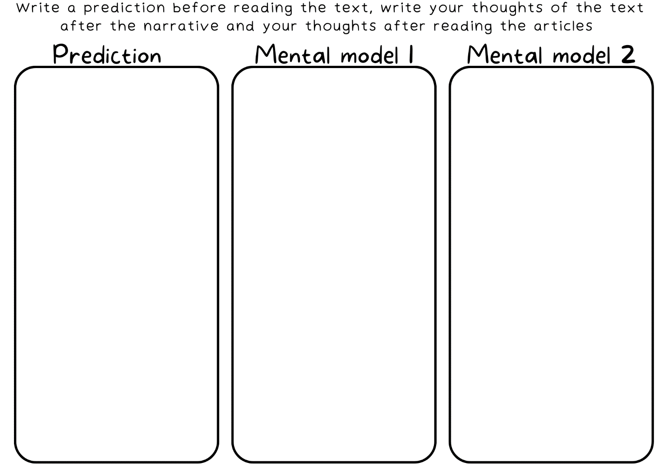

Resource 2 – cards
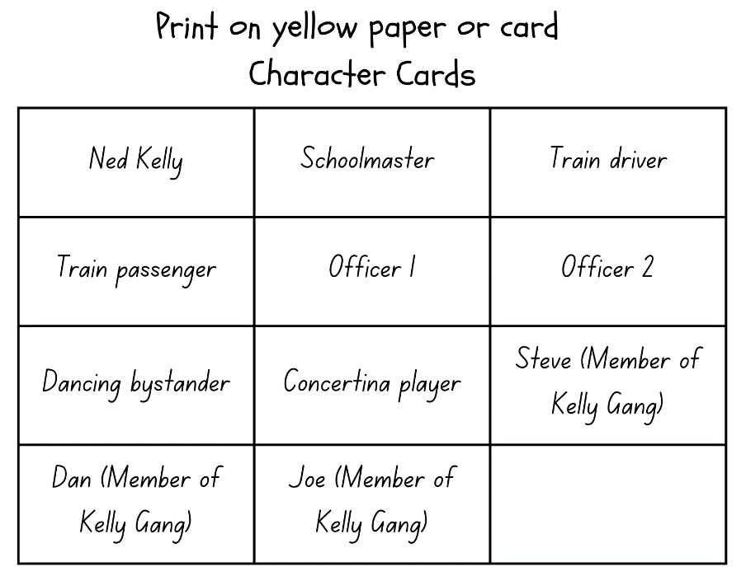
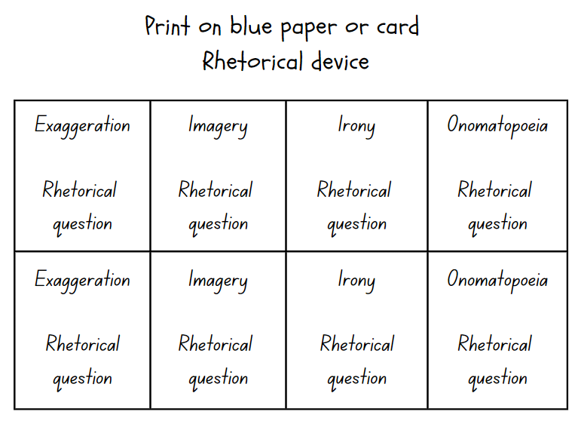
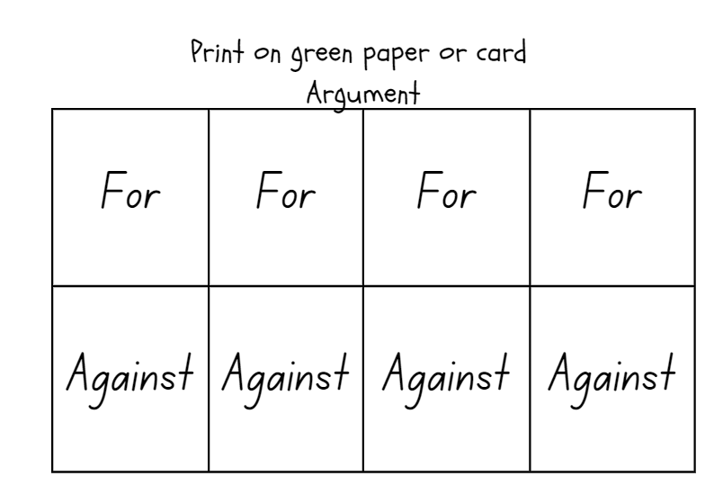

Resource 3 – Venn diagram
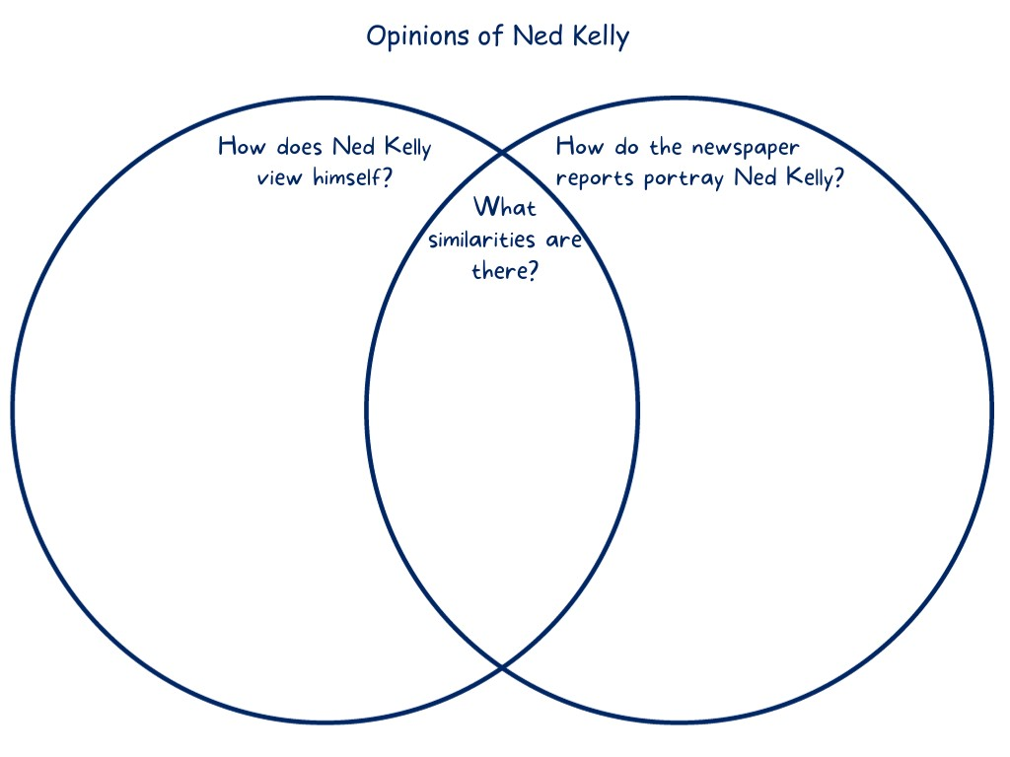

Resource 4 – modality
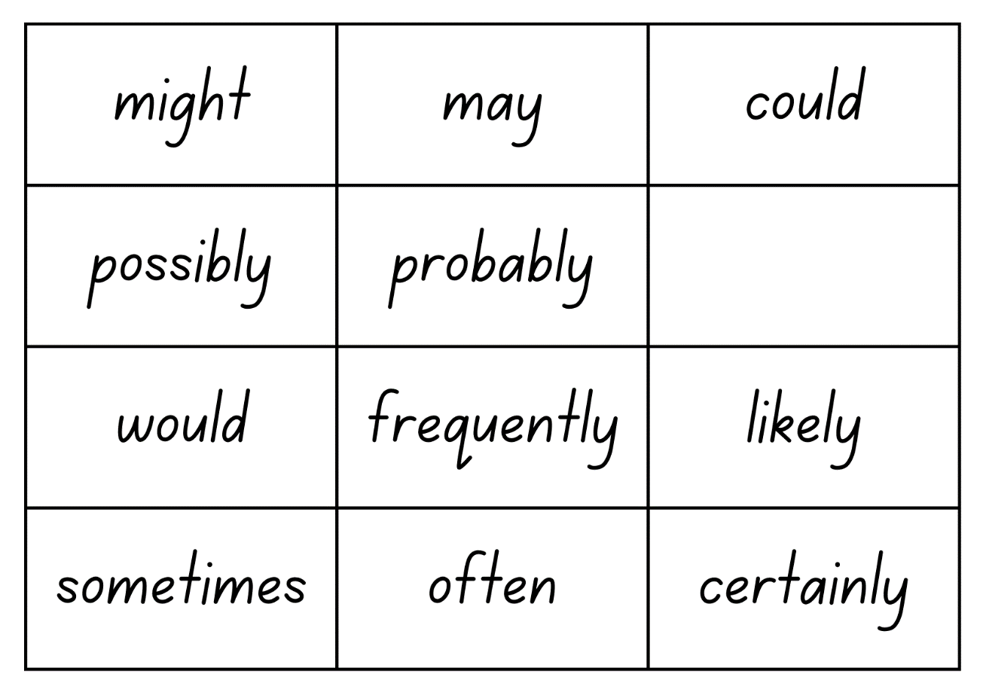
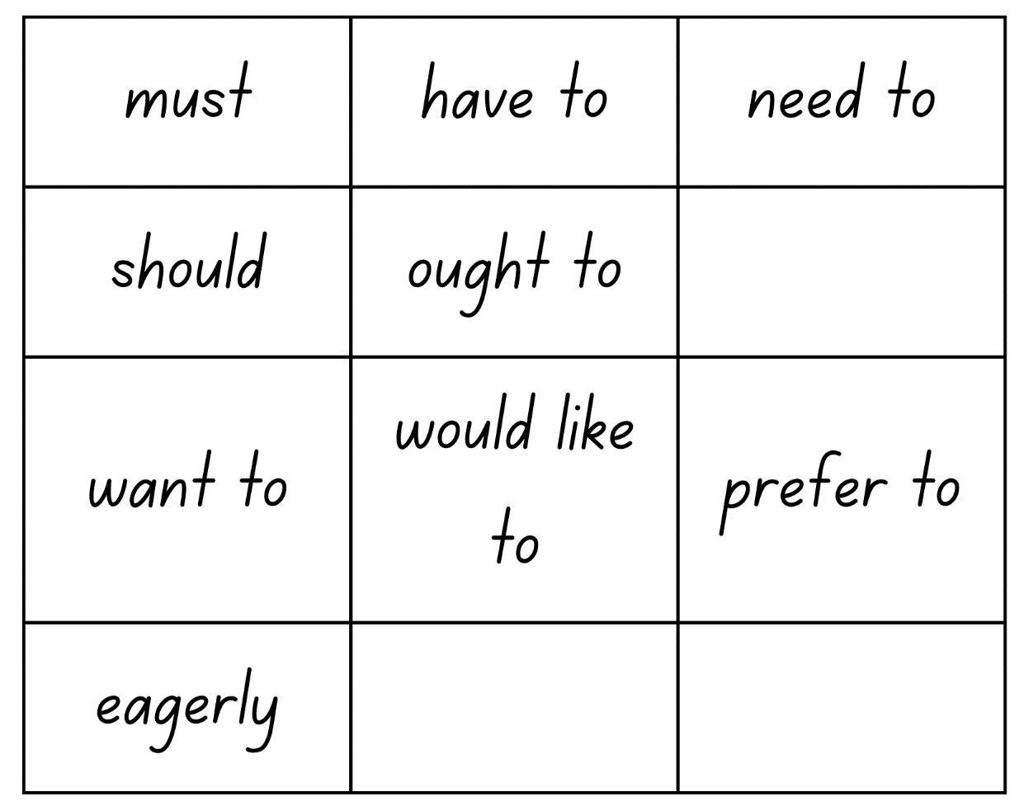
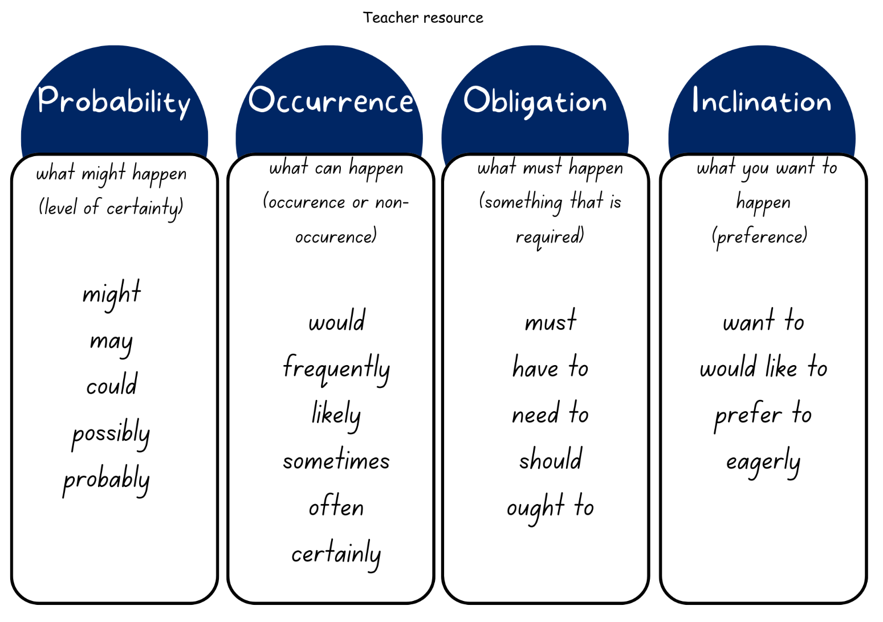

Resource 5 – planning template
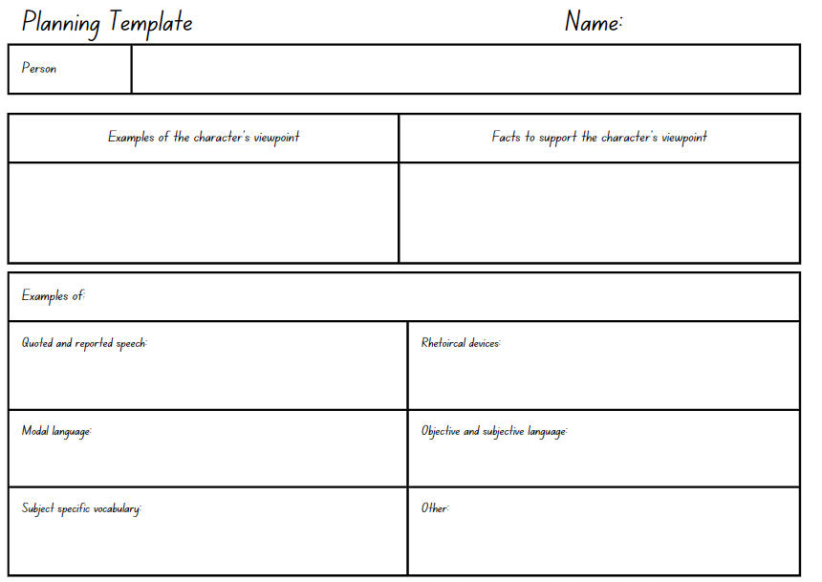

Resource 6 – writing process
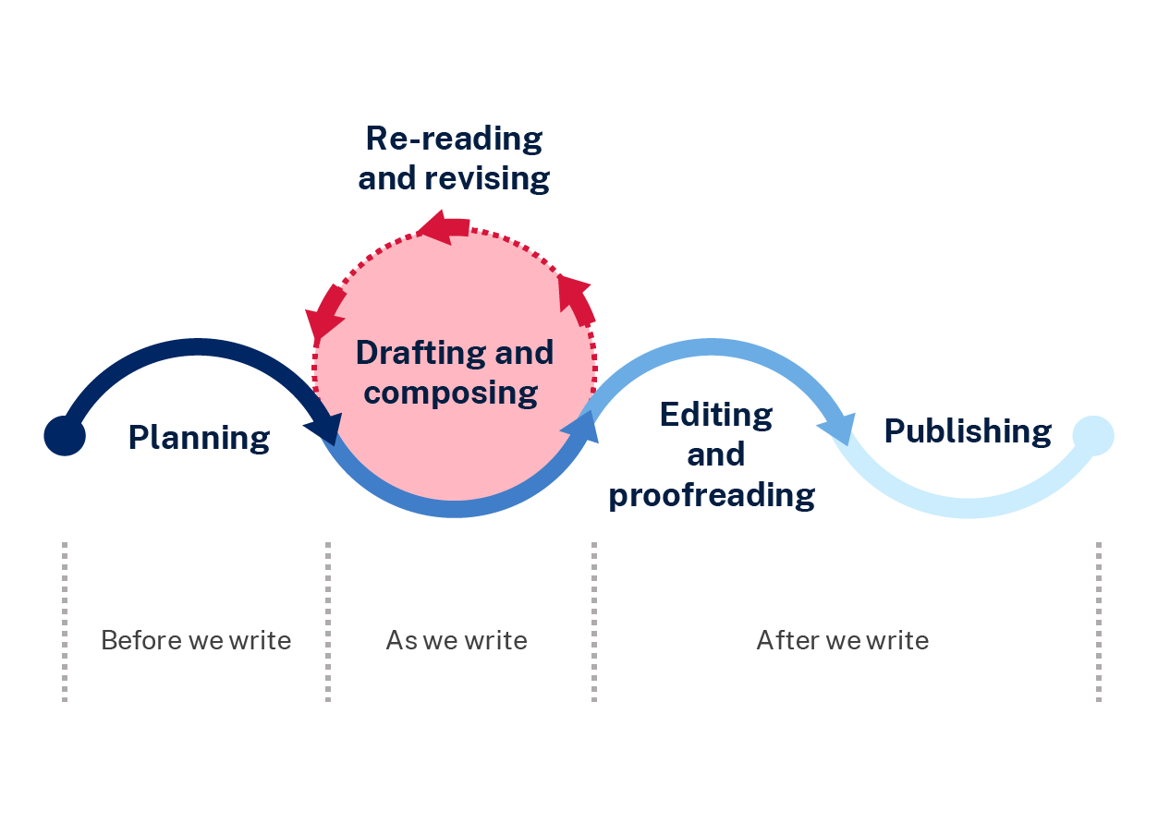

References
This resource contains NSW Curriculum and syllabus content. The NSW Curriculum is developed by the NSW Education Standards Authority. This content is prepared by NESA for and on behalf of the Crown in right of the State of New South Wales. The material is protected by Crown copyright.
Please refer to the NESA Copyright Disclaimer for more information. https://educationstandards.nsw.edu.au/wps/portal/nesa/mini-footer/copyright
NESA holds the only official and up-to-date versions of the NSW Curriculum and syllabus documents. Please visit the NSW Education Standards Authority (NESA) website https://educationstandards.nsw.edu.au/ and the NSW Curriculum website https://curriculum.nsw.edu.au/home.
English K–10 Syllabus © NSW Education Standards Authority (NESA) for and on behalf of the Crown in right of the State of New South Wales, 2022.
National Literacy Learning Progression © Australian Curriculum, Assessment and Reporting Authority (ACARA) 2010 to present, unless otherwise indicated. This material was downloaded from the Australian Curriculum website (National Literacy Learning Progression) (accessed 11 September 2023) and was not modified.
Greenwood M (2010) Ned Kelly and the Green Sash (Lessac F illus) Walker Books, Australia. ISBN: 9781922244598
Holbrook M (10 November 2020) ‘Ned Kelly’ [video], ABC, Behind the News website, accessed 23 June 2023.
National Library of Australia (2 November 1878) ‘Bushranging in Victoria: The Argus Monday October 28th’, Trove , accessed 26 June 2023.
National Museum of Australia (n.d.) ‘Ned Kelly: Hero or criminal?’, Digital Classroom National Museum of Australia website, accessed 19 June 2023.
National Museum of Australia (n.d.) ‘Ned Kelly: Hero or murderer? Evidence files A–H’ Digital Classroom National Museum of Australia website, accessed 23 June 2023.
National Gallery of Australia (n.d.) Sidney Nolan’s Ned Kelly Series, National Gallery of Australia website, accessed 27 June 2023.
NESA (NSW Education Standards Authority) (2023) ‘Glossary’, Resources, NESA website, accessed 20 November 2023.
President and Fellows of Harvard College and Harvard Graduate School of Education (2015) ‘I Used to Think... Now I Think...’, Resources: Thinking Routine Toolbox, Project Zero website, accessed 16 August 2023.
President and Fellows of Harvard College and Harvard Graduate School of Education (2020) ‘+1 Routine’, Resources: Thinking Routine Toolbox, Project Zero website, accessed 11 August 2023.
State of New South Wales (Department of Education) (2023) ‘Reading comprehension lesson advice guide’, Hub Resources, Universal Resources Hub website, accessed 8 November 2023.
State of New South Wales (Department of Education) (2022) ‘Text structure: Stage 3’ [PDF 3.58 MB], Literacy and Numeracy Teaching Strategies – Reading, NSW Department of Education, accessed 20 November 2023.
Sutherland D G (1880) Letter written by Donald G. Sutherland to his parents State Library of Victoria website, accessed 26 June 2023.
Victorian Collections and content contributors (2011) The Last Stand of the Kelly Gang: Sites in Glenrowan, Victorian Collections website, accessed 27 June 2023.

© State of New South Wales (Department of Education), 2023
The copyright material published in this resource is subject to the Copyright Act 1968 (Cth) and is owned by the NSW Department of Education or, where indicated, by a party other than the NSW Department of Education (third-party material).
Copyright material available in this resource and owned by the NSW Department of Education is licensed under a Creative Commons Attribution 4.0 International (CC BY 4.0) license.
This license allows you to share and adapt the material for any purpose, even commercially.
Attribution should be given to © State of New South Wales (Department of Education), 2023.
Material in this resource not available under a Creative Commons license:
- the NSW Department of Education logo, other logos and trademark-protected material
- material owned by a third party that has been reproduced with permission. You will need to obtain permission from the third party to reuse its material.
Links to third-party material and websites
Please note that the provided (reading/viewing material/list/links/texts) are a suggestion only and implies no endorsement, by the New South Wales Department of Education, of any author, publisher, or book title. School principals and teachers are best placed to assess the suitability of resources that would complement the curriculum and reflect the needs and interests of their students.
If you use the links provided in this document to access a third-party's website, you acknowledge that the terms of use, including licence terms set out on the third-party's website apply to the use which may be made of the materials on that third-party website or where permitted by the Copyright Act 1968 (Cth). The department accepts no responsibility for content on third-party websites.

