English Stage 2 First year – Unit 1
Narrative – Fantastic Mr Fox

Contents
Unit overview and instructions for use 7
Teacher notes 9
Outcomes and content 11
Resources 16
Week 1 19
Component A teaching and learning 19
Teaching guide 19
Planning framework 32
Component B teaching and learning 32
Learning intentions and success criteria 33
Learning intention 33
Success criteria 33
Lesson 1 – understanding the expectations of a narrative 33
Lesson 2 – visualising richly created characters 37
Lesson 3 – creating vivid characters 40
Lesson 4 – determining character traits 43
Week 2 47
Component A teaching and learning 47
Teaching guide 47
Planning framework 60
Component B teaching and learning 60
Learning intentions and success criteria 60
Learning intention 60
Success criteria 60
Lesson 5 – identifying problems that drive a narrative 61
Lesson 6 – building tension and suspense in a narrative 63
Lesson 7 – creating tension in an event – part 1 65
Lesson 8 – creating tension in an event – part 2 68
Week 3 70
Component A teaching and learning 70
Teaching guide 70
Planning framework 81
Component B teaching and learning 81
Learning intentions and success criteria 81
Learning intention 81
Success criteria 82
Lesson 9 – visualising settings 82
Lesson 10 – building vivid descriptions of character and settings 84
Lesson 11 – exploring moral dilemmas in narratives 87
Lesson 12 – creating descriptions of characters and settings 89
Week 4 92
Component A teaching and learning 92
Teaching guide 92
Planning framework 102
Component B teaching and learning 102
Learning intentions and success criteria 102
Learning intention 102
Success criteria 102
Lesson 13 – creating tension 103
Lesson 14 – resolving tension 107
Lesson 15 – exploring resolutions in narratives 110
Lesson 16 – planning a narrative 112
Week 5 115
Component A teaching and learning 115
Teaching guide 115
Planning framework 123
Component B teaching and learning 123
Learning intentions and success criteria 124
Learning intention 124
Success criteria 124
Lesson 17 – planning and drafting an orientation 125
Lesson 18 – drafting a complication and series of events 126
Lesson 19 – drafting a resolution 127
Lesson 20 – revising and editing 128
Resource 1 – fluency and close reading passage analysis 131
Resource 2 – vocabulary and morphology example 134
Resource 3 – vocabulary and morphology 136
Resource 4 – interaction protocols 137
Resource 5 – orientation 138
Resource 6 – types of adjectives 139
Resource 7 – character traits 140
Resource 8 – fluency and close reading passage analysis 141
Resource 9 – Somebody, wanted, but, so, then 144
Resource 10 – fluency and close reading passage analysis 145
Resource 11 – story map example 148
Resource 12 – Freytag’s pyramid 149
Resource 13 – Freytag’s pyramid planning template 150
References 151

Unit overview and instructions for use
In this 5-week unit, students will gain greater understanding of the textual concepts of narrative and characterisation. Through the study of the text Fantastic Mr Fox, students will explore how narratives set up expectations for the reader using predictable structure and familiar characters and situations. Students will analyse excerpts of the text and use these as the basis for their own innovation. Students will also plan, draft and revise a narrative sequel to Fantastic Mr Fox using an orientation, complication, and resolution structure.
Outcomes and content in this unit are organised into Component A and Component B. The components are connected, with learning in Component A complementing learning in Component B.
Note: the duration of this unit can be adapted to suit individual school contexts. For example, learning could occur across 5 days rather than 4.
The table below highlights the focus areas and preparation required for Component A and Component B.
Teaching and learning | Component A | Component B
Suggested duration | 60 minutes × 4 days/week or equivalent | 60 minutes × 4 days/week or equivalent
Explicit teaching focus areas | Component A addresses content from the focus areas:  - Reading fluency  - Reading comprehension  - Spelling  - Vocabulary  - Creating written texts  - Handwriting and digital transcription  It centres on the development of foundational skills and knowledge through regular, systematic and repeated practice. | Component B addresses content from the focus areas:  - Oral language and communication  - Reading comprehension  - Vocabulary  - Creating written texts  - Understanding and responding to literature  It centres on the conceptual understandings of English and exemplifies the importance of learning about and enjoying literature through the study of quality texts.
Preparing for teaching and learning | - Specific teaching and learning activities need to be developed by the teacher. When planning for these activities, please refer to the Component A outcomes and content, teaching guides and planning frameworks.  - Plan and document how you will sequence teaching and learning in whole-class and targeted-groups across the 5-week cycle as required. This should be based on student needs identified through ongoing assessment data. | - Familiarise yourself with the mentor and supporting texts and textual concepts, and the teaching and learning sequence.  - Determine how you will support students in whole-class and targeted-groups across the 5-week cycle as required. This should be based on student needs identified through ongoing assessment data.
English K–10 Syllabus © NSW Education Standards Authority (NESA) for and on behalf of the Crown in right of the State of New South Wales, 2022.

Teacher notes
- Narrative is the mentor concept of this unit, explored using the text Fantastic Mr Fox by Roald Dahl. Narrative refers to an account of events or experiences, which are real or imagined. In English literary theory, narrative includes a story (what is narrated) and a discourse (how it is narrated). Narrative can present as an explicit sequencing of events (type of text) or it can be an implied or inferred component in a text (NESA Glossary).
- Understanding of narrative can be supported through watching the department’s video: Understanding narrative (3:51).
- While ‘narrative’ is the mentor concept for the conceptual component of this unit, the supporting concept of ‘characterisation’ is explored within the relevant section(s) of the mentor and/or supporting texts.
- For information on adverbial phrases, declarative sentences, exclamatory sentences and coordinating conjunctions refer to the NESA Glossary.
- In addition to the resources listed, students will require access to short passages of the mentor and/or supporting texts. Teachers can copy extracts from texts in reliance on the Statutory Text and Artistic Works Licence. Teachers need to attribute the extracts and include the following notice: ‘This material has been copied [and communicated to you] in accordance with the statutory licence in section 113P of the Copyright Act. Any further reproduction or communication of this material by you may be the subject of copyright protection under the Act. Do not remove this notice’.
- Consider prior student knowledge of narrative and character as developed in Stage 1.
- There is a consistent use of dialogue throughout Fantastic Mr Fox. While content points related to dialogue are not included within this unit, learning from Stage 1 can be referred to.
- Reflect on student learning and engagement in activities and record differentiation and adjustments within the unit to inform future teaching and learning. One way of doing this could be to add comments to the digital file.
- In NSW classrooms there is a diverse range of students including Aboriginal and Torres Strait Islander students, students learning English as an additional language or dialect, high potential and gifted students and students with disability. Some students may identify with more than one of these groups, or possibly all of them. Refer to Curriculum planning for every student – advice for further information.
- Content points are linked to the National Literacy Learning Progression version (3).
Levels and indicators sourced from National Literacy Learning Progression © Australian Curriculum, Assessment and Reporting Authority (ACARA), (accessed 7 August 2023) and was not modified. See references for more information.

Outcomes and content
The table below outlines the outcomes and content for this unit. The letters 'A' and 'B' in the header refer to Components A and B. The numbers 1 to 5 refer to weeks. The use of 'x' in these columns indicates where the content points are intended to be addressed and in which week.
Focus area and outcome, content points and National Literacy Learning Progression | A | B | 1 | 2 | 3 | 4 | 5
Oral language and communication
EN2-OLC-01 communicates with familiar audiences for social and learning purposes, by interacting, understanding and presenting
- Follow agreed-upon protocols and assigned roles for classroom interactions in person and through the use of technology (InT5) |  | x | x | x | x | x | x
- Listen actively to identify spoken information, acknowledging the value of others’ contributions (LiS6) |  | x | x | x | x | x | x
Vocabulary
EN2-VOCAB-01 builds knowledge and use of Tier 1, Tier 2 and Tier 3 vocabulary through interacting, wide reading and writing, and by defining and analysing words
- Build personal Tier 1, Tier 2 and Tier 3 vocabulary through social and learning interactions, reading and writing (SpK5) | x | x | x | x | x | x | x
- Apply morphemic knowledge to change word meanings by adding different prefixes and suffixes to a base word or root (SpG9) | x |  | x | x | x | x | x
Reading fluency
EN2-REFLU-01 sustains independent reading with accuracy, automaticity, rate and prosody suited to purpose, audience and meaning
- Syllabify, blend grapheme–phoneme correspondences and use morphemic knowledge as strategies for reading words accurately (PKW8) | x |  | x | x | x | x | x
- Explain how prosodic reading involves emphasis, expression, intonation and pausing | x |  | x | x | x | x | x
Reading comprehension
EN2-RECOM-01 reads and comprehends texts for wide purposes using knowledge of text structures and language, and by monitoring comprehension
- Identify similarities and compare differences within and between texts by making text-to-self, text-to-text and text-to-world connections |  | x | x |  | x
- Use morphemic knowledge to read and understand the meaning of words (UnT7) | x |  | x | x
- Use key words from a text to visualise events, characters and settings when making inferences and confirming predictions | x | x | x | x | x | x | x
- Identify where meaning breaks down when reading (UnT6) | x |  | x | x | x | x | x
Creating written texts
EN2-CWT-01 plans, creates and revises written texts for imaginative purposes, using text features, sentence-level grammar, punctuation and word-level language for a target audience
EN2-CWT-02 plans, creates and revises written texts for informative purposes, using text features, sentence-level grammar, punctuation and word-level language for a target audience
EN2-CWT-03 plans, creates and revises written texts for persuasive purposes, using text features, sentence-level grammar, punctuation and word-level language for a target audience
- Use an orientation, complication, resolution structure to create narratives centred on time, place and characters (CrT8) |  | x | x | x | x | x | x
- Use adverbial phrases or clauses to add information to the verb or verb group of the main or other clauses, to provide reasons for circumstances (GrA5) | x | x |  | x | x | x | x
- Use declarative sentences to provide facts or state a viewpoint | x | x | x | x |  |  | x
- Use exclamatory sentences to emphasise a point or express a strong emotion | x | x |  |  | x | x
- Use coordinating conjunctions in compound sentences to compare and contrast, or for addition (GrA4) | x | x |  | x | x | x | x
- Use capital letters to indicate beginning of a sentence, proper nouns, headings and subheading, to indicate the beginning of a poetry line, for emphasis, and when using acronym (PuN5) | x | x | x | x | x | x | x
- Use commas between words in a list or to separate adjectives when more than one is used (PuN4, PuN6) | x | x | x | x | x | x | x
- Use adjectives to develop descriptive features (CrT8) | x | x | x | x | x | x | x
Spelling
EN2-SPELL-01 selects, applies and describes appropriate phonological, orthographic and morphological generalisations and strategies when spelling in a range of contexts
- Explain how to segment multisyllabic words into syllables and phonemes, and apply this knowledge when spelling | x |  | x | x | x | x | x
- Identify differences in vowel phonemes (short, long, diphthong and schwa vowels) (SpG9) | x |  | x | x | x | x | x
- Apply knowledge of taught vowel graphemes when spelling (SpG9) | x |  | x | x | x | x | x
- Identify inflected suffixes, explaining when and how to treat base words when they are affixed, and apply this knowledge when spelling (SpG9) | x |  | x | x | x | x | x
Handwriting and digital transcription
EN2-HANDW-01 forms legible joined letters to develop handwriting fluency
EN2-HANDW-02 uses digital technologies to create texts
- Understand that legible handwriting is consistent in size and spacing and can support learning (HwK6) | x |  | x | x | x | x | x
Understanding and responding to literature
EN2-UARL-01 identifies and describes how ideas are represented in literature and strategically uses similar representations when creating texts
- Describe how narratives set up expectations using familiar, real and imagined characters, situations and phrases |  | x | x | x | x | x | x
- Recognise that characters may be identified through familiar, individual or group characteristics |  | x | x |  | x | x
English K–10 Syllabus © NSW Education Standards Authority (NESA) for and on behalf of the Crown in right of the State of New South Wales, 2022.

Resources
The resources in the table below are referred to in this unit. Letters 'A' and 'B' in the header refer to Component A and B respectively, and the numbers 1 to 5 indicate weeks. The use of 'x' in these columns indicate whether the resources are required in Component A, B or both, and in which week.
Resource | A | B | 1 | 2 | 3 | 4 | 5
Dahl R (2007) Fantastic Mr Fox (Blake Q, illus) Penguin Random House Children's UK, United Kingdom. ISBN: 9780142410349 | x | x | x | x | x | x | x
Resource 1 – fluency and close reading passage analysis | x |  | x
Resource 2 – vocabulary and morphology example | x |  | x
Resource 3 – vocabulary and morphology | x |  | x
Resource 4 – interaction protocols |  | x | x
Resource 5 – orientation |  | x | x |  |  |  | x
Individual whiteboards |  | x | x
Sticky notes |  | x | x
Resource 6 – types of adjectives |  | x | x
Resource 7 – character traits |  | x | x |  | x
Resource 8 – fluency and close reading passage analysis | x | x |  | x
Resource 9 – Somebody, wanted, but, so, then |  | x |  | x | x | x | x
Resource 10 – fluency and close reading passage analysis | x | x |  |  | x
Resource 11 – story map example |  | x |  |  | x
A3 paper |  | x |  |  | x
Resource 12 – Freytag’s pyramid |  | x |  |  |  | x
Range of familiar picture books |  | x |  |  |  | x
Resource 13 – Freytag's pyramid planning template |  | x |  |  |  | x

Week 1

Component A teaching and learning
Component A focuses on the development of foundational skills and knowledge through regular, systematic and repeated practice. The mentor and supporting texts used in Component B of this unit can support the effective implementation of Component A teaching and learning.

Teaching guide
Guidance for explicit teaching, teaching notes, resources and examples for the related outcomes and content points have been provided in the table below.
Focus areas and teaching notes | Resources and examples
Reading fluency  Reading automaticity and rate  - Syllabify, blend grapheme–phoneme correspondences and use morphemic knowledge as strategies for reading words accurately  - Locate and syllabify multisyllabic words, including those with morphemic suffixes (for example, -ing, -ly)  - For every syllable, there is at least one vowel phoneme.  - Morphemic suffixes usually form their own syllable (including -ing, -ly, -est).  - The morphemic suffix -ed forms a syllable when pronounced as ‘ed’ but does not when pronounced as ‘d’ or ‘t’. | Reading fluency  Reading automaticity and rate  - Resource 1 – fluency and close reading passage analysis – Chapter 1: The Three Farmers (pp 1–4), from ‘Down in the valley there...’ to ‘...used to sing when they saw them’ (245 words).  - Suggested words from the passage  - Morphemic information  - enormous – enormous + ly  - disgusting – disgust + ing  - cleverest – clever + est  - smothered – smother + ed.  - Syllables  - enormously – 4 syllables  - disgusting – 3 syllables  - cleverest – 3 syllables  - smothered – 2 syllables.  Note:  - The passage from the text will need to be a teacher-created resource.  - Content in Reading fluency will support learning in the focus areas Vocabulary, Reading comprehension and Spelling.
Prosody  - Explain how prosodic reading involves emphasis, expression, intonation and pausing  - Emphasis is when the reader gives extra importance or focus to specific words or parts of a sentence. It helps to convey the meaning or feeling behind the text.  - Readers may emphasise words that:  - highlight exaggeration  - are repeated in close succession. | Prosody  - Suggested sentences to illustrate the use of emphasis from the passage  - Exaggeration: ‘He was enormously fat.’  - Repetition: ‘They were rich men. They were also nasty men. All three of them were about as nasty and mean as any men you could meet.’
Reading comprehension  Comprehending language  - Use morphemic knowledge to change word meaning by adding different prefixes and suffixes to a base word or root  - There are 2 types of morphemes – free (independent) morphemes and bound (dependent) morphemes.  - Free morphemes can function as stand-alone words with specific meaning. These are sometimes known as base words.  - Bound morphemes, when added to words, alter their meaning or create new words. They cannot occur independently. Bound morphemes include prefixes (un-,  dis-) which are at the beginning of words and suffixes (-ed, -s) which are added to the ends of words.  - Focus suffixes: -ly, -y, -ing, -est | Reading comprehension  Comprehending language  - See Reading fluency
Monitoring comprehension  - Identify where meaning breaks down when reading  - A break in comprehension can occur when a text includes  - comparisons or metaphors  - complex cohesive ties within and between sentences (pronouns)  - increasingly complex sentence structures. | Monitoring comprehension  - Sentences with comparisons or metaphors  - ‘He was a kind of pot-bellied dwarf.’  - ‘He was so short his chin would have been underwater in the shallow end of any swimming-pool in the world.’  - ‘He was as thin as a pencil and the cleverest of them all.’  - Sentences with complex cohesive ties (5-line chant and final sentence in the passage)  - The 3 characters are referred to by their physical attributes and qualities rather than their names  - ‘one fat’ (Boggis); ‘one short’ (Bunce); ‘one lean’ (Bean)  - ‘These horrible crooks’ refers to the 3 farmers.  - The subject of the sentence is ellipsed  - ‘were none the less equally mean’ (they/the farmers).  - Sentences with increasingly complex sentence structures  - ‘This [why Boggis was ‘enormously fat’] was because he ate three boiled chickens smothered with dumplings every day for breakfast, lunch and supper.’  - ‘He mashed the livers into a disgusting paste and then stuffed the paste into the doughnuts.’  - ‘Instead [of eating], he drank gallons of strong cider which he made from apples in his orchard.’  Note: these sentences are complex to comprehend as they have multiple clauses surrounding the main clause (highlighted in bold). There is also information which is implied (included in square parentheses).
Vocabulary  Learning and using words  - Build personal Tier 1, Tier 2 and Tier 3 vocabulary through interacting, wide reading and writing, and by defining and analysing words  - Authors use adjectives and adverbs to describe character features and settings.  - Adjectives are words that describe, identify or quantify a noun or a pronoun. Authors use adjectives to provide descriptions of characters and settings (NESA 2023).  - Adverbs are words that tell something about a verb, adjective or another adverb. They indicate things like manner, place or time (NESA 2023). | Vocabulary  Learning and using words  - Suggested vocabulary from the passage  - Adjectives: horrible, lean, beast(ly), disgust(ing)  - Adverbs: enormous(ly), equal(ly), clever(est)
Defining and analysing words  - Apply morphemic knowledge to change word meanings by adding different prefixes and suffixes to a base word or root  - Suffixes can be added to base words to adjust their meaning.  - -ly means ‘a characteristic of’ and attaches to nouns to form adjectives, or for adjectives to form adverbs  - -y means ‘characterised by’ and attaches to nouns and verbs to create adjectives  - -ing can be added to some nouns to turn them into adjectives, describing something that causes a certain feeling or emotion  - -est usually attach to adjectives that have one syllable. Adding -est creates the superlative form of an adjective. | Defining and analysing words  - Resource 2 – vocabulary and morphology example  - Resource 3 – vocabulary and morphology  Note:  - Content in Vocabulary will support learning in the focus areas Reading fluency, Reading comprehension and Spelling.  - See Reading comprehension for the definition of focus suffixes.
Spelling  Phonological component  - Explain how to segment multisyllabic words into syllables and phonemes, and apply this knowledge when spelling  - Segment words into syllables. For example, turkey has 2 syllables.  - Segment words into phonemes. For example, 4 phonemes (t-ur-k-ey).  - Identify differences in vowel phonemes (short, long, diphthong and schwa vowels)  - /ee/ as in me is a long vowel phoneme. The most common graphemes that represent the long vowel phoneme /ee/ as in ‘me’ include e_e, ey, y, ea, e, ee  - The first syllable in the word valleys has a short vowel phoneme and the second syllable has a long vowel. | Spelling  Note: each week of learning contains a phonological, orthographic and morphological focus. These focuses are intended to be taught simultaneously through linguistic inquiry. Suggested words have been selected to show how phonological, orthographic and morphological content can be integrated. In addition to words selected from the mentor and/or supporting text, additional sample words for inquiry are provided.  Phonological component  - Suggested words from the Week 1 reading material – Chapters 1 to 2: valley(s), geese, Bean, lean, mean, turkey(s), tree(s), creep(s), each, beast(s), behind, decent, three  - Sample words: theme(s), cream(s), beacon(s), coffee(s), referee(s), refugee(s), jockey(s), monkey(s), baby-babies, candy-candies, cherry-cherries, berry-berries, inquiry-inquiries
Orthographic component  - Apply knowledge of taught vowel graphemes when spelling  - The most common graphemes that represent the long vowel phoneme /ee/ as in ‘me’ include [ee, ea, e_e, ey, e, y].  - [ee, ea, ey] are vowel digraphs.  - [e_e] is a split digraph.  - [e, y] are single letter graphemes. | Orthographic component  - As above
Morphological component  - Identify inflected suffixes, explaining when and how to treat words when they are affixed, and apply this knowledge when spelling  - An inflected suffix is a bound (dependent) morpheme added to the end of a base word to assign a number to a word, to indicate possession or tense, or to provide a comparison (-s, -es, -ing, -ed, -er, -est)  - The inflected suffixes -s and -es change a noun from singular (one) to plural (more than one)  - To create plurals, add an -s to the end of most words. If the word ends in a consonant and then -y, replace the ‘-y’ with an ‘i’ before adding the -es suffix. | Morphological component  - As above  Note: content in Spelling will support learning in the focus areas Reading fluency, Vocabulary and Reading comprehension.
Creating written texts  Sentence-level grammar  - Use declarative sentences to provide facts or state a viewpoint  - A declarative sentence is a statement presented as a complete sentence to provide fact, evidence or detail (NESA 2023).  - Declarative sentences usually end with a full stop. They are the most common type of sentence.  - Simple sentence features  - A sentence is a complete thought.  - A simple sentence (or a main clause) contains a subject and predicate.  - A predicate is a word or group of words that give information about the subject in a sentence or clause. A predicate always starts with a finite verb.  - A finite verb is a verb that has a subject. | Creating written texts  Sentence-level grammar  - Suggested declarative sentences (simple) from the passage:  - ‘Boggis was a chicken farmer.’  - ‘He kept thousands of chickens.’  - ‘Bunce was a duck-and-goose farmer.’  - ‘They were nasty men.’  - ‘He kept thousands of turkeys in an orchard full of apples.’  - ‘Their names were Farmer Boggis, Farmer Bunce and Farmer Bean.’
Punctuation  - Use capital letters to indicate the beginning of a sentence, proper nouns, headings and subheadings, to indicate the beginning of a poetry line, for emphasis, and when using acronyms  - A sentence begins with a capital letter and ends with a full stop, exclamation mark or question mark.  - Character names are proper nouns and are signalled by a capital letter (Farmer Boggis, Boggis, Mr. Fox).  - Use commas between words in a list or to separate adjectives when more than one is used  - Commas are used when there are 2 or more adjectives modifying a noun. For example, Jett has a small, green car to show us. | Punctuation  - As above  - Declarative sentences inspired by text showing use of adjectives separated by a comma  - ‘They were rich, nasty men.’  - ‘Boggis ate juicy, boiled chickens smothered with hot, sticky dumplings.’  - ‘In the wood there was a huge, sturdy tree.’  Note: in Chapters 1 and 2, Roald Dahl mostly uses one adjective to modify a noun. For this reason, sentences inspired by the text have been created for teaching purposes.
Word-level language  - Use adjectives to develop descriptive features  - Adjectives can be used to describe a noun or a pronoun.  - Adjective types include  - Descriptive: these indicate size, shape, colour, texture, taste, sound, opinions (mean), emotions/feelings (cranky)  - Quantifying: these indicate how much of something there is or how many there are  - Classifying: these categorise or classify a noun into a particular group or category (a chicken farmer).  - Compound adjectives are made up of more than one word and are separated with a dash. For example, turkey-and-apple farmer  - Predicate adjectives are placed following a relating verb which describes the subject. For example, they were nasty. | Word-level language  - As above
Handwriting and digital transcription  Handwriting legibility and fluency  - Understand that legible handwriting is consistent in size and spacing and can support learning  - Form the ‘down’ letters l, t and i using consistent size and spacing  - Formation: All ‘down’ letters begin at the top of the letter and end at the bottom.  - Size: Letters should be in proportion in both width and height.  - Slope: Letters need to maintain the same slope, that is, they need to be parallel. All letters slope slightly to the right.  - Form basic punctuation marks, including full stops and commas  - Full stops and commas are positioned on the baseline. | Handwriting and digital transcription  Handwriting legibility and fluency  - Suggested fluency pattern  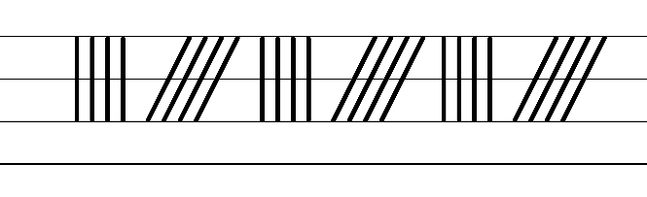  - Example NSW Foundation Style handwriting formation  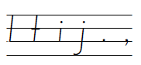  - Suggested practice text from the passage  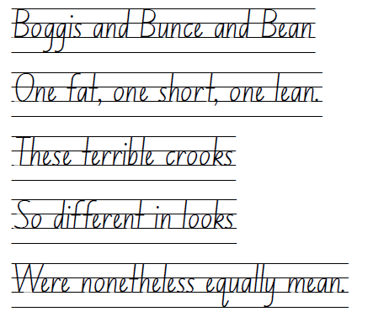  Note: students who are fluent in NSW Foundation Style can begin to use NSW Foundation Precursive and Cursive Style.

Planning framework
To plan and document Component A teaching and learning, a planning scaffold [DOCX 228 KB] is provided. To support you in your planning, a link to a detailed example of a one-week teaching and learning cycle is included in the scaffold. Additional resources to support teaching and learning in each focus area can be found at Lesson advice guides.

Component B teaching and learning
The following teaching and learning sequence has been designed to address Component B outcomes and content and develops conceptual understandings of English through the study of quality texts. Adapt the sequence as required to best meet the needs of your students.

Learning intentions and success criteria
Learning intentions and success criteria are best co-constructed with students.

Learning intention
Students are learning to understand the role of the orientation when setting up expectations in a narrative.

Success criteria
Students can:
- describe the key features of a narrative orientation
- use information, including key words, from a text to visualise characters and make inferences
- identify and describe character traits using evidence from a text
- create character descriptions using a range of adjectives for effect
- create and apply agreed-upon protocols for classroom interactions.

Lesson 1 – understanding the expectations of a narrative
- Explore the important role of interacting with others as a learning strategy. This may include discussing how interacting with others helps us to:
- remember information
- keep the brain active and alert
- clarify understanding and connect different ideas
- understand different perspectives.
- Develop a shared criterion, or agreed-upon protocols, for successful interactions with a ‘partner’ and in ‘whole-class’ contexts. Display the protocols on Resource 4 – interaction protocols. Explain that these will be referred to throughout the unit to refocus and refine students’ use of skills and strategies.
- Explain that students will engage in learning based on a selected text over the coming weeks. Keep the title and cover of Fantastic Mr Fox hidden and promote predictions by slowly revealing one or 2 sentences from a key part of the text. For example, the following excerpt from Chapter 10 (p 38) can guide students to uncover the narrative elements within the text:
- Text purpose, characterisation and setting. Read the first sentence – ‘Dad, I wish you would tell us where we are going.’ Ask:
- What type of text might this be and how do you know? What might its purpose be? Why do you think that?
- What characters could be involved?
- Where might they be going?
- Setting. Read the second sentence – ‘I dare not do that’ [omit ‘said Mr Fox’ from the passage] ‘…because this place I am hoping to get to is so marvellous that if I described it to you now you would go wild with excitement.’ Ask:
- Where might this ‘marvellous’ place be?
- Why would this place make the characters go ‘wild with excitement’?
- Problem or complication. Read the third sentence – ‘And then, if we failed to get there (which is very possible), you would die of disappointment.’ Ask:
- How does this sentence indicate that there may be a problem?
- Why might the characters fail to get to the marvellous place?
- Characterisation. Read the final sentence – ‘I don’t want to raise your hopes too much, my darlings.’ Ask:
- What information does this give us about the relationship between the characters?
- Do you think this relationship will be important in the text? Why?
- Reveal the cover of Fantastic Mr Fox by Roald Dahl. Ask:
- Having seen the cover, what type of text might this be? Why do you think that?
- Who do you think the main character is? What do you think the character will be like?
- Provide time for students to make and share connections. For example, to other texts written by Roald Dahl. Explain that you will read Fantastic Mr Fox over the coming weeks.
- Outline that the excerpt read as part of the ‘slow reveal’ highlighted that this text is a narrative. On individual whiteboards, students record prior knowledge of narrative. Draw on students’ responses to highlight key features of narrative and record on an anchor chart. For example:
- structural elements, such as orientation, complication, a series of events that attempt to resolve the complication, and resolution
- use of familiar and imagined characters
- use of real and imagined settings
- use of real or imagined events or experiences
- the textual purpose is to entertain.
- This anchor chart will be referred to in Lesson 5.
- Read Chapter 1 and Chapter 2 without showing students the illustrations.
- Explain that narratives often begin with an orientation. Discuss and record the key features of an orientation. For example:
- introducing the main characters
- describing the setting, including when the story took place
- foreshadowing a potential problem.
- Display an enlarged copy of Resource 5 – orientation. Model identifying and recording some text details from the orientation. For example, the information provided about the text’s setting and main characters.
- Students use Resource 5 – orientation to identify and record details from the orientation.
Too hard? Students record the details from the orientation using drawings.
Too easy? Students write a summary of the orientation using the key details.
- Provide time for students to reflect on their learning. Encourage responses which focus on textual understanding as well as the use of protocols to support learning interactions. Ask:
- What do you remember about what you learned today?
- Why do you think this learning matters?
- Students share thinking with a partner prior to writing their ideas on a sticky note as an exit ticket.

Lesson 2 – visualising richly created characters
- Revise protocols for partner and group interactions. With the class, add additional protocols onto Resource 4 – interaction protocols that are important in group situations.
- Explore Roald Dahl’s rich characterisation in Fantastic Mr Fox and how he has framed certain characters to be either ‘good’ or ‘bad’. Explain that characterisation is the term for the qualities that authors give to their characters regarding how they look, behave, think, feel and communicate.
Note: characterisation is the technical construction and representation of any personality or person-like figure in text, including features such as their appearance, actions, words or thoughts. (NESA Glossary)
- Revise Chapters 1 and 2 of Fantastic Mr Fox. Using the information in the orientation, discuss the characters in the text and then discuss typical features of main characters. For example, main characters are impacted by the plot, or they drive the plot along. Explain that narratives also have supporting characters. In pairs, students determine the main and supporting characters in the text that has been read so far.
- Investigate how words from the text support the reader to visualise the characters. Display and read the paragraph that describes Farmer Boggis in Chapter 1, from ‘Boggis was a...’ to ‘...breakfast, lunch and supper’ (p 2).
- As a class, discuss and determine the key words that describe how Farmer Boggis looks and behaves. For example, ‘enormously fat’, ‘ate three boiled chickens smothered with dumplings every day for breakfast, lunch and dinner’. Explore words that highlight Boggis’ revoltingness and the way Dahl has used exaggeration. For example, eating one boiled chicken a day may be okay, but eating 9 boiled chickens a day is gluttonous.
- Investigate the representation of the other 2 farmers by providing small groups of students with copies of:
- the paragraph that describes Farmer Bunce in Chapter 1 from ‘Bunce was a...’ to ‘...and a beastly temper’ (p 3)
- the paragraph that describes Farmer Bean in Chapter 1 from ‘Bean was a...’ to ‘...cleverest of them all’ (p 4).
- Students locate, discuss and share key words and phrases that describe how Bean and Bunce look and behave. Students examine the language used to exemplify Bunce and Bean’s characteristics. Share findings as a class.
- Explain that Chapter 2 provides additional information about the farmers using dialogue. Without showing the illustrations, display and read the conversation between the farmers in Chapter 2 (p 9) from ‘Dang and blast that lousy beast...’ to ‘...It’s under a huge tree...’.
- As a class, re-read the dialogue to locate, examine and discuss the key words that describe how Farmer Boggis thinks, feels and communicates. For example, ‘“But how?” said Boggis. “How on earth can we catch the blighter?”’ shows Boggis talking with the other farmers about Mr Fox. By understanding that ‘blighter’ means ‘someone who is seen to be annoying’, the reader can infer that Boggis feels angry. Boggis’ repeated questioning also shows that he is frustrated and at a loss for how to catch the villainous Mr Fox.
- Provide students with a copy of the dialogue passage that has just been used. In their groups from activity 6, students examine the dialogue to identify additional information about the characters. Support students to make and share inferences.
- Explain that Roald Dahl’s rich characterisation helps the reader to visualise, or imagine, the characters. Highlight that being able to visualise characters and events helps the reader to engage with the story and make judgments or predictions about what is to come.
- Model the process of visualising Farmer Boggis using key words from the text. Think aloud while drawing and labelling an illustration of him. Brainstorm other vocabulary that could be used to describe Boggis. Add additional features and labels to the illustration that are consistent with his characterisation.
- Students use the excerpts from the text to draw and label an illustration of either Farmer Bunce or Farmer Bean. Students discuss other vocabulary that could be used to describe their character and add additional features and labels to their illustration. Encourage students to draw on vocabulary introduced in Component A. For example, beastly and disgusting.
Too hard? Students draw and then orally describe one of the farmers.
Too easy? Students write a descriptive paragraph of one of the farmers using the vocabulary identified in activity 12.
- Display the illustrations of Farmer Boggis, Farmer Bunce and Farmer Bean on pages 2 to 4. Students compare their illustrations and the illustrations created by Quentin Blake, highlighting the similarities and differences.

Lesson 3 – creating vivid characters
- Display the character descriptions of Farmer Boggis, Farmer Bunce and Farmer Bean on pages 2 to 4.
- Revise declarative sentences, as introduced in Component A, and explain that Roald Dahl uses a series of declarative sentences to describe each character.
- As a class, identify the use of declarative sentences in the 3 paragraphs. For example:
- ‘Bean was a turkey-and-apple farmer.’
- ‘He kept thousands of turkeys in an orchard full of apple trees.’
- ‘He never ate any food at all.’
- Ask students to explain why they think Roald Dahl has used declarative sentences (to convey facts or provide information about the characters).
- Ask students to consider what techniques Roald Dahl has used to create vivid characters. Draw students’ attention to the broad range of adjectives that have been used. Connect this observation with learning about adjectives and commas as introduced in Component A.
- In groups, students classify the adjectives identified in activity 5 using Resource 6 – types of adjectives. For example, ‘long’ is a descriptive adjective.
- Discuss what the character descriptions would be like if only one type of adjective was used. For example, only descriptive adjectives based on size or colour.
- Students Think-Pair-Share to provide additional examples of adjectives for each category.
- Revisit the paragraphs that describe Farmer Boggis, Farmer Bunce and Farmer Bean. Compare the structure of each paragraph by asking students to determine similarities. For example, each paragraph begins with the farmer’s name and occupation, followed by details about their appearance, diet and personality.
- Explain that students will use this structure to write a vivid character description for a fourth farmer that could be added to Fantastic Mr Fox.
- In pairs, students generate ideas for a fourth farmer. Students draw their farmer and add labels to record their ideas.
- Co-construct a success criteria for the character description. For example, I can write a detailed description of an imagined character that includes:
- familiar character traits
- declarative sentences to provide facts
- adjectives to develop descriptive features
- commas to separate adjectives
- capital letters for the beginning of sentences and for proper nouns.
- Model writing a character description of a fourth farmer. For example:
Farmer Betty was an ostrich-and-corn farmer. She kept hundreds of ostriches in giant paddocks full of corn. She was so tall that her head was almost in the clouds. Every day she devoured 10 cobs of corn that were drowned in lard for every meal. These wedged in her teeth and left a dirty, yellow stain around her mouth. This annoyed her terribly and left her in a cranky mood.
Note: this example also includes simple adverbial phrases describing ‘where’ and ‘when’.
- Students write a character description of their fourth farmer.
Too hard? Provide sentence stems. For example, [Farmer name] was a…farmer. He kept... He was...
Too easy? Students use a combination of simple and compound declarative sentences.
- Examine protocols from Resource 4 – interaction protocols prior to pairs sharing their character descriptions. Students provide peer feedback using the success criteria and the Tell, Ask, Give (TAG) strategy.
- Give time for students revise their character description based on feedback received from their peer.
- Strategically select students to share their character descriptions to highlight techniques that have been used to create a vivid character description.
Assessment task 1 – observations and work samples from this lesson allow students to demonstrate achievement towards the following syllabus outcome and content point:
EN2-CWT-01 – plans, creates and revises written texts for imaginative purposes, using text features, sentence-level grammar, punctuation and word-level language for a target audience
- use declarative sentences to provide facts or state a viewpoint
- use adjectives to develop descriptive features
- use capital letters to indicate beginning of a sentence, proper nouns, headings and subheading, to indicate the beginning of a poetry line, for emphasis, and when using acronym.
- use commas between words in a list or to separate adjectives when more than one is used.

Lesson 4 – determining character traits
- Explain that, in this lesson, students will explore character traits and their impact on narrative conventions. Ask:
- Who is/are the villain(s) in Fantastic Mr Fox?
- What information in the text supports your opinion?
- Who do you think the hero(es) will be? Why?
- Explain that students will explore the character of Mr Fox. Discuss how the character of a fox is familiar in many children’s narratives. Make connections with other texts. For example, The Gingerbread Man, Peter Rabbit by Beatrix Potter, The Gruffalo by Julia Donaldson, Hattie and the Fox by Mem Fox and Zootopia the movie. Students turn and talk to determine the similarities between the representations of foxes in these narratives. For example, foxes are often seen to be the villain and are portrayed as cunning, sneaky, clever. Ask if Mr Fox shares the same characteristics as foxes in other narratives.
- Review Chapter 2 of Fantastic Mr Fox and the information gained about Mr Fox. For example, Mr Fox is part of a family of foxes including Mrs Fox and 4 Small Foxes. He lives in a hole under a big tree with his family. He regularly takes food from the 3 farmers to feed his family.
- Read the start of Chapter 3, to gain additional information about Mr Fox stopping at ‘Bang-bang! Bang-bang! Bang-bang!’ (p 12). Note: the remainder of Chapter 3 will be read in Lesson 5.
- Students Think-Pair-Share to discuss the following questions:
- What details are consistent in both Chapters 2 and 3? For example, Mr Fox is loving towards Mrs Fox because he calls her ‘my darling’ in both chapters.
- What new information is gained about Mr Fox? For example, Mr Fox is cautious of the farmers as seen in how he carefully comes out of the hole. This is new information as previously Mr Fox appeared cocky and wasn’t scared of the farmers.
- Explain that the new information about Mr Fox introduced in Chapter 3 is an example of how authors develop characters throughout a narrative and that over time characters may show a range of characteristics or traits.
- Display the list of character traits on Resource 7 – character traits. Select several students to choose a trait from the list and act out what that trait might look like. For example, for the trait ‘cautious’ a student might tiptoe towards the door and slowly peer around the corner. The class can attempt to identify the trait and clarify an understanding of its meaning.
- Using Resource 7 – character traits, model using Chapter 2 and the section of Chapter 3 to select traits which match Mr Fox’s character. Provide a justification. For example, Mr Fox is a confident character highlighted through:
- Mr Fox’s dialogue to Mrs Fox where he says, ‘Ducks it shall be!’ and ‘I can smell those goons a mile away... I can even smell one from the other’. The dialogue indicates that he can get anything from the farmers and outwit them easily.
- Mrs Fox’s dialogue when she warns Mr Fox not to be too confident. She says, ‘Now do be careful’ and ‘Yes, but just don’t get careless’.
- Provide small groups of students with copies or excerpts of the text. Students use Resource 7 – character traits to determine which traits match Mr Fox’s character using evidence from the text to support their thinking. Students record ideas on sticky notes.
- Place sticky notes from activity 9 around an enlarged illustration of Mr Fox. As a class create a verbal summary of Mr Fox’s traits. Highlight the complexity of Mr Fox as a character. For example, Mr Fox is clever and loving, but he is also cocky and sly.
- Model writing about a character trait that Mr Fox possesses using evidence from the text. For example:
Mr Fox is clever. He is clever because he can outsmart the farmers. The clever fox smells each farmer’s scent on the wind so they can’t catch him.
- Students select 3–4 character traits to write about in a brief literary review.
Too hard? Provide students with sentence starters. For example, Mr Fox is …. One example that shows this is...
Too easy? Students use quotes from the text within their writing to justify their thinking.
- Provide students with the opportunity to self-assess their interaction skills during this learning sequence. This can be completed by asking students to hold one to 3 fingers next to their chest to represent their skill and engagement with specific protocols that have been created as part of the 3 talk contexts: partner, group and whole class. Students’ justifications for their responses can be shared as appropriate.
Assessment task 2 – observations and work samples from this lesson allow students to demonstrate achievement towards the following syllabus outcome and content point:
EN2-UARL-01 – identifies and describes how ideas are represented in literature and strategically uses similar representations when creating texts
- recognise that characters may be identified through familiar, individual or group characteristics.

Week 2

Component A teaching and learning
Component A focuses on the development of foundational skills and knowledge through regular, systematic and repeated practice. The mentor and supporting texts used in Component B of this unit can support the effective implementation of Component A teaching and learning.

Teaching guide
Guidance for explicit teaching, teaching notes, resources and examples for the related outcomes and content points have been provided in the table below.
Focus areas and teaching notes | Resources and examples
Reading fluency  Reading automaticity and rate  - Syllabify, blend grapheme–phoneme correspondences and use morphemic knowledge as strategies for reading words accurately  - Review: For every syllable, there is at least one vowel phoneme.  - Review: Morphemic suffixes usually form their own syllable.  - Review: The morphemic suffix -ed only forms a syllable when it is pronounced as ‘ed’.  - Morphemes can be added before (prefix) or after (suffix) a base word.  - Base words can have more than one bound morpheme. | Reading fluency  Reading automaticity and rate  - Resource 8 – fluency and close reading passage analysis– Chapter 3: The Shooting (pp 11–13), from ‘Mr Fox crept up the dark tunnel...’ to ‘...Bang-bang! Bang-bang! Bang-bang!’ (291 words).  - Suggested words from the passage  - Morphemic information  - flattened – flat(t) + en + ed  - especially – e + special + ly  - shining – shin(e) + ing  - polished – polish + ed.  - Syllables  - flattened – 2 syllables  - especially – 4 syllables  - shining – 2 syllables  - polished – 2 syllables.
Prosody  - Explain how prosodic reading involves emphasis, expression, intonation and pausing  - Review: Words and phrases can be emphasised to highlight exaggeration and the repetition of words in close succession.  - A pause is a short stop or break when reading. It can be used to add dramatic effect, including suspense.  - The length of a pause can be determined by sentence punctuation. For example:  - a full stop means a long pause  - a comma means a short one  - an ellipsis (…) can mean a long suspenseful pause. | Prosody  - Pausing could be used in the passage to  - show the slow and careful movements of Mr Fox as he comes out of his hole by stopping at the end of each sentence.  - mimic waiting after ‘he waited a long time’.  - create suspense when ‘he crept a little further out of the hole...’
Reading comprehension  Comprehending language  - Use morphemic knowledge to change word meanings by adding suffixes  - Review: Free and bound morphemes.  - Review: The meaning of the suffixes: -ly, -y, -est and -ing.  - Verbs can be written in past, present or future tense.  - Past tense verbs usually have the suffix -ed.  - Irregular verbs do not follow the ordinary pattern of regular verbs. They do not add -ed to form the past tense as regular verbs do. For example, creep/crept.  - Many verbs ending in -ing do not locate a verb in time. They need to be placed with a finite verb to show tense | Reading comprehension  Comprehending language  - See Reading fluency.
Monitoring comprehension  - Identify where meaning breaks down when reading  - Review: A break in comprehension can occur when a text includes  - comparisons or metaphors  - cohesive ties within and between sentences  - increasingly complex sentence structures. | Monitoring comprehension  - Suggested sentence with a metaphor from the passage  - ‘Quick as a whip, Mr Fox jumped back into his hole and at that same instant the entire wood seemed to explode around him.’  - Suggested sentence with cohesive ties between sentences and an increasingly complex sentence structure from the passage  - ‘He found none [the scent of danger], and he was just about to go trotting forward into the wood when he heard or thought he heard a tiny noise, a soft rustling sound, as though someone had moved a foot ever so gently through a patch of dried leaves.’  Note: these sentences are complex to comprehend as they have multiple clauses surrounding the main clauses (highlighted in bold). There is also information which is implied (included in square parentheses).
Vocabulary  Learning and using words  - Build personal Tier 1, Tier 2 and Tier 3 vocabulary through interacting, wide reading and writing, and by defining and analysing words  - Review: Adjectives and adverbs can be used to describe character features and settings.  - Authors use carefully selected action verbs to describe events and create suspense.  - Action verbs involve an action – something that can be done. | Vocabulary  Learning and using words  - Suggested vocabulary from the passage  - Adjectives and adverbs: entire, murky, polish, especially, rustling  - Action verbs: crouched, crept, poked, sniffed, inched, twitched, flattened, pricked, heard, sniffing, trotting, crouching.
Defining and analysing words  - Apply morphemic knowledge to change word meanings by adding different prefixes and suffixes to a base word or root  - Review: Suffixes can be added to base words to adjust their meaning  - -ly means ‘a characteristic of’ and attaches to nouns to form adjectives, or for adjectives to form adverbs  - -y means ‘characterised by’ and attaches to nouns and verbs to create adjectives  - -ing can be added to some nouns to turn them into adjectives, describing something that causes a certain feeling or emotion  - -est usually attach to adjectives that have one syllable. Adding -est creates the superlative form of an adjective. | Defining and analysing words  - As above  - Resource 3 – vocabulary and morphology  Note: the suggested vocabulary and resources will support learning in the focus areas of Reading comprehension and Spelling.
Spelling  Phonological component  - Explain how to segment multisyllabic words into syllables and phonemes, and apply this knowledge when spelling  - Segment words into syllables. For example, evening has 2 syllables.  - Segment words into phonemes. For example, 5 phonemes (e_e-v-n-i-ng)  - Identify differences in vowel phonemes (short, long, diphthong and schwa vowels)  - /ee/ as in me is a long vowel phoneme. The most common graphemes that represent the long vowel phoneme /ee/ as in ‘me’ include: e_e, ey, y, ea, e, ee  - Both syllables in the word might use long vowel phonemes. | Spelling  Phonological component  - Suggested words from the Week 2 reading material – Chapters 3 to 8: tree(s), leave(s), sleep, peace, Bean, mighty, speed, evening, teeth, sleeping-bag(s), creep, sweetheart(s)  - Sample words: athlete(s), stream(s), eagle(s), street(s), alley(s), chimney(s), beach(es), peach(es), leash(es), seamstress(es), recess(es) speech(es), screech(es)
Orthographic component  - Apply knowledge of taught vowel graphemes when spelling  - The most common graphemes that represent the long vowel phoneme /ee/ as in ‘me’ include: [ee, ea, e_e, ey, e, y].  - [ee, ea, ey] are vowel digraphs.  - [e_e] is a split digraph.  - [e, y] are single letter graphemes. | Orthographic component  - As above
Morphological component  - Identify inflected suffixes, explaining when and how to treat words when they are affixed, and apply this knowledge when spelling  - The inflected suffixes -s and -es change a noun from singular (one) to plural (more than one)  - Review: To create plurals, add an -s to the end of most words. If the word ends in a consonant and then -y, replace the ‘-y’ with an ‘i’ before adding the -es suffix.  - When a noun ends in a -s/sh/ss/ch, add the -es suffix to create the plural form. | Morphological component  - As above  Note: content in Spelling will support learning in the focus areas Reading fluency, Vocabulary and Reading comprehension.
Creating written texts  Sentence-level grammar  - Use declarative sentences to provide facts or state a viewpoint  - Review: declarative sentences with adjectives to describe character features.  - Use coordinating conjunctions in compound sentences to compare and contrast, or for addition  - Compound sentence features, include  - an independent clause contains meaning by itself and can stand alone as a complete sentence  - each independent clause is of equal importance.  - A coordinating conjunction is a word or group of words that function to link 2 independent clauses within a sentence.  - Coordinating conjunctions, include  - and (provides additional information)  - but (presents a contrast or exception – the second clause makes a statement that contrasts with the first clause)  - so (presents a consequence – the second clause happens because of the first clause).  - When the subject of the verb is the same in both clauses, it can be omitted from the second clause.  - A comma is often placed before after the first independent clause, before the coordinating conjunction.  - Use adverbial phrases or clauses to add information to the verb or verb group of the main or other clauses, to provide reasons for circumstances  - An adverbial phrase is a group of words that modifies the verb in the main clause. It can provide additional information on reason or circumstance.  - when (adverbial phrase of time)  - where (adverbial phrase of place)  - Adverbial phrases do not contain both a subject and a verb. They cannot stand along as an independent clause/sentence. | Creating written texts  Sentence-level grammar  - Suggested simple declarative sentences from the passage  - ‘Mr Fox crept up the dark tunnel to the mouth of his hole.’  - ‘He inched forward a little more.’  - ‘Somewhere in the sky the moon was shining.’  - ‘It was a small silver speck of moonlight shining on a polished surface.’  - Suggested compound declarative sentences from the passage  - ‘He poked his long handsome face out into the night air and [he] sniffed once.’*  - He moved an inch or two forward and [he] stopped.  - He heard a tiny noise, so he flattened his body against the ground and [he] lay very still.’*  - He waited a long time, but he heard nothing more.  Note: coordinating conjunctions have been highlighted in bold. Where the subject of the clause is implied, this is included in square parentheses.  - Suggested sentences with adverbial phrases from the passage  - ‘Somewhere in the sky the moon was shining.’  - ‘Just then, his sharp night-eyes caught a glint of something bright behind a tree not far away.’  - ‘It was a small silver speck of moonlight shining on a polished surface.’  Note: bold text highlights the adverbial phrases. Additional adverbial phrases can be located in the suggested simple and compound sentence examples.
Punctuation  - Use capital letters to indicate the beginning of a sentence and for proper nouns.  - Review: A capital is used at the beginning of a sentence.  - Review: Proper nouns are signalled by a capital letter.  - Use commas between words in a list or to separate adjectives when more than one is used.  - Review: Commas are used when there are 2 or more adjectives modifying a noun. | Punctuation  - As above  - Declarative sentences inspired by text showing use of adjectives separated by a comma  - ‘He poked his long, handsome face out into the night’s air.’  - ‘He heard a tiny, soft, rustling sound.’  - ‘It was a small, silver speck of moonlight shining on a polished surface.’  Note: in Chapters 3 to 8, Roald Dahl mostly uses one adjective to modify a noun. For this reason, sentences inspired by the text have been created for teaching purposes.
Word-level language  - Use adjectives to develop descriptive features  - Review: Adjectives can be used to describe a noun or a pronoun.  - Review: Types of adjectives, including descriptive, quantifying, classifying adjectives.  - Review: Compound and predicate adjectives. | Word-level language  - As above
Handwriting and digital transcription  Handwriting legibility and fluency  - Understand that legible handwriting is consistent in size and spacing and can support learning  - Form the ‘clockwise’ letters r, n, m, h, p, b and k using consistent size and spacing  - Pencil grip: The pen(cil) should be held firmly between the thumb and index finger, balanced on the middle finger (not too tightly).  - Paper position: The non-writing hand is carefully placed on the paper to steady it.  - Form basic punctuation marks, including a question mark  - Question marks are full height. They are the same height as capital letters. | Handwriting and digital transcription  Handwriting legibility and fluency  - Suggested fluency pattern  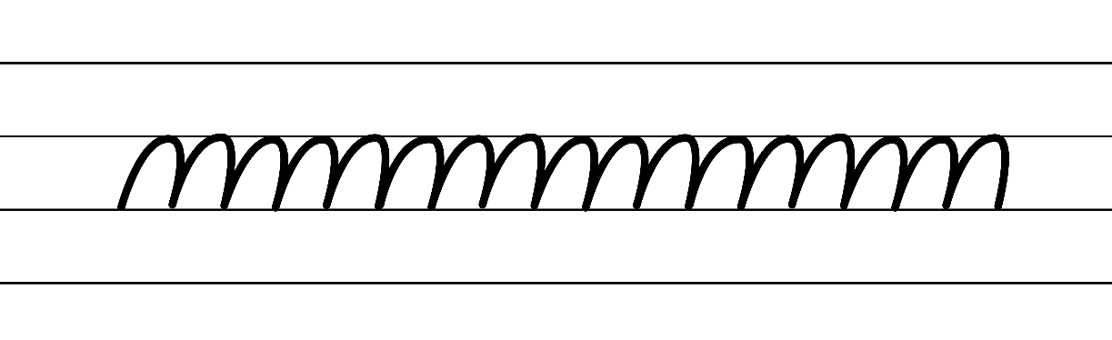  - Example NSW Foundation Style handwriting formation  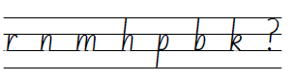  - Suggested practice text from the passage  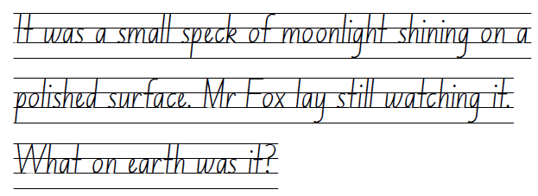  Note: students who are fluent in NSW Foundation Style can begin to use NSW Foundation Precursive and Cursive Style.

Planning framework
To plan and document Component A teaching and learning, a planning scaffold [DOCX 228 KB] is provided. To support you in your planning, a link to a detailed example of a one-week teaching and learning cycle is included in the scaffold. Additional resources to support teaching and learning in each focus area can be found at Lesson advice guides.

Component B teaching and learning
The following teaching and learning sequence has been designed to address Component B outcomes and content and develops conceptual understandings of English through the study of quality texts. Adapt the sequence as required to best meet the needs of your students.

Learning intentions and success criteria
Learning intentions and success criteria are best co-constructed with students.

Learning intention
Students are learning to understand the role of the complication and series of events in driving a narrative.

Success criteria
Students can:
- identify structural elements of a narrative, including the complication and patterns that drive a narrative
- recognise and describe authorial techniques that create tension within an event
- create an event that builds tension through the use of action verbs and adverbial phrases.

Lesson 5 – identifying problems that drive a narrative
- Review the previously read chapters in Fantastic Mr Fox, recalling details from the orientation.
- Refer to the anchor chart from Lesson 1 to review structural features of a narrative. Ask guiding questions to draw out students’ understanding of where typical narrative structure would move to next (the complication and series of events). For example:
- Has the complication of Fantastic Mr Fox been revealed yet?
- If so, what is it? If no, what might it be?
- Explain that the complication and series of events that follow build suspense and tension to enhance reader engagement. Consider how the complication or problem is rarely resolved in the first attempt.
- Display Resource 9 – Somebody, wanted, but, so, then. Explain that this strategy can be used to identify key elements of a narrative, including the complication and the series of events. Demonstrate how to use the strategy using a familiar story.
- In pairs, students identify the conflict of the narrative and the attempt that has been made towards its resolution, using the ‘Somebody, Wanted, But, So, Then’ strategy. For example:
- Somebody: Mr Fox
- Wanted: To provide for his family
- But: The farmers did not want him to steal from them
- So: The farmers tried to shoot him
- But: Mr Fox was too quick and got away...
- So: …
- But: ...
Note: students will not be able to identify the ‘then’ as this will unfold in the text’s final resolution. This will be revisited in Lesson 15.
- Share student responses. Point out that the foxes and the farmers have opposing goals, and this is how tension is initially built in the narrative.
- Explain that the shooting of Mr Fox is the first attempt in the narrative by the farmers to catch him. Read Chapter 3 to Chapter 6, exploring the problem/attempt (‘but’/‘so’) pattern in the narrative.
- Discuss the multiple attempts and failures by the farmers to stop Mr Fox from stealing. Using Resource 9 – Somebody, wanted, but, so, then from activity 4, model adding information using details from Chapter 3. For example, Mr Fox wanted to provide for his family, but the farmers did not want him to steal from them, so the farmers shot him, but they only got his tail and he ran away.
- Students use the ‘Somebody, Wanted, But, So, Then’ strategy to continue recording information from Chapter 4 to Chapter 6. For example, So – the farmers got their shovels to dig the foxes out; But – the foxes were quicker at digging; So – the farmers fetched machines to dig the foxes out; But – no matter how much they dug they still couldn’t get to the foxes.
Too hard? Students use the ‘Somebody, Wanted, But, So, Then’ strategy to orally share information.
- Students share their recorded information with the class, discussing the various attempts and failures depicted in each chapter. Highlight the tension that is built through the attempt/failure narrative pattern, further engaging the reader in the text. While students share, create a class version of Resource 9 – Somebody, wanted, but, so, then to document text details from Chapters 1 to 6. This class version will be added to in Week 2, Week 3, Week 4 and Week 5 as the narrative continues to unfold.

Lesson 6 – building tension and suspense in a narrative
- Review learning from Lesson 5, exploring the different ways the farmers attempted to catch Mr Fox.
- Read Chapters 7 and 8 of Fantastic Mr Fox. Highlight that the attempt/fail pattern as discussed in Lesson 5 has concluded, but the farmers are persisting in trying to catch Mr Fox. Discuss the new complication that has emerged (the foxes are beginning to starve) and update the class version of Resource 9 – Somebody, wanted, but, so, then from Lesson 5.
- Explain that Roald Dahl used a range of techniques throughout Chapters 3 to 8 to slow down and speed up the pace of events.
- Display Chapter 3: The Shooting (pp 10–13) that has been read in Component A. Explain that the passage can be broken into 2 sections, each with variation in their pacing. Read the passage and have students locate where the pace or tension rises.
Note: this is in the paragraph starting with ‘Just then, his sharp night eyes...’ (p 12).
- Explain that in the first suspense-filled part of the passage, the author has built tension by breaking the action into tiny stages. Read the passage aloud with students acting the part of Mr Fox. Identify and record the number of small stages that were described in this scene. For example, Mr Fox:
- crept up the tunnel to the mouth of his hole
- poked his face out
- sniffed once
- moved forward
- stopped.
- Describe that through using small steps in a series of short sentences (with full stops as pause points), the author can slow down the action, almost mimicking the stealthy movements of Mr Fox.
- With a partner, students identify and discuss the action verbs used and their impact on the Mr Fox’s movement. Share responses, highlighting how the verbs impact on both the visual and auditory elements of the scene.
- Revise the use of adverbial phrases from Component A, and their role in modifying the verbs to provide additional information about reason or circumstance. In pairs, students locate and describe the adverbial phrases based on if they are providing details about time (when), place (where), manner (how) or reason (why). Students share responses and provide justifications.
- Read the passage for students to act out again, this time with a heightened sense of the author’s attempt to slow the pace of events and provide specific details about reason and circumstance.
- Draw students’ attention to the second part of the passage. With a partner, students re-read the passage and determine where the author has increased the pace and the techniques used. For example:
- phrases related to time, such as ‘Just then’, ‘Quick as a whip’, ‘at that same instant’.
- action verbs and verb phrases, such as ‘jumped’, ‘explode’, ‘Now it was moving’.
- use of italics and exclamations in Mr Fox’s thoughts, such as ‘Great heavens! It was the barrel of a gun!’
- sound effects (onomatopoeia) in italics as exclamations, such as ‘Bang-bang! Bang-bang! Bang-bang!’
- Explore the adverbial phrases that are used by the author to support visualisation of the scene. For example, ‘behind a tree not far away’, ‘on a polished surface’, ‘lay still’, ‘into his hole’, ‘at that same instant’ and ‘around him’.
- Re-read the passage a final time for students to act, showing a distinct change in movements as the scene progresses.
- Explain that students will consider other ways Boggis, Bunce and Bean could attempt to catch Mr Fox.
- In small groups, students brainstorm and record their ideas in a list. For example, play loud music so the foxes run away, pour water down the hole, set a trap, send dogs into the foxes’ den.
- Students then brainstorm ways their suggested ideas might fail. These can be written in alignment to their original list. For example, the farmers play loud music, but the speaker runs out of battery; or they pour water down the hole, but the foxes know how to swim to a watertight part of their den. These ideas will be drawn on in Lesson 7.
- Share student responses to highlight creative ‘problem-solution’ scenarios.

Lesson 7 – creating tension in an event – part 1
- Review learning from Lesson 6, reflecting on how tension was created in ‘the shooting’ of Mr Fox. Explain that students will use the same model to write their own event that creates tension.
- Using ideas from Lesson 6, students select an idea for how the farmers will attempt to catch Mr Fox. For example, setting a trap outside the hole of his den. Model creating a list of actions broken into small steps that describe the farmers setting up their plan. Include simple adverbial phrases as appropriate. For example:
- Bean located a metal trap in his shed
- Boggis lugged the trap across the paddock
- Bunce placed some duck meat in the trap to lure the fox
- Farmers snuck back to the nearby tree
- Farmers hid out of sight of the fox and waited for the fox to appear.
- To determine if the storyline makes sense to an audience, students can act out the steps and make changes if required.
- Co-construct a success criteria for writing. For example, I can write a narrative event that builds tension and includes:
- adjectives to develop descriptive features
- simple and compound sentences
- action verbs that impact on the pace of events
- adverbial phrases to describe circumstances
- sentence punctuation.
- Model turning the small steps into a series of cohesive sentences. For example:
After searching high and low, Bean found it. He located a metal trap in his shed. He called in Boggis who lugged the heavy trap across the paddock, and they placed it near the entrance to the foxes’ den. Bunce appeared soon after holding some duck meat in his hands. He carefully placed it down in between the razor-sharp jaws of the trap, and gently placed autumn leaves around as a disguise. With smirks on their faces, the farmers slowly retreated to the tree to eagerly wait for Mr Fox to appear.
- Students use the model to create a series of steps based on their selected attempt to catch Mr Fox. Provide the opportunity for students to review their plan by acting it out as a rehearsal strategy with a partner.
- Students write a paragraph, describing the setting up of their plan to catch Mr Fox.
Too hard? Orally co-construct the event, writing down the action verbs. Students act out the event, then use the list of action verbs as a prompt for writing.
Too easy? Students use a thesaurus to identify and select more precise action verbs for their event.
- In pairs, students share their paragraph and provide peer feedback using the success criteria and the Tell, Ask, Give (TAG) strategy.
- Students revise their paragraph, applying feedback received from their peer.
- As a class, share students’ writing highlighting the techniques that have been used to create tension. Inform students that they will create the remainder of the scene in the following lesson.

Lesson 8 – creating tension in an event – part 2
- Review how Roald Dahl created suspense as Mr Fox came out of his hole in Chapter 3 (pp 10–13) and the setting up of the farmers’ plan as created in Lesson 7.
- Use the planning strategy from Lesson 7, activity 2 to write Mr Fox’s response to the attempt to catch him (before the momentum change). For example, Mr Fox:
- snuck out of his den
- looked left and right
- sniffed the breeze
- noticed the waft of fresh meat
- moved slowly towards the aroma
- reached out to the delicious-looking treat using his long, elegant paw
- caught a glimpse of shiny silver amongst the coloured leaves.
- As a form of planning, or rehearsal for writing, encourage students to act out the steps, with one or two students playing the role of the farmers and carrying out their plan to catch the foxes.
- Review the success criteria from Lesson 7.
- Model turning the small steps into a series of cohesive sentences. For example:
Mr Fox could not hear noise from outside, so he decided to sneak out of the den. He poked his head out of the hole and looked left to right. No farmers were in sight. Sniffing the breeze, Mr Fox noticed the waft of fresh meat in the air. He moved slowly towards the tempting aroma and reached his elegant paw towards the delicious-looking treat. Suddenly, Fox caught a glimpse of shiny silver amongst the coloured leaves.
- Students write a paragraph, describing Mr Fox’s response in the attempt to catch him.
- To complete the event, model writing several short sentences that utilise techniques that increase the pace, as discussed in Lesson 6, activity 10. For example:
In an instant, he realised what it was. A trap. Good golly! He turned around quickly and darted away from the trap. Snap! The sound of the jaws closing echoed into the quiet night. Mr Fox dove into the safety of his den, but not before realising that the last of his precious tail had been left in the jaws that nearly took his life.
- Students write a series of sentences which complete their attempt to catch Mr Fox.
- In pairs, students share their paragraph and provide peer feedback using the success criteria and the Tell, Ask, Give (TAG) strategy.
- Students revise their paragraph, applying feedback received from their peer.

Week 3

Component A teaching and learning
Component A focuses on the development of foundational skills and knowledge through regular, systematic and repeated practice. The mentor and supporting texts used in Component B of this unit can support the effective implementation of Component A teaching and learning.

Teaching guide
Guidance for explicit teaching, teaching notes, resources and examples for the related outcomes and content points have been provided in the table below.
Focus areas and teaching notes | Resources and examples
Reading fluency  Reading automaticity and rate  - Syllabify, blend grapheme–phoneme correspondences and use morphemic knowledge as strategies for reading words accurately  - Review: For every syllable, there is at least one vowel phoneme.  - Review: Morphemic suffixes usually form their own syllable.  - Review: The morphemic suffix -ed only forms a syllable when it is pronounced as ‘ed’.  - Review: Morphemes can be added before (prefix) or after (suffix) a base word.  - Adding the suffix -ing may change the base word. If the base word ends with an -e, omit the -e before adding -ing. | Reading fluency  Reading automaticity and rate  - Resource 10 – fluency and close reading passage analysis  - Passage 1: Boggis’s Chicken House: Chapter 10 (p 40) from ‘Carefully, Mr Fox began pushing up the floorboards...’ to ‘...First of all, everyone have a drink of water!’ (241 words)  - Passage 2: Bunce’s Giant Storehouse: Chapter 13 (p 51) from ‘He reached high and pushed up one wooden floorboard...’ to ‘This is my party, so I shall do the choosing.’ (240 words)  - Passage 3: Bean’s Secret Cider Cellar: Chapter 15 (p 63) from ‘Mr Fox laughed and began pulling more bricks out...’ to ‘...This cellar is right underneath the farmhouse itself.’ (221 words)  - Suggested words from the passage  - Morphemic information  - prancing – pranc(e) + ing  - dancing – danc(e) + ing  - chasing – chas(e) + ing  - dangling – dangl(e) + ing.  - Syllables  - prancing – 2 syllables  - dancing – 2 syllables  - chasing – 2 syllables  - dangling – 2 syllables.
Prosody  - Explain how prosodic reading involves emphasis, expression, intonation and pausing  - Review: Words and phrases can be emphasised to highlight exaggeration and the repetition of words in close succession.  - Review: Pausing can be used to add dramatic effect, including suspense.  - Reading with expression involves using the appropriate tone, pitch and stresses for the text. Using expression can highlight the emotion in a text.  - Expression could be used for:  - exclamatory sentences finishing with an exclamation mark  - character dialogue  - vocabulary with emotive connotation  - words written in italics | Prosody  - Suggested sentences to illustrate the use of expression  - Exclamatory sentences: ‘...what a fantastic sight it was that now met their eyes!’  - Character dialogue: ‘Come on up!’ he sang out.  - Vocabulary with emotive connotation: hallelujah, hooray, wild with excitement  - Italics: ‘I’ve done it first time!’
Reading comprehension  Comprehending language  - Use key words from a text to visualise events, characters and settings when making inferences and confirming predictions  - Making inferences involves connecting pieces of information together to clarify the author’s message. | Reading comprehension  Comprehending language  - Key words and phrases from each passage  - Passage 1: Words with sensory details (quiet, whispered, cautiously) provide an inference that the characters think Farmer Boggis may be in the Chicken House  - Passage 2: The wording: ‘a fox’s dream, a badger’s dream, a paradise for hungry animals’ indicates that Bunce’s Giant Storehouse is going to be filled with delicious food  - Passage 3: ‘They found themselves in a vast, damp, gloomy cellar. “This is it!” cried Mr Fox.’ Although the cellar is described as empty, Mr Fox’s comment infers that he knows something that the other characters do not know.
Monitoring comprehension  - Identify where meaning breaks down when reading  - A break in comprehension can occur when a reader needs to make inferences. | Monitoring comprehension  - As above
Vocabulary  Learning and using words  - Build personal Tier 1, Tier 2 and Tier 3 vocabulary through social and learning interactions, reading and writing  - Review: Adjectives and adverbs can be used to describe character features and settings.  - Review: Action verbs can be used to describe events in a narrative. | Vocabulary  Learning and using words  - Suggested vocabulary from the passages  - Passage 1: prancing, scrambled, teeming  - Passage 2: poked, gaped, proclaimed, overwhelmed, dangling, ravenously, luscious  - Passage 3: vast, gloomy, peered, underneath
Defining and analysing words  - Apply morphemic knowledge to change word meanings by adding different prefixes and suffixes to a base word or root  - Review: Suffixes can be added to base words to adjust their meaning | Defining and analysing words  - As above
Spelling  Phonological component  - Explain how to segment multisyllabic words into syllables and phonemes, and apply this knowledge when spelling  - Segment words into syllables. For example, hooray has 2 syllables.  - Segment words into phonemes. For example, 4 phonemes (h-oo-r-ay).  - Identify differences in vowel phonemes (short, long, diphthong and schwa vowels)  - /ay/ is a diphthong. Diphthongs are a single phoneme that glides from one vowel to another. The position of the mouth changes while saying these phonemes.  - The first syllable in the word playing has a diphthong and the second syllable has a short vowel. | Spelling  Phonological component  - Suggested words from the Week 3 reading material – Chapters 9 to 15: crazy, fail, mistaken, wait, hooray, place, straight, tail, pace-paces-paced-pacing, gape-gapes-gaping-gaped, proclaim-proclaims-proclaiming-proclaimed, display-displays-displaying-displayed.  - Sample words: rain-rains-rained-raining, paint-paints-painting-painted, play-plays-played-playing, delay-delays-delaying-delayed, prey-preys-preyed-preying, straighten-straightens-straightened-straightening, weigh-weighs-weighed-weighing, exclaim-exclaims-exclaiming-exclaimed.
Orthographic component  - Apply knowledge of taught vowel graphemes when spelling  - [ai, ay, ey] are vowel digraphs that represent the diphthong /ay/. This phoneme can also be represented using the split digraph [a_e] and the quadgraphs [aigh, eigh]. The grapheme [a] makes the long vowel sound when positioned at the end of a syllable. | Orthographic component  - As above
Morphological component  - Identify inflected suffixes, explaining when and how to treat words when they are affixed, and apply this knowledge when spelling  - The inflected suffixes -s, -ing, -ed change the tense of a verb. The suffixes -s and -ing express present tense, -ed expresses past tense; -ing also expresses future tense.  - When a word ends in a -y, keep the -y before adding the suffix (play, playing). Compare to plurality rule where you replace the ‘-y’ with an ‘i’ before adding -es. | Morphological component  - As above  Note: content in Spelling will support learning in the focus areas Reading fluency, Vocabulary and Reading comprehension.
Creating written texts  Sentence-level grammar  - Use exclamatory sentences to emphasise a point or express a strong emotion  - Introduce exclamatory sentences. Exclamatory sentences  - emphasise a point or express strong emotion  - end with an exclamation mark to express a strong emotion such as surprise, excitement or fear.  - Use coordinating conjunctions in compound sentences to compare and contrast, or for addition  - Review simple and compound sentence features.  - Use adverbial phrases or clauses to add information to the verb or verb group of the main or other clauses, to provide reasons for or circumstances  - Review adverbial phrases. Adverbial phrases  - describe verbs, adjectives and other adverbs.  - answer questions, such as how, when, why, where and how often.  - can contain or be made up of a prepositional phrase when it is acting as an adverb, modifying the verb. A prepositional phrase is made up of a preposition, along with the noun or noun phrase that follows it. | Creating written texts  Sentence-level grammar  - Suggested simple and compound exclamatory sentences from the passage  Passage 1  - ‘I’ve done it!’ he yelled.’  - ‘The small four foxes scrambled up out of the tunnel and what a fantastic sight it was that now met their eyes!’  Passage 2  - ‘I’ve done it again!’  - ‘I've hit it smack on the nose!’  Passage 3  - ‘This is it!’ cried Mr Fox.’  - ‘Tremendous!’ shouted Badger.’  - Simple and compound sentences with adverbial phrases from the text:  Passage 1  - ‘He let out a shriek of excitement.’ (how/manner)  - ‘He pulled himself up through the gap in the floor and started prancing and dancing with joy.’* (where/place; how/manner)  - ‘They were in a huge shed and the whole place was teeming with chickens.’ (where/place; how/manner)  Passage 2  - ‘He poked his head through the gap.’ (where/place)  - ‘Quickly Badger and the three Small Foxes scrambled up after him.’ (how/manner; where/place)  - ‘And up above, dangling from the rafters, there must have been at least a hundred smoked hams and fifty sides of bacon!’ (where/place)  Passage 3  - ‘Mr Fox laughed and [he] began pulling more bricks out of the wall.’ (where/place)  - ‘They found themselves in a vast, damp, gloomy cellar’.’ (where/place)  Note: coordinating conjunctions have been italicised. Where the subject of the clause is implied, this is included in square parentheses. Adverbials phrases are bolded.
Handwriting and digital transcription  Handwriting legibility and fluency  - Understand that legible handwriting is consistent in size and spacing and can support learning  - Form the ‘anticlockwise’ letters c, o, a, d, g, q, e, s and f using consistent size and spacing  - Spacing: Consistent spacing supports the legibility and appearance of handwriting. Draw attention to appropriate spacing within words, between words and between lines of writing.  - Form basic punctuation marks, including an exclamation mark  - Exclamation marks are full height. They are the same height as capital letters. | Handwriting and digital transcription  Handwriting legibility and fluency  - Suggested fluency pattern  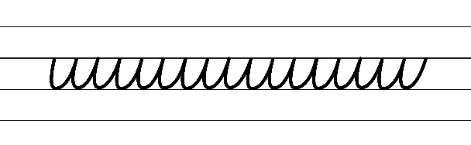  - Example NSW Foundation Style handwriting formation  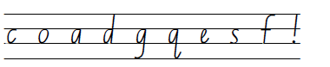  - Suggested practice text from the passage  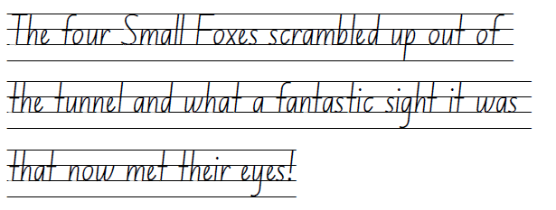  Note: students who are fluent in NSW Foundation Style can begin to use NSW Foundation Precursive and Cursive Style.

Planning framework
To plan and document Component A teaching and learning, a planning scaffold [DOCX 228 KB] is provided. To support you in your planning, a link to a detailed example of a one-week teaching and learning cycle is included in the scaffold. Additional resources to support teaching and learning in each focus area can be found at Lesson advice guides.

Component B teaching and learning
The following teaching and learning sequence has been designed to address Component B outcomes and content and develops conceptual understandings of English through the study of quality texts. Adapt the sequence as required to best meet the needs of your students.

Learning intentions and success criteria
Learning intentions and success criteria are best co-constructed with students.

Learning intention
Students are learning to identify and use language features in the creation of setting descriptions.

Success criteria
Students can:
- use key words from a text to visualise characters and settings
- identify and analyse language features which build description
- follow class protocols, including acknowledging others’ contributions, when sharing their opinions
- create a detailed description of an imagined setting.

Lesson 9 – visualising settings
- Explain that students will further develop their interaction skills in a small group through retelling story events and creating a story map.
- Set up the interaction component of the lesson by reviewing and adding to the list of protocols that have been a focus throughout the previous lessons. Provide time for small groups of students to negotiate a specific group-work protocol that they will use as a focus during learning time. For example, acknowledging the value of others’ contributions. Students describe and demonstrate what success with their focus will look like.
- Continue with the lesson by briefly reviewing narrative features, including setting, characters and structural elements, such as orientation, complication, series of events, resolution, as well as characterisation elements.
- Students work together in their group to determine the key story and character events from Chapter 1 to 8 of Fantastic Mr Fox. Students rehearse retelling the story chapter-by-chapter, with the title or first page of each chapter acting as a memory cue. Encourage students to include key vocabulary that has been introduced in Component A.
- Pause to reflect on interaction skills amongst the groups.
- Read Chapter 9 which outlines Mr. Fox’s next plan to outwit the farmers and his family’s heightened desperation. Explore how this is highlighted through character actions and dialogue. For example, Mr Fox did not speak for a long time while trying desperately to think of a way out. Continue adding to the class version of Resource 9 – Somebody, wanted, but, so, then from Lesson 5.
- Explain that, in the coming chapters, the story setting will play a significant role in the events. Draw students’ attention to the setting of Fantastic Mr Fox. Define ‘setting’ as the time and place in which a story is located. Students Think-Pair-Share the details of the setting that have been revealed so far. For example, the narrative is set in a valley where there are 3 farms.
- Provide small groups of students with a piece of A3 paper. Explain that students will create a story map which combines elements from the retell from the start of the lesson.
Note: a story map is a graphic organiser that is used to help children retell or discuss the storyline of a book or an invented story, its characters, settings and the order of events (Snow & Serry 2023).
- Model and then support students to scan the text to locate key words and phrases in Chapter 1 to 9 that support visualising the story setting. This information may come from sections of the text dedicated to explaining the setting, as well as through character descriptions and story events. For example:
- ‘Down in the valley there were three farms.’ (p 1)
- ‘On a hill above the valley there was a huge wood... In the hole lived Mr. Fox and Mrs. Fox and their four Small Foxes.’ (p 7)
- ‘Mr Boggis was hiding behind his Chicken House Number One... heading for Chicken House Number Four at the other end of the farm.’ (p 8)
- ‘The hole the machines had dug was like the crater of a volcano.’ (p 28)
- ‘The tents surrounded Mr Fox’s hole.’ (p 31)
- Use key words and phrases to create a sample story map to represent the narrative settings. Refer to Resource 11 – story map example.
- Students work together in their group to create and annotate a story map with labels. Continue to check-in and provide feedback on each group’s interaction focus.
- As a class, share story maps and make predictions about where the coming events in the narrative may occur.
- Read Chapters 10 to 11 to confirm predictions. Continue adding to the class version of Resource 9 – Somebody, wanted, but, so, then. Students can also add details to their story maps as necessary.
Too easy? Students extend their map by including references to the underground story setting. For example, ‘The tunnel began to grow longer and longer. It sloped steeply downward.’ (p 18)
Too hard? Provide students with the direct quotes from the text that contain setting details. Provide students with printed pictures to use on their story map, or complete digitally using digital pictures and drawing tools.

Lesson 10 – building vivid descriptions of character and settings
- Review the story maps from Lesson 9. Explain that students will continue to use key words from the text to visualise additional settings as they are introduced into the text, as well as identify the role characters play in narrative plots.
- Identify the characters that have been introduced in previous chapters, including Mrs Fox and the 4 Small Foxes. Using a displayed copy of Resource 7 – character traits, students Think-Pair-Share a character trait that describes Mrs Fox and/or the 4 Small Foxes. Students justify their responses using character actions from the text.
- Read Chapters 12 to 13, which introduce new characters (Badger and his family) and a new setting (Bunce’s Giant Storehouse). Ask why these characters might have been added. Discuss how, by adding these characters, the story’s complication becomes larger as there are 3 other animal families who are starving underground. The additional characters also seek help from Mr Fox which positions him as ‘fantastic’ and the hero of the story. Discuss the role that Mr Fox plays, directing the others to carry out his plan, including in his extended monologue on pages 54 and 55. Continue adding to the class version of Resource 9 – Somebody, wanted, but, so, then from Lesson 5.
- Revisit parts of the text which highlight how the characters are described and interact when they enter each of the new story settings. Revise how adjectives and adverbial phrases, as introduced in previous lessons and Component A, are used to provide information and build descriptions. Display the sections of text that describe:
- Boggis’s Chicken House: Chapter 10 (p 39) from ‘Carefully, Mr Fox began pushing up the floorboards...’ to ‘...First of all, everyone have a drink of water!’ (See Component A – Passage 1)
- Bunce’s Giant Storehouse: Chapter 13 (p 50) from ‘He reached high and pushed up one wooden floorboard...’ to ‘This is my party, so I shall do the choosing.’ (See Component A – Passage 2)
- Students turn and talk to locate adjectives used to describe the settings.
- As a class, analyse adjectives that promote exaggeration. For example, using ‘great’ and ‘mighty’ to describe size; ‘thousands and thousands’ to describe quantity and ‘finest’ and ‘fattest’ to describe quality. Compare the use of less impactful adjectives. For example, if Roald Dahl used ‘big’ instead of ‘mighty’ or ‘many’ instead of ‘thousands and thousands’.
- Complete the same analysis with adverbial phrases. For example, ‘They started running around in all directions’ indicates the 4 Small Foxes’ excitement and desperation to catch the chickens.
- Select sentences from either of the passages to use as a focus for innovation. Write each sentence with specific words and phrases deleted or altered, highlighting the impact of the under and overuse of descriptive language. For example:
Original: ‘This my dear old badger’, proclaimed Mr Fox, ‘is Bunce’s Mighty Storehouse! All his finest stuff is stored in here before he sends it off to market.’
Innovation 1: ‘This, badger,’ said Mr Fox, ‘is Bunce’s shed. He keeps his stuff in here.’ [under use of descriptive language]
Innovation 2: ‘This, my beautiful and wonderful friend,’ exclaimed Mr Fox, ‘is Bunce’s Magnificent, Mighty and Marvellous Storehouse. His sensational, gigantic and tasty stash of plump and delicious ducks and geese are secretly horded in here before he sends them off to the very busy market in the enormous city. [overuse of descriptive language]
- Students select and innovate on sentences from the text, showing the under and overuse of descriptive language.
- Model how to add an internal visual of the 2 settings to the story map from Lesson 9. See Resource 11 – story map example. Students add illustrations of Boggis’ Chicken House and Bunce’s Giant Storehouse to their story map.
- Students label their story map using adjectives and adverbial phrases that support visualising. Encourage students to use additional information from the chapter to support their illustration. For example, ‘the board creaked most terribly’ may imply that the floorboards are old.
- Display Quentin Blake’s illustrations of Boggis’ Chicken House (p 39 and p 41) and Bunce’s Giant Storehouse (p 52 and p 53). Students compare with their own illustrations.
Assessment task 3 – observations and work samples from this lesson allow students to demonstrate achievement towards the following syllabus outcomes and content points:
EN2-VOCAB-01 – builds knowledge and use of Tier 1, Tier 2 and Tier 3 vocabulary through interacting, wide reading and writing, and by defining and analysing words
- build personal Tier 1, Tier 2 and Tier 3 vocabulary through social and learning interactions, reading and writing.
EN2-RECOM-01 – reads and comprehends texts for wide purposes using knowledge of text structures and language, and by monitoring comprehension
- use key words from a text to visualise events, characters and settings when making inferences and confirming predictions.

Lesson 11 – exploring moral dilemmas in narratives
- Read the title of Chapter 14, ‘Badger Has Doubts’. Ask what Badger’s doubts might be. Prompt students to consider predictions based on their understanding of narrative structure, settings and characterisation. Students share predictions with a partner.
- Read Chapter 14. Display section of the text from ‘Suddenly Badger said...’ to ‘...suppose we’ll have to,’ said Badger.’ (pp 58–60). Ask:
- Why is Badger feeling doubtful?
- How does Mr Fox try to ease Badger’s concerns?
- Continue adding to the class version of Resource 9 – Somebody, wanted, but, so, then from Lesson 5.
- Introduce the idea of a moral dilemma. Think-Pair-Share other texts where the characters face a moral dilemma. For example, in The Lion and the Mouse, the mouse, despite being prey to the lion, must decide whether to help the lion or escape and ensure its own safety. Explore how Badger faces a moral dilemma (the decision to steal from the farmers to protect and care for his family OR to not steal and potentially let his family go hungry). Discuss how Badger’s actions and choices may conflict with his personal values.
- Explain that students will participate in a Conscience alley activity and express their opinion about Badger's actions. Ask students if Badger should have joined Mr Fox in stealing from the Farmers. Develop agreed protocols when using this technique. For example, students will share one point at a time, listen actively and respect others’ opinions.
Note: Conscience alley is an adaptation of the classic class debate that engages students in argument development, persuasive communication and critical thinking.
- Divide the class into 2 groups. One side agreeing with Badger’s actions (that he should steal for his family) and the other disagreeing (that he should not steal).
- Each team prepares an argument that can be communicated verbally. All students should develop at least one point to support their team’s argument. For example, think of your family, Badger; you need to do whatever you can to save them.
- Students form an alley with the teams lined up on each side, facing each other. Walk slowly down the middle of the alley, while students present their arguments. Encourage students to listen actively and consider different perspectives. If students make a similar argument, they should acknowledge the other person’s contribution and build upon their point. For example, ‘Johnny is right, Badger. Stealing is against the law and you are not a criminal.’
- After all students have shared their arguments, discuss students’ thoughts, insights and reflections. Students analyse the reasons behind their own opinions and consider how they differ from their peers’.
- Students write a short reflection about Badger’s actions and their view of stealing from the farmers. Prompt students to provide reasons for their opinion, using ideas shared during the conscience alley activity.
Assessment task 4 – observations from this lesson allow students to demonstrate achievement towards the following syllabus outcome and content points:
EN2-OLC-01 – communicates with familiar audiences for social and learning purposes, by interacting, understanding and presenting
- follow agreed-upon protocols and assigned roles for classroom interactions in person and through the use of technology
- listen actively to identify spoken information, acknowledging the value of others’ contributions.
EN2-RECOM-01 – reads and comprehends texts for wide purposes using knowledge of text structures and language, and by monitoring comprehension
- identify similarities and compare differences within and between texts by making text-to-self, text-to-text and text-to-world connections.

Lesson 12 – creating descriptions of characters and settings
- Read Chapter 15. Discuss Fox’s continued attempt to influence the other characters, including the newly introduced Rat. For example, by getting Rat to move out of the way by giving him a ‘brilliant smile’, ‘flashing his white teeth’ and threatening to ‘eat him up-in-one-gulp!’ As events unfold, add to the class version of Resource 9 – Somebody, wanted, but, so, then from Lesson 5.
- Investigate the structure and language features of the 3 setting descriptions, highlighting the similarities and the impact on the reader. Refer to Resource 10 – fluency and comprehension passage analysis. Annotations can be written on an enlarged copy of the text as a strategy for learning and student engagement. For example, highlighting and labelling the use of exclamatory sentences in dialogue to heighten excitement.
- Explain that students will use the structure identified in activity 2 to write a vivid setting description that could be added to Fantastic Mr Fox. Students use their description of the fourth farmer from Lesson 3 to write about a new setting that Mr Fox and his sidekicks could enter and steal something from.
- Students brainstorm ideas for the setting for their fourth farmer. For example, a barn filled with eggs and feathers on an ostrich farm or a greenhouse brimming with tomatoes on a vegetable farm.
- Model creating and labelling a sketch of a ‘house/storehouse’ for the fourth farmer. Highlight how the sketch can be used strategically for idea development and as a plan for writing.
- Students draw and label their own sketch with labelled parts that use different types of adjectives and adverbial phrases.
- Co-construct a success criteria for the setting description. For example, I can write a detailed description of an imagined setting that includes:
- simple and compound sentences to give details about the setting
- adverbial phrases to provide additional information about time, place, manner or reason
- exclamatory sentences to highlight characters’ emotions
- adjectives to develop descriptive features
- sentence punctuation.
- Model writing a paragraph prior to students creating their own. For example:
Mr Fox finds the new setting: ‘I’ve done it again!’ Mr Fox proclaimed. He hauled himself up through the opening into Betty’s Barn. ‘Come and see what I have found, my darlings!’
Response from additional character(s): The 4 Small Foxes clambered up behind Mr Fox. Once again, they were amazed by what they saw.
Description of setting: Against the 4 walls, there were the biggest, glossiest and most-divine speckled eggs Mr Fox had ever seen! Thousands of ostrich eggs sat delicately upon the shelves just waiting to be eaten by the starving animals.
Exclamation and direction from Mr Fox: ‘How wonderful I am. Now you wait here. I’m going in!’ said Mr Fox to his children.
Character actions within the setting: Mr Fox walked towards the shelves and ever so carefully selected the finest eggs to place in his bag. The Small Foxes tiptoed up next to him to choose their own eggs for the magnificent feast.
- Students write their own paragraph based on their writing plan.
- In pairs, students share their paragraph and provide peer feedback using the success criteria and the Tell, Ask, Give (TAG) strategy.
- Students revise their paragraph, applying feedback received from their peer.
- Reflect on learning by selecting students to share their writing and explain the techniques they used to create a vivid description of the fourth farmer’s storehouse.

Week 4

Component A teaching and learning
Component A focuses on the development of foundational skills and knowledge through regular, systematic and repeated practice. The mentor and supporting texts used in Component B of this unit can support the effective implementation of Component A teaching and learning.

Teaching guide
Guidance for explicit teaching, teaching notes, resources and examples for the related outcomes and content points have been provided in the table below.
Focus areas and teaching notes | Resources and examples
Reading fluency  Reading automaticity and rate  - Syllabify, blend grapheme–phoneme correspondences and use morphemic knowledge as strategies for reading words accurately  - Review: For every syllable, there is at least one vowel phoneme.  - Review: Morphemic suffixes usually form their own syllable.  - Review: For every syllable, there is at least one vowel phoneme.  - Review: The morphemic suffix -ed only forms a syllable when it is pronounced as ‘ed’.  - Review: Morphemes can be added before (prefix) or after (suffix) a base word.  - Review: Adding the suffix -ing may change the base word. If the base word ends with an -e, omit the -e before adding  -ing. | Reading fluency  Reading automaticity and rate  - Fluency and close reading passage  - Passage 1: The Woman: Chapter 16 (p 67) from “Quick!” said Mr Fox...’ to ‘...tail as a souvenir’ (278 words)  - Passage 2: The Great Feast: Chapter 17 (p 78) from ‘But now, my friends...’ to ‘...speech went on for many minutes’ (260 words)  - Suggested words from the passage:  - Morphemic information  - crouched – crouch + ed  - breathing – breath(e) + ing  - paused – paus(e) + ed  - carried – carry + ed.  - Syllables  - crouched – 1 syllable  - breathing – 2 syllables  - paused – 1 syllable  - carried – 2 syllables.
Prosody  - Explain how prosodic reading involves emphasis, expression, intonation and pausing  - Review: Words and phrases can be emphasised to highlight exaggeration and the repetition of words in close succession.  - Review: Pausing can be used to add dramatic effect, including suspense.  - Review: Using expression can highlight the emotion in a text.  - Intonation is the pattern or melody of pitch changes in connected speech, especially the pitch pattern of a sentence (NESA 2023). The rising and falling of pitch can  - indicate a question is being asked  - highlight important information  - signal intention  - convey attitude or emotion. | Prosody  - Suggested sentences to illustrate the use of intonation  - Asking a question: ‘If we go out, we’ll be killed. Right?’  - Highlighting important information and signalling intention: ‘And everyday, we will eat like kings.’  - Conveying attitude or emotion: “Forever!” they cried.’
Reading comprehension  Comprehending language  - Use key words from a text to visualise events, characters and settings when making inferences and confirming predictions  - Making inferences involves connecting pieces of information together to clarify the author’s message. | Reading comprehension  Comprehending language  - Key words and phrases from each passage  - Passage 1: The clause ‘she carried a big rolling-pin’ indicates that Mabel has something to use as a weapon if she was to find the animals.  - Passage 1: ‘The jar she took was next but one to the jar behind which Mr Fox was hiding’. The reader can infer that Mr Fox is very close to being found by Mabel.  - Passage 2: ‘we will eat like kings’ indicates that Mr Fox will gather enough food for a feast everyday.  - Passage 2: ‘The cheering that followed this speech went on for many minutes’. From the phrase ‘for many minutes’, readers can infer that the animals thought Mr Fox’s idea was so fantastic that they cheered for an extended time.
Monitoring comprehension  - Identify where meaning breaks down when reading  - A break in comprehension can occur when a reader needs to make inferences. | Monitoring comprehension  - As above
Vocabulary  Learning and using words  - Build personal Tier 1, Tier 2 and Tier 3 vocabulary through social and learning interactions, reading and writing  - Review: Adjectives and adverbs can be used to describe character features and settings.  - Review: Action verbs can be used to describe events in a narrative. | Vocabulary  Learning and using words  - Suggested vocabulary from the passages  - Passage 1: crouched, peering, paused, peeping  - Passage 2: hugely, grinning, finest.
Defining and analysing words  - Apply morphemic knowledge to change word meanings by adding different prefixes and suffixes to a base word or root  - Review: Suffixes can be added to base words to adjust their meaning | Defining and analysing words  - As above
Spelling  Phonological component  - Explain how to segment multisyllabic words into syllables and phonemes, and apply this knowledge when spelling  - Segment words into syllables. For example, beginning has 3 syllables.  - Segment words into phonemes. For example, 7 phonemes (b-e-g-i-nn-i-ng)  - Identify differences in vowel phonemes (short, long, diphthong and schwa vowels)  - The first syllable in the word amazing has a schwa phoneme and the second syllable has a long vowel phoneme. | Spelling  Phonological component  - Suggested words from the Week 4 reading material – Chapters 16 to 18: they, straight, today, way, tail, place, yesterday, Mabel, away, amazing, game, taste, table, stay-stays-staying-stayed, taste-tastes-tasting-tasted, place-places-placing-placed  - Sample words: skate-skates-skating-skated, taste-tastes-tasting-tasted, escape-escapes-escaping-escaped, excavate-excavates-excavating-excavated, bake-bakes-baking-baked
Orthographic component  - Apply knowledge of taught vowel graphemes when spelling  - The most common graphemes that represent the long vowel phoneme /ay/ as in say include: [ai, ay, a, a_e, ey]. [aigh, eigh] are less commonly used representations. | Orthographic component  - As above
Morphological component  - Identify inflected suffixes, explaining when and how to treat words when they are affixed, and apply this knowledge when spelling  - The inflected suffixes -s, -ing, -ed change the tense of a verb. The suffixes -s and -ing express present tense, -ed expresses past tense; -ing also expresses future tense.  - When a verb ends with a consonant -e  - add -d to express past tense  - omit e then add -ing to express present tense.  - Teach that inflected suffix -ed can be represented by 3 different phonemes:  - /d/ as in sailed. This phoneme is used when the base word ends with a voiced sound.  - /t/ as in fished. This phoneme is used when the base word ends with an unvoiced sound.  - /ed/ as in rented. This phoneme is used when the base word ends in [t] or [d]. This sound forms a new syllable. This suffix is pronounced in 3 different ways, but is always spelled -ed. | Morphological component  - As above
Creating written texts  Sentence-level grammar  - Use exclamatory sentences to emphasise a point or express a strong emotion  - Review exclamatory sentences.  - Use coordinating conjunctions in compound sentences to compare and contrast, or for addition.  - Review simple and compound sentence features.  - Use adverbial phrases or clauses to add information to the verb or verb group of the main or other clauses, to provide reasons for or circumstances  - Review adverbial phrases. | Creating written texts  Sentence-level grammar  - Suggested simple and compound exclamatory sentences from the passage  Passage 1  - ‘‘I’ve done it!’ he yelled.’  - ‘The small four foxes scrambled up out of the tunnel and what a fantastic sight it was that now met their eyes!’  Passage 2  - ‘'We do indeed!’ said Badger.’  - ‘‘Forever!’ they cried.’  - Simple and compound sentences with adverbial phrases from the text:  Passage 1  - ‘At the foot of the steps, the woman paused, looking from left to right.’ (where/place, how/manner)  - ‘The woman in the cellar reached out and she lifted a jar of cider from the shelf.’ (where/place)*  Passage 2  - ‘We have a safe tunnel leading to three of the finest stores in the world!’ (where/place)  - ‘There was a buzz of excitement around the table.’ (how/manner, where/place)
Handwriting and digital transcription  Handwriting legibility and fluency  - Understand that legible handwriting is consistent in size and spacing and can support learning  - Form the ‘diagonal’ letters v, w, x and z and the ‘down-up’ letters u and y with consistent size and spacing  - Review previously taught information on consistency, including direction of movements for letter formation, size, slope and spacing.  - Focus on the pen(cil) lift and drop for the letters x and y.  - Form basic punctuation marks, including commas and speech marks  - Commas are positioned on the baseline.  - Speech marks are positioned to rest below the top line (Line 1). | Handwriting and digital transcription  Handwriting legibility and fluency  - Suggested fluency pattern  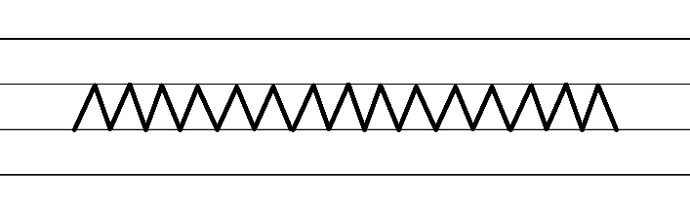  - Example NSW Foundation Style handwriting formation  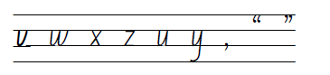  - Suggested practice inspired by the passage  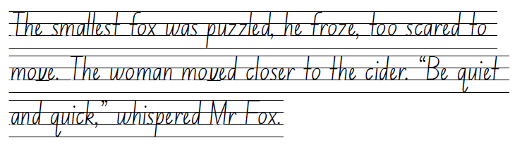  Note: students who are fluent in NSW Foundation Style can begin to use NSW Foundation Precursive and Cursive Style.

Planning framework
To plan and document Component A teaching and learning, a planning scaffold [DOCX 228 KB] is provided. To support you in your planning, a link to a detailed example of a one-week teaching and learning cycle is included in the scaffold. Additional resources to support teaching and learning in each focus area can be found at Lesson advice guides.

Component B teaching and learning
The following teaching and learning sequence has been designed to address Component B outcomes and content and develops conceptual understandings of English through the study of quality texts. Adapt the sequence as required to best meet the needs of your students.

Learning intentions and success criteria
Learning intentions and success criteria are best co-constructed with students.

Learning intention
Students are learning to understand the role of the resolution in a narrative and use their knowledge of narrative structure to plan for creating a narrative.

Success criteria
Students can:
- identify and analyse language features which build tension in an event
- create an imagined event which uses language features to build tension
- understand the purpose of a resolution and recognise different types of resolutions that narratives may use
- plan for a narrative with an orientation, complication and resolution structure.

Lesson 13 – creating tension
- Review Chapter 15 including the end of the chapter where Mabel’s introduction increases tension in the narrative. Ask students to predict what might happen in the next chapter and the role this character may play in the narrative.
- Read Chapter 16. Add the events of Chapter 16 to the class version of Resource 9 – Somebody, wanted, but, so, then from Lesson 5.
- Highlight the increase in tension when Mabel almost discovers the animals. Display Resource 12 – Freytag’s pyramid. Discuss and locate where the events from Chapters 15 and 16 would be placed on the pyramid (climax). Reflect on the text read so far and discuss where events of the story would be located on the pyramid.
- Discuss that tension is often used in the climax of a narrative. Tension creates suspense and helps the reader make a connection with the characters. Creating tension also helps readers anticipate future events or actions of characters. Effective writers keep the reader intrigued through including elements such as dramatic action or conflict. At this point in a narrative, the author often leaves the reader wondering ‘what’s next?’
- As introduced in Lesson 6, remind students that Roald Dahl has built tension by breaking the action into tiny stages. Re-read the excerpt of the text aloud from ‘At that moment they heard a woman’s voice...’ to ‘...carried a big rolling pin in one hand’ (pp 66–67). Select students to act out the parts of Mr Fox, Badger, Rat and Mabel when reading the text excerpt.
- Identify and record the number of small stages that were described in this scene. For example:
- The animals froze
- The door opened
- Mabel came down the stairs
- The animals hid
- The animals peered around the jars
- Mabel paused, looking from left to right
- Mabel walked to where most of the animals were hiding
- Mabel stood close to the animals
- Mr Fox noticed the rolling pin in Mabel’s hands.
- Describe that through using small stages, the authors can slow down the action and increase the tension felt by the reader.
- Use the excerpt to further analyse the language features Roald Dahl used to create tension. For example, ‘The animals froze’ (p 66) is a 3-word simple sentence which helps creates anticipation. The simplicity of the sentence and the verb ‘froze’ conveys a sense of sudden danger and has a greater impact than ‘stopped’.
- Revise the use of adverbial phrases as taught in Component A and how they enrich vivid descriptions through providing details about reasons and circumstances (who, what, where, when, why, how). For example, the adverbial phrase ‘absolutely still’ (p 66) creates a more detailed description of the animal’s actions.
- Explain that students will add tension to their paragraph from Lesson 12. Students should build tension through the appearance of another character into the setting they have described. Note: analysing and writing the resolution to the suspenseful event will occur in Lesson 14.
- Co-construct a success criteria for the tension paragraph. For example, I can write a paragraph that adds tension which includes:
- simple and compound sentences to describe the small steps in a tension sequence
- exclamatory sentences to express strong emotions
- adverbial phrases to provide information about time, place, manner or reason
- adjectives to develop descriptive features.
- Model writing a paragraph prior to students creating their own. For example:
Introduction to the event: Without warning Mr Fox and the Small Foxes heard a car door slam and heavy footsteps coming towards the barn door.
Action sequence in small steps: The animals stood motionless. Their eyes widened and their jaws dropped. The footsteps kept coming closer. Mr Fox pointed towards 6, large bags of ostrich feathers in the corner of the barn. ‘Quick!’ said Mr Fox. ‘Hide behind here!’ They all scurried forward and hid. Peeking out from their hiding place, they saw Betty’s sister Bertha standing in the doorway. She stopped and her huge shadow cast darkness over half of the barn. She looked around and took 4, large steps towards them. Mr Fox held his breath and stretched out his arms to cover the Smallest Fox.
- Students re-read their writing from Lesson 12 and share ideas of additional characters that could add tension.
- Provide time for students to write the beginning of their tension sequence.
Too hard? Students write their paragraph using fewer steps in their tension sequence.
Too easy? Students add dialogue to their paragraph.
- In pairs, students re-read and revise their writing. Encourage partners to ask guiding questions such as:
- Do you need to add more stages to help build the tension?
- Can you change some adjectives or verbs for greater impact?
- Reflect on the techniques students used in their writing.
- Briefly consider possible ways for the tension sequence to continue. This will provide students with time to brainstorm ideas before the next lesson.

Lesson 14 – resolving tension
- Students recall and record different ways the author created tension. For example, using small steps to describe the action and the use of adverbial phrases to add detail to character’s actions.
- Re-read and review the tension that was built in the end of Chapter 15 and Chapter 16. Provide small groups of students a copy of the passage. Students investigate other techniques the author used. Ask guiding questions. For example:
- Which character actions have the greatest impact on the level of tension?
- Why might Roald Dahl have included details about the sound of Mabel’s breathing?
- How is ‘The Woman’ described? Does this impact the tension?
- Why did the author have Mabel carry a rolling pin?
- How does the dialogue add to the tension?
- Which individual words and phrases add to the tension?
- Explore how the tension was resolved at the end of the chapter. The author does not explicitly say Mabel left the cellar but writes that she ‘climbed slowly out of sight up the steps’ and ‘the door slammed’. Discuss the impact of the short simple sentence which signifies the animals being out of immediate danger.
- Explain that students will finish writing their tension sequence from Lesson 13. The tension created by the addition of a new character will be resolved by the character leaving.
- Co-construct a success criteria for the tension paragraph. For example, I can write a paragraph that resolves tension which includes:
- simple and compound sentences to describe the small steps in a tension sequence
- exclamatory sentences to show emotion
- adverbial phrases to provide information about time, place, manner or reason
- carefully selected words to increase tension.
- Model writing a paragraph to resolve tension prior to students creating their own. If needed, provide a scaffold to structure the series of events. This can support students to write events in a clear sequence and avoid run-on sentences. For example:
Description of Bertha’s actions: Bertha stood and looked around.
Animal response: They could hear her loud breathing and saw a large, black frying pan in her hand.
Bertha’s actions: Bertha banged the frying pan. The noise echoed around the barn.
Dialogue: ‘How many eggs will those farmers want?’ muttered Bertha.
Bertha’s actions and dialogue: She scanned the shelves. ‘I really don’t want to be cooking eggs for everyone. I want to be out capturing that loathsome fox.’
Animal response: Mr Fox peered between the bags of ostrich feathers and he could see Bertha moving towards him.
Bertha’s actions and dialogue: ‘Ah ha!’ she exclaimed. She reached for the eggs directly above Mr Fox’s head.
Animal response: Mr Fox could feel Badger nervously shaking beside him.
Bertha’s actions: Bertha turned and walked to the door. She stopped and looked around the barn one more time before huffing loudly and walking out.
End of danger: Bertha’s footsteps faded.
Animal escape: ‘Quick!’ said Mr Fox. ‘Grab your eggs and run for it!’
- In pairs, students re-read and revise their writing from Lesson 12 and Lesson 13. Students plan how the tension will be resolved.
- Students independently add to their writing to resolve the tension.
Too hard? Students write their paragraph using fewer steps in their tension sequence.
Too easy? Students add dialogue to their paragraph.
- In pairs, students re-read and revise their writing. Encourage partners to ask guiding questions such as:
- Do you need to add more stages to help build the tension?
- How could adjectives and adverbial phrases be used for greater impact?
- Share a few samples of student writing, highlighting the techniques used to increase and resolve tension.
Assessment task 5 – collecting work samples from this lesson allow students to demonstrate achievement towards the following syllabus outcomes and content point:
EN2-CWT-01 – plans, creates and revises written texts for imaginative purposes, using text features, sentence-level grammar, punctuation and word-level language for a target audience
- use exclamatory sentences to emphasise a point or express a strong emotion
- use adverbial phrases or clauses to add information to the verb or verb group of the main or other clauses, to provide reasons for or circumstance
- use coordinating conjunctions in compound sentences to compare and contrast, or for addition.

Lesson 15 – exploring resolutions in narratives
- Revise the purpose of a resolution. For example, to provide closure, satisfy the reader’s expectations and give a sense of completion to the story.
- Brainstorm different types of resolutions. For example:
- Lesson or moral – the main character grows and learns a valuable lesson at the end of the story
- Surprise ending – the story goes in an unexpected direction
- Happy or resolved ending – the problem faced by the characters is solved in a positive or satisfying way
- Humorous ending – the story ends with a funny thought or action
- Cliffhanger ending – the story is not resolved and leaves the reader with unanswered questions
- Circular ending – the story ends where it began.
- Display a range of familiar picture books. For example, Pig the Pug by Aaron Blabey, The Three Little Pigs, The Tortoise and the Hare by Aesop, Don’t Let the Pigeon Drive the Bus by Mo Willems, Peggy: A Brave Chicken on a Big Adventure by Anna Walker, Boy by Phil Cummings, Farmer Duck by Martin Waddell.
- As a class, determine the types of resolutions used by authors. Explore how some texts could be categorised into multiple types of resolutions. For example, Pig the Pug could be categorised into moral, humorous and happy/resolved ending.
- Ask students to predict what type of resolution Fantastic Mr Fox has and why. In pairs, students walk and talk for an allocated time, discussing their response. Students decide on a response and share with the class or another group.
- Read Chapter 17 of Fantastic Mr Fox and reflect on student predictions.
- In pairs, students analyse what type of resolution Roald Dahl used in Fantastic Mr Fox. Students provide details and examples from the text to support their thinking. For example, it’s a happy ending because the animals end up with a supply of food. Share student responses.
- Divide the class into small groups and provide each group with the text excerpt from ‘But now, my friends...’ to ‘...speech went on for many minutes’ (pp 79–80). In their groups, each student selects a character (Mr Fox, Badger, Rabbits) and the group re-enacts the scene from the text, focusing on the characters’ emotions and reactions during Mr Fox’s speech.
- After each group performs their role play, use guiding questions to deepen students’ understanding of the text. For example:
- What do the characters’ reactions reveal about their feelings towards Mr Fox’s plan?
- What effect does the cheering and responses from the characters have on the resolution?
- Display the class version of Resource 9 – Somebody, wanted, but, so, then from Lesson 5. Add events from Chapter 17 and reflect on the resolution of Fantastic Mr Fox using the ‘then’ part of the strategy. For example, ‘Then Mr Fox outsmarted the farmers with his plan to create an underground village, keeping the animals safe and fed underground.’
- Ask students if the problem has been resolved for all the characters. Share student responses.
- Read Chapter 18. Highlight that the outcome for all characters has been provided. Take a vote as a class to determine which type of resolution is used. For example, circular ending, resolved ending, cliff hanger ending. Create a graph to display results. Students can justify their responses either orally or as a written task.

Lesson 16 – planning a narrative
- Reflect on Chapters 17 and 18. Ask students if Mr Fox’s solution is sustainable and why or why not.
- Explain that students will write a sequel to Fantastic Mr Fox over the next few lessons. The sequel will begin with an event that disrupts the underground animals’ access to the farmers’ storehouses. Students may plan and write in pairs or individually. This lesson will focus on planning a narrative using the narrative structure explored in this unit (orientation, complication, resolution) and developing characters with familiar, group or individual characteristics.
- Co-construct success criteria for writing, based on text features of Fantastic Mr Fox. For example, ‘I can plan and write a narrative that includes:
- an orientation, complication (series of events) and resolution
- a variety of sentences for effect (declarative, exclamatory, simple and compound sentences)
- adjectives to build descriptive features
- adverbial phrases to provide information about time, place, manner or reason.’
- As a class, brainstorm different events that could disrupt the underground animals’ access to the farmers’ storehouses. For example, some of the underground tunnels cave in, the farmers lay concrete on the floor of their storehouses.
- Model selecting one of the ideas generated and using Resource 13 – Freytag's pyramid planning template to plan a sequel for Fantastic Mr Fox.
- Individually or in pairs, students select an idea and plan their ideas for their narrative sequel using Resource 13 – Freytag's pyramid planning template.
Too hard? Scaffold planning further by completing plan with students.
- Students share their planning with another class member, explaining their storyline to ensure the action builds, there is a resolution to the complication and that their planned narrative makes sense. Their partner should listen actively, acknowledging their ideas and asking questions to clarify thinking.
- Students modify their plan if needed.
Assessment task 6 – observations and work samples from this lesson allow students to demonstrate achievement towards the following syllabus outcomes and content points:
EN2-CWT-01 – plans, creates and revises written texts for imaginative purposes, using text features, sentence-level grammar, punctuation and word-level language for a target audience
- use an orientation, complication, resolution structure to create narratives centred on time, place and characters.
EN2-UARL-01 – identifies and describes how ideas are represented in literature and strategically uses similar representations when creating texts
- describe how narratives set up expectations using familiar, real and imagined characters, situations and phrases.

Week 5

Component A teaching and learning
Component A focuses on the development of foundational skills and knowledge through regular, systematic and repeated practice. The mentor and supporting texts used in Component B of this unit can support the effective implementation of Component A teaching and learning.

Teaching guide
Guidance for explicit teaching, teaching notes, resources and examples for the related outcomes and content points have been provided in the table below.
Focus areas and teaching notes | Resources and examples
Reading fluency  Reading automaticity and rate  - Syllabify, blend grapheme–phoneme correspondences and use morphemic knowledge as strategies for reading words accurately  - Review: For every syllable, there is at least one vowel phoneme.  - Review: Morphemic suffixes usually form their own syllable.  - Review: The morphemic suffix -ed only forms a syllable when it is pronounced as ‘ed’.  - Review: Morphemes can be added before (prefix) or after (suffix) a base word.  - Review: Adding the suffix -ing may change the base word. If the base word ends with an -e, omit the -e before adding  -ing. | Reading fluency  Reading automaticity and rate  - Fluency and close reading passage- Chapter 18: Still Waiting (pp 81–82), from ‘Outside the fox’s hole...’ to ‘...they are still waiting’ (95 words)  - Suggested words from the passage  - Morphemic information  - beginning – begin + ing  - trickling – trickl(e) + ing  - handy – hand + y  - waiting – wait + ing.  - Syllables  - beginning – 3 syllables  - trickling – 2 syllables  - handy – 2 syllables  - waiting – 2 syllables.
Prosody  - Explain how prosodic reading involves emphasis, expression, intonation and pausing  - Review: Words and phrases can be emphasised to highlight exaggeration and the repetition of words in close succession.  - Review: Pausing can be used to add dramatic effect, including suspense.  - Review: Using expression can highlight the emotion in a text.  - Review: Intonation can be used to indicate a question is being asked, to highlight important information and to convey attitude or emotion. | Prosody  - Suggested sentences to illustrate the use of prosodic reading  - Pause to show time passed: ‘They sat there by the hole, waiting for the fox to come out’.  - Expression to highlight the miserable mood of the farmers: ‘“He won’t stay down there much longer now,” Boggis said.’  - Intonation to highlight important information: ‘And so far as I know, they are still waiting’.
Reading comprehension  Comprehending language  - Use key words from a text to visualise events, characters and settings when making inferences and confirming predictions  - Making inferences involves connecting pieces of information together to clarify the author’s message. | Reading comprehension  Comprehending language  - Key words and phrases from the passage  - ‘Beginning to rain’ and ‘water was trickling down...into their shoes’ indicates the farmers had been sitting waiting for a long time’.  - From ‘must be famished’, the reader can infer that the farmers have no idea that their storehouses have been raided.  - ‘They are still waiting’ highlights that the farmers haven’t realised that Mr Fox has found a source of food after all this time
Monitoring comprehension  - Identify where meaning breaks down when reading  - A break in comprehension can occur when a reader needs to make inferences. | Monitoring comprehension  - As above
Vocabulary  Learning and using words  - Build personal Tier 1, Tier 2 and Tier 3 vocabulary through social and learning interactions, reading and writing  - Review: Adjectives and adverbs can be used to describe character features and settings.  - Review: Action verbs can be used to describe events in a narrative. | Vocabulary  Learning and using words  - Suggested vocabulary from the passage: trickling, famished, dash  - Review vocabulary from previous 4 weeks.
Defining and analysing words  - Apply morphemic knowledge to change word meanings by adding different prefixes and suffixes to a base word or root  - Review: Suffixes can be added to base words to adjust their meaning | Defining and analysing words  - As above
Spelling  Phonological component  - Explain how to segment multisyllabic words into syllables and phonemes, and apply this knowledge when spelling  - Segment words into syllables. For example, waiting has 2 syllables.  - Segment words into phonemes. For example, 5 phonemes (w-ai-t-i-ng).  - Identify differences in vowel phonemes (short, long, diphthong and schwa vowels)  - The most common graphemes that represent the long vowel phonemes /ee/ and /ay/ | Spelling  Phonological component  - Consolidate previous 4 weeks of learning.
Orthographic component  - Apply knowledge of taught vowel graphemes when spelling  - Review the common representations for long vowel phoneme /ee/ and /ay/ as per previous 4 weeks of learning | Orthographic component  - As above
Morphological component  - Identify inflected suffixes, explaining when and how to treat words when they are affixed, and apply this knowledge when spelling  - Inflected suffixes: plurals (-s/es) and tense (-s, -ing, -ed) | Morphological component  - As above
Creating written texts  Sentence-level grammar  - Use declarative sentences to provide facts or state a viewpoint  - Review declarative sentences.  - Use coordinating conjunctions in compound sentences to compare and contrast, or for addition  - Review simple and compound sentence features.  - Use adverbial phrases or clauses to add information to the verb or verb group of the main or other clauses, to provide reasons for or circumstances  - Review adverbial phrases. | Creating written texts  Sentence-level grammar  - Suggested simple and compound declarative sentences from the passage  - ‘It was beginning to rain.’  - ‘“The brute must be famished,” said Bunce.’  - ‘Water was trickling down the necks of the three men and into their shoes’.  - Simple and compound sentences with adverbial phrases from the text  - ‘Outside the fox’s hole, Boggis and Bunce and Bean sat beside their tents with their guns in their laps.’ (where/place)  - ‘They sat there by the hole, waiting for the fox to come out.’ (where/place, why/reason)  Note:  - Subordinating conjunctions are in bold  - The detail in the brackets describes the type of information being provided in the adverbial phrase/s that are underlined.
Handwriting and digital transcription  Handwriting legibility and fluency  - Understand that legible handwriting is consistent in size and spacing and can support learning  - Form numerals with consistent size and spacing  - Numerals are full height or ‘tall’ letters. They are twice the height of ‘short’ letters.  - Focus on the correct starting place and direction of movement for each numeral, including pen(cil) lifts and drops for the numerals 4 and 9. | Handwriting and digital transcription  Handwriting legibility and fluency  - Suggested fluency pattern  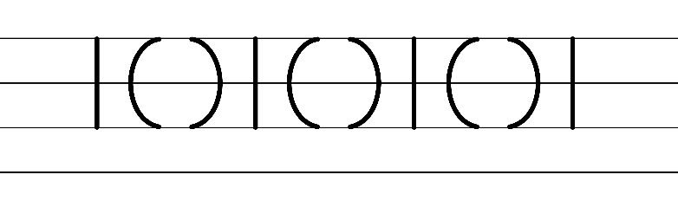  - Example NSW Foundation Style handwriting formation  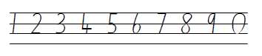  - Suggested practice innovated from the passage  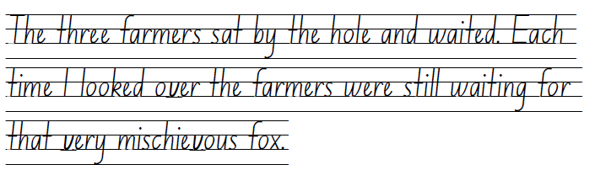  Note: students who are fluent in NSW Foundation Style can begin to use NSW Foundation Precursive and Cursive Style.

Planning framework
To plan and document Component A teaching and learning, a planning scaffold [DOCX 228 KB] is provided. To support you in your planning, a link to a detailed example of a one-week teaching and learning cycle is included in the scaffold. Additional resources to support teaching and learning in each focus area can be found at Lesson advice guides.

Component B teaching and learning
The following teaching and learning sequence has been designed to address Component B outcomes and content and develops conceptual understandings of English through the study of quality texts. Adapt the sequence as required to best meet the needs of your students.

Learning intentions and success criteria
Learning intentions and success criteria are best co-constructed with students.

Learning intention
Students are learning to apply their understanding of narrative and characterisation to draft, revise and edit a narrative that uses an orientation, complication, resolution structure.

Success criteria
Students can:
- flexibly use the writing processes of drafting, editing, revising and publishing to create a narrative
- use adverbial phrases to add details about actions (how, when, where or why) in their own writing
- effectively use adjectives to build descriptions of events, complications and resolutions
- confidently use a variety of sentences (declarative, exclamatory and compound)
- reflect on the textual concepts of narrative and characterisation.

Lesson 17 – planning and drafting an orientation
- Explain that students will be using their planning from Lesson 16 to write a sequel to Fantastic Mr Fox. This lesson will focus on planning and drafting an orientation.
- Revise the structural elements of an orientation from Lesson 1. For example:
- introducing the main and supporting characters (characterisation)
- describing the setting
- indicating the time
- foreshadowing a potential problem
- engaging details to draw the reader in.
- Model using Resource 5 – orientation to plan an orientation. For example:
- Characters: Mr Fox, Badger, Farmer Boggis, Farmer Bunce, Farmer Bean
- Setting: dark underground tunnel
- Indication of time: months later
- Foreshadowing of a potential problem: farmers lay concrete on their storehouse floors
- Engaging details: adjectives, exclamatory sentences, variation of sentences.
- Model using Resource 5 – orientation and the success criteria from Lesson 16 to write an orientation.
- Display the orientation in the classroom to use in subsequent lessons during modelled writing and check it against the success criteria from Lesson 16.
- Students use Resource 5 – orientation to plan their orientation.
- Students use their planned ideas and the modelled writing in activity 4 to write an orientation for their sequel.
Too hard? Work in targeted small groups to jointly construct an orientation with students, using their plans.
Too easy? Students select precise adjectives to add descriptive detail to their writing.
- Students work together to revise their writing using the success criteria from Lesson 16 and the structural elements of an orientation. Students apply feedback given.
- Share a few samples of student writing, highlighting use of the structural elements of an orientation.

Lesson 18 – drafting a complication and series of events
- Display Resource 9 – Somebody, wanted, but, so, then from Lesson 5 to review the complication from Fantastic Mr Fox. Revise the ways Roald Dahl engaged the reader through a complication (a series of events, tension and suspense, attempting to solve a problem and failing).
- Students review their orientation written in Lesson 17 and their narrative plan from Lesson 16. Explain that students will use their narrative plan from to draft a complication and series of events for their sequel to Fantastic Mr Fox.
- Using the planned narrative from Lesson 16 and the modelled orientation from Lesson 17, demonstrate how to write the complication and series of small events over several paragraphs. This could be done as an interactive writing session. Guide students to apply their knowledge of Component A content about adverbial phrases to provide further information and adjectives to build descriptive features.
- Discuss how the series of events helps to build tension. Identify how the constructed text has met the success criteria from Lesson 16.
- Students use their plan from Lesson 16 and orientation from Lesson 17 to write a series of events that builds tension.
Too hard? Jointly construct the complication using a minimal number of events. Students use talk-to-text technology to draft this section of the sequel.
- Students work together to revise their writing using the success criteria from Lesson 16 and the modelled complication and series of events. Students apply feedback given.
- Share a few samples of student writing, highlighting increased tension as the series of events progresses.

Lesson 19 – drafting a resolution
- Explore the purpose of a resolution and review the different types of resolutions from Lesson 15. In pairs, students reflect on Fantastic Mr Fox’s resolution and explore the type of resolution they have planned to use in their sequel.
- Using the planned narrative from Lesson 16 and the modelled writing from Lesson 17 and Lesson 18, demonstrate how to write a resolution over several paragraphs that concludes, or ‘wraps’ up a story. This can be done as an interactive writing session.
- Guide students to write using a variety of sentences and punctuation, including capital letters and commas.
- Identify how the co-constructed text has met the success criteria from Lesson 16.
- Students review their plan from Lesson 16 and re-read previous writing. Students use their plan to draft a resolution to their sequel.
Too hard? Jointly construct the resolution. Students use talk-to-text technology to draft this section of the sequel.
- Students work together to revise their writing using the success criteria from Lesson 16 and the modelled resolution. Students apply feedback given.
- Share a few samples of student writing, highlighting the types of resolutions that were used by students.

Lesson 20 – revising and editing
- Explain the difference between revising and editing. Ask students how authors, like Roald Dahl, revise and edit their texts until they are satisfied with the final product.
Note: editing involves making changes to spelling, punctuation and capitalisation. Revising involves looking over the writing as a whole and reworking the organisation and details. Grammatical features, text structure and vocabulary choices are considered during the revising stage.
- Using a modelled piece of writing from the previous lessons, model revising and editing using the success criteria from Lesson 16.
- Provide time for students to revise and edit their writing. Prompt with guiding questions, such as:
- Are you meeting your purpose? (revising)
- Is there a better way to structure your writing? (revising)
- Where do you need to add more detail? (revising)
- Is your spelling accurate? (editing)
- Does your writing contain full sentences and punctuation? (editing)
- Will the reader be able to understand what you have written? (editing)
- Encourage students to read their writing aloud to identify mistakes that they might have missed when reading silently.
- In pairs, students share their narrative and provide peer feedback using the success criteria and the Tell, Ask, Give (TAG) strategy. Students revise and edit their writing based on feedback received. Optional: students digitally publish their work using word processing software or using legible handwriting that is consistent in size and spacing. Published work could be shared with a wider audience. For example, displaying in the school library.
- Use exit tickets to demonstrate student knowledge of the textual concepts, narrative and characterisation. Options for an exit ticket may include:
- Has the text, Fantastic Mr Fox, taught you anything new about the structural elements or features of a narrative? Have you used any of these in your writing?
- Has the author, Roald Dahl, taught you how to use descriptive language to create vivid images? Can you give an example of a descriptive passage that stood out to you? How have you used a similar style in your writing? Share an example from your own writing.
- What was your favourite part of Fantastic Mr Fox, and why? How did the Roald Dahl use the narrative structure and language to make that part of the story particularly enjoyable for you?
- What did you think of the characters in Fantastic Mr Fox? How did the author use language to make them interesting and unique? Did you use any of these techniques to create interesting characters in your writing?
- In your opinion, what was the main message or theme of Fantastic Mr Fox? How did Roald Dahl use the narrative structure and language to communicate that message to the reader?

Resource 1 – fluency and close reading passage analysis
Focus | Notes
Passage | Chapter 1 – The Three Farmers: From “Down in the valley...” to “...sing when they saw them.” (245 words)
Synopsis | This passage is the opening chapter to the book. It describes the setting and introduces 3 of the main characters, Boggis, Bunce and Bean. It is part of the orientation to the narrative.  Roald Dahl describes how horrible each farmer is with rich language which positions the reader to dislike them from the beginning.
Passage structure | The text is structured into:  Setting  Additional information about the setting and the characters that live in it.  - Description of character 1  - Description of character 2  - Description of character 3  Summary  - The character descriptions each include:  - The character’s name and occupation  - Details of occupation  - Appearance  - Additional details (such as diet, habits or personality).  The mocking song at the end of the passage reiterates the awfulness of the characters.
Language features | Descriptive language  The author uses a range of adjective types to describe each character’s features including:  - Descriptive (disgusting, rich, nasty, beastly, horrible), classifying (duck-and-goose farmer) and quantifying (thousands, three) adjectives.  - Adjectives are positioned before the noun in noun groups (chicken farmer) as well as following a relating verb (was fat).  This variety increases interest and draws out both the similarities and differences between the 3 farmers.  Strong action verbs are also used, such as ‘smothered’, ‘mashed’, ‘stuffed’.  Exaggeration:  This is used to exemplify that the 3 farmers are the ‘bad guys’ in this story. There is exaggeration in terms of how the characters look, as well as their habits – what they do, for example Boggis didn’t just eat one chicken a day, he ate 9…and they were stuffed with a paste of doughnuts and goose-livers.  Comparison:  This technique supports the reader to visualise the characters. ‘He was a kind of pot-bellied dwarf’, ‘He was so short his chin would have been underwater in the shallow end of any swimming pool in the world.’  Repetition:  There are multiple forms of repetition, including:  - sentence types (declarative)  - structure (subject in theme position), for example, They were rich men/They were nasty men/Boggis was a chicken farmer.  - word choice (alliteration), for example, Boggis, Bunce and Bean.

Resource 2 – vocabulary and morphology example
Sample word | Context | Morphology | Student-friendly definition
enormously | ‘He [Boggis] was enormously fat.’ (p 2) | Base word: enormous (adjective) Morpheme: -ly. -ly changes a noun to an adjective; It means ‘how something is’. | Enormously means really, really big or extremely large. It's when something is much, much larger than usual.
beastly | ‘This diet gave him [Bunce] a tummy-ache and a beastly temper.’ (p 3) | Base word: beast (noun)  Morpheme: -ly. -ly changes a noun to an adjective; It means ‘how something is’. | Beastly means something that is super strong and impressive, just like a powerful beast.
disgusting | ‘He [Bunce] mashed the livers into a disgusting paste and then stuffed the paste into the doughnuts.’ (p 3) | Base word: disgust (verb) Morpheme:  -ing. The bound morpheme -ing. | Disgusting means something that is gross or yucky. It's when something looks, smells, or tastes terrible and makes you feel sick or want to turn away.
cleverest | ‘He [Bean] was as thin as a pencil and the cleverest of them all.’ (p 4) | Base word: clever (adjective) Morpheme: -est. The bound morpheme -est means ‘the most’. | Cleverest means the smartest or most intelligent. When we say someone is the cleverest, it means they are the smartest or most clever among a group of people.
lean | ‘Boggis and Bunce and Bean  One fat, one short, one lean’ (p 5) | Base word: lean (adjective)  Without much fat; thin and fit | Lean means to bend or tilt to one side. It's like when something is not standing straight or balanced.
horrible | ‘These [Boggis, Bunce and Bean] horrible crooks’ (p 5) | Base word: horrible (adjective) | Horrible means something that is very, very bad or unpleasant. It's a word we use to describe something that we don't like.
crook | ‘These [Boggis, Bunce and Bean] horrible crooks’ (p 5) | Base word: crook (noun) | Crook means someone who is dishonest or involved in illegal activities. It refers to someone who doesn’t follow the rules or breaks the law for personal gain.
equally | ‘Were none the less equally mean’ (p 5) | Base word: equal; Morpheme: -ly (as above) | Equally means the same as or when 2 or more things are alike. When we say that the farmers are equally mean, it means that are as mean as each other.

Resource 3 – vocabulary and morphology
Sample word | Context | Morphology | Student-friendly definition
enormously | ‘He [Boggis] was enormously fat.’ (p 2).
beastly | ‘This diet gave him [Bunce] a tummy-ache and a beastly temper.’ (p 3)
disgusting | ‘He [Bunce] mashed the livers into a disgusting paste and then stuffed the paste into the doughnuts.’ (p 3)
cleverest | ‘He [Bean] was as thin as a pencil and the cleverest of them all.’ (p 4)
lean | ‘Boggis and Bunce and Bean  One fat, one short, one lean’ (p 5)
horrible | ‘These [Boggis, Bunce and Bean] horrible crooks’ (p 5)
crook | ‘These [Boggis, Bunce and Bean] horrible crooks’ (p 5)
equally | ‘Were none the less equally mean’ (p 5)

Resource 4 – interaction protocols
Whole class | Small group | Partner

Resource 5 – orientation
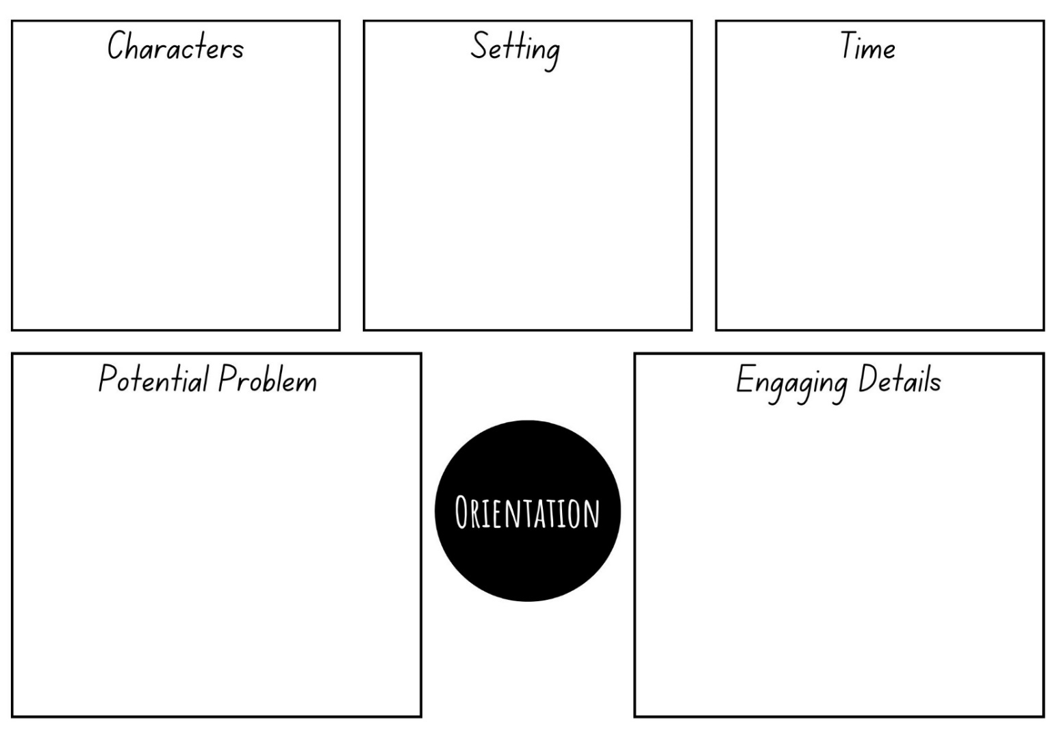

Resource 6 – types of adjectives
Quantifying | Descriptive | Classifying
three | rich | chicken

Resource 7 – character traits
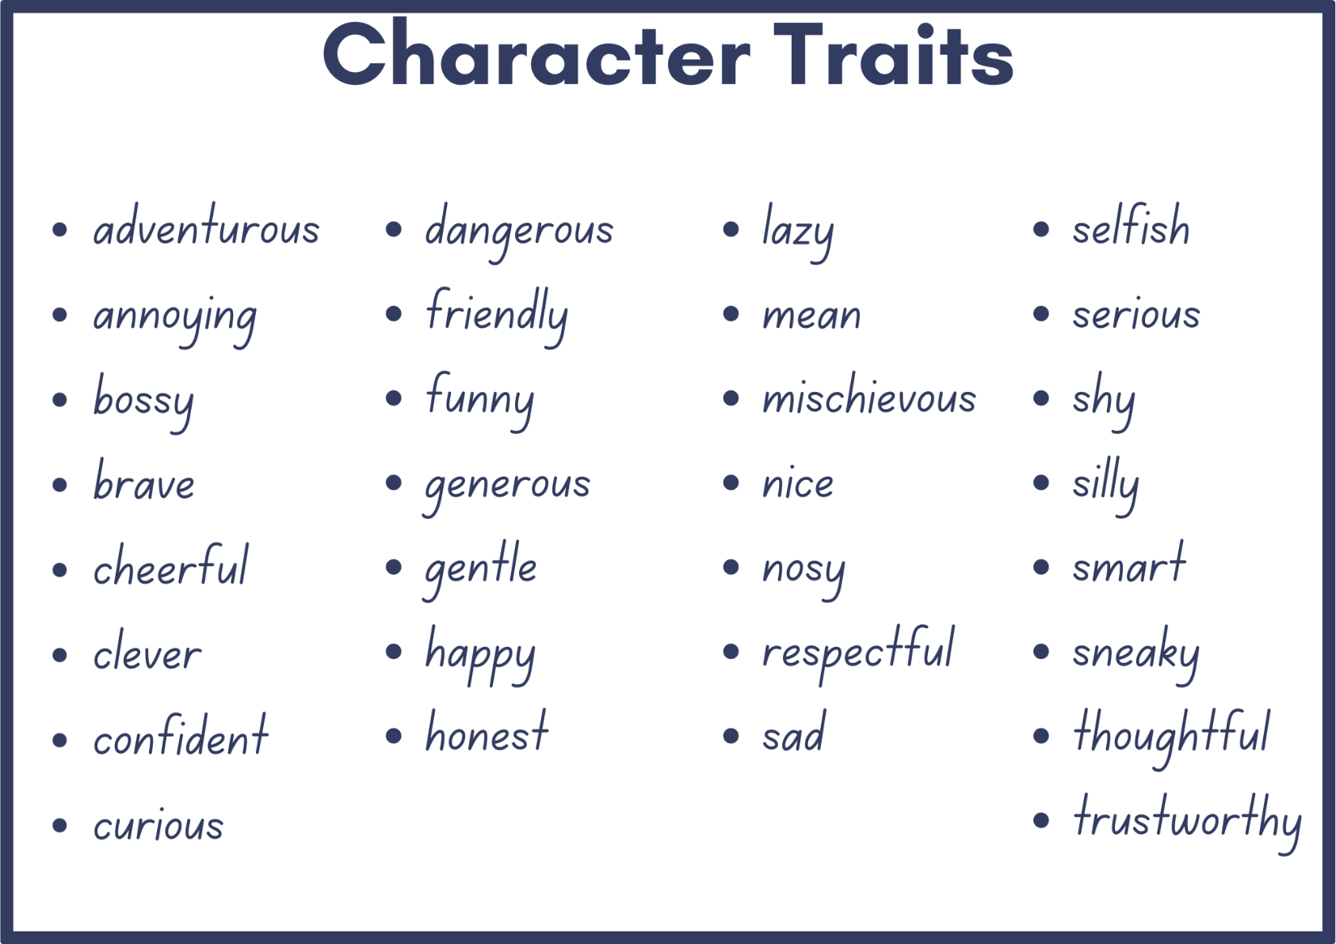

Resource 8 – fluency and close reading passage analysis
Focus | Notes
Passage | Chapter 3 – The Shooting: From ‘Mr Fox crept up the dark tunnel...’ to ‘...Bang-bang! Bang-bang! Bang-bang!’ (297 words)
Synopsis | This passage is the farmers’ first attempt at ridding themselves of Mr Fox and is the beginning of the war between the characters. To set the scene, Roald Dahl provides details about the farmers’ plan to wait just outside the entrance to Mr Fox’s den, each with a loaded gun. In a plan to outwit Mr Fox, they have positioned themselves so that the wind would not blow their scent in his direction.
Passage structure | The text structure can be described as follows:  - Mr Fox leaves the safety of his den  - The passage begins with Mr Fox cautiously coming out of his hole. He proceeds with great caution and moves slowly. The author describes each movement in detail, slowing down the pace of the event to build suspense and anticipation.  - A problem is foregrounded  - Mr Fox’s ears pricked as he senses a problem. The slow movements and caution are continued with his internal dialogue being added to the description.  - The problem is realised  - The clever Mr Fox realises what the problem is and dives into the safety of his hole as the farmers take aim and the entire wood explodes around him.
Language features | Descriptive language  - The author provides details about both the event and setting using adverbial phrases and clauses (where: Mr Fox crept up the dark tunnel to the mouth of his hole; when: He waited a long time...; how: Mr Fox lay still...This allows the reader to visualise the events that are taking place.  - Adjectives are used to sharpen descriptions. For example, Mr Fox’s face is described as ‘long and handsome’; and just prior to the woods ‘exploding’, visual imagery is enhanced using a range of descriptive adjectives, such as ‘a small silver speck of moonlight shining on a polished surface’.  - The author uses onomatopoeic words like ‘rustling’ and ‘bang-bang’ to create auditory imagery and heighten the reader’s sense of the soundings.  Pacing  - The choice of vivid action verbs highlights a change in pacing. Within the first section of the passage, the verbs illustrate the quiet and careful actions of Mr Fox (crept, poked, sniffed, inched). These contrast with verbs used later in the passage which convey fast action and movement (jumped, explode). This creates a dynamic rhythm that keeps the reader engaged.  - Temporal phrases are also used to highlight the change in pacing. For example, ‘he was just about to go forward’ adds to the sense of anticipation, whereas ‘quick as a whip’ and ‘at that same instant’ intensify the sense of action and engagement.  Inner thoughts  - The main character’s thoughts are expressed to bring the reader closer to the action (‘It must have been a field mouse’; Great heavens!). This adds depth to the character and helps the reader empathise with him.

Resource 9 – Somebody, wanted, but, so, then
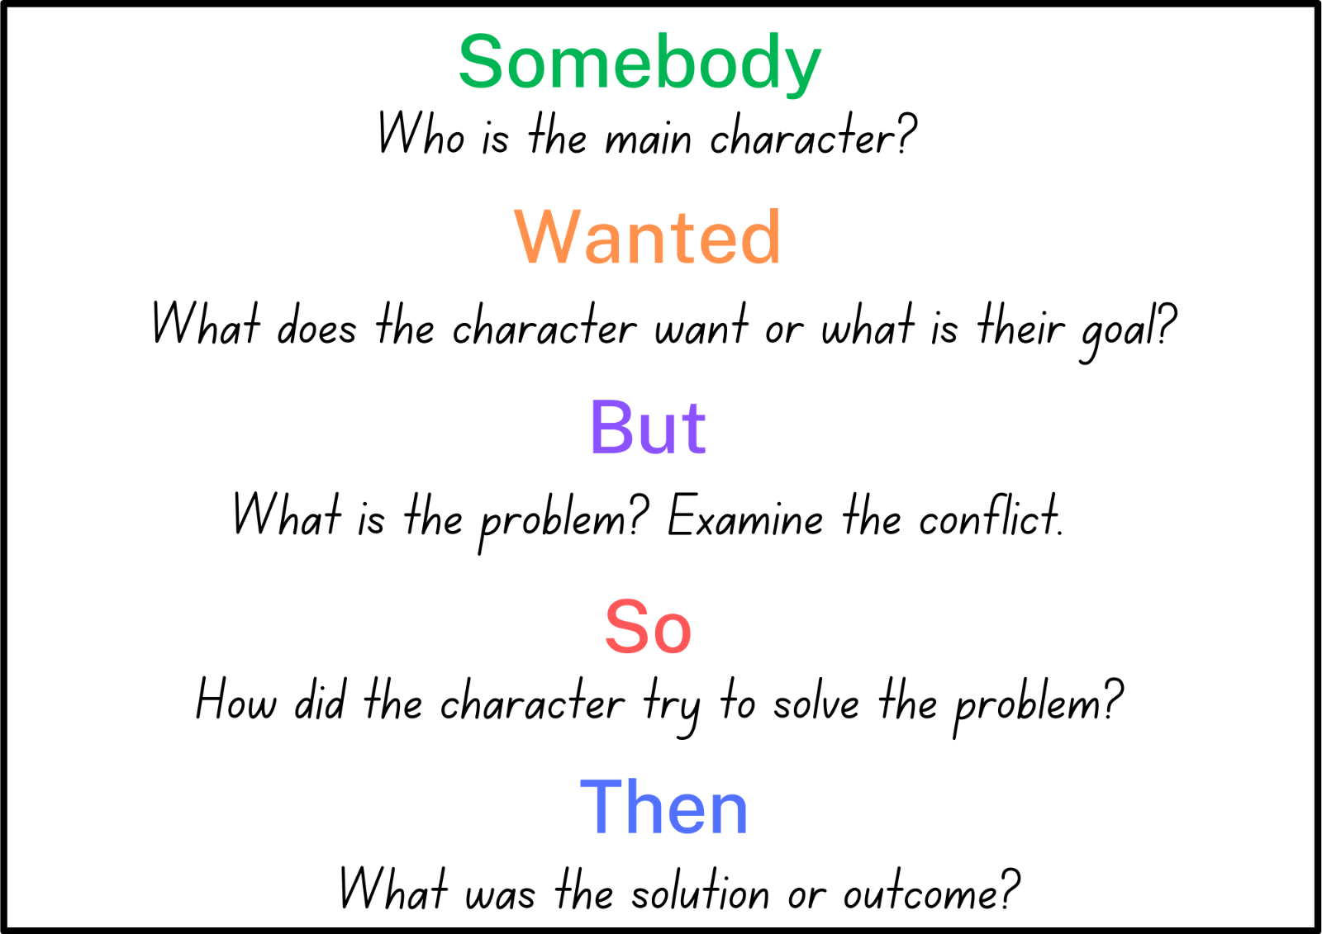

Resource 10 – fluency and close reading passage analysis
Focus | Notes
Passages | Passage 1: Chapter 10 – Boggis’s Chicken House Number One  From ‘Carefully, Mr Fox began pushing...’ to ‘...First of all, everyone have a drink of water!’ (241 words)  Passage 2: Chapter 13 – Bunce’s Giant Storehouse  From ‘He reached high and pushed up ..’ to ‘...This is my party, so I shall do the choosing’ (240 words)  Passage 3: Chapter 15 – Bean’s Secret Cider Cellar  From ‘Mr Fox laughed and began pulling more bricks out...’ to ‘...This cellar is right underneath the farmhouse itself.’ (221 words)
Synopsis | Passage 1: After three days and nights without food, Mr Fox and his family were faced with the threat of starvation. However, Mr Fox’s relentless determination and cunning allows him to think of a new plan which leads him (and the three Small Foxes) to successfully infiltrate Boggis’s Chicken House Number One.  Passages 2 and 3: Mr Fox’s thinking shifts from stealing food for the survival of his family, to a plan of preparing a ‘whacking great feast’ for both his family and his underground friends who are impacted by the farmers’ quest to capture the fox. This leads him to tunnel his way underground to Bunce’s Giant Storehouse and Bean’s Secret Cider Cellar for a smorgasbord of the finest produce.
Passage structure | The text structure of each passage can be described as follows:  - Mr Fox carefully enters the setting location.  - This is coupled with dialogue which expresses Mr Fox’s delight in himself and his achievements.  - A description of the location is provided.  - The unique features of the setting are described including the glorious display of food and drink on offer.  - Mr Fox’s character sidekicks (e.g. the Four Small Foxes, Badger or Rat) react.  - This includes a description of both movements and dialogue. Interactions between Mr Fox and the other characters are provided, with Mr Fox consistently showing that he is the most fantastic of them all and decides on what can or cannot be taken from the farmers.
Language features | Direct speech: The author uses direct speech to allow the characters to express their thoughts, emotions and reactions directly. Exclamations such as, “I’ve done it!”, “This is it!” and “Hooray!” express Mr Fox’s triumph and intensify the emotional impact and energetic atmosphere of the scenes. It is common to see the use of repetition in the dialogue across each of the passages.  Mr Fox’s use of imperatives, such as “Wait!” and “Calm down!” highlight his authoritative tone and position as a leader figure, although we also see Mr Fox’s continued devotion to his family through terms of endearment such as, ‘my darlings’.  Descriptive language: Each passage uses descriptive language to vividly portray the settings and the objects within them. For example, phrases like ‘huge shed’, ‘stacked in cupboards and piled upon shelves,’ and ‘big glass jars’ paint a clear picture of the surroundings.  Pacing: Excitement is achieved through the description of action and movement. The Small Foxes running in all directions to chase the chickens creates a lively scene. The careful selection of verbs and verb phrases such as, ‘...started prancing and dancing with joy’, ‘went wild with excitement’ and ‘scrambled up out of the tunnel’ contrast to the slow-paced, stealthy movements described when navigating through the tunnels.

Resource 11 – story map example
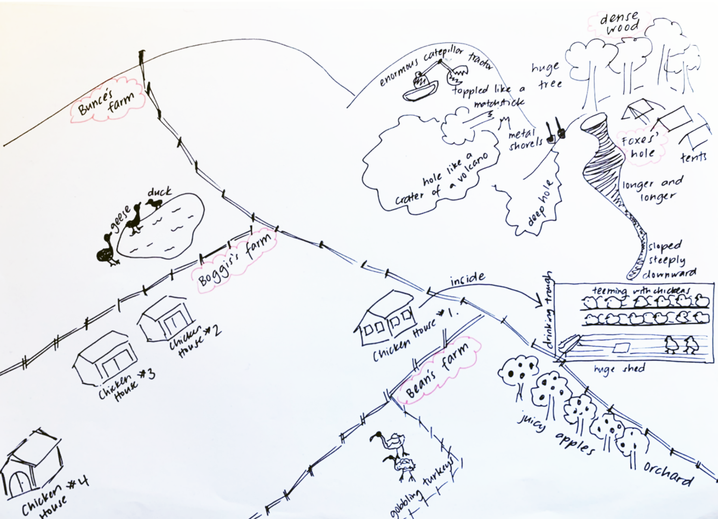

Resource 12 – Freytag’s pyramid
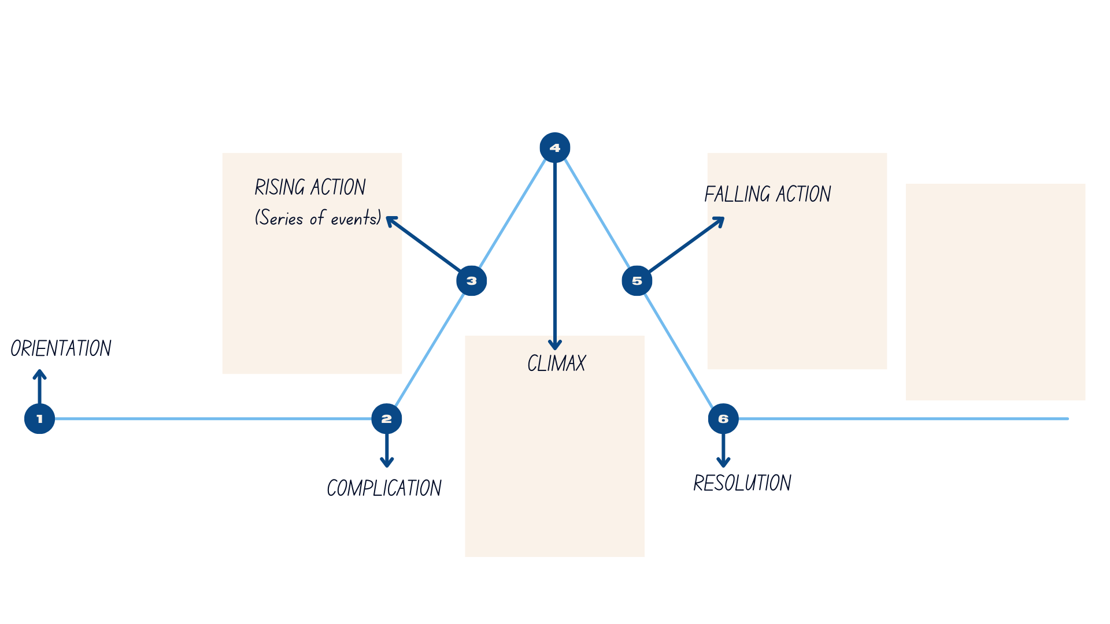

Resource 13 – Freytag’s pyramid planning template
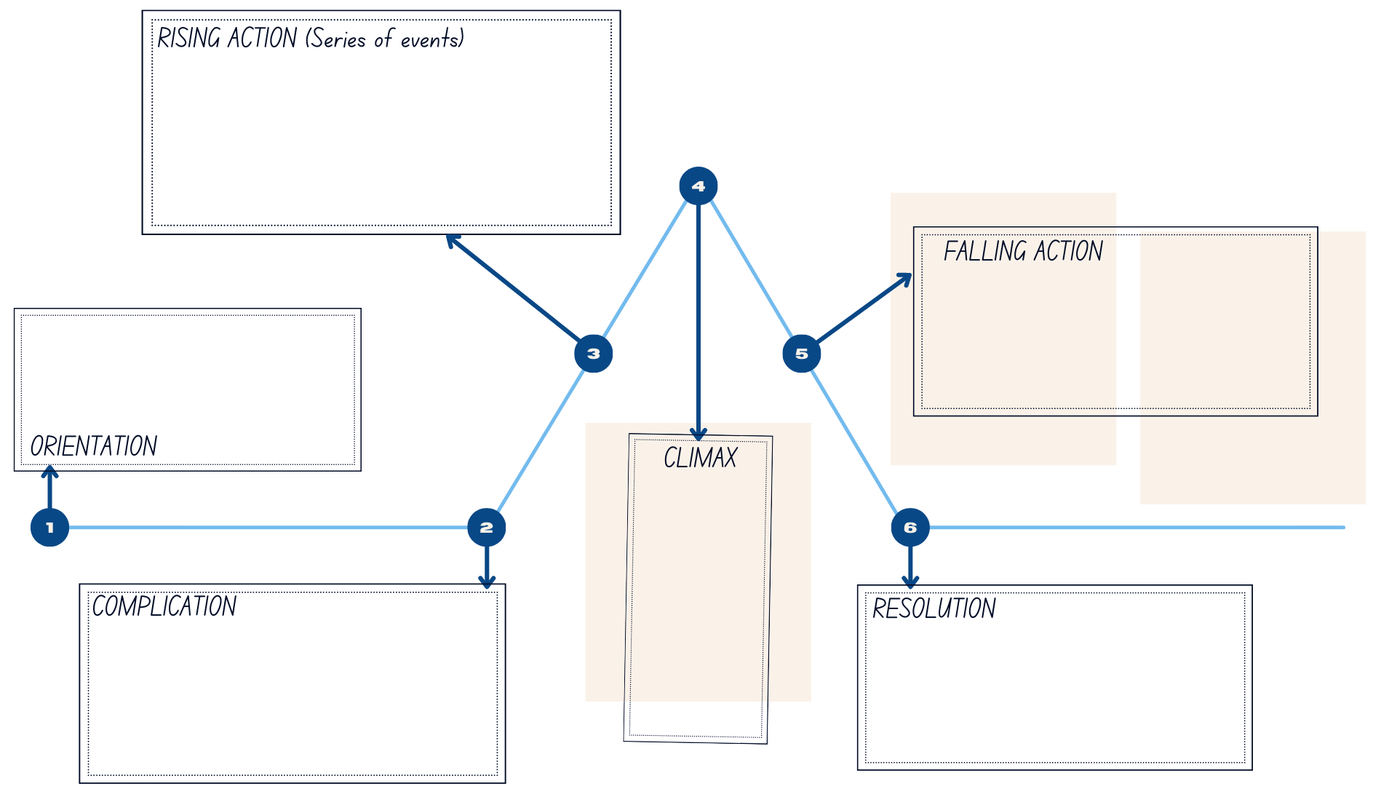

References
This resource contains NSW Curriculum and syllabus content. The NSW Curriculum is developed by the NSW Education Standards Authority. This content is prepared by NESA for and on behalf of the Crown in right of the State of New South Wales. The material is protected by Crown copyright.
Please refer to the NESA Copyright Disclaimer for more information. https://educationstandards.nsw.edu.au/wps/portal/nesa/mini-footer/copyright
NESA holds the only official and up-to-date versions of the NSW Curriculum and syllabus documents. Please visit the NSW Education Standards Authority (NESA) website https://educationstandards.nsw.edu.au/wps/portal/nesa/home and the NSW Curriculum website https://curriculum.nsw.edu.au.
English K–10 Syllabus © NSW Education Standards Authority (NESA) for and on behalf of the Crown in right of the State of New South Wales, 2022.
National Literacy Learning Progression © Australian Curriculum, Assessment and Reporting Authority (ACARA) 2010 to present, unless otherwise indicated. This material was downloaded from the Australian Curriculum website (National Literacy Learning Progression) (accessed 7 August 2023) and was not modified.
Dahl R (2007) Fantastic Mr Fox (Blake Q, illus), Penguin Random House Children's UK, United Kingdom.
NESA (NSW Education Standards Authority) (2023) ‘Glossary’, Resources, NESA website, accessed 7 August 2023.
Snow P and Serry T (2023) ‘Chapter 5: Oral Language’, Effective Instruction in Reading and Spelling, MRU Press, Macquarie Park.
© State of New South Wales (Department of Education), 2023
The copyright material published in this resource is subject to the Copyright Act 1968 (Cth) and is owned by the NSW Department of Education or, where indicated, by a party other than the NSW Department of Education (third-party material).
Copyright material available in this resource and owned by the NSW Department of Education is licensed under a Creative Commons Attribution 4.0 International (CC BY 4.0) license.
This license allows you to share and adapt the material for any purpose, even commercially.
Attribution should be given to © State of New South Wales (Department of Education), 2023.
Material in this resource not available under a Creative Commons license:
- the NSW Department of Education logo, other logos and trademark-protected material
- material owned by a third party that has been reproduced with permission. You will need to obtain permission from the third party to reuse its material.
Links to third-party material and websites
Please note that the provided (reading/viewing material/list/links/texts) are a suggestion only and implies no endorsement, by the New South Wales Department of Education, of any author, publisher, or book title. School principals and teachers are best placed to assess the suitability of resources that would complement the curriculum and reflect the needs and interests of their students.
If you use the links provided in this document to access a third-party's website, you acknowledge that the terms of use, including licence terms set out on the third-party's website apply to the use which may be made of the materials on that third-party website or where permitted by the Copyright Act 1968 (Cth). The department accepts no responsibility for content on third-party websites.

