English Stage 2 second year – Unit 12

Contents
Unit overview and instructions for use 5
Teacher notes 7
Outcomes and content 9
Resources 17
Week 1 20
Component A teaching and learning 20
Planning framework 20
Component B teaching and learning 20
Learning intentions and success criteria 20
Learning intention 21
Success criteria 21
Lesson 1 – exploring colour and similes 21
Lesson 2 – exploring imagery 24
Lesson 3 – acting verbs, adverbial phrases and personification 26
Lesson 4 – salience and rhyming couplets 28
Week 2 31
Component A teaching and learning 31
Planning framework 31
Component B teaching and learning 31
Learning intentions and success criteria 31
Learning intention 32
Success criteria 32
Lesson 5 – adjectival clauses 32
Lesson 6 – introducing Bindi and free verse poetry 35
Lesson 7 – characterisation of Bindi 38
Lesson 8 – exploring the use of Australian Indigenous Language 40
Week 3 44
Component A teaching and learning 44
Planning framework 44
Component B teaching and learning 44
Learning intentions and success criteria 44
Learning intention 45
Success criteria 45
Lesson 9 – identifying and using pronouns in poetry 45
Lesson 10 – exploring onomatopoeia and repetition 49
Lesson 11 – exploring imagery using synonyms 52
Lesson 12 – punctuation and characterisation 54
Week 4 58
Component A teaching and learning 58
Planning framework 58
Component B teaching and learning 58
Learning intentions and success criteria 58
Learning intention 59
Success criteria 59
Lesson 13 – inferring character traits and homonyms 59
Lesson 14 – connotations of the black cockatoo 63
Lesson 15 – exploring the significance of mealtime poems 67
Lesson 16 – symbolism in Bindi 70
Week 5 74
Component A teaching and learning 74
Planning framework 74
Component B teaching and learning 74
Learning intentions and success criteria 74
Learning intention 75
Success criteria 75
Lesson 17 – planning and drafting a free verse poem about family 75
Lesson 18 – editing and presenting a free verse poem about family 78
Lesson 19 – planning a poem about a precious treasure 80
Lesson 20 – treasure poem – publishing and presenting a multimodal text 83
Resource 1 – fire and country images 85
Resource 2 – five senses template 88
Resource 3 – Bindi’s character profile 89
Resource 4 – being Bindi 90
Resource 5 – vocabulary word mat 91
Resource 6 – inferring character traits 92
Resource 7 – Garrall poetry planning template 93
Resource 8 – Fambam planning template 94
Resource 9 – poetry planning template 95
References 96

Unit overview and instructions for use
In this 5-week unit, students will explore the mentor concept of ‘imagery, symbol and connotation’ and the supporting concept of ‘characterisation’ through the use of the mentor text, Bindi by Kirli Saunders and the supporting text, Fire by Jackie French. Narrative elements are also explored throughout the unit.
Students will produce writing that includes figurative language and free verse poetry. They will develop skills to use language purposefully by applying their understanding of the textual concepts to produce writing that evokes feelings or creates images, while engaging the reader.
Outcomes and content in this unit are organised into Component A and Component B. The components are connected, with learning in Component A complementing learning in Component B.
Note: the duration of this unit can be adapted to suit individual school contexts. For example, learning could occur across 5 days rather than 4.
The table below highlights the focus areas and preparation required for Component A and Component B.
Teaching and learning | Component A | Component B
Suggested duration | 60 minutes × 4 days/week or equivalent | 60 minutes × 4 days/week or equivalent
Explicit teaching focus areas | Component A addresses content from the focus areas:  - Vocabulary  - Reading fluency  - Reading comprehension  - Creating written texts  - Spelling  - Handwriting and digital transcription  It centres on the development of foundational skills and knowledge through regular, systematic and repeated practice. | Component B addresses content from the focus areas:  - Oral language and communication  - Vocabulary  - Reading comprehension  - Creating written texts  - Understanding and responding to literature  It centres on the conceptual understandings of English and exemplifies the importance of learning about and enjoying literature through the study of quality texts.
Preparing for teaching and learning | - Specific teaching and learning activities need to be developed by the teacher. When planning for these activities, please refer to the Component A outcomes and content, teaching guides and planning frameworks.  - Plan and document how you will sequence teaching and learning in whole-class and targeted-groups across the 5-week cycle as required. This should be based on student needs identified through ongoing assessment data. | - Familiarise yourself with the mentor and supporting texts and textual concepts, and the teaching and learning sequence.  - Determine how you will support students in whole-class and targeted-groups across the 5-week cycle as required. This should be based on student needs identified through ongoing assessment data.
English K–10 Syllabus © NSW Education Standards Authority (NESA) for and on behalf of the Crown in right of the State of New South Wales, 2022.

Teacher notes
At the NSW Department of Education, we recognise the traditional custodians of the lands and waterways where we work and live. We celebrate Aboriginal and/or Torres Strait Islander Peoples’ unique cultural and spiritual relationship to Country and acknowledge the significance of their cultures in Australia. We pay respect to Ancestors and Elders past, present and future. The department recognises that by acknowledging our past, we are laying the groundwork for a future that embraces all Australians; a future based on mutual respect and shared responsibility.
- Imagery, symbol and connotation extend words and symbols beyond their literal meaning. They are used to provide deeper meaning, evoke emotion and enhance enjoyment in texts (English Textual Concepts and Learning Processes 2016).
- Understanding of imagery, symbol and connotation can be supported through watching the department’s video: Understanding connotation, imagery and symbol video (6:06).
- While ‘imagery, symbol and connotation’ is the mentor textual concept and 'characterisation' is the supporting concept, 'narrative' elements are also explored. Additional textual concepts may be included based on individual school context and student needs.
- For information on adverbial phrases and adjectival clauses refer to the NESA Glossary.
- In addition to the resources listed, students will require access to short passages of the mentor and/or supporting texts. Teachers can copy extracts from texts in reliance on the Statutory Text and Artistic Works Licence. Teachers need to attribute the extracts and include the following notice: ‘This material has been copied [and communicated to you] in accordance with the statutory licence in section 113P of the Copyright Act. Any further reproduction or communication of this material by you may be the subject of copyright protection under the Act. Do not remove this notice’.
- This unit could enhance student learning towards the achievement of science and technology, HSIE, and creative arts outcomes.
- Consider prior student knowledge on sustainability, bushfires, Aboriginal and/or Torres Strait Islander fire management practices (cool burning). Students should be familiar with what Australian Indigenous Country(s) their school is on.
- Reflect on student learning and engagement in activities and record differentiation and adjustments within the unit to inform future teaching and learning. One way of doing this could be to add comments to the digital file.
- In NSW classrooms there is a diverse range of students including Aboriginal and/or Torres Strait Islander students, students learning English as an additional language or dialect, high potential and gifted students and students with disability. Some students may identify with more than one of these groups, or possibly all of them. Refer to Curriculum planning for every student – advice for further information.
- Content points are linked to the National Literacy Learning Progression (version 3).
Levels and indicators sourced from National Literacy Learning Progression © Australian Curriculum, Assessment and Reporting Authority (ACARA), (accessed 31 August 2023) and was not modified. See references for more information.

Outcomes and content
The table below outlines the outcomes and content for this unit. The letters 'A' and 'B' in the header refer to Components A and B. The numbers 1 to 5 refer to weeks. The use of 'x' in these columns indicates where the content points are intended to be addressed and in which week.
Focus area and outcome, content points and National Literacy Learning Progression | A | B | 1 | 2 | 3 | 4 | 5
Oral language and communication
EN2-OLC-01 communicates with familiar audiences for social and learning purposes, by interacting, understanding and presenting
- Identify cultural practices and/or protocols that Aboriginal and/or Torres Strait Islander Peoples use to interact, and how these may relate to specific roles |  | x |  | x | x | x
- Identify how inferred or literal meaning is impacted by tone, pace, pitch and volume, gesture and posture communication, and how these affect the audience |  | x | x | x | x | x | x
- Identify language features in spoken texts that contribute to own or others’ enjoyment and understanding |  | x | x |  | x |  | x
- Adjust volume, pace and intonation to enhance meaning when presenting and reciting (SpK5) |  | x | x | x | x | x | x
Vocabulary
EN2-VOCAB-01 builds knowledge and use of Tier 1, Tier 2 and Tier 3 vocabulary through interacting, wide reading and writing, and by defining and analysing words
- Understand that Aboriginal English is a recognised dialect and that Aboriginal English words are used in multimodal, spoken and written texts (SpK6) |  | x |  | x | x | x
- Identify and use terminology associated with figurative language encountered in texts (UnT7) | x | x | x | x | x | x | x
- Understand that many words derive from other languages, including Aboriginal and Torres Strait Islander Languages, and that the pronunciation and spelling of words may reflect their etymology | x |  |  | x | x | x
- Use a thesaurus to locate synonyms and antonyms or to clarify dictionary meanings, to expand vocabulary | x | x |  |  | x | x | x
- Define meanings for homonyms according to context | x | x |  | x | x | x
- Apply morphemic knowledge to change word meanings by adding different prefixes and suffixes to a base word or root (SpG9) | x |  |  | x | x | x
Reading fluency
EN2-REFLU-01 sustains independent reading with accuracy, automaticity, rate and prosody suited to purpose, audience and meaning
- Adjust voice, tone, volume and pitch reflected by the punctuation in a text, to enhance reading fluency and support comprehension (FlY5) | x |  |  |  | x | x | x
- Recognise that there are different purposes and audiences for reading and adjust reading rate to suit a text’s purpose (FlY5) | x |  | x | x | x | x
- Reflect on how adjusting reading rate and prosody supports comprehension and can engage an audience | x |  | x | x |  |  | x
Reading comprehension
EN2-RECOM-01 reads and comprehends texts for wide purposes using knowledge of text structures and language, and by monitoring comprehension
- Identify similarities and compare differences within and between texts by making text-to-self, text-to-text and text-to-world connections |  | x | x | x |  | x | x
- Describe how multimodal features enhance meaning and contribute to salience in texts (UnT7) | x | x | x | x | x | x | x
- Identify different types of verbs that control meaning | x | x | x |  | x
- Identify word patterns, including repetition, that create cohesion or effect | x | x |  | x | x
- Use knowledge of homonyms to understand metaphor and to support inference (UnT7) | x | x |  | x | x | x
- Identify where meaning breaks down when reading (UnT6) | x |  | x | x | x | x
- Identify and use strategies to repair reading when meaning breaks down (UnT6) | x |  | x | x | x | x
- Ask questions to clarify meaning and promote deeper understanding of a text (LiS6, UnT6) |  | x | x | x | x | x
- Reflect on own understanding of texts and monitor own goals for reading | x |  | x |  |  |  | x
Creating written texts
EN2-CWT-01 plans, creates and revises written texts for imaginative purposes, using text features, sentence-level grammar, punctuation and word-level language for a target audience
EN2-CWT-02 plans, creates and revises written texts for informative purposes, using text features, sentence-level grammar, punctuation and word-level language for a target audience
EN2-CWT-03 plans, creates and revises written texts for persuasive purposes, using text features, sentence-level grammar, punctuation and word-level language for a target audience
- Experiment with different poetic forms using stanzas |  | x |  | x | x | x | x
- Experiment with poetry to include innovative use of punctuation to suit purpose and for effect |  | x |  | x | x | x | x
- Maintain noun–pronoun referencing across a text for cohesion (CrT7) | x | x |  | x | x
- Use language to create imagery or humour, including idioms, puns, simile and personification (CrT8) |  | x | x | x | x | x | x
- Select and use multimodal features to add meaning |  | x | x |  | x |  | x
- Use adjectival clauses with noun groups to add information to subjects and objects | x | x | x | x |  | x | x
- Use adverbial phrases or clauses to add information to the verb or verb group of the main or other clauses, to provide reasons for or circumstances (GrA4) | x | x | x | x |  |  | x
- Select and use precise saying, thinking, acting, and relating verbs and verb groups to align with text purposes (GrA5, CrT8) | x | x | x | x | x
- Use capital letters to indicate the beginning of a sentence, proper nouns, headings and subheadings, to indicate the beginning of a poetry line, for emphasis, and when using acronyms (PuN5) | x | x |  |  | x |  | x
- Experiment with words, word order and repetition for rhetorical effect or to create atmosphere (CrT8) |  | x |  | x | x
- Use adjectives to develop descriptive features (CrT8) | x | x | x | x | x | x | x
- Use synonyms to replace words to avoid repetition and engage the reader (CrT7) | x | x |  |  | x | x | x
- Plan structures and language to suit the purpose of a text (CrT7) |  | x | x | x |  |  | x
- Create texts by drawing on personal and others’ experiences, and texts read, viewed and listened to for inspiration and ideas |  | x | x | x | x | x | x
- Create texts using digital technologies (HwK7) |  | x |  |  |  |  | x
Spelling
EN2-SPELL-01 selects, applies and describes appropriate phonological, orthographic and morphological generalisations and strategies when spelling in a range of contexts
- Explain how to segment multisyllabic words into syllables and phonemes, and apply this knowledge when spelling | x |  | x | x | x | x | x
- Recognise stressed and unstressed syllables in multisyllabic words and apply this knowledge when spelling | x |  |  |  |  | x
- Understand that the schwa occurs in an unstressed syllable and apply this knowledge when spelling | x |  |  |  |  | x
- Understand that some graphemes are dependent on their position in a word in English and apply this knowledge when spelling | x |  | x | x | x | x | x
- Proofread, identify and correct misspellings when creating written texts | x |  |  | x
- Identify inflected suffixes, explaining when and how to treat base words when they are affixed, and apply this knowledge when spelling (SpG9) | x |  |  | x |  | x | x
- Identify derivational suffixes such as -able, -ness, -ian and -ment, explaining when and how to treat base words when they are affixed, and apply this knowledge when spelling | x |  | x |  | x |  | x
Handwriting and digital transcription
EN2-HANDW-01 forms legible joined letters to develop handwriting fluency
EN2-HANDW-02 uses digital technologies to create texts
- Apply appropriate pressure when joining letters | x |  | x |  |  | x
- Sustain the NSW Foundation Style cursive to facilitate fluency and legibility across a text (HwK6) | x |  | x | x |  | x | x
- Search, filter, select, download and save relevant digital information | x |  | x |  | x | x | x
- Monitor goals that build on typing accuracy and rate | x |  |  | x | x |  | x
Understanding and responding to literature
EN2-UARL-01 identifies and describes how ideas are represented in literature and strategically uses similar representations when creating texts
- Identify the purpose and structure of Aboriginal and Torres Strait Islander cultural narratives |  | x |  | x | x | x
- Recognise that characters may be identified through familiar, individual or group characteristics |  | x |  | x | x | x
- Describe ways in which characters are represented in literature and experiment with characterisation when creating texts |  | x |  | x | x | x | x
- Identify figurative language in literature and how it can influence meaning, and experiment with figurative language when creating texts (CrT8, UnT7) |  | x | x | x |  | x | x
- Describe how words, sounds, images, logos and colour contribute to meaning in literature |  | x | x | x | x | x | x
- Recognise how Aboriginal and Torres Strait Islander authors use imagery and symbols in texts |  | x |  | x | x | x | x
English K–10 Syllabus © NSW Education Standards Authority (NESA) for and on behalf of the Crown in right of the State of New South Wales, 2022.

Resources
The resources in the table below are referred to in this unit. Letters 'A' and 'B' in the header refer to Component A and B respectively, and the numbers 1 to 5 indicate weeks. The use of 'x' in these columns indicate whether the resources are required in Component A, B or both, and in which week.
Resource | A | B | 1 | 2 | 3 | 4 | 5
French J (2014) Fire (B Whatley, illus), Scholastic, Australia. ISBN13: 9781742838199 | x | x | x | x | x | x | x
Saunders K (2020) Bindi (D Leffler, illus), Magabala Books, Australia. ISBN13: 9781922613448 | x | x |  | x | x | x | x
Resource 1 – fire and country images |  | x | x
Video: Backburning, Caring for Country – Behind the News (3:09) |  | x | x
Individual whiteboards |  | x | x |  | x
Video: Story talks with Kirli Saunders – Poetry and verse (8:16) |  | x |  | x |  |  | x
Resource 2 – five senses template (one enlarged copy and individual copies for each student) |  | x |  | x | x | x
Resource 3 – Bindi’s character profile |  | x |  | x | x
Resource 4 – being Bindi |  | x |  | x
Resource 5 – vocabulary word mat |  | x |  | x
Thesaurus | x | x |  |  | x | x | x
Strips of paper |  | x |  | x | x
Resource 6 – inferring character traits |  | x |  |  |  | x
Video: ‘Cry of the Glossy’ – Kirli Saunders (10:17) |  | x |  |  |  | x
Factsheet: Balireh | Glossy Black-cockatoo [PDF 51 KB] |  | x |  |  |  | x
Resource 7 – Garrall poetry planning template |  | x |  |  |  | x
Resource 8 – Fambam planning template |  | x |  |  |  |  | x
Resource 9 – poetry planning template |  | x |  |  |  |  | x

Week 1

Component A teaching and learning
Component A focuses on the development of foundational skills and knowledge through regular, systematic and repeated practice. The mentor and supporting texts used in Component B of this unit can support the effective implementation of Component A teaching and learning.

Planning framework
To plan and document Component A teaching and learning, a planning scaffold [DOCX 81 KB] is provided. To support you in your planning, a link to a detailed example of a one-week teaching and learning cycle is included in the scaffold. Additional resources to support teaching and learning in each focus area can be found at Lesson advice guides.

Component B teaching and learning
The following teaching and learning sequence has been designed to address Component B outcomes and content and develops conceptual understandings of English through the study of quality texts. Adapt the sequence as required to best meet the needs of your students.

Learning intentions and success criteria
Learning intentions and success criteria are best co-constructed with students.

Learning intention
Students are learning to develop a deeper understanding of symbol and imagery and its value within a text.

Success criteria
Students can:
- understand that words and images convey ideas and feelings
- identify that images and symbols bring deeper meaning to a text
- write sentences using acting verbs, adverbial phrases and personification
- explore the use of salience to write rhyming couplets.

Lesson 1 – exploring colour and similes
- Display the first image from Resource 1 – fire and country images. Students view the image for 30 seconds considering what they might see, hear, smell, taste and touch. Students record 10 words or phrases associated with the image. Display the image for a further 30 seconds and write 10 additional related words or phrases. Discuss student responses. Repeat for image 2 and image 3.
- Display the cover of Fire by Jackie French. Before reading, ask text orientation questions. For example:
- What do you think the text is about? Why do you think this?
- What features draw your attention?
- Who is the author?
- Have you read any other Jackie French texts? What are they?
- Share and discuss Jackie French’s experiences with fire, using the information about the author written on the last page.
- Read and discuss Bruce Whatley’s experiences with fire and his illustration style, using the information written on the last page of Fire.
- Watch Backburning, Caring for Country – Behind the News (3:09). As a class, record ideas about backburning using a Plus, Minus, Interesting (PMI) chart.
- Read Fire. Ask:
- What is the purpose of this text?
- Does this text relate to events that have occurred around the world?
- What connections can be identified between the Behind the News video and Fire?
- Look closely at the illustrations in Fire, focusing on the colour orange (particularly the fire and the firefighter’s orange uniform). Draw attention to other colours used. Remind students that illustrators use different techniques such as imagery and symbolism to contribute to meaning and help the audience emotionally connect to the text.
- After viewing the illustrations, ask the following questions and record student responses:
- What colour(s) in the images stand out? For example, orange/red, green
- What do you think the colours represent? For example:
- orange/red: danger – fire, help – firefighter/CFA worker
- green: life and regrowth.
- Students Think-Pair-Share ideas or feelings that are evoked when viewing the warm colours compared to the cool colours in the illustrations. Brainstorm and record emotive words.
- Revise the meaning of similes.
Simile: a figure of speech that compares the similar qualities of 2 different things. The comparison usually includes like, as, or as if (NESA 2023).
- Co-construct writing similes for the colour orange. For example, the flames were as orange as the sunset over the ocean; the flames danced like orange ribbons in the fire.
- Students write several similes about the colour orange.
Too hard? Provide students with sentence stems for writing.
Too easy? Students write similes using a different colour from the text.
- Optional: students draw an illustration to accompany their simile, focusing on the image that their words create for the reader. As a class, record additional information on the Plus, Minus, Interesting (PMI) chart. Discuss the similarities and differences between the video and the text.

Lesson 2 – exploring imagery
- Display the front cover of Fire and select students to retell the main parts of the text, using the prompts: first, then, next, finally.
- Ask students to identify how the text is structured and what the text purpose is. For example, it is written as rhyming verse poetry in narrative form to entertain and inform the reader.
- Discuss the descriptive and figurative language used in the text and how it helps to create visual images and influences the meaning.
- Display the word ‘imagery’ and ask students to share what they think it means. Explicitly teach that imagery is the use of figurative language to represent objects, characters, actions or ideas to appeal to the senses of the reader.
- Underline the root word ‘image’ and explain that it is something that can physically be seen, like a photo, or something imagined in the mind. For example, the author provides a description for the audience to visualise.
Note: make the link for students between the root words of imagery, imagine, imagination.
- Write the sentence, ‘The grass was green in the playground’. Ask students to close their eyes and use their senses to describe what they can visualise. Brainstorm and record. For example:
- see: green grass, cherry red monkey bars, sky blue slide, tall, thin climbing frame
- touch: cold, bumpy step
- hear: birds chirping, children laughing
- smell: freshly cut grass.
- Explain that authors often give clues rather than telling the reader exactly what is happening to build interest and keep the reader entertained, sparking their imaginations.
- Students suggest ways to improve the sentence ‘The grass was green in the playground’, using the word bank from activity 6. Encourage students to give clues about the playground being green, without using the word ‘green’. For example, strips of lime and mint coloured grass grew wildly around the tall, thin legs of the climbing frame.
- Read the first double page of Fire. In pairs, students identify and share the imagery created by the descriptive language.
- Display the page beginning with, ‘Leaves are ash...’. In pairs, students use their senses to describe what they can see and record on individual whiteboards. For example, charred, burnt, smoulders.
- As a class, share and record student responses from the brainstorm, in activity 6.
- Model writing sentences based on the illustration, focusing on the senses. Refer to the brainstorm. For example:
- The charcoal tree lay smouldering surrounded by orange flames.
- Tall, broken trees stand in the silence after the fire has passed.
- Students write sentences based on the illustration, focusing on their senses. Refer to the brainstorm.
Too hard? Provide students with sentence stems.
Too easy? Students incorporate similes in their writing.
- Model presenting the example sentences focusing on adjusting volume, pace and intonation. Remind students that this enhances meaning and engages the audience.
- In small groups, students read their sentences, focusing on adjusting their volume, pace and intonation to enhance meaning and engage their audience.

Lesson 3 – acting verbs, adverbial phrases and personification
- Re-read Fire by Jackie French. Ask:
- What is the purpose of the text? How do you know?
- What words does the author use to describe the fire?
- What words or phrases build an image in the reader’s mind?
- Revise verbs (saying, thinking, acting, and relating), as taught in Component A. Re-read the first 2 double pages of the text and ask students to identify the acting verbs. Create a word bank of acting verbs. For example, lay, sucked, winding, flickered, crept, snickered, leapt.
Note: the word bank will be used in Lesson 12.
- Discuss why the author uses acting verbs and how they control meaning, for example to create a sense of urgency and describe the movement of the fire.
- Revise adverbial phrases, as taught in Component A. Remind students that adverbial phrases provide information about where, when, with what, how far, how long, with whom, about what, as what.
- Examine the following sentence from the text and identify the acting verbs and adverbial phrase.
‘Fires (noun) are fought (acting verbs) in many ways (adverbial phrase).’
- Display the double page with the koala illustration. Select a noun and co-construct a sentence including an acting verb and adverbial phrase. For example, Thirsty koalas (noun) are drinking (acting verb) from the hands of brave firefighters (adverbial phrase).
- In pairs, students select a noun from the double page and co-construct a sentence to include an acting verb and adverbial phrase. Students swap sentences with another pair. Each pair labels the acting verb and adverbial phrase in the sentence.
- Discuss the meaning and purpose of personification. Explain that it creates vivid imagery for the reader by attributing human characteristics to abstractions such as things or animals.
- Display the sentence, ‘Trees licked by tongues of fire’ and explore personification. Ask:
- What do you visualise when you hear this sentence?
- What human characteristic does the author give fire? For example, ‘Trees licked by tongues of fire...’.
- Why do you think the author uses personification? For example, to help the reader visualise what is happening and to add detail.
- Display the double page beginning with, ‘One small spark brought fire awake...’, with the text covered.
- In pairs, students use personification to describe what is happening in the illustration, using the verb word bank from activity 2.
- As a class, encourage several students to share their sentences. Draw attention to the way acting verbs create personification by giving the noun their human characteristics.
- Select a double page from the text. Model writing sentences to describe what is happening in the illustrations, using acting verbs, adverbial phrases and personification.
- Display a different double page from the text. Students write sentences to describe what is happening in the illustrations, using acting verbs, adverbial phrases and personification.
Too hard? In pairs, students share ideas before writing their sentences.
Too easy? Students incorporate other figurative language techniques, such as simile and metaphor.
- In groups, students share one sentence that describes the illustration. Each student must share a sentence that is different to their peers’.

Lesson 4 – salience and rhyming couplets
- Refer to the illustrations throughout Fire. Ask:
- How do the illustrations connect to the words in the text?
- How do the illustrations contribute to meaning?
- Explicitly teach that salience is a strategy used to highlight what is important in a text through images and word choices. These multimodal features enhance meaning. Display the double page beginning with, ‘King fire has a short, harsh reign’ to explore salience, symbolism and the enhanced meaning within the illustrations. Discuss:
- What is the first thing you see on these pages? For example, the white bird and the line the wings create, the grey poles coming down the page.
- Why do you think the illustrator makes this a salient point?
- Explain that a symbol is an object, character or entity that can be understood to represent a larger idea, action or feeling. Discuss the aspects of visual literacy and the use of symbolism in the illustrations. For example:
- colour – the white bird indicates peace, the cool colours present a calm and positive environment
- balance – the bird is closer, the house is in the distance, the fence is getting smaller to show the perspective of it moving away
- light – shows that it is day, the haze in the sky indicates that the fire is clearing but not gone yet.
- Display the double page that starts with ‘But fires are fought...’. In small groups, students analyse the illustrations for aspects of visual literacy and symbolism. Discuss and record. For example:
The CFA logo is a symbol of promise and hope, hands being held is a symbol of promise, care and reassurance, the orange on CFA workers vest is a bright and noticeable colour, contrasting the ruins in the background.
- Discuss and list what objects can be seen on the displayed double page in Fire. For example, car, tree, koala, burnt remains, CFA worker. Brainstorm relevant adjectives and rhyming words to describe these objects.
- Students identify and record the rhyming words, on the displayed double page in Fire. For example, ‘ways/days’, ‘share/bare’, ‘lost/cost’.
- Revise the meaning of a rhyming couplet.
Rhyming couplet: a poem that often recounts an event. It is written in pairs of lines that rhyme (DoE 2023a)
- Jointly construct a rhyming couplet based on the noun ‘tree’, referring to the brainstorm from activity 5. For example, the graceful cockatoo sat perched on the tree, longing to fly across the land and be free.
- Students select an object from the list in activity 5 and write a rhyming couplet to describe it.
Too hard? Provide students with a pair of rhyming words to create their rhyming couplets. For example, tree/free; car/far.
Too easy? Students incorporate similes in their rhyming couplets.
- From another double page, have students record the salient points and explain how they add meaning to the text. Students list objects that can be seen and select one to describe and write a rhyming couplet.
Too hard? Provide students with a pair of rhyming words to create their rhyming couplets. For example, tree/free; car/far.
Too easy? Students incorporate similes in their rhyming couplets.
- In small groups, students read their writing couplet while their peers identify the object and rhyming words.

Week 2

Component A teaching and learning
Component A focuses on the development of foundational skills and knowledge through regular, systematic and repeated practice. The mentor and supporting texts used in Component B of this unit can support the effective implementation of Component A teaching and learning.

Planning framework
To plan and document Component A teaching and learning, a planning scaffold [DOCX 81 KB] is provided. To support you in your planning, a link to a detailed example of a one-week teaching and learning cycle is included in the scaffold. Additional resources to support teaching and learning in each focus area can be found at Lesson advice guides.

Component B teaching and learning
The following teaching and learning sequence has been designed to address Component B outcomes and content and develops conceptual understandings of English through the study of quality texts. Adapt the sequence as required to best meet the needs of your students.

Learning intentions and success criteria
Learning intentions and success criteria are best co-constructed with students.

Learning intention
Students are learning to use imagery, symbol, and connotation when creating texts and recognise how Aboriginal and/or Torres Strait Islander authors use imagery and symbols in texts.

Success criteria
Students can:
- write adjectival clauses to add information
- recognise how authors experiment with poetry to create meaning and engage the reader
- explore character by developing a character profile
- explore the use of Aboriginal English in spoken and written texts.

Lesson 5 – adjectival clauses
- Revise symbolism and salience from Lesson 4. Ask students to close their eyes. Display the double page from the text that states, ‘And time itself...’. Ask students to open their eyes. Display the double page for 5 seconds and remove. Ask:
- What is the first thing you see when you look at the double page?
- Why is this illustration important?
- What does this object represent? For example, the grass tree has new growth to show that even after such a destructive natural disaster, life goes on and regeneration occurs.
- Ask students to close their eyes. Display the first double page of the text. Ask students to open their eyes and record the objects they see on the page. For example, cockatoo, house, tree, hills.
- Revise adjectival clauses from Component A. Remind students that adjectival clauses provide information that gives more information about the qualities or characteristics of a person or a named thing.
- Model writing an adjectival clause using one of the words from activity 2. For example, ‘The cockatoo, perched high in the tree, observed the calm before the fire approached the valley’. Explain that the adjectival clause ‘perched high in the tree’ indicates that the cockatoo is high above the valley.
- In pairs, students record one adjectival clause for another object listed in activity 2, on a strip of paper.
- Students form small groups with other students who selected the same object. Students take turns reading their adjectival clause to the group while their peers identify how the object has been described.
- Repeat activity 5 and 6, using the last double page of the text.
- Discuss the differences of the land before and after the fire. Ask students to write statements about the land before and after the fire using the adjectival clauses.
- Revise language techniques that have been discussed. Explain that students will need to include some of the language techniques in their writing. For example:
- acting verbs
- adverbial phrases
- imagery and personification
- rhyming couplets
- adjectival clauses.
- Model writing a statement about the land during the fire using language techniques from activity 10. For example:
Amid the raging fire, the firefighters worked tirelessly to save the house that held so many precious memories for the family.
Like a superhero, the firefighter asked the flames to calm down and let the scared little house stay safe.
After the fire had passed, the family’s heart no longer raced,
their cherished home remained unharmed, in that fiery embrace.
- Students write their statements.
Too hard? Provide a copy of the teacher example for students to modify.
- Students share their statements with a partner.

Lesson 6 – introducing Bindi and free verse poetry
- Source and display image of a black cockatoo. Complete the Zoom in activity to draw attention to its colours, including, red, yellow and black.
- Display the front cover of Bindi by Kirli Saunders. Ask:
- What do you think the book will be about?
- What personal connections can you make to the cover?
- Can you make any connections between Bindi and Fire?
- Why have the illustrators used different coloured cockatoos? What might these different colours symbolise?
- Read the background information on the author, Kirli Saunders and the illustrator, Dub Leffer, on p 129 of the text.
- Explain that Bindi is a cultural narrative written using free verse poetry. For example:
Thunder rolls,
from booming clouds
Hanging overhead, growling -
like black dogs.
Flashing brilliant white fangs.
Free verse poetry: a poem that does not use traditional rhythm or rhyme. It often sounds like natural speech. It is popular with modern poets as there are no restrictions on expressing their thoughts and emotions (DoE 2023a).
- View Story Talks with Kirli Saunders - Poetry and verse (0:00–5:20). Students use ‘Pose, pause, pounce, bounce’ to share what they learned about free verse from Kirli Saunders.
Pose, pause, pounce, bounce: pose a question, allowing thinking time. A student is then pounced upon to give an answer. It then bounces to another student who must add and extend upon that response using the prompt ‘yes and…’. This is continued around the class.
- Read pages 3 to 8 from Bindi. Ask:
- How is the text structured and what is the purpose? For example, it is written as rhyming free verse poetry, in narrative form, to entertain and inform the reader.
- What did you notice while you were listening to the poems?
- How can you tell this text is written in free verse poetry? For example, the playful yet purposeful placement of lines and stanzas, limited punctuation, no traditional use of rhyme or rhythm.
- Where do you think the text is set? How do you know? How is it different or similar to where you live?
- What connections are there between Fire and Bindi?
- Did you notice the author using another language or dialect other than Australian English? What word can you identify?
- Source a country and city soundscape. Ask students to complete Resource 2 – five senses template for each environment, recording what they might see, hear, smell, touch and taste. Students share their ideas.
- Revise the meaning of a stanza.
Stanza: a group of lines within a poem, similar to a verse in a song. In some poems, stanzas may be of a standard length. The length of a stanza can vary. Stanzas provide a structure which may be predictable (helps meaning), contribute to the pace and rhythm of a poem and emphasise a stage in the poem (like a paragraph in prose) (DoE 2023a).
- Select a sense from Resource 2 – 5 senses template. Model writing one stanza (4 lines) for either the country or the city. Consider the purpose and structure for writing. For example:
Country – hear
With ears wide open, you can hear the smallest of things,
The country's own sound, where life's calm and peaceful.
From crickets at night to the rooster's early morning call,
In the country, listening to nature is serenity.
- Students select one of the senses from their completed Resource 2 – 5 senses template to write one stanza (4 lines) for either the country or the city. Consider the purpose and structure for writing.
Too hard? Students are provided with sentence stems for writing.
Too easy? Students include other senses and incorporate figurative language.
- Students share their writing with a partner who has written a stanza for the other setting.

Lesson 7 – characterisation of Bindi
- Explain that Bindi is the protagonist in the text and students will be developing a characterisation profile about her. Define characterisation.
Characterisation: the technical construction and representation of any personality or person-like figure in text, including features such as their appearance, actions, words or thoughts (NESA 2023).
- Re-read pages 3 to 8 from Bindi. Whilst reading, model using prompts to infer information about Bindi. This information will be used to build a characterisation profile for Bindi. For example, I wonder...
- where Bindi lives?
- what relationships Bindi has with her friends, family and Country?
- how she feels towards school?
- what she likes and dislikes?
- what Bindi’s hobbies, interests and passions are?
- what language(s) Bindi is speaking?
- Display a T-chart with 2 headings: words/phrases and evidence from the text. Complete the T-chart, by identifying words or phrases to describe Bindi’s character and how she is represented, adding details of evidence from the text. For example, Bindi is social – ‘But mostly you’ll find me on an adventure with my friends’ (p 4). Speaks a second language known as Aboriginal English – ‘Wedayo’ (p 3).
- Students complete Resource 3 – Bindi’s character profile, referring to the completed T chart, from activity 2.
Note: this will be added to throughout the unit.
- Re-read ‘Being Bindi’ (pp 3–4). Explain that Bindi introduces herself to her classmates, which helps the reader understand her character.
- Distribute Resource 4 – being Bindi. Students turn and talk to discuss the incomplete sections of Resource 4 – being Bindi. Students complete Resource 4 – being Bindi and introduce themselves to their partner. Encourage students to use a language they may use at home.
- Model writing a stanza titled ‘Being Mrs Green’ to develop a character. For example:
Hello, I'm Mrs Green and I teach Year 4 you see,
I live in Sydney near the beach.
I have 3 dogs and a guinea pig,
My heart is full when I am playing netball with my friends.
- Students write a stanza titled ‘Being ____ (student’s first name)’ to develop their character, referring to Resource 4 – being Bindi.
Too hard? Students are provided with stanza sentence stems to encourage writing.
Too easy? Students incorporate adjectival phrases.
- Optional: students publish their writing. Display around the classroom.
- Ask students to share their stanzas.

Lesson 8 – exploring the use of Australian Indigenous Language
- Read pages 9 to 16 from Bindi. Ask questions to clarify understanding. For example:
- What do you know about Bindi’s mum?
- Why has Aunty Lindy been invited into Bindi’s class?
- What is the purpose of adding these chapters to the text? For example, to gain an insight into Bindi’s family and school, use of Gundungarra language to identify people and things, reference to Country, Ancestors and Old People, symbolism. This information provides details about Bindi’s culture.
- Display and read page 15 from Bindi. Ask:
- Why do you think the author has used Gundungurra language throughout the text? For example, to engage and educate the reader through cultural narrative and create a link to Bindi’s role as part of the Gundungurra community, her culture and experiences.
- What can you infer the following Gundungurra words might mean?
- garrall (black cockatoo)
- karrat (rain).
- Introduce the Gundungarra word list on pages 124 to 125 of the text. Use the word list to translate and pronounce the word ‘canbe’.
- Model filling in Resource 5 – vocabulary word mat using the word ‘canbe’.
- Students complete Resource 5 – vocabulary word mat, selecting one of the following Gundungurra words: budjan, Duwi, daora, garrall, karrat.
Too hard? Students use the Gundungarra word list to complete Resource 5 – vocabulary word mat.
Too easy? Students select a word from their local Aboriginal and/or Torres Strait Islander language(s).
- Refer to page 15 of Bindi, where the author describes the symbolic colours of the garrall; black, red and yellow. Ask:
- What do you associate with each colour?
- What might these colours symbolise? For example, the Aboriginal flag.
- Where have you seen these colours together around the school?
- What Australian Indigenous Country is our school on?
- Display Resource 2 – five senses template. Explain that students will use their senses to record phrases to describe the school surroundings. For example, hear the birds chirping, see some blue feathers, feel the cool wind on my skin.
- Distribute Resource 2 – five senses template. Move to an appropriate area for students to record ideas for each sense. Return to the classroom.
- Model writing sentences for 2 of the senses, incorporating adjectival clauses, acting verbs and figurative language devices. For example, ‘I can hear the birds chirping noisily, in the treetops.’
- Students write sentences for each of their senses, incorporating adjectival clauses, acting verbs and figurative language devices. Refer to completed Resource 2 – five senses template. For example, birds chirping – I can hear the birds, that have blue feathers, chirping noisily in the tall treetops.
- Demonstrate incorporating words from the local Aboriginal and/or Torres Strait Islander language/s or the Gundungurra word list into the modelled sentences from activity 9. For example, I can hear the birds chirping noisily, in the treetops – I can hear the budjan chirping noisily in the treetops.
- Students use the local Aboriginal and/or Torres Strait Islander language/s or the Gundungurra word list to incorporate Aboriginal and/or Torres Strait Islander language(s) into their sentence.
Too hard? Provide students with several words from the Gundungurra word list, to use in their sentences. For example, budjan (bird), bunyal (sun), burral (day), daore (earth), guwara (strong wind), yana (walk).
Too easy? Students annotate their work identifying where they have used: Aboriginal and Torres Strait Islander language/s, adjectives, verbs, adjectival phrases, and figurative language.
- In pairs, students read their writing while their partner identifies the Aboriginal and/or Torres Strait Islander language(s) or the Gundungurra word that has been used.
Assessment task 1 – observations and work samples from this lesson allow students to demonstrate achievement towards the following syllabus outcomes and content points:
EN2-VOCAB-01 – builds knowledge and use of Tier 1, Tier 2 and Tier 3 vocabulary through interacting, wide reading and writing, and by defining and analysing words
- understand that Aboriginal English is a recognised dialect and that Aboriginal English words are used in multimodal, spoken and written texts.
EN2-CWT-01 – plans, creates and revises written texts for imaginative purposes, using text features, sentence-level grammar, punctuation and word-level language for a target audience
- create texts by drawing on personal and others’ experiences, and texts read, viewed and listened to for inspiration and ideas.
EN2-UARL-01 – identifies and describes how ideas are represented in literature and strategically uses similar representations when creating texts
- recognise how Aboriginal and Torres Strait Islander authors use imagery and symbols in texts.

Week 3

Component A teaching and learning
Component A focuses on the development of foundational skills and knowledge through regular, systematic and repeated practice. The mentor and supporting texts used in Component B of this unit can support the effective implementation of Component A teaching and learning.

Planning framework
To plan and document Component A teaching and learning, a planning scaffold [DOCX 81 KB] is provided. To support you in your planning, a link to a detailed example of a one-week teaching and learning cycle is included in the scaffold. Additional resources to support teaching and learning in each focus area can be found at Lesson advice guides.

Component B teaching and learning
The following teaching and learning sequence has been designed to address Component B outcomes and content and develops conceptual understandings of English through the study of quality texts. Adapt the sequence as required to best meet the needs of your students.

Learning intentions and success criteria
Learning intentions and success criteria are best co-constructed with students.

Learning intention
Students are learning to experiment with different poetic forms.

Success criteria
Students can:
- use pronouns for cohesion in poetry
- identify and use word patterns and onomatopoeia to create effect
- experiment with words and describe how they contribute to meaning and enhance effect
- experiment with poetry to include the use of punctuation for effect
- adjust volume and pace when presenting.

Lesson 9 – identifying and using pronouns in poetry
- Revise pronouns from Component A. Remind students that pronouns are words that replace nouns. For example, Bindi – her.
- Revise noun-pronoun agreement from Component A.

Noun-pronoun agreement: occurs where the correct pronoun is selected for the noun or noun group to which it is referring.
For example, The children were looking for their father in the supermarket (NESA 2023).
- Display ‘Art Class 1’ (p 17–18) from Bindi. In pairs, students identify and record the pronouns and noun-pronoun agreement in the poem, on whiteboards. Ask:
- Why are pronouns used in writing? For example, to replace a name.
- What are the benefits of using pronouns when writing about characters? For example, names do not become repetitive.
- What else do we learn in this poem? For example, how much Bindi enjoys art class with Miss T.
- What phrases/lines give us this information? For example, ‘She understands and compliments me quietly’ (p 17).
- Students Think-Pair-Share to develop a summary of how Bindi feels about art in ‘Art Class 1’ (pp 17–18), focusing on the pronouns and noun-pronoun agreement used to describe Bindi (name, her, she). For example:
Bindi likes art and she completes extra tasks. Her favourite part is painting as she is a very strong painter. Bindi is looking forward to doing the mural with her friends.
- Students share their favourite lesson at school. Group students according to their favourite subject/lesson. Students record vocabulary and reasons for why this is their favourite part of the school day. For example:
English group: I can read interesting stories by different authors; I can write short stories about personal experiences; I can share my opinions on different topics; I can learn about where words come from.
- As a class, brainstorm the best things about lunch time.
- Using the ideas generated, co-construct a free verse poem about lunch time being the favourite time of the day. When writing, model using pronouns and noun-pronoun agreement to identify the class. For example, Year 4, we, us, our.
Lunchtime, we escape from desks and books
in Year 4, it's time for us to go on an adventure.
Munching on our home packed food
playing with friends around the tree.
Sharing laughter and fun
it really is the highlight of our day.
- Referring to the ideas created in their small groups in activity 5, students write a free verse poem about their favourite lesson varying the pronouns to avoid repetition and ensuring noun-pronoun agreement.
Too hard? In pairs, students create a free verse poem about their favourite subject or lesson.
Too easy? Encourage students to incorporate adverbial phrases into their free verse poem.
- Read pages 19 to 32 from Bindi. Students add information about Bindi to their copy of Resource 3 – Bindi’s character profile from Lesson 7. For example:
‘5.2’ (p 19–24)
- Bindi likes nature, she planted the she-oaks
- observant, she notices the turtles resting in the sun on the old logs
- best friend is Olive, they play hockey together and swim
- Bindi is responsible, her parents let her make her own way to school and look after her sister
- she doesn’t like maths
- she enjoys drawing, making, painting, creating
- storyteller, she wants to tell stories that matter
- a little cheeky, paints on her bedroom wall, dad tells her not to do it again but mum knows she will
- she dances, covered in ochre, on Country for the Elders.
- In pairs, students discuss the ideas they have on Resource 3 – Bindi’s character profile and record additional ideas.
- As a class, discuss how the author's inclusion of her Aboriginal and Torres Strait Islander culture has been represented in the text.
Assessment task 2 – observations and work samples from this lesson allow students to demonstrate achievement towards the following syllabus outcomes and content points:
EN2-CWT-01 plans, creates and revises written texts for imaginative purposes, using text features, sentence-level grammar, punctuation and word-level language for a target audience
- maintain noun–pronoun referencing across a text for cohesion.

Lesson 10 – exploring onomatopoeia and repetition
- Read pages 33 to 52 from Bindi. Ask questions to clarify understanding. For example:
- What role does hockey play in Bindi’s life? How do you know?
- How do the words and images create effect and connect to the words on the pages?
- What insight into Bindi’s character do these poems provide? For example, her attitude, emotions and character strengths.
Note: use this as an opportunity to add to Resource 3 – Bindi’s character profile.
- Explicitly teach the meaning and purpose of onomatopoeia and repetition.
Onomatopoeia: a word that phonetically imitates or is indicative of the sound that it describes. For example, bang, splash, oink, miaow (NESA 2023).
Repetition: deliberate repetition of key words can work to persuade, unify the poem, emphasise a point, or depict tedium (DoE 2023a).
- Display pages 15, 30, and 52 from Bindi. Discuss how repetition is used with onomatopoeia to build a strong auditory experience and create a sense of imagery and humour for the reader. For example, ‘Brrrrrrriiiiiiiiiing! Brrrrrrriiiiiiiiiing!’ (p 30) ‘...thrump thrump thrump thrump...’ (p 52).
- Explain that in ‘Walk Home’ (pp 41–42), Bindi recounts her journey home from school and uses onomatopoeia to describe the sounds she hears, including, ‘squash’, ‘ding dong’, ‘Woooshhhh!’, ‘eeeeep!’.
- Discuss and record what students see, hear, smell, feel and taste on their way home from school, on an enlarged copy of Resource 2 – five senses template.
- Add onomatopoeic words to indicate the sound of the words described, in the ‘hear’ section of Resource 2 – five senses template. For example, tweet, beep, honk, vroom, thud, bam, woof, swish.
- Model writing a poem describing the journey home from school, incorporating sensory language, repetition and onomatopoeia, referring to completed Resource 2 – five senses template. For example:
Homeward bound, the Year 4 student's go on their way
the world comes alive as they begin their journey home.
The rumbling of buses, an impatient honking car beep, beep, beep
as they walk away, the school bell's fading echo, a distant, gentle riiinnnng, riiinnnng, riiinnnng.
Leaves swishhhh on the trees, in the soft, light
They can taste adventure as they plan their afternoon.
- Students write a poem describing their journey home from school, incorporating sensory language, repetition and onomatopoeia referring to completed Resource 2 – five senses template.
Too hard? Provide students with a scaffold for the poem where each stanza focuses on a different sense.
Too easy? Encourage students to incorporate other figurative language techniques such as simile, metaphor and personification in their poem, to enhance meaning.
- Explain that students will recite their poems. Discuss how to engage the audience by adjusting volume, pace and intonation to enhance meaning.
- Recite the teacher poem from activity 7, using appropriate volume, pace and intonation.
- In pairs, students recite their journey home poems, using appropriate volume, pace and intonation.
- Read pages 53 to 57 from Bindi. Ask:
- Why has the author included ‘Absence Note’ (p 55)? How is it different to the rest of the text?
- How would you describe Bindi’s relationship with her horse Nelly?
- What is the significance of the rhetorical question ‘wondering if perhaps it is damaged from falling like me?’ (p 57). How does Bindi relate to the garrall?
Assessment task 3 – observations and work samples from this lesson allow students to demonstrate achievement towards the following syllabus outcomes and content points:
EN2-RECOM-01 – reads and comprehends texts for wide purposes using knowledge of text structures and language, and by monitoring comprehension
- identify word patterns, including repetition, that create cohesion or effect.

Lesson 11 – exploring imagery using synonyms
- Write the word ‘evacuation’ on the board. Ask students to share feelings and words they think of when they hear the word evacuation. For example, scared, confusion, anger, panic, emergency, leave the room or area, school evacuation drill.
- Read pages 61 to 76 from Bindi. Ask questions to clarify understanding. For example:
- How is allowing ‘nature to take its course.’ (p 61) a central theme of Bindi?
- How do you think Bindi and her family are feeling? What evidence from the text tells us this?
- What type of language is used in these poems? For example, high modality, emotive words.
- Why do you think the author uses those words? For example, to evoke an emotional response from the reader.
- What connections can you make to ‘they have not been licked by flames’ (p 71)? For example, the connection between the 2 texts in the unit. ‘Trees licked by tongues of fire’ from the text Fire by Jackie French.
- Draw attention to the excerpt from page 67 from Bindi, ‘Parents from school drag their kids hurriedly through the shops…'. Discuss and highlight examples of high modality and emotive language. For example, drag, hurriedly, frantically, beating, race.
- Revise synonyms, as taught in Component A. Rewrite the excerpt from activity 3, replacing the highlighted words with synonyms that have less impact. For example, drag – take, hurriedly – quickly, frantically run – jog around, beating – tapping.
- Compare the 2 passages and discuss how each one impacts the reader and why the language choices are so important.
- Display ‘Groceries’ (pp 67–68). Discuss and highlight examples of high modality and emotive language. For example, ‘hurriedly’, ‘frantically’, ‘beating’, ‘race’, ‘pushes’, ‘scrounging’, ‘worry’, ‘emergency’, ‘unpredictable’, ‘unsure’.
- Revise how to use a thesaurus, as taught in Component A. Students use a thesaurus to list synonyms for the highlighted words from activity 6. For example, race: chase, sprint, dash.
- Students rewrite a section of ‘Groceries’ (pp 67–68), selecting replacement synonyms from activity 7.
Too hard? Provide students with a list of synonyms to use during writing.
Too easy? Encourage students to rewrite the poem including similes or metaphors to describe the sense of worry and panic experienced by the characters.
- Explain that multimodal combines 2 or more ways to communicate. For example, a text could include words, pictures, photographs or diagrams.
- Students select and use multimodal features to illustrate their rewritten section, enhancing the effect of the words for the reader.
- In groups, students recite their poems, using appropriate volume, pace and intonation. Students compare the synonyms used in each poem and explain their use of multimodal features.

Lesson 12 – punctuation and characterisation
- Display ‘Canbe’ (pp 77–79) from Bindi. In pairs, students read ‘Canbe’ and complete the S-I-T: Surprising, Interesting, Troubling, using verbs and adjectives to identify:
- one ‘Surprising’ fact or idea
- one ‘Interesting’ fact or idea
- one ‘Troubling’ fact or idea.
- Students connect with other pairs, pose their findings and obtain and record any relevant additional information.
- Read ‘Canbe’ adjusting volume, pace and intonation to reflect how line breaks are used in place of punctuation. Draw attention to the use of capital letters to indicate the beginning of a new idea, as taught in Component A. Ask:
- What do you notice about how the poem was read?
- What makes the poem flow?
- What effect do the line breaks and punctuation have on the reader?
- Why does the author choose to write using this structure?
- Who is Canbe? How do you know?
- Why is Canbe presented as a character? For example, ‘This is out of character for Canbe’ (p 78).
- Why do you think the pronoun ‘she’ is used to describe Canbe?
- Display concrete poems throughout Bindi. For example, ‘Horse Ride’ (pp 51–52), ‘Canbe’ (pp 77–79), ‘Hockey Game’ (pp 117–119). Ask students what style of poetry these poems are (concrete poems). Explain that a concrete poem is a poem that creates a visual image on the page, to be viewed rather than read aloud.
- Revise verbs (saying, thinking, acting, and relating), as taught in Component A. Identify the types of verbs used in the concrete poems and explore how they control meaning. For example:
- saying – express responses – says (p 77)
- thinking – depict thoughts and feelings – worry (p 77), think (p 78)
- acting – represent physical happenings – quivering (p 51), slipping (p 51), passing (p 108)
- relating – can help define or describe – been (p 77), is (p 77), has (p 79).
- Refer to Fire by Jackie French and display the double page, ‘Clear the gutters...’. Draw attention to the capital letters indicating a new line, as taught in Component A. Discuss and record how the fire is moving, using acting verbs and personification. Refer to the word bank from Lesson 3.
- Jointly construct sentences on strips of paper, to personify Canbe’s movements, using verbs to help control meaning. Refer to the SIT technique in activity 1 and the word bank from Lesson 3.
- In pairs, students write sentences on strips of paper to personify Canbe’s movements, using verbs to help control meaning. Refer to the SIT technique in activity 1 and the word bank from Lesson 3.
Too hard? Provide students with sentence stems to write the concrete poem.
Too easy? Encourage students to add complexity to their poem using figurative language or symbolism.
- Model the construction of a concrete poem by cutting the jointly constructed sentence strips into different pieces (letters/words/phrases). Apply punctuation and formatting to create a graphic arrangement of words, letters and symbols on a new piece of paper. Once the layout has been finalised, glue pieces to paper.
- Returning to their partner, students cut their sentences to arrange into a concrete poem, applying punctuation and formatting to create a graphic arrangement of words, letters and symbols.
- Students recite their concrete poem to the class, concentrating on volume, pace and intonation to engage the audience.
Assessment task 4 – observations and work samples from this lesson allow students to demonstrate achievement towards the following syllabus outcomes and content points:
EN2-RECOM-01 – reads and comprehends texts for wide purposes using knowledge of text structures and language, and by monitoring comprehension
- identify different types of verbs that control meaning
- ask questions to clarify meaning and promote deeper understanding of a text.
EN2-CWT-01 – plans, creates and revises written texts for imaginative purposes, using text features, sentence-level grammar, punctuation and word-level language for a target audience
- experiment with poetry to include innovative use of punctuation to suit purpose and for effect
- select and use precise saying, thinking, acting, and relating verbs and verb groups to align with text purposes.
EN2-UARL-01 – identifies and describes how ideas are represented in literature and strategically uses similar representations when creating texts
- recognise that characters may be identified through familiar, individual or group characteristics.

Week 4

Component A teaching and learning
Component A focuses on the development of foundational skills and knowledge through regular, systematic and repeated practice. The mentor and supporting texts used in Component B of this unit can support the effective implementation of Component A teaching and learning.

Planning framework
To plan and document Component A teaching and learning, a planning scaffold [DOCX 81 KB] is provided. To support you in your planning, a link to a detailed example of a one-week teaching and learning cycle is included in the scaffold. Additional resources to support teaching and learning in each focus area can be found at Lesson advice guides.

Component B teaching and learning
The following teaching and learning sequence has been designed to address Component B outcomes and content and develops conceptual understandings of English through the study of quality texts. Adapt the sequence as required to best meet the needs of your students.

Learning intentions and success criteria
Learning intentions and success criteria are best co-constructed with students.

Learning intention
Students are learning to identify, describe and use symbols and connotation to create texts.

Success criteria
Students can:
- understand why authors use homonyms
- recognise that characters can be identified through individual characteristics
- identify and describe how ideas are represented in texts (connotations)
- describe how Aboriginal and Torres Strait Islander authors use symbols in texts
- use symbolism and figurative language to create meaning.

Lesson 13 – inferring character traits and homonyms
- Revise homonyms from Component A. Display and read ‘17.3’ (p 88) from Bindi. Draw students' attention to the words in italics. Ask:
- Why might these words be written this way?
- What do you know about the meaning of these words? For example, they have a double meaning.
- Why has the author added homonyms into the poem? For example, for humour, to engage the reader, to be playful and creative.
Homonym: a word having the same sound and the same spelling as another, but a different meaning.
- Annotate '17.3’ with the different meanings of the words in italics, to show they are homonyms. For example:
The poem is talking about the vocabulary used in a maths lesson about angles; ‘getting straight to the point’ (p 88) is referencing being direct, not dancing around an idea but stating it as it is; when used in the maths lesson, it is referencing a straight angle of 180 degrees.
- Read pages 80 to 91 of Bindi. Ask questions to clarify understanding. For example:
- What emotions might Bindi and her family have when returning to their home?
- Why does the author describe school as ‘sombre’ (p 88). For example, even though the children can reconnect with friends at school, it may not be a happy place because many have lost their homes and might be worried about their future.
- How does Bindi’s strong connection to her community form a significant part of her identity?
- Who are some of the people within the poems that are important to Bindi?
- What tells us they are important? For example, Aunty Lindy is important to Bindi because she looks up to her as an elder in her community, ‘Aunty gives me hope’ (p 90).
- Explain that character traits are the different qualities that define a character such as their personality, thoughts, feelings and actions. Students consider someone who is important to them and record adjectives and personality traits to describe them. For example, Mum is kind, generous, tall, hilarious and sometimes a little clumsy.
- Explain how some traits cannot be seen, so the author needs to give the reader clues. For example, to describe clumsy, the author can write ‘Mum dribbled her pumpkin soup down her white top as she ate dinner in front of the television.’
- Ask students if they have any words on their list that need to be described through actions. Using a student example, discuss different things characters might do to display that trait. For example, if characters are kind, they might help people cross the road, offer to make someone a cool drink on a hot day or give compliments to others.
- Share the example of Mum from activity 4 and model categorising the character traits and adjectives using a T-chart with the headings ‘Observable’ and ‘Inferred’. Students share their own words, adding to the T-chart.
- Display and read poems that establish Aunty Lindy’s character. For example, ‘2.2’ (pp 14–16), ‘Aunty Lindy’ (pp 89–91), ‘Back at School’ (pp 113–114).
- Students use evidence from the poems to discuss Aunty Lindy. Record several student responses on an enlarged Resource 6 – inferring character traits. Ask:
- What traits (observable or inferred) does Aunty Lindy have?
- What is Aunty Lindy’s significance in the community?
- What is her significance in Bindi’s life?
- What important lessons does Aunty Lindy teach Bindi?
- How does her character draw the reader’s attention to Aboriginal history, culture and beliefs?
- Students complete Resource 6 – inferring character traits for Aunty Lindy’s character, referring to the enlarged Resource 6 – inferring character traits.
- Model writing sentences about Aunty Lindy including adjectival clauses and similes, referring to the enlarged Resource 6 – inferring character traits. For example:
Aunty Lindy, who Bindi deeply admires, planted the she-oaks with care. Aunty Lindy is as wise as an owl.
- Students use their completed Resource 6 – inferring character traits to write sentences using adjectival clauses and similes to describe Aunty Lindy’s character. Encourage students to consider her significant role in the text in their responses.
Too hard? Provide students with sentence starters.
Too easy? Students include additional figurative language in their sentences.
- Read pages 92 to 100 from Bindi. Ask:
- Why do you think Bindi takes the garrall with her on the family bawa yana (bush walk)?
- What is the importance of the comparison of colour (blackened trees and shades of green) on page 93?
- Why does Mum get teary again (p 99)? What might she be thinking about?
- Why do you think Bindi’s parents donated stationery, lunch boxes and water bottles to the school? What does this tell you about the family?
Assessment task 5 – observations and work samples from this lesson allow students to demonstrate achievement towards the following syllabus outcomes and content points:
EN2-VOCAB-01 builds knowledge and use of Tier 1, Tier 2 and Tier 3 vocabulary through interacting, wide reading and writing, and by defining and analysing words
- define meanings for homonyms according to context.
EN2-RECOM-01 reads and comprehends texts for wide purposes using knowledge of text structures and language, and by monitoring comprehension
- use knowledge of homonyms to understand metaphor and to support inference.

Lesson 14 – connotations of the black cockatoo
- Read pages 101 to 114 from Bindi. Ask:
- What connections can you make between Bindi and the garrall? For example, they are linked through their broken parts – arm/wing.
- What is the author’s purpose for making the garrall a significant part of the text?
- Why do you think the author repeats the word ‘naora’ (p 112)? For example, to create an effect for the reader.
- What do you think ‘naora’ means?
- Explore the symbolism and parallels between the garrall’s broken wing and Bindi’s broken arm and how they both heal over time. Ask students how they might feel if they were Bindi. For example, frustrated, lack of freedom and independence, feeling confined.
- As a class, record similarities and differences between Bindi and the garrall using a Venn diagram.
- Explain the term connotation.
Connotation: the nuances or implied meaning attached to language, beyond that of its literal or dictionary meanings. Connotations may be positive, negative, or neutral (NESA 2023).
- View ‘Cry of the Glossy’ – Kirli Saunders (0:00–2:00). Discuss what the video teaches about the role of the garrall and its importance in Aboriginal/Indigenous culture.
- Read Balireh | Glossy Black-cockatoo [PDF 51.1 KB]. Ask:
- What is this text about?
- What connections can you make between the Balireh | Glossy Black-cockatoo and Bindi?
- Why is the Glossy Black-cockatoo important to Aboriginal and/or Torres Strait Islander culture?
- Using this new information, ask students to reflect on what they think the garrall symbolises in the text and its overall significance.
- Revisit prior learning in Lesson 8 focusing on the connotations of black, red, yellow and the link between the garrall’s colours and the Aboriginal flag, using Gundungurra language when appropriate. Refer to references of the garrall throughout the text to support analysis and discussion. For example:
Garrall and colour references:
‘She tells us of garrall, a budjan with symbolic colours – black, red and yellow’, ‘a totem budjan, one that sings in the karrat and speaks of canbe. We pause to hear her calls from far away: naora naora naora’ (p 15).
‘When the black cockatoo disappears and the sky dries I’ll know we’re done for’ (p 22).
‘all black with speckled cheeks, canbe blazing in her tail’ (p 29).
‘black feathers of a fallen fledgling’ (p 57).
‘what better place and time to stumble upon one another, than under tumbled trees. I trust this meeting of broken beings was meant to be’ (p 61).
‘she should begin to fly in the coming days... and I will learn to fly again too’ (pp 94–95).
‘I softly scratch her yellow speckled cheeks, wiping away my tears’ (p 111).
- Source and display an image of a black cockatoo/garrall. Brainstorm and record words or phrases describing the garrall.
- Explain that students will write a free verse poem about the garrall. Model completing Resource 7 – Garrall poetry planning template to plan a free verse poem on the garrall. Refer to the brainstorm from activity 8.
- Students complete Resource 7 – Garrall poetry planning template to plan their free verse poem on the garrall, referring to the brainstorm from activity 8.
- As a class, co-construct one stanza of a free verse poem referring to modelled Resource 7 – Garrall poetry planning template. For example:
In the morning's amber glow, a black cockatoo soars,
its wings, like midnight silk, glide through the sky.
With a screeching call that echoes,
with a sudden flutter of glossy wings, the black cockatoo lands gracefully on the sturdy branch.
- Students write a free verse poem about the garrall, referring to their completed Resource 7 – Garrall poetry planning template and the co-constructed stanza. Students focus on the elements of colour, sound, symbolism and connotation associated with the garrall referenced throughout the text, and figurative language.
Too hard? Students rewrite the co-constructed stanza, using words from their planning template.
Too easy? Encourage students to incorporate homonyms and consider the use of punctuation and formatting to create a graphic arrangement of words, letters and symbols.
Assessment task 6 – observations and work samples from this lesson allow students to demonstrate achievement towards the following syllabus outcomes and content points:
EN2-OLC-01 communicates with familiar audiences for social and learning purposes, by interacting, understanding and presenting
- identify cultural practices and/or protocols that Aboriginal and/or Torres Strait Islander Peoples use to interact, and how these may relate to specific roles.
EN2-CWT-01 – plans, creates and revises written texts for imaginative purposes, using text features, sentence-level grammar, punctuation and word-level language for a target audience
- use language to create imagery or humour, including idioms, puns, simile and personification.
EN2-UARL-01 – identifies and describes how ideas are represented in literature and strategically uses similar representations when creating texts
- identify the purpose and structure of Aboriginal and Torres Strait Islander cultural narratives
- describe how words, sounds, images, logos and colour contribute to meaning in literature.

Lesson 15 – exploring the significance of mealtime poems
- Read pages 115 to 116 from Bindi.
- Discuss how the author has embedded 6 mealtime-related poems throughout the text. Revisit mealtime poems from the book and explore the symbolism of mealtime as an everyday ritual for Bindi and her family. Ask:
- Why do you think Kirli Saunders incorporates so many mealtime poems? What is their significance in the text?
- What does the audience learn about Bindi and her family from these poems?
- What do the different dishes represent to Bindi and her family?
- How do these mealtime poems resonate with your own experiences?
- Discuss how the family mealtime can be seen as a symbol of shared family life, which brings family members together and creates a sense of connection. For example:
‘Curried Sausages’ (pp 5–6) – Bindi’s parents are interested in what is going on in their children’s daily lives
‘Rockmelon for dinner’ (pp 12–13) – Mum is caring and considerate. The poem also highlights that the family enjoy each other's company.
‘Mum’s Creamy Pasta’ (pp 46–48) – they are a close-knit family who know a lot about each other, their interests (Omeo and plants), their mannerisms and habits (Elsie moving food around her plate and asking questions about ‘everything’) and their histories (Mum’s childhood, shelling peas and having been taken away).
‘Potato Bake’ (pp 61–62) – there is trust in each other.
‘Mushroom Risotto’ (pp 94–95) – they are supportive towards each other and everyone’s interests (Omeo interested in truffles after reading about them so makes the risotto; this spikes Elsie’s interest in pigs and the perch they have in the kitchen for the garrall they have taken in to care for while its wing heals).
‘Crispy Skin Salmon’ (pp 115–16) – they encourage each other's goals and dreams. Students turn and talk about special family recipes they eat or know or meals that are important to them. Allow time for students to share their responses with the class. Encourage students to consider meals for different or special occasions, such as a birthday.
- Students share their special family recipes and why they are significant. Record student responses. For example:
My family recipe is Beef Stroganoff. On our birthdays, we get to choose what we eat for dinner. After dinner there is always crumble and ice cream for dessert, one of Mum’s specialties.
- Model writing a poem about a personal special family recipe using ‘think alouds’, using a range of figurative language techniques, including simile, metaphor, personification. While writing, pause to explain thinking, word choices, and figurative language techniques. For example:
Beef stroganoff
Birthdays were special in our family.
Everyone got to pick
what they wanted to eat for dinner.
Every year,
without fail,
I would pick beef stroganoff.
Mum would prepare the meal
while we were at school.
As we walked through the door
in the afternoon
we were greeted with
the familiar, comforting smell.
Dessert was always the same,
regardless of whose birthday it was.
Crumble!
The fruit would change
depending on the season
but the rich, buttery, crunchy topping
remained a constant.
- Students write a free verse poem about a special meal they enjoy with family or friends, using the strategies modelled in activity 5.
Too hard? Students illustrate the family meal and write descriptive sentences.
- Students edit their poems to enhance their word choice using synonyms, referring to a thesaurus.

Lesson 16 – symbolism in Bindi
- Read pages 117 to 123 from Bindi. Ask:
- What is the main purpose of the text, Bindi?
- What messages is the author trying to convey to the audience?
- What do we learn about Aboriginal and/or Torres Strait Islander culture and traditions from reading Bindi?
- How does the inclusion of Gundungurra language in Bindi enhance the reader’s understanding of the importance of language in Aboriginal and/or Torres Strait Islander culture?
- Discuss how Bindi is divided into 3 sections, Seedlings (p 1), Cinders (p 59), Sprouts (p 97). Display the images. Ask:
- Why do you think the author divides the book this way?
- What do you notice about the three images at the start of each section? For example, the different stages of the she-oak branch are related to the titles of the sections.
- What does this imagery symbolise? For example, bushfires, recovery, growth.
- Reread ‘School Mural’ (p 123). Ask how the key messages are presented by the author. For example, healing, resilience, sustainability and the significant value of Australian Aboriginal and/or Torres Strait Islander perspectives.
- Draw attention to the she-oak in its initial stages of regrowth after the bushfires on the final page of the text (p 123) and discuss how this symbolises regeneration.
- Ask students to recall and share other symbols presented throughout the text. Create a list of the symbols used throughout Bindi and analyse their associated meanings. For example:
- black, red and yellow – the colours of the Aboriginal flag (p 15)
- garrall – hope and faith (p 22)
- broken arm/wing – damage and lack of freedom (p 57)
- arms outstretched – comfort, sympathy and love (p 82)
- healed arm/wing – freedom, being unrestrained, relief and good health (p 101)
- garrall feather – a natural treasure (p 115)
- sprout – hope for a better world, healing and regeneration (p 123).
- In small groups, encourage students to make connections between Fire and Bindi, focusing on the symbols, meaning and connotation presented in both texts. For example:
The white cockatoo in Fire and the black cockatoo in Bindi both symbolise hope, even though they are different colours.
The sprouts that appear in Fire and Bindi both symbolise regeneration and hope for a better world.
The hand holding and embrace in Fire and the outstretched arms in Bindi (p 82) both symbolise comfort, sympathy and compassion.
- As a class, students share the connections made between Fire and Bindi.
- Display ‘Bedroom Wall Mural 1’ (p 22), ‘Bedroom Wall Mural 2’ (p 43), ‘Bedroom Wall Mural 3’ (p 63), ‘Bedroom Wall Mural 4’ (p 69), ‘School Mural’ (p 123). Ask students how these poems connect various parts of the story and convey the author’s key messages through symbolism and imagery. For example, the connection between Bindi creating her bedroom mural in preparation for the school mural.
- Source and display images of the regrowth and regeneration that occurs after a fire. Using a thesaurus, students turn and talk to list relevant adjectives and verbs to describe the images. For example, emerge, budding, rise, dazzling, bloom, delicate, warm. Students share their ideas, adding to the word bank from Lesson 3.
- Refer to the word bank of adjectives and verbs to co-construct figurative language phrases. For example, the sun’s warm embrace.
- Explain that students will write a poem about regrowth and regeneration. Model writing one stanza using figurative language to describe the images, referring to the word bank. For example:
The delicate sprouts emerge
from the once ashen grey floor
blooming under the sun’s warm embrace
a promise of a new tomorrow.
- Students write a poem about regrowth and regeneration, using figurative language to describe the images and referring to the word bank.
Too hard? Students replace the adjectives and verbs in the modelled poem.
Too easy? Encourage students to add complexity to their stanzas by using more challenging figurative language techniques.
- Students publish their poems to accompany the mural and display in the classroom.
- Optional: students create a class mural, which focuses on the regeneration that occurs after a bushfire.

Week 5

Component A teaching and learning
Component A focuses on the development of foundational skills and knowledge through regular, systematic and repeated practice. The mentor and supporting texts used in Component B of this unit can support the effective implementation of Component A teaching and learning.

Planning framework
To plan and document Component A teaching and learning, a planning scaffold [DOCX 81 KB] is provided. To support you in your planning, a link to a detailed example of a one-week teaching and learning cycle is included in the scaffold. Additional resources to support teaching and learning in each focus area can be found at Lesson advice guides.

Component B teaching and learning
The following teaching and learning sequence has been designed to address Component B outcomes and content and develops conceptual understandings of English through the study of quality texts. Adapt the sequence as required to best meet the needs of your students.

Learning intentions and success criteria
Learning intentions and success criteria are best co-constructed with students.

Learning intention
Students are learning to develop a deeper understanding of imagery, symbol, and connotation to create poetry.

Success criteria
Students can:
- plan a poem by drawing on texts read for inspiration and ideas
- create a poem using figurative language to engage the reader
- use symbols and imagery to write a poem
- understand and use multimodal features to enhance meaning.

Lesson 17 – planning and drafting a free verse poem about family
- View Story Talks with Kirli Saunders - Poetry and verse (5:22–7:12). While listening to Kirli Saunders read the poem ‘Fambam’, encourage students to think about:
- how Kirli varies her volume, pace, intonation, gesture and posture
- how inferred or literal meaning is impacted when people speak this way
- how the speaking devices impact the audience.
- Discuss student thinking from activity 1. Revisit Bindi’s close connection to her family and how it forms a significant part of her identity.
- Define the terms idiom and metaphor. Explore the use of figurative language in the text, including idiom and metaphor. For example, idiom – ‘jack of all trades’ (p 9); metaphor – ‘Mum/Rosie is warm butter sliding down toast’ (p 9).
Idiom: a commonly used phrase or expression, usually figurative or non-literal, that has an understood meaning specific to a language or dialect (NESA 2023). For example, over the moon, half asleep, pull your socks up.
Metaphor: linguistic – a figure of speech used for effect that implies one thing by referring to another. Literary – an object, entity or situation that can be regarded as representing something else (NESA 2023).
- Source and display idioms that students may be familiar with. For example, break a leg, it’s a piece of cake, hold your horses. Discuss the literal and inferred meaning of each.
- Explain that students will write their own free verse ‘Fambam’ poem, based on their own family members. They will build the knowledge and consider how to represent the family members in their poem.
Note: students may choose to include immediate and extended family members, or close friends.
- Explore the purpose for writing their own free verse ‘Fambam’ poem. Discuss the structure and language that can be included, to suit the purpose of their poem.
- Co-construct a success criteria for free verse poem writing. For example:
- write a free verse poem about family members
- use figurative language such as metaphors, similes, personification, idioms
- use adjectives and verbs to provide detail about each family member
- use adjectival clauses
- use adverbial phrases
- use correct punctuation, for example capital letters to indicate the beginning of a poetry line or idea.
- Students use Resource 8 – Fambam planning template to record ideas about their own family members.
- Display an enlarged copy of Resource 8 – Fambam planning template. Students share ideas from their own planning to record on the enlarged copy and include additional information on their Resource 8 – Fambam planning template.
- Jointly construct part of the ‘Fambam’ poem about a fictional family member, such as a brother, referring to the enlarged copy of Resource 8 – Fambam planning template. For example:
Sebastian/Sebbie, he is the baby
and milks it for all it’s worth!
Most days you’ll see him
dancing around the toy room.
Or zooming down the street
on his bright red tricycle.
Mornings are his favourite time of day.
Reading books and
nibbling on snacks.
Pancakes for breakfast are
always popular.
Light as a feather
and drowned in maple syrup.
- Students begin drafting their own free verse poem of ‘Fambam’, based on members of their family.
Note: students will finalise their draft in Lesson 18.

Lesson 18 – editing and presenting a free verse poem about family
- Remind students that they are writing a free verse poem about their family based on ‘Fambam’ (pp 9–11) from Bindi.
- Students complete their free verse ‘Fambam’ poem started in Lesson 17.
- In pairs, students share their poems and provide peer feedback, referring to the co-constructed success criteria from Lesson 17.
- Provide time for students to edit their work based on the peer feedback.
- Revise and present the co-constructed ‘Fambam’ poem from Lesson 17, focusing on adjusting volume, pace and intonation. Remind students that this enhances meaning and engages the audience.
- Students read their final free verse poems to the class. Encourage students to adjust their volume, pace and intonation to enhance meaning when presenting.
- Students provide verbal feedback discussing the aspects of each presentation that they enjoyed, identifying the figurative language used.
- Optional: students publish their poems for display in the classroom.
Assessment task 7 – observations and work samples from this lesson allow students to demonstrate achievement towards the following syllabus outcomes and content points:
EN2-OLC-01 communicates with familiar audiences for social and learning purposes, by interacting, understanding and presenting
- identify how inferred or literal meaning is impacted by tone, pace, pitch and volume, gesture and posture communication, and how these affect the audience
- identify language features in spoken texts that contribute to own or others’ enjoyment and understanding
- adjust volume, pace and intonation to enhance meaning when presenting and reciting.
EN2-CWT-01 plans, creates and revises written texts for imaginative purposes, using text features, sentence-level grammar, punctuation and word-level language for a target audience
- experiment with different poetic forms using stanzas
- use adjectival clauses with noun groups to add information to subjects and objects
- use adverbial phrases or clauses to add information to the verb or verb group of the main or other clauses, to provide reasons for or circumstances
- use capital letters to indicate the beginning of a sentence, proper nouns, headings and subheadings, to indicate the beginning of a poetry line, for emphasis, and when using acronyms
- use adjectives to develop descriptive features
- plan structures and language to suit the purpose of a text.
EN2-UARL-01 – identifies and describes how ideas are represented in literature and strategically uses similar representations when creating texts
- describe ways in which characters are represented in literature and experiment with characterisation when creating texts
- identify figurative language in literature and how it can influence meaning, and experiment with figurative language when creating texts.

Lesson 19 – planning a poem about a precious treasure
- Reread pages 113 to 116 of Bindi. Discuss if students have ever found a precious treasure on their way home from school.
- Refer to the list of symbols identified in the text in Lesson 16. Discuss how the author’s decision to embed symbols in the text enhances its overall effect and significance.
- Take students outside on a scavenger hunt to find a natural ‘treasure’ that symbolises something they have a connection with. For example, a leaf, a feather, a flower petal. Return to the classroom.
Note: ensure a treasure is collected to use as a modelled example.
- Students turn and talk to explain why they chose their item, focusing on what it symbolises to them.
- As a class, brainstorm and record a word bank of adjectives to describe the natural ‘treasures’. For example, soft, brittle, smooth, curled, fragile.
- Introduce the teacher-collected treasure. Co-construct figurative language phrases to describe the item using the adjectives from the word bank. For example:
The feather is as light as a cloud (simile).
The fragile feather is an offer of peace (metaphor).
The soft feather’s whispers are carried on the gentle breeze (personification).
- Ask students what the characters consider as precious in Fire and Bindi and if there are any connections between the texts.
- Students think of a precious item that symbolises something special to them. The item may be the natural treasure they found in activity 3 or a treasure they have at home. For example, a shell they found on a family holiday, a horseshoe symbolising their love of horse riding, or a special toy they received as a birthday gift. Students share reasons for their choice in small groups.
- Model completing Resource 9 – poetry planning template using a precious item, or the teacher collected treasure.
- Students complete Resource 9 – poetry planning template about a precious item that symbolises something special to them.
Note: students may use the treasure collected in activity 3.
Too hard? Provide students with sentence stems and encourage them to focus on similes and metaphors.
Too easy? Students may choose to create a compilation of poems on various symbols.
- Students edit their completed planning template, using a thesaurus to source synonyms for adjectives and verbs.
Assessment task 8 – observations and work samples from this lesson allow students to demonstrate achievement towards the following syllabus outcome and content points:
EN2-VOCAB-01 builds knowledge and use of Tier 1, Tier 2 and Tier 3 vocabulary through interacting, wide reading and writing, and by defining and analysing words
- identify and use terminology associated with figurative language encountered in texts
- use a thesaurus to locate synonyms and antonyms or to clarify dictionary meanings, to expand vocabulary.
EN2-RECOM-01 – reads and comprehends texts for wide purposes using knowledge of text structures and language, and by monitoring comprehension
- identify similarities and compare differences within and between texts by making text-to-self, text-to-text and text-to-world connections.
EN2-CWT-01 – plans, creates and revises written texts for imaginative purposes, using text features, sentence-level grammar, punctuation and word-level language for a target audience
- experiment with words, word order and repetition for rhetorical effect or to create atmosphere
- use synonyms to replace words to avoid repetition and engage the reader.

Lesson 20 – treasure poem – publishing and presenting a multimodal text
- Explain that students will use their completed Resource 9 – poetry planning template from Lesson 19 to write rhyming couplets or a free verse poem about a precious item that symbolises something special to them. Encourage students to refer to the word bank of adjectives and joint construction of figurative language phrases from Lesson 19.
- Explain that students will create a multimodal presentation. Remind students that a salience point is the first thing the reader sees and that enhances meaning. Students should include their rhyming couplets or a free verse poem and images, to ensure they create a salience point for the audience. Revise the meaning of multimodal and discuss the features that could be included. For example, pictures, photographs, diagrams.
- Model creating a multimodal presentation of a poem using technology and software appropriate for the school’s context. For example, Apple iMovie with voiceover, Google Slides presentation, Canva for Education, watercolour artwork.
- Students create a multimodal presentation of their poem using technology and software appropriate for the school’s context.
- Students present their multimodal presentations.
- Optional: hold a showcase for parents and families to view students’ multimodal presentations.
- Students engage in a unit reflection, discussing and sharing what they enjoyed about the unit by completing the 3-2-1 strategy to summarise key learnings. The 3-2-1 strategy requires students to consider 3 things they have learned, 2 questions they have and one reason for this learning.
Assessment task 9 – observations and work samples from this lesson allow students to demonstrate achievement towards the following syllabus outcomes and content points:
EN2-RECOM-01 – reads and comprehends texts for wide purposes using knowledge of text structures and language, and by monitoring comprehension
- describe how multimodal features enhance meaning and contribute to salience in texts.
EN2-CWT-01 – plans, creates and revises written texts for imaginative purposes, using text features, sentence-level grammar, punctuation and word-level language for a target audience
- select and use multimodal features to add meaning
- create texts using digital technologies.

Resource 1 – fire and country images
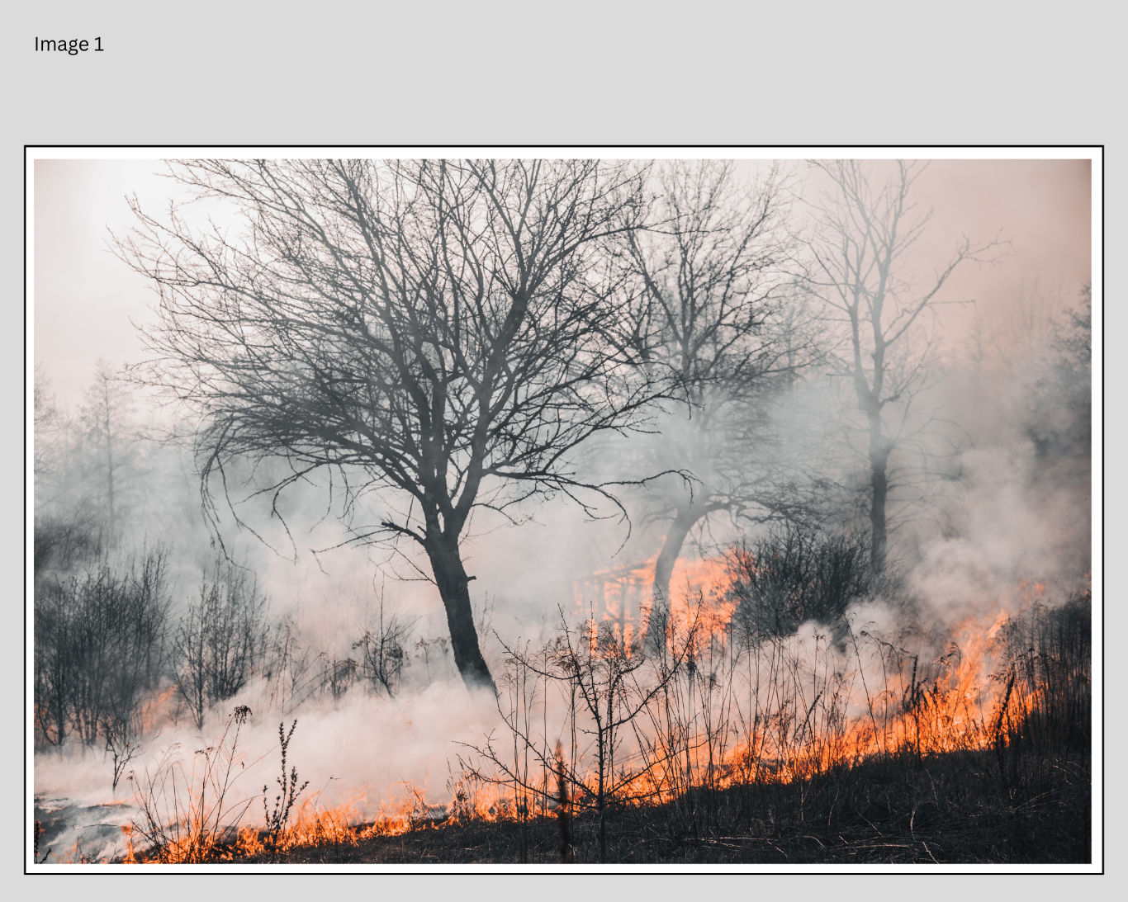
© Vladyslav Dukhin via Canva.com
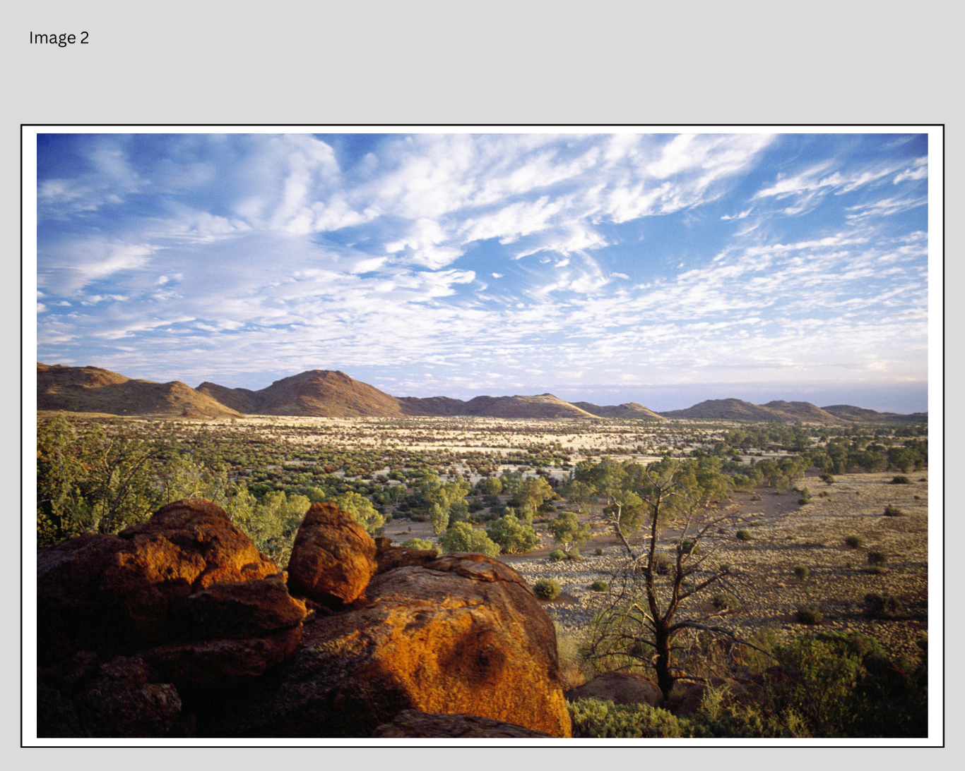
© Tourism Australia via Canva.com
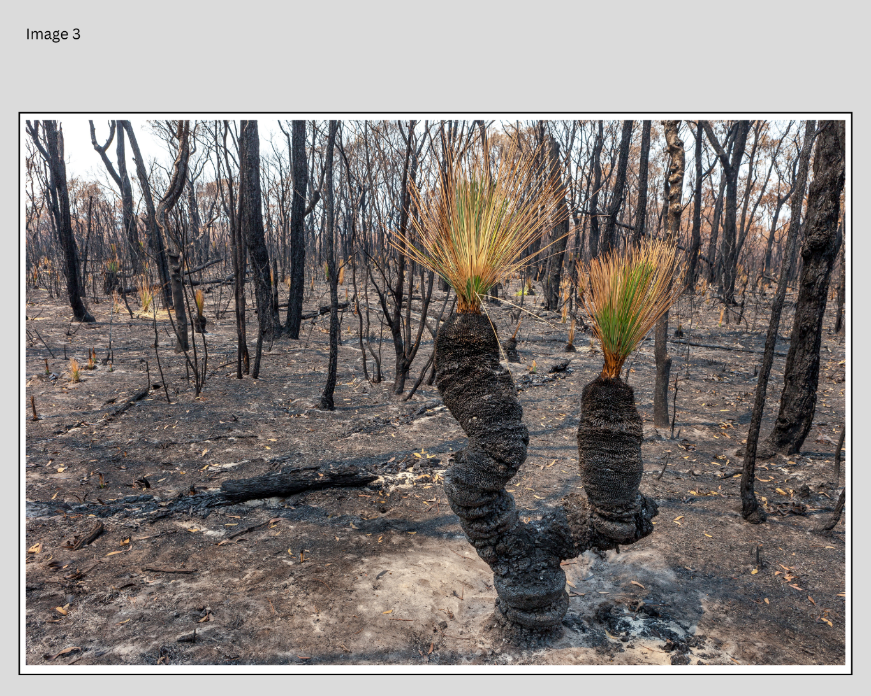
© Edward Haylan via Canva.com

Resource 2 – five senses template
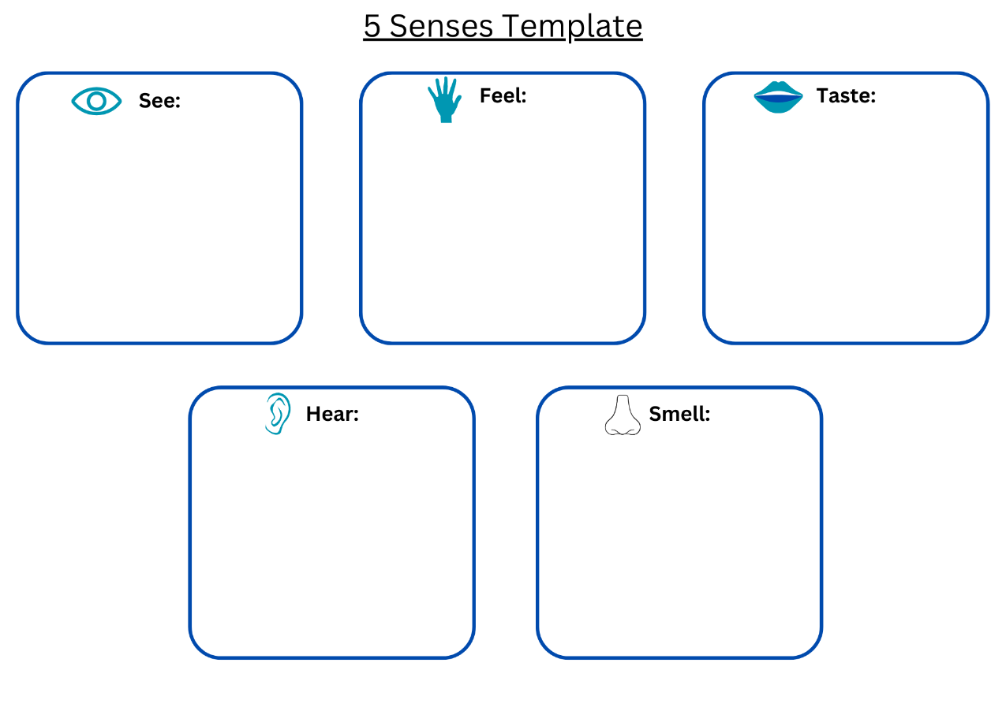

Resource 3 – Bindi’s character profile
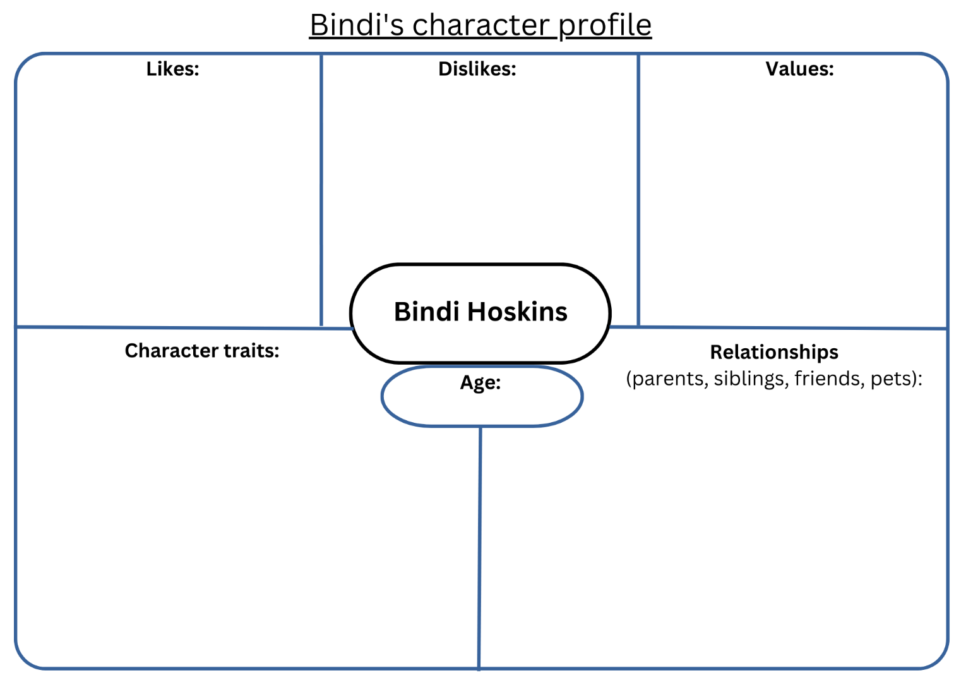

Resource 4 – being Bindi
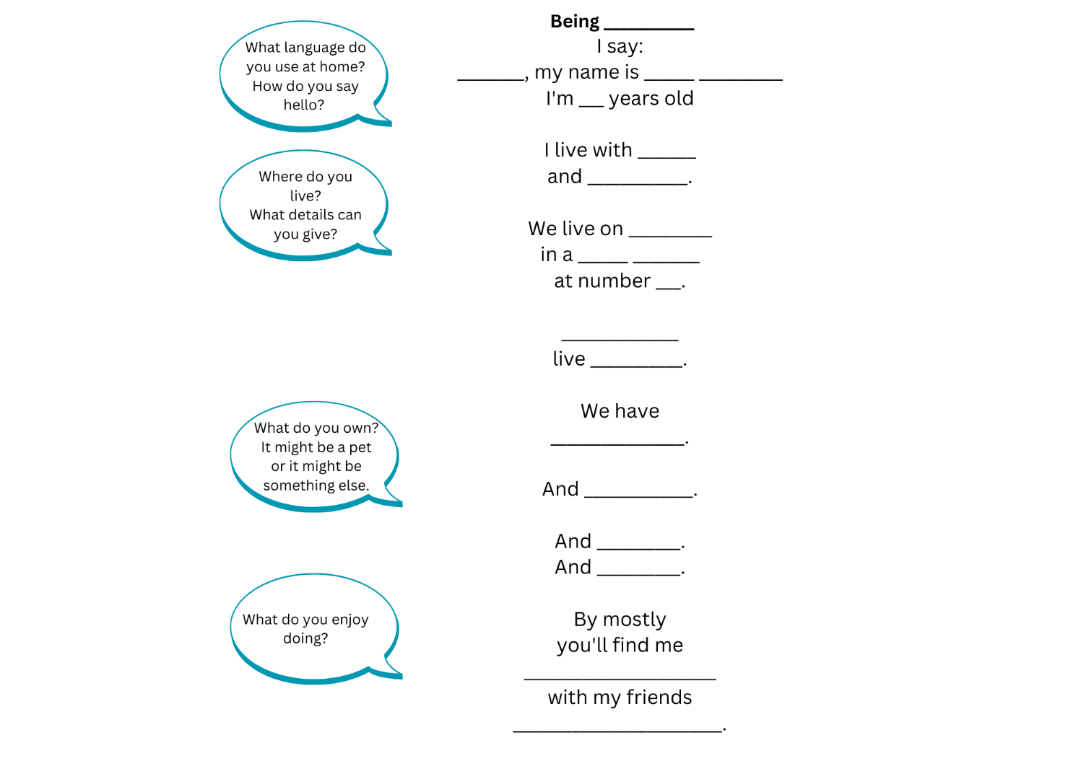

Resource 5 – vocabulary word mat
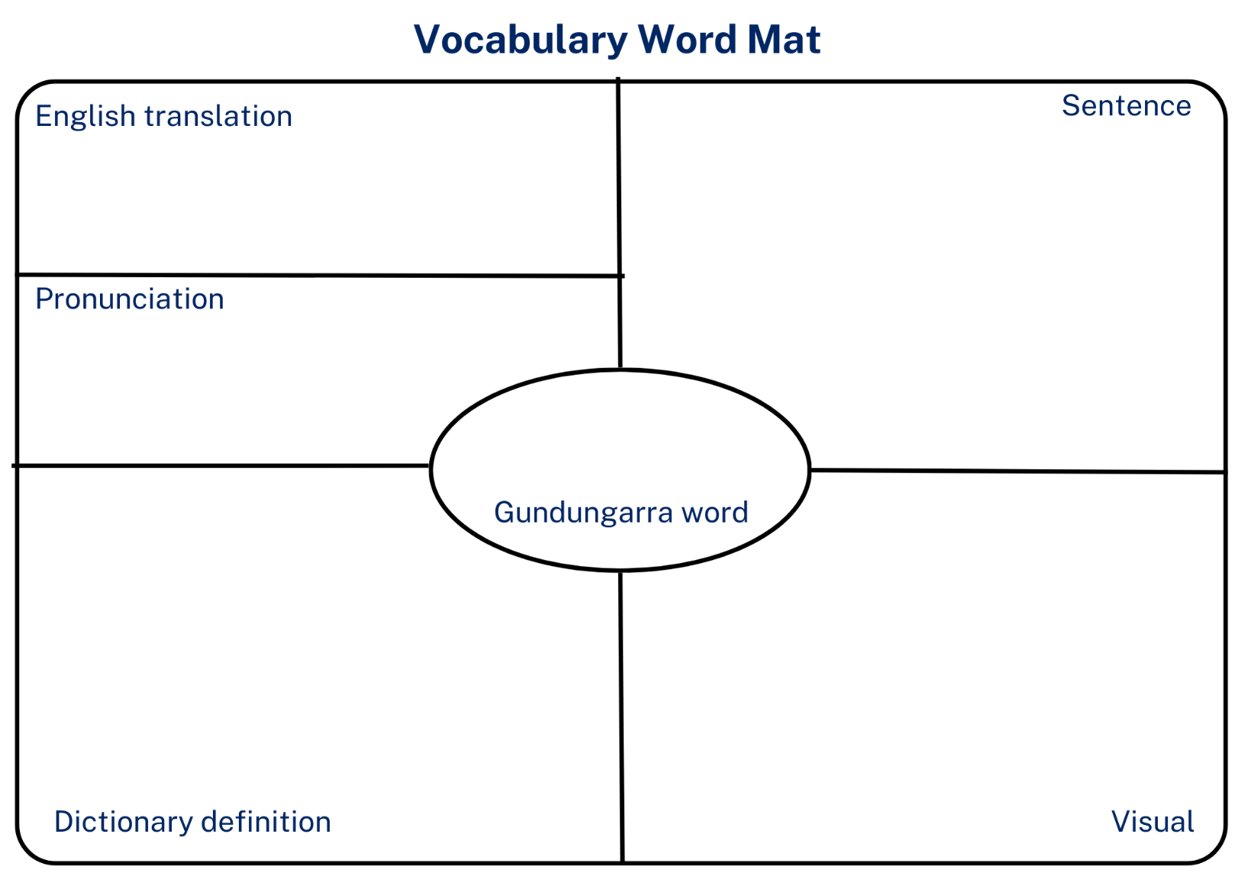

Resource 6 – inferring character traits
What the text says (evidence) | What we can infer
p 14 ‘Country you belong to’ | Aunty Lindy feels a deep connection to Country

Resource 7 – Garrall poetry planning template
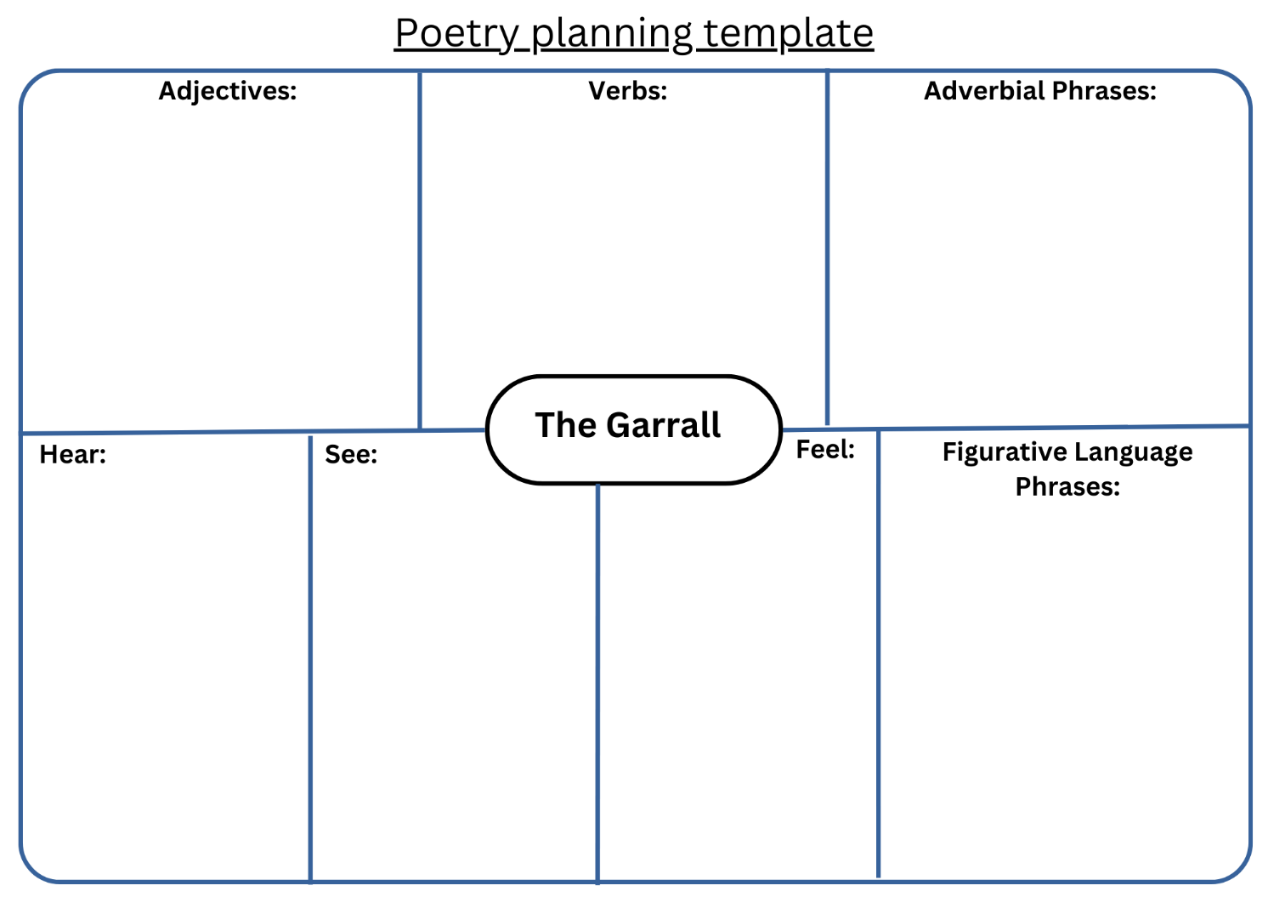

Resource 8 – Fambam planning template
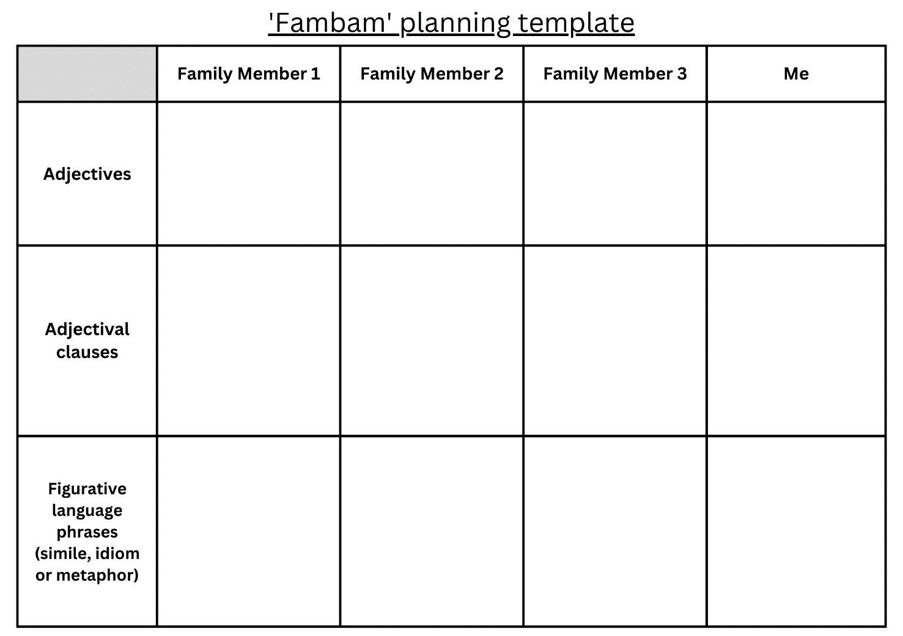

Resource 9 – poetry planning template
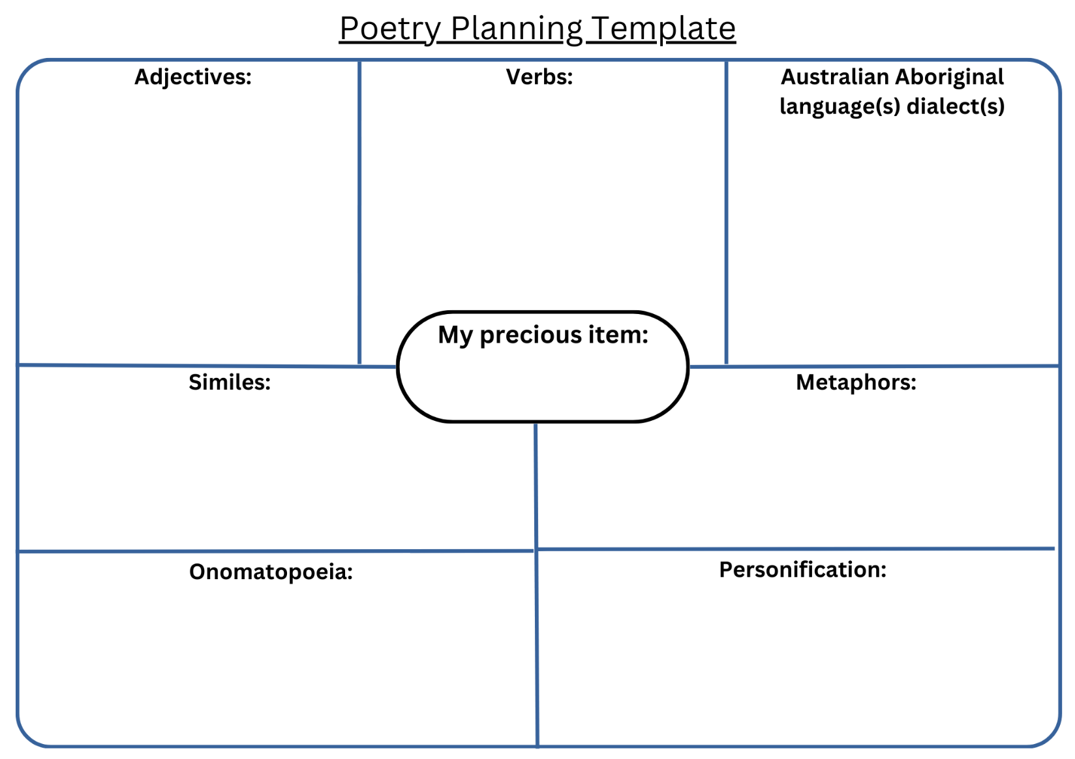

References
This [document/resource] contains NSW Curriculum and syllabus content. The NSW Curriculum is developed by the NSW Education Standards Authority. This content is prepared by NESA for and on behalf of the Crown in right of the State of New South Wales. The material is protected by Crown copyright.
Please refer to the NESA Copyright Disclaimer for more information. https://educationstandards.nsw.edu.au/wps/portal/nesa/mini-footer/copyright
NESA holds the only official and up-to-date versions of the NSW Curriculum and syllabus documents. Please visit the NSW Education Standards Authority (NESA) website https://educationstandards.nsw.edu.au/ and the NSW Curriculum website https://curriculum.nsw.edu.au/.
English K–10 Syllabus © NSW Education Standards Authority (NESA) for and on behalf of the Crown in right of the State of New South Wales, 2022.
National Literacy Learning Progression © Australian Curriculum, Assessment and Reporting Authority (ACARA) 2010 to present, unless otherwise indicated. This material was downloaded from the Australian Curriculum website (National Literacy Learning Progression) (accessed 31 August 2023) and was not modified.
Behind the News (22 August 2017) 'Backburning, Caring for Country - Behind the News' [video], Behind the News, YouTube, accessed 25 July 2023.
Facing History & Ourselves (2017) S-I-T: Surprising, Interesting, Troubling, Facing History & Ourselves website, accessed 26 July 2023.
French J (2014) Fire (Whatley B, illus.), Scholastic Press, Australia.
Kirli Saunders (2023) 'Cry of the Glossy' [video], Kirli Saunders, Kirli Saunders website, accessed 25 July 2023.
Saunders K (2020) Bindi (Leffler D, illus.), Magabala Books, Australia.
State Library Victoria (1 December 2020) 'Story talks with Kirli Saunders - Poetry and verse' [video], State Library Victoria, YouTube, accessed 26 July 2023.
State of New South Wales (Department of Education) (2023a) ‘English A to Z’, Parents and carers, NSW Department of Education website, accessed 25 July 2023.
State of New South Wales (Department of Education) (2023b) Visible thinking in the languages classroom – building deeper understanding and student engagement [DOCX 7.76 MB], NSW Department of Education, accessed 25 July 2023.
Tween Regional Museum (n.d.) Barileh | Glossy Black-cockatoo, Tweed Regional Museum website, accessed 27 July 2023.

© State of New South Wales (Department of Education), 2023
The copyright material published in this resource is subject to the Copyright Act 1968 (Cth) and is owned by the NSW Department of Education or, where indicated, by a party other than the NSW Department of Education (third-party material).
Copyright material available in this resource and owned by the NSW Department of Education is licensed under a Creative Commons Attribution 4.0 International (CC BY 4.0) license.
This license allows you to share and adapt the material for any purpose, even commercially.
Attribution should be given to © State of New South Wales (Department of Education), 2023.
Material in this resource not available under a Creative Commons license:
- the NSW Department of Education logo, other logos and trademark-protected material
- material owned by a third party that has been reproduced with permission. You will need to obtain permission from the third party to reuse its material.
Links to third-party material and websites
Please note that the provided (reading/viewing material/list/links/texts) are a suggestion only and implies no endorsement, by the New South Wales Department of Education, of any author, publisher, or book title. School principals and teachers are best placed to assess the suitability of resources that would complement the curriculum and reflect the needs and interests of their students.
If you use the links provided in this document to access a third-party's website, you acknowledge that the terms of use, including licence terms set out on the third-party's website apply to the use which may be made of the materials on that third-party website or where permitted by the Copyright Act 1968 (Cth). The department accepts no responsibility for content on third-party websites.

