English Stage 2 first year– Unit 4

Contents
Unit overview and instructions for use 5
Teacher notes 7
Outcomes and content 9
Resources 15
Week 1 18
Component A teaching and learning 18
Planning framework 18
Component B teaching and learning 18
Learning intentions and success criteria 18
Learning intention 19
Success criteria 19
Lesson 1 – exploring Piano Fingers 19
Lesson 2 – using metaphors to create imagery 23
Lesson 3 – understanding symbols in texts 25
Lesson 4 – analysing descriptive language in a text 28
Week 2 31
Component A teaching and learning 31
Planning framework 31
Component B teaching and learning 31
Learning intentions and success criteria 31
Learning intention 32
Success criteria 32
Lesson 5 – using personification to create imagery 32
Lesson 6 – identifying and using salience in words 36
Lesson 7 – identifying and using salience in images 39
Lesson 8 – innovating on Piano Fingers 41
Week 3 45
Component A teaching and learning 45
Planning framework 45
Component B teaching and learning 45
Learning intentions and success criteria 45
Learning intention 46
Success criteria 46
Lesson 9 – publishing a multimodal text using salience 46
Lesson 10 – publishing and presenting a multimodal text 48
Lesson 11 – experimenting with poetry 49
Lesson 12 – Sonam and the Silence 52
Week 4 55
Component A teaching and learning 55
Planning framework 55
Component B teaching and learning 55
Learning intentions and success criteria 55
Learning intention 56
Success criteria 56
Lesson 13 – similes and symbolism 56
Lesson 14 – exploring characterisation 59
Lesson 15 – building descriptions of a character 60
Lesson 16 – comparing Bea and Sonam 62
Week 5 65
Component A teaching and learning 65
Planning framework 65
Component B teaching and learning 65
Learning intentions and success criteria 65
Learning intention 66
Success criteria 66
Lesson 17 – planning a journal entry 66
Lesson 18 – drafting and composing a journal entry 68
Lesson 19 – feedback, editing and publishing 70
Lesson 20 – reflecting on the textual concepts 72
Resource 1 – connotation images 73
Resource 2 – symbols 75
Resource 3 – metaphorical symbols 76
Resource 4 – think board 77
Resource 5 – personification 78
Resource 6 – ice cream advertisement 79
Resource 7 – summer poem 80
Resource 8 – poem background 81
Resource 9 – writing process 82
Resource 10 – Piano Fingers scaffold 83
Resource 11 – five senses 84
Resource 12 – simile match 85
Resource 13 – character analysis 86
Resource 14 – journal planning template 87
References 89

Unit overview and instructions for use
In this 5-week unit, students will gain a deeper understanding of the textual concepts of imagery, symbol and connotation and characterisation. Through the texts Piano Fingers and Sonam and the Silence, students will explore how authors use imagery and symbols in literature and identify how figurative language can influence meaning. Students will experiment using salience and figurative language to create a multimodal text. Students will also make connections to characters in a text by composing a journal entry.
Outcomes and content in this unit are organised into Component A and Component B. The components are connected, with learning in Component A complementing learning in Component B.
Note: the duration of this unit can be adapted to suit individual school contexts. For example, learning could occur across 5 days rather than 4.
The table below highlights the focus areas and preparation required for Component A and Component B.
Teaching and learning | Component A | Component B
Suggested duration | 60 minutes × 4 days/week or equivalent | 60 minutes × 4 days/week or equivalent
Explicit teaching focus areas | Component A addresses content from the focus areas:  - Vocabulary  - Reading fluency  - Reading comprehension  - Creating written texts  - Spelling  - Handwriting and digital transcription  It centres on the development of foundational skills and knowledge through regular, systematic and repeated practice. | Component B addresses content from the focus areas:  - Oral language and communication  - Vocabulary  - Reading comprehension  - Creating written texts  - Understanding and responding to literature  It centres on the conceptual understandings of English and exemplifies the importance of learning about and enjoying literature through the study of quality texts.
Preparing for teaching and learning | - Specific teaching and learning activities need to be developed by the teacher. When planning for these activities, please refer to the Component A outcomes and content, teaching guides and planning frameworks.  - Plan and document how you will sequence teaching and learning in whole-class and targeted-groups across the five-week cycle as required. This should be based on student needs identified through ongoing assessment data. | - Familiarise yourself with the mentor and supporting texts and textual concepts, and the teaching and learning sequence.  - Determine how you will support students in whole-class and targeted-groups across the 5-week cycle as required. This should be based on student needs identified through ongoing assessment data.
English K–10 Syllabus © NSW Education Standards Authority (NESA) for and on behalf of the Crown in right of the State of New South Wales, 2022.

Teacher notes
- ‘Imagery, symbol and connotation’ is the mentor concept of this unit, explored using the texts Piano Fingers by Caroline Magerl and Sonam and the Silence by Eddie Ayres.
- Imagery is the use of figurative language to represent objects, characters, actions or ideas in such a way that they appeal to the senses of the reader or viewer.
- Symbol is an object, character or entity that can be understood to represent a larger idea, action or feeling. Depending on context, audience and purpose, symbols can have commonly agreed or reinforced associations, or they can be dynamic. Symbols can operate within texts, or they can serve as meaning-making devices of language in the real world.
- Connotation is the nuances or implied meaning attached to language, beyond that of its literal or dictionary meanings. Connotations may be positive, negative, or neutral (NESA Glossary).
- Understanding of imagery symbol and connotation can be supported through watching the department’s video: Understanding connotation, imagery and symbol video (6:06).
- While ‘imagery, symbol and connotation’ is the mentor concept for the conceptual component of this unit, the supporting concept of ‘characterisation’ is also explored. Additional textual concepts may be included based on individual school context and student needs.
- Some of the content in this unit requires sensitivity awareness. Access and provide support if needed.
- For information on figurative language, adverbial phrases and subordinating and coordinating conjunctions refer to the NESA Glossary.
- In addition to the resources listed, students will require access to short passages of the mentor and/or supporting texts. Teachers can copy extracts from texts in reliance on the Statutory Text and Artistic Works Licence. Teachers need to attribute the extracts and include the following notice: ‘This material has been copied [and communicated to you] in accordance with the statutory licence in section 113P of the Copyright Act. Any further reproduction or communication of this material by you may be the subject of copyright protection under the Act. Do not remove this notice’.
- Consider prior student knowledge of imagery symbol and connotation and figurative language.
- Reflect on student learning and engagement in activities and record differentiation and adjustments within the unit to inform future teaching and learning. One way of doing this could be to add comments to the digital file.
- In NSW classrooms there is a diverse range of students including Aboriginal students, students learning English as an additional language or dialect, high potential and gifted students and students with disability. Some students may identify with more than one of these groups, or possibly all of them. Refer to Curriculum planning for every student – advice for further information.
- Content points are linked to the National Literacy Learning Progression version (3).
Levels and indicators sourced from National Literacy Learning Progression © Australian Curriculum, Assessment and Reporting Authority (ACARA), (accessed 4 September 2023) and was not modified. See references for more information.

Outcomes and content
The table below outlines the outcomes and content for this unit. The letters 'A' and 'B' in the header refer to Components A and B. The numbers 1 to 5 refer to weeks. The use of 'x' in these columns indicates where the content points are intended to be addressed and in which week.
Focus area and outcome, content points and National Literacy Learning Progression | A | B | 1 | 2 | 3 | 4 | 5
Oral language and communication
EN2-OLC-01 communicates with familiar audiences for social and learning purposes, by interacting, understanding and presenting
- Follow agreed-upon protocols and assigned roles for classroom interactions in person and through the use of technology (InT5) |  | x | x | x | x | x | x
- Identify language features in spoken texts that contribute to own or others’ enjoyment and understanding |  | x |  |  | x
- Plan and deliver spoken presentations using language and structure to suit purpose and audience (SpK5) |  | x |  |  | x
- Adjust volume, pace and intonation to enhance meaning when presenting and reciting (SpK5) |  | x |  | x | x
Vocabulary
EN2-VOCAB-01 builds knowledge and use of Tier 1, Tier 2 and Tier 3 vocabulary through interacting, wide reading and writing, and by defining and analysing words
- Identify and use terminology associated with figurative language encountered in texts (UnT7) | x | x | x | x |  | x | x
- Apply morphemic knowledge to change word meanings by adding different prefixes and suffixes to a base word or root (SpG9) | x |  |  |  | x | x | x
Reading fluency
EN2-REFLU-01 sustains independent reading with accuracy, automaticity, rate and prosody suited to purpose, audience and meaning
- Explain how effortless and accurate word reading, at a pace appropriate for text and purpose, can support reading fluency and comprehension | x |  | x | x |  | x | x
- Read multisyllabic words, phrases and continuous texts with accuracy and appropriate rate suited to reading purpose (FlY5, PKW8) | x |  | x | x | x | x | x
- Demonstrate use of navigation pathways to support fluency when engaging with print, visual and multimodal texts (UnT7) | x |  | x | x | x
- Adjust voice, tone, volume and pitch reflected by the punctuation in a text, to enhance reading fluency and support comprehension (FlY5) | x |  | x | x | x | x | x
- Recognise that there are different purposes and audiences for reading and adjust reading rate to suit a text’s purpose (FlY5) | x |  | x | x | x | x
- Monitor and adjust own goals for improving reading fluency | x |  |  |  | x | x | x
Reading comprehension
EN2-RECOM-01 reads and comprehends texts for wide purposes using knowledge of text structures and language, and by monitoring comprehension
- Select and read texts of personal interest and to gather information for learning (UnT7) | x |  | x | x | x | x | x
- Identify similarities and compare differences within and between texts by making text-to-self, text-to-text and text-to-world connections | x | x | x |  | x | x | x
- Describe how multimodal features enhance meaning and contribute to salience in texts (UnT7) | x | x |  | x | x | x
- Understand that literal information can be sourced directly from a text and that inferences can be made by using multiple sources of information | x |  | x | x |  |  | x
- Identify where meaning breaks down when reading (UnT6) | x |  | x | x | x | x | x
- Identify and use strategies to repair reading when meaning breaks down (UnT6) | x |  | x | x | x | x | x
Creating written texts
EN2-CWT-01 plans, creates and revises written texts for imaginative purposes, using text features, sentence-level grammar, punctuation and word-level language for a target audience
- Experiment with different poetic forms using stanzas |  | x |  |  | x
- Use language to create imagery or humour, including idioms, puns, simile and personification (CrT8) |  | x | x |  | x |  | x
- Select and use multimodal features to add meaning |  | x |  |  | x | x
- Use adverbial phrases or clauses to add information to the verb or verb group of the main or other clauses, to provide reasons for or circumstance | x | x | x |  | x | x | x
- Use coordinating conjunctions in compound sentences to compare and contrast, or for addition (GrA4) | x | x |  |  | x | x | x
- Use subordinating conjunctions in complex sentences to signal sequence, reason or cause and effect (GrA6) | x | x |  |  | x | x | x
- Select and use precise saying, thinking, acting, and relating verbs and verb groups to align with text purposes (GrA5, CrT8) | x | x | x | x |  | x | x
- Use capital letters to indicate the beginning of a sentence, proper nouns, headings and subheadings, to indicate the beginning of a poetry line, for emphasis, and when using acronym (PuN5, PuN7) | x | x |  | x | x | x | x
- Use adjectives to develop descriptive features (CrT8) | x | x | x | x | x | x
- Reflect on and monitor texts according to given criteria, and respond to feedback from others |  | x |  | x | x |  | x
Spelling
EN2-SPELL-01 selects, applies and describes appropriate phonological, orthographic and morphological generalisations and strategies when spelling in a range of contexts
- Identify differences in vowel phonemes (short, long, diphthong and schwa vowels) (SpG9) | x |  | x | x | x | x | x
- Apply knowledge of taught vowel graphemes when spelling (SpG9) | x |  | x | x | x | x | x
- Proofread, identify and correct misspellings when creating written texts (SpG9) | x |  |  | x
- Identify inflected suffixes, explaining when and how to treat base words when they are affixed, and apply this knowledge when spelling (SpG9) | x |  |  |  | x | x | x
- Identify derivational suffixes such as -able, -ness, -ian and -ment, explaining when and how to treat base words when they are affixed, and apply this knowledge when spelling (SpG9) | x |  | x | x |  |  | x
- Correctly spell irregular plural words across a range of written contexts (SpG11) | x |  |  |  | x | x | x
Handwriting and digital transcription
EN2-HANDW-01 forms legible joined letters to develop handwriting fluency
EN2-HANDW-02 uses digital technologies to create texts
- Join letters using consistent size and spacing to develop fluency (HwK6) | x |  | x |  |  | x
- Use knowledge of the keyboard layout and functions to type texts (HwK7) | x |  |  | x | x |  | x
Understanding and responding to literature
EN2-UARL-01 identifies and describes how ideas are represented in literature and strategically uses similar representations when creating texts
- Recognise imagery and symbols in literature (UnT7) |  | x | x | x |  | x
- Identify figurative language in literature and how it can influence meaning, and experiment with figurative language when creating texts (CrT8, UnT7) |  | x | x | x | x | x | x
- Recognise that characters may be identified through familiar, individual or group characteristics |  | x |  |  |  | x | x
English K–10 Syllabus © NSW Education Standards Authority (NESA) for and on behalf of the Crown in right of the State of New South Wales, 2022.

Resources
The resources in the table below are referred to in this unit. Letters 'A' and 'B' in the header refer to Component A and B respectively, and the numbers 1 to 5 indicate weeks. The use of 'x' in these columns indicate whether the resources are required in Component A, B or both, and in which week.
Resource | A | B | 1 | 2 | 3 | 4 | 5
Magerl C (2022) Piano Fingers, Walker Books Australia. ISBN13: 9781760652616. | x | x | x | x | x | x
Ayres E (2018) Sonam and the Silence (Taher R, illus), Allen & Unwin, Australia. ISBN13: 9781760293666. | x | x |  |  |  | x | x
Resource 1 – connotation images |  | x | x
Resource 2 – symbols |  | x | x
Resource 3 – metaphorical symbols |  | x | x
Resource 4 – think board |  | x | x
Resource 5 – personification |  | x |  | x
Resource 6 – ice cream advertisement |  | x |  | x
Resource 7 – summer poem |  | x |  | x
Resource 8 – poem background |  | x |  | x
Resource 9 – writing process |  | x |  | x |  |  | x
Resource 10 – Piano Fingers scaffold |  | x |  | x
Resource 11 – five senses |  | x |  |  | x
Resource 12 – simile match |  | x |  |  |  |  | x
Resource 13 – character analysis |  | x |  |  |  | x
Resource 14 – journal planning template |  | x |  |  |  |  | x
Venn diagram |  | x |  |  | x | x

Week 1

Component A teaching and learning
Component A focuses on the development of foundational skills and knowledge through regular, systematic and repeated practice. The mentor and supporting texts used in Component B of this unit can support the effective implementation of Component A teaching and learning.

Planning framework
To plan and document Component A teaching and learning, a planning scaffold [DOCX 81 KB] is provided. To support you in your planning, a link to a detailed example of a one-week teaching and learning cycle is included in the scaffold. Additional resources to support teaching and learning in each focus area can be found at Lesson advice guides.

Component B teaching and learning
The following teaching and learning sequence has been designed to address Component B outcomes and content and develops conceptual understandings of English through the study of quality texts. Adapt the sequence as required to best meet the needs of your students.

Learning intentions and success criteria
Learning intentions and success criteria are best co-constructed with students.

Learning intention
Students are learning to identify how authors use imagery and symbol to enhance the meaning in texts.

Success criteria
Students can:
- use written and visual clues to understand the meaning of a text
- identify and use metaphors to create imagery
- understand how authors use symbols to build meaning and create imagery
- identify and use descriptive language to build descriptions and create imagery.

Lesson 1 – exploring Piano Fingers
- Display the first image of a field from Resource 1 – connotation images. Explore how images can create different emotional responses in a viewer. For example, colours can evoke specific emotions, or a viewer may make connections to personal experiences or memories. Provide small groups of students with an A3 version of the first image. In groups, students record words to describe how the image makes them feel and/or concepts it could represent. For example, happiness, spring, new life, hopeful, peaceful, relaxed, holidays, cheerful, calm.
- As a class, develop protocols for partner and group interactions. For example, active listening or using and building on others’ ideas. Provide small groups of students with an A3 version of the second image from Resource 1 – connotation images. In groups, students record words to describe how the image makes them feel and/or concepts it could represent. For example, suffering, dry, unhappy, hopeless, stress, worry, anxiety, uncertainty, loss.
- Students share their ideas. Explore the similarities and differences between responses. Ask students to consider why the same image may ignite different or similar responses in a viewer. Introduce the idea that authors/illustrators often use images to evoke emotions in a reader.
- Display the front cover of Piano Fingers and discuss the title. Ask:
- What type of text do you think this is? Why?
- What do you think piano fingers are? What makes you say that?
- Who do you think the story is about? Predict what the character might do in the text.
- As a class, discuss what students notice about the cover of the text. Encourage students to consider their responses from activities 1 and 2. Ask guiding questions, for example:
- What is the first thing you see? Why?
- What colour stands out the most?
- How does this front cover make you feel? Why?
- What do you think the small black symbols represent (musical notes)?
- Why do think there are flowers at the top of the page? What do flowers often represent?
- Introduce the textual concept of ‘imagery, symbol and connotation’. Co-construct a definition of imagery, symbol and connotation on an anchor chart and display in the classroom.
Note: imagery is the use of figurative language to represent objects, characters, actions or ideas in such a way that they appeal to the senses of the reader or viewer. Symbol is an object, character or entity that can be understood to represent a larger idea, action or feeling. Depending on context, audience and purpose, symbols can have commonly agreed or reinforced associations, or they can be dynamic. Symbols can operate within texts, or they can serve as meaning-making devices of language in the real world. Connotation is the nuances or implied meaning attached to language, beyond that of its literal or dictionary meanings. Connotations may be positive, negative, or neutral (NESA Glossary).
- Display the information about Caroline Magerl from the Penguin Books Australia website. As a class, read the information and discuss the author’s artistic background. Draw students’ attention to the fact that Caroline Magerl is an artist and an author. Ask students how they think Caroline Magerl’s experiences as an artist could influence the visuals in her books. Explore how Caroline Magerl has used imagery, symbol and/or connotation on the front cover. For example, the flowers at the top could represent growing and changing.
- Read Piano Fingers. After reading, identify Tier 2 and Tier 3 vocabulary and discuss the meaning of each word using context clues from the text. For example, brummed, crotchets, quavers, symphonies, flourished, debut, encore, conducted, maestro. Ask questions to further develop students’ understanding of the text. For example:
- How do you think Bea felt being the only one in her family that didn’t play an instrument?
- Why do you think Isla stopped Bea playing the triangle? How do you think Bea felt?
- How does Maestro Gus help Bea?
- What do you think Maestro Gus represents?
- What type of music do you think Bea played on the page where it says, ‘And then music bloomed’? Can you elaborate on why you think Bea was upset afterwards?
- Students Think-Pair-Share how Bea felt at the beginning of the story and how she felt at the end. Encourage students to explain why her feelings changed throughout the text. Flick through the text and summarise the key events that contributed to Bea’s changes. For example:
- I noticed that in Bea’s family, everyone plays an instrument except Bea. I think she feels left out. When she tried to play an instrument, her sister didn’t think it sounded the way it should.
- Bea then decided to try to play the piano, with the help of Maestro Gus.
- Bea tried playing the piano and really enjoyed it. However, she became upset when she realised there was no one there to hear her music.
- At the end, Bea’s sister Isla came to help Bea and they made beautiful music together.
- Discuss a time when students tried something new or experienced something that was challenging. Ask guiding questions:
- What happened and what did you do?
- How did you feel or react to the situation? Why?
- What did you do that was similar or different to Bea?
- Students write about their experience, identifying their emotions, actions and responses. In pairs, students share their writing.
Too easy? Students include a deeper analysis of their experience using cause and effect.

Lesson 2 – using metaphors to create imagery
- Ask students to close their eyes and think about what they see, feel and hear when the following statement is read aloud: The thunder was a mighty lion, roaring and bellowing across the land. Discuss the following questions:
- What did you see? What did you hear? How did it make you feel?
- How is thunder being described?
- Do you think the thunder is an actual lion? Why or why not?
- Why would thunder be described in this way?
- Explain that figurative language is one way that authors create imagery and influence meaning in texts. Explore how metaphors are a type of figurative language that authors use to describe something as being something else. Display and discuss different metaphors. For example:
- “Your bedroom is a dump!” Mum exclaimed.
- The classroom was a noisy zoo.
- Her lovely voice was music to my ears.
- He got lost in a sea of memories.
- The road ahead was a ribbon stretching across the desert.
Note: a metaphor is an object, entity or situation that can be regarded as representing something else (NESA Glossary).
- Co-construct a definition for metaphors and record it on the anchor chart from Lesson 1. In pairs, students identify what is being described and how it is being described. For example, the bedroom is being compared to a dump and conveys the idea that the room is extremely messy.
- Re-read Piano Fingers, recording the metaphors from the text. For example:
- ‘Crotchets and quavers showered from her honey fog machine.’
- ‘A baby mountain.’
- ‘There are whole symphonies up those sleeves.’
- ‘The sound of an icy tear falling from a star.’
- ‘A song of winter trees.’
- ‘Then up through the mothfoggy dark it drifted, a thin little song, a left out in the rain song.’
- Explore the meaning of each metaphor and how they add meaning and impact to the text. For example, the piano is compared to ‘a baby mountain’. This can be interpreted as Bea viewing the piano as a challenge. Climbing mountains often requires hard work, resilience and persistence, which links to the challenge of learning to play the piano. Remind students that metaphors are a type of figurative language that are used to create imagery.
- Display the double-page spread with images of the piano, lamp and billowing curtains from the text. On individual whiteboards, students experiment creating metaphors to describe each object. For example:
- The piano was a towering skyscraper, looming above Bea.
- The curtains were a cascading waterfall.
- The lamp was a spotlight, lighting up the stage.
Too easy? Students choose different objects from the text and create metaphors describing them.
- In pairs, students share their metaphors. Optional: one student reads out their metaphor while their partner draws what they visualise. Students swap roles and repeat the process. As a class, reflect on the purpose of metaphors and how they are used to create imagery.
- Students choose an object from the text and write a descriptive paragraph using a variety of metaphors.
Too hard? Students draw and label an object from the text using descriptive language and metaphors.

Lesson 3 – understanding symbols in texts
- Place images from Resource 2 – symbols around the classroom. Students complete a symbol scavenger hunt by walking around the classroom to identify and record the symbols they find. As a class, discuss what the symbol represented, where students have seen them and why they are used.
- Display Resource 3 – metaphorical symbols. Explain that some symbols are not literal and may convey deeper meanings and associations. In pairs, students analyse each metaphorical symbol and explore what it represents. Encourage students to focus on the connotations, or emotions, associated with each image. Ask guiding questions, such as:
- What mental models are created in your mind?
- What words or phrases do you think of? Why do you associate them with the image?
- How does the image make you feel?
- What do you think the image represents? Why?
- Revise the textual concept of ‘imagery, symbol and connotation’ from the Lesson 1. Explain that authors use symbols to represent ideas, add meaning and emotions in a text. Highlight how symbols can often be interpreted in different ways, based on the viewer or reader’s prior knowledge and/or experiences.
- Re-read and revise the text, Piano Fingers. Pause throughout the text to identify and record the symbols Caroline Magerl used. For example, the piano, music notes, flowers, the concept of music, the maestro, coloured confetti.
Note: there may be more symbols in the text that can be found.
- Discuss how symbols are often hidden within texts and can be a repeated image, word, character or an idea. Emphasise that the associated meanings for each symbol may only apply to this text and that the representation of the same idea could mean something different in another text. As a class, explore the meaning of the symbols identified in activity 4. Discuss what the symbol represents, and the connotations and emotions associated with the symbol. For example:
- piano – a challenge or hurdle to overcome
- music notes – new learning and resilience
- flowers – growing knowledge and achieving success
- the concept of music – hope and family connection
- the maestro – motivation, perseverance and striving to succeed
- coloured confetti – celebration and achievement
- the sheet of music – the key to Bea learning how to play the piano.
- Using one of the symbols explored in activity 5, model completing Resource 4 – think board. Use think-alouds to draw what is visualised, record words or phrases associated with the symbol, emotions it evoked and what the symbol could mean.
- Students select a different symbol from activity 5 and complete Resource 4 – think board.
Too hard? Students draw a picture of what they think the symbol means and record associated words around their drawing.
- As a class, share students think boards and explain their reasoning.
- Students write a paragraph explaining why they think Caroline Magerl included the symbol in the text, how it enhances meaning and the impact it has on the reader.

Lesson 4 – analysing descriptive language in a text
- Revise ways authors add descriptions to texts. For example, using figurative language, adjectives or verbs and including details related to the senses.
- Re-read Piano Fingers. Revise different types of adjectives from learning in Component A. Explore how Caroline Magerl used a variety of adjectives to create vivid descriptions of the characters and objects in the text. Record examples from the text and the types of adjectives used. For example:
- big musical family (descriptive and classifying)
- bigger musical things (comparative)
- tiny gold wheels (descriptive)
- most sparkling debut (comparative)
- thin little song (descriptive)
- Analyse how the author’s language choices enhance imagery and create vivid images in the reader’s mind. For example, the choice to include ‘most’ before ‘sparkling’ creates a clear image of success and achievement and that it was more sparkling that any other debut. Students Think-Pair-Share to identify the impact different types of adjectives have on the reader.
- Provide students with sentences or phrases from the text without adjectives. For example, ‘She just couldn’t wait for her music to start.’ On individual whiteboards, students experiment using a variety of adjectives to enhance the meaning of the sentence. For example, ‘She just couldn’t wait for her enchanting music to start’ (descriptive), ‘She just couldn’t wait for her classical music to start’ (classifying).
- Explore how Caroline Magerl used verbs in the text as another way to build descriptions. Revise types of verbs from learning in Component A, including thinking, saying, relating and acting verbs.
Note: a verb is a word that tells what is happening. Different types of verbs include action verbs: They danced; thinking verbs: I forgot; saying verbs: He whispered; relating verbs: They are (NESA Glossary).
- Flick through the text and identify the types of verbs used (relating, acting and saying). Display the excerpt from the text that begins with ‘In easy swoops…’ and ends at “That’s not how it goes, Bea.” Deconstruct the passage, highlighting the verbs, identifying type of verb, and recording the impact the verb has on the reader.
- Provide students with a different excerpt from the text. In pairs, students deconstruct the passage, highlighting the verbs, identifying the type of verb, and recording the impact that the verb has on the reader. As a class, share student responses.
- Display the page with the text ‘Maestro Gus flourished his tails.’ Define the verb ‘flourished’ and choose students to act out the movement that Maestro Gus performed with his tailcoat. Explore how the word ‘flourished’ supports the meaning of the text and conveys information about the character, Maestro Gus. For example, the verb adds a sense of theatrics to the sentence and makes it clear that Maestro Gus is a confident performer.
- Ask students to brainstorm other verbs that could be used in the sentence. For example, moved, swept, waved. In pairs, students experiment changing the verbs in the sentence. Encourage students to use adverbs to add meaning to the verb. For example, ‘Maestro Gus proudly waved his tails.’
- Display an illustration from the text. For example, the page where Bea is bowing on the chair after she performs. Model writing a paragraph about Bea using descriptive and figurative language (metaphors, adjectives, verbs). For example:
Bea gracefully settled herself in front of the majestic beast she was about to tame. Her fingers created delicate whispers as she lightly caressed the keys. With each press, the sounds grew stronger and louder. Bea bravely explored the new land of music and felt crotchets and quavers fly through her body. The piano was suddenly telling stories that had never been told before.
- Deconstruct the paragraph, highlighting the different language choices. As a class, co-construct success criteria for writing.
- Using an illustration from the text, students write a paragraph using descriptive and figurative language. Encourage students to include metaphors and a variety of adjectives and verbs.
Too hard? Students label the illustration with descriptive language and experiment using metaphors.
- Share student writing. Ask guiding questions, such as:
- How did the language choices create a sensory experience for the reader?
- What type of adjectives and verbs did you use? How do they help build descriptions and create imagery?
- What emotions did you want the reader to feel when they were reading your text?
- Do you feel you were successful in creating imagery? What makes you say that?

Week 2

Component A teaching and learning
Component A focuses on the development of foundational skills and knowledge through regular, systematic and repeated practice. The mentor and supporting texts used in Component B of this unit can support the effective implementation of Component A teaching and learning.

Planning framework
To plan and document Component A teaching and learning, a planning scaffold [DOCX 81 KB] is provided. To support you in your planning, a link to a detailed example of a one-week teaching and learning cycle is included in the scaffold. Additional resources to support teaching and learning in each focus area can be found at Lesson advice guides.

Component B teaching and learning
The following teaching and learning sequence has been designed to address Component B outcomes and content and develops conceptual understandings of English through the study of quality texts. Adapt the sequence as required to best meet the needs of your students.

Learning intentions and success criteria
Learning intentions and success criteria are best co-constructed with students.

Learning intention
Students are learning to identify how authors use figurative language and multimodal features to create imagery.

Success criteria
Students can:
- identify and use personification to build imagery
- describe how salience is used to enhance meaning in a text
- use salient features to add meaning and purpose to texts
- innovate on a text using figurative language.

Lesson 5 – using personification to create imagery
- Ask students to close their eyes. Read aloud the following sentence: The moon was behind the clouds. Ask guiding questions, such as:
- What do you see in your mind?
- What do you think the moon is doing? What makes you say that?
- How did the words in the sentence support your mental model?
- Ask students to close their eyes again. Read aloud the following sentence, ‘The moon played hide and seek with the clouds.’ Ask the guiding questions from activity 1. Discuss the differences between the 2 sentences and ask students which sentence created a stronger image in their minds and why.
- Revise how authors use figurative language to create imagery and influence meaning in texts. Introduce the concept of personification as a form of figurative language. Co-construct a class definition.
Note: personification is attributing human characteristics to abstractions such as love, things or animals (NESA Glossary).
- Re-read Piano Fingers, identifying and recording examples of personification. For example:
- ‘The sound of an icy tear falling from a star.’
- ‘The piano began to huff and hum from its great belly strings.’
- ‘And then music bloomed.’
- ‘A huff, a hum, a silky growl rolled around the walls, strolled across the ceiling, shimmied in the curtains… to wherever music goes.’
- Analyse the examples, identifying the inanimate object and how the author made it come to life in the reader’s mind. Discuss the meaning of each sentence, referring to the text for clues. Students explain why they think the author gave human characteristics to non-human things and how it supports the purpose of the text.
- Discuss the author’s specific word choices in the examples and how they add to the meaning of the text. For example, ‘The sound of an icy tear falling from a star’ implies a very soft, high-pitched, delicate note that Bea first plays because she is uncertain and lacking in confidence.
- Ask students to close their eyes and listen to Tchaikovsky's Nutcracker for wind duet (5:14) from (0:45 to 1:09). Students Think-Pair-Share to explain how the music made them feel and describe what they visualised in their minds. Discuss how pitch (high or low sounds), tempo (speed), dynamics (loud or soft), rhythm (the beat) and melody (the musical tune) are often used by composers to create certain moods and effects. Continue playing the song from (1:09 to 1:39) and explore how the music changed. Identify the differences between the 2 pieces of music and the different emotions evoked.
- Display the page that begins with ‘And then music bloomed…’ from Piano Fingers. Ask students what is happening on the page, what Bea is starting to do and how she is feeling. Explore how the written language and visuals compare Bea’s music to flowers blooming in springtime.
- Ask students to close their eyes. Read the page again, asking students to think about the type of music that might match this part of the text. Ask the following questions:
- Do you think the music is loud or soft? Why?
- Do you think the music is fast or slow? Why?
- Do you think the music is high or low pitched? Why?
- How would you describe the music Bea is playing? What makes you say that?
- Have you heard similar music to this before? If so, where and in what context?
- Play the Beethoven Emperor Concerto (41:21) from (1:53 to 2:48). While listening, students record words on individual whiteboards to describe the emotions they associate with the music. Students share their ideas and explain why they chose those emotions.
- Ask students if the music is similar or different to what they imagined Bea playing. Encourage students to explain their thinking.
- Re-read the sentence ‘A song of winter trees spinning barley sugar clouds for springtime.’ Explore the use of personification, ‘spinning barley sugar clouds for springtime’. As a class, brainstorm and record other examples of personification that could be used to describe the type of music Bea played. For example:
- The flowers danced happily.
- Crotchets and quavers tiptoed down the hallway.
- The piano laughed with joy.
- The birds sang a happy song.
- Display Resource 5 – personification. Display the page from the text with the curtain moving in the wind. Jointly construct examples of personification for the image. Explore the importance of using a variety of verbs to create vivid descriptions.
- Students use Resource 5 – personification to create sentences using personification for each object, assigning human characteristics to each item from the text. Encourage students to generate new ideas rather than changing the verb.
Too hard? Students experiment using different verbs to change the sentence.
Too easy? Students choose their own objects from the text and write a paragraph using figurative language, including personification.
- Students write a descriptive paragraph describing one page from Piano Fingers using personification. Encourage students to use their ideas from activity 14.
Too hard? Students draw and label an image from the text using descriptive language (adjectives, verbs).
Too easy? Students write an explanation of the types of figurative language used in activity 13 and the impact it has on the reader.
- In pairs, students share their writing, explaining their use of personification and intended purpose. As a class, reflect on the purpose of personification and how authors use it to create imagery.
Assessment task 1 – observations and work samples from this lesson allows students to demonstrate achievement towards the following syllabus outcomes and content points:
EN2-VOCAB-01 – builds knowledge and use of Tier 1, Tier 2 and Tier 3 vocabulary through interacting, wide reading and writing, and by defining and analysing words
- identify and use terminology associated with figurative language encountered in texts.
EN2-UARL-01 – identifies and describes how ideas are represented in literature and strategically uses similar representations when creating texts
- recognise imagery and symbols in literature
- identify figurative language in literature and how it can influence meaning, and experiment with figurative language when creating texts.

Lesson 6 – identifying and using salience in words
- Display Resource 6 – ice cream advertisement. Ask students what the most noticeable feature is and why. Brainstorm a list of features the author used to capture the viewer’s attention. For example, colour, image and text placement, font style and size (bold, italics, underlined). Explore how the author has used these features to support the text’s purpose and engage the audience.
- Introduce the term ‘salience’. Explain that salience is a strategy used to highlight what is important in a text. In written text, salience may be conveyed by positioning the most important idea at the beginning of a sentence, or through font styling such as the use of bold, underlined or italicised text. In an image, salience may be created through framing an object in the foreground and/or by its size or distinct colour (NESA Glossary).
- Explore how Caroline Magerl used salience in written text in Piano Fingers. Display the double page spread with the text, ‘Bink, bink, bink’. Ask:
- When you look at this page, what words do you look at first? Why?
- What words are written differently on this page? For example, bigger, bolder, different font style.
- Why do you think the author made specific words stand out?
- Do you think the order of words on the page enhance the meaning of the text? What makes you say that?
- As a class, analyse the double-page spread from activity 3 to explore the techniques used by the author. For example:
- Repetition: creates emphasis and makes the page more memorable.
- Text placement: the word ‘bink’ next to the image of Bea playing the instrument. This suggests that Bea is hitting the triangle harder at the start before becoming disinterested in the instrument.
- Font size: the large ‘bink’ reflects the louder sound of the triangle and the small ‘bink’ reflects the softer sound of the triangle.
- Font style: the word ‘not’ is bigger and bolder reflecting Isla’s feelings towards Bea’s ability to play the triangle.
- Flick through the whole text, exploring how salience has been used to highlight words and phrases and the impact it has on the reader. For example:
- Font style: Different font used to represent onomatopoeia, ‘Crashtinkle’, ‘plunk’ and ‘plink’.
- Font size and placement: ‘to wherever music goes’ is bold, large and flows to represent a musical melody.
- Font size and style: most of the dialogue contains larger and bolder words with exclamations to help convey the character’s emotions.
- Display the page that starts with ‘And then music bloomed’. Explore how text placement has been used, including the use of indenting sentences. Identify that the indenting has been used to highlight the text that describes Bea’s music to encourage the reader to visualise the music. The word ‘listen’ is bolder and larger. Ask students what type of sentence has been used (imperative sentence) and how it supports the meaning of the text. Explore the similarities of this page to the structure of a poem (stanza) through the use of indenting.
Note: poetry is often written in ‘chunks’ or stanzas. Stanzas are separated from each other by spaces or line breaks and are often used to group related ideas or create a structural pattern in a poem.
- Display Resource 7 – summer poem and read the poem aloud. Explore how salience could be used to enhance the meaning of the text and evoke emotions in the reader. Ask students to read the poem aloud, identifying where they would emphasise words and/or phrases and why.
- Provide students with a copy of Resource 8 – poem background. Students re-write the poem, using salience to emphasise parts of the poem and capture the reader’s attention. Encourage students to consider text placement (indenting), font style and size (bold, italics, underlining), punctuation (capital letters, exclamation marks).
- As a class, revise protocols for group interactions. For example, active listening or using and building on others’ ideas. In small groups, students share their poems and explain how the salience of their text enhances the meaning and engages the reader.

Lesson 7 – identifying and using salience in images
- Revise how salience is used in words from Lesson 6. Discuss how salience can also be used within images to help them stand out, capture the reader’s attention and create visual impact. Flick through Piano Fingers and explore how salience has been used in images. For example:
- Colour: represents different emotions or ideas
- Framing: guides the reader's attention to certain parts of the image to enhance meaning
- Size and scale: emphasises the main idea, compares and contrasts the size of an object or character with its surroundings
- Positioning: establishes a visual hierarchy, emphasises objects or characters, create tension, reveal relationships
- Isolation: creates visual contrast, draws the reader's attention to one image or colour
- Facial expressions and eye contact: communicate emotions, creates connections to the reader.
- Display the double page that begins with ‘“Fine!” said Bea.’ Ask students what part of the image captures their attention first and why. For example, students may notice the framed circular images of Bea, Isla’s violin bow, Bea in the doorway. Discuss how framing has been used on the second page to show Bea’s journey down the stairs. Explore how the position of Bea in the last circle is encouraging the reader to turn the page.
- Display the double page that has Bea sitting on the piano stool and contains the word ‘…room’. Ask students what part of the image captures their attention first and why. For example, the yellow spotlight shining on the piano or the position of the curtain. Ask students where their attention is drawn next. For example, the position of the curtain draws the reader’s attention to the piano, the spotlight on the piano draws the reader’s attention to Bea looking down, guiding the reader towards the paper hat. Explore the impact salience has on the meaning of the text. For example, everything around the room is quite dark with the piano being the main source of light, which represents Bea’s turbulent emotions. Use sticky notes to label the different elements on this page.
- Revise protocols group interactions. Provide groups of students with a double-page spread from the text. In groups, students use peer discussion and conferencing to analyse how salience has been used to capture the reader’s attention and enhance the meaning of the text. Encourage students to follow agreed-upon protocols when interacting. Students record their ideas on sticky notes.
- Students write a reflection describing how multimodal features are used to enhance meaning and contribute to salience in words and images. Encourage students to use examples from Piano Fingers to support their thinking. Ask guiding questions, for example:
- Why do authors use salience in words? How does it impact the reader?
- Why do illustrators use salience in images? How does it impact the reader?
- What techniques do authors and/or illustrators use to create salience in texts? Why are they important?
Assessment task 2 – observations and work samples from this lesson allows students to demonstrate achievement towards the following syllabus outcomes and content points:
EN2-OLC-01 – communicates with familiar audiences for social and learning purposes, by interacting, understanding and presenting
- follow agreed-upon protocols and assigned roles for classroom interactions in person and through the use of technology.
EN2-RECOM-01 – reads and comprehends texts for wide purposes using knowledge of text structures and language, and by monitoring comprehension
- describe how multimodal features enhance meaning and contribute to salience in texts.

Lesson 8 – innovating on Piano Fingers
- Display the double page spread from Piano Fingers that begins with ‘And then music bloomed’. Re-read the text on the page and revise the types of figurative language Caroline Magerl used. Analyse the impact on the reader and how it enhances meaning in the text. For example:
- ‘music bloomed’ implies that music burst out of the piano (metaphor)
- ‘a song of winter trees’ represents that the music is new and just starting to grow (metaphor)
- ‘spinning barley sugar clouds for springtime’ suggests that Bea is playing high pitched, delicate music that sounds sweet (personification).
- Review how salience can be used in written text from Lesson 6. Analyse how salience has been used in images to engage the reader and enhance the meaning of the written text. For example:
- Framing: the text is framed with a circular border
- Colour: the use of yellow spotlights to highlight the maestro and Bea
- Positioning: Bea’s fingers pointing upwards, in the direction of the Maestro
- Size and scale: the size of Bea and Maestro compared to the piano and the flowers around the page
- Facial expression and eye contact: Bea directly looking at the reader.
- Ask students to close their eyes and imagine what the page would look like if Bea tried to play the piano, but the music did not sound as good as she hoped. Ask guiding questions, such as:
- Do you think the flowers would be blooming? Why or why not?
- What colours would be used? Why?
- What other symbols could be used on the page to represent how Bea is feeling?
- What sounds do you imagine? How could figurative language be used to describe the sounds?
- Explain that students will innovate off the page and create a double-page spread with Bea playing the piano but showing the music does not sound as good as she hoped.
- Using the text as an exemplar, co-construct success criteria for writing. For example:
- use figurative language to create imagery
- use multimodal features to influence meaning and contribute to salience
- use adjectives to develop descriptive features
- experiment with poetic forms using stanzas
- use capital letters to indicate a new poetry line.
- As a class, brainstorm and record examples of figurative language that could be used to describe the music Bea would play to show the music not sounding as good as she hoped.
- Using the ideas brainstormed in activity 6, model writing the text. For example:
And then,
music withered.
A song
of howling wind
throwing angry sparks of lightning
towards the earth.
Hide!
A sound more awful than
screeching nails on a chalkboard.
- As a class, recite the poem adjusting volume, pace and intonation.
- Revise the writing process using Resource 9 – writing process. Explain that students will orally plan their ideas with a partner. Provide time for students to share their ideas before writing.
- Explain that students will begin drafting and composing their text. Explore the cyclical process and the importance of re-reading and revising during this phase. Students draft and compose their text.
Too hard? Students complete Resource 10 – Piano Fingers scaffold.
Too easy? Students write an additional stanza experimenting with different types of figurative language, such as repetition, similes and hyperbole.
- In pairs, students provide peer feedback using the success criteria. Students reflect on the figurative language they used, explaining why the language choices they made.

Week 3

Component A teaching and learning
Component A focuses on the development of foundational skills and knowledge through regular, systematic and repeated practice. The mentor and supporting texts used in Component B of this unit can support the effective implementation of Component A teaching and learning.

Planning framework
To plan and document Component A teaching and learning, a planning scaffold [DOCX 81 KB] is provided. To support you in your planning, a link to a detailed example of a one-week teaching and learning cycle is included in the scaffold. Additional resources to support teaching and learning in each focus area can be found at Lesson advice guides.

Component B teaching and learning
The following teaching and learning sequence has been designed to address Component B outcomes and content and develops conceptual understandings of English through the study of quality texts. Adapt the sequence as required to best meet the needs of your students.

Learning intentions and success criteria
Learning intentions and success criteria are best co-constructed with students.

Learning intention
Students are learning to use imagery to create multimodal texts and analyse language features in a text that support its purpose.

Success criteria
Students can:
- use visual and written elements to create imagery in a multimodal text
- adjust volume, pace and intonation to enhance meaning when presenting
- analyse language features in spoken texts
- experiment with poetic forms using figurative language
- understand inferred meaning of a text and make text-to-self and text-to-world connections.

Lesson 9 – publishing a multimodal text using salience
- Set a timer for one minute. On individual whiteboards, students record ways authors and/or illustrators use salience in images and words. For example, framing, colour, font size and style. Share student responses. If needed, revise how multimodal features enhance meaning and contribute to salience in texts from Lesson 6 and Lesson 7.
- Explain that students will publish their writing from Lesson 8 by creating a double-page spread, just like Caroline Magerl did in Piano Fingers.
- Display a blank piece of A3 paper in landscape orientation and the modelled text from Lesson 8. Ask students how salience could be used to enhance meaning. For example, text placement (indenting, top/middle/bottom of the page), font size and style (bold, italics, underlined, punctation). Model using salient features to re-write the text on the A3 paper. While modelling, use think-alouds to explain each choice.
Note: leave blank space around the words to add visual images.
- Students publish their written text on A3 paper, ensuring they leave space for visual images.
- Review student ideas from activity 1, exploring ways salience in images can enhance the meaning of a text. For example, colour, framing, size and scale, positioning, isolation of an image, facial expressions and eye contact.
- Using the modelled text, explore what images and colours could be included to enhance the meaning of the text and convey Bea’s emotions. For example:
- ‘music withered’ could be represented by dying, colourless flowers
- ‘a song of howling winds’ could be represented by dark storm clouds
- ‘a sound more awful than screeching nails on a chalkboard’ could be represented by a dry, cracked landscape.
- Explore how the ways in which images are positioned could be used to draw the reader’s attention to certain parts of the page. For example, the bolts of lightning might be pointing to Bea, the piano, the dying flowers or the written text.
- Explore how framing could be used to highlight certain aspects on the page. For example, the written text could be inside a white circle to highlight the importance of the text, Bea could be placed in the middle of the page.
- Display the modelled text from activity 3. Model using salience in images to create an artwork around the text to enhance its meaning. Model using colour to convey emotion, size and scale to make images more noticeable, positioning and/or framing to draw the reader’s attention to it. Co-construct success criteria, ensuring students use multimodal features to enhance the meaning of their text and contribute to salience.
- Students use the same A3 paper from activity 4 to begin drawing the illustrations to their text. Explain that students will continue publishing their artwork in Lesson 10.

Lesson 10 – publishing and presenting a multimodal text
- Students continue publishing their artwork to support their written text from Lesson 9.
- Revise protocols for group interactions. In small groups, students share their published work explaining how multimodal features enhance meaning and contribute to salience in text.
- Explain that students will present their published work to the class. Co-construct success criteria for student presentations. For example:
- present with a clear voice
- adjust volume to add meaning to the text and engage the audience
- maintain a steady pace
- use intonation for emphasis and to engage the audience.
- Provide time for students to practise their spoken presentation. Students then present to the class. While one student is presenting, students use the success criteria to provide feedback.
- As a class, reflect on student presentations. Students share the language features used in spoken texts that contribute to their enjoyment and understanding.
Assessment task 3 – observations and work samples from this lesson allows students to demonstrate achievement towards the following syllabus outcomes and content points:
EN2-OLC-01 – communicates with familiar audiences for social and learning purposes, by interacting, understanding and presenting
- plan and deliver spoken presentations using language and structure to suit purpose and audience
- adjust volume, pace and intonation to enhance meaning when presenting and reciting.
EN2-CWT-01 – plans, creates and revises written texts for persuasive purposes, using text features, sentence-level grammar, punctuation and word-level language for a target audience
- select and use multimodal features to add meaning
- reflect on and monitor texts according to given criteria and respond to feedback from others.

Lesson 11 – experimenting with poetry
- Listen to Air poem (1:09) without displaying the text. Play multiple times if necessary. Ask the following questions:
- What is the poem about? Describe the mental model created in your mind.
- What features of the poem were enjoyable?
- What language features were used? Why do you think the author used them? For example, onomatopoeia and repetition create imagery and engage the audience.
- Who else do you think would enjoy this poem? Why?
- Listen to The Coming of Teddy Bears poem (0:52). Play multiple times if necessary. Repeat the questions from activity 1. Focus on the language features used to enhance enjoyment and understanding of the text. For example, the use of alliteration, personification and repetition.
- Listen to Last night, I saw the city breathing poem (1:23). Play multiple times if necessary. Repeat the questions from activity 1. Focus on the language features used to enhance enjoyment and understanding of the text. For example, the use of similes, personification, metaphors and repetition.
- After listening to all 3 poems, discuss the similarities and differences. In pairs, students discuss which poem they enjoyed the most and explain why. Reflect on the different ways authors engage the audience in spoken texts.
- Re-read Piano Fingers, exploring the theme of family (through Bea and Isla’s relationship). Discuss the concept of family and discuss emotions, images and ideas associated with it.
- Explain that students will further explore the theme of family using the 5 senses. Students use Resource 11 – five senses to brainstorm words and/or phrases associated with family. For example:
- smell – fresh pancakes cooking, freshly cut grass after Dad has mowed the lawn, Sunday roast dinner, air freshener
- taste – salty seawater, delicious ice cream, barbecued prawns, the bitter aftertaste of an argument
- see – siblings arguing, sibling playing, parents cooking, hugs and kisses, pets playing in the backyard
- hear – BBQ sizzling, TV blaring, music playing, birds chirping in the backyard, waves crashing on the beach
- touch/feel – the burning metal of the slide, the spiky thorns of the rose bush in the backyard, safe, loved, happy.
- Share student ideas.
- Model creating a poem about family using the 5 senses. For example:
Four pairs of eyes watch the sun slowly sink into the backyard. (See/alliteration)
Sizzle, sizzle, sizzle! Oh no! The sausages are burnt to a crisp! (Hear/onomatopoeia and repetition)
Every Sunday, Dad’s famous blueberry pancakes make my tastebuds dance. (Taste/personification)
I am a cheetah, sprinting across the smooth carpet of silky green grass that softly caresses my feet. (Touch/metaphor)
The smell of crisp air freshener drifts up my nose as my beastly brother bolts from the bathroom. (Smell/alliteration)
- Deconstruct the modelled example and identify how figurative language has been used to engage the audience. Co-construct success criteria for writing.
- Students use their planned ideas from activity 6 to write their poem.
Too hard? Provide students with sentence starters for each of the senses. For example, I see, I hear, I smell, I taste, I feel.
- In small groups, students recite their poem adjusting volume, pace and intonation to enhance meaning.
Assessment task 4 – observations and work samples from this lesson allow students to demonstrate achievement towards the following syllabus outcomes and content points:
EN2-OLC-01 – communicates with familiar audiences for social and learning purposes, by interacting, understanding and presenting
- identify language features in spoken texts that contribute to own or others’ enjoyment and understanding.
EN2-CWT-01 – plans, creates and revises written texts for persuasive purposes, using text features, sentence-level grammar, punctuation and word-level language for a target audience
- experiment with different poetic forms using stanzas
- use language to create imagery or humour, including idioms, puns, simile and personification
- use adjectives to develop descriptive features
- use capital letters to indicate the beginning of a sentence, proper nouns, headings and subheadings, to indicate the beginning of a poetry line, for emphasis, and when using acronym.

Lesson 12 – Sonam and the Silence
- Read the author’s note at the back of Sonam and the Silence. Explore the context of the book by identifying Afghanistan on a map and discuss how the Taliban used to have power over the country in the 1990s. After losing power in 2001, the Taliban recently regained power in 2021. Explain that the Taliban have strong beliefs and, as a result, some things are banned in Afghanistan, such as music.
- Students Think-Pair-Share to discuss how they would feel if they were not allowed to play or listen to music.
- Display the front cover of Sonam and the Silence. Explore the images on the front cover. Ask:
- What do you think the girl is holding? Why do you think that?
- Where do you think she is? Why?
- What do you think she might be doing? How could she be feeling?
- Students predict who and what they think the text will be about. Read the blurb, asking students if their prediction has changed. Discuss the term ‘fable’ and what a ‘fable-like story’ could be. Revise that a fable is a short, fictional narrative that conveys a moral to help the audience understand themselves, each other and the world.
- Read the text. After reading, review new Tier 2 and Tier 3 vocabulary. Discuss the meaning of each word and use context clues within the text. For example, metal beaters, beggars, pomegranate, forbidden, nurturing, rubab, thrive, shrill, withdrawn, foreign, withered, cradles.
- Explore information about Eddie Ayres using the author’s note. For example, Eddie Ayers lived in Afghanistan and taught music at the Afghanistan National Institute of Music to orphans and children for a year. This experience had a significant impact on Eddie. In pairs, students explain why they think Eddie Ayres wrote Sonam and the Silence.
- Review the main events in the text. Ask questions to support students inferential understanding. For example:
- Why do you think everyone in Sonam’s family goes to work?
- Sonam starts working when she is 7. How would you feel if you had to work when you were 7?
- Why do you think the old man breaks the rules and plays music?
- Why does Sonam have to sneak away to see the old man?
- When Sonam’s brother forbade her from playing music, why do you think she became withdrawn?
- What do you think is happening when Sonam sees planes and soldiers in the city? What makes you say that?
- What do you think happened to the old man?
- Why did Sonam plant a pomegranate tree in her garden?
- Why do you think Sonam’s brother hid the rubab?
- How does Sonam feel when she plays music?
- Discuss students’ personal responses to the text. Ask students what the text made them think about and how it made them feel.
- Display a Venn diagram with the headings ‘Life in Afghanistan’ and ‘Life in Australia’. As a class, discuss and record ideas to describe what life is like for Sonam in Afghanistan. For example, music is banned, children go to work, beggars are on the street, there are soldiers in the cities, people buy food from the markets. Discuss and record ideas to describe what life is like for children living in Australia. For example, children must go to school, children can’t work until they are teenagers, everyone can play music and dance, there are lots of activities for children to participate in, people buy food from grocery stores. Record any ideas that are common in both countries in the middle section. Encourage students to make text-to-self and text-to-world connections.
- Revise coordinating and subordinating conjunctions from Component A. Model using ideas from the Venn diagram to compare Sonam’s life with students’ lives in Australia. For example, While I listen to the radio in my car, Sonam needs to sneak away to play her musical instrument.
- Students write a paragraph comparing their life to Sonam’s using coordinating and subordinating conjunctions.
Too hard? Students draw and label an image of Sonam’s life and an image of their life. Students orally describe the similarities and differences.

Week 4

Component A teaching and learning
Component A focuses on the development of foundational skills and knowledge through regular, systematic and repeated practice. The mentor and supporting texts used in Component B of this unit can support the effective implementation of Component A teaching and learning.

Planning framework
To plan and document Component A teaching and learning, a planning scaffold [DOCX 81 KB] is provided. To support you in your planning, a link to a detailed example of a one-week teaching and learning cycle is included in the scaffold. Additional resources to support teaching and learning in each focus area can be found at Lesson advice guides.

Component B teaching and learning
The following teaching and learning sequence has been designed to address Component B outcomes and content and develops conceptual understandings of English through the study of quality texts. Adapt the sequence as required to best meet the needs of your students.

Learning intentions and success criteria
Learning intentions and success criteria are best co-constructed with students.

Learning intention
Students are learning to recognise how authors use language features to develop characterisation in texts.

Success criteria
Students can:
- use similes and symbolism to describe setting and characters
- use a range of sentence types to describe characters
- use adverbial phrases and clauses to describe characters
- use subordinating and coordinating conjunctions to compare and contrast 2 characters.

Lesson 13 – similes and symbolism
- Explore how similes are a type of figurative language that authors use to compare the similar qualities of 2 different things using ‘like’ or ‘as’. Provide small groups of students with Resource 12 – simile match. Students match the simile, for example, ‘The storm raged on like an angry giant.’ Students analyse each simile and explore how they can be used to enhance the reader’s understanding, create mental pictures and evoke emotions.
- Revise how figurative language is used to create imagery and influence meaning in texts. Re-read Sonam and the Silence, identifying and recording similes. After reading, discuss the meaning of each simile. For example:
- ‘The music drifts away like clouds.’ This conveys the idea that music is slowly disappearing from Sonam’s life, just as clouds disperse and vanish. The simile conveys sadness as Soman is losing something due to the strict rules in Afghanistan.
- ‘She learns that music is like a pomegranate tree.’ As the pomegranate tree is native to Afghanistan, it requires nurturing and care, similar to learning a new skill such as playing a musical instrument. This conveys the idea that learning an instrument takes time, dedication and a lot of practice.
- Revise symbolism from Lesson 3 and how authors use symbols in texts to represent ideas, convey messages and add meaning. Symbols are also used by authors to help achieve their intended purpose and can be a repeated image, word, character or an idea. Highlight that symbols can often be interpreted in many different ways, based on the reader’s prior knowledge and experiences.
- Flick through Sonam and the Silence, identifying important and/or repeated symbols throughout the text. Encourage students to consider how colour is used to convey meaning. For example:
- the mulberry and pomegranate trees at the beginning could symbolise freedom and safety
- the rubab could represent Sonam’s joy and freedom
- the repetition of the colour black could symbolise the tension within the country
- the cord wrapped around Sonam could symbolise silence and restrictions
- the withered pomegranate tree could symbolise death and destruction
- the fruit on the pomegranate tree at the end could symbolise hope
- the rubab buried under the tree could symbolise new life and love.
- Focus on one of the symbols, for example, the pomegranate tree at the beginning of the text. Brainstorm and model creating similes to describe the symbol, referring to the text for meaning and context. For example:
- The dangling pomegranates are like red rubies hanging from a necklace.
- The lush green leaves stretched over Sonam like a warm blanket.
- The tree was as graceful as a dancer.
- The pomegranate tree was as old as time.
- In pairs or small groups, students choose a different symbol from the text and experiment using similes to describe the symbol. Encourage students to refer to the text for meaning and context.
- Review the text and identify the different places. For example, the markets, the old man’s garden, Sonam’s garden and the city. Students write a paragraph describing one of the places, using descriptive and figurative language. Encourage students to describe the objects and characters, and include symbols that are specific to their place. For example, the pomegranate tree in Sonam’s garden. Provide time for students to add multimodal features to add meaning to their text. Encourage students to consider how colour could be used to convey emotions.
Too hard? Students write a paragraph about their symbol from activity 6.
- Students take turns reading their paragraph to the class. While listening, students close their eyes and visualise what is being described. Students share their visualisations and how the use of figurative language, including similes, helped to create vivid images.

Lesson 14 – exploring characterisation
- Revise the concept of characterisation and how authors use a variety of techniques to build and develop characters in texts and intentionally represent characters in different ways. Create a class definition of characterisation.
Note: characterisation is the technical construction and representation of any personality or person-like figure in text, including features such as their appearance, actions, words or thoughts.
- Re-read Sonam and the Silence. While listening, students record words and phrases on individual whiteboards that could be used to describe Sonam. Encourage students to use adjectives, verbs and figurative language. For example, as brave as a lion, playful, musical, seven years old, youngest, rebellious, has a heart of gold.
- Students share their ideas, building on each other’s responses to develop greater understanding of Sonam as a character. Discuss the importance of Sonam’s relationship to music throughout the text and how this relationship changes.
- In pairs or small groups, students participate in a Hot seat activity to further understand her emotions and motivations. Encourage students to ask higher order questions. For example:
- Why did you decide to play the rubab even though it was forbidden?
- How would you feel if you had never met the old man?
- Why do you love music so much?
- What is it like living in a city where there are soldiers and gunfire?
- Explain why you wanted to plant the pomegranate seeds in your garden.
- What do you think would have happened if you had never heard the music?
- Provide students with a copy of Resource 13 – character analysis. Students record words and phrases to describe Sonam’s personality, her context of living in Afghanistan, her appearance and her relationship to music.
- Revise how authors use a variety of sentence types (simple, compound, complex) to engage the reader, build descriptions and convey information about a character’s emotions and actions.
- Using student ideas from activity 5, model writing a description of Sonam, using a variety of sentence types to enhance meaning and engage the reader.
- Students use their completed character analysis to write a text that describes Sonam’s character. Encourage students to experiment using figurative language.
Too hard? Students write their descriptive paragraphs using simple and compound sentences.

Lesson 15 – building descriptions of a character
- Display an image of Bea from Piano Fingers. Re-read the text, with students recording words and phrases that could be used to describe Bea on individual whiteboards. Encourage students to use figurative language. For example, as small as a mouse, enthusiastic, curious, temperamental, drama queen, sassy, a storm in a teacup, a whirlwind of emotions. Share ideas and discuss Bea as a character.
- As a class, complete Resource 13 – character analysis. Record words and phrases to describe Bea’s personality, context, appearance and relationship to music.
- Revise adverbial phrases and clauses from Component A. Model writing descriptive sentences about Bea using adverbial phrases. For example:
- Bea practises playing the piano to get better. (reason/why)
- Bea played the piano with graceful fingers. (manner/how)
- Model writing descriptive sentences about Bea using adverbial clauses. For example:
- Bea’s confidence grew when she practised playing music. (time/when)
- Bea likes to follow the music wherever it goes. (place/where)
- Bea succeeded only with her sister’s help. (manner/how)
- Bea is not resilient because she slumped on the piano seat. (reason/why)
- Students use their ideas from the character analysis to write a text that describes Bea. Encourage students to use a variety of sentence types and adverbial phrases and clauses. Remind students to describe Bea’s personality, context, appearance and relationship to music.
Too hard? Students draw and label Bea.
Too easy? Students incorporate figurative language into their descriptive paragraphs.
- Revise protocols for group interactions. In groups of 4, students create a freeze frame to show Bea’s emotional journey from the beginning of the text to the end. Each student in the group will use their whole body to create a physical, still image depicting Bea’s emotions from one part of the text. Groups of students share their freeze frames with the class, sharing the reasoning behind their freeze frame.

Lesson 16 – comparing Bea and Sonam
- As a class, display a Venn diagram with the headings ‘Bea’ and ‘Sonam’. Using students’ ideas from Lesson 14 and Lesson 15, record words and phrases on each section of the Venn diagram to compare Bea and Sonam. Encourage students to consider how each character can be identified through familiar, individual and/or group characteristics. For example, Sonam and Bea’s individual characters are similar and include determination and resilience.
- Revise subordinating and coordinating conjunctions from previous learning and Component A. For example, Bea tried learning how to play a triangle (independent clause) but she was meant for bigger things (independent clause). When Sonam went to the old man’s garden (dependent clause), she learnt to love music (independent clause).
- Model writing a comparison of Bea and Sonam, using subordinating or coordinating conjunctions. Refer to context, appearance, personality and their relationship to music from Resource 13 – character analysis. For example:
Bea is a curious, young girl and Sonam is a brave, resilient girl. Bea lives in a place that is similar to our context but Sonam lives in Afghanistan. Sonam uses music to express herself while Bea plays music for fun. Although Bea gives up at first, Sonam refuses to be silenced.
- Students write comparison of Bea and Sonam. Encourage students to use their character analysis from Lesson 14 and Lesson 15.
Too hard? Students write compound sentences using coordinating conjunctions to compare Bea and Sonam.
Too easy? Students write a detailed paragraph comparing themselves and the 2 characters.
- In pairs, students share their work. Using different coloured highlighters, students identify their partner’s subordinating and coordinating conjunctions.
- As a class, play ‘Two truths and a lie’. Model writing 3 statements about either Sonam, Bea or both characters on the board. Ensure 2 statements are true and one is a lie and that all statements relate to the characterisation of Bea and Sonam, rather than simple facts about the characters. For example:
- Sonam and Bea both live in similar contexts. (lie)
- Sonam is very resilient and refuses to give up her love of music. (truth)
- At first, Bea feels like the odd one out in her family. (truth)
- Play the game several times, choosing different students to generate the true and false statements about the characterisation of Bea and Sonam. Encourage students to identify any similarities and differences between themselves and the 2 characters.
- As a class, reflect that each character can be identified through individual, familiar and/or group characteristics.
Assessment task 5 – observations and work samples from this lesson allows students to demonstrate achievement towards the following syllabus outcomes and content points:
EN2-RECOM-01 – reads and comprehends texts for wide purposes using knowledge of text structures and language, and by monitoring comprehension
- identify similarities and compare differences within and between texts by making text-to-self, text-to-text and text-to-world connections.
EN2-CWT-01 – plans, creates and revises written texts for persuasive purposes, using text features, sentence-level grammar, punctuation and word-level language for a target audience
- use subordinating conjunctions in complex sentences to signal sequence, reason or cause and effect
- use coordinating conjunctions in compound sentences to compare and contrast, or for addition.
EN2-UARL-01 – identifies and describes how ideas are represented in literature and strategically uses similar representations when creating texts
- recognise that characters may be identified through familiar, individual or group characteristics.

Week 5

Component A teaching and learning
Component A focuses on the development of foundational skills and knowledge through regular, systematic and repeated practice. The mentor and supporting texts used in Component B of this unit can support the effective implementation of Component A teaching and learning.

Planning framework
To plan and document Component A teaching and learning, a planning scaffold [DOCX 81 KB] is provided. To support you in your planning, a link to a detailed example of a one-week teaching and learning cycle is included in the scaffold. Additional resources to support teaching and learning in each focus area can be found at Lesson advice guides.

Component B teaching and learning
The following teaching and learning sequence has been designed to address Component B outcomes and content and develops conceptual understandings of English through the study of quality texts. Adapt the sequence as required to best meet the needs of your students.

Learning intentions and success criteria
Learning intentions and success criteria are best co-constructed with students.

Learning intention
Students are learning to plan, compose, edit and publish a written text that reflects characterisation.

Success criteria
Students can:
- compose a journal entry to convey an emotional response
- use a range of language devices to draft and compose a journal entry
- use success criteria to proofread and edit own writing
- identify techniques used by authors to develop characterisation and imagery, symbol and connotation.

Lesson 17 – planning a journal entry
- On sticky notes, students write one object, passion or hobby that they really love and couldn’t live without. For example, an iPad, dance, soccer, playing the piano, art. Display the sticky notes and ask students to explain what they have chosen and why it is important to them. After this discussion, remove all sticky notes and discard. Ask students to imagine that this object, passion or hobby has been taken away from them. Discuss how this would make them feel.
- Display the page from Sonam and the Silence where she loses her music and becomes withdrawn. Re-read this page and explore how the author and illustrator conveyed Sonam’s emotions when music was taken away from her using the following prompts:
- Explain what you think the word withdrawn means. How do you think Sonam feels?
- Explore the term ‘spirit’ and how it is referring to her inner emotions and identity. What do you think ‘Her spirit is dull and tired’ means?
- Discuss how ‘Her world is so noisy’ refers to the ongoing gunfire. Even though it’s so noisy, why do you think Sonam feels as though everything is silent?
- What are the main colours that have been used? Why do you think predominantly dark colours have been used on this page? How has the colour red been used to convey meaning? What could it represent?
- Draw students’ attention to the cord that is wrapped around Sonam, which could represent a string from the rubab. What is the significance of the musical cord being wrapped around Sonam?
- Why do you think the pomegranates are all spread out around Sonam and pointing down, as though they are moving away?
- Explain that students will write a journal entry, imagining something they love being taken away from them and describing their emotional response. Refer to activity 1 and discuss the emotions the students felt when they imagined something they loved being taken away from them.
- Review the writing process using Resource 9 – writing process. Explain that this lesson will focus on the planning phase of writing.
- Students begin planning and record words, phrases and key ideas on Resource 14 – journal planning template. Encourage students to make text-to-self connections with how Sonam felt when music was taken from her.
- Explain that students will draft and compose their text in Lesson 18.

Lesson 18 – drafting and composing a journal entry
- Revise students planned ideas from Lesson 17 and the purpose of the task, to highlight their emotional response to something significant being taken away from them.
- Using ideas from Lesson 17, jointly construct a journal entry. For example:
Dear Diary,
Today was the worst day of my life! My heart has been smashed into a million pieces and scattered to the wind. A few hours ago, I was eating dinner with my family. As always, the TV was informing us of current events, which I normally ignore. But this time, my ears pricked up and I suddenly jolted upright like a meercat. I gasped in shock! The reporter suddenly announced in breaking news that all organised sport will be banned across the whole country. I couldn’t believe what I was hearing!
The reporter explained that there have been too many serious injuries and accidents because people have become too competitive during sporting events. We aren’t allowed to play any competitive sports or do any group training. I am so heartbroken and devastated. Tears are running down my face. My dream of becoming an international soccer player has gone down the drain.
I feel sorry for the doctors and nurses who are working so hard. I understand that it is difficult for them to help all of the people who have been hurt at sporting events. But now I won’t be able to go to my daily team training where I sprint around the field. I was so close to beating my best time but now my dream is drifting away like clouds.
What can I do to fix this? So many ideas dance through my mind. Maybe I could write a letter! That’s what I’ll do. I will write a letter to the local council member and start a petition to try and make this ban go away as quick as a flash! Playing soccer for Australia is all I’ve ever wanted to do. I can’t imagine doing anything else so I have to fix this now!
- Deconstruct the text and co-construct success criteria. For example:
- use figurative language such as similes, metaphors and personification
- use thinking, saying, relating and acting verbs
- use adverbial phrases and clauses
- use subordinating and coordinating conjunctions
- use capital letters to indicate the beginning of a sentence, proper nouns or when using acronyms.
- Students use their plan from Lesson 17 to draft and compose their journal entry, reflecting on their imagined loss. Encourage students to refer to the success criteria to re-read and revise their writing throughout the drafting and composing stage.
Too hard? Provide students with sentence starters to support their writing.
Assessment task 6 – collecting work samples from this lesson allows students to demonstrate achievement towards the following syllabus outcomes and content points:
EN2-VOCAB-01 – builds knowledge and use of Tier 1, Tier 2 and Tier 3 vocabulary through interacting, wide reading and writing, and by defining and analysing words
- identify and use terminology associated with figurative language encountered in texts.
EN2-CWT-01 – plans, creates and revises written texts for persuasive purposes, using text features, sentence-level grammar, punctuation and word-level language for a target audience
- select and use precise saying, thinking, acting, and relating verbs and verb groups to align with text purposes
- use adverbial phrases or clauses to add information to the verb or verb group of the main or other clauses, to provide reasons for or circumstance
- use subordinating conjunctions in complex sentences to signal sequence, reason or cause and effect
- use coordinating conjunctions in compound sentences to compare and contrast, or for addition
- use capital letters to indicate the beginning of a sentence, proper nouns, headings and subheadings, to indicate the beginning of a poetry line, for emphasis, and when using acronym.

Lesson 19 – feedback, editing and publishing
- Display Resource 9 – writing process and explain that this lesson will focus on the ‘after we write’ phase. Revise the co-constructed success criteria for writing from Lesson 18.
- In pairs, students use the success criteria to provide peer feedback. Work with small groups to provide additional feedback to each student using the success criteria.
- Students revise their work, applying peer and teacher feedback to improve their writing and meet the success criteria.
- Provide time for students to publish their journal entry using a digital platform such as Microsoft PowerPoint, Google Slides or Canva for Education.
- Conduct a gallery walk of students’ completed published work. Encourage students to reflect on the language techniques used to convey emotion and achieve the intended purpose.
- Revise protocols for group interactions. In small groups, students ask questions to further explore how they felt when their object, passion or hobby was taken away. For example:
- What was taken away? How was it taken away?
- Why was this so important to you?
- How did you feel?
- How did you act on your feelings?
- If this happened to your parents when they were young, how do you think they would have reacted?
- If you can’t get it back, what do you think you might do instead?
- Explore the similarities between students’ responses. Encourage students to make text-to-self connections between how they felt and how Sonam felt when music was taken away from her. Discuss why authors use characters with familiar characteristics or experiences. For example, to depict real life emotions and allow the reader to make connections to the text.

Lesson 20 – reflecting on the textual concepts
- Provide students with sticky notes. Display the terms ‘characterisation’ and ‘imagery, symbol and connotation’ on the board. Students write words or phrases related to each concept and place them next to the corresponding textual concept. For example, what the concept is, examples of the concept in texts, techniques or language features.
- As a class, revise and define each concept, referring to class definitions from previous lessons.
- Focus on the textual concept of imagery, symbol and connotation. Discuss how students think Eddie Ayres or Caroline Magerl used imagery, symbol and connotation to create a stronger impact on the reader. Encourage students to explain their thinking using examples from the text. Record ideas on an anchor chart.
- Ask students which author used imagery, symbol and connotation more effectively and why. Students write an evaluative response, providing evidence from the text to support their reasoning.
- Focus on the textual concept of characterisation. Discuss how students think Eddie Ayres or Caroline Magerl used characterisation to create a stronger impact on the reader. Encourage students to explain their thinking using examples from the text. Record ideas on an anchor chart.
- Ask students which author developed the concept of characterisation more effectively and why. Students write an evaluative response, providing evidence from the text to support their reasoning.
- Focusing on one of the concepts, students debate their opinions, justifying their responses with evidence from the texts. This can be done as a whole class, in pairs or in small groups.
- Refer to the sticky note activity from activity 1, adding any additional ideas to each display. Reflect on each textual concept and the techniques used by authors to highlight these concepts in texts.

Resource 1 – connotation images
© David Bartus via Canva.com

© Free-Photos via Canva.com

Resource 2 – symbols

Resource 3 – metaphorical symbols

Resource 4 – think board
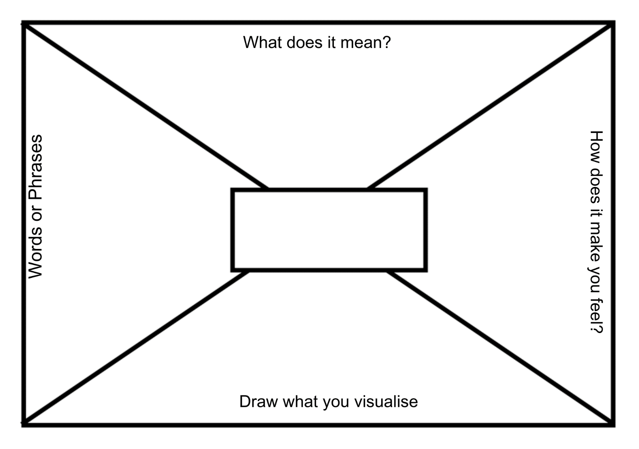

Resource 5 – personification
Object | Description of the object | Personification
Curtain | The wind is making the curtain move.
Piano | Piano playing an angry song.
Music Notes | Music notes falling to the ground.
Streetlights | Streetlight shining on the maestro.
Tree | Tree is against the house.

Resource 6 – ice cream advertisement

Resource 7 – summer poem
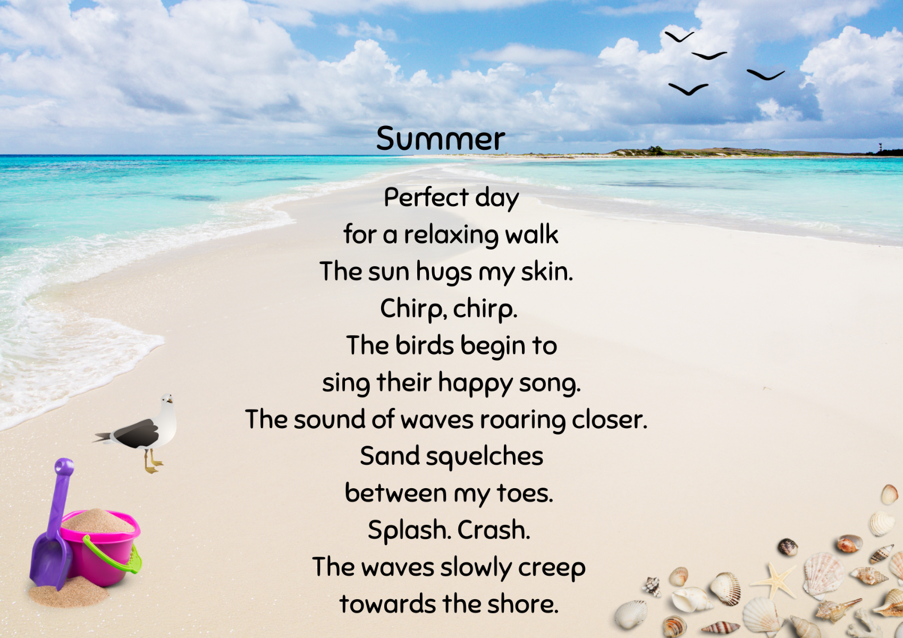

Resource 8 – poem background

Resource 9 – writing process
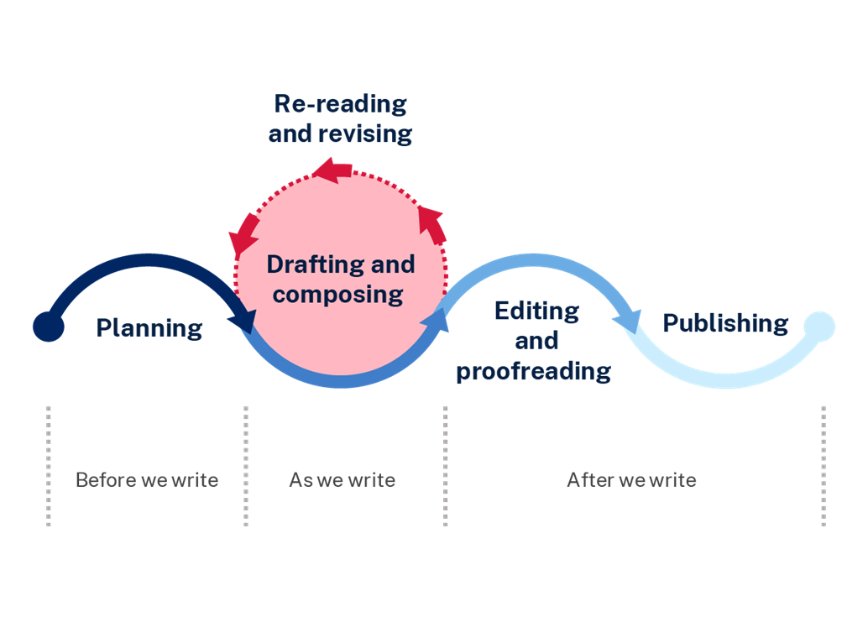

Resource 10 – Piano Fingers scaffold
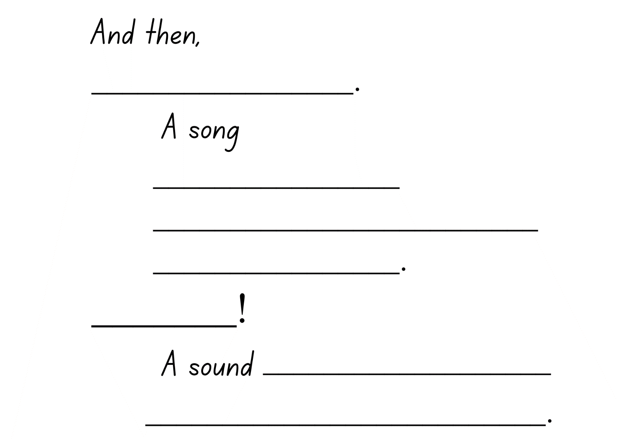

Resource 11 – five senses
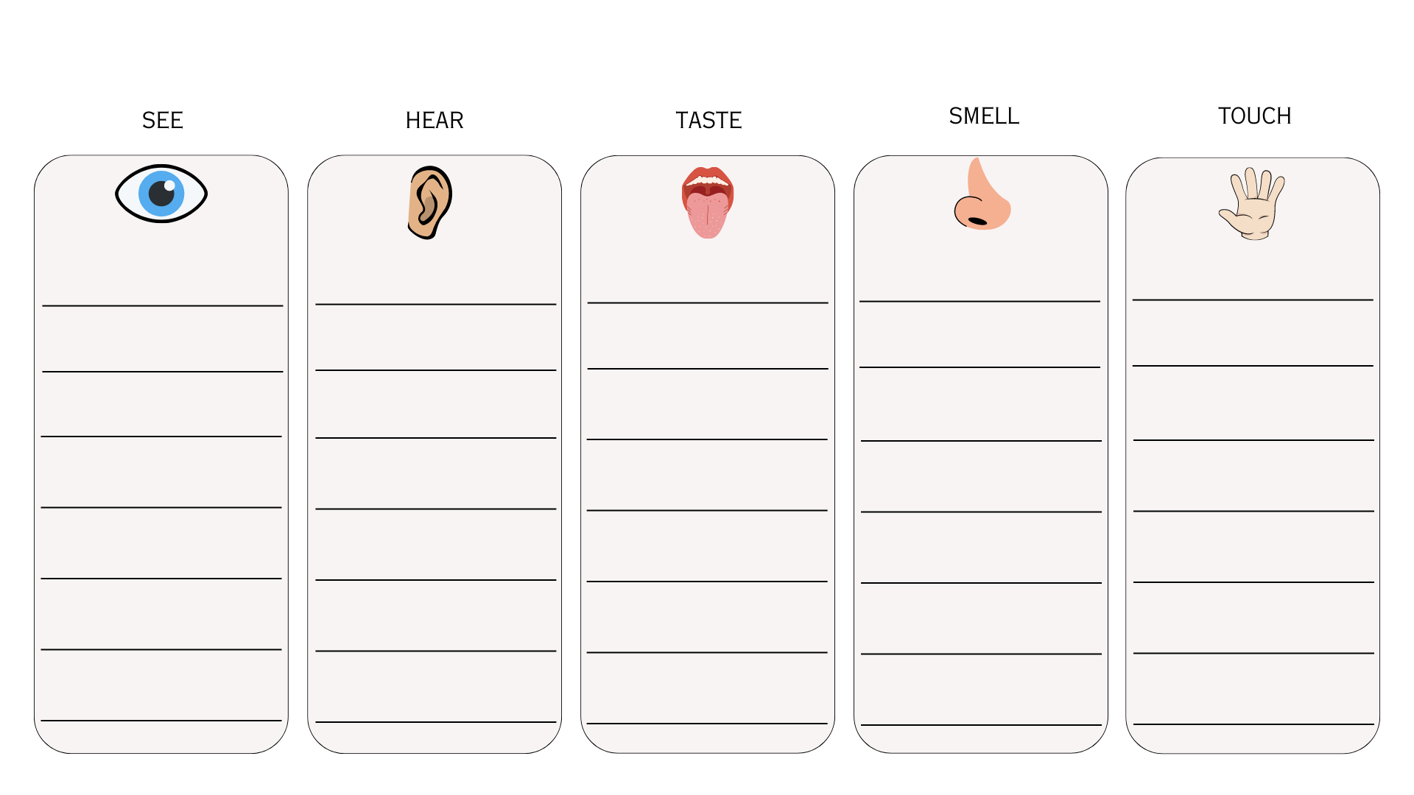

Resource 12 – simile match
The storm raged on like | a pack of wolves.
The car roared down the highway like | a summer’s day.
Her smile was as bright as | an angry giant.
The wind howled in the trees like | a thread.
His patience was as thin as | a moonless cave.
The night was as dark as | a hungry lion.
The detective’s instincts were as sharp as | a burning ember.
The sun set in the sky like | a mathematician’s mind.

Resource 13 – character analysis
Character’s name: ___________________________________
Personality | Context
Appearance | Relationship to music

Resource 14 – journal planning template
Guiding questions | Responses
- What was taken away?
- What happened?
- How was it taken away?
- Where were you?
- What were you doing?
- Was anyone with you?
- Why do think this happened?
- How did it make you feel?
- What do are you going to do next? Are you going to try to get it back? If so, how?
- Are you going to replace it with something else? If so, what?
- Explain your thinking and reasoning.

References
This resource contains NSW Curriculum and syllabus content. The NSW Curriculum is developed by the NSW Education Standards Authority. This content is prepared by NESA for and on behalf of the Crown in right of the State of New South Wales. The material is protected by Crown copyright.
Please refer to the NESA Copyright Disclaimer for more information. https://educationstandards.nsw.edu.au/wps/portal/nesa/mini-footer/copyright
NESA holds the only official and up-to-date versions of the NSW Curriculum and syllabus documents. Please visit the NSW Education Standards Authority (NESA) website https://educationstandards.nsw.edu.au/ and the NSW Curriculum website https://curriculum.nsw.edu.au/home.
English K–10 Syllabus © NSW Education Standards Authority (NESA) for and on behalf of the Crown in right of the State of New South Wales, 2022.
National Literacy Learning Progression © Australian Curriculum, Assessment and Reporting Authority (ACARA) 2010 to present, unless otherwise indicated. This material was downloaded from the Australian Curriculum website (National Literacy Learning Progression) (accessed 4 September 2023) and was not modified.
NESA (NSW Education Standards Authority) (2023) ‘Glossary’, Resources, NESA website, accessed 4 September 2023.
ABC Classic (24 December 2022) ‘Tchaikovsky's Nutcracker for wind duet’ [video], ABC Classics, YouTube, accessed 10 August 2023.
ABC Classic (25 August 2017) ‘Beethoven Emperor Concerto - Gerard Willems’ [video], ABC Classic, YouTube, accessed 10 August 2023.
Ayres E (2018) Sonam and the Silence (Taher R, illus), Allen & Unwin Australia, Australia.
Fusek-Peters A (2023) Last Night, I saw the City Breathing, Children’s Poetry Archive website, accessed 28 August 2023.
Lee D (2023) The Coming of Teddy Bears, Children’s Poetry Archive website, accessed 28 August 2023.
Magerl C (2022) Piano Fingers, Walker Books Australia.
Penguin Random House (n.d.) Caroline Magerl, Penguin Books Australia website, accessed 20 July 2023.
Rosen M (2023) Air, Children’s Poetry Archive website, accessed 28 August 2023.

© State of New South Wales (Department of Education), 2023
The copyright material published in this resource is subject to the Copyright Act 1968 (Cth) and is owned by the NSW Department of Education or, where indicated, by a party other than the NSW Department of Education (third-party material).
Copyright material available in this resource and owned by the NSW Department of Education is licensed under a Creative Commons Attribution 4.0 International (CC BY 4.0) license.
This license allows you to share and adapt the material for any purpose, even commercially.
Attribution should be given to © State of New South Wales (Department of Education), 2023.
Material in this resource not available under a Creative Commons license:
- the NSW Department of Education logo, other logos and trademark-protected material
- material owned by a third party that has been reproduced with permission. You will need to obtain permission from the third party to reuse its material.
Links to third-party material and websites
Please note that the provided (reading/viewing material/list/links/texts) are a suggestion only and implies no endorsement, by the New South Wales Department of Education, of any author, publisher, or book title. School principals and teachers are best placed to assess the suitability of resources that would complement the curriculum and reflect the needs and interests of their students.
If you use the links provided in this document to access a third-party's website, you acknowledge that the terms of use, including licence terms set out on the third-party's website apply to the use which may be made of the materials on that third-party website or where permitted by the Copyright Act 1968 (Cth). The department accepts no responsibility for content on third-party websites.

