English 3–6 Multi-age – Year B Unit 2

Contents
Unit overview and instructions for use 8
Teacher notes 10
Outcomes and content 12
Resources 23
Week 1 25
Component A teaching and learning 25
Teaching guide 25
Planning framework 42
Component B teaching and learning 42
Learning intentions and success criteria 43
Lesson 1 – building background knowledge 44
Whole 44
Lesson 2 – understanding text authority 46
Whole 47
Lesson 3 – introducing Yahoo Creek 49
Whole 49
Part 51
Whole 52
Lesson 4 – argument and perspective 53
Whole 53
Part 55
Whole 57
Week 2 58
Component A teaching and learning 58
Teaching guide 58
Planning framework 79
Component B teaching and learning 79
Learning intentions and success criteria 79
Lesson 5 – exploring genre 80
Whole 80
Lesson 6 – exploring multimodal elements 83
Whole 84
Lesson 7 – author’s intent and authority 87
Whole 87
Part 89
Whole 92
Lesson 8 – using modality for impact 92
Whole 93
Part 96
Whole 97
Week 3 99
Component A teaching and learning 99
Teaching guide 99
Planning framework 116
Component B teaching and learning 116
Learning intentions and success criteria 117
Lesson 9 – language features to enhance authority 118
Whole 118
Part 119
Part 120
Whole 121
Lesson 10 – using and expanding sentences for purpose and effect 121
Whole 121
Part 123
Part 125
Whole 126
Lesson 11 – rhetorical devices to persuade 126
Whole 126
Part 127
Part 128
Whole 130
Lesson 12 – using persuasive devices 130
Whole 130
Part 131
Part 133
Whole 134
Week 4 137
Component A teaching and learning 137
Teaching guide 137
Planning framework 155
Component B teaching and learning 156
Learning intentions and success criteria 156
Lesson 13 – guided planning for persuasive writing 157
Whole 157
Lesson 14 – guided writing using persuasive devices 160
Whole 160
Lesson 15 – conducting research to plan for writing 162
Whole 162
Lesson 16 – planning and drafting the introduction of a persuasive text 164
Whole 164
Week 5 166
Component A teaching and learning 166
Teaching guide 166
Planning framework 180
Component B teaching and learning 180
Learning intentions and success criteria 180
Lesson 17 – drafting and composing a persuasive text 181
Whole 181
Lesson 18 – using feedback to edit and improve writing 182
Whole 183
Lesson 19 – multimodal features to enhance meaning 185
Whole 185
Lesson 20 – publishing and presenting 186
Whole 186
Resource 1 – authority evaluation checklist 189
Resource 2 – diamond ranking organiser 190
Resource 3 – argument and perspective 191
Resource 4 – fluency and close reading passage analysis (Week 2) 192
Resource 5 – fluency and close reading passage analysis (Week 3) 195
Resource 6 – question matrix 197
Resource 7 – matching rhetorical devices 198
Resource 8 – rhetorical devices table 199
Resource 9 – Goulburn Evening Penny Post article 200
Resource 10 – exemplar text 201
Resource 11 – research scaffold 202
References 204

Unit overview and instructions for use
In this 5-week unit, students will develop their understanding of ‘argument and authority’ and ‘genre’ through deep text analysis of Yahoo Creek by Tohby Riddle. Students will learn that an author’s perspective is highlighted by the points of view that they present within a text, while also considering the credibility of sources of information. They will draft, revise, edit and publish a multimodal persuasive text that includes persuasive and rhetorical devices, arguing the existence or non-existence of an elusive creature that people are reported to have encountered.
Outcomes and content in this unit are organised into Component A and Component B. The components are connected, with learning in Component A complementing learning in Component B.
Note: the duration of this unit can be adapted to suit individual school contexts. For example, learning could occur across 5 days rather than 4.
The table below highlights the focus areas and preparation required for Component A and Component B.
Teaching and learning | Component A | Component B
Suggested duration | 60 minutes × 4 days/week or equivalent | 60 minutes × 4 days/week or equivalent
Explicit teaching focus areas | Component A addresses content from the focus areas:  - Vocabulary  - Reading fluency (Stage 2)  - Reading comprehension  - Creating written texts  - Spelling  - Handwriting and digital transcription  It centres on the development of foundational skills and knowledge through regular, systematic and repeated practice. | Component B addresses content from the focus areas:  - Oral language and communication  - Vocabulary  - Reading comprehension  - Creating written texts  - Understanding and responding to literature  It centres on the conceptual understandings of English and exemplifies the importance of learning about and enjoying literature through the study of quality texts.
Preparing for teaching and learning | - Specific teaching and learning activities need to be developed by the teacher. When planning for these activities, please refer to the Component A outcomes and content, teaching guides and planning frameworks.  - Plan and document how you will sequence teaching and learning in whole-class and targeted-groups across the 5-week cycle as required. This should be based on student needs identified through ongoing assessment data. | - Familiarise yourself with the mentor and supporting texts and textual concepts, and the teaching and learning sequence.  - Determine how you will support students in whole-class and targeted-groups across the 5-week cycle as required. This should be based on student needs identified through ongoing assessment data.
English K–10 Syllabus © NSW Education Standards Authority (NESA) for and on behalf of the Crown in right of the State of New South Wales, 2022.

Teacher notes
- ‘Argument and authority’ is the mentor concept of this unit, explored using the text Yahoo Creek by Tohby Riddle. ‘Argument’ refers to a stated position about an idea. It is the way in which various dimensions of a text (such as theme, perspective, and style) represent a particular position on an issue. ‘Authority’ refers to authority of a text (how trustworthy, authentic or valid an audience may find the representation of ideas, experiences, perspectives and arguments in a text) and authority over a text (the varying degrees to which the meaning of a text is controlled or constructed by its creator(s) and by its audience) (NESA 2023).
- Understanding of ‘argument and authority’ can be supported through watching the department’s videos: Understanding argument (3:17) and Understanding authority (2:39).
- While ‘argument and authority’ is the mentor concept for the conceptual component of this unit, the supporting concept of ‘genre’ is explored within the relevant section(s) of the mentor and/or supporting texts.
- For information on Tier 2 words, Tier 3 words, multimodal texts, modality, rhetorical questions, declarative, exclamatory, interrogative and imperative sentences, adverbial phrases, quoted and reported speech, refer to the NESA Glossary.
- In addition to the resources listed, students will require access to short passages of the mentor and/or supporting texts. Teachers can copy extracts from texts in reliance on the Statutory Text and Artistic Works Licence. Teachers need to attribute the extracts and include the following notice: ‘This material has been copied [and communicated to you] in accordance with the statutory licence in section 113P of the Copyright Act. Any further reproduction or communication of this material by you may be the subject of copyright protection under the Act. Do not remove this notice’.
- This unit may enhance student learning towards the achievement of Human Society and its Environment (HSIE) outcomes.
- Reflect on student learning and engagement in activities and record differentiation and adjustments within the unit to inform future teaching and learning. One way of doing this could be to add comments to the digital file.
- In NSW classrooms there is a diverse range of students including Aboriginal and Torres Strait Islander students, students learning English as an additional language or dialect, high potential and gifted students and students with disability. Some students may identify with more than one of these groups, or possibly all of them. Refer to Curriculum planning for every student – advice for further information.
- Content points are linked to the National Literacy Learning Progression (version 3).
Levels and indicators sourced from National Literacy Learning Progression © Australian Curriculum, Assessment and Reporting Authority (ACARA), (accessed 29 August 2023) and was not modified. See references for more information.

Outcomes and content
The tables below outlines the outcomes and content for this unit. The letters 'A' and 'B' in the header refer to Components A and B. The numbers 1 to 5 refer to weeks. The use of 'x' in these columns indicates where the content points are intended to be addressed and in which week.
Stage 2 focus area and outcome, content points and National Literacy Learning Progression | A | B | 1 | 2 | 3 | 4 | 5
Oral language and communication
EN2-OLC-01 communicates with familiar audiences for social and learning purposes, by interacting, understanding and presenting
- Identify contexts in which social conventions can vary and influence interactions (InT4, InT5) |  | x | x | x | x | x | x
- Understand that rhetorical questions can be used for intentional effect |  | x |  |  | x |  | x
- Identify the evidence a speaker provides to support a particular point of view |  | x |  |  |  | x | x
- State a reasoned argument in a presentation about learning area content, to a familiar audience (SpK5, SpK6) |  | x |  |  |  | x | x
- Include multimodal features in planned and delivered presentations, to expand meaning and engage an audience (SpK5) |  | x |  |  |  |  | x
Vocabulary
EN2-VOCAB-01 builds knowledge and use of Tier 1, Tier 2 and Tier 3 vocabulary through interacting, wide reading and writing, and by defining and analysing words
- Describe how modal words indicate degrees of probability, occurrence, obligation and inclination (UnT7) | x | x | x | x | x | x | x
- Understand and use language associated with digital texts |  | x |  | x |  | x | x
Reading fluency
EN2-REFLU-01 sustains independent reading with accuracy, automaticity, rate and prosody suited to purpose, audience and meaning
- Demonstrate use of navigation pathways to support fluency when engaging with print, visual and multimodal texts (UnT7) | x |  | x | x | x | x | x
- Recognise that there are different purposes and audiences for reading and adjust reading rate to suit a text’s purpose (FlY5) | x |  | x | x | x | x | x
Reading comprehension
EN2-RECOM-01 reads and comprehends texts for wide purposes using knowledge of text structures and language, and by monitoring comprehension
- Locate, select and retrieve relevant information from a print or digital text and consider accuracy of information presented |  | x | x | x | x | x
- Identify different structures and features of persuasive, informative and imaginative texts | x | x | x | x | x
- Identify the difference between quoted speech and reported speech | x | x |  | x | x
- Understand that literal information can be sourced directly from a text and that inferences can be made by using multiple sources of information | x | x | x | x |  | x | x
- Make gist statements and record them to monitor understanding (UnT6) | x | x | x | x | x | x | x
Creating written texts
EN2-CWT-03 plans, creates and revises written texts for persuasive purposes, using text features, sentence-level grammar, punctuation and word-level language for a target audience
- Sequence argument points in paragraphs that begin with a topic sentence and support the development of ideas (CrT8) |  | x |  |  |  | x | x
- Experiment with modality to modulate an argument for persuasive effect (CrT8) |  | x |  | x | x | x | x
- Select and use multimodal features to add meaning |  | x |  | x |  |  | x
- Use adverbial phrases or clauses to add information to the verb or verb group of the main or other clauses, to provide reasons for or circumstances (GrA5) | x | x | x | x | x | x | x
- Use declarative sentences to provide facts or state a viewpoint | x | x | x |  | x | x | x
- Use exclamatory sentences to emphasise a point or express a strong emotion | x | x | x | x | x | x | x
- Use interrogative sentences to ask a direct question, or for rhetorical effect to engage the reader with a viewpoint | x | x | x | x | x | x | x
- Understand and use quoted and reported text or speech in own writing | x | x |  | x | x | x | x
- Use topic-specific Tier 2 and Tier 3 vocabulary to demonstrate authority (CrT8) | x | x | x | x |  | x | x
Spelling
EN2-SPELL-01 selects, applies and describes appropriate phonological, orthographic and morphological generalisations and strategies when spelling in a range of contexts
- Explain how to segment multisyllabic words into syllables and phonemes, and apply this knowledge when spelling | x |  | x | x | x | x | x
- Identify differences in vowel phonemes (short, long, diphthong and schwa vowels) (SpG9) | x |  | x | x | x | x | x
- Understand that some graphemes are dependent on their position in a word in English and apply this knowledge when spelling | x |  | x | x | x | x | x
- Proofread, identify and correct misspellings when creating written texts (SpG9) | x |  |  |  | x | x | x
- Identify inflected suffixes, explaining when and how to treat base words when they are affixed, and apply this knowledge when spelling (SpG9) | x |  | x | x | x | x | x
Handwriting and digital transcription
EN2-HANDW-01 forms legible joined letters to develop handwriting fluency
EN2-HANDW-02 uses digital technologies to create texts
- Understand that legible handwriting is consistent in size and spacing and can support learning (HwK6) | x |  |  | x | x | x
- Join letters when writing familiar words (HwK6) | x |  |  | x |  | x
- Position a chosen device in a way that facilitates efficient and sustained text creation | x |  | x |  | x |  | x
- Use knowledge of the keyboard layout and functions to type texts (HwK7) | x |  |  |  | x |  | x
- Monitor goals that build on typing accuracy and rate | x |  | x |  | x |  | x
Understanding and responding to literature
EN2-UARL-01 identifies and describes how ideas are represented in literature and strategically uses similar representations when creating texts
- Identify different text genres when a text is characterised by more than a single genre |  | x |  | x | x | x
- Understand that to control impact and effect authors make intentional choices about language, form and structure (UnT7) |  | x | x | x | x | x | x
English K–10 Syllabus © NSW Education Standards Authority (NESA) for and on behalf of the Crown in right of the State of New South Wales, 2022.
Stage 3 focus area and outcome, content points and National Literacy Learning Progression | A | B | 1 | 2 | 3 | 4 | 5
Oral language and communication
EN3-OLC-01 communicates to wide audiences with social and cultural awareness, by interacting and presenting, and by analysing and evaluating for understanding
- Identify varying social conventions that influence interactions across wide audiences (LiS6) |  | x | x | x | x | x | x
- Apply active listening strategies by retelling or repeating what another person has expressed and by building on what has been said (InT5, InT6) |  | x | x | x | x | x | x
- Evaluate the effectiveness of rhetorical questions used for intentional effect |  | x |  |  | x |  | x
- Present multimodal arguments that include research and references, topic-specific vocabulary and the selection of persuasive techniques appropriate to audience (SpK6) |  | x |  |  |  | x | x
Vocabulary
EN3-VOCAB-01 extends Tier 2 and Tier 3 vocabulary through interacting, wide reading and writing, morphological analysis and generating precise definitions for specific contexts
- Identify and use words that convey subjective, emotive and persuasive meanings in texts | x | x | x | x | x | x | x
- Use metalanguage when discussing language features encountered in texts (UnT9, CrT9) | x | x | x | x | x | x | x
- Evaluate the effectiveness of modal words used in texts to intensify or soften emotional responses (CrT9) | x | x | x | x | x | x | x
Reading comprehension
EN3-RECOM-01 fluently reads and comprehends texts for wide purposes, analysing text structures and language, and by monitoring comprehension
- Efficiently follow signposting features to navigate print and digital texts | x | x | x | x | x | x | x
- Select texts from print or digital sources to gather and organise research on a topic |  | x |  | x |  | x
- Use criteria to determine the accuracy and reliability of sourced information |  | x | x | x |  | x
- Explain how modality can have subtle impacts on the meanings of words and contribute to deeper understanding when reading (UnT9) |  | x |  | x
- Question the assertions made by authors when engaging with print and digital texts | x | x |  | x | x | x
- Check the accuracy of own recorded gist statements made during reading, before summarising information to determine a text’s main themes, ideas or concepts | x | x | x | x |  | x | x
Creating written texts
EN3-CWT-01 plans, creates and revises written texts for multiple purposes and audiences through selection of text features, sentence-level grammar, punctuation and word-level language
- Choose text formats with appropriate text structures, features and language to persuade a target audience (CrT9) |  | x |  |  |  | x | x
- Use rhetorical devices targeted to the audience (CrT9) |  | x |  |  | x | x | x
- Use modality to qualify or strengthen arguments |  | x |  | x | x | x | x
- Choose multimodal features suited to a target audience and purpose, to reinforce and extend ideas |  | x |  | x |  | x | x
- Experiment with the placement of adverbial clauses, to modify the meaning or to add detail to a verb or verb group (GrA6) | x | x | x | x | x | x | x
- Make choices about the use of declarative, exclamatory, interrogative and imperative sentences to suit text purpose, and for meaning and effect (CrT8) | x | x | x |  | x | x | x
- Use topic-specific Tier 2 and Tier 3 vocabulary intentionally to add credibility and enhance authority (CrT9) | x | x | x | x | x | x | x
- Assess the reliability and authority of sources, including digital sources, when researching and acknowledging texts |  | x | x | x |  | x
Spelling
EN3-SPELL-01 automatically applies taught phonological, orthographic and morphological generalisations and strategies when spelling in a range of contexts, and justifies spelling strategies used to spell unfamiliar words
- Segment unfamiliar multisyllabic words into syllables and phonemes as a strategy when spelling | x |  | x | x | x | x | x
- Recognise that the same grapheme can represent different phonemes when spelling (SpG10) | x |  | x | x | x | x | x
- Proofread written texts to correct misspellings, making use of spelling reference tools where required | x |  |  |  | x | x | x
- Explain and use spelling conventions to add derivational suffixes such as -ion, -ian, -ence, -ous to base words or roots (SpG10) | x |  | x | x | x | x | x
Handwriting and digital transcription
EN3-HANDW-01 sustains a legible, fluent and automatic handwriting style
EN3-HANDW-02 selects digital technologies to suit audience and purpose to create texts
- Sustain writing with a legible, fluent and personal handwriting style across a text (HwK8) | x |  |  | x |  | x
- Navigate the keyboard with efficiency and accuracy when typing words, numerals, punctuation and other symbols (HwK8) | x |  | x |  | x |  | x
- Understand that the position of the device in relation to the user can affect posture and glare | x |  | x |  | x
Understanding and responding to literature
EN3-UARL-02 analyses representations of ideas in literature through genre and theme that reflect perspective and context, argument and authority, and adapts these representations when creating texts
- Explain how genre can be recognised by established codes and conventions that govern content and construction of literature, and apply this knowledge when creating texts |  | x |  | x | x | x
- Recognise how an argument is influenced by perspective and create texts that adopt a perspective beyond personal experience |  | x | x | x | x | x | x
- Compare the reliability and validity of texts to make judgements about their authority |  | x | x | x | x | x | x
English K–10 Syllabus © NSW Education Standards Authority (NESA) for and on behalf of the Crown in right of the State of New South Wales, 2022.

Resources
The resources in the table below are referred to in this unit. Letters 'A' and 'B' in the header refer to Component A and B respectively, and the numbers 1 to 5 indicate weeks. The use of 'x' in these columns indicate whether the resources are required in Component A, B or both, and in which week.
Resource | A | B | 1 | 2 | 3 | 4 | 5
Riddle T (2019) Yahoo Creek: An Australian Mystery, Allen & Unwin, Sydney, ISBN13: 9781760631451 | x | x | x | x | x | x | x
Images of pioneering Australia (for example, gold rush, early explorers) |  | x | x
Individual whiteboards |  | x | x
Resource 1 – authority evaluation checklist |  | x | x
Resource 2 – diamond ranking organiser |  | x | x
Resource 3 – argument and perspective |  | x | x
Resource 4 – fluency and close reading passage analysis (Week 2) | x |  |  | x
Resource 5 – fluency and close reading passage analysis (Week 3) | x |  |  |  | x
Resource 6 – question matrix |  | x |  |  | x
Resource 7 – matching rhetorical devices |  | x |  |  | x
Resource 8 – rhetorical devices table |  | x |  |  | x
Resource 9 – Goulburn Evening Penny Post article |  | x |  |  | x
Resource 10 – exemplar text |  | x |  |  |  | x
Resource 11 – research scaffold |  | x |  |  |  | x | x
Devices or technology to conduct research and publish texts |  | x |  |  |  | x | x

Week 1

Component A teaching and learning
Component A focuses on the development of foundational skills and knowledge through regular, systematic and repeated practice. The mentor and supporting texts used in Component B of this unit can support the effective implementation of Component A teaching and learning.

Teaching guide
Guidance for explicit teaching, teaching notes, resources and examples for the related outcomes and content points have been provided in the table below.
Focus areas and teaching notes | Resources and examples
Reading fluency  Reading automaticity and rate (Stage 2)  - Demonstrate use of navigation pathways to support fluency when engaging with print, visual and multimodal texts  - Navigation pathways refer to the paths followed while moving through the content of a text. They involve navigating the text to support fluency in a way that does not disrupt the overall comprehension and allows the reader to engage with print, visual and multimodal texts. | Reading fluency  Reading automaticity and rate (Stage 2)  - Fluency and close reading passage: Author Note from ‘Australia’s Great Dividing Range...’ to ‘... from my Elder Uncle Paul Gordon.’ (241 words)  Note: the passage from the text will need to be a teacher-created resource.  - The identified navigation pathway within the Author Note is the use of a title and clear paragraphs. The reader follows a typical top to bottom, left to right navigation path.
Monitoring reading fluency (Stage 2)  - Recognise that there are different purposes and audiences for reading and adjust reading rate to suit a text’s purpose  - Reading rate for literacy texts may depend on the use of expression, pausing, emphasis and the author’s use of phrasing.  - Reading rate for informative texts may depend on the vocabulary used. For example, Tier 3 technical and subject specific vocabulary may require the reader to slow down. | Monitoring reading fluency (Stage 2)  - The purpose of reading is to gain an understanding about the creation of the book including information about the Great Dividing Range, the relevance of place names and the significance of Ngiyampaa Elder's words. It also acknowledges contributors and resources and pays respect to the traditional custodians of the land. Reading rate may need to be adjusted:  - for Tier 2 language that may require the reader to slow down. For example, inaccessible, puzzling, mountainous range, mysterious, permission, particular  - for Aboriginal words that may require the reader to slow down. For example, Ngiyampaa, Dharug  - for the names of locations. For example, Great Dividing Range, Yahoo Island, Yahoo Point, Little Yahoo Mountain.
Reading comprehension  Monitoring comprehension (Stage 2)  - Make gist statements and record them to monitor understanding  - Gist statements are succinct notes that summarise what has been read. They may be recorded in print or digitally. | Reading comprehension  Monitoring comprehension (Stage 2)  - Suggested examples of gist statements about the passage  - Mysterious reports about yahoos or hairy men still emerge from places along the range.  - The words of Ngiyampaa Elder Peter Williams are essential for understanding the story.  - The Great Dividing Range is a significant location for events mentioned in early newspaper reports.
Comprehending text structures and features (Stage 2)  - Identify different structures and features of persuasive, informative and imaginative texts  - Persuasive texts are designed to convince a reader of a particular opinion or way of thinking on an issue. A persuasive text may express an opinion while discussing, analysing and/or evaluating an issue.  - Informative text’s primary purpose is to provide information through explanation, description, argument, analysis, ordering and presentation of evidence and procedures.  - Imaginative texts represent ideas, feelings and mental images in words or visual images. Imaginative texts entertain or provoke thought through their creative use of literary elements and make connections between ideas and experiences. | Comprehending text structures and features (Stage 2)  - Suggested examples of features of informative and imaginative texts presented in the passage include:  - Informative: the passage provides historical information about the Great Dividing Range and its significance in early newspaper reports.  - Imaginative: the use of descriptive language to describe the creature's appearance and behaviour invokes imaginative imagery.
Reading comprehension  Reading fluently (Stage 3)  - Efficiently follow signposting features to navigate print and digital texts  - Signposting features refer to elements within a text that guide the reader through structure and content of a text. These features serve as ‘signposts’ that indicate the direction the text is taking and help the reader follow along. | Reading comprehension  Reading fluently (Stage 3)  - Suggested examples of signposting features in the passage:  - Signposting features such as headings, paragraphs and topic sentences enable readers to quickly navigate and comprehend the text's structure and content.
Monitoring comprehension (Stage 3)  - Check the accuracy of own recorded gist statements made during reading, before summarising information to determine a text’s main themes, ideas or concepts  - To check accuracy, students may review the original source, compare with supporting details, cross-reference with a peer. | Monitoring comprehension (Stage 3)  - Students need to check the accuracy of their recorded gist statements and ensure the reliability of their summaries when determining a passage’s main themes, ideas, or concepts. This may include revisiting the passage, comparing gist statements, highlighting key information.
Vocabulary  Learning and using words (Stage 2)  - Describe how modal words indicate degrees of probability, occurrence, obligation and inclination  - Modal words are a specific group of auxiliary verbs that modify the main verb in a sentence. Modal verbs express various shades of meaning including  - Probability: certainly, surely, definitely  - Occurrence: always, never, consistently  - Obligation: ought to, should, may  - Inclination: want, wish, would like to (NESA 2023).  - They help convey the writer’s attitude, certainty or necessity regarding the action or state being described. | Vocabulary  Learning and using words (Stage 2)  - Suggested example of modal vocabulary from the Author Note  - ‘It's possible that early place names...’ (probability)  - ‘Perhaps these names hint at puzzling incidents...’ (probability)  - ‘Certainly, mysterious reports to do with yahoos...’ (probability)  - ‘...have been disturbed from their slumbers by noises, resembling at times a person choking...’ (occurrence)  - ‘Additional acknowledgement must go to Trove…' (obligation)
Vocabulary  Learning and using words (Stage 3)  - Identify and use words that convey subjective, emotive and persuasive meanings in texts  - Subjective language is used to convey personal opinions or beliefs. It reflects the perspective of the individual to the reader or audience.  - Emotive language is specifically selected to evoke strong emotions, reactions or feelings to the reader or audience.  - Persuasive language is used to convince the reader to agree with a particular point of view.  - Use metalanguage when discussing language features encountered in texts  - Metalanguage includes the technical terms used to describe and discuss how language and texts function (NESA 2023). | Vocabulary  Learning and using words (Stage 3)  - Suggested examples of words from the passage that convey subjective, emotive and persuasive meaning  - Subjective: ‘Perhaps these names hint at puzzling incidents...’, ‘Certainly, mysterious reports to do with yahoos...’.  - Emotive: ‘Deeply thankful to Uncle Pete for permission...’.  - Persuasive: ‘They were so terrified at the apparition and the hideous noise it made that they left their work...’  - Suggested examples of metalanguage that could be used to discuss language features from the Author Note:  - Metaphor: ‘...my publisher, for coming aboard this unusual vessel and offering vital navigation in unchartered water...’  - Proper noun: ‘Ngiyampaa Elder Peter Williams...’, ‘Australia Council for the Arts...’  - Adjectives: ‘...rugged and mountainous...’  - Quoted speech: Uncle Pete says: 'This is what I was taught...’
Defining and analysing words (Stage 3)  - Evaluate the effectiveness of modal words used in texts to intensify or soften emotional responses  - Modal words are verbs or auxiliary verbs that modify or indicate the mood or attitude of the verb in a sentence. | Defining and analysing words (Stage 3)  - As above, see Stage 2 examples.
Spelling  Phonological component (Stage 2)  - Explain how to segment multisyllabic words into syllables and phonemes, and apply this knowledge when spelling  - Revise segmenting multisyllabic words into syllables and phonemes. This is a phonological skill that should be practised regularly.  - Identify differences in vowel phonemes (short, long, diphthong and schwa vowels)  - Identify the long vowel phoneme: /oo/ as in soon within focus words. [u_e, ue, oo, ew, ough, oe]  - This phoneme is often referred to as the long /oo/. It is a diphthong.  - A schwa is a vowel sound in an unstressed/unaccented syllable, where a vowel does not make its long or short vowel sound. It usually sounds like the short /u/ sound but is shorter, softer and weaker. The suffixes -er and -est are often pronounced as a schwa. | Spelling  Note: each week of learning contains a phonological, orthographic and morphological focus. These focuses are intended to be taught simultaneously through linguistic inquiry. Suggested words are selected to show how phonological, orthographic and morphological content can be integrated. In addition to words selected from the mentor and/or supporting text, additional sample words for inquiry are provided.  - Suggested words from the passage  - yahoo, through.  - Sample words for inquiry  - costume, flute, glue, continue, cartoon, teaspoon, screw, grew, shoe, Smooth-smoother-smoothest, new-newer-newest, blue-bluer-bluest, cruel-crueler-cruelest, rude-ruder-rudest.
Orthographic component (Stage 2)  - Understand that some graphemes are dependent on their position in a word in English and apply this knowledge when spelling  - Common representations for the long vowel phoneme /oo/ include [u_e, ue and ew]. Alternative spellings include [oe] and the quadgraph [ough].  - [u_e, ue, ew, ough, oe] are often used at the end of base words. [oo] is often used in the middle of base words. | Orthographic component (Stage 2)  - As above
Morphological component (Stage 2)  - Identify inflected suffixes, explaining when and how to treat base words when they are affixed, and apply this knowledge when spelling  - An inflected suffix is a bound morpheme added to the end of a base word to assign a number to a word, to indicate possession or tense, or to provide a comparison (-s, -es, -ing, -ed, -er, est).  - The inflected suffixes -er and -est usually attach to adjectives that have one syllable (fine, finer). Adjectives with more than one syllable often use the words ‘more’ and ‘most’ instead of using the inflected suffixes (polite, most polite).  - When an adjective has more than one syllable and ends in consonant -y, replace the y with i before adding the suffix, happy-happier-happiest.  - For adjectives that are single syllable CVC words, the final consonant is usually doubled before adding -er or -est big, bigger). | Morphological component (Stage 2)  - As above
Spelling  Phonological component (Stage 3)  - Segment unfamiliar multisyllabic words into syllables and phonemes as a strategy when spelling  - Revise segmenting multisyllabic words into syllables and phonemes. This is a phonological skill that should be practised regularly. | Spelling  Phonological component (Stage 3)  - Suggested words from the passage: location, kilometres, possible, nowhere.  - Sample words for inquiry: hospital, monster, document, solid, colossal, oxygen, possible, onion, Trove, process, also, comfortable, admit-admission, permit-permission, commit-commission, emit-emission, omit-omission, submit-submission, transmit-transmission.
Orthographic component (Stage 3)  - Recognise that the same grapheme can represent different phonemes  - The single-letter grapheme [o] can represent /o/, /oa/, /u/.  - [o] can be used to represent /o/ as in ‘on’, /oa/ as in ‘own’ and /u/ as in ‘come’. Consider the grapheme’s position within base words. | Orthographic component (Stage 3)  - As above
Morphological component (Stage 3)  - Explain and use spelling conventions to add derivational suffixes such as -ssion to base words or roots  - Introduce derivational suffix: -ssion  - ‘-ssion’ meaning ‘act’ or ‘process’  - attaches to verbs to form nouns  - Explore that the suffix ‘-ssion’ follows when a verb ends in ‘mit’: permit-permission. | Morphological component (Stage 3)  - As above
Creating written texts  Sentence-level grammar (Stage 2)  - Use declarative sentences to provide facts or state a viewpoint  - A statement presented as a complete sentence to provide fact, evidence or detail (NESA 2023).  - Use exclamatory sentences to emphasise a point or express a strong emotion  - A statement expressing a strong emotion, formed as a complete sentence, and often ending with an exclamation mark (NESA 2023).  - Use interrogative sentences to ask a direct question, or for rhetorical effect to engage the reader with a viewpoint  - A sentence that asks a direct or indirect question (NESA 2023).  - Use adverbial phrases or clauses to add information to the verb or verb group of the main or other clauses, to provide reasons for or circumstances  - Adverbial phrases add meaning to, or modify, the action of verbs, adjectives and other adverbs.  - Adverbial clauses are a type of subordinate (or dependent) clause that add meaning to a verb, adjective or adverb.  - Review different types of adverbial phrases that can provide information about circumstance or reason  - when (adverbial phrase/clause of circumstance – time)  - where (adverbial phrase of circumstance – place)  - how (adverbial phrase of circumstance – manner)  - why (adverbial phrase of circumstance – reason). | Creating written texts  Sentence-level grammar (Stage 2)  - Suggested example of a declarative sentence innovated from the passage  - The Yahoo lives in the Australian bushland.  - Suggested example of an exclamatory sentence innovated from the passage  - What an incredible journey!  - Suggested example of an interrogative sentence innovated from the passage and used for rhetorical effect  - Why do the names ‘Yahoo Gully’, ‘Yahoo Hill’, and ‘Yahoo Creek’ echo with mystery and hint at untold tales along the Great Dividing Range?  - Suggested examples of adverbial phrases from the passage  - ‘...still come from places, along the Great Dividing Range.’ (where)  - ‘The process drew on many walks and wonderings, over many seasons, through the surrounding forests, scrub, heath and sandstone.’ (when) (where)
Word-level language (Stage 2)  - Use topic-specific Tier 2 and Tier 3 vocabulary to demonstrate authority  - Tier 2 words: general academic words that can be used across a variety of domains. Tier 2 words add power and precision to written and spoken language but many Tier 2 words are most commonly found in written language.  - Tier 3 words: words that are used rarely (low frequency) and only in highly specific situations (NESA 2023).  - The use of Tier 2 and Tier 3 language can demonstrate validity and authenticity of an author’s ideas, experiences, perspectives and arguments. | Word-level language (Stage 2)  - Suggested examples of Tier 2 and Tier 3 words from the text  - Tier 2: integral, incidents, mountainous, inaccessible, vast, historical, mysterious  - Tier 3: Yahoo Gully, Yahoo Range, Yahoo Creek, Ngiyampaa Elder.
Creating written texts  Sentence-level grammar (Stage 3)  - Experiment with the placement of adverbial clauses, to modify the meaning or to add detail to a verb or verb group  - review adverbial phrases  - review adverbial clauses.  - Make choices about the use of declarative, exclamatory, interrogative and imperative sentences to suit text purpose, and for meaning and effect.  - Declarative sentences are statements presented as a complete sentence to provide fact, evidence or detail.  - Exclamatory sentences are statements expressing a strong emotion, formed as a complete sentence, and often ending with an exclamation mark.  - Interrogative sentences are sentences that ask a direct or indirect question.  - Imperative sentences are sentences conveying a direct command, request, invitation, warning or instruction, typically directed to an implied person (NESA 2023). | Creating written texts  Sentence-level grammar (Stage 3)  - To review adverbial phrases, see Stage 2 Creating written texts examples.  - Suggested example of an adverbial clause from the passage  - Adverbial clause: ‘When settlers named places, one type of name was an “incident name” after an event that had supposedly happened there.’ (why)  - Suggested examples of declarative, exclamatory, interrogative and imperative sentences innovated from the passage  - Declarative: ‘Australia’s Great Dividing Range is the location for all the events mentioned in these early newspaper reports.’  - Exclamatory: ‘How fascinating it is to uncover the mysteries of the Great Dividing Range!’  - Interrogative: ‘Do these names hint at puzzling incidents at the places?’  - Imperative: ‘We must pay respects to the traditional custodians of the land and embrace diverse perspectives.’
Word-level language (Stage 3)  - Use topic-specific Tier 2 and Tier 3 vocabulary intentionally to add credibility and enhance authority  - Tier 2 words: general academic words that can be used across a variety of domains. Tier 2 words add power and precision to written and spoken language but many Tier 2 words are most commonly found in written language.  - Tier 3 words: words that are used rarely (low frequency) and only in highly specific situations. (NESA 2023) | Word-level language (Stage 3)  - Suggested examples of Tier 2 and Tier 3 words from the text  - Tier 2: integral, incidents, mountainous, inaccessible, vast, historical, mysterious  - Tier 3: Yahoo Gully, Yahoo Range, Yahoo Creek, Ngiyampaa Elder.
Handwriting and digital transcription  Software functionalities and typing (Stage 2 Year 3)  - Position a chosen device in a way that facilitates efficient and sustained text creation  - Positioning a device or monitor at an appropriate height and angle. | Handwriting and digital transcription  Software functionalities and typing (Stage 2 Year 3)  - The screen should be positioned straight in front of the user at approximately an arms-length away. The device or monitor is placed so the top of the screen is at or just below eye level.  - Students should be seated at desks on chairs that are an appropriate height so that their feet can be placed flat on the floor.
Handwriting and digital transcription  Software functionalities and typing (Stage 2 Year 4)  - Monitor goals that build on typing accuracy and rate  - Set goals that build on typing accuracy and rate. | Handwriting and digital transcription  Software functionalities and typing (Stage 2 Year 4)  - Support students to value accuracy of typing over speed when setting goals.
Handwriting and digital transcription  Software functionalities and typing (Stage 3 Year 5)  - Understand that the position of the device in relation to the user can affect posture and glare  - Manage the wellbeing of self and others by supporting healthy and manageable device practices. | Handwriting and digital transcription  Software functionalities and typing (Stage 3 Year 5)  - Students understand how posture and glare can be affected by the position of a device.
Handwriting and digital transcription  Software functionalities and typing (Stage 3 Year 6)  - Navigate the keyboard with efficiency and accuracy when typing words, numerals, punctuation and other symbols  - Understand that the position of the device in relation to the user can affect posture and glare.  - Use correct posture to navigate the keyboard with efficiency when typing words. | Handwriting and digital transcription  Software functionalities and typing (Stage 3 Year 6)  - Students use key vocabulary from the mentor and/or supporting texts to revise  - device positioning and posture.  - touch typing skills including the home, top and bottom rows.

Planning framework
To plan and document Component A teaching and learning, a planning scaffold [DOCX 81 KB] is provided. To support you in your planning, a link to a detailed example of a one-week teaching and learning cycle is included in the scaffold. Additional resources to support teaching and learning in each focus area can be found at Lesson advice guides.

Component B teaching and learning
The following teaching and learning sequence has been designed to address Component B outcomes and content and develops conceptual understandings of English through the study of quality texts. Adapt the sequence as required to best meet the needs of your students.

Learning intentions and success criteria
Learning intentions and success criteria are best co-constructed with students. The table below contains suggested learning intention and success criteria.
Element | Stage 2 | Stage 3
Learning intention | Students are learning to identify different points of view presented by authors and to assess the authority and accuracy of a text. | Students are learning how different points of view can be presented to highlight an author’s perspective and to critically analyse the authority of a text.
Success criteria | Students can:  - understand the purpose and concept of authority in texts  - create gist statements that capture the main messages from a text  - consider the accuracy of information presented  - discuss different point of views presented in a text, considering the influences that may have developed them. | Students can:  - understand the purpose and concept of authority in texts  - analyse and evaluate the authority of a text by examining its source, credibility, and language features  - evaluate the reliability and credibility of sources based on criteria to make judgements about their authority  - recognise how an argument is influenced by perspective.

Lesson 1 – building background knowledge
The following teaching and learning activities support multi-age settings.

Whole
- Explore how behaviour can change and adapt in different situations due to varying contexts. Explain that collaboration with others relies on understanding and applying social conventions, such as taking turns and adjusting the way we address people based on the formality of the setting.
- Establish clear class expectations and define roles for interactions with peers and teachers throughout the unit. Encourage students to consider how they can demonstrate respect as learners, which may include:
- following the teacher's instructions
- valuing and respecting each other's ideas
- actively listening to and considering each other's viewpoints
- engaging in appropriate communication
- resolving conflicts in a peaceful manner.
- Initiate a discussion about the roles that students will assume during this unit and what behaviour is suitable for each role. For example, contrast the expectations for whole-class discussions with those for turn and talk or small group activities.
- Source and display a range of images of Australia in the late 1800s, such as images from the gold rush and early European settlers.
- Students share what they see, know and wonder about the images from this period. Students may use prior knowledge from concepts learnt in studying Australian history.
- Display the Australian bushland painting Lost (1886) by Frederick McCubbin. Explain that McCubbin was an Australian landscape artist of this period. His painting style often reflected the lifestyles of early settlers in the Australian bushland. Ask:
- What do you notice in this image? For example, a young person, alone, looking downward in dense bushland.
- What do you think they are feeling? For example, helpless, disorientated, anxious.
- What message is McCubbin trying to portray? For example, the harshness of the landscape or the isolation of the figure.
- How does he paint the Australian bushland? For example, uniquely dense to highlight it as dangerous as people could quite easily become lost and the environmental conditions are extremely harsh.
- What image of Australia does it create? For example, Australia is an isolated, lonely and untamed place.
- Optional: visit the Art Gallery of NSW website to learn more about Frederick McCubbin and view more of his art.
- Discuss how people communicated during this time. For example, telegrams, newspapers, letters delivered by horse-drawn coach.
- Provide students with a KWLH chart, asking them to think about how and why people communicated in the late 1800s to the early 1900s. Students complete the What I know (K) and What I want to know (W) sections. Optional: students add to KWLH chart throughout the unit.
- Use the Trove website to source and display an example text from this period, such as a letter or newspaper. Provide time for students to make and share observations. Discuss the purpose and features of the text. For example, font and handwriting style, spelling and grammar, language and modality, document appearance, writing implements used.
- Introduce the mentor concepts, argument and authority. Explain that learning in the unit will explore both ‘argument’ and ‘authority’ and will begin with a focus on authority. Watch Understanding authority (2:39). While watching, pause to draw attention to the questions that may support the evaluation of sources. For example:
- Is it written by an expert?
- Is it written in an appropriate style?
- Is it published by a reputable source?
- Is it a collaborative creation?
- Explain that authority is how trustworthy, authentic or valid an audience may find the representation of ideas, experiences, perspectives and arguments in a text (NESA Glossary).
- Provide students with a copy of the example text from the Trove website from activity 10. In pairs, students use the question prompts from activity 11 to evaluate the reliability and validity of the text. Students make and record a judgement about its authority using evidence from the text to support their reasoning. As a class, share student responses, prompting students to explain and elaborate on their point of view using evidence from the text.

Lesson 2 – understanding text authority
The following teaching and learning activities support multi-age settings.

Whole
- Ask students if they have ever heard of the Loch Ness Monster or a Yeti. Discuss the idea that people can see a creature, but there may be doubts as to whether that creature exists. Ask if students have heard of other such creatures. For example, Big Foot or Yowie.
- Display and read the article about the Yeti from the Kids News website.
- Remind students to consider how they will demonstrate respect as learners during partner discussions. Students turn and talk:
- What is the purpose of this text? Why do you think that?
- What features do you notice in this text? For example, headline, sub-headings, quotes, language features.
- From whose point of view is the article written? How do you know?
- Explore text authority. Display Resource 1 – authority evaluation checklist. Use the checklist to model analysing the reliability and validity of the Kids News article from activity 2 and make a judgement about the text’s authority. Ask:
- What is the purpose of the text? Why has the author written it?
- What evidence has the author used?
- Is it reliable? Is it accurate? How do you know?
- Who is providing the information?
- Does this article have authority? Why or why not?
- Introduce gist statements as short statements that summarise the main idea or most important point of what has been read, heard or viewed. Outline that a gist statement demonstrates the reader’s understanding of the text.
Note: gist statements are succinct thoughts and information that capture the generalisations gleaned from what has been read, heard or viewed (NESA Glossary).
- Explain the process of ‘getting the GIST’:
- Gather information about background knowledge and key vocabulary
- Identify the topic: use vocabulary to guide ideas
- Summarise the text by placing vocabulary into key points
- Top and tail: check first and last sentences as these may reinforce the main idea.
- Display the Kids News article from activity 2. Explore how the article can be divided into sections to support summarising. For example, the Yeti, Big Foot, and the Yowie.
- Model using Resource 2 – diamond ranking organiser and the GIST process from activity 6 to determine the main message of one section of the Kids News article. For example, the Yeti section. Think aloud to identify 9 key words from the text and record them on the diamond ranking organiser. For example, mountaineers, Yeti, footprints, expedition, mythical, Himalayas, scientists, evidence, existence. Model using the 9 key words to write a gist statement. For example:
Mountaineers captured photos of large footprints that may have belonged to the mythical creature known as the Yeti. Scientists report there is no evidence to support the Yeti’s existence. The footprints were found during an expedition in the Himalayas, adding to the mystery surrounding the mythical creature.
- Students use Resource 2 – diamond ranking organiser to identify key vocabulary and record their own gist statements to explain the main messages in each section of the Kids News article.
- In pairs, students share their gist statements. Stage 3 students should also check the accuracy of their recorded gist statements before summarising to ensure the reliability of their summaries when determining a passage’s main message.

Lesson 3 – introducing Yahoo Creek
The following teaching and learning activities support multi-age settings.

Whole
- Write the word ‘Yahoo’ on the board. In small groups, students discuss what this word might mean or refer to. Record answers.
- Cover the front of Yahoo Creek with sticky notes and slowly reveal parts of the cover. Keep the illustration of the Yahoo and the subtitle, An Australian Mystery, covered. Analyse the cover with students by asking the following questions:
- What do you notice about the cover?
- What do you predict the text might be about? Why do you think this?
- What might the purpose of the text be? How do you know?
- Where do you think the text might be set? Why?
- Are there any clues that might tell us about when the text is set? How do you know?
- Draw attention to the swags and billycan in the illustration. Prompt students to make connections to the Frederick McCubbin artworks from Lesson 1.
- Read the blurb on the back cover. Draw attention to the date on the newspaper excerpt, ‘1886’. Ask students to think about what they know about Australia in the late 1800s. Optional: students add to the KWLH chart from Lesson 1.
- Open the book and read the headlines featured on the inside covers of the back and front of the book.
- Instruct students to visualise the Yahoo in their minds, based on the descriptions in the headlines.
- On individual whiteboards, students draw a visual representation of what they believe the Yahoo will look like based on the descriptions from the blurb and the newspaper headlines. Students compare their representations of the Yahoo. Discuss how the language in the featured headlines may influence and inform students’ perception of the creature.
- Remove the remaining sticky notes from the front cover to reveal the illustration of the Yahoo and the subtitle, An Australian Mystery. Draw students’ attention to the silhouette of the Yahoo on the front inside cover. Discuss whether the illustrations reflect the headlines on the front and back cover pages.
- Read Yahoo Creek from the beginning to ‘...it is because he let them go!’ (Peter Williams excerpt).
- Students Think-Pair-Share what they notice about the text. Prompt students to consider the text’s purpose, structure and visual features.
- Explain that Yahoo Creek explores the mystery of the Yahoo through newspaper accounts of European settlers, farmers and their children’s encounters with the 'yahoo', 'hairy man' or 'yowie' from 1847–1944.
- Review the concept of authority and explore the authority newspaper articles typically have.
- Display Resource 1 – authority evaluation checklist. Select a newspaper account from the section of Yahoo Creek that has been read. Referring to the evaluation checklist, discuss its reliability and validity and make a judgement about the text’s authority.

Part
The table below details the differentiated teaching and learning activities for each stage.
Stage 2 (teacher guided) | Stage 3 (in pairs/independent)
- Select and read aloud another article from Yahoo Creek. For example, the article from Bombala Times dated 15 November 1912. Ask:  - What is the purpose of this article? Why do you think that?  - What features do you notice in this text? For example, headline, sub-headings, quotes, language features.  - From whose point of view is the article written? How do you know?  - What evidence does the author provide to support their point of view?  - Deconstruct the selected article and highlight how the author has made intentional choices about language, form and structure to convince a reader of a particular point of view. For example, formal tone and language, modality, written as a newspaper article from the perspective of a European settler, the use of exclamatory sentences to emphasise a point or express strong emotion.  - Analyse the authority of the article using Resource 1 – authority evaluation checklist.  - Record responses against the checklist using examples from the text to support reasoning. | - Provide students with Resource 1 – authority evaluation checklist.  - In pairs, students select another article from the beginning of Yahoo Creek and use the authority evaluation checklist to compare the reliability and validity of the text with the Kids News article from Lesson 2.  - Using their text analysis and comparison, students make a judgement about the authority of each article and record their response using evidence and reasoning to support their judgement.

Whole
- Provide time for students to share, question and discuss their analyses and comparisons. Encourage students to justify their responses using evidence from the text.

Lesson 4 – argument and perspective
The following teaching and learning activities support multi-age settings.

Whole
- Discuss the reasons people may have settled in Australia in the 1800s. Consider opportunities they may have been seeking and challenges they may have faced. For example, opportunities may have included seeking wealth during the gold rush, establishing agriculture; challenges may have been leaving behind family members, strange and different land/environment, unfamiliarity with navigating the land, isolation, uncertainty.
- Read the remainder of Yahoo Creek. Provide time for students to make and share observations.
- Discuss how the text presents different points of view on the same idea, the Yahoo.
- Select an article from the text. Model how the author has made intentional choices about language, form and structure to present a particular point of view. For example, formal tone and language, expertise and credentials, modality, the use of exclamatory sentences to emphasise a point or express strong emotion, presented as historical fiction.
Note: point of view is the position from which the information and events of a text are intended to be perceived by its audience. Point of view is constructed through the narrator, voice or images of the text and by characters or voices presented within it. Point of view should not be confused with the term ‘perspective’ or with notions of opinion (NESA Glossary).
- Consider Yahoo Creek and point of view. Ask:
- Are there different points of view presented in the text? How do you know? Why is this important?
- Whose points of view are presented in the text? What may have influenced their views? Why do you think that?
- As a reader, why is it important to consider different points of view?
- Do all the newspaper reports present the same point of view? Why or why not?
- What can you infer about the encounters with the Yahoo from these reports?
- Display and read aloud the following excerpts from the text:
- Excerpt 1: ‘When the hairy man encountered Europeans it might have been looking to connect with them. But they didn’t understand this. Instead they were terrified.’ – Peter Williams, Ngiyampaa Elder, North West NSW.
- Excerpt 2: ‘They were so terrified at the apparition and the hideous noise it made when it saw them that they left their work as timber-getters, and at once cleared out from the locality, leaving tools and work done behind them.’ – Bombala Times 15 November 1912.
- Student’s Think-Pair-Share:
- Whose point of view do these excerpts represent? What similarities or differences do you notice?
- Why might their views be different? What background knowledge supports your opinion?
Note: perspective is the lens through which the author perceives the world and creates a text, or the lens through which the reader or viewer perceives the world and understands a text. Readers may also temporarily adopt the perspectives of others as a way of understanding texts (NESA Glossary).

Part
The table below details the differentiated teaching and learning activities for each stage.
Stage 2 (in pairs/independently) | Stage 3 (teacher guided)
- Students explore the existence of the Yahoo from the points of view of Aboriginal and/or Torres Strait Islander peoples and European settlers, farmers, and their children.  - Students create a T-chart with headings ‘Aboriginal and/or Torres strait Islander peoples’ and ‘European settlers, farmers and their children’.  - Students select several articles from the text, identifying and recording information that proves the existence of the Yahoo from the different points of view presented. For example, ‘A Tantawanglo resident claims to have seen the Yahoo covered with long reddish hair, stand upright like a human being.’ ‘Ngiyampaa Elder, Peter Williams states that the berai is a spiritual figure but with a physical body and a strong smell like a wet dog.’  - In pairs, students consider the evidence they have recorded and discuss the accuracy of the information presented. | - Revisit the Yahoo Creek text excerpts from activity 6.  - Students Think-Pair-Share the reliability and validity of each excerpt to make a judgement about its authority. For example, the newspaper extracts have less authority as they are personal perspectives and include the authors’ emotions and opinion to shape the arguments.  - Students identify the points of view presented by each author in relation to the existence of the Yahoo and record on Resource 3 – argument and perspective. For example:  - The point of view presented in excerpt 1 is that the Yahoo is misunderstood.  - The point of view presented in excerpt 2 is that the Yahoo is a terrifying apparition.  - Refer to the points of view presented in each excerpt to explore perspective. Explain how the perspective of each author draws on their personal experiences, values and beliefs and includes the author’s emotions and opinion. Discuss how the author’s perspective must be considered when determining the authority of a text.  - Using background knowledge, discuss the experiences or events that may have influenced the perspective of each author.  - Students identify and record the perspective of each author on Resource 3 – argument and perspective. For example, Aboriginal and/or Torres Strait Islander histories with European settlers; Australia is an untamed and dangerous place to the Europeans.  - Explain how an argument is influenced by perspective. Students compose an argument informed by the perspective and point of view of each author and record it on Resource 3 – argument and perspective. For example, the Yahoo is a peaceful and spiritual creature that is misunderstood because of its appearance; the Yahoo is a creature to be feared due to its terrifying appearance.

Whole
- Read the Author’s Note on the last page of the text. Draw students’ attention to the third paragraph. Revise how Aboriginal and/or Torres Strait Islander peoples pass down knowledge of culture and histories through storytelling.
- Discuss how the inclusion of the Aboriginal and/or Torres Strait Islander people’s perspective of the Yahoo ‘berai’ is integral to the text. Encourage students to make connections to other Aboriginal and/or Torres Strait Islander stories significant to their context.

Week 2

Component A teaching and learning
Component A focuses on the development of foundational skills and knowledge through regular, systematic and repeated practice. The mentor and supporting texts used in Component B of this unit can support the effective implementation of Component A teaching and learning.

Teaching guide
Guidance for explicit teaching, teaching notes, resources and examples for the related outcomes and content points have been provided in the table below.
Focus areas and teaching notes | Resources and examples
Reading fluency  Reading automaticity and rate (Stage 2)  - Demonstrate use of navigation pathways to support fluency when engaging with print, visual and multimodal texts  - Navigation pathways refer to the paths followed while moving through the content of a text. They involve navigating the text to support fluency in a way that does not disrupt the overall comprehension and allows the reader to engage with print, visual and multimodal texts. | Reading fluency  Reading automaticity and rate (Stage 2)  - Resource 4 – fluency and close reading passage analysis (Week 2): Yahoo Creek from the 'Who has not heard...’ (Newcastle Morning Herald and Miners’ Advocate) until ‘...with their tails between their legs’ (Freeman’s Journal) (208 words).  Note: the passage from the text will need to be a teacher-created resource.  - The text selected is positioned on the left-hand page of the double-spread. Some articles are depicted as actual newspaper clippings, such as from The Mercury 18 October 1912. Pages are representative of a time long ago with mould spots and discolouration. They display Old English font to reflect the styles of the early settlement and colonial period.
Monitoring reading fluency (Stage 2)  - Recognise that there are different purposes and audiences for reading and adjust reading rate to suit a text’s purpose  - Reading rate for literacy texts may depend on the use of expression, pausing, emphasis and the author’s use of phrasing.  - Reading rate for informative texts may depend on the vocabulary used. For example, Tier 3 technical and subject specific vocabulary may require the reader to slow down. | Monitoring reading fluency (Stage 2)  - The purpose for reading is to gain information about the various sightings of the Yahoo. Adjust reading rate for  - adding expression for emotive words and phrases. For example, terrified, hideous noise, frightened and tails between their legs  - Tier 3 technical words that may require the reader to slow down. For example, earliest settlement, colony, bushmen, timber-getters, locality, shepherd.
Reading comprehension  Monitoring comprehension (Stage 2)  - Make gist statements and record them to monitor understanding  - Gist statements are succinct notes that summarise what has been read. They may be recorded in print or digitally. | Reading comprehension  Monitoring comprehension (Stage 2)  - Suggested gist statements in relation to the passage  - Bushmen claim to have encountered a large, ape-like creature.  - There are reports that the hairy man has been spotted in Cunningham’s Creek.
Comprehending text structures and features (Stage 2)  - Identify the difference between quoted speech and reported speech  - Quoted speech is the exact wording expressed by a person, reproduced in quotation marks.  - Reported speech is speech in a text used to communicate what someone else said, but without using the exact words. In reported speech the tense of the verbs is often changed (NESA 2023). | Comprehending text structures and features (Stage 2)  - Suggested examples of quoted speech and reported speech from the passage  - Reported speech: ‘Bushmen at various times have reported that they had seen an immense ape-like animal, but it had always managed to escape them.’  - Innovated quoted speech: Bushmen at various times have reported, 'We have seen an immense ape-like animal, but it has always gotten away!’
Reading comprehension  Reading fluently (Stage 3)  - Efficiently follow signposting features to navigate print and digital texts  - Signposting features refer to elements within a text that guide the reader through the structure and content of a text. These features serve as ‘signposts’ that indicate the direction the text is taking and help the reader follow along. | Reading comprehension  Reading fluently (Stage 3)  - Suggested example of signposting from the passage  - Newspaper articles are printed within text boxes, serving as signposts to guide the reader through the text.
Monitoring comprehension (Stage 3)  - Question the assertions made by authors when engaging with print and digital texts  - This involves questioning if information presented by the author is authoritative, and if the author’s use of others’ perspectives and opinions have been accounted for in the text (NESA 2023). | Monitoring comprehension (Stage 3)  - Suggested questions in relation to the text  - What criteria are used to determine the reliability of these men's claims?  - How can we ensure that the descriptions coincided without any bias or external influence?  - Could there be any psychological or cultural factors influencing their perception and recollection of the events?  - Could the descriptions have been influenced by the existing beliefs or expectations about the creature?
Vocabulary  Learning and using words (Stage 2)  - Describe how modal words indicate degrees of probability, occurrence, obligation and inclination  - Modal words are a specific group of auxiliary verbs that modify the main verb in a sentence. Modal verbs express various shades of meaning including  - Probability: certainly, surely, definitely  - Occurrence: always, never, consistently  - Obligation: ought to, should, may  - Inclination: want, wish, would like to (NESA 2023).  - They help convey the writer’s attitude, certainty or necessity regarding the action or state being described. | Vocabulary  Learning and using words (Stage 2)  - Suggested modal words from the passage  - '...it had always managed to escape them.’ (occurrence)  - ‘...who unhesitatingly assert that they had seen...’ (probability)
Vocabulary  Learning and using words (Stage 3)  - Identify and use words that convey subjective, emotive and persuasive meanings in texts  - Subjective language is used to convey personal opinions or beliefs. It reflects the perspective of the individual to the reader or audience  - Emotive language is specifically selected to evoke strong emotions, reactions or feelings from the reader or audience  - Persuasive language is used to convince the reader to agree with a particular point of view.  - Use metalanguage when discussing language features encountered in texts  - Metalanguage includes the technical terms used to describe and discuss how language and texts function (NESA 2023). | Vocabulary  Learning and using words (Stage 3)  - Suggested examples of words and phrases from the passage that convey subjective, emotive or persuasive meaning  - ‘Who has not heard, from the earliest settlement of the colony, the [Aboriginal people] speaking of some unearthly animal or inhuman creature...namely – the Yahoo-Devil Devil, or the Hairy Man of the Wood?’  - ‘Bushmen at various times have reported that they had seen an immense ape-like animal, but it had always managed to escape them.’  - ‘I have met men (and reliable men at that) who unhesitatingly assert that they had seen this hairy man-shaped animal at short distances. They were so terrified at the apparition and the hideous noise it made when it saw them that they left their work as timber-getters...’  - Suggested examples of vocabulary from the passage to explore metalanguage  - ‘They were so terrified at the apparition and the hideous noise it made when it saw them that they left their work as timber-getters, and at once cleared out from the locality, leaving tools and work done behind them’ (Bombala Times 1912)  - adjectives: terrified, hideous  - action verbs: cleared out, left
Defining and analysing words (Stage 3)  - Evaluate the effectiveness of modal words used in texts to intensify or soften emotional responses  - Modal words are verbs or auxiliary verbs that modify or indicate the mood or attitude of the verb in a sentence. | Defining and analysing words (Stage 3)  - Suggested examples of modal words used in the passage to intensify or soften emotional responses  - Newcastle Morning Herald and Miners’ Advocate  - Unearthly: describes something supernatural or strange nature.  - Inhuman: signifying otherworldly quality.  - Mercury  - Bushman: refers to individuals skilled in bushcraft or living in the wilderness.  - Immense: suggests great size or magnitude.  - Ape-like: describes the resemblance of the animal to an ape.
Spelling  Phonological component (Stage 2)  - Explain how to segment multisyllabic words into syllables and phonemes, and apply this knowledge when spelling  - Revise segmenting multisyllabic words into syllables and phonemes. This is a phonological skill that should be practised regularly.  - Identify differences in vowel phonemes (short, long, diphthong and schwa vowels)  - Identify short vowel phoneme /o/ as in ‘cot’ within focus words.  - Identify schwa within focus words.  - For example, the first and second syllables in the word ‘problem’ are short vowel phonemes. | Spelling  Phonological component (Stage 2)  - Suggested words from the passage  - colony, October.  - Sample words for inquiry  - venom, logic, common, wander, swan, squash, quality, cauliflower, soggy-soggier-soggiest, glossy-glossier-glossiest, bossy-bossier-bossiest, hot-hotter-hottest, salty-saltier-saltiest.
Orthographic component (Stage 2)  - Understand that some graphemes are dependent on their position in a word in English and apply this knowledge when spelling  - [o, a] are graphemes that represent the short vowel phoneme /o/ as in ‘cot’. This phoneme can also be represented using the vowel digraph [au].  - [o] is often used in the middle and beginning of base words. [a] is used in the middle of base words, often after the graphemes [w] and [qu]. [au] is used in the middle of base words. | Orthographic component (Stage 2)  - As above
Morphological component (Stage 2)  - Identify inflected suffixes, explaining when and how to treat base words when they are affixed, and apply this knowledge when spelling  - Revise inflected suffixes -er and -est for comparison. | Morphological component (Stage 2)  - As above
Spelling  Phonological component (Stage 3)  - Segment unfamiliar multisyllabic words into syllables and phonemes as a strategy when spelling  - Revise segmenting unfamiliar multisyllabic words into syllables and phonemes as a strategy when spelling. | Spelling  Phonological component (Stage 3)  - Suggested words from the passage  - various, apparition, large.  - Sample words for inquiry  - arcade, article, canary, dictionary, quarter, wardrobe, muscular, circular, rare-rarity, scarce-scarcity, certain-certainty, cruel-cruelty, frail-frailty, safe-safety, brutal-brutality, clarity, dignity, enormity, anxiety, variety, notoriety, society.
Orthographic component (Stage 3)  - Recognise that the same grapheme can represent different phonemes  - Grapheme [ar] can represent /ar/, /air/, /or/, schwa.  - [ar] is often used to represent /ar/ as in 'farm’, /air/ as in ‘scarce and /or/ as in ‘warm. [ar] can often be pronounced as a schwa. Consider the grapheme’s position within base words. | Orthographic component (Stage 3)  - As above
Morphological component (Stage 3)  - Explain and use spelling conventions to add derivational suffixes: -ity, -ety, -ty to base words or roots  - Introduce derivational suffixes  - ‘-ity’, ‘-ety’, ‘-ty’ meaning ‘state or condition of being, doing’  - Explore adding ‘-ity’ and ‘-ty’ to adjectives to form nouns, eg real-reality, certain-certainty, technical-technicality  - Explore adding ‘-ity’, ‘-ety’, and ‘-ty’ to bound stems (incomplete root words) to form nouns, eg char-charity, anxi-anxiety, liber-liberty. | Morphological component (Stage 3)  - As above
Creating written texts  Sentence-level grammar (Stage 2)  - Use interrogative sentences to ask a direct question, or for rhetorical effect to engage the reader with a viewpoint  - A sentence that asks a direct or indirect question (NESA 2023).  - Use adverbial phrases or clauses to add information to the verb or verb group of the main or other clauses, to provide reasons for or circumstances  - Adverbial phrases add meaning to, or modify, the action of verbs, adjectives and other adverbs  - Adverbial clauses are a type of subordinate (or dependent) clauses that add meaning to a verb, adjective or adverb  - Review different types of adverbial phrases that can provide information about circumstance or reason  - when (adverbial phrase/clause of circumstance – time)  - where (adverbial phrase of circumstance – place)  - how (adverbial phrase of circumstance – manner)  - why (adverbial phrase of circumstance – reason). | Creating written texts  Sentence-level grammar (Stage 2)  - Suggested example of an interrogative sentence from the passage  - ‘Who has not heard, from the earliest settlement of the colony, the [Aboriginal people] speaking of some unearthly animal or inhuman creature...namely – the Yahoo-Devil Devil, or the Hairy Man of the Wood?’  - Suggested example of an adverbial phrase from the passage  - Adverbial phrase: ‘Bushmen at various times have reported that they had seen an immense ape-like animal, but it had always managed to escape them.’ (when)
Punctuation (Stage 2)  - Understand and use quoted and reported text or speech in own writing  - Use quotation marks for quoted speech: “We climbed the mountain in record time,” said the mountaineers.  - Do not use quotation marks for reported speech: The mountaineers said that they climbed the mountain in record time. | Punctuation (Stage 2)  - Suggested example of quoted and reported text or speech from the passage  - The phrase ‘Bushmen at various times have reported...’ introduces reported speech, conveying the accounts shared by the bushmen regarding their encounters with the creature.  - The phrase “I have met men...who unhesitatingly assert" introduces the reporter's direct speech, relaying the claims made by individuals who saw the creature.
Word-level language (Stage 2)  - Use topic-specific Tier 2 and Tier 3 vocabulary to demonstrate authority  - Tier 2 words: general academic words that can be used across a variety of domains. Tier 2 words add power and precision to written and spoken language but many Tier 2 words are most commonly found in written language.  - Tier 3 words: words that are used rarely (low frequency) and only in highly specific situations (NESA 2023). | Word-level language (Stage 2)  - Suggested examples of Tier 2 and Tier 3 words from the text  - Tier 2: ‘Bushmen at various times have reported...’ Mercury 18 October 1912, and ‘A Tantawanglo resident states that it stood upright like a human being.’
Creating written texts  Sentence-level grammar (Stage 3)  - Experiment with the placement of adverbial clauses, to modify the meaning or to add detail to a verb or verb group  - Review adverbial phrases  - Review adverbial clauses  - The adverbial clause can be placed at the beginning, middle of end of a sentence. | Creating written texts  Sentence-level grammar (Stage 3)  - Suggested example of an adverbial phrase from the passage  - ‘Bushmen at various times have reported that they had seen an immense ape-like animal, but it had always managed to escape them.’ (when)  - It had always managed to escape them, but Bushmen at various times have reported that they had seen an immense ape-like animal.  - Suggested example of an adverbial clause innovated from the passage  - Bushmen reported seeing an ape-like creature when exploring deep in the scrub.  - When exploring deep in the scrub, Bushmen reported seeing an ape-like creature.
Word-level language (Stage 3)  - Use topic-specific Tier 2 and Tier 3 vocabulary intentionally to add credibility and enhance authority  - Tier 2 words: general academic words that can be used across a variety of domains. Tier 2 words add power and precision to written and spoken language but many Tier 2 words are most commonly found in written language.  - Tier 3 words: words that are used rarely (low frequency) and only in highly specific situations (NESA 2023). | Word-level language (Stage 3)  - Suggested examples of Tier 2 and Tier 3 words from the text  - Tier 2 – ‘I have met men (and reliable men at that) who unhesitatingly assert that they have seen this hairy man-shaped animal at short distances.’  - Tier 3 – ‘A Shepherd in W. Suttor’s employ averred that he had seen a hairy man in a scrub north of Cuningham's Creek.’
Handwriting and digital transcription  Handwriting legibility and fluency (Stage 2 Year 3)  - Understand that legible handwriting is consistent in size and spacing and can support learning  - Form capital letters with consistent size and spacing, including  - vertical and horizontal: E, F, H, I, L and T  - diagonal: A, K, M, N, V, W, X, Y and Z.  - Uppercase letters are full height or ‘tall’ letters. They are twice the height of ‘short’ letters.  - Focus on the correct starting place and direction of movement for each letter shape, including pen(cil) lifts and drops. | Handwriting and digital transcription  Handwriting legibility and fluency (Stage 2 Year 3)  - Suggested fluency pattern  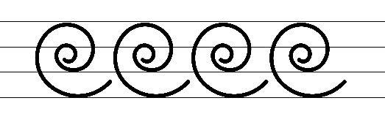  - Example letter formations  - Suggested practice text from the passage  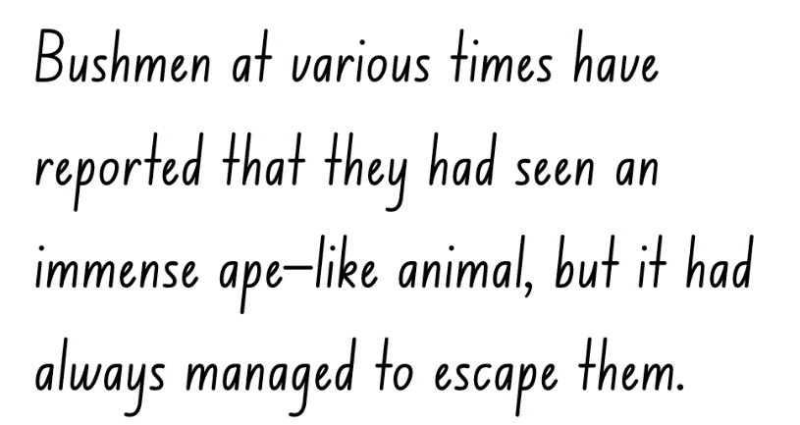  Note: some left-handed students may prefer to form some letters differently. For example, cross strokes in the letters A, H and T may go from left to right, rather than right to left.
Handwriting and digital transcription  Handwriting legibility and fluency (Stage 2 Year 4)  - Join letters when writing familiar words  - Diagonal joins to letters f and from q and z.  - Diagonally join to letters f, and from q and z, when writing familiar words.  - Letters join onto the letter f just below the neckline (or Line 2).  - When joining from the letter z, there is a little wave before joining to the next letter. | Handwriting and digital transcription  Handwriting legibility and fluency (Stage 2 Year 4)  - Suggested fluency pattern  - Example diagonal joins  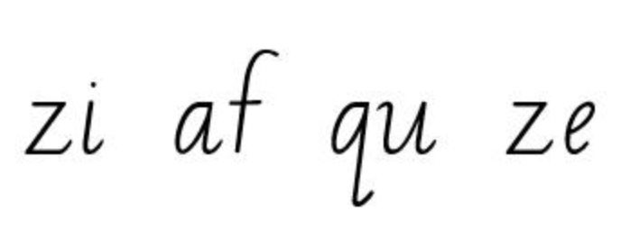  - Familiar words could include  - Suggested practice text from the passage  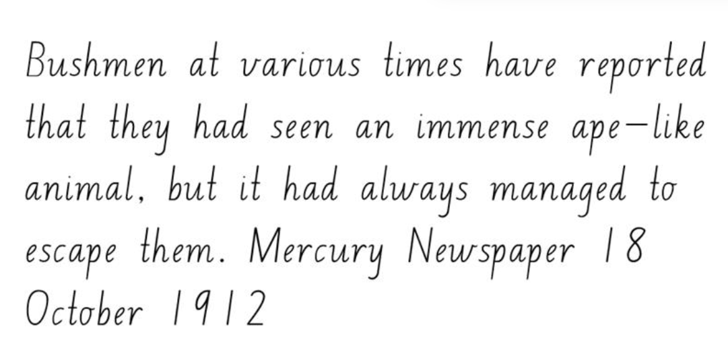
Handwriting and digital transcription  Handwriting legibility and fluency (Stage 3 Year 5)  - Sustain writing with a legible, fluent and personal handwriting style across a text  - Sustain legible and fluent handwriting across a text.  - Revise writing numerals. | Handwriting and digital transcription  Handwriting legibility and fluency (Stage 3 Year 5)  - Suggested fluency pattern  - Example numeral formations  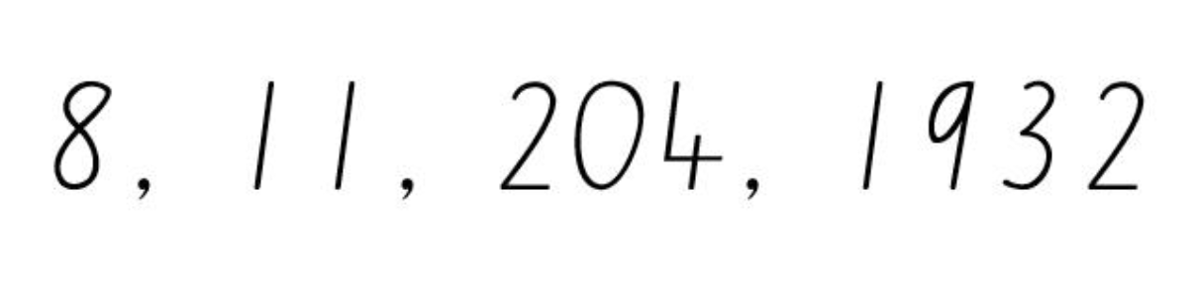  - Suggested practice text from the passage  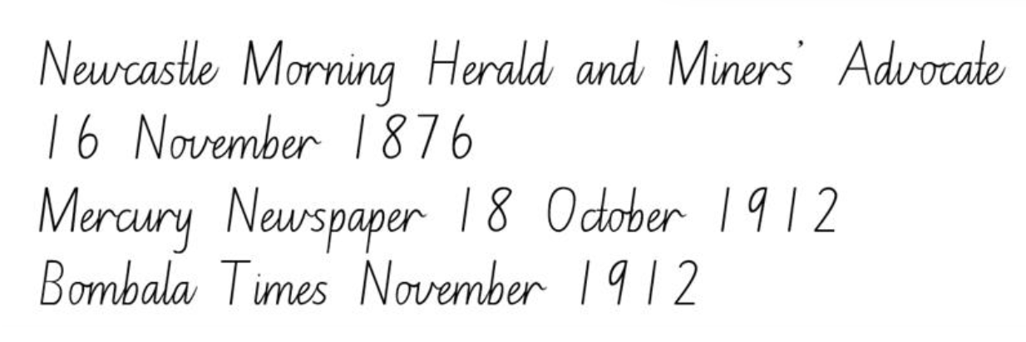  - Encourage students to evaluate their own handwriting after practising. For example, ask them to circle numerals they believe are formed well.
Handwriting and digital transcription  Handwriting legibility and fluency (Stage 3 Year 6)  - Sustain writing with a legible, fluent and personal handwriting style across a text  - Fluency joins with double s. | Handwriting and digital transcription  Handwriting legibility and fluency (Stage 3 Year 6)  - Suggested fluency pattern  - Example double ss letter formation  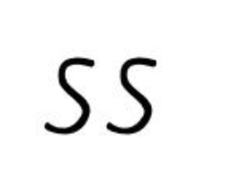  - Suggested practice text innovated from the passage  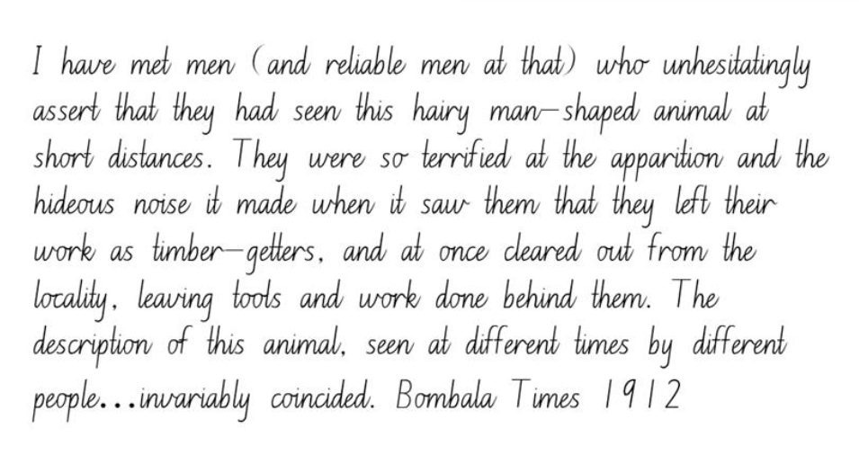  - Encourage students to evaluate their own handwriting after practising. For example, ask them to circle double s joins they believe are formed well.

Planning framework
To plan and document Component A teaching and learning, a planning scaffold [DOCX 81 KB] is provided. To support you in your planning, a link to a detailed example of a one-week teaching and learning cycle is included in the scaffold. Additional resources to support teaching and learning in each focus area can be found at Lesson advice guides.

Component B teaching and learning
The following teaching and learning sequence has been designed to address Component B outcomes and content and develops conceptual understandings of English through the study of quality texts. Adapt the sequence as required to best meet the needs of your students.

Learning intentions and success criteria
Learning intentions and success criteria are best co-constructed with students. The table below contains suggested learning intention and success criteria.
Element | Stage 2 | Stage 3
Learning intention | Students are learning to recognise and identify different text genres through language, form and function. | Students are learning to identify and analyse the genre of texts through established codes and conventions.
Success criteria | Students can:  - group different types of texts according to similarities in language, form and function  - evaluate the language, form and structure of a text to determine reliability and authority  - add multimodal features to a text to enhance meaning and authority  - describe the impact and effect authors make through intentional choices about language, form and structure  - understand and use different degrees of modality to persuade. | Students can:  - recognise and group different types of texts by their established codes and conventions  - analyse the impact and effect authors make through intentional choices about language, form and structure  - explore the use, purpose and influence of multimodal features in texts  - analyse the author’s intentional choices of language, form and structure and their impact on the authority of a text  - assess and modify the level of modality in a text.

Lesson 5 – exploring genre
The following teaching and learning activities support multi-age settings.

Whole
- Explain that during the lesson students will work in small groups and in pairs. Refer to Lesson 1 and discuss the class expectations when interacting with peers.
- Review different structures and features of persuasive, informative and imaginative texts from learning in Component A (Stage 2). Gather a collection of texts with varying text conventions, including genre, form and function. For example, fiction and non-fiction picture books, novels, graphic novels, magazines, comic books, fairy tales, historical fiction, adventure narrative, science fiction, news reports). Texts will be used again in activity 10.
- Ask students how these texts can be grouped, why they can be grouped that way, and what the groups can be called. For example, fiction and non-fiction, or grouped according to subject matter. Students share their ideas.
- Introduce genre as a text convention used to group different types of texts according to similarities in form and function. Explore how genre conventions are the characteristics of a particular genre that shape the reader’s expectation and understanding of a text. Discuss how although genre can vary, it can be recognised by its codes and conventions. For example:
- Code: sounds, spelling and grammar.
- Form: literary forms include poetry, picture books, chapter books, factual forms include informative books, historical reports.
- Function: the way the elements of a text, such as words, illustrations and sounds, contribute to meeting its overall purpose. For example, to inform, to persuade, to entertain.
- Mode: the process of communication such as sounds, music, printed or spoken words, images and gestures.
- Medium: the means of communication, such as print based publishing, broadcasting, or the internet.
Note: code and convention are agreed systems of making, communicating and interpreting meaning (NESA Glossary).
- Display the cover of Yahoo Creek. Ask:
- How is the text presented (form)? For example, non-fiction text, including personal historical accounts and First Nations cultural narratives, in the form of a picture book.
- How does the author use codes such as spelling and grammar? For example, quoted and reported text, sentence structure, colonial language.
- How is the text communicated (mode)? For example, printed words and illustrations.
- How is the text conveyed (medium)? For example, published picture book.
- Explain that Yahoo Creek is a hybrid text that contains multiple genres. For example, non-fiction text, including personal historical accounts and First Nations cultural narratives. Explain that authors often use elements from different genres to create engaging texts.
- Discuss how understanding genre conventions establishes reader expectations by helping the audience know what to expect. Genre also helps authors follow the form and function of the genre when creating texts. It provides readers with a guide or scaffold.
- Brainstorm known genres. For example, fairy tales, historical fiction, adventure narrative, science fiction, news report.
- Select one genre identified in activity 8. Model creating a concept map to identify and record elements typical of that genre. For example, news reports usually include facts or opinions, information, details of events, quotes from sources, statistics, research, photos or videos, attention grabbing headlines.
- In small groups, students select a genre from activity 8. Provide students with a text example of that genre from activity 2. Using the text as a model, students create a concept map to identify and record elements typical of their chosen genre.
- Provide time for each group to share their genre concept map. As a class, consider each genre and the elements, codes and conventions the reader expects. Discuss any additional elements and add to the concept map from activity 9.
- Students individually record gist statements to summarise and explain the key elements of each genre identified in activity 11. For example, news articles are non-fiction texts that provide information about current events. They often have quotes from sources, statistics and images. News articles sometimes present the author’s opinion of the event.
- In pairs, students check the accuracy of their recorded gist statements by comparing their statements.
Too hard? Students write a gist statement to summarise the elements of one genre.
- Students reflect on their understanding of genre using an exit ticket. Ask guiding questions, for example:
- Which genres of text do you enjoy? Why?
- How does knowing the genre of a text help a reader navigate and engage with it effectively?
- How can some genres blend together or overlap? Can you think of examples where texts incorporate elements from multiple genres? How does this impact the overall message conveyed?
- If you are going to create a text, what genre will it be? Why?

Lesson 6 – exploring multimodal elements
The following teaching and learning activities support multi-age settings.

Whole
- Revise the concept of ‘genre’ from Lesson 5 and the different genres represented in Yahoo Creek. For example, the printed text is non-fiction, it contains historical accounts from newspapers and transcripts of Peter Williams, a Ngiyampaa Elder, sharing a cultural narrative; it contains imaginative illustrations.
- Display and examine the inside cover of Yahoo Creek. Discuss the image of the silhouette filled with newspaper articles. Ask what effect the picture has on the reader and how it establishes the reader’s expectations of the text.
- Explain that Yahoo Creek is a multimodal text. Students Think-Pair-Share:
- What do you think multimodal means?
- Why do you think we would consider this to be an example of a multimodal text?
Note: a multimodal text is a text that combines 2 or more expressive modes to communicate (NESA Glossary). Expressive modes include linguistic, visual, auditory, spatial and gestural modes.
- Display the inside back cover of Yahoo Creek. Explore how the newspaper articles are presented. For example, number of articles, headlines, use of font and colour. Students analyse the effect it has on the audience.
- Re-read Yahoo Creek, stopping at the page that starts with ‘Berai can be kind and gentle...’ focusing on the illustrations. Explore the visual features. Provide time for students to make and share observations. For example, the limited colour palette of blues and greys give the impression of moonlight.
- Examine how the pages with text are coloured to appear old and stained. Ask students how this contributes to the meaning of the text. For example, it shows that the newspaper articles are authored by people who lived a long time ago.
- Display pages with illustrations of the Yahoo. Explore how the Yahoo is portrayed. For example, the Yahoo is often drawn with an illuminated outline. Ask:
- Why do you think Tohby Riddle represents the Yahoo in this way?
- How do the illustrations make you feel about the Yahoo? Why?
- How do the illustrations add meaning?
- Do the illustrations match the descriptions in the printed text? What makes you think that?
- How can words and illustrations in a text support you, as a reader, to make inferences?
- Display the page where a settler’s daughter comes face to face with the Yahoo. Compare how the Yahoo and the girl are represented. For example, the illustration of the girl has more detail, the illustration of the Yahoo is a simple silhouette. Ask:
- What do you notice?
- Why do you think Tohby Riddle has done this?
- What effect does it have on the reader’s understanding of the Yahoo? What makes you think that?
- Display the text on the double page that starts with ‘The creature...has caused much alarm to a whole camp of stone-breakers...’ to ‘...also believed that one lived in the mountains there. Sydney Morning Herald 8 June 1935’. Keep the illustration covered.
- Discuss who may have originally authored each news report. Consider their point of view and how that point of view is presented in each report. For example, a European settler who feels ill at ease in the rugged Australian bushland.
- Draw comparisons between the different portrayals of the Yahoo in the text. Ask students what they notice about how the Yahoo is portrayed in the news reports, Aboriginal Elder’s account and illustrations.
- Discuss how the language, form and structure of the text might influence the reader’s perspective of the Yahoo. For example, descriptions such as, ‘covered with shaggy black hair all over’, ‘horrible yelling’, ‘body is hard and sinewy’. Ask:
- Do the illustrations reflect the language used in the news reports? Why or why not?
- Do the illustrations reflect the language used by the Ngiyampaa Elder, Peter Williams. What makes you think that?
- In pairs, students present their point of view of the Yahoo and provide arguments to justify it. For example:
- The Yahoo is a peaceful and spiritual creature that is misunderstood because of its appearance. There is no evidence of the Yahoo hurting anyone.
- The Yahoo is a creature to be feared due to its terrifying appearance. This point of view is supported by multiple sightings of the creature.
- Revise learning about exclamatory sentences from Component A. Model using the Headline routine [PDF 184 KB] to compose a headline that synthesizes a particular point of view about the Yahoo. For example, ‘Hero or Villain? Locals Can’t Decide!’ Highlight the use of exclamatory sentences to emphasise a point or express a strong emotion.
- Students use the Headline routine [PDF 184 KB] to compose a headline that synthesizes their point of view. For example, ‘Misunderstood Hairy Man Just Wants to Connect’; ‘Hideous Apparition Terrifies Locals…Again!’
- Students select and add a multimodal feature to their Headline text from activity 15 to expand meaning and reinforce the point of view presented. For example, an image, map, timeline.
- In small groups, student share their multimodal text without telling their point of view. The rest of the group take turns to identify the point of view presented in the text.

Lesson 7 – author’s intent and authority
The following teaching and learning activities support multi-age settings.

Whole
- Revise the textual concept, authority. Display Resource 1 – authority evaluation checklist. Discuss the authority that Tohby Riddle has to write a text about the Yahoo.
- Visit Tohby Riddle’s website and read the information about Yahoo Creek. Display the paragraphs that begin with ‘In an innovative approach to history and storytelling...’ and ends with ‘... is intended to amplify the mood and mystery of the stories.’ Ask:
- How is the text presented (form)?
- How has the author used codes such as spelling and grammar?
- How is the text communicated (mode)?
- How is the text conveyed (medium)?
- What genre is the website and explain how you know?
- Discuss how Yahoo Creek is compiled of excerpts from news reports and words from Peter Williams, an Ngiyampaa Elder.
- Consider how Tohby Riddle made intentional choices about language, form and structure to tell the story of the Yahoo. Ask:
- Where do you think Tohby Riddle found the news reports to include in his text? For example, an online search engine.
- Why might he have selected specific reports? For example, they included emotive and subjective language.
- How might he have been intentional about the language and structure of the text? For example, he may have adjusted or omitted words from reports.
- Display the page with Peter Williams’ words ‘Berai can be kind and gentle...’. Students Think-Pair-Share:
- Why do you think Tohby Riddle included Peter Williams’ point of view? What was his intent?
- What effect do Peter Williams’ words have on the reader? Why do you think that?
- Do Peter Williams’ words have authority? Why or why not?
- Re-read and display the page with the report from The Mudgee Guardian and North-Western Representative 17 June 1909, that starts with ‘Residents of the ‘Bar’ have been...’ to ‘...disturbing the peace of the neighbourhood.’ Ask:
- Why do you think Tohby Riddle included this news report?
- What effect does it have on the reader? Why do you think that?
- Does the article have authority? Why or why not?
- Ask students if they have ever wondered what life was like in the past or how people got their news long ago. Explain that they will explore a website called Trove that helps readers discover the history of Australia through old newspapers.
- Display the Trove website on the screen or computer. Provide a brief overview of Trove, emphasising that it is a digital library that contains a vast collection of Australian newspapers, books, photos, and more. While viewing, model using language associated with digital texts. For example, website, URL, hyperlink, tab.
- Demonstrate how to use the Trove search bar. For example, start by searching for ‘gold rush’ or ‘first car in Australia’. Model how to click on a newspaper article to read it and view what people wrote in the past. Navigate to the ‘About’ tab and scroll to the ‘What is Trove?’ page. Provide time for students to read, discuss and share their observations.
- Model how to use the Trove website to find additional news reports about the Yahoo, or Hairy Man. Discuss how Tohby Riddle used Trove to research and build background knowledge when writing Yahoo Creek. Ask:
- What challenges might Tohby Riddle have faced when writing Yahoo Creek?
- How might he have been intentional with language, form and structure while using words written by other people?
- Display and read the page with the report from The Mudgee Guardian and North-Western Representative, 17 June 1909, that starts with ‘Residents of the ‘Bar’ have been...’ to ‘...disturbing the peace of the neighbourhood.’

Part
The table below details the differentiated teaching and learning activities for each stage.
Stage 2 (teacher guided/small groups) | Stage 3 (independent)
- Re-read the page with the report used in activity 11.  - Read and display the ‘Hairy Man’ original news report from The Mudgee Guardian and North-Western Representative, 17 June 1909, published on Trove.  - Ask students to identify the genre of each report. Revise how a text can be categorised by more than a single genre. For example, a non-fiction text that includes personal historical accounts, in the form of a website or picture book.  - Explore how authors make intentional decisions about every aspect of their text. Highlight the differences in the texts. For example, the original news report has more information about how long the residents of the ‘Bar’ have been affected.  - Ask students how and why Tohby Riddle made intentional choices about language. For example, he removed some words because they are not necessary for telling the story of the Yahoo. Discuss whether the changes to the text impact it’s authority.  - Review different types of modal words from Component A. Highlight the author’s use of modal words and describe how these indicate possibility, necessity or certainty in a statement. For example, have, at times, several persons.  - Discuss how author’s control of the modality of a text can strengthen arguments and add weight to their point of view.  - Students select several articles from the text and reflect on the following questions:  - Who wrote the newspaper article?  - What impression do they give of the Yahoo? What language tells us this?  - What type of modal words were used? List them from high to low modality.  - Using Resource 1 – authority evaluation checklist, students consider the authority of the articles.  - In small groups, students order the articles according to reliability and authority. Prompt students to consider the language, form and structural choices of each article to justify their decision. | - Provide students with a copy of the ‘Hairy Man’ original news report from The Mudgee Guardian and North-Western Representative, 17 June 1909.  - Students use Resource 1 – authority evaluation checklist to compare the reliability and validity of the reports from activity 11 and activity 22.  - Students use a graphic organiser such as a T-chart or Venn diagram to record their comparisons.  - Using their text analysis and comparison, students question the assertions made by each author and make a judgement about the authority of each article. Students record their response using evidence and reasoning to support their judgement.  - Students use Trove to find additional news reports about the Yahoo, or Hairy Man. Repeat activities 24 and 25.

Whole
- Reflect on the purpose of the articles examined during the lesson and the different perspectives presented. Revise how the authority of a text refers to how trustworthy it is. Discuss the importance of writing with authority when creating texts, as well as the importance of critical thinking when responding to texts to make judgements about their authority.
Stage 3 Assessment task 1 – observations and work samples from this lesson allow students to demonstrate achievement towards the following syllabus outcomes and content points:
EN3-RECOM-01 – fluently reads and comprehends texts for wide purposes, analysing text structures and language, and by monitoring comprehension
- question the assertions made by authors when engaging with print and digital texts
- use criteria to determine the accuracy and reliability of sourced information.
EN3-UARL-02 – analyses representations of ideas in literature through genre and theme that reflect perspective and context, argument and authority, and adapts these representations when creating texts
- compare the reliability and validity of texts to make judgements about their authority.

Lesson 8 – using modality for impact
The following teaching and learning activities support multi-age settings.

Whole
- Display the sentence, ‘I have met men who think they may have possibly seen a hairy man-shaped animal in the far-off distance.’ Ask:
- Do you believe this statement?
- Does it have authority? Why or why not?
- Is the language persuasive? Why or why not?
- Display the quote ‘I have met men (and reliable men at that) who unhesitatingly assert that they had seen this hairy man-shaped animal at short distances.’ Ask:
- Do you believe this statement?
- Does it have authority? Why or why not?
- Is the language persuasive? Why or why not?
- Why do you think the words ‘and reliable men at that’ are included in brackets? How does it impact how convincing the sentence is?
- Revisit the mentor concepts of argument and authority. Explain that an argument is not a dispute, but a stated position about an idea. It is the way in which various dimensions of a text (such as theme, perspective, and style) can be understood to represent a particular position on an issue (NESA Glossary). An understanding of argument can help authors to write persuasively.
- Revise how when writing to persuade an audience, the modality of the text can determine the effectiveness. Review types of modal words (Stage 2) and the effectiveness of modal words (Stage 3) from Component A. Revise that modality refers to the possibility, necessity or certainty in a statement. Discuss how author’s modality control of a text can strengthen arguments and add weight to their point of view.
- Discuss how Tohby Riddle controlled the modality of Yahoo Creek through the intentional selection of specific news reports. For example, ‘Mr Prosser assures us there is no exaggeration about this affair, and everyone at the mill believes in the existence of this strange creature.’ (Sydney Morning Herald, 12 October 1877).
- Explain that modal words are a category of supporting verbs that express various degrees of probability, occurrence, obligation and inclination in a sentence. These words modify the main verb and help convey the author’s attitude, certainty or necessity regarding the action or state being described. For example:
- Degrees of probability express different levels of certainty or possibility. They help us understand how likely something is to happen or how necessary it is for something to be true. For example, ‘His arms don’t hang down as low as people say.’ (Peter Williams Ngiyampaa Elder, North West NSW).
- Degrees of obligation refer to different levels of duty or responsibility. They describe how strongly we should or must do something, help us understand our responsibilities as well as what is expected of us. ‘Mr Prosser assures us there is no exaggeration about this affair...’ (Sydney Morning Herald, 12 October 1877).
- Degrees of occurrence refer to frequency or whether something will occur or not. ‘But, depending on their behaviour, they can be bad and violent too.’ (Peter Williams, Ngiyampaa Elder, North West NSW).
- Degrees of inclination refers to the willingness, readiness or necessity to do something. ‘Some time in the night I heard a noise similar to what an entire horse would make when looking over the fence at a mare.’ (Hillston Spectator and Lachlan River Advertiser, 14 August 1903).
- Construct and display a 4-column table with the headings ‘degrees of probability’, ‘degrees of obligation’, ‘degrees of inclination’ and ‘degrees of occurrence’. Display a list of words that fit into these categories. For example:
- Degrees of probability: certainly, surely, definitely
- Degrees of obligation: always, never, consistently
- Degrees of occurrence: ought to, should, may
- Degrees of inclination: want, wish, would like to
- As a class, sort the words into the appropriate category. Students add additional words to each category.
Too easy? Students create a cline for each category and rank the words from lowest to highest modality. Students rewrite the sentences in activity 6 as stronger examples of occurrence and inclination.
- Display the double-page spread in Yahoo Creek that starts with Peter Williams’ words ‘Berai can be kind and gentle...’. Identify words which indicate modality. For example, can, depending, believe, might. Analyse the strength of the modality. Ask:
- Why is this different to the way the newspaper articles are written?
- Do Peter’s words and the newspaper articles share the same purpose? For example, both discuss the Yahoo’s description and behaviour from their individual point of view.
- Write the sentence, ‘I think the Yahoo might exist.’ Identify words that relate to modality and which category of modality they relate to. For example, ‘think’ and ‘might’ indicate degrees of probability. Discuss how the sentence could be strengthened to intensify emotional responses. Co-construct a new sentence using higher modality vocabulary. For example, I am utterly convinced that the Yahoo is real.

Part
The table below details the differentiated teaching and learning activities for each stage.
Stage 2 (teacher guided) | Stage 3 (in pairs/independent)
- Review the 4 categories of modal words.  - Present students with a sentence that has low degrees of modality. For example:  - ‘It is unlikely that the Yahoo will be seen during the daylight.’ (probability)  - ‘It is rare to see the immense ape-like animal.’ (occurrence)  - ‘You may choose to do your own research on the Yahoo.’ (obligation)  - ‘The men refused to work, however, their feelings might change if they felt safe.’ (inclination).  - Explore how each sentence could be strengthened recording a new sentence using a different modal word.  - Explain that students will imagine they have seen the Yahoo. Model writing a sentence of an eyewitness account that includes high modality vocabulary.  - Students record sentences about the Yahoo that include high modality vocabulary. | - Students imagine they have seen the Yahoo and write an eyewitness account sharing their story, including details such as who, what, when and where. Students should use high modality vocabulary to persuade the reader that their encounter occurred.  - Students swap their writing with a partner and underline or highlight modal words. Students evaluate the effectiveness of the modal words used and how they can intensify or soften emotional responses.

Whole
- In pairs, students share their writing and provide peer feedback using the strategy Tell, Ask, Give (TAG). Encourage students to identify high modality vocabulary and words that could be strengthened to higher modality.
- Students edit and strengthen their writing based on the feedback provided.
Stage 2 Assessment task 1 – observations and work samples from this lesson allow students to demonstrate achievement towards the following syllabus outcomes and content points:
EN2-VOCAB-01 – builds knowledge and use of Tier 1, Tier 2 and Tier 3 vocabulary through interacting, wide reading and writing, and by defining and analysing words
- describe how modal words indicate degrees of probability, occurrence, obligation and inclination.
EN2-UARL-01 – identifies and describes how ideas are represented in literature and strategically uses similar representations when creating texts
- understand that to control impact and effect authors make intentional choices about language, form and structure.
Stage 3 Assessment task 2 – observations and work samples from this lesson allow students to demonstrate achievement towards the following syllabus outcomes and content points:
EN3-VOCAB-01 – extends Tier 2 and Tier 3 vocabulary through interacting, wide reading and writing, morphological analysis and generating precise definitions for specific contexts
- use metalanguage when discussing language features encountered in texts
EN3-RECOM-01 – fluently reads and comprehends texts for wide purposes, analysing text structures and language, and by monitoring comprehension
- explain how modality can have subtle impacts on the meanings of words and contribute to deeper understanding when reading.

Week 3

Component A teaching and learning
Component A focuses on the development of foundational skills and knowledge through regular, systematic and repeated practice. The mentor and supporting texts used in Component B of this unit can support the effective implementation of Component A teaching and learning.

Teaching guide
Guidance for explicit teaching, teaching notes, resources and examples for the related outcomes and content points have been provided in the table below.
Focus areas and teaching notes | Resources and examples
Reading fluency  Reading automaticity and rate (Stage 2)  - Demonstrate the use of navigation pathways to support fluency when engaging with print, visual and multimodal texts  - Navigation pathways refer to the paths followed while moving through the content of a text. They involve navigating the text to support fluency in a way that does not disrupt the overall comprehension and allows the reader to engage with print, visual and multimodal texts. | Reading fluency  Reading automaticity and rate (Stage 2)  - Resource 4 – fluency and close reading passage analysis (Week 2): Peter Williams Ngiyampaa Elder, North West NSW from ‘We call the big fella berai...’ to ‘...because he let them go!’ (126 words).  Note: the passage from the text will need to be a teacher-created resource.  - The passage is positioned across the double-spread and the text is centred. To move through the content, the reader follows a common top to bottom, left to right path.
Monitoring reading fluency (Stage 2)  - Recognise that there are different purposes and audiences for reading and adjust reading rate to suit a text’s purpose  - Reading rate for literacy texts may depend on the use of expression, pausing, emphasis and the author’s use of phrasing.  - Reading rate for informative texts may depend on the vocabulary used. For example, Tier 3 technical and subject-specific vocabulary may require the reader to slow down. | Monitoring reading fluency (Stage 2)  - The purpose for reading is to understand the cultural narrative of Berai as told by Ngiyampaa Elder, Peter Williams. Reading rate may need to be adjusted:  - to draw out key information  - to read Aboriginal words, such as ‘berai’ and ‘yuriwirrina’  - to draw inferences from the narrative. For example, Berai is so strong that no man could ever escape from him.
Reading comprehension  Monitoring comprehension (Stage 2)  - Make gist statements and record them to monitor understanding  - Gist statements are succinct notes that summarise what has been read. They may be recorded in print or digitally. | Reading comprehension  Monitoring comprehension (Stage 2)  - Suggested examples of gist statements  - Berai is a spiritual figure to the Ngiyampaa people.  - Berai is described as a 9-foot-tall being with reddish hair, wide shoulders, and powerful hands.  - There is another creature called Yuriwirrina, smaller in size but still strong.  - It is believed that those who escape from Berai do so because he allows them to go.
Comprehending text structures and features (Stage 2)  - Identify different structures and features of persuasive, informative and imaginative texts  - Persuasive texts are designed to convince a reader of a particular opinion or way of thinking on an issue. A persuasive text may express an opinion while discussing, analysing and/or evaluating an issue.  - Informative text purpose is to provide information through explanation, description, argument, analysis, ordering and presentation of evidence and procedures.  - Imaginative texts represent ideas, feelings and mental images in words or visual images. Imaginative texts entertain or provoke thought through their creative use of literary elements and make connections between ideas and experiences (NESA Glossary). | Comprehending text structures and features (Stage 2)  - The passage is largely informative, providing detailed descriptions of the physical attributes, behaviour and cultural significance of the berai and yuriwirrina creatures. It informs the reader about their appearance, strength, scent, and spiritual relevance to the Ngiyampaa people.
Reading comprehension  Reading fluently (Stage 3)  - Efficiently follow signposting features to navigate print and digital texts  - Signposting features refer to elements that guide the reader through the structure and content of a text. These features serve as ‘signposts’ that indicate the direction the text is taking and help the reader follow along. | Reading comprehension  Reading fluently (Stage 3)  - Suggested example of signposting from the passage  - The opening statement of each paragraph indicates the content of the paragraph. For example, ‘We call the big fella berai.’  - Attribution at the end indicates the source of information. For example, ‘Peter Williams, Ngiyampaa Elder, North West NSW’.
Monitoring comprehension (Stage 3)  - Question the assertions made by authors when engaging with print and digital texts  - This involves questioning if information presented by the author is authoritative, and if the author’s use of others’ perspectives and opinions have been accounted for in the text. | Monitoring comprehension (Stage 3)  - Suggested questions in relation to the text  - How can a creature be both ‘pretty much human’ and ‘9 feet tall’?  - How is it determined that the hairy man intentionally lets someone escape? Is there any historical or cultural context that sheds light on this claim?
Vocabulary  Learning and using words (Stage 2)  - Describe how modal words indicate degrees of probability, occurrence, obligation and inclination  - Modal words are a specific group of auxiliary verbs that modify the main verb in a sentence. Modal verbs express various shades of meaning including  - Probability: certainly, surely, definitely  - Occurrence: always, never, consistently  - Obligation: ought to, should, may  - Inclination: want, wish, would like to (NESA 2023).  - They help convey the writer’s attitude, certainty or necessity regarding the action or state being described. | Vocabulary  Learning and using words (Stage 2)  - Suggested examples of modal words from the passage  - ‘His arms don’t hang down as low as people say.’ (occurrence)  - ‘But, depending on their behaviour, they can be bad and violent too.’ (probability)
Vocabulary  Learning and using words (Stage 3)  - Identify and use words that convey subjective, emotive and persuasive meanings in texts  - Subjective language is used to convey personal opinions or beliefs. It reflects the perspective of the individual to the reader or audience.  - Emotive language is specifically selected to evoke strong emotions, reactions or feelings from the reader or audience.  - Persuasive language is used to convince the reader to agree with a particular point of view.  - Use metalanguage when discussing language features encountered in texts  - Metalanguage includes the technical terms used to describe and discuss how language and texts function (NESA 2023). | Vocabulary  Learning and using words (Stage 3)  - Suggested examples of words from the passage that convey subjective, emotive or persuasive meaning  - Subjective: ‘We call the big fella berai’, ‘To my people, he is a spiritual figure...’, ‘There is a little fella too.’  - Emotive: ‘His scream is like nothing else’, ‘...a strong smell like a wet dog.’  - Suggested metalanguage to discuss vocabulary from the passage  - Adjectives: ‘wide’, ‘reddish’, ‘very large’ and ‘powerful’.  - Exaggeration: ‘very large’, ‘could crush someone's skull, if he wanted to’.  - Simile: ‘strong smell like a wet dog’.  - Exclamatory sentence: ‘If some escapes from a hairy man it is because he let them go!’
Defining and analysing words (Stage 3)  - Evaluate the effectiveness of modal words used in texts to intensify or soften emotional responses  - Modal words are verbs or auxiliary verbs that modify or indicate the mood or attitude of the verb in a sentence. | Defining and analysing words (Stage 3)  - As above, see Stage 2 Vocabulary examples.
Spelling  Phonological component (Stage 2)  - Explain how to segment multisyllabic words into syllables and phonemes, and apply this knowledge when spelling  - Revise segmenting multisyllabic words into syllables and phonemes. This is a phonological skill that should be practised regularly.  Phonological component (Stage 2)  - Identify differences in vowel phonemes (short, long, diphthong and schwa vowels)  - Identify short vowel phoneme /i/ as in ‘it’. | Spelling  Phonological component (Stage 2)  - Suggested words from the passage:  - big, his, spiritual, physical.  - Sample words for inquiry  - innocent, compliment, inquisitive, university, literacy, system, sympathy, gymnastics, rhythm, myth, inspect-inspected-inspecting, consider-considering-considered, deliver-delivered-delivering, inform-informed-informing, participate-participating-participated.
Orthographic component (Stage 2)  - Understand that some graphemes are dependent on their position in a word in English and apply this knowledge when spelling  - [i, y, e] are graphemes that represent the short vowel phoneme /i/ as in ‘it’.  - [i] is often used in the beginning or middle of base words. [y] is used in the middle of base words. [e] is used in the beginning or middle of words.  - Proofread, identify and correct misspellings when creating texts  - Introduce proofreading by identifying and correcting misspellings when creating written texts.  - Proofreading by identifying and correcting misspellings, should be practised regularly. | Orthographic component (Stage 2)  - As above  - Writing produced in Component B could be utilised, or a passage of text featuring short vowel phoneme /i/ words.
Morphological component (Stage 2)  - Identify inflected suffixes, explaining when and how to treat base words when they are affixed, and apply this knowledge when spelling  - The inflected suffixes -s, -ing, -ed change the tense of a verb. The suffixes -s and -ing express present tense, -ed expresses past tense; -ing also expresses future tense.  - In single syllable CVC words, the final consonant is doubled before adding -ed or -ing (shop, shopping).  - In 2 or more syllable words with a stressed final CVC syllable, the final consonant is doubled before adding -ed or -ing (begin, beginning).  - In 2 or more syllable words with a stressed opening syllable, no doubling of the final consonant is needed (follow, following). | Morphological component (Stage 2)  - As above
Spelling  Phonological component (Stage 3)  - Segment unfamiliar multisyllabic words into syllables and phonemes as a strategy when spelling  - Revise segmenting multisyllabic words into syllables and phonemes. This is a phonological skill that should be practised regularly. | Spelling  Phonological component (Stage 3)  - Suggested words from the passage: managed, timber-getters.  - Sample words for inquiry: giant, large, log, grubs, figure, gully, dog, legs, beverage, encourage, allergy, refugee, synergy, physic-physical, medic-medical, ethic-ethical, emotion-emotional, deny-denial, revive-revival, remove-removal, reverse-reversal, appraise-appraisal.
Orthographic component (Stage 3)  - Recognise that the same grapheme can represent different phonemes  - The single-letter grapheme [g] can represent /g/, /j/.  - [g] is often used to represent /g/ as in 'gas’ or /j/ as in ‘gentle’. Consider the grapheme’s position within base words.  - Proofread written texts to correct misspellings, making use of spelling reference tools where required  - Introduce proofreading written texts to correct misspellings, making use of spelling reference tools where required.  - Spelling reference tools may include word walls, print or online dictionaries and assistive technologies. | Orthographic component (Stage 3)  - As above  - Writing produced in Component B could be utilised, or a passage featuring target morphology or orthography.
Morphological component (Stage 3)  - Explain and use spelling conventions to add derivational suffix: -al to base words or roots  - Derivational suffix: -al  - ‘-al’ meaning ‘having characteristics of; like’  - attaches to verbs to form nouns, eg dismiss-dismissal  - attaches to nouns to form adjectives, eg logic-logical  - explore ‘drop the e’ and ‘change the y to i' generalisations: arrive-arrival, deny-denial. | Morphological component (Stage 3)  - As above
Creating written texts  Sentence-level grammar (Stage 2)  - Use declarative sentences to provide facts or state a viewpoint  - A statement presented as a complete sentence to provide fact, evidence or detail (NESA 2023).  - Use exclamatory sentences to emphasise a point or express a strong emotion.  - A statement expressing a strong emotion, formed as a complete sentence, and often ending with an exclamation mark (NESA 2023).  - Use adverbial phrases or clauses to add information to the verb or verb group of the main or other clauses, to provide reasons for or circumstances  - Adverbial phrases add meaning to, or modify, the action of verbs, adjectives and other adverbs  - Adverbial clauses are a type of subordinate (or dependent) clause that add meaning to a verb, adjective or adverb  - Review different types of adverbial phrases that can provide information about circumstance or reason:  - when (adverbial phrase/clause of circumstance – time)  - where (adverbial phrase of circumstance – place)  - how (adverbial phrase of circumstance – manner)  - why (adverbial phrase of circumstance – reason). | Creating written texts  Sentence-level grammar (Stage 2)  - Suggested example of a declarative sentence from the passage  - ‘We call the big fella berai.’.  - Suggested example of an exclamatory sentence from the passage  - ‘If someone escapes from a hairy man it is because he let them go!’ Peter Williams, Ngiyampaa Elder, North West NSW.  - Suggested example of an adverbial phrase innovated from the passage  - Berai screams in a threatening way. (manner)
Punctuation (Stage 2)  - Understand and use quoted and reported text or speech in own writing  - Use quotation marks for quoted text: “We climbed the mountain in record time,” said the mountaineers.  - Do not use quotation marks for reported text: The mountaineers said that they climbed the mountain in record time. | Punctuation (Stage 2)  - Suggested example of quoted and reported text or speech from the passage  - ‘His scream is like nothing else.’  - ‘To my people, he is a spiritual figure, but he has a physical body and a strong smell like a wet dog.’
Creating written texts  Sentence-level grammar (Stage 3)  - Experiment with the placement of adverbial clauses, to modify the meaning or to add detail to a verb or verb group  - Review adverbial phrases  - Review adverbial clauses  - The adverbial clause can be placed at the beginning, middle of end of a sentence.  - Make choices about the use of declarative, exclamatory, interrogative and imperative sentences to suit text purpose, and for meaning and effect  - Declarative sentences are statements presented as a complete sentence to provide fact, evidence or detail.  - Exclamatory sentences are statements expressing a strong emotion, formed as a complete sentence, and often ending with an exclamation mark.  - Interrogative sentences are sentences that ask a direct or indirect question.  - Imperative sentences convey a direct command, request, invitation, warning or instruction, typically directed to an implied person (NESA Glossary). | Creating written texts  Sentence-level grammar (Stage 3)  - Suggested example of an adverbial clause innovated from the passage  - They were so terrified at the apparition and the hideous noise it made, they cleared out and left their tools behind.  - They cleared out and left their tools behind as they were so terrified at the apparition and the hideous noise it made.  - See Stage 2 Creating written text examples.
Handwriting and digital transcription  Handwriting fluency and legibility (Stage 2 Year 3)  - Understand that legible handwriting is consistent in size and spacing and can support learning  - Capital letters with consistent size and spacing, including  - curved: B, C, D, G, J, O, P, Q, R, S, U. | Handwriting and digital transcription  Handwriting fluency and legibility (Stage 2 Year 3)  - Example letter formation
Software functionalities and typing (Stage 2 Year 3)  - Position a chosen device in a way that facilitates efficient and sustained text creation  - Revise placement of device or monitor at appropriate eye level. Demonstrate good posture.  - Introduce the use of external accessories such as including a mouse. This can be positioned on the right or left side of the keyboard. | Software functionalities and typing (Stage 2 Year 3)  - Good posture may include sitting up straight, aligning head with their spine, shoulders relaxed.
Software functionalities and typing (Stage 2 Year 4)  - Monitor goals that build on typing accuracy and rate  - Use knowledge of the keyboard layout using the home, top and bottom row to build on typing accuracy and rate. | Software functionalities and typing (Stage 2 Year 4)  - Focus on letters.
Software functionalities and typing (Stage 2 Year 4)  - Use knowledge of the keyboard layout and functions to type texts  - Use knowledge of the keyboard layout using the home, top and bottom row to type texts. | Software functionalities and typing (Stage 2 Year 4)  - Texts created as part of Component B teaching and learning could be utilised.
Handwriting and digital transcription  Software functionalities and typing (Stage 3 Year 5)  - Navigate the keyboard with efficiency and accuracy when typing words, numerals, punctuation and other symbols  - Navigate the keyboard efficiently when typing words.  - Understand that the position of the device in relation to the user can affect posture and glare | Handwriting and digital transcription  Software functionalities and typing (Stage 3 Year 5)  - Revise device positioning and posture.  - Revise touch typing skills including the home, top and bottom rows.
Software functionalities and typing (Stage 3 Year 6)  - Navigate the keyboard with efficiency and accuracy when typing words, numerals, punctuation and other symbols  - Navigate the keyboard with efficiency and accuracy when typing symbols and numerals.  - Revise that symbols are typed using the shift key. | Software functionalities and typing (Stage 3 Year 6)  - Suggested examples: !, ?, $, @, &, “”, +, =, -, ×, 1, 2, 3  - Students could practice touch typing  - a passage from the mentor or supporting text  - an email  - symbols and numerals from a mathematics lesson.

Planning framework
To plan and document Component A teaching and learning, a planning scaffold [DOCX 81 KB] is provided. To support you in your planning, a link to a detailed example of a one-week teaching and learning cycle is included in the scaffold. Additional resources to support teaching and learning in each focus area can be found at Lesson advice guides.

Component B teaching and learning
The following teaching and learning sequence has been designed to address Component B outcomes and content and develops conceptual understandings of English through the study of quality texts. Adapt the sequence as required to best meet the needs of your students.

Learning intentions and success criteria
Learning intentions and success criteria are best co-constructed with students. The table below contains suggested learning intention and success criteria.
Element | Stage 2 | Stage 3
Learning intention | Students are learning how authors make intentional choices about language, form and structure to control impact and effect. | Students are learning to identify and use rhetorical and persuasive devices and evaluate their impact on the credibility and authority of texts.
Success criteria | Students can:  - identify and use language features that enhance text authority  - use a variety of sentence types including declarative, exclamatory and interrogative sentences to suit text purpose  - identify and explain text genre  - identify persuasive devices used by authors and analyse their impact. | Students can:  - analyse language features in a text and explain how they add credibility and enhance authority  - make choices about the use of declarative, exclamatory, interrogative and imperative sentences to suit text purpose, add credibility and for effect  - explain how genre can be recognised by established codes and conventions  - use rhetorical devices to persuade and engage an audience  - recognise how an argument is influenced by perspective.

Lesson 9 – language features to enhance authority
The following teaching and learning activities support multi-age settings.

Whole
- Revise quoted and reported speech, as introduced in Component A. Explain that quoted speech is repeating the actual words of a speaker using quotation marks. Explain that reported speech is used to communicate what someone else said without using the exact words. In reported speech the tense of the verbs is often changed. For example, ‘Bushmen have reported that they have seen an immense ape-like animal’.
- As a class or in small groups, students form a line or sit in a circle. Explain that students must report what they hear instead of repeating it. Establish a simple starting sentence, for example, ‘I love to visit the Blue Mountains.’ The first student whispers the sentence to the next but, instead of whispering it as a direct quote, they use reported speech format. For example, ‘Bindi said she loves to visit the Blue Mountains’. Each student uses reported speech to report the sentence to the next student. Keep passing the reported speech sentence until it reaches the last student. The last student says the final sentence aloud. Compare the final reported sentence with the original sentence. Discuss any differences or changes that occurred during the reporting process.
- Discuss different text genres that may include quoted or reported speech, why the authors of those texts might use it and its effect on the reader.
- Display the page in Yahoo Creek that begins with ‘A shepherd in W. Suttor’s employ...’ Model changing the reported speech to quoted speech. For example, ‘The shepherd exclaimed, “I saw a hairy man in the scrub north of Cunningham’s creek. It walked upright and was covered with hair. My dogs ran away with their tails between their legs!”’

Part
The table below details the differentiated teaching and learning activities for each stage.
Stage 2 (teacher guided) | Stage 3 (in pairs/independent)
- Re-read the Kids News article about the Yeti. Display the section that starts with ‘Mount Makalu stands near...’ and ends with ‘...the samples belonged to bears.’  - Identify the use of quoted and reported speech. Students highlight the vocabulary that indicates reported speech. For example, reported, assert, averred. Identify other saying verbs that might be used for reported speech.  - Provide a fictional example of an eyewitness account of the Yahoo in reported speech. For example, Mr Papadakis claims to have spotted the mysterious Yahoo at dusk while he was bringing in laundry. He declared that the Yahoo hid in the shadows at the edge of the bushland near his house. | - Students revisit the page in Yahoo Creek that begins with ‘A shepherd in W. Suttor’s employ...’  - In pairs, students discuss the credibility and authority of the article using examples from the text to support their discussions. For example, it provides a detailed description from an eyewitness (shepherd). It includes location of the sighting, physical appearance of the Yahoo, and the impact the Yahoo had on the shepherd’s dogs who normally ‘hunted everything else’ (hyperbole) and ‘ran back...with their tails between their legs’.  - Students identify and record examples of topic-specific Tier 2 vocabulary and saying verbs and their effect on the credibility of the author and the authority of the text. For example:  - topic-specific Tier 2 vocabulary: author uses ‘employ’, ‘shepherd’ to add precision to the reported speech  - saying verbs: the author uses ‘averred’ to add credibility and precision to reported speech.

Part
The table below details the differentiated teaching and learning activities for each stage.
Stage 2 (independent/in pairs) | Stage 3 (teacher guided)
- Students rewrite the reported speech example in activity 6 as quoted speech. For example, ‘Mr Papadakis exclaimed, “I saw him! I saw the Yahoo when I was bringing in the laundry. It was right on dusk, and he was lurking in the shadows at the edge of the bush. He was standing just 5 metres from my back door!”’  - In pairs, students share their responses and make comparisons between saying verbs in their quoted speech examples. | - Compare the use of quoted and reported speech in the text. Highlight how Peter William’s contributions are recorded entirely as quoted speech, whereas the news reports feature reported speech only.  - Discuss possible reasons why the author, Tohby Riddle, recorded all of Peter William’s words as quoted speech. For example:  - to provide a different perspective  - he could interview him at the time of writing.

Whole
- Reflect on how an argument is influenced by perspective and ways authors enhance authority and credibility of a text. For example, quoted or reported speech, Tier 2 and 3 vocabulary.

Lesson 10 – using and expanding sentences for purpose and effect
The following teaching and learning activities support multi-age settings.

Whole
- Review declarative, interrogative and exclamatory sentences, as introduced in Component A. Display a range of different types of sentences. For example:
- ‘The Yeti is part of Nepalese folklore.’ (declarative sentence to provide facts)
- ‘What an astonishing discovery!’ (exclamatory sentence to express surprise)
- ‘If scientists have found little evidence of the Yeti’s existence, how could they be real?’ (interrogative sentence for rhetorical effect).
- In pairs, students identify the purpose of each sentence and explain why authors use different types of sentences. For example, to engage the audience, for emphasis, to support the reader’s understanding. Reflect on the importance of including different types of sentences when creating written texts.
- Explore how the use of different types of sentences impacts the authority of the reports in Yahoo Creek, and the arguments they present. For example, the declarative sentences on the page that begins with ‘The creature...has caused much alarm...’ and ends with ‘...also believed that one lived in the mountains there’ provides information about the Yahoo and are presented as facts.
- Explore the effect of the interrogative sentence on the page that starts with ‘Who has not heard...’ and ends with ‘...or the Hairy Man of the Wood?’ For example, used by the author for rhetorical effect to engage the reader with a viewpoint.
- Display Resource 6 – question Matrix. Demonstrate how the question matrix can be used to develop interrogative sentences that increase in complexity.
Note: Stage 3 will be using Resource 6 – question matrix to develop interrogative sentences to role play an interview with the Yahoo.
- Discuss the effect of the exclamatory sentence on the page that begins with ‘There is a little fella...’ and ends with ‘...it is because he let them go!’ For example, adds strength to the emotions being conveyed by Peter Williams.
- Revise adverbial phrases and clauses, as explored in Component A. Students identify the adverbial phrase or clause in the following excerpts from the text and explain what information the adverbial phrase or clause is providing:
- ‘It appears that two children named Summers saw the same animal or similar...about two years ago.’ Empire 17 April 1871 (adverbial phrase – indicates when)
- ‘At this time our dogs became terrified with fear and were crouching against us for protection.’ Hillston Spectator and Lachlan River Advertiser 14 August 1903 (adverbial clause – indicates how)
- ‘The Aboriginal people at Twofold Bay also believed that one lived in the mountains there.’ Sydney Morning Herald 8 June 1935 (adverbial phrase – indicates where)
- “We believe that berai can guide or teach a person, helping them to learn the lessons of the lore - to make them stronger.” Peter Williams, Ngiyampaa Elder North West NSW (adverbial phrase – indicates why)

Part
The table below details the differentiated teaching and learning activities for each stage.
Stage 2 (teacher guided) | Stage 3 (in pairs)
- Display the double-page spread with the illustration of the Yahoo facing the young girl. Model writing an account of what is happening in the illustration from the point of view of the settler’s daughter. Use declarative, interrogative and exclamatory sentences, and adverbial phrases or clauses. For example:  ‘A settler’s daughter went to get the cows a short distance from the family hut. Suddenly, in that remote location, she stood face to face with a hairy creature! The girl must have been petrified! The hairy creature stood tall, with big, strong hands. With one step he could have crushed her. Then, the girl’s sister called out that she had all the cows, and the hairy creature took once last look before he walked away.’ | - In pairs, students use Resource 6 – question matrix to develop and record a range of interrogative sentences to role play an interview with the Yahoo. For example:  - What can you tell us about yourself?  - Why might you be alone?  - How will you continue to survive?  - In pairs, students record their responses to the interrogative questions from the perspective of the Yahoo using declarative and exclamatory sentences, and adverbial phrases and/or clauses. For example:  - ‘I am a primate who has lived on this land for thousands of years.’ (declarative sentence, adverbial phrase)  - ‘My family disappeared because the European timber-getters began clearing the scrub.’ (declarative sentence, adverbial clause)  - ‘I was devastated! It makes me so angry!’ (exclamatory sentences)  - ‘I don’t want to harm the early settlers, but I scream loudly each night when I think about my family.’ (declarative sentence, adverbial clause)  - ‘Why can’t the early settlers understand I just want to find my family?’ (interrogatory sentence).  - In pairs, students analyse their writing by using different coloured pencils or highlighters to identify the declarative, interrogative and exclamatory sentences, and circling the adverbial phrases or clauses.

Part
The table below details the differentiated teaching and learning activities for each stage.
Stage 2 (independent) | Stage 3 (teacher guided)
- Students write an account of what is happening in the illustration from the point of view of the Yahoo. Remind students to include declarative, interrogative and exclamatory sentences, and adverbial phrases or clauses in their account.  Too hard? Provide students with examples of declarative, interrogative and exclamatory sentences from the mentor text. Students sort them into categories based on their sentence type.  - Students analyse their writing by using different coloured pencils or highlighters to identify the declarative, interrogative and exclamatory sentences, and circling the adverbial phrases or clauses. | - Select students to role play their interview.  - Discuss how the responses from the perspective of the Yahoo (through declarative, exclamatory and interrogatory sentences, adverbial phrases and/or clauses) add meaning and effect to the authority of the text.

Whole
- Reflect on how texts can present different points of view on the same idea and how each point of view is presented by the author to influence the reader’s perspective. Discuss how and why authors make intentional choices about language, form and structure to present a particular point of view. For example, the use of declarative, interrogative and exclamatory sentences to emphasise a point, express strong emotion or for rhetorical effect to engage the reader with a viewpoint.

Lesson 11 – rhetorical devices to persuade
The following teaching and learning activities support multi-age settings.

Whole
- Revise the mentor concept of argument and authority. Remind students that an argument is not a dispute but can be a single perspective that is presented or defended.
- Display the cover of Yahoo Creek. Ask:
- What 2 points of view are presented in the text? For example, Peter Williams’ point of view presents the Yahoo as an important spiritual figure, and the news reports of the early settlers' points of view present the Yahoo as a threatening and menacing presence.
- Based on the points of view shown in Yahoo Creek, what do you think the author’s perspective on the Yahoo is? What argument is Tohby Riddle presenting?
- Based on the points of view shown in Yahoo Creek, what is your perspective on the Yahoo?
- Discuss the balanced presentation of the points of view of both the early settlers and the Ngiyampaa people. Discuss how each point of view is presented and the language features used by the author to influence the reader’s perspective. For example, the author’s use of quoted and reported speech, modality and rhetorical devices such as hyperbole and rhetorical questions.
- Explain that when writing to persuade, authors can use interrogative sentences for rhetorical effect to engage the audience with a particular viewpoint. Discuss how rhetorical devices are strategies used by writers and speakers intentionally and for effect. They can enhance writing by making it more powerful, persuasive, or interesting. Emphasise that rhetorical devices are used across different purposes for writing, not just to persuade.
- Students Think-Pair-Share rhetorical devices they know.

Part
The table below details the differentiated teaching and learning activities for each stage.
Stage 2 (teacher guided) | Stage 3 (in pairs)
- Record an interrogative sentence example to model their use in making a point or emphasising an idea by posing a rhetorical question. For example, ‘Why wouldn’t you believe the Yahoo is real?’  - Revise how interrogative sentences can be used by authors for rhetorical effect to engage the reader with a viewpoint.  - Model writing a text about the Yahoo that presents a particular point of view, using an example of a rhetorical device such as rhetorical question to engage. For example:  ‘Have you heard about the mysterious Yahoo that roams the Australian bush? It has been widely reported that the Yahoo is a frightening, hairy man-shaped animal, whose hideous cries have been disturbing the peace of the neighbourhood. | - Students revise prior knowledge of rhetorical devices and use Resource 7 – matching rhetorical devices to match rhetorical devices with their definitions.  Too easy? Students brainstorm a list of rhetorical devices and record a definition for each.  - Students Think-Pair-Share an example for each rhetorical device and record it on Resource 7 – matching rhetorical devices.

Part
The table below details the differentiated teaching and learning activities for each stage.
Stage 2 (independent) | Stage 3 (teacher guided/independent)
- Students write a text about the Yahoo that presents a particular point of view, using an example of a rhetorical device such as rhetorical question to engage the reader.  - Students share their writing and provide peer feedback on whether the inclusion of rhetorical questions made their text more powerful, persuasive, or interesting and why. | - Students share their rhetorical devices from activity 10.  - Select and record several student examples, using think-alouds to highlight key features of the rhetorical device. For example, the use of exclamation marks in hyperbole.  - Use an example from the text to model recording the author’s use of rhetorical devices for effect. For example, ‘...powerful hands that could crush someone’s skull.’ (hyperbole).  - Provide each student with Resource 8 – Rhetorical devices table and excerpts from Yahoo Creek. For example:  - ‘...the Yahoo-Devil Devil... (repetition)  - ‘...he has a physical body and a strong smell like a wet dog’ (simile)  - ‘Two children named Summers saw the same animal or similar...’ (alliteration)  - Why wouldn’t you believe the Yahoo is real? (rhetorical question)  - The Yahoo is a shaggy dog. (metaphor)  - Students record examples of rhetorical devices on Resource 8 – rhetorical devices table.

Whole
- Reflect on the effect of rhetorical devices to enhance the authority and influence of a text and engage the audience with a particular viewpoint.

Lesson 12 – using persuasive devices
The following teaching and learning activities support multi-age settings.

Whole
- Discuss the perspective of the early settlers towards the Yahoo in the news reports presented in the mentor text, Yahoo Creek and consider their authority. For example, the settlers consider the Yahoo to be a threatening presence, however they may not have authority to speak on the matter as they are newcomers to the land.
- Revise genre conventions as the characteristics of a particular genre that shape the reader’s expectation and understanding of a text. Discuss how although genre can vary, it can be recognised by its codes and conventions.
- Display and read Resource 9 – Goulburn Evening Penny Post article. Discuss the perspective presented and the authority of the author. Students explore the genre of the text and record their ideas. Ask:
- How is the text presented (form)? For example, nonfiction text, including personal historical accounts in the form of a report.
- How do the elements of the text, such as the inclusion of facts or opinions, information, details of events and quotes from sources contribute to meeting its overall purpose? For example, to inform, to persuade, to entertain.
- How does the author use codes such as spelling and grammar? For example, quoted and reported text, sentence structure, colonial language.
- How is the text communicated (mode)? For example, printed words and headline.
- How is the text conveyed (medium)? For example, this news article was sourced from a digital library.
- Share student responses.
- Deconstruct the text to model the author’s use of persuasive and rhetorical devices that support and strengthen their argument. For example, the use of modality (Stage 2 and 3) and hyperbole (Stage 3). For example, ‘...he saw a hairy individual, 7 feet high at least...striding across 5 feed drains and 5 feet high fallen trees without the slightest trouble...’
- Identify and discuss the author’s use of quoted and reported speech and evaluate its impact on the credibility and authority of the text. For example, quoted speech: ‘...Hamlet’s wise injunction about there being “more things in heaven and earth than are dreamt of in our philosophy”’ supports the possibility that the Yahoo is real.
- Explain that another powerful device authors use to persuade is emotive language as it makes the audience feel something. Identify the use of emotive language in the article and discuss the effect it has on the reader. Encourage students to make connections between emotive language and rhetorical devices, such as hyperbole.

Part
The table below details the differentiated teaching and learning activities for each stage.
Stage 2 (independent) | Stage 3 (teacher guided)
- Students re-read the Kids News article and identify and highlight the author’s use of persuasive devices including declarative, exclamatory and interrogative sentences, modality, quoted and reported speech. | - Revise how understanding genre conventions supports reader expectations of texts. Genre also helps authors follow the form and function of the genre when creating texts.  - Explain that students will apply their knowledge of genre to rewrite the news article from the Goulburn Evening Penny Post for a modern audience, using persuasive and rhetorical devices such as modality, hyperbole, and/or varied sentence types.  - Provide students with a copy of Resource 9 – Goulburn Evening Penny Post article  - Model rewriting the first sentence of the Trove news report, up to ‘...much credence attached to their tales.’ Think aloud to include persuasive and rhetorical devices such as modality, hyperbole, and/or varied sentence types. For example:  “Occasionally," the Braidwood Dispatch reports, "we receive accounts of a truly remarkable phenomenon—an unknown creature, straddling the blurred line between man and beast, sighted in various remote corners of our district." Witnesses to these sightings, typically individuals in bush occupations, have faced doubt and jest upon sharing their experiences when venturing into town. Consequently, their narratives have often been met with limited credibility.”

Part
The table below details the differentiated teaching and learning activities for each stage.
Stage 2 (teacher guided) | Stage 3 (independent)
- Display an enlarged Venn Diagram and use think-alouds to make comparisons between Resource 9 – Goulburn Evening Penny Post article and the Kid News article. Ask:  - How are the articles similar?  - How are the articles different?  - Which article is more persuasive? What makes you say that?  - What examples of modal words do they use to persuade in each article? For example, ‘Scientists have found little evidence of the Yeti’s existence so far.’ (indicates degree of probability) Kids News Article, ‘Other persons have seen the creature...’ (indicates degree of occurrence) who avow they will never pass over the same part of the road again...’ (indicates degree of inclination). Goulburn Evening Penny Post.  - Which article has more authority? Why?  - Students use a Venn diagram and work independently or in pairs to record comparisons between Resource 9 – Goulburn Evening Penny Post article and the Kid News article. | - Students rewrite the news report from Resource 9 – Goulburn Evening Penny Post article to appeal to a modern audience.  - Students use different coloured pencils or highlighters to identify persuasive and rhetorical devices used in their writing.  Too hard? Provide a less complex article from Yahoo Creek to rewrite.

Whole
- Reflect on the authority of the Resource 9 – Goulbourn Evening Penny Post article. Discuss how trustworthy, authentic or valid the author’s representation of ideas, experiences, perspectives and arguments are presented.
- Using evidence from the text, draw comparisons between how authors write today, compared to writing from the past. For example, spelling and grammar, vocabulary, sentence structure, and the use of quoted speech more frequently.
Stage 2 Assessment task 2 – observations and work samples from this lesson allow students to demonstrate achievement towards the following syllabus outcomes and content points:
EN2-OLC-01 – communicates with familiar audiences for social and learning purposes, by interacting, understanding and presenting
- understand that rhetorical questions can be used for intentional effect.
EN2-RECOM-01 – reads and comprehends texts for wide purposes using knowledge of text structures and language, and by monitoring comprehension
- identify different structures and features of persuasive, informative and imaginative texts
- identify the difference between quoted speech and reported speech.
EN2-UARL-01 – identifies and describes how ideas are represented in literature and strategically uses similar representations when creating texts
- identify different text genres when a text is characterised by more than a single genre.
Stage 3 Assessment task 3 – observations and work samples from this lesson allow students to demonstrate achievement towards the following syllabus outcomes and content points:
EN3-VOCAB-01 – extends Tier 2 and Tier 3 vocabulary through interacting, wide reading and writing, morphological analysis and generating precise definitions for specific contexts
- identify and use words that convey subjective, emotive and persuasive meanings in texts
- evaluate the effectiveness of modal words used in texts to intensify or soften emotional responses.
EN3-UARL-02 – analyses representations of ideas in literature through genre and theme that reflect perspective and context, argument and authority, and adapts these representations when creating texts
- explain how genre can be recognised by established codes and conventions that govern content and construction of literature, and apply this knowledge when creating texts.

Week 4

Component A teaching and learning
Component A focuses on the development of foundational skills and knowledge through regular, systematic and repeated practice. The mentor and supporting texts used in Component B of this unit can support the effective implementation of Component A teaching and learning.

Teaching guide
Guidance for explicit teaching, teaching notes, resources and examples for the related outcomes and content points have been provided in the table below.
Focus areas and teaching notes | Resources and examples
Reading fluency  Reading automaticity and rate (Stage 2)  - Demonstrate use of navigation pathways to support fluency when engaging with print, visual and multimodal texts  - Navigation pathways refer to the paths followed while moving through the content of a text. They involve navigating the text to support fluency in a way that does not disrupt the overall comprehension and allows the reader to engage with print, visual and multimodal texts. | Reading fluency  Reading automaticity and rate (Stage 2)  - Fluency and close reading passage: Peter Williams, Ngiyampaa Elder, North West NSW from ‘Berai can be kind and gentle...’ to ‘...they were terrified.’ (95 words)  Note: the passage from the text will need to be a teacher-created resource.  - The passage is positioned across the double-spread and the text is centred. It is clear, applies a contemporary font, and has a sense of calm.
Monitoring reading fluency (Stage 2)  - Recognise that there are different purposes and audiences for reading and adjust reading rate to suit a text’s purpose  - Reading rate for literacy texts may depend on the use of expression, pausing, emphasis and the author’s use of phrasing  - Reading rate for informative texts may depend on the vocabulary used. For example, Tier 3 technical and subject specific vocabulary may require the reader to slow down. | Monitoring reading fluency (Stage 2)  - The purpose of reading is to gain information about berai and the role of berai as part of the cultural narrative of the Ngiyampaa people. Reading rate may be adjusted:  - to add expression for emotive words and phrases. For example, ‘gentle’, ‘violent’, ‘they were terrified  - to read Aboriginal words, such as ‘berai’, ‘yuriwirrina’.
Reading comprehension  Monitoring comprehension (Stage 2)  - Make gist statements and record them to monitor understanding  - Gist statements are succinct notes that summarise what has been read. They may be recorded in print or digitally. | Reading comprehension  Monitoring comprehension (Stage 2)  - Suggested examples of gist statements about the passage  - The text is presented by Peter Williams, an Ngiyampaa Elder from North West NSW.  - It is believed that berai can play a role in guiding and teaching individuals.  - Berai can possess kind and gentle qualities, but their behaviour can also become negative and violent depending on individual actions.
Comprehending text structures and features (Stage 2)  - Understand that literal information can be sourced directly from a text and that inferences can be made by using multiple sources of information  - Literal information: Having only the most direct meaning (NESA 2023).  - Inference: A conclusion reached on the basis of evidence and reasoning (NESA 2023). | Comprehending text structures and features (Stage 2)  - Suggested examples from the passage  - Literal information: Learning to communicate with berai and yuriwirrina involves a ceremonial process.  - Inference: The ‘hairy man’ may have approached Europeans with friendly intentions, but due to misunderstanding, fear arose instead.
Reading comprehension  Reading fluently (Stage 3)  - Efficiently follow signposting features to navigate print and digital texts  - Signposting features refer to elements that guide the reader through the structure and content of a text. These features serve as ‘signposts’ that indicate the direction the text is taking and help the reader follow along. | Reading comprehension  Reading fluently (Stage 3)  - Suggested example of signposting from the passage  - The opening statement of each paragraph indicates the content of the paragraph. For example, ‘Berai can be...’  - Attribution at the end indicates the source of information. For example, ‘Peter Williams, Ngiyampaa Elder, North West NSW’.
Monitoring comprehension (Stage 3)  - Question the assertions made by authors when engaging with print and digital texts  - Questioning if the information presented by the author is authoritative, and whether the author has accounted for others’ perspectives and opinions in the text. | Monitoring comprehension (Stage 3)  - Suggested example of questioning the assertions made by authors  - Assertion: the encounter between the ‘hairy man’ and Europeans led to fear instead of understanding. Question: Are there any accounts or records from that time period that corroborate this assertion?
Vocabulary  Learning and using words (Stage 2)  - Describe how modal words indicate degrees of probability, occurrence, obligation and inclination  - Modal words are a specific group of auxiliary verbs that modify the main verb in a sentence. Modal verbs express various shades of meaning including:  - Probability: certainly, surely, definitely  - Occurrence: always, never, consistently  - Obligation: ought to, should, may  - Inclination: want, wish, would like to (NESA 2023).  - They help convey the writer’s attitude, certainty or necessity regarding the action or state being described. | Vocabulary  Learning and using words (Stage 2)  - Suggested examples of modal words from the passage  - ‘Berai can be kind and gentle...’ (obligation)  - ‘...it might have been looking to connect...’ (inclination).
Vocabulary  Learning and using words (Stage 3)  - Identify and use words that convey subjective, emotive and persuasive meanings in texts  - Subjective language is used to convey personal opinions or beliefs. It reflects the perspective of the individual to the reader or audience.  - Emotive language is specifically selected to evoke strong emotions, reactions or feelings from the reader or audience.  - Persuasive language is used to convince the reader to agree with a particular point of view. | Vocabulary  Learning and using words (Stage 3)  - Suggested examples of words from the passage that convey subjective, emotive or persuasive meaning  - Subjective: ‘But, depending on a person’s behaviour, they can be bad and violent too’, ‘We believe that berai can guide or teach a person...’, ‘When the hairy man encountered Europeans it might have been looking to connect with them.’  - Emotive: ‘But they didn’t understand this. Instead, they were terrified.’
Learning and using words (Stage 3)  - Use metalanguage when discussing language features encountered in texts  - Metalanguage includes the technical terms used to describe and discuss how language and texts function (NESA 2023). | Learning and using words (Stage 3)  - Suggested examples of metalanguage to discuss the passage  - Adjectives: ‘kind and gentle’, ‘bad and violent’  - Action verbs: ‘teach’, ‘guide’, ‘learnt’, ‘encountered’.
Defining and analysing words (Stage 3)  - Evaluate the effectiveness of modal words used in texts to intensify or soften emotional responses  - Modal words are verbs or auxiliary verbs that modify or indicate the mood or attitude of the verb in a sentence. | Defining and analysing words (Stage 3)  - Suggested examples of modal words used in texts to intensify or soften emotional responses:  - ‘Berai can be kind and gentle…', ‘...can be bad and violent...’, ‘...might have been looking to connect...’.
Spelling  Phonological component (Stage 2)  - Explain how to segment multisyllabic words into syllables and phonemes, and apply this knowledge when spelling  - Revise segmenting unfamiliar multisyllabic words into syllables and phonemes as a strategy when spelling.  - Identify differences in vowel phonemes (short, long, diphthong and schwa vowels)  - Identify the short vowel phoneme /u/ as in ‘up’ within focus words. | Spelling  Phonological component (Stage 2)  - Suggested words from the passage  - something, but, understand-understands-understanding-understood.  - Sample words for inquiry  - chuckle, drummer, month, glove, young, cousin, flood-floods-flooding-flooded, discover-discovers-discovering-discovered, blush-blushes-blushing-blushed, wonder-wonders-wondering-wondered, double-doubles-doubling-doubled.
Orthographic component (Stage 2)  - Understand that some graphemes are dependent on their position in a word in English and apply this knowledge when spelling  - [u, o] are graphemes that represent the short vowel phoneme /u/ as in ‘up’. This phoneme can also be represented using the vowel digraphs [ou, oo].  - The use of different graphemes can be dependent on their position in a word. [u, o, ou, oo] are often used in the middle of base words.  - Proofread, identify and correct misspellings when creating texts  - Review proofreading by identifying and correcting misspellings when creating written texts.  - Proofreading by identifying and correcting misspellings, should be practised regularly. | Orthographic component (Stage 2)  - As above  - Writing produced in Component B could be utilised, or a passage of text featuring short vowel phoneme /u/ words.
Morphological component (Stage 2)  - Identify inflected suffixes, explaining when and how to treat base words when they are affixed, and apply this knowledge when spelling  - Revise inflected suffixes for tense (-s, -ing, -ed). | Morphological component (Stage 2)  - As above
Spelling  Phonological component (Stage 3)  - Segment unfamiliar multisyllabic words into syllables and phonemes as a strategy when spelling  - Segment unfamiliar multisyllabic words into syllables and phonemes as a strategy when spelling | Spelling  Phonological component (Stage 3)  - Suggested words from the passage:  - gentle, guide, stronger.  - Sample words for inquiry:  - real-really, instant-instantly, powerful-powerfully, evident-evidently, grave-gravely, lone-lonely, innocent-innocently, desperate-desperately, equal-equally, emotional-emotionally.
Orthographic component (Stage 3)  - Recognise that the same grapheme can represent different phonemes  - Grapheme [g] representing /g/, /j/  - Highlight the different phonemes represented by the grapheme [g]. [g] is often used to represent /g/ as in 'gas’ or /j/ as in ‘gentle’. Consider the grapheme’s position within base words.  - Proofread written texts to correct misspellings, making use of spelling reference tools where required  - Apply proofreading by identifying and correcting misspellings when creating written texts.  - Proofreading by identifying and correcting misspellings should be practised regularly. | Orthographic component (Stage 3)  - As above  - Writing produced in Component B could be utilised, or a passage of text featuring target morphological words.
Morphological component (Stage 3)  - Explain and use spelling conventions to add derivational suffixes such as derivational suffix: -ly, -ally to base words or roots  - Introduce derivational suffix  - ‘-ly’ (revision), -ally meaning ‘how something is; or like’  - Attaches to adjectives to form adverbs  - Explore ‘change the y to i' generalisation: happy-happily.  - Explore ‘change the -le to -ly' generalisation: gentle-gently.  - Explore if the base word ends in ‘-ic’ or ‘-al’, add ‘-ally’: terrific- terrifically, emotional-emotionally. | Morphological component (Stage 3)  - As above
Creating written texts  Sentence-level grammar (Stage 2)  - Use exclamatory sentences to emphasise a point or express a strong emotion  - A statement expressing a strong emotion, formed as a complete sentence, and often ending with an exclamation mark (NESA 2023).  - Use adverbial phrases or clauses to add information to the verb or verb group of the main or other clauses, to provide reasons for or circumstances  - Adverbial phrases add meaning to, or modify, the action of verbs, adjectives and other adverbs  - Adverbial clauses are a type of subordinate (or dependent) clause that add meaning to a verb, adjective or adverb  - Review different types of adverbial phrases that can provide information about circumstance or reason:  - when (adverbial phrase/clause of circumstance – time)  - where (adverbial phrase of circumstance – place)  - how (adverbial phrase of circumstance – manner)  - why (adverbial phrase of circumstance – reason). | Creating written texts  Sentence-level grammar (Stage 2)  - Suggested example of an exclamatory sentence innovated from the passage  - Exclamatory sentence: How astonishing that the Europeans were terrified instead of understanding the intentions!  - Suggested example of an adverbial phrase from the passage  - Adverbial phrase: ‘...depending on a person’s behaviour, they can be bad and violent too.’ (why)
Creating written texts  Sentence-level grammar (Stage 3)  - Experiment with the placement of adverbial clauses, to modify the meaning or to add detail to a verb or verb group  - Review adverbial phrases  - Review adverbial clauses  - The adverbial clause can be placed at the beginning, middle of end of a sentence.  - Make choices about the use of declarative, exclamatory, interrogative and imperative sentences to suit text purpose, and for meaning and effect.  - Declarative sentences are statements presented as a complete sentence to provide fact, evidence or detail.  - Exclamatory sentences are statements expressing a strong emotion, formed as a complete sentence, and often ending with an exclamation mark.  - Interrogative sentences are sentences that ask a direct or indirect question.  - Imperative sentences convey a direct command, request, invitation, warning or instruction, typically directed to an implied person (NESA 2023). | Creating written texts  Sentence-level grammar (Stage 3)  - Suggested example of an adverbial clause from the passage  - ‘When the hairy man encountered Europeans, it might have been looking to connect with them.’ (when)  - ‘It might have been looking to connect with them, when the hairy man encountered Europeans’.  - Suggested examples of declarative, exclamatory, interrogative and imperative sentences innovated from the passage:  - Declarative: ‘Berai can be kind and gentle.’  - Exclamatory: ‘What an incredible creature!’  - Interrogative: ‘Do you think when the hairy man encountered Europeans it might have been looking to connect with them?’  - Imperative: ‘Consider the deep significance of being able to communicate with berai or yuriwirrina.’
Handwriting and digital transcription  Handwriting legibility and fluency (Stage 2 Year 3)  - Understand that legible handwriting is consistent in size and spacing and can support learning  - Revise formation of all letters, lower case and capitals.  - Revise formation of numerals.  - Form punctuation marks correctly, including  - full stop  - exclamation mark  - question mark  - speech marks  - apostrophe. | Handwriting and digital transcription  Handwriting legibility and fluency (Stage 2 Year 3)  - Suggested fluency pattern  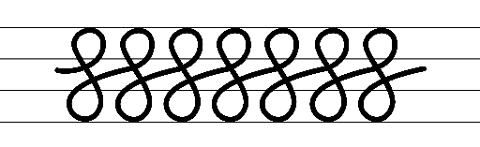  - Example letter formation  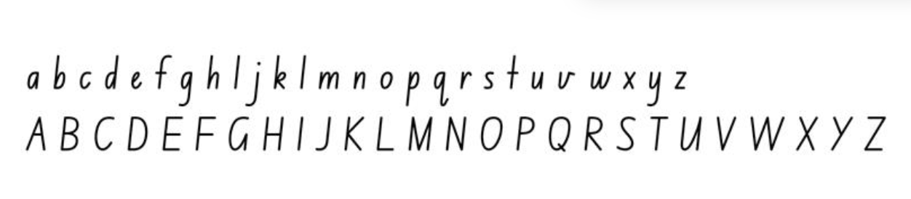  - Example numeral formation  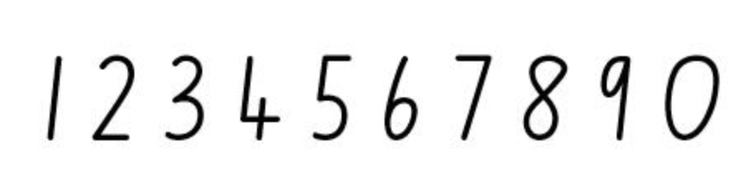  - Example punctuation formation  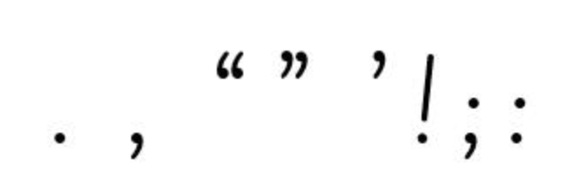  - Suggested practice text from the passage  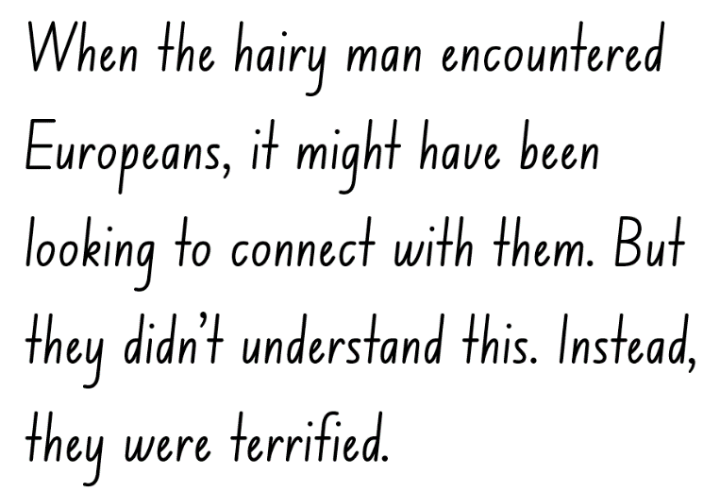
Handwriting legibility and fluency (Stage 2 Year 4)  - Join letters when writing familiar words  - Horizontally join letters when writing familiar words.  - Horizontal joins are used to join after the letters o, r, v, w and x: notice a slight dip in the horizontal join.  - Focus on horizontally joining to a short letter. | Handwriting legibility and fluency (Stage 2 Year 4)  - Suggested fluency pattern  - Example horizontal joins to a short letter  - Familiar words could include  - Suggested practice text from the passage  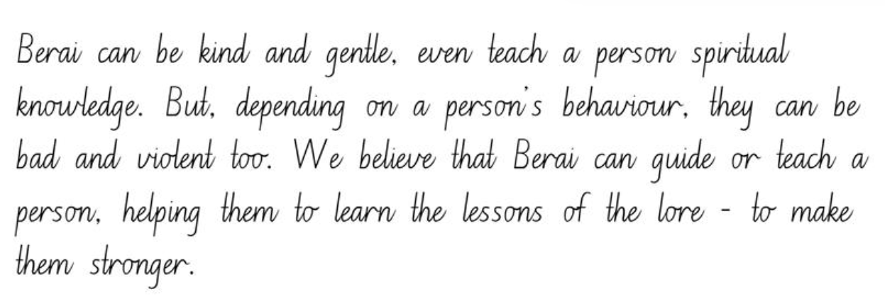
Handwriting and digital transcription  Handwriting legibility and fluency (Stage 3 Year 5)  - Sustain writing with a legible, fluent and personal handwriting style across a text  - Sustain legible and fluent handwriting across a text.  - Revise writing punctuation marks. | Handwriting and digital transcription  Handwriting legibility and fluency (Stage 3 Year 5)  - Suggested fluency pattern  - Suggested practice text from the passage  - Encourage students to evaluate their own handwriting after practising. For example, ask them to circle punctuation marks they believe are formed well.
Handwriting legibility and fluency (Stage 3 Year 6)  - Sustain writing with a legible, fluent and personal handwriting style across a text  - Write symbols to sustain legible and fluent handwriting across a text. | Handwriting legibility and fluency (Stage 3 Year 6)  - Suggested fluency passage  - Example symbols could include  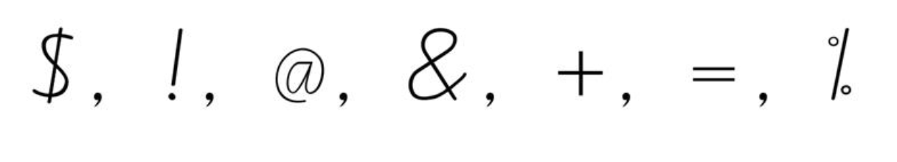  - Suggested practice text from the passage  - Other suggested practice texts could include  - a letter  - symbols from a mathematics lesson.

Planning framework
To plan and document Component A teaching and learning, a planning scaffold [DOCX 81 KB] is provided. To support you in your planning, a link to a detailed example of a one-week teaching and learning cycle is included in the scaffold. Additional resources to support teaching and learning in each focus area can be found at Lesson advice guides.

Component B teaching and learning
The following teaching and learning sequence has been designed to address Component B outcomes and content and develops conceptual understandings of English through the study of quality texts. Adapt the sequence as required to best meet the needs of your students.

Learning intentions and success criteria
Learning intentions and success criteria are best co-constructed with students. The table below contains suggested learning intention and success criteria.
Element | Stage 2 | Stage 3
Learning intention | Students are learning that authors make intentional choices about language, form and structure to control impact and effect. | Students are learning that an argument is influenced by perspective and to create texts that adopt a perspective beyond personal experience.
Success criteria | Students can:  - identify different structures and features of persuasive texts  - sequence argument points in paragraphs that begin with a topic sentence  - locate, select and retrieve information and consider accuracy of the information presented  - use gist statements to explain key ideas. | Students can:  - explore and analyse the effectiveness of persuasive devices  - use modality to qualify or strengthen arguments  - research and summarise information from a range of print and digital sources to plan for writing  - assess the reliability and authority of sources when researching.

Lesson 13 – guided planning for persuasive writing
The following teaching and learning activities support multi-age settings.

Whole
- Display a variety of persuasive texts around the classroom. For example, a speech, social media post, letter, advertisement, product review. In pairs, students walk around the classroom and consider the purpose of each text. Ask:
- What is the genre of the text?
- Why did the author write the text? What is their purpose?
- What structure and language choices does the author use to influence and engage the audience?
- How can we assess the authority, credibility and accuracy of the text?
- Use examples from the text, Yahoo Creek to model and revise sentence structures for persuasive effect. For example, the author’s use of declarative, interrogative, exclamatory and imperative sentences for providing facts, expressing strong emotion and/or engaging the audience with a particular point of view.
- Explain that students will compose a text to present the argument that the Yahoo is real. Discuss how the purpose of the text is to persuade the audience to take the position of the author.
- Co-construct success criteria for writing and where appropriate, differentiate for Stage 2 and Stage 3. For example:
- include a statement of position, sequenced arguments in paragraphs and a conclusion
- use declarative, interrogative and exclamatory sentences for effect
- use adverbial phrases and/or clauses to add information about verbs or verb groups
- use topic-specific Tier 2 and Tier 3 vocabulary to add credibility and enhance authority
- experiment (Stage 2) and use (Stage 3) modality to strengthen an argument
- use quoted and reported speech (Stage 2)
- use rhetorical devices, such as rhetorical questions and hyperbole to engage (Stage 3).
Note: this co-constructed success criteria will be referred to for the remainder of the unit.
- Display an enlarged brainstorming template. Use a variety of sources, including the mentor text, Yahoo Creek and additional news reports sourced from Trove, to brainstorm and record arguments that support the existence of the Yahoo.
- Think aloud to select and sequence arguments from most to least convincing and identify where specific persuasive devices are used to enhance the authority and credibility of the argument.
- Students Think-Pair-Share further arguments that support the existence of the Yahoo. Discuss student ideas and add to the brainstorming template used in activity 6.
- Display an enlarged persuasive writing scaffold. Explore the structure of a written persuasive text (introduction, sequenced arguments in paragraphs, conclusion).
- Discuss the purpose of the introduction. For example, an opening statement to inform the audience of the author’s position or point of view. Explain that the introduction sets the tone for the text and needs to be engaging, clear and persuasive.
- Display Resource 10 – exemplar text. Use the co-constructed success criteria to deconstruct the features of the introduction. Students annotate and record these features on their own copy of Resource 10 – exemplar text. For example, a clear statement of position, use of rhetorical questions to capture the audience's attention, previews supporting arguments that will be expanded in additional paragraphs, topic specific vocabulary to add credibility and enhance authority.
- Students use the persuasive writing scaffold to write an introduction to their own persuasive text about the existence of the Yahoo. Prompt students to refer to ideas recorded on the brainstorming template from activity 6.
Note: students will continue writing their persuasive text in Lesson 14.
Too hard? Co-construct an introduction with students. Provide students with sentence strips to sequence an introduction.
Too easy? Students identify the persuasive devices used in their introduction.

Lesson 14 – guided writing using persuasive devices
The following teaching and learning activities support multi-age settings.

Whole
- Revise the co-constructed success criteria from Lesson 13.
- Explain that students will write the supporting arguments and conclusion for their persuasive text about the existence of the Yahoo.
- Select and use an argument from activity 6 in Lesson 13 to model composing a paragraph for the first supporting argument. Use think-alouds to deconstruct the features of the paragraph. For example, begins with a topic sentence that states the argument, includes supporting details, topic-specific vocabulary and persuasive devices to add credibility and enhance authority. For example:
According to residents and tourists alike, the Yahoo has been spotted on numerous occasions. Eyewitnesses describe seeing a towering, hairy body, hovering in the shadows. One local resident, Angus MacLeod, reported "I was out for an early morning walk in the bush. I saw it with my own eyes, through a gap in the mist, a figure lingering by the edge of the tree line! I moved towards it, but it took fright and fled into the scrubland." These accounts, spanning decades, cannot be dismissed as mere fantasy. Experts have collected and analysed many eyewitness reports and have identified many similarities. This adds further credibility to the Yahoo’s existence.
- Students use their planning and persuasive writing scaffold from Lesson 13 to write the supporting arguments for their persuasive text. Encourage Stage 3 students to include additional rhetorical devices such as hyperbole to persuade their audience. For example, ‘Eyewitnesses describe seeing a towering hairy body...’
- Discuss the purpose and structure of the conclusion in a persuasive text. For example, restate the argument, briefly summarise the key points or arguments, language to appeal to the reader’s emotions or values, call to action or memorable closing statement.
- Co-construct a conclusion. Think aloud to restate the point of view presented, summarise key points, use persuasive devices and include a call to action or memorable closing statement. For example:
Whilst the existence of the creature known as the Yahoo remains shrouded in mystery, the combination of compelling eyewitness accounts and cultural stories suggests that there may indeed be more to the legend than meets the eye. The Yahoo serves as a testament to the enduring power of myth and legend in our cultural heritage, reminding us of the enchanting mysteries that still hide within the vast and unexplored corners of our world.
- Students write the conclusion for their persuasive text about the existence of the Yahoo on their persuasive writing scaffold.
- Provide time for students to use the success criteria to revise and edit their writing.
- Revise multimodal texts and discuss how visual features can add meaning and reinforce ideas. Brainstorm visual features that can be added to the text to reinforce and extend their ideas. Consider what features can add to the authority of text. For example, a photograph, map or a scientific diagram.
- Students create a multimodal text by adding a visual feature to expand meaning. For example, images, graph, timeline, map of reported sightings.

Lesson 15 – conducting research to plan for writing
The following teaching and learning activities support multi-age settings.

Whole
- Have students brainstorm and record mythical or elusive creatures that people report encountering. For example, the Loch Ness monster, Bigfoot, the Abominable Snowman, the Yeti. Consider any creatures that may be local to the school context.
- Explain that students will create a persuasive text on the existence or non-existence of another mythical or elusive creature.
- Students Think-Pair-Share their chosen creature and what their argument is. For example, the Loch Ness does not exist.
- Discuss strategies for locating, selecting and retrieving information from texts, using language associated with digital texts. Use a selection of print and digital sources to model how literal information can be sourced directly from a text, whilst inferences can be made by using multiple sources of information.
- Revise how to assess the reliability, accuracy and authority of information when researching, and prompt students to select evidence that supports their argument. For example, location of reported sightings, interviews with eyewitnesses.
- Display Resource 11 – research scaffold and revise the use of gist statements to support summarisation.
- Students research their chosen mythical or elusive creature, and record key ideas (gist statements) of relevant information, acknowledging source(s) of information on Resource 11 – research scaffold. Ensure students record topic-specific Tier 2 and Tier 3 vocabulary to support their writing.
Too hard? Scaffold student research by selecting information and providing a list of reliable digital sources for students to access.
- Select students to share their gist statements from their initial research and discuss whether they support their position in the argument. Encourage Stage 3 students to check the accuracy of their recorded gist statements.
Stage 2 Assessment task 3 – observations and work samples from this lesson allow students to demonstrate achievement towards the following syllabus outcomes and content points:
EN2-VOCAB-01 – builds knowledge and use of Tier 1, Tier 2 and Tier 3 vocabulary through interacting, wide reading and writing, and by defining and analysing words
- understand and use language associated with digital texts.
EN2-RECOM-01 – reads and comprehends texts for wide purposes using knowledge of text structures and language, and by monitoring comprehension
- locate, select and retrieve relevant information from a print or digital text and consider accuracy of information presented
- understand that literal information can be sourced directly from a text and that inferences can be made by using multiple sources of information
- make gist statements and record them to monitor understanding.
Stage 3 Assessment task 4 – observations and work samples from this lesson allow students to demonstrate achievement towards the following syllabus outcomes and content points:
EN3-RECOM-01 – fluently reads and comprehends texts for wide purposes, analysing text structures and language, and by monitoring comprehension
- efficiently follow signposting features to navigate print and digital texts
- select texts from print or digital sources to gather and organise research on a topic
- check the accuracy of own recorded gist statements made during reading, before summarising information to determine a text’s main themes, ideas or concepts.
EN3-CWT-01 – plans, creates and revises written texts for multiple purposes and audiences through selection of text features, sentence-level grammar, punctuation and word-level language
- assess the reliability and authority of sources, including digital sources, when researching and acknowledging texts.

Lesson 16 – planning and drafting the introduction of a persuasive text
The following teaching and learning activities support multi-age settings.

Whole
- In pairs or small groups, students discuss the creature they are writing about, their main arguments to support or deny its existence, and how they will add authority to their text.
- Display and review the co-constructed success criteria developed in Lesson 13. Discuss any criteria that could be added, such as the use of multimodal features including images, graphs, timelines and maps to add meaning to texts.
- Students review their recorded information from Lesson 15 and use it to group information into supporting arguments. Prompt students to refer to the co-constructed success criteria and ensure they have the information required to write persuasively and with authority. For example, include information from experts that includes topic-specific Tier 2 and Tier 3 vocabulary.
- Provide time for additional research as needed.
- Students use the persuasive writing scaffold to organise their research and plan their persuasive text.
- In pairs, students share their research and use the co-constructed success criteria to provide feedback on their partner’s plan. Students refine their plan based on peer feedback. Provide time for additional research as needed.
- Display the deconstructed exemplar text from Lesson 13 to revise the features of the introduction in a persuasive text.
- Students draft and compose the introduction for their persuasive text. Encourage students to re-read and revise their writing, referring to co-constructed success criteria to strengthen their ideas.
Too hard? Work with a small group of students to co-construct an introduction. Provide students with sentence stems to support their writing.
- Explain that students will continue drafting and composing their text in Lesson 17.

Week 5

Component A teaching and learning
Component A focuses on the development of foundational skills and knowledge through regular, systematic and repeated practice. The mentor and supporting texts used in Component B of this unit can support the effective implementation of Component A teaching and learning.

Teaching guide
Guidance for explicit teaching, teaching notes, resources and examples for the related outcomes and content points have been provided in the table below.
Focus areas and teaching notes | Resources and examples
Reading fluency  Reading automaticity and rate (Stage 2)  - Demonstrate use of navigation pathways to support fluency when engaging with print, visual and multimodal texts  - Navigation pathways refer to the paths followed while moving through the content of a text. They involve navigating the text to support fluency in a way that does not disrupt the overall comprehension and allows the reader to engage with print, visual and multimodal texts. | Reading fluency  Reading automaticity and rate (Stage 2)  - Fluency and close reading passage: Yahoo Creek from 'The creature...’ (Sydney Morning Herald 11 December 1866) until ‘...in the mountains there’ (Sydney Morning Herald 8 June 1935) (164 words)  Note: the passage from the text will need to be a teacher-created resource.  - The passage selected is positioned on left-hand page of the double-spread. The articles are depicted as actual newspaper clippings. The reader moves through the content from top to bottom, attending to the illustration on the right.
Monitoring reading fluency (Stage 2)  - Recognise that there are different purposes and audiences for reading and adjust reading rate to suit a text’s purpose  - Reading rate for literacy texts may depend on the use of expression, pausing, emphasis and the author’s use of phrasing  - Reading rate for informative texts may depend on the vocabulary used. For example, Tier 3 technical and subject specific vocabulary may require the reader to slow down. | Monitoring reading fluency (Stage 2)  - The purpose of reading this passage is to gain further information about the physical appearance and behaviour of the Yahoo, according to accounts published in various newspapers. Reading rate may be adjusted:  - to add expression for emotive words and phrases. For example, ‘caused much alarm...’, horrible yelling’, ‘...capable of tearing down small trees...’  - to accurately read Tier 2 and 3 words. For example, ‘stone-breakers’, ‘district’, ‘douligah’.
Reading comprehension  Monitoring comprehension (Stage 2)  - Make gist statements and record them to monitor understanding  - Gist statements are succinct notes that summarise what has been read. They may be recorded in print or digitally. | Reading comprehension  Monitoring comprehension (Stage 2)  - Suggested examples of gist statements  - The creature with shaggy black hair caused fear among stone-breakers and road makers.  - The ‘hairy man’ is capable of tearing down trees and lifting rocks.  - He lives in the mountains and is believed by Aboriginal people to exist.
Comprehending text structures and features (Stage 2)  - Understand that literal information can be sourced directly from a text and that inferences can be made by using multiple sources of information  - Literal information: Having only the most direct meaning (NESA 2023).  - Inference: A conclusion reached on the basis of evidence and reasoning (NESA 2023). | Comprehending text structures and features (Stage 2)  - Suggested examples from the passage  - Literal information: The creature was covered with shaggy black hair and made a horrible yelling sound.  - Inference: The Hairy man's ability to tear down trees and lift rocks implies immense strength and power.
Reading comprehension  Reading fluently (Stage 3)  - Efficiently follow signposting features to navigate print and digital texts  - Signposting features refer to elements that guide the reader through the structure and content of a text. These features serve as ‘signposts’ that indicate the direction the text is taking and help the reader follow along. | Reading comprehension  Reading fluently (Stage 3)  - Suggested example of signposting from the passage  - The use of ellipses creates emphasis and intrigue, inviting the reader to continue reading to find out more about the creature's behaviour ‘He had hair all over his body, and… he remained in the mountains during daylight…’
Monitoring comprehension (Stage 3)  - Check the accuracy of own recorded gist statements made during reading, before summarising information to determine a text’s main themes, ideas or concepts.  - To check accuracy, students may review the original source, compare with supporting details, cross-reference with a peer. | Monitoring comprehension (Stage 3)  - Students need to check the accuracy of their recorded gist statements and ensure the reliability of their summaries when determining a passage’s main themes, ideas, or concepts. This may include revisiting the passage.
Vocabulary  Learning and using words (Stage 2)  - Describe how modal words indicate degrees of probability, occurrence, obligation and inclination  - Modal words are a specific group of auxiliary verbs that modify the main verb in a sentence. Modal verbs express various shades of meaning including:  - Probability: certainly, surely, definitely  - Occurrence: always, never, consistently  - Obligation: ought to, should, may  - Inclination: want, wish, would like to (NESA 2023).  - They help convey the writer’s attitude, certainty or necessity regarding the action or state being described. | Vocabulary  Learning and using words (Stage 2)  - Suggested vocabulary from the passage  - ‘...believed that one lived in the mountains there...’ (probability)  - ‘When the hairy man encountered Europeans it might have been looking to connect with them. (probability)
Vocabulary  Learning and using words (Stage 3)  - Identify and use words that convey subjective, emotive and persuasive meanings in texts  - Subjective language is used to convey personal opinions or beliefs. It reflects the perspective of the individual to the reader or audience.  - Emotive language is specifically selected to evoke strong emotions, reactions or feelings from the reader or audience.  - Persuasive language is used to convince the reader to agree with a particular point of view.  - Use metalanguage when discussing language features encountered in texts  - Metalanguage includes the technical terms used to describe and discuss how language and texts function (NESA 2023). | Vocabulary  Learning and using words (Stage 3)  - Suggested examples of words from the passage that convey subjective, emotive and persuasive meaning  - Subjective: ‘It made a most horrible yelling’, ‘This creature evidently belongs to the ape type’, ‘They describe the douligah as a man of powerful build...’  - Emotive: ‘caused much alarm’, ‘most horrible yelling’  - Persuasive: ‘This creature evidently belongs to the ape type.’  - Suggested metalanguage to use when discussing language features encountered in the passage  - Simile: ‘The whole of his body is hard and sinewy, like wood to the touch.’  - Adjectives: ‘shaggy black hair’, ‘powerful build’  - Proper nouns: ‘Sydney Morning Herald’, ‘Twofold Bay’.
Defining and analysing words (Stage 3)  - Evaluate the effectiveness of modal words used in texts to intensify or soften emotional responses  - Modal words are verbs or auxiliary verbs that modify or indicate the mood or attitude of the verb in a sentence. | Defining and analysing words (Stage 3)  - As above, see Stage 2 Vocabulary examples.
Spelling  Phonological component (Stage 2)  - Explain how to segment multisyllabic words into syllables and phonemes, and apply this knowledge when spelling  - Revise segmenting multisyllabic words into syllables and phonemes. This is a phonological skill that should be practised regularly.  - Identify differences in vowel phonemes (short, long, diphthong and schwa vowels)  - Identify long vowel phoneme /oo/ within focus words.  - Identify short vowel phonemes /o/, /i/, /u/ within focus words. | Spelling  Phonological component (Stage 2)  - Consolidate previous 4 weeks of learning.
Orthographic component (Stage 2)  - Understand that some graphemes are dependent on their position in a word in English and apply this knowledge when spelling  - Consider the position of graphemes that represent /oo/, /o/, /i/ and /u/ in words as per previous 4 weeks of learning.  - Proofread, identify and correct misspellings when creating texts  - Review proofreading by identifying and correcting misspellings when creating written texts. Proofreading, and identifying and correcting misspellings, should be practised regularly. | Orthographic component (Stage 2)  - As above  - Writing produced in Component B could be utilised, or a passage of text featuring words with target phonemes or inflected suffixes.
Morphological component (Stage 2)  - Identify inflected suffixes, explaining when and how to treat base words when they are affixed, and apply this knowledge when spelling  - Review inflected suffixes:  - plural (-s, -es)  - tense (-s, -ing, -ed)  - comparative (-er) and superlative (-est). | Morphological component (Stage 2)  - As above
Spelling  Phonological component (Stage 3)  - Segment unfamiliar multisyllabic words into syllables and phonemes as a strategy when spelling  - Revise segmenting unfamiliar multisyllabic words into syllables and phonemes as a strategy when spelling. | Spelling  Phonological component (Stage 3)  - Consolidate previous 4 weeks of learning.
Orthographic component (Stage 3)  - Recognise that the same grapheme can represent different phonemes  - Review different phonemes represented by graphemes [o], [ar], [g].  - Proofread written texts to correct misspellings, making use of spelling reference tools where required  - Proofread by identifying and correcting misspellings when creating written texts.  - Spelling reference tools may include word walls, print or online dictionaries and assistive technologies. | Orthographic component (Stage 3)  - As above  - Writing produced in Component B could be utilised, or a passage featuring target morphology or orthography.
Morphological component (Stage 3)  - Explain and use spelling conventions to add derivational suffixes such as -ion, -ian, -ence, -ous to base words or roots  - Revise derivational suffixes: -ssion, -ity, -ety, -ty, -al, -ly, -ally. | Morphological component (Stage 3)  - As above
Creating written texts  Sentence-level grammar (Stage 2)  - Use exclamatory sentences to emphasise a point or express a strong emotion  - A statement expressing a strong emotion, formed as a complete sentence, and often ending with an exclamation mark (NESA 2023).  - Use interrogative sentences to ask a direct question, or for rhetorical effect to engage the reader with a viewpoint  - A sentence that asks a direct or indirect question (NESA 2023).  - Understand and use quoted and reported text or speech in own writing  - Use quotation marks for quoted text: “We climbed the mountain in record time!”  - Do not use quotation marks for reported text: The mountaineers said that they climbed the mountain in record time. | Creating written texts  Sentence-level grammar (Stage 2)  - Suggested example of an exclamatory sentence innovated from the passage  - What a truly astonishing creature, causing such fear and alarm with its shaggy black hair and horrible yelling!  - Suggested example of an interrogative sentence innovated from the passage  - Could it be that these mysterious creatures are connected to the ape type?  - Suggested example of quoted and reported speech innovated from the passage  - “The creature… has caused much alarm to the whole camp!” exclaimed the stone-breakers.  - In the Sydney Morning Herald article, they describe the douligah as a man of powerful build who is capable of tearing down small trees and lifting great rocks.
Creating written texts  Sentence-level grammar (Stage 3)  - Experiment with the placement of adverbial clauses, to modify the meaning or to add detail to a verb or verb group  - Review adverbial phrases.  - Review adverbial clauses.  - Make choices about the use of declarative, exclamatory, interrogative and imperative sentences to suit text purpose, and for meaning and effect  - Declarative sentences are statements presented as a complete sentence to provide fact, evidence or detail.  - Exclamatory sentences are statements expressing a strong emotion, formed as a complete sentence, and often ending with an exclamation mark.  - Interrogative sentences ask a direct or indirect question.  - Imperative sentences convey a direct command, request, invitation, warning or instruction, typically directed to an implied person (NESA 2023). | Creating written texts  Sentence-level grammar (Stage 3)  - Suggested example of an adverbial clause innovated from the passage  - The powerful douligah lifts great rocks as though they are grains of sand. (how)  - Suggested examples of declarative, exclamatory, interrogative and imperative sentences innovated from the passage:  - Declarative: The Aboriginal People in this district are aware of the existence of these animals.  - Exclamatory: What a horrible yelling it made!  - Interrogative: Were there a great number of these creatures some time ago?  - Imperative: Be cautious around the creature and its shaggy black hair.
Handwriting and digital transcription  Software functionalities and typing (Stage 2 Year 3)  - Position a chosen device in a way that facilitates efficient and sustained text creation  - Students are learning to position a device or monitor at an appropriate height and angle.  - Revise the position of device or monitor at appropriate eye level to support good posture. | Handwriting and digital transcription  Software functionalities and typing (Stage 2 Year 3)  - Introduce the use of external accessories such as keyboard and mouse to support ergonomic.
Software functionalities and typing (Stage 2 Year 4)  - Monitor goals that build on typing accuracy and rate  - Monitor goals to build on typing accuracy and rate.  - Use knowledge of the keyboard layout using the home, top and bottom row to build on typing accuracy and rate. | Software functionalities and typing (Stage 2 Year 4)  - Focus on:  - letters  - letter combinations.
Handwriting and digital transcription  Software functionalities and typing (Stage 3 Year 5)  - Navigate the keyboard with efficiency and accuracy when typing words, numerals, punctuation and other symbols  - Navigate the keyboard efficiently when typing numerals. | Handwriting and digital transcription  Software functionalities and typing (Stage 3 Year 5)  - Type numerals using the numeral row and the numeric keypad.
Software functionalities and typing (Stage 3 Year 6)  - Navigate the keyboard with efficiency and accuracy when typing words, numerals, punctuation and other symbols  - Navigate the keyboard with efficiency when typing punctuation marks. | Software functionalities and typing (Stage 3 Year 6)  - Suggested punctuation marks could include: !, ?, “”,  - Students practice touch typing punctuation symbols using a passage from the mentor and or supporting text.

Planning framework
To plan and document Component A teaching and learning, a planning scaffold [DOCX 81 KB] is provided. To support you in your planning, a link to a detailed example of a one-week teaching and learning cycle is included in the scaffold. Additional resources to support teaching and learning in each focus area can be found at Lesson advice guides.

Component B teaching and learning
The following teaching and learning sequence has been designed to address Component B outcomes and content and develops conceptual understandings of English through the study of quality texts. Adapt the sequence as required to best meet the needs of your students.

Learning intentions and success criteria
Learning intentions and success criteria are best co-constructed with students. The table below contains suggested learning intention and success criteria.
Element | Stage 2 | Stage 3
Learning intention | Students are learning to plan, draft, revise and publish a persuasive multimodal text. | Students are learning to plan, draft, revise and publish a multimodal text to persuade an audience and demonstrate authority.
Success criteria | Students can:  - sequence arguments in paragraphs that begin with a topic sentence  - select and use multimodal features to add meaning  - use success criteria to provide peer feedback and refine writing  - state a reasoned argument in a presentation  - identify the evidence a speaker provides to support their point of view. | Students can:  - use words that convey subjective, emotive and persuasive meanings in texts  - experiment with multimodal features to reinforce and extend ideas  - reflect on and assess the authority of texts and use success criteria to refine writing  - present multimodal arguments that include research and references, topic specific vocabulary and persuasive devices appropriate to audience.

Lesson 17 – drafting and composing a persuasive text
The following teaching and learning activities support multi-age settings.

Whole
- Display the co-constructed success criteria from Lesson 13.
- Students reflect on the introduction of their persuasive text from Lesson 16 . Ask:
- Is there a clear statement of position?
- Are the supporting arguments introduced?
- Does the text have authority? Why or why not?
- Use examples from the text Yahoo Creek to model and revise how authors enhance authority and engage the reader. For example, quoted and reported speech to enhance authority, modality and rhetorical devices to strengthen arguments.
- Students draft and compose the body paragraphs of their persuasive text from Lesson 16. When writing body paragraphs, remind students to use correct paragraph structure. For example, topic sentence with supporting evidence.
- Revise the purpose of a conclusion (to sum up the author’s position). Students draft and compose their conclusion. When writing the conclusion, remind students to restate the argument, briefly summarise the key points or arguments, use language to appeal to the reader’s emotions or values, and finish with a call to action or memorable closing statement.
- Encourage students to re-read and revise their writing throughout the drafting and composing phase. Students refer to the co-constructed success criteria to strengthen their ideas.
Too hard? Co-construct or provide a detailed scaffold to support students’ writing.

Lesson 18 – using feedback to edit and improve writing
The following teaching and learning activities support multi-age settings.

Whole
- Provide time for students to finish drafting their persuasive text from Lesson 16 and Lesson 17.
- Revisit learning from Component A about proofreading and editing. Discuss the difference between revising and editing. For example, editing involves making changes to spelling and punctuation while revising involves looking over the writing as a whole and reworking the organisation and details. Grammatical features, text structure and language choices are also considered during the revising stage.
- Encourage students to reflect on the structure of the text and ensure it has an introduction, body paragraphs and a conclusion, and the established codes and convention of a persuasive text (Stage 3). Students use the co-constructed success criteria from Lesson 13 to edit, revise and improve their persuasive text.
- Select a peer feedback protocol for students to use. In pairs, students use the success criteria to provide feedback.
- Provide time for students to edit and revise their writing based on their feedback.
Stage 2 Assessment task 4 – observations and work samples from this lesson allow students to demonstrate achievement towards the following syllabus outcome and content points:
EN2-CWT-03 – plans, creates and revises written texts for persuasive purposes, using text features, sentence-level grammar, punctuation and word-level language for a target audience
- sequence argument points in paragraphs that begin with a topic sentence and support the development of ideas
- experiment with modality to modulate an argument for persuasive effect
- use adverbial phrases or clauses to add information to the verb or verb group of the main or other clauses, to provide reasons for or circumstances
- use declarative sentences to provide facts or state a viewpoint
- use exclamatory sentences to emphasise a point or express a strong emotion
- use interrogative sentences to ask a direct question, or for rhetorical effect to engage the reader with a viewpoint
- understand and use quoted and reported text or speech in own writing
- use topic-specific Tier 2 and Tier 3 vocabulary to demonstrate authority.
Stage 3 Assessment task 5 – observations and work samples from this lesson allow students to demonstrate achievement towards the following syllabus outcomes and content points:
EN3-CWT-01 – plans, creates and revises written texts for multiple purposes and audiences through selection of text features, sentence-level grammar, punctuation and word-level language
- choose text formats with appropriate text structures, features and language to persuade a target audience
- use rhetorical devices targeted to the audience
- use modality to qualify or strengthen arguments
- experiment with the placement of adverbial clauses, to modify the meaning or to add detail to a verb or verb group
- make choices about the use of declarative, exclamatory, interrogative and imperative sentences to suit text purpose, and for meaning and effect
- use topic-specific Tier 2 and Tier 3 vocabulary intentionally to add credibility and enhance authority.
EN3-UARL-02 – analyses representations of ideas in literature through genre and theme that reflect perspective and context, argument and authority, and adapts these representations when creating texts
- recognise how an argument is influenced by perspective and create texts that adopt a perspective beyond personal experience.

Lesson 19 – multimodal features to enhance meaning
The following teaching and learning activities support multi-age settings.

Whole
- Revise multimodal texts as texts that combine 2 or more expressive modes to communicate.
- Review Yahoo Creek and the Kids News article. Discuss and analyse the visual features in each text. Ask students:
- What visual features are used and why might the authors have selected these? For example, news reports are presented as newspaper clippings, illustrations are only 2 colours, photographs of mountains and museum models.
- How do the visual features add meaning? What makes you think that?
- Do the visual features enhance the authority of the text? Why or why not?
- Explore digital tools that can be used to publish students’ texts. For example, Canva for Education, Microsoft PowerPoint or Google Slides. As a class, evaluate the effectiveness of different tools in creating an engaging digital text. Encourage students to use language associated with digital texts (Stage 2).
- Using a student writing sample, select a digital tool and model creating a multimodal text. Model adding visual elements such as photographs, maps and newspaper clippings to expand meaning and enhance the authority of the text.
- Students publish a multimodal text by combining their persuasive text with visual elements to expand meaning and enhance the authority of the text.

Lesson 20 – publishing and presenting
The following teaching and learning activities support multi-age settings.

Whole
- Students finalise publication of their multimodal persuasive texts.
- Explain that students will share their text and present their arguments to their peers. Review Lesson 1 on how behaviour can change and adapt in different situations. Discuss agreed-upon class expectations and roles during interactions. For example:
- An active listener will maintain eye contact with the presenter, listen attentively, use positive body language and avoid distractions. They may take notes, ask questions, and provide constructive feedback at the end of the presentation.
- The presenter will effectively communicate their arguments, maintain eye contact, speak clearly, and manage their time effectively.
- Using the agreed upon expectations, provide time for students to practise their presentation.
- In small groups, students take turns presenting their multimodal text. After each presentation, students reflect on the arguments and key evidence provided by each speaker and consider the authority of the arguments. Using the success criteria, students provide written feedback to their peer on a sticky note. Encourage Stage 3 students to evaluate the effectiveness of rhetorical questions used by their peers.
- Students complete a self-assessment to reflect on their presentation using the peer feedback provided. Ask:
- What are some things you did successfully?
- What are some things you could improve upon?
- Students reflect on their understanding of argument and authority using an exit ticket. Ask guiding questions, such as:
- What did you learn about argument? Why is this learning important? Where else can you apply this learning?
- What did you learn about authority? Why is this learning important? Where else can you apply this learning?
Stage 2 Assessment task 5 – observations and work samples from this lesson allow students to demonstrate achievement towards the following syllabus outcomes and content points:
EN2-OLC-01 – communicates with familiar audiences for social and learning purposes, by interacting, understanding and presenting
- identify contexts in which social conventions can vary and influence interactions
- identify the evidence a speaker provides to support a particular point of view
- state a reasoned argument in a presentation about learning area content, to a familiar audience
- include multimodal features in planned and delivered presentations, to expand meaning and engage an audience.
EN2-CWT-03 – plans, creates and revises written texts for persuasive purposes, using text features, sentence-level grammar, punctuation and word-level language for a target audience
- select and use multimodal features to add meaning.
Stage 3 Assessment task 6 – observations and work samples from this lesson allow students to demonstrate achievement towards the following syllabus outcomes and content points:
EN3-OLC-01 – communicates to wide audiences with social and cultural awareness, by interacting and presenting, and by analysing and evaluating for understanding
- identify varying social conventions that influence interactions across wide audiences
- apply active listening strategies by retelling or repeating what another person has expressed and by building on what has been said
- evaluate the effectiveness of rhetorical questions used for intentional effect
- present multimodal arguments that include research and references, topic-specific vocabulary and the selection of persuasive techniques appropriate to audience.
EN3-CWT-01 – plans, creates and revises written texts for multiple purposes and audiences through selection of text features, sentence-level grammar, punctuation and word-level language
- choose multimodal features suited to a target audience and purpose, to reinforce and extend ideas.

Resource 1 – authority evaluation checklist
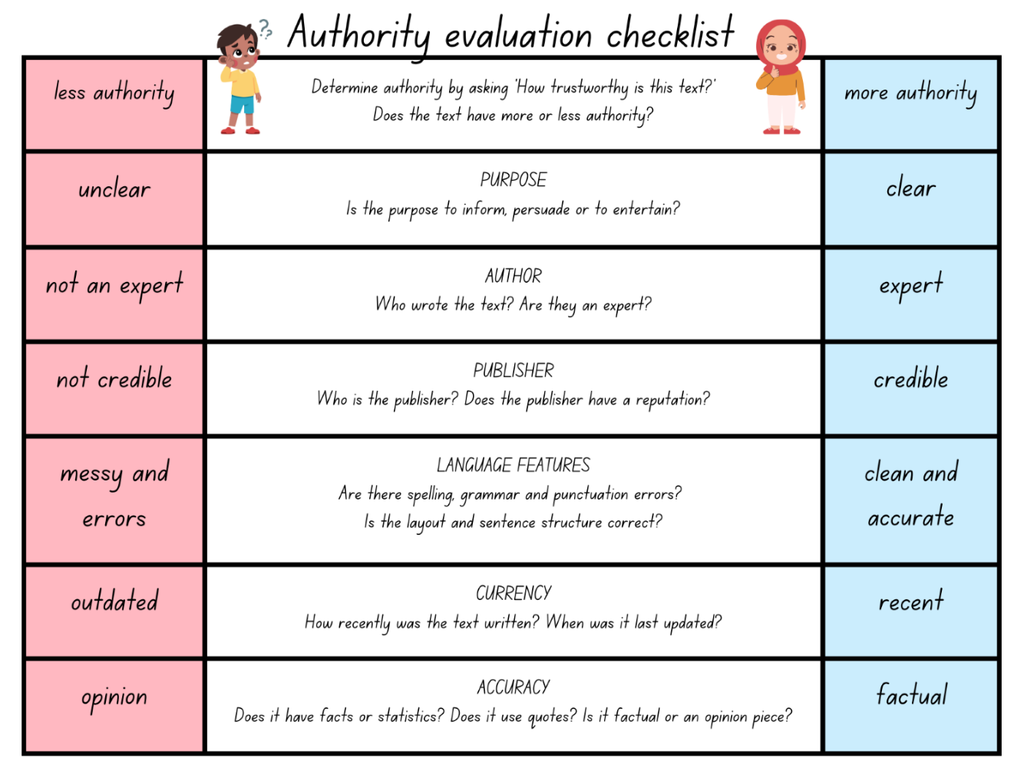

Resource 2 – diamond ranking organiser
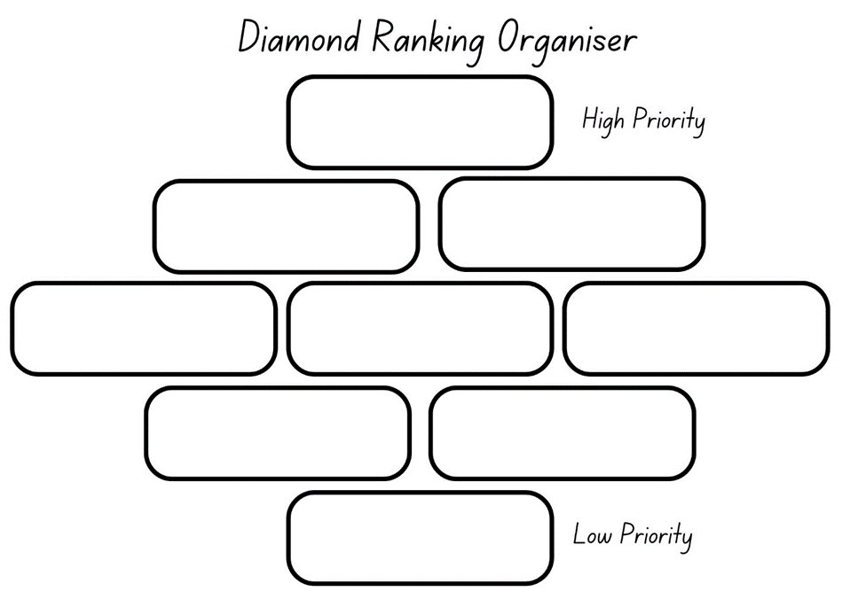

Resource 3 – argument and perspective
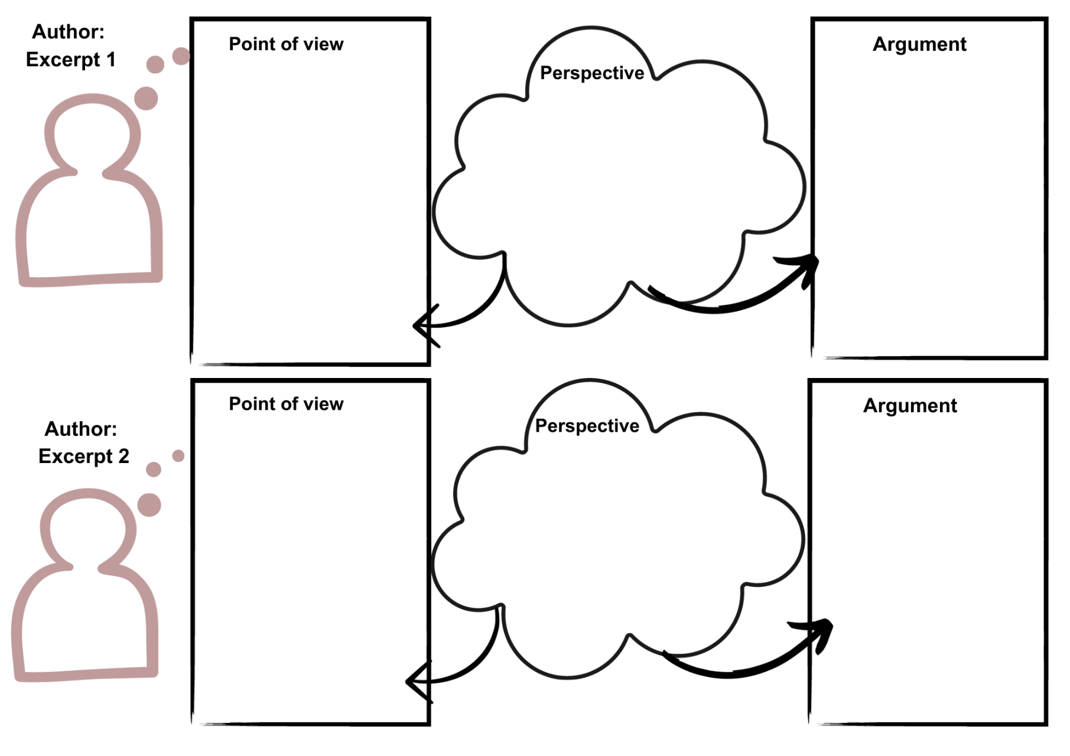

Resource 4 – fluency and close reading passage analysis (Week 2)
Focus | Notes
Passage | Yahoo Creek: from the 'Who has not heard... (Newcastle Morning Herald and Miners’ Advocate) until '...with their tails between their legs.’ (Freeman’s Journal) (208 words)
Synopsis | The newspaper reports follow a chronological and consistent format, presenting a series of firsthand accounts and observations about the Hairy Man. The reports show different perspectives and experiences.  - Newcastle Morning Herald and Miners’ Advocate: this newspaper report reflects on the Aboriginal people’s accounts of an otherworldly creature, often referred to as the Yahoo-Devil Devil or the Hairy Man of the Wood.  - Mercury: this newspaper report discusses how bushmen on different occasions claimed to have encountered a large, ape-like creature. Despite these reported sightings, the creature consistently evaded capture.  - Bombala Times: this report explores firsthand accounts where credible individuals claim to have encountered a hairy, human-shaped creature at close range. The encounters were so alarming that witnesses abandoned their work due to the creature's frightening appearance and unsettling noises. Notably, descriptions of this animal, witnessed by various people on separate occasions, consistently matched.  - Freeman’s Journal: the passage describes a shepherd who claimed to have encountered a creature resembling a hairy man in scrub north of Cunningham's Creek. The creature stood upright, covered in hair and terrified the shepherd's dogs.
Passage structure | - Each newspaper article builds on the information and description of the ‘hairy man’.  - Different text boxes are used to emphasise that the information presented is taken from different newspaper clippings.  - It combines visual illustrations and written text. The combination of text and illustration, adds to the mysterious nature of the text, while supporting the descriptions given of the ‘hairy man’.  - It includes eyewitness accounts or testimonies from individuals who claim to have witnessed encounters with the creature. These accounts vary in detail and come from different perspectives, such as Aboriginal people, bushmen, shepherds, or reliable men. The witnesses describe their observations of the creature, its appearance, behaviour, and the circumstances of the encounter.  - The reports include details about the creature’s characteristics and appearance such as being hairy, man-shaped, or ape-like. These details contribute to building the image of the creature in the reader's mind.  - Some reports convey the emotional impact of the encounters on the witnesses. They describe feelings of terror, fear, or astonishment experienced by those who encountered the creature.  - The reports often highlight the consistency of the descriptions given by different witnesses who encountered the creature separately and at different times to validate the accounts.  - Each report concludes by specifying the source of the information, which is usually a newspaper, along with the date of publication. This adds a sense of authenticity and historical context to the accounts.
Language features | - Rhetorical question: the first report begins with a rhetorical question (‘Who has not heard...’) to engage the reader and evoke a sense of familiarity with the topic, emphasising the long-standing nature of the creature's presence.  - Descriptive language: each report uses descriptive language to vividly depict the creature's appearance and behaviour. Phrases like ‘unearthly animal’, 'inhuman creature’, ‘immense ape-like animal’, and ‘hairy man-shaped animal’ paint a detailed picture in the reader's mind.  - Repetition: the phrase ‘Yahoo-Devil Devil, or the Hairy Man of the Wood’ uses repetition to create a memorable and evocative description of the creature.  - Emotive language: emotive language is used to convey the emotional impact of the encounters. Words like ‘terrified’, ‘hideous noise’, ‘frightened’, and ‘tails between their legs’ evoke strong feelings and help the reader connect with the witnesses' experiences.

Resource 5 – fluency and close reading passage analysis (Week 3)
Focus | Notes
Passage | Yahoo Creek: Peter Williams Ngiyampaa Elder, North West NSW from ‘We call the big fella...’ to ‘...because he let them go!’ (126 words)
Synopsis | The passage provides insights into the cultural significance and physical attributes of the berai and yuriwirrina as understood by the Ngiyampaa people, offering a unique perspective on these creatures.  Peter Williams, a Ngiyampaa Elder from North West NSW, provides a description of the berai and yuriwirrina, which are creatures of significance in their culture. The berai is depicted as a tall, human-like figure standing about nine feet tall with wide shoulders and reddish hair all over its body. Despite its human-like appearance, the berai is distinct with its powerful hands and a unique scream. Yuriwirrina, described as a smaller entity, is only a few feet tall, but possesses considerable strength. Williams emphasises that, to his people, the berai and yuriwirri are both spiritual figures and physical creatures.
Passage structure | - Introduction: Peter Williams introduces the subject: "We call the big fella berai."  - Description of Berai: ‘Berai looks pretty much human’, ‘nine feet tall, with wide shoulders’, ‘his arms don’t hang down as low as some people say’, ‘he has reddish hair all over and very large, powerful hands.’  - Introduction and description of Yuriwirrina: ‘There is a little fella too’, ‘though yuriwirrina are little they are still very strong.’  - Explanatory statement: ‘If someone escapes from a hairy man it is because he let them go!’  - Attribution: crediting the source, ‘By Peter Williams, Ngiyampaa Elder, North West NSW.’
Language features | - Descriptive language to vividly depict the appearance of berai: ‘Berai looks pretty much human...’  - Cultural terminology: ‘We call the big fella berai...’  - Similes: ‘His scream is like nothing else’, ‘a strong smell like a wet dog.’  - Sensory language: ‘His scream is like nothing else...’, ‘a strong smell like a wet dog...’  - Exclamatory sentences: ‘If someone escapes from a hairy man it is because he let them go!’

Resource 6 – question matrix
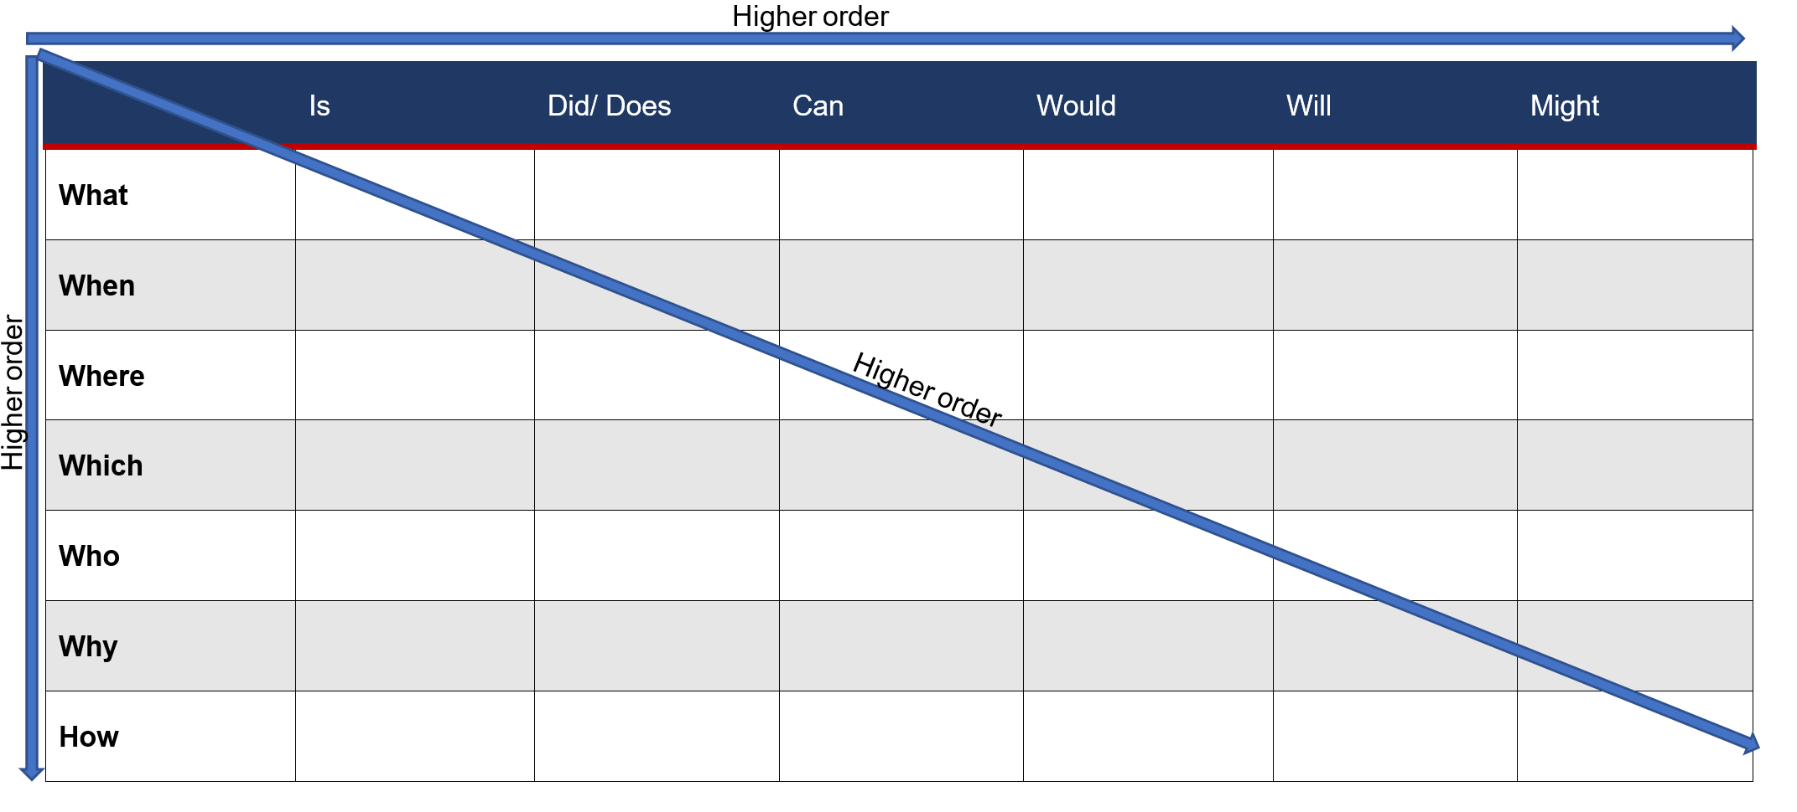

Resource 7 – matching rhetorical devices
Match the rhetorical device to its correct definition and record an example for each.
Rhetorical device | Definition
Rhetorical questions | Exaggeration to make something seem more exciting or dramatic. It adds emphasis and creates a strong effect.
Hyperbole | Way of describing something by saying it is something else. It helps paint a picture in our minds and makes comparisons.
Repetition | Comparison between 2 things using ‘like’ or ‘as’. Similes help to show similarities and make descriptions more vivid.
Metaphor | Questions that are asked to provoke thought rather than require an answer. They are used by speakers and writers to make a point or emphasise an idea.
Similes | Words in a sentence or phrase that start with the same sound. It makes the words sound catchy and helps them stick in our minds.
Alliteration | Words or phrases are repeated to make a point or make something more memorable. It helps to emphasise a message.

Resource 8 – rhetorical devices table
Record examples of rhetorical devices.
Rhetorical device | Teacher example | Student created examples
Rhetorical questions
Hyperbole
Metaphors
Similes
Repetition
Alliteration

Resource 9 – Goulburn Evening Penny Post article
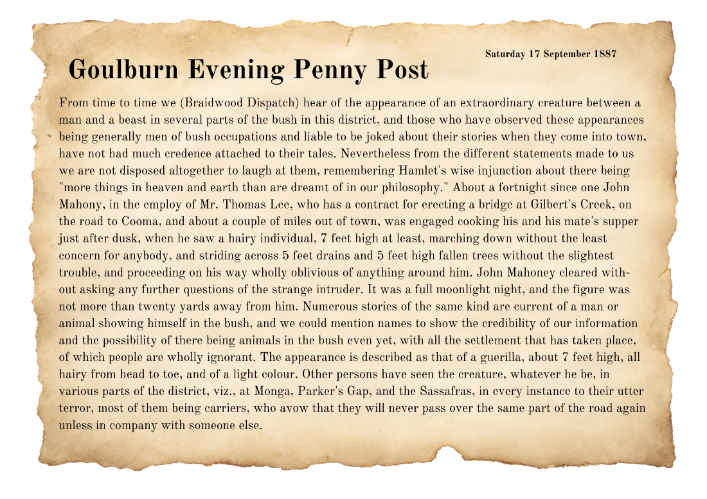
Source: Goulburn Evening Penny Post

Resource 10 – exemplar text
Use the success criteria in Lesson 13 to deconstruct the introduction from a persuasive text.
Title | The Yahoo: More than just a myth!
Introduction | Have you heard the tales of a creature lurking deep within the Australian bush? Tales of the Yahoo have intrigued and mystified for generations, with countless sightings recorded over many years. While some dismiss it as a tall tale, the cultural stories of the Ngiyampaa people support the elusive creature’s existence. The Yahoo is more than just a myth.

Resource 11 – research scaffold
Source | Key information

References
This resource contains NSW Curriculum and syllabus content. The NSW Curriculum is developed by the NSW Education Standards Authority. This content is prepared by NESA for and on behalf of the Crown in right of the State of New South Wales. The material is protected by Crown copyright.
Please refer to the NESA Copyright Disclaimer for more information. https://educationstandards.nsw.edu.au/wps/portal/nesa/mini-footer/copyright
NESA holds the only official and up-to-date versions of the NSW Curriculum and syllabus documents. Please visit the NSW Education Standards Authority (NESA) website https://educationstandards.nsw.edu.au/ and the NSW Curriculum website https://curriculum.nsw.edu.au
English K–10 Syllabus © NSW Education Standards Authority (NESA) for and on behalf of the Crown in right of the State of New South Wales, 2022
National Literacy Learning Progression © Australian Curriculum, Assessment and Reporting Authority (ACARA) 2010 to present, unless otherwise indicated. This material was downloaded from the Australian Curriculum website (National Literacy Learning Progression) (accessed 11 September 2023) and was not modified.
Art Gallery of New South Wales (2023) Frederick McCubbin, Art Gallery of New South Wales website, accessed 29 August 2023.
McCubbin F (1886) Lost [painting], National Gallery of Victoria, Australia, accessed 31 August 2023.
Nationwide News Pty Ltd (1 May, 2019) ‘Mountaineers photograph massive footprints they believe belong to a mythical creature called a Yeti’, Kids News, accessed 29 August 2023.
NESA (NSW Education Standards Authority) (2023) ‘Glossary’, Resources, NESA website, accessed 31 July 2023.
NLA (National Library of Australia) (17 September 1887) ‘Another Yahoo’ Goulburn Evening Penny Post (NSW: 1881 – 1940), Trove website, accessed 29 August 2023.
NLA (17 June 1909) ‘Hairy Man’ Mudgee Guardian and North-Western Representative (NSW: 1890-1954), Trove website, accessed 29 August 2023.
NMA (National Museum of Australia) (2022) ‘Blue Mountains Crossing’, Defining Moments, NMA website, accessed 29 August 2023.
Riddle T (2019) Yahoo Creek: An Australian Mystery, Allen & Unwin, Sydney.
Riddle T (2023) Yahoo Creek: An Australian Mystery, Tohby Riddle website, accessed 1 September 2023.
State of New South Wales (Department of Education) (2023) Argument, Textual Concepts, NSW Department of Education website, accessed 31 July 2023.
State of New South Wales (Department of Education) (2023) Authority, Textual Concepts, NSW Department of Education website, accessed 31 July 2023.
State of New South Wales (Department of Education) (2023) Genre, Textual Concepts, NSW Department of Education website, accessed 31 July 2023.
Wiederhold C & Kagan S. (2006) Cooperative Learning & Higher-Level Thinking: The Q-Matrix, Hawker Brownlow Education.
© State of New South Wales (Department of Education), 2023
The copyright material published in this resource is subject to the Copyright Act 1968 (Cth) and is owned by the NSW Department of Education or, where indicated, by a party other than the NSW Department of Education (third-party material).
Copyright material available in this resource and owned by the NSW Department of Education is licensed under a Creative Commons Attribution 4.0 International (CC BY 4.0) license.
This license allows you to share and adapt the material for any purpose, even commercially.
Attribution should be given to © State of New South Wales (Department of Education), 2023.
Material in this resource not available under a Creative Commons license:
- the NSW Department of Education logo, other logos and trademark-protected material
- material owned by a third party that has been reproduced with permission. You will need to obtain permission from the third party to reuse its material.
Links to third-party material and websites
Please note that the provided (reading/viewing material/list/links/texts) are a suggestion only and implies no endorsement, by the New South Wales Department of Education, of any author, publisher, or book title. School principals and teachers are best placed to assess the suitability of resources that would complement the curriculum and reflect the needs and interests of their students.
If you use the links provided in this document to access a third-party's website, you acknowledge that the terms of use, including licence terms set out on the third-party's website apply to the use which may be made of the materials on that third-party website or where permitted by the Copyright Act 1968 (Cth). The department accepts no responsibility for content on third-party websites.

