English 3–6 Multi-age – Year B Unit 1
Narrative – Just Tricking

Contents
Unit overview and instructions for use 7
Teacher notes 10
Outcomes and content 12
Resources 22
Week 1 24
Component A teaching and learning 24
Teaching guide 24
Planning framework 48
Component B teaching and learning 48
Learning intentions and success criteria 48
Lesson 1 – Identifying patterns and conventions in narratives 49
Whole 49
Part 51
Part 52
Whole 53
Lesson 2 – Unpacking narrative conventions 55
Whole 55
Part 57
Whole 58
Lesson 3 – Using adjectives to describe the setting 59
Whole 59
Part 61
Lesson 4 – How does Andy Griffiths create settings? 64
Whole 65
Week 2 67
Component A teaching and learning 67
Teaching guide 67
Planning framework 91
Component B teaching and learning 91
Learning intentions and success criteria 92
Lesson 5 – Characterisation 93
Whole 93
Lesson 6 – Exploring characterisation and stereotypes 96
Whole 96
Lesson 7 – Exaggerating character descriptions 99
Whole 99
Lesson 8 – Writing a detailed character description 100
Whole 100
Week 3 102
Component A teaching and learning 102
Teaching guide 102
Planning framework 126
Component B teaching and learning 126
Learning intentions and success criteria 126
Lesson 9 – Introducing ‘Nick-Knockers Anonymous’ 128
Whole 128
Part 129
Whole 129
Lesson 10 – Understanding the author’s purpose 132
Whole 132
Lesson 11 – Using precise verbs and adjectives 133
Whole 133
Part 134
Lesson 12 – Developing complications 135
Whole 135
Week 4 139
Component A teaching and learning 139
Teaching guide 139
Planning framework 162
Component B teaching and learning 162
Learning intentions and success criteria 162
Lesson 13 – Exploring resolutions 163
Whole 164
Part 165
Lesson 14 – Rewriting resolutions 166
Whole 167
Part 168
Whole 169
Lesson 15 – Modelling a pocket book 170
Whole 170
Lesson 16 – Planning a pocket book 172
Whole 172
Week 5 173
Component A teaching and learning 173
Teaching guide 173
Planning framework 192
Component B teaching and learning 193
Learning intentions and success criteria 193
Lesson 17 – Creating a pocket book narrative (part 1) 194
Whole 194
Lesson 18 – Creating a pocket book narrative (part 2) 195
Whole 195
Lesson 19 – Publishing a pocket book narrative 196
Whole 196
Lesson 20 – Sharing pocket book narratives 197
Whole 197
Resource 1 – Fluency and close reading passage analysis (Week 1) 200
Resource 2 – Andy’s bedroom 202
Resource 3 – Familiar characters 203
Resource 4 – Fluency and close reading passage analysis (Week 3) 204
References 207

Unit overview and instructions for use
In this 5-week unit, students will explore the textual concepts of narrative and characterisation. Students will consider how the mentor text of Just Tricking sets up expectations and then diverts from expectations to suit the author’s purpose and audience. Students will analyse the creation of characters and how characterisation can be used to drive the plot. Students will utilise elements of the support text Once Upon a Slime: 45 Fun Ways to Get Writing … Fast! to write a narrative, providing details about setting, characters and actions.
Outcomes and content in this unit are organised into Component A and Component B. The components are connected, with learning in Component A complementing learning in Component B.
Note: the duration of this unit can be adapted to suit individual school contexts. For example, learning could occur across 5 days rather than 4.
The table below highlights the focus areas and preparation required for Component A and Component B.
Teaching and learning | Component A | Component B
Suggested duration | 60 minutes × 4 days/week or equivalent | 60 minutes × 4 days/week or equivalent
Explicit teaching focus areas | Component A addresses content from the focus areas:  - Vocabulary  - Reading fluency (Stage 2)  - Reading comprehension  - Creating written texts  - Spelling  - Handwriting and digital transcription  It centres on the development of foundational skills and knowledge through regular, systematic and repeated practice. | Component B addresses content from the focus areas:  - Oral language and communication  - Vocabulary  - Reading comprehension  - Creating written texts  - Understanding and responding to literature  It centres on the conceptual understandings of English and exemplifies the importance of learning about and enjoying literature through the study of quality texts.
Preparing for teaching and learning | - Specific teaching and learning activities need to be developed by the teacher. When planning for these activities, please refer to the Component A outcomes and content, teaching guides and planning frameworks.  - Plan and document how you will sequence teaching and learning in whole-class and targeted-groups across the 5-week cycle as required. This should be based on student needs identified through ongoing assessment data. | - Familiarise yourself with the mentor and supporting texts and textual concepts, and the teaching and learning sequence.  - Determine how you will support students in whole-class and targeted-groups across the 5-week cycle as required. This should be based on student needs identified through ongoing assessment data.
English K–10 Syllabus © NSW Education Standards Authority (NESA) for and on behalf of the Crown in right of the State of New South Wales, 2022.

Teacher notes
- Narrative is an account of events or experiences, which are real or imagined. In English literary theory, narrative includes a story (what is narrated) and a discourse (how it is narrated). Narrative can present as an explicit sequencing of events (type of text) or it can be an implied or inferred component in a text (NESA 2023).
- Understanding of narrative can be supported through watching the department’s video: Narrative (3:51).
- While narrative is the mentor concept for the conceptual component of this unit, the supporting concept of characterisation will also be explored.
- For information on characterisation, adjectives, similes, metaphors, personification and appositives, refer to the NESA Glossary.
- This unit could enhance student learning towards the achievement of PDHPE outcomes.
- Consider prior student knowledge of traditional narratives, adjectives, similes, metaphors, personification, compound and complex sentences.
- In addition to the resources listed, students will require access to short passages of the mentor and/or supporting texts. Teachers can copy extracts from texts in reliance on the Statutory Text and Artistic Works Licence. Teachers need to attribute the extracts and include the following notice: ‘This material has been copied [and communicated to you] in accordance with the statutory licence in section 113P of the Copyright Act. Any further reproduction or communication of this material by you may be the subject of copyright protection under the Act. Do not remove this notice’.
- Reflect on student learning and engagement in activities and record differentiation and adjustments within the unit to inform future teaching and learning.
- In NSW classrooms there is a diverse range of students including Aboriginal and Torres Strait Islander students, students learning English as an additional language or dialect, high potential and gifted students and students with disability. Some students may identify with more than one of these groups, or possibly all of them. Refer to Curriculum planning for every student – advice for further information.
- Content points are linked to the National Literacy Learning Progression (version 3).
Levels and indicators sourced from National Literacy Learning Progression © Australian Curriculum, Assessment and Reporting Authority (ACARA), (accessed 31 August 2023) and was not modified. See references for more information.

Outcomes and content
The tables below outlines the outcomes and content for this unit. The letters 'A' and 'B' in the header refer to Components A and B. The numbers 1 to 5 refer to weeks. The use of 'x' in these columns indicates where the content points are intended to be addressed and in which week.
Stage 2 focus area and outcome, content points and National Literacy Learning Progression | A | B | 1 | 2 | 3 | 4 | 5
Oral language and communication
EN2-OLC-01 communicates with familiar audiences for social and learning purposes, by interacting, understanding and presenting
- Identify contexts in which social conventions can vary and influence interactions (InT4, InT5) |  | x | x
- Follow agreed-upon protocols and assigned roles for classroom interactions in person and through the use of technology (InT5) |  | x | x |  | x
- Listen actively to identify spoken information, acknowledging the value of others’ contributions (LiS6) |  | x | x |  | x
- Plan and deliver spoken presentations using language and structure to suit purpose and audience (SpK5) |  | x |  |  |  | x | x
Vocabulary
EN2-VOCAB-01 builds knowledge and use of Tier 1, Tier 2 and Tier 3 vocabulary through interacting, wide reading and writing, and by defining and analysing words
- Build personal Tier 1, Tier 2 and Tier 3 vocabulary through social and learning interactions, reading and writing (SpK5) | x | x | x | x | x | x | x
- Apply morphemic knowledge to change word meanings by adding different prefixes and suffixes to a base word or root (SpG9) | x |  | x | x | x | x | x
Reading fluency
EN2-REFLU-01 sustains independent reading with accuracy, automaticity, rate and prosody suited to purpose, audience and meaning
- Syllabify, blend grapheme–phoneme correspondences and use morphemic knowledge as strategies for reading words accurately (PKW8) | x |  | x | x | x | x | x
- Explain how prosodic reading involves emphasis, expression, intonation and pausing | x |  | x | x | x | x | x
Reading comprehension
EN2-RECOM-01 reads and comprehends texts for wide purposes using knowledge of text structures and language, and by monitoring comprehension
- Identify different purposes and strategies for reading (FlY5) | x | x |  | x | x | x
- Use morphemic knowledge to read and understand the meaning of words (UnT7) | x |  | x | x | x | x
- Use key words from a text to visualise events, characters and settings when making inferences and confirming predictions | x | x | x | x | x | x | x
- Understand that word contractions are a feature of informal language and that apostrophes of contraction are used to signal missing letters | x | x |  | x | x |  | x
- Identify where meaning breaks down when reading (UnT6) | x |  |  | x | x | x | x
Creating written texts
EN2-CWT-01 plans, creates and revises written texts for imaginative purposes, using text features, sentence-level grammar, punctuation and word-level language for a target audience
EN2-CWT-02 plans, creates and revises written texts for informative purposes, using text features, sentence-level grammar, punctuation and word-level language for a target audience
EN2-CWT-03 plans, creates and revises written texts for persuasive purposes, using text features, sentence-level grammar, punctuation and word-level language for a target audience
- Use an orientation, complication, resolution structure to create narratives centred on time, place and characters (CrT8) |  | x |  |  |  | x | x
- Use coordinating conjunctions in compound sentences to compare and contrast, or for addition (GrA4) | x | x |  | x | x | x | x
- Select and use precise saying, thinking, acting, and relating verbs and verb groups to align with text purposes (GrA5, CrT8) | x | x |  | x | x | x | x
- Use declarative sentences to provide facts or state a viewpoint | x | x | x | x | x | x | x
- Use capital letters to indicate the beginning of a sentence, proper nouns, headings and subheadings, to indicate the beginning of a poetry line, for emphasis, and when using acronyms (PuN5, PuN7) | x | x | x |  | x | x | x
- Use commas between words in a list or to separate adjectives when more than one is used (PuN4, PuN6) | x | x | x | x | x | x | x
- Use adjectives to develop descriptive features (CrT8) | x | x | x | x | x | x | x
- Plan structures and language to suit the purpose of a text (CrT7) |  | x |  |  | x | x
Spelling
EN2-SPELL-01 selects, applies and describes appropriate phonological, orthographic and morphological generalisations and strategies when spelling in a range of contexts
- Explain how to segment multisyllabic words into syllables and phonemes, and apply this knowledge when spelling (SpG7) | x |  | x | x | x | x | x
- Identify differences in vowel phonemes (short, long, diphthong and schwa vowels) (SpG9) | x |  | x | x | x | x | x
- Apply knowledge of taught vowel graphemes when spelling (SpG9) | x |  | x | x | x | x | x
- Identify inflected suffixes, explaining when and how to treat base words when they are affixed, and apply this knowledge when spelling (SpG9) | x |  | x | x | x | x | x
Handwriting and digital transcription
EN2-HANDW-01 forms legible joined letters to develop handwriting fluency
EN2-HANDW-02 uses digital technologies to create texts
- Understand that legible handwriting is consistent in size and spacing and can support learning (HwK6) | x |  | x | x | x | x | x
- Join letters when writing familiar words (HwK6) | x |  | x | x | x | x | x
Understanding and responding to literature
EN2-UARL-01 identifies and describes how ideas are represented in literature and strategically uses similar representations when creating texts
- Describe the interplay of plot, character and setting in different types of narratives |  | x | x | x | x
- Describe how narrative conventions engage the reader |  | x | x | x | x | x | x
- Describe how a character drives the plot in a narrative |  | x |  | x
English K–10 Syllabus © NSW Education Standards Authority (NESA) for and on behalf of the Crown in right of the State of New South Wales, 2022.
Stage 3 focus area and outcome, content points and National Literacy Learning Progression | A | B | 1 | 2 | 3 | 4 | 5
Oral language and communication
EN3-OLC-01 communicates to wide audiences with social and cultural awareness, by interacting and presenting, and by analysing and evaluating for understanding
- Identify varying social conventions that influence interactions across wide audiences (LiS6) |  | x | x
- Follow agreed-upon protocols and define individual roles as needed for in-person or online interactions, establishing specific goals, criteria or timeframes (LiS6) |  | x | x |  | x
- Apply interactive listening strategies by responding to and providing feedback to the speaker (InT5) |  | x | x |  | x
- Deliver presentations suited to purpose and audience (SpK6) |  | x |  |  |  |  | x
Vocabulary
EN3-VOCAB-01 extends Tier 2 and Tier 3 vocabulary through interacting, wide reading and writing, morphological analysis and generating precise definitions for specific contexts
- Identify newly encountered words from interactions and wide reading, and use them in writing, discussions and presentations | x | x | x | x | x | x | x
- Analyse morphemic structures of Tier 2 and Tier 3 words to determine their meaning (SpG10, SpG11) | x |  | x | x | x | x | x
Reading comprehension
EN3-RECOM-01 fluently reads and comprehends texts for wide purposes, analysing text structures and language, and by monitoring comprehension
- Syllabify, blend grapheme–phoneme correspondences and use morphemic knowledge as strategies for reading words accurately (SpG10, PKW9, FlY6) | x |  | x | x | x | x | x
- Compare purposes for different texts and consider why authors and illustrators have structured texts in particular ways (UnT8) | x | x | x |  | x
- Use morphology and etymology to work out the meaning of unfamiliar words (SpG11, UnT9) | x |  | x |  | x | x
- Identify cause and effect, using knowledge of causal connectives | x |  | x |  |  | x | x
- Monitor and repair reading when meaning breaks down (UnT9) | x |  | x | x | x | x | x
Creating written texts
EN3-CWT-01 plans, creates and revises written texts for multiple purposes and audiences through selection of text features, sentence-level grammar, punctuation and word-level language
- Experiment with characterisation (CrT9) |  | x |  | x |  |  | x
- Create written texts that include multiple paragraphs with clear, coherent transition of ideas (CrT9) | x | x |  |  | x |  | x
- Make choices about verbs and verb groups to achieve precision and add detail (GrA6) | x | x | x | x | x | x | x
- Include appositives to provide details to nouns and to vary sentence structures suited to text purpose (CrT8) | x | x |  | x | x | x | x
- Use capital letters at the beginning of a sentence, to indicate proper nouns, for headings and subheadings, to indicate the beginning of a poetry line, for emphasis, and when using acronyms (PuN5) | x | x | x | x | x | x | x
- Use a comma to separate a subordinate clause or a phrase from the main clause, or to separate information within a sentence, or to separate items in a list (CrT8, PuN4, PuN6) | x | x |  | x | x | x | x
- Experiment with dashes and parentheses for humorous or ironic effect | x | x |  | x | x | x | x
- Use print or digital tools to plan, sequence, create, revise, edit and publish texts |  | x |  |  |  |  | x
Spelling
EN3-SPELL-01 automatically applies taught phonological, orthographic and morphological generalisations and strategies when spelling in a range of contexts, and justifies spelling strategies used to spell unfamiliar words
- Segment unfamiliar multisyllabic words into syllables and phonemes as a strategy when spelling | x |  | x | x | x | x | x
- Recognise that the same grapheme can represent different phonemes (SpG10) | x |  | x | x | x | x | x
- Explain and use spelling conventions to add derivational suffixes such as -ion, -ian, -ence, -ous to base words or roots (SpG10) | x |  | x | x | x | x | x
Handwriting and digital transcription
EN3-HANDW-01 sustains a legible, fluent and automatic handwriting style
EN3-HANDW-02 selects digital technologies to suit audience and purpose to create texts
- Sustain writing with a legible, fluent and personal handwriting style across a text (HwK8) | x |  | x | x | x | x | x
Understanding and responding to literature
EN3-UARL-01 analyses representations of ideas in literature through narrative, character, imagery, symbol and connotation, and adapts these representations when creating texts
EN3-UARL-02 analyses representations of ideas in literature through genre and theme that reflect perspective and context, argument and authority, and adapts these representations when creating texts
- Describe how patterns in narratives set up expectations and notice when those patterns are subverted |  | x | x |  | x | x | x
- Recognise how character archetypes and stereotypes are represented in literature |  | x |  | x |  |  | x
English K–10 Syllabus © NSW Education Standards Authority (NESA) for and on behalf of the Crown in right of the State of New South Wales, 2022.

Resources
The resources in the table below are referred to in this unit. Letters 'A' and 'B' in the header refer to Component A and B respectively, and the numbers 1 to 5 indicate weeks. The use of 'x' in these columns indicate whether the resources are required in Component A, B or both, and in which week.
Resource | A | B | 1 | 2 | 3 | 4 | 5
Griffiths A (1999) Just Tricking! (Denton T illus), Pan Australia. ISBN13: 9780330361415. | x | x | x | x | x | x | x
Griffiths A (2013) Once Upon a Slime: 45 Fun Ways to Get Writing … Fast! (Denton T illus), Pan Australia. ISBN13 – 9781742612096. |  | x | x | x | x | x | x
Digital story: The Imagineer Read By Ryan McNaught (Brickman) 📚🧸 | Play School Story Time | ABC Kids (5:38) |  | x | x
Storyboard template |  | x | x |  | x | x
T-chart |  | x | x | x
Individual whiteboards |  | x | x | x
Resource 1 – fluency and close reading analysis (Week 1) | x |  | x
Resource 2 – Andy’s bedroom (enlarged to A3) |  | x | x
Five senses chart |  | x | x
A3 size enlargement of page 129 from Once Upon a Slime: 45 Fun Ways to Get Writing … Fast! |  | x |  | x
Resource 3 – familiar characters (enlarged to A3) |  | x |  | x
Resource 4 – fluency and close reading passage analysis (Week 3) | x |  |  | x
Venn diagram |  | x |  |  | x
Video: Debra Frasier talks on Editing (1:21) |  | x |  |  |  |  | x
A4 or A3 plain paper (enough for each student to create their pocket book) |  | x |  |  |  |  | x

Week 1

Component A teaching and learning
Component A focuses on the development of foundational skills and knowledge through regular, systematic and repeated practice. The mentor and supporting texts used in Component B of this unit can support the effective implementation of Component A teaching and learning.

Teaching guide
Guidance for explicit teaching, teaching notes, resources and examples for the related outcomes and content points have been provided in the table below.
Focus areas and teaching notes | Resources and examples
Reading fluency  Reading automaticity and rate (Stage 2)  - Syllabify, blend grapheme–phoneme correspondences and use morphemic knowledge as strategies for reading words accurately  - Locate and syllabify multisyllabic words, including those with morphemic suffixes (-ing, -ed, -ly).  - Morphemic suffixes usually form their own syllable.  - For every syllable, there is at least one vowel phoneme.  - The morphemic suffix -ed forms a syllable when pronounced as ‘ed’ but does not when pronounced as ‘d’ or ‘t’. | Reading fluency  Reading automaticity and rate (Stage 2)  - Resource 1 – fluency and close reading passage analysis (Week 1) – Page 3 from ‘Pooh! What a stink!...’ to ‘...stare at the ceiling some more’ (135 words)  Note:  - The passage from the text will need to be a teacher-created resource.  - Content in Reading fluency will support learning in the focus areas of Vocabulary, Reading comprehension and Spelling.  - Suggested words from the passage  - Morphemic information  - washing – wash + ing  - cleaned – clean + ed  - brilliantly – brilliant + ly.  - Syllables  - washing – 2 syllables  - showered – 2 syllables  - cleaned – 1 syllables  - brilliantly – 3 syllables.
Prosody (Stage 2)  - Explain how prosodic reading involves emphasis, expression, intonation and pausing  - A pause is a short stop or break when reading. It can be used to add dramatic effect, including suspense.  - Intonation is the pattern or melody of pitch changes in connected speech, especially the pitch pattern of a sentence (NESA 2023).  - Pausing and intonation when reading aloud is essential in reading. The use of punctuation such as commas ( , ) and full stops ( . ) will assist in effectively pausing and using end of sentence intonation. | Prosody (Stage 2)  - Suggested sentence to illustrate the use of pausing and intonation using a question mark  - I stare at the ceiling. (declarative sentence – lower pitch). What else would a real corpse do? (question – raise pitch) (p 3).
Reading comprehension  Comprehending language (Stage 2)  - Use morphemic knowledge to read and understand the meaning of words  - Use morphemic knowledge to read and understand Tier 2 words that describe characters and settings features (-ly, -y, -ing).  - Suffix -ing changes the tense of a verb. -ing expresses present tense; -ing also expresses future tense.  - Suffix -ly means ‘a characteristic of’ and attaches to nouns to form adjectives, adjectives to form adverbs.  - Use key words from a text to visualise events, characters and settings when making inferences and confirming predictions  - Key words for describing a setting include nouns that provide concrete details about the physical elements of the setting. For example, the places, locations and things that make up the story’s environment.  - Key words for describing a setting include adjectives that describe the physical attributes of the location.  - Key words for describing a setting include prepositions and prepositional phrases that provide spatial and positional information. | Reading comprehension  Comprehending language (Stage 2)  - See Stage 2 Vocabulary examples  - Suggested key words from the text to visualise setting  - ‘Pooh, what a stink! When’s the last time you cleaned this room? It’s an absolute pigsty! Dirty socks and undies everywhere’ (p 3).
Reading comprehension  Reading fluently (Stage 3)  - Syllabify, blend grapheme–phoneme correspondences and use morphemic knowledge as strategies for reading words accurately  - Locate and syllabify multisyllabic words, including those with morphemic suffixes (-ing, -ed, -ly).  - Morphemic suffixes usually form their own syllable.  - For every syllable, there is at least one vowel phoneme.  - The morphemic suffix -ed forms a syllable when pronounced as ‘ed’ but does not when pronounced as ‘d’ or ‘t’. | Reading comprehension  Reading fluently (Stage 3)  - As above (see Stage 2 Reading fluency examples)
Comprehending language (Stage 3)  - Use morphology and etymology to work out the meaning of unfamiliar words  - Understanding the units of meaning within words (prefixes, suffixes, base words and roots) assists readers in determining overall word meaning.  - Understanding the etymology of words assists in explaining the origins of, and changes to, words in relation to meaning.  - Identify cause and effect, using knowledge of causal connectives  - Connectives relate ideas to one another and help show the logic of the information. Connectives are important resources for creating cohesion in texts.  - Causal connectives are words or phrases that show cause and effect. For example, in consequence, so, because, for, since, therefore, as a result. | Comprehending language (Stage 3)  - Suggested etymology from the passage  - Corpse: The term corpse is an Old English word ‘corps’ or ‘corpse’, which meant ‘body’ or ‘dead body’. This Old English term can be traced back to the Proto-Germanic word korpaz, meaning ‘body’ or ‘trunk’.  - Example sentences from the Week 1 reading material showing cause and effect  - ‘I’m just pretending I’m dead so I don’t have to go to school.’ (p 1)  - ‘Just leave me alone so I can rot in peace.’ (p 3).
Monitoring comprehension (Stage 3)  - Monitor and repair reading when meaning breaks down  - Meaning may break down when unfamiliar vocabulary is introduced, when background knowledge is required or when simple and complex sentence structures require re-reading. | Monitoring comprehension (Stage 3)  - Suggested examples from the passage of when meaning may breakdown  - Unfamiliar vocabulary is introduced or background knowledge is required: corpse (p 3), witty (p 3).  - Declarative sentences with multiple commas and the use of questioning: ‘I stare at the ceiling. What else would a real corpse do? It’s not as if it would make some brilliantly witty comeback, like, I’m not going to school today because I’m dead’ (p 3).
Vocabulary  Learning and using words (Stage 2)  - Build personal Tier 1, Tier 2 and Tier 3 vocabulary through social and learning interactions, reading and writing  - Tier 1 words: Basic-level, everyday words (NESA 2023).  - Tier 2 words: General academic words that can be used across a variety of domains. Tier 2 words add power and precision to written and spoken language but many Tier 2 words are most commonly found in written language (NESA 2023).  - Tier 3 words: Words that are used rarely (low frequency) and only in highly specific situations (NESA 2023).  - Authors use adjectives to describe character features and settings.  - Adjectives are words that describe, identify or quantify a noun or a pronoun. Authors use adjectives to provide descriptions of characters and settings (NESA 2023). | Vocabulary  Learning and using words (Stage 2)  - Tier 2 vocabulary from the passage  - Tier 2 adjectives: stinky (p 3), dirty (p 3), witty (p 3)  - Additional innovated vocabulary (adjectives): disgusting, putrid, rancid, vile, shambolic.
Defining and analysing words (Stage 2)  - Apply morphemic knowledge to change word meanings by adding different prefixes and suffixes to a base word or root  - Use morphemic knowledge to read and understand Tier 2 words (-ed, -ing, -ly).  - Suffix -ed changes the verb to past tense.  - Suffix -ing changes the tense of a verb. -ing expresses present tense; -ing also expresses future tense.  - Suffix -ly means ‘a characteristic of’ and attaches to nouns to form adjectives, adjectives to form adverbs.  - Consider how adding different prefixes or suffixes to the base word or root changes word meaning. | Defining and analysing words (Stage 2)  - Using morphemic knowledge to read and understand Tier 2 words  - going (p 3) washing (p 3)  - cleaned (p 3), showered (p 3), dressed (p 3)  - brilliantly (p 3).
Vocabulary  Learning and using words (Stage 3)  - Identify newly encountered words from interactions and wide reading, and use them in writing, discussions and presentations  - Identify and discuss the meanings of newly encountered Tier 2 and Tier 3 words in the text to improve vocabulary knowledge and comprehension. It could be a word with an unfamiliar meaning, an unusual spelling or a term specific to a certain context. | Vocabulary  Learning and using words (Stage 3)  - Possible newly encountered words from the passage:  - obedience (p 1), stink (p 3), pigsty (p 3), ceiling (p 3), corpse (p 3), rot (p 3), witty (p 3), paralysed (p 4).
Defining and analysing words (Stage 3)  - Analyse morphemic structures of Tier 2 and Tier 3 words to determine their meaning  - Morphemes can be words themselves or parts of words, such as prefixes, suffixes and root words. Analysing morphemic structures involves breaking words down into their constituent morphemes to understand how the meaning is formed. | Defining and analysing words (Stage 3)  - Suggested examples of words from the passage that use morphemic knowledge to read and understand Tier 2 words  - going (p 3) washing (p 3)  - cleaned (p 3), showered (p 3), dressed (p 3)  - brilliantly (p 3).
Spelling  Phonological component (Stage 2)  - Explain how to segment multisyllabic words into syllables and phonemes, and apply this knowledge when spelling  - As introduced in Early Stage 1 and Stage 1, revise segmenting multisyllabic words into syllables and phonemes. For example, ‘maybe’ has 2 syllables and 4 phonemes (m-ay-b-e). This is a phonological skill that should be practised regularly.  - Identify differences in vowel phonemes (short, long, diphthong and schwa vowels  - The most common graphemes that represent the long vowel phoneme /ee/ as in ‘me’ include: e_e, ey, y, ea, e, ee. | Spelling  Note: each week of learning contains a phonological, orthographic and morphological focus. These focuses are intended to be taught simultaneously through linguistic inquiry. Suggested words have been selected to show how phonological, orthographic and morphological content can be integrated. In addition to words selected from the mentor and/or supporting text, additional sample words for inquiry are provided.  Stage 2 Phonological component  - Suggested words from the Week 1 reading material  - maybe, obedience, each, been, week(s), already, breathing, see.  - Sample words for inquiry  - athlete(s), stream(s), eagle(s), street(s), alley(s), chimney(s), trophy-trophies, cherry-cherries, ferry-ferries, family-families, bakery-bakeries, beach(es), leash(es), seamstress(es), recess(es) speech(es), screech(es).
Orthographic component (Stage 2)  - Apply knowledge of taught vowel graphemes when spelling  - The most common graphemes that represent the long vowel phoneme /ee/ as in ‘me’ include: [ee, ea, e_e, ey, e, y].  - [ee, ea, ey] are vowel digraphs that represent the phoneme /ee/. This phoneme can also be represented using the split digraph [e_e] and the graphemes [e, y]. | Orthographic component (Stage 2)  - As above
Morphological component (Stage 2)  - Identify inflected suffixes, explaining when and how to treat base words when they are affixed, and apply this knowledge when spelling  - An inflected suffix is a bound morpheme added to the end of a base word to assign a number to a word, to indicate possession or tense, or to provide a comparison (-s, -es, -ing, -ed, -er, est).  The inflected suffixes -s and -es change a noun from singular (one) to plural (more than one).  - When a noun ends in a consonant and then -y, replace the -y with an ‘i’ before adding the -es suffix.  - When a noun ends in a -s/sh/ss/ch, add the -es suffix to create the plural form. | Morphological component (Stage 2)  - As above
Spelling  Phonological component (Stage 3)  - Segment unfamiliar multisyllabic words into syllables and phonemes as a strategy when spelling  - Revise segmenting multisyllabic words into syllables and phonemes. This is a phonological skill that should be practised regularly. | Spelling  Phonological component (Stage 3)  - Suggested words from the Week 1 reading material  - morning, corpse, forever, corner, worms.  - Sample words for inquiry  - organ, thorn, flora, dormant, sector, worldly, worship, sponsor, elevator, password, store-storage, short-shortage, orphan-orphanage, anchor-anchorage, pass-passage, post-postage, marry-marriage, carry-carriage, cover-coverage, bag-baggage, pack-package, use-usage, waste-wastage, stow-stowage, block-blockage.
Orthographic component (Stage 3)  - Recognise that the same grapheme can represent different phonemes  - Grapheme [or] representing /or/, /er/ and /schwa/  - Highlight the different phonemes represented by the grapheme [or]. [or] is often used to represent /or/ as in ‘fork’, /er/ as in ‘word’. [er] can often be pronounced as a schwa. Note the grapheme’s position within base words. | Orthographic component (Stage 3)  - As above
Morphological component (Stage 3)  - Explain and use spelling conventions to add derivational suffixes such as -ion, -ian, -ence, -ous to base words or roots  - Revise derivational suffixes. The suffix -age can be added to verbs to form nouns, nouns to form names of places.  - Introduce suffix:  - ‘-age’: meaning ‘result of, state of’  - Explore adding -age to verbs to form nouns: pack-package  - Explore adding -age to nouns to form names of places: orphan-orphanage  - Explore ‘drop the e’ generalisation: use-usage. | Morphological component (Stage 3)  - As above
Creating written texts  Sentence-level grammar (Stage 2)  - Use declarative sentences to provide facts or state a viewpoint  - Review simple sentence features  - A sentence is a complete thought (sentence vs sentence fragment).  - A simple sentence (or a main clause) contains a subject and a verb.  - A declarative sentence is a statement presented as a complete sentence to provide fact, evidence or detail (NESA 2023). | Creating written texts  Sentence-level grammar (Stage 2)  - Example simple, declarative sentences from the passage  - ‘She walks out of the room.’  - ‘I stare at the ceiling.’  - Example declarative sentences from the Week 1 reading material:  - ‘It’s 8.15am and I’m still in bed.’ (p 1)  - ‘I’m just pretending I’m dead so I don’t have to go to school. (p 18)  - ‘If I can convince Mum and Dad that I’m dead, not only will I have pulled off one of the greatest practical jokes of the century, but I’ll get off going to school for the rest of the year.’ (p 1).
Punctuation (Stage 2)  - Use capital letters to indicate the beginning of a sentence, proper nouns, headings and subheadings, to indicate the beginning of a poetry line, for emphasis, and when using acronyms  - A sentence begins with a capital letter and ends with a full stop, exclamation mark or question mark.  - Character names are proper nouns and are signalled by a capital letter. | Punctuation (Stage 2)  - Example sentence punctuation from the passage  - As above.  - Examples of capital letters to indicate proper nouns from the passage  - Mum (p 3), Dad (p 3), Andy (p 3).
Word-level language (Stage 2)  - Use adjectives to develop descriptive features  - Adjectives can be used to describe a noun or a pronoun.  - Adjective types include  - descriptive: these indicate size, shape, colour, texture, taste, sound, opinions (mean), emotions/feelings (cranky)  - quantifying: these indicate how much of something there is or how many there are  - classifying: these categorise or classify a noun into a particular group or category (a chicken farmer).  - possessive: these indicate who owns something.  - Predicate adjectives are placed following a relating verb which describes the subject. For example, they were nasty. | Word-level language (Stage 2)  - Sentences with adjectives innovated from the text  - Oh, what a chaotic mess of a room, with disgusting piles of dirty laundry and toys strewn everywhere!  - The smell in here is putrid and rancid, making it hard to even breathe!  - It's a shambolic disaster in here, with clothes, papers, and random items thrown about in complete disarray!  - How can anyone stand the putrid smell in this room? It's absolutely vile!
Creating written texts  Sentence-level grammar (Stage 3)  - Make choices about verbs and verb groups to achieve precision and add detail  - A verb is a word that indicates what is happening.  - Review different types of verbs: action, thinking, feeling, saying and relating.  - A verb group is a group of words built around a verb (NESA 2023). Verb groups may contain:  - auxiliary/'helping’ verbs to indicate tense or modality, for example, ‘I am going soon. I must leave before dark.’  - contain 2 or more verbs, for example, ‘The wolf huffed and puffed.’  - other words such as adverbs or prepositions, for example, ‘The plane took off.’ | Creating written texts  Sentence-level grammar (Stage 3)  - Example sentences from Week 1 reading material featuring verbs and verb groups  - ‘If I can convince Mum and Dad that I’m dead, not only will I have pulled off one of the greatest practical jokes of the century, but I’ll get off going to school for the rest of the year.’ (p 1)  - ‘I’ve been taking Sooty to obedience classes each Sunday morning.’ (p 1)  - ‘I’m just pretending I’m dead so I don’t have to go to school.’ (p 18)
Punctuation (Stage 3)  - Use capital letters at the beginning of a sentence, to indicate proper nouns, for headings and subheadings, to indicate the beginning of a poetry line, for emphasis, and when using acronyms  - Review sentence boundary punctuation, including capital letters to indicate the beginning of a sentence and to indicate proper nouns. | Punctuation (Stage 3)  - As above
Handwriting and digital transcription  Handwriting legibility and fluency (Stage 2 Year 3)  - Understand that legible handwriting is consistent in size and spacing and can support learning  - Form the ‘down’ letters l, t and i using consistent size and spacing  - Formation: All ‘down’ letters begin at the top of the letter and end at the bottom.  - Size: Letters should be in proportion in both width and height.  - Slope: Letters need to maintain the same slope, that is, they need to be parallel. All letters slope slightly to the right.  - Form basic punctuation marks, including full stops and commas  - Full stops and commas are positioned on the baseline. | Handwriting and digital transcription  Handwriting legibility and fluency (Stage 2 Year 3)  - Suggested fluency pattern  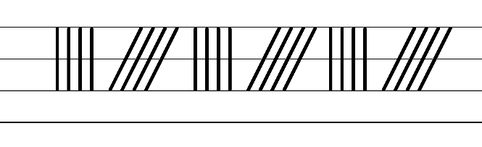  - Example NSW Foundation Style handwriting formation  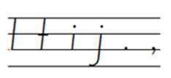  - Suggested practice text from the passage  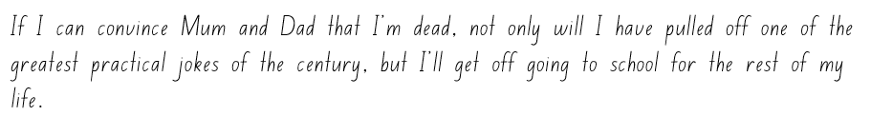  Note: students who are fluent in NSW Foundation Style can begin to use NSW Foundation Precursive and Cursive Style.
Handwriting and digital transcription  Handwriting legibility and fluency (Stage 2 Year 4)  - Join letters when writing familiar words  - Practise diagonally joining to short letters when writing familiar words.  - Diagonal joins to short letters may include me, nu, ie, li, hi, ce, en, te, au, di. | Handwriting and digital transcription  Handwriting legibility and fluency (Stage 2 Year 4)  - Suggested fluency pattern  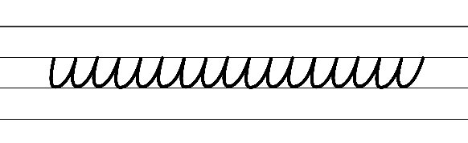  - Example letter joins  - Familiar words could include  - Alternatively, words could be selected from mentor or supporting texts.  - Suggested practice text from the passage  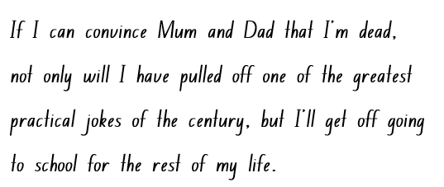  - Alternatively, words could be selected from mentor or supporting texts.
Handwriting and digital transcription  Handwriting legibility and fluency (Stage 3 Year 5)  - Sustain writing with a legible, fluent and personal handwriting style across a text  - Form legible and fluent NSW Foundation Style printing, including  - lower case letters  - upper case letters  - punctuation marks  - numerals.  - Posture  - Feet are to be flat on the floor with the back of the chair supporting the hollow of the back.  - The body should be upright.  - The writing arm should pivot from the elbow.  - Paper  - The non-writing hand holds the paper. This non-writing arm can take the weight to allow the writing arm to glide over the writing surface.  - Pencil grip  - Hold the pen(cil) between the thumb and index finger with the pen(cil) resting on the middle finger. | Handwriting and digital transcription  Handwriting legibility and fluency (Stage 3 Year 5)  - Suggested fluency pattern  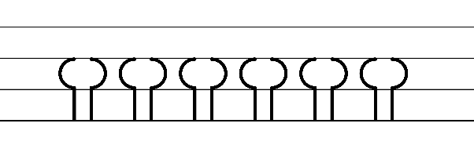  - Example NSW Foundation Style handwriting formation  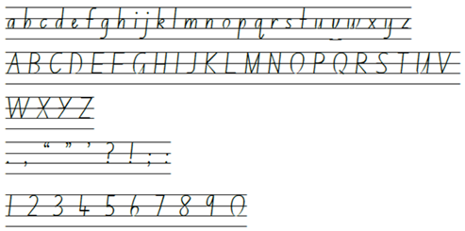  - Suggested practice text from the passage  - Encourage students to evaluate their own handwriting after practising. For example, asking them to circle diagonal joins they believe are formed well.
Handwriting and digital transcription  Handwriting legibility and fluency (Stage 3 Year 6)  - Sustain writing with a legible, fluent and personal handwriting style across a text  - Revise diagonal joins from the baseline to short letters. These are sometimes referred to as baseline joins.  - Diagonal joins come from letters with exits near the baseline, including a, c, d, e, h, i, k, l, m, n, t, u and z.  - Diagonal joins to short letters continue the exit hook diagonally upwards to the start of the next letter.  - Most diagonal joins meet the next letter at the top of the letter’s body at a 45-degree angle.  - When a diagonal join meets the letter s the letter shape may stay the same or change to the speed cursive alternative.  - Revise diagonal joins from the baseline to tall letters, including b, d, h, k, l and t. These are sometimes referred to as neckline joins.  - Loops can be used with tall letters so that the top of the letter does not need to be retraced.  - Loops cross the letter at the ascender (or neckline).  - The tall letters ‘d’ and ‘t’ do not usually include a loop.  - Personal stylistic choices may be included in different contexts, such as the use of cursive loops.  - Letter shapes and spacing should be even. Every letter can be formed within a parallelogram which tilts slightly to the right.  - Students may only require the baseline when practising handwriting skills.  - It may be more appropriate for some students to consolidate a cursive handwriting style rather than introducing a cursive looped style. | Handwriting and digital transcription  Handwriting legibility and fluency (Stage 3 Year 6)  - Suggested fluency pattern:  - Example diagonal joins to short letters, including NSW Foundation Style and Speed Cursive options for the letter ‘s’  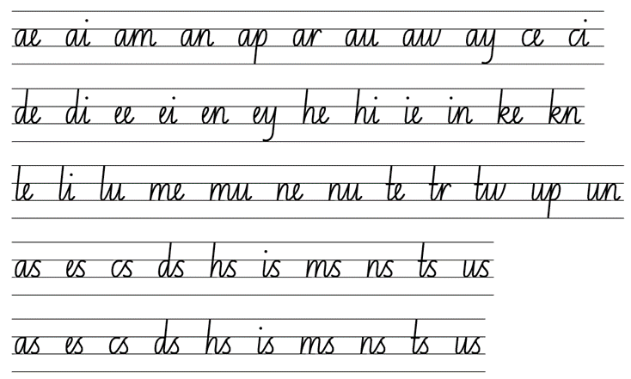  - Example diagonal joins to tall letters (with and without loops)  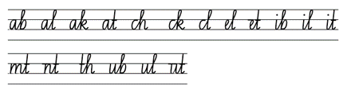  - Suggested handwriting practice passage from the text  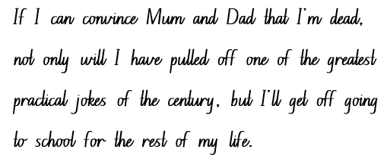

Planning framework
To plan and document Component A teaching and learning, a planning scaffold [DOCX 81 KB] is provided. To support you in your planning, a link to a detailed example of a one-week teaching and learning cycle is included in the scaffold. Additional resources to support teaching and learning in each focus area can be found at Lesson advice guides.

Component B teaching and learning
The following teaching and learning sequence has been designed to address Component B outcomes and content and develops conceptual understandings of English through the study of quality texts. Adapt the sequence as required to best meet the needs of your students.

Learning intentions and success criteria
Learning intentions and success criteria are best co-constructed with students. The table below contains a suggested learning intention and success criteria.
Element | Stage 2 | Stage 3
Learning intention | Students are learning to identify and describe narrative conventions and structures that engage the reader. | Students are learning to analyse representations of ideas in narratives and adapt these representations when creating their own texts.
Success criteria | Students can:  - follow established protocols and assigned roles for classroom interactions, whether in-person or through technological platforms  - identify the traditional structure and conventions of a narrative  - use declarative sentences to create a complication  - use adjectives and Tier 2 vocabulary to develop descriptive sentences of a setting. | Students can:  - follow established protocols and assigned roles for classroom interactions, whether in-person or through technological platforms  - identify the traditional structure and conventions of a narrative  - describe how patterns in narratives set up expectations and notice when those patterns are subverted  - use a commas accurately  - identify and use new vocabulary, including adjectives to create a descriptive paragraph about a setting.

Lesson 1 – identifying patterns and conventions in narratives
The following teaching and learning activities support multi-age settings.

Whole
- Set class expectations with agreed-upon protocols and roles. Ask students how they can be respectful learners. For example:
- follow the teacher’s instructions
- respect each other
- actively listen to each other’s thoughts and opinions
- be honest and courteous
- communicate appropriately.
- Discuss roles students may play in this unit and what would be the appropriate behaviour. For example, when whole class discussions take place in contrast to when they are doing a turn and talk or a small group activity.
Note: narratives are an account of events or experiences, which can be real or imagined. In English literary theory, narrative includes a story (what is narrated) and a discourse (how it is narrated). Narrative can present as an explicit sequencing of events (type of text) or it can be an implied or inferred component in a text (NESA, 2023).
- Introduce the textual concept, narrative. Explore student knowledge and understanding of narratives. Ask:
- What do you know about narratives? What is their purpose?
- What do you, as the reader, expect from narratives? Why?
- Discuss how readers have certain expectations when engaging with narratives as they often follow familiar patterns. For example, use of familiar characters, settings and structural elements, such as orientation, complication, series of events and resolution.
- Find and display a digital image of the cover of The Imagineer by Christopher Cheng and Lucia Masciullo. Students record and share a prediction, drawing on discussion from activity 4.
- View The Imagineer Read By Ryan McNaught (Brickman) 📚🧸 | Play School Story Time | ABC Kids (5:38). After viewing, ask:
- What did you notice? For example, the narrative had one main character who had to overcome a problem.
- Did the narrative follow a familiar pattern? What makes you think that?
- What did you find engaging? Why?
- Encourage students to make connections to other familiar narratives.
- Begin developing class list of narrative features. For example, narratives often follow an orientation, complication, series of events and resolution structure; narratives often have one main character. Record and display.

Part
The table below details the differentiated teaching and learning activities for each stage.
Stage 2 (teacher guided) | Stage 3 (in pairs/small groups/independent)
- Model creating a storyboard based on The Imagineer.  - Use the think aloud strategy to identify key narrative elements. For example, the orientation introduces the first setting and the main character. | - Students independently recount and record the main ideas in the narrative.  Too hard? Students orally retell the main ideas in the narrative.  - In pairs or small groups, students discuss the following questions.  - What expectations did you have? What made you think that?  - What familiar patterns appear in this text?  - What predictions did you make?

Part
The table below details the differentiated teaching and learning activities for each stage.
Stage 2 (independent) | Stage 3 (teacher guided/independent)
- Students independently create a storyboard based on The Imagineer.  - Students label their storyboard using language from the narrative criteria from activity 8.  Too hard? Students orally identify narrative features on their storyboard.  Too easy? Students write an explanation of each illustration on their story board. | - Prompt students to identify how their prediction was underpinned by their expectations. For example, ‘I predicted that the girl is the main character and that she is an inventor. I thought that because I know that narratives usually have one main character.’  - Provide the sentence stems:  - Before viewing The Imagineer, my expectations were...  - After viewing The Imagineer, my expectations were confirmed by...  - Students use the sentence stems to record what their expectations were and if/how they were confirmed.  Too hard? Students orally explain what their expectations were and if/how they were confirmed.

Whole
- Provide time for students to reflect on learning. Ask:
- What questions do you have about this learning? What do you wonder?
- What is something new that you learned? What is something that was reinforced for you?
- Why do you think this learning is important?
- Students share their ideas.
Stage 2 Assessment task 1 – Observations from this lesson allow students to demonstrate achievement towards the following syllabus outcome and content points:
EN2-OLC-01 – communicates with familiar audiences for social and learning purposes, by interacting, understanding and presenting
- identify contexts in which social conventions can vary and influence interactions
- follow agreed-upon protocols and assigned roles for classroom interactions in person and through the use of technology
- listen actively to identify spoken information, acknowledging the value of others’ contributions.
Stage 3 Assessment task 1 – Observations from this lesson allow students to demonstrate achievement towards the following syllabus outcome and content points:
EN3-OLC-01 – communicates to wide audiences with social and cultural awareness, by interacting and presenting, and by analysing and evaluating for understanding
- identify varying social conventions that influence interactions across wide audiences
- follow agreed-upon protocols and define individual roles as needed for in-person or online interactions, establishing specific goals, criteria or timeframes
- apply interactive listening strategies by responding to and providing feedback to the speaker.

Lesson 2 – unpacking narrative conventions
The following teaching and learning activities support multi-age settings.

Whole
- Introduce the phrase ‘playing dead’. Ask students what they think it means and why. Students turn and talk about a situation that they might want to avoid, by pretending to be asleep or by ‘playing dead’. For example, to avoid household chores.
- View class criteria for the key features of narratives from Lesson 1, activity 8. Introduce the text Just Tricking. Display the front and back covers. Ask:
- What do you think this text might be about? What makes you think that?
- What are your expectations of Just Tricking? Why?
- What do you notice? What questions do you have?
- Do you think Just Tricking will contain any of the key narrative features? Why or why not?
- Read the following excerpt from Chapter 1 – ‘Playing Dead’: ‘It’s 8:15am. And I’m still in bed. I should have got up an hour ago. But I didn’t. You want to know why? Because I am dead. Well, not really dead. I’m just pretending I’m dead so I don’t have to go to school.’
- Ask students what the purpose of the passage might be. For example, it orientates the reader to the setting, character and potential complications of the narrative.
- Display a T-chart with the headings ‘Our Expectations’ and ‘Events in Playing Dead’. Students discuss their expectations of the story, predict what they think might happen and explain their reasoning. Consider that the audience may expect that Andy gets in trouble and ends up having to go to school. Highlight the title of the book Just Tricking as well as the chapter title ‘Playing Dead’. Ask if these give any clues on how the narrative may subvert from expectations. Under the heading ‘Expectations’, record the class expectations of the chapter ‘Playing Dead’. For example, Andy will get grounded.
- Read Chapter 1 – ‘Playing Dead’ from the beginning to ‘...Is that clear?’ (p 5).
- Based on this excerpt, guide students toward identifying the narrative elements within the text. For example:
Setting:
Read ‘Suddenly Mum bustles into the room. “What? Still in bed? Come on, you’ll be late!”’ (p 2). Ask:
- Where is this story set?
- How do you know?
- What does this tell us about the time of day this scene is set?
Characters:
Ask:
- Who are the characters?
- Who do you think is the main character?
- From whose point of view is the narrative presented?
- Why do you think Andy Griffiths wrote in first person? Consider that the author has used his own first name for the main character of the narrative.
- How does this impact the reader?
- Revise declarative sentences, as introduced in Component A. Remind students that declarative sentences are used to provide facts or state a viewpoint. Explain that Andy Griffiths uses declarative sentences to state facts about the main character’s current predicament and orient the reader.

Part
The table below details the differentiated teaching and learning activities for each stage.
Stage 2 (teacher guided) | Stage 3 (in pairs/independent)
- Ask students how their parents would respond, if they acted as Andy did. For example, my parents would not believe me and tell me to get out of bed immediately and get to school.  - Discuss that if Andy’s parents acted the way you expected, the narrative would end abruptly. Explain that a narrative needs a series of complications for the plot to develop and move along.  - Model how a complication could be written using declarative sentences. For example, Andy’s parents call the doctor, Andy’s dog licks his face and makes him laugh (when he was trying to play dead).  - Students independently record some of the complications that might arise throughout the rest of the story, using declarative sentences.  Too hard? Jointly construct declarative sentences with students. | - Pairs discuss the excerpt and consider what is known about narrative conventions and structure, and how the story may progress.  - Students brainstorm possible complications that Andy may encounter as the story progresses on individual whiteboards, then share possible complications with another pair.  - Students take on the role of the author and independently write the next complication of the narrative, considering narrative conventions and structure.

Whole
- Students from Stage 2 Think-Pair-Share with Stage 3 students to share their predictions for the next complication.
- Read the remainder of Chapter 1 – ‘Playing Dead’.
- Students turn and talk to discuss the follow questions:
- What did you expect would happen? Why did you think that?
- What did happen?
- Was it the same as your expectation?
- Display the T-chart from activity 5 and record the events that occurred in the narrative. For example, Dad buries Andy. Discuss how the readers’ expectations have been disrupted and what effect this had on the audience.

Lesson 3 – using adjectives to describe the setting
The following teaching and learning activities support multi-age settings.

Whole
- Review the events in Just Tricking!, ‘Playing Dead’, such as Andy plays dead as an excuse to get out of going to school.
- Read Once Upon a Slime: 45 Fun Ways to Get Writing … Fast!, ‘Making up excuses’ (p 82). In small groups, students record and share 10 excuses to get out of an activity listed on page 82.
- Students share the variety of excuses discussed.
- Review key features of narratives, including characters and structural elements such as the setting. Students Think-Pair-Share what conventions have been revealed so far.
- Display the description of Andy’s room on page 3 of Chapter 1 – ‘Playing Dead’, from ‘Pooh, what a stink!’ to ‘...and I’m not going to drive you.’
- Revise adjectives as introduced in Component A. Remind students that adjectives describe, identify or quantify a noun or a pronoun. Different types of adjectives include possessive, quantifying, descriptive, comparative, superlative and classifying. Explain that Andy Griffiths uses adjectives for the audience to visualise the settings in which the story takes place.
- Investigate how key words from the text support the reader to visualise the setting. Discuss and determine how the author describes Andy’s room.
- Identify key words and phrases in the text. For example, ask:
- What does the phrase ‘Pooh, what a stink!’ (p 3) tell the audience?
- What sense is he using?
- Why would he include that in a description?
- What effect does that have in creating a mental model of Andy’s bedroom?
- Discuss the sentence ‘It’s an absolute pigsty!’ (p 3). Explain that this is a metaphor (a figure of speech used for effect that implies one thing by referring to another). Ask:
- What is a pigsty?
- What mental model does this metaphor create?
- Why might Andy Griffiths have chosen this metaphor to describe Andy’s room?
- Consider the sentence ‘Dirty socks and undies everywhere’ (p 3). Ask:
- Why do you think Andy Griffiths specifies ‘socks and undies’ instead of just saying clothes?
- Analyse the effectiveness of the descriptive language choices in this paragraph.
- What other adjectives or phrases could Andy Griffiths have used to describe Andy’s room?
- Consider the description of Andy’s room. Display Resource 2 – Andy’s bedroom and draw on information from the image. For example, the window and blinds are closed, food scraps are lying around. Brainstorm additional adjectives that could have been used to add more detail to the description of Andy’s room.
- Model writing a description of Andy’s room, using the language highlighted in activity 8 and different types of adjectives. Highlight when commas are used between adjectives.
- Revise that the setting tells information about where the story is taking place.

Part
The table below details the differentiated teaching and learning activities for each stage.
Stage 2 (independent/in pairs) | Stage 3 (teacher guided/independent)
- In pairs or small groups students brainstorm additional adjectives to describe Andy’s room, using the following questions that reflect the five senses:  - What can you hear?  - What can you taste?  - What can you feel?  - What can you see?  - What do you smell?  - Students record adjectives using a Five senses chart.  - Using brainstormed vocabulary (adjectives) students write a description of Andy’s bedroom.  Too easy? Students write a descriptive paragraph about their own bedroom.  - Students highlight the adjectives used in their description.  - In pairs, students share their work. | - Students close their eyes and imagine their bedroom at home. Ask questions that reflect the five senses:  - What can you hear?  - What can you smell?  - What can you taste?  - What can you feel?  - What can you see?  - Students write a list of adjectives using the Five senses chart about their bedroom.  - Model using literary devices including similes and metaphors. For example, ‘My room is as smelly as a rotten fish’ or ‘My room is an oasis.’  - Students write a descriptive paragraph about their bedroom, including figurative language.  - Students use a thesaurus or online thesaurus to find synonyms and Tier 2 words to strengthen their adjectives or description. For example, big – mammoth.  Too easy? Challenge students to include additional literary devices such as personification.
Stage 2 Assessment task 2 – Observations and work samples from this lesson allow students to demonstrate achievement towards the following syllabus outcomes and content points:
EN2-RECOM-01 – reads and comprehends texts for wide purposes using knowledge of text structures and language, and by monitoring comprehension
- use key words from a text to visualise events, characters and settings when making inferences and confirming predictions.
EN2-VOCAB-01 – builds knowledge and use of Tier 1, Tier 2 and Tier 3 vocabulary through interacting, wide reading and writing, and by defining and analysing words
- build personal Tier 1, Tier 2 and Tier 3 vocabulary through social and learning interactions, reading and writing.
EN2-CWT-01 – plans, creates and revises written texts for imaginative purposes, using text features, sentence-level grammar, punctuation and word-level language for a target audience
- use adjectives to develop descriptive features
- use commas between words in a list or to separate adjectives when more than one is used.
EN2-UARL-01 – identifies and describes how ideas are represented in literature and strategically uses similar representations when creating texts
- describe the interplay of plot, character and setting in different types of narratives
- describe how narrative conventions engage the reader.
Stage 3 Assessment task 2 – Observations and work samples from this lesson allow students to demonstrate achievement towards the following syllabus outcome(s) and content point(s):
EN3-VOCAB-01 – extends Tier 2 and Tier 3 vocabulary through interacting, wide reading and writing, morphological analysis and generating precise definitions for specific contexts
- identify newly encountered words from interactions and wide reading, and use them in writing, discussions and presentations.
EN3-RECOM-01 – fluently reads and comprehends texts for wide purposes, analysing text structures and language, and by monitoring comprehension
- compare purposes for different texts and consider why authors and illustrators have structured texts in particular ways.
EN3-UARL-01 – analyses representations of ideas in literature through narrative, character, imagery, symbol and connotation, and adapts these representations when creating texts
- describes how patterns in narratives set up expectations and notice when those patterns are subverted.

Lesson 4 – How does Andy Griffiths create settings?
The following teaching and learning activities support multi-age settings.

Whole
- Review how stories are powerful tools that shape readers’ understanding of narratives and captivate their imagination. Discuss how descriptive settings enhance a narrative. Settings are where characters and events unfold, adding context to the narrative.
- Explore how Andy Griffiths draws on personal experiences to inspire stories and settings. For example, The 26-Storey Treehouse.
- Explain that students will create an illustration of their own incredible place and write a detailed description of the setting.
- Display the enlarged illustration on page 129 of Once Upon a Slime: 45 Fun Ways to Get Writing … Fast! Brainstorm adjectives that could be used to describe the setting represented. Create an anchor chart of adjectives that may be used to describe this setting. For example, ‘Man-eating shark tank’.
- Model writing a description of the illustration. Use the think aloud strategy to justify word selection, including analysing morphemic structure to identify word meaning.
- Display page 132 of Once Upon a Slime: 45 Fun Ways to Get Writing … Fast! from ‘Try this...’ to ‘... label your incredible place.’
- Students draw an incredible place, label it with adjectives and record a description using declarative sentences. As they are working, prompt Stage 3 students to explain word meanings through the analysis of morphemic structures.
Too hard? Provide sentence starters. For example, ‘My incredible place is...’, ‘My incredible place looks like...’, ‘My incredible place sounds like...’
Stage 2 Assessment task 3 – Observations and work samples from this lesson allow students to demonstrate achievement towards the following syllabus outcomes and content points:
EN2-VOCAB-01 – builds knowledge and use of Tier 1, Tier 2 and Tier 3 vocabulary through interacting, wide reading and writing, and by defining and analysing words
- build personal Tier 1, Tier 2 and Tier 3 vocabulary through social and learning interactions, reading and writing.
EN2-CWT-01 – plans, creates and revises written texts for imaginative purposes, using text features, sentence-level grammar, punctuation and word-level language for a target audience
- use adjectives to develop descriptive features
- use commas between words in a list or to separate adjectives when more than one is used
- plan structures and language to suit the purpose of a text.
Stage 3 Assessment task 3 – Observations from this lesson allow students to demonstrate achievement towards the following syllabus outcomes and content points:
EN3-VOCAB-01 – extends Tier 2 and Tier 3 vocabulary through interacting, wide reading and writing, morphological analysis and generating precise definitions for specific contexts
- identify newly encountered words from interactions and wide reading, and use them in writing, discussions and presentations
- analyse morphemic structures of Tier 2 and Tier 3 words to determine their meaning.

Week 2

Component A teaching and learning
Component A focuses on the development of foundational skills and knowledge through regular, systematic and repeated practice. The mentor and supporting texts used in Component B of this unit can support the effective implementation of Component A teaching and learning.

Teaching guide
Guidance for explicit teaching, teaching notes, resources and examples for the related outcomes and content points have been provided in the table below.
Focus areas and teaching notes | Resources and examples
Reading fluency  Reading automaticity and rate (Stage 2)  - Syllabify, blend grapheme–phoneme correspondences and use morphemic knowledge as strategies for reading words accurately  - Locate and syllabify multisyllabic words, including those with morphemic suffixes (-ing, -ed, -ly).  - Morphemic suffixes usually form their own syllable.  - For every syllable, there is at least one vowel phoneme.  - The morphemic suffix -ed forms a syllable when pronounced as ‘ed’ but does not when pronounced as ‘d’ or ‘t’. | Reading fluency  Reading automaticity and rate (Stage 2)  - Fluency and close reading passage: page 13 from ‘Hang on I can feel something...’ to page 14 ‘...and I’m sorry!’ (184 words).  Note:  - The passage from the text will need to be a teacher-created resource.  - Content in Reading fluency will support learning in the focus areas of Vocabulary, Reading comprehension and Spelling.  - Suggested words from the passage  - Morphemic information  - scratching – scratch + ing  - shocked – shock + ed  - goggling – goggl(e) + ing.  - Syllables  - practical – 3 syllables  - realises – 3 syllables  - anything – 3 syllables  - goggling – 2 syllables.
Prosody (Stage 2)  - Explain how prosodic reading involves emphasis, expression, intonation and pausing  - Emphasis is when the reader gives extra importance or focus to specific words or parts of a sentence. It helps to convey the meaning or feeling behind the text.  - Readers may emphasise words that  - highlight exaggeration  - are repeated in close succession. | Prosody (Stage 2)  - Example sentences to illustrate the use of emphasis from the passage  - ‘Anything would be better than this. Even school.’  - ‘I sit up and scream: “I confess! You win! I was just tricking!’’’  - ‘The sight of me rising from the dead has them goggling at me in horror...’
Reading comprehension  Reading for interest and wide purposes (Stage 2)  - Identify different purposes and strategies for reading  - Purposes might include reading for enjoyment, to gather information, to understand the author’s viewpoint and to find information to support an opinion.  - The purpose for reading helps to determine the strategies that will be utilised. For example, if the purpose for reading is to find specific information, the strategy of scanning may be used.  - Reading dialogue in a narrative text serves multiple purposes and requires specific strategies to fully comprehend the story and characters. | Reading comprehension  Reading for interest and wide purposes (Stage 2)  - Suggested strategies and purposes for reading dialogue in the passage  - Character development: The dialogue provides insights into Andy’s personality, values and emotions.  - Plot advancement: Important plot points are revealed through dialogue in this passage. The humorous nature of the text is further developed when Andy desperately tries to convince his parents that he was just tricking all along. The passage shows that Andy’s parents are now performing a prank on Andy.
Comprehending language (Stage 2)  - Use morphemic knowledge to read and understand Tier 2 vocabulary  - Suffix -ing changes the tense of a verb. -ing expresses present tense; -ing also expresses future tense.  - Suffix -ed changes the tense of a verb. -ed expresses past tense.  - Suffix -ly means ‘a characteristic of’ and attaches to nouns to form adjectives, adjectives to form adverbs.  - Use key words from a text to visualise events, characters and settings when making inferences and confirming predictions  - Key text words can include verbs describing what characters do and how events unfold in a narrative. Action verbs can be used to depict the movement in a scene.  - Understand that word contractions are a feature of informal language and that apostrophes of contraction are used to signal missing letters  - A contraction is a shortened form of one or 2 words (one of which is usually a verb). In a contraction, an apostrophe takes the place of the missing letter or letters (NESA 2023).  - Contractions are regularly used in Just Tricking, helping to create the informal language expected of a child. | Comprehending language (Stage 2)  - See Stage 2 Vocabulary examples  - Key words from the fluency passage to visualise events  - ‘Urgent jabbing and scratching. The weight of the dirt on my belly is lifting.’  - The words ‘jabbing’ and ‘scratching’ suggests sudden, sharp and uncomfortable movements. The word ‘lifting’ is used to visualise the event of the dirt coming away from Andy’s belly.  - Example sentences from the passage featuring contractions  - ‘He’s the only one who realises I’m not dead!’  - ‘As the weight of the dirt lifts, I decide I don’t care about playing dead anymore.’  - 'I was playing a dumb joke and I’m sorry!’
Monitoring comprehension (Stage 2)  - Identify where meaning breaks down when reading  - A break in comprehension can occur when a text includes  - unknown vocabulary  - figurative language. | Monitoring comprehension (Stage 2)  - Suggested vocabulary from the passage  - spade (p 13), goggling (p 13), brandishing (p 14), resuscitation (p 15)  - Suggested phrase using figurative language from the passage:  - Hyperbole: ‘rising from the dead’. (p 13)
Reading comprehension  Reading fluently (Stage 3)  - Syllabify, blend grapheme–phoneme correspondences and use morphemic knowledge as strategies for reading words accurately  - Locate and syllabify multisyllabic words, including those with morphemic suffixes (-ing, -ed, -ly).  - Morphemic suffixes usually form their own syllable.  - For every syllable, there is at least one vowel phoneme.  - The morphemic suffix -ed forms a syllable when pronounced as ‘ed’ but does not when pronounced as ‘d’ or ‘t’. | Reading comprehension  Reading fluently (Stage 3)  - As above (see Stage 2 Reading fluency)
Monitoring comprehension (Stage 3)  - Monitor and repair reading when meaning breaks down  - Meaning may break down when  - unfamiliar vocabulary is encountered  - pronouns are frequently used  - there is exchanging dialogue between characters.  - Strategies to repair reading may include pausing, self-correcting, re-reading or reading on, using phonic morphemic or word knowledge and reactivating background knowledge. | Monitoring comprehension (Stage 3)  - Suggested examples of where meaning may breakdown in the passage  - Unfamiliar vocabulary: goggling (p 13), spade (p 13), brandishing (p 14), resuscitation (p 15)  - Reading written dialogue and using pronouns: ‘Is everything all right?’ she asks. ‘I’m afraid I’ve got some bad news,’ says Dad. ‘I don’t know how, or why, but it appears that Andy is no longer living... that is to say, he is...er...dead.’ ‘Oh no,’ she says, and starts to cry. ‘Oh no!’ (p 6)
Vocabulary  Learning and using words (Stage 2)  - Build personal Tier 1, Tier 2 and Tier 3 vocabulary through social and learning interactions, reading and writing  - Tier 1 words: Basic-level, everyday words (NESA 2023).  - Tier 2 words: General academic words that can be used across a variety of domains. They are of high utility for mature language users and are commonly used in written language (NESA 2023).  - Tier 3 words: Words that are used rarely (low frequency) and only in highly specific situations (NESA 2023). | Vocabulary  Learning and using words (Stage 2)  - Suggested vocabulary from the passage  - Tier 2 vocabulary: paralysed (p 5), gnawing (p 9), urgent (p 13), confess (p 13), spade (p 13), brandishing (p 14).
Defining and analysing words (Stage 2)  - Apply morphemic knowledge to change word meanings by adding different prefixes and suffixes to a base word or root  - Use morphemic knowledge to read and understand Tier 2 words (-ed, -ing).  - Suffix -ed changes the tense of the verb. -ed expresses past tense.  - Suffix -ing changes the tense of a verb. -ing expresses present tense; -ing also expresses future tense. | Defining and analysing words (Stage 2)  - Suggested vocabulary from the fluency passage  - playing: play (base word) + ing (suffix) (p 13)  - scratching: scratch (base word) + ing (p 13)  - screaming: scream (base word) + ing (p 13)  - shocked: shock (base word) + ed (p 13).
Vocabulary  Learning and using words (Stage 3)  - Identify newly encountered words from interactions and wide reading, and use them in writing, discussions and presentations  - Identify and discuss the meanings of newly encountered Tier 2 and Tier 3 words in the text to improve vocabulary knowledge and comprehension. It could be a word with an unfamiliar meaning, an unusual spelling or a term specific to a certain context. | Vocabulary  Learning and using words (Stage 3)  - Possible newly encountered words from the passage and Week 2 reading material  - goggling (p 13)  - spade (p 13)  - brandishing (p 14)  - resuscitation (p 15).
Defining and analysing words (Stage 3)  - Analyse morphemic structures of Tier 2 and Tier 3 words to determine their meaning  - Morphemes can be words themselves or parts of words, such as prefixes, suffixes and root words. Analysing morphemic structures involves breaking words down into their constituent morphemes to understand how the meaning is formed. | Defining and analysing words (Stage 3)  - As above (see Stage 2 Vocabulary examples)
Spelling  Phonological component (Stage 2)  - Explain how to segment multisyllabic words into syllables and phonemes, and apply this knowledge when spelling  - As introduced in Early Stage 1 and Stage 1, revise segmenting multisyllabic words into syllables and phonemes. For example, ‘maybe’ has 2 syllables and 4 phonemes (m-ay-b-e). This is a phonological skill that should be practised regularly.  - Identify differences in vowel phonemes (short, long, diphthong and schwa vowels)  - The long vowel phoneme /ay/ as in say can be represented using [ai, ay, a, a_e, ey, aigh, eigh].  - /ay/ is a diphthong. Diphthongs are a single phoneme that glides from one vowel to another. The position of the mouth changes while saying these phonemes.  - Teach students to identify differences in vowel phonemes (short, long, diphthong and schwa vowels). For example, the first syllable in the word playing has a diphthong and the second syllable has a short vowel. | Spelling  Phonological component (Stage 2)  - Suggested words from the Week 2 reading material  - weight (p 13), save (p 13), playing (p 13), place (p 14), take (p 15).  - Sample words for inquiry  - delay-delays-delaying-delayed, prey-preys-preyed-preying, straighten-straightens-straightened-straightening, excavate-excavates-excavating-excavated, bake-bakes-baking-baked.
Orthographic component (Stage 2)  - Apply knowledge of taught vowel graphemes when spelling  - The most common graphemes that represent the long vowel phoneme /ay/ as in ‘say’ include: [ai, ay, a, a_e, ey]. [aigh, eigh] are less commonly used representations.  - [ai, ay, ey] are vowel digraphs that represent the diphthong /ay/. This phoneme can also be represented using the split digraph [a_e] and the quadgraphs [aigh, eigh]. The grapheme [a] makes the long vowel sound when positioned at the end of a syllable. | Orthographic component (Stage 2)  - As above
Morphological component (Stage 2)  - Identify inflected suffixes, explaining when and how to treat base words when they are affixed, and apply this knowledge when spelling  - The inflected suffixes -s, -ing, -ed change the tense of a verb. The suffixes -s and -ing express present tense, -ed expresses past tense; -ing also expresses future tense.  - When a word ends in a -y, keep the -y before adding the suffix (play, playing). Compare to the plurality generalisation where you replace the -y with an ‘i’ before adding -es. When a verb ends with a consonant -e, add -d to express past tense or omit -e, then add -ing to express present tense. | Morphological component (Stage 2)  - As above
Spelling  Phonological component (Stage 3)  - Segment unfamiliar multisyllabic words into syllables and phonemes as a strategy when spelling  - Revise segmenting multisyllabic words into syllables and phonemes. This is a phonological skill that should be practised regularly. | Spelling  Phonological component (Stage 3)  - Suggested words from the Week 2 reading material  - horror (p 13), sorry (p 14), words (p 14), normal (p 14), forward (p 14).  - Sample words for inquiry  - informative, navigator, prior, choir, horror, forum, tutor, equator, organism, sense-sensory, direct-directory, participate-participatory, mandate-mandatory, invent-inventory, advise-advisory, migrate-migratory.
Orthographic component (Stage 3)  - Recognise that the same grapheme can represent different phonemes  - Grapheme [or] represents /or/, /er/ and /schwa/. | Orthographic component (Stage 3)  - As above
Morphological component (Stage 3)  - Explain and use spelling conventions to add derivational suffixes, such as -ion, -ian, -ence, -ous to base words or roots  - Introduce suffix  - ‘-ory’: indicating ‘a place or something having a specific use relating to’, ‘characterised by’  - attaches to verbs to form nouns: observe-observatory, direct-director  - attaches to verbs and nouns to form adjectives: sense-sensory  - explore the ‘drop the e’ generalisation: sense-sensory. | Morphological component (Stage 3)  - As above
Creating written texts  Sentence-level grammar (Stage 2)  - Use coordinating conjunctions in compound sentences to compare and contrast, or for addition  - Review compound sentence features, including  - an independent clause contains meaning by itself and can stand one as a complete sentence  - each independent clause is of equal importance  - a coordinating conjunction is a word or group of words that function to link 2 independent clauses within a sentence  - a comma is often placed before the coordinating conjunction.  - Coordinating conjunctions are a word or group of words that function to link 2 independent clauses within a sentence (NESA 2023).  - Coordinating conjunctions include  - and (provides additional information)  - but (presents a contrast or exception – the second clause makes a statement that contrasts with the first clause)  - or (presents an alternative item or idea – the 2 clauses offer alternative actions that the subject might do)  - so (presents a consequence – the second clause happens because of the first clause).  - Select and use precise saying, thinking, acting, and relating verbs and verb groups to align with text purpose  - A verb is a word that indicates what is happening.  - A verb group is a group of words built around a verb (NESA 2023).  - Use declarative sentences to provide facts or state a viewpoint  - Review declarative sentences.  - A declarative sentence is a statement presented as a complete sentence to provide fact, evidence or detail (NESA 2023). | Creating written texts  Sentence-level grammar (Stage 2)  - Example compound sentences from the passage  - I wipe the mud out of my eyes and see my parents staring down at me (p 13).  - Example compound sentences from the Week 2 reading material  - ‘I push him away but he keeps coming back for more.’ (p 14)  - ‘I leap out of the hole and rush to his side.’ (p 14).  - Example verbs and verb groups from the passage:  - Saying verbs: scream (p 13), tell (p 14)  - Acting verbs: wipe (p 13), staring (p 13)  - Relating verbs: was (p 13), be (p 13)  - Verb groups: can feel (p 13), must be able (p 13).  - Example declarative sentences from the passage  - As above
Punctuation (Stage 2)  - Use commas between words in a list or to separate adjectives when more than one is used  - Commas are a punctuation mark used to show separation between parts of a sentence, such as clauses or phrases, where separation is important to the meaning. Commas are also used to separate words, phrases or numbers in a series (NESA 2023). | Punctuation (Stage 2)  - Suggested example from the passage of a comma used to separate information within a sentence  - ‘Hang on, I can feel something on my stomach.’ (p 13)  - Suggested example of a comma used to separate adjectives when more than one is used. Sentence has been innovated from the fluency passage  - ‘I wipe the thick, sticky mud out of my eyes and see my concerned, bewildered parents staring down at me.’ (p 13)
Word-level language (Stage 2)  - Use adjectives to develop descriptive features  - Adjectives can be used for imaginative purposes to describe characters, settings and events.  - Descriptive adjectives give more information about the noun or pronoun. They help to add details about the noun they are modifying. This can be related to size, shape, colour, texture and other qualities. | Word-level language (Stage 2)  - Example adjectives from the passage:  - urgent (p 13), frozen (p 13).
Creating written texts  Sentence-level grammar (Stage 3)  - Make choices about verbs and verb groups to achieve precision and add detail  - A verb is a word that indicates what is happening.  - Review different types of verbs: action, thinking, feeling, saying and relating.  - A verb group is a group of words built around a verb (NESA 2023). Verb groups may contain  - auxiliary or 'helping’ verbs to indicate tense or modality, for example, ‘I am going soon. I must leave before dark.’  - contain 2 or more verbs, for example, ‘The wolf huffed and puffed.’  - other words such as adverbs or prepositions, for example, ‘The plane took off.’  - Include appositives to provide details to nouns and to vary sentence structures suited to text purpose  - An appositive is a noun or pronoun that is positioned beside another noun or pronoun to explain or identify it. An appositive often includes modifiers.  - Appositives can be words, phrases or clauses that affect or enhance the meaning of a noun or pronoun. | Creating written texts  Sentence-level grammar (Stage 3)  - As above (see Stage 2 Creating written text examples)  - Innovated sentences including an appositive to provide details to the noun from the passage  - ‘I’ve been taking Sooty, the world’s naughtiest cat, to obedience classes each Sunday morning.’  - ‘Dad, caring and concerned, hands Mum his handkerchief.’
Punctuation (Stage 3)  - Use a comma to separate a subordinate clause or a phrase from the main clause, or to separate information within a sentence, or to separate items in a list  - Commas are a punctuation marker used to show separation between parts of a sentence, such as clauses or phrases, where separation is important to the meaning. Commas are also used to separate words, phrases or numbers in a series (NESA 2023).  - Experiment with dashes and parentheses for humorous or ironic effect  - Dashes enclose extra information.  - Dashes are used for humorous effect  - as an interruption or an aside  - to provide unexpected or contradictory information  - to provide playful exaggeration. | Punctuation (Stage 3)  - As above (see Stage 2 Creating written text examples)  - Example sentences from the Week 2 reading material using dashes  - ‘If I ever get out of this- and it’s beginning to look like there’s not much hope of that- I'm never going to play another practical joke for as long as I live.’ (p13)  - ‘I’m not dead- I was just tricking!’ (p 15)
Handwriting and digital transcription  Handwriting legibility and fluency (Stage 2 Year 3)  - Understand that legible handwriting is consistent in size and spacing and can support learning  - Form the ‘clockwise’ letters r, n, m, h, p, b and k using consistent size and spacing  - Pencil grip: The pen(cil) should be held firmly between the thumb and index finger, balanced on the middle finger (not too tightly).  - Paper position: The non-writing hand is carefully placed on the paper to steady it.  - Form basic punctuation marks, including a question mark  - Question marks are full height. They are the same height as capital letters. | Handwriting and digital transcription  Handwriting legibility and fluency (Stage 2 Year 3)  - Suggested fluency pattern  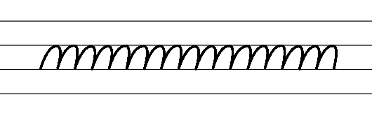  - Example NSW Foundation Style handwriting formation  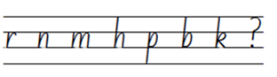  - Suggested practice text from the passage  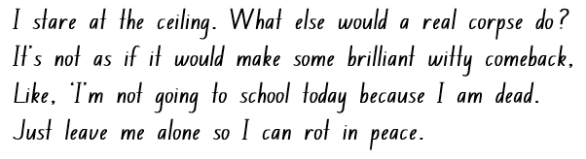  Note: students who are fluent in NSW Foundation Style can begin to use NSW Foundation Precursive and Cursive Style.
Handwriting and digital transcription  Handwriting legibility and fluency (Stage 2 Year 4)  - Join letters when writing familiar words  - Diagonally join to tall letters when writing familiar words.  - Diagonal joins to tall letters. | Handwriting and digital transcription  Handwriting legibility and fluency (Stage 2 Year 4)  - Suggested fluency pattern  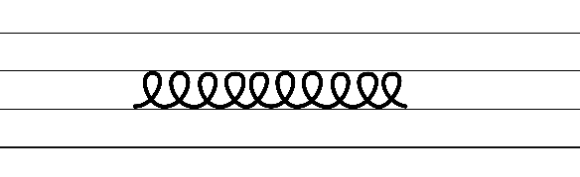  - Example letter joins to tall letters  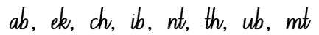  - Familiar words could include  - Suggested practice text from the passage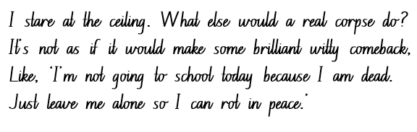
Handwriting and digital transcription  Handwriting legibility and fluency (Stage 3 Year 5)  - Sustain writing with a legible, fluent and personal handwriting style across a text  - Form legible and fluent diagonal joins from the baseline to short letters from a downstroke. These are sometimes referred to as baseline joins.  - Diagonal joins come from letters with exits near the baseline, including a, c, d, e, h, i, k, l, m, n, u and z.  - Diagonal joins to short letters continue the exit hook diagonally upwards to the start of the next letter.  - Most diagonal joins meet the next letter at the top of the letter’s body at a 45-degree angle.  - Highlight the position of the diagonal join to the letter e.  - Form legible and fluent diagonal letters from the baseline to tall letters.  - Diagonal joins from the baseline to tall letters join at line 2 (the neckline) and continue all the way to line 1 (the top line) before retracing part of the way back down and finishing the new letter.  - Focus attention on how joins provide a quick change in direction for letters that end on a downstroke at the baseline. Emphasise the downstroke so joining movements are not overemphasised and widened. | Handwriting and digital transcription  Handwriting legibility and fluency (Stage 3 Year 5)  - Suggested fluency pattern  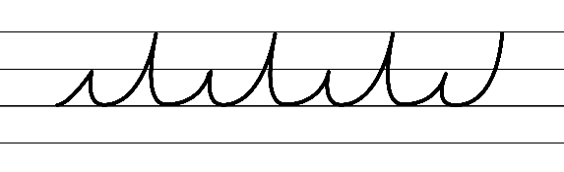  - Example NSW Foundation Style handwriting formation − diagonal joins to short letters from a downstroke  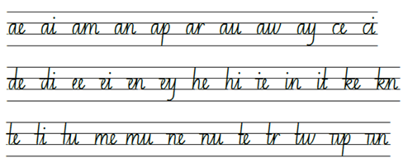  - Example NSW Foundation Style handwriting formation − diagonal joins to tall letters from a downstroke  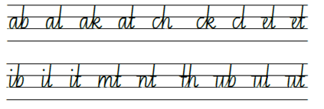  - Suggested practice text from the passage  - Encourage students to evaluate their own handwriting after practising. For example, asking them to circle horizontal joins they believe are formed well.
Handwriting and digital transcription  Handwriting legibility and fluency (Stage 3 Year 6)  - Sustain writing with a legible, fluent and personal handwriting style across a text  - Revise horizontal joins to short letters. The letters o, r, v, w and x join the following on line 2 (or the neckline).  - There is a slight dip in a horizontal join to a short letter.  - Revise horizontal joins to tall letters. These join the tall letter just below the ascender (or neckline). If the letter has a cursive loop, it begins at the ascender.  - Encourage students to evaluate their own handwriting after practising. For example, asking them to circle well-formed horizontal joins that are consistent in size, spacing and slope. | Handwriting and digital transcription  Handwriting legibility and fluency (Stage 3 Year 6)  - Suggested fluency  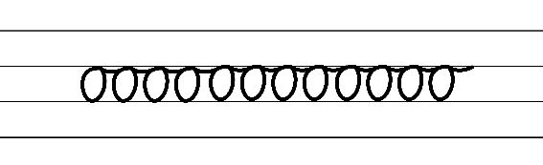  - Example horizontal joins to short letters in cursive style  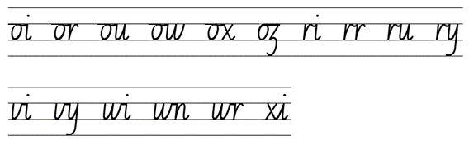  - Example horizontal joins to tall letters in cursive style  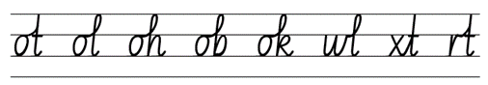  - Suggested practice text from the passage  - Encourage students to evaluate their own handwriting after practising. For example, asking them to circle horizontal joins they believe are formed well.

Planning framework
To plan and document Component A teaching and learning, a planning scaffold [DOCX 81 KB] is provided. To support you in your planning, a link to a detailed example of a one-week teaching and learning cycle is included in the scaffold. Additional resources to support teaching and learning in each focus area can be found at Lesson advice guides.

Component B teaching and learning
The following teaching and learning sequence has been designed to address Component B outcomes and content and develops conceptual understandings of English through the study of quality texts. Adapt the sequence as required to best meet the needs of your students.

Learning intentions and success criteria
Learning intentions and success criteria are best co-constructed with students. The table below contains a suggested learning intention and success criteria.
Element | Stage 2 | Stage 3
Learning intention | Students are learning to understand the role of characterisation within narratives. | Students are learning to understand the impact characters have within narratives and experiment with characterisation.
Success criteria | Students can:  - identify and describe character traits using evidence from the text  - describe attributes of characters  - identify how a character drives the plot in a narrative  - create character descriptions using adjectives for effect. | Students can:  - identify and describe character traits using evidence from the text  - identify stereotypes and archetypes  - identify how a character drives a plot forward and experiment with manipulating the character to manipulate the plot  - create character descriptions using adjectives, figurative language and appositives.

Lesson 5 – characterisation
The following teaching and learning activities support multi-age settings.

Whole
- Read page 27 of Once Upon a Slime, from ‘Guess who?’
- Students select a familiar person to describe aloud to a partner. They record their character description without revealing their identity. For example, appearance, interests and what they typically say or do. Students share their description with a partner who attempts to guess their identity.
- Review with students how narrative conventions engage the reader. For example, Andy Griffiths uses familiar characters and settings, Tim Winton creates detailed descriptions of settings.
Note: character is a person (or animal) created in a text (usually narrative) to represent human characteristics including physical, emotional and intellectual characteristics, habits and behaviour (NESA, 2023). Characterisation is the technical construction and representation of any personality or person-like figure in text, including features such as their appearance, actions, words or thoughts (NESA, 2023).
- Introduce the supporting concept of characterisation. Ask:
- What is a character?
- Why are characters necessary? What roles do they play in narratives? For example, characters drive the plot.
- How do characters engage the audience? For example, characters evoke emotions from the audience.
- How do authors create characters that the audience can connect with? Why do they do this? For example, to engage their audience.
- Display Resource 3 – familiar characters. Ask how students would expect these characters to behave.
- In small groups or pairs, students share their expectations of how the familiar characters may behave and what role they might play in narratives.
- Recount the main events of Just Tricking! Chapter 1 – ‘Playing Dead’.
- Students identify the characters and discuss why Andy Griffiths creates narratives with characters and settings that are familiar to his audience. For example, the character Andy is a mischievous 10-year-old boy, his parents are constantly having to deal with his practical jokes.
- Explain that characters are the vehicle through which the author drives the plot forward.
- Ask:
- How would you expect a parent or adult to behave in this situation?
- How does the author contradict our expectations? How does this allow the story to develop?
- Why does this make it humorous to the audience?
- Students analyse a character from Just Tricking by creating a written response. Encourage them to include action, thinking and feeling verbs in their response. Consider:
- Who is the character?
- What problems does this character face?
- How did this make them feel?
- How did the character behave toward the problem?
- Did they act the way you expected them to? Why or why not? How did this impact the reader?
Too hard? Work with students in a small group.
Too easy? Students highlight precise action, thinking and feeling verbs in their response.
Stage 2 Assessment task 4 – Observations and work samples from this lesson allow students to demonstrate achievement towards the following syllabus outcomes and content points:
EN2-RECOM-01 – reads and comprehends texts for wide purposes using knowledge of text structures and language, and by monitoring comprehension
- use key words from a text to visualise events, characters ad settings when making inferences and confirming predictions.
EN2-UARL-01 – identifies and describes how ideas are represented in literature and strategically uses similar representations when creating texts
- describe how a character drives the plot in a narrative.

Lesson 6 – exploring characterisation and stereotypes
The following teaching and learning activities support multi-age settings.

Whole
- Display Resource 3 – familiar characters. Explain that these characters are stereotypes. A stereotype is a widely held but fixed and oversimplified image or idea of a particular type of person or thing (NESA 2018).
- Ask students to provide examples of where stereotypical characters didn’t act in the way we expected. For example, in The Paper Bag Princess, the prince was evil and wanted to take over the world, the dragon was timid and couldn’t breathe fire.
- Discuss the characters that have been identified throughout the unit. For example, Andy.
- Students turn and talk about the following questions:
- Is the character Andy stereotypical for a 10-year-old boy? Why do you say that?
- How does his character drive the plot?
- Are his parents stereotypical? How so?
- What impact does this have on the narrative?
- Explain that in film and literature characters are often heroes and villains. These characters usually have stereotypical features that put them into either category. Discuss what attributes are stereotypical of a hero and what attributes are stereotypical of a villain. Students identify some of these characters from film and literature. For example, audiences want Harry Potter to succeed because they connect with him, he is created as a character who has been poorly treated and faced difficulties, he behaves in an honourable way. Audiences want Voldemort to fail because of the deeds he has done, the way he behaves and is described.
- Discuss adjectives that describe stereotypical heroes and villains. Record responses in a T-chart.
- Explain that when creating a character, students should consider these questions:
- How do you want to portray your character to the reader?
- How will you do this? For example, using a range of descriptive adjectives such as ‘fire breathing dragon’.
- How could you use plot to display your characters traits?
- Model creating a character description using adjectives and appropriate punctuation. Ensure you include their behaviour in a situation to convey their character traits. For example:
The evil sorcerer rubbed his coarse, wrinkled hands together in delight. His grey, steely eyes stared at the scribbled plan. He cackled with glee. Shadow, his scruffy dog, begged at his feet. Clumps of his mattered fur lay scattered over the decrepit furniture. Count Vandermere roughly shoved him to the side. “Out of my way!” he hollered. Whimpering, the dog raced from the room, like a startled deer. Striding across the broken wooden floorboards, the Count ripped open the door. It screamed in protest. The tails of his worn-out suit flapped in the chilling breeze. Dust swirled around the room, like a hurricane. The smell of mildew hung heavy in the air. The Count grabbed his shabby top hat and placed it on top of his balding head. His thin lips pressed upwards into a wicked smile. He wrapped his threadbare coat around his shoulders and marched out into the bleak night.
- Highlight and discuss the elements contained in this passage. For example, punctuation including capital letters and full stops, an appositive, adjectives, precise verbs, similes, personification, proper nouns, commas between adjectives, 5 senses.
- Students draw the character and setting visualised from the passage. Students label their drawings using adjectives to identify descriptive features.
Stage 2 Assessment task 5 – Observations from this lesson allow students to demonstrate achievement towards the following syllabus outcomes and content points:
EN2-UARL-01 – identifies and describes how ideas are represented in literature and strategically uses similar representations when creating texts
- describe how a character drives the plot in a narrative.
Stage 3 Assessment task 4 – Observations from this lesson allow students to demonstrate achievement towards the following syllabus outcomes and content points:
EN3-CWT-01 – plans, creates and revises written texts for multiple purposes and audiences through selection of text features, sentence-level grammar, punctuation and word-level language
- experiment with characterisation.
EN3-UARL-01 – analyses representations of ideas in literature through narrative, character, imagery, symbol and connotation, and adapts these representations when creating texts
- recognise how character archetypes and stereotypes are represented in literature.

Lesson 7 – exaggerating character descriptions
The following teaching and learning activities support multi-age settings.

Whole
- Read page 110 of Chapter 9 – ‘Invisipills’ from Just Tricking.
- Ask:
- What image has the author created of the character Mrs Wharton?
- How do you feel about this character?
- What language does the author use to create the audience’s perception?
- Why has the author wanted the audience to feel this way? For example, to create a stereotypical perception of a librarian.
- What effect does the use of repetition have in the sentences. For example, “She’s telling kids off...” (p 110).
- Read Chapter 2 – ‘Characters’ from Once Upon a Slime: 45 Fun Ways to Get Writing … Fast!
- Ask how Andy Griffiths creates his characters. For example, they are based on real life experiences, he uses exaggeration.
- Revise appositives from Component A. Identify the use of appositives within Chapter 2 – ‘Characters’ from Once Upon a Slime: 45 Fun Ways to Get Writing … Fast! For example, ‘In real life- Danny Pickett was-and still is- a very funny and fun-loving person.’ Further examples can be found on page 26. Reflect on how these could be used to provide details about a character.
- Select a fictitious character from a well-known traditional narrative that students are familiar with. For example, Little Red Riding Hood.
- List ways students could exaggerate or change features of this character. For example, Little Red Riding Hood could become braver, her hood might become a superhero cape, she may become taller and more muscular.
- Ask students to think of a family member and list adjectives and attributes they would use to describe this person.
- Read pages 165 to168 from Once Upon a Slime: 45 Fun Ways to Get Writing … Fast! Students use this as inspiration to create a drawing to represent their character. Remind them that they are trying to exaggerate the attributes that they listed to make a more interesting character. Encourage students to model their drawing using Terry Denton’s drawing style. For example, cartoon like, highly detailed and labelled.
Too hard? Prompt students to consider how they could exaggerate aspects of their character.
Too easy? Students use appositives to describe their character.
- Conduct a gallery walk of the characters. Provide students with sticky notes to add additional adjectives or adjectival phrase to describe each character. These will be revisited in Lesson 8.

Lesson 8 – writing a detailed character description
The following teaching and learning activities support multi-age settings.

Whole
- Play a game of Hot Seat with the students taking on roles of characters from Just Tricking.
- Students reflect on the language used to describe their characters in Lesson 7.
- Review the character description jointly constructed in Lesson 6. Students turn and talk and discuss the following questions:
- How did the language create an image of this character?
- How did we demonstrate their behaviour?
- What other language features could be used to further develop the readers’ mental model of this character?
- Explain that students are going to write a detailed character description of their favourite character from the gallery walk in Lesson 7.
- Create a class success criteria to support students’ in writing their character descriptions.
- Students write a detailed character description that includes a setting reflective of the characters traits.
Too hard? Provide sentence scaffolds to guide students through their description. For example, begin with a sentence describing the character’s facial features. Write a sentence describing their clothing. Describe where they are.
Too easy? Students write a scene in which their character reacts to a situation to demonstrate their personality.

Week 3

Component A teaching and learning
Component A focuses on the development of foundational skills and knowledge through regular, systematic and repeated practice. The mentor and supporting texts used in Component B of this unit can support the effective implementation of Component A teaching and learning.

Teaching guide
Guidance for explicit teaching, teaching notes, resources and examples for the related outcomes and content points have been provided in the table below.
Focus areas and teaching notes | Resources and examples
Reading fluency  Reading automaticity and rate (Stage 2)  - Syllabify, blend grapheme–phoneme correspondences and use morphemic knowledge as strategies for reading words accurately  - Locate and syllabify multisyllabic words, including those with morphemic suffixes (-ing, -ed, -ly).  - Morphemic suffixes usually form their own syllable.  - For every syllable, there is at least one vowel phoneme.  - The morphemic suffix -ed forms a syllable when pronounced as ‘ed’ but does not when pronounced as ‘d’ or ‘t’. | Reading fluency  Reading automaticity and rate (Stage 2)  - Fluency and close reading passage – Page 47 from ‘So what I’ve decided to do is...’ to page 47 ‘...no answer (178 words).  Note:  - The passage from the text will need to be a teacher-created resource.  - Content in Reading fluency will support learning in the focus areas of Vocabulary, Reading comprehension and Spelling.  - Suggested words from the passage  - Morphemic information  - impressed – impress + ed  - looking – look + ing  - absolutely – absolute + ly.  - Syllables  - nobody – 3 syllables  - chandelier – 3 syllables  - beautiful – 3 syllables  - ladder – 2 syllables.
Prosody (Stage 2)  - Explain how prosodic reading involves emphasis, expression, intonation and pausing  - Reading with expression involves using the appropriate tone, pitch and stresses for the text. Using expression can highlight the emotion in a text.  - Expression could be used for  - exclamatory sentences finishing with an exclamation mark  - character dialogue  - vocabulary with emotive connotation  - words written in italics. | Prosody (Stage 2)  - Suggested sentences to illustrate the use of expression from the passage  - ‘That way, when Mum and Dad come home fuming about my lousy reports and launch into their “it’s time we had a little talk” routine, they’re going to be struck by how beautiful the house is looking and they’ll forget all about lecturing me.’  - ‘Hello!’ I call. ‘Hello?’ No answer.
Reading comprehension  Reading for interest and wide purposes (Stage 2)  - Identify different purposes and strategies for reading  - Purposes might include reading for enjoyment, to gather information, to understand the author’s viewpoint and to find information to support an opinion.  - The purpose for reading helps to determine the strategies that will be utilised. For example, if the purpose for reading is to find specific information, the strategy of scanning may be used. | Reading comprehension  Reading for interest and wide purposes (Stage 2)  - Purpose of this passage: reading for enjoyment and to provide information about Andy’s plan to impress his parents.  - Strategies may include making connections and inferring. The passage details how Andy has cleaned the house to distract his parents from his parent-teacher interview. Whilst Andy thinks the plan will work, the inference can be made that his parents will not be distracted.
Comprehending language (Stage 2)  - Use morphemic knowledge to read and understand the meaning of words  - Suffixes can be added to base words to adjust their meaning.  - ‘-ly’ means ‘a characteristic of’ and attaches to nouns to form adjectives, or for adjectives to form adverbs  - ‘-y’ means ‘characterised by’ and attaches to nouns and verbs to create adjectives  - ‘-ing’ can be added to some nouns to turn them into adjectives, describing something that causes a certain feeling or emotion  - ‘-ed’ when added to a verb changes to past tense.  - Use key words from a text to visualise events, characters and settings when making inferences and confirming predictions  - Key words used to describe characters can encompass various aspects of their personalities, appearances, traits, behaviours and emotions. These words help readers form a mental image of the character and understand their role within the narrative.  - Understand that word contractions are a feature of informal language and that apostrophes of contraction are used to signal missing letters  - A contraction is a shortened form of one or 2 words (one of which is usually a verb). In a contraction, an apostrophe takes the place of the missing letter or letters (NESA 2023).  - Contractions are regularly used in Just Tricking, helping to create the informal language expected of a child. | Comprehending language (Stage 2)  - Morphemic information of words from the passage:  - normally: normal + ly (p 45)  - thinking: think + ing (p 45)  - decided: decid(e)+ ed (p 46)  - suddenly: sudden +ly (p 47).  - To describe how Andy’s parents may react, key words from the passage include  - ‘fuming about my lousy reports’, ‘launch into their “it's time we had a little talk” routine’  - ‘struck by how beautiful the house is’, ‘so impressed’, ‘let me eat a whole bucket of ice-cream’.  - Example sentences from the passage featuring contractions  - ‘...they’re suddenly going to be struck by how beautiful the house is...’  - ‘They’ll be so impressed that I cleaned up the house without being asked that, as a reward, they’ll let me eat a whole bucket of chocolate ice-cream...’  - ‘I’m halfway through polishing the second light-globe on the chandelier.’
Monitoring comprehension (Stage 2)  - Identify where meaning breaks down when reading  - Meaning may break down when unfamiliar vocabulary or phrases are introduced, or background knowledge is required.  - Meaning may break down when figurative language is used. For example, if similes are taken too literally or misinterpreted.  - A simile is a type of figurative language that compares 2 things using ‘like’ or ‘as’ to create a vivid image or description. | Monitoring comprehension (Stage 2)  - Suggested examples from the passage where meaning may breakdown  - Vocabulary: lecturing, gullible, chandelier.  - Hyperbole:‘...make it absolutely clean and spotless – right down to the very last light-globe.’  - Exaggerated language: ‘right down to the very last light-globe’ and ‘whole bucket of chocolate ice-cream’.
Reading comprehension  Reading fluently (Stage 3)  - Syllabify, blend grapheme–phoneme correspondences and use morphemic knowledge as strategies for reading words accurately  - Locate and syllabify multisyllabic words, including those with morphemic suffixes (-ing, -ed, -ly).  - Morphemic suffixes usually form their own syllable.  - For every syllable, there is at least one vowel phoneme.  - The morphemic suffix -ed forms a syllable when pronounced as ‘ed’ but does not when pronounced as ‘d’ or ‘t’. | Reading comprehension  Reading fluently (Stage 3)  - As above (see Stage 2 Reading fluency examples)
Comprehending language (Stage 3)  - Use morphology and etymology to work out the meaning of unfamiliar words  - Understanding the etymology of words assists in explaining the origins of, and changes to, words in relation to meaning. The etymology of words can also assist in understanding the spelling of words. | Comprehending language (Stage 3)  - Suggested etymology from the passage  - ‘chandelier’: chandelier is a French word meaning a branched cluster of lights suspended from the ceiling. This word features the French spelling for /sh/ ‘ch’ as used in other French words such as chef, chaperone and parachute.
Monitoring comprehension (Stage 3)  - Monitor and repair reading when meaning breaks down  - Strategies to repair reading may include pausing, self-correcting, re-reading or reading on; using phonic morphemic or word knowledge and reactivating background knowledge. | Monitoring comprehension (Stage 3)  - As above (see Stage 2 Reading comprehension)
Vocabulary  Learning and using words (Stage 2)  - Build personal Tier 1, Tier 2 and Tier 3 vocabulary through social and learning interactions, reading and writing  - Tier 1 words: Basic-level, everyday words (NESA 2023).  - Tier 2 words: General academic words that can be used across a variety of domains. They are of high utility for mature language users and are commonly used in written language (NESA 2023).  - Tier 3 words: Words that are used rarely (low frequency) and only in highly specific situations (NESA 2023). | Vocabulary  Learning and using words (Stage 2)  - Suggested Tier 2 vocabulary from the passage: lousy, suddenly, lecturing, impressed, gullible, chandelier.
Defining and analysing words (Stage 2)  - Apply morphemic knowledge to change word meanings by adding different prefixes and suffixes to a base word or root  - Use morphemic knowledge to read and understand Tier 2 words (-ly, -y, -ing).  - Suffix -ing changes the tense of a verb. -ing expresses present tense; -ing also expresses future tense.  - Suffix -ly means ‘a characteristic of’ and attaches to nouns to form adjectives, adjectives to form adverbs. | Defining and analysing words (Stage 2)  - Suggested morphology from the passage  - absolutely, suddenly, polishing, looking.
Vocabulary  Learning and using words (Stage 3)  - Identify newly encountered words from interactions and wide reading, and use them in writing, discussions and presentations  - Identify and discuss the meanings of newly encountered Tier 2 and Tier 3 words in the text to improve vocabulary knowledge and comprehension. It could be a word with an unfamiliar meaning, an unusual spelling, or a term specific to a certain context. | Vocabulary  Learning and using words (Stage 3)  - Possible newly encountered words from passage  - lousy, lecturing, gullible, chandelier.
Defining and analysing words (Stage 3)  - Analyse morphemic structures of Tier 2 and Tier 3 words to determine their meaning  - There are 2 types of morphemes – free (independent) morphemes and bound (dependent) morphemes.  - Free morphemes can function as stand-alone words with specific meaning. These are sometimes known as base words.  - Bound morphemes, when added to words, alter their meaning or create new words. They cannot occur independently. Bound morphemes include prefixes (un-, dis-) which are at the beginning of words and suffixes (-ed, -s) which are added to the ends of words.  - Understanding the meaning of different morphemes assists in determining an unfamiliar word’s meaning. | Defining and analysing words (Stage 3)  - Morphemic information of Tier 2 words from the passage  - lecturing: lectur(e) + ing  - lousy: louse + y  - gullible: gull + ible.
Spelling  Phonological component (Stage 2)  - Explain how to segment multisyllabic words into syllables and phonemes, and apply this knowledge when spelling  - As introduced in Early Stage 1 and Stage 1, revise segmenting multisyllabic words into syllables and phonemes. For example, ‘maybe’ has 2 syllables and 4 phonemes (m-ay-b-e). This is a phonological skill that should be practised regularly.  - Identify differences in vowel phonemes (short, long, diphthong and schwa vowels)  - The long vowel phoneme /ow/ as in own can be represented by [oa, ow, o_e, o, oe]. | Spelling  Phonological component (Stage 2)  - Suggested words from the Week 3 reading material  - globe, home, joke, going, so, whole, open, pillows.  - Sample words for inquiry  - bloke(s), globe(s), dingo(es), tomato(es), hose-hoses-hosing-hosed, float-floats-floating-floated, doze-dozes-dozing-dozed.
Orthographic component (Stage 2)  - Apply knowledge of taught vowel graphemes when spelling  - The long vowel phoneme /ow/ can be represented by the vowel digraphs [oa, ow, oe]. The grapheme [o] and the split digraph [o_e] can also be used to represent the phoneme /ow/.  - The use of different graphemes can be dependent on their position in a word. [oa, o] are often used in the middle of words. [ow, o_e, oe] are often used at the end of base words. | Orthographic component (Stage 2)  - As above
Morphological component (Stage 2)  - Identify inflected suffixes, explaining when and how to treat base words when they are affixed, and apply this knowledge when spelling  - Inflected suffixes  - plural (-s, -es)  - tense (-s, -ing, -ed).  - The inflected suffixes -s and -es change a noun from singular (one) to plural (more than one).  - The inflected suffixes -s, -ing, -ed change the tense of a verb. The suffixes -s and -ing express present tense, -ed expresses past tense; -ing also expresses future tense. | Morphological component (Stage 2)  - As above
Spelling  Phonological component (Stage 3)  - Segment unfamiliar multisyllabic words into syllables and phonemes as a strategy when spelling  - Revise segmenting multisyllabic words into syllables and phonemes. This is a phonological skill that should be practised regularly. | Spelling  Phonological component (Stage 3)  - Suggested words from the Week 3 reading material  - concentrating, clean, chocolate, ice-cream.  - Sample words for inquiry  - concentrate-concentration, celebrate-celebration, construct-construction generate-generation, populate-population, prevent-prevention, educate-education, distribute-distribution, innovate-innovation, invent-invention, extinct-extinction, habitat-habitation, ignite-ignition, oppress-oppression.
Orthographic component (Stage 3)  - Recognise that the same grapheme can represent different phonemes  - Graph [c] representing /k/ and /s/  - Highlight the different phonemes that are represented by the grapheme [c]. [c] can be used to represent /k/ as in ‘kid’ and /s/ as in ‘city’. Note the grapheme’s position within base words. | Orthographic component (Stage 3)  - As above
Morphological component (Stage 3)  - Explain and use spelling conventions to add derivational suffixes such as -ion, -ian, -ence, -ous to base words or roots  - Derivational suffix: -ion  - Introduce suffix  - ‘-ion’ meaning ‘act’ or ‘process’  - Explore adding -ion to verbs to form nouns. For example, educate-education, discuss-discussion.  - Explore the ‘drop the e’ generalisation. For example, educate-education. | Morphological component (Stage 3)  - As above
Creating written texts  Sentence level grammar (Stage 2)  - Use coordinating conjunctions in compound sentences to compare and contrast, or for addition  - Review compound sentences and coordinating conjunctions.  - Coordinating conjunctions include  - and (provides additional information)  - but (presents a contrast or exception – the second clause makes a statement that contrasts with the first clause)  - or (presents an alternative item or idea – the 2 clauses offer alternative actions that the subject might do)  - so (presents a consequence – the second clause happens because of the first clause).  - Select and use precise saying, thinking, acting, and relating verbs and verb groups to align with text purpose  - Review verbs and verb groups.  - Review different types of verbs: action, thinking, feeling, saying and relating.  - Use declarative sentences to provide facts or state a viewpoint  - A declarative sentence is a statement presented as a complete sentence to provide fact, evidence or detail (NESA 2023). | Creating written texts  Sentence level grammar (Stage 2)  - Example coordinating conjunctions in compound sentences from Week 3 reading material  - ‘Normally, I would be making prank phone calls, setting up buckets of water over half-opened doors and putting rubber snakes under pillows- but not tonight.’ (p 45)  - ‘I’ve worked really hard this year, but my teachers are all against me.’ (p 46)  - ‘I’ve tried to explain this to them, but they won’t listen.’ (p 46)  - Example verbs from compound sentences above  - Action: would be making, setting up, putting, have worked, won’t listen  - Relating: are  - Thinking: tried to explain.  - Example declarative sentences from the passage  - ‘I’m halfway through polishing the second light-globe on the chandelier.’  - ‘There’s a knock on the door.’  - ‘It can’t be Mum and Dad because they’re not due back for at least half an hour.’
Punctuation (Stage 2)  - Use commas between words in a list or to separate adjectives when more than one is use  - Commas are a punctuation marker used to show separation between parts of a sentence, such as clauses or phrases, where separation is important to the meaning. Commas are also used to separate words, phrases or numbers in a series (NESA 2023).  - Review using commas to separate adjectives.  - Commas are used to separate words or phrases in a list. A good way to test if the comma is in the correct position is to replace it with one of the conjunctions and or or.  - Use capital letters to indicate the beginning of a sentence, proper nouns, headings and subheadings, to indicate the beginning of a poetry line, for emphasis, and when using acronyms  - Review sentence boundary punctuation, including capital letters to indicate the beginning of a sentence and to indicate proper nouns. | Punctuation (Stage 2)  - Example sentences from the Week 3 reading material using commas to show separation of words or phrases in a list  - ‘Normally, I would be making prank phone calls, setting up buckets of water over half-opened doors and putting rubber snakes under pillows- but not tonight.’ (p 45)  - ‘I jump off the ladder, sprint to the door and open it- all in one fluid movement.’ (p 50)  - Suggested examples of sentence punctuation  - See above.  - Suggested examples of proper nouns from the passage  - Mum, Dad, Andy, Danny Pickett.
Word-level language (Stage 2)  - Use adjectives to develop descriptive features  - Adjectives are words that describe, identify or quantify a noun or a pronoun. Different types of adjectives include possessive, quantifying, descriptive, comparative, superlative and classifying (NESA 2023).  - Adjectives can be used for imaginative purposes to describe characters, settings and events. | Word-level language (Stage 2)  - Suggested adjectives from the passage  - Descriptive: spotless, beautiful  - Classifying: chocolate  - Quantifying: whole, second.
Creating written texts  Sentence level grammar (Stage 3)  - Include appositives to provide details to nouns and to vary sentence structures suited to text purpose  - Appositives can be words, phrases or clauses that affect or enhance the meaning of a noun or pronoun. They can be placed beside a noun to explain it more fully.  - Appositives can describe, identify or explain.  - Appositive words or phrases can follow the noun it describes (Sydney, the capital of NSW, is the largest city in Australia).  - Appositive words or phrases can precede the noun (The capital of NSW, Sydney, is the largest city in Australia). | Creating written texts  Sentence level grammar (Stage 3)  - Innovated sentences including an appositive to provide details to the noun from the passage  - Andy, known for his clever pranks, plans to tidy up the house and make it spotless – right down to the very last light-globe.  - Danny Pickett, a compulsive nick-knocker, cannot bear to walk past a house without knocking on the door.
Punctuation (Stage 3)  - Use capital letters to indicate the beginning of a sentence, proper nouns, headings and subheadings, to indicate the beginning of a poetry line, for emphasis, and when using acronyms  - Review sentence boundary punctuation, including capital letters to indicate the beginning of a sentence and to indicate proper nouns.  - Use a comma to separate a subordinate clause or a phrase from the main clause, or to separate information within a sentence, or to separate items in a list  - Commas are a punctuation marker used to show separation between parts of a sentence, such as clauses or phrases, where separation is important to the meaning. Commas are also used to separate words, phrases or numbers in a series (NESA 2023).  - Experiment with dashes and parentheses for humorous or ironic effect  - Dashes enclose extra information.  - Dashes are used for humorous effect  - as an interruption or an aside  - to provide unexpected or contradictory information  - to provide playful exaggeration. | Punctuation (Stage 3)  - As above (see Stage 2 Creating written text examples)  - Suggested examples of a comma to separate a subordinate clause or a phrase from the main clause from the Week 3 reading material  - ‘They think that just because I spend a lot of time talking and laughing in class, I’m not concentrating.’ (p 46)  - ‘But what they don’t realise is, I can’t help talking and laughing in class because I get so excited about schoolwork.’ (p 46)  - Example sentences from the Week 3 reading material using dashes  - ‘It’s like I said- they're all against me.’ (p 46)  - ‘So what I’ve decided to do is tidy up the house and make it absolutely clean and spotless- right down to the very last light-globe.’ (p 47)  - ‘And I can guess exactly who that somebody is- Danny Pickett.’ (p 48)
Handwriting and digital transcription  Handwriting legibility and fluency (Stage 2 Year 3)  - Understand that legible handwriting is consistent in size and spacing and can support learning  - Form the ‘anticlockwise’ letters c, o, a, d, g, q, e, s and f using consistent size and spacing  - Spacing: consistent spacing supports the legibility and appearance of handwriting. Draw attention to appropriate spacing within words, between words and between lines of writing.  - Form basic punctuation marks, including an exclamation mark  - Exclamation marks are full height. They are the same height as capital letters. | Handwriting and digital transcription  Handwriting legibility and fluency (Stage 2 Year 3)  - Suggested fluency pattern  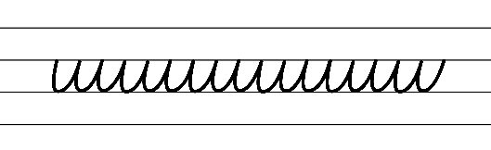  - Example NSW Foundation Style handwriting formation  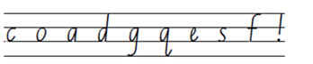  - Suggested practice text from the passage  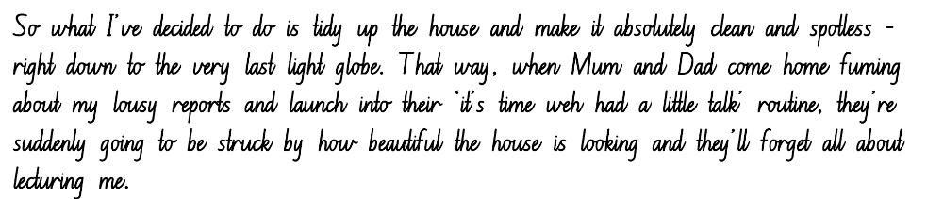  Note: students who are fluent in NSW Foundation Style can begin to use NSW Foundation Precursive and Cursive Style.
Handwriting legibility and fluency (Stage 2 Year 4)  - Join letters when writing familiar words  - Diagonally join to anti-clockwise letters when writing familiar words.  - Diagonal joins to anti-clockwise letters. | Handwriting legibility and fluency (Stage 2 Year 4)  - Suggested fluency pattern  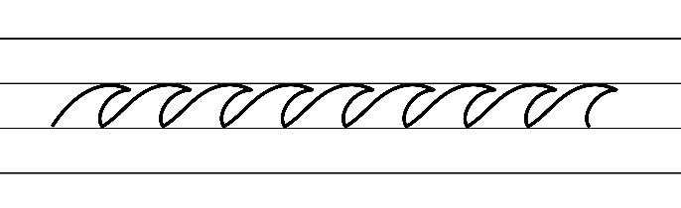  - Example joins to anti-clockwise letters  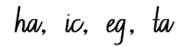  - Retrace the top of an anti-clockwise letter following a horizontal or diagonal join  - Familiar words could include  - Suggested practice text from the passage  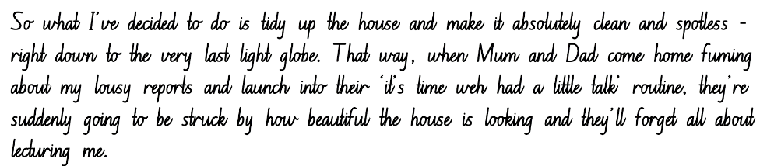
Handwriting legibility and fluency (Stage 3 Year 5)  - Sustain writing with a legible, fluent and personal handwriting style across a text  - Form legible and fluent diagonal joins to anticlockwise letters, including to a, c, d, g, o and q. These are sometimes referred to as backtouch or drop-in joins.  - To form a join to anticlockwise letters, continue the exit hook almost up to line 2 (the neckline) then draw in the anticlockwise letter so that it neatly touches the end of the exit hook.  - Slope cards can be used to reinforce spatial relations, including the maintaining of a consistent parallel slope between letters. | Handwriting legibility and fluency (Stage 3 Year 5)  - Suggested fluency pattern  - Example NSW Foundation Style handwriting formation – diagonal joins to anticlockwise letters  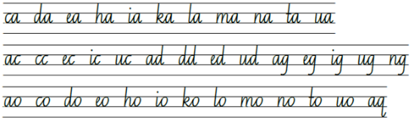  - Suggested practice text from the passage:  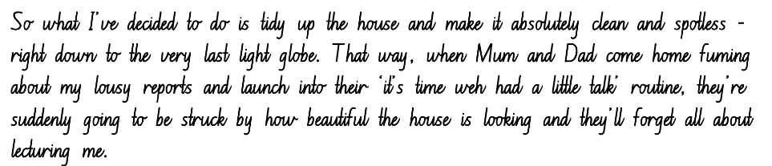
Handwriting legibility and fluency (Stage 3 Year 6)  - Sustain writing with a legible, fluent and personal handwriting style across a text  - Revise horizontal joins to anticlockwise letters, including to a, c, d, g, o and q  - When a horizontal join is made to an anti-clockwise letter, the top of the letter is retraced to join the previous letter.  - Revise horizontal joins to the letter e  - When a horizontal join is made to the letter e, the exit dip needs to be dropped lower to start the entry to the letter in its usual position.  - Revise horizontal joins to the letter s  - When writing the letter s, the formation and join can change depending on its position in a word. It can have a diagonal join, a horizontal join, or no join. | Handwriting legibility and fluency (Stage 3 Year 6)  - Suggested fluency pattern  - Example horizontal joins to anticlockwise letters  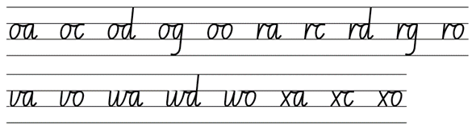  - Example horizontal joins to the letter e  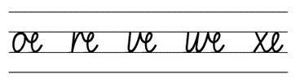  - Example horizontal joins to the letter s  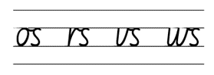  - Students write a passage from the mentor or supporting text  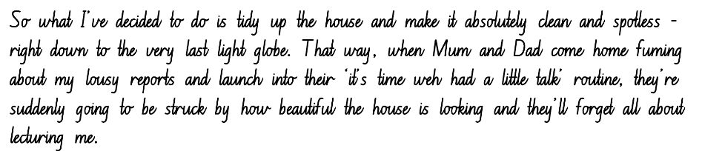

Planning framework
To plan and document Component A teaching and learning, a planning scaffold [DOCX 81 KB] is provided. To support you in your planning, a link to a detailed example of a one-week teaching and learning cycle is included in the scaffold. Additional resources to support teaching and learning in each focus area can be found at Lesson advice guides.

Component B teaching and learning
The following teaching and learning sequence has been designed to address Component B outcomes and content and develops conceptual understandings of English through the study of quality texts. Adapt the sequence as required to best meet the needs of your students.

Learning intentions and success criteria
Learning intentions and success criteria are best co-constructed with students. The table below contains a suggested learning intention and success criteria.
Element | Stage 2 | Stage 3
Learning intention | Students are learning to recognise narrative conventions and language features used to create narrative texts. | Students are learning to analyse and identify patterns in narratives, how they establish expectations, and recognise instances where those patterns are subverted.
Success criteria | Students can:  - identify narrative conventions including complications  - compare a traditional narrative and a non-traditional narrative  - identify the author’s purpose and their identified audience when creating a text  - understand that word contractions are features of informal language  - use coordinating conjunctions in compound sentences to compare and contrast  - select and use precise saying, thinking, acting and relating verbs. | Students can:  - describe how patterns in narratives set up expectations and notice when those patterns are subverted  - compare and contrast a traditional narrative with an untraditional narrative  - identify the author’s purpose and their identified audience when creating a text  - experiment with dashes and parentheses for humorous or ironic effect  - select verbs and verb groups to achieve precision in writing  - use a comma to separate a subordinate clause or a phrase from the main clause.

Lesson 9 – introducing ‘Nick-Knockers Anonymous’
The following teaching and learning activities support multi-age settings.

Whole
- Perform a practical joke on the class. For example, put the class clock forwards 2 hours.
- Students turn and talk and discuss the following questions:
- Have you ever performed a practical joke?
- Have you had a practical joke played on you?
- What effect did it have on the person?
- Ask:
- What practical jokes have been played in Just Tricking.
- Do you think the practical joke went too far in ‘Playing Dead’?
- Write the title of Chapter 4 – ‘Nick-Knockers Anonymous’ on the board. Ask students to make predictions about the text.
- Read Chapter 4, from pages 45 to 53, ‘Thursday night. Mum and dad...’ to ‘...Revenge!’
- Students Think-Pair-Share to summarise what has happened in the narrative so far.

Part
The table below details the differentiated teaching and learning activities for each stage.
Stage 2 (pairs/independent) | Stage 3 (teacher guided/small group)
- Students discuss with a partner what they predict will happen next in the narrative.  - Students draw what they think will happen next.  Too easy? Students accompany their drawing with a written prediction of what will happen in the story, explaining why they believe that will happen. | - Students Think-Pair-Share what they predict will happen next in the narrative.  - Demonstrate how a student can write a prediction and justify their prediction using the text and prior knowledge. For example, I think that... will happen, because I know that... which is supported by...  - Students write their predictions.

Whole
- Students present their predictions and justifications to the class. Explain that this is how readers infer from texts, using their prior knowledge.
- As a class, finish reading Chapter 4 – ‘Nick–Knockers Anonymous’.
- Explain that, sometimes to engage the audience, a story needs to divert from the traditional structure or have an unexpected twist.
- Students turn and talk about the following questions:
- What is the twist in this narrative?
- What is the purpose of the author not following expectations?
- As a class, look specifically at the following lines:
- ‘It’s like I said- they’re all against me’ (p 46).
- ‘And I can guess exactly who that somebody is- Danny Pickett’ (p 48).
- Ask:
- What is the purpose of the dash? For example, the dash is often used for comic timing in humorous situation.
- What does the dash make you do when you are reading?
- Can you find other examples in the story?
- Why would the author include these?
- Ask Stage 3 students to construct sentences where a dash or parentheses is used for humour. Stage 2 students can provide feedback on how effective the dash or parenthesis is in building humour.
Stage 2 Assessment task 6 – Observations from this lesson allow students to demonstrate achievement towards the following syllabus outcomes and content points:
EN2-RECOM-01 – reads and comprehends texts for wide purposes using knowledge of text structures and language, and by monitoring comprehension
- identify different purposes and strategies for reading.
EN2-UARL-01 – identifies and describes how ideas re represented in literature and strategically uses similar representations when creating texts
- describe the interplay of plot, character and setting in different types of narratives
- describe how narrative conventions engage the reader.
Stage 3 Assessment task 5 – Observations from this lesson allow students to demonstrate achievement towards the following syllabus outcomes and content points:
EN3-UARL-01 – analyses representations of ideas in literature through narrative, character, imagery, symbol and connotation, and adapts these representations when creating texts
- describes how patterns in narratives set up expectations and notice when those patterns are subverted.
EN3-CWT-01 plans, creates and revises written texts for multiple purposes and audiences through selection of text features, sentence-level grammar, punctuation and word-level language
- experiment with dashes for parentheses for humorous or ironic effect.

Lesson 10 – understanding the author’s purpose
The following teaching and learning activities support multi-age settings.

Whole
- Review the 2 narratives from Just Tricking.
- Explain to students that every author has a purpose or reason for creating a text. Discuss the author’s purpose in Just Tricking. For example, Andy Griffiths created the narratives to entertain and engage younger readers (and possibly reluctant readers) through humour.
- Review The Imagineer that the class viewed in Lesson 1.
- Select one of the Just Tricking narratives. Use a Venn Diagram to identify similarities and differences between The Imagineer and the Just Tricking narrative. Encourage students to consider narrative patterns, narrative conventions, audience and purpose.
- Analyse the ideas from the Venn Diagram. Students explain which narrative structure they prefer and compose a written response, justifying their answer. Encourage students to use compound sentences and coordinating conjunctions to compare and contrast in their responses.
Stage 2 Assessment task 7 – Observations and work samples from this lesson allow students to demonstrate achievement towards the following syllabus outcome(s) and content point(s):
EN2-CWT-01 plans, creates and revises written texts for imaginative purposes, using text features, sentence-level grammar, punctuation and word-level language for a target audience
- use coordinating conjunctions in compound sentences to compare and contrast, or for addition.

Lesson 11 – using precise verbs and adjectives
The following teaching and learning activities support multi-age settings.

Whole
- Revise verbs and how using precise verbs enhances the audience’s understanding of plot, character and narrative conventions.
- Students turn and talk to select more precise action verbs for run, eat, said.
- Read Just Tricking pages 50 to 52, from ‘I go to the laundry’ to ‘I’ve dealt with Danny.’ Students identify the verbs by clapping their hands as the narrative is read. Pause after each clap and ask a student to record the verb on the board. Prompt students to record one or 2 alternative precise verbs.
- Discuss how the author has written this passage similarly to the structure of a procedural text, listing the steps to make an interesting mixture for Andy’s practical joke.
- In pairs, students identify any complex sentences in the passage. For example, ‘Once it’s all pretty-well mixed, I carry the bucket up the hall to the front door’ (p 51). Ask:
- Where is the comma used in this sentence?
- What is the comma separating? Why? For example, to separate the subordinate clause from the independent clause.
- Explain that students are going to create a piece of write a procedural text to create a mixture Andy will give to Mrs Wharton to clean the library windows. Remind students to include precise verbs and a range of adjectives.
- Students Think-Pair-Share ingredients that could be used in the mixture for Mrs Wharton to clean the library windows. Remind students that these ingredients may not be your traditional window cleaning items. Record a list of ingredients.
- Create a list of adjectives they might use to describe each ingredient/material. For example, crushed chilli peppers. Model drawing and labelling each ingredient with adjectives.

Part
The table below details the differentiated teaching and learning activities for each stage.
Stage 2 (teacher guided) | Stage 3 (independent)
- Co-construct a list of precise verbs that might be used in a procedural text. Ask, what will you need to do? For example, grab, knock, tip.  - Co-construct the start of the procedure. For example, I go to the laundry and grab a yellow plastic bucket...  - Students continue to write their procedural text.  - In pairs, students share their procedural texts. Partners provide feedback including how effectively verbs or adjectives have been used.  - Students revise and edit their writing based on peer feedback. | - Students write their procedural text, including complex sentences.  - Students underline the verbs and circle the adjectives they used in their writing.  - In pairs, share their procedural texts. Partners provide feedback including how effectively complex sentences, verbs, and adjectives have been used.  - Students revise and edit their writing based on peer feedback.
Too hard? Provide students with sentence starters including a range of verbs and adjectives to structure their writing.

Lesson 12 – developing complications
The following teaching and learning activities support multi-age settings.

Whole
- Play charades with the students acting out scenarios that could be used in complications. For example, walking on a tight rope, riding a skateboard down a steep hill, running on a hot path.
- Discuss the purpose of complications in driving the narrative forward and keeping the audience engaged. Read select pages of Chapter 5 – ‘Danger! Danger!’ (pp 41, 45–46) from Once Upon a Slime: 45 Fun Ways to Get Writing … Fast!
- Discuss strategies Andy Griffiths uses to create complications for characters within a story. For example, using dangerous situations.
- Students turn and talk about the following questions:
- Do you solve a complication as soon as it happens? For example, Sarah fell over and twisted her ankle. She was able to get up and keep walking.
- What would be the effect on a story if this is what happened when a complication occurred? For example, there would be no suspense, it wouldn’t engage the reader and the narrative would end.
- Read page 43 of Once Upon a Slime: 45 Fun Ways to Get Writing … Fast!, from ‘What if she’s been in an accident?’ to ‘I’m sure Mrs Chalkboard is fine!’
- List the complications that might have happened to Mrs Chalkboard in the order they are mentioned. Draw attention to the way each complication becomes larger.
- Explore the language used in this text. Ask:
- What are ‘she’s’, ‘don’t’, ‘that’s’, ‘you’re’ and ‘I’m’ examples of?
- Why does Andy Griffiths use them? (For example, to engage with the audience’s language.)
- Are they used for informal or formal writing?
- Provide students with one of Andy Griffiths’ complications. For example, flying high above the ground attached to a helium balloon.
- Brainstorm how this complication could be developed to create more suspense through exaggeration. Record suggestions.
- Provide small groups of students with a comic storyboard. Groups select a complication from the list. One student draws the complication on the comic storyboard, then the next student draws a slightly larger complication in response to the first. This continues until all students have had the opportunity to add to the complications in the comic storyboard.
- Remind students to start with a small complication and gradually increase the complications until they become very dangerous and exaggerated. Direct students to think about the Mrs Chalkboard example on page 43 of Once Upon a Slime: 45 Fun Ways to Get Writing … Fast!
- Remind students to be respectful of other people’s work and revise the expectations for behaviour as they take on the role of a contributing author.
- Students present their building complications back to the class. This could be done as a drama activity.
Too easy? Students identify which 3 complications they might include in a story and discuss ways in which the character could journey from one complication to the next.
Stage 2 Assessment task 8 – Observations from this lesson allow students to demonstrate achievement towards the following syllabus outcomes and content points:
EN2-OLC-01 – communicates with familiar audiences for social and learning purposes, by interacting, understanding and presenting
- follow agreed upon protocols and assigned roles for classroom interactions in person and through the use of technology
- listen actively to identify spoken information, acknowledging the value of others’ contributions
- plan and deliver spoken presentations using language and structure to suit the purpose and audience.
EN2-RECOM-01 reads and comprehends texts for wide purposes using knowledge of text structures and language, and by monitoring comprehension
- understand that word contractions are a feature of informal language and that apostrophes of contraction are used to signal missing letters.
Stage 3 Assessment task 6 – Observations from this lesson allow students to demonstrate achievement towards the following syllabus outcomes and content points:
EN3-OLC-01 – communicates to wide audiences with social and cultural awareness, by interacting and presenting, and by analysing and evaluating for understanding
- follow agreed upon protocols and define individual roles as needed for in-person or online interactions, establishing specific goals, criteria or timeframes
- deliver presentations suitable to purpose and audience.

Week 4

Component A teaching and learning
Component A focuses on the development of foundational skills and knowledge through regular, systematic and repeated practice. The mentor and supporting texts used in Component B of this unit can support the effective implementation of Component A teaching and learning.

Teaching guide
Guidance for explicit teaching, teaching notes, resources and examples for the related outcomes and content points have been provided in the table below.
Focus areas and teaching notes | Resources and examples
Reading fluency  Reading automaticity and rate (Stage 2)  - Syllabify, blend grapheme–phoneme correspondences and use morphemic knowledge as strategies for reading words accurately  - Locate and syllabify multisyllabic words, including those with morphemic suffixes (-ing, -ed, -ly).  - Morphemic suffixes usually form their own syllable.  - For every syllable, there is at least one vowel phoneme.  - The morphemic suffix -ed forms a syllable when pronounced as ‘ed’ but does not when pronounced as ‘d’ or ‘t’. | Reading fluency  Reading automaticity and rate (Stage 2)  - Resource 4 – fluency close and reading passage analysis (Week 3) – Page 50 from ‘He's gone...’ to page 51 ‘...is so heavy and gluggy.’ (316 words)  - Suggested words from the passage  - Morphemic information  - mixing – mix + ing  - vacuumed – vacuum + ed  - crushed – crush + ed  - slowly – slow + ly.  - Syllables:  - mixing – 2 syllables  - vacuumed – 2 syllables  - crushed – 1 syllable  - slowly – 2 syllables.  Note:  - The passage from the text will need to be a teacher-created resource.  - Content in Reading fluency will support learning in the focus areas of Vocabulary, Reading comprehension and Spelling.
Prosody (Stage 2)  - Explain how prosodic reading involves emphasis, expression, intonation and pausing  - Emphasis is when the reader gives extra importance or focus to specific words or parts of a sentence. It helps to convey the meaning or feeling behind the text.  - Readers may emphasise words that  - highlight exaggeration  - are repeated in close succession. | Prosody (Stage 2)  - Suggested sentences to illustrate the use of emphasis from the passage  - ‘I’m going to catch him and kill him.’  - ‘I slam the door.’  - ‘This means war.’
Reading comprehension  Reading for interest and wide purpose (Stage 2)  - Identify different purposes and strategies for reading  - Purposes might include reading for enjoyment, to gather information, to understand the author’s viewpoint and to find information to support an opinion.  - The purpose for reading helps to determine the strategies that will be utilised. For example, if the purpose for reading is to find specific information, the strategy of scanning may be used. | Reading comprehension  Reading for interest and wide purposes (Stage 2)  - Purpose of this passage: reading for enjoyment and to provide information about Andy’s plan to get even with Danny Pickett.  - Strategies may include inferring. The passage details all the ingredients Andy has put into his mixture, with the inference that he is making it as disgusting as possible.
Comprehending language (Stage 2)  - Use morphemic knowledge to read and understand the meaning of words  - Suffixes can be added to base words to adjust their meaning.  - ‘-ly’ means ‘a characteristic of’ and attaches to nouns to form adjectives, or for adjectives to form adverbs  - ‘-ing’ can be added to some nouns to turn them into adjectives, describing something that causes a certain feeling or emotion.  - Use key words from a text to visualise events, characters and settings when making inferences and confirming predictions  - Key words for describing an event or scene include nouns that provide concrete details. For example, the places, locations and things that make up the story’s environment.  - Key words for describing a scene of the event include adjectives that describe the physical attributes of the location.  - Key words that drive a narrative and provide essential context for understanding the unfolding story include the verbs.  - Key words used within figurative language adds depth and richness to descriptions, allowing readers to form mental images that go beyond literal interpretations. | Comprehending language (Stage 2)  - Suggested words from the passage  - mixing: mix + ing (p 50)  - vacuumed: vacuum + ed (p 50)  - crushed: crush + ed (p 50)  - slowly: slow + ly (p 51)  - gluggy: glug(g) + y (p 51).  - Key words from the text to visualise the scene  - ‘He’s gone. Nobody but the wind. A flurry of brown autumn leaves blows through the door and onto the carpet – the carpet that I vacuumed only fifteen minutes ago. I slam the door.’  - ‘Danny is fast on his feet.’  - ‘I go to the laundry and grab the yellow plastic bucket. I take it back to the kitchen and fill it about halfway with white flour.’
Monitoring comprehension (Stage 2)  - Identify where meaning breaks down when reading  - Meaning may break down when figurative language is used. For example, if similes are taken too literally or misinterpreted. | Monitoring comprehension (Stage 2)  - Examples of figurative language from the passage  - ‘I'm going to catch him and kill him.’ (p 50)  - ‘Nobody but the wind.’ (p 50)  - ‘This means war.’ (p 50)  - ‘Danny’s fast on his feet, I'll give him that.’ (p 50).
Reading comprehension  Reading fluently (Stage 3)  - Syllabify, blend grapheme–phoneme correspondences and use morphemic knowledge as strategies for reading words accurately  - Locate and syllabify multisyllabic words, including those with morphemic suffixes (-ing, -ed, -ly).  - Morphemic suffixes usually form their own syllable.  - For every syllable, there is at least one vowel phoneme.  - The morphemic suffix -ed forms a syllable when pronounced as ‘ed’ but does not when pronounced as ‘d’ or ‘t’. | Reading comprehension  Reading fluently (Stage 3)  - As above (see Stage 2 Reading fluency)
Comprehending language (Stage 3)  - Use morphology and etymology to work out the meaning of unfamiliar words  - Understanding the etymology of words assists in explaining the origins of, and changes to, words in relation to meaning. The etymology of words can also assist in understanding the spelling of words. | Comprehending language (Stage 3)  - Suggested etymology from the passage  - Vacuum: the term ‘vacuum’ comes from the Latin ‘vacuus’ meaning ‘empty’.  - Relish: the term ‘relish’; comes from the comes from the Old French ‘reles’ and the Middle English ‘relesche’, meaning ‘something remaining’ or ‘something left over’.
Comprehending language (Stage 3)  - Identify cause and effect, using knowledge of causal connectives  - Connectives relate ideas to one another and help show the logic of the information. Connectives are important resources for creating cohesion in texts.  - Causal connectives are words or phrases that show cause and effect. For example, in consequence, so, because, for, since, therefore, as a result. | Comprehending language (Stage 3)  - Example sentences from the Week 4 reading material showing cause and effect  - ‘It’s hard work because the mixture is so heavy and gluggy.’ (p 51)  - ‘After about ten minutes of mixing there’s still lots of lumps, so I get out the blender...’ (p. 51).
Monitoring comprehension (Stage 3)  - Monitor and repair reading when meaning breaks down  - Strategies to repair reading may include pausing, self-correcting, re-reading or reading on; using phonic morphemic or word knowledge and reactivating background knowledge. | Monitoring comprehension (Stage 3)  - As above (see Stage 2 Reading comprehension)
Vocabulary  Learning and using words (Stage 2)  - Build personal Tier 1, Tier 2 and Tier 3 vocabulary through social and learning interactions, reading and writing  - Tier 1 words: Basic-level, everyday words (NESA 2023).  - Tier 2 words: General academic words that can be used across a variety of domains. They are of high utility for mature language users and are commonly used in written language (NESA 2023).  - Tier 3 words: Words that are used rarely (low frequency) and only in highly specific situations (NESA 2023). | Vocabulary  Learning and using words (Stage 2)  - Examples from the fluency passage  - Tier 2 vocabulary: fluid, flurry, brain-power, gluggy, ought.  - Other related vocabulary  - mischievous, disobedient, manipulative.
Defining and analysing words (Stage 2)  - Apply morphemic knowledge to change word meanings by adding different prefixes and suffixes to a base word or root  - Use morphemic knowledge to read and understand Tier 2 words (-ly, -y, -ing).  - Suffix -ing changes the tense of a verb. -ing expresses present tense; -ing also expresses future tense.  - Suffix -ly means ‘a characteristic of’ and attaches to nouns to form adjectives, adjectives to form adverbs. | Defining and analysing words (Stage 2)  - Suggested morphology from the Week 4 reading material  - hardly (p 49), polishing (p 49), gluggy (p 51), suddenly (p 51).
Vocabulary  Learning and using words (Stage 3)  - Identify newly encountered words from interactions and wide reading, and use them in writing, discussions and presentations  - Identify and discuss the meanings of newly encountered Tier 2 and Tier 3 words in the text to improve vocabulary knowledge and comprehension. It could be a word with an unfamiliar meaning, an unusual spelling, or a term specific to a certain context. | Vocabulary  Learning and using words (Stage 3)  - Possible newly encountered words from passage: fluid, flurry, brain-power, gluggy, ought.  - Other related vocabulary: mischievous, disobedient, manipulative.
Defining and analysing words (Stage 3)  - Analyse morphemic structures of Tier 2 and Tier 3 words to determine their meaning  - Morphemes can be words themselves or parts of words, such as prefixes, suffixes and root words. Analysing morphemic structures involves breaking words down into their constituent morphemes to understand how the meaning is formed. | Defining and analysing words (Stage 3)  - As above (see Stage 2 examples)
Spelling  Phonological component (Stage 2)  - Explain how to segment multisyllabic words into syllables and phonemes, and apply this knowledge when spelling  - As introduced in Early Stage 1 and Stage 1, revise segmenting multisyllabic words into syllables and phonemes. For example, ‘maybe’ has 2 syllables and 4 phonemes (m-ay-b-e). This is a phonological skill that should be practised regularly.  - Identify differences in vowel phonemes (short, long, diphthong and schwa vowels)  - The long vowel phoneme /igh/ as in my can be represented by [i_e, ie, i, y, igh]. | Spelling  Phonological component (Stage 2)  - Suggested words from Week 4 reading material  - driving (p 49), give (p 50), whines (p 53), strike (p 53).  - Sample words for inquiry  - magpie(s), tie(s), bicep(s), giant(s), pilot(s), pirate(s), night(s), hike-hikes-hiking-hiked, swipe-swipes-swiping-swiped, sigh-sighs-sighing-sighed, mime-mimes-miming-mimed.
Orthographic component (Stage 2)  - Apply knowledge of taught vowel graphemes when spelling  - The long vowel phoneme /igh/ can be represented by the vowel digraph [ie], trigraph [igh] and the split digraph [i_e]. The grapheme [o] and the split digraph [o_e] can also be used to represent the phoneme /ow/. | Orthographic component (Stage 2)  - As above
Morphological component (Stage 2)  - Identify inflected suffixes, explaining when and how to treat base words when they are affixed, and apply this knowledge when spelling  - Inflected suffixes: plural (-s, -es) tense (-s, -ing, -ed)  - The inflected suffixes -s and -es change a noun from singular (one) to plural (more than one).  - The inflected suffixes -s, -ing, -ed change the tense of a verb. The suffixes -s and -ing express present tense, -ed expresses past tense; -ing also expresses future tense. | Morphological component (Stage 2)  - As above
Spelling  Phonological component (Stage 3)  - Segment unfamiliar multisyllabic words into syllables and phonemes as a strategy when spelling  - Revise segmenting multisyllabic words into syllables and phonemes. This is a phonological skill that should be practised regularly. | Spelling  Phonological component (Stage 3)  - Suggested words from the Week 4 reading material  - bottle (p 50), dozen (p 50), front (p 51), mosquito (p 53), moment (p 55).  - Sample words for inquiry  - modern, observe, frozen, zero, yodel, Monday, money, some, love, discover, govern, conserve-conservation, admire-admiration, expire-expiration, form-formation, relax-relaxation, tempt-temptation, limit-limitation, add-addition, oppose-opposition, compete-competition, define-definition, occupy-occupation.
Orthographic component (Stage 3)  - Recognise that the same grapheme can represent different phonemes  - Graph [o] representing /o, /oa/ and /u/  - Highlight the different phonemes represented by the grapheme [o]. [o] can be used to represent /o/ as in ‘on’, /oa/ as in ‘own’ and /u/ as in ‘come’. Note the grapheme’s position within base words. | Orthographic component (Stage 3)  - As above
Morphological component (Stage 3)  - Explain and use spelling conventions to add derivational suffixes such as -ion, -ian, -ence, -ous to base words or roots  - Introduce suffix  - ‘-ation’ and ‘-ition’ meaning ‘act’ or ‘process’  - attaches to verbs to form nouns  - there is no strict rule for when to use -ation or -ition: starve-starvation, compete-competition. | Morphological component (Stage 3)  - As above
Creating written texts  Sentence-level grammar (Stage 2)  - Use coordinating conjunctions in compound sentences to compare and contrast, or for addition  - Review compound sentences.  - Review coordinating conjunctions.  - Select and use precise saying, thinking, acting, and relating verbs and verb groups to align with text purpose  - Review verbs and verb groups.  - Review different types of verbs: action, thinking, feeling, saying and relating.  - Use declarative sentences to provide facts or state a viewpoint  - A declarative sentence is a statement presented as a complete sentence to provide fact, evidence or detail (NESA 2023). | Creating written texts  Sentence level grammar (Stage 2)  - Suggested compound sentences from the Week 4 reading material  - ‘Danny’s still knocking, but I’m not going to open the door.’ (p 49)  - ‘I tip all the ingredients into the bucket and start mixing them up with a wooden spoon.’ (p 51)  - ‘After about ten minutes of mixing there’s still lots of lumps, so I get out the blender and pour a litre or so into the jug.’ (p 51)  - Suggested verbs and verb groups from the compound sentences above  - Action: is still knocking, am not going to open, tip, start mixing, get out, pour.  - Suggested declarative sentences from the passage  - ‘He's gone.’  - ‘I'll be ready next time.’  - ‘I go to the laundry and grab the yellow bucket.’
Punctuation (Stage 2)  - Use capital letters to indicate the beginning of a sentence, proper nouns, headings and subheadings, to indicate the beginning of a poetry line, for emphasis, and when using acronyms  - Review sentence boundary punctuation, including capital letters to indicate the beginning of a sentence and to indicate proper nouns.  - Use commas between words in a list or to separate adjectives when more than one is used  - Review using commas to separate adjectives.  - Commas are used to separate words or phrases in a list. A good way to test if the comma is in the correct position is to replace it with one of the conjunctions and or or. | Punctuation (Stage 2)  - As above  - Example sentences to illustrate the use of commas to separate adjectives  - ‘I grab the yellow, plastic basket from the laundry and head back to the kitchen.’  - ‘Suddenly there’s reddish-black, stink sauce everywhere.’
Word-level language (Stage 2)  - Use adjectives to develop descriptive features  - Adjectives are words that describes, identifies or quantifies a noun or a pronoun. Different types of adjectives include possessive, quantifying, descriptive, comparative, superlative and classifying (NESA 2023). | Word-level language (Stage 2)  - Example adjectives from the passage  - descriptive: yellow, gluggy, heavy, crushed  - classifying: plastic, tomato, soy  - quantifying: whole.
Creating written texts  Sentence-level grammar (Stage 3)  - Make choices about verbs and verb groups to achieve precision and add detail  - A verb is a word that indicates what is happening.  - Review different types of verbs: action, thinking, feeling, saying and relating.  - A verb group is a group of words built around a verb (NESA 2023). Verb groups may contain  - auxiliary or 'helping’ verbs to indicate tense or modality, for example, ‘I am going soon. I must leave before dark.’  - contain 2 or more verbs, for example, ‘The wolf huffed and puffed.’  - other words such as adverbs or prepositions, for example, ‘The plane took off.’  - Include appositives to provide details to nouns and to vary sentence structures suited to text purpose  - Appositives can be words, phrases or clauses that affect or enhance the meaning of a noun or pronoun. They can be placed beside a noun to explain it more fully.  - Appositives can describe, identify or explain.  - Appositive words or phrases can follow the noun it describes (Sydney, the capital of NSW, is the largest city in Australia)  - Appositive words or phrases can precede the noun (The capital of NSW, Sydney, is the largest city in Australia). | Creating written texts  Sentence level grammar (Stage 3)  - As above (see Stage 2 examples)  - Innovated sentence including an appositive to provide details to the noun from the passage  - ‘Danny, fast on his feet, proved to be quite a challenge for me.’  - ‘Fast on his feet, Danny is no match for my brain-power.’
Punctuation (Stage 3)  - Use capital letters at the beginning of a sentence, to indicate proper nouns, for headings and subheadings, to indicate the beginning of a poetry line, for emphasis, and when using acronyms  - Review sentence boundary punctuation, including capital letters to indicate the beginning of a sentence and to indicate proper nouns.  - Use a comma to separate a subordinate clause or a phrase from the main clause, or to separate information within a sentence, or to separate items in a list  - Commas are a punctuation marker used to show separation between parts of a sentence, such as clauses or phrases, where separation is important to the meaning. Commas are also used to separate words, phrases or numbers in a series (NESA 2023).  - Experiment with dashes and parentheses for humorous or ironic effect  - Dashes enclose extra information.  - Dashes are used for humorous effect  - as an interruption or an aside  - to provide unexpected or contradictory information  - to provide playful exaggeration. | Punctuation (Stage 3)  - As above  - Example sentences to illustrate the use of commas  - ‘Danny’s fast on his feet, I’ll give him that.’ (p 50)  - ‘But when it comes to brain-power, he’s no match for me.’  - ‘I grab the yellow, plastic basket from the laundry and head back to the kitchen.’  - Example use of dashes from the passage  - ‘I jump off the ladder, sprint to the door and open it – all in one fluid movement.’  - ‘A flurry of brown autumn leaves blows through the door and onto the carpet – the carpet that I vacuumed only fifteen minutes ago.’
Handwriting and digital transcription  Handwriting legibility and fluency (Stage 2 Year 3)  - Understand that legible handwriting is consistent in size and spacing and can support learning  - Form the ‘diagonal’ letters v, w, x and z and the ‘down-up’ letters u and y with consistent size and spacing  - Review previously taught information on consistency, including direction of movements for letter formation, size, slope and spacing.  - Focus on the pen(cil) lift and drop for the letters x and y.  - Form basic punctuation marks, including commas and speech marks  - Commas are positioned on the baseline.  - Speech marks are positioned to rest below the top line (Line 1). | Handwriting and digital transcription  Handwriting legibility and fluency (Stage 2 Year 3)  - Suggested fluency pattern  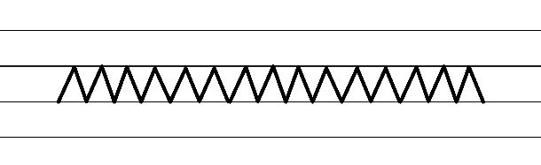  - Example NSW Foundation Style handwriting formation  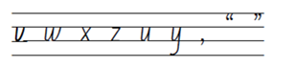  - Suggested practice text from the passage  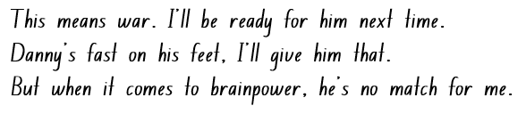  Note: students who are fluent in NSW Foundation Style can begin to use NSW Foundation Precursive and Cursive Style.
Handwriting legibility and fluency (Stage 2 Year 4)  - Join letters when writing familiar word  - diagonally join to anti- clockwise letters when writing familiar words  - diagonal joins to anti-clockwise letters. | Handwriting legibility and fluency (Stage 2 Year 4)  - Suggested fluency pattern  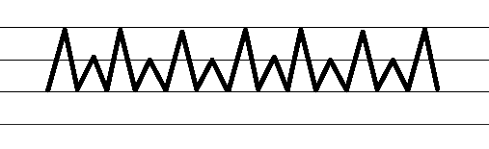  - Example diagonal joins to anticlockwise letters  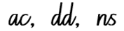  - Familiar words could include  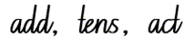  - Suggested practice text from the passage  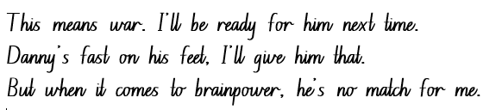
Handwriting legibility and fluency (Stage 3 Year 5)  - Sustain writing with a legible, fluent and personal handwriting style across a text  - Form legible and fluent horizontal joins to short letters. These are sometimes known as neckline joins. The letters o, r, v, w and x join to the following letter with a horizontal join.  - There is a slight dip in a horizontal join to a short letter.  - Form legible and fluent horizontal joins to tall letters.  - Horizontal joins meet the tall letter at line 2 (the neckline) and continue to the top of the letter before it is retraced back down. | Handwriting legibility and fluency (Stage 3 Year 5)  - Suggested fluency pattern  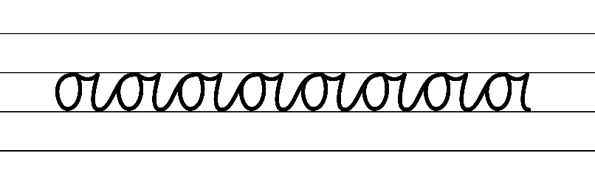  - Example NSW Foundation Style handwriting formation – horizontal joins to short letter  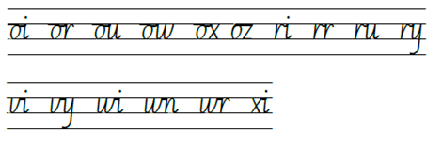  - Suggested practice text from the passage
Handwriting legibility and fluency (Stage 3 Year 6)  - Sustain writing with a legible, fluent and personal handwriting style across a text  - Revise cursive loops from descenders, including from the letters g, j and y. These are sometimes known as baseline loops.  - Baseline loops for letters with descenders can increase fluency and add to a personal writing style.  - The loop on the descender crosses at the baseline and joins the letter in its usual position. | Handwriting legibility and fluency (Stage 3 Year 6)  - Suggested fluency pattern  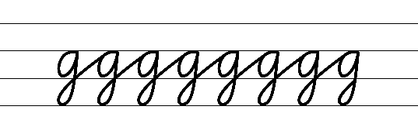  - Example cursive loops from descenders  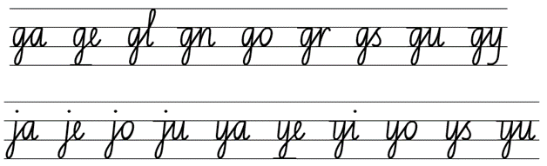  - Suggested practice text from the passage

Planning framework
To plan and document Component A teaching and learning, a planning scaffold [DOCX 81 KB] is provided. To support you in your planning, a link to a detailed example of a one-week teaching and learning cycle is included in the scaffold. Additional resources to support teaching and learning in each focus area can be found at Lesson advice guides.

Component B teaching and learning
The following teaching and learning sequence has been designed to address Component B outcomes and content and develops conceptual understandings of English through the study of quality texts. Adapt the sequence as required to best meet the needs of your students.

Learning intentions and success criteria
Learning intentions and success criteria are best co-constructed with students. The table below contains a suggested learning intention and success criteria.
Element | Stage 2 | Stage 3
Learning intention | Students are learning to understand the purpose of a resolution in a narrative. | Students are learning to understand the purpose of a resolution in a narrative and how this pattern can be manipulated to achieve different effects on an audience.
Success criteria | Students can:  - identify a resolution  - identify the purpose of a resolution  - describe traditional narrative resolutions  - write an effective resolution to a story  - write compound sentences containing coordinating conjunctions  - develop a plan to create their narrative. | Students can:  - identify different types and purpose of a resolution  - compare a traditional resolution to a resolution where patterns are subverted  - identify the authors intent when subverting traditional patterns of a narrative  - write an effective resolution to a story to achieve a specific purpose for the identified audience  - use compound and complex sentences in their writing  - develop a plan to create their narrative.

Lesson 13 – exploring resolutions
The following teaching and learning activities support multi-age settings.

Whole
- Revise the purpose of a resolution. For example, to provide closure, satisfy the reader’s expectations and give a sense of completion to the story.
- Discuss with students how they would feel if they read a narrative with an unfulfilling resolution. For example, then they woke up and realised it had all been a dream.
- Ask:
- Do you consider this resolution to be effective and satisfying to the audience? Why or why not?
- Why is it important for the author to construct a resolution that is effective to the audience? For example, the reader feels satisfied and enhances their enjoyment of the text.
- Discuss different types of resolutions. For example:
- Lesson or moral – the main character grows and learns something
- Surprise ending – the reader is left with an unexpected ending or twist
- Happy ending – the problem faced by the characters is solved in a positive or expected way
- Humorous ending – the story ends with a funny thought or action
- Cliffhanger ending – the story ends with the reader wanting more. For example, a sequel.
- Identify narratives that include these types of resolutions. For example, the resolution to The Three Little Pigs provides a lesson to the audience that it is more important to take the time, care, and pride in what you do.
- Discuss the strategies Andy Griffiths uses, including twists and surprises for humorous effect in his resolutions. For example, in ‘Playing Dead’ it appears that Andy is going to deceive his parents and not have to go to school. Unexpectedly, his parents go along with the trick and they end up tricking Andy into thinking his dad is dead.
- In pairs, students discuss the resolution in ‘Nick–Knockers Anonymous’, identifying the strategy Andy Griffiths uses to achieve the type of resolution.
- Model writing compound sentences that include coordinating conjunctions to compare and contrast narrative resolutions. For example, The Three Little Pigs and ‘Nick–Knockers Anonymous’.

Part
The table below details the differentiated teaching and learning activities for each stage.
Stage 2 (independent) | Stage 3 (teacher guided)
- In pairs, students discuss to compare and contrast the resolution from ‘Playing Dead’ with resolution from The Imagineer.  - Students record their ideas, writing compound sentences. Encourage students to use a range of coordinating conjunctions to compare and contrast the resolutions.  - Students highlight the coordinating conjunctions used in their compound sentences.  - In pairs, students share their sentences.  Too easy? Students create compound sentences independently using different conjunctions to compare 2 other narrative resolutions. | - Review that complex sentences communicate more than one idea and are comprised of an independent and dependant clause.  - Model writing complex sentences to compare the purpose of 2 different narrative resolutions. For example, While the purpose of The Three Little Pigs’ resolution is to teach a lesson, Nick Knockers Anonymous uses a surprise ending to entertain the audience.  - Students write a complex sentence comparing 2 different narrative resolutions.  - In pairs, students share their sentences.

Lesson 14 – rewriting resolutions
The following teaching and learning activities support multi-age settings.

Whole
- Revise what students know and understand about resolutions. Discuss the role of resolutions in a narrative and the effect they have on an audience.
- Re-read ‘Nick-Knockers Anonymous’ from Just Tricking until page 53, ‘...that’s it. Now!’
- Discuss how Andy Griffiths uses a range of sentences (simple/compound/complex) to build suspense prior to the resolution.
- Ask students to identify the type of sentences:
- ‘He’s coming alright.’ (declarative/simple)
- ‘I’ve got my ear pressed up against the crack of the front door so I can hear even the tiniest movements on the verandah.’ (compound)
- ‘Once it’s all pretty-well mixed, I carry the bucket up the hall to the front door.’ (complex)
- Review the types of resolutions from Lesson 13 activity 4.
- Model re-writing the resolution of ‘Nick-Knockers Anonymous’ using an alternative ending where Andy learns a lesson. Ensure that a range of sentence structures, precise verbs and descriptive adjectives are included by highlighting these with students. For example:
Andy ripped open the door and threw the congealed mess over his unsuspecting victim. Danny screamed. The slimy sludge dripped from his head, cascading to the floor. At that exact moment, Andy’s mum and dad stepped out of their car. They were home early. Andy’s mum’s eyes opened wide in horror. His dad’s face grew red as a tomato and steam burst out of his ears.
“Andy!” howled his mum.
Danny turned on his heel and scattered like a cat, leaving a trail of gooey mess behind him. Andy was in serious trouble now. His mum stormed up to the doorstep.
“Clean up that mess now!” she screamed. Andy hung his head in shame. Slowly he trudged into the house and retrieved the mop and bucket. As his parents looked on in disappointment, Andy began the great clean up. His tricking days had come to an end.
- Explain that students are going to re-write the ending of the narrative ‘Nick-Knockers Anonymous’ by selecting a different type of resolution. Discuss that students will be required to show varied sentence types to build the tension like Andy Griffiths. Co-construct differentiated success criteria.

Part
The table below details the differentiated teaching and learning activities for each stage.
Stage 2 (teacher guided) | Stage 3 (independent/pairs)
- Select a different type of resolution for the narrative ‘Nick-Knockers Anonymous’. For example, surprise, happy, cliffhanger.  - Jointly construct the new resolution for ‘Nick-Knockers Anonymous’, referring to the Stage 2 success criteria. Model the use of compound sentences, precise verbs and descriptive adjectives.  - Students record the jointly constructed resolution and highlight the use of compound sentences, circle the verbs and underline the adjectives. | - Students select and re-write a different type of resolution for the narrative ‘Nick-Knockers Anonymous’. For example, surprise, happy, or cliffhanger.  - Students peer edit a partner’s work, identifying the different type of resolution and highlight the inclusion of compound and complex sentences, precise verbs and adjectives.  - Students revise their work based on the feedback and edit to ensure they have achieved the success criteria.  Too hard? Students draw and label an illustration depicting an alternative resolution.

Whole
- Selected Stage 3 students share their new resolutions with the class.
- Discuss if these endings would suit Andy Griffiths’ style of writing. Discuss why these endings would change the style of the writing and impact of the reader.
Stage 2 Assessment task 9 – Observations and work samples from this lesson allow students to demonstrate achievement towards the following syllabus outcome(s) and content point(s):
EN2-CWT-01 – plans, creates and revises written texts for imaginative purposes, using text features, sentence-level grammar, punctuation and word-level language for a target audience
- use adjectives to develop descriptive features.
Stage 3 Assessment task 7 – Observations and work samples from this lesson allow students to demonstrate achievement towards the following syllabus outcome(s) and content point(s):
EN3-UARL-01 – analyses representations of ideas in literature through narrative, character, imagery, symbol and connotation, and adapts these representations when creating texts
- describes how patterns in narratives set up expectations and notice when those patterns are subverted.
EN3-CWT-01 plans, creates and revises written texts for multiple purposes and audiences through selection of text features, sentence-level grammar, punctuation and word-level language
- make choices about verbs and verb groups to achieve precision and add detail.

Lesson 15 – modelling a pocket book
The following teaching and learning activities support multi-age settings.

Whole
- Read Chapter 31 – ‘Pocket Books’ from Once upon a Slime: 45 Fun Ways to Get Writing … Fast!
- Analyse why Andy Griffiths developed pocket books to begin writing narratives. Explore how it might support young writers to develop their writing skills.
- Identify narrative conventions and patterns within the sample pocket book (pp 226–228) from Once upon a Slime: 45 Fun Ways to Get Writing … Fast! For example, characters, settings, orientations, complications and resolutions. Identify conventions that could be expanded upon.
- Explain that students will use Andy Griffiths’ idea of a pocket book to create their own narrative. This lesson will focus on planning a narrative using narrative conventions and patterns explored in this unit.
- Co-construct differentiated success criteria for a pocket book narrative recreation. For example, an engaging and humorous narrative includes:
- an orientation, complication, resolution (Stage 2) and multiple paragraphs with clear, coherent transition of ideas (Stage 3)
- accurate declarative, compound (Stage 2) and complex sentences (Stage 3)
- punctuation, including capital letters and commas to list adjectives
- precise verbs
- a variety of tiered vocabulary
- a range of adjectives to build descriptions of characters, settings, complications and resolutions
- careful planning, revising, editing to create published texts (Stage 3).
- Brainstorm ideas for a narrative based on Just Tricking. The narrative is to involve a trick of some kind. Refer to Chapter 31 (p 229) ‘Make a pocket book’ and ‘Resources’ section (pp 335–336).
- Select an idea from the list and model creating a plan for a pocket book using the storyboard template. Identify the audience and purpose of the narrative. Ensure that the plan includes characters, setting, orientation, complications and resolutions. Planning could include simple illustrations (drawing inspiration from Terry Denton’s character creations) and dot points when addressing each narrative convention or pattern.
- Discuss if the narrative will follow a traditional structure or whether it will subvert from expectations as in Just Tricking. Explore how humour could be included.

Lesson 16 – planning a pocket book
The following teaching and learning activities support multi-age settings.

Whole
- Review the teacher model using the storyboard and success criteria from Lesson 15.
- Revisit the ideas list for writing a narrative from Lesson 15.
- Students select their own idea from the list or think of their own to create their pocket book.
- Students plan their pocket book using the storyboard template. Remind students to identify the audience and the purpose of the narrative, illustrate and briefly record what is happening in each illustration. Students ensure their plan includes characters, setting, orientation, complications and resolutions. Students will need to consider whether the narrative will follow a traditional structure or subvert from expectations as in Just Tricking.
- Ask students to identify and highlight the narrative conventions and patterns in their storyboard.
Too hard? Provide a wider range of ideas including images to promote thinking.

Week 5

Component A teaching and learning
Component A focuses on the development of foundational skills and knowledge through regular, systematic and repeated practice. The mentor and supporting texts used in Component B of this unit can support the effective implementation of Component A teaching and learning.

Teaching guide
Guidance for explicit teaching, teaching notes, resources and examples for the related outcomes and content points have been provided in the table below.
Focus areas and teaching notes | Resources and examples
Reading fluency  Reading automaticity and rate (Stage 2)  - Syllabify, blend grapheme–phoneme correspondences and use morphemic knowledge as strategies for reading words accurately  - Locate and syllabify multisyllabic words, including those with morphemic suffixes (-ing, -ed, -ly).  - Morphemic suffixes usually form their own syllable.  - For every syllable, there is at least one vowel phoneme.  - The morphemic suffix -ed forms a syllable when pronounced as ‘ed’ but does not when pronounced as ‘d’ or ‘t’. | Reading fluency  Reading automaticity and rate (Stage 2)  - Fluency and close reading passage – page 53 ‘I open the front door...’ to page 55 ‘...It’s just a matter of time.’ (304 words)  Note:  - The passage from the text will need to be a teacher-created resource.  - Content in Reading fluency will support learning in the focus areas Vocabulary, Reading comprehension and Spelling.  - Suggested words from the passage  - Morphemic information  - prepared – prepar(e) + ed  - standing – stand + ing  - trembling – trembl(e) + ing  - softly – soft + ly.  - Syllables  - prepared – 2 syllables  - standing – 2 syllables  - trembling – 2 syllables  - softly – 2 syllables.
Prosody (Stage 2)  - Explain how prosodic reading involves emphasis, expression, intonation and pausing  - Pausing and intonation when reading aloud is essential in reading. The use of punctuation such as commas ( , ) and full stops ( . ) will assist in effectively pausing and using end of sentence intonation. | Prosody (Stage 2)  - Suggested sentence to illustrate the use of pausing and intonation  - ‘All over the entrance hall, all over Mum.’ (p 54)  - ‘He appears calm, but hid ears are very red, and they’re trembling – that’s not a good sign.’ (p 54)
Reading comprehension  Comprehending language (Stage 2)  - Use key words from a text to visualise events, characters and settings when making inferences and confirming predictions  - Key words for describing an event include nouns that provide concrete details about the physical elements of the event, verbs to describe the action taking place and adjectives and adverbs to create a vivid picture of the event in the reader’s mind. Figurative language can also be used to help the reader visualise the event. | Reading comprehension  Comprehending language (Stage 2)  - Key words and phrases from the Week 5 reading material to visualise an event  - ‘The mixture is everywhere. All over the entrance hall, all over the wire door and all over Mum. She’s standing there looking like the creature from the black lagoon. The goo slimes off her clothes and collects in a puddle at her feet.’ (p 54)
Comprehending language (Stage 2)  - Understand that word contractions are a feature of informal language and that apostrophes of contraction are used to signal missing letters  - A contraction is a shortened form of one or 2 words (one of which is usually a verb). In a contraction, an apostrophe takes the place of the missing letter or letters (NESA 2023).  - Contractions are regularly used in Just Tricking, helping to create the informal language expected of a child. | Comprehending language (Stage 2)  - Example sentences from the passage featuring contractions  - ‘It’s a perfect throw. I’ve caught him red-handed. He’s covered in the stinking gooey brew. I can’t even see his face.’
Monitoring comprehension (Stage 2)  - Identify where meaning breaks down when reading  - Meaning may break down when figurative language is used. For example, if idioms are not known or are taken too literally or if similes or metaphors are misunderstood. | Monitoring comprehension (Stage 2)  - Example figurative language from the passage where meaning may break down  - ‘caught him red-handed': this idiom means to catch someone in the act of a crime or wrongdoing.  - ‘like the creature from the black lagoon’: this simile refers to a character from the 1954 horror film, Creature of the Black Lagoon.  - ‘eating out of the palm of my hand’: this idiom means to easily make someone do what you think or want.
Reading comprehension  Reading fluently (Stage 3)  - Syllabify, blend grapheme–phoneme correspondences and use morphemic knowledge as strategies for reading words accurately  - Locate and syllabify multisyllabic words, including those with morphemic suffixes (-ing, -ed, -ly).  - Morphemic suffixes usually form their own syllable.  - For every syllable, there is at least one vowel phoneme.  - The morphemic suffix -ed forms a syllable when pronounced as ‘ed’ but does not when pronounced as ‘d’ or ‘t’. | Reading comprehension  Reading fluently (Stage 3)  - As above (see Stage 2 Reading fluency examples)
Comprehending language (Stage 3)  - Identify cause and effect, using knowledge of causal connectives  - Connectives relate ideas to one another and help show the logic of the information. Connectives are important resources for creating cohesion in texts.  - Causal connectives are words or phrases that show cause and effect. For example, in consequence, so, because, for, since, therefore, as, as a result. | Comprehending language (Stage 3)  - Example sentences from Week 5 reading material showing cause and effect  - ‘I’ve got my ear pressed up against the crack of the front door so I can hear even the tiniest movement on the verandah.’ (p 52)  - ‘It creaks as he opens it.’ (p 53)
Monitoring comprehension (Stage 3)  - Monitor and repair reading when meaning breaks down  - Strategies to repair reading may include pausing, self-correcting, re-reading or reading on; using phonic morphemic or word knowledge and reactivating background knowledge. | Monitoring comprehension (Stage 3)  - As above (see Stage 2 Reading comprehension examples)
Vocabulary  Learning and using words (Stage 2)  - Build personal Tier 1, Tier 2 and Tier 3 vocabulary through social and learning interactions, reading and writing  - Tier 1 words: Basic-level, everyday words (NESA 2023).  - Tier 2 words: General academic words that can be used across a variety of domains. They are of high utility for mature language users and are commonly used in written language (NESA 2023).  - Tier 3 words: Words that are used rarely (low frequency) and only in highly specific situations (NESA 2023). | Vocabulary  Learning and using words (Stage 2)  - Suggested Tier 2 vocabulary from the passage  - heave, contents, revenge, gasps, realise, appears, pathetic, entrance, trembling, stifling.
Defining and analysing words (Stage 2)  - Apply morphemic knowledge to change word meanings by adding different prefixes and suffixes to a base word or root  - Use morphemic knowledge to read and understand Tier 2 words (-ly, -y, -ing).  - Suffix -ing changes the tense of a verb. -ing expresses present tense; -ing also expresses future tense.  - Suffix -ly means ‘a characteristic of’ and attaches to nouns to form adjectives, adjectives to form adverbs. | Defining and analysing words (Stage 2)  - Suggested morphology from the passage  - gasp – gasps, gasping, gasped  - realise – realises, realising, realised, realisation  - tremble – trembles, trembling, trembled  - stifle – stifles, stifling, stifled.
Vocabulary  Learning and using words (Stage 3)  - Identify newly encountered words from interactions and wide reading, and use them in writing, discussions and presentations  - Identify and discuss the meanings of newly encountered Tier 2 and Tier 3 words in the text to improve vocabulary knowledge and comprehension. It could be a word with an unfamiliar meaning, an unusual spelling, or a term specific to a certain context. | Vocabulary  Learning and using words (Stage 3)  - Possible newly encountered words from passage  - tremble, stifling, red-handed, gasps, appears, contents.
Defining and analysing words (Stage 3)  - Analyse morphemic structures of Tier 2 and Tier 3 words to determine their meaning  - Morphemes can be words themselves or parts of words, such as prefixes, suffixes, and root words. Analysing morphemic structures involves breaking words down into their constituent morphemes to understand how the meaning is formed. | Defining and analysing words (Stage 3)  - As above (see Stage 2 example)
Spelling  Phonological component (Stage 2)  - Explain how to segment multisyllabic words into syllables and phonemes, and apply this knowledge when spelling  - As introduced in Early Stage 1 and Stage 1, revise segmenting multisyllabic words into syllables and phonemes. For example, ‘maybe’ has 2 syllables and 4 phonemes (m-ay-b-e). This is a phonological skill that should be practised regularly.  - Identify differences in vowel phonemes (short, long, diphthong and schwa vowels)  - Review long vowel phonemes /ee/, /ay/, /ow/, /igh/. | Spelling  Phonological component (Stage 2)  - Consolidate previous 4 weeks of learning.
Orthographic component (Stage 2)  - Apply knowledge of taught vowel graphemes when spelling  - Review the common representations for long vowel phonemes /ee/, /ay/, /ow/, /igh/ | Orthographic component (Stage 2)  - As above
Morphological component (Stage 2)  - Identify inflected suffixes, explaining when and how to treat base words when they are affixed, and apply this knowledge when spelling  - Review inflected suffixes: plurals (-s/es) and tense (-s, -ing, -ed). | Morphological component (Stage 2)  - As above
Spelling  Phonological component (Stage 3)  - Segment unfamiliar multisyllabic words into syllables and phonemes as a strategy when spelling  - Revise segmenting unfamiliar multisyllabic words into syllables and phonemes as a strategy when spelling. | Spelling  Phonological component (Stage 3)  - Consolidate previous 4 weeks of learning.
Orthographic component (Stage 3)  - Recognise that the same grapheme can represent different phonemes  - Different phonemes represented by graphemes [or], [c] and [o]. | Orthographic component (Stage 3)  - As above
Morphological component (Stage 3)  - Explain and use spelling conventions to add derivational suffixes such as -ion, -ian, -ence, -ous to base words or roots  - Revise derivational suffixes: -age, -ory, -ion, -ation, -ition. | Morphological component (Stage 3)  - As above
Creating written texts  Sentence-level grammar (Stage 2)  - Use coordinating conjunctions in compound sentences to compare and contrast, or for addition  - Review compound sentences.  - Review coordinating conjunctions.  - Select and use precise saying, thinking, acting, and relating verbs and verb groups to align with text purpose  - Review verbs and verb groups.  - Review different types of verbs: action, thinking, feeling, saying and relating.  - Use declarative sentences to provide facts or state a viewpoint  - Review declarative sentences. | Creating written texts  Sentence-level grammar (Stage 2)  - Example compound sentences from the passage  - ‘I open the front door and heave the contents of the bucket onto Danny.’  - ‘The goo slimes off her clothes and collects in a puddle at her feet.’  - ‘He appears calm, but his ears are very red, and they’re trembling.’  - Suggested verbs and verb groups from the compound sentences above  - action: open, heave, slimes, collects, appears  - relating: are.  - Suggested declarative sentences from the passage  - ‘I realise I’ve made a terrible mistake.’  - ‘The mixture is everywhere.’  - ‘Nothing in all her years of putting up with my jokes has prepared her for this.’
Punctuation (Stage 2)  - Use capital letters to indicate the beginning of a sentence, proper nouns, headings and subheadings, to indicate the beginning of a poetry line, for emphasis, and when using acronyms  - Review sentence boundary punctuation, including capital letters to indicate the beginning of a sentence and to indicate proper nouns.  - Use commas between words in a list or to separate adjectives when more than one is used  - Commas are a punctuation marker used to show separation between parts of a sentence, such as clauses or phrases, where separation is important to the meaning. Commas are also used to separate words, phrases or numbers in a series (NESA 2023). | Punctuation (Stage 2)  - As above  - Example of commas used to separate words in a list from the passage  - ‘I take out a bottle of tomato sauce, a bottle of soy sauce, a tin of blackberry jam, a can of tomato paste, a jar of corn relish, a bottle of vinegar, a can of spaghetti, a jar of peanut butter, a jar of vegemite, a dozen eggs, a jar of honey, a packet of cornflakes and a small jar of crushed chilli peppers’. (p 50)
Word-level language (Stage 2)  - Use adjectives to develop descriptive features  - Adjectives are words that describes, identifies or quantifies a noun or a pronoun. Different types of adjectives include possessive, quantifying, descriptive, comparative, superlative and classifying (NESA 2023). | Word-level language (Stage 2)  - Suggested adjectives from the passage  - superlative adjective: funnier (p 52)  - descriptive adjectives: perfect (p 53), gooey (p 53), chunky (p 54).
Creating written texts  Sentence-level grammar (Stage 3)  - Make choices about verbs and verb groups to achieve precision and add detail  - Verbs are essential building blocks in a narrative, shaping a narrative’s structure, characters and atmosphere. Verbs are powerful tools that writers use to convey action, emotion and meaning, enabling readers to immerse themselves in the narrative and experience the story on a deeper level.  - Include appositives to provide details to nouns and to vary sentence structures suited to text purpose  - Appositives can be words, phrases or clauses that affect or enhance the meaning of a noun or pronoun. They can be placed beside a noun to explain it more fully.  - Appositives can describe, identify or explain.  - Appositive words or phrases can follow the noun it describes (Sydney, the capital of NSW, is the largest city in Australia)  - Appositive words or phrases can precede the noun (The capital of NSW, Sydney, is the largest city in Australia). | Creating written texts  Sentence-level grammar (Stage 3)  - As above (see Stage 2 Creating written texts)  - Innovated sentences to include an appositive from the passage  - ‘Mum, covered in stinking gooey brew, gasps in shock.’  - ‘Dad, face red and ears trembling, appears behind Mum.’
Punctuation (Stage 3)  - Use capital letters at the beginning of a sentence, to indicate proper nouns, for headings and subheadings, to indicate the beginning of a poetry line, for emphasis, and when using acronyms  - Review sentence boundary punctuation, including capital letters to indicate the beginning of a sentence and to indicate proper nouns.  - Use a comma to separate a subordinate clause or a phrase from the main clause, or to separate information within a sentence, or to separate items in a list  - Commas are a punctuation marker used to show separation between parts of a sentence, such as clauses or phrases, where separation is important to the meaning. Commas are also used to separate words, phrases or numbers in a series (NESA 2023). | Punctuation (Stage 3)  - As above (see Stage 2 Creating written texts)  - Example of commas used to separate information within a sentence from the passage  - ‘He appears calm, but his ears are very red, and they’re trembling.’
Handwriting and digital transcription  Handwriting legibility and fluency (Stage 2 Year 3)  - Understand that legible handwriting is consistent in size and spacing and can support learning  - Form numerals with consistent size and spacing  - Numerals are full height or ‘tall’ letters. They are twice the height of ‘short’ letters.  - Focus on the correct starting place and direction of movement for each numeral, including pen(cil) lifts and drops for the numerals 4 and 9. | Handwriting and digital transcription  Handwriting legibility and fluency (Stage 2 Year 3)  - Suggested fluency pattern  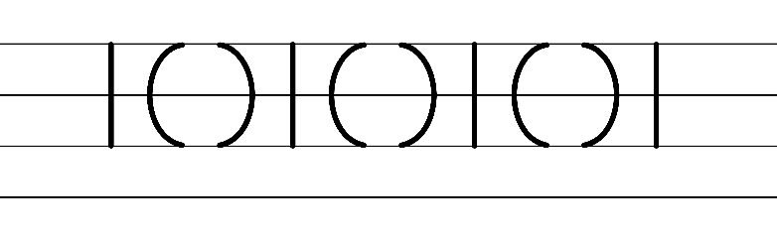  - Example of NSW Foundation Style handwriting formation  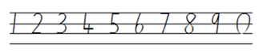  Note: students who are fluent in NSW Foundation Style can begin to use NSW Foundation Precursive and Cursive Style.  - Suggested practice text from the passage  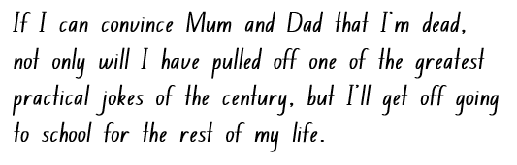
Handwriting legibility and fluency (Stage 2 Year 4)  - Join letters when writing familiar words  - Write familiar words that include letters that do not join.  - No join is needed after the letters b, f, g, j, p, s, y. | Handwriting legibility and fluency (Stage 2 Year 4)  - Suggested fluency pattern  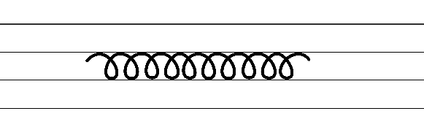  - No join is needed after the letters  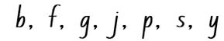  - Familiar words could include  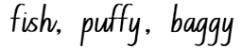  - Suggested practice text from the passage:  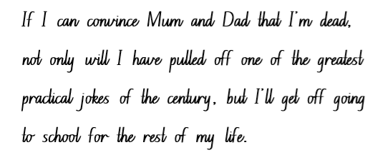
Handwriting and digital transcription  Handwriting legibility and fluency (Stage 3 Year 5)  - Sustain writing with a legible, fluent and personal handwriting style across a text  - Form legible and fluent horizontal joins to anticlockwise letters, including to a, c, d, g, o and q.  - When a horizontal join is made to an anti-clockwise letter, the top of the letter is retraced a little. | Handwriting and digital transcription  Handwriting legibility and fluency (Stage 3 Year 5)  - Suggested fluency pattern  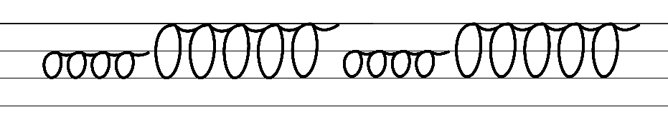  - Example NSW Foundation Style handwriting formation − horizontal joins to anticlockwise letters  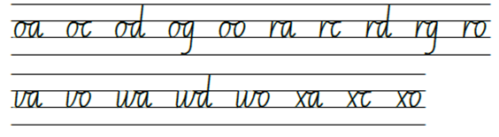  - Suggested practice text from the passage
Handwriting legibility and fluency (Stage 3 Year 6)  - Sustain writing with a legible, fluent and personal handwriting style across a text  - Revise cursive loops for the letter f.  - Loops can be included as part of the ascender and the descender.  - Descender loops for the letter f can support fluency and developing a personal handwriting style. | Handwriting legibility and fluency (Stage 3 Year 6)  - Suggested fluency pattern  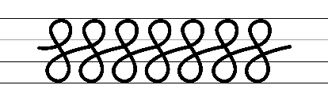  - Example of ascender and descender cursive loops for the letter f  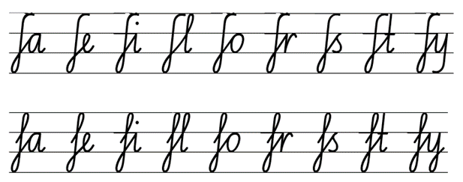  - Suggested practice text from the passage

Planning framework
To plan and document Component A teaching and learning, a planning scaffold [DOCX 81 KB] is provided. To support you in your planning, a link to a detailed example of a one-week teaching and learning cycle is included in the scaffold. Additional resources to support teaching and learning in each focus area can be found at Lesson advice guides.

Component B teaching and learning
The following teaching and learning sequence has been designed to address Component B outcomes and content and develops conceptual understandings of English through the study of quality texts. Adapt the sequence as required to best meet the needs of your students.

Learning intentions and success criteria
Learning intentions and success criteria are best co-constructed with students. The table below contains a suggested learning intention and success criteria.
Element | Stage 2 | Stage 3
Learning intention | Students are learning to apply their understanding of narrative conventions and characterisation to draft, edit and publish a narrative. | Students are learning to apply their understanding of narrative conventions, patterns and characterisation to draft, edit and publish a narrative to engage the audience.
Success criteria | Students can:  - use an orientation, complication, resolution structure to create a narrative  - use precise verbs  - effectively use a variety of tiered vocabulary in own narrative  - use a range of adjectives to build descriptions of settings, complications and resolutions  - use punctuation, including capital letters, and commas to list adjectives  - use a variety of sentences (declarative and compound). | Students can:  - use precise verbs  - effectively use a variety of tiered vocabulary in own narrative  - use a range of adjectives to build descriptions of characters, settings, complications and resolutions  - use punctuation, including capital letters, and commas to list adjectives  - use a variety of sentences (declarative and compound and complex)  - create written texts that include multiple paragraphs with clear, coherent transition of ideas  - use print or digital tools to plan, sequence, create, revise, edit and publish texts.

Lesson 17 – creating a pocket book narrative (part 1)
The following teaching and learning activities support multi-age settings.

Whole
- Students reflect on their storyboard pocket book narrative plan. Ask:
- Who is the intended audience?
- What is the purpose?
- Have you included all the narrative conventions?
- Will this plan help you to address the success criteria for writing?
- In pairs, students share their plans, highlighting the narrative conventions, precise verbs and adjectives used and provide peer feedback. Students action feedback to edit their plan.
- Revise the features of a pocket book in Chapter 31 – ‘Pocket books’ (pp 226–228) from Once Upon a Slime: 45 Fun Ways to Get Writing … Fast! For example, multiple pages, a new illustration on each page, uses narrative structure and conventions.
- Students begin to create their pocket book narrative using the storyboard plan.

Lesson 18 – creating a pocket book narrative (part 2)
The following teaching and learning activities support multi-age settings.

Whole
- Students finish creating their pocket book narrative using the storyboard plan.
- Explain the difference between revising and editing. Ask how authors, like Andy Griffiths, revise and edit their texts until they were satisfied with the final product. Ask what students think authors check for.
- View the video about the process of editing a book (1:21). Ask why it is important to edit writing.
- Using a co-constructed piece of writing from the previous lessons, model revising and editing using the success criteria from Lesson 15.
- In pairs, students provide feedback to a peer using the success criteria from Lesson 15.
- Students revise and edit their work based on the feedback to ensure they have achieved the success criteria.
Too hard? Support students to provide and apply feedback to their pocket book narratives.
Note: editing involves making changes to spelling, punctuation and capitalisation. Revising involves looking over the writing as a whole and reworking the organisation and details. Grammatical features, text structure and vocabulary choices are considered during the revising stage.

Lesson 19 – publishing a pocket book narrative
The following teaching and learning activities support multi-age settings.

Whole
- Review ‘How to Make a Pocket Book’ (p 225) in Chapter 31. Guide students through creating the physical pocket book. A variation on this could be the size of the paper used to create the pocket book. For example, Stage 3 students could use A3 paper so that they have more room to write a more detailed text. Each student should produce their own pocket book.
- Students publish their pocket books.
- Students add illustrations to their pocket books. They could draw inspiration from Terry Denton’s character creations.

Lesson 20 – sharing pocket book narratives
The following teaching and learning activities support multi-age settings.

Whole
- In small groups, students present their pocket book narratives, focusing on engaging their audience.
- Students consider the following questions in providing feedback on the presentation:
- What did you find engaging? Why?
- Did the narrative follow a familiar pattern? What makes you think that?
- What questions do I have about this narrative?
- Students may like to share their pocket books with younger students in the school. For example, Kindergarten buddies.
Stage 2 Assessment task 10 – Observations and work samples from this lesson allow students to demonstrate achievement towards the following syllabus outcomes and content points:
EN2-OLC-01 – communicates with familiar audiences for social and learning purposes, by interacting, understanding and presenting
- plan and deliver spoken presentations using language and structure to suit purpose and audience.
EN2-CWT-01 – plans, creates and revises written texts for imaginative purposes using text features, sentence-level grammar, punctuation and word-level language for a target audience
- use an orientation, complication, resolution structure to create narratives centred on time, place and characters
- use capital letters to indicate the beginning of a sentence, proper nouns, heading and subheadings, to indicate the beginning of a poetry line, for emphasis, and when using acronyms
- plans structures and language to suit the purpose of the text
- use commas between words in a list or to separate adjectives when more than one is used
- use adjectives to develop descriptive features
- select and use precise saying, thinking, acting and relating verbs and verb groups to align with text purposes
- use declarative sentences to provide facts or state a viewpoint.
Stage 3 Assessment task 8 – Observations and work samples from this lesson allow students to demonstrate achievement towards the following syllabus outcomes and content points:
EN3-OLC-01 communicates to wide audiences with social and cultural awareness, by interacting and presenting, and by analysing and evaluating for understanding
- deliver presentations suited to purpose and audience.
EN3-CWT-01 – plans, creates and revises written texts for multiple purposes and audiences through selection of text features, sentence-level grammar, punctuation and word-level language
- experiment with characterisation
- create written texts that include multiple paragraphs with clear, coherent transition of ideas
- make choices about verbs and verb groups to achieve precision and add detail
- include appositives to provide details to nouns and to vary sentence structures suited to text purpose
- use capital letters at the beginning of a sentence, to indicate proper nouns, for headings and subheadings, to indicate the beginning of a poetry line, for emphasis, and when using acronyms
- use a comma to separate a subordinate clause or a phrase from the main clause, or to separate information within a sentence, or to separate items in a list
- use print or digital tools to plan, sequence, create, revise, edit and publish texts.

Resource 1 – fluency and close reading passage analysis (Week 1)
Focus | Notes
Passage | From Chapter 1, Just Tricking! p 3 from ‘Pooh! What a stink!’ to ‘...stare at the ceiling some more.’ (135 words)
Synopsis | This passage shows the protagonist, Andy doing a prank by pretending to be dead to avoid going to school. When Andy’s mother enters the room and scolds him about the messy state of the room, expressing frustration over the dirty socks and undies scattered around. She gives him an ultimatum to get ready and leave the house in 10 minutes or be late for school.
Passage structure | The main character Andy is describing the situation as he lies on the floor, pretending to be dead to avoid going to school. The passage sets a tone of humour and mischief while describing the setting of Andy’s bedroom.  Direct speech: Mum: "Pooh, what a stink! When’s the last time you cleaned this room?..." The mother's voice and scolding are directly quoted. This establishes the mother's irritation and the messy state of the room.  Internal monologue: "I stare at the ceiling. What else would a real corpse do?..." Andy’s thoughts are presented here, describing his contemplation of how a real corpse would behave. This adds to the humorous nature of the passage.
Language features | Descriptive language to visualise the setting: "It’s an absolute pig-sty! Dirty socks and undies everywhere." The use of descriptive language emphasizes the messy state of the room. This adds humour and paints a vivid picture of the mess.  Rhetorical question: "Why can’t you just put them in the washing basket?" The question is a rhetorical question that doesn't expect an answer but shows the mother’s frustration.  Repetition: "stare at the ceiling". The repetition of the phrase emphasizes Andy’s contemplation over the way he can avoid going to school.  Contractions: a feature of informal language. Apostrophes of contraction are used to signal missing letters.  "It’s": "It’s an absolute pig-sty!"  "can’t": "Why can’t you just put them in the washing basket?"  "I’m": "and I’m not going to drive you.’"  "She’s": "She walks out of the room."  Commas  Separating a subordinate clause: "If you’re not showered, dressed and out of this house in ten minutes you’re going to be late, and I’m not going to drive you."  Separating information within a sentence: "Pooh, what a stink! When’s the last time you cleaned this room? It’s an absolute pig-sty! Dirty socks and undies everywhere."

Resource 2 – Andy’s bedroom
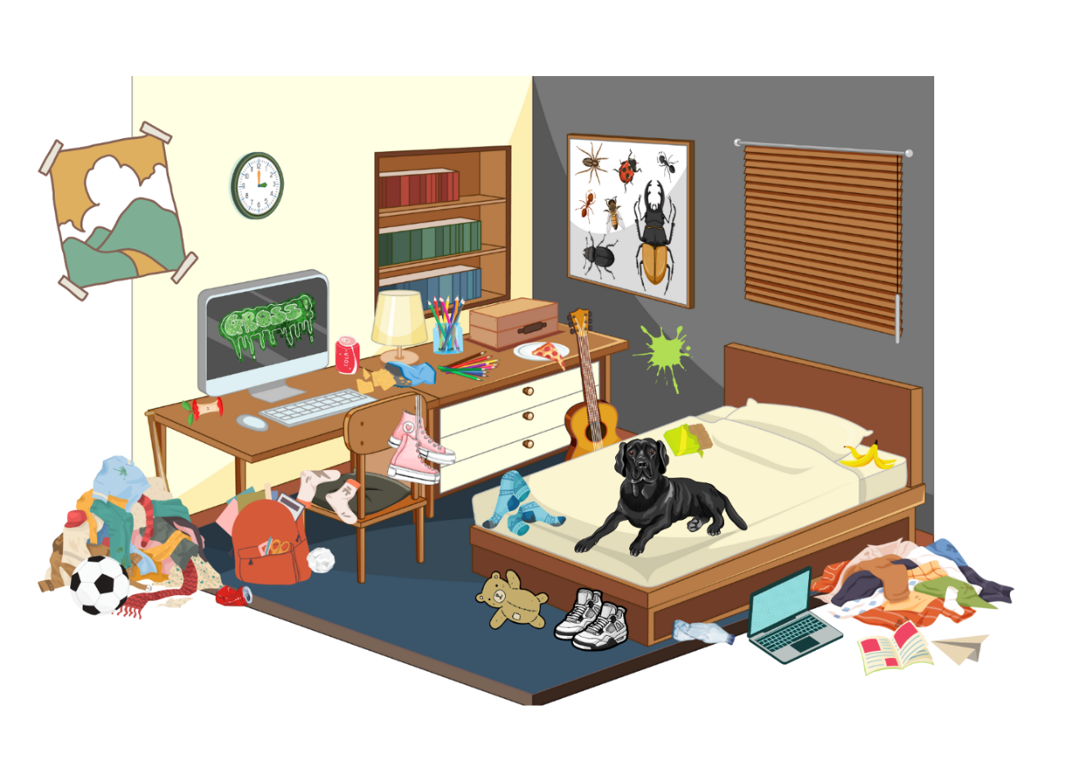

Resource 3 – familiar characters
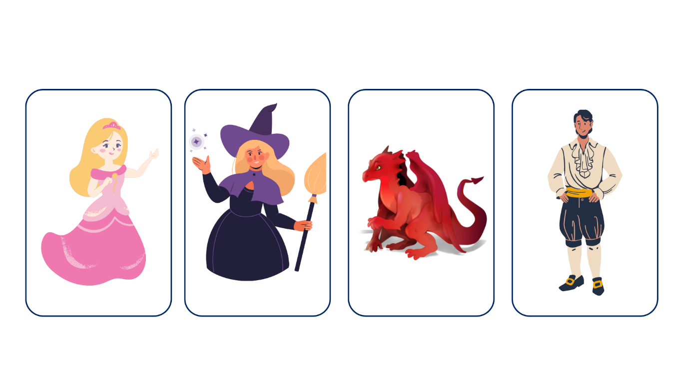

Resource 4 – fluency and close reading passage analysis (Week 3)
Focus | Notes
Passage | From Chapter 4, ‘Nick-Knockers anonymous’, p 47 from ‘So what I’ve decided...’ to ‘...at least half an hour.’ (316 words)
Synopsis | In this passage, the protagonist, Andy, has decided to tidy up the house to avoid getting in trouble with his parents over his bad school reports and the impending lecture. Andy hopes to impress his parents with the clean house and, instead of being in trouble, be rewarded for his efforts in cleaning the house. While Andy is busy cleaning, his efforts are interrupted by a knock on the door.
Passage structure | The passage follows a logical progression, starting with Andy's decision to clean the house and his reasoning behind it. This leads to Andy’s anticipation of a positive outcome. Then, there is a shift in action when an unexpected knock on the door occurs, creating a sense of uncertainty.
Language features | Descriptive language and imagery: create vivid mental images.  - ‘...absolutely clean and spotless,’ ‘beautiful the house is looking,’ and ‘polishing the second light-globe on the chandelier’  Hyperbole: exaggerations intended to emphasize a point, rather than be taken literally.  - ‘...make it absolutely clean and spotless – right down to the very last light-globe.’  Contractions: a feature of informal language. Apostrophes of contraction are used to signal missing letters.  - ‘I’ve’: ‘So what I’ve decided to do...’  - ‘It’s’: ‘...make it absolutely clean and spotless – right down to the very last light-globe.’  - ‘they’re’: ‘...they’re suddenly going to be struck by how beautiful the house is looking...’  - ‘They’ll’: ‘They’ll be so impressed that I cleaned up the house...’  - ‘I’m’: ‘...I’m halfway through polishing the second light-globe on the chandelier.’  - ‘can’t’: ‘...It can’t be Mum and Dad because they’re not due back for at least half an hour.’  Tier 2 vocabulary: experiment with word choices to create humour.  - lousy, suddenly, lecturing, impressed, gullible, chandelier  Exaggerated language: adds a touch of imagination and exaggeration.  - ‘right down to the very last light-globe' and ‘whole bucket of chocolate ice-cream'  Declarative sentences: provide facts or state a viewpoint.  ‘I’m halfway through polishing the second light-globe on the chandelier.’  ‘There’s a knock on the door.’  ‘It can’t be Mum and Dad because they’re not due back for at least half an hour.’

References
This resource contains NSW Curriculum and syllabus content. The NSW Curriculum is developed by the NSW Education Standards Authority. This content is prepared by NESA for and on behalf of the Crown in right of the State of New South Wales. The material is protected by Crown copyright.
Please refer to the NESA Copyright Disclaimer for more information. https://educationstandards.nsw.edu.au/wps/portal/nesa/mini-footer/copyright
NESA holds the only official and up-to-date versions of the NSW Curriculum and syllabus documents. Please visit the NSW Education Standards Authority (NESA) website https://educationstandards.nsw.edu.au/ and the NSW Curriculum website https://curriculum.nsw.edu.au.
English K–10 Syllabus © NSW Education Standards Authority (NESA) for and on behalf of the Crown in right of the State of New South Wales, 2022.
PDHPE K–10 Syllabus © NSW Education Standards Authority (NESA) for and on behalf of the Crown in right of the State of New South Wales, 2018.
National Literacy Learning Progression © Australian Curriculum, Assessment and Reporting Authority (ACARA) 2010 to present, unless otherwise indicated. This material was downloaded from the Australian Curriculum website (National Literacy Learning Progression) (accessed 30 August 2023) and was not modified.
ABC (Australian Broadcasting Corporation) (7 December 2022) 'The Imagineer Read By Ryan McNaught (Brickman) 📚🧸 | Play School Story Time | ABC Kids' [video], ABC Kids, YouTube, accessed 30 June, 2023.
ETA (English Teachers Association) and NSW Department of Education (2016) Character, English Textual Concepts website, accessed 30 June 2023.
ETA (English Teachers Association) and NSW Department of Education (2016) Narrative, English Textual Concepts website, accessed 30 June 2023.
Frasier D (16 June 2009), 'Debra Frasier talks on Editing' [video], Debra Frasier, YouTube, accessed 30 June 2023.
Griffiths A (1999) Just Tricking (Denton T illus), Pan Australia.
Griffiths A (2013) Once Upon a Slime: 45 Fun Ways to Get Writing … Fast! (Denton T illus), Pan Australia.
NESA (NSW Education Standards Authority) (2023) ‘Glossary’, Resources, NESA website, accessed 5 September 2023.

© State of New South Wales (Department of Education), 2023
The copyright material published in this resource is subject to the Copyright Act 1968 (Cth) and is owned by the NSW Department of Education or, where indicated, by a party other than the NSW Department of Education (third-party material).
Copyright material available in this resource and owned by the NSW Department of Education is licensed under a Creative Commons Attribution 4.0 International (CC BY 4.0) license.
This license allows you to share and adapt the material for any purpose, even commercially.
Attribution should be given to © State of New South Wales (Department of Education), 2023.
Material in this resource not available under a Creative Commons license:
- the NSW Department of Education logo, other logos and trademark-protected material
- material owned by a third party that has been reproduced with permission. You will need to obtain permission from the third party to reuse its material.
Links to third-party material and websites
Please note that the provided (reading/viewing material/list/links/texts) are a suggestion only and implies no endorsement, by the New South Wales Department of Education, of any author, publisher, or book title. School principals and teachers are best placed to assess the suitability of resources that would complement the curriculum and reflect the needs and interests of their students.
If you use the links provided in this document to access a third-party's website, you acknowledge that the terms of use, including licence terms set out on the third-party's website apply to the use which may be made of the materials on that third-party website or where permitted by the Copyright Act 1968 (Cth). The department accepts no responsibility for content on third-party websites.

