English 3–6 Multi-age – Year B – Unit 3
Genre – Leila and the Blue Fox

Contents
Unit overview and instructions for use 7
Teacher notes 9
Outcomes and content 11
Resources 23
Week 1 25
Component B teaching and learning 25
Learning intentions and success criteria 25
Component A teaching and learning 26
Planning framework 26
Lesson 1 – understanding genre 27
Whole 27
Lesson 2 – building background knowledge and introducing Leila and the Blue Fox 29
Whole 29
Lesson 3 – exploring the author’s perspective and context 33
Whole 33
Part 35
Whole 36
Lesson 4 – making connections to the text 36
Whole 37
Part 39
Part 40
Whole 41
Week 2 43
Component A teaching and learning 43
Planning framework 43
Component B teaching and learning 43
Learning intentions and success criteria 43
Lesson 5 – analysing language features in informative texts 45
Whole 45
Part 46
Part 48
Whole 50
Lesson 6 – language that connects with and informs an audience 50
Whole 50
Part 52
Part 53
Lesson 7 – exploring similarities and differences in informative texts 55
Whole 55
Lesson 8 – exploring perspectives in texts 57
Whole 57
Week 3 61
Component A teaching and learning 61
Planning framework 61
Component B teaching and learning 61
Learning intentions and success criteria 61
Lesson 9 – researching and summarising topic-related ideas 62
Whole 63
Part 65
Part 66
Lesson 10 – drafting and composing an informative text 69
Whole 70
Part 70
Lesson 11 – drafting, composing and feedback 73
Whole 73
Lesson 12 – publishing and presenting a multimodal text 75
Whole 75
Week 4 79
Component A teaching and learning 79
Planning framework 79
Component B teaching and learning 79
Learning intentions and success criteria 79
Lesson 13 – communicating through different modes 80
Whole 81
Part 82
Whole 83
Lesson 14 – using information to create descriptions 84
Whole 84
Lesson 15 – composing a text to connect with an audience 89
Whole 89
Lesson 16 – adding multimodal features to a text 91
Whole 92
Week 5 94
Component A teaching and learning 94
Planning framework 94
Component B teaching and learning 94
Learning intentions and success criteria 94
Lesson 17 – planning a text with multiple genres 95
Whole 96
Lesson 18 – drafting and composing a text with multiple genres 98
Whole 98
Lesson 19 – publishing a multimodal text 99
Whole 100
Lesson 20 – presenting and reflecting on textual concepts 102
Whole 102
Resource 1 – nominalisations 106
Resource 2 – humpback whales 107
Resource 3 – polar bears 108
Resource 4 – spot the similarities 109
Resource 5 – Arctic fox informative text 110
Resource 6 – writing process 111
Resource 7 – social media post 112
Resource 8 – protect our polar bears 113
Resource 9 – poster planning 114
References 115

Unit overview and instructions for use
In this 5-week unit, students will gain a deeper understanding of the textual concepts of ‘genre’ and ‘perspective and context’ through an analysis of the text Leila and the Blue Fox. Throughout the unit, students will apply their understanding of genre to analyse texts and identify their purpose, subject matter, form, structure and language choices. Students will experiment with creating a variety of texts using their understanding of structure and language choices to suit a text’s purpose.
Outcomes and content in this unit are organised into Component A and Component B. The components are connected, with learning in Component A complementing learning in Component B.
Note: the duration of this unit can be adapted to suit individual school contexts. For example, learning could occur across 5 days rather than 4.
The table below highlights the focus areas and preparation required for Component A and Component B.
Teaching and learning | Component A | Component B
Suggested duration | 60 minutes × 4 days/week or equivalent | 60 minutes × 4 days/week or equivalent
Explicit teaching focus areas | Component A addresses content from the focus areas:  - Vocabulary  - Reading fluency (Stage 2)  - Reading comprehension  - Creating written texts  - Spelling  - Handwriting and digital transcription  It centres on the development of foundational skills and knowledge through regular, systematic and repeated practice. | Component B addresses content from the focus areas:  - Oral language and communication  - Vocabulary  - Reading comprehension  - Creating written texts  - Understanding and responding to literature  It centres on the conceptual understandings of English and exemplifies the importance of learning about and enjoying literature through the study of quality texts.
Preparing for teaching and learning | - Specific teaching and learning activities need to be developed by the teacher. When planning for these activities, please refer to the Component A outcomes and content, teaching guides and planning frameworks.  - Plan and document how you will sequence teaching and learning in whole-class and targeted-groups across the 5-week cycle as required. This should be based on student needs identified through ongoing assessment data. | - Familiarise yourself with the mentor and supporting texts and textual concepts, and the teaching and learning sequence.  - Determine how you will support students in whole-class and targeted-groups across the 5-week cycle as required. This should be based on student needs identified through ongoing assessment data.
English K–10 Syllabus © NSW Education Standards Authority (NESA) for and on behalf of the Crown in right of the State of New South Wales, 2022.

Teacher notes
- Genre is the mentor concept of this unit, explored using the text Leila and the Blue Fox by Kiran Millwood Hargrave and illustrated by Tom de Freston.
- Genre is defined as the categories into which texts are grouped based on similarities in premise, structure and function. The ‘genre’ of a text describes larger recurring patterns of subject matter and textual structures observable between texts, such as typical plots, characters and setting (NESA Glossary).
- Understanding genre can be supported through watching the department’s video: Understanding genre (3:00).
- While genre is the mentor concept for the conceptual component of this unit, the supporting concepts of perspective and context can be also be explored. Additional textual concepts may be included based on individual school context and student needs.
- Some of the content in this unit requires sensitivity awareness. Access Supporting refugee students if needed. For further information, visit Save the Children Federation, Inc.
- For information on imperative, declarative, exclamatory and interrogative sentences, subordinating conjunctions, coordinating conjunctions, nominalisation and appositives refer to the NESA Glossary.
- In addition to the resources listed, students will require access to short passages of the mentor and/or supporting texts. Teachers can copy extracts from texts in reliance on the Statutory Text and Artistic Works Licence. Teachers need to attribute the extracts and include the following notice: ‘This material has been copied [and communicated to you] in accordance with the statutory licence in section 113P of the Copyright Act. Any further reproduction or communication of this material by you may be the subject of copyright protection under the Act. Do not remove this notice’.
- This unit could enhance student learning towards the achievement of human society and its environment (HSIE) and/or science and technology outcomes.
- Consider prior student knowledge of the textual concept, ‘genre’.
- Reflect on student learning and engagement in activities and record differentiation and adjustments within the unit to inform future teaching and learning. One way of doing this could be to add comments to the digital file.
- In NSW classrooms there is a diverse range of students including Aboriginal and/or Torres Strait Islander students, students learning English as an additional language or dialect, high potential and gifted students and students with disability. Some students may identify with more than one of these groups, or possibly all of them. Refer to Curriculum planning for every student – advice for further information.
- Content points are linked to the National Literacy Learning Progression version (3).
Levels and indicators sourced from National Literacy Learning Progression © Australian Curriculum, Assessment and Reporting Authority (ACARA), (accessed 19 October 2023) and was not modified. See references for more information.

Outcomes and content
The tables below outline the outcomes and content for this unit. The letters 'A' and 'B' in the header refer to Components A and B. The numbers 1 to 5 refer to weeks. The use of 'x' in these columns indicates where the content points are intended to be addressed and in which week.
Stage 2 focus area and outcome, content points and National Literacy Learning Progression | A | B | 1 | 2 | 3 | 4 | 5
Oral language and communication
EN2-OLC-01 communicates with familiar audiences for social and learning purposes, by interacting, understanding and presenting
- Contribute to discussions with peers and stay on topic, build on others' ideas and express own ideas (InT4) |  | x | x | x | x | x | x
- Make notes when listening to spoken texts, asking questions to clarify or follow up on information and seeking assistance if required (LiS6) |  | x | x |  | x
- Identify how inferred or literal meaning is impacted by tone, pace, pitch and volume, gesture and posture communication, and how these affect the audience |  | x | x |  |  |  | x
- Include multimodal features in planned and delivered presentations, to expand meaning and engage an audience |  | x |  |  | x |  | x
Vocabulary
EN2-VOCAB-01 builds knowledge and use of Tier 1, Tier 2 and Tier 3 vocabulary through interacting, wide reading and writing, and by defining and analysing words
- Build personal Tier 1, Tier 2 and Tier 3 vocabulary through social and learning interactions, reading and writing (SpK5) | x | x | x | x | x | x | x
- Understand that many words derive from other languages, including Aboriginal and Torres Strait Islander Languages, and that the pronunciation and spelling of words may reflect their etymology | x | x | x | x | x
- Apply morphemic knowledge to change word meanings by adding different prefixes and suffixes to a base word or root (SpG9) | x |  | x | x | x | x | x
Reading fluency
EN2-REFLU-01 sustains independent reading with accuracy, automaticity, rate and prosody suited to purpose, audience and meaning
- Syllabify, blend grapheme–phoneme correspondences and use morphemic knowledge as strategies for reading words accurately (PKW8) | x |  | x | x | x | x | x
- Read multisyllabic words, phrases and continuous texts with accuracy and appropriate rate suited to reading purpose (FlY5, PKW8) | x |  | x | x | x | x | x
- Adjust voice, tone, volume and pitch reflected by the punctuation in a text, to enhance reading fluency and support comprehension (FlY5) | x |  | x | x | x | x | x
- Recognise that there are different purposes and audiences for reading and adjust reading rate to suit a text’s purpose (FlY5) | x |  | x | x | x
Reading comprehension
EN2-RECOM-01 reads and comprehends texts for wide purposes using knowledge of text structures and language, and by monitoring comprehension
- Build topic knowledge, including key vocabulary, and activate background knowledge prior to and during reading (UnT7) | x | x | x | x | x | x | x
- Identify similarities and compare differences within and between texts by making text-to-self, text-to-text and text-to-world connections |  | x | x | x | x | x
- Locate, select and retrieve relevant information from a print or digital text and consider accuracy of information presented |  | x | x |  | x
- Determine the relevance of a text for a specific purpose (UnT7) |  | x |  | x | x
- Understand that word contractions are a feature of informal language and that apostrophes of contraction are used to signal missing letters | x |  |  | x | x | x
- Identify and use strategies to repair reading when meaning breaks down (UnT6) | x |  | x | x | x | x | x
- Ask questions to clarify meaning and promote deeper understanding of a text (LiS6, UnT6) | x | x | x | x | x | x | x
Creating written texts
EN2-CWT-02 plans, creates and revises written texts for informative purposes, using text features, sentence-level grammar, punctuation and word-level language for a target audience
- Create informative written texts that include headings, paragraphs beginning with topic sentences, and may conclude information in a final paragraph (CrT8) |  | x |  |  | x |  | x
- Create written texts that describe experiences and observations to connect with and inform an audience (CrT8) |  | x | x | x | x | x | x
- Use coordinating conjunctions in compound sentences to compare and contrast, or for addition (GrA4) | x | x | x | x | x | x | x
- Use subordinating conjunctions in complex sentences to signal sequence, reason or cause and effect (GrA6) | x | x | x | x | x | x | x
- Use declarative sentences to provide facts or state a viewpoint | x | x | x | x | x | x | x
- Use imperative sentences to advise, provide instructions, express a request or a command | x | x | x | x |  | x | x
- Use apostrophes for contractions, and to show singular and plural possession (PuN4, PuN5, SpG9) | x | x |  |  | x | x | x
- Use topic-specific Tier 2 and Tier 3 vocabulary to demonstrate authority (CrT8) | x | x | x | x | x | x | x
- Research, summarise and list topic-related ideas when planning |  | x | x |  | x
Spelling
EN2-SPELL-01 selects, applies and describes appropriate phonological, orthographic and morphological generalisations and strategies when spelling in a range of contexts
- Explain how to segment multisyllabic words into syllables and phonemes, and apply this knowledge when spelling | x |  | x | x | x | x | x
- Identify differences in vowel phonemes (short, long, diphthong and schwa vowels) (SpG9) | x |  | x | x | x | x | x
- Understand that graphemes can be explained by their etymology (SpG9) | x |  | x | x |  |  | x
- Identify inflected suffixes, explaining when and how to treat base words when they are affixed, and apply this knowledge when spelling (SpG9) | x |  | x | x |  |  | x
- Identify prefixes that require no change to the base word or root when they are affixed, and apply this knowledge when spelling (SpG9) | x |  |  |  | x | x | x
Handwriting and digital transcription
EN2-HANDW-01 forms legible joined letters to develop handwriting fluency
EN2-HANDW-02 uses digital technologies to create texts
- Join letters using consistent size and spacing to develop fluency (Year 3) (HwK6) | x |  | x | x | x | x | x
- Sustain the NSW Foundation Style cursive to facilitate fluency and legibility across a text (Year 4) (HwK6) | x |  | x |  | x
- Position a chosen device in a way that facilitates efficient and sustained text creation | x |  |  | x |  | x
Understanding and responding to literature
EN2-UARL-01 identifies and describes how ideas are represented in literature and strategically uses similar representations when creating texts
- Identify different text genres when a text is characterised by more than a single genre |  | x | x | x | x | x | x
- Understand that literature is created by drawing upon personal, social and cultural contexts and perspectives (UnT8) |  | x | x |  |  | x | x
English K–10 Syllabus © NSW Education Standards Authority (NESA) for and on behalf of the Crown in right of the State of New South Wales, 2022.

Stage 3 focus area and outcome, content points and National Literacy Learning Progression | A | B | 1 | 2 | 3 | 4 | 5
Oral language and communication
EN3-OLC-01 communicates to wide audiences with social and cultural awareness, by interacting and presenting, and by analysing and evaluating for understanding
- Initiate and contribute to sustained discussions, through questioning, building on and evaluating shared information (InT5) |  | x | x | x | x | x | x
- Evaluate the role of gesture during social and learning interactions and describe its impact on the audience |  | x | x |  |  |  | x
- Analyse how audio elements in texts integrate with linguistic, visual, gestural and spatial elements to create meaning and impact (SpK6) |  | x | x | x
- Select multimedia components, visual displays or use gestural features to enhance and bring clarity to presentations (SpK6) |  | x |  |  | x | x | x
Vocabulary
EN3-VOCAB-01 extends Tier 2 and Tier 3 vocabulary through interacting, wide reading and writing, morphological analysis and generating precise definitions for specific contexts
- Identify and use words that convey informative and objective meanings in texts | x | x |  | x | x | x | x
- Identify and use words derived from other languages, including Aboriginal and Torres Strait Islander Languages, and know that the pronunciation and spelling of words may reflect their etymology (UnT9) | x | x | x | x | x
- Analyse morphemic structures of Tier 2 and Tier 3 words to determine their meaning (SpG10, SpG11) | x |  | x | x | x | x | x
Reading comprehension
EN3-RECOM-01 fluently reads and comprehends texts for wide purposes, analysing text structures and language, and by monitoring comprehension
- Syllabify, blend grapheme–phoneme correspondences and use morphemic knowledge as strategies for reading words accurately (SpG10, PKW9, FlY6) | x |  | x | x | x | x | x
- Adjust reading approach to suit the purpose for reading (UnT8) | x |  | x | x | x | x | x
- Bring subject vocabulary, technical vocabulary, background knowledge and conceptual knowledge to new reading tasks (UnT8) | x | x | x | x | x | x | x
- Use knowledge of text structure to navigate the text to locate specific information (UnT8) |  | x | x | x | x | x | x
- Recognise that personal narratives contain more subjective language, but factual accounts of events contain more objective language |  | x |  | x |  | x | x
- Ask questions to clarify thinking, and to provide reasons or evidence (LiS6) | x | x | x | x | x | x | x
- Categorise information or ideas and create hierarchies to aid recall and support summarisation | x | x | x | x | x
Creating written texts
EN3-CWT-01 plans, creates and revises written texts for multiple purposes and audiences through selection of text features, sentence-level grammar, punctuation and word-level language
- Describe and/or explain ideas through logically sequenced paragraphs (CrT9) |  | x | x | x | x | x | x
- Compare and contrast or discuss cause and effect through sequenced paragraphs (CrT9) |  | x |  |  | x | x
- Include appositives to provide details to nouns and to vary sentence structures suited to text purpose (CrT8) | x | x |  | x | x | x
- Create nominalisations to convey abstract ideas and concepts succinctly and authoritatively (GrA7) | x | x |  | x | x | x | x
- Make choices about the use of declarative, exclamatory, interrogative and imperative sentences to suit text purpose, and for meaning and effect (CrT8) | x | x | x | x | x | x | x
- Use parentheses in the first instance when abbreviating names using acronyms, and when acknowledging a source (PuN7) | x | x |  |  | x |  | x
- Use topic-specific Tier 2 and Tier 3 vocabulary intentionally to add credibility and enhance authority (CrT9) | x | x | x | x | x | x | x
- Select text formats for combined purposes, creating hybrid texts for target audiences |  | x |  |  |  | x | x
- Research and summarise information from several sources to plan for writing |  | x | x |  | x
Spelling
EN3-SPELL-01 automatically applies taught phonological, orthographic and morphological generalisations and strategies when spelling in a range of contexts, and justifies spelling strategies used to spell unfamiliar words
- Segment unfamiliar multisyllabic words into syllables and phonemes as a strategy when spelling | x |  | x | x | x | x | x
- Recognise that the same grapheme can represent different phonemes (SpG10) | x |  | x | x | x | x | x
- Proofread written texts to correct misspellings, making use of spelling reference tools where required | x |  |  | x |  |  | x
- Explain and use spelling conventions for assimilated prefixes such as in-, ad-, com- (SpG10) | x |  | x | x | x | x | x
Handwriting and digital transcription
EN3-HANDW-01 sustains a legible, fluent and automatic handwriting style
EN3-HANDW-02 selects digital technologies to suit audience and purpose to create texts
- Sustain writing with a legible, fluent and personal handwriting style across a text (HwK8) | x |  | x |  | x | x | x
- Adjust handwriting style to suit writing purpose (HwK8) | x |  |  | x |  |  | x
- Navigate the keyboard with efficiency and accuracy when typing words, numerals, punctuation and other symbols (Hwk8) | x |  |  | x |  | x
Understanding and responding to literature
EN3-UARL-02 analyses representations of ideas in literature through genre and theme that reflect perspective and context, argument and authority, and adapts these representations when creating texts
- Explain how genre can be recognised by established codes and conventions that govern content and construction of literature, and apply this knowledge when creating texts |  | x | x | x | x | x | x
- Reflect on and explain how personal, social and cultural context is expressed in own text |  | x | x | x |  | x | x
English K–10 Syllabus © NSW Education Standards Authority (NESA) for and on behalf of the Crown in right of the State of New South Wales, 2022.

Resources
The resources in the table below are referred to in this unit. Letters 'A' and 'B' in the header refer to Component A and B respectively, and the numbers 1 to 5 indicate weeks. The use of 'x' in these columns indicates whether the resources are required in Component A, B or both, and in which week.
Resource | A | B | 1 | 2 | 3 | 4 | 5
Millwood Hargrave K (2022) Leila and the Blue Fox (Freston T, illus.), Hachette Children's Books, Australia. ISBN13: 9781510110274 | x | x | x | x | x | x | x
Venn diagram |  | x | x | x
T-chart |  | x | x | x
Informative writing scaffold |  | x |  |  | x
Resource 1 – nominalisations |  | x |  | x
Resource 2 – humpback whales |  | x |  | x
Resource 3 – polar bears |  | x |  | x
Resource 4 – spot the similarities |  | x |  |  | x
Resource 5 – Arctic fox informative text |  | x |  |  | x
Resource 6 – writing process |  | x |  |  | x | x | x
Resource 7 – social media post |  | x |  |  |  | x
Resource 8 – protect our polar bears |  | x |  |  |  |  | x
Resource 9 – poster planning |  | x |  |  |  |  | x

Week 1

Component B teaching and learning
The following teaching and learning sequence has been designed to address Component B outcomes and content and develops conceptual understandings of English through the study of quality texts. Adapt the sequence as required to best meet the needs of your students.

Learning intentions and success criteria
Learning intentions and success criteria are best co-constructed with students. The table below contains suggested learning intention and success criteria.
Element | Stage 2 | Stage 3
Learning intention | Students are learning to understand the conventions of genre and identify language features when a text is characterised by more than one single genre. | Students are learning to recognise and analyse texts with features that do not follow the form and function of a single genre.
Success criteria | Students can:  - identify different text genres according to form and function  - make notes to build background knowledge of a topic  - identify how an author’s personal perspective and context can influence the development of a text  - identify language features that support a text’s purpose  - create a written text that describes personal experiences and connections to a text read. | Students can:  - identify and analyse different text genres according to form and function  - use note taking as a tool to build topic knowledge and activate prior knowledge  - explain how an author’s personal perspective and context can influence and be expressed in a text  - analyse language features used to achieve a text’s purpose  - express personal connections with a text through a logically sequenced paragraph.

Component A teaching and learning
Component A focuses on the development of foundational skills and knowledge through regular, systematic and repeated practice. The mentor and supporting texts used in Component B of this unit can support the effective implementation of Component A teaching and learning.

Planning framework
To plan and document Component A teaching and learning, a planning scaffold [DOCX 81 KB] is provided. To support you in your planning, a link to a detailed example of a one-week teaching and learning cycle is included in the scaffold. Additional resources to support teaching and learning in each focus area can be found at Lesson advice guides.

Lesson 1 – understanding genre
The following teaching and learning activities support multi-age settings.

Whole
- Place a range of different texts around the classroom. For example, fiction and non-fiction picture books and novels, posters, letters, journals. Include digital texts to display on devices or provide printed photographs of them. For example, podcasts, websites, audiobooks and videos.
- In small groups, students select several displayed texts and experiment grouping them into different categories. For example, fiction and non-fiction, print and digital or according to subject or purpose. As a class, students share their ideas and elaborate on how they have categorised their texts. Ask:
- Why have you categorised the texts in this way?
- Are there other ways these texts can be categorised?
- Is it difficult to categorise the texts? Why or why not?
- Are some texts easier to group than others? Why do you think that?
- Why is it important to categorise a text in different ways?
- Introduce or revise the textual concept of ‘genre’. Explain that genre is a term used to group different types of texts according to similarities in structure and function. Explore how genre can vary according to:
- Form: literary forms include poetry, picture books, chapter books; factual forms include informative books, historical reports.
- Function: the way the elements of a text, such as words, illustrations and sounds, contribute to meeting its overall purpose. For example, to inform, to persuade, to entertain.
- Mode: the process of communication such as sounds, music, printed or spoken words, images and gestures.
- Medium: the means of communication, such as print based publishing, broadcasting or the internet.
- In pairs, students turn and talk to reflect on their understanding of genre. Ask guiding questions to support student thinking. For example:
- Why is it important to understand genre?
- How can genre help us understand and group texts?
- Explain that by identifying the genre of a text, readers will be able to:
- know what to expect before and during reading
- predict patterns (structure) and vocabulary they might encounter (for example, Tier 3 words associated with a particular subject)
- select texts based on need or interest (reading to research or for enjoyment).
- Individually or in pairs, students record a definition of genre. For example:
Genre is used to describe the way different types of texts function and are structured. Texts can be grouped into different genres or categories and vary according to mode and medium. Examples of genre include informative, imaginative, persuasive, explanatory, and procedural texts.
- Share responses and co-construct a class definition of genre.
- Explicitly teach that hybrid texts are composite texts resulting from combining elements from different genres, styles and modes (NESA Glossary). Compare 2 different types of texts and explore their differences. For example, Just Tricking by Andy Griffiths is a traditional narrative that follows a linear story line. Yahoo Creek by Tohby Riddle has a multimodal approach to historical storytelling and uses newspaper extracts which are juxtaposed with the words of an Aboriginal Elder.
- Reflect on the textual concept of genre. Ask guiding questions to support student thinking. For example:
- How can genre help us understand and group texts?
- What are the advantages to readers in identifying the genre of a text?
- What elements of a text do you need to consider when trying to determine its genre?
- Can you think of any real-life scenarios where understanding genre could be useful?

Lesson 2 – building background knowledge and introducing Leila and the Blue Fox
The following teaching and learning activities support multi-age settings.

Whole
- Review the co-constructed definition of genre from Lesson 1. Display the front cover of Leila and the Blue Fox, encouraging students to make observations and interpretations about the text using the See-Think-Wonder routine. Read the blurb on the back cover. Ask:
- What do you predict this text will be about?
- What is the purpose of the text?
- What do you notice about the features of the cover? For example, what is the purpose of the colours the illustrator, Tom de Freston, has used?
- What genre can the text be?
- Read the preface at the beginning of the text starting from ‘The Inuit call her tiriganiarkjuk...’ to ‘...and only herself.’ While reading, model asking questions to clarify meaning and promote deeper understanding of the text. For example:
- Who are the Inuits?
- How is the fox significant?
- Why are the scientists tracking Miso?
- As a class, record questions to answer while reading the text.
- Explain that the term Inuits refers broadly to the Arctic Indigenous population of Alaska, Canada and Greenland. As a class, brainstorm what students already know about the Arctic Circle to activate students’ prior knowledge.
- Watch Exploring the Arctic (20:03) stopping at 1:45. In pairs, students discuss new learning.
- Introduce the skill of note taking, exploring what it is and its purpose. In pairs, students brainstorm reasons why clear and concise note taking is important. Encourage students to consider the benefits of capturing key information. Students share their thinking.
- Rewatch the video from activity 5 (stopping at 1:45) and model note taking when listening to spoken texts about the Arctic. Use think-alouds to categorise the information presented. Provide students with an opportunity to ask questions to clarify or follow up on information.
- View the Britannica Kids: Arctic regions website. As a class, read the information. In pairs, students locate 4–5 key ideas and record ideas in their own words. Encourage Stage 3 students to consider how they use their knowledge of text structure to locate information and categorise information to support summarisation. Share responses.
Too hard? Students record key ideas as illustrations or work with a mentor partner.
- Explore the genre of the Exploring the Arctic video and the Arctic Regions website. Ask:
- What is the purpose/relevance of each text?
- How are the texts presented (form)? For example, video, website.
- What structure and language choices are used and how do they support the text’s purpose? For example, declarative sentences, Tier 3 vocabulary, headings or subheadings, bolded vocabulary.
- How are the texts communicated (mode)? For example, written language, spoken language, images.
- Do you think the texts achieve their purpose?
- Watch Arctic: Our Frozen Planet Trailer | BBC Earth (1:30). Ask students what new information they learnt about the Arctic.
- Explore the use of audio elements such as sound effects, images, positioning and gestures when presenting information about the Arctic. For example:
- Sound effects – ambient sounds of the Arctic, animal sounds.
- Images – video footage, inclusion of a variety of animals.
- Positioning – aerial view, close up.
- Analyse the impact of integrating visual and audio elements and determine whether it enhances the viewer’s understanding about the Arctic. For example:
- Sound effects – grab the viewer’s attention and provides a sensory experience.
- Images – video footage allows for a more concrete understanding compared to static images.
- Positioning – helps the viewer visualise the vast scale of the Arctic landscape.
- Students rewatch Exploring the Arctic (20:03) stopping at 1:45 to analyse the use of audio and how it impacts literal meaning.
- Students evaluate the effectiveness of each text and explain which text best helped them understand new information about the Arctic. For example, the use of visuals in the video helped bring complex ideas to life.
- Read Chapter 1 of Leila and the Blue Fox. Provide time for students to make connections to the information explored in the video and website. After reading, ask questions to clarify meaning and promote deeper understanding of the chapter. For example:
- How do you think Leila is feeling? How do you know? Encourage students to use examples from the text to support their thinking. For example, ‘Leila tries to swallow down the lump in her throat as they approach the signs, written in unfamiliar Norwegian...’ (p 5).
- On page 5 the word ‘other’ is in the centre of the page and in large font. What is the significance of this within the text? Why do you think Leila was unsurprised to see this sign at the airport?
- Describe a time you have felt like Leila, disappointed by someone.
- Explain that students will continue reading the text throughout the unit.

Lesson 3 – exploring the author’s perspective and context
The following teaching and learning activities support multi-age settings.

Whole
- Read a fact and fib statement about the Arctic. Explain that students will stand up if they think the statement is a fact and sit down if it is a fib. For example:
- The Arctic is extremely cold in winter, with temperatures well below freezing (fact).
- Inuits are a group of people that live in Australia (fib).
- The Arctic is home to unique wildlife like polar bears, Arctic foxes, reindeer, seals, and whales (fact).
- Climate change is a major concern in the Arctic (fact).
- An imaginary line, called the White Circle, surrounds most of the area (fib).
- Read Chapter 2 of Leila and the Blue Fox. Ask questions to clarify meaning and promote deeper understanding of the chapter. For example:
- What connection does Leila make to her past while driving through the tunnel? What does this tell us?
- What are the similarities between Leila and the fox in Chapter 2?
- Ask students what they notice about the text structure in Chapter 1 compared to Chapter 2. For example, the colour and addition of illustrations. Explore how the text is told in parallel through the thoughts of the fox and Leila’s narrative. Ask guiding questions, for example:
- How are the chapters different? For example, Chapter 1 focuses on Leila’s narrative through dialogue and Chapter 2 shifts from Leila’s narrative to the thoughts of the fox.
- What is the purpose of changing the structure? For example, to highlight the parallel stories and contrast their experiences.
- Introduce the textual concept of perspective and context.
Note: perspective is a lens through which the author perceives the world and creates a text, or the lens through which the reader or viewer perceives the world and understands a text. Readers may also temporarily adopt the perspectives of others as a way of understanding texts. Context is the range of personal, situational, social, historical and cultural circumstances that shape how texts and their representations are conceived, constructed, understood and interpreted (NESA Glossary).
- Explain that an author’s personal context including their unique background, experiences and perspectives can influence their writing. Read the Authors’ note on the second last page of Leila and the Blue Fox.
- Explore how Kiran Millwood Hargrave’s personal context shapes the story of Leila and the Blue Fox. For example, Kiran Millwood Hargrave expresses her perspective by drawing on her personal experiences of migration. Her personal context influences the characters she creates and their emotions, the themes explored and the choices she makes in her storytelling.
- As a class, students discuss how the author’s personal context and perspective is reflected in the story so far. Encourage students to identify specific elements such as character emotions, themes, or narrative choices.
- In pairs, students explore why Kiran Millwood Hargrave includes the Authors’ note in the text. Ask:
- What do you think Kiran Millwood Hargrave hopes to achieve by including this page? Why do you think that?
- How can you describe the purpose of this passage? What makes you say this? (to inform, to persuade).
- What is the main message explored in this passage? What makes you say this?

Part
The table below details the differentiated teaching and learning activities for each stage.
Stage 2 (teacher guided/in pairs) | Stage 3 (in pairs/small groups)
- Display the Authors’ note. Identify language features that support the text’s purpose (to inform). For example, Tier 3 words, proper nouns.  - Revise imperative and declarative sentences from Component A and how they convey a direct command, request, invitation, warning or instruction.  - Explore how the author uses language features to persuade the reader. Display the sentence ‘We need to look after our world and its animals and keep telling their tales’ from the Authors’ note. Ask students how this sentence supports the text's purpose (to persuade). For example, commanding the reader to care for the animals and the importance of raising awareness and promoting conservation.  - In pairs, students identify other imperative sentences in the Authors’ note. For example, ‘...many more of us need to raise our voices and fight for people’s right to live where they choose.’ Ask students to explain the impact of the sentence and how it supports the text's purpose.  - Provide pairs of students with the Authors’ note. Students deconstruct and annotate the passage to identify language choices that support its purpose (to inform and persuade). | - In pairs, provide students with the Authors’ note. Students deconstruct and annotate the passage to identify language choices that support its purpose (to inform and persuade). For example:  - Proper nouns: Svalbard, Ellesmere Island.  - Tier 3 words: migrants, ecology, prejudice.  - Emotive language: misplaced fear, ignorance.  - Exclamatory sentences: ‘...it’s very interesting!’  - Imperative sentences: We should welcome them.  - Modality: need, believe, should.  - In small groups, students evaluate the language choices and the impact they have on the reader.  Too hard? Students orally explain how the language choices support the purpose of the text.

Whole
- In pairs, students explore how understanding the author’s context enhances the reader’s appreciation of the text. For example, readers gain a deeper understanding of the layers that contribute to the narrative and themes of Leila and the Blue Fox.

Lesson 4 – making connections to the text
The following teaching and learning activities support multi-age settings.

Whole
- Display words and/or phrases in the classroom that derive from other languages. For example, bonjour (French), ciao (Italian), hola (Spanish), terima kasih (Indonesian). Ask:
- What do you notice about the words and/or phrases?
- Can you identify the languages these words come from?
- Can you think of situations where knowing these words or phrases can be helpful?
- Revise how words can derive from other languages from Component A. Explore the importance of understanding and appreciating different languages and cultures from around the world.
- Read pages 14 to 15. Ask students if they notice any interesting vocabulary choices made by Kiran Millwood Hargrave, such as words that they may not have read before.
- Revise the textual concept of context. Highlight that literature is created by drawing upon personal, social and cultural contexts and perspectives.
- Explore why the author makes the intentional choice to include Norwegian words. For example, it highlights the cultural context, enhances authenticity and provides the reader with an opportunity to learn about the language and culture.
- In pairs, provide students with the excerpt of text on pages 14 and 15. Students locate non-English words within the text and infer their possible English meanings.
- Share students’ findings to record the Norwegian words and their English translations on a T-chart. For example, ja (yes), jenta mi (my girl), lillemor (little mother), Tromso (a city in Norway). Encourage students to consider how these words could be incorporated into their own context.
- Provide small groups of students with a Norwegian word from the T-chart. Students develop, rehearse and perform a short role play that incorporates the non-English word. Encourage students to use expression and gestures to enhance their performance and convey meaning.
- Students provide feedback on each group's performance, identifying the use of tone, volume and gesture. Students identify how tone, pace, pitch, volume and/or gesture impacted their understanding of the meaning of Norwegian words.
- Read Chapter 3 and Chapter 4 of Leila and the Blue Fox. Ask questions to clarify meaning and promote deeper thinking of the chapter. For example:
- ‘Professor Amani Saleh’ gives us what type of information about Leila’s mother (p 29)?
- How is the fox captured?
- What emotions do you believe Miso is experiencing? What clues does the text offer to support your thinking?
- Why does Leila refer to finding the photograph as a ‘punch in the guts’ (p 40)? How does this phrase impact the reader?
- Can you recall a time in your life when you discovered something from your past, like Leila finding the photograph, that stirred strong emotions or memories?
- Review how an author’s personal context may influence the text from Lesson 3. Explain that personal context can be influenced by cultural background, personal experiences, beliefs, and values and plays a significant role in how readers interpret and comprehend texts.
- Explore how personal connections can be made between students’ context and Leila and the Blue Fox. For example, moving to another country. Students turn and talk to share connections they have made with the text so far. Ask guiding questions:
- Have you ever experienced something similar to what the characters are going through in the story? How did it make you feel?
- Can you recall a time when you faced a challenge or obstacle like the one in the text? What did you do to overcome it?
- Have you ever had a similar feeling or emotion as described in the text? How did you handle it?
- Has a place or setting in the story reminded you of somewhere you have been or would like to visit? How does it compare to your own experiences or expectations?

Part
The table below details the differentiated teaching and learning activities for each stage.
Stage 2 (independent/in pairs) | Stage 3 (teacher guided)
- Students choose a moment or scene from the text that they can relate to. For example, a specific event, a character's feelings, or a problem they have faced before.  - Students draw a picture of that moment or scene and write about the connection they made.  Too hard? Provide students with sentence starters. For example, ‘I drew this because it reminded me of the time I...’  - In pairs, students explore the similarities and differences between their connections. | - Revise the structure of a paragraph. For example:  - Topic sentence: introduces the main idea.  - Supporting sentences: provide details, examples, and explanations related to the topic.  - Concluding sentence: summarises the paragraph or transitions to the next sentence.  - Jointly construct sequenced paragraphs to explore a personal connection to the text using topic sentences, supporting sentences and a concluding sentence.

Part
The table below details the differentiated teaching and learning activities for each stage.
Stage 2 (teacher guided/independent) | Stage 3 (independent/in pairs)
- Revise the structure of a paragraph. For example:  - Topic sentence: introduces the main idea.  - Supporting sentences: provide details, examples, and explanations related to the topic.  - Concluding sentence: summarises the paragraph or transitions to the next sentence.  - Revise coordinating conjunctions from Component A. Using a student example from activity 14, model writing a paragraph about the connections they made to the text.  - Students write a paragraph expanding on the connections they made to the text.  Too hard? Jointly construct a paragraph using student ideas. | - Students independently write sequenced paragraphs to explore their own connections to the text. For example, text-to-self, text-to-text and/or text-to-world connections.  Too hard? Students write a paragraph about their text-to-self connections.  - In pairs, students share their paragraphs and provide peer feedback. Students reflect on connections they make to the text and identify similarities and/or differences between their responses.

Whole
- Students share the connections they make to the text with the class. Guide students to consider how their cultural and personal context impacts the connections they make to the text. For example, students might reflect on how their cultural background influences their interpretation of certain themes, characters, or events in the text.
- Explain to students that reflecting on their own context and connections encourages a deeper understanding of how personal experiences shape the way readers engage with and interpret literature.
Stage 2 Assessment task 1 – observations from this lesson allow students to demonstrate achievement towards the following syllabus outcomes and content points:
EN2-OLC-01 – communicates with familiar audiences for social and learning purposes, by interacting, understanding and presenting
- identify how inferred or literal meaning is impacted by tone, pace, pitch and volume, gesture and posture communication, and how these affect the audience.
EN2-VOCAB-01 – builds knowledge and use of Tier 1, Tier 2 and Tier 3 vocabulary through interacting, wide reading and writing, and by defining and analysing words
- understand that many words derive from other languages, including Aboriginal and Torres Strait Islander Languages, and that the pronunciation and spelling of words may reflect their etymology.
EN2-RECOM-01 – reads and comprehends texts for wide purposes using knowledge of text structures and language, and by monitoring comprehension
- identify similarities and compare differences within and between texts by making text-to-self, text-to-text and text-to-world connections.
Stage 3 Assessment task 1 – observations from this lesson allow students to demonstrate achievement towards the following syllabus outcomes and content points:
EN3-OLC-01 – communicates to wide audiences with social and cultural awareness, by interacting and presenting, and by analysing and evaluating for understanding
- evaluate the role of gesture during social and learning interactions and describe its impact on the audience.
EN3-VOCAB-01 – extends Tier 2 and Tier 3 vocabulary through interacting, wide reading and writing, morphological analysis and generating precise definitions for specific contexts
- identify and use words derived from other languages, including Aboriginal and Torres Strait Islander Languages, and know that the pronunciation and spelling of words may reflect their etymology.

Week 2

Component A teaching and learning
Component A focuses on the development of foundational skills and knowledge through regular, systematic and repeated practice. The mentor and supporting texts used in Component B of this unit can support the effective implementation of Component A teaching and learning.

Planning framework
To plan and document Component A teaching and learning, a planning scaffold [DOCX 81 KB] is provided. To support you in your planning, a link to a detailed example of a one-week teaching and learning cycle is included in the scaffold. Additional resources to support teaching and learning in each focus area can be found at Lesson advice guides.

Component B teaching and learning
The following teaching and learning sequence has been designed to address Component B outcomes and content and develops conceptual understandings of English through the study of quality texts. Adapt the sequence as required to best meet the needs of your students.

Learning intentions and success criteria
Learning intentions and success criteria are best co-constructed with students. The table below contains suggested learning intention and success criteria.
Element | Stage 2 | Stage 3
Learning intention | Students are learning to experiment with language features that support a text’s purpose. | Students are learning to apply their understanding of genre to analyse and select language features that support a text’s purpose.
Success criteria | Students can:  - identify and use coordinating and subordinating conjunctions to signal cause and effect in informative texts  - recognise how language choices are used to connect with and inform an audience  - compare and contrast language features within and between texts  - ask questions to clarify meaning and promote a deeper understanding of a text  - explore personal perspectives in texts. | Students can:  - analyse and use nominalisations to convey complex ideas in informative texts  - recognise the different purposes for subjective and objective language according to text genre  - identify the similarities and compare differences within and between texts by analysing language choices  - pose questions that clarify meaning and provide evidence to demonstrate a deep understanding of a text  - reflect on and explain how personal perspective is expressed in texts.

Lesson 5 – analysing language features in informative texts
The following teaching and learning activities support multi-age settings.

Whole
- Revise the co-constructed definition of genre from Lesson 1. Examine how Kiran Millwood Hargrave creates a hybrid text that informs and entertains through the parallel storylines of Miso and Leila.
- Review Chapter 1 to Chapter 4 of Leila and the Blue Fox. In small groups, students select either Miso or Leila and record what they have learned about that character and their journey so far.
- As a class, share responses and discuss the similarities between the characters. For example, both characters have experienced migration and faced danger in their quest to find a new home. Leila has crossed borders to find a new home and Miso is looking for a safe home. Each character is searching for connection; Leila with her mother and Miso in her search for a mate.
- Read Chapter 5. Discuss what Liv is referring to when she says ‘proving animals can adapt through migration even in these most extreme times’ (p 46). For example, climate change.
- Draw students' attention to page 49. Students Think-Pair-Share about how the text on the page connects to Liv’s reference to climate change. For example, ‘the ground is different’ refers to the changing environment and that the ground has turned to ice. Share student responses.
- View United Nation: Climate Action Fast Facts, focusing on the ‘What is Climate Change?’ section. As a class, read through 2–3 facts. Ask:
- What is the purpose/relevance of the text? For example, to inform and call the reader to action.
- Who is the intended audience?
- How is the text presented (form)? For example, website.
- What structure and language choices are used? For example, imperative sentences, Tier 3 vocabulary, headings/subheadings.
- How is the text communicated (mode)? For example, written language, images.
- Do you think this text achieves its purpose?

Part
The table below details the differentiated teaching and learning activities for each stage.
Stage 2 (in pairs) | Stage 3 (teacher guided)
- In pairs, students explore the United Nation: Climate Action Fast Facts website and analyse the language choices used and how they convey meaning. For example:  - Tier 3 vocabulary: greenhouse gas, carbon dioxide, methane, biodiversity, ecosystems.  - Coordinating conjunction: ‘Climate change is a huge challenge, but we already know many solutions.’  - Declarative sentence to inform: ‘Climate change can be a natural process where temperature, rainfall, wind and other elements vary over decades or more.’  - Imperative sentence to call for action: ‘Everyone must take climate action, but people and countries creating more of the problem have a greater responsibility to act first.’  - Students record the language choices that support the purpose of the text.  - Students discuss and record the 3 main ideas from the website in their own words. Encourage students to use Tier 3 vocabulary.  Too easy? Students write a summary of the main ideas from the website. | - Jointly navigate the United Nation: Climate Action Fast Facts website and explore the main ideas conveyed. Ask students to explain how their knowledge of text structure helps them to navigate the text to locate specific information. For example, the use of headings/subheadings.  - Revise learning about nominalisations from Component A. Explore how the author uses nominalisations to create a succinct text that demonstrates authority. For example:  - ‘But today we are experiencing unprecedented rapid warming from human activities, primarily due to burning fossil fuels that generate greenhouse gas emissions.’  - ‘Energy, industry, agriculture and waste disposal are among the major emitters.’  - ‘One critical step is for industrialised countries to fulfil their commitment to provide $100 billion a year to developing countries so they can adapt and move towards greener economies.’  - ‘Adaptation will be required everywhere but must be prioritised now for the most vulnerable people with the fewest resources to cope with climate hazards.’  - As a class, reflect on how nominalisations are used to convey information and enhance authority. Ask:  - What impact do nominalisations have on the audience?  - How might the text differ if the author had chosen to use more verbs and adjectives instead of relying on nominalisations? Consider the impact on both clarity and authority.  - How do nominalisations align with the text’s message (to raise awareness about climate change)?

Part
The table below details the differentiated teaching and learning activities for each stage.
Stage 2 (teacher guided) | Stage 3 (in pairs)
- Review subordinating conjunctions from Component A and how they can be used to signal cause and effect. Explain that subordinating conjunctions help the reader comprehend how events or actions are connected. Examples of subordinating conjunctions that show cause and effect include ‘because’, ‘since’, ‘so’, ‘as a result’ and ‘due to’.  - Guide students to identify how subordinating conjunctions have been used to signal cause and effect in the United Nation: Climate Action Fast Facts. For example:  - ‘But today we are experiencing rapid warming from human activities, primarily due to burning fossil fuels that generate greenhouse gas emissions.’  - ‘One critical step is for industrialised countries to fulfil their commitment to provide $100 billion a year to developing countries so they can adapt and move towards greener economies.’  - Model writing a complex sentence about climate change using a subordinating conjunction to signal cause and effect.  - Students compose sentences about climate change using subordinating conjunctions.  Too hard? Provide students with cause-and-effect statements about climate change. Students write the sentence using a subordinating conjunction. | - Provide students with Resource 1 – nominalisations. In pairs or individually, students practise the process of nominalisation by changing the verbs to nouns.  - Students share their responses with a peer and discuss the purpose of using nominalisations in their writing. For example, nominalisations can help express complex ideas clearly.

Whole
- As a class, reflect on the textual concept of genre. Ask students how their understanding of genre helped them navigate and engage with the United Nation website.

Lesson 6 – language that connects with and informs an audience
The following teaching and learning activities support multi-age settings.

Whole
- Read Chapter 6 of Leila and the Blue Fox. Ask questions to clarify meaning and promote deeper thinking of the chapter. For example:
- What is the job of a meteorologist? Do you think this is an important job?
- ‘…Britt lets out a low whistle’ (p 53). Why does Britt respond this way?
- What does Britt mean by, “That sort of double life, or half-life, whichever way you want to look at it” (p 54).
- What equipment does Leila need before travelling north (p 54)?
- Display and compare the 2 sentences ‘A map filled the main wall, showing the top portion of the world, curved off by a line labelled “The Arctic Circle”’ (p 56) and ‘It’s beautiful, the Arctic. It’s like being in another world, or out of space’ (p 62). Ask guiding questions, such as:
- How are these sentences similar or different?
- What language choices does the author make in each sentence? Why?
- Which sentence connects with you more? What makes you say that?
- Explain that authors use a variety of language to connect with (subjective language) and inform (objective language) an audience depending on the genre and purpose of the text.
Note: subjective language is words used to communicate based on opinion, feelings or personal biases. Objective language is fact-based, measurable and observable, verifiable and unbiased. It does not include a speaker or writer’s point of view, interpretation or judgement (NESA Glossary) (Stage 3).
- Review the 2 sentences from activity 1. Guide students to identify the language features used including facts (objective language) and personal opinions (subjective language). Explore the purpose of each sentence (to inform or to connect).
- Watch Polar Bears International: Polar Bears & The Changing Arctic: Ursula (7:18). Ask:
- What is the purpose of the video and who is the intended audience?
- What is the subject matter or main message? How do you know?
- How is the text presented?
- How does the narrator’s perspective influence the language choices used?
- How is the text conveyed (mode)? For example, multimodal text (spoken language, audio, visuals, written text).
- How does your understanding of genre help you navigate and engage with the information presented?
- What text-to-text connections can you make between the video and Leila and the Blue Fox? Why?
- Display an enlarged copy of a T-chart with one column titled ‘to connect’ (subjective language) and the other ‘to inform’ (objective language). Rewatch Polar Bears International: Polar Bears & The Changing Arctic: Ursula (7:18), pausing to identify the use of language features. For example:
- To connect (subjective language): ‘I couldn't help but feel excited at the thought of those adorable little polar bears exploring the world for the first time.’
- To inform (objective language): ‘In this region of the sub arctic, sea ice forms in the fall, covers the bay through the winter and spring and melts completely in the summer months.’
- As a class, record examples on the T-chart from activity 6 and discuss the effect of language in the text.

Part
The table below details the differentiated teaching and learning activities for each stage.
Stage 2 (teacher guided) | Stage 3 (in pairs)
- Revise declarative and imperative sentences from Component A. Explore how language features are used in the video to connect with and inform the audience. For example:  - Declarative sentence (inform): ‘Since 1984, the polar bear population in Western Hudson Bay has declined by 30%.’  - Imperative sentence (connect): ‘We can choose to act now to halt climate change.’  - Emotive language (connect): ‘I couldn’t help feel excited at the thought of those adorable little polar bears exploring the world for the very first time.’  - Model using ideas from the T-chart in activity 7 to record a variety of sentences about polar bears. | - In pairs, students write a paragraph using either subjective or objective language about polar bears. Optional: assign each pair of students with the focus (subjective or objective). For example:  - Subjective language: ‘Polar bears are one of the most magnificent animals on our planet and are masterful in their search for food.’  - Objective language: ‘Polar bears are carnivorous mammals that are well-adapted to their Arctic habitat.’  - Students compare their paragraph with another pair and evaluate the effect the language choices have on the reader.

Part
The table below details the differentiated teaching and learning activities for each stage.
Stage 2 (independently/small groups) | Stage 3 (teacher guided)
- Students use ideas from the T-chart in activity 7 to record a variety of sentences about polar bears.  Too hard? Provide students with sentence stems such as, ‘Polar bears are...’, ‘We need to help polar bears because...’.  - In small groups, students share their writing and reflect how different language features can connect and/or inform an audience. Encourage students to stay on topic and build on others’ ideas. | - Watch Polar Bears International: Polar Bears & The Changing Arctic: Ursula (7:18).  - Explore the use of visual and audio elements such as sound effects, images, positioning and gestures in the video.  - Analyse the impact of the integration of audio elements on the viewer and how it enhances their understanding about the polar bears. Encourage students to initiate and contribute to discussions by asking reflective questions.
- As a class, reflect on the types of language features used in the video from activity 5. Encourage students to consider how different genres require specific language choices to support the text’s purpose.
Stage 3 Assessment task 2 – observations and work samples from this lesson allow students to demonstrate achievement towards the following syllabus outcomes and content points:
EN3-OLC-01 – communicates to wide audiences with social and cultural awareness, by interacting and presenting, and by analysing and evaluating for understanding
- initiate and contribute to sustained discussions, through questioning, building on and evaluating shared information
- analyse how audio elements in texts integrate with linguistic, visual, gestural and spatial elements to create meaning and impact.
EN3-VOCAB-01 – extends Tier 2 and Tier 3 vocabulary through interacting, wide reading and writing, morphological analysis and generating precise definitions for specific contexts
- identify and use words that convey informative and objective meanings in texts.

Lesson 7 – exploring similarities and differences in informative texts
The following teaching and learning activities support multi-age settings.

Whole
- Research the weather forecast for the day. Divide students into pairs and assign each student the role of describing the weather forecast using declarative sentences (Stage 2) or objective language (Stage 3) and imperative sentences (Stage 2) and subjective language (Stage 3). For example:
- Declarative sentence/objective language: ‘There is an 80% chance of rainfall and gale force winds on the radar today’.
- Imperative sentence/subjective language: ‘The weather outside will be horrendous today and you should stay inside to avoid the shocking wind’.
- Display Resource 2 – humpback whales and Resource 3 – polar bears. Explore similarities and differences between the texts. Encourage students to use their understanding of genre to consider how the structure and language choices support the text’s purpose.
- In small groups, students use a Venn diagram to record the similarities and differences between the texts. For example, both texts share the same purpose and use headings and subheadings. The text ‘Humpback whales’ uses a combination of language that informs and connects to the reader (subjective and objective language) while the Polar bears text only uses language that informs (declarative sentences/objective language).
- Share responses and compare students' findings and explore the genre of the 2 texts. Ask:
- How does each text’s genre support the author’s intended purpose?
- How does genre influence the structure and language choices of the texts?
- What patterns do you notice that are specific to this genre?
- How are these texts different to Leila and the Blue Fox?
- Students compose a reflective paragraph considering which of the texts from activity 2 appeals to them more and why. Encourage students to provide examples of specific language features that influenced their choice. For example, 'Humpback whales' included objective and subjective language, making the information feel more engaging and relatable.
Too hard? Students use the Venn diagram from activity 3 as a scaffold.
- In pairs, students share their paragraphs and explain why they found one text more appealing than the other. Encourage students to consider how individual perspectives and experiences may influence their preferences. As a class, reflect on how structure and language choices in texts can impact readers' preferences.
- Read Chapter 8 of Leila and the Blue Fox. While reading, ask guiding questions to support students' comprehension. For example:
- What do you think ‘euphoria’ (p 78) means?
- Why do you think Leila pretends not to remember leaving Damascus?
- How do you think Britt feels about yoga? How do we know this?
- Have you ever felt anxious or nervous about trying something new with your friends? (text-to-self)
- Draw students’ attention to the language and textual features in the chapter. For example, the use of dialogue, figurative language, Tier 2 and Tier 3 vocabulary. Discuss the differences and similarities between the novel and the Humpback whales and Polar bears texts and how the language choices reflect the purpose of the text.

Lesson 8 – exploring perspectives in texts
The following teaching and learning activities support multi-age settings.

Whole
- Display Tier 2 and Tier 3 words from Leila and the Blue Fox. For example, Norway, Inuit, climate change, migration, Arctic fox, meteorologist. Students play a game of What’s the question? posing questions based on the Tier 2 and Tier 3 words. For example, if the answer is meteorologist, the question is, ‘What does Leila’s mum for work?’
- Read Chapter 9 of Leila and the Blue Fox, stopping at sentence the '...Mum and Matty look at each other and laugh’ (p 89).
- Display the passage on page 89 from ‘The collar is a little bigger than I’d like...’ to '...Mum and Matty look at each other and laugh’. Highlight the need to ask questions to comprehend and interpret the text. Model posing a question, for example, ‘Why do Mum and Matty find humour in Leila’s question?’
- In pairs, students brainstorm questions to help them clarify meaning and gain a deeper understanding of Chapter 9. Encourage students to think about what is unclear or intriguing in the passage.
- As a class, share student’s questions. Continue reading Chapter 9 and use information from the text to answer student’s questions.
- Revise the concept of perspective as a lens through which the author perceives the world and creates a text. Remind students that authors bring their unique perspective and context to their writing.
- Watch the video Kiran Millwood Hargrave & Tom de Freston On Leila and the Blue Fox (1:54) where Kiran Millwood Hargrave and Tom de Freston discuss the inspiration behind Leila and the Blue Fox.
- In small groups, students reflect on the video. Ask:
- What inspired the authors to write Leila and the Blue Fox?
- What text-to-world connections can you make?
- How do they want readers to perceive the Arctic fox's journey?
- In what ways do the authors consider the fox's point of view in the text?
- As a class, explore how the authors’ perspective on climate change is evident in the text. For example:
- Vivid images of the ice melting and cracking, depicting the foxes fight for survival.
- Descriptive language highlighting the harshness of the environment.
- Character development of the Arctic fox.
- Explain that students will write about a topic that is important to them from their perspective. Ask students how their perspective will influence their writing. Brainstorm possible topics students can write about. For example, a special place, cultural traditions or celebrations, a passion or hobby, the importance of recycling.
- Revise the structure of a paragraph from Lesson 4. Students write about a personal experience or topic important to them. Stage 3 students explain their ideas through logically sequenced paragraphs.
Too hard? Students work in teacher supported groups to compose a paragraph.
Too easy? Students research their topic and include information to support their perspective.
- Share student writing. In pairs, students reflect on how their perspective and context is expressed in their text.
Stage 2 Assessment task 2 – observations from this lesson allow students to demonstrate achievement towards the following syllabus outcome and content point:
EN2-RECOM-01 – reads and comprehends texts for wide purposes using knowledge of text structures and language, and by monitoring comprehension
- ask questions to clarify meaning and promote deeper understanding of a text.
Stage 3 Assessment task 3 – observations and work samples from this lesson allow students to demonstrate achievement towards the following syllabus outcomes and content points:
EN3-RECOM-01 – fluently reads and comprehends texts for wide purposes, analysing text structures and language, and by monitoring comprehension
- ask questions to clarify thinking, and to provide reasons or evidence.
EN3-UARL-02 – analyses representations of ideas in literature through genre and theme that reflect perspective and context, argument and authority, and adapts these representations when creating texts
- reflect on and explain how personal, social and cultural context is expressed in own text.

Week 3

Component A teaching and learning
Component A focuses on the development of foundational skills and knowledge through regular, systematic and repeated practice. The mentor and supporting texts used in Component B of this unit can support the effective implementation of Component A teaching and learning.

Planning framework
To plan and document Component A teaching and learning, a planning scaffold [DOCX 81 KB] is provided. To support you in your planning, a link to a detailed example of a one-week teaching and learning cycle is included in the scaffold. Additional resources to support teaching and learning in each focus area can be found at Lesson advice guides.

Component B teaching and learning
The following teaching and learning sequence has been designed to address Component B outcomes and content and develops conceptual understandings of English through the study of quality texts. Adapt the sequence as required to best meet the needs of your students.

Learning intentions and success criteria
Learning intentions and success criteria are best co-constructed with students. The table below contains suggested learning intention and success criteria.
Element | Stage 2 | Stage 3
Learning intention | Students are learning to plan and compose an informative text using intentional text features and language choices. | Students are learning to plan and compose an informative text through selection of genre specific text features and language choices.
Success criteria | Students can:  - research, summarise and take relevant notes to plan for writing  - use structure and language choices to compose informative texts  - publish informative texts using multimodal features  - present texts using multimodal features to engage an audience. | Students can:  - research and summarise information from a variety of sources to plan for writing  - construct logically sequenced paragraphs that inform an audience  - publish informative texts using multimodal features  - select multimedia components to enhance and bring clarity to presentations.

Lesson 9 – researching and summarising topic-related ideas
The following teaching and learning activities support multi-age settings.

Whole
- Display Resource 4 – spot the similarities. Students observe each image and in pairs, identify similarities between the animals. Encourage students to use prior knowledge and learning about climate change in the Arctic. Share student observations.
- Read Chapter 10 of Leila and the Blue Fox. Provide time for students to make connections to the text. Ask guiding questions to clarify meaning and promote deeper understanding of the chapter. For example:
- ‘She’s becoming invested...’ (p 102): Why do you think the author uses subjective language to express Leila’s emotions?
- Why do you think Miso’s fur is shedding? How do you know?
- What type of social media strategies do you think Leila uses to increase the number of followers on her Twitter account? What makes you say that?
- Re-read the passage on page 105 and 106 from ‘You must never fall in love with a wild animal’ (p 105) to ‘It’s all about survival’ (p 106). Explore how this passage informs the reader about polar bears and the challenges they face surviving in the wilderness.
- Explain that students will research another Arctic animal (the polar bear) and use their research to create an informative text. Students will explore how polar bears are affected by climate change using a variety of sources. Ask:
- When researching, why is it important to use different types of sources to gather information?
- How do you determine if a research source is reliable?
- Why is it important to acknowledge the source of information when note taking?
- When reading new information, what will you need to consider? For example, if the information is presented objectively, if the author has shared their personal opinions.
- What are the benefits of viewing multiple sources when researching? What makes you say that? For example, ensuring the accuracy of information presented.
- As a class, view the Britannica Kids: Polar Bears website. Ask guiding questions to determine the relevance of the text. For example:
- What is the purpose of the website, and who is the intended audience?
- What is the subject matter or main message? How do you know?
- How is the text presented?
- What structural features are used? How do they support the purpose of the text? For example, headings, subheadings, bold text, pictures, diagrams, additional videos.
- What language choices are used? How do they support the purpose of the text? For example, objective and informative words, Tier 2 and 3 vocabulary, declarative sentences to provide facts, coordinating conjunctions for addition, subordinating conjunctions to signal sequence.
- How is the text conveyed (mode)? For example, multimodal text includes spoken language, audio, visuals, text.
- How can you categorise or sort the information presented? For example, ‘habitat’, ‘physical features’, ‘threats’.

Part
The table below details the differentiated teaching and learning activities for each stage.
Stage 2 (teacher guided) | Stage 3 (small groups)
- Read the information from the Britannica Kids: Polar Bears website.  - Display the headings ‘habitat’, 'diet’ and ‘threats’. Model using the information from the website to record topic-related ideas under the heading ‘habitat’. For example:  - Earth’s Arctic region  - Primarily found on sea ice.  - Emphasize how ideas are recorded in bullet points, incorporate key vocabulary, and are summarised in own words.  - Watch the polar bear (2:04) video. Jointly record topic-related ideas under the heading ‘diet’. Use revoicing to support students to record ideas in their own words.  - Students research, summarise, list topic-related ideas under the headings ‘habitat’, ‘physical features’ and ‘threats’. | - Provide small groups of students with a variety of sources to research polar bears. For example, books, websites, podcasts and videos. The following websites could be used:  - National Geographic Kids: Polar Bears  - Britannica Kids: Polar Bears  - Polar Bear Facts: Polar Bears International  - World Wildlife Fund: Polar Bear  - Encourage students to clarify thinking and/or to provide reasons.  - Students use their knowledge of text structure to navigate the text to locate specific information. Students record their summarised ideas under the headings ‘habitat’, ‘diet’ and ‘threats’ using informative and objective language. Encourage students to record interesting facts about polar bears to support their writing.  Too easy? Students choose their own headings to record information. For example, ‘physical features’, ‘reproduction’.

Part
The table below details the differentiated teaching and learning activities for each stage.
Stage 2 (in pairs/small groups) | Stage 3 (teacher guided)
- In pairs or small groups, students use a variety of sources to research polar bears. For example, books, websites, podcasts and videos. The following websites could be used:  - National Geographic Kids: Polar Bears  - Britannica Kids: Polar Bears  - Polar Bear Facts: Polar Bears International  - World Wildlife Fund: Polar Bear  - While viewing sources, students consider the relevance of the text and the information presented. Encourage students to ask questions to clarify thinking or promote deeper understanding of polar bears.  - Students summarise and record topic-related ideas in their own words. | - Share students’ notes about polar bears and explain how they categorised the information presented.  - Revise parentheses from Component A. Model using students’ notes and how to use parentheses to acknowledge a source. For example, (enter name, date of information source).  - Students review their summarised notes and experiment using parentheses to acknowledge a source.  - Revise appositives from Component A and how they provide details to nouns. Jointly construct appositives about ‘The Arctic’. For example:  - The Arctic, a vast and frozen wilderness, is home to many unique animals.  - The Arctic, a region known for its surrounding landmasses and unique indigenous cultures, presents a tapestry of diverse ecosystems.  - The Arctic, a barometer of climate change, reflects the rapid transformations occurring on our planet.  - The Arctic, a region defined by its harsh conditions and extreme isolation, challenges all who venture into its remote expanses with unforgiving weather.  - In pairs, students experiment using appositives to provide details about polar bears. For example, Polar Bears, large mammals well adapted to their Arctic environment.  - Students review their summarised notes from activity 13. Students include appositives to provide details to nouns.
- Each group or pair of students presents their summarised information about polar bears. Encourage students to stay on topic and build on others’ ideas. After presenting, students ask questions to clarify meaning to gain a deeper understanding of polar bears.
- Provide time for students to add additional information to their notes to support drafting and composing in Lesson 10.
Stage 2 Assessment task 3 – observations and work samples from this lesson allow students to demonstrate achievement towards the following syllabus outcomes and content points:
EN2-OLC-01 – communicates with familiar audiences for social and learning purposes, by interacting, understanding and presenting
- contribute to discussions with peers and stay on topic, build on others' ideas and express own ideas
- make notes when listening to spoken texts, asking questions to clarify or follow up on information and seeking assistance if required.
EN2-VOCAB-01 – builds knowledge and use of Tier 1, Tier 2 and Tier 3 vocabulary through interacting, wide reading and writing, and by defining and analysing words
- build personal Tier 1, Tier 2 and Tier 3 vocabulary through social and learning interactions, reading and writing.
EN2-RECOM-01 – reads and comprehends texts for wide purposes using knowledge of text structures and language, and by monitoring comprehension
- build topic knowledge, including key vocabulary, and activate background knowledge prior to and during reading
- locate, select and retrieve relevant information from a print or digital text and consider accuracy of information presented
- determine the relevance of a text for a specific purpose.
EN2-CWT-02 – plans, creates and revises written texts for informative purposes, using text features, sentence-level grammar, punctuation and word-level language for a target audience
- research, summarise and list topic-related ideas when planning.
Stage 3 Assessment task 4 – observations and work samples from this lesson allow students to demonstrate achievement towards the following syllabus outcomes and content points:
EN3-RECOM-01 – fluently reads and comprehends texts for wide purposes, analysing text structures and language, and by monitoring comprehension
- bring subject vocabulary, technical vocabulary, background knowledge and conceptual knowledge to new reading tasks
- use knowledge of text structure to navigate the text to locate specific information
- categorise information or ideas and create hierarchies to aid recall and support summarisation.
EN3-CWT-01 – plans, creates and revises written texts for multiple purposes and audiences through selection of text features, sentence-level grammar, punctuation and word-level language
- research and summarise information from several sources to plan for writing.

Lesson 10 – drafting and composing an informative text
The following teaching and learning activities support multi-age settings.

Whole
- Ask students a range of true or false questions about polar bears. Students move to the right side of the classroom if they think it is true and to the left if they think it is false. For example:
- Polar bears are native to Antarctica (false).
- Polar bears are the largest land carnivores (true).
- Polar bears only eat plants and berries (false).
- Polar bears are listed as a threatened species due to climate change (true).
- Revise the purpose for writing from Lesson 9 (to create an informative text about polar bears). Display Resource 5 – Arctic fox informative text. Ask:
- What is the purpose of the text? How do you know?
- How is the text structured? Why do you think it is structured this way?
- What language features are used? How do they support the purpose of the text? For example, informative and objective vocabulary.
- How does your understanding of genre help you navigate and engage with the text?

Part
The table below details the differentiated teaching and learning activities for each stage.
Stage 2 (teacher guided) | Stage 3 (in pairs)
- Deconstruct Resource 5 – Arctic fox informative text and explore the structure and language features. For example:  - headings and subheadings to create a clear and logical structure, break up large pieces of information, support navigation pathways  - sequenced paragraphs with topic sentences  - topic-specific Tier 2 and Tier 3 vocabulary (adaptability, insulating, lemmings, tenacious, scavengers)  - apostrophes for possession (it’s, Iceland’s, fox’s)  - coordinating conjunctions for compound sentences to show additional information. For example, Arctic foxes are resourceful hunters, and their diet primarily includes animals such as lemming, voles and birds  - subordinating conjunctions in complex sentences to signal cause and effect. For example, Global warming results in the loss of vital sea ice for the Arctic fox, leading to a shorter season and increased competition from red foxes. | - In pairs, students deconstruct Resource 5 – Arctic fox informative text. Students explore the structure and language features used. For example:  - headings and subheadings to create a clear and logical structure, break up large pieces of information, support navigation pathways  - sequenced paragraphs  - topic-specific Tier 2 and Tier 3 vocabulary (adaptability, insulating, lemmings, tenacious, scavengers)  - nominalisations (climate change, global warming, scavengers, competition, climate fluctuations)  - objective and informative language  - appositives to provide details to nouns. For example, The Arctic fox, known for its remarkable adaptability to the world's harshest environments, is a creature of extraordinary survival.
- As a class, share ideas and explore how the structure and language features support the purpose of the text. Using Resource 5 – Arctic fox informative text as an exemplar, co-construct success criteria for writing. For example:
Stage 2 success criteria | Stage 3 success criteria
Students can:  - use headings to organise information  - structure paragraphs beginning with topic sentences  - use coordinating conjunctions to compare and contrast or for addition  - use subordinating conjunctions to signal sequence, reason or cause and effect  - use declarative sentences to provide facts  - use topic-specific Tier 2 and Tier 3 vocabulary  - include multimodal features to add meaning. | Students can:  - include logically sequenced paragraphs  - show cause and effect through sequenced paragraphs  - include appositives to provide details to nouns  - use declarative sentences to inform the reader  - create nominalisations to ensure the text is succinct and credible  - use topic-specific Tier 2 and Tier 3 vocabulary to add credibility and enhance authority  - use parentheses when abbreviating names using acronyms and/or to acknowledge a source  - include multimodal features to add meaning.
- Introduce Resource 6 – writing process. Explain how good writers move back and forth between the phases to produce quality writing. Clarify that this lesson will focus on the drafting and composing phase.
- Display an enlarged informative writing scaffold. Explore the structure of the writing scaffold (title, opening statement, sequenced paragraphs, conclusion). Using students’ notes about polar bears from Lesson 9, model writing an introduction and the first paragraph using the informative writing scaffold. Display in the classroom to use in Lesson 11.
- Students begin drafting their informative text. Encourage students to reread and revise their writing throughout the drafting and composing phase.
Too hard? Guide students during the drafting and composing phase. Use voice to text technology if required.
- In pairs, students share their writing. Explain that students will continue drafting and composing their text in Lesson 11.

Lesson 11 – drafting, composing and feedback
The following teaching and learning activities support multi-age settings.

Whole
- Read Chapter 11 of Leila and the Blue Fox. Ask guiding questions, such as:
- Why do you think Britt is avoiding her mother?
- Why does being down low give Leila ‘an entirely new perspective?’ (p 114)
- What is a fjord, takk and voersagod? Refer to Lesson 4 and revise how words can derive from other languages.
- Revise the purpose of writing (to inform) and success criteria from Lesson 10. Review the modelled text and co-constructed success criteria from Lesson 10. Review the Resource 6 – writing process and explain that students will continue drafting and composing their informative text.
- Using students’ notes about polar bears from Lesson 9, model writing additional paragraphs and a conclusion on the enlarged informative writing scaffold from Lesson 10.
- Students use their notes from Lesson 9 to complete their informative text.
Too hard? Model transferring notes into paragraphs. Use voice to text technology if required.
- Review the writing process and discuss the difference between revising and editing. For example, editing involves making changes to spelling and punctuation while revising involves looking over the writing as a whole and reworking the organisation and details. Grammatical features, text structure and language choices are also considered during the revising stage. Explain that students will now focus on peer feedback, editing, and proofreading.
- Select a peer feedback protocol for students to use. In pairs, students provide feedback using the co-constructed success criteria from Lesson 10. Provide time for students to apply feedback and edit their writing.
- Students reflect on their writing using the success criteria. Ask guiding questions, for example:
Stage 2 reflective questions | Stage 3 reflective questions
- How does the structure of my text support its purpose?  - Does my writing include declarative sentences to provide facts? Provide an example.  - How have coordinating and/or subordinating conjunctions been used? Provide an example.  - What topic-specific Tier 2 and Tier 3 vocabulary are included? How do they demonstrate expertise of the topic? | - How does the structure of my text support its purpose?  - Have I included a range of declarative sentences to inform the reader?  - Does my writing include appositives to provide more details to nouns? How does this support the reader?  - Does my writing include nominalisation to ensure my text is succinct and credible?  - What topic-specific Tier 2 and Tier 3 vocabulary is included? How do these words demonstrate authority?  - Does my writing include objective and informative language to convey the information in a clear, unbiased, and factual manner?

Lesson 12 – publishing and presenting a multimodal text
The following teaching and learning activities support multi-age settings.

Whole
- Review the exemplar text Resource 5 – Arctic fox informative text. Revise ways of presenting or publishing work as a multimodal text. For example, including 2 modes, such as images or diagrams, sound, written or spoken language.
- In pairs, students explore how they will publish and present their text. Ask:
- What form will you use to publish your text? (poster, digital poster, slideshow)
- How will your text be communicated (mode)? (written language, images, sound, spoken language)
- How will your text be conveyed (medium)? (printed, digitally)
- What impact does the inclusion of multimodal features have on the reader? For example, expand meaning, make engaging.
- Students choose how they will publish their multimodal text. For example, a poster using craft materials, digital poster using Canva for Education, slideshow using Microsoft PowerPoint. Provide time for students to publish their text.
- In small groups, students present their texts. Optional: use a projector or screen to display students’ texts.
- Reflect on student presentations. Ask guiding questions:
- How does the inclusion of multimodal features expand meaning and engage the audience?
- When researching, what sources are most valuable? Why?
- How did you decide which information to include in your text?
- How did you structure your text to make it easy for your audience to understand?
- What language features are included to support the reader to understand new information?
- Do you believe you achieved the purpose of your text? Why or why not?
Stage 2 Assessment task 4 – collecting work samples from this lesson allow students to demonstrate achievement towards the following syllabus outcome and content points:
EN2-CWT-02 – plans, creates and revises written texts for informative purposes, using text features, sentence-level grammar, punctuation and word-level language for a target audience
- create informative written texts that include headings, paragraphs beginning with topic sentences, and may conclude information in a final paragraph
- use coordinating conjunctions in compound sentences to compare and contrast, or for addition
- use subordinating conjunctions in complex sentences to signal sequence, reason or cause and effect
- use declarative sentences to provide facts or state a viewpoint
- use topic-specific Tier 2 and Tier 3 vocabulary to demonstrate authority.
Stage 3 Assessment task 5 – collecting work samples from this lesson allow students to demonstrate achievement towards the following syllabus outcome and content points:
EN3-CWT-01 – plans, creates and revises written texts for multiple purposes and audiences through selection of text features, sentence-level grammar, punctuation and word-level language
- compare and contrast or discuss cause and effect through sequenced paragraphs
- include appositives to provide details to nouns and to vary sentence structures suited to text purpose
- create nominalisations to convey abstract ideas and concepts succinctly and authoritatively
- make choices about the use of declarative, exclamatory, interrogative and imperative sentences to suit text purpose, and for meaning and effect
- use parentheses in the first instance when abbreviating names using acronyms, and when acknowledging a source
- use topic-specific Tier 2 and Tier 3 vocabulary intentionally to add credibility and enhance authority.

Week 4

Component A teaching and learning
Component A focuses on the development of foundational skills and knowledge through regular, systematic and repeated practice. The mentor and supporting texts used in Component B of this unit can support the effective implementation of Component A teaching and learning.

Planning framework
To plan and document Component A teaching and learning, a planning scaffold [DOCX 81 KB] is provided. To support you in your planning, a link to a detailed example of a one-week teaching and learning cycle is included in the scaffold. Additional resources to support teaching and learning in each focus area can be found at Lesson advice guides.

Component B teaching and learning
The following teaching and learning sequence has been designed to address Component B outcomes and content and develops conceptual understandings of English through the study of quality texts. Adapt the sequence as required to best meet the needs of your students.

Learning intentions and success criteria
Learning intentions and success criteria are best co-constructed with students. The table below contains suggested learning intention and success criteria.
Element | Stage 2 | Stage 3
Learning intention | Students are learning to experiment with structure and language choices to change the genre of a text. | Students are learning to use their understanding of genre codes and conventions to create written texts.
Success criteria | Students can:  - draw on social contexts and personal perspectives to create informal texts  - use language features to describe experiences and connect with an audience  - plan, draft, compose and edit own texts  - present texts using multimodal features to engage an audience. | Students can:  - draw on personal and social context to create informal texts  - use a variety of sentence types to suit text purpose  - plan, draft, compose and edit a text that include logically sequenced paragraphs  - select multimedia components to enhance and bring clarity to presentations.

Lesson 13 – communicating through different modes
The following teaching and learning activities support multi-age settings.

Whole
- Display Resource 7 – social media post. Ask:
- What is the purpose of this text? For example, to inform and persuade.
- What can this mode of communication be used for? Why? For example, quick, informal communication.
- What do you notice about the structure of this text? For example, hashtags are used to reach a wider audience.
- Have you seen this sort of text before? Provide time for students to make text-to-text connections.
- What language features do you notice? How do they support the purpose of the text? For example, succinct word choices.
- Discuss the importance of raising awareness about climate change. Ask students what modes of communication they can use to raise awareness. Explain that Twitter (now known as X) is a social media platform that is often used for communication in today’s context. Highlight that Twitter (now known as X) has a limit on the number of words allowed in each tweet. The author must use succinct word choices to effectively convey their key message and achieve the intended purpose.
- Re-read page 91 and 92 of Leila and the Blue Fox. Ask:
- For what purpose do you think Matty starts a Twitter account?
- Do you think this is an effective form of communication? Why or why not?
- Do you think Leila will be successful as social media manager? What makes you say that?
- Read Chapter 12 of Leila and the Blue Fox. Draw students' attention to the tweet on page 121. Discuss the language features used. For example, informal, subjective (opinions) and objective language (facts), succinct word choices, apostrophes for contractions to show possession and hashtags.
- Re-read Resource 7 – social media post. Ask:
- Where can you find a text like this?
- Why do you think the author creates this text?
- How might the author’s perspective and/or context influence their message?

Part
The table below details the differentiated teaching and learning activities for each stage.
Stage 2 (teacher guided) | Stage 3 (in pairs)
- Explain that Twitter is an informal method of communication. Review contractions from Component A. Explore how contractions are commonly used to signal informal language in social media communication to create an informal tone and make messages more concise.  - Revise how apostrophes can be used for contractions or possession from Component A. For example:  - Apostrophes for contractions: ‘Don’t get your hopes up too high...’, ‘It’ll take an hour to land’, ‘She’s already walked 1,8000 miles...’ (p 121).  - Apostrophes for singular possession: ‘…Matty to check Miso’s exact location’ (p 120).  - Apostrophes for plural possession: polar bears’ habitats.  - Students select a page from Chapter 12 and explore how apostrophes are used. For example, contractions, singular or plural possession. | - In pairs, students analyse Resource 7 – social media post and record the language features used. For example:  - contractions (review from Stage 2): let’s, fox’s  - imperative sentence: Act now, spread the word, and protect their habitat!  - subjective language: furry Arctic pals!  - informal language: Hey there  - nominalisation: ...support the protection of their home  - hashtags: #SaveTheArcticFox #ClimateAction #ProtectOurPlanet #ActForNature.  - Students evaluate the effectiveness of the language choices and how they support the purpose of the text.

Whole
- As a class, students share their findings. Ask students to explain what structural and/or language choices the author makes to support the purpose of the text.
- Jointly construct a tweet about climate change awareness using language features such as imperative sentences and/or subjective language and contractions.
- Students create a tweet about climate change awareness. Encourage students to consider what structure and language choices will support the purpose of their text.
Too easy? Students consider the impact of climate change in their local context and write a social media post outlining the impact and ways the community can address the issue.
- Students share their tweets on a digital whiteboard, such as Microsoft Whiteboard to record their tweets.
- In pairs, students provide feedback. Encourage students to provide one positive comment and one suggestion for improvement for their peers' tweets.
- Optional: students participate in a gallery walk.

Lesson 14 – using information to create descriptions
The following teaching and learning activities support multi-age settings.

Whole
- Revise what students know about the Arctic fox. Ask guiding questions, such as:
- What does an Arctic fox look like?
- Where does it live?
- What does it eat?
- How might climate change affect it?
- Re-read page 94 to page 100 of Leila and the Blue Fox. Explain that this section of text describes the fox's journey to find food. Ask students how they feel when reading the text, for example anxious that the fox will be hunted by the polar bear.
- As a class, explore how the fox might be feeling during this journey. Brainstorm words and phrases from the text that show the fox's thoughts and emotions. For example, ‘Fox waits until he is truly gone, and approaches, inch by inch, towards the food’, ‘She waits, she watches. She tries not to be hunted, as she looks for something to hunt’ (p 100). Explore how these language choices create reveal the fox’s emotions. For example, ‘The fox is cautious, patient, and fearful due to the presence of the bear. The fox is trying to balance its need for food with the need to stay safe’.
- In pairs, students turn and talk to discuss the passage. Ask guiding questions, such as:
- Why do you think the author chooses to tell the story through the fox’s thoughts?
- What is the purpose of this passage?
- How does this passage make you feel? Why?
- What language features are used in the passage?
- What prior knowledge do you have about the Arctic fox, polar bears and the Arctic Circle that can help you understand the passage? For example, Arctic foxes: skilled at tracking food, cautious and vigilant to avoid potential threats. Polar bears: powerful and dominant predators in the Arctic environment, effective hunters. Arctic Circle: food resources are scarce and competition for survival is intense due to the extreme conditions, climate change is affecting the availability of food.
- As a class, students share their answers.
- Provide small groups with page 49 and 50 of Leila and the Blue Fox. Students analyse the language choices used and the effect it has on the reader. Students record their findings. Provide time for each group to present their ideas to the class.
- Explain that, just like Kiran Millwood Hargrave uses descriptions to tell Miso’s journey, students will write a description of the polar bear's thoughts and experiences while trying to find food. Students will use their knowledge and information about polar bears and the Arctic Circle to write their description.
- Model using information about polar bears, developed in previous lessons, to create a text describes the polar bear’s experience of finding food. For example:
Bear ventures deep into the heart of the Arctic, his senses attuned to every nuance of the pristine landscape. His powerful form moves carefully as he seeks food in this frozen world. He’s becoming tired from endless days of searching for food. He finds a patch of ice where the scent of opportunity grows stronger. With each step, the anticipation in his heart quickens. A feast awaits, just beneath the icy surface.
With a magnificent leap, he breaks through the ice and plunges into the freezing water. The chase is intense, a dance of predator and prey beneath the icy water. There’s a battle. Bear can’t and won’t be defeated. Bear captures his prize. He emerges from the icy waters, triumphant, with the seal securely in his grasp. There's a sense of fulfillment as he devours his hard-earned meal. A top predator in this unforgiving wilderness. While other scavengers lurk, Bear feasts.
- Deconstruct the modelled text and explore the purpose of each paragraph and the relationship between the 2 paragraphs. For example:
- Paragraph 1: introduces bear’s search for food in the harsh environment (cause).
- Paragraph 2: depicts bear’s actions after finding food (effect).
- Deconstruct the modelled text and highlight how language is used to connect with an audience. For example:
- Declarative sentences to provide facts: ‘There is a battle. Bear captures his prize’.
- Figurative language: ‘dance like a predator.’
- Subjective language (Stage 3): ‘anticipation, ‘intense,’ ‘triumphant,’ and ‘fulfillment’ convey emotions and personal experiences.
- Tier 2 vocabulary: ventures, attuned, feast, intense, captures, emerges, devours, lurking.
- Apostrophes for contractions: There’s, can’t, won’t.
- Apostrophes for singular possession: Bear’s feast.
- Coordinating conjunctions in compound sentences: ‘Bear can’t and won’t be defeated’ (for addition).
- Subordinating conjunctions in complex sentences: ‘While other scavengers lurk, Bear feasts’ (to signal sequence).
- As a class, co-construct success criteria and display in the classroom to use in Lesson 15. For example:
Stage 2 success criteria | Stage 3 success criteria
Students can:  - create a text that describe experiences  - use coordinating conjunctions in compound sentences and subordinating conjunctions in complex sentences  - use declarative sentences to provide facts  - use apostrophes for contractions and to show possession  - use topic-specific Tier 2 and 3 vocabulary to enhance meaning and connect with and inform the audience  - include multimodal features to expand meaning and engage the audience. | Students can:  - use words to convey informative meanings in texts  - describe ideas through logically sequenced paragraphs  - use a range of sentence structures to suit the purpose of the text (declarative, exclamatory, interrogative, imperative)  - use topic-specific Tier 2 and 3 vocabulary to enhance meaning and authority  - experiment with and include multimodal features to expand meaning and engage the audience.
- Read Chapter 13 of Leila and the Blue Fox. Explore how the author effectively uses descriptive language throughout the chapter. Ask guiding questions:
- ‘The sky is a dazzlement of purest white, and Leila wishes she brought her snow goggles. The air is so cold it makes her gasp.’ (p 134). How does the descriptive language used help you understand where Leila is?
- ‘Leila sees he his loaded like a packhorse...’ (p 137). What image does this simile create of Matty?
- ‘Leila feels her cheeks might crack from smiling so wide.’ What emotions do you think Leila is experiencing based on this description? What makes you say that?
- How does the descriptive language in the chapter make you feel as a reader?
- How do the language choices help you develop a deeper understanding of the text?

Lesson 15 – composing a text to connect with an audience
The following teaching and learning activities support multi-age settings.

Whole
- Watch Polar bear walking and rolling on ice (0.54). In pairs, students brainstorm thoughts and emotions for the polar bear.
- Remind students that they will use their knowledge of polar bears and the Arctic Circle to write a description of the polar bear's experiences while trying to find food in the context of a changing environment.
- In pairs, allow time for students orally plan ideas for their paragraph and then record their planned ideas.
- Refer to Resource 6 – writing process. Remind students how writers move through the different phases to produce quality texts. Explain that students will move from the planning phase to drafting and composing.
- Students draft and compose their description referring to the co-constructed success criteria from Lesson 14.
Too hard? Students visualise and draw the polar bear’s experience. Students label their drawing using adjectives to describe the bear’s emotions.
Too easy? Students write paragraphs describing the polar bear's thoughts and emotions during a different experience. For example, searching for a new home.
- Emphasise the importance of re-reading and revising during the drafting and composing phase of writing.
- Ask guiding questions to promote self-assessment as part of the revising phase of the writing process. For example:
- Is the purpose of your text clear? What makes you say that?
- How does the structure of your text support its purpose?
- How does topic-specific Tier 2 and Tier 3 vocabulary demonstrate authority? (Stage 2)
- How does the use of Tier 2 and Tier 3 vocabulary add credibility and enhance authority? (Stage 3)
- What language choices did you make to connect with the audience? (Stage 2)
- How is subjective language used in your text? What impact does it have on the reader? (Stage 3)
- Explain that students will use peer feedback to proofread and edit their writing. Select a peer feedback protocol for students to use. In pairs, students review their writing and provide feedback using the success criteria. Provide time for students to enact feedback and improve their writing.
Stage 2 Assessment task 5 – collecting work samples from this lesson allow students to demonstrate achievement towards the following syllabus outcomes and content points:
EN2-CWT-02 – plans, creates and revises written texts for informative purposes, using text features, sentence-level grammar, punctuation and word-level language for a target audience
- create written texts that describe experiences and observations to connect with and inform an audience
- use apostrophes for contractions, and to show singular and plural possession.
EN2-UARL-01 – identifies and describes how ideas are represented in literature and strategically uses similar representations when creating texts
- understand that literature is created by drawing upon personal, social and cultural contexts and perspectives.
Stage 3 Assessment task 6 – observations and work samples from this lesson allow students to demonstrate achievement towards the following syllabus outcomes and content points:
EN3-RECOM-01 – fluently reads and comprehends texts for wide purposes, analysing text structures and language, and by monitoring comprehension
- recognise that personal narratives contain more subjective language, but factual accounts of events contain more objective language.
EN3-CWT-01 – plans, creates and revises written texts for multiple purposes and audiences through selection of text features, sentence-level grammar, punctuation and word-level language
- describe and/or explain ideas through logically sequenced paragraphs.

Lesson 16 – adding multimodal features to a text
The following teaching and learning activities support multi-age settings.

Whole
- Read Chapter 14 of Leila and the Blue Fox. While reading, pause and ask questions to support students’ understanding of the chapter. For example:
- ‘Leila’s heart turns to ice – the outline, the pebble-black nose of a polar bear’ (p 144). Why do you think Kiran Millwood Hargrave compares Leila’s heart to ice?
- When the bear is spotted, Matty communicates to the group using a range of imperative sentences (‘Bury the food’, ‘Slow’, ‘Spread your arms’, ‘All of you. Together’). What does this tell us about the situation they are in and Matty’s level of authority within the group?
- Re-read and display page 147. Ask:
- Why has the author decided to combine an illustration of the polar bear with the text on this page?
- What do you notice about the size of the polar bear compared to the text?
- How does the image make you feel? Why?
- How does the illustration of the polar bear influence the reader’s understanding of the text?
- Explore types of multimodal features and how they can be used to add impact and deepen the meaning of the text. For example, text size, images, layout, colour.
- Revisit Resource 6 – writing process and reflect on how the students, as writers, have moved through the planning, drafting, composing, revising and editing phases. Discuss the purpose of publishing as the next phase.
- Explain that students will publish their descriptions from Lesson 15 using multimodal features.
- Students publish their multimodal text by presenting it on an A3 piece of paper or using a digital platform such as Canva for Education or Google Slides.
- Explain that students will present their texts to a small group. Explore the importance of using tone, pace, pitch, volume and gestures when presenting to a group. Co-construct success criteria for presenting. For example:
- speak clearly using appropriate volume, pace and pronunciation
- maintain eye contact to engage the audience
- use appropriate facial expressions, gestures and body language
- listen actively to the presenter.
- In small groups, students present their multimodal texts. Students refer to the success criteria to provide quality feedback to their peers.

Week 5

Component A teaching and learning
Component A focuses on the development of foundational skills and knowledge through regular, systematic and repeated practice. The mentor and supporting texts used in Component B of this unit can support the effective implementation of Component A teaching and learning.

Planning framework
To plan and document Component A teaching and learning, a planning scaffold [DOCX 81 KB] is provided. To support you in your planning, a link to a detailed example of a one-week teaching and learning cycle is included in the scaffold. Additional resources to support teaching and learning in each focus area can be found at Lesson advice guides.

Component B teaching and learning
The following teaching and learning sequence has been designed to address Component B outcomes and content and develops conceptual understandings of English through the study of quality texts. Adapt the sequence as required to best meet the needs of your students.

Learning intentions and success criteria
Learning intentions and success criteria are best co-constructed with students. The table below contains suggested learning intention and success criteria.
Element | Stage 2 | Stage 3
Learning intention | Students are learning to apply their understanding of genre to create a text with multiple purposes. | Students are learning to create a hybrid text by selecting text formats for combined purposes.
Success criteria | Students can:  - understand that texts can have multiple purposes  - plan, draft and revise a text to inform and persuade  - deliver planned presentations that include multimodal features to expand meaning and engage an audience  - reflect on own presentations using success criteria and feedback. | Students can:  - select text formats for combined purposes, creating a plan for a hybrid text  - plan, draft, and revise a text to inform and persuade  - select multimedia components to enhance and bring clarity to presentations  - reflect on own presentations using success criteria and feedback.

Lesson 17 – planning a text with multiple genres
The following teaching and learning activities support multi-age settings.

Whole
- Read Chapter 15 of Leila and the Blue Fox. While reading, pause and ask:
- What are international waters? For example, international waters are areas of ‘high seas’. This means they are areas of the sea that are open to all and are not bound by borders of a country, or territorial seas.
- Why does Leila say ‘promise’ (p 162) miserably?
- Why does the phone feel heavy like a brick in Leila’s hand? What makes you say that?
- What do you think will happen to Miso now?
- Display Resource 8 – protect our polar bears. Revise the concept of genre and ask:
- What is the purpose? How do you know?
- How is the text presented (form)? Poster with multimodal features.
- How is the text communicated (mode) and conveyed (medium)? Written language with visuals, digital or printed.
- Explain that students will use their understanding of genre to analyse the text. On individual whiteboards, students create 2 columns with the headings ‘to inform’ and ‘to persuade’.
- Students record the genre conventions under each column. For example:
- To inform: headings, subheadings, photographs, informative and objective language, declarative sentences.
- To persuade: subjective language, imperative sentences, emotive language, pronouns.
- Share and record student responses and discuss any commonalities.
- Explain that students will plan a multimodal text with multiple purposes (hybrid text) about the effects of climate change on polar bears. Students will include information about polar bears and persuade the reader to take action against climate change.
- Review the terms ‘hybrid text’ and ‘multimodal text’. For example, hybrid texts combine elements from different genres, styles, and modes. Multimodal texts combine 2 or more expressive modes to communicate (NESA Glossary).
- As a class, brainstorm what students already know about polar bears.
- Explain that students will use their notes about polar bears from Lesson 12 to plan a hybrid multimodal text in the form of a poster.
- Display Resource 9 – poster planning and review Resource 6 – writing process. Use a think-aloud to model how to use knowledge of polar bears to create a plan for a hybrid multimodal text. For example, ‘My informative text includes important information about the effect of climate change on polar bears. These facts will help persuade the audience of the need for action to support the vulnerable animals.’
- Students use Resource 9 – poster planning to begin planning a text with the purpose to inform and persuade.
- In pairs, students reflect on and share their plans. Display a list of guiding questions to support revising and editing. For example:
- How will the reader identify the multiple purposes of the text?
- How will the text engage the audience?
- What language features will be used to connect with and inform the audience?
- Explain that students will draft and compose their poster in Lesson 18.

Lesson 18 – drafting and composing a text with multiple genres
The following teaching and learning activities support multi-age settings.

Whole
- Revisit the planning template from Lesson 17 and the purpose of writing (to inform and persuade).
- In pairs, students review their planned ideas from Lesson 17. Provide time for students to add to their plan if needed.
- Review Resource 6 – writing process. Explain that this lesson will focus on the drafting and composing phases of the writing process.
- Discuss what makes a successful hybrid (text with multiple genres) multimodal text. Co-construct success criteria for writing and display in the classroom. For example:
Stage 2 success criteria | Stage 3 success criteria
Students can:  - use headings and paragraphs to organise a text with multiple purposes  - include topic sentences to sequence paragraphs  - use coordinating and/or subordinating conjunctions  - use declarative sentences to provide facts  - use imperative sentences to express a request or command  - use topic-specific Tier 2 and 3 vocabulary to enhance meaning and demonstrate authority  - include multimodal features to expand meaning and engage the audience. | Students can:  - draft, compose and publish a text with multiple purposes using headings and paragraphs  - include logically sequenced paragraphs  - use a variety of sentence types (declarative, exclamatory, interrogative and imperative sentences) to suit text purpose  - use topic-specific Tier 2 and 3 vocabulary to enhance meaning and authority  - experiment with and include multimodal features to expand meaning and engage the audience.
- Students draft and compose their hybrid text. Encourage students to reread and revise their writing using the success criteria.
Too easy? Students engage the audience emotionally by creating a narrative from the perspective of the polar bear.
- Students share their drafts with a peer and provide feedback based using the success criteria. Provide time for students to enact feedback and improve their writing.

Lesson 19 – publishing a multimodal text
The following teaching and learning activities support multi-age settings.

Whole
- Ask students what makes a text or piece of writing engaging. Students turn and talk to discuss their ideas.
- Review Resource 6 – writing process and explain that this lesson will focus on the publishing phase of the writing process.
- Display Resource 8 – protect our polar bears. Draw students' attention to the multimodal features of the text, such as:
- enlarged images and text
- images that complement the information
- photographs and clipart
- colour contrast (black and white)
- text features, such as bold text and underline of key information.
- Discuss the purpose of the text and how the modes used (images, text, layout) support the text’s purpose (to inform and persuade).
- Students consider features that will enhance their texts to convey deeper understanding and meet the purpose of their text (to inform and persuade an audience).
- As a class, explore various options for publishing. For example, poster using craft materials, digital poster using Canva for Education, slideshow using Microsoft PowerPoint or Google Slides. These options can include images, captions, labelled diagrams and other visual/audio elements.
- Students use their writing from Lesson 18 to publish their multimodal text.
Too easy? Students include interactive features, such as pull-out tabs or interactive elements, such as using a QR code that links to additional information/videos about climate change.
- Students use the success criteria to self-assess and reflect on how the multimodal features contribute to the overall effectiveness of their text.
- Explain that students will present their multimodal texts in Lesson 20. Discuss the importance of clear communication and engaging presentation techniques. Review and adjust the co-constructed success criteria for oral presentations from Lesson 16.
Stage 2 Assessment task 6 – collecting work samples from this lesson allow students to demonstrate achievement towards the following syllabus outcomes and content points:
EN2-CWT-02 – plans, creates and revises written texts for informative purposes, using text features, sentence-level grammar, punctuation and word-level language for a target audience
- use subordinating conjunctions in complex sentences to signal sequence, reason or cause and effect
- use imperative sentences to advise, provide instructions, express a request or a command
- use declarative sentences to provide facts or state a viewpoint
- use topic-specific Tier 2 and Tier 3 vocabulary to demonstrate authority.
Stage 3 Assessment task 7 – collecting work samples from this lesson allow students to demonstrate achievement towards the following syllabus outcome and content points:
EN3-CWT-01 – plans, creates and revises written texts for multiple purposes and audiences through selection of text features, sentence-level grammar, punctuation and word-level language
- describe and/or explain ideas through logically sequenced paragraphs
- make choices about the use of declarative, exclamatory, interrogative and imperative sentences to suit text purpose, and for meaning and effect
- use topic-specific Tier 2 and Tier 3 vocabulary intentionally to add credibility and enhance authority
- select text formats for combined purposes, creating hybrid texts for target audiences.

Lesson 20 – presenting and reflecting on textual concepts
The following teaching and learning activities support multi-age settings.

Whole
- Explain that students will present their multimodal texts to inform and engage the audience.
- Review the success criteria for oral presentations from Lesson 19. Provide students with an opportunity to rehearse their presentation.
- Students take turns presenting their multimodal text using appropriate tone, volume and/or gestures.
- After each presentation, students provide peer feedback using the Tell, Ask, Give (TAG) format. Encourage students to consider how tone, pace, pitch, volume and/or gesture impact their understanding of the information presented.
- After all presentations are complete, provide time for students to read the feedback.
- Students complete a self-assessment to reflect on their learning. Ask:
- What are some things you did successfully?
- What are some things you can improve upon?
- How do the multimedia components, visual displays or gestural features enhance and bring clarity to your presentation? (Stage 3)
- Students use exit tickets to reflect on the textual concepts and demonstrate their understanding of ‘genre’ and ‘perspective and context’. For example:
- What is genre? Explain it in your own words
- How does knowing the genre of a text help the reader navigate and engage with it effectively?
- How does the purpose and intended audience of a text influence its genre?
- In what ways do different genres require specific forms, structures and language choices? How do these impact the effectiveness of the text and support its purpose?
- How does the author's perspective shape the overall view of the world in texts?
- How does your perspective as an author influence your written work?
- How does understanding an author’s context enhance your appreciation of the text?
- In what ways does your personal, social and cultural context influence how you interpret and create written texts?
Stage 2 Assessment task 7 – observations and work samples from this lesson allow students to demonstrate achievement towards the following syllabus outcomes and content points:
EN2-OLC-01 – communicates with familiar audiences for social and learning purposes, by interacting, understanding and presenting
- include multimodal features in planned and delivered presentations, to expand meaning and engage an audience.
EN2-UARL-01 – identifies and describes how ideas are represented in literature and strategically uses similar representations when creating texts
- identify different text genres when a text is characterised by more than a single genre
- understand that literature is created by drawing upon personal, social and cultural contexts and perspectives.
Stage 3 Assessment task 8 – observations and work samples from this lesson allow students to demonstrate achievement towards the following syllabus outcomes and content points:
EN3-OLC-01 – communicates to wide audiences with social and cultural awareness, by interacting and presenting, and by analysing and evaluating for understanding
- select multimedia components, visual displays or use gestural features to enhance and bring clarity to presentations.
EN3-UARL-02 – analyses representations of ideas in literature through genre and theme that reflect perspective and context, argument and authority, and adapts these representations when creating texts
- explain how genre can be recognised by established codes and conventions that govern content and construction of literature, and apply this knowledge when creating texts.

Resource 1 – nominalisations
Verb | Noun | Use in a sentence
protect | protection | The fur of an Arctic fox provides both camouflage and protection from the extreme cold.
adapt
predict
respond
emit
commit
investigate
dispose
reject

Resource 2 – humpback whales
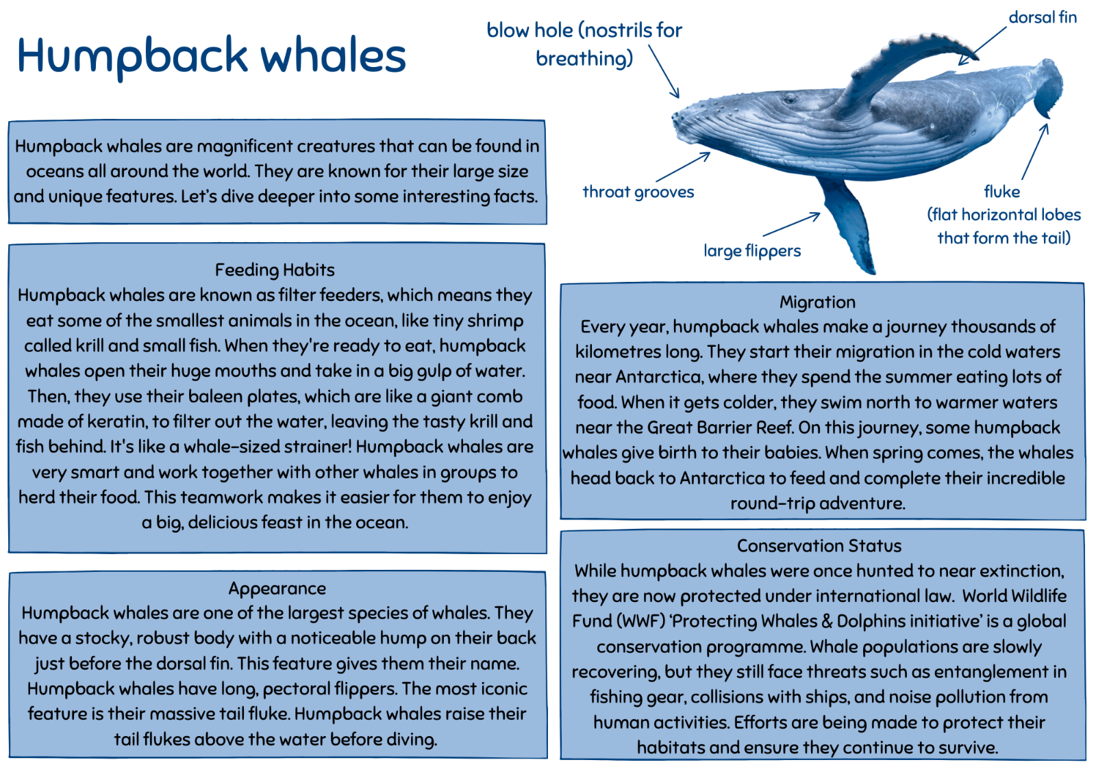

Resource 3 – polar bears
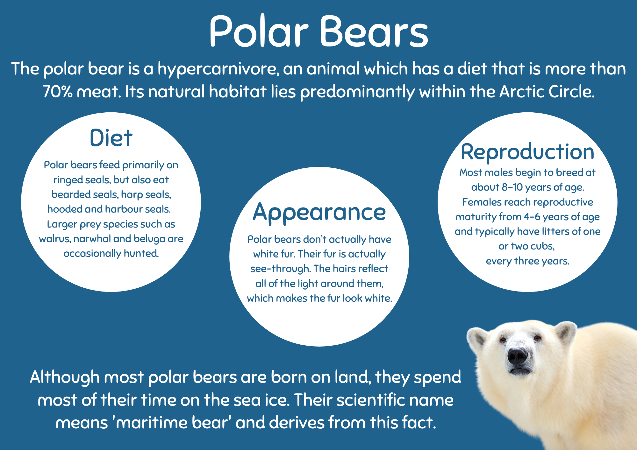

Resource 4 – spot the similarities
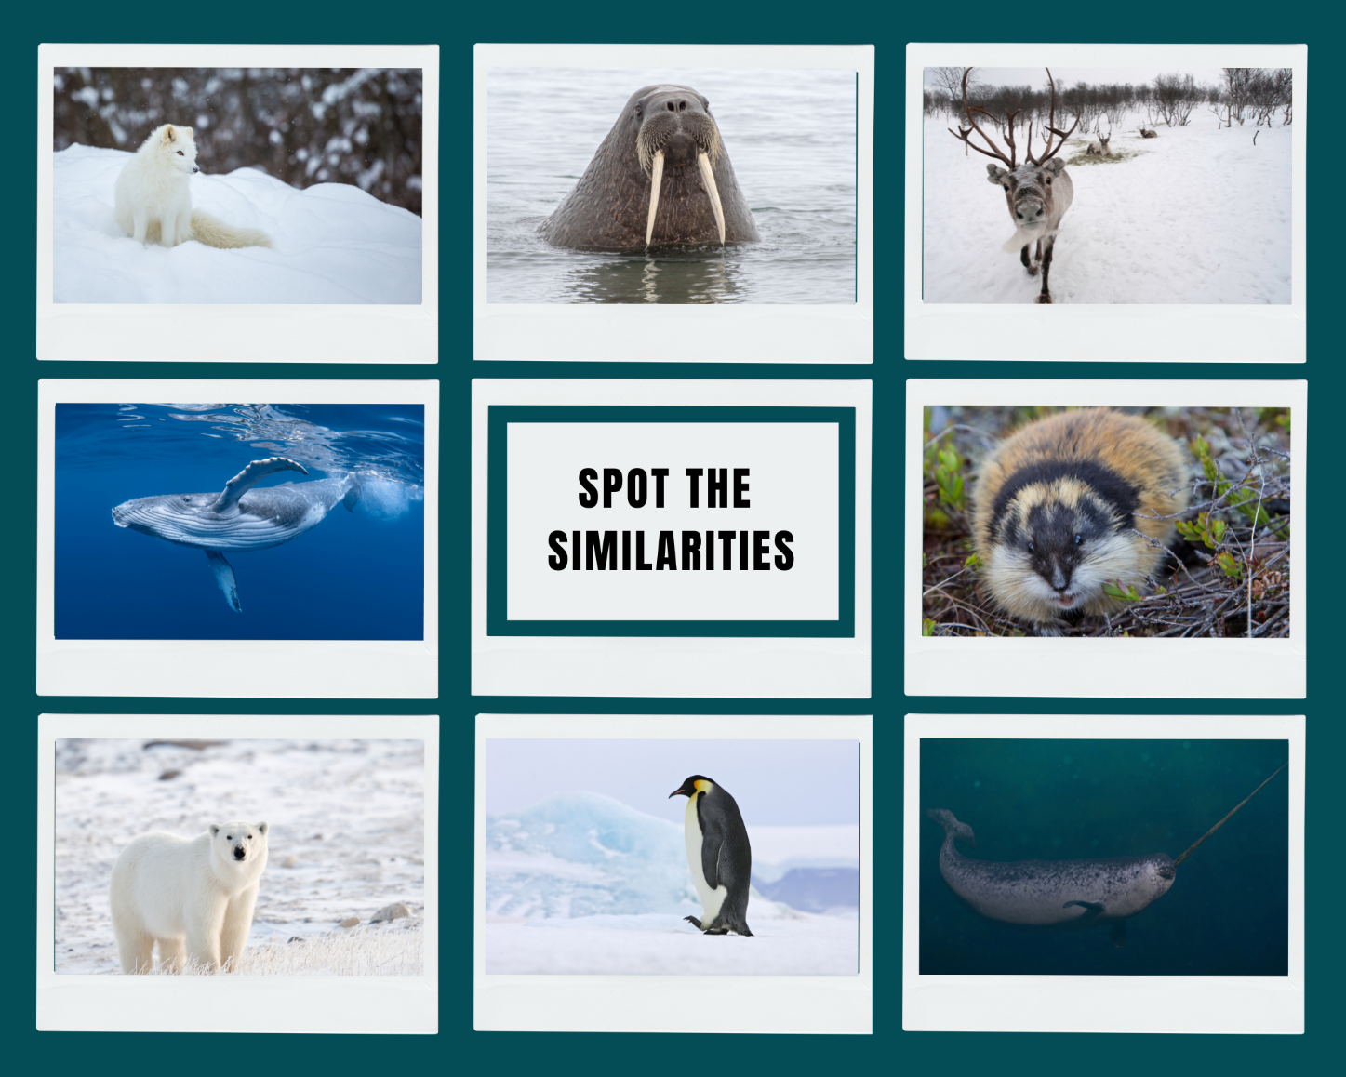

Resource 5 – Arctic fox informative text
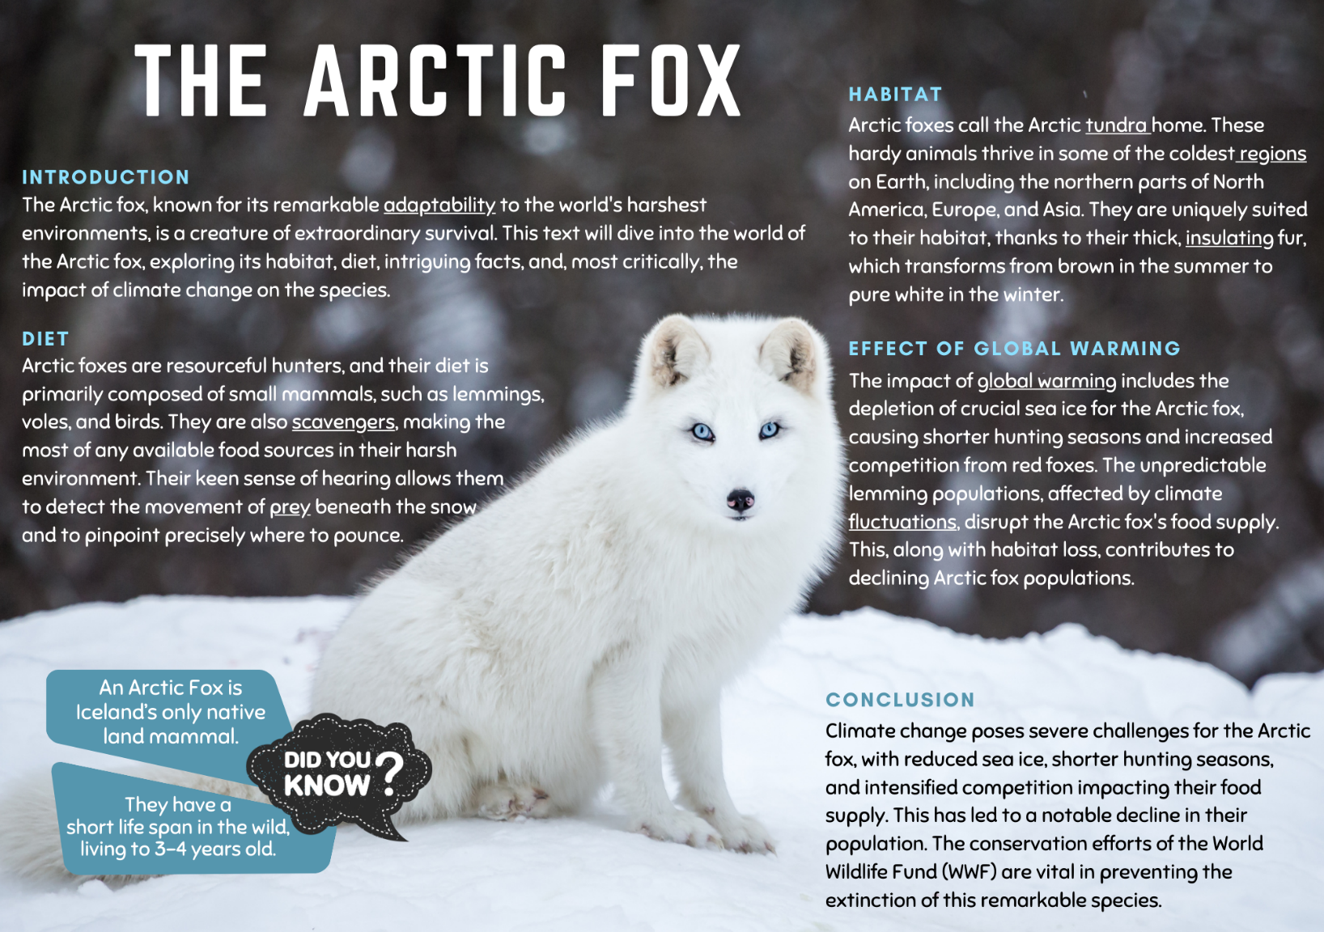

Resource 6 – writing process
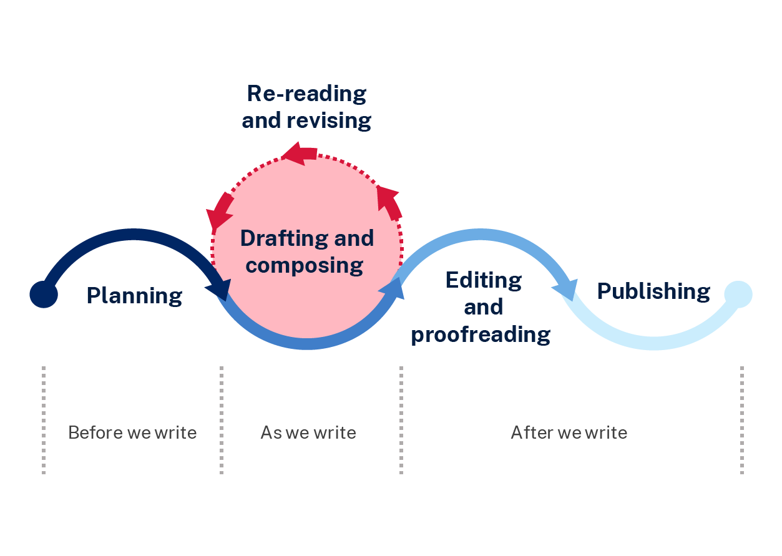

Resource 7 – social media post
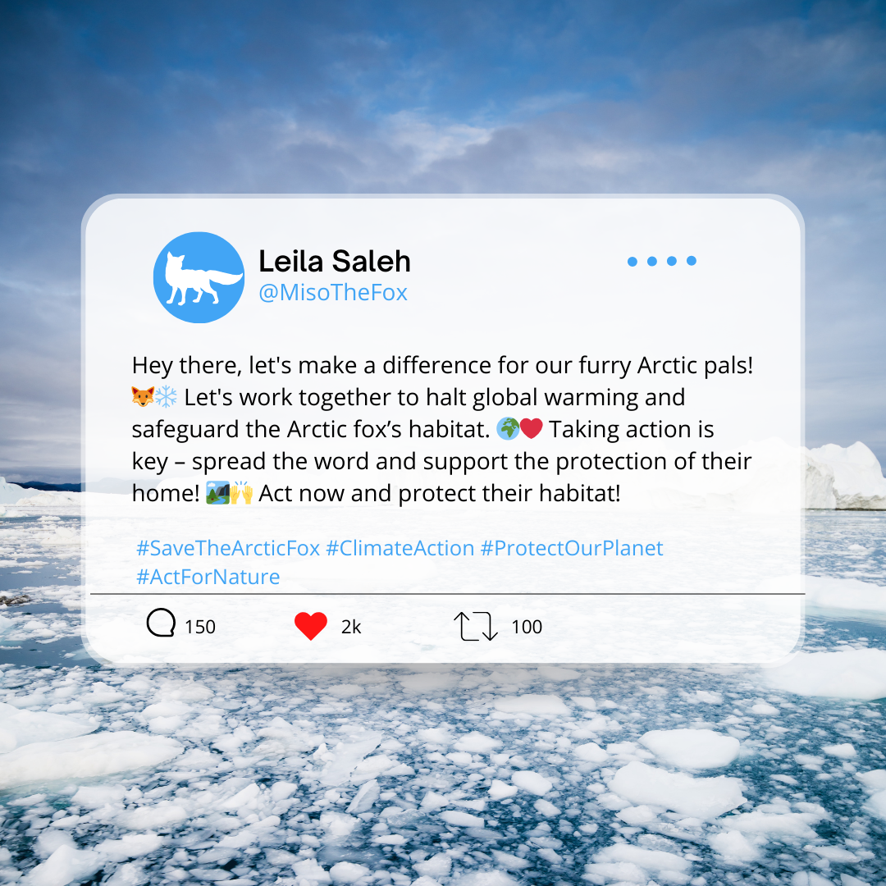

Resource 8 – protect our polar bears
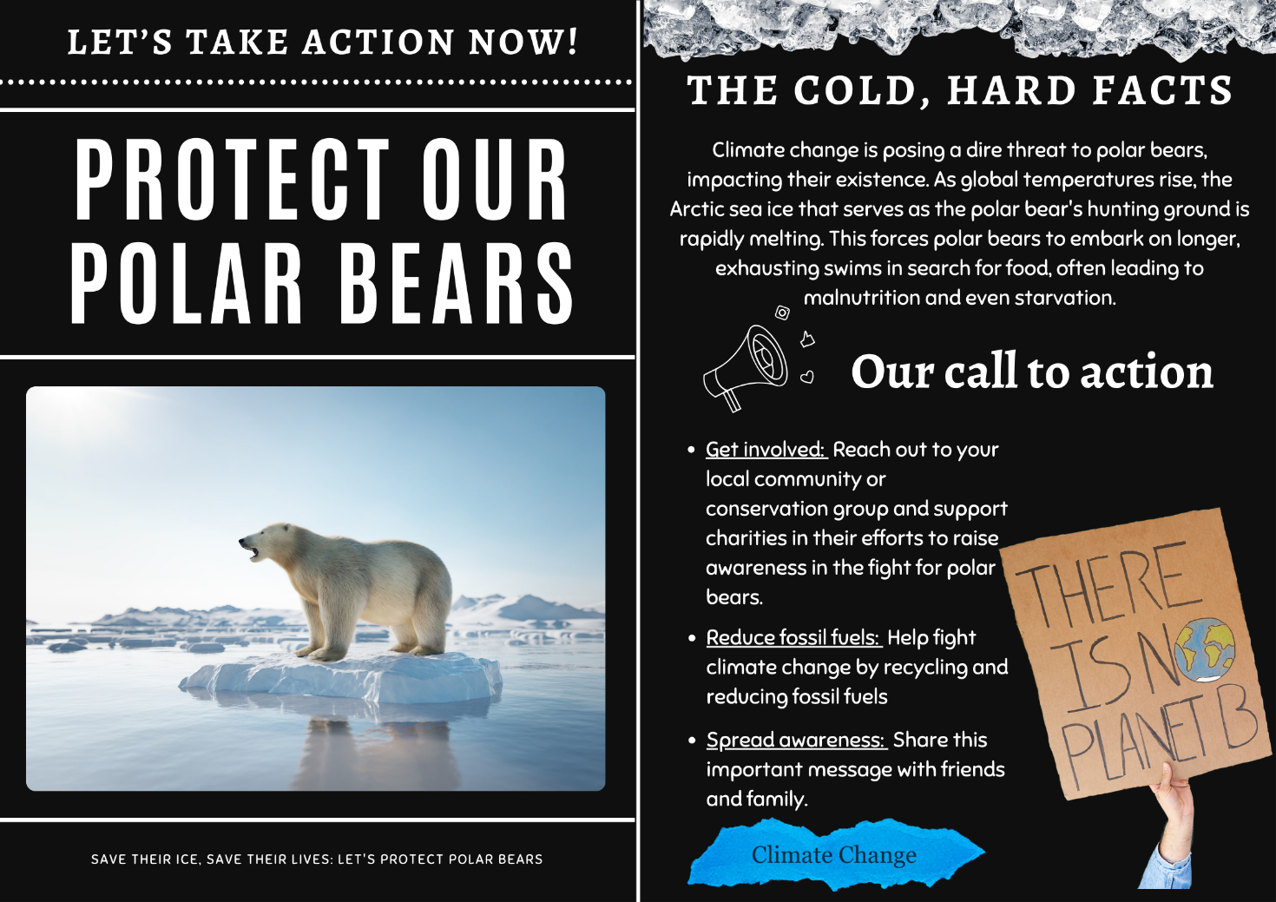

Resource 9 – poster planning
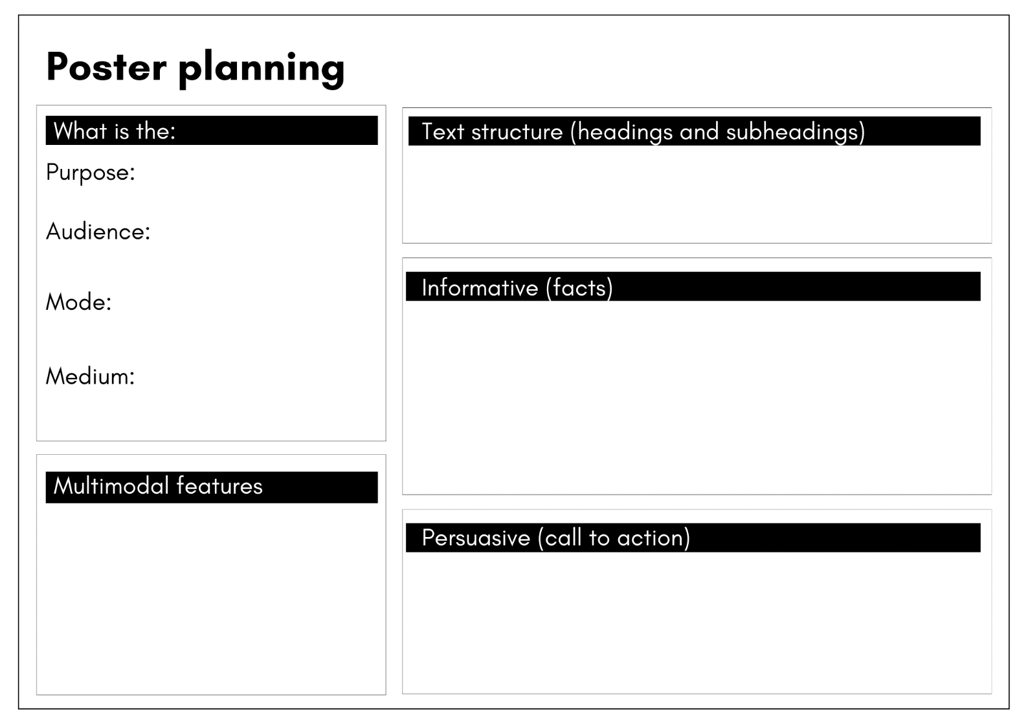

References
This resource contains NSW Curriculum and syllabus content. The NSW Curriculum is developed by the NSW Education Standards Authority. This content is prepared by NESA for and on behalf of the Crown in right of the State of New South Wales. The material is protected by Crown copyright.
Please refer to the NESA Copyright Disclaimer for more information. https://educationstandards.nsw.edu.au/wps/portal/nesa/mini-footer/copyright
NESA holds the only official and up-to-date versions of the NSW Curriculum and syllabus documents. Please visit the NSW Education Standards Authority (NESA) website https://educationstandards.nsw.edu.au/wps/portal/nesa/home and the NSW Curriculum website https://curriculum.nsw.edu.au/.
English K–10 Syllabus © NSW Education Standards Authority (NESA) for and on behalf of the Crown in right of the State of New South Wales, 2022.
National Literacy Learning Progression © Australian Curriculum, Assessment and Reporting Authority (ACARA) 2010 to present, unless otherwise indicated. This material was downloaded from the Australian Curriculum website (National Literacy Learning Progression) (accessed 19 October 2023) and was not modified.
BBC Earth (22 January 2023) ‘Arctic: Our Frozen Planet Trailer | BBC Earth’ [video], BBC Earth, YouTube, accessed 28 November 2023.
Britannica Kids (2023) Arctic Regions, Britannica Kids website, accessed 23 October 2023.
Britannica Kids (2023) polar bear, Britannica Kids website, accessed 23 October 2023.
Free School (11 January 2018) ‘Exploring the Arctic for Kids: Arctic Animals and Climates for Children – FreeSchool' [video], Free School, YouTube, accessed 23 October 2023.
Millwood Hargrave K (2022) Leila and the Blue Fox (Freston T, illus.), Hachette Children's Books, Australia.
National Geographic Kids (n.d.) Polar Bear, National Geographic Kids website, accessed 23 October 2023.
NESA (NSW Education Standards Authority) (2023) ‘Glossary’, Resources, NESA website, accessed 19 October 2023.
Polar Bears International (2023) ‘Polar Bear Facts’, Just for Kids, Polar Bears International website, accessed 23 October 2023.
Polar Bears International (27 February 2019) 'Ursula' [video], Polar Bears International, YouTube, accessed 23 October 2023.
United Nations (n.d.) Climate Action Fast Facts, United Nations Climate Change website, accessed 23 October 2023.
Waterstones Kids (16 November 2023) ‘Kiran Millwood Hargrave & Tom de Freston On Leila and the Blue Fox’ [video], Waterstones Kids, YouTube, accessed 29 November 2023.
World Wildlife Fund (WWF) (n.d.) ‘Polar Bear’, Species, World Wildlife Fund (WWF) website, accessed 23 October 2023.
WWF Schweiz (16 January 2018) ‘Polar bear walking and rolling on ice’ [video], WWF Schweiz, YouTube, accessed 23 October 2023.

© State of New South Wales (Department of Education), 2023
The copyright material published in this resource is subject to the Copyright Act 1968 (Cth) and is owned by the NSW Department of Education or, where indicated, by a party other than the NSW Department of Education (third-party material).
Copyright material available in this resource and owned by the NSW Department of Education is licensed under a Creative Commons Attribution 4.0 International (CC BY 4.0) license.
This license allows you to share and adapt the material for any purpose, even commercially.
Attribution should be given to © State of New South Wales (Department of Education), 2023.
Material in this resource not available under a Creative Commons license:
- the NSW Department of Education logo, other logos and trademark-protected material
- material owned by a third party that has been reproduced with permission. You will need to obtain permission from the third party to reuse its material.
Links to third-party material and websites
Please note that the provided (reading/viewing material/list/links/texts) are a suggestion only and implies no endorsement, by the New South Wales Department of Education, of any author, publisher, or book title. School principals and teachers are best placed to assess the suitability of resources that would complement the curriculum and reflect the needs and interests of their students.
If you use the links provided in this document to access a third-party's website, you acknowledge that the terms of use, including licence terms set out on the third-party's website apply to the use which may be made of the materials on that third-party website or where permitted by the Copyright Act 1968 (Cth). The department accepts no responsibility for content on third-party websites.

