English 3–6 Multi-age – Year A Unit 2
Argument and authority – Desert Lake, The story of Kati Thanda-Lake Eyre
Contents
Unit overview and instructions for use 5
Teacher notes 7
Outcomes and content 9
Resources 21
Week 1 24
Component A teaching and learning 24
Component B teaching and learning 41
Lesson 1 – exploring genre through Desert Lake 42
Lesson 2 – exploring text structures and language features 46
Lesson 3 – creating a hybrid text (part 1) 48
Lesson 4 – creating a hybrid text (part 2) 51
Week 2 56
Component A teaching and learning 56
Component B teaching and learning 77
Lesson 5 – navigating and summarising online texts 78
Lesson 6 – exploring authority and authorship 82
Lesson 7 – subjective and objective language 86
Lesson 8 – emotive language to support argument 92
Week 3 97
Component A teaching and learning 97
Component B teaching and learning 118
Lesson 9 – using sentences for purpose and effect 119
Lesson 10 – evaluating persuasive techniques 123
Lesson 11 – using modal words for persuasive effect 127
Lesson 12 – constructing convincing arguments 131
Week 4 135
Component A teaching and learning 135
Component B teaching and learning 158
Lesson 13 – structuring persuasive texts 159
Lesson 14 – using speech for persuasive effect 162
Lesson 15 – researching and planning for a persuasive text 165
Lesson 16 – using information to compose a persuasive text 170
Week 5 172
Component A teaching and learning 172
Component B teaching and learning 191
Lesson 17 – revising and editing to enhance authority and authorship 192
Lesson 18 – publishing and reflecting 194
Lesson 19 – presenting a multimodal text 197
Lesson 20 – presenting and reflecting 201
Resource 1 – fluency and close reading passage analysis (Week 1) 204
Resource 2 – vocabulary scaffold 209
Resource 3 – text detectives 211
Resource 4 – hybrid text exemplar 212
Resource 5 – diamond ranking organiser 213
Resource 6 – authority evaluation checklist 214
Resource 7 – fluency and close reading passage analysis (Week 2) 215
Resource 8 – vocabulary scaffold 220
Resource 9 – Venn diagram 223
Resource 10 – objective or subjective sort 224
Resource 11 – advertisement exemplar 225
Resource 12 – Kati Thanda-Lake Eyre 226
Resource 13 – Visit Kati Thanda-Lake Eyre brochure 227
Resource 14 – research and planning template 228
References 229
Further reading 230

Unit overview and instructions for use
In this 5-week unit, students will gain greater understanding of the textual concepts of argument and authority, and genre. Through study of the mentor text Desert Lake, The Story of Kati Thanda-Lake Eyre and supporting digital texts, students will recognise that an argument can be presented as a single perspective and understand the difference between authority and authorship. Students will analyse digital texts to locate and retrieve relevant information to plan, revise, edit and publish a persuasive multimodal national park brochure.
Outcomes and content in this unit are organised into Component A and Component B. The components are connected, with learning in Component A complementing learning in Component B.
Note: the duration of this unit can be adapted to suit individual school contexts. For example, learning could occur across 5 days rather than 4.
The table below highlights the focus areas and preparation required for Component A and Component B.
Teaching and learning | Component A | Component B
Suggested duration | 60 minutes × 4 days/week or equivalent | 60 minutes × 4 days/week or equivalent
Explicit teaching focus areas | Component A addresses content from the focus areas:  - Vocabulary  - Reading fluency (Stage 2)  - Reading comprehension  - Creating written texts  - Spelling  - Handwriting and digital transcription  It centres on the development of foundational skills and knowledge through regular, systematic and repeated practice. | Component B addresses content from the focus areas:  - Oral language and communication  - Vocabulary  - Reading comprehension  - Creating written texts  - Understanding and responding to literature  It centres on the conceptual understandings of English and exemplifies the importance of learning about and enjoying literature through the study of quality texts.
Preparing for teaching and learning | - Specific teaching and learning activities need to be developed by the teacher. When planning for these activities, please refer to the Component A outcomes and content, teaching guides and planning frameworks.  - Plan and document how you will sequence teaching and learning in whole-class and targeted-groups across the 5-week cycle as required. This should be based on student needs identified through ongoing assessment data. | - Familiarise yourself with the mentor and supporting texts and textual concepts, and the teaching and learning sequence.  - Determine how you will support students in whole-class and targeted-groups across the 5-week cycle as required. This should be based on student needs identified through ongoing assessment data.
English K–10 Syllabus © NSW Education Standards Authority (NESA) for and on behalf of the Crown in right of the State of New South Wales, 2022.

Teacher notes
- Argument and authority are the key concepts of this unit, explored through the mentor text Desert Lake, The story of Kati Thanda-Lake Eyre and the supporting texts National Parks and Wildlife South Australia – Kati Thanda and South Australia's Guide to Kati Thanda-Lake Eyre Travel blog. Argument refers to a stated position about an idea. It is the way in which various dimensions of a text (such as theme, perspective, and style) can be understood to represent a particular position on an issue (NESA glossary). Authority refers to authority of a text (how trustworthy, authentic or valid an audience may find the representation of ideas, experiences, perspectives and arguments in a text) and authority over a text (the varying degrees to which the meaning of a text is controlled or constructed by its creator(s) and by its audience) (NESA Glossary).
- Understanding of Argument and authority can be supported through watching the department’s videos: Understanding argument (3:17) and Understanding authority (2:39).
- While ‘argument and authority’ are the mentor concepts for Component B, the supporting concept of ‘genre’ will be also be explored. The supporting concept will be explored in the unit within the relevant section(s) of the mentor and supporting texts. Additional textual concepts may be included based on individual school context and student needs.
- For information on adverbial phrases, Tier 2 words, Tier 3 words, multimodal texts and modality refer to the NESA Glossary.
- In addition to the resources listed, students will require access to short passages of the mentor and/or supporting texts. Teachers can copy extracts from texts in reliance on the Statutory Text and Artistic Works Licence. Teachers need to attribute the extracts and include the following notice: ‘This material has been copied [and communicated to you] in accordance with the statutory licence in section 113P of the Copyright Act. Any further reproduction or communication of this material by you may be the subject of copyright protection under the Act. Do not remove this notice’.
- This unit could enhance student learning towards the achievement of Human Society and its Environment (HSIE) outcomes.
- Reflect on student learning and engagement in activities and record differentiation and adjustments within the unit to inform future teaching and learning. One way of doing this could be to add comments to the digital file.
- In NSW classrooms there is a diverse range of students including Aboriginal and/or Torres Strait Islander students, students learning English as an additional language or dialect, high potential and gifted students and students with disability. Some students may identify with more than one of these groups, or possibly all of them. Refer to Curriculum planning for every student – advice for further information.
- Content points are linked to the National Literacy Learning Progression version (3).
Levels and indicators sourced from National Literacy Learning Progression © Australian Curriculum, Assessment and Reporting Authority (ACARA), (accessed 9 August 2023) and was not modified. See references for more information.

Outcomes and content
The tables below outlines the outcomes and content for this unit. The letters 'A' and 'B' in the header refer to Components A and B. The numbers 1 to 5 refer to weeks. The use of 'x' in these columns indicates where the content points are intended to be addressed and in which week.
Stage 2 focus area and outcome, content points and National Literacy Learning Progression | A | B | 1 | 2 | 3 | 4 | 5
Oral language and communication
EN2-OLC-01 communicates with familiar audiences for social and learning purposes, by interacting, understanding and presenting
- Understand that rhetorical questions can be used for intentional effect |  | x |  |  | x | x | x
- Identify the evidence a speaker provides to support a particular point of view |  | x |  |  | x | x
- State a reasoned argument in a presentation about learning area content, to a familiar audience (SpK5, SpK6) |  | x |  |  | x |  | x
- Include multimodal features in planned and delivered presentations, to expand meaning and engage an audience (SpK5) |  | x |  |  | x |  | x
Vocabulary
EN2-VOCAB-01 builds knowledge and use of Tier 1, Tier 2 and Tier 3 vocabulary through interacting, wide reading and writing, and by defining and analysing words
- Build personal Tier 1, Tier 2 and Tier 3 vocabulary through social and learning interactions, reading and writing (SpK5) | x | x | x | x | x | x | x
- Describe how modal words indicate degrees of probability, occurrence, obligation and inclination (UnT7) | x | x |  |  | x | x
- Understand and use language associated with digital texts |  | x |  | x | x | x | x
Reading fluency
EN2-REFLU-01 sustains independent reading with accuracy, automaticity, rate and prosody suited to purpose, audience and meaning
- Demonstrate use of navigation pathways to support fluency when engaging with print, visual and multimodal texts (UnT7) | x |  | x | x | x | x | x
- Recognise that there are different purposes and audiences for reading and adjust reading rate to suit a text’s purpose (FIY5) | x |  | x | x | x | x | x
Reading comprehension
EN2-RECOM-01 reads and comprehends texts for wide purposes using knowledge of text structures and language, and by monitoring comprehension
- Locate, select and retrieve relevant information from a print or digital text and consider accuracy of information presented | x | x |  | x | x | x
- Identify different structures and features of persuasive, informative and imaginative texts |  | x | x | x | x | x | x
- Understand that literal information can be sourced directly from a text and that inferences can be made by using multiple sources of information | x | x | x | x | x | x | x
- Identify and describe the difference between subjective and objective language in texts (UnT7) | x | x |  | x | x | x | x
- Make gist statements and record them to monitor understanding (UnT6) | x | x |  | x | x | x
Creating written texts
EN2-CWT-03 plans, creates and revises written texts for persuasive purposes, using text features, sentence-level grammar, punctuation and word-level language for a target audience
- Create written texts that argue a viewpoint using rhetorical devices to persuade an audience |  | x |  | x | x | x | x
- Use a structure that includes a statement of position, has sequenced paragraphs and a conclusion (CrT8) |  | x |  |  | x | x | x
- Select and use multimodal features to add meaning |  | x |  | x | x | x | x
- Use adverbial phrases or clauses to add information to the verb or verb group of the main or other clauses, to provide reasons for or circumstances | x | x | x |  | x | x | x
- Select and use precise saying, thinking, acting, and relating verbs and verb groups to align with text purposes (GrA5, CrT8) | x | x | x |  | x | x | x
- Use exclamatory sentences to emphasise a point or express a strong emotion | x | x |  | x | x | x | x
- Use interrogative sentences to ask a direct question, or for rhetorical effect to engage the reader with a viewpoint | x | x |  |  | x | x | x
- Understand and use quoted and reported text or speech in own writing | x | x |  |  |  | x | x
- Use topic-specific Tier 2 and Tier 3 vocabulary to demonstrate authority (CrT8) |  | x | x | x | x | x | x
- Experiment with modality to indicate probability, occurrence, obligation or inclination |  | x |  |  | x | x | x
Spelling
EN2-SPELL-01 selects, applies and describes appropriate phonological, orthographic and morphological generalisations and strategies when spelling in a range of contexts
- Explain how to segment multisyllabic words into syllables and phonemes, and apply this knowledge when spelling | x |  | x | x | x | x | x
- Identify differences in vowel phonemes (short, long, diphthong and schwa vowels) (SpG9) | x |  | x | x | x | x | x
- Understand that some graphemes are dependent on their position in a word in English and apply this knowledge when spelling | x |  | x | x | x | x | x
- Proofread, identify and correct misspellings when creating written texts (SpG9) | x |  |  |  | x | x | x
- Identify inflected suffixes, explaining when and how to treat base words when they are affixed, and apply this knowledge when spelling (SpG9) | x |  | x | x | x | x | x
Handwriting and digital transcription
EN2-HANDW-01 forms legible joined letters to develop handwriting fluency
EN2-HANDW-02 uses digital technologies to create texts
- Understand that legible handwriting is consistent in size and spacing and can support learning (Year 3) (HwK6) | x |  |  | x |  | x
- Join letters when writing familiar words (Year 4) (HwK6) | x |  |  | x |  | x
- Position a chosen device in a way that facilitates efficient and sustained text creation (Year 3) | x | x |  | x |  |  | x
- Monitor goals that build on typing accuracy and rate (Year 4) | x | x |  | x |  |  | x
Understanding and responding to literature
EN2-UARL-01 identifies and describes how ideas are represented in literature and strategically uses similar representations when creating texts
- Understand that genre refers to texts that are grouped according to purpose, subject matter, form, structure and language choices, and that a type of text can differ in mode and medium |  | x | x | x |  |  | x
- Recognise that an argument is not a dispute but can be a single perspective that is presented or defended (UnT7) |  | x |  |  | x | x | x
- Describe the difference between authorship and authority |  | x | x |  | x | x | x
English K–10 Syllabus © NSW Education Standards Authority (NESA) for and on behalf of the Crown in right of the State of New South Wales, 2022.
Stage 3 focus area and outcome, content points and National Literacy Learning Progression | A | B | 1 | 2 | 3 | 4 | 5
Oral language and communication
EN3-OLC-01 communicates to wide audiences with social and cultural awareness, by interacting and presenting, and by analysing and evaluating for understanding
- Apply active listening strategies by retelling or repeating what another person has expressed and by building on what has been said. (InT5, InT6) |  | x |  |  | x | x
- Evaluate the effectiveness of rhetorical questions used for intentional effect |  | x |  |  | x | x | x
- Present multimodal arguments that include research and references, topic-specific vocabulary and the selection of persuasive techniques appropriate to audience (SpK6) |  | x |  |  | x |  | x
Vocabulary
EN3-VOCAB-01 extends Tier 2 and Tier 3 vocabulary through interacting, wide reading and writing, morphological analysis and generating precise definitions for specific contexts
- Identify and use words that convey subjective, emotive and persuasive meanings in texts |  | x |  | x | x | x | x
- Use metalanguage when discussing language features encountered in texts (UnT9, CrT9) | x | x | x | x | x | x | x
- Evaluate the effectiveness of modal words used in texts to intensify or soften emotional responses (CrT9) |  | x |  |  | x | x | x
- Identify newly encountered words from interactions and wide reading, and use them in writing, discussions and presentations | x | x | x | x | x | x | x
Reading comprehension
EN3-RECOM-01 fluently reads and comprehends texts for wide purposes, analysing text structures and language, and by monitoring comprehension
- Efficiently follow signposting features to navigate print and digital texts | x | x | x | x | x | x | x
- Select texts from print or digital sources to gather and organise research on a topic |  | x |  | x |  | x
- Compare and evaluate print and digital texts for their pertinence to a task, their authority and their level of detail (UnT8) |  | x |  | x | x | x
- Compare purposes for different texts and consider why authors and illustrators have structured texts in particular ways (UnT8) |  | x | x | x | x | x
- Explain how modality can have subtle impacts on the meanings of words and contribute to deeper understanding when reading (UnT9) | x | x |  |  | x | x
- Compare and evaluate subjective and objective language to identify bias | x | x |  | x | x | x
- Check the accuracy of own recorded gist statements made during reading, before summarising information to determine a text’s main themes, ideas or concepts | x | x |  | x | x | x
Creating written texts
EN3-CWT-01 plans, creates and revises written texts for multiple purposes and audiences through selection of text features, sentence-level grammar, punctuation and word-level language
- Group ideas to develop a statement of position, and clear, logical lines of argument that synthesise points, and structure a rhetorically effective conclusion |  | x |  |  | x | x | x
- Create objective, impersonal arguments (CrT9) |  | x |  | x | x | x | x
- Combine personal and objective arguments for persuasive effect |  | x |  | x | x | x | x
- Choose multimodal features suited to a target audience and purpose, to reinforce and extend ideas |  | x |  |  | x |  | x
- Make choices about verbs and verb groups to achieve precision and add detail (GrA6) | x | x | x | x | x | x | x
- Experiment with the placement of adverbial clauses, to modify the meaning or to add detail to a verb or verb group (GrA6) | x | x | x |  |  | x | x
- Make choices about the use of declarative, exclamatory, interrogative and imperative sentences to suit text purpose, and for meaning and effect (CrT8) | x | x |  | x | x | x | x
- Use topic-specific Tier 2 and Tier 3 vocabulary intentionally to add credibility and enhance authority (CrT9) |  | x | x | x | x | x | x
- Control modality related to probability, occurrence, obligation or inclination for precision | x | x |  |  | x | x | x
- Assess the reliability and authority of sources, including digital sources, when researching and acknowledging texts |  | x |  | x |  | x
Spelling
EN3-SPELL-01 automatically applies taught phonological, orthographic and morphological generalisations and strategies when spelling in a range of contexts, and justifies spelling strategies used to spell unfamiliar words
- Segment unfamiliar multisyllabic words into syllables and phonemes as a strategy when spelling | x |  | x | x | x | x | x
- Recognise that the same grapheme can represent different phonemes (SpG10) | x |  | x | x | x | x | x
- Proofread written texts to correct misspellings, making use of spelling reference tools when required | x |  |  |  | x | x | x
- Explain and use spelling conventions to add derivational suffixes such as -ion, -ian, -ence, -ous to base words or roots (SpG10) | x |  | x | x | x | x | x
Handwriting and digital transcription
EN3-HANDW-01 sustains a legible, fluent and automatic handwriting style
EN3-HANDW-02 selects digital technologies to suit audience and purpose to create texts
- Sustain writing with a legible, fluent and personal handwriting style across a text (HwK8) | x |  |  | x |  | x
- Navigate the keyboard with efficiency and accuracy when typing words, numerals, punctuation and other symbols (HwK8) | x |  | x |  | x |  | x
- Understand that the position of the device in relation to the user can affect posture and glare | x |  | x |  | x |  | x
Understanding and responding to literature
EN3-UARL-02 analyses representations of ideas in literature through genre and theme that reflect perspective and context, argument and authority, and adapts these representations when creating texts
- Examine and experiment with elements in literature that do not follow the form and function of a single genre |  | x | x | x |  |  | x
- Understand the authority given to objectivity versus subjectivity in arguments |  | x |  | x | x | x | x
- Analyse and compare features within and between texts, that characterise an authoritative style (UnT7) |  | x |  | x | x
English K–10 Syllabus © NSW Education Standards Authority (NESA) for and on behalf of the Crown in right of the State of New South Wales, 2022.

Resources
The resources in the table below are referred to in this unit. Letters 'A' and 'B' in the header refer to Component A and B respectively, and the numbers 1 to 5 indicate weeks. The use of 'x' in these columns indicate whether the resources are required in Component A, B or both, and in which week.
Resource | A | B | 1 | 2 | 3 | 4 | 5
Freeman P (2016) Desert Lake, The Story of Kati Thanda-Lake Eyre (Anelli L, illus), Walker Books. ISBN: 9781760650384 | x | x | x | x | x | x
Webpage: Kati Thanda-Lake Eyre National Park. |  | x |  | x | x | x
Webpage: South Australia's Guide to Kati Thanda-Lake Eyre travel blog |  | x |  | x | x | x
Resource 1 – fluency and close reading passage analysis (Week 1) | x |  | x
Resource 2 – vocabulary scaffold | x |  | x
Resource 3 – text detectives |  | x | x
Resource 4 – hybrid text exemplar |  | x | x
Google Earth: Kati Thanda-Lake Eyre National Park |  | x |  | x
Resource 5 – diamond ranking organiser |  | x |  | x
Resource 6 – authority evaluation checklist |  | x |  | x
Resource 7 – fluency and close reading passage analysis (Week 2) | x |  |  | x
Resource 8 – vocabulary scaffold | x |  |  | x
Resource 9 – Venn diagram |  | x |  | x
Webpage: Come and Say G'day |  | x |  | x
Resource 10 – objective or subjective sort |  | x |  | x
Webpage: Kati Thanda – Lake Eyre |  | x |  | x
Resource 11 – advertisement exemplar |  | x |  | x
Resource 12 – Kati Thanda-Lake Eyre |  | x |  |  | x
Webpage: Deep Creek National Park |  | x |  |  |  | x
Resource 13 – Visit Kati Thanda-Lake Eyre brochure |  | x |  |  |  | x | x
Video: Lake Eyre (3:48) |  | x |  |  |  | x
Resource 14 – research and planning template |  | x |  |  |  | x
Webpage: Guest Post: Pamela Freeman on writing Desert Lake |  | x |  |  |  |  | x
Video: It's All Good Down Under with Hamish Blake | Come and Say G'day (1:19) |  | x |  |  |  |  | x

Week 1

Component A teaching and learning
Component A focuses on the development of foundational skills and knowledge through regular, systematic and repeated practice. The mentor and supporting texts used in Component B of this unit can support the effective implementation of Component A teaching and learning.

Teaching guide
Guidance for explicit teaching, teaching notes, resources and examples for the related outcomes and content points have been provided in the table below.
Focus areas and teaching notes | Resources and examples
Reading fluency  Reading rate and automaticity (Stage 2)  - Demonstrate use of navigation pathways to support fluency when engaging with print, visual and multimodal texts  - Navigation pathways refers to the path followed while moving through the content of a text. It involves navigating the text to support fluency in a way that doesn't disrupt the overall comprehension and allows the reader to engage with print, visual, and multimodal texts. | Reading fluency  Reading rate and automaticity (Stage 2)  - Resource 1 – fluency and close reading passage analysis (Week 1)  - Passage 1 of Desert Lake: Pages 16 to 17 from ‘The skies above the lake are alive with birds...’ to ‘...where they are safe from predators.’ (77 words)  - Passage 2 of Desert Lake: Pages 18 to 19 from ‘As the desert flames red and gold with sunset...’ to ‘...come only when the lake is full.’ (62 words)  Note:  - The passage from the text will need to be a teacher-created resource.  - Content in Reading fluency will support learning in the focus areas Vocabulary, Reading comprehension and Spelling.  Reading automaticity and rate  - The passage in Desert Lake uses different font to distinguish between informative and literary purpose and structure.  - Literary text is situated on the left-hand page of the double spread and at the top of the page on the left had side.  - Informative text is situated on the right-hand page of the double spread at the bottom of the page.
Monitoring reading fluency (Stage 2)  - Recognise that there are different purposes and audiences for reading and adjust reading rate to suit a text’s purpose  - Reading rate for literary texts may depend on the use of expression, pausing, emphasis and the author’s use of phrasing.  - Reading rate for informative texts may depend on the vocabulary used. For example, Tier 3 technical and subject specific vocabulary may require the reader to slow down. | Monitoring reading fluency (Stage 2)  - The passage is read for informative and literary purposes.  - Changes in size of font indicates where the reader should add expression. For example, ‘shrieking’ (p 16), ‘squawking’ (p 16)  - Adjust reading rate for Tier 3 technical words that may require the reader to slow down. For example, colonies (p 17), predators (p 17).
Reading comprehension  Monitoring comprehension (Stage 2)  - Make gist statements and record them to monitor understanding  - Gist statements are succinct notes that summarise what has been read. They may be recorded in print or digitally. | Reading comprehension  Monitoring comprehension (Stage 2)  - An example of a gist statement to summarise page 16 and 17: Freeman describes a scene from Kati Thanda detailing birds’ nesting behaviour.
Comprehending text structures and features (Stage 2)  - Understand that literal information can be sourced directly from a text and that inferences can be made by using multiple sources of information  - Literal information: Having only the most direct meaning (NESA 2023).  - Inference: A conclusion reached on the basis of evidence and reasoning (NESA 2023). | Comprehending text structures and features (Stage 2)  - Literal information presented in the factual paragraph: ‘Pelicans and gulls both nest in colonies where hundreds of nests are clustered together on the ground.’ (p 17)  - Inferences: the sentence in Desert Lake ‘The skies are alive with birds’ (p 16) implies that there is a significant presence of birds in the sky, suggesting a vibrant and active atmosphere. It suggests that there is a notable number of birds flying or present in the sky, creating a lively and animated scene.  - Inferences: the sentence in Desert Lake ‘Wedge-tailed eagle circling high above’ (p 17) implies that the wedge tailed eagle is in search of prey or surveying its surroundings.
Reading comprehension  Reading fluently (Stage 3)  - Efficiently follow signposting features to navigate print and digital texts  - Signposting features refer to elements within a text that guide the reader through structure and content of a text. These features serve as ‘signposts’ that indicate the direction the text is taking and help the reader follow along. | Reading comprehension  Reading fluently (Stage 3)  - As above, see Stage 2 Reading fluency.
Monitoring comprehension (Stage 3)  - Check the accuracy of own recorded gist statements made during reading, before summarising information to determine a text’s main themes, ideas or concepts  - To check accuracy, students may review the original source, compare with supporting details, cross-reference with a peer. | Monitoring comprehension (Stage 3)  - As above, see Stage 2 Reading comprehension.
Vocabulary  Learning and using words (Stage 2)  - Build personal Tier 1, Tier 2 and Tier 3 vocabulary through social and learning interactions, reading and writing  - Tier 2 words: General academic words that can be used across a variety of domains. Tier 2 words add power and precision to written and spoken language, but many Tier 2 words are most commonly found in written language (NESA 2023). | Vocabulary  Learning and using words (Stage 2)  - Suggested vocabulary from the passage  - Tier 2 verbs: shrieking, squawking, whistle, circling, clustered hopping, emerge, crawl  - Tier 2 nouns: ducklings, pelicans, colonies, shrubs, predators, sunset, burrows, lake, lizard, stones  - Resource 2 – vocabulary scaffold.
Vocabulary  Learning and using words (Stage 3)  - Use metalanguage when discussing texts  - Metalanguage includes the technical terms used to describe and discuss how language and texts function (NESA 2023). | Vocabulary  Learning and using words (Stage 3)  - Suggested examples to illustrate metalanguage in the passages  - Informative and narrative text, verbs and verb groups, adverbial phrases, subjective and objective language.
Learning and using words (Stage 3)  - Identify newly encountered words from interactions and wide reading, and use them in writing, discussions and presentations  - Identify and discuss the meanings of newly encountered Tier 2 and Tier 3 words in the text to improve vocabulary knowledge and comprehension. It could be a word with an unfamiliar meaning, an unusual spelling or a term specific to a certain context. | Learning and using words (Stage 3)  - As above, see Stage 2 Vocabulary examples.
Spelling  Phonological component (Stage 2)  - Explain how to segment multisyllabic words into syllables and phonemes, and apply this knowledge when spelling.  - Revise segmenting multisyllabic words into syllables and phonemes. This is a phonological skill that should be practised regularly. | Spelling  Note: each week of learning contains a phonological, orthographic and morphological focus. These focuses are intended to be taught simultaneously through linguistic inquiry. Suggested words have been selected are selected to show how phonological, orthographic and morphological content can be integrated. In addition to words selected from the mentor and/or supporting text, additional sample words for inquiry are provided.  Phonological component (Stage 2)  - Suggested words from Desert Lake: blue, huge, pools, New Zealand, food.  - Sample words for inquiry: nude, dune, volume, true, value, spoon, zoo, mushroom, chew, blew, through, canoe, few-fewer-fewest, true-truer-truest, blue-bluer-bluest, cruel-crueler-cruelest, soon-sooner-soonest, cute-cuter-cutest.
Phonological component (Stage 2)  - Identify differences in vowel phonemes (short, long, diphthong and schwa vowels)  - Long vowel phoneme: /oo/ as in soon [u_e, ue, oo, ew, ough, oe].  - This phoneme is often referred to as the long /oo/. It is a diphthong. Common representations include [u_e, ue and ew]. Alternative spellings include [oe] and the quadgraph [ough].  - Schwa /ə/: [–er, –est].  - A schwa is a vowel sound in an unstressed/unaccented syllable, where a vowel does not make its long or short vowel sound. It usually sounds like the short /u/ sound but is shorter, softer and weaker. The suffixes –er and –est are often pronounced as a schwa (eg higher). | Phonological component (Stage 2)  - As above
Orthographic component (Stage 2)  - Understand that some graphemes are dependent on their position in a word in English and apply this knowledge when spelling  - The use of different graphemes can be dependent on their position in a word. [u_e, ue, ew, ough, oe] are often used at the end of base words. [oo] is often used in the middle of base words. | Orthographic component (Stage 2)  - As above
Morphological component (Stage 2)  - Identify inflected suffixes, explaining when and how to treat base words when they are affixed, and apply this knowledge when spelling  - Inflected suffixes: comparative (-er) and superlative (-est).  - An inflected suffix is a bound morpheme added to the end of a base word to assign a number to a word, to indicate possession or tense, or to provide a comparison (for example, -s, -es, -ing, -ed, -er, est).  - The inflected suffixes -er and -est usually attach to adjectives that have one syllable (for example, fine, finer).  - Adjectives with more than one syllable often use the words ‘more’ and ‘most’ instead of using the inflected suffixes (for example, polite, most polite).  - When an adjective has more than one syllable and ends in consonant -y, replace the ‘y’ with ‘i’ before adding the suffix, for example, happy-happier-happiest.  - For adjectives that are single syllable CVC words, the final consonant is usually doubled before adding -er or -est (for example, big, bigger). | Morphological component (Stage 2)  - As above
Spelling  Phonological component (Stage 3)  - Segment unfamiliar multisyllabic words into syllables and phonemes as a strategy when spelling.  - Revise segmenting multisyllabic words into syllables and phonemes. This is a phonological skill that should be practised regularly. | Spelling  Phonological component (Stage 3)  - Suggested words from Desert Lake: sky, years, empty, sleepy, gradually, wearily, tiny, many.  - Sample words for inquiry: thirsty, weighty, grouchy, python, identify, sympathy, mystify, harmony-harmonise, sympathy-sympathise. apology-apologise, strategy-strategise, colony-colonise, priority-prioritise, category-categorise, capital-capitalise, hospital-hospitalise, social-socialise, modern-modernise, weapon-weaponise, stable-stablise.
Orthographic component (Stage 3)  - Recognise that the same grapheme can represent different phonemes  - Grapheme [y] representing /ee/, /igh/, /i/ and /y/.  - Highlight the different phonemes represented by the grapheme [y]. [y] is often used to represent /ee/ as in happy, /igh/ as in sky, /i/ as in gym and /y/ as in yellow. Note the grapheme’s position within base words. | Orthographic component (Stage 3)  - As above
Morphological component (Stage 3)  - Explain and use spelling conventions to add derivational suffixes such as -ion, -ian, -ence, -ous to base words or roots  - Derivational suffix: -ise.  - Derivational suffixes are added to a base word or root to change part of speech.  - Introduce suffix  - -ise meaning ‘quality, state or function’ or ‘make or become’  - Attaches to nouns to form nouns, for example, expert-expertise  - Attaches to nouns to form verbs, for example, hospital-hospitalise  - Teach ‘drop the e’ rule, for example, stable-stablise  - Teach ‘drop the y’ rule, for example, apology-apologise | Morphological component (Stage 3)  - As above
Creating written texts  Sentence-level grammar (Stage 2)  - Use adverbial phrases or clauses to add information to the verb or verb group of the main or other clauses, to provide reasons for or circumstances  - Adverbial phrases add meaning to, or modify, the action of verbs, adjectives and other adverbs.  - Adverbial clauses are a type of subordinate (or dependent) clauses that add meaning to a verb, adjective or adverb.  - Review different types of adverbial phrases that can provide information about circumstance or reason  - When (adverbial phrase/clause of circumstance – time)  - Where (adverbial phrase of circumstance – place)  - How (adverbial phrase of circumstance – manner)  - Why (adverbial phrase of circumstance – reason). | Creating written texts  Sentence-level grammar (Stage 2)  - Suggested sentences with adverbial phrases from the text  - ‘About every ten years the inland rivers flood into the lake.’ (p 9)  - ‘Day after day, flocks of pelicans patrol the lake.’ (p 20).  - Sentence with adverbial clauses from the text  - ‘Once they hatch, the tadpoles grow into frogs in just a few weeks.’ (p 12).  - Suggested sentence with adverbial phrase and clause from the passage: ‘Smaller birds make nests in shrubs where they are safe from predators.’ (p 17)  - Adverbial phrase: in shrubs  - Adverbial clause: where they are safe from predators.
Sentence-level grammar (Stage 2)  - Select and use precise saying, thinking, acting, and relating verbs and verb groups to align with text purposes  - Review action verbs.  - Review verb groups: a verb group is a group of words built around a verb. Verb groups: may include auxiliary verbs (‘helping’ verbs used to indicate tense or modality), may include other words such as adverbs and prepositions.  - Verb groups are sometimes referred to as a complex verb or compound verb (NESA 2023). | Sentence-level grammar (Stage 2)  - Suggested verbs from the passage  - Action verbs: shrieking (p 16), squawking (p 17), circling (p 17) whistle (p 17), circling (p 17), clustered (p 17)  - Verb groups: are clustered (p 17), are safe (p 17).
Creating written texts  Sentence-level grammar (Stage 3)  - Make choices about verbs and verb groups to achieve precision and add detail.  - Review types of verbs (action, thinking, feeling, saying and relating).  - Review identification of the head verb in a clause or verb group.  - Review verb groups (sometimes known as a complex verb or compound verb) containing  - auxiliary/'helping’ verbs to indicate tense or modality  - contain 2 or more verbs  - other words such as adverbs or prepositions. | Creating written texts  Sentence-level grammar (Stage 3)  - As above, see Stage 2 Creating written texts.
Sentence-level grammar (Stage 3)  - Experiment with the placement of adverbial clauses, to modify the meaning or to add detail to a verb or verb group.  - Review adverbial phrases and clauses (to provide reasons for or circumstances).  - Adverbial clause: a dependent clause that modifies a verb, adjective or another adverb. It includes words that provide information about the time, place, condition, reason, manner or purpose (NESA Glossary). | Sentence-level grammar (Stage 3)  - Adverbial clause placed at the beginning of the sentence  - ‘Once they hatch, the tadpoles grow into frogs in just a few weeks.’ (p 12).  - The adverbial clause is placed at the beginning of a sentence. It indicates a specific point in time, emphasising that the growth into frogs happens after the tadpoles hatch.
Handwriting and digital transcription  Software functionalities and typing (Stage 2 Year 3)  - Position a chosen device in a way that facilitates efficient and sustained text creation  - Position a device or monitor at an appropriate height and angle. | Handwriting and digital transcription  Software functionalities and typing (Stage 2 Year 3)  - Device or monitors are placed so the top is at eye level.  - Students practise at tables and chairs supporting ergonomic device use and clear vision.
Software functionalities and typing (Stage 2 Year 3)  - Position a chosen device in a way that facilitates efficient and sustained text creation.  - Position a device or monitor at an appropriate height and angle. | Software functionalities and typing (Stage 2 Year 3)  - Device or monitors are placed so the top is at eye level.  - Students practise at tables and chairs supporting ergonomic device use and clear vision.
Software functionalities and typing (Stage 2 Year 4)  - Monitor goals that build on typing accuracy and rate  - Set goals that build on typing accuracy and rate. | Software functionalities and typing (Stage 2 Year 4)  - Support students to value accuracy of typing over speed when setting goals.
Handwriting and digital transcription  Software functionalities and typing (Stage 3 Year 5)  - Understand that the position of the device in relation to the user can affect posture and glare  - Manage the wellbeing of self and others by supporting healthy and manageable device practices. | Handwriting and digital transcription  Software functionalities and typing (Stage 3 Year 5)  - Students understand how posture and glare can be affected by the position of a device.
Software functionalities and typing (Stage 3 Year 6)  - Navigate the keyboard with efficiency and accuracy when typing words, numerals, punctuation and other symbols  - Understand that the position of the device in relation to the user can affect posture and glare.  - Use correct posture to navigate the keyboard with efficiency when typing words. | Software functionalities and typing (Stage 3 Year 6)  - Students use key vocabulary from the mentor and or supporting texts to revise.  - device positioning and posture  - touch typing skills including the home, top and bottom rows.

Planning framework
To plan and document Component A teaching and learning, a planning scaffold [DOCX 228 KB] is provided. To support you in your planning, a link to a detailed example of a one-week teaching and learning cycle is included in the scaffold. Additional resources to support teaching and learning in each focus area can be found at Lesson advice guides.

Component B teaching and learning
The following teaching and learning sequence has been designed to address Component B outcomes and content and develops conceptual understandings of English through the study of quality texts. Adapt the sequence as required to best meet the needs of your students.

Learning intentions and success criteria
Learning intentions and success criteria are best co-constructed with students. The table below contains suggested learning intentions and success criteria.
Element | Stage 2 | Stage 3
Learning intention | Students are learning to identify the genre of various texts and apply knowledge of genre to create hybrid texts. | Students are learning to experiment with elements in literature that do not follow the form and function of a single genre to create a hybrid text.
Success criteria | Students can:  - understand that texts can be categorised into genres and that types of texts arise from similarities of purpose  - recognise that particular types of texts can be identified through features and structures  - create a narrative genre for a hybrid text  - create an informative genre for a hybrid text. | Students can:  - understand that texts can be categorised into genres that have similar functions, ideas, forms and conventions  - recognise that particular types of texts can be identified through features and structures but may be adapted for interesting effect  - create a narrative genre for a hybrid text  - create an informative genre for a hybrid text.

Lesson 1 – exploring genre through Desert Lake
The following teaching and learning activities support multi-age settings.

Whole
- Host a walk through the school library, gathering a collection of texts of varying genres (fiction and non-fiction picture books, novels, magazines, comic books).
- Ask students how these texts could be grouped. For example, fiction and non-fiction, according to subject matter. Share ideas with the class.
- Students turn and talk to discuss their favourite type of book to read and why. For example, ‘I like adventure books because they are full of action and suspense.’
- Introduce the supporting concept of ‘genre’. Ask students if they have heard of the word genre, where they have heard it and what it means. Explain that genre is a term used to group different types of texts according to similarities in form and function. These could include informative, imaginative and persuasive texts. Genre can vary according to mode (process of communication such as sounds, music, printed or spoken words, images and gestures) and medium (means of communication, such as publishing or the internet) of the text delivery. Some aspects of genre are recognisable and familiar while others break conventions, are challenged and change over time. Knowing which genre a text falls into helps the reader know what to expect. It can also help readers to group similar texts to organise them, like in the library or in a book shop.
- Display the front and back cover of Desert Lake, The Story of Kati Thanda-Lake Eyre. Explain that analysing a text can help the reader to understand the genre of a text. Identify and discuss:
- the 2 titles: Desert Lake and The story of Kati Thanda-Lake Eyre
- the author: Pamela Freeman
- the illustrator: Liz Anelli
- the publisher: Walker Books Australia
- the blurb.
- Flip through the book and make predictions about the genre using the following questions:
- What might the purpose of the text be? To inform, persuade or entertain?
- What might the subject matter of the text be?
- How might the text be structured?
- How is the text presented (form)?
- How is the text communicated (mode)? For example, printed words and illustrations
- How is the text conveyed (medium)? For example, published picture book.
- To activate prior knowledge, students stand in a circle and share one fact they know about lakes or deserts. For example, deserts are dry environments with little rainfall while lakes are bodies of water that support diverse aquatic ecosystems. Based on student responses, discuss the contrast between the 2 environments.
- On sticky notes, students record wonderings about the title of the book, Desert Lake, The Story of Kati Thanda-Lake Eyre. For example, ‘I wonder where Lake Eyre is located?’ ‘I wonder how there can be a lake in the desert?’ ‘I wonder what plants are there?’ Record wonderings on an anchor chart.
- Explain that Desert Lake, The Story of Kati Thanda-Lake Eyre has 2 names. Kati Thanda is the Aboriginal name and Lake Eyre is the name given by European explorers. Emphasise the importance of listening to native speakers or audio recordings of 'Kati Thanda' and ‘Lake Eyre’ being pronounced correctly. Encourage active listening and imitation to develop an accurate pronunciation.
- Read Desert Lake, The Story of Kati Thanda-Lake Eyre, pausing to clarify information and vocabulary. Discuss observations between the narrative and informative text.
Too hard? Use real images of Kati Thanda and tools such as Google Earth to support background knowledge.
Too easy? Provide students with a graphic organiser to write what they know about Kati Thanda at the beginning of the lesson. Students add to the organiser as the unit progresses.
- Students Think-Pair-Share to discuss the questions using evidence from the text:
- What do you notice about how the text is presented? Does it make you wonder about anything?
- How do you think the illustrations support the text? Why do you think that?
- What is the purpose of the text? How do you know?
- What message is the author trying to communicate? What clues suggest this?
- What genre is it? Where would this book go if it was in the library? What other books would it be grouped with?
- What clues in the text tell you which parts are fiction and non-fiction?
- Explain that Pamela Freeman has blended 2 genres together. She combines both informative and narrative text to communicate information about Kati Thanda-Lake Eyre.
- Highlight that Desert Lake, The Story of Kati Thanda-Lake Eyre is a mix of 2 genres in one text, meaning it is a hybrid text. Encourage students to analyse techniques used by Pamela Freeman to create a hybrid text, along with their intended effects. For example, she combines features from fiction and non-fiction texts (literary descriptions, information, illustrations, an index page) to create something new and exciting. Pamela Freeman has used a combination of narrative and informative text to make reading more interesting and enjoyable.
- Reflect on the library walk and class discussions to co-construct a shared definition of genre. For example, genres help readers understand different types of texts. Genre is used to group different types of texts that share similarities of purpose, and could include informative, imaginative, and persuasive texts. Genres help readers understand different types of texts that have the same purpose but different subject matter. Consider where the hybrid text, Desert Lake, The Story of Kati Thanda-Lake Eyre, sits within the definition. Display in the classroom for future reference.

Lesson 2 – exploring text structures and language features
The following teaching and learning activities support multi-age settings.

Whole
- Re-read Desert Lake, The Story of Kati Thanda-Lake Eyre and review hybrid texts. Recall how Pamela Freeman has written the text as a blended genre of narrative and informative text.
- Display a double-page spread of Desert Lake, The Story of Kati Thanda-Lake Eyre. Model analysing the text features Pamela Freeman has used to support the narrative and informative purpose of the text on a T-chart. For example:
- Narrative features: descriptive language, illustrations, a change in font style, sizing for words such as ‘lift into the sky’, ‘emerge...’ and ‘crawl...’, and various text pathways.
- Informative features: factual information, headings, illustrations, an index, text pathways, change in font.
- Using the T-chart, provide students with a range of narrative and informative sentences or phrases from Desert Lake, The Story of Kati Thanda-Lake Eyre. Students sort the descriptions into narrative or informative text and provide reasons. For example:
- Narrative descriptions such as ‘Blinding white with the salt of an ancient sea’; and ‘water swirls and roars down the empty riverbeds towards the lake’ place emphasis on description, vivid vocabulary and poetic style to entertain.
- Informative descriptions such as ‘below the lake-bed, the frogs can sleep for many years’ and ‘They live off fat and water stored in their bodies’ presents factual, straightforward information to inform.
- In pairs, students select a double-page spread from Desert Lake, The Story of Kati Thanda-Lake Eyre and locate and identify specific text features and structures that are representative of narrative and informative texts. Using Resource 3 – text detectives, students record specific narrative and informative sentences or phrases from their chosen pages.
- Discuss why Pamela Freeman used various text features in the narrative and informative descriptions of the text. Discuss their importance in contributing to defining text types and shaping their purpose to entertain and inform.
- Display a double-page spread of the text. Identify and analyse the language Pamela Freeman has changed in size or layout. For example, changes in key vocabulary such as verbs and verb groups. Ask students to think about why Pamela Freeman has used this feature. For example, Pamela Freeman draws the reader’s attention to precise verbs and verb groups to enhance meaning and to emphasise the actions of the wildlife and the lake. Reinforce that authors are strategic in emphasising key words so that meaning is not lost.
- Brainstorm the definition of Tier 2 and Tier 3 vocabulary as explored in Component A. For example, Tier 2 words are general academic words that can be used across a variety of domains and Tier 3 words can only be used in highly specific contexts. Model finding examples of Tier 2 and Tier 3 words from the narrative and informative text to add to the T-chart from activity 3. For example, Tier 2 words such as ‘swirls’ and ‘roars’ are sophisticated verbs used in the narrative text. ‘Salt crust’, and ‘lake-bed’ are subject specific Tier 3 nouns used to name elements of the lake in the informative text.
- In pairs, students continue to use Resource 3 – text detectives to scan through their double-page spread to find examples of Tier 2 and 3 vocabulary. Share student responses and record on the T-chart. Consider which genre most of the Tier 2 and 3 words have come from. Discuss why authors make choices to use Tier 3 words in informative texts. For example, the use of Tier 3 words adds precision and credibility to a text.
- Use exit tickets to demonstrate student knowledge of text features and language features in a hybrid text. For example:
- What were the similarities and differences between the text features, structures and language choices of the 2 types of texts in Desert Lake, The Story of Kati Thanda-Lake Eyre?
- Which specific elements or features in Desert Lake, The Story of Kati Thanda-Lake Eyre caught your attention and helped you understand the text better?
- How does understanding text features, structures and language help a reader to understand the genre of a text?

Lesson 3 – creating a hybrid text (part 1)
The following teaching and learning activities support multi-age settings.

Whole
- Two truths and a lie: In small groups, students record 3 statements about genre, two being truths, and one being a lie. The goal is to identify which statement is the lie. For example, genres are types of texts such as fiction and non-fiction (truth), genres are fixed and cannot be blended (lie), and genres serve as a tool for readers and writers to understand and navigate different types of texts (truth). Statements can be used as a discussion point to review learning of genre.
- Display the double-page spread on pages 14 to 15 of Desert Lake, The Story of Kati Thanda-Lake Eyre. Re-read the narrative text on page 14 about pelicans. Review what features and language choices Pamela Freeman has made to support the texts’ purpose ‘to entertain’. For example, changes in text sizing, precise verbs, Tier 2 and 3 vocabulary.
- Model deconstructing the sentence ‘Far, far away, pelicans lift into the sky – hundreds of them, heading for the lake to nest’ (p 14). For example:
- Subject: pelicans
- Verb group: lift into
- Object: the sky
- Adverbial phrase: Far, far away (beginning of sentence) and heading for the lake to nest (end of sentence)
- Phrase providing more information about the subject: hundreds of them.
- Discuss why Pamela Freeman has chosen to use specific language choices. For example, verbs and verb groups convey the actions and movements of the pelicans in an engaging manner. By using verbs, the author brings the narrative to life and provides a sense of movement and action within the scene. The adverbial phrases of place inform readers where the pelicans are going.
- In pairs, students deconstruct the sentence ‘Their huge wings speed them across the great red desert to the one spot where their babies will be safe from dingoes and foxes - the new islands in the middle of the lake’. For example:
- Subject: their huge wings (pelicans)
- Verb group: speed them across
- Object: the great red desert
- Adverbial phrase: to the one spot
- Adverbial clause: where their babies will be safe from dingoes and foxes
- Phrase providing more information about the noun ‘one spot’: the new islands in the middle of the lake.
- Explain that over the next 2 lessons, students will innovate from Desert Lake, The Story of Kati Thanda-Lake Eyre and experiment with genre by using text and language features to create their own mini hybrid text.
- Display the double-page spread on pages 8 to 9 of Desert Lake, The Story of Kati Thanda-Lake Eyre with the text concealed. View and discuss the illustration. Explain that students will construct a text about kangaroos in the form of a literary description.
- Display Resource 4 – hybrid text exemplar. Read and discuss the narrative features of the hybrid text for the purpose of entertaining.
- Using Resource 4 – hybrid text exemplar, co-construct a success criteria for writing a literary description. For example:
- include descriptive language features
- use Tier 2 and Tier 3 vocabulary
- use adverbial phrases or clauses
- use precise verbs and verb groups.
- Using the co-constructed success criteria model writing a literary description about kangaroos. For example:
As the distant rumble of thunder echoes through the vastness of Kati Thanda, a sense of anticipation fills the air. The kangaroos of this ancient land bound gracefully across the arid landscape as the promise of rain draws near. A soft breeze carries with it the kangaroos' keen senses. Their heads tilt upwards and their ears perk as they listen to the whispers of raindrops yet to fall.
- Provide time for students to compose a literary description about kangaroos using the illustrations on pages 8 to 9 as a guide.
Too hard? Provide students with a scaffold that prompts their thinking to support writing. For example, subject (animal), actions (verbs), how and/or where (adverbial).
Too easy? Students change other words within the sentence and write additional sentences to experiment with the placement of the adverbial.
- Encourage students to refer to the success criteria and revise their work during the writing process. Students may wish to experiment with text features such as larger font to enhance meaning as in Desert Lake, The Story of Kati Thanda-Lake Eyre.
- Students complete an exit ticket to reflect and explain what language choices they used that support the texts' purpose (to entertain).
Note: students will continue to experiment with genre in Lesson 4 by adding informative text to complement their literary descriptions.

Lesson 4 – creating a hybrid text (part 2)
The following teaching and learning activities support multi-age settings.

Whole
- Flip through Desert Lake, The Story of Kati Thanda-Lake Eyre, briefly showing a range of pages. Ask students what they notice about the features of the informative text. For example, ‘I notice there is an ‘About Kati Thanda-Lake Eyre’ heading, there is an index page and a map’. Students share their observations.
- Review that text structures and language features support the texts’ purpose ‘to inform’. For example, the use of headings, maps, an index, facts and Tier 3 vocabulary.
- Explain that Desert Lake, The Story of Kati Thanda-Lake Eyre is a multimodal text combining 2 or more expressive modes to communicate. Ask students what multimodal features they can identify in Desert Lake, The Story of Kati Thanda-Lake Eyre. For example, the use of text, illustrations, an index page and a map. Ask students to consider the purpose multimodal features in Desert Lake, The Story of Kati Thanda-Lake Eyre. Ask students why Pamela Freeman has used print and visual features. For example, to add meaning to the text, extend on ideas and enhance credibility.
- Draw attention to the layout of the text and the navigation pathways the reader needs to take to follow the informative text sections in Desert Lake, The Story of Kati Thanda-Lake Eyre. For example, the font stays the same, but the pathway of the text changes. Discuss the purpose of using navigation pathways in informative texts. For example, a visual representation that enhances engagement and meaning.
- Display the index page of Desert Lake, The Story of Kati Thanda-Lake Eyre. Ask students why authors may use an index in an informative text. For example, a reference tool that helps readers quickly locate specific information within a book. Explain that an index is typically found at the end of a text and lists keywords, topics, or names along with the page numbers of where they can be found.
- Using the index, ask students to find pages that may include information about pelicans. Model following signposting features to navigate through the printed text. Use topic words referenced in the index on birds (pp 16, 17, 19, 25) and nests (p 14) to find information on pelicans.
- Display and read the informative passage on page 15 of Desert Lake, The Story of Kati Thanda-Lake Eyre from ‘Pelicans fly as far as 1500 kilometres...’ to ‘...pelicans don’t come in years when the lake is dry.’
- As a class, identify the language features from the passage. For example:
- Subject: pelicans
- Tier 2 vocabulary: fly, dry, full, fills, lake
- Tier 3 vocabulary: Tasman Sea, New Zealand
- Adverbial phrase: as far as 1500 kilometres.
- Ask students why Pamela Freeman has used Tier 3 (subject specific) vocabulary in the informative genre.
- Explain that students will continue their hybrid text from Lesson 6. Students will write an informative passage about kangaroos to complement their literary descriptions from the previous lesson.
- Display Resource 4 – hybrid text exemplar. Read and discuss the language features presented for the purpose of informing including the use of Tier 2 and Tier 3 words.
- As a class, use a vocabulary pyramid to brainstorm Tier 2 and Tier 3 words related to kangaroos to plan for writing. Encourage students to make links to the illustrations on pages 8 to 9 as a guide. For example, students may select vocabulary based on a kangaroo's behaviour and habitat.
- Using Resource 4 – hybrid text exemplar, co-construct a success criteria for writing an informative text. For example:
- include informative descriptions
- use Tier 2 and Tier 3 vocabulary
- use adverbial phrases or clauses
- use precise verbs and verb groups.
- Using the co-constructed success criteria, model writing an informative text on kangaroos. For example:
Kangaroos, inhabitants of this historic terrain, exhibit a characteristic bounding motion across the dry landscape of Kati Thanda-Lake Eyre as the likelihood of rain approaches. Kangaroos display heightened sensory awareness where their heads incline upward, and their ears become more alert as they listen to the faint sounds of impending rain.
- Model asking questions to promote self-assessment using the co-constructed success criteria as part of the revising phase of the writing cycle. For example:
- Is the informative purpose of my text clear?
- Did I use Tier 2 and Tier 3 vocabulary?
- Have I used precise verbs?
- Have I included adverbial phrases?
- Provide time for students to compose an informative text about kangaroos. Encourage students to refer to the success criteria to revise their work during the writing process.
Too hard? Provide some simple informative texts about kangaroos to support vocabulary choices when brainstorming tiered words.
Too easy? Students use other multimodal features to enhance their double-page spread and experiment with the placement of ideas within sentences for maximum impact.
- Optional: Students publish their hybrid text using text features or illustrations to enhance the impact of their text as in Desert Lake, The Story of Kati Thanda-Lake Eyre.
- Students participate in a gallery walk to share and celebrate their final hybrid texts with their peers. Encourage students to provide peer feedback on challenges and successes while creating their blended genre text.
Stage 2 Assessment task 1 – observations and work samples from this lesson allow students to demonstrate achievement towards the following syllabus outcomes and content points:
EN2-VOCAB-01 – builds knowledge and use of Tier 1, Tier 2 and Tier 3 vocabulary through interacting, wide reading and writing, and by defining and analysing words
- build personal Tier 1, Tier 2 and Tier 3 vocabulary through social and learning interactions, reading and writing.
EN2-RECOM-01 – reads and comprehends texts for wide purposes using knowledge of text structures and language, and by monitoring comprehension
- identify different structures and features of persuasive, informative and imaginative texts.
EN2-UARL-01 – identifies and describes how ideas are represented in literature and strategically uses similar representations when creating texts
- understand that genre refers to texts that are grouped according to purpose, subject matter, form, structure and language choices, and that a type of text can differ in mode and medium.
Stage 3 Assessment task 1 – observations and work samples from this lesson allow students to demonstrate achievement towards the following syllabus outcomes and content points:
EN3-VOCAB-01 – extends Tier 2 and Tier 3 vocabulary through interacting, wide reading and writing, morphological analysis and generating precise definitions for specific contexts
- use metalanguage when discussing language features encountered in texts
- identify newly encountered words from interactions and wide reading, and use them in writing, discussions and presentations.
EN3-UARL-02 – analyses representations of ideas in literature through genre and theme that reflect perspective and context, argument and authority, and adapts these representations when creating texts
- examine and experiment with elements in literature that do not follow the form and function of a single genre.

Week 2

Component A teaching and learning
Component A focuses on the development of foundational skills and knowledge through regular, systematic and repeated practice. The mentor and supporting texts used in Component B of this unit can support the effective implementation of Component A teaching and learning.

Teaching guide
Guidance for explicit teaching, teaching notes, resources and examples for the related outcomes and content points have been provided in the table below.
Focus areas and teaching notes | Resources and examples
Reading fluency  Reading rate and automaticity (Stage 2)  - Demonstrate use of navigation pathways to support fluency when engaging with print, visual and multimodal texts  - Navigation pathways refers to the path followed while moving through the content of a text. It involves navigating the text to support fluency in a way that doesn't disrupt the overall comprehension and allows the reader to engage with print, visual, and multimodal texts. | Reading fluency  Reading rate and automaticity (Stage 2)  - Resource 7 – fluency and close reading passage analysis (Week 2)  - Passage 1: National Parks and Wildlife South Australia – Kati Thanda from ‘Australia’s largest salt lake...’ to ‘...stone-strewn tablelands.’ (173 words)  - Passage 2: South Australia’s Guide to Kati Thanda-Lake Eyre travel blog from the page heading, and then ‘Stretching a mind boggling...’ to ‘...pink and orange hues.’ (103 words)  - Resource 8 – vocabulary scaffold  Note  - The passage from the text will need to be a teacher-created resource.  - Content in Reading fluency will support learning in the focus areas of Vocabulary, Reading comprehension and Spelling.  - Identified navigation pathway within the passages is the use of titles, drop down menus, images and hyperlinks embedded within text.
Monitoring reading fluency (Stage 2)  - Recognise that there are different purposes and audiences for reading and adjust reading rate to suit a text’s purpose  - The passages have been written for informative purposes.  - Reading rate for literary texts may depend on the use of expression, pausing, emphasis and the author’s use of phrasing.  - Reading rate for informative texts may depend on the vocabulary used. For example, Tier 3 technical and subject specific vocabulary may require the reader to slow down. | Monitoring reading fluency (Stage 2)  - Within this passage, reading is for informative purposes.  - Reading rate may need to be adjusted for the following vocabulary  - Passage 1: Lake Eyre, Kati Thanda, Northern Territory, capacity, isolation, ed-necked avo­cets, band­ed stilts and gull-billed terns, salinity  - Passage 2: saltpans, downpours, oasis, networks of channels, streams and floodplains.
Reading comprehension  Reading for interest and wide purposes (Stage 2)  - Locate, select and retrieve relevant information from a print or digital text and consider accuracy of information presented  - Locate: identify and find appropriate sources that contain the information needed. This may involve searching through search engines on the internet.  - Select: evaluate the sources they've located to determine their credibility, reliability, and relevance to the topic.  - Retrieve: extract the relevant information from the selected sources. This might involve reading the material thoroughly, taking notes, and summarising the key points that pertain to the research question.  - Consider accuracy: assess the accuracy and reliability of the information presented in the sources. This involves cross-referencing with other reputable sources, checking for biases or misinformation, and verifying facts. | Reading comprehension  Reading for interest and wide purposes (Stage 2)  - Making connections between online passages and the text Desert Lake, The Story of Kati Thanda-Lake Eyre to learn more about Kati Thanda Lake Eyre.
Comprehending language (Stage 2)  - Identify and describe the difference between subjective and objective language in texts  - Subjective language: words used to communicate based on opinion, feelings or personal biases (NESA 2023).  - Objective language: language that is fact-based, measurable and observable, verifiable and unbiased. It does not include a speaker or writer’s point of view, interpretation or judgement. (NESA 2023). | Comprehending language (Stage 2)  - Subjective language: mind-boggling (Travel blog), dreamlike (Travel blog), jaw-dropping (Travel blog)  - Objective language: ‘Australia’s largest salt lake...’ (National Parks), ‘... the park features red sand dunes and mesas.’ (National Parks).
Monitoring comprehension (Stage 2)  - Make gist statements and record them to monitor understanding  - A gist statement is a succinct thought and information that captures the generalisations gleaned from what has been read, heard or viewed (NESA 2023). | Monitoring comprehension (Stage 2)  - An example of a gist statement for Passage 1  - The passage describes the size and location of Lake Eyre Kati Than­da as Australia's largest salt lake and the changes that occur in the environment when it rains.  - An example of a gist statement for Passage 2  - The passage uses descriptive language to highlight the size and location of Kati-Thanda and its natural features.
Reading comprehension  Reading fluently (Stage 3)  - Efficiently follow signposting features to navigate print and digital texts  - Efficiently following signposting features is the ability to effectively use visual cues, organisational structures, and design elements within the print and digital texts to quickly and easily locate information. | Reading comprehension  Reading fluently (Stage 3)  - Identified navigation pathway within this passage is the use of titles, drop down menus, images and hyperlinks embedded within text.
Comprehending language (Stage 3)  - Explain how modality can have subtle impacts on the meanings of words and contribute to deeper understanding when reading  - Modality includes aspects of language that suggest a particular perspective on subjects and/or events. Modality forms a continuum from high modality (always, must) to low modality (might, could) (NESA 2023).  - Bias is a systematic favouring of certain outcomes more than others, due to unfair influence (knowingly or otherwise) (NESA 2023). | Comprehending language (Stage 3)  - Suggested words to illustrate modality (National Parks and Wildlife South Australia – Kati Thanda)  - ‘From the air, water salin­i­ty vari­a­tions can be seen as remark­able swirling cur­rent patterns.’ (inclination)  - ‘You could join oth­ers to help look after a park. You can take part in work­ing bees, train­ing and oth­er events.’ (inclination)  - ‘You should trav­el in con­voy and car­ry reserves of fuel, water and food.’ (obligation).
Comprehending language (Stage 3)  - Compare and evaluate subjective and objective language to identify bias  - Subjective language: words used to communicate based on opinion, feelings or personal biases. (NESA 2023)  - Objective language: language that is fact-based, measurable and observable, verifiable and unbiased. It does not include a speaker or writer's point of view, interpretation or judgement (NESA 2023).  - Bias: a systematic favouring of certain outcomes more than others, due to unfair influence (knowingly or otherwise) (NESA 2023). | Comprehending language (Stage 3)  - Examples of objective language from Passage 1  - 'Australia's largest salt lake, Lake Eyre/ Kati Than­da has a catch­ment area from three states and the North­ern Ter­ri­to­ry.'  - Example subjective language from Passage 1  - 'You may feel a sense of iso­la­tion stand­ing on the dry lake edge...'  - Example of objective language from Passage 2  - 'Once every few years, networks of channels, streams and floodplains converge in Kati Thanda-Lake Eyre National Park...'  - Example subjective language from Passage 2  - 'Its seemingly-endless expanse of shimmering salt crystals lure travellers year-round, but the real magic happens when the lake is flooded by desert rain.'
Monitoring comprehension (Stage 3)  - Check the accuracy of own recorded gist statements made during reading, before summarising information to determine a text's main themes, ideas or concepts  - To check accuracy, students may review the original source, compare with supporting details or cross-reference with a peer. | Monitoring comprehension (Stage 3)  - As above, see Stage 2 Reading comprehension.
Vocabulary  Learning and using words (Stage 2)  - Describe how modal words indicate degrees of probability, occurrence, obligation and inclination  - Modal words are a specific group of auxiliary verbs that modify the main verb in a sentence. Modal verbs express various shades of meaning including  - Probability: certainly, surely, definitely  - Occurrence: always, never, consistently  - Obligation: ought to, should, may  - Inclination: want, wish, would like to (NESA 2023). | Vocabulary  Learning and using words (Stage 2)  - Suggested example from Passage 2: (South Australia – Travel Blog)  - ‘To camp in the park, you must have a Desert Parks Pass or a day entry permit.’ (obligation).  - Suggested example from Passage 1: (National Parks and Wildlife South Australia – Kati Thanda)  - ‘From the air, water salin­i­ty vari­a­tions can be seen as remark­able swirling cur­rent patterns.’ (inclination)  - ‘You could join oth­ers to help look after a park. You can take part in work­ing bees, train­ing and oth­er events.’ (inclination)  - ‘You should trav­el in con­voy and car­ry reserves of fuel, water and food.’ (obligation).
Vocabulary  Defining and analysing words (Stage 3)  - Evaluate the effectiveness of modal words used in texts to intensify or soften emotional response  - Modality includes aspects of language that suggest a particular perspective on subjects and/or events. Modality forms a continuum from high modality (always, must) to low modality (might, could) (NESA 2023).  - The effectiveness of modal words used in texts can be achieved through comparison. For example, determining which word is more effective in these sentences: ‘He always spoke cruelly to her’, or ‘He occasionally spoke cruelly to her’ (NESA 2023). | Vocabulary  Defining and analysing words (Stage 3)  - As above, see Stage 2 Vocabulary examples.
Spelling  Phonological component (Stage 2)  - Explain how to segment multisyllabic words into syllables and phonemes, and apply this knowledge when spelling  - Revise segmenting multisyllabic words into syllables and phonemes. This is a phonological skill that should be practised regularly. | Spelling  Phonological component (Stage 2)  - Suggested words from  - Passage 1: covering, isolation, conditions  - Passage 2: mind-boggling, converge, orange  - Sample words for inquiry: frost, fog, problem, watch, swamp, squash, quantity, sausage, foggy-foggier-foggiest, smoggy-smoggier-smoggiest, jolly-jollier-jolliest, strong-stronger-strongest.
Phonological component (Stage 2)  - Identify differences in vowel phonemes (short, long, diphthong and schwa vowels)  - Short vowel phoneme:/o/ as in cot [o, a, au].  - Schwa /ə/: [-er, -est].  - Revise identifying differences in vowel phonemes (short, long, diphthong and schwa vowels). For example, the first and second syllables in the word problem have a short vowel and the third syllable is a long vowel phoneme. | Phonological component (Stage 2)  - As above
Orthographic component (Stage 2)  - Understand that some graphemes are dependent on their position in a word in English and apply this knowledge when spelling  - [o, a] are graphemes that represent the short vowel phoneme /o/ as in cot. This phoneme can also be represented using the vowel digraph [au].  - [oa, ow, oe] are vowel digraphs that represent the long vowel phoneme /ow/ as in own. This phoneme can also be represented using the split digraph [o_e] and the grapheme [o].  - The use of different graphemes can be dependent on their position in a word. [o] is used in the middle and beginning of base words. [a] is used in the middle of base words, often after the graphemes [w] and [qu]. [au] is used in the middle of base words. | Orthographic component (Stage 2)  - As above
Morphological component (Stage 2)  - Identify inflected suffixes, explaining when and how to treat base words when they are affixed, and apply this knowledge when spelling  - Inflected suffixes: comparative (-er) and superlative (-est).  - Revise inflected suffixes -er and -est for comparison. | Morphological component (Stage 2)  - As above
Spelling  Phonological component (Stage 3)  - Segment unfamiliar multisyllabic words into syllables and phonemes as a strategy when spelling.  - Revise segmenting multisyllabic words into syllables and phonemes. This is a phonological skill that should be practised regularly. | Spelling  Phonological component (Stage 3)  - Suggested words from the passages  - Passage 1: rains  - Passage 2: floodplains, detailing.  - Sample words for inquiry: plait, chaise, domain, said, again, against, certain, fountain, captain, mountain, sailing, aisle, raisin, train-trainee, detain-detainee, address-addressee, absent-absentee, employ-employee, escape-escapee, refuge-refugee, invite-invitee.
Orthographic component (Stage 3)  - Recognise that the same grapheme can represent different phonemes  - Grapheme [ai] representing /ay/, /a/, /e/, /schwa/.  - Highlight the different phonemes represented by the grapheme [ai]. [ai] is often used to represent /ay/ as in chain, /a/ as in plait and /e/ as in said. [ai] can often be pronounced as a schwa. Note the grapheme’s position within base words. | Orthographic component (Stage 3)  - As above
Morphological component (Stage 3)  - Explain and use spelling conventions to add derivational suffixes such as -ion, -ian, -ence, -ous to base words or roots  - Derivational suffix: ‘-ee’.  - Introduce suffix  - ‘-ee’ meaning ‘a person who is a recipient of an action or in a specified state’  - Attaches to verbs and nouns to form nouns, for example, employ-employee, train-trainee, absent-absentee  - Explore when the base word ends with an ‘e’, only one ‘e’ needs to be added. | Morphological component (Stage 3)  - As above
Creating written texts  Sentence-level grammar (Stage 2)  - Use exclamatory sentences to emphasise a point or express a strong emotion (including an exclamation mark)  - An exclamation mark is used at the end of an exclamatory sentence to express a strong emotion such as surprise, excitement, fear or surprise. | Creating written texts  Sentence-level grammar (Stage 2)  - Exclamatory sentence: How­ev­er, the lake has only filled to capac­i­ty three times in the last 160 year! (Innovated sentence from National Parks and Wildlife South Australia-Kati Thanda)
Creating written texts  Sentence-level grammar (Stage 3)  - Make choices about the use of declarative, exclamatory, interrogative and imperative sentences to suit text purpose, and for meaning and effect  - Declarative: a statement presented as a complete sentence to provide fact, evidence or detail (NESA 2023).  - Exclamatory: a statement expressing a strong emotion, formed as a complete sentence, and often ending with an exclamation mark (NESA 2023).  - Interrogative: a sentence that asks a direct or indirect question (NESA 2023).  - Imperative: a complete sentence conveying a direct command, request, invitation, warning or instruction, typically directed to an implied person (NESA 2023). | Creating written texts  Sentence-level grammar (Stage 3)  - Opportunities to explore the use of use of declarative, exclamatory, interrogative and imperative sentences from the passage  - Declarative sentence: ‘The north lake itself is huge, cov­er­ing an area 144km long and 77km wide, and at 15.2 metres below sea lev­el, it is the low­est point in Aus­tralia.’ (National Parks and Wildlife South Australia-Kati Thanda)  - Exclamatory sentence: ‘How­ev­er, the lake has only filled to capac­i­ty three times in the last 160 years!’ (Innovated sentence from National Parks and Wildlife South Australia-Kati Thanda)  - Interrogative sentence: ‘Ready to start planning your trip?’ (South Australia – Travel Blog)  - Imperative sentence: ‘Take your rub­bish with you.’ (National Parks and Wildlife South Australia – Kati Thanda).
Handwriting and digital transcription  Handwriting legibility and fluency (Stage 2 Year 3)  - Understand that legible handwriting is consistent in size and spacing and can support learning  - Students are learning to form precursive letters b, f, g, j, p, s, y, r using consistent size and spacing.  - No join is needed after the letters b, f, g, j, p, s, y and r. | Handwriting and digital transcription  Handwriting legibility and fluency (Stage 2 Year 3)  - Suggested fluency pattern  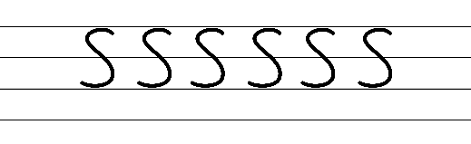  - Example precursive letter formation  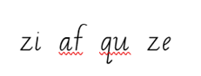  - Familiar words could include  - Suggested practice from the passage  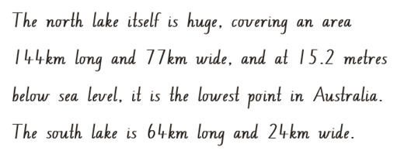
Handwriting legibility and fluency (Stage 2 Year 4)  - Join letters when writing familiar words  - Diagonal joins to letters f and from q and z.  - Diagonally join to letters f, and from q and z, when writing familiar words. | Handwriting legibility and fluency (Stage 2 Year 4)  - Suggested fluency pattern  - Example diagonal joins  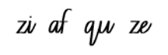  - Familiar words could include  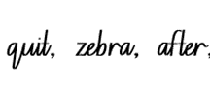  - Suggested practice text from the passage:  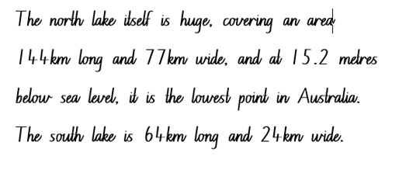
Handwriting and digital transcription  Handwriting legibility and fluency (Stage 3 Year 5)  - Sustain writing with a legible, fluent and personal handwriting style across a text  - Sustain legible and fluent handwriting across a text.  - Revise writing numerals. | Handwriting and digital transcription  Handwriting legibility and fluency (Stage 3 Year 5)  - Suggested fluency pattern  - Example numeral formations  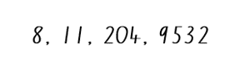  - Suggested practice text from the passage  - Encourage students to evaluate their own handwriting after practising. For example, asking them to circle numerals they believe are formed well.
Handwriting legibility and fluency (Stage 3 Year 6)  - Sustain writing with a legible, fluent and personal handwriting style across a text  - Sustain legible and fluent handwriting across a text.  - Fluency joins with double s. | Handwriting legibility and fluency (Stage 3 Year 6)  - Suggested fluency pattern  - Example double ss letter formation  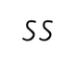  - Suggested practice text innovated from the passage  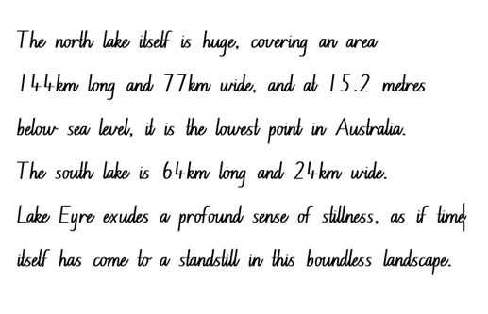  - Encourage students to evaluate their own handwriting after practising. For example, asking them to circle double s joins they believe are formed well.

Planning framework
To plan and document Component A teaching and learning, a planning scaffold [DOCX 228 KB] is provided. To support you in your planning, a link to a detailed example of a one-week teaching and learning cycle is included in the scaffold. Additional resources to support teaching and learning in each focus area can be found at Lesson advice guides.

Component B teaching and learning
The following teaching and learning sequence has been designed to address Component B outcomes and content and develops conceptual understandings of English through the study of quality texts. Adapt the sequence as required to best meet the needs of your students.

Learning intentions and success criteria
Learning intentions and success criteria are best co-constructed with students. The table below contains suggested learning intentions and success criteria.
Element | Stage 2 | Stage 3
Learning intention | Students are learning to understand the level of authority of a text and the features of a text that give authority to research information. | Students are learning to understand that authority is valued but can be questioned when researching information.
Success criteria | Students can:  - explore vocabulary and record gist statements to monitor understanding  - understand authority through the accuracy of information presented  - identify and describe the difference between objective and subjective language in texts  - use exclamatory sentences to express a strong emotion. | Students can:  - record gist statements and check their accuracy  - evaluate texts for their authority  - learn and use words that convey subjective and emotive meanings  - make choices about exclamatory sentences and emotive language for persuasive purposes.

Lesson 5 – navigating and summarising online texts
The following teaching and learning activities support multi-age settings.

Whole
- Use Google Earth to explore Kati Thanda-Lake Eyre. Explore images of Kati Thanda to promote student curiosity about the lake. Ask students what they see, think and wonder.
- Ask students to imagine they were given the opportunity to visit Kati Thanda-Lake Eyre as tourists. Ask students if they think we could trust Pamela Freeman’s information presented on Kati Thanda-Lake Eyre. Explain that she visited as a tourist herself, so she has some authority to give information, however her scientific knowledge may be limited.
- Students Think-Pair-Share about where tourists could find information about travelling to Kati Thanda-Lake Eyre. For example, websites, brochures, travel agent, podcast, YouTube. Ask students how tourists would know if the information was reliable and trustworthy.
- Display the National Parks and Wildlife South Australia website. Observe the National Parks and Wildlife Services logo and the URL to determine credibility. Have students give the source (.gov, a federal government site) a ranking out of 5.
- Define authority of a text as how trustworthy, reliable or valid an audience may find the representation of ideas, experiences, perspectives and arguments in a text. Explain that text features, such as genre, theme, visual elements and language choices impact the authority of a text. Discuss that as a tourist travelling to Kati Thanda Lake Eyre, a government website would provide the authority to give reliable information that travellers could trust.
- Revisit the importance of evaluating sources of information for credibility to ensure information is true and how readers use information to form ideas and opinions.
- As a class, read and follow signposting features to navigate through the homepage of the National Parks website.
- Optional: Students read and explore the website on devices, independently or with a partner.
- Explain that the National Parks and Wildlife South Australia webpage is multimodal. It combines 2 or more expressive modes to communicate. Highlight that the webpage uses a combination of images, text and interactive elements to inform readers about Kati Thanda-Lake Eyre.
- Ask students:
- What genre is the text? For example, informative text or description.
- What is the purpose of the website? For example, to provide information about Kati Thanda-Lake Eyre.
- What are the different sections of the webpage? For example, home page, navigation menu, search function, images, headings, links to social media.
- What features allow you to navigate through the website? For example, hyperlinks used for underlined words, images, headings, icons, next page/previous page arrows, information in top and bottom banner to browse through the website, cursor changes from an arrow to a hand to indicate hyperlinks.
- How could you find specific information? For example, using a key word search at the top of the web page.
- Direct students to enter ‘Kati Thanda’ in the search bar to navigate to the National Parks and Wildlife South Australia – Kati Thanda webpage.
- Compare National Parks and Wildlife South Australia – Kati Thanda to Desert Lake, The Story of Kati Thanda-Lake Eyre. Ask students what they notice about the digital text in comparison to the printed text. Ask students why the website has a greater authoritative style than Desert Lake, The Story of Kati Thanda-Lake Eyre. For example, the website is an official government site that is regularly updated by experts and it uses photographs rather than illustrations.
- Explain that students will explore the National Parks and Wildlife South Australia – Kati Thanda webpage to identify and record the ‘gist’ or main idea of a section of the text. Review that a gist statement is a short summary that tells the reader the main idea or the most important points of something read or heard. By carefully considering the main idea and key points, a gist statement can provide information about the author's expertise and the overall authority of the text.
- Explain the process of ‘getting the GIST.’
- Gather information about background knowledge and key vocabulary
- Identify the topic: Use vocabulary to guide ideas
- Summarise the text by placing vocabulary into key points
- Top and tail: check first and last sentences as these may reinforce the main idea.
- Display and read ‘Plants’ in the ‘Plants and animals’ section of the National Parks and Wildlife South Australia – Kati Thanda webpage. Pause to clarify information and vocabulary.
- Using the ‘Plants’ information from National Parks and Wildlife South Australia – Kati Thanda, students Think-Pair-Share to identify 9 key words from the text. For example, vegetation, park, sparse, canegrass, acacias, heavy rain, blaze of colour, plants, and birds. Share student responses.
- Ask students to determine what vocabulary would be considered most significant to least significant and record on Resource 5: Diamond ranking. Using the think aloud strategy, model underlining the first and last sentence in the text to support the overall idea.
- Model writing a gist statement using the vocabulary selected on Resource 5: Diamond ranking to monitor understanding. For example:
The passage describes the sparse vegetation at Kati Thanda-Lake Eyre, including specific plants like canegrass and acacias. After heavy rain, the area becomes a blaze of colour with flowers that attract a range of insects and birds.

Part
The table below details the differentiated teaching and learning activities for each stage.
Stage 2 (pairs/teacher guided) | Stage 3 (pairs)
- Students explore the National Parks and Wildlife South Australia – Kati Thanda webpage and read about animals in the ‘Plants and animals’ tab.  - In pairs, students complete Resource 5 – diamond ranking organiser to identify key vocabulary.  - Students use Resource 5 – diamond ranking organiser to record gist statements to monitor understanding.  - In small groups, students share their gist statements about their topic.  Too hard? Students record gist statement orally using a digital device. | - Students explore the National Parks and Wildlife South Australia – Kati Thanda webpage and read about ‘Know before you go’ in the ‘Safety’ tab.  - In pairs, students complete Resource 5 – diamond ranking organiser identifying key vocabulary in the 'Know before you go’ section of the safety tab.  - Students use Resource 5 – diamond ranking organiser to record gist statements to monitor understanding.  Too easy? Students explore the different navigational pathways of the website to write several gist statements about a topic of their choice.  - In small groups, students share and compare gist statements to check accuracy.

Lesson 6 – exploring authority and authorship
The following teaching and learning activities support multi-age settings.

Whole
- Review Lesson 5 and co-construct a definition for authority. For example, authority is the expertise or credibility that someone has in a specific subject or field. Display for future reference.
- Pose the question: Who do we trust? Create a mind map of students’ responses. Discuss situations where students encounter authority figures in their daily lives. For example, doctors, teachers, parents, or community members. Explain that authority figures are people who have knowledge, expertise, or experience in a particular area.
- Ask the following questions to explore how authority can differ across different contexts:
- Who would you trust to give you medical advice when you are sick? Why?
- Who would you trust to help you improve your soccer skills? Why?
- Who would you trust to teach you about multiplication? Why?
- Discuss examples of when students have questioned the credibility of texts they have encountered. Ask students how they determine the authority of a text.
- Use Resource 6 – authority evaluation checklist to analyse and evaluate the authority of the National Parks and Wildlife South Australia website. For example:
- Purpose: Is the purpose to inform, persuade or to entertain? For example, to inform about Kati Thanda-Lake Eyre.
- Author: Who wrote the text? Are they an expert? For example, the author is unclear.
- Publisher: Who is the publisher, and do they have a credible reputation? For example, the Government of South Australia Department for Environment.
- Language features: Are there spelling, grammar or punctuation errors? For example, the webpage is written in in clear and accurate English.
- Currency: How recently was the text written? When was it updated? For example, the link to the desert parks bulletin gives information that is regularly updated. In the ‘Disclaimer’ section of the website it states that the information and data on this site is subject to change without notice. This implies that the information is recent.
- Accuracy: Does it have facts or statistics? For example, facts are given throughout the website ‘The north lake itself is huge, covering an area 144 km long and 77 km wide, and at 15.2 metres below sea level, it is the lowest point in Australia.’
- Describe the difference between authorship and authority. For example, authority relates to the credibility and expertise of an individual or organisation while authorship is the act of creating or producing written work. In authorship, an author takes responsibility for the content, ideas, and expression conveyed in the work. An authority figure may or may not be an author, and an author may or may not have authority in their field. For example:
- National Parks and Wildlife South Australia – Kati Thanda website: The authorship belongs to the Government of South Australia Department for Environment. As an organisation, they are recognised as having expertise in the field and therefore have high authority to give trustworthy information.
- Desert Lake, The Story of Kati Thanda-Lake Eyre: The authorship belongs to Pamela Freeman. As an author, while she has experienced Kati Thanda-Lake Eyre, she is not regarded an expert and therefore has low authority to give trustworthy information.
- Discuss the importance of evaluating texts for credibility to ensure information is trustworthy and how readers use this to form their own ideas and opinions.
- In pairs, provide students with Resource 6 – authority evaluation checklist and a range of informative texts, for example, print and digital non-fictions texts, advertisements, posters and reviews. Students analyse texts to determine their credibility and justify their reasoning. Highlight that responses to and interpretations of a text may vary and may have more or less credibility.
Too hard? Reduce the ‘Authority evaluation checklist’ to include fewer criteria (purpose, author and publisher only).
Too easy? Students create their own criteria to determine credibility of a source.
- Students complete an exit ticket to reflect and explain the difference between authorship and authority. Emphasise the importance of understanding the difference between authorship and authority and that authors may shape interpretation of a text but may not be able to control it. Explain that students can use Resource 6 – authority evaluation checklist to determine the credibility of a source in future research.
Stage 2 Assessment task 2 – observations from this lesson allow students to demonstrate achievement towards the following syllabus outcome and content point:
EN2-UARL-01 – identifies and describes how ideas are represented in literature and strategically uses similar representations when creating texts
- describe the difference between authorship and authority.
Stage 3 Assessment task 2 – observations from this lesson allow students to demonstrate achievement towards the following syllabus outcome and content point:
EN3-RECOM-01 – fluently reads and comprehends texts for wide purposes, analysing text structures and language, and by monitoring comprehension
- compare and evaluate print and digital texts for their pertinence to a task, their authority and their level of detail.

Lesson 7 – subjective and objective language
The following teaching and learning activities support multi-age settings.

Whole
- Let’s hashtag it: model writing a hashtag statement related to the unit of learning. The hashtag statement should be concise and capture a key idea or concept. For example, #LakeEyreishuge. Provide sticky notes for students to record hashtag statements. Encourage students to reflect on main ideas, important concepts or interesting facts about the learning so far. Remind students to use the symbol # before the statement to indicate a hashtag. Create a hashtag gallery. Students share and discuss with their peers.
- Ask students if they are familiar with hashtags. Discuss how hashtags are used on social media platforms to engage with specific topics or discussions. Discuss other platforms used to engage in specific topics such as blogs. Ask students if they have read or followed a blog. Explain that a blog is a type of website where individuals or organisations share thoughts, experiences, or information. Explain that the word ‘blog’ is a shortened form of ‘weblog,’ which refers to an online journal or diary.
- Introduce the South Australia's Guide to Kati Thanda-Lake Eyre-Travel blog. Explain that the blog is another medium for informing an audience about Kati Thanda-Lake Eyre.
- As a class, explore and read South Australia's Guide to Kati Thanda-Lake Eyre-Travel blog. Pause to clarify information and vocabulary. Facilitate a discussion about what they notice in the informative text. Ask guiding questions:
- Who is the intended audience of the travel blog? For example, travellers and tourists.
- What is the purpose of the blog? Is it informative, entertaining, personal, or a combination? How do you know?
- What features make the blog multimodal? For example, text, photos, videos, captions and hyperlinks.
- How does the author encourage user engagement through comments or social media interactions? For example, links to social media platforms and a ‘Stay in touch’ newsletter option.
- Is there a sense of authority established through the blog's currency and author's expertise? For example, the blog was published by the South Australian Government in May 2022, enhancing author authority.
- How is the language is presented? Is it based on fact or opinion?
- Review and discuss the difference between objective and subjective language. For example, objective language is impersonal that is factual and can be proven. Subjective language is personal and is used to communicate an opinion. Subjective language cannot be proven as true or false, right or wrong.
- Using South Australia's Guide to Kati Thanda-Lake Eyre-Travel blog, highlight the sentence under the subheading ‘Join a tour’ that reads ‘One of the most popular (not to mention jaw-dropping) ways to experience this natural wonder is on a Lake Eyre Tour.’ Identify key vocabulary which assists a reader to determine whether the statement is subjective or objective. Ask the following questions:
- What is the gist of the sentence?
- Is the sentence objective or subjective?
- What makes you think that?
- How could you prove this statement?
- Do you think everyone thinks the same?
- Explain that the sentence uses subjective language to communicate an opinion about Kati Thanda-Lake Eyre. The term ‘most popular’ reflects a subjective opinion rather than an objective fact. The adjective ‘jaw-dropping’ conveys the speaker's subjective, personal opinion using emotion to describe the experience. Ask students why they think the author has used subjective language. For example, the author is trying to convince readers to travel there.
- Using South Australia's Guide to Kati Thanda-Lake Eyre-Travel blog, highlight the sentence under the heading ‘Visiting Lake Eyre’ that reads ‘Located 647 kilometres north-east of Adelaide, Kati Thanda-Lake Eyre is Australia’s biggest salt lake and was formed approximately 200 million years ago and is the lowest point below sea level on the Australian continent.’ Identify key vocabulary which assists readers to determine whether the statement is subjective or objective using the guiding questions from activity 6.
- Explain that the sentence uses objective language to communicate facts about Kati Thanda-Lake Eyre. It provides specific details and objective information about the location, characteristics, and geological history of Kati Thanda-Lake Eyre. Ask students why they think the author has used objective language. For example, the objective language is accurate, giving the text more authority.
- In small groups, students use Resource 9 – Venn diagram to read and identify subjective and objective sentences used in Desert Lake, The Story of Kati Thanda-Lake Eyre, National Parks and Wildlife South Australia – Kati Thanda and South Australia’s Guide to Kati Thanda-Lake Eyre travel blog. Students identify, highlight and analyse the subjective sentences in one colour and the objective sentences in another colour. Ask students what they notice about the similarities in all 3 texts. Students record similarities in the overlapping sections of Resource 9 – Venn diagram.
- Ask students if the use of subjective or objective language gives a text more or less authority. For example, using objective language makes the texts more accurate and reliable, which gives a text more authority. The blog contains objective language which supports subjective opinions, giving it more authority. The blog has less authority than the National Parks text which contains mainly objective language.

Part
The table below details the differentiated teaching and learning activities for each stage.
Stage 2 (small groups) | Stage 3 (teacher guided/small groups/pairs)
- Using Resource 10 – objective or subjective sort, students sort sentences into subjective or objective. Encourage students to use key vocabulary to determine if the sentence is objective or subjective.  Too hard? Students highlight key words in the sentences which demonstrate objectivity and subjectivity.  Too easy? Students identify and compare subjective and objective language in other texts such as the newspaper, online news platforms, magazines or blogs.  - Drawing on information from the 3 texts in activity 10, students write their own objective and subjective sentences about Kati Thanda Lake Eyre. | - Discuss the definition of the word bias. Co-construct a definition of bias. For example, bias is having a preference or a tendency to think or act in a certain way, often without being aware of it.  - Ask students which type of language is more biased: Objective or subjective language? Discuss that subjective language is more biased. Looking at the Venn diagram, ask students which text contained more subjective language. Ask students: Does this mean it is more biased? Why or why not? Students share responses.  - Display South Australia’s Guide to Kati Thanda-Lake Eyre travel blog. Analyse and record the features (genre, theme, visual elements, language choices) that characterise an authoritative style. For example, personal experiences, accessed via a government website, factual information and photographs.  - Divide students in to 2 groups. Each group will analyse and record the features that characterise an authoritative style of either Desert Lake, The Story of Kati Thanda-Lake Eyre or National Parks and Wildlife South Australia – Kati Thanda.  - Students share their findings.  - In pairs, students compare the features between the 3 texts and determine which text has the strongest authoritative style.
- As a class, discuss how South Australia's Guide to Kati Thanda-Lake Eyre travel blog uses objective and subjective language to argue or state a point of view about travelling to Kati Thanda-Lake Eyre. Ask:
- What do facts usually have that opinions do not? For example, objective language including numbers, statistics, and information that is proven to be true.
- What do opinions have that facts do not? For example, subjective language that cannot be proven.
- Do facts help readers trust authors? Why?
- Do opinions help readers trust authors? Why?
- Students complete an exit ticket to reflect and explain how using subjective and objective language impacts the authority of a text. Answers should focus on the following ideas:
- Objective language helps an audience to trust what has been written and provides more authority. Facts often contain numbers, statistics and specific proven detail about a topic. This information helps readers feel confident that the writer has done their research. Facts also make the reader believe that the information is honest and trustworthy.
- Subjective language helps readers feel the author’s emotions about a topic. It helps connect to an author’s point of view.
- Optional: Walk and talk: Instruct students to walk around the room. Call out ‘objective’ or ‘subjective.’ Students share with the person nearest them an ‘objective’ or a ‘subjective’ statement about Kati Thanda-Lake Eyre. Once students have shared a statement, they begin walking again once ‘walk’ has been called out. Alternate between objective and subjective talk.
Stage 2 Assessment task 3 – observations from this lesson allow students to demonstrate achievement towards the following syllabus outcome and content points:
EN2-RECOM-01 – reads and comprehends texts for wide purposes using knowledge of text structures and language, and by monitoring comprehension
- identify and describe the difference between subjective and objective language in texts
- make gist statements and record them to monitor understanding.
Stage 3 Assessment task 3 – observations from this lesson allow students to demonstrate achievement towards the following syllabus outcomes and content points:
EN3-RECOM-01 – fluently reads and comprehends texts for wide purposes, analysing text structures and language, and by monitoring comprehension
- compare and evaluate subjective and objective language to identify bias.
EN3-RECOM-01 – fluently reads and comprehends texts for wide purposes, analysing text structures and language, and by monitoring comprehension
- compare purposes for different texts and consider why authors and illustrators have structured texts in particular ways
- check the accuracy of own recorded gist statements made during reading, before summarising information to determine a text’s main themes, ideas or concepts.
EN3-UARL-02 – analyses representations of ideas in literature through genre and theme that reflect perspective and context, argument and authority, and adapts these representations when creating texts
- understand the authority given to objectivity versus subjectivity in arguments
- analyse and compare features within and between texts, that characterise an authoritative style.

Lesson 8 – emotive language to support argument
The following teaching and learning activities support multi-age settings.

Whole
- Watch Tourism Australia: Come and say G’Day (1:00). Ask students what type of text is presented and how they know. Ask if the advertisement made them feel certain emotions. For example, positive, excited, curious and welcomed.
- Explain that emotive language is the use of words and phrases that aim to evoke strong emotions or feelings in the audience. Re-watch Tourism Australia: Come and say G’Day (1:00) and ask students to listen and record examples of emotive language. For example, ‘It’s remarkable,’ ‘It’s amazing,’ ‘I love it’ and ‘Wow, there’s nothing like Australia.’
- Students Think-Pair-Share the following questions:
- Who is the intended audience? For example, travellers, tourists.
- What is the purpose of using emotive language in an advertisement? For example, for persuasive effect.
- Why does the advertisement want the audience to feel that way? For example, it’s appealing to the audience by evoking emotions because they are trying to convince the audience to visit Australia.
- Introduce the concept of ‘argument’. Ask students what they think an argument is. Explain that an argument is a stated position about an idea. It is a form of persuasion. Ask students how the advertisement includes aspects of an argument? For example, the advertisement makes the audience believe that Australia is an amazing, remarkable and special place to visit by using emotive language. Explain that emotive language is often used in persuasive texts to evoke an emotional response from the audience.
- Revisit the South Australia’s Guide to Kati Thanda-Lake Eyre travel blog. Read the opening sentence ‘Welcome to South Australia’s Kati Thanda Lake Eyre: A glistening salt pan spanning hundreds of kilometres, transformed by desert downpours into a thriving oasis.’ Discuss that the author has positioned the argument from the outset, using the beginning of the text to introduce the author’s statement of position.
- As a class, find examples of emotive language used in the statement of position. For example, ‘welcome’, ‘glistening,’ ‘transformed’ and ‘thriving.’ Ask students what the purpose of using emotive language in the travel blog would be. For example, to engage the reader's emotions and create a sense of excitement and interest in the destination.
- Using the South Australia’s Guide to Kati Thanda-Lake Eyre travel blog, highlight the sentence: ‘Let’s stay in touch. Sign up for our newsletter and get top stories, exclusive offers, events and free travel inspiration straight to your inbox!’ Ask students what type of sentence is presented. For example, an exclamatory sentence.
- As introduced in Component A, review the exclamation mark as a punctuation tool to emphasise a point or express a strong emotion. Ask students to identify what effect the exclamation mark has on the sentence and its audience. For example, it adds emphasis, encouraging the reader to take action and sign up for the newsletter. The exclamation mark conveys a sense of urgency and highlights the benefits of subscribing. It aims to capture the reader's attention and create a sense of anticipation or excitement about the content they will receive.
- Students Think-Pair-Share the following questions:
- What may happen to the authority of a text if exclamatory sentences are overused? For example, it reduces the impact and the credibility of the author.
- What effect would a different punctation mark, such a full stop, have on the meaning of the sentence? For example, the sentence would become a statement rather than an urgent and excited invitation.
- Discuss the power of emotive language and the use of exclamatory sentences as persuasive techniques to support the effectiveness of an argument and its purpose to persuade.
- Model writing an exclamatory sentence with emotive language that could be included on the South Australia’s Guide to Kati Thanda-Lake Eyre travel blog. For example, ‘What a stunning natural wonder Kati Thanda-Lake Eyre is!’
- Students Think-Pair-Share to offer examples of exclamatory sentences about Kati Thanda-Lake Eyre using emotive language. Provide time for sharing and discussion.
- Explore the ‘See and do’ tab of the National Parks and Wildlife South Australia – Kati Thanda webpage to read and gain background knowledge of the ‘Scenic flights’ information. Using Outback spirit tours- Kati-Thanda Lake Eyre as an example, highlight the use of emotive language such as ‘breathtaking, ‘best’ and ‘unique’ used as a persuasive technique to persuade viewers to ‘travel with the Lake Eyre experts.’
- Using Resource 11 – advertisement exemplar, as an additional example, highlight the use of exclamatory sentences by incorporating emotive language to support their argument. Discuss the importance of supporting exclamatory sentences with objective and subjective language to maintain the overall strength and effectiveness of the argument whilst supporting the authority of a text.
- Explain that students will create an advertisement for a camp site at Kati Thanda-Lake Eyre by using exclamatory sentences and emotive language for persuasive effect. Students explore the ‘Stay in the park’ section of the See and do’ tab of the National Parks and Wildlife South Australia- Kati Thanda webpage. Encourage students to use the additional information presented on the homepage to support their advertisement. For example, the cost of $13.50 to stay per night at the Halligan Bay Point Campground. Instruct students to incorporate emotive language intentionally to support their arguments.
- Using Resource 11 – advertisement exemplar, co-construct success criteria for developing an effective advertisement.
- In small groups, provide time for students to compose, revise and edit their advertisement using language choices for the purpose of persuading.
Too hard? Brainstorm a bank of emotive words that could be used in the advertisement and display them for all students to refer to, such as wonderful, magical, inspiring, incredible, remarkable, outstanding, breath-taking, heart-stopping, memorable.
Too easy? Provide students choice in the mode used to create the advertisement. Students may like to use digital platforms such as Canva, Google Slides or PowerPoint to enhance their work. Students can emphasise emotive language through font size and colour and experiment with emotive imagery to strengthen their argument.

Week 3

Component A teaching and learning
Component A focuses on the development of foundational skills and knowledge through regular, systematic and repeated practice. The mentor and supporting texts used in Component B of this unit can support the effective implementation of Component A teaching and learning.

Teaching guide
Guidance for explicit teaching, teaching notes, resources and examples for the related outcomes and content points have been provided in the table below.
Focus areas and teaching notes | Resources and examples
Reading fluency  Reading rate and automaticity (Stage 2)  - Demonstrate use of navigation pathways to support fluency when engaging with print, visual and multimodal texts  - Navigation pathways refers to the path followed while moving through the content of a text. It involves navigating the text to support fluency in a way that doesn't disrupt the overall comprehension and allows the reader to engage with print, visual, and multimodal texts. | Reading fluency  Reading rate and automaticity (Stage 2)  - Fluency and close reading passage – National Parks and Wildlife Service South Australia-Care for the park you love (119 words).  - Navigational pathways included in the passage  - hyperlinks to page, drop down menu, tabs, headings, following information to bullet points, additional hyperlinks embedded within the text.  Note:  - The passage from the text will need to be a teacher-created resource.  - Content in Reading fluency will support learning in the focus areas of Vocabulary, Reading comprehension and Spelling.
Monitoring reading fluency (Stage 2)  - Recognise that there are different purposes and audiences for reading and adjust reading rate to suit a text’s purpose  - Reading rate for informative texts may depend on the vocabulary used. For example, Tier 3 technical and subject specific vocabulary may require the reader to slow down. | Monitoring reading fluency (Stage 2)  - The passage is read for informative purposes  - Readers may adjust rate for subject specific Tier 3 words such as conservation, geological and sanctuaries.
Reading comprehension  Reading for interest and wide purposes (Stage 2)  - Locate, select and retrieve relevant information from a print or digital text and consider accuracy of information presented  - Locate: Identify and find appropriate sources that contain the information needed. This may involve searching through search engines on the internet.  - Select: Evaluate the sources they've located to determine their credibility, reliability, and relevance to the topic.  - Retrieve: Extract the relevant information from the selected sources. This might involve reading the material thoroughly, taking notes, and summarising the key points that pertain to the research question.  - Consider accuracy: Assess the accuracy and reliability of the information presented in the sources. This involves cross-referencing with other reputable sources, checking for biases or misinformation, and verifying facts. | Reading comprehension  Reading for interest and wide purposes (Stage 2)  - For example, highlight that the passage is part of a government of Australia website to highlight the authority of the source.
Comprehending text structures and features (Stage 2)  - Understand that literal information can be sourced directly from a text and that inferences can be made by using multiple sources of information  - Literal information: Having only the most direct meaning (NESA 2023).  - Inference: A conclusion reached on the basis of evidence and reasoning (NESA 2023). | Comprehending text structures and features (Stage 2)  - Suggested example of literal and inferential understandings from the passage  - Literal: how to care for the park  - Inferential: The importance of environmental sustainability and protecting national parks in particular Lake Eyre-Kati Thanda.
Comprehending language (Stage 2)  - Identify and describe the difference between subjective and objective language in texts  - Subjective language: Words used to communicate based on opinion, feelings or personal biases. (NESA 2023).  - Objective language: Language that is fact-based, measurable and observable, verifiable and unbiased. It does not include a speaker or writer’s point of view, interpretation or judgement (NESA 2023). | Comprehending language (Stage 2)  - Suggested subjective and objective language within the passage  - Subjective language  - ‘We are for­tu­nate in South Aus­tralia’  - ‘Care for the park you love’  - ‘So many beautiful national parks’.  - Objective language  - ‘There are no bins in parks.’
Reading comprehension  Reading fluently (Stage 3)  - Efficiently follow signposting features to navigate print and digital texts  - Signposting features refer to elements within a text that guide the reader through structure and content of a text. These features serve as ‘signposts’ that indicate the direction the text is taking and help the reader follow along. | Reading comprehension  Reading fluently (Stage 3)  - Signposting features to navigate through the passage include: hyperlinks/hypertext to page, drop down menu, tabs, heading, following information to bullet points, additional hyperlinks within the text.
Comprehending language (Stage 3)  - Explain how modality can have subtle impacts on the meanings of words and contribute to deeper understanding when reading  - Modality includes aspects of language that suggest a particular perspective on subjects and/or events. Modality forms a continuum from high modality (always, must) to low modality (might, could) (NESA 2023). | Comprehending language (Stage 3)  - As above, see Stage 2 example.
Vocabulary  Learning and using words (Stage 2)  - Build personal Tier 1, Tier 2 and Tier 3 vocabulary through social and learning interactions, reading and writing  - Tier 1 words: basic-level, everyday words (NESA 2023).  - Tier 2 words: general academic words that can be used across a variety of domains. Tier 2 words add power and precision to written and spoken language but many Tier 2 words are most commonly found in written language (NESA 2023).  - Tier 3 words: words that are used rarely (low frequency) and only in highly specific situations (NESA 2023). | Vocabulary  Learning and using words (Stage 2)  - Suggested vocabulary from the passage include  - Tier 1: stay, clean, make, enjoy, needs  - Tier 2: beautiful, fortunate, considerate, respect, disturb, defined, cultural, special, trails  - Tier 3: conservation, geological, heritage and marine sanctuaries.
Learning and using words (Stage 2)  - Describe how modal words indicate degrees of probability, occurrence, obligation and inclination  - Modal words are a specific group of auxiliary verbs that modify the main verb in a sentence.  - Modal words of obligation express a sense of necessity or requirement. | Learning and using words (Stage 2)  - Suggested modal words from the passage include:  - ‘Thank you for tread­ing light­ly and respect­ing local cul­ture to ensure future gen­er­a­tions can enjoy these spe­cial places too.’ ‘Can’ expresses a sense of obligation.  - ‘We are for­tu­nate in South Aus­tralia to have so many beau­ti­ful nation­al parks to bush­walk, ride, camp and stay in and it’s vital that we take good care of them.’ ‘Vital’ expresses a high degree of obligation.
Vocabulary  Learning and using words (Stage 3)  - Use metalanguage when discussing language features encountered in texts  - Metalanguage includes the technical terms used to describe and discuss how language and texts function (NESA 2023). | Vocabulary  Learning and using words (Stage 3)  - Suggested examples to illustrate metalanguage in the informative passage  - Headings, subheadings, imperative sentences beginning with a verb, subjective and objective language  - Includes a direct address to the audience (‘Thank you for tread­ing light­ly and respect­ing local cul­ture’) that uses personal pronouns to appeal to the reader- a technique used as though the author is speaking directly with its audience. This helps the reader feel as though they are part of the conversation.
Defining and analysing words (Stage 3)  - Evaluate the effectiveness of modal words used in texts to intensify or soften emotional responses  - Modal words are a specific group of auxiliary verbs that modify the main verb in a sentence.  - Modal words of obligation express a sense of necessity or requirement. | Defining and analysing words (Stage 3)  - Suggested modal words from the passage used to intensify a response  - ‘Thank you for tread­ing light­ly and respect­ing local cul­ture to ensure future gen­er­a­tions can enjoy these spe­cial places too.’ ‘Can’ expresses a sense of obligation.  - ‘We are for­tu­nate in South Aus­tralia to have so many beau­ti­ful nation­al parks to bush­walk, ride, camp and stay in and it’s vital that we take good care of them.’ The word ‘vital’ communicates a high degree of obligation to convey the importance of protecting and caring for the national parks.
Spelling  Phonological component (Stage 2)  - Explain how to segment multisyllabic words into syllables and phonemes, and apply this knowledge when spelling  - Revise segmenting multisyllabic words into syllables and phonemes. This is a phonological skill that should be practised regularly. | Spelling  Phonological component (Stage 2)  - Suggested words from the Week 3 reading material: bins, it, rubbish, visitors.  - Sample words for inquiry: difficult, thimble, physical, typical, cylinder, symbol, mystery, pretty, English, hit-hitting, ship-shipping-shipped, skip-skipping-skipped, kick-kicking-kicked, sit-sitting-sat, begin-beginning-began, admit-admitted-admitting.
Phonological component (Stage 2)  - Identify differences in vowel phonemes (short, long, diphthong and schwa vowels)  - Short vowel phoneme: /i/ as in it [i, y, e].  - [i, y, e] are graphemes that represent the short vowel phoneme /i/ as in it. | Phonological component (Stage 2)  - As above
Orthographic component (Stage 2)  - Understand that some graphemes are dependent on their position in a word in English and apply this knowledge when spelling  - The use of different graphemes can be dependent on their position in a word. [i] is used in the beginning or middle of base words. [y] is used in the middle of base words. [e] is used in the beginning or middle of words. | Orthographic component (Stage 2)  - As above
Orthographic component (Stage 2)  - Proofread, identify and correct misspellings when creating texts  - Introduce proofreading and identifying and correcting misspellings when creating written texts. Proofreading, and identifying and correcting misspellings, should be practised regularly. | Orthographic component (Stage 2)  - Writing produced in Component B could be utilised, or a passage of text featuring short vowel phoneme /i/ words.
Morphological component (Stage 2)  - Identify inflected suffixes, explaining when and how to treat base words when they are affixed, and apply this knowledge when spelling  - Inflected suffixes: tense (-s, -ing, -ed).  - The inflected suffixes -s, -ing, -ed change the tense of a verb. The suffixes -s and -ing express present tense, -ed expresses past tense; -ing also expresses future tense.  - In single syllable CVC words, the final consonant is doubled before adding -ed or -ing (for example, shop, shopping).  - In 2 or more syllable words with a stressed final CVC syllable, the final consonant is doubled before adding –ed or -ing (for example, begin, beginning).  - In 2 or more syllable words with a stressed opening syllable, no doubling of the final consonant is needed (for example, follow, following). | Morphological component (Stage 2)  - As above
Spelling  Phonological component (Stage 3)  - Segment unfamiliar multisyllabic words into syllables and phonemes as a strategy when spelling  - As introduced across Early Stage 1 to Stage 2, revise segmenting multisyllabic words into syllables and phonemes. This is a phonological skill that should be practised regularly. | Spelling  Phonological component (Stage 3)  - Suggested words from the Week 3 reading material: ride-rideable, respect-respectable, remove-removable, considerate-considerable.  - Sample words for inquiry: throttle, muddle, ladle, gentle, crumple, chuckle, dazzle, grapple, temple, adjust-adjustable, enjoy-enjoyable, bear-bearable, edit-editable, note-notable, value-valuable, believe-believable, comfort-comfortable, move-moveable, horrible, possible, terrible, visible, access-accessible, digest-digestible, response-responsible, sense-sensible.
Orthographic component (Stage 3)  - Recognise that the same grapheme can represent different phonemes  - Grapheme [le] representing /l/ and /ul/.  - The grapheme [le] represents the phonemes /l/ and /ul/. The phoneme /l/ often follows the graphemes [t, d], for example, battle. [le] is pronounced as the syllable /ul/ following graphemes other than [t, d], for example, drizzle. | Orthographic component (Stage 3)  - As above
Orthographic component (Stage 3)  - Proofread written texts to correct misspellings, making use of spelling reference tools where required  - Introduce proofreading and identifying and correcting misspellings when creating written texts. Proofreading, and identifying and correcting misspellings, should be practised regularly. | Orthographic component (Stage 3)  - Writing produced in Component B could be utilised, or a passage of text featuring grapheme /le/ or -able/-ible words.
Morphological component (Stage 3)  - Explain and use spelling conventions to add derivational suffixes such as -ion, -ian, -ence, -ous to base words or roots  - Derivational suffix: -able, -ible.  - Revise derivational suffixes. Derivational suffixes are added to a base word or root to change part of speech.  - Revise roots as words or word parts that form new words when prefixes or suffixes are added to them. Understanding the meanings of common roots assists students in reading multisyllabic words and in understanding the meaning of unfamiliar words that are particularly common in academic subjects, including the sciences and mathematics.  - Introduce derivational suffix  - -able (revision), -ible meaning ‘capable of’  - Attaches to verbs to form adjectives  - -able is more common and usually attached to complete root words: enjoy-enjoyable  - -ible is generally attached to incomplete root words: horr-horrible  - Explore ‘drop the final e’ generalisation and exceptions: believe-believable, move-movable/moveable. | Morphological component (Stage 3)  - As above
Creating written texts  Sentence-level grammar (Stage 2)  - Use adverbial phrases or clauses to add information to the verb or verb group of the main or other clauses, to provide reasons for or circumstances  - A phrase is a group of words in a sentence that does not contain a verb and its subject; A group of related words that form part of a sentence and do not include a verb and its subject (NESA 2023).  - Adverbial phrases add meaning to, or modify, the action of verbs, adjectives and other adverbs.  - Adverbial clauses are a type of subordinate (or dependent) clauses that add meaning to a verb, adjective or adverb.  - Adverbial phrases and clauses can provide information about circumstance or reason  - When: an adverbial phrase/clause of circumstance – time  - Where: an adverbial phrase of circumstance – place  - How: an adverbial phrase of circumstance – manner  - Why: an adverbial phrase of circumstance – reason. | Creating written texts  Sentence-level grammar (Stage 2)  - Suggested adverbial phrases or clauses from the passage  - Adverbial phrase of reason from the passage  - ‘Thank you for tread­ing light­ly and respect­ing local cul­ture to ensure future gen­er­a­tions can enjoy these spe­cial places too.’  - Adverbial phrase of time from the passage  - ‘When you take your rub­bish home rangers and parks staff can spend more time on con­ser­va­tion and help­ing visitors.’
Sentence-level grammar (Stage 2)  - Select and use precise saying, thinking, acting, and relating verbs and verb groups to align with text purposes  - Review action and relating verbs.  - Review verb groups: A verb group is a group of words built around a verb. Verb groups may include auxiliary verbs (‘helping’ verbs used to indicate tense or modality) and may include other words such as adverbs and prepositions. | Sentence-level grammar (Stage 2)  - Suggested verbs from the passage  - Action verbs: ride, camp, stay, visit, bushwalk  - Relating verbs: can, have, are, be  - Verb groups: are fortunate, help protect, to have.
Sentence-level grammar (Stage 2)  - Use exclamatory sentences to emphasise a point or express a strong emotion  - An exclamation mark is used at the end of an exclamation to express a strong emotion such as surprise, excitement, fear or surprise. | Sentence-level grammar (Stage 2)  - Innovated sentence from the passage to illustrate an exclamatory sentence to emphasise a strong emotion  - Care for the park you love!  - Innovated sentence from the passage to illustrate an exclamatory sentence to emphasise a point  - Take your rub­bish home with you!
Sentence-level grammar (Stage 2)  - Use interrogative sentences to ask a direct question, or for rhetorical effect to engage the reader with a viewpoint  - Interrogative sentences elicit responses, prompt reflection, or create curiosity in the reader. They can be used to initiate conversations, express viewpoints, or create engagement by inviting the reader to consider a particular topic or perspective. | Sentence-level grammar (Stage 2)  - Innovated sentence from the passage to illustrate an interrogative sentence  - Will you protect your national park?
Punctuation (Stage 2)  - Understand and use quoted and reported text or speech in own writing  - Review speech marks for simple dialogue and quoted speech at the beginning and end of a sentence.  - Reported (or indirect) speech is an account – or report – of what someone has said. Indirect speech does not require inverted commas. It is usually written in past tense, because it is describing what someone has said.  - Introduce quoted speech in the middle of a sentence/or/starting a new line for each new speaker. | Punctuation (Stage 2)  - Innovated sentence to illustrate the use of quoted and reported speech includes  - Quoted Speech: The park ranger addressed the group, saying, "When you visit parks, leave no trace that you were there."  - Reported Speech: The guide emphasised the importance of leaving no trace when visiting parks and mentioned that visitors should take their rubbish home with them.
Creating written texts  Sentence-level grammar (Stage 3)  - Make choices about verbs and verb groups to achieve precision and add detail  - Review types of verbs (action, thinking, feeling, saying and relating).  - Review identification of the head verb in a clause or verb group.  - Review verb groups (sometimes known as a complex verb or compound verb) containing  - auxiliary/'helping’ verbs to indicate tense or modality  - 2 or more verbs  - other words such as adverbs or prepositions. | Creating written texts  Sentence-level grammar (Stage 3)  - As above, see Stage 2 Creating written texts.
Sentence-level grammar (Stage 3)  - Experiment with the placement of adverbial clauses, to modify the meaning or to add detail to a verb or verb group  - Adverbial clause: A dependent clause that modifies a verb, adjective or another adverb. It includes words that provide information about the time, place, condition, reason, manner or purpose (NESA Glossary). | Sentence-level grammar (Stage 3)  - Suggested adverbial clause from the passage  - ‘Thank you for tread­ing light­ly and respect­ing local cul­ture to ensure future gen­er­a­tions can enjoy these spe­cial places too.’  - Placing the adverbial clause at the end of a sentence, adds information about what the result was of the action.  - An example of changing the placement of an adverbial clause could include  - To ensure future gen­er­a­tions can enjoy these spe­cial places too, tread lightly and respect local culture.
Sentence-level grammar (Stage 3)  - Make choices about the use of declarative, exclamatory, interrogative and imperative sentences to suit text purpose, and for meaning and effect  - Declarative: a statement presented as a complete sentence to provide fact, evidence or detail (NESA 2023).  - Exclamatory: a statement expressing a strong emotion, formed as a complete sentence, and often ending with an exclamation mark (NESA 2023).  - Interrogative: a sentence that asks a direct or indirect question (NESA 2023).  - Imperative: a complete sentence conveying a direct command, request, invitation, warning or instruction, typically directed to an implied person (NESA 2023). | Sentence-level grammar (Stage 3)  - Suggested sentences from the passage to illustrate declarative, exclamatory, interrogative and imperative sentences  - Declarative: ‘When you take your rub­bish home rangers and parks staff can spend more time on con­ser­va­tion and help­ing visitors.’  - Exclamatory: Take your rub­bish home with you! (Innovated sentence from the passage to illustrate an exclamatory sentence to emphasise a point)  - Interrogative: Will you protect your national park? (Innovated sentence from the passage to illustrate an interrogative sentence)  - Imperative: ‘Keep to defined tracks and walk­ing trails.’
Handwriting and digital transcription  Software functionalities and typing (Stage 2 Year 3)  - Position a chosen device in a way that facilitates efficient and sustained text creation  - Review placement of device or monitor at appropriate eye level.  - Demonstrate good posture when using a device. | Handwriting and digital transcription  Software functionalities and typing (Stage 2 Year 3)  - Suggested examples  - sitting up straight  - aligning head with their spine  - shoulders relaxed.
Software functionalities and typing (Stage 2 Year 4)  - Monitor goals that build on typing accuracy and rate  - Use knowledge of the keyboard layout using the home, top and bottom row to build on typing accuracy and rate. | Software functionalities and typing (Stage 2 Year 4)  - Focus on letters.
Handwriting and digital transcription  Software functionalities and typing (Stage 3 Year 5)  - Navigate the keyboard with efficiency and accuracy when typing words, numerals, punctuation and other symbols  - Navigate the keyboard efficiently when typing words. | Handwriting and digital transcription  Software functionalities and typing (Stage 3 Year 5)  - Revise device positioning and posture.  - Revise touch typing skills including the home, top and bottom rows.
Software functionalities and typing (Stage 3 Year 6)  - Navigate the keyboard with efficiency and accuracy when typing words, numerals, punctuation and other symbols  - Navigate the keyboard with efficiency and accuracy when typing symbols and numerals.  - Revise that symbols are typed using the shift key. | Software functionalities and typing (Stage 3 Year 6)  - Suggested examples: !, ?, $, @, &, “”, +, =, -, x, 1, 2, 3.  - Students could practice touch typing  - a passage from the mentor or supporting text  - an email  - symbols and numerals from a mathematics lesson.

Planning framework
To plan and document Component A teaching and learning, a planning scaffold [DOCX 228 KB] is provided. To support you in your planning, a link to a detailed example of a one-week teaching and learning cycle is included in the scaffold. Additional resources to support teaching and learning in each focus area can be found at Lesson advice guides.

Component B teaching and learning
The following teaching and learning sequence has been designed to address Component B outcomes and content and develops conceptual understandings of English through the study of quality texts. Adapt the sequence as required to best meet the needs of your students.

Learning intentions and success criteria
Learning intentions and success criteria are best co-constructed with students. The table below contains suggested learning intentions and success criteria.
Element | Stage 2 | Stage 3
Learning intention | Students are learning to write a persuasive argument using modal language. | Students are learning to understand the authority given to objectivity versus subjectivity when writing arguments.
Success criteria | Students can:  - use interrogative sentences for rhetorical effect  - deliver arguments to expand meaning and identify evidence a speaker provides to support a point of view  - experiment with modality  - create written texts for persuasive purposes that include a statement of position and a paragraph that is made up of evidence. | Students can:  - make choices about the use of declarative, exclamatory, interrogative and imperative sentences to suit purpose and effect  - present arguments using persuasive techniques and apply active listening strategies  - evaluate the effectiveness of modal words and explain how modality can impact meaning  - create written texts for persuasive purposes that include a statement of position and a clear argument.

Lesson 9 – using sentences for purpose and effect
The following teaching and learning activities support multi-age settings.

Whole
- Mystery object: Select a student to sit in the 'spotlight' with a concealed object that only they can see. The student in the spotlight must respond to questions asked by the class to unveil what the mystery object is. Encourage quick questioning and responses to create an inquisitive atmosphere. Ask students if they were using declarative, exclamatory or interrogative questions.
- Highlight and discuss the use of interrogative sentences across Desert Lake, The Story of Kati Thanda-Lake Eyre, National Parks and Wildlife South Australia – Kati Thanda website and South Australia’s Guide to Kati Thanda-Lake Eyre travel blog.
- Display the following interrogative question ‘Which parks can you ride in?’ from the National Parks and Wildlife South Australia – Kati Thanda website.
- Explain that different sentences are used for different purposes. Brainstorm and review declarative, interrogative, and exclamatory sentences as explored in Component A:
- Declarative sentences: make statements or convey information. They end with a full stop.
- Interrogative sentences: ask questions. They end with a question mark.
- Exclamatory sentences: express strong emotions or excitement. They end with an exclamation mark.
- Display and read Resource 12 – Kati Thanda-Lake Eyre. Pause to clarify information and vocabulary.
- Identify and highlight the structure of the argument presented. For example, the statement of position, the arguments and a rhetorically effective conclusion.
- Discuss how the use of declarative, exclamatory and interrogative sentences affects the argument and authority of the text. For example:
- The declarative sentence, ‘Every few years, the lake causes an abundance of wildlife and breathtaking natural scenery’ presents a balance of combining personal, subjective and objective language to establish authority and credibility of the advertisement.
- The interrogative sentence, ‘How would you like to see the expansive lake from high up in the air?’ serves as a rhetorical question, engaging the reader and encouraging them to imagine the experience of viewing the lake from above.
- The exclamatory sentence, ‘Everyone must visit Kati Thanda-Lake Eyre!’ clearly states the position of the author and conveys enthusiasm or a sense of urgency. It adds persuasive power to the advertisement by emphasising the importance and impact of visiting the location.

Part
The table below details the differentiated teaching and learning activities for each stage.
Stage 2 (independent) | Stage 3 (teacher guided)
- Using Resource 12: Kati Thanda Lake Eyre, students use different coloured pencils or makers to identify and highlight declarative, exclamatory and interrogative sentences. | - Review imperative sentences. Explain that imperative sentences give commands, make requests, or offer instructions. They often begin with a verb and can end with a period or exclamation mark.  - Using Resource 12 – Kati Thanda-Lake Eyre, students identify imperative sentences. For example, ‘Plan your trip now and make sure to visit Kati Thanda-Lake Eyre!’  - Encourage students to consider their purpose in the text and the effect on the reader. Ask students if the sentence adds to the argument and authority of the text. For example, it serves as a command, urging the reader to take action. This sentence adds persuasion to the advertisement.

Whole
- Explain that students will write a paragraph to promote their hometown using a range of sentences. In pairs, students brainstorm the best features of their hometown providing examples to support reasoning.
- Using Resource 12 – Kati Thanda-Lake Eyre as an exemplar, co-construct success criteria for writing to promote a hometown. For example:
- use a range of sentences
- use topic specific vocabulary
- use examples to describe hometown features
- use a combination of subjective and objective arguments for the purpose of persuading
- choose multimodal features through illustrations or photographs to enhance meaning.
- Using the co-constructed success criteria, model writing a paragraph to promote your hometown using examples.
- Provide time for students to compose, revise and edit their writing.
Too hard? Facilitate use of text-to-speech technology of audio or video recording to produce this text.
Too easy? Students write a persuasive text to promote another familiar place using a range of sentences to add meaning.
- In pairs, students share their writing and offer feedback using a ‘Glow and Grow’ comment to improve the argument and authority of the text. Explain that a ‘glow’ comment is offering positive feedback and a ‘grow’ comment is something to improve on. Students consider the following questions to assist in offering feedback:
- Is there a good balance of different sentence types including personal and objective arguments?
- Are there any sentences that could be added or changed to make the argument and authority stronger?
- Which sentences make the text more convincing or powerful?

Lesson 10 – evaluating persuasive techniques
The following teaching and learning activities support multi-age settings.

Whole
- ‘I went to Kati-Thanda Lake Eyre, and I saw...’: Students sit in a circle to participate in a listening game based on their knowledge of Kati Thanda-Lake Eyre. Select a student to begin the sentence ‘I went to Kati Thanda-Lake Eyre, and I saw...’ Students apply active listening by repeating the sentence and repeating the previous response from their peer before adding on with a new idea. For example, I went to Kati Thanda Lake Eyre, and I saw a lake, a frog, a river, a pelican. The game continues until all students have had the opportunity to participate.
- As a class, show the video from the South Australia's Guide to Kati Thanda-Lake Eyre Travel blog and determine its genre using guiding questions:
- What is the purpose of the text? Is it to inform, persuade or entertain?
- What is the subject matter of the text?
- What language and features can be used?
- How is the text presented (form)?
- How is the text communicated (mode)?
- How is the text conveyed (medium)?
- Students Think-Pair-Share to determine if spoken text would have made the video more persuasive. Ask students what the spoken text would have sounded like if its purpose was to persuade.
- Display the following passage and read aloud without prosody.
To discover Kati Thanda-Lake Eyre in all its glory, check out our guide detailing how and when to visit, what Kati Thanda-Lake Eyre tours do and where to stay during your time in the outback.
- After reading, ask students how the text could sound more persuasive. For example, changes to volume and intonation.
- In pairs, students read the passage from activity 4 using prosody for persuasive effect.
- Display Resource 12 – Kati Thanda-Lake Eyre. Read aloud to students without prosody.
Kati Thanda-Lake Eyre
Everyone must visit Kati Thanda-Lake Eyre! This place captivates visitors with its vast stretch of glistening salt crystals. It is truly a marvel of nature. The true enchantment unfolds when desert rains transform the lake. Every few years, the lake causes an abundance of wildlife and breathtaking natural scenery. How would you like to see to see the expansive lake from high up in the air? It’s as easy as booking a flight from one of the neighbouring towns. Then you can lie in your swag at night and gaze upon the stars. Can you resist the allure of such an awe-inspiring sight? Plan your trip now and make sure to visit Kati Thanda-Lake Eyre!
- As a class, identify the persuasive language features the author has used to write the argument. For example, emotive language, rhetorical questions, a combination of question types, subjective and objective language.
- Identify the persuasive techniques that can be added to orally present the argument for the purpose of expanding meaning and engaging the audience. For example, adjusting the voice to show emotion, considering tone, pace and volume, incorporating movement or gesture.
- Model orally presenting Resource 12 – Kati Thanda-Lake Eyre using the persuasive techniques identified, reading prosodically.
- Explain that students will orally present their multimodal hometown argument from Lesson 9 in a persuasive manner.
- As a class, brainstorm what active listening looks like.
- Students practise orally presenting their hometown argument.
Stage 2 (small groups) | Stage 3 (teacher guided)
- In small groups, students present their multimodal presentation to promote their hometown. Encourage students to present with emotion using prosody and gestures to engage their peers.  - Students apply active listening skills to provide feedback to their peers. Students identify the evidence a speaker has provided to support their hometown arguments. | - Explain that students will apply active listening strategies to retell, repeat or build on what the speaker has expressed about their hometown.  - Ask a student to present their hometown argument. Model retelling, repeating or building on the student’s argument.  - In small groups, students present their multimodal presentation to engage their peers. Encourage students to present with emotion using prosody and gestures.  - Students apply active listening skills by retelling, repeating or by building on from what their peers have said and identify the evidence a speaker has provided to support their argument.

Whole
- Reflect on what students found most valuable, and how they felt about presenting and actively listening to their peers' arguments. Evaluate how persuasive techniques served to enhance the effectiveness of an argument, expand meaning and engage the audience.
Stage 2 Assessment task 4 – observations from this lesson allow students to demonstrate achievement towards the following syllabus outcome and content point:
EN2-OLC-01 – communicates with familiar audiences for social and learning purposes, by interacting, understanding and presenting
- identify the evidence a speaker provides to support a particular point of view.
Stage 3 Assessment task 4 – observations from this lesson allow students to demonstrate achievement towards the following syllabus outcome and content point:
EN3-OLC-01 – communicates to wide audiences with social and cultural awareness, by interacting and presenting, and by analysing and evaluating for understanding
- apply active listening strategies by retelling or repeating what another person has expressed and by building on what has been said.

Lesson 11 – using modal words for persuasive effect
The following teaching and learning activities support multi-age settings.

Whole
- Re-read Desert Lake, The Story of Kati Thanda-Lake Eyre. Ask students to identify if Desert Lake, The Story of Kati Thanda-Lake Eyre presents an argument that is disputed or a single perspective, point of view or ‘way of seeing things.’ Discuss that Pamela Freeman has presented a single perspective through the narrative and informative text that showcases the natural beauty of Lake Eyre before and after rain.
- Explain that Pamela Freeman is an award-winning author. Ask students to identify the awards that Desert Lake, The Story of Kati Thanda-Lake Eyre has been shortlisted for by observing the front cover of the text. For example, the NSW Premier’s Literary Awards, NSW Premier’s History Awards, Environment Award for Children’s Literature, Children’s Book Council of Australia Award.
- Display the following award criteria that has been adapted from the Environment Award for Children’s Literature:
- appreciation of nature and care for the natural environment
- embarks on a journey that celebrates the beauty and wonders of nature
- expresses captivating language and quality illustrations.
- Optional: students find the criteria for these awards on the relevant awards websites.
- Discuss if Desert Lake, The Story of Kati Thanda-Lake Eyre would address the criteria. Ask students why they think Desert Lake, The Story of Kati Thanda-Lake Eyre would have won this award. For example, Desert Lake, The Story of Kati Thanda-Lake Eyre showcases the natural environment of Kati Thanda-Lake Eyre in the double page illustrations. Desert Lake, The Story of Kati Thanda-Lake Eyre deserves to win because it represents the natural landscape and diverse wildlife of Kati Thanda-Lake Eyre.
- Gone in 60 seconds: in small groups, students are given 60 seconds to orally argue or persuade others their point of view on why Desert Lake, The Story of Kati Thanda-Lake Eyre deserved to have been awarded the Environment Award for Children’s Literature. The goal is to make the longest time without repeating ideas. Students are encouraged to use the criteria in activity 3 as well as their own ideas to support their reasons. For example, Desert Lake, The Story of Kati Thanda-Lake Eyre deserves to win the award because the text and illustrations capture the amazing natural event that occurs when the rain falls in Kati Thanda-Lake Eyre. Desert Lake, The Story of Kati Thanda-Lake Eyre deserves to win because it is factual and entertaining.
- As a class, students share arguments presented in activity 5. Record on an anchor chart.
- Building on from learning in Component A, review modal language and the impact it can have on a reader when writing persuasively. Discuss how modal words indicate degrees of probability, occurrence, obligation and inclination. Record a range of modal verbs (must, will, can, might, should, ought to) and have students rate them out of 5 from strongest to weakest.
- Display the National Parks and Wildlife South Australia website. Identify modal words. For example:
- Probability: You could join others to help look after a park. You can take part in working bees, training and other events.
- Obligation: You should travel in convoy and carry reserves of fuel, water and food. Assis­tance dogs must be appro­pri­ate­ly restrained on a lead and remain under your effec­tive con­trol at all times while in a park or reserve.
- Inclination: Want to help? Want to join oth­ers and become a Park Friend?
- Occurrence: This huge lake attracts birds from thou­sands of kilo­me­tres away – how they know there will be a feast for them... remains a mystery.
- Ask students to explain why the author has included modal words and how they impact each sentence. For example, the word ‘must’ indicates obligation. It expresses a strong sense of necessity. The word ‘must’ conveys that it is essential for assistance dogs to be appropriately restrained on a lead and remain under effective control while in the park.
- As a class, brainstorm a list of modal words. Record on an anchor chart and display for reference in future lessons. For example:
- Probability: could, might, may, certainly, surely, definitely
- Occurrence: will, shall, would, always, never, consistently
- Obligation: must, should, ought to, want, wish, would like to
- Inclination: can, could, would, want, wish, would like to.
- Explain that students will use modality to build on and strengthen the arguments recorded in activity 6. For example, Desert Lake, The Story of Kati Thanda-Lake Eyre absolutely deserves to win the Environment Award for Children’s Literature because it showcases the beautiful natural environment of Kati Thanda-Lake Eyre in the double page illustrations.
- In small groups, students strengthen arguments using modality. Students record on sticky notes.
Too hard? Provide students with a scaffold of modal word options to select to strengthen their argument for Desert Lake, The Story of Kati Thanda-Lake Eyre winning an award.
Too easy? Students add a low, medium and high modality word to their argument and discuss how using different degrees of modality changes the meaning and impact of their argument.
- Provide time for students to share their arguments. Discuss how strong or persuasive each argument is and arrange sticky notes on a cline starting from the weakest to the strongest argument. Students justify their placement by exploring the use of modality used.
- As a class, reflect on how modal words indicate degrees of probability, occurrence, obligation or inclination for precision (Stage 2). Discuss how modality can have different impacts on the meanings of words to intensify or soften an emotional response and how modality can contribute to a deeper understanding when reading (Stage 3).
Stage 2 Assessment task 5 – observations from this lesson allow students to demonstrate achievement towards the following syllabus outcomes and content points:
EN2-VOCAB-01 – builds knowledge and use of Tier 1, Tier 2 and Tier 3 vocabulary through interacting, wide reading and writing, and by defining and analysing words
- describe how modal words indicate degrees of probability, occurrence, obligation and inclination.
EN2-UARL-01 – identifies and describes how ideas are represented in literature and strategically uses similar representations when creating texts
- recognise that an argument is not a dispute but can be a single perspective that is presented or defended.
Stage 3 Assessment task 5 – observations from this lesson allow students to demonstrate achievement towards the following syllabus outcomes and content points:
EN3-VOCAB-01 – extends Tier 2 and Tier 3 vocabulary through interacting, wide reading and writing, morphological analysis and generating precise definitions for specific contexts
- evaluate the effectiveness of modal words used in texts to intensify or soften emotional responses.
EN3-RECOM-01 – fluently reads and comprehends texts for wide purposes, analysing text structures and language, and by monitoring comprehension
- explain how modality can have subtle impacts on the meanings of words and contribute to deeper understanding when reading.

Lesson 12 – constructing convincing arguments
The following teaching and learning activities support multi-age settings.

Whole
- Using the modal word anchor chart from Lesson 11 ask ‘Would you rather’ questions to the class. For example, ‘Would you rather eat chocolate or ice-cream?’ ‘Would you rather live in the city or the country?’ Students turn and talk to discuss their point of view using modal words from the anchor chart. For example, I would definitely prefer to eat ice-cream as it’s refreshing and I can choose from a range of flavours.
- Review the concept of argument. Co-construct a definition. For example, an argument is a stated position about an idea. It is a form of persuasion. Display in the classroom for future reference.
- Revisit the National Parks and Wildlife South Australia – Kati Thanda website. Guide students to select the ‘Know before you go’ tab at the top of the webpage to scroll down to ‘Care for the park you love’ tab including ‘How to ‘leave no trace’ on your next visit to a national park’.
- Read and discuss key vocabulary and information. Guide students to make inferences about the author’s intended message. For example, to inform readers that Kati Thanda-Lake Eyre needs to be protected.
- Display ‘Your Park Pics’ from National Parks and Wildlife South Australia – Kati Thanda located at the bottom of the website and ask students why images have been presented. For example, to showcase the beauty and uniqueness of Kati Thanda-Lake Eyre.
- View the image of the Marree Man (an earthen artwork of a hunter with what appears to be a stick or boomerang in his hand. The artwork is etched into a plateau in South Australia). Navigate to the ‘Traditional owners’ section of the website to read about the Arabana and the Dieri People.
- Discuss the significant Aboriginal cultural and spiritual significance of Kati Thanda-Lake Eyre. Emphasise that the lake and its surrounding areas hold deep connections to the Aboriginal Peoples who have lived in the region for thousands of years. Lake Eyre, known as Kati Thanda in the Arabana language, is considered a sacred site and plays a vital role in their cultural heritage.
- Explain that students will imagine creating an additional tab on the National Parks and Wildlife South Australia website, to communicate the importance of conserving Kati Thanda-Lake Eyre, including its history, cultural significance and diverse flora and fauna.
- To build background knowledge and learn about cultural history and conservation, navigate through the National Parks and Wildlife South Australia website, specifically the ‘Understanding parks’ tab. As a class, students take notes and record gist statements to monitor understanding of important information.
- Ask students what structural features they notice in the tabs. For example, subheadings, dot points and paragraphs.
- Model writing an argument about the importance of conserving Kati Thanda-Lake Eyre using knowledge of the text structure and language features of a persuasive text. Use think-alouds to model writing paragraphs that contain a single idea and are made up of topic sentences and evidence. Emphasise language features used (rhetorical questions, modality, objective and subjective language, exclamatory sentences) for persuasive effect and to enhance authority. For example:
Importance of conserving Kati Thanda Lake Eyre
Plants and animals
Imagine visiting Kati Thanda- Lake Eyre and no plants or animals were in sight? After a down pour, the remarkable landscape bursts into colour and is sur­round­ed by a sea of grass-green foliage. The lake is home to breeding birds who have flown from China and Japan, along with lizards, shrimp and perch. It is essential that visitors conserve this valuable environment so future generations can enjoy Kati Thanda- Lake Eyre in all its beauty. This site is truly breathtaking and should be protected at all costs!
Visitors must:
- respect wildlife
- preserve plant life.
- As a class, analyse the features within the text that enhance authoritative.
- Using the modelled example from activity 10, co-construct success criteria for writing. For example:
- use statement of position, clear and sequenced paragraph
- use interrogative questions or rhetorical devices for persuasive effect
- use adverbial phrases or clauses
- use precise verbs and verb groups
- use exclamatory sentences to emphasise a point or express a strong emotion
- use topic specific Tier 2 and Tier 3 vocabulary to demonstrate authority
- use subjective (personal) and objective (impersonal) language
- experiment with modality.
- Provide time for students to plan, compose, revise and edit their arguments for conserving Kati Thanda-Lake Eyre.
Too hard? Use sentence starters to assist students with composing.
Too easy? Students explore other websites for conserving Kati Thanda Lake Eyre to enhance their writing.
- Optional: Students publish their tab using multimodal features.
- In pairs, students swap their writing and evaluate the text features that enhance authority.

Week 4

Component A teaching and learning
Component A focuses on the development of foundational skills and knowledge through regular, systematic and repeated practice. The mentor and supporting texts used in Component B of this unit can support the effective implementation of Component A teaching and learning.

Teaching guide
Guidance for explicit teaching, teaching notes, resources and examples for the related outcomes and content points have been provided in the table below.
Focus areas and teaching notes | Resources and examples
Reading fluency  Reading rate and automaticity (Stage 2)  - Demonstrate use of navigation pathways to support fluency when engaging with print, visual and multimodal texts  - Navigation pathways refers to the path followed while moving through the content of a text. It involves navigating the text to support fluency in a way that doesn't disrupt the overall comprehension and allows the reader to engage with print, visual, and multimodal texts. | Reading fluency  Reading rate and automaticity (Stage 2)  - Fluency and close reading passage – Resource 13 – Visit Kati Thanda-Lake Eyre brochure.  Note:  - The passage from the text will need to be a teacher-created resource.  - Content in Reading fluency will support learning in the focus areas Vocabulary, Reading comprehension and Spelling.  - Subheadings are used a navigational pathway to group information. Students will need to use these to take a logical path through the text.  - Use of icons and images are used as navigational pathways to supports information within each paragraph.
Monitoring reading fluency (Stage 2)  - Recognise that there are different purposes and audiences for reading and adjust reading rate to suit a text’s purpose  - Reading rate for literary texts may depend on the use of expression, pausing, emphasis and the author’s use of phrasing.  - Reading rate for informative texts may depend on the vocabulary used. For example, unfamiliar Tier 2 vocabulary may require the reader to slow down. | Monitoring reading fluency (Stage 2)  - The purpose of reading the travel brochure would include to gain information for planning a possible location for a holiday.  - Reading rate may be adjusted with unfamiliar Tier 2 vocabulary such as iconic, glistening, panoramic.
Reading comprehension  Comprehending text structures and features (Stage 2)  - Understand that literal information can be sourced directly from a text and that inferences can be made by using multiple sources of information  - Literal information: having only the most direct meaning (NESA 2023)  - Inference: a conclusion reached on the basis of evidence and reasoning (NESA 2023). | Reading comprehension  Comprehending text structures and features (Stage 2)  - Opportunities to explore literal and inferential information from the passage  - Literal: ‘The lake is 144 km in length and 64 km wide.’ and ‘The lake has only filled to capacity three times in the last 160 years.’  - Inference: ‘Photograph the spectacular lake and desert country at sunrise and sunset.’ Students can infer the best time to view the lake and desert country is at sunrise and sunset.
Comprehending language (Stage 2)  - Identify and describe the difference between subjective and objective language in texts  - Subjective language: words used to communicate based on opinion, feelings or personal biases (NESA 2023).  - Objective language: language that is fact-based, measurable and observable, verifiable and unbiased. It does not include a speaker or writer’s point of view, interpretation or judgement (NESA 2023). | Comprehending language(Stage 2)  - Subjective language: ‘It is an incredible place.’ ‘Kati Thanda Lake Eyre is a showstopper all year round.’  - Objective language: ‘Kati Thanda-Lake Eyre is one of the world’s largest lakes.’
Monitoring comprehension (Stage 2)  - Make gist statements and record them to monitor understanding  - Gist statements are succinct notes that summarise what has been read. They may be recorded in print or digitally. | Monitoring comprehension (Stage 2)  - Example gist statement to summarise the purpose of the travel brochure  - The author provides readers with essential information to consider when visiting Kati Thanda-Lake Eyre.
Reading comprehension  Reading fluently (Stage 3)  - Efficiently follow signposting features to navigate print and digital texts  - Signposting features refer to elements within a text that guide the reader through structure and content of a text. These features serve as ‘signposts’ that indicate the direction the text is taking and help the reader follow along. | Reading comprehension  Reading fluently (Stage 3)  - As above, see Stage 2 Reading fluency.
Comprehending language (Stage 3)  - Explain how modality can have subtle impacts on the meanings of words and contribute to deeper understanding when reading  - Modality includes aspects of language that suggest a particular perspective on subjects and/or events. Modality forms a continuum from high modality (always, must) to low modality (might, could) (NESA 2023).  - Compare and evaluate subjective and objective language to identify bias  - Subjective language: words used to communicate based on opinion, feelings or personal biases (NESA 2023).  - Objective language: language that is fact-based, measurable and observable, verifiable and unbiased. It does not include a speaker or writer’s point of view, interpretation or judgement (NESA 2023).  - Bias: a systematic favouring of certain outcomes more than others, due to unfair influence (knowingly or otherwise) (NESA 2023). | Comprehending language (Stage 3)  - As above, see Stage 2 Reading comprehension.  - Subjective language with identified bias: ‘It is an incredible place.’ ‘Kati Thanda Lake Eyre is a showstopper all year round.’
Monitoring comprehension (Stage 3)  - Check the accuracy of own recorded gist statements made during reading, before summarising information to determine a text’s main themes, ideas or concepts  - To check accuracy, students may review the original source, compare with supporting details, cross-reference with a peer. | Monitoring comprehension (Stage 3)  - As above, see Stage 2 Reading comprehension.
Reading fluently (Stage 3)  - Efficiently follow signposting features to navigate print and digital texts  - Signposting features refer to elements within a text that guide the reader through structure and content of a text. These features serve as ‘signposts’ that indicate the direction the text is taking and help the reader follow along. | Reading fluently (Stage 3)  - As above, see Stage 2 example.
Vocabulary  Learning and using words (Stage 2)  - Build personal Tier 1, Tier 2 and Tier 3 vocabulary through social and learning interactions, reading and writing  - Tier 1 words: basic-level, everyday words. (NESA 2023)  - Tier 2 words: general academic words that can be used across a variety of domains. Tier 2 words add power and precision to written and spoken language but many Tier 2 words are most commonly found in written language. (NESA 2023)  - Tier 3 words: words that are used rarely (low frequency) and only in highly specific situations. (NESA 2023).  - Describe how modal words indicate degrees of probability, occurrence, obligation and inclination  - Modal words are a specific group of auxiliary verbs that modify the main verb in a sentence. Modal verbs express various shades of meaning including  - probability  - occurrence  - obligation  - inclination. | Vocabulary  Learning and using words (Stage 2)  - Suggested Tier 1, Tier 2, and Tier 3 vocabulary from the passage  - Tier 1: plane, simply, provide, visit, place  - Tier 2: glistening, spanning, transforming, avid, iconic, spectacular, boasts, incredible  - Tier 3: kilometres, capacity, seasonal, oasis, panoramic, salt pan.  - Suggested modal word to indicate degree of obligation/inclination  - “You must visit Kati Thanda-Lake Eyre!”.
Vocabulary  Learning and using words (Stage 3)  - Use metalanguage when discussing language features encountered in texts  - Metalanguage includes the technical terms used to describe and discuss how language and texts function (NESA 2023). | Vocabulary  Learning and using words (Stage 3)  - Suggested metalanguage when reading the informative/persuasive travel brochure includes  - headings, subheadings, images, icons, listed information as dot points, objective and subjective information, quotes.
Learning and using words (Stage 3)  - Identify newly encountered words from interaction and wide reading, and use them in writing, discussions and presentations  - Refers to the process of learning and incorporating unfamiliar or newly learned vocabulary into various forms of communication, including writing, verbal discussions, and presentations. | Learning and using words (Stage 3)  - Suggested newly encountered words from the travel brochure may include  - Salt pan, oasis, avid, panoramic, iconic.
Spelling  Phonological component (Stage 2)  - Explain how to segment multisyllabic words into syllables and phonemes, and apply this knowledge when spelling  - Revise segmenting multisyllabic words into syllables and phonemes. This is a phonological skill that should be practised regularly. | Spelling  Phonological component (Stage 2)  - Suggested words from the Week 4 reading material: underground, unveil.  - Sample words for inquiry: under, umbrella, Monday, discover, comfortable, company, rough, tough, blood, scrunch-scrunches-scrunching-scrunched, cover-covers-covering-covered, scrub-scrubs-scrubbing-scrubbed, shove-shoves-shoving-shoved, worry-worries-worrying-worried, touch-touches-touching-touched.
Phonological component (Stage 2)  - Identify differences in vowel phonemes (short, long, diphthong and schwa vowels)  - Short vowel phoneme: /u/ as in up.  - [u, o, ou, oo].  - [u, o] are graphemes that represent the short vowel phoneme /u/ as in up. This phoneme can also be represented using the vowel digraphs [ou, oo]. | Phonological component (Stage 2)  - As above
Orthographic component (Stage 2)  - Understand that some graphemes are dependent on their position in a word in English and apply this knowledge when spelling  - The use of different graphemes can be dependent on their position in a word. [u, o, ou, oo] are often used in the middle of base words. | Orthographic component (Stage 2)  - As above
Orthographic component (Stage 2)  - Proofread, identify and correct misspellings when creating texts  - Review proofreading and identifying and correcting misspellings when creating written texts. Proofreading, and identifying and correcting misspellings, should be practised regularly. | Orthographic component (Stage 2)  - Writing produced in Component B could be utilised, or a passage of text featuring short vowel phoneme /u/ words.
Morphological component (Stage 2)  - Identify inflected suffixes, explaining when and how to treat base words when they are affixed, and apply this knowledge when spelling  - Inflected suffixes: tense (-s, -ing, -ed).  - Revise inflected suffixes for tense (-s, -ing, -ed). | Morphological component (Stage 2)  - As above
Spelling  Phonological component (Stage 3)  - Segment unfamiliar multisyllabic words into syllables and phonemes as a strategy when spelling  - Revise segmenting multisyllabic words into syllables and phonemes. This is a phonological skill that should be practised regularly. | Spelling  Phonological component (Stage 3)  - Sample words for inquiry: affirm, circus, quirky, smirking, souvenir, delirious, envious, laborious, spacious, religious, anxious, gracious, hideous, gaseous, courteous, righteous.
Orthographic component (Stage 3)  - Recognise that the same grapheme can represent different phonemes  - Grapheme [ir] representing /er/, /ear/.  - Highlight the different phonemes represented by the grapheme [ir]. [ir] is often used to represent /er/ as in first and /ear/ as in souvenir. Note the grapheme’s position within base words. | Orthographic component (Stage 3)  - As above
Orthographic component (Stage 3)  - Proofread written texts to correct misspellings, making use of spelling reference tools where required  - Practise proofreading and identifying and correcting misspellings when creating written texts. Writing produced in Component B could be utilised, or a passage of text featuring short vowel phoneme /i/ words. Proofreading, and identifying and correcting misspellings, should be practised regularly. | Orthographic component (Stage 3)  - Writing produced in Component B could be utilised, or a passage of text featuring grapheme /ir/ words.
Morphological component (Stage 3)  - Explain and use spelling conventions to add derivational suffixes such as -ion, -ian, -ence, -ous to base words or roots  - Derivational suffix: -eous, -ious.  - Introduce derivational suffix  - -eous, -ious meaning ‘having qualities of’  - attaches to nouns to form adjectives  - teach that there is no strict rule for when to use -eous or -ious.  - The suffix -ious is more common than -eous space-spacious, courtesy-courteous.  - Both suffixes can be pronounced as ‘us’ or as ‘ee-uss’. Teach these adjectives in groups by spelling and pronunciation. | Morphological component (Stage 3)  - As above
Creating written texts  Sentence-level grammar (Stage 2)  - Use adverbial phrases or clauses to add information to the verb or verb group of the main or other clauses, to provide reasons for or circumstances  - Review different types of adverbial phrases. For example  - When (adverbial phrase of time)  - Where (adverbial phrase of place)  - How (adverbial phrase of manner)  - Why (adverbial phrase of reason). | Creating written texts  Sentence-level grammar (Stage 2)  - Adverbial clause of place: ‘Scenic flights provide spectacular views across the park and showcase the seasonal wildlife.’ Provides detail about where the views can be seen while on a scenic flight.
Sentence-level grammar (Stage 2)  - Select and use precise saying, thinking, acting, and relating verbs and verb groups to align with text purposes  - Review action and relating verbs.  - Review verb groups: A verb group is a group of words built around a verb. Verb groups: may include auxiliary verbs (‘helping’ verbs used to indicate tense or modality), may include other words such as adverbs and prepositions. | Sentence-level grammar (Stage 2)  - Suggested verbs from the passage  - Action verbs: spanning, transformed, fly, hire, follow, photograph  - Relating verbs: was, has, is, can  - Verb groups: has only filled, was formed, can fly.
Sentence-level grammar (Stage 2)  - Use exclamatory sentences to emphasise a point or express a strong emotion  - An exclamation mark is used at the end of an exclamatory sentence to express a strong emotion such as surprise, excitement, fear or surprise.  - Use interrogative sentences to ask a direct question, or for rhetorical effect to engage the reader with a viewpoint  - An interrogative sentence asks a direct or indirect question. They can be used for rhetorical effect to engage the reader. | Sentence-level grammar (Stage 2)  - Suggested exclamatory sentences from the passage to emphasise a point  - ‘Come to South Australia’s Kati Thanda-Lake Eyre!’  - ‘You must visit Kati Thanda-Lake Eyre!’  - Suggested interrogative sentences used as rhetorical effect to engage the reader  - ‘Did you know?’  - ‘Are you ready to visit?’
Punctuation (Stage 2)  - Understand and use quoted and reported text or speech in own writing  - Review: speech marks for simple dialogue, quoted speech at the beginning and end of a sentence.  - Reported (or indirect) speech is an account – or report – of what someone has said. Indirect speech does not require inverted commas. It is usually written in past tense, because it is describing what someone has said.  - Introduce: quoted speech in the middle of a sentence/or/starting a new line for each new speaker. | Punctuation (Stage 2)  - Suggested use of quoted speech from the passage  - ‘Kati Thanda-Lake Eyre is a showstopper all-year round.’ National Parks South Australia.
Creating written texts  Sentence-level grammar (Stage 3)  - Make choices about verbs and verb groups to achieve precision and add detail  - Review types of verbs (action, thinking, feeling, saying and relating).  - Review identification of the head verb in a clause or verb group.  - Review verb groups (sometimes known as a complex verb or compound verb) containing  - auxiliary/'helping’ verbs to indicate tense or modality  - contain 2 or more verbs  - other words such as adverbs or prepositions. | Creating written texts  Sentence-level grammar (Stage 3)  - As above, see Stage 2 Creating written texts.
Sentence-level grammar (Stage 3)  - Experiment with the placement of adverbial clauses, to modify the meaning or to add detail to a verb or verb group  - Review adverbial phrases and clauses (to provide reasons for or circumstances)  - Adverbial clause: A dependent clause that modifies a verb, adjective or another adverb. It includes words that provide information about the time, place, condition, reason, manner or purpose. (NESA Glossary).  - When an adverbial clause is placed in the middle of a sentence, it can give more details about where. | Sentence-level grammar (Stage 3)  - Adverbial clause of place placed in the middle of a sentence providing information about place (where): ‘Scenic flights provide spectacular views across the park and showcase the seasonal wildlife.’
Sentence-level grammar (Stage 3)  - Make choices about the use of declarative, exclamatory, interrogative and imperative sentences to suit text purpose, and for meaning and effect  - Declarative: a statement presented as a complete sentence to provide fact, evidence or detail (NESA 2023).  - Exclamatory: a statement expressing a strong emotion, formed as a complete sentence, and often ending with an exclamation mark. (NESA 2023)  - Interrogative: a sentence that asks a direct or indirect question (NESA 2023).  - Imperative: a complete sentence conveying a direct command, request, invitation, warning or instruction, typically directed to an implied person (NESA 2023). | Sentence-level grammar (Stage 3)  - Suggested sentences from the passage that reflect text purpose  - Declarative: ‘Kati Thanda-Lake Eyre was formed approx. 200 million years ago.’  - Exclamatory: ‘Come to South Australia’s Kati Thanda-Lake Eyre!’  - Interrogative: ‘Are you ready to visit?’  - Imperative: ‘If you’re an avid four-wheel-driver, fly from Adelaide to Coober Pedy, hire a car and follow the outback loop or simply experience the real outback with a 4WD tour.’
Handwriting and digital transcription  Handwriting legibility and fluency (Stage 2 Year 3)  - Understand that legible handwriting is consistent in size and spacing and can support learning.  - Form vertical and horizontal capital letters using consistent size and shape.  - Form diagonal capital letters using consistent size and shape. | Handwriting and digital transcription  Handwriting legibility and fluency (Stage 2 Year 3)  - Suggested fluency pattern  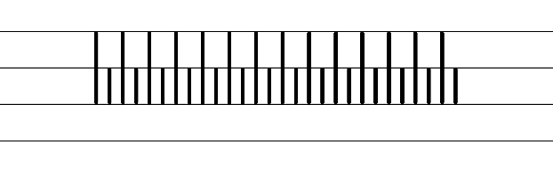  - Example vertical/horizontal capital letter formation  - Example diagonal capital letter formation  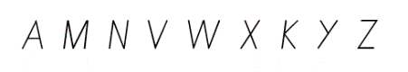  - Suggested practice text from the passage  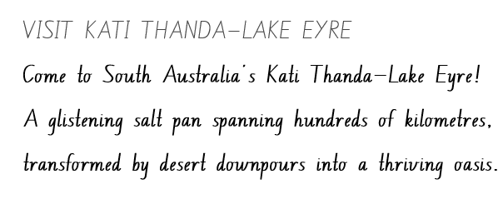
Handwriting legibility and fluency (Stage 2 Year 4)  - Join letters when writing familiar words.  - Horizontally join letters when writing familiar words.  - Horizontal joins are used to join after the letters o, r, v, w and x: notice a slight dip in the horizontal join.  - Focus on horizontally joining to a short letter. | Handwriting legibility and fluency (Stage 2 Year 4)  - Suggested fluency pattern  - Example horizontal joins to a short letter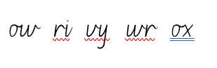  - Familiar words could include:  - Suggested practice text from the passage  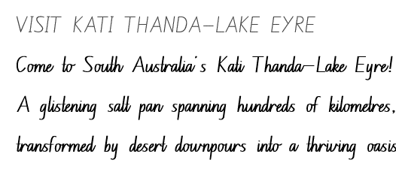
Handwriting and digital transcription  Handwriting legibility and fluency (Stage 3 Year 5)  - Sustain writing with a legible, fluent and personal handwriting style across a text.  - Sustain legible and fluent handwriting across a text.  - Revise writing punctuation marks. | Handwriting and digital transcription  Handwriting legibility and fluency (Stage 3 Year 5)  - Suggested fluency pattern  - Suggested practice text from the passage  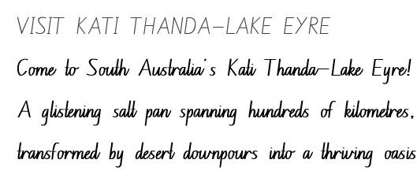  - Encourage students to evaluate their own handwriting after practising. For example, asking them to circle punctuation marks they believe are formed well.
Handwriting legibility and fluency (Stage 3 Year 6)  - Sustain writing with a legible, fluent and personal handwriting style across a text.  - Write symbols to sustain legible and fluent handwriting across a text. | Handwriting legibility and fluency (Stage 3 Year 6)  - Suggested fluency passage  - Example symbols could include  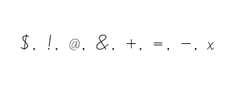  - Suggested practice text from the passage  - Other suggested practice texts could include  - a letter  - symbols from a mathematics lesson.

Planning framework
To plan and document Component A teaching and learning, a planning scaffold [DOCX 228 KB] is provided. To support you in your planning, a link to a detailed example of a one-week teaching and learning cycle is included in the scaffold. Additional resources to support teaching and learning in each focus area can be found at Lesson advice guides.

Component B teaching and learning
The following teaching and learning sequence has been designed to address Component B outcomes and content and develops conceptual understandings of English through the study of quality texts. Adapt the sequence as required to best meet the needs of your students.

Learning intentions and success criteria
Learning intentions and success criteria are best co-constructed with students. The table below contains suggested learning intentions and success criteria.
Element | Stage 2 | Stage 3
Learning intention | Students are learning to create written texts that present a single perspective and are supported by information and ideas presented in a structured way. | Students are learning to create written arguments that consider audience, form and purpose.
Success criteria | Students can:  - write a statement of position supported by evidence  - understand and use quoted and reported speech  - locate, select and retrieve information to plan for writing  - compose a written argument using structure and features for a persuasive purpose. | Students can:  - write a statement of position supported by text structure and language features  - use quoted and reported speech for persuasive effect  - select texts to gather and organise research to plan for writing  - compose subjective and objective arguments using structures and features for persuasive effect.

Lesson 13 – structuring persuasive texts
The following teaching and learning activities support multi-age settings.

Whole
- Display the ‘Your park pics #deepcreekconservationpark’ section of the National Parks and Wildlife Services South Australia – Deep Creek National Park website. Revise how images can impact an informative text. For example, enhancing meaning and making a text more engaging. Ask students how the strategic use of images enhances the persuasive impact of an argument. For example, they create a visual and emotional connection and add credibility. Explain that by effectively integrating images into a text, authors can amplify the persuasive power of their arguments.
- Students Think-Pair-Share and discuss their understanding of persuasive techniques. Provide time for sharing and discussion.
- Explain that persuasive techniques help authors make their writing more interesting and convincing. Explain that persuasive techniques are the visual, spoken and written language choices that authors make to strengthen arguments.
- Emphasise that writing in the persuasive genre can be seen in many different modes, such as advertisements, speeches, newspapers and travel brochures. Explain that the more authority a persuasive piece of writing has, the more convincing it will be.
- Display Resource 13 – Visit Kati Thanda-Lake Eyre brochure students turn and talk to discuss the questions:
- What is the purpose of the text? Is it to inform, persuade or entertain?
- What is the subject matter of the text?
- How is the text presented (form)?
- How is the text communicated (mode)?
- How is the text conveyed (medium)?
- Read Resource 13 – Visit Kati Thanda-Lake Eyre brochure. Pause to discuss vocabulary and information.
- Using Resource 13 – Visit Kati Thanda-Lake Eyre brochure identify and record on an anchor chart the structure of the text. For example:
- Heading: Visit Kati Thanda Lake Eyre
- A statement of position: Unveil Nature’s Masterpiece
- Sequenced paragraphs: It’s easy to get there, Lots to see and do, Comfy outback accommodation, Did you know?
- Rhetorically effective conclusion: Are you ready to visit?
- Students turn and talk to identify and record examples of language features and structures used as persuasive techniques in the persuasive text. For example, rhetorical questions, objective language, subjective language, adjectives, emotive language, quoted speech, adverbial phrases, modal words, verbs and verb groups, images, headings, subheadings, sentence types including exclamatory sentences. Share student responses.
- Read and compare the statement of position in the texts: Resource 13 – Visit Kati Thanda-Lake Eyre brochure and South Australia’s Guide to Kati Thanda-Lake Eyre travel blog. For example, the brochure has a short catchy statement of position that grabs attention and serves as a hook for the reader. The travel blog has a longer statement of position that allows for more elaboration and evidence.
- Explain that students will write a persuasive text to entice visitors to explore Deep Creek National Park.
- Using Resource 13 – Visit Kati Thanda-Lake Eyre brochure, co-construct success criteria for writing. For example:
- include a heading, a statement of position and well sequenced paragraphs
- include a rhetorically effective conclusion (Stage 3)
- use modal words for persuasive effect
- use objective and subjective language
- use a range of sentences.
- Model writing a heading, clear statement of position and the first argument to promote Deep Creek National Park. Use think-alouds while modelling to highlight that paragraphs are made up of topic sentences and evidence. Emphasise language features used for persuasive effect. For example:
Heading: Discover nature’s secret
Statement of position: You must discover Deep Creek National Park!
Argument: Experience the enchantment of the park as you discover the captivating native plants and animals, such as kangaroos, echidnas, and a variety of bird species that are easily observable and their sounds can be heard throughout the park. Deep Creek National Park provides perfect viewpoints to witness the magnificent gathering of southern right whales along Australia's scenic southern coastline.
- In pairs, students explore National Parks and Wildlife Services South Australia - Deep Creek National Park. Students browse the website to locate, select and retrieve relevant information to build background knowledge. Students record their research using key vocabulary and gist statements.
- Using information gained from research, students plan their persuasive text to promote Deep Creek National Park.
- Provide time for students to compose a persuasive text with a clear statement of position and argument promoting Deep Creek National Park. Encourage students to refer back to the co-constructed success criteria to monitor their writing.
- In small groups, students share their writing, seeking and providing feedback. Students reflect on success criteria to discuss how language features and text structures shape the effectiveness of their persuasive text.

Lesson 14 – using speech for persuasive effect
The following teaching and learning activities support multi-age settings.

Whole
- Telephone game: students form a line or sit in a circle. Explain that students will practise reporting what they hear instead of directly repeating it. Establish a starting sentence, choose a simple sentence. For example, ‘Ice-cream is my favourite food.’ The first player whispers the starting sentence to the person next to them, but instead of whispering it as a direct quote, they should report it in reported speech format. For example, Tim said that ice-cream is his favourite food. Each player then reports what they heard to the next person, using the reported speech format. Keep passing the reported speech sentences from player to player until it reaches the last person in the line or circle. The last player says the final reported sentence out loud, sharing what they heard with the entire group. Compare the final reported sentence with the original starting sentence. Discuss any differences or changes that occurred during the reporting process.
- Explain that the ‘Telephone game’ encourages players to practice transforming direct speech into reported speech. Explain that direct speech is the reporting of speech by repeating the actual words of a speaker using quotation marks. Explain that reported speech in a text is used to communicate what someone else said, but without using the exact words. In reported speech the tense of the verbs is often changed.
- Watch BTN Lake Eyre (3:48). Ask students what the purpose and argument in the video is. For example, to inform viewers about Kati Thanda-Lake Eyre and persuade viewers to visit this spectacular site. Ask students to identify the speakers in the video. For example, the presenter, the park ranger and the environmental scientist. Ask students why they think the BTN presenter included the environmental scientist in the video. For example, to provide an expert on the topic and to support the presenter's argument of how amazing Kati Thanda-Lake Eyre is.
- Rewatch BTN Lake Eyre (3:48) from 2:45 minutes to 2:58 minutes (or view the transcript) and discuss the following spoken text. ‘Now life has shot out everywhere and scientists have shot up everywhere to study it! One of them is Professor Richard Kingsford and he's been studying the effect the drought had on water birds across Australia.’ Ask:
- Why did the presenter voice this? For example, it reinforced the ideas in the video, adds credibility and authority to a text because he is an expert scientist and supports the argument within the video that this site is a natural wonder.
- How can environmental experts' knowledge be used in a brochure to make it stronger and more convincing for the readers? For example, using direct quotes or explanations from a park ranger or scientist would contribute to the credibility and persuasive effect of the brochure.
- Display Resource 13 – Visit Kati Thanda-Lake Eyre brochure. Draw students’ attention to the top right-hand corner of the text. Ask students whether the speech is quoted or reported.
- Model reporting direct speech using the spoken text from the park ranger in BTN Lake Eyre (3:48) at 39 seconds. For example, ‘All of a sudden the water starts rising and it just seems to take on another look altogether’ declared Don Rowlands, a Kati Thanda-Lake Eyre park ranger. Ask students whether they think using quoted or reported speech makes a text more credible and why.
- Explain that the choice of saying verbs can influence the credibility and precision of quoted speech. Ask students to brainstorm a range of saying verbs that could add credibility and precision when reporting direct speech. For example, asserted, declared, emphasised, illustrated, concluded, explained and stated. Ask students to determine how the use of saying verbs may change depending on who the speaker may be. For example, a child, a tourist, an expert.
- Provide students with a scenario related to Kati Thanda-Lake Eyre that requires interviewing or reporting on an event. For example, you are a reporter covering the arrival of water at Kati Thanda-Lake Eyre after a long dry spell. Explain that students will interview some tourists visiting the lake and report on their experiences.
- Provide groups time to conduct interviews. Encourage students to take turns playing the roles of the reporter and the interviewee.
- Optional: Groups present their interviews in the form of a short written or video news report.
- Explain that students will use the information conducted from the interview to write quoted and reported speech.
- Model writing quoted and reported speech using quotation marks when using the exact words spoken by the interviewees (quoted speech) and to summarise or paraphrase when using reported speech. Highlight the use of precise saying verbs when using direct speech. For example:
Direct speech: The tourist exclaimed, ‘Wow, this waterfall is absolutely mesmerizing! I've never seen anything like it!’
Reported speech: The tourist marvelled at the sight, declaring that they had never seen anything like it before.
- Provide time for students to compose and share their writing.

Lesson 15 – researching and planning for a persuasive text
The following teaching and learning activities support multi-age settings.

Whole
- Display a T-chart with the headings ‘Positive’ and ‘Negative’. Explain that students will discuss the positive and negative aspects of online research and how it relates to finding literal information and making inferences. For example:
- Literal information: literal information refers to facts, details, or information that is directly stated within a text.
- Inferences: inferences involve drawing conclusions or making interpretations based on the information available. Inferences go beyond the explicit or literal information presented in a text.
- Students share positive and negative aspects of conducting research online. For example, positive aspects include content being easily accessible and negative aspects include dealing with too much information, determining credibility and authority.
- Emphasise that while literal information can be sourced directly from a text, making inferences often requires using multiple sources of information to gather evidence and draw conclusions.
- Encourage students to consider how these positive and negative aspects of online research can impact their ability to find literal information and make accurate inferences.
- Facilitate a discussion where students discuss the challenges they have encountered when researching online to find literal information or make inferences. Highlight the importance of critically evaluating sources, considering credibility and authority, and using multiple sources to make accurate inferences. Ask students to discuss what strategies they have implemented to overcome challenges when researching online.
- Explain that students will locate, select and retrieve relevant information to create a persuasive, multimodal national park brochure for tourists or travellers to use when visiting the national park.
- Co-construct a success criteria for creating a multimodal national park brochure. For example:
- use a statement of position, clear paragraphs and a conclusion (Stage 2)
- use a statement of position, clear logical arguments and a rhetorically effective conclusion (Stage 3)
- use interrogative questions or rhetorical devices for persuasive effect
- use adverbial phrases or clauses
- use precise verbs and verb groups
- use exclamatory sentences to emphasise a point or express a strong emotion
- use quoted or reported speech
- use topic specific Tier 2 and Tier 3 vocabulary to demonstrate authority
- use subjective (personal) and objective (impersonal) language
- experiment with modality (Stage 2)
- control modality (Stage 3)
- include multimodal features to enhance meaning.
- Display the National Parks and Wildlife Services South Australia - Deep Creek National Park website. Navigate to the ‘Getting there’ tab. Model the process of researching to locate, select and retrieve specific information. Use the following example as a guide to assist in selecting and evaluating information using Resource 14 – research and planning template.
- Source evaluation: check the author and publishers' expertise. What is the website's credibility and purpose?
- Record important information: record key words or phrases that provide information about important details.
- Use your own words: identify the main idea using key words and gist statements to paraphrase information.
- Create a structured format: use of bullet points, headings, or numbered lists to create a clear and organised summary.
- Ask students how they would follow signposting features to navigate the website to find information about how to get to the national park. Model the following steps:
- Use the Google search bar to enter a key phrase. For example, how to get to Deep Creek National Park?
- Scan the search results and examine website URLs to determine authority. For example, websites ending in .gov are authored by the government and have more authority.
- Open multiple tabs for comparison and cross-referencing.
- Be aware of bias or opinion in online texts.
- Draw students' attention to the ‘multimodal features’ section on Resource 14 – research and planning template. Explain that students will include multimodal features to add meaning and enhance their brochure.
- Model completing Resource 14 – research and planning template using information from Kati Thanda-Lake Eyre National Park.
- Distribute Resource 14 – research and planning template. Explain that students can create their brochure on a South Australian or NSW national park. For example:
- Beachport Conservation Park South Australia
- Gawler Ranges National Park South Australia
- Lincoln National Park in South Australia
- Myall Lakes National Park New South Wales
- Kosciusko National Park New South Wales
- Blue Mountains National Park New South Wales
Note: Stage 3 students can compare and evaluate print and digital texts related to their pertinence to the task, their authority and their level of detail.
- Provide time to research and plan for writing. Students locate, select and retrieve relevant information, using Resource 14 – research and planning template to record their findings using key words and phrases.
Stage 2 Assessment task 6 – observations and work samples from this lesson allow students to demonstrate achievement towards the following syllabus outcomes and content points
EN2-VOCAB-01 – builds knowledge and use of Tier 1, Tier 2 and Tier 3 vocabulary through interacting, wide reading and writing, and by defining and analysing words
- understand and use language associated with digital texts.
EN2-RECOM-01 – reads and comprehends texts for wide purposes using knowledge of text structures and language, and by monitoring comprehension
- locate, select and retrieve relevant information from a print or digital text and consider accuracy of information presented
- understands that literal information can be sourced directly from a text and that inferences can be made by using multiple sources of information.
Stage 3 Assessment task 6 – observations and work samples from this lesson allow students to demonstrate achievement towards the following syllabus outcome and content points:
EN3-RECOM-01 – fluently reads and comprehends texts for wide purposes, analysing text structures and language, and by monitoring comprehension
- efficiently follow signposting features to navigate print and digital texts
- select texts from print or digital sources to gather and organise research on a topic.

Lesson 16 – using information to compose a persuasive text
The following teaching and learning activities support multi-age settings.

Whole
- Revise the task introduced in Lesson 15, to create a multimodal national park brochure. Discuss the intended audience and purpose for writing.
- Display Resource 13 – Visit Kati Thanda-Lake Eyre brochure. Read and spend time analysing language features and text structures and how these support the purpose of persuading.
- Using Resource 14 – research and planning template and Resource 13 – Visit Kati Thanda-Lake Eyre brochure, review the co-constructed success criteria for composing multimodal national park brochure.
- Explain that students will use their completed Resource 14 – research and planning template from Lesson 15 to compose their national park brochure.
- Provide time for students to compose their brochure (print or digital) persuading visitors to stay and explore the national park of their choice. Prompt students to refer to their planning template and the success criteria to monitor writing.
Too hard? Facilitate use of text to speech, audio or video recording to produce this text.

Week 5

Component A teaching and learning
Component A focuses on the development of foundational skills and knowledge through regular, systematic and repeated practice. The mentor and supporting texts used in Component B of this unit can support the effective implementation of Component A teaching and learning.

Teaching guide
Guidance for explicit teaching, teaching notes, resources and examples for the related outcomes and content points have been provided in the table below.
Focus areas and teaching notes | Resources and examples
Reading fluency  Reading rate and automaticity (Stage 2)  - Demonstrate use of navigation pathways to support fluency when engaging with print, visual and multimodal texts  - Navigation pathways refers to the path followed while moving through the content of a text. It involves navigating the text to support fluency in a way that doesn't disrupt the overall comprehension and allows the reader to engage with print, visual, and multimodal texts. | Reading fluency  Reading rate and automaticity (Stage 2)  - Fluency and close reading passage: Kids Book Review- Guest Post: Pamela Freeman on writing Desert Lake (540 words approximately)  Note:  - The passage from the text will need to be a teacher-created resource.  - Content in Reading fluency will support learning in the focus areas Vocabulary, Reading comprehension and Spelling.  - Navigation pathways within passage to support fluency  - use of different coloured font to indicate someone else has written those sections  - photographs and images to enhance descriptions of the landscape.
Monitoring reading fluency (Stage 2)  - Recognise that there are different purposes and audiences for reading and adjust reading rate to suit a text’s purpose  - Reading rate for informative texts may depend on the vocabulary used. For example, Tier 3 technical and subject specific vocabulary may require the reader to slow down. | Monitoring reading fluency (Stage 2)  - Readers may adjust rate for subject specific Tier 3 words such as hibernation and safari.
Reading comprehension  Comprehending text structures and features (Stage 2)  - Understand that literal information can be sourced directly from a text and that inferences can be made by using multiple sources of information  - Literal information: Having only the most direct meaning (NESA 2023).  - Inference: A conclusion reached on the basis of evidence and reasoning (NESA 2023). | Reading comprehension  Comprehending text structures and features (Stage 2)  - Example literal information sourced from the passage  - ‘In early 2009, there were big floods in Queensland.’  - ‘The white of the ground is salt.’  - Inferences may be drawn from the multiple texts covered in previous weeks.
Comprehending language (Stage 2)  - Identify and describe the difference between subjective and objective language in texts  - Subjective language: Words used to communicate based on opinion, feelings or personal biases. (NESA 2023)  - Objective language: Language that is fact-based, measurable and observable, verifiable and unbiased. It does not include a speaker or writer’s point of view, interpretation or judgement (NESA 2023). | Comprehending language (Stage 2)  - Examples from the passage to assist in describing the difference between subjective and objective language  - Subjective: ‘The southern part of Kati Thanda-Lake Eyre only fills very very rarely, and was still dry when we visited.’  - Objective: ‘I love the desert because you never know what you’re going to find there.’
Monitoring comprehension (Stage 2)  - Make gist statements and record them to monitor understanding  - A gist statement is a succinct thought and information that captures the generalisations gleaned from what has been read, heard or viewed (NESA 2023). | Monitoring comprehension (Stage 2)  - Example gist statement showing the reason for the author’s visit to Kati Thanda-Lake Eyre  - Pamela Freeman was fascinated by the wildlife and landscape of Kati Thanda-Lake Eyre so she went to explore it to help her write the book Desert Lake, The Story of Kati Thanda-Lake Eyre.
Reading comprehension  Reading fluently (Stage 3)  - Efficiently follow signposting features to navigate print and digital texts  - Signposting features refer to elements within a text that guide the reader through structure and content of a text. These features serve as ‘signposts’ that indicate the direction the text is taking and help the reader follow along. | Reading comprehension  Reading fluently (Stage 3)  - Possible signposting features to navigate the text from the passage include  - labels on photographs  - hyperlinks within text.
Comprehending language (Stage 3)  - Explain how modality can have subtle impacts on the meanings of words and contribute to deeper understanding when reading  - Modality includes aspects of language that suggest a particular perspective on subjects and/or events. Modality forms a continuum from high modality (always, must) to low modality (might, could) (NESA 2023). | Comprehending language (Stage 3)  - As above, see Stage 2 Reading comprehension.
Comprehending language (Stage 3)  - Compare and evaluate subjective and objective language to identify bias  - Subjective language: words used to communicate based on opinion, feelings or personal biases (NESA 2023).  - Objective language: language that is fact-based, measurable and observable, verifiable and unbiased. It does not include a speaker or writer’s point of view, interpretation or judgement (NESA 2023).  - Bias: a systematic favouring of certain outcomes more than others, due to unfair influence (knowingly or otherwise) (NESA 2023). | Comprehending language (Stage 3)  - As above, see Stage 2 Reading comprehension.
Monitoring comprehension (Stage 3)  - Check the accuracy of own recorded gist statements made during reading, before summarising information to determine a text’s main themes, ideas or concepts  - To check accuracy, students may review the original source, compare with supporting details, cross-reference with a peer. | Monitoring comprehension (Stage 3)  - As above, see Stage 2 Reading comprehension.
Vocabulary  Learning and using words (Stage 2)  - Build personal Tier 1, Tier 2 and Tier 3 vocabulary through social and learning interactions, reading and writing  - Tier 1 words: basic-level, everyday words. (NESA 2023)  - Tier 2 words: general academic words that can be used across a variety of domains. Tier 2 words add power and precision to written and spoken language but many Tier 2 words are most commonly found in written language (NESA 2023).  - Tier 3 words: words that are used rarely (low frequency) and only in highly specific situations (NESA 2023).  - Describe how modal words indicate degrees of probability, occurrence, obligation and inclination  - Modal words are a specific group of auxiliary verbs that modify the main verb in a sentence. Modal verbs express various shades of meaning including  - probability  - occurrence  - obligation  - inclination. | Vocabulary  Learning and using words (Stage 2)  - Example vocabulary from the passage  - Tier 1: occurs, drains, admit, wonderful  - Tier 2: gather, extraordinary, explosion, fascinated, deserted, leisurely  - Tier 3: continent, hibernation, estivation, hatch, safari.  - Example modal words from the passage to indicate degrees of inclination  - ‘I admit I would have liked to take a more leisurely holiday there, but I wasn’t confident about driving through the desert by myself.’
Vocabulary  Learning and using words (Stage 3)  - Use metalanguage when discussing language features encountered in texts  - Metalanguage includes the technical terms used to describe and discuss how language and texts function (NESA 2023).  - Identify newly encountered words from interaction and wide reading, and use them in writing, discussions and presentations  - Identify and discuss the meanings of newly encountered Tier 2 and Tier 3 words in the text to improve vocabulary knowledge and comprehension. It could be a word with an unfamiliar meaning, an unusual spelling or a term specific to a certain context. | Vocabulary  Learning and using words (Stage 3)  - Suggested metalanguage when reading the informative article includes  - headings, subheadings, images, icons, listed information as dot points, objective and subjective information, quotes.  - Suggested newly encountered words from the passage includes  - continent, hibernation, estivation, pitched.
Spelling  Phonological component (Stage 2)  - Explain how to segment multisyllabic words into syllables and phonemes, and apply this knowledge when spelling  - Revise segmenting multisyllabic words into syllables and phonemes. This is a phonological skill that should be practised regularly. | Spelling  Phonological component (Stage 2)  - Consolidate previous 4 weeks of learning.
Phonological component (Stage 2)  - Identify differences in vowel phonemes (short, long, diphthong and schwa vowels)  - Long vowel phoneme /oo/.  - Short vowel phonemes /o/, /i/, /up/. | Phonological component (Stage 2)  - As above
Orthographic component (Stage 2)  - Understand that some graphemes are dependent on their position in a word in English and apply this knowledge when spelling  - Consider the position of graphemes that represent /oo/, /o/, /i/ and /u/ in words as per previous 4 weeks of learning. | Orthographic component (Stage 2)  - As above
Orthographic component (Stage 2)  - Proofread, identify and correct misspellings when creating texts  - Review proofreading and identifying and correcting misspellings when creating written texts. Proofreading, and identifying and correcting misspellings, should be practised regularly. | Orthographic component (Stage 2)  - Writing produced in Component B could be utilised, or a passage of text featuring target phonemes or morphological words.
Morphological component (Stage 2)  - Identify inflected suffixes, explaining when and how to treat base words when they are affixed, and apply this knowledge when spelling  - Inflected suffixes  - plural (-s, -es)  - tense (-s, -ing, -ed)  - comparative (-er) and superlative (-est). | Morphological component (Stage 2)  - As above
Spelling  Phonological component (Stage 3)  - Segment unfamiliar multisyllabic words into syllables and phonemes as a strategy when spelling  - Revise segmenting multisyllabic words into syllables and phonemes. This is a phonological skill that should be practised regularly. | Spelling  Phonological component (Stage 3)  - Consolidate previous 4 weeks of learning.
Orthographic component (Stage 3)  - Recognise that the same grapheme can represent different phonemes  - Different phonemes represented by graphemes [y], [ai], [le] and [ir]. | Orthographic component (Stage 3)  - As above
Orthographic component (Stage 3)  - Proofread written texts to correct misspellings, making use of spelling reference tools where required  - Apply proofreading and identifying and correcting misspellings when creating written texts. Writing produced in Component B could be utilised, or a passage of text featuring short vowel phoneme /i/ words. Proofreading, and identifying and correcting misspellings, should be practised regularly. | Orthographic component (Stage 3)  - As above.
Morphological component (Stage 3)  - Explain and use spelling conventions to add derivational suffixes such as -ion, -ian, -ence, -ous to base words or roots  - Derivational suffixes: -ise, -ee, -able, -ible. | Morphological component (Stage 3)  - As above
Creating written texts  Sentence-level grammar (Stage 2)  - Use adverbial phrases or clauses to add information to the verb or verb group of the main or other clauses, to provide reasons for or circumstances  - Review different types of adverbial phrases. For example  - When (adverbial phrase of time)  - Where (adverbial phrase of place)  - How (adverbial phrase of manner)  - Why (adverbial phrase of reason). | Creating written texts  Sentence-level grammar (Stage 2)  - Adverbial phrases from the passage  - ‘In early 2009, there were big floods in Queensland.’  - This adverbial phrase provides information about when the big floods in Queensland occurred.  - ‘So my son and I went on an outback safari to Lake Eyre.’  - This adverbial phrase provides information about where Pamela Freeman travelled.
Sentence-level grammar (Stage 2)  - Select and use precise saying, thinking, acting, and relating verbs and verb groups to align with text purposes  - Review action and relating verbs.  - Review verb groups: A verb group is a group of words built around a verb. Verb groups: may include auxiliary verbs (‘helping’ verbs used to indicate tense or modality), may include other words such as adverbs and prepositions. | Sentence-level grammar (Stage 2)  - Example verbs from the passage  - Action verbs: gather, nest, occurred, pitched  - Relating verbs: is, are, was  - Verb groups: are swept, was more workable.
Sentence-level grammar (Stage 2)  - Use exclamatory sentences to emphasise a point or express a strong emotion  - An exclamation mark is used at the end of an exclamatory sentence to express a strong emotion such as surprise, excitement, fear or surprise. | Sentence-level grammar (Stage 2)  - Example exclamatory sentence to express a strong emotion from the passage  - ‘So poor Liz had to do another set of roughs, and then produced some of the most fabulous illustrations I have ever seen!’.
Sentence-level grammar (Stage 2)  - Use interrogative sentences to ask a direct question, or for rhetorical effect to engage the reader with a viewpoint  - An interrogative sentence asks a direct or indirect question. They can be used for rhetorical effect to engage the reader. | Sentence-level grammar (Stage 2)  - Example of innovated interrogative sentence using the passage  - Excerpt from passage: ‘I love the desert because you never know what you’re going to find there.’  - Innovated interrogative question: Don’t you love that you never know what you’re going to find when you’re in the desert?
Punctuation (Stage 2)  - Understand and use quoted and reported text or speech in own writing  - Review: speech marks for simple dialogue, quoted speech at the beginning and end of a sentence.  - Reported (or indirect) speech is an account – or report – of what someone has said. Indirect speech does not require inverted commas. It is usually written in past tense, because it is describing what someone has said.  - Introduce: quoted speech in the middle of a sentence/or/starting a new line for each new speaker. | Punctuation (Stage 2)  - Examples of quoted and reported speech innovated from the passage  - Quoted speech: Pamela Freeman shared her journey, saying, "I really wanted to go to Lake Eyre and see this for myself – and it occurred to me that it would make a great picture book."  - Reported speech sentence: Pamela Freeman explained that she had a strong desire to visit Lake Eyre and witness the phenomenon firsthand. She realized that the experience could be the basis for an engaging picture book.  - Examples of quoted and reported speech innovated from the passage  - Quoted speech: Pamela Freeman shared her journey, saying, "I really wanted to go to Lake Eyre and see this for myself – and it occurred to me that it would make a great picture book."  - Reported speech sentence: Pamela Freeman explained that she had a strong desire to visit Lake Eyre and witness the phenomenon firsthand. She realized that the experience could be the basis for an engaging picture book.
Creating written texts  Sentence-level grammar (Stage 3)  - Make choices about verbs and verb groups to achieve precision and add detail  - Review types of verbs (action, thinking, feeling, saying and relating).  - Review identification of the head verb in a clause or verb group.  - Review verb groups (sometimes known as a complex verb or compound verb) containing  - auxiliary/'helping’ verbs to indicate tense or modality  - contain 2 or more verbs  - other words such as adverbs or prepositions. | Creating written texts  Sentence-level grammar (Stage 3)  - As above, see Stage 2 Creating written texts.
Sentence-level grammar (Stage 3)  - Experiment with the placement of adverbial clauses, to modify the meaning or to add detail to a verb or verb group  - Review different types of adverbial phrases. For example  - When (adverbial phrase of time)  - Where (adverbial phrase of place)  - How (adverbial phrase of manner)  - Why (adverbial phrase of reason). | Sentence-level grammar (Stage 3)  - Adverbial phrases from the passage  - ‘In early 2009, there were big floods in Queensland.’  - This adverbial phrase placed at the beginning of the sentence provides information about when the big floods in Queensland occurred.  - ‘So my son and I went on an outback safari to Lake Eyre.’  - This adverbial phrase placed at the end of the sentence provides information about where Pamela Freeman travelled.
Sentence-level grammar (Stage 3)  - Make choices about the use of declarative, exclamatory, interrogative and imperative sentences to suit text purpose, and for meaning and effect  - Declarative: a statement presented as a complete sentence to provide fact, evidence or detail (NESA 2023).  - Exclamatory: a statement expressing a strong emotion, formed as a complete sentence, and often ending with an exclamation mark (NESA 2023).  - Interrogative: a sentence that asks a direct or indirect question (NESA 2023).  - Imperative: a complete sentence conveying a direct command, request, invitation, warning or instruction, typically directed to an implied person (NESA 2023). | Sentence-level grammar (Stage 3)  - As above, see Stage 2 Creating written texts.
Handwriting and digital transcription  Software functionalities and typing (Stage 2 Year 3)  - Position a chosen device in a way that facilitates efficient and sustained text creation  - Students are learning to position a device or monitor at an appropriate height and angle.  - Revise the position of device or monitor at appropriate eye level to support good posture. | Handwriting and digital transcription  Software functionalities and typing (Stage 2 Year 3)  - Introduce the use of external accessories such as keyboard and mouse to support ergonomic.
Software functionalities and typing (Stage 3 Year 4)  - Monitor goals that build on typing accuracy and rate  - Monitor goals to build on typing accuracy and rate.  - Use knowledge of the keyboard layout using the home, top and bottom row to build on typing accuracy and rate. | Software functionalities and typing (Stage 3 Year 4)  - Focus on  - letters  - letter combinations.
Handwriting and digital transcription  Software functionalities and typing (Stage 3 Year 5)  - Navigate the keyboard with efficiency and accuracy when typing words, numerals, punctuation and other symbols  - Navigate the keyboard efficiently when typing numerals. | Handwriting and digital transcription  Software functionalities and typing (Stage 3 Year 5)  - Type numerals using the numeral row and the numeric keypad.
Software functionalities and typing (Stage 3 Year 6)  - Navigate the keyboard with efficiency and accuracy when typing words, numerals, punctuation and other symbols  - Navigating the keyboard with efficiency when typing punctuation marks. | Software functionalities and typing (Stage 3 Year 6)  - Suggested punctuation marks could include: !, ?, “”  - Students practice touch typing punctuation symbols using a passage from the mentor and or supporting text.

Planning framework
To plan and document Component A teaching and learning, a planning scaffold [DOCX 228 KB] is provided. To support you in your planning, a link to a detailed example of a one-week teaching and learning cycle is included in the scaffold. Additional resources to support teaching and learning in each focus area can be found at Lesson advice guides.

Component B teaching and learning
The following teaching and learning sequence has been designed to address Component B outcomes and content and develops conceptual understandings of English through the study of quality texts. Adapt the sequence as required to best meet the needs of your students.

Learning intentions and success criteria
Learning intentions and success criteria are best co-constructed with students. The table below contains suggested learning intentions and success criteria.
Element | Stage 2 | Stage 3
Learning intention | Students are learning to apply their understanding of argument and authority to revise, edit and publish an argument that includes a statement of position, sequenced paragraphs and a conclusion. | Students are learning to apply their understanding of argument and authority by grouping ideas to develop a statement of position, clear logical lines of argument and structure a rhetorically effective conclusion.
Success criteria | Students can:  - revise writing to enhance its persuasive effect and edit for spelling and punctuation.  - select and use multimodal features to add meaning when publishing.  - deliver prepared multimodal presentations to expand meaning and engage an audience  - reflect on the textual concepts of argument and authority and genre. | Students can:  - revise writing to enhance its persuasive effect and edit for spelling and punctuation.  - incorporate multimodal features when publishing to reinforce and extend ideas.  - present multimodal arguments with a selection of persuasive techniques appropriate to the audience  - reflect on the textual concepts of argument and authority and genre.

Lesson 17 – revising and editing to enhance authority and authorship
The following teaching and learning activities support multi-age settings.

Whole
- Prompt students to reflect on revising and editing as essential stages in the writing process and their relation to the authority and authorship of a text. Ask:
- What is the purpose of revising and editing in the writing process?
- How does revising contribute to the overall authority and credibility of written work?
- Why is it important for authors to take ownership of their writing through the revising and editing process?
- In what ways does a well-revised and edited text build trust with the audience?
- How does the quality of writing in terms of grammar and punctuation impact the authority of the author?
- Explain that the authority of a text lies in its credibility, accuracy, and reliability. Explain that when an author revises and edits their work, it enhances the authority of the text. Emphasise that when readers encounter a well-revised and edited text, they are more likely to trust the information presented.
- Revise the co-constructed success criteria. Discuss how the criteria can be applied to their writing to enhance persuasion, clarity and authority.
- Provide time for students to revise and edit their writing, referring to the co-constructed success criteria.
- In pairs, students share their writing and provide peer feedback using the success criteria and the Tell, Ask, Give (TAG) strategy.
- Provide time for students to apply feedback to enhance the overall argument and authority of their persuasive, multimodal national park brochure.
- As a class, reflect on revising and editing. Ask students to share the improvements that were made and how the changes enhanced their writing’s credibility and authority.
- Collect student writing and provide additional feedback for students to enact in Lesson 18.

Lesson 18 – publishing and reflecting
The following teaching and learning activities support multi-age settings.

Whole
- Students proofread their writing and apply any additional teacher feedback to finalise their brochure.
- Display the Kids Book Review – Pamela Freeman. Read the paragraph ‘I wrote the first draft of the book in the second half of 2009. Seven years later it is being published… Yes, seven years, because a) it took a long time to find the right illustrator, b) picture books take a long time to create (especially when your illustrator, Liz Anelli, gets a grant to actually go to the lake!) and c) Walker Books like to get everything perfect, so we did about, oh, somewhere around 15 drafts. Maybe 20. Maybe more.’
- Discuss the important aspects of the publishing phase of the writing cycle as highlighted in Kids Book Review – Pamela Freeman. For example:
- Time and patience: Pamela Freeman mentions that it took seven years from the first draft to the publication of the book. This indicates that the process of finding the right illustrator, creating the picture book, and going through multiple drafts requires a significant investment of time.
- Collaboration: Pamela Freeman mentions that it took time to find the right illustrator, Liz Anelli. This collaboration is as the illustrations played a crucial role in conveying the text through the illustrations.
- Attention to detail: the author's mention of doing about 15 to 20 drafts (or maybe more) highlights the meticulous attention to detail during the publishing phase. It shows that walker books, the publisher is committed to getting everything just right before finalising the book for publication.
- In pairs, students discuss how they will organise their text layout to publish it, including multimodal features. Ask:
- In what form will you publish your text? For example, creating a written text using legible handwriting that is consistent in size and spacing.
- What digital options have you explored for publishing your work? For example, the use of Canva, PowerPoint or other digital platforms.
- What multimodal features will reinforce or extend ideas presented in your text? For example, visuals (maps, diagrams, symbols photographs) headings, and captions.
- Students publish their persuasive, multimodal brochures to include multimodal features such as photographs, maps or illustrations. Display brochures in the classroom.
- Distribute 3 sticky notes to each student. Invite students to read up to 3 other pieces of writing leaving positive feedback as a way of recognising and celebrating students’ achievements in writing.
- After feedback is given, ‘Share the Chair’ where students are selected to read their writing to the class.
Stage 2 Assessment task 7 – collecting work samples from this lesson allows students to demonstrate achievement towards the following syllabus outcome and content points:
EN2-CWT-03 – plans, creates and revises written texts for persuasive purposes, using text features, sentence-level grammar, punctuation and word-level language for a target audience
- create written texts that argue a viewpoint using rhetorical devices to persuade an audience
- use a structure that includes a statement of position, has sequenced paragraphs and a conclusion
- select and use multimodal features to add meaning
- use adverbial phrases or clauses to add information to the verb or verb group of the main or other clauses, to provide reasons for or circumstances
- select and use precise saying, thinking, acting, and relating verbs and verb groups to align with text purposes
- use exclamatory sentences to emphasise a point or express a strong emotion
- use interrogative sentences to ask a direct question, or for rhetorical effect to engage the reader with a viewpoint
- understand and use quoted and reported text or speech in own writing
- use topic-specific Tier 2 and Tier 3 vocabulary to demonstrate authority
- experiment with modality to indicate probability, occurrence, obligation or inclination.
Stage 3 Assessment task 7 – collecting work samples from this lesson allows students to demonstrate achievement towards the following syllabus outcomes and content points:
EN3-VOCAB-01 – extends Tier 2 and Tier 3 vocabulary through interacting, wide reading and writing, morphological analysis and generating precise definitions for specific contexts
- identify and use words that convey subjective, emotive and persuasive meanings in texts.
EN3-CWT-01 – plans, creates and revises written texts for multiple purposes and audiences through selection of text features, sentence-level grammar, punctuation and word-level language
- group ideas to develop a statement of position, and clear, logical lines of argument that synthesise points, and structure a rhetorically effective conclusion
- create objective, impersonal arguments
- combine personal and objective arguments for persuasive effect
- choose multimodal features suited to a target audience and purpose, to reinforce and extend ideas
- make choices about verbs and verb groups to achieve precision and add detail
- experiment with the placement of adverbial clauses, to modify the meaning or to add detail to a verb or verb group
- make choices about the use of declarative, exclamatory, interrogative and imperative sentences to suit text purpose, and for meaning and effect
- use topic-specific Tier 2 and Tier 3 vocabulary intentionally to add credibility and enhance authority
- control modality related to probability, occurrence, obligation or inclination for precision
- assess the reliability and authority of sources, including digital sources, when researching and acknowledging texts.

Lesson 19 – presenting a multimodal text
The following teaching and learning activities support multi-age settings.
- View It's All Good Down Under with Hamish Blake | Come and Say G'day (1:19) from Tourism Australia. Students Think-Pair-Share the subject matter, purpose and audience of the advertisement. For example, the ad highlights the country's diverse attractions, natural beauty, unique wildlife, cultural experiences, and friendly hospitality to persuade travellers to visit.
- Re-watch It's All Good Down Under with Hamish Blake | Come and Say G'day (1:19) from Tourism Australia. Spend time reflecting on the authors use of language features in the advertisement for the purpose of persuading. Ask students to record evidence the speaker provides to support their point of view on sticky notes. For example:
- Emotive language – don’t miss this
- Strong arguments – beautiful scenery, amazing wildlife, good experiences
- Interrogative sentences – do you hear that? Can you smell that?
- Rhetorical questions – how good does this feel? How good is this? How goods that?
- Objective language – 180 million years old
- Subjective language – every day is a good day
- Exclamatory sentences – how good is this!
- Multimodal features – audio, images, maps, captions, video
- Share student responses and display sticky notes.
- Ask students how multimodal features can expand meaning and engage the audience.
- Explain that when creating a multimodal text, which combines multiple modes of communication such as text, images, videos, and audio, an audience can interact with and respond to the different modes of communication present in the text.
- Re-watch It's All Good Down Under with Hamish Blake | Come and Say G'day (1:19). In pairs, students use a Y-chart to observe and record how the advertisement has tried to appeal to the viewers senses (sounds like, looks like, feels like) using multimodal features. For example:
- Sounds like – use of music, sound effects and rhetorical devices: ‘Do you hear that?’
- Looks like – use of real-life footage of natural scenery, wildlife and cuisine
- Feels like – sense of feeling welcomed ‘Come and say G-day!’ and using rhetorical devices: Can you smell that?
- Reinforce how multimodal features of the text expand meaning and engage the audience.
- Explain that in the advertisement, the main presenter, comedian Hamish Blake, plays a significant role in adding authority to the text. As a famous and trusted Australian figure, his presence lends credibility to the argument that Australia is a wonderful place to visit. To establish a connection with the audience right from the start, Hamish begins the video by saying, ‘G'day, I'm Hamish.’ This deliberate choice to greet the audience and introduce himself aims to gain trust and establish his authority.
- Ask students to identify other individuals featured in the advertisement and what gives them authority. For example, the advertisement includes tour guides, park rangers, and business owners from various Australian states. The inclusion of these individuals suggests that they possess extensive knowledge about their respective areas and are enthusiastic about encouraging people to visit. Their expertise and passion enhance the overall authority of the message in the advertisement.
- Display the words ‘tour guide.’ Students Think-Pair-Share to discuss the definition of ‘tour’. For example, a tour is a guided journey or excursion usually involving a group of people traveling together to visit specific destinations or experiencing particular activities. Students Think-Pair-Share to discuss the definition of ‘tour guide’. For example, an individual who leads and provides information to a group of people (often visitors or tourists) during a guided tour. Ask students if they have experienced a tour or seen a tour guide in real life. Explain that a tour guide presents an argument in the form of a single perspective for the purpose to persuade.
- In small groups, brainstorm how a tour guide engages their audience whilst maintaining authority. Ask the following questions:
- How does a tour guide engage their audience? For example, by talking about the places they visit in an exciting and informative way. They could use declarative sentences to share information, interrogative sentences to ask a direct question or exclamatory sentences to emphasise a point or express a strong emotion. They could use gestures and humour.
- How does a tour guide maintain authority? For example, by having a lot of knowledge and expertise about the tour's subject. They go through special training to learn about the places they visit, including history, culture, and fun facts.
- As a class, share student responses and brainstorm ideas on an anchor chart using the sentence starter: ‘To be a good tour guide we would need to...’
- Explain that students will present their multimodal national park brochure as a tour guide pitch, with the purpose of persuading people to visit the park. Explain that students can include a combination of text, images, motion, or audio features to support their national park tour guide pitch.
- Using ideas from activity 11, co-construct success criteria for presenting a national park tour guide pitch for the purpose of persuading. For example:
- use of reasoned arguments that present knowledge and information
- use of rhetorical questions for intentional effect
- present multimodal arguments that include research and references (Stage 3)
- include multimodal features through text, images, motion, or audio
- use topic specific vocabulary
- use persuasive techniques to engage the audience such as using an expressive voice, considering tone, pace and volume, and incorporating gesture.
- Using Resource 13 – Visit Kati Thanda-Lake Eyre brochure and the success criteria, model presenting a short tour guide pitch taking into consideration audience, purpose, rhetorical questions for intentional effect, multimodal features and persuasive techniques.
- Provide time for students to practise their presentation and include multimodal features. Encourage students to think about the evidence they will provide to support their point of view whilst engaging their audience and maintaining authority. Students will present their tour guide pitch in Lesson 20. Optional: Students record a video of their tour guide pitch using digital devices, then watch and refine their presentation.

Lesson 20 – presenting and reflecting
The following teaching and learning activities support multi-age settings.

Whole
- Review co-constructed success criteria for presenting a national park tour guide pitch for the purpose of persuading.
- Students present their national park tour guide pitch to the class, including multimodal features to expand and engage the audience.
- Referring to co-constructed success criteria from Lesson 19, students identify the evidence a speaker provides to support their point of view. Students apply active listening strategies by retelling, repeating or by building on from what has been said (Stage 3).
- Recap student learning from the unit. Use exit tickets to reflect on the textual concepts of genre, argument and authority. For example:
- What is an argument?
- How do you determine the authority or credibility of a text when researching information?
- What text features characterise an authoritative style? (Stage 3)
- Why is it important to consider the author's background and expertise when evaluating the reliability of a text?
- How do language features and text structures of an argument affect its effectiveness? Provide an example to support your answer.
- What are some techniques used in persuasive writing to strengthen an argument? Give an example.
- Reflect on your own writing. What persuasive techniques did you use in your writing and presenting to share your point of view?
- What does genre mean?
- What is the purpose of using different genres?
- How can understanding different genres help you become a better reader and writer?
- Why is this learning important? Where else might you be able to apply it?
Stage 2 Assessment task 8 – observations and work samples from this lesson allow students to demonstrate achievement towards the following syllabus outcome and content points:
EN2-OLC-01 – communicates with familiar audiences for social and learning purposes, by interacting, understanding and presenting
- understand that rhetorical questions can be used for intentional effect
- state a reasoned argument in a presentation about learning area content, to a familiar audience
- include multimodal features in planned and delivered presentations, to expand meaning and engage an audience.
Stage 3 Assessment task 8 – observations and work samples from this lesson allow students to demonstrate achievement towards the following syllabus outcomes and content points:
EN3-OLC-01 – communicates to wide audiences with social and cultural awareness, by interacting and presenting, and by analysing and evaluating for understanding
- evaluate the effectiveness of rhetorical questions used for intentional effect
- present multimodal arguments that include research and references, topic-specific vocabulary and the selection of persuasive techniques appropriate to audience.
EN3-VOCAB-01 – extends Tier 2 and Tier 3 vocabulary through interacting, wide reading and writing, morphological analysis and generating precise definitions for specific contexts
- identify newly encountered words from interactions and wide reading, and use them in writing, discussions and presentations.

Resource 1 – fluency and close reading passage analysis (Week 1)
Focus | Notes
Passage | pp 16–17 From ‘The skies above the lake are alive with birds.’ to ‘Smaller birds make nests in shrubs where they are safe from predators.’ (77 words)  pp 18–19 From ‘As the desert flames red and gold with sunset...’ to ‘But many of the birds come only when the lake is full.’ (62 words)
Synopsis | pp 16–17: Pamela Freeman describes a scene from Kati Thanda where the skies above the lake are filled with birds and portrays their various activities.  pp 18–19: Pamela Freeman describes the scene of the desert at sunset. It mentions the desert flames red and gold with sunset, indicating the vibrant colours of the sky. In this setting, tiny hopping mice come out of their burrows located on the lake shore, and dragon lizards crawl under stones to seek shelter from the cold night air. The passage also notes that humans live near the lake, suggesting the presence of human inhabitants in the area. Additionally, it mentions that while the mice, lizards, and humans are permanent residents, many birds only come to the area when the lake is full.
Passage structure | - The passages are structured into literary and informative text.  - Throughout the book and including pp 16-19, narrative and informative texts run parallel. The informative text relates directly and succinctly to the information above and is included to educate and validate the story.  - Different font and text size keep the two clear and separate from each other.  - It combines visual illustrations and written text. Through the combination of text and illustration, readers explore the beauty of the environment including the animals (pelicans, gulls, ducks, ducklings, eagles, mice, and lizards) that survive in Kati Thanda.  - The relationship between the illustrations and the text help contribute to the overall meaning. The illustrations support the text and provide additional information developing a deeper understanding of the wildlife that inhabits Kati Thanda-Lake Eyre.  - The font type in the narrative text sometimes features words in a larger font size. For example, ‘shrieking’, ‘squawking’, ‘circling high above’. These text features enhance understanding of the interactions and liveliness of the lake.
Language features | Narrative text (pp 16–17)  - In the passage, verb use is dynamic and engaging, creating a sense of action and movement.  - The verb ‘are’ is used to describe the state of the skies, indicating that they are currently ‘alive’ with birds. This verb choice helps set the scene and establish the vibrant atmosphere.  - Action verbs like ‘bring’, ‘feed’, ‘squawking’, ‘whistle’, and ‘follow’ depict the various activities and behaviours of the birds. These verbs effectively convey the motion and energy within the scene.  - Noun groups such as ‘shrieking gulls’ and ‘pink-eared ducks’ enhance the description of the birds, adding specific qualities and characteristics  - The verb ‘circling’ describes the movement of the wedge-tailed eagle, emphasizing its presence and height above the scene.  - The adverbial phrase ‘The skies above the lake are alive with birds’ provides information to help set the scene and create a visual image of the birds soaring above the water.  Informative text (pp 16–17)  - The passage utilises specific tier 2 and 3 vocabulary related to bird behaviour and habitats. Examples include ‘nest’, ‘colonies’, ‘predators’, and ‘shrubs’. These technical terms provide precision and accuracy in describing the nesting habits of various bird species.  - The adverbial phrase ‘Smaller birds make nests in shrubs where they are safe from predators’ provides information about how the animals stay safe and sheltered and hints to the kinds of plant life is found at the lake.  Narrative text (pp 18–19)  - Several action verbs are used to describe the actions and behaviours of different subjects. For example  - flames: this verb is used metaphorically to describe the action of the desert in displaying vibrant colours during sunset. It conveys a sense of intensity and vividness  - emerge: this verb is used to describe the action of the tiny hopping mice coming out of their burrows. It suggests the mice appearing or becoming visible  - crawl: this verb is used to describe the movement of the dragon lizards as they move under their stones. It implies a slow and deliberate motion.  - The use of descriptive adjectives such as ‘tiny’, ‘weary’ and ‘cold’ adds depth and specificity to the description. These adjectives provide details about the size of the mice, the fatigue of the lizards, and the temperature of the night air.  - The passage presents a contrast between the actions of the mice and lizards. While the mice emerge from their burrows, the lizards crawl wearily under their stones. This contrast adds variety to the description and highlights the different behaviours of these creatures.  - The adverbial clause ‘But many of the birds come only when the lake is full.’ modifies the verb ‘come’ and specifies the condition or time period when the birds arrive, specifically when the lake is full. (Stage 3 only)  - ‘As the desert flames red and gold with sunset, tiny hopping mice emerge from their burrows on the lake shore while the dragon lizards crawl wearily under their stones, safe from the cold night air.’  - Clause: As the desert flames red and gold with sunset  - Phrase: on the lake shore (where)  Informative text (pp 18–19)  - The repetition of the phrase "near the lake" emphasises the proximity of the mice, lizards, and humans to the lake. This repetition helps to reinforce the idea that these creatures reside in close proximity to the water.  - The use of an exclamation mark after ‘and so do humans!’ adds emphasis and expresses surprise or excitement. It highlights the fact that humans also live near the lake to contrast them with the animals mentioned earlier.  - The passage presents a contrast between the permanent residents (mice, lizards, and humans) and the migratory behaviour of birds. It contrasts the continuous presence of the mice, lizards, and humans near the lake with the temporary visits of the birds when the lake is full. This contrast adds interest and depth to the description.

Resource 2 – vocabulary scaffold
Sample word | Context | Morphology | Student-friendly definition
shrieking | ‘Shrieking gulls bring fish and insects to feed their babies...’ (p 16) | Base word: shriek (verb)  Suffix: The suffix in shrieking is -ing. It comes after the base word and indicates the present participle form of the verb. | Shrieking means the action of producing a loud, high-pitched sound
woven | ‘Shrieking gulls... who are in woven grass nets...’ (p 16) | Root word: weave (verb) | Woven means when something has been made by interlacing or crossing threads or materials together.
squawking | ‘Shrieking gulls bring fish and insects to feed their babies, who are in woven grass nets squawking for food.’ (p 16) | Base word: squawk (verb)  The suffix in squawking is -ing. It is added to the base word squawk to indicate the present participle form of the verb. | Squawking describes the action of producing a loud, harsh cry or noise that is currently happening.
whistle | ‘Two pink eared ducks whistle to their ducklings...’ (p 17) | Base word: whistle (verb) | To whistle means to produce a soft, high-pitched sound. It is a short, clear, and often repeated sound that ducks use for communication.
clustered | ‘Pelicans and gulls both nest in colonies where hundreds of nests are clustered together on the ground.’ (p 17) | Base word: cluster (verb)  The suffix in clustered is -ed. It is added to the base word cluster to indicate the past participle form of the verb. | Clustered means a group or collection of things that are close together.
emerge | ‘As the desert flames red and gold...mice emerge from their burrows on the lake shore...’ (p 18) | Base word: merge (verb) indicating the action of coming together or combining.  The prefix in emerge is e-. It is added to the base word "merge" to indicate the direction or action of appearing. | Emerge means to come out, appear, or become visible. It's like when something that was hidden or not seen before suddenly shows up or comes into view.

Resource 3 – text detectives
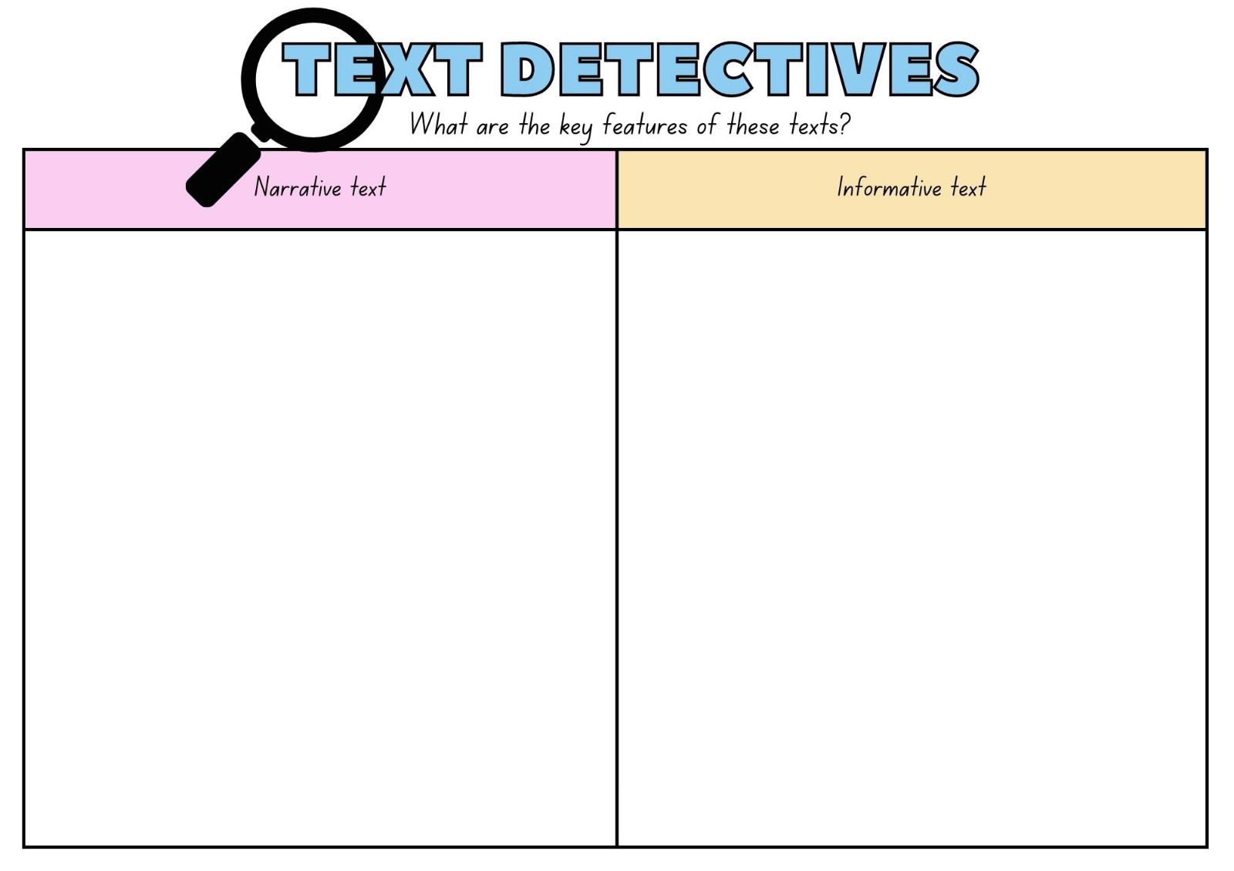

Resource 4 – hybrid text exemplar
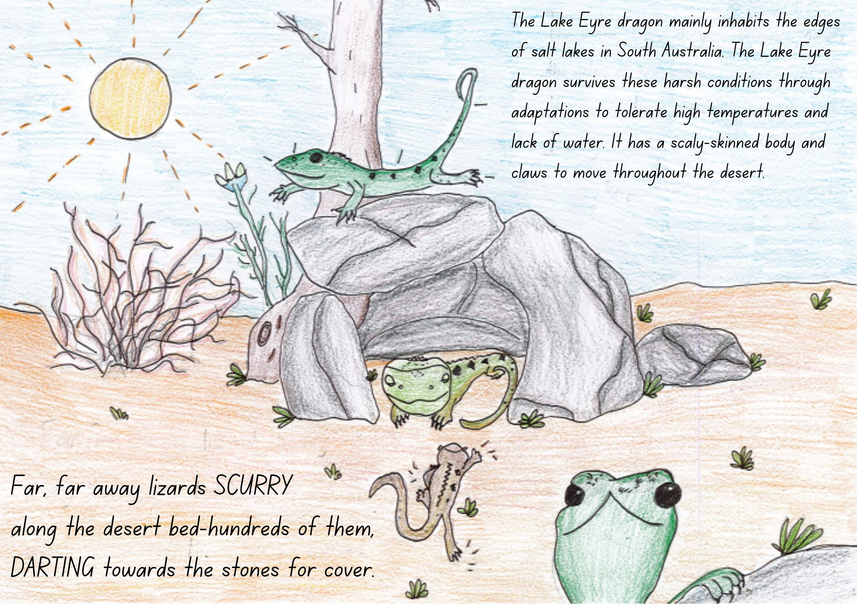

Resource 5 – diamond ranking organiser
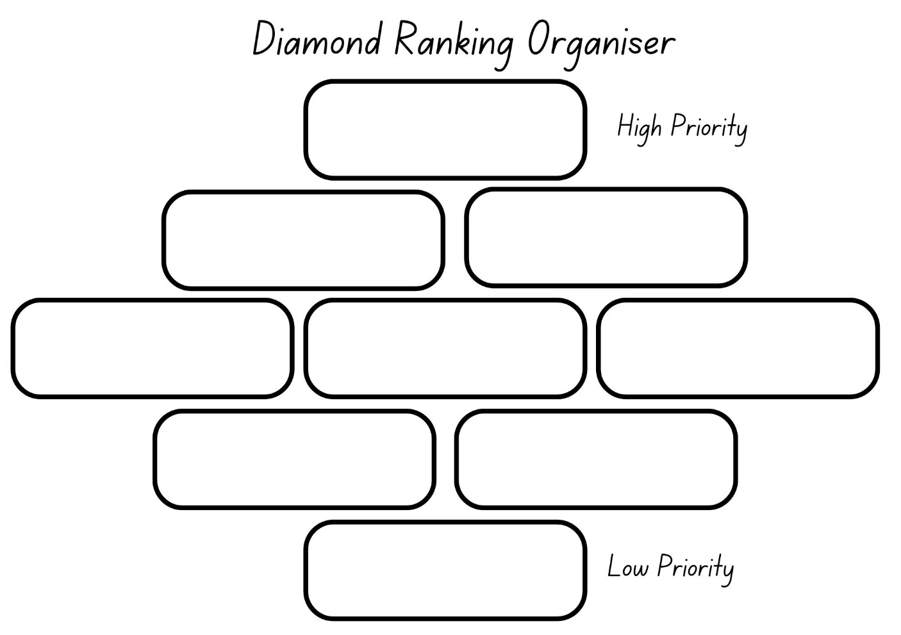

Resource 6 – authority evaluation checklist
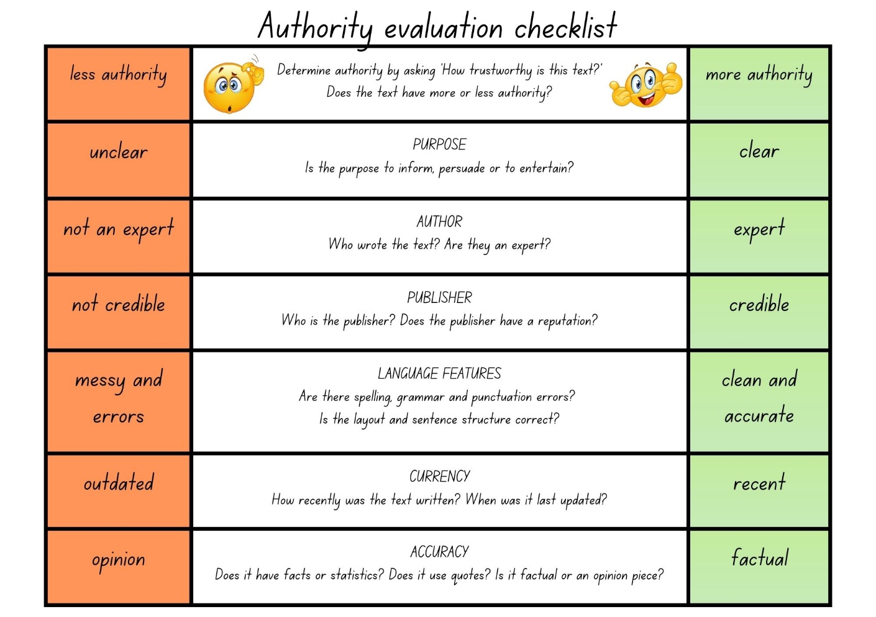

Resource 7 – fluency and close reading passage analysis (Week 2)
Focus | Notes
Passage 1: Lesson 5–6  Passage 2: Lesson 7–8 | Passage 1:  National Parks and Wildlife South Australia – Kati Thanda  ‘About’ section from ‘Australia’s largest salt lake...’ to ‘...stone-strewn tablelands.’ (173 words)  Passage 2:  South Australia’s Guide to Kati Thanda-Lake Eyre travel blog  From the heading, and then ‘Stretching a mind boggling...’ to ‘...pink and orange hues.’ (103 words)
Synopsis | Passage 1: This text is presented in the ‘About’ tab on the National parks' webpage providing introductory information about Kati Thanda-Lake Eyre National Park. It highlights the lake's size, location, and its significance as the lowest point in Australia.  Passage 2: The passage describes Kati Thanda-Lake Eyre, as a remarkable natural feature in South Australia.
Passage structure | Passage 1:  - Paragraph 1: Introductory paragraph about the lake and its location and size.  - Paragraph 2: Explores the isolated state of the lake when its dry and how heavy rains and weather changes its conditions. When there is water in the lake, it’s full of life.  Passage 2:  Introduction: The passage starts with a welcoming statement, introducing the reader to ‘South Australia's Kati Thanda-Lake Eyre’, which is described as a glistening salt pan spanning hundreds of kilometres and transformed into a thriving oasis by desert downpours.
Language features | Passage 1:  - Adverbial phrases  - Once every eight years on average  - In the last 160 years  - As far as the eye can see  - With heavy rains and the right conditions  - In the thousands  - When there's water in the lake (CLAUSE)  - Away from the lake  - Subjective: You may feel a sense of isolation.  - Objective: Most sentences are presented through an objective lens.  - Declarative sentences  - Flood waters cov­er the lake once every eight years on aver­age.  - It becomes a breed­ing site, teem­ing with species that are tol­er­ant of salinity.  - Emotive language  - You may feel a sense of iso­la­tion...  - Tier 2 vocabulary: descend, capacity, tolerant, isolation  - Tier 3 vocabulary: salinity, mesas, claypans, tablelands, species  - Verbs: covering, cover, filled, standing, seeing, teeming, descend, rise, becomes  - Adjectives: heavy, salty, huge, red, dry.  Passage 2:  - Emotive language: The text includes emotive language to evoke feelings of awe and fascination in the reader. Words like ‘thriving oasis’, ‘abundance of wildlife’, ‘stunning natural beauty’, and ‘captivating hues’ evoke positive and captivating emotions.  - Descriptive language: The passage uses descriptive language to paint a picture of the location. Phrases such as ‘glistening salt pan’, ‘mind-boggling’, ‘seemingly-endless expanse’, and ‘shimmering salt crystals’ create a visual image in the reader's mind.  - Adverbial phrases  - in the Flinders Ranges and Outback  - in Kati Thanda-Lake Eyre National Park  - once every few years.  - Subjective: mind-boggling, dreamlike, stunning natural beauty, real magic.  - Objective: 144 kilometres by 77 kilometres, networks of channels, streams and floodplains converge in Kati Thanda-Lake Eyre National Park.  - Declarative sentences: Stretching a mind-boggling 144 kilometres by 77 kilometres, South Australia’s Kati-Thanda-Lake Eyre in the Flinders Rangers and Outback, truly is a natural wonder.  - Tier 2 vocabulary: converge, expanse, lure, abundance, wildlife, channels, expanse, natural, truly.  - Tier 3 vocabulary: oasis, floodplains, hues.  - Verbs: thriving, glistening, flooded, shimmering.  - Adjectives: orange, stunning.

Resource 8 – vocabulary scaffold
Sample word | Context | Morphology | Student-friendly definition
teeming | ‘It becomes a breed­ing site,  teem­ing with species that are tol­er­ant of salinity.’ (National Parks and Wildlife South Australia – Kati Thanda) | Base word: teem (verb).  Suffix: -ing to form the present participle of the verb, indicating an ongoing or continuous action. | Teeming means full or abundant, describing the state of the lake as a breeding site filled with numerous species.
lure | ‘Its seemingly endless expanse of shimmering salt crystals lure travellers year-round' (South Australia’s Guide to Kati Thanda-Lake Eyre travel blog). | Base word: lure (verb) | Lure means something that attracts or entices someone or something.
abundance | ‘Once every few years, networks of channels, streams and floodplains converge in Kati Thanda-Lake Eyre National Park, bringing with them an abundance of wildlife...’ (South Australia’s Guide to Kati Thanda-Lake Eyre travel blog) | The root abund- is derived from the Latin word abundare, meaning to overflow or to be plentiful. The suffix -ance is added to the root to form a noun indicating a state or quality. | Abundance means the state of being plentiful or having a large quantity of something.
truly | ‘...South Australia’s Kati Thanda-Lake Eyre in the Flinders Ranges and Outback, truly is a natural wonder.’ (South Australia's Guide to Kati Thanda-Lake Eyre – Travel blog) | Base word: true (adjective) indicates something that is fact or reality.  Suffix: -ly is added to the base word to form truly (adverb). | Truly means truthfulness or accuracy of the statement.
dreamlike | ‘... networks of channels, streams and floodplains converge in Kati Thanda-Lake Eyre National Park, bringing with them an abundance of wildlife, stunning natural beauty and dreamlike pink and orange hues.’ (South Australia’s Guide to Kati Thanda-Lake Eyre travel blog). | Compound word: dream + like (suffix -ing showing tense). | Dreamlike means that something feels or appears strange or unreal.
mind-boggling | ‘Stretching a mind-boggling 144 kilometres by 77 kilometres, South Australia’s Kati Thanda-Lake Eyre in the Flinders Ranges and Outback’ (South Australia’s Guide to Kati Thanda-Lake Eyre travel blog). | Compound adjective: mind-boggling (suffix -ing showing tense). | Mind-boggling means something that is astonishing, overwhelming or difficult to comprehend.

Resource 9 – Venn diagram
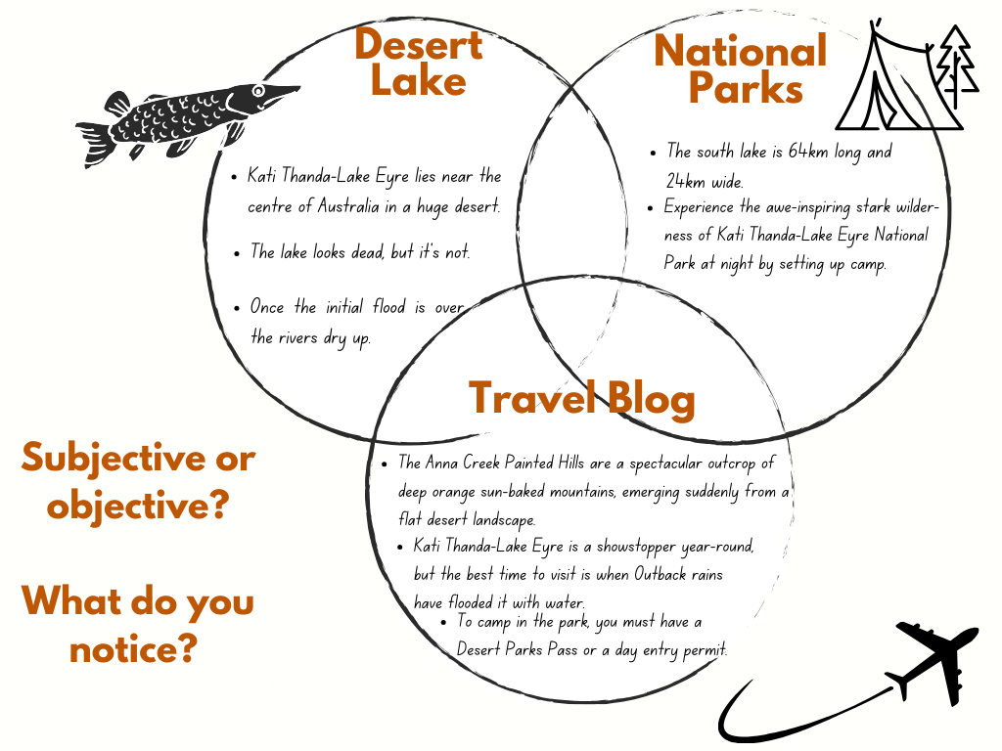

Resource 10 – objective or subjective sort
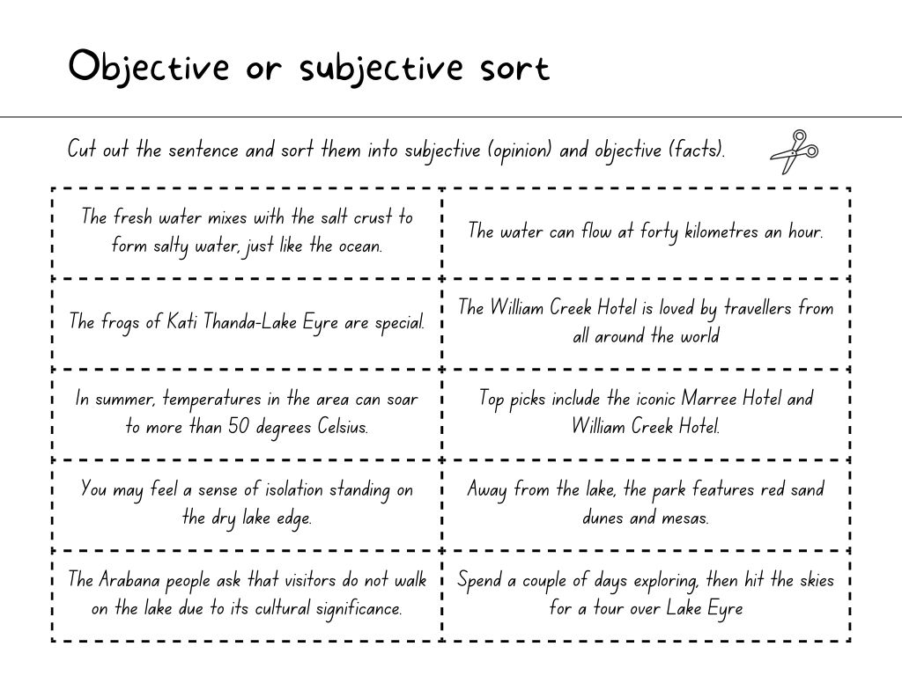

Resource 11 – advertisement exemplar
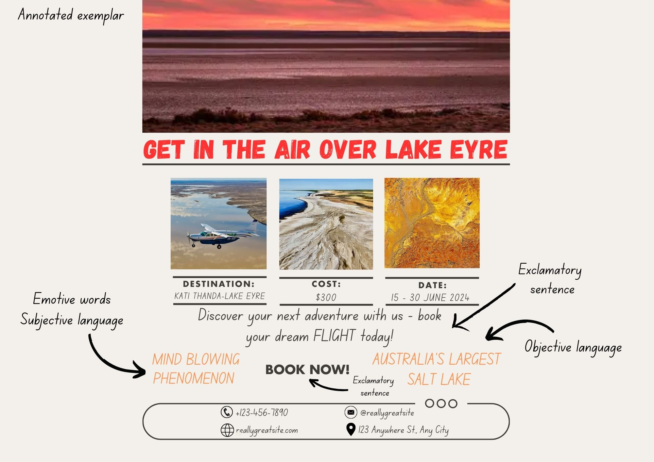

Resource 12 – Kati Thanda-Lake Eyre
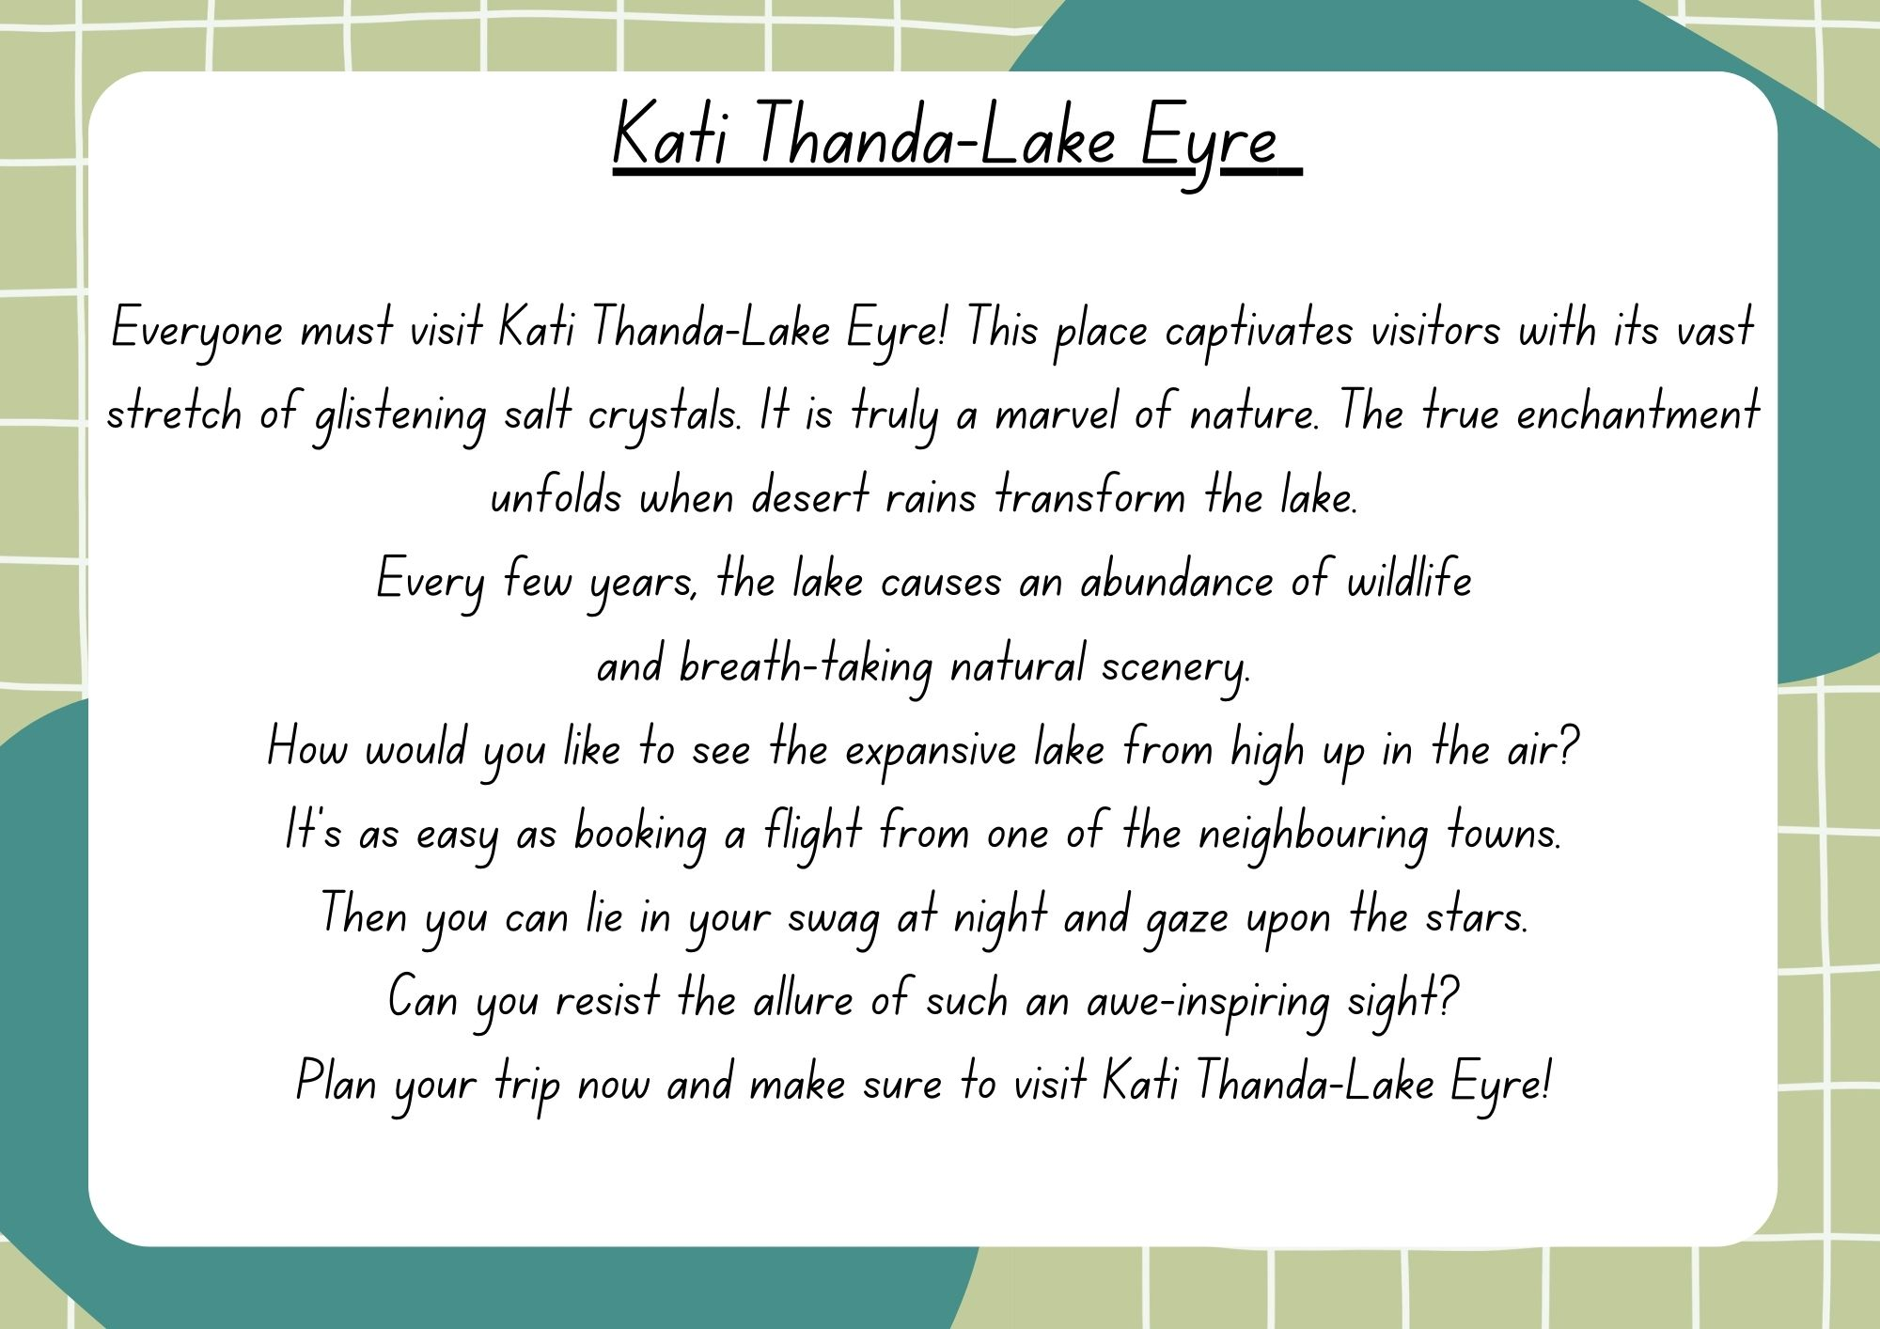

Resource 13 – Visit Kati Thanda-Lake Eyre brochure
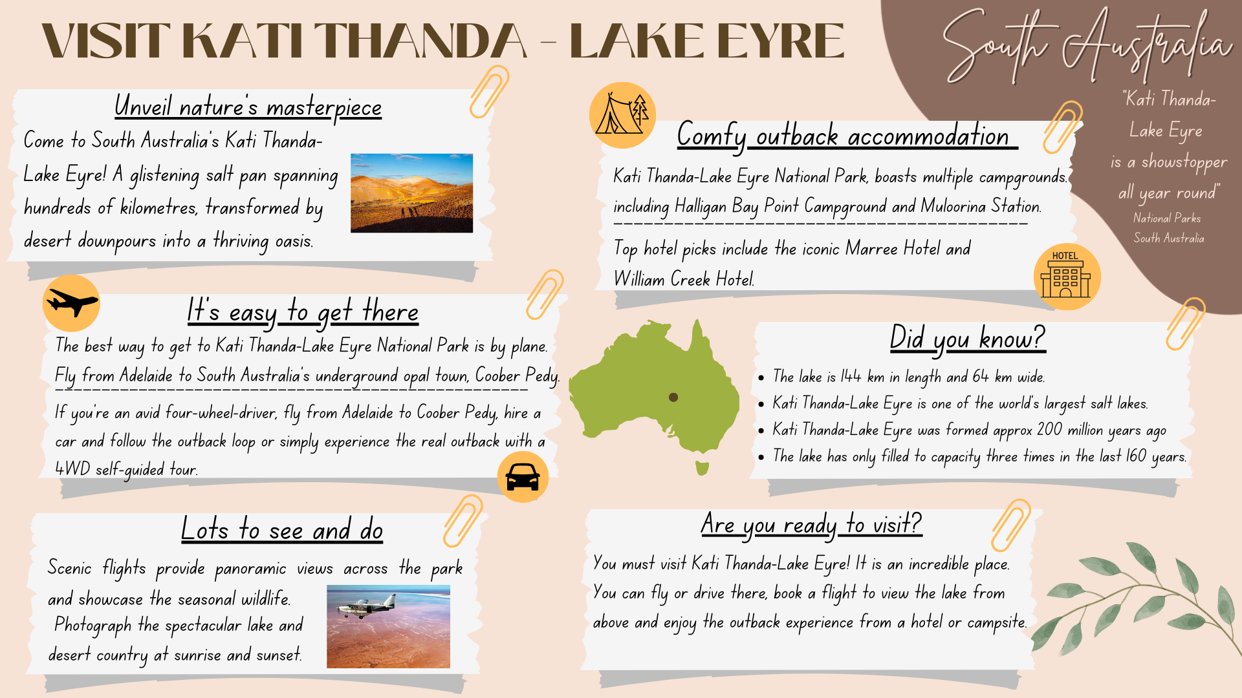

Resource 14 – research and planning template
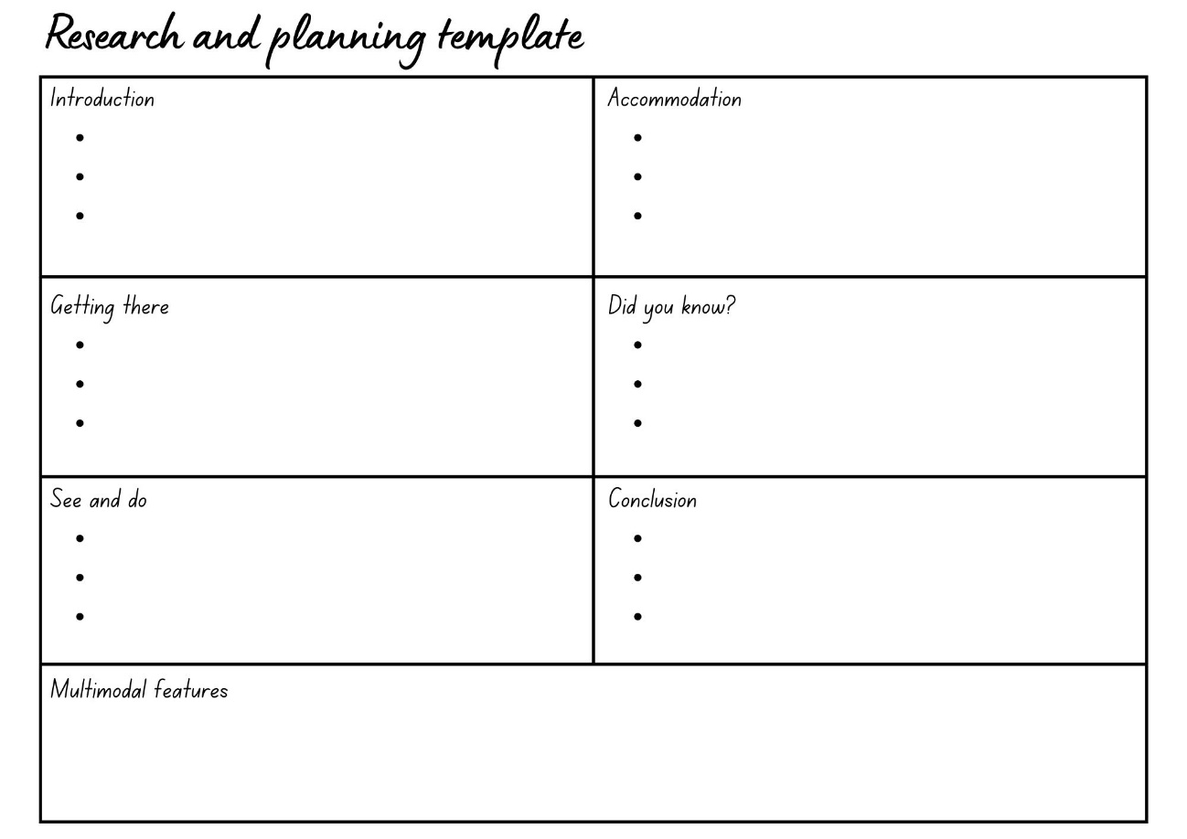

References
This resource contains NSW Curriculum and syllabus content. The NSW Curriculum is developed by the NSW Education Standards Authority. This content is prepared by NESA for and on behalf of the Crown in right of the State of New South Wales. The material is protected by Crown copyright.
Please refer to the NESA Copyright Disclaimer for more information. https://educationstandards.nsw.edu.au/wps/portal/nesa/mini-footer/copyright
NESA holds the only official and up-to-date versions of the NSW Curriculum and syllabus documents. Please visit the NSW Education Standards Authority (NESA) website https://educationstandards.nsw.edu.au/wps/portal/nesa/home and the NSW Curriculum website https://curriculum.nsw.edu.au.
English K–10 Syllabus © NSW Education Standards Authority (NESA) for and on behalf of the Crown in right of the State of New South Wales, 2022.
National Literacy Learning Progression © Australian Curriculum, Assessment and Reporting Authority (ACARA) 2010 to present, unless otherwise indicated. This material was downloaded from the Australian Curriculum website (National Literacy Learning Progression) (accessed 9 August 2023) and was not modified.
ABC (2009) 'Lake Eyre' [video], Behind the News, ABC website, accessed 26 June 2023.
Australia (21 October 2022) ‘It's All Good Down Under with Hamish Blake | Come and Say G'day’ [video], Australia, YouTube, accessed 26 June 2023.
Freeman P (2016) Desert Lake, The Story of Kati Thanda-Lake Eyre (Anelli L, illus.), Walker Books, Australia.
Google Earth (n.d.) Kath Thanda-Lake Eyre National Park [Google Earth map], accessed 26 June 2023.
Government of South Australia (Department of Environment and Water) (2023) Deep Creek National Park, National Parks and Wildlife Service South Australia website, accessed 26 June 2023.
Government of South Australia (Department of Environment and Water) (2023) Kati Thanda-Lake Eyre National Park, National Parks and Wildlife Service South Australia website, accessed 26 June 2023.
Government of South Australia (Department of Environment and Water) (2023) South Australia's Guide to Kati Thanda Lake Eyre-Travel blog, South Australian Tourism Commission website, accessed 26 June 2023.
NESA (NSW Education Standards Authority) (2023) ‘Glossary’, Resources, NESA website, accessed 26 June 2023.
Outback Spirit Tours (2023) Kati Thanda – Lake Eyre, Outback Spirit Tours website, accessed 26 June 2023.
Tourism Australia (2022) Come and Say G'day, Tourism Australia website, accessed 26 June 2023.
Whelan S (2016) Guest Post: Pamela Freeman on writing Desert Lake, Kids' Book Review website, accessed 26 June 2023.

Further reading
State of New South Wales (Department of Education) (2022) ‘Stage 2 reading - Main idea’, Stage 2 reading, NSW Department of Education website, accessed 13 July 2023.
State of New South Wales (Department of Education) (2022) ‘Stage 3 reading - Main idea’, Stage 3 reading strategies, NSW Department of Education website, accessed 13 July 2023.
State of New South Wales (Department of Education) (2022) ‘Stage 2 reading - Text Structure’, Stage 2 reading, NSW Department of Education website, accessed 13 July 2023.
State of New South Wales (Department of Education) (2022) ‘Stage 3 reading - Text Structure’, Stage 3 reading strategies, NSW Department of Education website, accessed 13 July 2023.

© State of New South Wales (Department of Education), 2023
The copyright material published in this resource is subject to the Copyright Act 1968 (Cth) and is owned by the NSW Department of Education or, where indicated, by a party other than the NSW Department of Education (third-party material).
Copyright material available in this resource and owned by the NSW Department of Education is licensed under a Creative Commons Attribution 4.0 International (CC BY 4.0) license.
This license allows you to share and adapt the material for any purpose, even commercially.
Attribution should be given to © State of New South Wales (Department of Education), 2023.
Material in this resource not available under a Creative Commons license:
- the NSW Department of Education logo, other logos and trademark-protected material
- material owned by a third party that has been reproduced with permission. You will need to obtain permission from the third party to reuse its material.
Links to third-party material and websites
Please note that the provided (reading/viewing material/list/links/texts) are a suggestion only and implies no endorsement, by the New South Wales Department of Education, of any author, publisher, or book title. School principals and teachers are best placed to assess the suitability of resources that would complement the curriculum and reflect the needs and interests of their students.
If you use the links provided in this document to access a third-party's website, you acknowledge that the terms of use, including licence terms set out on the third-party's website apply to the use which may be made of the materials on that third-party website or where permitted by the Copyright Act 1968 (Cth). The department accepts no responsibility for content on third-party websites.

