English 3–6 Multi-age – Year A Unit 1
Narrative – Blueback
Contents
Unit overview and instructions for use 7
Teacher notes 9
Outcomes and content 11
Resources 22
Week 1 25
Component A teaching and learning 25
Teaching guide 25
Planning framework 45
Component B teaching and learning 46
Learning intentions and success criteria 46
Lesson 1 – unravelling the orientation 47
Whole 47
Lesson 2 – using key words to describe the setting 51
Whole 51
Part 52
Lesson 3 – using adjectives to describe characters 55
Whole 55
Lesson 4 – creating character descriptions 57
Whole 57
Week 2 61
Component A teaching and learning 61
Teaching guide 61
Planning framework 83
Component B teaching and learning 84
Learning intentions and success criteria 84
Lesson 5 – making connections between own experiences and those depicted in narratives 85
Whole 85
Part 87
Whole 88
Lesson 6 – understanding tension through dialogue 89
Whole 89
Lesson 7 – using dialogue to create tension 92
Whole 92
Lesson 8 – exploring themes in a narrative 94
Whole 94
Week 3 98
Component A teaching and learning 98
Teaching guide 98
Planning framework 120
Component B teaching and learning 121
Learning intentions and success criteria 121
Lesson 9 – creating tension through events 122
Whole 122
Lesson 10 – crafting interview questions for characterisation 125
Whole 125
Part 126
Whole 127
Lesson 11 – characterisation through relationships 128
Whole 128
Part 129
Whole 130
Lesson 12 – resolution of a narrative 131
Whole 131
Week 4 135
Component A teaching and learning 135
Teaching guide 135
Planning framework 158
Component B teaching and learning 158
Learning intentions and success criteria 158
Lesson 13 – structure of a narrative 159
Whole 159
Lesson 14 – planning a narrative 162
Whole 162
Lesson 15 – planning and drafting an orientation 166
Whole 166
Lesson 16 – drafting a complication and series of events 167
Whole 167
Week 5 169
Component A teaching and learning 169
Teaching guide 169
Planning framework 187
Component B teaching and learning 187
Learning intentions and success criteria 188
Lesson 17 – drafting a resolution 189
Whole 189
Lesson 18 – revising and editing 190
Whole 190
Lesson 19 – publishing 191
Whole 191
Lesson 20 – presenting and reflecting 194
Whole 194
Resource 1 – fluency and close reading passage analysis (Week 1) 198
Resource 2 – interaction protocols 202
Resource 3 – the Jackson property 203
Resource 4 – Dora Jackson 204
Resource 5 – character traits – Abel Jackson 205
Resource 6 – my life and Abel’s life 206
Resource 7 – coordinating conjunctions 207
Resource 8 – comic strip template 208
Resource 9 – interview questions 209
Resource 10 – interviewing a character – Q & A 210
Resource 11 – character sociogram 211
Resource 12 – character sociogram exemplar 212
Resource 13 – Somebody, Wanted, But, So, Then 213
Resource 14 – fluency and close reading passage analysis 214
Resource 15 – Freytag’s pyramid planning template 217
References 218

Unit overview and instructions for use
In this 5-week unit, students will explore the textual concepts of narrative and characterisation. Students will consider how the mentor text of Blueback sets up expectations using characters that are identified through familiar characteristics and attributes. Students will make connections between their own or shared experiences as well as key themes to write a narrative providing details about setting, characters, and actions.
Outcomes and content in this unit are organised into Component A and Component B. The components are connected, with learning in Component A complementing learning in Component B.
Note: the duration of this unit can be adapted to suit individual school contexts. For example, learning could occur across 5 days rather than 4.
The table below highlights the focus areas and preparation required for Component A and Component B.
Teaching and learning | Component A | Component B
Suggested duration | 60 minutes × 4 days/week or equivalent | 60 minutes × 4 days/week or equivalent
Explicit teaching focus areas | Component A addresses content from the focus areas:  - Vocabulary  - Reading fluency (Stage 2)  - Reading comprehension  - Creating written texts  - Spelling  - Handwriting and digital transcription  It centres on the development of foundational skills and knowledge through regular, systematic and repeated practice. | Component B addresses content from the focus areas:  - Oral language and communication  - Vocabulary  - Reading comprehension  - Creating written texts  - Understanding and responding to literature  It centres on the conceptual understandings of English and exemplifies the importance of learning about and enjoying literature through the study of quality texts.
Preparing for teaching and learning | - Specific teaching and learning activities need to be developed by the teacher. When planning for these activities, please refer to the Component A outcomes and content, teaching guides and planning frameworks.  - Plan and document how you will sequence teaching and learning in whole-class and targeted-groups across the 5-week cycle as required. This should be based on student needs identified through ongoing assessment data. | - Familiarise yourself with the mentor and supporting texts and textual concepts, and the teaching and learning sequence.  - Determine how you will support students in whole-class and targeted-groups across the 5-week cycle as required. This should be based on student needs identified through ongoing assessment data.
English K–10 Syllabus © NSW Education Standards Authority (NESA) for and on behalf of the Crown in right of the State of New South Wales, 2022.

Teacher notes
- Narrative is the key concept of this unit, explored using the mentor text Blueback by Tim Winton. Narrative refers to an account of events or experiences, which are real or imagined. In English literary theory, narrative includes a story (what is narrated) and a discourse (how it is narrated). Narrative can present as an explicit sequencing of events (type of text) or it can be an implied or inferred component in a text (NESA 2023).
- Understanding of narrative can be supported through watching the department’s video: Understanding narrative (3:51).
- While ‘narrative’ is the mentor concept for Component B, the supporting concept of ‘characterisation’ will also be explored.
- For information on coordinating conjunctions and appositives refer to the NESA Glossary.
- In addition to the resources listed, students will require access to short passages of the mentor and/or supporting texts. Teachers can copy extracts from texts in reliance on the Statutory Text and Artistic Works Licence. Teachers need to attribute the extracts and include the following notice: ‘This material has been copied [and communicated to you] in accordance with the statutory licence in section 113P of the Copyright Act. Any further reproduction or communication of this material by you may be the subject of copyright protection under the Act. Do not remove this notice’.
- This unit could enhance student learning towards the achievement of science and technology and Human Society and its Environment (HSIE) outcomes.
- Reflect on student learning and engagement in activities and record differentiation and adjustments within the unit to inform future teaching and learning. One way of doing this could be to add comments to the digital file.
- In NSW classrooms there is a diverse range of students including Aboriginal and/or Torres Strait Islander students, students learning English as an additional language or dialect, high potential and gifted students and students with disability. Some students may identify with more than one of these groups, or possibly all of them. Refer to Curriculum planning for every student – advice for further information.
- Content points are linked to the National Literacy Learning Progression version (3).
Levels and indicators sourced from National Literacy Learning Progression © Australian Curriculum, Assessment and Reporting Authority (ACARA), (accessed 11 September 2023) and was not modified. See references for more information.

Outcomes and content
The tables below outline the outcomes and content for this unit. The letters 'A' and 'B' in the header refer to Components A and B. The numbers 1 to 5 refer to weeks. The use of 'x' in these columns indicates where the content points are intended to be addressed and in which week.
Stage 2 focus area and outcome, content points and National Literacy Learning Progression | A | B | 1 | 2 | 3 | 4 | 5
Oral language and communication
EN2-OLC-01 communicates with familiar audiences for social and learning purposes, by interacting, understanding and presenting
- Identify contexts in which social conventions can vary and influence interactions (InT4, InT5) |  | x | x |  |  |  | x
- Follow agreed-upon protocols and assigned roles for classroom interactions in person and through the use of technology (InT5) |  | x | x | x | x | x | x
- Listen actively to identify spoken information, acknowledging the value of others’ contributions (LiS6) |  | x | x | x | x | x | x
- Plan and deliver spoken presentations using language and structure to suit purpose and audience (SpK5) |  | x |  | x |  |  | x
Vocabulary
EN2-VOCAB-01 builds knowledge and use of Tier 1, Tier 2 and Tier 3 vocabulary through interacting, wide reading and writing, and by defining and analysing words
- Build personal Tier 1, Tier 2 and Tier 3 vocabulary through social and learning interactions, reading and writing (SpK5) | x | x | x | x | x | x | x
- Apply morphemic knowledge to change word meanings by adding different prefixes and suffixes to a base word or root (SpG9) | x | x | x | x | x | x | x
Reading fluency
EN2-REFLU-01 sustains independent reading with accuracy, automaticity, rate and prosody suited to purpose, audience and meaning
- Syllabify, blend grapheme–phoneme correspondences and use morphemic knowledge as strategies for reading words accurately (PKW8) | x |  | x | x | x | x | x
- Explain how prosodic reading involves emphasis, expression, intonation and pausing | x |  | x | x | x | x | x
Reading comprehension
EN2-RECOM-01 reads and comprehends texts for wide purposes using knowledge of text structures and language, and by monitoring comprehension
- Identify different purposes and strategies for reading (FIY5) | x |  |  | x | x | x
- Understand that dialogue is a common feature of imaginative texts, signalled by quotation marks or speech bubbles to indicate interactions between characters | x | x |  | x | x
- Use morphemic knowledge to read and understand the meaning of words (UnT7) | x |  | x | x | x | x | x
- Use key words from a text to visualise events, characters and settings when making inferences and confirming predictions | x | x | x | x | x | x | x
- Identify where meaning breaks down when reading (UnT6) | x |  |  | x | x | x | x
Creating written texts
EN2-CWT-01 plans, creates and revises written texts for imaginative purposes, using text features, sentence-level grammar, punctuation and word-level language for a target audience
EN2-CWT-02 plans, creates and revises written texts for informative purposes, using text features, sentence-level grammar, punctuation and word-level language for a target audience
EN2-CWT-03 plans, creates and revises written texts for persuasive purposes, using text features, sentence-level grammar, punctuation and word-level language for a target audience
- Sequence ideas and actions into paragraphs aligned to the stages of the text, to provide elaborated details about settings, character motives and actions (CrT8) |  | x | x |  | x | x | x
- Use coordinating conjunctions in compound sentences to compare and contrast, or for addition (GrA4) | x | x |  | x | x | x | x
- Select and use precise saying, thinking, acting, and relating verbs and verb groups to align with text purpose (GrA5, CrT8) | x | x |  | x | x | x | x
- Use declarative sentences to provide facts or state a viewpoint | x | x | x | x | x | x | x
- Use capital letters to indicate the beginning of a sentence, proper nouns, headings and subheadings, to indicate the beginning of a poetry line, for emphasis, and when using acronyms (PuN5, PuN7) | x | x | x | x | x | x | x
- Use commas between words in a list or to separate adjectives when more than one is used (PuN4, PuN6) | x | x |  | x | x | x | x
- Use adjectives to develop descriptive features (CrT8) | x | x | x | x | x | x | x
- Plan structures and language to suit the purpose of a text (CrT7) |  | x |  |  |  | x | x
Spelling
EN2-SPELL-01 selects, applies and describes appropriate phonological, orthographic and morphological generalisations and strategies when spelling in a range of contexts
- Explain how to segment multisyllabic words into syllables and phonemes, and apply this knowledge when spelling (SpG7) | x |  | x | x | x | x | x
- Identify differences in vowel phonemes (short, long, diphthong and schwa vowels) (SpG9) | x |  | x | x | x | x | x
- Apply knowledge of taught vowel graphemes when spelling (SpG9) | x |  | x | x | x | x | x
- Identify inflected suffixes, explaining when and how to treat base words when they are affixed, and apply this knowledge when spelling (SpG9) | x |  | x | x | x | x | x
Handwriting and digital transcription
EN2-HANDW-01 forms legible joined letters to develop handwriting fluency
EN2-HANDW-02 uses digital technologies to create texts
- Understand that legible handwriting is consistent in size and spacing and can support learning (HwK6) | x |  | x | x | x | x | x
- Join letters when writing familiar words (HwK6) | x |  | x | x | x | x | x
Understanding and responding to literature
EN2-UARL-01 identifies and describes how ideas are represented in literature and strategically uses similar representations when creating texts
- Describe how narratives set up expectations using familiar, real and imagined characters, situations and phrases |  | x | x | x | x | x | x
- Describe connections between own or shared experiences and those depicted in narratives (UnT6) |  | x | x | x | x | x | x
- Recognise that characters may be identified through familiar, individual or group characteristics |  | x | x | x | x | x | x
English K–10 Syllabus © NSW Education Standards Authority (NESA) for and on behalf of the Crown in right of the State of New South Wales, 2022.

Stage 3 focus area and outcome, content points and National Literacy Learning Progression | A | B | 1 | 2 | 3 | 4 | 5
Oral language and communication
EN3-OLC-01 communicates to wide audiences with social and cultural awareness, by interacting and presenting, and by analysing and evaluating for understanding
- Identify varying social conventions that influence interactions across wide audiences (LiS6) |  | x | x | x | x | x | x
- Follow agreed-upon protocols and define individual roles as needed for in-person or online interactions, establishing specific goals, criteria or timeframes (LiS6) |  | x | x | x | x | x | x
- Apply interactive listening strategies by responding to and providing feedback to the speaker (InT5) |  | x | x | x | x | x | x
- Deliver presentations suited to purpose and audience (SpK6) |  | x | x | x | x | x | x
Vocabulary
EN3-VOCAB-01 extends Tier 2 and Tier 3 vocabulary through interacting, wide reading and writing, morphological analysis and generating precise definitions for specific contexts
- Identify newly encountered words from interactions and wide reading, and use them in writing, discussions and presentations | x | x | x | x | x | x | x
- Analyse morphemic structures of Tier 2 and Tier 3 words to determine their meaning (SpG10, SpG11) | x |  | x | x | x | x | x
Reading comprehension
EN3-RECOM-01 fluently reads and comprehends texts for wide purposes, analysing text structures and language, and by monitoring comprehension
- Syllabify, blend grapheme–phoneme correspondences and use morphemic knowledge as strategies for reading words accurately (SpG10, PKW9, FIY6) | x |  | x | x | x | x | x
- Compare purposes for different texts and consider why authors and illustrators have structured texts in particular ways (UnT8) |  | x | x
- Use morphology and etymology to work out the meaning of unfamiliar words (SpG11, UnT9) | x |  | x |  | x | x
- Understand that sentence openers signal what the sentence will be about, and that the rest of the sentence can provide new information |  | x | x | x | x
- Monitor and repair reading when meaning breaks down (UnT9) | x |  | x | x | x | x | x
Creating written texts
EN3-CWT-01 plans, creates and revises written texts for multiple purposes and audiences through selection of text features, sentence-level grammar, punctuation and word-level language
- Make creative choices about temporal and spatial settings, character profiles and motives to enhance reader engagement (CrT9) |  | x |  |  |  | x | x
- Create written texts that include multiple paragraphs with clear, coherent transition of ideas (CrT9) |  | x |  |  | x | x | x
- Make choices about verbs and verb groups to achieve precision and add detail (GrA6) | x | x |  | x | x | x | x
- Include appositives to provide details to nouns and to vary sentence structures suited to text purpose (CrT8) | x | x |  |  | x | x | x
- Use capital letters at the beginning of a sentence, to indicate proper nouns, for headings and subheadings, to indicate the beginning of a poetry line, for emphasis, and when using acronyms (PuN5) | x | x | x |  |  | x | x
- Use a comma to separate a subordinate clause or a phrase from the main clause, or to separate information within a sentence, or to separate items in a list (CrT8, PuN4, PuN6) | x | x |  | x | x | x | x
- Use print or digital tools to plan, sequence, create, revise, edit and publish texts |  | x |  |  |  | x | x
Spelling
EN3-SPELL-01 automatically applies taught phonological, orthographic and morphological generalisations and strategies when spelling in a range of contexts, and justifies spelling strategies used to spell unfamiliar words
- Segment unfamiliar multisyllabic words into syllables and phonemes as a strategy when spelling | x |  | x | x | x | x | x
- Recognise that the same grapheme can represent different phonemes (SpG10) | x |  | x | x | x | x | x
- Explain and use spelling conventions to add derivational suffixes such as -ion, -ian, -ence, -ous to base words or roots (SpG10) | x |  | x | x | x | x | x
Handwriting and digital transcription
EN3-HANDW-01 sustains a legible, fluent and automatic handwriting style
EN3-HANDW-02 selects digital technologies to suit audience and purpose to create texts
- Sustain writing with a legible, fluent and personal handwriting style across a text (HwK8) | x |  | x | x | x | x | x
Understanding and responding to literature
EN3-UARL-01 analyses representations of ideas in literature through narrative, character, imagery, symbol and connotation, and adapts these representations when creating texts
- Recognise that narratives reflect both personal and common lived experiences and offer models of behaviour, which may be rejected or accepted |  | x | x | x | x | x | x
- Analyse attributes of character and use similar attributes when creating texts |  | x | x | x | x | x | x
English K–10 Syllabus © NSW Education Standards Authority (NESA) for and on behalf of the Crown in right of the State of New South Wales, 2022.

Resources
The resources in the table below are referred to in this unit. Letters 'A' and 'B' in the header refer to Component A and B respectively, and the numbers 1 to 5 indicate weeks. The use of 'x' in these columns indicate whether the resources are required in Component A, B or both, and in which week.
Resource | A | B | 1 | 2 | 3 | 4 | 5
Winton T (1997) Blueback, Penguin Australia Pty Ltd. ISBN: 9780143304333 | x | x | x | x | x | x | x
Individual whiteboards |  | x | x
Resource 1 – fluency and close reading passage analysis (Week 1) | x |  | x
Resource 2 – interaction protocols |  | x | x
Video: Blueback | Official Trailer | 2023 [HD] (2:15) |  | x | x
Resource 3 – the Jackson property |  | x | x
Resource 4 – Dora Jackson |  | x | x
Resource 5 – character traits – Abel Jackson |  | x | x
Character posters |  | x | x
Sticky notes |  | x | x
Resource 6 – my life and Abel’s life |  | x |  | x
Resource 7 – coordinating conjunctions |  | x |  | x
Resource 8 – comic strip template |  | x |  | x
Video: Ningaloo Nyinggulu | Official Trailer | ABC TV + iview (1:31) |  | x |  | x
Article: Great Barrier Reef changes image from marine park to theme park with underwater statues and hotels |  | x |  | x
Article: Volunteers, wildlife staff rescue green sea turtle at Middleton Beach in South Australia |  | x |  | x
Resource 9 – interview questions (Stage 2) |  | x |  |  | x
Resource 10 – interviewing a character – Q & A (Stage 3) |  | x |  |  | x
Hot seat |  | x |  |  | x
Resource 11 – character sociogram |  | x |  |  | x
Resource 12 – character sociogram exemplar |  | x |  |  | x
Resource 13 – Somebody, Wanted, But, So, Then |  | x |  |  |  | x
Resource 14 – fluency and close reading passage analysis (Week 4) |  | x |  |  |  | x
Resource 15 – Freytag's pyramid planning template |  | x |  |  |  | x | x
Video: Debra Frasier talks on Editing (1:21) |  | x |  |  |  |  | x

Week 1

Component A teaching and learning
Component A focuses on the development of foundational skills and knowledge through regular, systematic and repeated practice. The mentor and supporting texts used in Component B of this unit can support the effective implementation of Component A teaching and learning.

Teaching guide
Guidance for explicit teaching, teaching notes, resources and examples for the related outcomes and content points have been provided in the table below.
Focus areas and teaching notes | Resources and examples
Reading fluency  Reading rate and automaticity (Stage 2)  - Syllabify, blend grapheme–phoneme correspondences and use morphemic knowledge as strategies for reading words accurately  - Locate and syllabify multisyllabic words, including those with morphemic suffixes (-ing, -ed, -ly).  - For every syllable, there is at least one vowel phoneme.  - Morphemic suffixes usually form their own syllable. | Reading fluency  Reading rate and automaticity (Stage 2)  - Resource 1 – fluency and close reading passage analysis – Chapter 2, page 16 from ‘After breakfast Abel carried seaweed up to the fruit trees...’ to Chapter 2, page 18 ‘...He was lonely sometimes but he liked being with his mother.’ (316 words)  Note:  - The passage from the text will need to be a teacher-created resource.  - Content in Reading fluency will support learning in the focus areas Vocabulary, Reading comprehension and Spelling.  - Suggested words from the passage  - Morphemic information  - emptying – empty + ing  - fished – fish + ed  - roamed – roam + ed  - lonely – lone + ly.  - Syllables  - fertiliser – 4 syllables  - mulberries – 3 syllables  - cemetery – 4 syllables  - orchard – 2 syllables.
Prosody (Stage 2)  - Explain how prosodic reading involves emphasis, expression, intonation and pausing  - A pause is a short stop or break when reading. It can be used to add dramatic effect, including suspense.  - Intonation is the pattern or melody of pitch changes in connected speech, especially the pitch pattern of a sentence (NESA 2023).  - Pausing and intonation when reading aloud is essential in reading. The use of punctuation such as commas ( , ) and full stops ( . ) will assist in effectively pausing and using end of sentence intonation. | Prosody (Stage 2)  - Suggested sentence to illustrate the use of pausing and intonation using commas and a full stop  - ‘Behind the orchard, where the bushland and forest began, there was a little family cemetery, a patch of white crosses and headstones to mark all the Jacksons who had lived there.’ (p 19)
Reading comprehension  Comprehending language (Stage 2)  - Use morphemic knowledge to read and understand the meaning of words  - Use morphemic knowledge to read and understand Tier 2 words that describe characters and settings features (-ly,  -y, -ing)  - Suffix -ing changes the tense of a verb: -ing expresses present tense; -ng also expresses future tense.  - Suffix -ly means ‘a characteristic of’ and attaches to nouns to form adjectives, adjectives to form adverbs | Reading comprehension  Comprehending language (Stage 2)  - As above, see Stage 2 Vocabulary examples.
Comprehending language (Stage 2)  - Use key words from a text to visualise events, characters and settings when making inferences and confirming predictions  - Key words for describing a setting include nouns that provide concrete details about the physical elements of the setting including the places, locations and things that make up the story’s environment.  - Key words for describing a setting include adjectives that describe the physical attributes of the location.  - Key words for describing a setting include prepositions and prepositional phrases that provide spatial and positional information. | Comprehending language (Stage 2)  - Key words from the text to visualise setting  - ‘Abel and his mother lived off the sea’ (p 17); ‘The land at Longboat Bay had been theirs since whaling times and all the land around them was a national park’ (p 17); ‘Behind the orchard, where the bushland and forest began, there was a little family cemetery, a patch of white crosses and headstones to mark all the Jacksons who had lived and died here.’ (p 18)  - ‘Some nights he stood on the back verandah to watch the kangaroos gather in the orchard’ (p 18); ‘When he got back to the house he could hear his mother clanking around in the shed’ (p 19); ‘He looked up at the mantlepiece and the old photo of his father.’
Reading comprehension  Reading fluently (Stage 3)  - Syllabify, blend grapheme–phoneme correspondences and use morphemic knowledge as strategies for reading words accurately  - Locate and syllabify multisyllabic words, including those with morphemic suffixes (-ing, -ed, -ly).  - For every syllable, there is at least one vowel phoneme.  - Morphemic suffixes usually form their own syllable. | Reading comprehension  Reading fluently (Stage 3)  - As above, see Stage 2 Reading fluency examples.
Comprehending language (Stage 3)  - Use morphology and etymology to work out the meaning of unfamiliar words  - Etymology refers to the origins of, and changes to, words in relation to meaning. (NESA 2023) | Comprehending language (Stage 3)  - Etymology for the word groper from the passage  - The term groper refers to a type of fish and comes from the Portuguese word garupa.
Monitoring comprehension (Stage 3)  - Monitor and repair reading when meaning breaks down  - Meaning may break down when unfamiliar vocabulary is introduced, when background knowledge is required, or complex sentence structures require re-reading. | Monitoring comprehension (Stage 3)  - Suggested vocabulary to be explained from the passage  - orchard, pilchards.  - Long sentences with complicated structures (multiple commas)  - ‘Behind the orchard, where the bushland and forest began, there was a little family cemetery, a patch of while crosses and headstones to mark all the Jacksons who have lived and died here.’ (p 17–18)
Vocabulary  Learning and using words (Stage 2)  - Build personal Tier 1, Tier 2 and Tier 3 vocabulary through social and learning interactions, reading and writing  - Tier 1 words: Basic-level, everyday words. (NESA 2023)  - Tier 2 words: General academic words that can be used across a variety of domains. Tier 2 words add power and precision to written and spoken language but many Tier 2 words are most commonly found in written language. (NESA 2023)  - Tier 3 words: Words that are used rarely (low frequency) and only in highly specific situations. (NESA 2023) | Vocabulary  Learning and using words (Stage 2)  - Suggested vocabulary from Week 1 reading material  - Tier 2 nouns: slope (p 16), jetty (p 16), orchard (p 17), fig (p 17), bushland (p 17), cemetery (p 17), crosses (p 17), headstones (p 17), national park (p 18), verandah (p 18)  - Tier 2: adjectives: stank (p 17), little (p 17), white (p 17)  - Tier 2 verbs: heaved (p 16), jangled (p 17), roamed (p 18), gather (p 18)  - Tier 3 nouns: pilchards (p17).
Defining and analysing words (Stage 2)  - Apply morphemic knowledge to change word meanings by adding different prefixes and suffixes to a base word or root  - Suffixes can be added to base words to adjust their meaning.  - Suffix -ed changes the verb to past tense.  - Suffix -ing changes the tense of a verb: -ing expresses present tense; -ing also expresses future tense.  - Suffix -ly means ‘a characteristic of’ and attaches to nouns to form adjectives, adjectives to form adverbs. | Defining and analysing words (Stage 2)  - Suggested vocabulary from Week 1 reading material  - filled (p 16), washed (p16), heaved (p 16) netted (p 17), jangled (p 17), anchored (p 21)  - emptying (p 17), living (p 18), scoffing (p 21), clanking (p19)  - suddenly (p 20).
Vocabulary  Learning and using words (Stage 3)  - Identify newly encountered words from interactions and wide reading, and use them in writing, discussions and presentations  - Identify and discuss the meanings of newly encountered Tier 2 and Tier 3 words in the text to improve vocabulary knowledge and comprehension. It could be a word with an unfamiliar meaning, an unusual spelling, or a term specific to a certain context. | Vocabulary  Learning and using words (Stage 3)  - Suggested vocabulary from the passage: whaling (p 17), cemetery (p 17), headstones (p 17), orchard (p 18), graze (p 18).
Defining and analysing words (Stage 3)  - Analyse morphemic structures of Tier 2 and Tier 3 words to determine their meaning  - Morphemes can be words themselves or parts of words, such as prefixes, suffixes, and root words. Analysing morphemic structures involves breaking words down into their constituent morphemes to understand how the meaning is formed. | Defining and analysing words (Stage 3)  - Suggested vocabulary from Week 1 reading material  - anchored (p 20), buried (p18), swooped (p 21) floated (p 21)  - dishing (p 16), following (p 20), scoffing (p 21), clanking (p 19)  - suddenly (p 20).
Spelling  Phonological component (Stage 2)  - Explain how to segment multisyllabic words into syllables and phonemes, and apply this knowledge when spelling  - As introduced in Early Stage 1 and Stage 1, revise segmenting multisyllabic words into syllables and phonemes. For example, jockey has 2 syllables and 4 phonemes (j-o-ck-ey). This is a phonological skill that should be practised regularly.  - Identify differences in vowel phonemes (short, long, diphthong and schwa vowels  - The most common graphemes that represent the long vowel phoneme /ee/ as in me include: e_e, ey, y, ea, e, ee  - [ee, ea, ey] are vowel digraphs  - [e_e] is a split digraph  - [e, y] are single letter graphemes. | Spelling  Note: each week of learning contains a phonological, orthographic and morphological focus. These focuses are intended to be taught simultaneously through linguistic inquiry. Suggested words have been selected to show how phonological, orthographic and morphological content can be integrated. In addition to words selected from the mentor and/or supporting text, additional sample words for inquiry are provided.  Phonological component (Stage 2)  - Suggested words from Week 1 reading material: jetty, sea, seat, seam, meat, ears, seaweed, family, mulberries, trees, secret, creatures, reef, study, body, heads.  - Sample words: theme(s), cream(s), beacon(s), ear(s), coffee(s), referee(s), refugee(s), jockey(s), monkey(s), baby-babies, candy-candies, cherry-cherries, berry-berries, inquiry-inquiries, peach(es), leech(es), dress(es), recess(es) speech(es), screech(es).
Orthographic component (Stage 2)  - Apply knowledge of taught vowel graphemes when spelling  - The most common graphemes that represent the long vowel phoneme /ee/ as in me include: [ee, ea, e_e, ey, e, y].  - [ee, ea, ey] are vowel digraphs that represent the phoneme /ee/. This phoneme can also be represented using the split digraph [e_e] and the graphemes [e, y]. | Orthographic component (Stage 2)  - As above
Morphological component (Stage 2)  - Identify inflected suffixes, explaining when and how to treat base words when they are affixed, and apply this knowledge when spelling  - Inflected suffixes: plurals (-s/es)  - An inflected suffix is a bound morpheme added to the end of a base word to assign a number to a word, to indicate possession or tense, or to provide a comparison  (-s, -es, -ing, -ed, -er, est).  The inflected suffixes -s and -es change a noun from singular (one) to plural (more than one).  - When a noun ends in a consonant and then -y, replace the ‘-y’ with an ‘i’ before adding the -es suffix.  - When a noun ends in a -s/sh/ss/ch, add the -es suffix to create the plural form. | Morphological component (Stage 2)  - As above
Phonological component (Stage 3)  - Segment unfamiliar multisyllabic words into syllables and phonemes as a strategy when spelling  - Revise segmenting multisyllabic words into syllables and phonemes. This is a phonological skill that should be practised regularly. | Phonological component (Stage 3)  - Words from Week 1 reading material: Abel, half, around, shack, plastic, crash, abalone.  - Sample words: accident, balance, bath, grass, wander, swampy, apron, active-activate, affection-affectionate, captive-captivate, fabric-fabricate, passion-passionate, consider-considerate, domestic-domesticate
Orthographic component (Stage 3)  - Recognise that the same grapheme can represent different phonemes  - Grapheme [a] can represent /a/, /ar/, /o/, /ay/ and /schwa/.  - Highlight the different phonemes represented by the graph [a]. [a] can be used to represent /a/ as in ‘at’, /ar/ as in ‘farm’, /o/ as in ‘was’ and /ay/ as in ‘basic’. [a] can often be pronounced as a schwa. Note the graph’s position within base words. | Orthographic component (Stage 3)  - As above
Morphological component (Stage 3)  - Explain and use spelling conventions to add derivational suffixes such as -ion, -ian, -ence, -ous to base words or roots  - Derivational suffixes are added to a base word or root to change part of speech. A base word is a morpheme that stands freely on its own to make a word. A root is a morpheme that gives the word its core meaning. A root may or may not stand alone as a word. Many roots in Standard Australian English derive from Latin and Greek.  - Introduce the suffix -ate, meaning possessing, having the appearance of characteristics, the product of a process.  - Teach adding -ate to nouns to form adjectives: fortune-fortunate  - Teach adding -ate to verbs to form nouns: condense-condensate  - Teach adding -ate to nouns and adjectives to form verbs: hyphen-hyphenate  - Teach ‘drop the e’ rule: active-activate. | Morphological component (Stage 3)  - As above
Creating written texts  Sentence level grammar (Stage 2)  - Use declarative sentences to provide facts or state a viewpoint  - Review simple sentence features. A sentence is a complete thought (sentence vs sentence fragment).  - A simple sentence (or a main clause) contains a subject and a verb.  - A declarative sentence is a statement presented as a complete sentence to provide fact, evidence or detail. (NESA 2023) | Creating written texts  Sentence level grammar (Stage 2)  - Simple sentence: ‘His mother was a good mechanic.’ (p 19)  - Declarative sentences from the passage  - ‘There were orange and lemon trees in the orchard as well as olives and mulberries.’ (p 17)  - ‘There were no mains electricity out at Longboat Bay, no water except rainwater and no TV.’ (p 18)  - ‘Some nights he stood on the back verandah to watch the kangaroos gather in the orchard.’ (p 18)
Punctuation (Stage 2)  - Use capital letters to indicate the beginning of a sentence, proper nouns, headings and subheadings, to indicate the beginning of a poetry line, for emphasis, and when using acronyms  - Review sentence boundary punctuation, including capital letters to indicate the beginning of a sentence and to indicate proper nouns. | Punctuation (Stage 2)  - Use capital letters to indicate proper nouns from the passage  - Abel Jackson (p 10), Blueback (p10), (p 17) Robbers Head (p 20), Jacksons (p 17), Longboat Bay (p 10).
Word-level language (Stage 2)  - Use adjectives to develop descriptive features  - Adjectives are words that describe, identify or quantify a noun or a pronoun. Different types of adjectives include possessive, quantifying, descriptive, comparative, superlative and classifying (NESA 2023).  - Adjectives can be used for imaginative purposes to describe characters, settings and events.  - Review use of noun groups to build descriptions of people and things, including article/pronoun, adjectives/noun.  - Descriptive adjectives give more information about the noun or pronoun. They help to add details about the noun they are modifying. This can be related to size, shape, colour, texture and other qualities. | Word-level language (Stage 2)  - Adjectives to describe Dora Jackson’s character  - Athletic: ‘Beautiful swimmer’ (p 4)  - Knowledgeable: ‘Everything he knew on land or under the sea he learned from her’ (p 4)  - Respected: ‘Talked about her with a kind of awe’ (p 36).  - Example noun groups: tiny silver fish (p 3), plastic dive crate (p 4), shiny hubcaps (p 4), rich compost (p 17), little family cemetery (p 17), brilliant red schools of nannygai (p 20), luminous water (p 20).
Creating written texts  Punctuation (Stage 3)  - Use capital letters to indicate the beginning of a sentence, proper nouns, headings and subheadings, to indicate the beginning of a poetry line, for emphasis, and when using acronyms  - Review sentence boundary punctuation, including capital letters to indicate the beginning of a sentence and to indicate proper nouns. | Creating written texts  Punctuation (Stage 3)  - As above, see Stage 2 examples.
Handwriting and digital transcription  Handwriting legibility and fluency (Stage 2 Year 3)  - Understand that legible handwriting is consistent in size and spacing and can support learning  - Form the ‘down’ letters l, t and i using consistent size and spacing  - Formation: All ‘down’ letters begin at the top of the letter and end at the bottom.  - Size: Letters should be in proportion in both width and height.  - Slope: Letters need to maintain the same slope, that is, they need to be parallel. All letters slope slightly to the right.  - Form basic punctuation marks, including full stops and commas  - Full stops and commas are positioned on the baseline. | Handwriting and digital transcription  Handwriting legibility and fluency (Stage 2 Year 3)  - Suggested fluency pattern  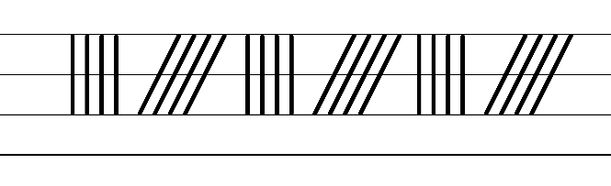  - Example NSW Foundation Style handwriting formation  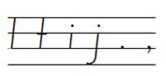  - Suggested practice text from the passage  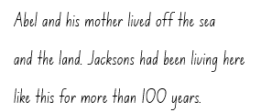  Note: students who are fluent in NSW Foundation Style can begin to use NSW Foundation Precursive and Cursive Style.
Handwriting legibility and fluency (Stage 2 Year 4)  - Join letters when writing familiar words  - Practise diagonally joining to short letters when writing familiar words.  - Diagonal joins to short letters may include me, nu, ie, li, hi, ce, en, te, au, di. | Handwriting legibility and fluency (Stage 2 Year 4)  - Suggested fluency pattern  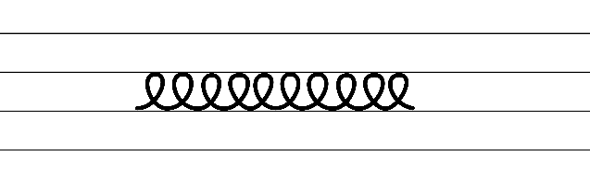  - Example letter joins  - Familiar words could include:  - Alternatively, words could be selected from mentor or supporting texts.  - Suggested practice text from the passage  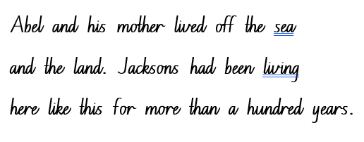
Handwriting and digital transcription  Handwriting legibility and fluency (Stage 3 Year 5)  - Sustain writing with a legible, fluent and personal handwriting style across a text  - Form legible and fluent Foundation Style printing, including  - lower case letters  - upper case letters  - punctuation marks  - numerals.  - Posture  - Feet are to be flat on the floor with the back of the chair supporting the hollow of the back.  - The body should be upright.  - The writing arm should pivot from the elbow.  - Paper  - The non-writing hand holds the paper. This non-writing arm can take the weight to allow the writing arm to glide over the writing surface.  - Pencil grip  - Hold the pen(cil) between the thumb and index finger with the pen(cil) resting on the middle finger. | Handwriting and digital transcription  Handwriting legibility and fluency (Stage 3 Year 5)  - Suggested fluency pattern  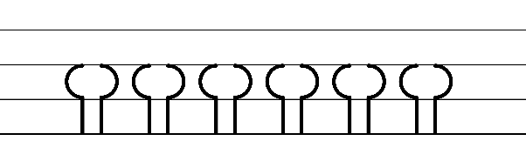  - Example NSW Foundation Style handwriting formation 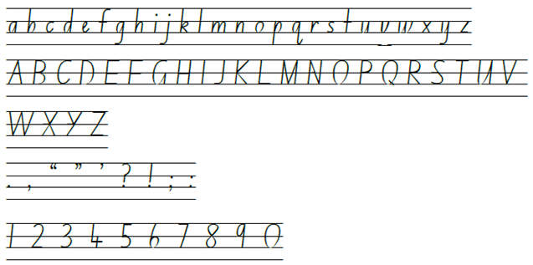  - Suggested practice text from the passage  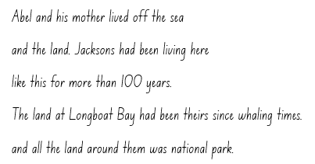
Handwriting legibility and fluency (Stage 3 Year 6)  - Sustain writing with a legible, fluent and personal handwriting style across a text  - Revise diagonal joins using a cursive looped style. | Handwriting legibility and fluency (Stage 3 Year 6)  - Suggested fluency pattern  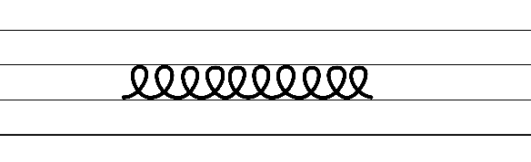  - Suggested practice text from the passage  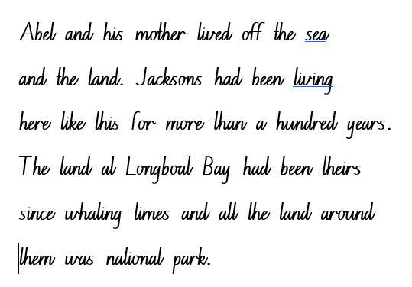  - Encourage students to evaluate their own handwriting after practising. For example, asking them to circle diagonal joins they believe are formed well.  Note: it may be more appropriate for students to consolidate a cursive handwriting style rather than introducing a cursive looped style.

Planning framework
To plan and document Component A teaching and learning, a planning scaffold [DOCX 228 KB] is provided. To support you in your planning, a link to a detailed example of a one-week teaching and learning cycle is included in the scaffold. Additional resources to support teaching and learning in each focus area can be found at Lesson advice guides.

Component B teaching and learning
The following teaching and learning sequence has been designed to address Component B outcomes and content and develops conceptual understandings of English through the study of quality texts. Adapt the sequence as required to best meet the needs of your students.

Learning intentions and success criteria
Learning intentions and success criteria are best co-constructed with students. The table below contains suggested learning intention and success criteria.
Element | Stage 2 | Stage 3
Learning intention | Students are learning to understand the features and purpose of an orientation in a narrative. | Students are learning to understand the features and purpose of an orientation in a narrative.
Success criteria | Students can:  - identify key features within an orientation to introduce setting and characters  - understand author’s purpose for writing a text  - identify and use declarative sentences containing adjectives to develop descriptions of characters and setting | Students can:  - analyse key features within an orientation to introduce setting and characters  - identify the purpose of sentence openers and the detail provided by the remainder of a sentence  - recognise an author’s purpose for writing a text  - use adjectives to analyse character attributes and describe features of the setting.

Lesson 1 – unravelling the orientation
The following teaching and learning activities support multi-age settings.

Whole
- Explore the importance of meaningful conversations in the classroom to create positive learning environments. Explain that talk plays an important role in learning by promoting clarification, active engagement, collaboration, reflection and consolidating knowledge and understanding. Explain that through active listening, students can also understand different perspectives and learn new ideas.
- Develop a shared criteria for classroom interaction with a whole-class, small group and partner context using Resource 2 – interaction protocols. Display agreed protocols for students to refer to. For example, listen respectfully, acknowledge the value of others’ contributions, offer constructive and supportive feedback, actively participate in learning. Explain that these will be referred to throughout the unit as guidelines for positive communication.
- Introduce the text Blueback by Tim Winton. Ask students if they have previously read the text, if they have heard of the author and, if so, what they know about the author. Display the front cover and ask students to predict what they think the book will be about. Explain that Tim Winton is a famous Australian author of both adult and children’s novels who decided at the age of 10 to be a writer. Explain that his writing captures his passion for the sea.
- Discuss that some of the best books are turned into movies for the purpose of entertaining and engaging an audience. Explain that a movie trailer is a short video that provides a preview of an upcoming film and aims to capture the essence of the story. Emphasise that trailers are designed to generate interest and excitement among viewers.
- Watch the Blueback Official Trailer (2:15) to spark curiosity. Evaluate how well the trailer worked to captivate students’ interest in the narrative. Ask students to think about what elements of the trailer contributed to generating excitement and curiosity among viewers.
- Based on the trailer, guide students to make predictions about the novel Blueback. Brainstorm ideas related to narrative conventions, such as text purpose, characterisation, setting, complication and themes.
- On individual whiteboards, students record prior knowledge of narrative. Draw on students’ responses to highlight key features of a narrative and record on an anchor chart. For example:
- structural elements such as orientation, complication, series of events or conflicts and resolution
- use of familiar and imagined characters
- use of real and imagined settings
- use of real or imagined events or experiences
- the purpose of a narrative (imaginative text) is to entertain
- underlying themes or messages.
- Read Chapters 1 to 3, pausing to discuss key words and information about characters, setting and events. Ask students to pay attention to the narrative elements and how the author conveys information and engages the reader.
- Compare and contrast the movie trailer with the beginning of the novel. Ask:
- What similarities and differences can be identified?
- How do these confirm or challenge earlier predictions?
- As a class, identify and record text details about the orientation from Chapters 1 to 3 of Blueback. For example, the information provided about the text’s setting, main characters, plot and overall tone of the story. Ask students to explore how the author, Tim Winton, has engaged and entertained readers. Encourage students to share parts of the narrative that resonated with them.
- Discuss the importance of a blurb on the back cover of a book. Explain that just like movie trailers, novels have a blurb on the back cover to entice and engage readers in the narrative. Ask:
- How does a blurb entice and engage readers in the narrative?
- Why do you think it is important for a blurb to provide a glimpse into the characters, setting, events, and themes of a narrative?
- Explain that students will write their own blurb for Blueback by drawing on Chapters 1 to 3 and will later compare their blurb to the blurb provided by Tim Winton.
- Model writing a blurb structured into a paragraph. Use think-alouds to capture the essence of the orientation while also engaging reader curiosity. Explain that a blurb is a concise summary and should avoid giving too much away. For example:
In a picturesque coastal town called Longboat Bay, young Abel and his adventurous mum Dora share a deep love for the ocean and its enchanting mysteries. Exploring the turquoise waters, Abel encounters Blueback, an extraordinary and mysterious fish that captures his heart. Join Abel on a remarkable journey filled with wonder, and the magic of the deep blue sea in Blueback by Tim Winton.
- Provide time for students to write a blurb in pairs. Remind students to focus on their knowledge of the text from Chapters 1 to 3 including information related to the orientation of the story (characters and setting). Encourage students to keep their blurbs concise and focused on enticing readers.
- In small groups, have students present their writing, discussing how their blurb captures the essence of the narrative’s orientation.
- Read Tim Winton’s blurb on the back cover of Blueback. Students discuss similarities and any significant differences. Display students’ blurbs on a story wall.
- Students use exit tickets to share their opinions and elaborate on them with reasons. Encourage responses that focus on textual understanding as well as the use of protocols to support learning conversations. Questions could include:
- Why do authors write narrative texts?
- How significant do you think the role of a blurb is in influencing readers to engage with a narrative?
- What impact does a blurb have on a reader's decision to read a particular book?
- How does understanding the orientation of a narrative contribute to our comprehension of the story?

Stage 3 Assessment task 1 – observations and work samples from this lesson allow students to demonstrate achievement towards the following syllabus outcome and content point:
EN3-RECOM-01 – fluently reads and comprehends texts for wide purposes, analysing text structures and language, and by monitoring comprehension
- compare purposes for different texts and consider why authors and illustrators have structured texts in particular ways.

Lesson 2 – using key words to describe the setting
The following teaching and learning activities support multi-age settings.

Whole
- Explain that the beginning of a narrative is often used to ‘set the scene’ or build the world in which the story is set. Explain that a setting involves where the events take place. Explain that authors create believable and engaging settings for their characters and their stories. When building their setting, authors consider physical location, environmental features, the weather, buildings, plants, animals, objects sights, sounds and smells. The setting can be used to establish mood, and sometimes it can even be a character itself.
- Revise Chapters 1 to 3 of Blueback.
- In pairs, students Think-Pair-Share to determine the setting of Blueback. Discuss that Blueback is set in the fictional town of Longboat Bay.
- Review the definition of Tier 2 vocabulary as taught in Component A. Explain how key Tier 2 words from the text support readers to visualise the setting of the narrative. Explain that, when reading or hearing a text, key words can be used to create a mental image to bring the text to life and engage in the imagination.
- Read from ‘Abel and his mother lived off the sea and the land...’ (p 17) to ‘He was lonely sometimes, but he liked being with his mother’ (p 18).
- As a class, discuss and determine key Tier 2 words that describe the setting of Longboat Bay and the Jackson property. For example, ‘Abel and his mother lived off the sea ‘(p 17); ‘The land at Longboat Bay had been theirs since whaling times and all the land around them was a national park’ (p 17); ‘Behind the orchard, where the bushland and forest began, there was a little family cemetery, a patch of white crosses and headstones to mark all the Jacksons who had lived and died here’ (p 18).
- Ask students to identify how adjectives are used to build description of the setting and its features. For example, little family, white crosses. Spend time determining key words and building vocabulary to visualise the setting of Longboat Bay and the Jackson property. Record answers on Resource 3 – the Jackson property.
- Read from ‘Some nights he stood on the back verandah to watch the kangaroos gather in the orchard’ (p 18) to ‘She said every engine was just a puzzle to solve’ (p 19,). Then read ‘Abel rode home in the boat with his head buzzing’ (p 29) to ‘Crying sometimes, thinking, remembering’ (p 30).

Part
The table below details the differentiated teaching and learning activities for each stage.
Stage 2 (pairs) | Stage 3 (teacher guided/small groups)
- In pairs, students locate, discuss and record key words that continue to build a description of the setting on Resource 3 – the Jackson property. For example, ‘Some nights he stood on the back verandah to watch the kangaroos gather in the orchard’ (p 18), ‘When he got back to the house he could hear his mother clanking around in the shed’ (p 19), ‘He looked up at the mantlepiece and the old photo of his father’ (p 29) and ‘Near the orchard there was an old peppermint tree with a deep fork in it. His mother kept a candle there and some pearl shells and a dolphin he once carved from driftwood’ (p 30).  Too hard? Provide excerpts of the text and students highlight key descriptive words. | - Explain how sentence openers usually signal what the sentence will be about.  - Provide students with sample sentence openers from the pages that have been read as a class. For example, ‘Looking at those roos he wondered...’ (p 18) and ‘When I’m older, he thought...’ (p 18)  - Discuss what these sentence openers tell the reader and what detail the rest of the sentence could provide.  - Using a range of openers from the text, students complete the sentences providing further detail to each opener. For example, ‘When Abel got back to the house he could hear...’ (p 19)  - the sound of the boats pulling into the Bay.  - his mother singing in the kitchen.  - Discuss the importance of information provided in sentence openers and the need for additional information in the remainder of the sentence.
- Model the process of visualising the setting. Using Chapters 2 to 3 of Blueback and Resource 3 – the Jackson property, begin to draw and label a map of the Jackson property. Add additional features and labels to the illustration that are consistent with identifying the setting in the text.
- In pairs, students use the excerpts from Chapters 2 to 3 of Blueback and Resource 3 – the Jackson property to record key words to assist with visualising the setting. Provide time for students to draw and label a map of the Jackson property. Students discuss other vocabulary that could be used to describe the setting and add additional features and labels to their illustration. Encourage students to draw on Tier 2 words introduced in Component A. Optional: students create a digital display of images that best represent the picture of the Jackson property that they have in their minds when reading the story.
- Students share their illustrations of the setting with the class by participating in a gallery walk. Encourage students to acknowledge the value of others’ contributions by comparing their illustrations and highlighting the similarities and differences. Display on story wall.
Stage 2 Assessment task 1 – observations and work samples from this lesson allow students to demonstrate achievement towards the following syllabus outcome and content point:
EN2-RECOM-01 – reads and comprehends texts for wide purposes using knowledge of text structures and language, and by monitoring comprehension
- use key words from a text to visualise events, characters and settings when making inferences and confirming predictions.
Stage 3 Assessment task 2 – observations and work samples from this lesson allow students to demonstrate achievement towards the following syllabus outcome and content point:
EN3-RECOM-01 – fluently reads and comprehends texts for wide purposes, analysing text structures and language, and by monitoring comprehension
- understand that sentence openers signal what the sentence will be about, and that the rest of the sentence can provide new information.

Lesson 3 – using adjectives to describe characters
The following teaching and learning activities support multi-age settings.

Whole
- Explain that characterisation is an important concept in narrative as it helps to drive the action and is a way of representing themes. Co-construct a class definition of the term ‘characterisation’ and display on the story wall for future reference. For example, ‘characterisation is a representation of any personality or person-like figure in a text that includes features, such as their appearance, actions, words or thoughts.’
- Review Chapters 1 to 3 of Blueback using the information from the orientation to discuss the characters in the text. Explore how Tim Winton has framed the characters in Blueback by presenting them as individuals with unique personalities, motivations and experiences. Discuss the importance of authors establishing relationships between characters by introducing them thoughtfully and chronologically. Ask:
- Who is the main character? How do you know?
- What relationship does Abel have with Dora?
- What relationship does Abel have with Blueback?
- Read Chapter 4 of Blueback. Pause to discuss key words and information about characters.
- Ask students to provide any additional information gained about characters in Chapter 4, including the introduction of Mad Macka. Explain that the new information gained about Dora, Abel and Mad Macka is an example of how authors develop characters throughout a narrative and that, over time, characters may show a range of familiar characteristics, attributes or traits.
- Discuss how authors use adjectives or traits to describe a character’s appearance (observable) and personality (not observable); these are words that describe a noun and add more detail so that a reader can develop a better understanding of a character. Brainstorm a list of character traits on an anchor chart. Display on the story wall for future reference.
- Explore Tim Winton’s characterisation in Blueback and how he relies on indirect characterisation techniques to help the reader understand Abel and Dora’s personalities. Explain that the author has not only described the characters visually but has made their characterisation evident in their actions and thoughts.
- Display Resource 4 – Dora Jackson and read the quotes (evidence) from the text. Students Think-Pair-Share to match the trait listed to the evidence provided from the text. Students share and justify their responses.
- Reinforce that some traits can only be inferred from Tim Winton’s descriptions of the characters’ actions, including what they say or think. Explain that Tim Winton constructs his characters through their speech, actions, appearance and interactions with other characters.
- Provide small groups with excerpts from the text. Explain that students will think of possible character traits for Abel Jackson using evidence from the text to support their reasoning.
- Provide time for students to read and highlight evidence from the excerpts to record Abel’s character traits on Resource 5 – character traits – Abel Jackson. Encourage students to select Tier 2 adjectives to describe Abel Jackson’s character traits or attributes. Share student responses.
Note: students will use Resource 5 – character traits – Abel Jackson for writing in Lesson 4.
- Provide students with opportunities to self-assess their classroom interactions during this learning experience. Ask students to reflect on their participation, considering their level of engagement and active listening during discussions. Ask students the following questions and encourage students to justify their responses
- Did you actively contribute to discussions, ask questions or share your thoughts and ideas?
- Reflect on the frequency and quality of your interactions with the teacher and your peers. In what context (partner, group, class) did you contribute the most?
- Students create a personal goal to strengthen their classroom interactions. Encourage students to regularly reflect on their personal goal related to classroom interactions. They can keep a journal or use a reflection sheet to jot down their observations and thoughts about their participation, communication and engagement with others (Stage 3).

Lesson 4 – creating character descriptions
The following teaching and learning activities support multi-age settings.

Whole
- Display character posters around the classroom. Each poster should represent a different character from the text, for example, Dora Jackson or Abel Jackson (there should be one colour poster per character). Provide students with sticky notes. Read an excerpt from the text, pausing for students to determine how Tim Winton constructs his characters through their speech, actions, appearance and interactions with other characters. Students identify the character and a character trait that reflects the excerpt. Students record the character trait on a sticky note and add it to the relevant character poster. For example:
- Dora Jackson
- ‘When Abel got back to the house he could hear his mother clanking around in the shed. She was working on the diesel generator with grease all up her arms. His mother was a good mechanic. She kept the truck and the outboard going on her own. She said every engine was just a puzzle to solve’ (p 19) (problem solver, self-sufficient)
- ‘She grabbed him by the arm and squeezed. “It's okay, love.”’ (reassuring)
- ‘Beautiful swimmer’ (p 4) (strong, athletic)
- ‘Everything he knew on land or under the sea he learned from her’ (p 4) (knowledgeable)
- ‘Talked about her with a kind of awe’ (p 36) (respected)
- Abel Jackson
- ‘Abel couldn’t imagine life without his mother’ (p 41) (loving)
- ‘He kept Blueback to himself, a secret from the rest of the world’ (p 25) (secretive, protective)
- ‘He wondered if a fish even remembered. When a fish died, did all those years just vanish?’ (p 26) (curious)
- ‘One season grew into another and Abel grew old enough to take the dinghy out on his own’ (p 37) (independent)
- ‘Abel Jackson had lived by the sea here at Longboat Bay ever since he could remember. His whole life was the sea and the bush.’ (p 10) (nature-loving)
- Students turn and talk to discuss and provide justifications for their thinking:
- What are Abel’s strengths and weaknesses? What makes him relatable?
- What key traits and qualities define Abel and how do they shape his actions and decisions?
- What role does Dora Jackson play in the narrative?
- How is she portrayed and what impact does she have on the other characters, particularly Abel?
- Why are characters important in a story? How do you know this?
- How do authors get their audience to connect with characters?
- Review declarative sentences and explain that Tim Winton uses a series of declarative sentences to describe characters. Read Chapter 5 and identify the use of declarative sentences. For example, ‘The year he turned thirteen Abel Jackson went away to school. Longboat Bay was a long way from towns big enough for their own high school so he had to live in a hostel in a big town inland’ (p 47). Ask students to explain why they think Tim Winton has used declarative sentences (to convey facts or provide information about the characters). Review the importance of using capital letters to indicate the beginning of a sentence and proper nouns.
- Explain that students will write a character description of Abel Jackson using their knowledge of capital letters, adjectives, declarative sentences and evidence from the text to provide information about his character traits.
- Co-construct a success criteria for writing a character description. For example:
- describe characters through familiar characteristics
- use declarative sentences to provide information about the character
- use adjectives to develop descriptive features
- use capital letters to indicate the beginning of a sentence and proper nouns.
- Model writing a character description of Dora Jackson. Use think-alouds to draw on information from Lesson 3 using Resource 4 – Dora Jackson. For example:
Dora Jackson is one of the main characters in the novel Blueback by Tim Winton. Dora is described as weathered by the sun and sea, with tanned skin and wrinkles. Her appearance reflects her life by the sea, spending most of her days working on the water. Dora's personality shines through her actions and beliefs. She is portrayed as wise and knowledgeable especially as Dora has an understanding and a respect for nature. Her love for the ocean is deeply ingrained, and she instils this appreciation in her son, Abel. Dora imparts her wisdom and knowledge to him, teaching him about the creatures that inhabit the sea. Dora's determination and self-sufficiency are prominent traits. As a single mother, she takes care of herself and her son, by working on their boat and maintaining their equipment.
- Provide time for students to write their character description of Abel Jackson. Encourage students to use adjectives displayed on character posters from activity 1 and Resource 5 – character traits – Abel Jackson from Lesson 3 to provide evidence from the text in their descriptions.
Too hard? Provide sentence stems. For example, ‘Abel was a…’
Too easy? Students use a combination of simple and compound declarative sentences.
- In pairs, students present their character description and provide peer feedback using the success criteria and the Tell, Ask, Give (TAG) strategy.
- Students revise and edit their character description, applying feedback received from their peer.

Week 2

Component A teaching and learning
Component A focuses on the development of foundational skills and knowledge through regular, systematic and repeated practice. The mentor and supporting texts used in Component B of this unit can support the effective implementation of Component A teaching and learning.

Teaching guide
Guidance for explicit teaching, teaching notes, resources and examples for the related outcomes and content points have been provided in the table below.
Focus areas and teaching notes | Resources and examples
Reading fluency  Reading rate and automaticity (Stage 2)  - Syllabify, blend grapheme–phoneme correspondences and use morphemic knowledge as strategies for reading words accurately  - Locate and syllabify multisyllabic words, including those with morphemic suffixes (-ing, -ed, -ous).  - For every syllable, there is at least one vowel phoneme.  - Morphemic suffixes usually form their own syllable. | Reading fluency  Reading rate and automaticity (Stage 2)  - Fluency and close reading passage- Chapter 7, from page 72 ‘He got up and went to the window...’ to page 74 ‘...Abel throttled up and they swerved out, thumping across the bay with the wind streaming in their hair’ (315 words).  - Suggested words from the passage  - Morphemic information  - hoisting – hoist + ing  - hammering – hammer + ing  - agitated – agitat(e) + ed  - dangerous – danger + ous.  - Syllables  - hoisting – 2 syllables  - hammering – 3 syllables  - agitated – 4 syllables  - dangerous – 3 syllables.  Note:  - The passage from the text will need to be a teacher-created resource.  - Content in Reading fluency will support learning in the focus areas Vocabulary, Reading comprehension and Spelling.
Prosody (Stage 2)  - Explain how prosodic reading involves emphasis, expression, intonation and pausing  - Emphasis is when the reader gives extra importance or focus to specific words or parts of a sentence. It helps to convey the meaning or feeling behind the text.  - Readers may emphasise words which  - highlight exaggeration  - are repeated in close succession. | Prosody (Stage 2)  - Suggested sentences to illustrate the use of emphasis from the passage using exaggeration and repetition  - ‘“There won’t be anything left on the reef at all. It’s wrong, Mum.” His mother said nothing. “Mum?” he pleaded.’ (p 73).
Reading comprehension  Reading for interest and wide purposes (Stage 2)  - Identify different purposes and strategies for reading  - Identifying the purpose for reading is crucial as different reading purposes require different strategies and skills. For example, if the purpose for reading is to find specific information, the strategy of scanning may be used.  - Purposes might include reading for enjoyment, to gather information, to understand the author’s viewpoint and to find information to support an opinion.  - The purpose for reading helps to determine the strategies that will be utilised. For example, if the purpose for reading is to find specific information, the strategy of scanning may be used.  - Reading dialogue in a narrative text serves multiple purposes and requires specific strategies to fully comprehend the story and characters. | Reading comprehension  Reading for interest and wide purposes (Stage 2)  - Suggested strategies and purposes for reading dialogue in the passage  - Character development: The dialogue provides insights into Abel’s personality, beliefs, values, and emotions.  - Plot advancement: Important plot points are revealed through dialogue in this passage. The conversation between Abel and his mother highlights the conflict and harm that Costello is causing to Longboat Bay.
Comprehending text structures and features (Stage 2)  - Understand that dialogue is a common feature of imaginative texts, signalled by quotation marks or speech bubbles to indicate interactions between characters  - Dialogue is conversation between 2 or more people; the conversation between characters in a text; an exchange of ideas or opinions on a particular issue; or a literary work in the form of a conversation. (NESA 2023)  - The purpose of dialogue in a narrative text aims to  - establish the tone and atmosphere of a scene  - reveal characters  - advance the storyline. | Comprehending text structures and features (Stage 2)  - Dialogue from fluency passage: “Costello’s giving the Bay a real hammering.” he said. “He’ll be at Robbers Head by lunchtime the way he’s going. There won’t be anything left on the reef at all. It’s wrong, mum.” (p 72)  - Through dialogue, Costello represents the threat of overfishing and destruction of the ocean.
Comprehending language (Stage 2)  - Use key words from a text to visualise events, characters and settings when making inferences and confirming predictions  - Key text words can include verbs or action words describing what characters do and how events unfold in a narrative. Key verbs can be used to depict the action and movement in a scene. | Comprehending language (Stage 2)  - Key words from the fluency passage to visualise events: ‘Abel throttled up and they swerved out, thumping across the bay with the wind streaming in their hair’ (p 74).  - The phrase ‘throttled up’ conveys a sense of acceleration and speed, adding tension to the action. The word ‘swerved’ suggests the sudden and sharp navigation of the boat. The word ‘thumping’ suggests a rhythmic and forceful movement, indicating that the ride is possibly bumpy due to the wind.
Monitoring comprehension (Stage 2)  - Identify where meaning breaks down when reading  - A break in comprehension can occur when a text includes  - unknown vocabulary  - use of figurative language. | Monitoring comprehension (Stage 2)  - Suggested vocabulary to be explained from the passage: hoisting, hammering, throttled up.  - Idioms are expressions that have a figurative meaning different from their literal interpretation and can sometimes cause misinterpretations when reading.  - “Costello is giving the bay a real hammering” is an example of figurative language, specifically an idiom. Idioms are expressions that have a figurative meaning different from their literal interpretation. The phrase is not to be taken literally, as Costello is not literally hitting the bay with a hammer.
Reading comprehension  Reading fluently (Stage 3)  - Syllabify, blend grapheme–phoneme correspondences and use morphemic knowledge as strategies for reading words accurately  - Locate and syllabify multisyllabic words, including those with morphemic suffixes (-ing, -ed, -ous).  - For every syllable, there is at least one vowel phoneme.  - Morphemic suffixes usually form their own syllable. | Reading comprehension  Reading fluently (Stage 3)  - As above, see Stage 2 Reading fluency examples.
Monitoring comprehension (Stage 3)  - Monitor and repair reading when meaning breaks down  - This may include pausing, self-correcting, re-reading or reading on, using phonic morphemic or word knowledge and reactivating background knowledge. | Monitoring comprehension (Stage 3)  - Meaning may break down when unfamiliar vocabulary is introduced or background knowledge is required. For example, hoisting, hammering, agitated, hauled, throttled up.  - Reading written dialogue can be challenging as characters’ names are sometimes used sparingly or are replaced with pronouns. This can lead to confusion about who is speaking, especially if there are multiple characters involved in the conversation.  - For example  ‘“He’ll be at Robbers Head by lunchtime the way he’s going. There won’t be anything left on the reef at all. It’s wrong mum.” His mother said nothing.’  ‘“Mum” he pleaded.’  - “Costello’s a hard case, Abel. He’s a vicious man. You’re thirteen years old.” (p 72)
Vocabulary  Learning and using words (Stage 2)  - Build personal Tier 1, Tier 2 and Tier 3 vocabulary through social and learning interactions, reading and writing  - Tier 1 words: Basic-level, everyday words (NESA 2023).  - Tier 2 words: General academic words that can be used across a variety of domains. They are of high utility for mature language users and are commonly used in written language (NESA 2023).  - Tier 3 words: Words that are used rarely (low frequency) and only in highly specific situations (NESA 2023). | Vocabulary  Learning and using words (Stage 2)  - Examples from the passage  - Tier 2 vocabulary: hoisting (p 72), hammering (p 72), hummed (p 73) agitated (p 73), hauled (p 73), verandah (p 74), stumped, thudding (p 7), throttled (p 74), swerved (p 74), thumping (p 74).
Defining and analysing words (Stage 2)  - Apply morphemic knowledge to change word meanings by adding different prefixes and suffixes to a base word or root  - Use morphemic knowledge to read and understand Tier 2 words (-ed, -ing, -ous).  - Suffix -ed changes the tense of the verb. -ed expresses past tense.  - Suffix -ing changes the tense of a verb: -ing expresses present tense; -ing also expresses future tense.  - Suffix -ous changes nouns into adjectives. -ous means ‘full of or having qualities of’. | Defining and analysing words (Stage 2)  - See Stage 2 Reading fluency examples.
Vocabulary  Learning and using words (Stage 3)  - Identify newly encountered words from interactions and wide reading, and use them in writing, discussions and presentations  - Identify and discuss the meanings of newly encountered Tier 2 and Tier 3 words in the text to improve vocabulary knowledge and comprehension. It could be a word with an unfamiliar meaning, an unusual spelling, or a term specific to a certain context. | Vocabulary  Learning and using words (Stage 3)  - Suggested newly encountered words from passage  - binoculars (p 72), buoy (p 72), hammering (p 72), agitated (p 73), hauled (p 73), verandah (p 74), throttled (p 74)
Defining and analysing words (Stage 3)  - Analyse morphemic structures of Tier 2 and Tier 3 words to determine their meaning  - Morphemes can be words themselves or parts of words, such as prefixes, suffixes and root words. Analysing morphemic structures involves breaking words down into their constituent morphemes to understand how the meaning is formed. | Defining and analysing words (Stage 3)  - As above, see Stage 2 examples.
Spelling  Phonological component (Stage 2)  - Explain how to segment multisyllabic words into syllables and phonemes, and apply this knowledge when spelling  - Revise segmenting multisyllabic words into syllables and phonemes. For example, jockey has 2 syllables and 4 phonemes (j-o-ck-ey). This is a phonological skill that should be practised regularly.  - Identify differences in vowel phonemes (short, long, diphthong and schwa vowels)  - Review long vowel phoneme /ay/ as in say.  - /ay/ is a diphthong. Diphthongs are a single phoneme that glides from one vowel to another. The position of the mouth changes while saying these phonemes.  - Teach students to identify differences in vowel phonemes (short, long, diphthong and schwa vowels). For example, the first syllable in the word playing has a diphthong and the second syllable has a short vowel. | Spelling  Phonological component (Stage 2)  - Suggested words from Week 2 reading material: trailer, days, wait-waits-waiting-waited, make-makes-making-made, they, whales, say-says-saying-said, became, spray-sprays-spraying-sprayed, bay, take-takes-taking-took, came, same, hate, weight, play-plays-playing-played  - Sample words: rain-rains-rained-raining, paint-paints-painting-painted, weigh-weighs-weighed-weighing, skate-skates-skating-skated, taste-tastes-tasting-tasted, escape-escapes-escaping-escaped.
Orthographic component (Stage 2)  - Apply knowledge of taught vowel graphemes when spelling  - The most common graphemes that represent the long vowel phoneme /ay/ as in ‘say’ include: [ai, ay, a, a_e, ey]. [aigh, eigh] are less commonly used representations.  - [ai, ay, ey] are vowel digraphs that represent the diphthong /ay/. This phoneme can also be represented using the split digraph [a_e] and the quadgraphs [aigh, eigh]. The grapheme [a] makes the long vowel sound when positioned at the end of a syllable. | Orthographic component (Stage 2)  - As above
Morphological component (Stage 2)  - Identify inflected suffixes, explaining when and how to treat base words when they are affixed, and apply this knowledge when spelling  - Inflected suffixes: tense (-s, -ing, -ed)  - The inflected suffixes -s, -ing, -ed change the tense of a verb. The suffixes -s and -ing express present tense, -ed expresses past tense; -ing also expresses future tense.  - When a word ends in a -y, keep the -y before adding the suffix (play, playing). Compare to the plurality rule where you replace the ‘-y’ with an ‘i’ before adding -es.  - When a verb ends with a consonant -e, add -d to express past tense or omit -e then add -ing to express present tense. | Morphological component (Stage 2)  - As above
Spelling  Phonological component (Stage 3)  - Segment unfamiliar multisyllabic words into syllables and phonemes as a strategy when spelling  - Segment unfamiliar multisyllabic words into syllables and phonemes as a strategy when spelling. | Spelling  Phonological component (Stage 3)  - Suggested words from Week 2 reading material: family, gravel, afternoon, snapper, watched, plankton.  - Sample words: phantom, bath, glasses, fast, squash, swab, was, apron, radio, pastry, hazy, narrate-narrative, collaborate-collaborative, communicate-communicative, initiate-initiative, imagine-imaginative, inform-informative, appreciate-appreciative, appositive.
Orthographic component (Stage 3)  - Recognise that the same grapheme can represent different phonemes  - Revise graph [a] representing /a/, /ar/, /o/, /ay/ and /schwa/.  - Highlight the different phonemes represented by the graph ‘a’. | Stage 3 Orthographic component (Stage 3)  - As above
Morphological component (Stage 3)  - Explain and use spelling conventions to add derivational suffixes, such as -ion, -ian, -ence, -ous to base words or roots  - Derivational suffixes are added to a base word or root to change part of speech  - Introduce suffixes  - ‘-ive’, ‘-ative’, ‘-itive’, meaning ‘a tendency, inclination or quality’  - Teach adding -ive, -ative, -itive to nouns and verbs to form adjectives  - Teach that some adjectives formed often become nouns (narrative)  - Teach ‘drop the e’ rule: imagine-imaginative  Note: -ative is the combination of 2 suffixes, -ate and -ive. | Morphological component (Stage 3)  - As above
Creating written texts  Sentence level grammar (Stage 2)  - Use coordinating conjunctions in compound sentences to compare and contrast, or for addition  - Coordinating conjunctions: A word or group of words that function to link two independent clauses within a sentence (NESA 2023).  - Select and use precise saying, thinking, acting, and relating verbs and verb groups to align with text purpose  - A verb is a word that tells what is happening.  - A verb group is a group of words built around a verb (NESA 2023)  - Use declarative sentences to provide facts or state a viewpoint  - A declarative sentence is a statement presented as a complete sentence to provide fact, evidence or detail (NESA 2023).  - Declarative sentences usually end with a full stop. They are the most common type of sentence. | Creating written texts  Sentence level grammar (Stage 2)  - Coordinating conjunction used in a compound sentence for addition  - ‘Abel picked up the binoculars and saw a diver hoisting up a huge bag of abalone’ (p 72).  - Suggested verbs and verb groups from the passage  - Saying verbs: pleaded (p 73) said (p 72)  - Acting verbs: stumped (p 74), swerved (p 74)  - Relating verbs: was (p 73), is (p 74)  - Verb groups: he’s going (p 73) had gone (p 73)  - Suggested declarative sentences from the passage  - ‘He got up and went to the window.’ (p 73).  - ‘After breakfast they pulled weeds in the vegetable garden.’ (p 73).  - ‘The soil was full of tiny bits bones that cut their fingertips.’ (p 73).  - ‘He checked his fuel and started his outboards.’ (p 74).
Creating written texts  Sentence level grammar (Stage 3)  - Make choices about verbs and verb groups to achieve precision and add detail  - A verb is a word that tells what is happening.  - A verb group is a group of words built around a verb (NESA 2023) | Creating written texts  Sentence level grammar (Stage 3)  - As above, see Stage 2 examples.
Punctuation (Stage 2)  - Use commas between words in a list or to separate adjectives when more than one is used  - Commas are a punctuation mark used to show separation between parts of a sentence, such as clauses or phrases, where separation is important to the meaning. Commas are also used to separate words, phrases or numbers in a series (NESA 2023). | Punctuation (Stage 2)  - Example of a comma in a sentence to separate information within a sentence  - ‘He kept an eye on the bay, saw bag after bag of abalone hauled up and it was like being pricked by fishbones all over’. (p 73)
Punctuation (Stage 3)  - Use a comma to separate a subordinate clause or a phrase from the main clause, or to separate information within a sentence, or to separate items in a list  - Commas are a punctuation marker used to show separation between parts of a sentence, such as clauses or phrases, where separation is important to the meaning. Commas are also used to separate words, phrases or numbers in a series (NESA 2023). | Punctuation (Stage 3)  - Example of a comma in a sentence used to separate adjectives when more than one is used. Sentence has been innovated from the fluency passage  - ‘The soil was full of tiny, sharp bones that cut their fingertips.’ (p 73).
Handwriting and digital transcription  Handwriting legibility and fluency (Stage 2 Year 3)  - Understand that legible handwriting is consistent in size and spacing and can support learning  - Form the ‘clockwise’ letters r, n, m, h, p, b and k using consistent size and spacing  - Pencil grip: The pen(cil) should be held firmly between the thumb and index finger, balanced on the middle finger (not too tightly).  - Paper position: The non-writing hand is carefully placed on the paper to steady it.  - Form basic punctuation marks, including a question mark  - Question marks are full height. They are the same height as capital letters. | Handwriting and digital transcription  Handwriting legibility and fluency (Stage 2 Year 3)  - Suggested fluency pattern  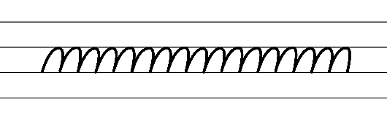  - Example NSW Foundation Style handwriting formation  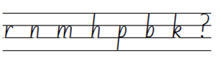  - Suggested practice text from the passage  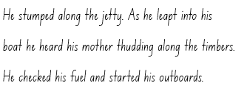  Note: students who are fluent in NSW Foundation Style can begin to use NSW Foundation Precursive and Cursive Style.
Handwriting legibility and fluency (Stage 2 Year 4)  - Join letters when writing familiar words  - Diagonally join to tall letters when writing familiar words.  - Diagonal joins to tall letters includes ab, ek, ch, ib, nt, th, ub and mt. | Handwriting legibility and fluency (Stage 2 Year 4)  - Suggested fluency pattern  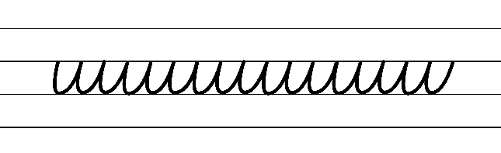  - Example letter joins to tall letters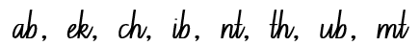  - Familiar words could include  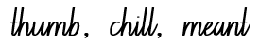  - Suggested practice text from the passage  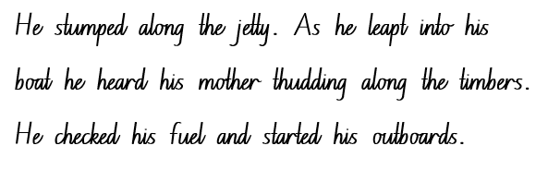
Handwriting and digital transcription  Handwriting legibility and fluency (Stage 3 Year 5)  - Sustain writing with a legible, fluent and personal handwriting style across a text  - Form legible and fluent diagonal joins from the baseline to short letters from a downstroke. These are sometimes referred to as baseline joins.  - Diagonal joins come from letters with exits near the baseline, including a, c, d, e, h, i, k, l, m, n, u and z.  - Diagonal joins to short letters continue the exit hook diagonally upwards to the start of the next letter.  - Most diagonal joins meet the next letter at the top of the letter’s body at a 45-degree angle.  - Highlight the position of the diagonal join to the letter e.  - Form legible and fluent diagonal letters from the baseline to tall letters.  - Diagonal joins from the baseline to tall letters join at line 2 (the neckline) and continue all the way to line 1 (the top line) before retracing part of the way back down and finishing the new letter.  - Focus attention on how joins provide a quick change in direction for letters that end on a downstroke at the baseline. Emphasise the downstroke so joining movements are not overemphasised and widened. | Handwriting and digital transcription  Handwriting legibility and fluency (Stage 3 Year 5)  - Suggested fluency pattern  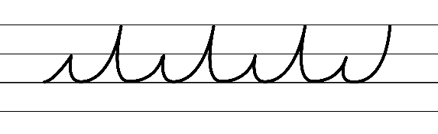  - Example NSW Foundation Style handwriting formation − diagonal joins to short letters from a downstroke  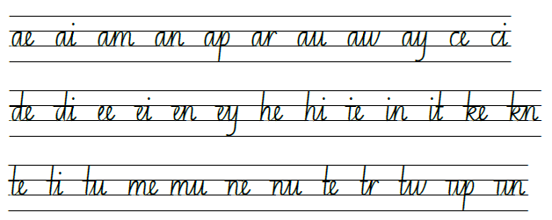  - Example NSW Foundation Style handwriting formation − diagonal joins to tall letters from a downstroke  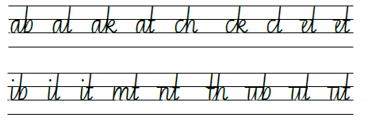  - Suggested practice text from the passage  - Encourage students to evaluate their own handwriting after practising. For example, asking them to circle horizontal joins they believe are formed well  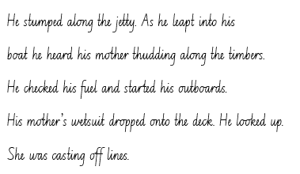
Handwriting legibility and fluency (Stage 3 Year 6)  - Sustain writing with a legible, fluent and personal handwriting style across a text  - Revise horizontal joins. | Handwriting legibility and fluency (Stage 3 Year 6)  - Suggested fluency pattern  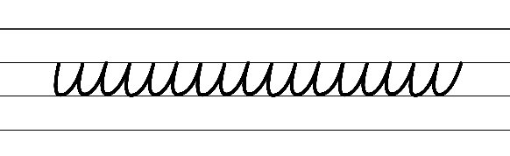  - Suggested practice text from the passage  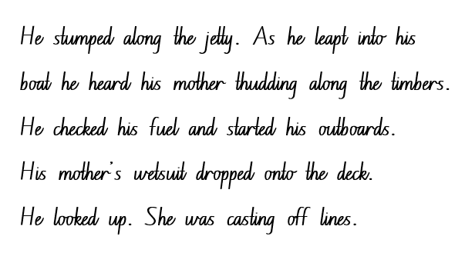  - Encourage students to evaluate their own handwriting after practising. For example, asking them to circle horizontal joins they believe are formed well.

Planning framework
To plan and document Component A teaching and learning, a planning scaffold [DOCX 228 KB] is provided. To support you in your planning, a link to a detailed example of a one-week teaching and learning cycle is included in the scaffold. Additional resources to support teaching and learning in each focus area can be found at Lesson advice guides.

Component B teaching and learning
The following teaching and learning sequence has been designed to address Component B outcomes and content and develops conceptual understandings of English through the study of quality texts. Adapt the sequence as required to best meet the needs of your students.

Learning intentions and success criteria
Learning intentions and success criteria are best co-constructed with students. The table below contains suggested learning intention and success criteria.
Element | Stage 2 | Stage 3
Learning intention | Students are learning to understand how narratives can rely on both real and imagined situations and characters. | Students are learning to understand how narratives can rely on both real and imagined situations and characters.
Success criteria | Students can:  - identify structural elements of a narrative including complication and series of events  - make connections between their personal experience and characters within the text  - write compound sentences, using coordinating conjunctions to compare or contrast  - experiment with dialogue and identify its purpose within a text  - identify themes within the text and the connection to real life scenarios and characters. | Students can:  - analyse structural elements of a narrative including complication and series of events that include conflict and tension  - use commas for a range of purposes including to separate a phrase from the main clause, to separate information within a sentence, or to separate items in a list  - identify models of behaviour explored in the themes of the text.

Lesson 5 – making connections between own experiences and those depicted in narratives
The following teaching and learning activities support multi-age settings.

Whole
- Review previously read chapters in Blueback, recalling details from the orientation.
- Refer to the anchor chart from Lesson 1 to review structural features of a narrative. Ask students to consider how Tim Winton has structured Blueback. Use questioning to draw out student understanding of where a typical narrative structure would move to next (the complication and series of events). Students turn and talk to discuss and provide justifications for their thinking. Ask:
- What is your understanding of a complication in a narrative? How would you define it in your own words?
- Is it essential to include a complication in the structure of a narrative? Why or why not? What purpose does it serve?
- Has the complication of Blueback been revealed yet? If so, what is it? If not, what might it be?
- Explain that the crucial stage of a narrative is the complication and series of events that follow. Explain that a narrative plot usually has more than one complication that builds suspense and tension to enhance reader engagement. Explain that, within a complication, the main characters experience conflict. The series of events that follow show characters overcoming internal and external challenges or conflicts to reach the story’s resolution.
- Read Chapter 6 of Blueback. Pause to explain that the novel contains large passages of time. Discuss key words and information.
- In pairs, students Think-Pair-Share to identify the main problem or complication of the narrative. For example, trying to keep Blueback and Longboat Bay safe. Students share responses.
- In pairs, students Think-Pair-Share to identify the internal conflict that has troubled Abel in Chapters 5 to 6. For example, moving away from home and feeling disconnected from his hometown.
- Ask students the following questions and to share their responses
- Why do you think Abel is so fond of Longboat Bay?
- What role does the sea play in establishing Abel’s connection to Longboat Bay?
- Can you relate to this feeling and experience? Do you have somewhere that you feel connected to?
- Analyse and discuss some of Tim Winton’s quotes in Chapters 5 to 6 that highlight the connection that Abel has with Blueback and his hometown. For example
- ‘I'll wither up and die away from this place, he thought as they bumped off down the gravel road. This is my place. This is where I belong’ (p 49).
- ‘Home throbbed in him like a headache’ (p 51).
- ‘Abel counted the days’ (p 57).
- Explain that students will make comparisons between their own lives and Abel’s life in Longboat Bay using a Venn diagram using Resource 6 – my life and Abel’s life. Encourage students to use key words and phrases when making inferences. For example, how they get to school, if they have pets, their responsibilities at home, who they live with and where they live as ideas to make comparisons to Abel’s life.
- In small groups, students complete Resource 6 – my life and Abel’s life.

Part
The table below details the differentiated teaching and learning activities for each stage.
Stage 2 (independent) | Stage 3 (teacher guided/small groups)
- Using key words and phrases from Resource 6 – my life and Abel’s life, students draw on their knowledge of declarative sentences using coordinating conjunctions from Component A to write a paragraph comparing their lives with Abel’s life. For example, ‘Abel travels to school by bus along the highway but I walk to school.’  - Provide students with Resource 7 – coordinating conjunctions to support writing. Remind students to apply capital letters for proper nouns and the use of adjectives to enhance meaning when writing.  Too hard? Students orally share sentences. | - Provide students with sentences from the text that contain commas for different purposes. For example, using a comma to separate a phrase from the main clause, to separate information within a sentence, or to separate items in a list. For example:  - ‘On the first day of the summer holidays, Abel’s mother met the bus on the highway’ (p 58).  - ‘Macka’s family had decided to give his boat to Abel. Boat, trailer, the lot’ (p 57).  - Have students identify the purpose of each of the commas. Discuss why authors use commas for different reasons. For example, ask what impact it has on the text or how the sentence might sound without the commas.  - Using key words and phrases from Resource 6 – my life and Abel’s life, students draw on their knowledge of sentences and commas to write a paragraph comparing their lives with Abel’s life.  - Encourage students to use commas in their writing to separate a phrase from the main clause, to separate information within a sentence or to separate items in a list. Remind students to apply capital letters for proper nouns and use adjectives to enhance meaning when writing.

Whole
- Students present their writing to highlight the similarities and differences between their life and Abel’s life. Students listen actively by acknowledging the value of others’ contributions and their identified connections. Display students’ work on a story wall.

Lesson 6 – understanding tension through dialogue
The following teaching and learning activities support multi-age settings.

Whole
- Ask students to recall what they know and understand about the narrative text. Review the orientation (characters and setting) and complication (keeping Blueback and Longboat Bay safe) thus far.
- Explain that a narrative builds suspense and tension which increases as the action rises from the complication to build to the narrative’s climax which enhances reader engagement. Explain that readers continue with a narrative because there is dramatic tension or conflict between characters (external conflict) or within a character (internal conflict). For example, in Chapters 5 to 6, Abel felt disconnected from his home and from Blueback when he went away to school (internal conflict).
- Read Chapters 7 to 8 of Blueback. Ask students to identify the tension that leads to the heightened drama, action, and movement of the narrative’s climax. Use think-alouds to facilitate a discussion about the use of dialogue to highlight the actions of Costello and the tension he creates for Longboat Bay. At the end of the chapter, students turn and talk to discuss:
- Why was Costello a problem for Abel and his community? How does Costello create conflict in the narrative?
- Why did Abel’s mother tell him she wanted to move inland because of him?
- Even though Abel’s mother discouraged him from going face to face with Costello and his men, how did she help to save Blueback from being killed?
- Do you think that Blueback’s life wouldn’t have been in danger if Abel had listened to his mother’s advice and stayed home? Why, why not?
- What key words in Chapter 7 highlight the tension Costello is creating in Longboat Bay?
- Revisit the excerpt ‘He got up and went to the window’ (p 72) to ‘Abel throttled up and they swerved out, thumping across the bay with the wind streaming in their hair’ (p 74). Discuss how dialogue is an essential component in achieving engagement and impact by progressing the plot, creating characterisation and generating tension. For example, the use of dialogue between Abel and his mother informs us about Costello becoming a problem for Abel and the community of Longboat Bay.
- Explain that Tim Winston does not ‘tell’ the reader about relationships; they are ‘shown’ in the dialogue. For example, the dialogue between Abel and his mother highlights Costello as a ‘vicious’ (p 73) character and the tension he creates in the community of Longboat Bay.
- Analyse the dialogue from Blueback to evaluate how Tim Winton represents Costello in the narrative. For example, ‘Costello’s giving the bay a real hammering... He’ll be at Robbers Head by lunchtime the way he’s going. There won’t be anything left on the reef at all. It’s wrong, mum’ (pp 72–73). Explore how the dialogue shows that Costello represents the threat of overfishing and destruction of the ocean.
- Analyse the dialogue ‘I’m making it my choice’ (p 73). Explain that the dialogue portrays Abel’s determination to confront Costello and highlights the significant role of environmental sustainability. Tim Winston uses the dialogue between Abel and his mother to show Dora’s protective nature of her son. For example, ‘Because if you went on your own it would be twice as stupid and twice as dangerous’ (p 74).
- As a class, reflect on the following questions:
- Why do authors use dialogue in a text?
- What is the purpose of the dialogue in Chapters 7 to 8 in relation to the building of the story’s climax?
- What does the dialogue between Abel and his mother reveal about Costello’s personality?
- What does the dialogue reveal about Abel and Dora’s personality?
- Are there any impactful lines of dialogue that resonate with you? Why do you think they stand out?
- Are there any hidden meanings in the dialogue that adds depth to the story?
- Refer to the final sentence of Chapter 8, ‘That summer he learnt that nothing in nature is as cruel and savage as a greedy human being’ (p 89). Ask students to Think-Pair-Share to discuss the purpose of the sentence and its emotional impact. Explain that the use of strong language, such as ‘cruel’ and ‘savage,’ evokes an emotional response from the readers, encouraging them to reflect on the actions of humans such as Costello and their implications.
- Ask what Abel and Costello might say if they came face to face. Students Think-Pair-Share to generate ideas. Students share back with the class.
- Explain that students will create a comic strip to portray the conversation between Costello and Abel.
- Model completing Resource 8 – comic strip template using illustrations and predicted dialogue between Abel and Costello with speech bubbles to depict the scene and the tension between the 2 characters. Use think-alouds to draw on students’ knowledge of Chapters 7 to 8 to include information about Costello’s fine, which cost him his licence and business.
- In pairs, students complete Resource 8 – comic strip template. This will also be used in Lesson 7. Encourage students to draw on Tier 2 vocabulary including adjectives to build description.
Note: students can use as many storyboard rectangles as needed.

Lesson 7 – using dialogue to create tension
The following teaching and learning activities support multi-age settings.

Whole
- Play a game of ‘Don’t say yes, don’t say no’ to develop students’ understanding of Abel and Costello’s character. In pairs, students take on the character roles of Abel and Costello. Drawing on their previous knowledge of Chapters 7 and 8, students engage in conversation while actively listening to questions posed by each other avoiding using of the words ‘yes’ and ‘no.’
- Review Chapters 7 and 8. Discuss how dialogue is a common feature in a narrative used to create characterisation and generate conflict.
- Review what students thought Abel and Costello might have said to one another, if they came face to face. Students briefly share ideas from Lesson 6 using Resource 8 – comic strip template.
- Explain that students will be using their ideas from Resource 8 – comic strip template to innovate from the mentor text to compose a short scene highlighting the interaction and conflict between Abel and Costello.
- As a class, brainstorm a list of verbs (as explored in component A) that can effectively convey action, emotion and description in students’ chosen scene. Explain that verbs are a tool that can bring dialogue to life and help transfer information in an engaging way. Ask students to consider verbs that align with the characters’ actions, emotions and the overall tone of the scene. For example, if the scene involves an argument between Abel and Costello, brainstorm verbs such as accused, shouted, demanded, defended and pleaded.
- Co-construct a success criteria for the short scene. For example:
- use declarative sentences
- use dialogue by signalling quotation marks
- use coordinating conjunctions in compound sentences
- use precise saying, thinking, acting, and relating verbs and verb groups
- use Tier 2 vocabulary including adjectives to develop descriptive features
- use capital letters to indicate the beginning of a sentence and for proper nouns.
- In a joint construction, use the information from Resource 8 – comic strip template in Lesson 6 to compose a short scene using quoted and narrated text to depict the tension and interaction between Abel and Costello. Carefully model how to transfer the dialogue from speech bubbles to sentences using quoted speech. Guide students to apply the ‘show, don’t tell’ strategy in their scene to build characterisation and tension.
- Using their Resource 8 – comic strip template, students complete their writing and refine ideas throughout the writing process.
- Explain that students will present their scenes to the class through a dramatic or expressive reading. Encourage students to consider how they will effectively present their scenes. Ask guiding questions, for example:
- What is the purpose of your presentation?
- How will you present the dialogue with expression to engage the audience?
- How will you maintain a clear structure while presenting?
- Students present their scenes to the class.
- Referring to co-constructed success criteria from activity 6, students use Two stars and a wish to provide feedback. Display comic strips on the story wall.
Stage 2 Assessment task 2 – observations and work samples from this lesson allow students to demonstrate achievement towards the following syllabus outcome and content point:
EN2-RECOM-01 – reads and comprehends texts for wide purposes using knowledge of text structures and language, and by monitoring comprehension
- understand that dialogue is a common feature of imaginative texts, signalled by quotation marks or speech bubbles to indicate interactions between characters.

Lesson 8 – exploring themes in a narrative
The following teaching and learning activities support multi-age settings.

Whole
- Explain that narratives can present a moral, also known as a lesson or a theme, that the author wants the reader to take away from the text. Explain that a moral or theme is the central meaning or significant message of a narrative. It is realised through the ways that setting, characterisation and plot develop and reflect each other. Draw attention to the fact that a moral or a theme is not always explicitly stated in a text; it is up to readers to understand and internalise the message by analysing characters, plot and other literary devices.
- Ask students what themes or messages Tim Winton shares through Blueback. Students share responses by brainstorming potential themes or messages and providing text evidence to support reasoning. For example:
- environmental sustainability
- marine conservation
- journey of life
- family and friendship
- belonging
- greed.
- Read ‘About the Author’ on the last page of Blueback and watch ABC: Ningaloo Nyinggulu (1:30). Discuss Tim Winton’s love of the sea and especially of the Ningaloo reef. Discuss his involvement in protecting the reef and others around Australia and how what he values in the natural environment is reflected in the themes explored in Blueback.
- Read Chapters 9 to 10. Pause to discuss how thematic threads are knitted through the complication and series of events.
- Discuss how the characters, setting and series of events contribute to the theme of environmental sustainability and marine conservation. For example, Dora writes to Abel explaining that investors came to Longboat Bay and submitted plans to change the landscape for financial gain which in turn would destroy the landscape and flora and fauna of Longboat Bay. Another example is the mystery of the pilchards floating dead along the coast.
- Highlight the increase in tension at the end of Chapter 10 as Dora expresses ‘“The ocean is sick,” said Abel’s mother. “Something’s wrong.”’ Discuss that tension is often used in a narrative. Tension creates suspense and helps the reader make a connection with the characters. Creating tension also helps readers anticipate future events or actions of characters. At this point in a narrative, the author often leaves the reader wondering ‘What’s next?’
- As a class, read and explore the articles ABC: Great Barrier Reef changes image from marine park to theme park with underwater statues and hotels and ABC: Volunteers, Wildlife staff rescue green seat turtle at Middleton Beach in South Australia. Discuss the effects of human development and pollution on the environment and marine life.
- Explain that students will be imagining a new event being introduced to Longboat Bay by innovating off the sentence from Chapter 10 ‘“The ocean is sick,” said Abel's mother. “Something's wrong.”’ Discuss the significance of this sentence and how it creates a sense of intrigue, concern and tension.
- Ask the following guiding questions:
- What could be wrong with the ocean?
- Are there any new characters or events that could disrupt the story?
- How will the themes of marine conservation or environmental sustainability be presented through the event?
- In small groups, students brainstorm ideas for a new event that causes tension in Longboat Bay. Encourage students to think creatively and consider different possibilities. Remind students to draw on the ideas from activity 5 about the effects of human impact on marine life. Encourage students to include details about the cause of the problem, its effects on characters and the environment.
Note: students will write a resolution to their complication in Lesson 12.
- Students share possible ideas for a new event that causes tension. Record on an anchor chart to use as a reference in Lesson 9.
- Use exit tickets to demonstrate student knowledge. Students share their opinions by elaborating with reasons. Encourage the use of protocols to support learning conversations. Ask:
- What is the main theme of Blueback?
- Why do you think Tim Winton chose this theme?
- What message do you think the story has for the reader?
- How does the story get you thinking?

Week 3

Component A teaching and learning
Component A focuses on the development of foundational skills and knowledge through regular, systematic and repeated practice. The mentor and supporting texts used in Component B of this unit can support the effective implementation of Component A teaching and learning.

Teaching guide
Guidance for explicit teaching, teaching notes, resources and examples for the related outcomes and content points have been provided in the table below.
Focus areas and teaching notes | Resources and examples
Reading fluency  Reading rate and automaticity (Stage 2)  - Syllabify, blend grapheme–phoneme correspondences and use morphemic knowledge as strategies for reading words accurately  - Locate and syllabify multisyllabic words, including those with morphemic suffixes (-ing, -ed, -ly).  - For every syllable, there is at least one vowel phoneme.  - Morphemic suffixes usually form their own syllable.  - The morphemic suffix -ed forms a syllable when pronounced as ‘ed’ but does not when pronounced as ‘d’ or ‘t’. | Reading fluency  Reading rate and automaticity (Stage 2)  - Fluency and close reading passage – Chapter 11, from page 110, ‘Abel Jackson met a girl who loved the sea...’ to page 113 ‘...Abel remembered the dolphins as a good omen because that was the night he asked Stella to marry him’ (396 words).  - Suggested words from the passage  - Morphemic information  - climbing – climb + ing  - remembered – remember + ed  - flirted – flirt + ed  - actually – actual + ly.  - Syllables  - celebration – 4 syllables  - abalone – 4 syllables  - embarrassed – 3 syllables  - remembered – 3 syllables.
Prosody (Stage 2)  - Explain how prosodic reading involves emphasis, expression, intonation and pausing  - Expression is the use of voice, intonation and facial expressions to convey the emotions, tone and meaning of the text being read aloud. It involves bringing the characters and the narrative to life by infusing the words with appropriate emotions and emphasising key points. When the reader gives extra importance or focus to specific words or parts of a sentence, it helps to convey the meaning behind the text. | Prosody (Stage 2)  - Suggested sentences using dialogue to illustrate the use of expression from the passage  - “Stella,” she said, “You know that you’ll have to share Abel, don’t you?”  - “Of course,” said Stella. “You’re his mother.” Dora Jackson laughed. “Actually, I was thinking of somebody else. Abel, let’s show her who we mean.”
Reading comprehension  Reading for interest and wide purposes (Stage 2)  - Identify different purposes and strategies for reading  - Identifying different purposes and strategies for reading is important when engaging with narratives. Each purpose and strategy can influence how readers interpret characters, events, and settings, and how they emotionally connect with the narrative. | Reading comprehension  Reading for interest and wide purposes (Stage 2)  - In Chapter 11, a new character is introduced (Stella). Abel’s strong connection to the ocean is highlighted through the dolphin being a good omen and readers explore the passage of time through Abel growing up and moving onto his next stage of life.
Comprehending language (Stage 2)  - Use morphemic knowledge to read and understand the meaning of words  - Suffixes can be added to base words to adjust their meaning.  - -ly means ‘a characteristic of’ and attaches to nouns to form adjectives, or for adjectives to form adverbs  - -y means ‘characterised by’ and attaches to nouns and verbs to create adjectives  - -ing can be added to some nouns to turn them into adjectives, describing something that causes a certain feeling or emotion  - -ed when added to a verb changes to past tense. | Comprehending language (Stage 2)  - Morphemic information of words from the passage  - climbing: climb + ing  - remembered: remember + ed  - sweated: sweat+ ed  - actually: actual + ly  - suddenly: sudden +ly  - papery: paper + y
Comprehending language (Stage 2)  - Use key words from a text to visualise events, characters and settings when making inferences and confirming predictions  - Key words used to describe characters can encompass various aspects of their personalities, appearances, traits, behaviours and emotions. These words help readers form a mental image of the character and understand their role within the narrative. | Comprehending language (Stage 2)  - Key words and phrases describing Stella: ‘sleek as a seal’ (p 110), ‘funny’ (p 110), ‘hair was black and shiny’ (p 110)  - Key words describing Dora: ‘lines like gull’s feet all over her face’ (p 110), ‘skin seemed dry and papery’ (p 111).  - Key words describing Abel: ‘nervous’ (p 111), ‘worried’ (p 111).
Monitoring comprehension (Stage 2)  - Identify where meaning breaks down when reading  - Meaning may break down when unfamiliar vocabulary or phrases are introduced, or background knowledge is required.  - Meaning may break down when figurative language is used. For example, if similes are taken too literally or misinterpreted.  - A simile is a type of figurative language that compares two things using ‘like’ or ‘as’ to create a vivid image or description. | Monitoring comprehension (Stage 2)  - Suggested vocabulary and phrases to be explained from the passage: sanctuary, bred in their haven (metaphorical meaning), teeming world, rippling, omen.  - The simile ‘she was as sleek as a seal,’ makes the comparison between Stella being the ‘she’ and ‘a seal.’ In this example, Stella does not physically resemble a seal but likely shares some qualities with a seal in terms of her gracefulness or elegance.  - The simile ‘abalone grew like snails’ suggests that the growth rate of abalone is like that of snails. Snails are known for their slow and steady pace of growth and the simile implies that abalone shares this characteristic.
Reading comprehension  Reading fluently (Stage 3)  - Syllabify, blend grapheme–phoneme correspondences and use morphemic knowledge as strategies for reading words accurately  - Locate and syllabify multisyllabic words, including those with morphemic suffixes (-ing, -ed, -ous).  - For every syllable, there is at least one vowel phoneme.  - Morphemic suffixes usually form their own syllable. | Reading comprehension  Reading fluently (Stage 3)  - As above, see Stage 2 Reading Fluency examples.
Comprehending language (Stage 3)  - Use morphology and etymology to work out the meaning of unfamiliar words  - The etymology or origins of, and changes to, words in relation to meaning. (NESA 2023) | Comprehending language (Stage 3)  - Morphemic information of words from the passage  - climbing: climb + ing  - remembered: remember + ed  - sweated: sweat + ed  - actually: actual + ly  - Suddenly: sudden +ly  - papery: paper + y
Monitoring comprehension (Stage 3)  - Monitor and repair reading when meaning breaks down  - This may include pausing, self-correcting, re-reading or reading on; using phonic morphemic or word knowledge and reactivating background knowledge. | Monitoring comprehension (Stage 3)  - As above, see Stage 2 Reading comprehension example.
Vocabulary  Learning and using words (Stage 2)  - Build personal Tier 1, Tier 2 and Tier 3 vocabulary through social and learning interactions, reading and writing  - Tier 1 words: Basic-level, everyday words (NESA 2023).  - Tier 2 words: General academic words that can be used across a variety of domains. They are of high utility for mature language users and are commonly used in written language (NESA 2023).  - Tier 3 words: Words that are used rarely (low frequency) and only in highly specific situations (NESA 2023). | Vocabulary  Learning and using words (Stage 2)  - Tier 2 vocabulary from the passage: papery (p 111) flirted (p 112), shrieked (p 112), nuzzled (p 112), twitched (p 112), heaved (p 112), boosted (p 112), swirled (p 112), champagne (p 112), frosted (p 112).
Defining and analysing words (Stage 2)  - Apply morphemic knowledge to change word meanings by adding different prefixes and suffixes to a base word or root  - Use morphemic knowledge to read and understand Tier 2 words (-ed, -ing, -ly)  - Suffix -ed changes the tense of the verb. -ed expresses past tense.  - Suffix -ing changes the tense of a verb: -ing expresses present tense; -ing also expresses future tense.  - Suffix -ly means ‘a characteristic of’ and attaches to nouns to form adjectives, adjectives to form adverbs. | Defining and analysing words (Stage 2)  - See Stage 2 Reading fluency examples.  - Suggested word inquiry: biologist (p 117) – bio, biology, biologist.
Vocabulary  Learning and using words (Stage 3)  - Identify newly encountered words from interactions and wide reading, and use them in writing, discussions and presentations  - Identify and discuss the meanings of newly encountered Tier 2 and Tier 3 words in the text to improve vocabulary knowledge and comprehension. It could be a word with an unfamiliar meaning, an unusual spelling, or a term specific to a certain context. | Vocabulary  Learning and using words (Stage 3)  - Suggested newly encountered words from passage: papery, twitched, heaved, boosted, bristled, omen.
Defining and analysing words (Stage 3)  - Analyse morphemic structures of Tier 2 and Tier 3 words to determine their meaning  - There are 2 types of morphemes – free (independent) morphemes and bound (dependent) morphemes.  - Free morphemes can function as stand-alone words with specific meaning. These are sometimes known as base words.  - Bound morphemes, when added to words, alter their meaning or create new words. They cannot occur independently. Bound morphemes include prefixes (un-, dis-) which are at the beginning of words and suffixes (-ed, -s) which are added to the ends of words.  - Focus suffixes: -ly, -y, -ing, -ed. | Defining and analysing words (Stage 3)  - Morphemic information of Tier 2 words from the passage  - climbing: climb + ing  - sweated: sweat + ed  - actually: actual + ly  - suddenly: sudden + ly  - papery: paper + y  - fooled: fool + ed
Spelling  Phonological component (Stage 2)  - Explain how to segment multisyllabic words into syllables and phonemes, and apply this knowledge when spelling  - Revise segmenting multisyllabic words into syllables and phonemes. For example, jockey has 2 syllables and 4 phonemes (j-o-ck-ey). This is a phonological skill that should be practised regularly.  - Identify differences in vowel phonemes (short, long, diphthong and schwa vowels)  - Revise long vowel phonemes /ow/ as in own  - The long vowel phoneme /ow/ can be represented by the vowel digraphs [oa, ow, oe]. The grapheme [o] and the split digraph [o_e] can also be used to represent the phoneme /ow/. | Spelling  Phonological component (Stage 2)  - Suggested words from Week 3 reading material- show-shows-showing-showed, groper(s), float-floats-floating-floated, omen(s), know-knows-knowing-knew, write-writes-writing-wrote, home(s), own-owns-owning-owned, hotel(s), shallow(s), swallow-swallows-swallowing-swallowed, close-closes-closing-closed.  - Sample words: bone(s), earlobe(s), gecko(es), potato(es), joke-jokes-joking-joked, boast-boasts-boasting-boasted.
Orthographic component (Stage 2)  - Apply knowledge of taught vowel graphemes when spelling  - The most common graphemes that represent the long vowel phoneme /ow/ as in ‘own’ include [oa, ow, o_e, o, oe] | Orthographic component (Stage 2)  - As above
Morphological component (Stage 2)  - Identify inflected suffixes, explaining when and how to treat base words when they are affixed, and apply this knowledge when spelling  - An inflected suffix is a bound morpheme added to the end of a base word to assign a number to a word, to indicate possession or tense, or to provide a comparison (-s, -es, -ing, -ed, -er, est).  - The inflected suffixes -s and -es change a noun from singular (one) to plural (more than one).  - The inflected suffixes -s, -ing, -ed change the tense of a verb. The suffixes -s and -ing express present tense, -ed expresses past tense; -ing also expresses future tense. | Morphological component (Stage 2)  - As above
Spelling  Phonological component (Stage 3)  - Segment unfamiliar multisyllabic words into syllables and phonemes as a strategy when spelling  - Revise segmenting multisyllabic words into syllables and phonemes. This is a phonological skill that should be practised regularly. | Spelling  Phonological component (Stage 3)  - Suggested words from Week 3 reading material- city, celebrate-celebration, circled, countries, century, confetti, coral, coast.  - Sample words: construct-construction, pollute-pollution, protect-protection, generate-generation, populate-population, prevent-prevention, educate-education, distribute-distribution, innovate-innovation, invent-invention, extinct-extinction, habitat-habitation, ignite-ignition, oppress-oppression.
Orthographic component (Stage 3)  - Recognise that the same grapheme can represent different phonemes  - Revise graph [c] representing /k/ and /s/.  - Highlight the different phonemes that are represented by the grapheme [c]. [c] can be used to represent /k/ as in kid and /s/ as in city. Note the grapheme’s position within base words. | Orthographic component (Stage 3)  - As above
Morphological component (Stage 3)  - Explain and use spelling conventions to add derivational suffixes such as -ion, -ian, -ence, -ous to base words or roots  - Introduce derivational suffix: -ion meaning ‘act’ or ‘process’  - Teach adding -ion to verbs to form nouns. For example, educate-education, discuss-discussion, mot-motion.  - Teach ‘drop the e’ rule. For example, educate-education. | Morphological component (Stage 3)  - As above.
Creating written texts  Sentence level grammar (Stage 2)  - Use coordinating conjunctions in compound sentences to compare and contrast, or for addition  - Coordinating conjunctions: A word or group of words that function to link 2 independent clauses within a sentence (NESA 2023).  - Select and use precise saying, thinking, acting, and relating verbs and verb groups to align with text purpose  - A verb is a word that tells what is happening (NESA 2023).  - A verb group is a group of words built around a verb (NESA 2023).  - Use declarative sentences to provide facts or state a viewpoint  - A declarative sentence is a statement presented as a complete sentence to provide fact, evidence or detail (NESA 2023). | Creating written texts  Sentence level grammar (Stage 2)  - Suggested coordinating conjunctions in compound sentences for contrast  - To him she’d always been young, but now, standing beside Stella, her skin seemed dry and papery. (p 111)  - Suggested verbs from the passage  - Saying verb: shrieked (p 112)  - Acting verbs: nuzzled (p 112), swirled (p 112).  - Suggested declarative sentences (simple) from the passage  - She was an old woman (p 111).  - It was like a celebration (p 113).
Word-level language (Stage 2)  - Use adjectives to develop descriptive features  - Adjectives are words that describe, identify or quantify a noun or a pronoun. Different types of adjectives include possessive, quantifying, descriptive, comparative, superlative and classifying (NESA 2023).  - Adjectives can be used for imaginative purposes to describe characters, settings and events.  - Descriptive adjectives give more information about the noun or pronoun. They help to add details about the noun they are modifying. This can be related to size, shape, colour, texture and other qualities. | Word-level language (Stage 2)  - Suggested adjectives from the passage  - lined (p 111)  - dry and papery (p 111)
Punctuation (Stage 2)  - Use commas between words in a list or to separate adjectives when more than one is use  - Commas are a punctuation marker used to show separation between parts of a sentence, such as clauses or phrases, where separation is important to the meaning. Commas are also used to separate words, phrases or numbers in a series (NESA 2023).  - Use capital letters to indicate the beginning of a sentence, proper nouns, headings and subheadings, to indicate the beginning of a poetry line, for emphasis, and when using acronyms  - Review sentence boundary punctuation, including capital letters to indicate the beginning of a sentence and to indicate proper nouns. | Punctuation (Stage 2)  - Use of commas between words in a list from the passage  - They ate squid and urchin eggs, apricots, grapes and melons. (p 112)  - Use of capital letters to indicate proper nouns in the fluency passage  - That summer Abel brought Stella to Longboat Bay (p 111).  - Suggested proper nouns using capital letters from the passage  - Abel Jackson, Dora Jackson, Longboat Bay, Stella, Robbers Head, Blueback.
Creating written texts  Sentence level grammar (Stage 3)  - Make choices about verbs and verb groups to achieve precision and add detail  - Verbs are essential building blocks in a narrative, shaping a narrative’s structure, characters, and atmosphere. Verbs are powerful tools that writers use to convey action, emotion, and meaning, enabling readers to immerse themselves in the narrative and experience the story on a deeper level.  - Include appositives to provide details to nouns and to vary sentence structures suited to text purpose  - An appositive is a noun or pronoun that is positioned beside another noun or pronoun to explain or identify it. An appositive often includes modifiers. | Creating written texts  Sentence level grammar (Stage 3)  - Suggested verbs from the fluency passage  - shrieked (p 112)  - nuzzled (p 112)  - swirled (p 112)  - Innovated sentence including an appositive to provide details to the noun from the passage  - Abel, a lifelong friend of the sea, remembered the dolphins as a good omen because that was the night he asked Stella to marry him. (p 113)
Punctuation (Stage 3)  - Use capital letters to indicate the beginning of a sentence, proper nouns, headings and subheadings, to indicate the beginning of a poetry line, for emphasis, and when using acronyms  - Review sentence boundary punctuation, including capital letters to indicate the beginning of a sentence and to indicate proper nouns.  - Use a comma to separate a subordinate clause or a phrase from the main clause, or to separate information within a sentence, or to separate items in a list  - Commas are a punctuation marker used to show separation between parts of a sentence, such as clauses or phrases, where separation is important to the meaning. Commas are also used to separate words, phrases or numbers in a series (NESA 2023). | Punctuation (Stage 3)  - Use of capital letters to indicate proper nouns from the passage  - That summer Abel brought Stella to Longboat Bay (p 111).  - Use of a comma to separate a subordinate clause or a phrase from the main clause from the passage  - With a young woman standing beside her, Dora Jackson looked old (p 111).
Handwriting and digital transcription  Handwriting legibility and fluency (Stage 2 Year 3)  - Understand that legible handwriting is consistent in size and spacing and can support learning  - Form the ‘anticlockwise’ letters c, o, a, d, g, q, e, s and f using consistent size and spacing  - Spacing: Consistent spacing supports the legibility and appearance of handwriting. Draw attention to appropriate spacing within words, between words and between lines of writing.  - Form basic punctuation marks, including an exclamation mark  - Exclamation marks are full height. They are the same height as capital letters. | Handwriting and digital transcription  Handwriting legibility and fluency (Stage 2 Year 3)  - Suggested fluency pattern  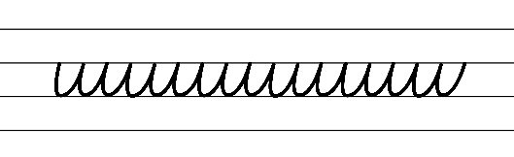  - Example NSW Foundation Style handwriting formation  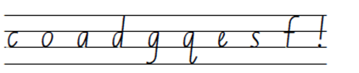  - Suggested practice text from the passage  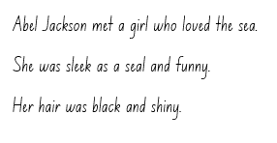  Note: students who are fluent in NSW Foundation Style can begin to use NSW Foundation Precursive and Cursive Style.
Handwriting legibility and fluency (Stage 2 Year 4)  - Join letters when writing familiar words  - Diagonally join to anti- clockwise letters when writing familiar words.  - Diagonal joins to anti-clockwise letters may include ha, ic, eg, ta.  - Retrace the top of an anti-clockwise letter following a horizontal/diagonal join. | Handwriting legibility and fluency (Stage 2 Year 4)  - Suggested fluency pattern  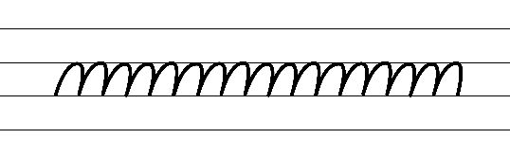  - Example joins to anti-clockwise letters  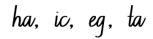  - Familiar words could include  - Suggested practice text from the passage  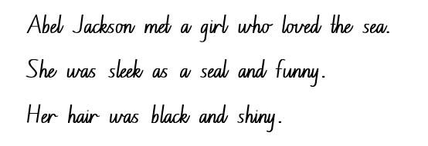
Handwriting and digital transcription  Handwriting legibility and fluency (Stage 3 Year 5)  - Sustain writing with a legible, fluent and personal handwriting style across a text  - Form legible and fluent diagonal joins to anticlockwise letters, including to a, c, d, g, o and q. These are sometimes referred to as backtouch or drop-in joins.  - To form a join to anticlockwise letters, continue the exit hook almost up to line 2 (the neckline) then draw in the anticlockwise letter so that it neatly touches the end of the exit hook.  - Slope cards can be used to reinforce spatial relations, including the maintaining of a consistent parallel slope between letters. | Handwriting and digital transcription  Handwriting legibility and fluency (Stage 3 Year 5)  - Suggested fluency pattern  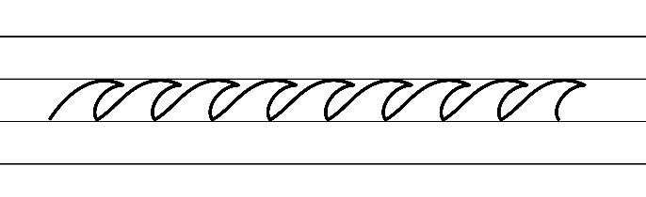  - Example NSW Foundation Style handwriting formation − diagonal joins to anticlockwise letters  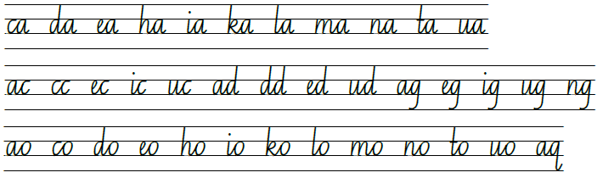  - Suggested practice text from the passage  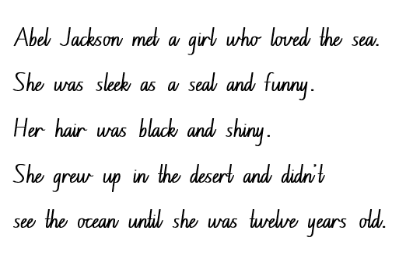
Handwriting legibility and fluency (Stage 3 Year 6)  - Sustain writing with a legible, fluent and personal handwriting style across a text  - Revise horizontal joins to the letter ‘e’. For example, oe, we, xe, re, ve. | Handwriting legibility and fluency (Stage 3 Year 6)  - Suggested fluency pattern  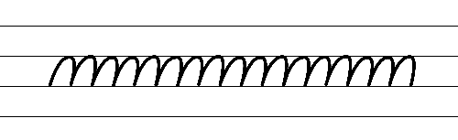  - Students write a passage from the mentor or supporting text.  - Encourage students to evaluate their own handwriting after practising. For example, asking them to circle horizontal joins to ‘e’ they believe are formed well.

Planning framework
To plan and document Component A teaching and learning, a planning scaffold [DOCX 228 KB] is provided. To support you in your planning, a link to a detailed example of a one-week teaching and learning cycle is included in the scaffold. Additional resources to support teaching and learning in each focus area can be found at Lesson advice guides.

Component B teaching and learning
The following teaching and learning sequence has been designed to address Component B outcomes and content and develops conceptual understandings of English through the study of quality texts. Adapt the sequence as required to best meet the needs of your students.

Learning intentions and success criteria
Learning intentions and success criteria are best co-constructed with students. The table below contains suggested learning intention and success criteria.
Element | Stage 2 | Stage 3
Learning intention | Students are learning to understand how characters contribute to different elements of a narrative. | Students are learning to understand how characters contribute to different elements of a narrative.
Success criteria | Students can:  - use a combination of adjectives, verbs and verb groups within declarative sentences to describe characters  - identify structural elements of a narrative including a resolution  - use capital letters at the beginning of a sentence or for proper nouns. | Students can:  - effectively use a combination of appositives, adjectives, verbs, verb groups and commas within a variety of sentence structures to describe characters  - understand and apply knowledge of narrative structural elements including resolutions  - consistently use capital letters at the beginning of a sentence and for proper nouns.

Lesson 9 – creating tension through events
The following teaching and learning activities support multi-age settings.

Whole
- Review Chapters 9 to 10 where tension is increased with the use of dialogue. For example, ‘“The ocean is sick,” said Abel’s mother. Something’s wrong”’ (p 104). Ask students to predict what might happen in the next chapter. Encourage students to use their understanding of the themes of the text (environmental sustainability and marine conservation) to support their predictions.
- Use the excerpt to further analyse the language features Tim Winton used to create tension. For example, ‘“It was a mystery.” And the more he thought about it the more the whole sea seemed to be a puzzle. Abel wanted to figure it out’ (p 104):
- ‘It was a mystery’ is a 4-word simple sentence which helps creates anticipation.
- The use of the word ‘puzzle’ in creates vivid imagery of a complex and perplexing situation. The idea of the sea as a puzzle evokes a sense of mystery and the need for unravelling its secrets, intensifying the tension.
- The sentence concludes with ‘Abel wanted to figure it out.’ This statement highlights Abel's personal investment in solving the mystery (character motivation), conveying his determination and implies that the mystery holds significance for him, further intensifying the tension.
- Review the anchor chart from Lesson 8. Explain that students will choose one idea from their brainstorming session that they find most interesting to write a new event by innovating off the sentence opener ‘“The ocean is sick,” said Abel's mother. “Something's wrong...”’
- Explain that students will add tension to their writing of a new event using details about the cause of the problem, its effects on the characters and the environment.
Note: students will analyse and write the resolution to the event in Lesson 12.
- Co-construct a success criteria for students’ writing. For example, I can write a paragraph that adds tension and includes:
- simple and compound sentences to describe the event using tension
- declarative sentences
- Tier 2 saying, thinking, acting, and relating verbs and verb groups
- Tier 2 adjectives to develop descriptive features
- capital letters to indicate the beginning of a sentence and for proper nouns
- correctly positioned commas.
- Model writing a paragraph prior to students creating their own. For example:
Abel's eyes widened and his jaw dropped. Plastic bottles and bags were sprawled across the shore, casting a sorrowful shadow on the vibrant sand. Longboat Bay had now been tragically transformed into a haunting landscape of plastic waste. Abel's heart felt heavy. The plastic waste had been hurting the animals and making the water sick. Even the normally lively pilchards floated silently and lifelessly along the coast. The very sight of it sent a shiver down his spine.
- Students write their own paragraph.
Too hard? Students work in pairs to write a paragraph.
Too easy? Students add dialogue to their paragraph.
- In pairs, students re-read, revise and edit their writing applying feedback received from their peer.
- Reflect on learning by selecting students to present their writing. Students listen actively, acknowledging the value of other’s contributions.

Lesson 10 – crafting interview questions for characterisation
The following teaching and learning activities support multi-age settings.

Whole
- Read Chapters 11 to 12. Ask students to discuss what happens in the chapters.
- Review the main complication or problem of the story. For example, to keep Blueback and Longboat Bay safe.
- Students Think-Pair-Share to discuss the definition of conflict within a narrative. For example, conflict involves the problems or tensions that a character experiences through the narrative’s series of events or rising action.
- Explain that conflict is what makes a story exciting and keeps the reader engaged. Explain that, like in real life, conflict in a story is an opportunity for characters to grow, transform, learn and evolve. Explain that readers continue with a narrative because there is dramatic tension or conflict between characters (external conflict) or within a character (internal conflict).
- Brainstorm and record a list of conflicts presented in Blueback. For example:
- Abel moving away from Longboat Bay.
- Dora standing up to developers.
- Abel’s mother telling the skippers to leave Blueback alone.
- Abel and Dora challenging Costello.
- The oil slick in longboat Bay.
- In small groups, students select a conflict to present a short drama freeze frame that depicts their assigned conflict.
- Optional: Provide cameras or iPads for groups to photograph or record their freeze frames. Students present their freeze frames to the class for their peers to guess.
- Ask students to identify the characters that appeared in Chapters 11 and 12. For example, Abel, Dora, Blueback, Stella. Record responses on the board.
- Explain that students will prepare a set of interview questions for a selected character from Chapters 11 to 12 with a focus on asking questions based on the information presented from Chapters 11 to 12 including their life as well as any conflict or tension experienced.
- Model writing questions for each character. Highlight the use of a capital letter for the beginning of a sentence. For example:
- Dora: How did you inspire Abel to develop a love of the sea? What are some of your most memorable encounters with Blueback?
- Abel: How did you meet Stella? How did you feel when you heard the news of the oil spill off the coast of Longboat Bay?
- Stella: How did you feel when you were introduced to Abel’s mother? What do you like the most about him?
- Blueback: What do you value the most about your friendship with Abel? What challenges have you faced in the underwater world, and how have you overcome them?

Part
The table below details the differentiated teaching and learning activities for each stage.
Stage 2 (in pairs) | Stage 3 (Independent and in pairs)
- In pairs, students use Resource 9 – interview questions to prepare a set of interview questions for one or more characters from Chapters 11 to 12. Students focus on asking questions based on the information presented in Chapters 11 to 12, including aspects of their character’s life as well as challenges or conflict they experienced. | - Students use Resource 10 – interviewing a character – Q & A to prepare a set of interview questions for a character they have selected from Chapters 11 to 12. Students focus on asking questions based on the information presented in Chapters 11 to 12, including aspects of the character’s life as well as challenges or conflict they experienced.  - In pairs, students take turns pretending to be their peer’s selected character and answer their questions. Students use evidence from the text to justify their responses.

Whole
- As a class, participate in a hot seat where students adopt a character persona (Abel, Dora, Stella or Blueback) and respond to questions asked by the audience whilst staying in character. The audience takes turns asking each character a question using their questions formulated from activity 10.

Lesson 11 – characterisation through relationships
The following teaching and learning activities support multi-age settings.

Whole
- As a class, engage in the game of ‘Two truths and one lie’. Model describing a character from Blueback in detail using 2 truths and one lie. The class then tries to identify the part of the description that is untrue. The game continues in pairs with students describing a new character and asking their partner to try to identify the part of the description that is untrue.
- Discuss that the characters in Blueback present an element of contemporary realism. It presents family relationships and friendships. It also constructs emotional conflict for Abel and Dora. Explain that readers recognise relationships within a text, for example, between groups or within families even if they are different to the reader’s immediate context. The way an author shows character development can be seen in the relationships the character has with others.
- Read Chapters 13 to 14 of Blueback.
- As a class, discuss the relationships within the narrative of Blueback using the following guiding questions
- What are the shared values or interests between the characters? For example, to protect the future of Longboat Bay.
- How do the characters support or challenge each other? For example, when Dora returns home from the hospital, Abel and Stella nurse her back to health.
- How would you describe the relationship between Abel and Dora? For example, Abel and Dora have a mother and son relationship of love, care and commitment.
- Are there any significant events or conflicts that shape their relationship? For example, the conflict from the developers and the whale bones washing up along the bay trigger Dora to write letters to politicians, scientists about protecting Blueback and the bay.
- What do the characters learn from each other? For example, environmental awareness, perseverance, responsibility, accountability, resilience, compassion, trust, love and sacrifice.
- Brainstorm a list of adjectives that describe the relationship between the characters of Abel, Dora, the developers, Stella and Baby Dora. For example, close, strong, supportive, committed, loving, concerned, protected, empathetic and caring. Highlight the use of a comma to separate words in a list. Display in the classroom as a reference.
- Explain that students will complete Resource 11 – character sociogram, looking at the relationships between the characters to determine how they feel about each other. Explain that analysing character relationships assists readers to recognise characters’ key characteristics or attributes as they progress through various events and actions throughout a narrative.
- Model drawing arrows to connect characters, showing the direction of their relationship and including key words and details using supporting ideas and inferences from the text (see Resource 12 – character sociogram exemplar).
- In pairs, students complete Resource 11 – character sociogram.

Part
The table below details the differentiated teaching and learning activities for each stage.
Stage 2 (independent) | Stage 3 (independent)
- Students use Resource 11 – character sociogram, to write a paragraph describing Abel through his relationships and the events that take place within the narrative. Encourage students to apply their knowledge of adjectives, verbs, verb groups, declarative sentences and commas to compose their description.  Too hard? Provide students with sentence starters to assist scaffold their writing. | - Students use Resource 11 – character sociogram to write a paragraph that provides a detailed description of Abel through his relationships and the events that take place within the narrative. Encourage students to apply their knowledge of appositives, adjectives, verbs, verb groups and commas to compose their description.  Too hard? Jointly construct a description of Abel.

Whole
- Students reflect on learning by sharing their writing with a peer.
- Use exit tickets to demonstrate student knowledge of narrative and characterisation. Encourage the use of protocols to support learning interactions. For example:
- Do the characters in the story work together as a team, or do they face conflicts with each other?
- How did the characters help each other or show kindness to one another in the story?
- How did the characters’ feelings and emotions affect their interactions with each other?
- Did the characters learn from each other or grow as individuals through their relationships?
- Which character is your favourite, and why do you like them?

Lesson 12 – resolution of a narrative
The following teaching and learning activities support multi-age settings.

Whole
- Narrative quiz: Provide students with statements to assess their understanding of Blueback. If a student thinks the statement is true, they perform star jumps; if they think the statement is false, they hold a squat stance. Students respond by offering the correct information to reinforce their understanding of the text. For example:
- Abel’s mother is a marine biologist who instils a love for the ocean in Abel. (True)
- Mad Macka liked to go diving with others for abalone. (False, he preferred to go diving alone)
- Businessmen tried to buy Dora’s land from her so they could develop it into a resort. (True)
- Abel went away to school the year he turned 12. (False, he was thirteen)
- Dora broke her leg when she fell down the verandah steps. (False, she broke her hip)
- Reflect upon the story of Blueback thus far. Ask students to predict and infer what might happen at the end of the story.
- Read Chapters 15 to 16 of Blueback. Pause to discuss key vocabulary and confirm predictions.
- Ask students to identify the falling action and how the complication was resolved for all characters in Blueback. For example, Dora was now at peace because Longboat Bay was preserved. Abel returned to the place he loved with Stella and their young daughter Dora, who can now grow up to enjoy Longboat Bay as he had as a young boy. Dora passes away and Abel and his wife stay on to continue the work she has started in protecting and advocating for the environment in their community.
- Discuss the purpose of a resolution. For example, to solve the problem and provide closure, satisfy the reader’s expectations and give a sense of completion to the story.
- Brainstorm different types of resolutions. For example:
- Moral or lesson – the main character grows and learns something
- Surprise ending – the reader is left with an unexpected ending or twist
- Happy ending – the problem faced by the characters is solved in a positive or expected way
- Humorous ending – the story ends with a funny thought or action
- Cliffhanger ending – the story ends with the reader wanting more (for example, a sequel).
- Students Think-Pair-Share to identify what type of resolution Tim Winton used in Blueback (happy ending/lesson), providing details and examples from the text to support thinking. Students share ideas.
- Explain that students will write a resolution to their complication from Lesson 9.
- Revisit the teacher modelled complication from Lesson 9.
- Students Think-Pair-Share to discuss a possible resolution to the complication. Record ideas on an anchor chart to use as a reference.
- Co-construct a success criteria for students’ writing. For example, I can write a paragraph that adds tension which includes:
- simple and compound sentences
- declarative sentences
- Tier 2 saying, thinking, acting, and relating verbs and verb groups
- Tier 2 adjectives to develop descriptive features
- capital letters to indicate the beginning of a sentence and for proper nouns
- correctly positioned commas
- appositives (Stage 3).
- Model rewriting a resolution using ideas recorded on the anchor chart. For example
Determined to make a difference, Abel, a passionate young activist, took a deep breath and gathered his thoughts. He reached out to the local community, organising a beach cleanup event. He invited friends and family to join him in restoring Longboat Bay to its former glory. The response was overwhelming, and on the day of the cleanup, a group of dedicated individuals stood shoulder to shoulder, armed with gloves and rubbish bags. As they worked tirelessly, the sorrowful shadow across the sand slowly lifted, replaced by a glimmer of hope. The plastic waste was collected, one piece at a time, and properly disposed of. The once lifeless pilchards now danced in the clear waters, thanking Abel and the community for their efforts. Through their collective action, they had given nature a chance to heal and thrive once more. Longboat Bay was on its way to becoming a pristine paradise again, and Abel knew that this was just the beginning of a journey towards a more sustainable and mindful future.
- Students re-read their complication written from Lesson 9 and write a resolution to their problem. Provide time for students to compose, revise and edit.
- In pairs, students share their writing and provide peer feedback using the success criteria and the Tell, Ask, Give (TAG) strategy.
Too hard? Students work in groups to generate ideas.

Week 4

Component A teaching and learning
Component A focuses on the development of foundational skills and knowledge through regular, systematic and repeated practice. The mentor and supporting texts used in Component B of this unit can support the effective implementation of Component A teaching and learning.

Teaching guide
Guidance for explicit teaching, teaching notes, resources and examples for the related outcomes and content points have been provided in the table below.
Focus areas and teaching notes | Resources and examples
Reading fluency  Reading rate and automaticity (Stage 2)  - Syllabify, blend grapheme–phoneme correspondences and use morphemic knowledge as strategies for reading words accurately  - Locate and syllabify multisyllabic words, including those with morphemic suffixes (-ing, -ed, -ly).  - For every syllable, there is at least one vowel phoneme.  - Morphemic suffixes usually form their own syllable. | Reading fluency  Reading rate and automaticity (Stage 2)  - Resource 14: Fluency and close reading passage analysis – Chapter 8, from page 87, ‘The shark looked flabby...’ to page 89 ‘...cruel and savage as a greedy human being’ (323 words).  - Suggested words from the passage  - Morphemic information  - painfully – painful + ly  - defeated – defeat + ed  - feeling – feel + ing  - pitiful – pit(y) + ful.  - Syllables  - flabby – 2 syllables  - savage – 2 syllables  - pitiful – 3 syllables: feel + ing  - defeated – 3 syllables.  Note:  - The passage from the text will need to be a teacher-created resource.  - Content in Reading fluency will support learning in the focus areas Vocabulary, Reading comprehension and Spelling.
Prosody (Stage 2)  - Explain how prosodic reading involves emphasis, expression, intonation and pausing  - Emphasis is when the reader gives extra importance or focus to specific words or parts of a sentence. It helps to convey the meaning or feeling behind the text.  - Readers may emphasise words which:  - highlight exaggeration  - are repeated in close succession. | Prosody (Stage 2)  - Suggested sentence to illustrate the use of emphasis from the passage using exaggeration and repetition  - ‘The shark couldn’t dive without being defeated by the buoy and dragged painfully back to the surface. The day it was hooked it would have dragged it under water for hours but now its strength was gone and every turn of its head, every kick of the tail was agony’ (p 87).
Reading comprehension  Reading for interest and wide purpose (Stage 2)  - Identify different purposes and strategies for reading  - Identifying different purposes and strategies for reading is important when engaging with narratives. Each purpose and strategy can influence how readers interpret characters, events, and settings, and how they emotionally connect with the narrative. | Reading comprehension  Reading for interest and wide purposes (Stage 2)  - Suggested sentence to illustrate the use of emphasis from the passage using exaggeration and repetition  - ‘The shark couldn’t dive without being defeated by the buoy and dragged painfully back to the surface. The day it was hooked it would have dragged it under water for hours but now its strength was gone and every turn of its head, every kick of the tail was agony.’ (p 87)
Comprehending language (Stage 2)  - Use morphemic knowledge to read and understand the meaning of words  - use morphemic knowledge to read and understand Tier 2 words that describe characters and settings features (-ly,  -ed, -ing)  - Suffix -ing changes the tense of a verb: -ing expresses present tense; -ing also expresses future tense.  - Suffix -ly means ‘a characteristic of’ and attaches to nouns to form adjectives, adjectives to form adverbs.  - Suffix -ed changes the verb to past tense. | Comprehending language (Stage 2)  - Morphemic information of words from the passage  - painfully: painful + ly  - defeated: defeat + ed  - feeling: feel + ing  - pitiful: pit(y) + ful
Comprehending language (Stage 2)  - Use key words from a text to visualise events, characters and settings when making inferences and confirming predictions  - Key words for describing an event or scene include nouns that provide concrete details about the physical elements of the scene of the event including the places, locations and things that make up the story’s environment.  - Key words for describing a scene of the event include adjectives that describe the physical attributes of the location.  - Key words that drive a narrative and provide essential context for understanding the unfolding story include the use of verbs.  - Key words used within figurative language adds depth and richness to descriptions, allowing readers to form mental images that go beyond literal interpretations. | Comprehending language (Stage 2)  - Key words from the text to visualise the scene  - ‘The shark looked wrinkled and flabby when it should have been thick and powerful as a tree. It wasn’t hard to see why. Everywhere it went it towed a big red buoy on a length of chain. It had a stainless steel meat hook in its jaws and it swam like a ghost itself.’ (p 87)
Monitoring comprehension (Stage 2)  - Identify where meaning breaks down when reading  - Meaning may break down when figurative language is used. For example, if similes are taken too literally or misinterpreted.  - Meaning may break down when sentence structures are complex. | Monitoring comprehension (Stage 2)  - Meaning may break down when figurative language is used  - ‘The shark looked wrinkled and flabby when it should have been thick and powerful as a tree.’ (p 87)  - ‘The buoy dragged behind like a ball on a chain.’ (p 87)  - ‘It sailed down into the black deep like a torpedoed ship.’ (p 88)  - Long sentences with complicated structures (multiple commas)  - ‘The day it was hooked it would have dragged it underwater for hours but now its strength was gone and every turn of its head, every kick of the tail was agony.’ (p 87)
Reading comprehension  Reading fluently (Stage 3)  - Syllabify, blend grapheme–phoneme correspondences and use morphemic knowledge as strategies for reading words accurately  - Locate and syllabify multisyllabic words, including those with morphemic suffixes (-ing, -ed, -ous).  - For every syllable, there is at least one vowel phoneme.  - Morphemic suffixes usually form their own syllable. | Reading comprehension  Reading fluently (Stage 3)  - As above, see Stage 2 Reading fluency examples.
Comprehending language (Stage 3)  - Use morphology and etymology to work out the meaning of unfamiliar words  - Etymology refers to the origins of, and changes to, words in relation to meaning (NESA 2023). | Comprehending language (Stage 3)  - Etymology for the word ‘buoy’ from the passage  - The term ‘buoy; comes from the Old French word ‘boie,’ which means ‘a float’ or ‘log.’
Monitoring comprehension (Stage 3)  - Monitor and repair reading when meaning breaks down  - This may include pausing, self-correcting, re-reading or reading on; using phonic morphemic or word knowledge and reactivating background knowledge. | Monitoring comprehension (Stage 3)  - As above, see Stage 2 Reading comprehension examples.
Vocabulary  Learning and using words (Stage 2)  - Build personal Tier 1, Tier 2 and Tier 3 vocabulary through social and learning interactions, reading and writing  - Tier 1 words: Basic-level, everyday words (NESA 2023).  - Tier 2 words: General academic words that can be used across a variety of domains. Tier 2 words add power and precision to written and spoken language but many Tier 2 words are most commonly found in written language (NESA 2023).  - Tier 3 words: Words that are used rarely (low frequency) and only in highly specific situations (NESA 2023). | Vocabulary  Learning and using words (Stage 2)  - Suggested Tier 2 vocabulary from the passage: curiosity, sluggishly, ashore, agony, restless, stencilled, miserable, suffering, pitiful, exhaustion, torpedoed, buoy, savage, greedy.
Defining and analysing words (Stage 2)  - Apply morphemic knowledge to change word meanings by adding different prefixes and suffixes to a base word or root  - Use morphemic knowledge to read and understand Tier 2 words (-ly, -y, -ing)  - Suffix -ing changes the tense of a verb. -ing expresses present tense; -ing also expresses future tense  - Suffix -ly means ‘a characteristic of’ and attaches to nouns to form adjectives, adjectives to form adverbs. | Defining and analysing words (Stage 2)  - Using morphemic knowledge to read and understand Tier 2 vocabulary  - agony (p 88), sparkling (p 88), feebly (p 88)  - nursing (p 85), swimming (p 87), suffering (p 88)  - fairly (p 85), abruptly (p 86), sluggishly (p 87)
Vocabulary  Learning and using words (Stage 3)  - Identify newly encountered words from interactions and wide reading, and use them in writing, discussions and presentations  - Identify newly encountered words from interactions and wide reading, and use them in writing, discussions and presentations.  - Students may come across words they haven't encountered before. It could be a word with an unfamiliar meaning, an unusual spelling, or a term specific to a certain context. | Vocabulary  Learning and using words (Stage 3)  - Suggested newly encountered words from the passage  - curiosity, sluggishly, ashore, agony, restless, stencilled, miserable, suffering, pitiful, exhaustion, torpedoed, buoy, savage.
Defining and analysing words (Stage 3)  - Analyse morphemic structures of Tier 2 and Tier 3 words to determine their meaning  - Morphemes can be words themselves or parts of words, such as prefixes, suffixes, and root words. Analysing morphemic structures involves breaking words down into their constituent morphemes to understand how the meaning is formed. | Defining and analysing words (Stage 3)  - As above, see Stage 2 Vocabulary examples.
Spelling  Phonological component (Stage 2)  - Explain how to segment multisyllabic words into syllables and phonemes, and apply this knowledge when spelling  - Revise segmenting multisyllabic words into syllables and phonemes. For example, jockey has 2 syllables and 4 phonemes (j-o-ck-ey). This is a phonological skill that should be practised regularly.  - Identify differences in vowel phonemes (short, long, diphthong and schwa vowels)  - Revise long vowel phoneme /igh/ as in my.  - Teach students to identify differences in vowel phonemes (short, long, diphthong and schwa vowels). For example, the first syllable in the word spotlight has a short vowel phoneme and the second syllable has a long vowel. | Spelling  Phonological component (Stage 2)  - Suggested words from Week 4 reading material: why, night(s), tiger(s), fine(s), licence(s)  - Sample words: fly(ies), pie(s), sky(ies), spider(s), tiger(s), bicycle(s), spotlight(s), bike(s), apply-applies-applying-applied, deny-denies-denying-denied, spy-spies-spying-spied, brighten-brightens-brightening-brightened.
Orthographic component (Stage 2)  - Apply knowledge of taught vowel graphemes when spelling  - The most common graphemes that represent the long vowel phoneme /igh/ as in ‘my’ include [i_e, ie, i, y, igh]  - The long vowel phoneme /igh/ can be represented by the vowel digraph [ie], trigraph [igh] and the split digraph [i_e]. The graphemes [i, y] can also represent this phoneme. | Orthographic component (Stage 2)  - As above
Morphological component (Stage 2)  - Identify inflected suffixes, explaining when and how to treat base words when they are affixed, and apply this knowledge when spelling  - Inflected suffixes: plural (-s, -es) tense (-s, -ing, -ed)  - The inflected suffixes -s and -es change a noun from singular (one) to plural (more than one).  - The inflected suffixes -s, -ing, -ed change the tense of a verb. The suffixes -s and -ing express present tense, -ed expresses past tense; -ing also expresses future tense | Morphological component (Stage 2)  - As above
Spelling  Phonological component (Stage 3)  - Segment unfamiliar multisyllabic words into syllables and phonemes as a strategy when spelling  - Revise segmenting multisyllabic words into syllables and phonemes. This is a phonological skill that should be practised regularly. | Spelling  Phonological component (Stage 3)  - Suggested words from Week 4 reading material: twice, licence, face, Costello, cloud, cut, cruel.  - Sample words: deduce-deduction, induce-induction, introduce-introduction, produce-production, reduce-reduction suck-suction, collude-collusion, ascend-ascension, decide-decision, deride-derision, erode-erosion, include-inclusion, provide-provision, prescribe-prescription, describe-description, inscribe-inscription, transcribe-transcription, subscribe-subscription.
Orthographic component (Stage 3)  - Recognise that the same grapheme can represent different phonemes  - Graph [c] can be used to represent the phonemes /k/ and /s/. | Orthographic component (Stage 3)  - As above
Morphological component (Stage 3)  - Explain and use spelling conventions to add derivational suffixes such as -ion, -ian, -ence, -ous to base words or roots  - Introduce suffix  - -tion and ‘-sion’ meaning ‘act’ or ‘process’  - attaches to verbs to form nouns  - teach that -tion is more common than -sion which often follows when a word ends in a -d, -de, -se, -t: decide-decision.  - Teach that when a word ends in ‘be’ replace with a ‘p’ and add -tion. For example, prescribe, prescription. | Morphological component (Stage 3)  - As above
Creating written texts  Sentence-level grammar (Stage 2)  - Use coordinating conjunctions in compound sentences to compare and contrast, or for addition  - Coordinating conjunctions: A word or group of words that function to link 2 independent clauses within a sentence (NESA 2023).  - Select and use precise saying, thinking, acting, and relating verbs and verb groups to align with text purpose  - A verb is a word that tells what is happening.  - A verb group is a group of words built around a verb (NESA 2023).  - Use declarative sentences to provide facts or state a viewpoint  - Review simple sentence features – a sentence is a complete thought (sentence vs sentence fragment)  - a simple sentence (or a main clause) contains a subject and a verb  - A declarative sentence is a statement presented as a complete sentence to provide fact, evidence or detail (NESA 2023). | Creating written texts  Sentence level grammar (Stage 2)  - Suggested coordinating conjunctions in compound sentences for contrast  - ‘The day it was hooked it would have dragged it underwater for hours but now its strength was gone and every turn of its head, every kick of the tail was agony.’ (p 87)  - Suggested coordinating conjunctions in compound sentences for addition  - ‘It was a pitiful sight and it sickened Abel.’ (p 88)  - Suggested verbs from the passage  - Acting verbs: dragged, lived, watched, sailed  - Relating verbs: had, have, was  - Suggested verb groups from the passage  - was hooked, would have dragged, was dead  - Suggested declarative sentences from the passage  - ‘There was no way he could save the shark now, even if he could cut it free.’ (p 88)  - ‘In the morning the tiger shark was dead.’ (p 88)  - ‘It sailed down into the black deep like a torpedoed ship.’ (p 88)
Punctuation (Stage 2)  - Use capital letters to indicate the beginning of a sentence, proper nouns, headings and subheadings, to indicate the beginning of a poetry line, for emphasis, and when using acronyms  - Review sentence boundary punctuation, including capital letters to indicate the beginning of a sentence and to indicate proper nouns.  - Use commas between words in a list or to separate adjectives when more than one is used  - Commas are a punctuation marker used to show separation between parts of a sentence, such as clauses or phrases, where separation is important to the meaning. Commas are also used to separate words, phrases or numbers in a series (NESA 2023). | Punctuation (Stage 2)  - Suggested proper nouns using capital letters from the passage  - Costello, Blueback, Abel  - Sentence to illustrate the use of commas to separate adjectives when more than one is used  - ‘Abel went back to school in the new year feeling older, different.’ (p 89)
Word-level language (Stage 2)  - Use adjectives to develop descriptive features  - Adjectives are words that describes, identifies or quantifies a noun or a pronoun. Different types of adjectives include possessive, quantifying, descriptive, comparative, superlative and classifying (NESA 2023).  - Adjectives can be used for imaginative purposes to describe characters, settings and events.  - Descriptive adjectives give more information about the noun or pronoun. They help to add details about the noun they are modifying. This can be related to size, shape, colour, texture and other qualities. | Word-level language (Stage 2)  - Suggested descriptive adjectives from the passage  - starving, wrinkled, flabby, thick, powerful, black, deep, miserable, sparkling, still, cruel, savage, greedy.
Creating written texts  Sentence-level grammar (Stage 3)  - Make choices about verbs and verb groups to achieve precision and add detail  - Verbs are essential building blocks in a narrative, shaping a narrative’s structure, characters, and atmosphere. Verbs are powerful tools that writers use to convey action, emotion, and meaning, enabling readers to immerse themselves in the narrative and experience the story on a deeper level.  - Include appositives to provide details to nouns and to vary sentence structures suited to text purpose  - An appositive is a noun or pronoun that is positioned beside another noun or pronoun to explain or identify it. An appositive often includes modifiers. | Creating written texts  Sentence level grammar (Stage 3)  - Suggested verbs from the passage  - Acting verbs: dragged, lived, watched, sailed  - Relating verbs: had, have, was  - Suggested verb groups from the passage: was hooked, would have dragged, was dead  - Innovated sentence including an appositive to provide details to the noun from the passage  - The tiger shark, a predator of the sea, was starving to death and dying of exhaustion (p 88).
Punctuation (Stage 3)  - Use capital letters at the beginning of a sentence, to indicate proper nouns, for headings and subheadings, to indicate the beginning of a poetry line, for emphasis, and when using acronyms  - Review sentence boundary punctuation, including capital letters to indicate the beginning of a sentence and to indicate proper nouns  - Use a comma to separate a subordinate clause or a phrase from the main clause, or to separate information within a sentence, or to separate items in a list  - Commas are a punctuation marker used to show separation between parts of a sentence, such as clauses or phrases, where separation is important to the meaning. Commas are also used to separate words, phrases or numbers in a series (NESA 2023). | Punctuation (Stage 3)  - Suggested proper nouns using capital letters from the passage  - Costello, Blueback, Abel  - Suggested sentence to illustrate using a comma to separate information within a sentence  - ‘It swam feebly up and down, restless with its terrible agony.’ (p 88)  - Sentence to illustrate using commas to separate adjectives when more than one is used  - ‘Abel went back to school in the new year feeling older, different.’ (p 89)
Handwriting and digital transcription  Handwriting legibility and fluency (Stage 2 Year 3)  - Understand that legible handwriting is consistent in size and spacing and can support learning  - Form the ‘diagonal’ letters v, w, x and z and the ‘down-up’ letters u and y with consistent size and spacing  - Review previously taught information on consistency, including direction of movements for letter formation, size, slope and spacing.  - Focus on the pen(cil) lift and drop for the letters x and y.  - Form basic punctuation marks, including commas and speech marks  - Commas are positioned on the baseline.  - Speech marks are positioned to rest below the top line (Line 1). | Handwriting and digital transcription  Handwriting legibility and fluency (Stage 2 Year 3)  - Suggested fluency pattern  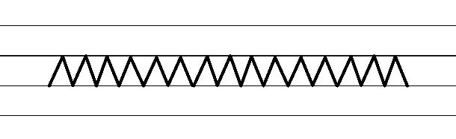  - Example NSW Foundation Style handwriting formation  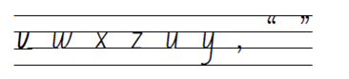  - Suggested practice text from the passage  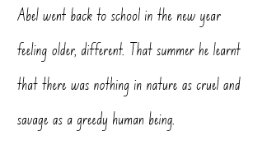  Note: students who are fluent in NSW Foundation Style can begin to use NSW Foundation Precursive and Cursive Style.
Handwriting legibility and fluency (Stage 2 Year 4)  - Join letters when writing familiar word  - Diagonally join to anti- clockwise letters when writing familiar words  - Diagonal joins to anti-clockwise letters. | Handwriting legibility and fluency (Stage 2 Year 4)  - Suggested fluency pattern  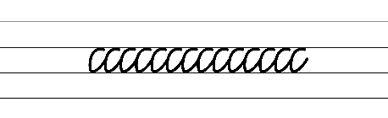  - Example diagonal joins to anticlockwise letters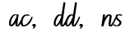  - Familiar words could include  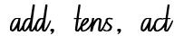  - Suggested practice text from the passage: 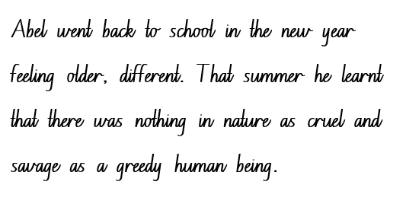
Handwriting and digital transcription  Handwriting legibility and fluency (Stage 3 Year 5)  - Sustain writing with a legible, fluent and personal handwriting style across a text  - Form legible and fluent horizontal joins to short letters. These are sometimes known as neckline joins. The letters o, r, v, w and x join to the following letter with a horizontal join.  - There is slight dip in a horizontal join to a short letter.  - Form legible and fluent horizontal joins to tall letters.  - Horizontal joins meet the tall letter at line 2 (the neckline) and continue to the top of the letter before it is retraced back down. | Handwriting and digital transcription  Handwriting legibility and fluency (Stage 3 Year 5)  - Suggested fluency pattern  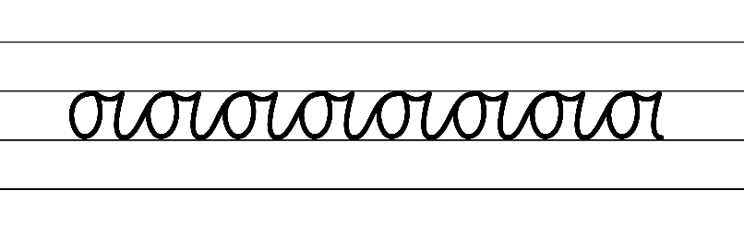  - Example NSW Foundation Style handwriting formation − horizontal joins to short letters  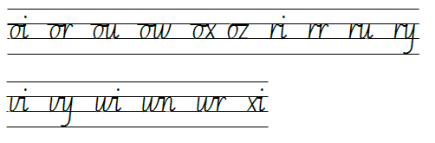  - Suggested practice text from the passage
Handwriting legibility and fluency (Stage 3 Year 6)  - Sustain writing with a legible, fluent and personal handwriting style across a text  - Revise no joins. | Handwriting legibility and fluency (Stage 3 Year 6)  - Suggested fluency pattern  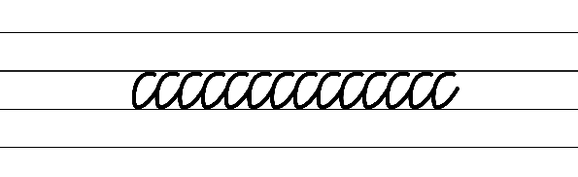  - Suggested practice text from the passage:  - Encourage students to evaluate their own handwriting after practising. For example, asking them to circle no joins they believe are formed well.

Planning framework
To plan and document Component A teaching and learning, a planning scaffold [DOCX 228 KB] is provided. To support you in your planning, a link to a detailed example of a one-week teaching and learning cycle is included in the scaffold. Additional resources to support teaching and learning in each focus area can be found at Lesson advice guides.

Component B teaching and learning
The following teaching and learning sequence has been designed to address Component B outcomes and content and develops conceptual understandings of English through the study of quality texts. Adapt the sequence as required to best meet the needs of your students.

Learning intentions and success criteria
Learning intentions and success criteria are best co-constructed with students. The table below contains suggested learning intention and success criteria.
Element | Stage 2 | Stage 3
Learning intention | Students are learning to plan and draft a narrative that includes an orientation, complication and resolution that is centred on a moral. | Students are learning to plan and draft a narrative that includes an orientation, complication and resolution that is centred on a moral.
Success criteria | Students can:  - plan and compose a sequential narrative using knowledge of text structure and features  - establish setting, characters and events drawn from real or imagined situations  - make effective vocabulary choices to build tension within a complication. | Students can:  - plan and compose a sequential narrative using multiple paragraphs with clear ideas  - establish setting, characters and events reflecting personal and common lived experiences  - apply vocabulary knowledge to add detail and enhance reader engagement when writing.

Lesson 13 – structure of a narrative
The following teaching and learning activities support multi-age settings.

Whole
- Finish the story: Gather in a class circle and have one student initiate the story of Blueback. Continue around the circle until each student has contributed to the retell of the story. Students should take turns to add one sentence each.
- Revise that narratives are written to entertain and engage an audience.
- Students turn and talk to review the structure of a narrative. For example, orientation, complication, rising action (series of events), climax, falling action and resolution.
- Ask why the structure of a narrative important to help the audience. For example, because it facilitates the audience’s understanding of, emotional connection to and engagement with the story.
- Explain that most narratives can be retold and summarised using the frame, ‘Somebody, Wanted, But, So, Then.’ Highlight that each word of the frame connects to the story structure. Explain that the frame identifies what to include in the summary and the order in which information should be presented. Emphasise that only the most important details about the story elements are included. For example:
- Somebody (Orientation – Who is the character?)
- Wanted (Motivation – What does the character want?)
- But (Complication – What is the problem or climax?)
- So (Rising action – Examine the tension and conflict. How did the characters try to solve the problem?)
- Then (Resolution – What was the falling action to the narrative’s solution or outcome?)
- Explain that it may be necessary to revisit the process of ‘But’ and ‘So’ repeatedly before reaching ‘Then’ as the resolution. For example, the orientation is the stage where the author introduces the setting, characters, and the overall context of the story. In Blueback, the narrative sets the stage in Longboat Bay, a precious and unique environment. The protagonist, Dora Jackson, is the ‘Somebody’ in this narrative stage. She is deeply connected to the bay and has a strong desire, the ‘Wanted’, to preserve and protect its natural beauty.
- Model writing a summary of Blueback using Resource 13 – Somebody, Wanted, But, So, Then. For example:
Somebody: Dora Jackson
Wanted: To preserve the precious environment of Longboat Bay
But: Developers see the potential of Longboat Bay as a tourist resort, wanting to purchase the land owned by Dora.
So: Dora refuses to sell, despite gifts, good money and later threats. After 5 years the developers lose interest and leave.
But: Long Boat Bay has been publicised as a world class diving experience for spearfishing and the chance to swim with an enormous blue groper. Large numbers of tourist vessels travel to the area. A month later, an oil tanker cracked in two off the coast of Longboat Bay.
So: Dora writes hundreds of letters, month after month, to politicians, bosses, scientists, newspaper editors.
But: The letters are ignored
So: Dora continues to write more letters.
Then: Longboat Bay is declared a marine sanctuary where everything that grows or lives there is protected by law.
- In small groups, students complete Resource 13 – Somebody, Wanted, But, So, Then then use this to write their own summary of Blueback by contributing to the stages of the narrative. Students may wish to use Abel as their ‘Somebody’.
Too hard? Students work in pairs to record a summary using the ‘Somebody, Wanted, But, So, Then’ frame.
- Select students to share their writing.
- Use guiding questions to reflect on the lesson. Encourage the use of protocols to support learning interactions. For example:
- How did the summary capture the key elements of the narrative?
- Were any important details omitted from the summary, and if so, how did it affect the overall understanding of the narrative?
- How did the narrative’s structure contribute to the engagement of the story?
- Did you enjoy the story? Why or why not? Explain what it was about the story that you did or didn’t like? Refer to a particular part of the narrative or a character in support of your answer.
- What was your favourite part of the story? What is the reason that you liked this part the most? Refer to a particular part of the story or character to support your answer?

Lesson 14 – planning a narrative
The following teaching and learning activities support multi-age settings.

Whole
- Ask students to brainstorm reasons why a reader may choose to read a narrative. For example:
- be entertained
- be exposed to different ideas
- learn how the world works
- escape the real world
- learn about the experiences of others
- develop empathy.
- Ask students to reflect on the quote from Blueback ‘nothing in nature is as cruel and savage as a greedy human being’ (p 89) and what it means.
- Explain that this quote reflects the moral or lesson of Blueback. Explain that while nature can sometimes be harsh and unforgiving, human greed and its consequences can sometimes exceed cruelty found in the natural world. Explain that the moral has the potential to inspire thought, empathy, and action in relation to protecting the environment and being mindful of human impact on the natural world.
- Ask students to provide examples of human actions that have negative consequences on the environment and marine life. For example, overfishing, pollution, land development.
- Explain that students will write their own narrative which reflects the moral or lesson ‘nothing in nature is as cruel and savage as a greedy human being’ (p 89) that could be presented as a written text, a movie script, comic strip, or readers theatre.
- Highlight that students will connect to their own or shared experience to write a narrative with characters described with familiar characteristics or attributes including character’s actions that drive the story. Explain that students may plan and write in pairs or individually.
- Explain that this lesson will focus on planning a narrative using the narrative stages and developing characters with familiar, group or individual characteristics.
- Display the quote ‘Nothing in nature is as cruel and savage as a greedy human being’ (p 89). Students turn and talk to brainstorm ideas for their narrative. For example, students could explore the consequences of human greed on marine life and highlight the importance of conservation and respect for the environment.
- Co-construct success criteria for writing that includes:
- Create a narrative using familiar characters and situations to enhance reader engagement (Stage 2)
- Create a narrative that reflects the emotions and actions of lived experiences including character behaviour (Stage 3)
- Stages of text organised into paragraphs to include an orientation, complication, rising action or series of events, climax, falling action and resolution
- Coordinating conjunctions in compound sentences
- Tier 2 verbs and verb groups
- Declarative sentences
- Capital letters
- Correctly positioned commas
- Tier 2 adjectives
- Appositives (Stage 3).
- Model planning a narrative using an enlarged copy of Resource 15 – Freytag's pyramid planning template.
- Individually or in pairs students select an idea and plan their narrative highlighting the moral or lesson ‘nothing in nature is as cruel and savage as a greedy human being’ (p 89) using Resource 15 – Freytag's pyramid planning template.
Too hard? Scaffold planning further by completing plan with students.
- In pairs, students share their plan and provide peer feedback. Students apply feedback to strengthen their plan.
Note: save student planning for use in the following lessons.
Stage 2 Assessment task 3 – collecting work samples from this lesson allows students to demonstrate achievement towards the following syllabus outcomes and content point:
EN2-CWT-01 – plans, creates and revises written texts for imaginative purposes, using text features, sentence-level grammar, punctuation and word-level language for a target audience
EN2-CWT-02 – plans, creates and revises written texts for informative purposes, using text features, sentence-level grammar, punctuation and word-level language for a target audience
EN2-CWT-03 – plans, creates and revises written texts for persuasive purposes, using text features, sentence-level grammar, punctuation and word-level language for a target audience
- plan structures and language to suit the purpose of a text.
Stage 3 Assessment task 3 – collecting work samples from this lesson allows students to demonstrate achievement towards the following syllabus outcome and content point:
EN3-CWT-01 – plans, creates and revises written texts for multiple purposes and audiences through selection of text features, sentence-level grammar, punctuation and word-level language
- use print or digital tools to plan, sequence, create, revise, edit and publish texts.

Lesson 15 – planning and drafting an orientation
The following teaching and learning activities support multi-age settings.

Whole
- Explain that students will be using their planning from Lesson 14 to write their own narrative to reflect the moral or lesson ‘nothing in nature is as cruel and savage as a greedy human being’ (p 89). Explain that this lesson will focus on planning and drafting an orientation.
- Review the success criteria.
- Revise the structural elements of an orientation. For example:
- introduction of characters
- description of setting including an indication of time and place
- engaging details to capture the reader.
- Model drafting the orientation of a narrative to reflect the moral or lesson ‘nothing in nature is as cruel and savage as a greedy human being’ (p 89) referring to the enlarged teacher modelled Resource 15 – Freytag's pyramid planning template and the co-constructed success criteria.
- Read the orientation as a class and display in the classroom to use in subsequent lessons.
- Using their plan, students begin to draft the orientation to their narrative.
Too hard? Provide sentence stems for an orientation paragraph(s).

Lesson 16 – drafting a complication and series of events
The following teaching and learning activities support multi-age settings.

Whole
- Explain that students will be using their plan from Lesson 14 to draft a complication to include rising action (series of events) and a climax for their narrative.
- Referring to the enlarged teacher modelled Resource 15 – Freytag's pyramid planning template from Lesson 14 and the modelled orientation from Lesson 15, model drafting the complication into paragraphs. This can be done as an interactive writing session, applying their knowledge from Component A content.
- Read the complication including the series of events and climax to identify how the co-constructed text has met the success criteria.
- Using their plan, students begin to draft their complication, rising action and climax for their narrative.
Too hard? Jointly construct the complication. Students use talk-to-text technology to draft this section of the narrative.
Stage 2 Assessment task 4 – collecting work samples from this lesson allows students to demonstrate achievement towards the following syllabus outcome and content points:
EN2-VOCAB-01 – builds knowledge and use of Tier 1, Tier 2 and Tier 3 vocabulary through interacting, wide reading and writing, and by defining and analysing words
- build personal Tier 1, Tier 2 and Tier 3 vocabulary through social and learning interactions, reading and writing
- apply morphemic knowledge to change word meanings by adding different prefixes and suffixes to a base word or root.
Stage 3 Assessment task 4 – collecting work samples from this lesson allows students to demonstrate achievement towards the following syllabus outcome and content point:
EN3-VOCAB-01 – extends Tier 2 and Tier 3 vocabulary through interacting, wide reading and writing, morphological analysis and generating precise definitions for specific contexts
- identify newly encountered words from interactions and wide reading, and use them in writing, discussions and presentations.

Week 5

Component A teaching and learning
Component A focuses on the development of foundational skills and knowledge through regular, systematic and repeated practice. The mentor and supporting texts used in Component B of this unit can support the effective implementation of Component A teaching and learning.

Teaching guide
Guidance for explicit teaching, teaching notes, resources and examples for the related outcomes and content points have been provided in the table below.
Focus areas and teaching notes | Resources and examples
Reading fluency  Reading rate and automaticity (Stage 2)  - Syllabify, blend grapheme–phoneme correspondences and use morphemic knowledge as strategies for reading words accurately  - Locate and syllabify multisyllabic words, including those with morphemic suffixes (-ing, -ed, -ly).  - For every syllable, there is at least one vowel phoneme.  - Morphemic suffixes usually form their own syllable. | Reading fluency  Reading rate and automaticity (Stage 2)  - Fluency and close reading passage – page 149 ‘Abel Jackson never regretted staying on at Longboat Bay...’ to page 151 ‘...quivering with life’ (304 words).  Note:  - The passage from the text will need to be a teacher-created resource.  - Content in Reading fluency will support learning in the focus areas Vocabulary, Reading comprehension and Spelling.  - Suggested words from the passage  - Morphemic information  - discovered – discover + ed  - pressed – press + ed  - quivering – quiver + ing  - staying – stay + ing.  - Syllables  - discovered – 3 syllables  - regretted – 3 syllables  - eventually – 4 syllables  - quivering – 3 syllables.
Prosody (Stage 2)  - Explain how prosodic reading involves emphasis, expression, intonation and pausing  - Pausing and intonation when reading aloud is essential in reading. The use of punctuation such as commas ( , ) and full stops ( . ) will assist in effectively pausing and using end of sentence intonation | Prosody (Stage 2)  - Suggested sentence to illustrate the use of pausing and intonation using commas and a full stop  - ‘They just seemed to know that, just past Robbers Head, hooks and nets awaited them.’ (p 149)  - ‘Out of the shadows, from a crack in the reef, a huge blue creature came swirling at them.’ (pp 150–151)
Reading comprehension  Comprehending language (Stage 2)  - Use key words from a text to visualise events, characters and settings when making inferences and confirming predictions  - Key words for describing a setting include nouns that provide concrete details about the physical elements of the setting including the places, locations and things that make up the story’s environment.  - Key words for describing a setting include adjectives that describe the physical attributes of the location. | Reading comprehension  Comprehending language (Stage 2)  - Key words and phrases from the text to visualise the scene at Longboat Bay.  - ‘The bay grew rich with life as fish came into the sanctuary. They seemed to know that just past Robbers Head, hooks and nets awaited them. They bred in their haven and swelled the stocks of the coast beyond. Seagrass, coral and sponges thrived. Abalone grew like snails in a garden. Dolphins and sharks came in.’ (p 149)
Monitoring comprehension (Stage 2)  - Identify where meaning breaks down when reading  - A break in comprehension can occur when a text includes  - use of figurative language  - increasingly complex sentence structures. | Monitoring comprehension (Stage 2)  - Sentences with figurative language  - Abalone grew like snails in a garden (p 149).  - The smallest diver hung like a sail between the grownups as they flew down to the rubbly bottom (p 150).  - Sentences with increasingly complex sentence structures  - ‘Out of the shadows, from a crack in the reef, a huge blue creature came swirling at them.’ (p 150)  - ‘He was the colour of all their dreams and he rested against the child, quivering with life.’ (p 151)
Reading comprehension  Reading fluently (Stage 3)  - Syllabify, blend grapheme–phoneme correspondences and use morphemic knowledge as strategies for reading words accurately  - locate and syllabify multisyllabic words, including those with morphemic suffixes (-ing, -ed, -ly)  - morphemic suffixes usually form their own syllable  - all syllables contain a vowel phoneme. | Reading comprehension  Reading fluently (Stage 3)  - As above, see Stage 2 Reading fluency examples.
Monitoring comprehension (Stage 3)  - Monitor and repair reading when meaning breaks down  - This may include pausing, self-correcting, re-reading or reading on; using phonic morphemic or word knowledge and reactivating background knowledge. | Monitoring comprehension (Stage 3)  - As above, see Stage 2 examples.
Vocabulary  Learning and using words (Stage 2)  - Build personal Tier 1, Tier 2 and Tier 3 vocabulary through social and learning interactions, reading and writing  - Tier 1 words: Basic-level, everyday words (NESA 2023).  - Tier 2 words: General academic words that can be used across a variety of domains. They are of high utility for mature language users and are commonly used in written language (NESA 2023).  - Tier 3 words: Words that are used rarely (low frequency) and only in highly specific situations (NESA 2023). | Vocabulary  Learning and using words (Stage 2)  - Tier 2 words from passage: sanctuary (p 149), awaited (p 49), teeming (p 150), enormous (p 151), rippling (p 151).  - Tier 3 words from passage: seagrass (p 149), coral (p 149), abalone (p 149).
Defining and analysing words (Stage 2)  - Apply morphemic knowledge to change word meanings by adding different prefixes and suffixes to a base word or root  - use morphemic knowledge to read and understand Tier 2 words (-ed, -ing).  - Suffix -ed changes the tense of the verb. -ed expresses past tense.  - Suffix -ing changes the tense of a verb. -ing expresses present tense; -ing also expresses future tense. | Defining and analysing words (Stage 2)  - Morphology example  - regretted – regret, regretting, regrettable (p 149)  - thrived – thrive, thriving (p 149)  - discovered – discover, discovering, discoverable (p 150)  - quivering – quiver, quivered (p 51)
Vocabulary  Learning and using words (Stage 3)  - Identify newly encountered words from interactions and wide reading, and use them in writing, discussions and presentations  - Identify newly encountered words from interactions and wide reading, and use them in writing, discussions and presentations.  - Students may come across words they haven't encountered before. It could be a word with an unfamiliar meaning, an unusual spelling, or a term specific to a certain context. | Vocabulary  Learning and using words (Stage 3)  - Suggested newly encountered words from passage  - sanctuary (p 149), teeming (p 150), rubbly (p 150), rippling (p 150) snorkel (p 151), quivering (p 151).
Defining and analysing words (Stage 3)  - Analyse morphemic structures of Tier 2 and Tier 3 words to determine their meaning  - Morphemes can be words themselves or parts of words, such as prefixes, suffixes, and root words. Analysing morphemic structures involves breaking words down into their constituent morphemes to understand how the meaning is formed. | Defining and analysing words (Stage 3)  - As above, see Stage 2 examples.
Spelling  Phonological component (Stage 2)  - Explain how to segment multisyllabic words into syllables and phonemes, and apply this knowledge when spelling  - Revise segmenting multisyllabic words into syllables and phonemes. For example, jockey has 2 syllables and 4 phonemes (j-o-ck-ey). This is a phonological skill that should be practised regularly.  - Identify differences in vowel phonemes (short, long, diphthong and schwa vowels)  - Revise long vowel phonemes /ee/, /ay/, /ow/, /igh/ as per previous 4 weeks of learning. | Spelling  Phonological component (Stage 2)  - Use suggested words from text and sample words from the previous 4 weeks of learning.
Orthographic component (Stage 2)  - Apply knowledge of taught vowel graphemes when spelling  - Review the common representations for long vowel phonemes /ee/, /ay/, /ow/, /igh/. | Orthographic component (Stage 2)  - As above
Morphological component (Stage 2)  - Identify inflected suffixes, explaining when and how to treat base words when they are affixed, and apply this knowledge when spelling  - Review inflected suffixes: plurals (-s/es) and tense (-s, -ing, -ed). | Morphological component (Stage 2)  - As above
Spelling  Phonological component (Stage 3)  - Segment unfamiliar multisyllabic words into syllables and phonemes as a strategy when spelling  - Revise segmenting unfamiliar multisyllabic words into syllables and phonemes as a strategy when spelling. | Spelling  Phonological component (Stage 3)  - Use suggested words from text and sample words from the previous 4 weeks of learning.
Orthographic component (Stage 3)  - Recognise that the same grapheme can represent different phonemes  - Different phonemes represented by graphemes [a] and [c]. | Orthographic component (Stage 3)  - As above
Morphological component (Stage 3)  - Explain and use spelling conventions to add derivational suffixes such as -ion, -ian, -ence, -ous to base words or roots  - Review derivational suffixes: -ate, -ive, -ative, -itive, -ion, -tion, -sion. | Morphological component (Stage 3)  - As above
Creating written texts  Sentence-level grammar (Stage 2)  - Use coordinating conjunctions in compound sentences to compare and contrast, or for addition  - Coordinating conjunctions: A word or group of words that function to link 2 independent clauses within a sentence (NESA 2023).  - Select and use precise saying, thinking, acting, and relating verbs and verb groups to align with text purpose  - A verb is a word that tells what is happening.  - A verb group is a group of words built around a verb (NESA 2023).  - Use declarative sentences to provide facts or state a viewpoint  - Review simple sentence features -a sentence is a complete thought (sentence vs sentence fragment)  - A simple sentence (or a main clause) contains a subject and a verb.  - A declarative sentence is a statement presented as a complete sentence to provide fact, evidence or detail (NESA 2023). | Creating written texts  Sentence-level grammar (Stage 2)  - Coordinating conjunctions used in a compound sentence for addition  - ‘The little girl’s eyes grew big in her mask and she chirped in her snorkel.’ (p 151)  - ‘She felt that it was about to swallow her and she pressed against her parents in panic.’ (p 151)  - Suggested verbs and verb groups from the passage  - Saying: chirped  - Thinking verbs: regretted, guessed, figured  - Acting verbs: quivering, fanned, slipped  - Relating verbs: was, have  - Verb groups: was about to swallow her  - Suggested declarative sentences from the passage  - Abel Jackson never regretted staying on at Longboat Bay. (p 149).  - They bred in their haven and swelled the stocks of the coast beyond (p 149).  - The fish’s head was enormous (p 151).  - His scales shone (p 151).
Word-level language (Stage 2)  - Use adjectives to develop descriptive features  - Adjectives are words that describes, identifies or quantifies a noun or a pronoun. Different types of adjectives include possessive, quantifying, descriptive, comparative, superlative and classifying (NESA 2023).  - Adjectives can be used for imaginative purposes to describe characters, settings and events.  - Descriptive adjectives give more information about the noun or pronoun. They help to add details about the noun they are modifying. This can be related to size, shape, colour, texture and other qualities. | Word-level language (Stage 2)  - Suggested adjectives from the passage  - Superlative adjective: smallest  - Descriptive adjectives: clear, huge, blue, little, big, enormous, rippling  - Quantifying adjectives: three.
Punctuation (Stage 2)  - Use capital letters to indicate the beginning of a sentence, proper nouns, headings and subheadings, to indicate the beginning of a poetry line, for emphasis, and when using acronyms  - Review sentence boundary punctuation, including capital letters to indicate the beginning of a sentence and to indicate proper nouns.  - Use commas between words in a list or to separate adjectives when more than one is used  - Commas are a punctuation marker used to show separation between parts of a sentence, such as clauses or phrases, where separation is important to the meaning. Commas are also used to separate words, phrases or numbers in a series (NESA 2023) | Punctuation (Stage 2)  - Suggested capital letters for proper nouns used in the passage  - Long boat Bay, Robbers Head, Abel, Stella, Mad Macka, Dora Jackson.  - Suggested commas used to separate words in a list  - ‘Seagrass, coral and sponges thrived’ (p 149).
Creating written texts  Sentence-level grammar (Stage 3)  - Make choices about verbs and verb groups to achieve precision and add detail  - Verbs are essential building blocks in a narrative, shaping a narrative’s structure, characters and atmosphere. Verbs are powerful tools that writers use to convey action, emotion and meaning, enabling readers to immerse themselves in the narrative and experience the story on a deeper level.  - Include appositives to provide details to nouns and to vary sentence structures suited to text purpose  - An appositive is a noun or pronoun that is positioned beside another noun or pronoun to explain or identify it. An appositive often includes modifiers. | Creating written texts  Sentence-level grammar (Stage 3)  - Suggested verbs and verb groups from the passage  - Saying: chirped  - Thinking verbs: regretted, guessed, figured  - Acting verbs: quivering, fanned, slipped  - Relating verbs: was, have  - Verb groups: was about to swallow her.  - Innovated sentence to include an appositive from the passage  - Abel Jackson, known for his adventurous spirit and love for the sea, never regretted staying on at Longboat Bay (p 149).
Punctuation (Stage 3)  - Use capital letters at the beginning of a sentence, to indicate proper nouns, for headings and subheadings, to indicate the beginning of a poetry line, for emphasis, and when using acronyms  - Review sentence boundary punctuation, including capital letters to indicate the beginning of a sentence and to indicate proper nouns.  - Use a comma to separate a subordinate clause or a phrase from the main clause, or to separate information within a sentence, or to separate items in a list  - Commas are a punctuation marker used to show separation between parts of a sentence, such as clauses or phrases, where separation is important to the meaning. Commas are also used to separate words, phrases or numbers in a series (NESA 2023). | Punctuation (Stage 3)  - Suggested capital letters for proper nouns used in the passage  - Long boat Bay, Robbers Head, Abel, Stella, Mad Macka, Dora Jackson  - Suggested commas used to separate words in a list  - Seagrass, coral and sponges thrived (p 149).  - Suggested commas to separate information within a sentence  - He was the colour of all their dreams and he rested against the child, quivering with life (p 151).
Handwriting and digital transcription  Handwriting legibility and fluency (Stage 2 Year 3)  - Understand that legible handwriting is consistent in size and spacing and can support learning  - Form numerals with consistent size and spacing  - Numerals are full height or ‘tall’ letters. They are twice the height of ‘short’ letters.  - Focus on the correct starting place and direction of movement for each numeral, including pen(cil) lifts and drops for the numerals 4 and 9. | Handwriting and digital transcription  Handwriting legibility and fluency (Stage 2 Year 3)  - Suggested fluency pattern  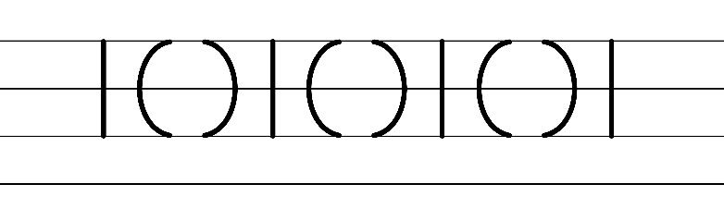  - Example NSW Foundation Style handwriting formation  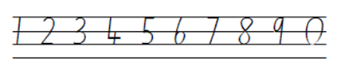  Note: students who are fluent in NSW Foundation Style can begin to use NSW Foundation Precursive and Cursive Style.
Handwriting legibility and fluency (Stage 2 Year 4)  - Join letters when writing familiar words  - Write familiar words that include letters that do not join.  - No join is needed after the letters b, f, g, j, p, s, y. | Handwriting legibility and fluency (Stage 2 Year 4)  - Suggested fluency pattern  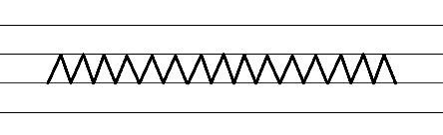  - No join is needed after the letters  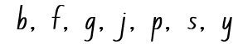  - Familiar words could include  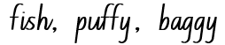  - Suggested practice text from the passage:  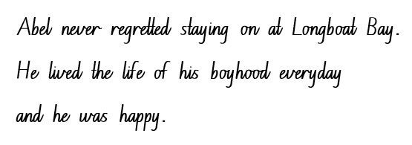
Handwriting and digital transcription  Handwriting legibility and fluency (Stage 3 Year 5)  - Sustain writing with a legible, fluent and personal handwriting style across a text  - Form legible and fluent horizontal joins to anticlockwise letters, including to a, c, d, g, o and q.  - When a horizontal join is made to an anti-clockwise letter, the top of the letter is retraced a little. | Handwriting and digital transcription  Handwriting legibility and fluency (Stage 3 Year 5)  - Suggested fluency pattern  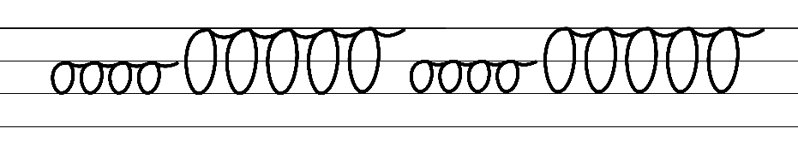  - Example NSW Foundation Style handwriting formation − horizontal joins to anticlockwise letters  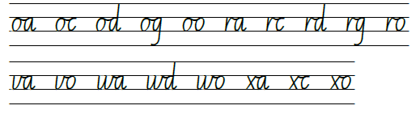  - Suggested practice text from the passage:  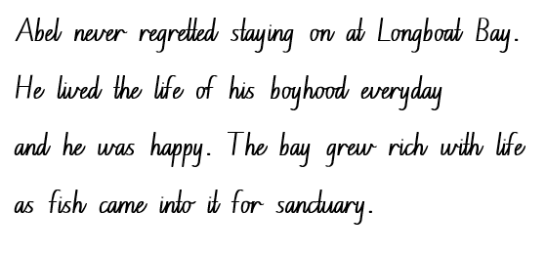
Handwriting legibility and fluency (Stage 3 Year 6)  - Sustain writing with a legible, fluent and personal handwriting style across a text  - Revise double letter joins. For example, ee, nn, ll, cc. | Handwriting legibility and fluency (Stage 3 Year 6)  - Suggested fluency pattern  - Example double letter joins  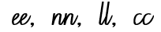  - Suggested practice text from the passage:  - Encourage students to evaluate their own handwriting after practising. For example, asking them to circle double letter joins they believe are formed well.

Planning framework
To plan and document Component A teaching and learning, a planning scaffold [DOCX 228 KB] is provided. To support you in your planning, a link to a detailed example of a one-week teaching and learning cycle is included in the scaffold. Additional resources to support teaching and learning in each focus area can be found at Lesson advice guides.

Component B teaching and learning
The following teaching and learning sequence has been designed to address Component B outcomes and content and develops conceptual understandings of English through the study of quality texts. Adapt the sequence as required to best meet the needs of your students.

Learning intentions and success criteria
Learning intentions and success criteria are best co-constructed with students. The table below contains suggested learning intention and success criteria.
Element | Stage 2 | Stage 3
Learning intention | Students are learning to apply their understanding of narrative and characterisation to revise, edit and publish a narrative that includes an orientation, complication, resolution that is centred on a moral. | Students are learning to apply their understanding of narrative and characterisation to revise, edit and publish a narrative that includes an orientation, complication, resolution that is centred on a moral.
Success criteria | Students can:  - use their knowledge of narrative text structure and features to compose a narrative using sequential ideas and actions  - effectively use a combination of adjectives, verbs and verb groups within declarative sentences to develop elaborate descriptions of characters and setting  - accurately use punctuation for a range of purposes including the end of a sentence, making a list and proper nouns.  - publish texts using legible handwriting. | Students can:  - create an engaging narrative that includes multiple paragraphs with coherent transition of ideas  - use a combination of verbs, verb groups, and appositives within a variety of sentence types to develop setting and character attributes  - effectively use punctuation for a range of purposes and for effect  - use print or digital tools to revise, edit and publish.

Lesson 17 – drafting a resolution
The following teaching and learning activities support multi-age settings.

Whole
- Explore the purpose of a resolution and explain that students will be drafting a resolution to their narrative, linking to the moral or lesson ‘nothing in nature is as cruel and savage as a greedy human being’ (p 89).
- Re-read and review the enlarged modelled Resource 15 – Freytag's pyramid planning template.
- As a class refer to the success criteria and read modelled orientation from Lesson 15 and the co-constructed complication and series of events from Lesson 16 to review learning.
- Model drafting the falling action and resolution of the narrative, referring to the enlarged teacher modelled Resource 15 – Freytag's pyramid planning template and the co-constructed writing samples and success criteria.
- Identify how the displayed narrative sample text has met the success criteria.
- Provide time for students to write their resolution using their plan.
Too hard? Provide sentence stems for each paragraph of the narrative.

Lesson 18 – revising and editing
The following teaching and learning activities support multi-age settings.

Whole
- Explain the difference between revising and editing. Ask students how they think authors, like Tim Winton, revise and edit their texts until they are satisfied with the final product. Ask what students think they check for.
- Explain that revising involves looking over the writing as a whole and reworking the organisation and details, including the grammatical features, text structure and vocabulary choices. Explain that editing involves making changes to spelling, punctuation and capitalisation.
- View Debra Frasier talks on Editing (1:21). Ask why it is important for students to edit their writing.
- Using a co-constructed piece of writing from the previous lessons, model revising and editing using the success criteria.
- Provide time for students to revise and edit their writing. Prompt with guiding questions:
- Are you meeting your purpose? (revising)
- Is there a better way to structure your writing? (revising)
- Where do you need to add more detail? (revising)
- Is your spelling accurate? (editing)
- Does your writing contain complete sentences and accurate punctuation? (editing)
- Will the reader be able to understand what you have written? (editing)
- Encourage students to read their writing aloud to assist in the revising and editing process. Remind students to refer to the success criteria to add or change details to reflect the criteria.
- Review protocols from Resource 2 – interaction protocols prior to pairs sharing their narrative. Students provide peer feedback using the success criteria and the Tell, Ask, Give (TAG) strategy and apply the feedback they receive.

Lesson 19 – publishing
The following teaching and learning activities support multi-age settings.

Whole
- Explain that publishing is the final step of the writing process. Explore the etymology of the word ‘publish’. For example, it derives from the Latin word publicus, which means ‘to make public’.
- Ask what the purpose of publishing a text is. For example, to share a final piece of writing with others. Discuss how texts, such as Blueback are published.
- Students proofread their narrative with a new partner and apply any additional feedback.
- Provide students with different ways to publish their narratives for a wider audience. For example
- creating a digital book using Book Creator or using word processing software
- creating a written text using legible handwriting that is consistent in size and spacing.
- Provide time for students to publish and illustrate their narrative.
Stage 2 Assessment task 5 – collecting work samples from this lesson allows students to demonstrate achievement towards the following syllabus outcomes and content points:
EN2-CWT-01 – plans, creates and revises written texts for imaginative purposes, using text features, sentence-level grammar, punctuation and word-level language for a target audience
EN2-CWT-02 – plans, creates and revises written texts for informative purposes, using text features, sentence-level grammar, punctuation and word-level language for a target audience
EN2-CWT-03 – plans, creates and revises written texts for persuasive purposes, using text features, sentence-level grammar, punctuation and word-level language for a target audience
- sequence ideas and actions into paragraphs aligned to the stages of the text, to provide elaborated details about settings, character motives and actions
- use coordinating conjunctions in compound sentences to compare and contrast, or for addition
- select and use precise saying, thinking, acting, and relating verbs and verb groups to align with text purpose
- use declarative sentences to provide facts or state a viewpoint
- use capital letters to indicate the beginning of a sentence, proper nouns, headings and subheadings, to indicate the beginning of a poetry line, for emphasis, and when using acronyms
- use commas between words in a list or to separate adjectives when more than one is used
- use adjectives to develop descriptive features.
Stage 3 Assessment task 5 – collecting work samples from this lesson allows students to demonstrate achievement towards the following syllabus outcome and content points:
EN3-CWT-01 – plans, creates and revises written texts for imaginative purposes, using text features, sentence-level grammar, punctuation and word-level language for a target audience
- make creative choices about temporal and spatial settings, character profiles and motives to enhance reader engagement
- create written texts that include multiple paragraphs with clear, coherent transition of ideas
- make choices about verbs and verb groups to achieve precision and add detail
- include appositives to provide details to nouns and to vary sentence structures suited to text purpose
- use capital letters at the beginning of a sentence, to indicate proper nouns, for headings and subheadings, to indicate the beginning of a poetry line, for emphasis, and when using acronyms
- use a comma to separate a subordinate clause or a phrase from the main clause, or to separate information within a sentence, or to separate items in a list.

Lesson 20 – presenting and reflecting
The following teaching and learning activities support multi-age settings.

Whole
- Students finish publishing their narratives in their chosen medium.
- Explain that students will present their narrative to the class. Refer to the communication protocol display and review guidelines for active listening prior to presentations to ensure a respectful and engaging environment. For example:
- Maintain eye contact with the speaker.
- Avoid interrupting while someone is speaking.
- Show non-verbal cues of attentiveness, such as nodding or smiling.
- Ask clarifying questions after each presentation, if appropriate.
- Provide time for students to rehearse and present their narrative to the class. Students listen actively. Encourage students to respond by providing feedback in relation to story engagement, characterisation, use of conflict and tension and originality of ideas.
- Look for opportunities to share student writing with a wider audience. For example, posting digitally or showcasing in the school newsletter or local library.
- Provide time for students to reflect on their learning of the textual concepts by using ‘I used to think, now I think’. Students reflect on the textual concepts and how their thinking has changed through the unit. Encourage responses which focus on the use of protocols to support learning interactions. Students complete the following thinking routine:
- I used to think narratives...
- Now I think...
- I used to think characterisation...
- Now I think...
- Students share thinking with a partner prior to writing their ideas on a sticky note as an exit ticket.
- Provide students with the opportunity to self-assess their classroom interactions during this unit. Ask students to reflect on their participation considering their level of engagement and active listening during whole class, small group and partner interactions.
- Students seek feedback from their peers and teacher to gain insights on and a comprehensive understanding of their interactions in the classroom.
- Students conduct a final self-assessment to evaluate the overall progress they have made in terms of their goal. Encourage students to be honest and thoughtful in their evaluation. Acknowledge and celebrate successes. (Stage 3).
Stage 2 Assessment task 6 – observations and work samples from this lesson allow students to demonstrate achievement towards the following syllabus outcomes and content points:
EN2-OLC-01 – communicates with familiar audiences for social and learning purposes, by interacting, understanding and presenting
- identify contexts in which social conventions can vary and influence interactions
- follow agreed-upon protocols and assigned roles for classroom interactions in person and through the use of technology
- listen actively to identify spoken information, acknowledging the value of others’ contributions
- plan and deliver spoken presentations using language and structure to suit purpose and audience.
EN2-UARL-01 – identifies and describes how ideas are represented in literature and strategically uses similar representations when creating texts
- describe how narratives set up expectations using familiar, real and imagined characters, situations and phrases
- describe connections between own or shared experiences and those depicted in narratives
- recognise that characters may be identified through familiar, individual or group characteristics.
Stage 3 Assessment task 6 – observations and work samples from this lesson allow students to demonstrate achievement towards the following syllabus outcomes and content points:
EN3-OLC-01 – communicates to wide audiences with social and cultural awareness, by interacting and presenting, and by analysing and evaluating for understanding
- identify varying social conventions that influence interactions across wide audiences
- follow agreed-upon protocols and define individual roles as needed for in-person or online interactions, establishing specific goals, criteria or timeframes
- apply interactive listening strategies by responding to and providing feedback to the speaker
- deliver presentations suited to purpose and audience.
EN3-UARL-01 – analyses representations of ideas in literature through narrative, character, imagery, symbol and connotation, and adapts these representations when creating texts
- recognise that narratives reflect both personal and common lived experiences and offer models of behaviour, which may be rejected or accepted
- analyse attributes of character and use similar attributes when creating texts.

Resource 1 – fluency and close reading passage analysis (Week 1)
Focus | Notes
Passage | From Chapter 2, page 16 ‘After breakfast Abel carried seaweed up to the fruit trees’ to Chapter 2, p18, ‘He was lonely sometimes but he liked being with his mother.’ (316 words)
Synopsis | The passage describes the setting which is primarily focused on Abel's family's land in Longboat Bay. It is a coastal area where Abel carries seaweed to the fruit trees and uses washed kelp as fertiliser. The orchard is described as having various types of trees, including fig trees, apricots, orange trees, lemon trees, olives, and mulberries. The presence of bells hung in each row of trees suggests an effort to deter birds from the fruit.  The Jackson family has a long history in the area, with their land being passed down for generations since the whaling times. The surrounding land is characterized as a national park, implying a natural environment. The presence of a small family cemetery behind the orchard, marked with white crosses and headstones, indicates a connection to the land and a sense of history and heritage for the Jackson family.  Abel and his mother engage in activities that allow them to sustain themselves. They rely on fishing, fruit and vegetable cultivation, and livestock rearing, including ducks, chickens (chooks), and goats. Their self-sufficiency is further emphasised by their reliance on rainwater for their water needs and their lack of access to mains electricity and television.  Despite the hard work involved in their lifestyle, Abel finds solace in the surrounding forest of the national park and the sea, where he roams and swims. The occasional loneliness he experiences is balanced by the companionship he shares with his mother.
Passage structure | The structure of the passage presents a descriptive account of the setting, within a narrative structure, focusing on the setting and activities of Abel and his family on their land in Longboat Bay. The text is structured into:  - Introduction: The passage begins with an overview of the setting, highlighting Abel's family's land in Longboat Bay as a coastal area where Abel carries seaweed and uses washed kelp as fertilizers for the fruit trees.  - Description of the orchard: The passage describes the orchard in detail, mentioning the various types of trees, such as fig trees, apricots, orange trees, lemon trees, olives, and mulberries. The presence of bells hung in each row of trees is also noted to deter birds.  - Historical context: The passage provides historical context by mentioning the long history of the Jackson family in the area, their land being passed down for generations since the whaling times. The surrounding land is described as a national park, indicating its natural environment. The presence of a small family cemetery behind the orchard is highlighted, marked with white crosses and headstones. This detail emphasises the family's connection to the land and their sense of history and heritage.  - Activities and self-sufficiency: The passage discusses the activities of Abel and his mother to sustain themselves, including fishing, fruit and vegetable cultivation, and livestock rearing. The reliance on rainwater and the lack of access to mains electricity and television highlight their self-sufficiency.  - Abel's solace and companionship: Despite the challenges and hard work involved in their lifestyle, the passage mentions how Abel finds solace in the surrounding forest and sea, where he roams and swims. The companionship he shares with his mother is also emphasized, balancing out any occasional loneliness he may experience.
Language features | - Descriptive language: The passage employs descriptive language to vividly depict the setting. It describes the coastal area of Abel's family's land in Longboat Bay, the various types of trees in the orchard, the distinct odour resulting from the compost, the presence of bells to deter birds, and the small family cemetery marked with white crosses and headstones.  - Sensory imagery: The passage utilises sensory imagery to engage the reader's senses. It mentions the strong odour resulting from the compost preparation, indicating the olfactory sense. The description of Abel's activities in the forest of the national park and swimming in the sea appeals to the senses of sight and touch.  - Historical context: The mention of the Jackson family's land being passed down for generations since the whaling times adds a historical context to the setting, highlighting the family's long-standing connection to the area.  - Symbolism: The small family cemetery behind the orchard, marked with white crosses and headstones, serves as a symbol of the family's history, heritage, and connection to the land.  - Contrast: The passage contrasts the self-sufficiency and simplicity of Abel and his mother's lifestyle with the lack of modern amenities such as mains electricity and television. This contrast highlights the hardship and resilience of their way of life.  - Emotive language: The passage uses emotive language to convey Abel's feelings and experiences. It mentions his occasional loneliness but also emphasises the companionship and closeness he shares with his mother.  - Repetition: The repetition of the phrase "Abel and his mother" reinforces their strong bond and the shared responsibilities in their sustainable way of life.

Resource 2 – interaction protocols
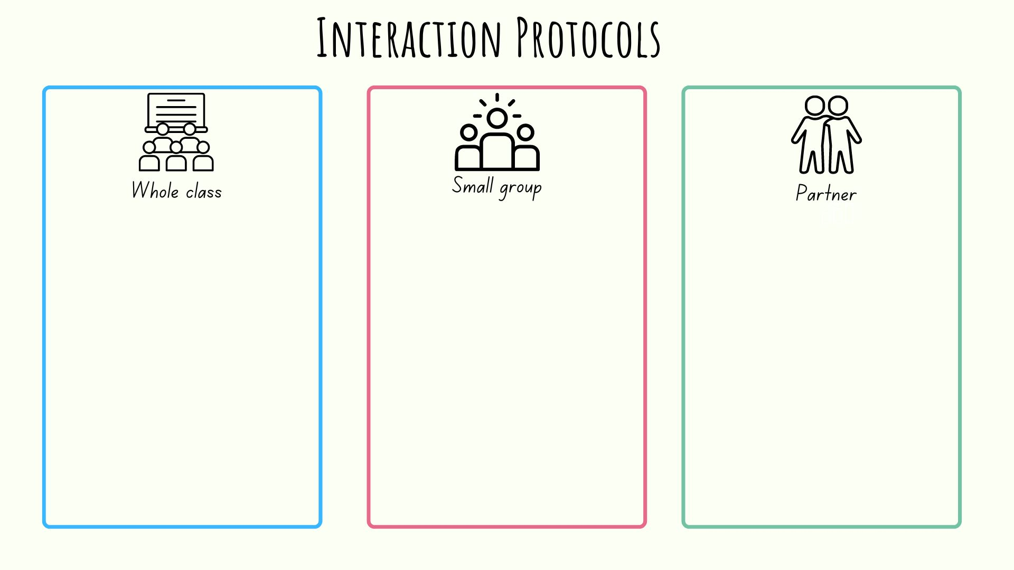

Resource 3 – the Jackson property
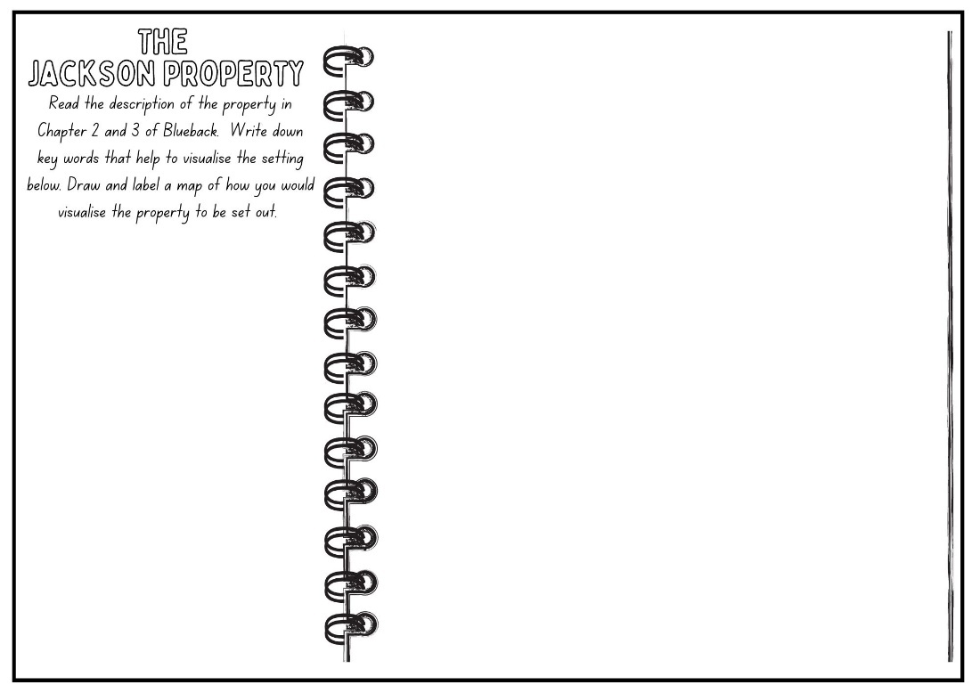

Resource 4 – Dora Jackson
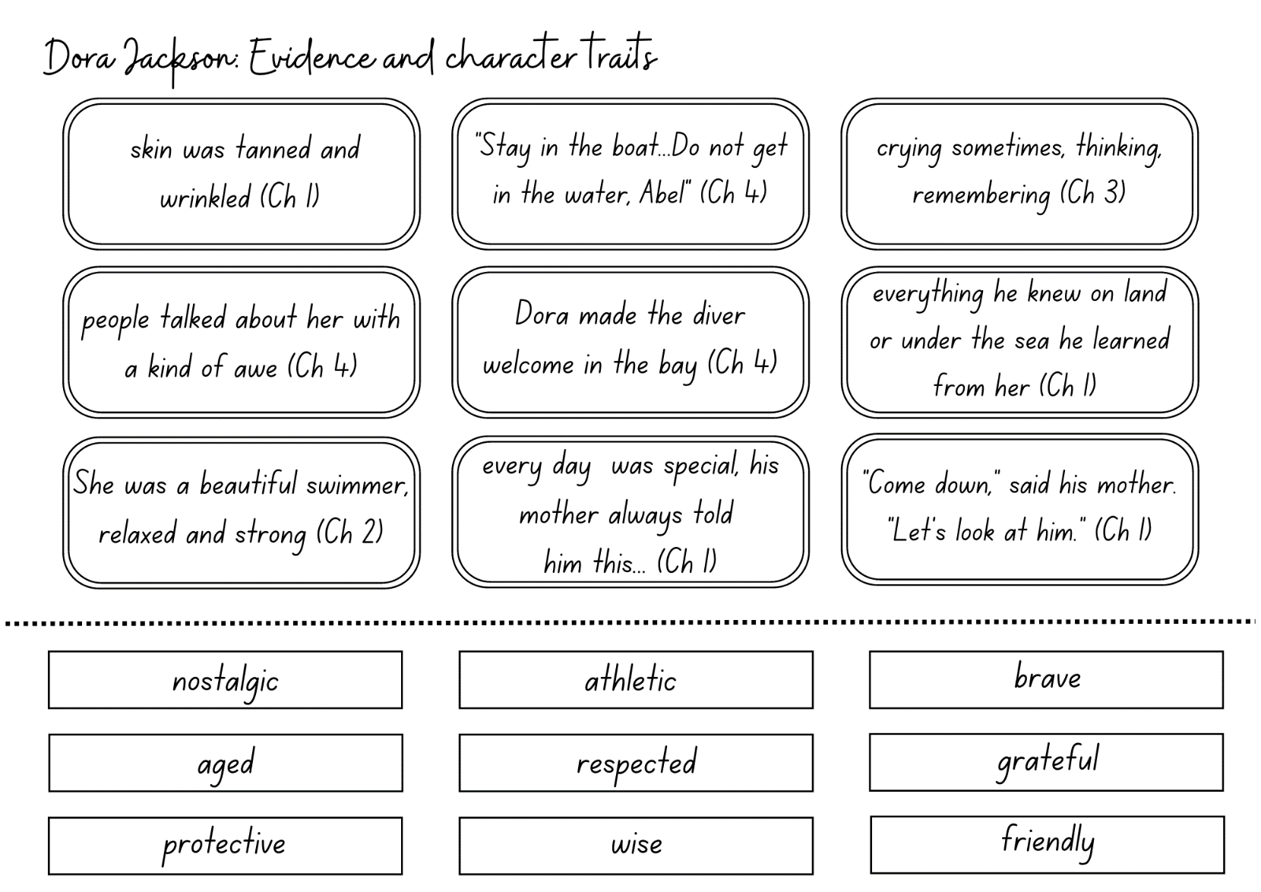

Resource 5 – character traits – Abel Jackson
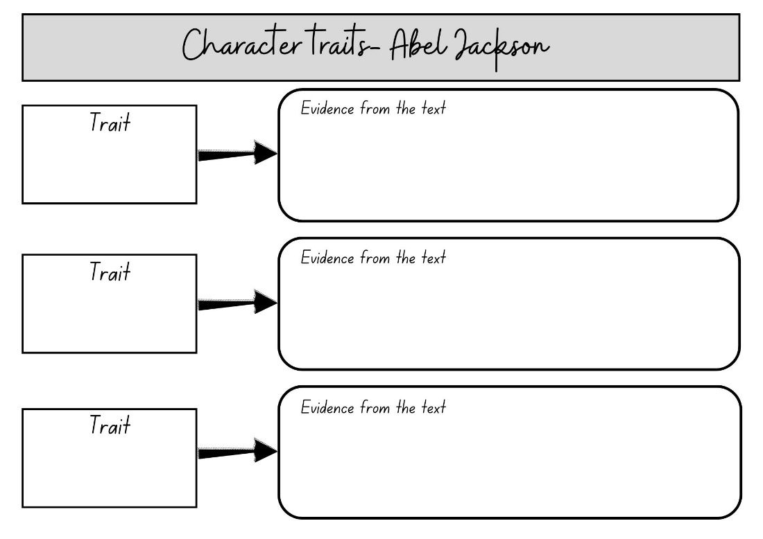

Resource 6 – my life and Abel’s life
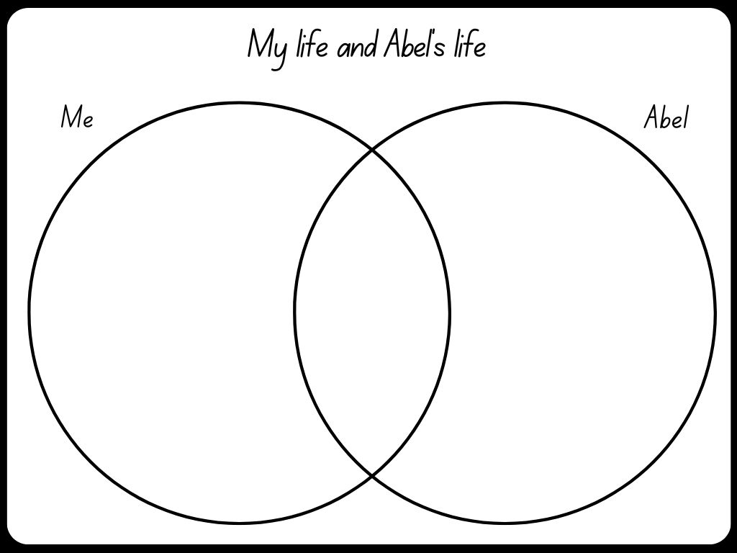

Resource 7 – coordinating conjunctions
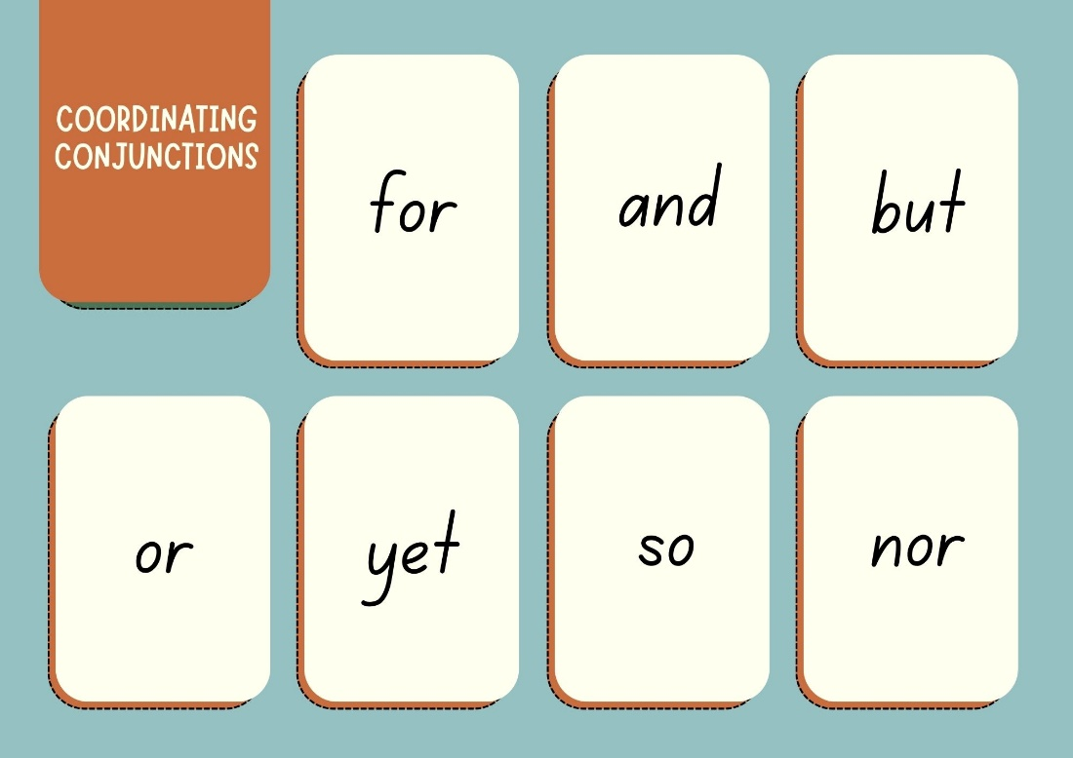

Resource 8 – comic strip template
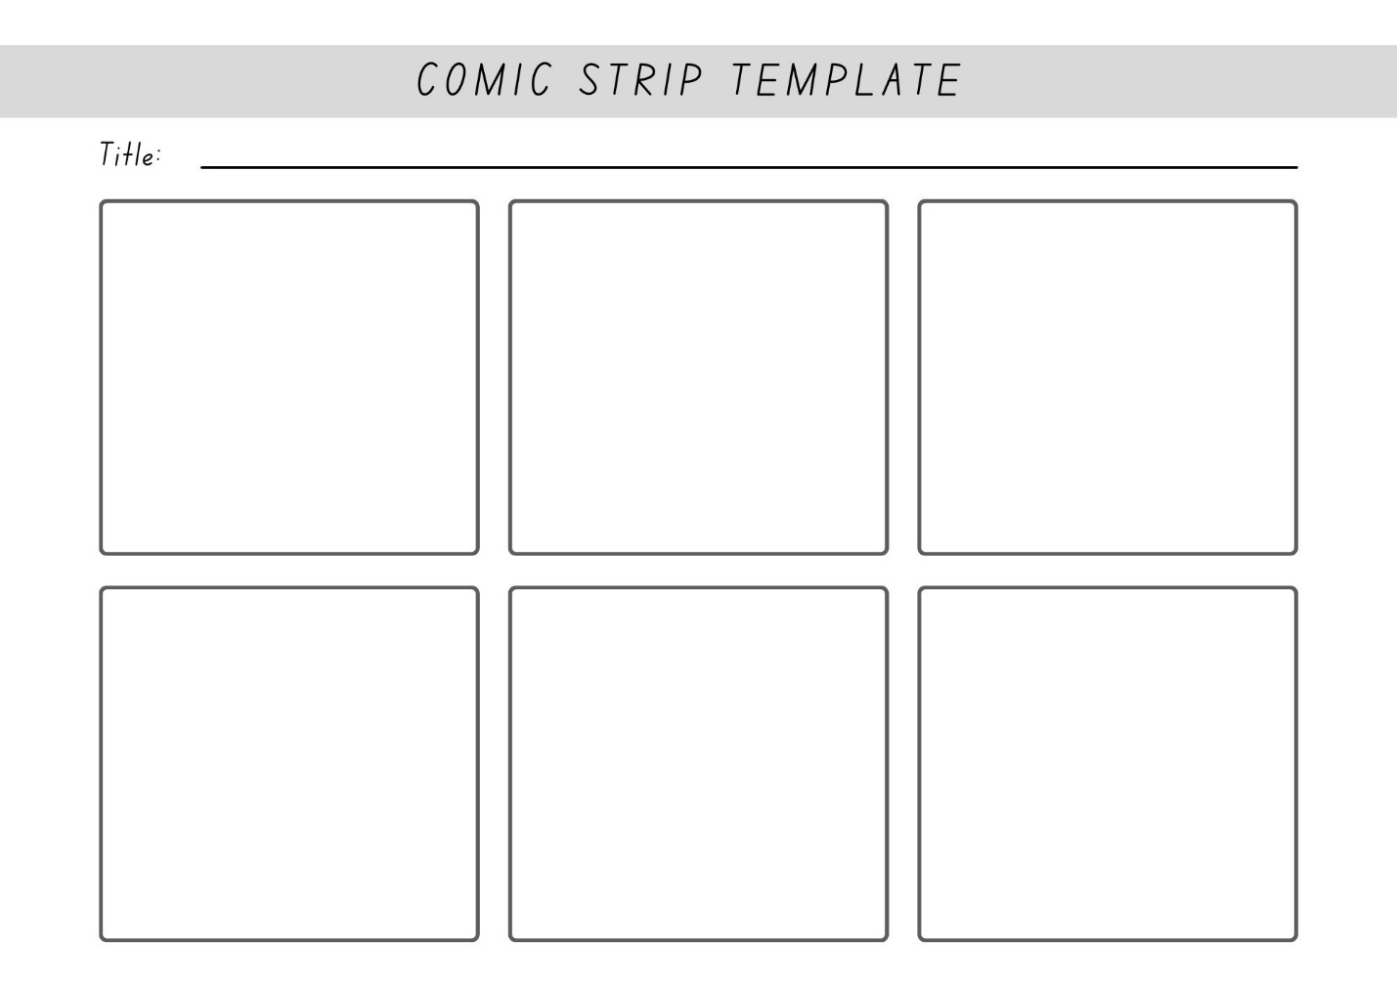

Resource 9 – interview questions
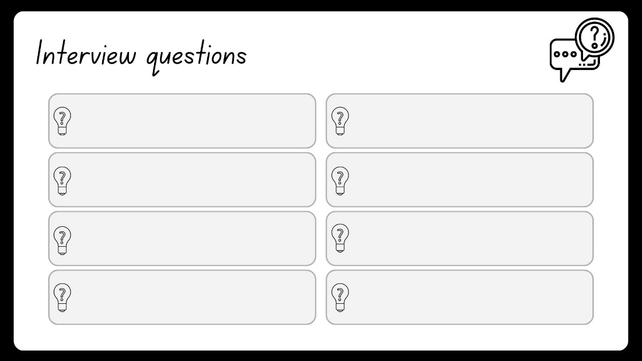

Resource 10 – interviewing a character – Q & A
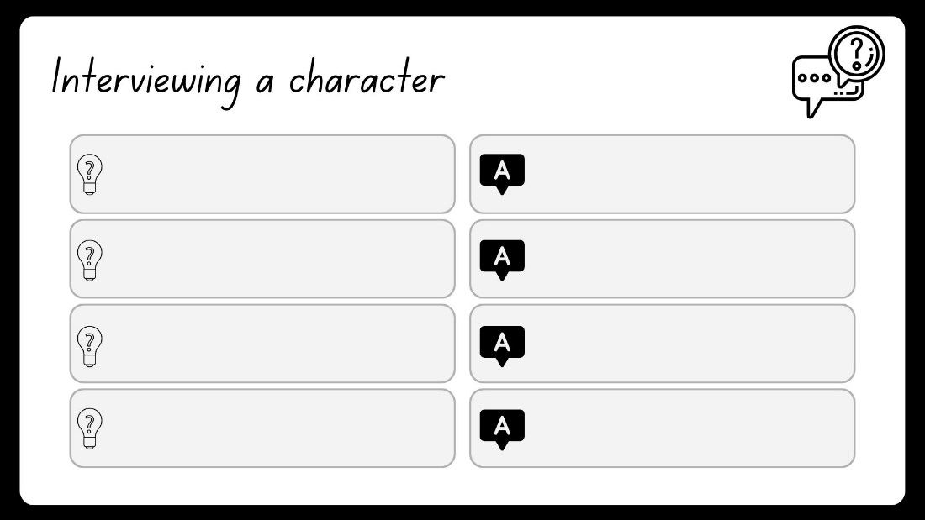

Resource 11 – character sociogram
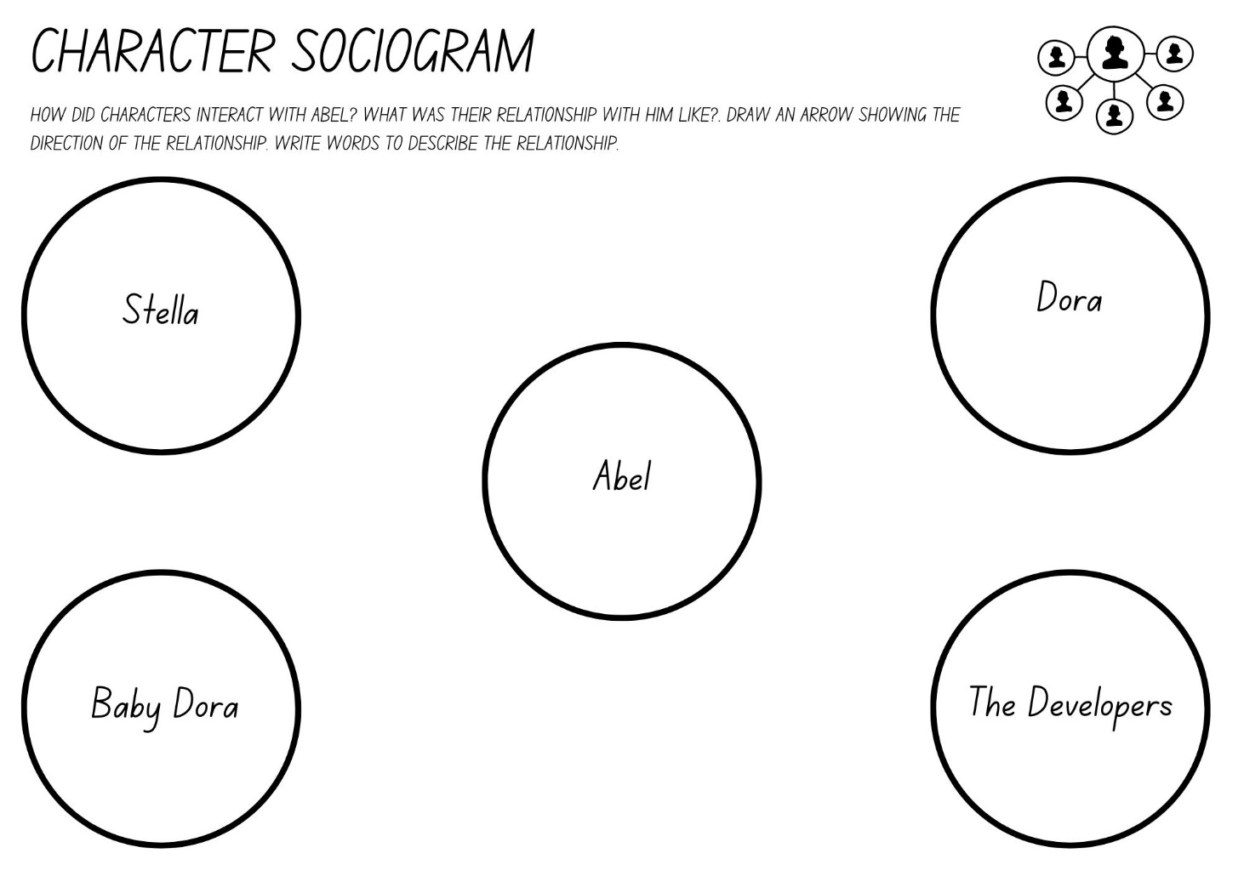

Resource 12 – character sociogram exemplar
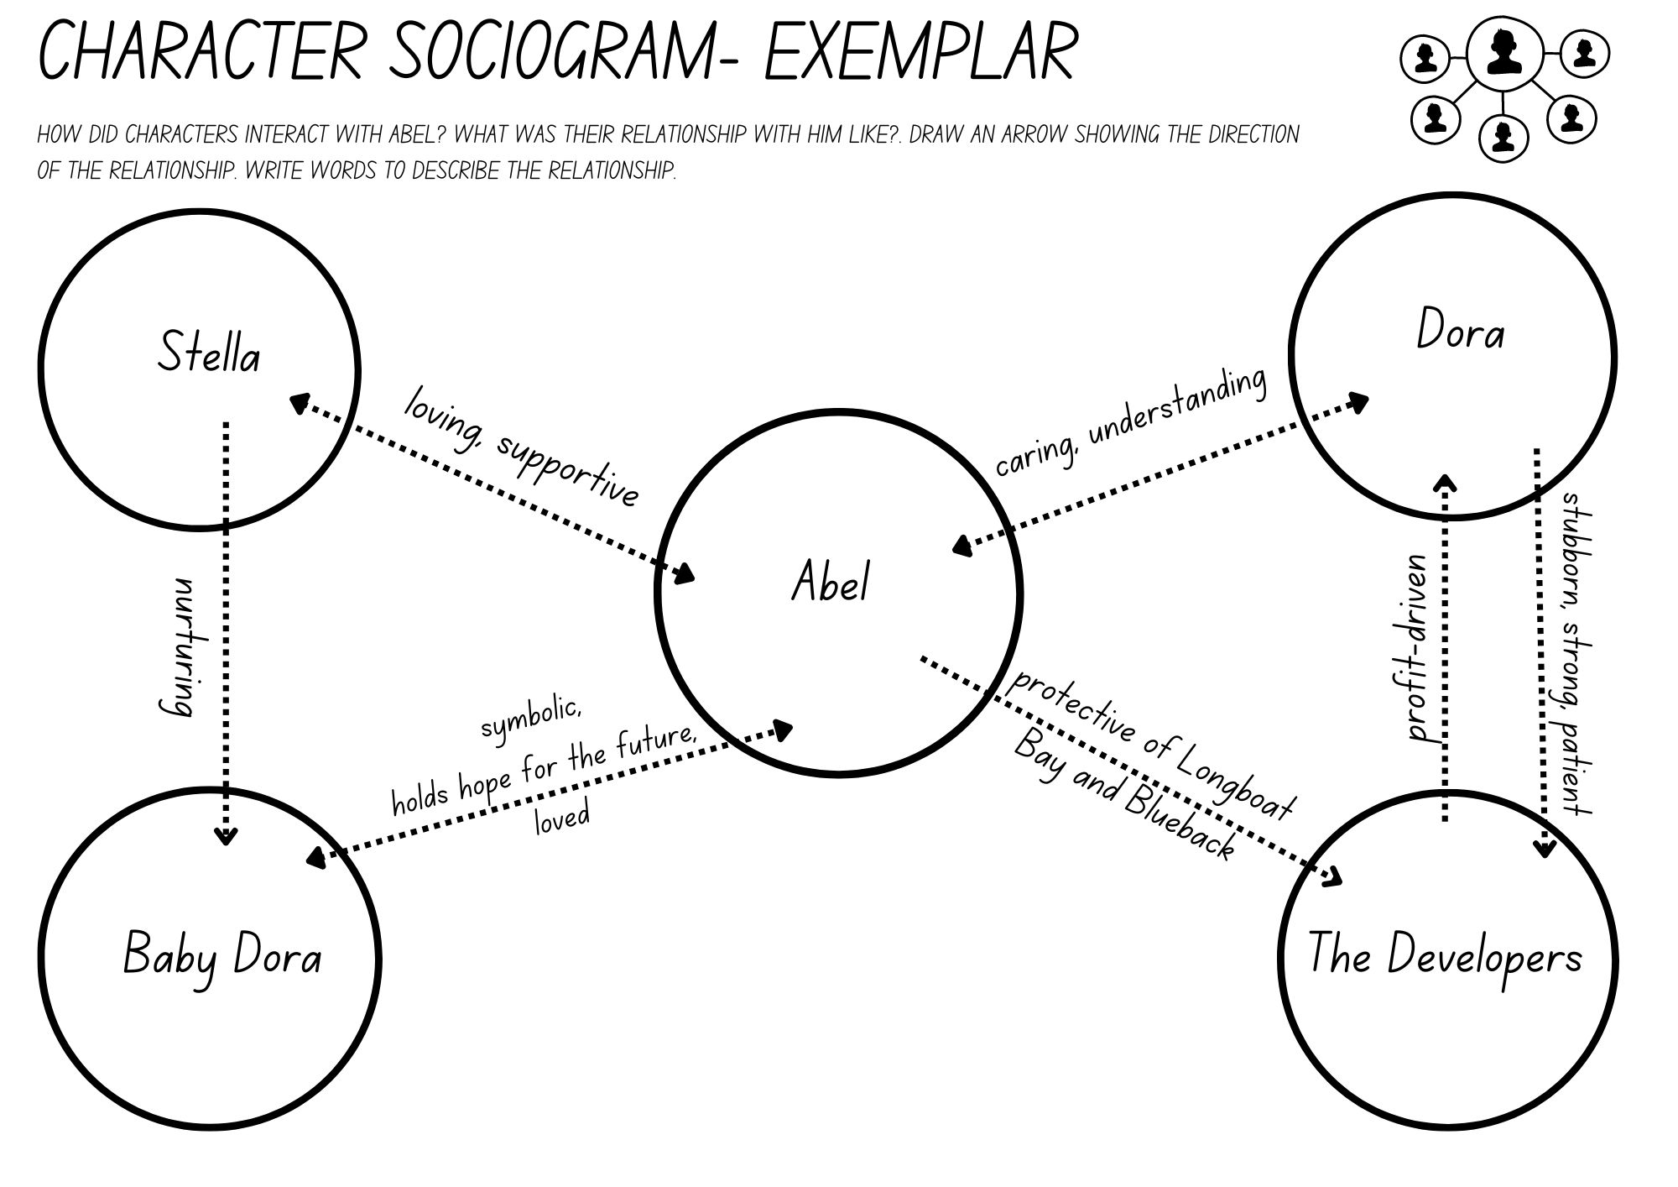

Resource 13 – Somebody, Wanted, But, So, Then
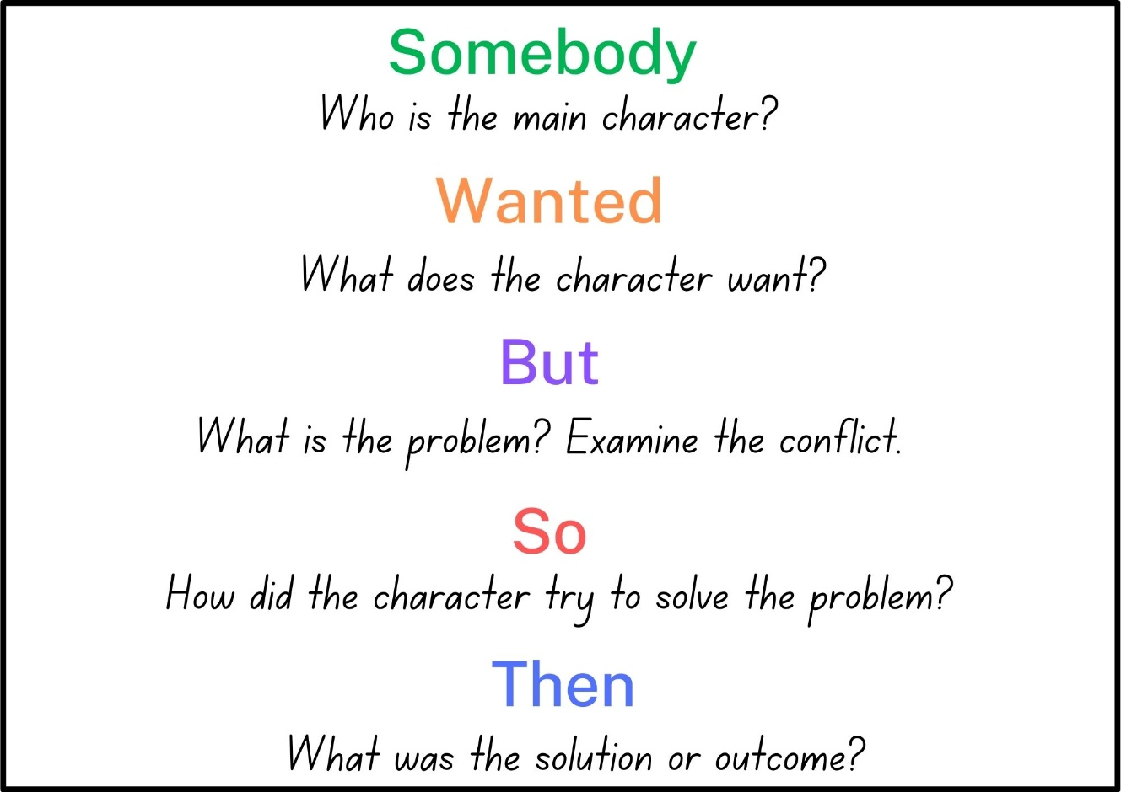

Resource 14 – fluency and close reading passage analysis
Focus | Notes
Passage | From Chapter 8, p 87 ‘The shark looked flabby when it should have been thick and powerful as a tree’ to Chapter 8, p 89 ‘That summer he learnt that there was nothing in nature as cruel and savage as a greedy human being.’ (323 words)
Synopsis | This passage describes a scene of a suffering tiger shark that is entangled with a red buoy and a meat hook. The shark's strength fades, and it can no longer escape the buoy's restraint, leading to its starvation and exhaustion. Abel, the protagonist, witnesses the shark's agony and feels deeply moved by its plight. Unable to save the shark, Abel watches it until it eventually dies. He removes the red buoy, revealing the name "COSTELLO" on it, signifying human involvement in the shark's suffering. The passage ends with Abel realising the cruelty of human beings toward nature. The experience leaves a lasting impact on him, leading to newfound insights and maturity.
Passage structure | The passage can be divided into 3 main sections, each following a distinct sequence of events:  - Description of the shark: The first section introduces the shark and provides a detailed description of its physical condition. It describes the shark as ‘wrinkled and flabby’ when it should have been ‘thick and powerful as a tree.’ The passage also reveals that the shark is towing a big red buoy on a chain and has a stainless steel meat hook in its jaws. The simile ‘swam like a ghost of itself’ highlights its weakened state. This section sets the scene and establishes the shark's suffering and agony.  - Abel's observations and reaction: The second section focuses on Abel's response to the shark's plight. Abel watches the shark all afternoon and becomes deeply disturbed by its suffering. He expresses his desire to end its agony. This section portrays Abel's empathy and compassion for the creature, highlighting his emotional connection to nature.  - The shark's fate and Abel's realisation: The third section delves into the resolution of the story. The next day, the shark is found dead on the beach, and Abel recognizes the name ‘COSTELLO’ stencilled on the red buoy, indicating human involvement in the shark's suffering. Abel then decides to release the shark's body back into the sea, free from the burden of the buoy. The passage concludes with Abel's realisation about the cruelty of human beings, suggesting that he has learned a valuable lesson about the impact of greed on nature.
Language features | - Similes: The author employs similes to compare the shark's appearance and movements to other objects, enhancing the reader's understanding and visualisation. Examples include ‘swam like a ghost of itself’ and ‘sailed down into the black deep like a torpedoed ship.’  - Imagery: Descriptive language and imagery are utilised to paint a clear picture of the shark's physical condition and its surroundings. Phrases such as ‘looked wrinkled and flabby’, ‘moonlight flash on the dragging buoy’, and ‘stiff and leathery on the beach’ create vivid mental images.  - Symbolism: The red buoy with the name ‘COSTELLO’ stencilled on the side serves as a symbolic representation of human interference and its impact on the shark's fate. The buoy represents captivity and suffering, highlighting the shark's struggle.  - Emotive Language: The use of emotive language, such as ‘pitiful sight,’ ‘sickened,’ ‘terrible agony,’ and ‘greedy human being,’ evokes strong feelings of sympathy and sadness in the reader, adding an emotional dimension to the narrative.  - Characterisation: The passage portrays Abel's compassion and helplessness in witnessing the shark's suffering, which contributes to his emotional growth and realisation about human cruelty. The way Tim Winton describes Abel's thoughts and actions develops his character.  - Foreshadowing: The description of the shark's condition and struggle throughout the passage foreshadows its eventual death. This creates a sense of anticipation for the reader and builds tension in the narrative.  - Metaphor: The phrase ‘sailed down into the black deep like a torpedoed ship’ uses a metaphor to compare the shark's descent into the water to that of a sinking ship, emphasising its lifeless state.

Resource 15 – Freytag’s pyramid planning template
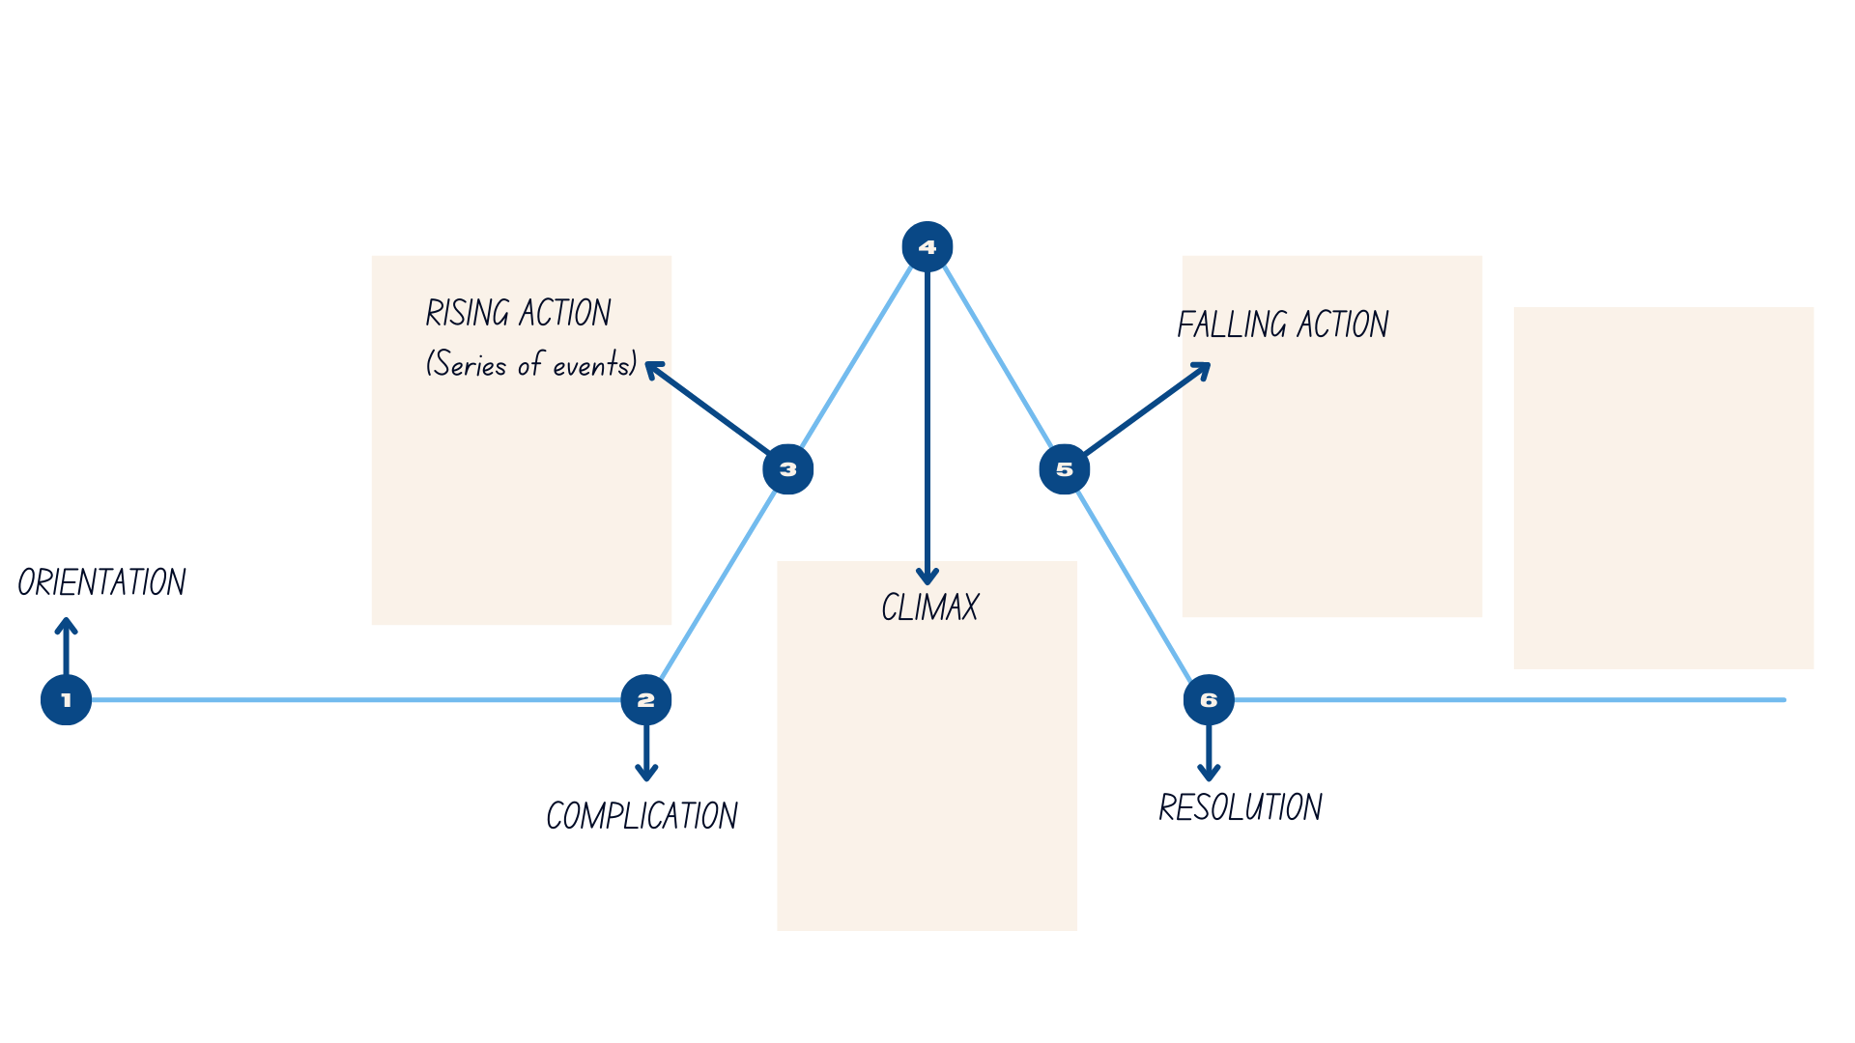

References
This resource contains NSW Curriculum and syllabus content. The NSW Curriculum is developed by the NSW Education Standards Authority. This content is prepared by NESA for and on behalf of the Crown in right of the State of New South Wales. The material is protected by Crown copyright.
Please refer to the NESA Copyright Disclaimer for more information. https://educationstandards.nsw.edu.au/wps/portal/nesa/mini-footer/copyright
NESA holds the only official and up-to-date versions of the NSW Curriculum and syllabus documents. Please visit the NSW Education Standards Authority (NESA) website https://educationstandards.nsw.edu.au/wps/portal/nesa/home and the NSW Curriculum website https://curriculum.nsw.edu.au/.
English K–10 Syllabus © NSW Education Standards Authority (NESA) for and on behalf of the Crown in right of the State of New South Wales, 2022.
National Literacy Learning Progression © Australian Curriculum, Assessment and Reporting Authority (ACARA) 2010 to present, unless otherwise indicated. This material was downloaded from the Australian Curriculum website (National Literacy Learning Progression) (accessed 11 September 2023) and was not modified.
ABC TV & iview (12 April 2023) ‘Ningaloo Nyinggulu | Official Trailer | ABC TV + iview’ [video], ABC TV & iview, YouTube, accessed 4 July 2023.
Copyright Agency and contributors (2023) ‘Blueback’, Lesson, Copyright Agency Reading Australia website, accessed 2 June 2023.
Frasier D (16 June 2009) 'Debra Frasier talks on Editing' [video], Debra Frasier, YouTube, accessed 6 July 2023.
Government of Western Australia (2010) It’s a novel Idea-Blueback [PDF 3.16MB], Government of Western Australia, accessed 4 August 2023.
Horn C (15 March 2023) ‘Volunteers, wildlife staff rescue green sea turtle at Middleton Beach in South Australia’, ABC News, accessed 4 July 2023.
McDonald L (2023) A New Literature Companion for Teachers, 3rd edn, Primary Teaching English Association Australia (PETAA), Marrickville.
NESA (NSW Education Standards Authority) (2023) ‘Glossary’, Resources, NESA website, accessed
Parsons A (2 September 2019) ‘Great Barrier Reef changes image from marine park to theme park with underwater statues and hotels’, ABC News, accessed 4 July 2023.
Roadshow Films (2023) 'Blueback | Official Trailer | 2023 [HD]' [video], Roadshow Films, YouTube, accessed 14 July 2023.
Winton T (1997) Blueback, Penguin Australia Pty Ltd.

© State of New South Wales (Department of Education), 2023
The copyright material published in this resource is subject to the Copyright Act 1968 (Cth) and is owned by the NSW Department of Education or, where indicated, by a party other than the NSW Department of Education (third-party material).
Copyright material available in this resource and owned by the NSW Department of Education is licensed under a Creative Commons Attribution 4.0 International (CC BY 4.0) license.
This license allows you to share and adapt the material for any purpose, even commercially.
Attribution should be given to © State of New South Wales (Department of Education), 2023.
Material in this resource not available under a Creative Commons license:
- the NSW Department of Education logo, other logos and trademark-protected material
- material owned by a third party that has been reproduced with permission. You will need to obtain permission from the third party to reuse its material.
Links to third-party material and websites
Please note that the provided (reading/viewing material/list/links/texts) are a suggestion only and implies no endorsement, by the New South Wales Department of Education, of any author, publisher, or book title. School principals and teachers are best placed to assess the suitability of resources that would complement the curriculum and reflect the needs and interests of their students.
If you use the links provided in this document to access a third-party's website, you acknowledge that the terms of use, including licence terms set out on the third-party's website apply to the use which may be made of the materials on that third-party website or where permitted by the Copyright Act 1968 (Cth). The department accepts no responsibility for content on third-party websites.

