English 3–6 Multi-age – Year A Unit 3

Contents
Unit overview and instructions for use 7
Teacher notes 9
Outcomes and content 11
Resources 22
Week 1 26
Component A teaching and learning 26
Planning framework 26
Component B teaching and learning 26
Learning intentions and success criteria 26
Lesson 1 – Deadly Science Wild Weather and genre 28
Whole 28
Lesson 2 – exploring and examining text structures and features 31
Whole 31
Part 33
Lesson 3 – language features within a text 34
Whole 34
Part 37
Whole 39
Lesson 4 – building subject specific vocabulary 40
Whole 40
Part 42
Whole 43
Week 2 44
Component A teaching and learning 44
Planning framework 44
Component B teaching and learning 44
Learning intentions and success criteria 44
Lesson 5 – listening for understanding and making notes 46
Whole 46
Whole 48
Part 49
Whole 50
Lesson 6 – exploring sentences 52
Whole 52
Part 53
Lesson 7 – following imperative sentences through experiments 55
Whole 55
Part 56
Whole 57
Lesson 8 – creating an informative text 58
Whole 58
Part 60
Whole 61
Week 3 62
Component A teaching and learning 62
Planning framework 62
Component B teaching and learning 62
Learning intentions and success criteria 62
Lesson 9 – researching and summarising 64
Whole 64
Part 66
Whole 68
Lesson 10 – identifying similarities and differences between texts 69
Whole 69
Lesson 11 – author purpose and perspective 75
Whole 75
Part 76
Part 77
Whole 79
Lesson 12 – historical accounts 80
Whole 80
Week 4 83
Component A teaching and learning 83
Planning framework 83
Component B teaching and learning 83
Learning intentions and success criteria 83
Lesson 13 – planning and researching (scientific) 84
Whole 85
Part 86
Part 87
Lesson 14 – creating a written text (scientific) 89
Whole 90
Lesson 15 – planning and researching (historical) 91
Whole 91
Lesson 16 – creating a written text (historical) 94
Whole 94
Week 5 96
Component A teaching and learning 96
Planning framework 96
Component B teaching and learning 96
Learning intentions and success criteria 96
Lesson 17 – revising and editing a hybrid text 97
Whole 98
Part 98
Lesson 18 – publishing a hybrid text 100
Whole 100
Lesson 19 – presenting a multimodal text 104
Whole 104
Lesson 20 – reflecting on learning and textual concepts 105
Whole 106
Resource 1 – scavenger hunt bingo 108
Resource 2 – Nyoongar seasons 109
Resource 3 – vocabulary jamboard 110
Resource 4 – sentences for meaning grid (Stage 3) 111
Resource 5 – Book Creator exemplar 112
Resource 6 – deadly facts card exemplar 113
Resource 7 – deadly facts card template 114
Resource 8 – summarising task board 115
Resource 9 – earthquakes 116
Resource 10 – researching and planning template 117
Resource 11 – Newcastle earthquake 118
Resource 12 – researching and planning a historical account 119
References 120

Unit overview and instructions for use
In this 5-week unit, students will gain greater understanding of the textual concepts of ‘genre’ and ‘perspective and context’. Through study of the mentor text Deadly Science Wild Weather and the supporting text Cyclone by Jackie French, students will apply their understanding of genre to analyse texts and identify their purpose, subject matter, form, structure and language choices. Students will plan, compose, revise, edit and publish a hybrid text recounting a historical extreme weather event in Australia.
Outcomes and content in this unit are organised into Component A and Component B. The components are connected, with learning in Component A complementing learning in Component B.
Note: the duration of this unit can be adapted to suit individual school contexts. For example, learning could occur across 5 days rather than 4.
The table below highlights the focus areas and preparation required for Component A and Component B.
Teaching and learning | Component A | Component B
Suggested duration | 60 minutes × 4 days/week or equivalent | 60 minutes × 4 days/week or equivalent
Explicit teaching focus areas | Component A addresses content from the focus areas:  - Vocabulary  - Reading fluency (Stage 2)  - Reading comprehension  - Creating written texts  - Spelling  - Handwriting and digital transcription  It centres on the development of foundational skills and knowledge through regular, systematic and repeated practice. | Component B addresses content from the focus areas:  - Oral language and communication  - Vocabulary  - Reading comprehension  - Creating written texts  - Understanding and responding to literature  It centres on the conceptual understandings of English and exemplifies the importance of learning about and enjoying literature through the study of quality texts.
Preparing for teaching and learning | - Specific teaching and learning activities need to be developed by the teacher. When planning for these activities, please refer to the Component A outcomes and content, teaching guides and planning frameworks.  - Plan and document how you will sequence teaching and learning in whole-class and targeted-groups across the 5-week cycle as required. This should be based on student needs identified through ongoing assessment data. | - Familiarise yourself with the mentor and supporting texts and textual concepts, and the teaching and learning sequence.  - Determine how you will support students in whole-class and targeted-groups across the 5-week cycle as required. This should be based on student needs identified through ongoing assessment data.
English K–10 Syllabus © NSW Education Standards Authority (NESA) for and on behalf of the Crown in right of the State of New South Wales, 2022.

Teacher notes
- Genre is defined as the categories into which texts are grouped. The term is often used to distinguish texts on the basis of, for example, their subject matter (detective, fiction, romance, science fiction, fantasy fiction), form and structure (poetry, novels, short stories) (NESA Glossary).
- Understanding of genre can be supported through watching the department’s video: Genre (3:00).
- While genre is the mentor concept for the conceptual component of this unit, the supporting concepts of perspective and context can also be explored. Additional textual concepts may be included based on individual school context and student needs.
- For information on coordinating conjunctions, hybrid texts, multimodal texts and multimedia, refer to the NESA Glossary.
- This unit could enhance student learning towards the achievement of Science and Technology outcomes.
Note: when exploring this unit, it is important to approach learning with sensitivity, with consideration to the experiences of students who may have encountered traumatic events related to weather.
- Lesson 7 involves conducting a mini tornado in a bottle experiment. Water, plastic bottles with caps, glitter and dishwashing liquid will be required.
- In addition to the resources listed, students will require access to extracts from the text. Teachers can copy extracts from texts in reliance on the Statutory Text and Artistic Works Licence. Teachers need to attribute the extracts and include the following notice: ‘This material has been copied [and communicated to you] in accordance with the statutory licence in section 113P of the Copyright Act. Any further reproduction or communication of this material by you may be the subject of copyright protection under the Act. Do not remove this notice’.
- Reflect on student learning and engagement in activities and record differentiation and adjustments within the unit to inform future teaching and learning. One way of doing this could be to add comments to the digital file.
- In NSW classrooms there are a diverse range of students including Aboriginal and Torres Strait Islander students, students learning English as an additional language or dialect, high potential and gifted students and students with disability. Some students may identify with more than one of these groups, or possibly all of them. Refer to Curriculum planning for every student – advice for further information.
- Content points are linked to the National Literacy Learning Progression (version 3).
Levels and indicators sourced from National Literacy Learning Progression © Australian Curriculum, Assessment and Reporting Authority (ACARA), (accessed 11 September 2023) and was not modified. See references for more information.

Outcomes and content
The tables below outlines the outcomes and content for this unit. The letters 'A' and 'B' in the header refer to Components A and B. The numbers 1 to 5 refer to weeks. The use of 'x' in these columns indicates where the content points are intended to be addressed and in which week.
Stage 2 focus area and outcome, content points and National Literacy Learning Progression | A | B | 1 | 2 | 3 | 4 | 5
Oral language and communication
EN2-OLC-01 communicates with familiar audiences for social and learning purposes, by interacting, understanding and presenting
- Contribute to discussions with peers and stay on topic, build on others' ideas and express own ideas (InT4) |  | x | x | x | x | x | x
- Make notes when listening to spoken texts, asking questions to clarify or follow up on information and seeking assistance if required (LiS5) |  | x | x | x | x
- Identify how inferred or literal meaning is impacted by tone, pace, pitch and volume, gesture and posture communication, and how these affect the audience |  | x |  | x |  |  | x
- Include multimodal features in planned and delivered presentations, to expand meaning and engage an audience (SpK5) |  | x |  | x |  |  | x
Vocabulary
EN2-VOCAB-01 builds knowledge and use of Tier 1, Tier 2 and Tier 3 vocabulary through interacting, wide reading and writing, and by defining and analysing words
- Build personal Tier 1, Tier 2 and Tier 3 vocabulary through social and learning interactions, reading and writing (SpK5) | x | x | x | x | x | x | x
- Understand that many words derive from other languages, including Aboriginal and Torres Strait Islander Languages, and that the pronunciation and spelling of words may reflect their etymology | x | x | x
Reading fluency
EN2-REFLU-01 sustains independent reading with accuracy, automaticity, rate and prosody suited to purpose, audience and meaning
- Read multisyllabic words, phrases and continuous texts with accuracy and appropriate rate suited to reading purpose (FIY5, PKW8) | x |  | x | x | x | x | x
- Adjust voice, tone, volume and pitch reflected by the punctuation in a text, to enhance reading fluency and support comprehension (FIY5) | x |  | x | x | x | x | x
Reading comprehension
EN2-RECOM-01 reads and comprehends texts for wide purposes using knowledge of text structures and language, and by monitoring comprehension
- Build topic knowledge, including key vocabulary, and activate background knowledge prior to and during reading (UnT7) | x | x | x | x | x | x | x
- Identify similarities and compare differences within and between texts by making text-to-self, text-to-text and text-to-world connections |  | x |  |  | x
- Identify and use strategies to repair reading when meaning breaks down (UnT6) | x |  | x | x | x | x | x
- Ask questions to clarify meaning and promote deeper understanding of a text (LiS6, UnT6) | x | x | x | x | x | x | x
- Use information from paragraphs or chapters to group related ideas and support summarisation of the whole text (UnT6) |  | x |  | x | x | x
Creating written texts
EN2-CWT-02 plans, creates and revises written texts for informative purposes, using text features, sentence-level grammar, punctuation and word-level language for a target audience
- Create informative written texts that include headings, paragraphs beginning with topic sentences, and may conclude information in a final paragraph (CrT8) |  | x |  | x |  | x | x
- Create written factual and historical accounts that include an introduction with the who, what, when, where and why of an experience or event, a description of a series of events and a conclusion (CrT8) |  | x |  | x | x | x | x
- Use definite articles for particular things and indefinite articles for general things for cohesion | x | x | x | x |  | x | x
- Use subordinating conjunctions in complex sentences to signal sequence, reason or cause and effect (GrA4) | x | x |  | x | x | x | x
- Use declarative sentences to provide facts or state a viewpoint | x | x |  | x | x | x | x
- Use imperative sentences to advise, provide instructions, express a request or a command | x | x |  | x | x | x | x
- Use apostrophes for contractions, and to show singular and plural possession (PuN4, PuN5, SpG9) | x | x |  |  | x | x | x
- Use topic specific Tier 2 and 3 Vocabulary to demonstrate authority (CrT8) | x | x | x | x | x | x | x
- Plan structures and language to suit the purpose of a text (CrT7) |  | x |  | x | x | x
- Research, summarise and list topic-related ideas when planning |  | x |  |  | x | x
Spelling
EN2-SPELL-01 selects, applies and describes appropriate phonological, orthographic and morphological generalisations and strategies when spelling in a range of contexts
- Explain how to segment multisyllabic words into syllables and phonemes, and apply this knowledge when spelling (SpG7) | x |  | x | x | x | x | x
- Identify differences in vowel phonemes (short, long, diphthong and schwa vowels) (SpG9) | x |  | x | x | x | x | x
- Understand that some graphemes are dependent on their position in a word in English and apply this knowledge when spelling | x |  | x | x | x | x | x
- Understand that graphemes can be explained by their etymology (SpG9) | x |  | x | x | x | x | x
- Identify prefixes that require no change to the base word or root when they are affixed, and apply this knowledge when spelling (SpG9) | x |  | x | x | x | x | x
Handwriting and digital transcription
EN2-HANDW-01 forms legible joined letters to develop handwriting fluency
EN2-HANDW-02 uses digital technologies to create texts
- Join letters using consistent size and spacing to develop fluency (Year 3) (HwK6) | x |  | x | x | x |  | x
- Sustain the NSW Foundation Style cursive to facilitate fluency and legibility across a text (Year 4) (HwK6) | x |  | x |  | x |  | x
- Position a chosen device in a way that facilitates efficient and sustained text creation (Year 3) | x |  |  |  |  | x
- Monitor goals that build on typing accuracy and rate (Year 4) | x |  | x |  |  | x
Understanding and responding to literature
EN2-UARL-01 identifies and describes how ideas are represented in literature and strategically uses similar representations when creating texts
- Understand that genre refers to texts that are grouped according to purpose, subject matter, form, structure and language choices, and that a type of text can differ in mode and medium |  | x | x | x | x | x | x
- Identify and discuss the purpose of a text, and its intended audience, mode and medium (UnT7) |  | x |  | x | x |  | x
English K–10 Syllabus © NSW Education Standards Authority (NESA) for and on behalf of the Crown in right of the State of New South Wales, 2022.
Stage 3 focus area and outcome, content points and National Literacy Learning Progression | A | B | 1 | 2 | 3 | 4 | 5
Oral language and communication
EN3-OLC-01 communicates to wide audiences with social and cultural awareness, by interacting and presenting, and by analysing and evaluating for understanding
- Initiate and contribute to sustained discussions, through questioning, building on and evaluating shared information (InT5) |  | x | x | x | x | x | x
- Evaluate the role of gesture during social and learning interactions and describe its impact on the audience |  | x |  | x |  |  | x
- Analyse how audio elements in texts integrate with linguistic, visual, gestural and spatial elements to create meaning and impact (SpK6) |  | x |  | x |  |  | x
- Select multimedia components, visual displays or use gestural features to enhance and bring clarity to presentations (SpK6) |  | x |  |  | x |  | x
Vocabulary
EN3-VOCAB-01 extends Tier 2 and Tier 3 vocabulary through interacting, wide reading and writing, morphological analysis and generating precise definitions for specific contexts
- Identify and use words that convey informative and objective meanings in texts | x | x | x | x | x | x | x
- Identify and use words derived from other languages, including Aboriginal and Torres Strait Islander Languages, and know that the pronunciation and spelling of words may reflect their etymology (UnT9) | x | x | x
Reading comprehension
EN3-RECOM-01 fluently reads and comprehends texts for wide purposes, analysing text structures and language, and by monitoring comprehension
- Efficiently follow signposting features to navigate print and digital texts | x |  | x | x | x | x | x
- Select texts from print or digital sources to gather and organise research on a topic |  | x | x | x |  | x
- Adjust reading approach to suit the purpose for reading (UnT8) | x | x | x | x | x | x | x
- Bring subject vocabulary, technical vocabulary, background knowledge and conceptual knowledge to new reading tasks (UnT8) | x | x | x | x | x
- Use knowledge of text structure to navigate the text to locate specific information (UnT8) | x | x | x | x | x | x
- Ask questions to clarify thinking, and to provide reasons or evidence (LiS6) | x | x | x | x | x | x | x
- Synthesise summaries of multiple texts and share information with peers to generate, compare and contrast new conceptual understandings | x | x |  |  | x | x
Creating written texts
EN3-CWT-01 plans, creates and revises written texts for multiple purposes and audiences through selection of text features, sentence-level grammar, punctuation and word-level language
- Develop informative texts that include headings, ideas grouped into paragraphs that include a topic sentence, and a paragraph with concluding information (CrT9) |  | x |  | x | x | x | x
- Create factual and historical accounts that incorporate broader contextual information (CrT8) |  | x |  |  | x | x | x
- Create nominalisations to convey abstract ideas and concepts succinctly and authoritatively (GrA7) | x | x | x | x | x | x | x
- Make choices about the use of declarative, exclamatory, interrogative and imperative sentences to suit text purpose, and for meaning and effect (CrT8) | x | x |  | x | x | x | x
- Use parentheses in the first instance when abbreviating names using acronyms, and when acknowledging a source (PuN7) | x | x |  | x | x | x | x
- Use topic-specific Tier 2 and Tier 3 vocabulary intentionally to add credibility and enhance authority (CrT9) | x | x | x | x | x | x | x
- Select text formats for combined purposes, creating hybrid texts for target audiences |  | x | x |  | x | x | x
- Research and summarise information from several sources to plan for writing |  | x |  |  | x | x
- Assess the reliability and authority of sources, including digital sources, when researching and acknowledging texts |  | x |  |  | x | x
Spelling
EN3-SPELL-01 automatically applies taught phonological, orthographic and morphological generalisations and strategies when spelling in a range of contexts, and justifies spelling strategies used to spell unfamiliar words
- Segment unfamiliar multisyllabic words into syllables and phonemes as a strategy when spelling | x |  | x | x | x | x | x
- Proofread written texts to correct misspellings, making use of spelling reference tools where required (late) | x |  | x | x | x | x | x
- Explain and use spelling conventions for assimilated prefixes such as in-, ad-, com- (SpG10) | x |  | x | x | x | x | x
Handwriting and digital transcription
EN3-HANDW-01 sustains a legible, fluent and automatic handwriting style
EN3-HANDW-02 selects digital technologies to suit audience and purpose to create texts
- Adjust handwriting style to suit writing purpose (HwK8) | x |  | x |  | x |  | x
- Navigate the keyboard with efficiency and accuracy when typing words, numerals, punctuation and other symbols (HwK8) | x |  | x |  |  | x | x
- Understand that the position of the device in relation to the user can affect posture and glare | x |  | x |  |  | x | x
Understanding and responding to literature
EN3-UARL-02 analyses representations of ideas in literature through genre and theme that reflect perspective and context, argument and authority, and adapts these representations when creating texts
- Examine and experiment with elements in literature that do not follow the form and function of a single genre |  | x | x | x | x |  | x
- Identify how perspective is made evident through authorial choices |  | x |  |  | x |  | x
English K–10 Syllabus © NSW Education Standards Authority (NESA) for and on behalf of the Crown in right of the State of New South Wales, 2022.

Resources
The resources in the table below are referred to in this unit. Letters 'A' and 'B' in the header refer to Component A and B respectively, and the numbers 1 to 5 indicate weeks. The use of 'x' in these columns indicate whether the resources are required in Component A, B or both, and in which week.
Resource | A | B | 1 | 2 | 3 | 4 | 5
Tutt C (ed) (2021) Deadly Science Wild Weather, Australian Geographic, Australia. ISBN: 9781922388162 | x | x | x | x | x | x | x
French J (2018) Cyclone, Scholastic Australia Pty Ltd. ISBN: 9781743623589 |  | x |  |  | x |  | x
Resource 1 – scavenger hunt bingo (optional) |  | x | x
Sticky notes |  | x | x
Laptops or tablets |  | x | x | x
Resource 2 – Nyoongar seasons |  | x | x
Mentimeter |  | x | x
Whiteboards |  | x | x
Resource 3 – vocabulary jamboard |  | x | x
Resource 4 – sentences for meaning grid (Stage 3) |  | x |  | x
Resource 5 – Book Creator exemplar |  | x |  | x
Book Creator |  | x |  | x
Australian Geographic: Science Experiment – Create a ‘tornado’ inside a bottle Materials for science experiment: plastic bottle with a cap, glitter and dishwashing liquid |  | x |  | x
What’s the question? |  | x |  | x
Resource 6 – deadly facts card exemplar |  | x |  | x
Resource 7 – deadly facts card template |  | x |  | x
Resource 8 – summarising task board |  | x |  |  | x
T chart |  | x |  |  | x
Venn diagram |  | x |  |  | x
Think-Pair-Share |  | x |  |  | x
Hot seat |  | x |  |  | x
Selection of factual and historical texts on extreme weather (print and digital) |  | x |  |  |  | x
Resource 9 – earthquakes |  | x |  |  |  | x | x
Resource 10 – researching and planning template |  | x |  |  |  | x | x
Resource 11 – Newcastle earthquake |  | x |  |  |  | x | x
Resource 12 – researching and planning a historical account |  | x |  |  |  | x | x

Week 1

Component A teaching and learning
Component A focuses on the development of foundational skills and knowledge through regular, systematic and repeated practice. The mentor and supporting texts used in Component B of this unit can support the effective implementation of Component A teaching and learning.

Planning framework
To plan and document Component A teaching and learning, a planning scaffold [DOCX 81 KB] is provided. To support you in your planning, a link to a detailed example of a one-week teaching and learning cycle is included in the scaffold. Additional resources to support teaching and learning in each focus area can be found at Lesson advice guides.

Component B teaching and learning
The following teaching and learning sequence has been designed to address Component B outcomes and content and develops conceptual understandings of English through the study of quality texts. Adapt the sequence as required to best meet the needs of your students.

Learning intentions and success criteria
Learning intentions and success criteria are best co-constructed with students. The table below contains suggested learning intention and success criteria.
Element | Stage 2 | Stage 3
Learning intention | Students are learning that texts can be grouped according to purpose, subject matter, form, structure and language choices and this is called genre. | Students are learning to experiment with elements in literature that do not follow the form and function of a single genre.
Success criteria | Students can:  - build topic knowledge, including key vocabulary, and activate background knowledge  - efficiently follow signposting features to navigate print and digital texts  - understand that many words derive from other languages, including Aboriginal and Torres Strait Islander Languages  - build personal Tier 1, Tier 2 and Tier 3 vocabulary. | Students can:  - bring subject vocabulary, technical vocabulary and background knowledge to new reading tasks  - use knowledge of text structure to navigate the text to locate specific information  - identify and use words derived from other languages, including Aboriginal and Torres Strait Islander Languages  - identify and use words that convey informative and objective meanings in texts.

Lesson 1 – Deadly Science Wild Weather and genre
The following teaching and learning activities support multi-age settings.

Whole
- Ask students to pick a weather-related fact or fib question to engage curiosity and engagement. For example:
- Cyclones are powerful twisting funnels of rising wind that reach down from supercell thunderstorms and hit the ground. (fib)
- Often a tsunami isn’t a single wave, but a series of waves separated by between 5 to 90 minutes. (fact)
- Australia has several active volcanoes on its mainland. (fib)
- Floods cost Australia $377 million per year and is the most expensive natural disaster. (fact)
- Hailstones can be as big as cricket balls, around 8 cm in diameter. (fact)
- Heatwaves are responsible for more deaths in Australia than any other natural hazard. (fact)
- Display the front and back cover of Deadly Science Wild Weather. Read the blurb on the back cover and the contents page.
- Display several pages from the text to observe the structure and features. Ask students to make careful observations through the see, think, wonder routine. For example:
- See: I see ... (Students discuss what they see/notice about the text)
- Think: I think ... (Students make predictions or connections to the text)
- Wonder: I wonder ... (Students discuss questions they may have about the text).
- Display the word ‘genre’ and provide students with time to discuss what they know about genre.
- Review that genre is a term used to group texts according to similarities in structure and function. For example, purpose, subject matter and language choices. These could include informative, imaginative and persuasive texts that can differ in mode and medium, such as printed words in a published book or spoken words on the internet. Explain that identifying genre helps readers make predictions about patterns in a text and understand the type of text they will be reading. Understanding genre also helps readers to select texts they are interested in.
- Ask students to brainstorm a range of genre categories and the purpose of each. For example, mysteries engage the reader to solve a puzzle, historical recounts provide insights into past events, biographies tell the life story of a real person. Other genres could include science fiction, fantasy and adventure. As students share their brainstormed answers, ask them to consider who the audience for each genre could be.
- Explain that the purpose of a text is one way of helping to identify genre. Ask students to recall other ways (categories) to identify the genre of a text, for example, subject matter, form, text structure, language choices, mode and medium. As each category is identified, record it on an anchor chart that can be referenced throughout the unit.
- Model writing questions that can be used to help identify the genre of a text and add to the anchor chart. As the chart is constructed, ask students to consider what questions could be asked in each category so that instruction moves from modelled to co-construction. For example:
- Purpose: What is the main purpose of the text? Does the text inform, entertain or persuade?
- Subject matter: What is the main topic or theme of the text? Is it related to animals, friendship, adventure, fantasy, science, history? Are there specific characters, settings, or events?
- Structure: What is the structure of the text? Is the text a narrative, an argument, a report, a letter, or a poem? Are there specific sections or headings within the text, such as an introduction or a conclusion?
- Language choices: Does the text contain specific vocabulary used that is associated with the subject matter? Is there figurative language such as metaphors, similes, or personification?
- Mode: Is the text written, spoken, or visual? Does the text rely on words, images, or a combination to communicate its message?
- Medium: In what format or platform is the text presented? Is it a book, magazine, website, social media post, video, or audio recording? How is the text delivered to the audience?
- Display a page from Deadly Science Wild Weather and explain that students will work in small groups and use the questions from activity 7 to analyse an allocated genre category.
- Divide students into small groups and allocate a genre category. Prompt students to refer to the questions from activity 7 to analyse the displayed page from the text. Select a group member to share the analysis using examples to justify their reasons.
- Ask students to share what genre category Deadly Science Wild Weather is. Explain that sometimes texts do not have a single genre and are not always fixed categories. Texts can be adapted or blended to create a hybrid text that combines features from multiple genres (informative can be scientific and historical) or mediums (images and text) to foster a unique reading experience.
- Students record a statement explaining the genre of Deadly Science Wild Weather using evidence from the text. For example, Deadly Science Wild Weather is scientific and historical because it informs the reader about weather events. It gives historical facts about extreme weather events. It is scientific because it includes scientific vocabulary and diagrams. Students share their statements with the class.
Too easy? Students use the chart from activity 7 to include correct category names to create a statement.
- Co-construct a class statement to explain the genre of Deadly Science Wild Weather and its hybrid nature. Display in the class for future reference.

Lesson 2 – exploring and examining text structures and features
The following teaching and learning activities support multi-age settings.

Whole
- Play a game of What am I? riddles. Provide students with clues to determine a season. For example:
- I fall between March and May. The weather begins to cool and leaves on trees change colour, creating beautiful displays of red, orange and yellow. What am I? (autumn)
- I bring warm sunny days and beach visits. It is the wet season for people living in far north Australia, which brings increased rainfall and humidity. What am I? (summer)
- I bring frosty nights, spurts of rainfall, chilly breezes that fill the atmosphere and ski season for those that enjoy active sports. What am I? (winter)
- I have sunny days and cool nights. Flowers bloom and trees once bare come alive with delicate buds that transform into lush green leaves creating a spectacular display of colour in the environment. What am I? (spring)
- Revisit the co-constructed class statement from Lesson 1 to reflect on the genre of Deadly Science Wild Weather.
- Briefly skim through Deadly Science Wild Weather. Discuss and record how the informative genre can be seen throughout the text. For example, the use of headings, subheadings, captions, tables, infographics, symbols, a contents page, diagrams, QR codes and images. Demonstrate how to use the informative features to navigate the text.
- Using the contents page, navigate to page 2 of Deadly Science Wild Weather to explore the topic of ‘Australian Seasons’.
- Read the heading ‘Australian Seasons’ and the paragraph on page 2 under the title. When reading, pause to clarify vocabulary and information. To build topic knowledge discuss the differences between the season models. For example, the ‘3-season model’ of the Gadgerong people compared to the 4-season European model.
- Students Think-Pair-Share to discuss why the author has used bold formatting in the paragraph. For example, to draw readers’ attention to the introductory paragraph about the connection between seasons.
- Read pages 2 and 3 of Deadly Science Wild Weather. Ask students to identify the subheadings. For example, ‘Weather patterns’, ‘El Niño’ and ‘La Niña’. Ask students why the author has used subheadings. For example, to briefly describe the information that follows and to guide readers to locate specific information.
- Model using the contents page to navigate to pages 22 to 23 of Deadly Science Wild Weather to explore ‘Earthquakes’. Discuss the text features and their purpose. Students discuss the similarities between the text features located on pages 2 to 3 of ‘Australian Seasons’ and pages 22 to 23 of ‘Earthquakes’. Reinforce that the text features used across the pages support the informative genre of the text.

Part
The table below details the differentiated teaching and learning activities for each stage.
Stage 2 (teacher guided, pairs) | Stage 3 (teacher guided)
- Model writing a ‘What am I?’ riddle using information on pages 22 to 23 about ‘Earthquakes’ that focus on the purpose, subject matter, form, structure and language choices. For example:  I am a visual representation that reinforces the impact of an earthquake. I have a caption to support meaning. I am split across pages 22 and 23. What am I? (A photograph/image of Christchurch, NZ).  - In pairs, students create ‘What am I?’ riddles using informative text features observed on pages 22 to 23 about ‘Earthquakes’. For example, images, labels, subheadings.  - Students join with another pair to share riddles. | - Display a question for students to examine the author’s choice of and impact of genres in Deadly Science Wild Weather. For example, why do you think the author chose to blend historical and scientific genres in the text?  - In small groups students write down as many answers as they can on a sticky note (one idea per sticky note) then stick it to the centre of the desk.  - At the end of a set time limit students review and discuss each other’s answers. A group leader could be allocated to initiate discussions and encourage others to contribute.  - After ideas have been shared and discussed, students write an explanation of how the text’s historical and scientific aspects complement each other.
- Optional: If multiple copies of the text are available, students use Resource 1 – scavenger hunt bingo, to navigate through pages 8 to 13 of Deadly Science Wild Weather to locate specific information on heatwaves (p 8), droughts (p 10) and floods (p 12) to build topic knowledge and an understanding of text structure and features.
- Students use an exit ticket to consolidate and reflect on learning. For example, 3-2-1:
- List 3 things you learned today
- List 2 questions you have about these things
- Give one reason why it's important to learn about these things.

Lesson 3 – language features within a text
The following teaching and learning activities support multi-age settings.

Whole
- Students connect with nature by stepping into an outdoor space. Encourage observations of surroundings, paying close attention to natural elements. For example, plants, animals and weather conditions. Engage students’ senses during the nature walk to enhance their connection with the environment.
- Ask students what information they can ascertain about weather and climate from the season phases in Australia. For example, in summer in Australia it is typically hot and dry. Support students to elaborate on their thinking by sharing what observations they can make about the environment. For example, what they can feel and see.
- Explain that Aboriginal and Torres Strait Islander peoples, Australia’s first scientists, have always held a deep understanding of the seasons and of how to tell when seasons are changing. Their observation of the environment over time has contributed to the understanding of how plants, animals, water, weather, fire and even stars interact.
- Refer to the contents page of Deadly Science Wild Weather to read the information about Deadly Science and the editor Corey Tutt to understand the perspective and context of the author. Ask students what they learnt about the editor. For example, he is a proud Kamilaroi man from Nowra on the New South Wales south coast. Highlight that the purpose for writing the text was to preserve history and ask students to explain why they think it is important.
- Display the Map of Indigenous Australia to build understanding of the many different and distinct Aboriginal and Torres Strait Islander groups. Use the zoom feature to locate Kamilaroi country.
- Explain that as an Aboriginal Australian and the founder of Deadly Science, Corey Tutt wanted to ensure that every remote Australian school had resources that tell the true history of Australia's first scientists. As a result, he was named the 2020 NSW Young Australian of the Year. Explain that understanding the author’s identity as a proud Kamilaroi man provides valuable insight into the Aboriginal perspective and context presented throughout the text.
- Watch BTN-Indigenous Seasons. Students turn and talk to identify 3 main points that they learnt from the video. For example, Indigenous knowledge and names of the seasons is unique to each language group across Australia. The number of seasons recognised in an annual cycle, the length of each season, and how they are understood differs depending on where the seasonal knowledge of Country has developed.
- Read and explore the diagrams showing seasons as understood by the Noongar people, the D’harawal people and the Bininj/Mungguy people on page 2 of Deadly Science Wild Weather. Explain unfamiliar key vocabulary. For example, climate, estuaries, bulbs, clan, mist. Review that diagrams are consistent with the features of an informative genre.
- Analyse the ‘Noongar seasons’ diagram on page 2 of Deadly Science Wild Weather. Discuss that Noongar people came from the south-west of Western Australia and that there are 14 different groups in the Noongar cultural block. Explain how the pronunciation and spelling of words in a language often reflect their etymology. Etymology helps readers understand how words have evolved over time, tracing their roots back to different languages and cultures.
- In pairs, students use the ‘Noongar seasons’ diagram to identify and record the seasonal words derived from Aboriginal and Torres Strait Islander Languages. For example, Birak, Bunuru, Djeran, Makuru, Djilba, Kambarang.
- Analyse the ‘D’harawal seasons’ diagram on page 2 of Deadly Science Wild Weather (displaying an enlarged copy will support ease of reading). Compare the language used with the Noongar season. For example, wet Noongar season is ‘Djeran’ and wet D’harawal season is ‘Bana’murra’yung’. Discuss how language varies across Indigenous communities and highlights the history of a rich scientific knowledge and understanding.
- Using the information surrounding the diagrams showing seasons, ask students to explore the translation of Indigenous terms. For example, ‘ngoonuni’ (flying-fox), ‘barrugin’ (echidna) and ‘burringoa’ (forest red gum). Highlight how many words and phrases in Indigenous Australian languages reflect the flora, fauna and geographic features specific to their regions. Ask students to reflect on and explain how Aboriginal and Torres Strait Islander communities perceive and interpret the changing seasons.
- Display the ‘Nyoongar calendar’ from the Bureau of Meteorology – Indigenous Weather Knowledge website and explain that the website gives more information about the seasons as understood by different Aboriginal and Torres Strait Islander groups.
- Navigate to the ‘select a calendar’ drop down menu. Select ‘Nyoongar’ and discuss the information on the page.

Part
The table below details the differentiated teaching and learning activities for each stage.
Stage 2 (teacher guided, independent) | Stage 3 (teacher guided, independent, small groups)
- In pairs or small groups, students use sticky notes to record the main points they have learnt about Indigenous weather patterns.  - Support students to group similar ideas. For example, Indigenous seasons are determined by plants, animals and stars. Indigenous seasons explain the Australian climate much better than the European seasons (summer, winter, spring and autumn).  - Revise definite and indefinite articles, as introduced in Component A and reinforce that ‘the’ is the only definite article and is always used before a noun. Ask students to identify examples of the use of ‘the’ as a definite article on page 2. For example:  - the seasons  - the temperature  - the Gaderong people  - the D’harawal people.  - Explain that definite articles are important because they provide specificity, clarity, and context to language. They help in structuring sentences correctly, conveying meaning accurately and ensuring effective communication between speakers and listeners. Highlight that indefinite articles refer to general, rather than specific things. ‘A’ and ‘an’ are indefinite articles. Understanding how to use definite and indefinite articles correctly is essential for effective communication and clear expression.  - Model creating a summary about Indigenous seasons from the grouped ideas in activity 15, highlighting the use of definite articles.  - Students independently write a summary of the information about Indigenous weather patterns. Remind students to keep similar ideas grouped together. | - Divide students into small groups to participate in a Jigsaw learning routine. Each group will become ‘class experts’ in one Nyoongar season. Students work with their group to explore and learn about their Nyoongar season using information from the Bureau of Meteorology – Indigenous Weather Knowledge website. Making laptops or tablets available would support group work.  - Using an enlarged copy of Resource 2 – Nyoongar seasons students record their findings on their selected Nyoongar season. Encourage students to watch the videos and make notes about the language used. For example, the Makuru season uses the term 'wardongs' meaning ravens.  - In small groups, students synthesise the information then share their expertise about the season they researched with their peers.  - Students take turns to ask questions to clarify and build on the information.  - As each group shares, students use Resource 2 – Nyoongar seasons to record information about the 6 seasons.  Too hard? Modify the template for students to record information on one season.  Too easy? Students investigate and compare seasons as understood by a different Aboriginal or Torres Strait Islander group.

Whole
- Model reflecting on the main points of learning by creating a sketch. For example, sketch plants and animals that help to understand weather patterns in Indigenous seasons (plants blooming, animals appearing during a certain weather pattern). Students complete a ‘sketch to reflect’.
Stage 2 Assessment task 1 – observations and work samples from this lesson allow students to demonstrate achievement towards the following syllabus outcome and content point:
EN2-VOCAB-01 – builds knowledge and use of Tier 1, Tier 2 and Tier 3 vocabulary through interacting, wide reading and writing, and by defining and analysing words
- understand that many words derive from other languages, including Aboriginal and Torres Strait Islander Languages, and that the pronunciation and spelling of words may reflect their etymology
Stage 3 Assessment task 1 – observations and work samples from this lesson allow students to demonstrate achievement towards the following syllabus outcome and content point:
EN3-VOCAB-01 – extends Tier 2 and Tier 3 vocabulary through interacting, wide reading and writing, morphological analysis and generating precise definitions for specific contexts
- identify and use words derived from other languages, including Aboriginal and Torres Strait Islander Languages, and know that the pronunciation and spelling of words may reflect their etymology.

Lesson 4 – building subject specific vocabulary
The following teaching and learning activities support multi-age settings.

Whole
- Brainstorm or use Mentimeter to construct a word cloud using words associated with bushfires to activate prior knowledge. For example, destruction, burn, fire fighter, smoke, summer.
- Display pages 4 to 5 of Deadly Science Wild Weather on ‘Fires’. Revise the text features from Lesson 2 (headings, subheadings, captions, tables, infographics, symbols, a contents page, diagrams, QR codes and images) and identify them in the text. Direct students to the QR code with the ‘Try it yourself’ caption.
- Explain that QR stands for Quick Response. Discuss the function of a QR code. For example, provides quick and convenient access to information online using a smartphone or QR code reader. Ask students why the author may have added a QR code, what impact it has on engagement and how it enhances the informative genre. For example, the QR code enhances the informative genre by engaging the audience in interactive experiences. It allows readers quick access to specific web pages for additional information or to provide experiences.
- Explain that, in the past, informative texts primarily relied on traditional mediums, such as printed text, images and diagrams to convey information. Emphasise that QR codes have become an increasingly popular way to connect and share information. Explain that Deadly Science Wild Weather was published in 2021 which is another indication of its modern context.
- Revise how words can be categorised into Tier 1, Tier 2 and Tier 3 as introduced in Component A. Discuss how Deadly Science Wild Weather uses words that convey informative and objective meaning. For example, the use of subject specific, technical language which informs readers about the topic of wild weather.
- Read pages 4 to 5 of Deadly Science Wild Weather on ‘Fires’. Read the ‘Fire frequency’ section of the text and model categorising and recording Tier 1, 2 and 3 words on a vocabulary pyramid. For example:
- Tier 1 – many, and, these, often
- Tier 2 – driest, spread, serious
- Tier 3 – inhabited, regeneration.
- Ask:
- What are some specific scientific terms or words you found in the text that helped you understand the topic better? Can you explain what they mean in your own words?
- How do Tier 3 words enhance this genre? For example, using subject specific vocabulary to build scientific ideas adds credibility and enhances authority.
- Were there any words or phrases in the text that expressed the author's opinion or feelings about the topic? How did you recognise these words and why do you think the author included them in a scientific text?

Part
The table below details the differentiated teaching and learning activities for each stage.
Stage 2 (pairs) | Stage 3 (teacher guided)
- Provide enlarged copies of page 4 of Deadly Science Wild Weather. In pairs students read the page to locate and record Tier 1, 2 and 3 words on a vocabulary pyramid using individual whiteboards.  - Each student selects one Tier 2 or 3 word from the vocabulary pyramid and completes Resource 3 – vocabulary jamboard.  Too hard: Students add other Tier 2 and 3 words about fires to their vocabulary pyramid. | - In pairs, students read ‘Black Summer fires’ on page 6 to 7 of Deadly Science Wild Weather to locate and record Tier 1, 2 and 3 words on a vocabulary pyramid using individual whiteboards.  - Discuss nominalisations, as introduced in Component A, and identify how they are used on page 7 for the words ‘populations’, ‘destructions’ and ‘observations’. Explain that authors make choices to use nominalisations when writing for the purpose of informing to present information objectively.  - Students select one Tier 2 or 3 word from the vocabulary pyramid to complete Resource 3 – vocabulary jamboard. Encourage students to use some identified nominalised verbs..  Too hard: Students add other Tier 2 and Tier 3 words about the Black Summer fires to their vocabulary pyramid.

Whole
- In pairs, students use whiteboards to scramble the letters of their word from Resource 3 – vocabulary jamboard for their partner to identify using clues (definition, sentence or questions, such as what other genres could explore this word). Once the word has been correctly identified, students can work to revise and edit each other's sentences on Resource 3 – vocabulary jamboard.
- Reflect on student learning by asking the following questions:
- Why is using Tier 2 and Tier 3 vocabulary important when writing informatively?
- Did the visual features in Deadly Science Wild Weather support you to understand some of the vocabulary? If so, how?
- Why do authors use nominalised words in informative texts? (Stage 3)

Week 2

Component A teaching and learning
Component A focuses on the development of foundational skills and knowledge through regular, systematic and repeated practice. The mentor and supporting texts used in Component B of this unit can support the effective implementation of Component A teaching and learning.

Planning framework
To plan and document Component A teaching and learning, a planning scaffold [DOCX 81 KB] is provided. To support you in your planning, a link to a detailed example of a one-week teaching and learning cycle is included in the scaffold. Additional resources to support teaching and learning in each focus area can be found at Lesson advice guides.

Component B teaching and learning
The following teaching and learning sequence has been designed to address Component B outcomes and content and develops conceptual understandings of English through the study of quality texts. Adapt the sequence as required to best meet the needs of your students.

Learning intentions and success criteria
Learning intentions and success criteria are best co-constructed with students. The table below contains suggested learning intention and success criteria.
Element | Stage 2 | Stage 3
Learning intention | Students apply their knowledge of genre to create an informative text. | Students apply their knowledge of genre to create a text that does not follow the form and function of a single genre.
Success criteria | Students can:  - identify how tone, pace, pitch and volume, gesture and posture of the speaker affect the audience  - use declarative and imperative sentences for meaning and effect  - use imperative sentences to provide instructions and conjunctions to write cause and effect sentences  - create informative written texts that include headings, and paragraphs beginning with topic sentences. | Students can:  - analyse how audio elements in texts integrate with linguistic, visual, gestural and spatial elements to create meaning and impact the audience  - make choices about the use of declarative, exclamatory, interrogative and imperative sentences to suit text purpose  - use imperative sentences to provide instructions and subordinating conjunctions in complex sentences for cause and effect, to suit the purpose  - develop informative texts that include headings and ideas grouped into paragraphs that include a topic sentence.

Lesson 5 – listening for understanding and making notes
The following teaching and learning activities support multi-age settings.

Whole
- View the video, BTN Bushfire Recap (3:45). Pause to discuss key vocabulary and information.
- Optional: provide students with devices to explore the BTN website with a partner. Make links to learning in Component A to remind students about the position of the device to support good posture and reduce glare.
- Students Think-Pair-Share to discuss the following questions:
- What is the purpose of the video? How do you know?
- What is the subject matter of the video and who is the intended audience? How do you know who the intended audience is?
- What language choices and structural features are used to support the purpose of the website?
- How would you describe the genre of the video?
- Explain that texts may be grouped according to purpose, subject matter, form, structure and language choices and that a text can differ in mode and medium.
- Identify the similarities of BTN Bushfire Recap (3:45) and ‘Black Summer fires’ on pages 6 to 7 of Deadly Science Wild Weather. For example, both texts provide historical and scientific factual accounts of weather-related events. Both texts include subject-specific objective language but are presented through different modes. Explain that, while authors carefully select text structures and features to achieve a particular purpose, conventions of images, audio, gesture and space are also selected and combined to make meaning.
- Revisit previous learning on mode and medium from Multiage Year A Unit 2 linking back to the questions noted on the anchor chart from Lesson 1. Co-construct a definition for mode and medium. For example, mode refers to how a text is communicated (sounds, music, spoken or printed words, images). Medium refers to how a text is conveyed.
- Discuss the elements used in both Deadly Science Wild Weather and BTN Bushfire Recap (3:45). Explain that both texts are multimodal.
Part
The table below details the differentiated teaching and learning activities for each stage.
Stage 2 (pairs) | Stage 3 (teacher guided)
- Students Think-Pair-Share to discuss and record answers to the following questions:  - How is the website presented (form)?  - How is the video communicated (mode)?  - How is the text conveyed (medium)?  - How does the video support readers to understand the information?  - Students write to explain the form, mode and medium of the video. | - Brainstorm a list of linguistic, visual, aural, gestural and spatial elements on an anchor chart. Add questions to support understanding. For example:  - Linguistic: vocabulary, oral and written language. Listen to the information communicated. Is it oral or written? Is information communicated through literal or inferred meaning?  - Visual: observe what visuals are used. Are they still or moving images?  - Audio: colours, viewpoints of still and moving images. Listen to the rhythm of the music and the sound effects. Does the presenter’s tone of voice change?  - Gestural: posture, facial expressions, body language. Observe the speaker’s body language. What gestures did they use?  - Spatial: the proximity, direction and position of layout and organisation of objects. Observe the layout of visuals. How are visuals and linguistic elements positioned?  - Discuss how meaning is impacted by audio elements to create meaning. Explain that when the class re-watches BTN, students will pay close attention to the linguistic, visual, aural, gestural and spatial elements.

Whole
- Review the skill of note taking from Unit 2. As a class, brainstorm the characteristics of effective note taking. For example:
- actively listening and engaging
- using a structured format including headings, subheadings, bullet points or numbering
- recording key vocabulary and phrases to capture the main ideas
- using abbreviations and the use of parenthesis in the first instance when abbreviating names using acronyms, and when acknowledging a source (Stage 3 – as taught in Component A).
- using symbols such as arrows or asterisks for important points.
Note: acronyms comprise the initial letters (and sometimes syllables) of the words in a term and are pronounced as a word, such as QANTAS, ANZAC, TAFE. Initialisms comprise the initial letters (or sounds) of the words in a term and are pronounced as letters, not as a word. For example, ABC, GST.
- Re-watch BTN Bushfire Recap (3:45) pausing to allow students to make notes. Prompt students to pay close attention to how information is communicated beyond spoken and written words.

Part
The table below details the differentiated teaching and learning activities for each stage.
Stage 2 (teacher guided) | Stage 3 (independent, pairs)
- Students make notes on who, what, when, where and why of the historical account of Australia’s 2019 bushfire season.  - Ask students to consider and explain how they were able to understand the literal and inferred meaning. Draw out students’ answers to highlight the importance of tone, pace, pitch and volume, gesture and posture as information in the BTN video was communicated.  - In pairs students share and discuss their notes. Model asking questions to clarify information so that students can add further details to their notes. | - Students make notes on the linguistic, visual, aural, gestural and spatial elements in the BTN video.  - Encourage Stage 3 students to apply parenthesis in their notes when using acronyms or providing additional information, as explored in Component A.

Whole
- Discuss observations and how meaning was impacted. For example, the use of linguistic and visual elements convey the severity of the tragic event (Stage 3). The presenter’s voice over allowed the audience to visually witness footage of the bushfires and their effect on the community and the environment (Stage 2).
- Revise gist statements from Unit 2 and discuss their purpose. In pairs, students co-construct a gist statement to capture the main idea about the 2019 Bushfire season using their notes from activity 12. Discuss how information shared in gist statements can be used to understand the genre of the text as readers can recognise the theme. Share student responses.
Note: gist statements may be used in Lesson 13 to support independent research topics.
Stage 2 Assessment task 2 – observations and work samples from this lesson allow students to demonstrate achievement towards the following syllabus outcome and content points:
EN2-OLC-01 – communicates with familiar audiences for social and learning purposes, by interacting, understanding and presenting
- make notes when listening to spoken texts, asking questions to clarify or follow up on information and seeking assistance if required
- identify how inferred or literal meaning is impacted by tone, pace, pitch and volume, gesture and posture communication, and how these affect the audience.
Stage 3 Assessment task 2 – observations and work samples from this lesson allow students to demonstrate achievement towards the following syllabus outcome and content points:
EN3-OLC-01 – communicates to wide audiences with social and cultural awareness, by interacting and presenting, and by analysing and evaluating for understanding
- evaluate the role of gesture during social and learning interactions and describe its impact on the audience
- analyse how audio elements in texts integrate with linguistic, visual, gestural and spatial elements to create meaning and impact.

Lesson 6 – exploring sentences
The following teaching and activities support multi-age settings.

Whole
- Play a game of true or false. Provide students with a list of true or false statements about hail and hailstorms from pages 14 to 15 of Deadly Science Wild Weather to activate background knowledge:
- Hailstones form in a type of cloud called a cumulonimbus. (True)
- Hailstorms only reach sizes of 6 cm in diameter. (False)
- During the 1999 Sydney hailstorm, hail pellets hurled to the ground at speeds of 200 km/h. (True)
- Hailstones are always perfectly spherical in shape. (False)
- Hailstones are known to cause serious damage to vehicles and property. (True)
- Display ‘Hailstorms’ on pages 14 to 15 of Deadly Science Wild Weather. Read and discuss key vocabulary and information. Ask students to identify the main sentence types used on page 14 to 15. For example, declarative sentences. Ask students why they think the author chose to use declarative sentences. For example, to present factual, scientific and objective information for the purpose of informing. Explain that authors make deliberate decisions about what types of sentences to use when creating a text which are called ‘authorial choices’.
- Brainstorm the 4 different sentence types as explored in Component A, declarative, imperative, exclamatory and interrogative.
Note: Stage 2 will focus on declarative and imperative sentences, and Stage 3 will apply their knowledge of all sentence types. For example:
- Declarative sentences are used to provide fact, evidence or detail.
- Imperative sentences used to advise, provide instructions and express a request or command.
- Exclamatory sentences are used to emphasise a point or express a strong emotion.
- Interrogative sentences are used to ask a direct or indirect question.
- Model writing a declarative, imperative, exclamatory and interrogative sentence and discuss the purpose of each. For example:
- Declarative: Hail falls from the sky during a thunderstorm.
- Imperative: Take cover when hail starts falling.

Part
The table below details the differentiated teaching and learning activities for each stage.
Stage 2 (pairs, small groups) | Stage 3 (teacher guided, independent)
- In pairs or small groups, students create an informative safety guide for a hailstorm. Students write declarative sentences then write impetrative sentences to give clear and practical instructions. For example:  Hailstorms are weather events where chunks of ice fall from the sky. Hailstorms can cause significant damage to property and people. If you are caught in a hailstorm, you should:  - Find shelter immediately!  - Cover your head with a thick blanket or pillow to protect yourself from hailstones. | - Model writing exclamatory and interrogative sentences and discuss the purpose of each. For example:  - Exclamatory: Wow, look at the size of the hailstone!  - Interrogative: How does hail form?  - Students use Resource 4 – sentences for meaning grid and page 14 to 15 of Deadly Science Wild Weather to write a range of different sentence types about hailstorms.  - Students revise and edit their writing to check for spelling and punctuation.  Too easy? Students create an informative text to include the use of different types of sentences such as a safety brochure for younger students.
- Optional: students use Book Creator to publish sentences using a 4-box comic strip. Students can capture 4 distinct selfies each reflecting a facial expression corresponding to one of the 4 sentences. Students insert sentences using speech bubbles to incorporate text. See Resource 5 – Book Creator exemplar. In the absence of Book Creator, students can record each sentence and illustrate selfies using Resource 4 – sentences for meaning grid in their 4-box comic strip. See example in Resource 5 – Book Creator exemplar.

Lesson 7 – following imperative sentences through experiments
The following teaching and learning activities support multi-age settings.

Whole
- Read pages 30 to 31 of Deadly Science Wild Weather about ‘Volcano case study Jilkminggan School’. Ask:
- What do you notice about the procedural text? For example, sentence types, layout, images to match.
- What is the purpose of imperative sentences? For example, to provide a series of step-by-step instructions.
- What text-to-text, text-to-self or text-to-world connections have you made? (Stage 2)
- What subject vocabulary, technical vocabulary or background knowledge helped you understand the text? (Stage 3)
- Explore how images are used to enhance meaning when following steps in a procedural text.
- Watch BTN Tornado (3:50) from 1:54 to 2:46. Pause to explain vocabulary and clarify information.
- Read pages 18 to 19 of Deadly Science Wild Weather about ‘Tornadoes’. Pause to explain vocabulary and clarify information. Read page 19 to explore the sequence ‘Inside a tornado’. Discuss how the diagram enhances a reader’s understanding of the written text.
- Follow the QR code on page 19 to explore Australian Geographic: Science Experiment – Create a ‘tornado’ inside a bottle.
- Explain that students will work in stage groups to follow the list of instructions (imperative sentences) to conduct an experiment to create a ‘tornado’ inside a bottle.
Note: to conduct the experiment, students will require water, a plastic bottle with a cap, glitter and dishwashing liquid.
- Read the Australian Geographic: Science Experiment – Create a ‘tornado’ inside a bottle explaining key vocabulary. Allow students to ask questions to clarify understanding of the experiment. Discuss why the author has selected to include a science experiment through a QR code. For example, to increase engagement and enhance learning.
- Distribute materials and instructions for students to follow from Australian Geographic: Science Experiment – Create a ‘tornado’ inside a bottle. Provide time for students to work collaboratively to conduct the science experiment.

Part
The table below details the differentiated teaching and learning activities for each stage.
Stage 2 (teacher guided) | Stage 3 (teacher guided, independent)
- Revise the concept of cause and effect. Explain that ‘cause’ means the reason why something happens and ‘effect’ is what happens as a result. Explain that cause and effect statements help readers understand how things are connected.  - Review subordinating conjunctions from Component A that signal cause and effect and record on an anchor chart. For example, consequently, because, since, therefore, due to, as a result of, therefore, so.  - Referring to the anchor chart from activity 10, co-construct a sentence using a subordinating conjunction to explain the cause and effect of tornadoes. For example, ‘A powerful storm called a tornado is formed as a result of warm air meeting cool air.’  - Students use topic knowledge gained from viewing BTN Tornado (3:50) and reading ‘Tornadoes’, pages 18 to 19 of Deadly Science Wild Weather, to Think-Pair-Share and record a cause and effect sentence to explain how tornadoes occur using a subordinating conjunction. Share student responses. | - Students innovate from the Australian Geographic: Science Experiment – Create a ‘tornado’ inside a bottle experiment to write their own instructions on ‘How to create your own tornado in a bottle’. Remind students to make choices about the correct sentence type to match the text’s purpose and for meaning and effect (engaging an audience).  Too hard? Students draw and label an illustration of the materials and steps.  Too easy? Students write an explanation of the experiment that integrates Tier 2 and Tier 3 vocabulary.  - In small groups students present their ‘How to create a tornado in a bottle’ instructions. Students offer feedback on clarity, accuracy and the choice of sentences to suit the text’s purpose and for meaning and effect.

Whole
- Students complete an exit ticket to consolidate and reflect on learning:
- In what ways can experiments be used in informative genres? (to enhance engagement and meaning). How do experiments contribute to the overall understanding of the topic?
- What are the advantages of using experiments in an informative genre compared to using other methods such as providing explanations or descriptions?
- Reflecting on your own learning experiences, are informative genres that incorporate experiments more engaging and memorable? Why or why not?

Lesson 8 – creating an informative text
The following teaching and learning activities support multi-age settings.

Whole
- In pairs, students wear a headband with a card attached, displaying a word or phrase from previous lessons. For example, genre, tornado, deadly, seasons. The objective is to guess the word or phrase on the card in the category of wild weather by asking yes or no questions. This aligns with the conventions of guessing games, where players employ deductive reasoning, critical thinking and effective communication to reach the correct answer.
- Revisit and analyse pages 18 to 19 titled ‘Tornadoes’ of Deadly Science Wild Weather to identify how information is grouped. Discuss how authors use categories and sub-categories when writing for informative purposes, For example, headings, subheadings and topic sentences within paragraphs.
- Explain that a topic sentence usually occurs at the start of a paragraph and outlines the main idea. The purpose of a topic sentence is to summarise the information or argument presented in the paragraph.
- Display and re-read ‘Tornado formation’ on page 18 of Deadly Science Wild Weather. Pause to identify the subheading, highlighting the topic sentence within the paragraph and discussing the paragraphs main idea. For example:
- Subheading: Tornado formation
- Topic sentence: When warm, moist air meets cool, dry air, instability is created in the atmosphere.
- Main idea: informs the reader about how tornadoes are formed.
- Display an enlarged copy of ‘Fire tornadoes’ on page 18 of Deadly Science Wild Weather. In pairs, students identify the topic sentence and the main idea of the paragraph. For example:
- Subheading: Fire tornadoes
- Topic sentence: During intense bushfires, such as those of the 2019–20 Black Summer, fire tornadoes can occur.
- Main idea: informs the reader that fire tornadoes can form during bushfires.
- Emphasise that the topic sentence uses the language of the subheading, reinforcing that the paragraph is about fire tornadoes.
- Explain that students will create a ‘Deadly Facts Card’ for the purpose of writing informatively. If needed revisit or explain the meaning of ‘Deadly’ from the Aboriginal and Torres Strait Islander context. Display Resource 6 – deadly facts card exemplar. Observe and analyse the features and structures of the text.
- Using Resource 6 – deadly facts card exemplar, co-create success criteria for learning. For example:
- headings, subheadings, topic sentences and paragraphs
- visual representations such as images or diagrams to enhance meaning
- Tier 2 and 3 words to demonstrate authority and informative meanings
- declarative sentences to provide facts
- imperative sentences to advise or express a request or command
- subordinating conjunctions in complex sentences.

Part
The table below details the differentiated teaching and learning activities for each stage.
Stage 2 (independent) | Stage 3 (teacher guided, independent)
- Students complete Resource 7 – deadly facts card template. using information from pages 18 to 19 of Deadly Science Wild Weather and from the BTN video in Lesson 7.  - Students use the success criteria from activity 8 to support the writing process. | - Continue to add Stage 3 content to the success criteria. Revisit previous learning as each point is added. For example:  - interrogative sentences to ask questions (Stage 3)  - exclamatory sentences to express emotion (Stage 3)  - parenthesis when abbreviating names using acronyms (Stage 3)  - nominalisation to support clarity (Stage 3).  - Students complete Resource 7 – deadly facts card template. using information from pages 18 to 19 of Deadly Science Wild Weather and from the BTN video in Lesson 7.  - Students use the success criteria from activities 10 and 11 to support the writing process.

Whole
- In stage pairs, students share their writing and use the success criteria to provide feedback. Students revise and edit their work.
- Provide examples of questions to support reflection on learning. For example:
- What part of the writing process did you enjoy the most?
- Is there something specific you would like to improve in your next informative text?

Week 3

Component A teaching and learning
Component A focuses on the development of foundational skills and knowledge through regular, systematic and repeated practice. The mentor and supporting texts used in Component B of this unit can support the effective implementation of Component A teaching and learning.

Planning framework
To plan and document Component A teaching and learning, a planning scaffold [DOCX 81 KB] is provided. To support you in your planning, a link to a detailed example of a one-week teaching and learning cycle is included in the scaffold. Additional resources to support teaching and learning in each focus area can be found at Lesson advice guides.

Component B teaching and learning
The following teaching and learning sequence has been designed to address Component B outcomes and content and develops conceptual understandings of English through the study of quality texts. Adapt the sequence as required to best meet the needs of your students.

Learning intentions and success criteria
Learning intentions and success criteria are best co-constructed with students. The table below contains suggested learning intention and success criteria.
Element | Stage 2 | Stage 3
Learning intention | Students are learning to understand how an author's purpose can be reflected through text structures and language choices. | Students are learning to understand how an author's perspective can be reflected through genre and authorial choices.
Success criteria | Students can:  - use key details of a text to create a summary  - identify similarities and compare differences within texts  - identify and discuss the purpose of a text and its intended audience, mode and medium  - create a historical account of a character  - use information from paragraphs to group-related ideas to summarise. | Students can:  - synthesise summaries of multiple texts and share information with peers  - compare informative and objective language within texts  - identify and describe how perspective is made evident through authorial choices  - create a detailed historical account.

Lesson 9 – researching and summarising
The following teaching and learning activities support multi-age settings.

Whole
- Encourage students to think about a memorable experience. For example, watching a great movie or going on a fantastic holiday. Ask students to consider how they felt compelled to share their experience with someone else. Discuss whether students provided a detailed account of every aspect or if they focused on conveying the main idea. Prompt students to share how they effectively communicated a summary or the ‘gist’ to share details.
- Discuss and define summarisation. For example, concisely recording relevant details. Reinforce that research and summarisation helps in understanding the purpose of a text and its genre. Explain that different genres have distinct purposes, such as informing, persuading or entertaining. Highlight that research helps to gather relevant information about a topic enabling a better understanding of its purpose and content.
- Ask how understanding different genres assists in identifying the main ideas, key details and supporting evidence when summarising texts. For example, summarising a factual report requires identifying the most important information, while summarising a narrative focuses on main events and characters.
- Brainstorm why summarising is an important skill when researching. Discuss how summarising helps readers to extract key information, identify main ideas and improve comprehension. Ask the following guiding questions:
- Why is it important to be able to summarise what you read or research?
- What are the benefits of summarising information in your own words?
- How does summarising help you understand and remember what you have read or researched?
- What strategies can you use to identify the most important information when summarising?
- How can summarising help you organise and present information in a clear and concise way?
- Using page 13 of Deadly Science Wild Weather, read the subheading ‘Flood impacts’ and the paragraph that follows. Use the think aloud strategy to model identifying, highlighting and recording key information including the topic sentence, circling key vocabulary and underlining key phrases. Encourage students to notice if vocabulary has been repeated. Record information on Resource 8 – summarising task board. For example:
- Title: Floods
- Subheading: Flood impacts
- Topic sentence: Floods impact people in different ways
- Key vocabulary and phrases:
- consequences of a flood depend on timing, location, amount of water, how fast water rises and flows
- damage to houses, belongings destroyed
- ruined roads and bridges (infrastructure)
- impacts to farms (losing or gaining soil).
- Summary: floods impact people in different ways and the consequences depend on timing, location, amount of water and how fast water rises and flows. Floods can destroy houses, damage belongings and can ruin infrastructure like roads and bridges. Floods also impact many farmers depending on whether they gain or lose their fertile soil.
- Using the modelled example, co-construct success criteria to support summarisation. For example:
- use clear and concise points that use relevant details
- use structured format that includes headings, subheadings, bullet points or numbering
- write in your own words but include key Tier 2 and 3 vocabulary and phrases captured from the text
- use parenthesis to abbreviate, for the introduction of acronyms or for providing additional information (Stage 3).

Part
Stage 2 (pairs) | Stage 3 (teacher guided, independent)
- Students work in pairs to read and analyse ‘Recent Floods’ on page 12 of Deadly Science Wild Weather. Students use Resource 8 – summarising task board to record details and monitor comprehension.  - Using the 3-2-1 summary strategy, ask students to use pages 12 to 13 titled ‘Floods’ in Deadly Science Wild Weather to identify and record:  - 3 relevant ideas  - 2 interesting facts  - one question.  - Optional: students combine the 3-2-1 summary with an audio recording tool to record their summary. | - Explain how readers need to change how they read when the purpose of reading changes. When searching for information to record and summarise, reading is often slower and repeated.  - Using Resource 8 – summarising task board, students read and analyse ‘How floods work’ in National Geographic Kids – Floods to record details and monitor comprehension. Using Resource 8 – summarising task board, students read and analyse the introductory paragraph of floods on page 12 of Deadly Science Wild Weather.  - Co-create questions that could be used to assess the reliability and authority of National Geographic Kids – Floods and the introductory paragraph of ‘Floods’ on page 12 of Deadly Science Wild Weather. For example:  - Who is the author/editor of the text? What qualifications does the author/editor have in the subject area?  - Can the information in the text be verified through other reputable sources?  - Where was the text published? Is it from a reputable source such as a well-known publisher?  - Who is the intended audience of the text? Does the level of complexity match the intended readership?  - Students discuss both summaries to compare and synthesise their ideas and understandings about ‘How floods develop’.

Whole
- In small groups, students share their summaries with their peers and provide feedback based on the co-constructed success criteria from activity 6. Encourage students to reflect on the process. Ask students to discuss what strategies worked well, what challenges they faced and what could be improved in the future.
Note: summarisation notes may be used in Lesson 13 to support independent research topics.
Stage 2 Assessment task 3– observations and work samples from this lesson allow students to demonstrate achievement towards the following syllabus outcome and content points:
EN2-RECOM-01 reads and comprehends texts for wide purposes using knowledge of text structures and language, and by monitoring comprehension
- use information from paragraphs or chapters to group related ideas and support summarisation of the whole text.
Stage 3 Assessment task 3– observations and work samples from this lesson allow students to demonstrate achievement towards the following syllabus outcome and content points:
EN3-RECOM-01 fluently reads and comprehends texts for wide purposes, analysing text structures and language, and by monitoring comprehension
- adjust reading approach to suit the purpose for reading
- use knowledge of text structure to navigate the text to locate specific information
- synthesise summaries of multiple texts and share information with peers to generate, compare and contrast new conceptual understandings.

Lesson 10 – identifying similarities and differences between texts
The following teaching and learning activities support multi-age settings.

Whole
- Explore pages 16 to 17 of Deadly Science Wild Weather to read about ‘Cyclones’ and ‘Cyclone destruction’. Students use the information about cyclones to provide a short summary of the text to the class.
- Conceal the title of the text Cyclone by Jackie French with sticky notes and introduce the front cover of the text. Allow time for students to see, think and wonder. Using the illustrations, ask students to predict what the text will be about.
- Slowly reveal the title on the front cover of the text Cyclone. Read the title of the text and use think-alouds to discuss the connection between the title and the illustration. Discuss how the images and text work together to create meaning. Discuss the author and illustrator’s skill in bringing the story to life on the page. For example, the font looks like debris from the house that is being swept away in the cyclone.
- Read the blurb and reflect on the genre checklist from Lesson 1 to determine the genre of the text. Encourage students to use examples from the text to support their thinking and reasoning. For example:
- What is the purpose of the text? Is it to inform, entertain or persuade?
- What is the subject matter of the text?
- How is the text presented (form)?
- Is there specific vocabulary used that is associated with the subject matter?
- Is the text written, spoken, or visual (mode)?
- In what format is the text presented (medium)?
- What do you think the genre will be?
- Read Cyclone, pausing to clarify vocabulary and monitor understanding of the information presented. Encourage students to ask questions as they listen to the story to clarify meaning and promote a deeper understanding of the text.
- In stage-based pairs, students Think-Pair-Share to discuss how Cyclone could be categorised in terms of genre to confirm their predictions from activity 2.
- Ask students to make text-to-text connections using Cyclone and the information on ‘cyclone destruction’ on page 17 of Deadly Science Wild Weather. For example, the texts provide information about cyclones. Cyclone is presented through a picture book and Deadly Science Wild Weather is presented as an informative text. Highlight the hybrid nature of Cyclone and Deadly Science Wild Weather. Explain that Deadly Science Wild Weather provides factual scientific and historical information about cyclones while Jackie French uses vivid descriptions to inform and entertain the reader by providing a historical account of Cyclone Tracy.
- Display an enlarged T-chart with the headings ‘To entertain’ and ‘To inform’. Re-read the first double page spread from the text.
- Model analysing the language Jackie French used to support the text’s purpose ‘To entertain’. Record ideas on an anchor chart. For example:
- Tier 2 verbs: crushed, flattened, snatching, snuggle
- Personification: wind snarls, skies weep grey, eaten by the night dark storm, wind can scream
- Simile: Planes fly south, like birds do
- Rhyme: fright and night, down and town
- Exclamatory sentence: But Santas’s sleigh is on its way! (Show emotion of excitement)
- Interrogative question: How can wind hurt Christmas Day?
- Analyse the text to identify the different language choices used to support the text’s purpose ‘To inform’. For example:
- Subheading: Darwin, December 1974
- Subordinating conjunction in a complex sentence: ‘The air is thick as it grows hotter’ signals a cause-and-effect relationship
- Tier 2 verbs: pelts, crushed, spiral
- Tier 3 vocabulary: Darwin, debris, wreckage
- Discuss how the text does not follow the form and function of a single genre.
- Display an enlarged Venn diagram with the headings ‘Deadly Science Wild Weather’ and ‘Cyclone’. Explain that students will consider how these texts could be grouped in similar and different ways. Students Think-Pair-Share to consider the purpose of the text, subject matter, form, structure, mode and medium.
Stage 2 (pairs) | Stage 3 (teacher guided, pairs)
- In pairs, students use a Venn diagram to analyse and record the similarities and differences between texts by making text-to-text connections. | - Using the Tier 2 and Tier 3 words from activity 10, support students to explain what information is conveyed by the author(s) through the choice of words. For example:  - debris means scattered fragments or wreckage. It conveys information about a chaotic or destructive event  - wreckage specifically refers to the remains of something that has been severely damaged or destroyed, especially in the context of accidents, disasters, or crashes. It provides clear information about the aftermath of a destructive event.  - Explain that the informative words used are objective as their meaning is not influenced by personal feelings, opinions or interpretations. Information is clear and factual, allowing readers to form their own opinions based on the presented data or facts.  - In pairs, students use a Venn diagram to analyse and record the similarities and differences between texts by making text-to-text connections. Prompt students to ask each other questions to clarify their thinking and reasoning as they complete the Venn diagram. For example:  - What Tier 2 or Tier 3 vocabulary is in Cyclone?  - Does any of the vocabulary match the other text?  - Students use the Venn diagram to explain which text uses more informative and objective words.
- As a class, share student responses and explore the variety of language choices used in the text. Illustrate how gaining insight into authors’ language choices helps readers to identify the genre of a text.
- Ask guiding questions to consolidate student understanding of genre. For example:
- How does the use of descriptive language help you identify the genre and purpose of a text?
- What specific words or phrases might indicate that a text belongs to a particular genre?
- What impact does the descriptive language have on the reader's engagement with and understanding of a text?
Stage 2 Assessment task 4 – observations and work samples from this lesson allow students to demonstrate achievement towards the following syllabus outcomes and content points:
EN2-OLC-01 – communicates with familiar audiences for social and learning purposes, by interacting, understanding and presenting
- contribute to discussions with peers and stay on topic, build on others' ideas and express own ideas.
EN2-VOCAB-01 – builds knowledge and use of Tier 1, Tier 2 and Tier 3 vocabulary through interacting, wide reading and writing, and by defining and analysing words
- build personal Tier 1, Tier 2 and Tier 3 vocabulary through social and learning interactions, reading and writing.
EN2-RECOM-01 – reads and comprehends texts for wide purposes using knowledge of text structures and language, and by monitoring comprehension
- build topic knowledge, including key vocabulary, and activate background knowledge prior to and during reading
- identify similarities and compare differences within and between texts by making text-to-self, text-to-text and text-to-world connections
- ask questions to clarify meaning and promote deeper understanding of a text.
Stage 3 Assessment task 4 – observations and work samples from this lesson allow students to demonstrate achievement towards the following syllabus outcomes and content points:
EN3-OLC-01 – communicates to wide audiences with social and cultural awareness, by interacting and presenting, and by analysing and evaluating for understanding
- initiate and contribute to sustained discussions, through questioning, building on and evaluating shared information.
EN3-VOCAB-01 – extends Tier 2 and Tier 3 vocabulary through interacting, wide reading and writing, morphological analysis and generating precise definitions for specific contexts
- identify and use words that convey informative and objective meanings in texts.
EN3-RECOM-01 – fluently reads and comprehends texts for wide purposes, analysing text structures and language, and by monitoring comprehension
- bring subject vocabulary, technical vocabulary, background knowledge and conceptual knowledge to new reading tasks
- ask questions to clarify thinking, and to provide reasons or evidence.

Lesson 11 – author purpose and perspective
The following teaching and learning activities support multi-age settings.

Whole
- As a class, discuss and define perspective as a lens through which the author perceives the world and creates a text, or the lens through which the reader or viewer perceives the world and understands a text. Explain that all authors have a perspective and a reason for writing a text.
- Watch Young Australian of the Year – Corey Tutt (2:46) and read the Atse: Interview with Corey Tutt to learn more about the editor of Deadly Science Wild Weather.
- Students Think-Pair-Share to discuss the following questions about Corey Tutt:
- What is the author’s purpose for writing?
- What is the author’s opinion or attitude about the subject of science?
- What was the author’s purpose for expressing this opinion or attitude?
- Re-read the information in the content’s page of Deadly Science Wild Weather that has the subheading ‘Deadly Science’. Explain that First Nations people were Australia’s first scientists and that Corey Tutt is committed to preserving Aboriginal and Torres Strait Islander history. Ask students to provide examples from the text to explore how Corey Tutt’s perspective is made evident through the text Deadly Science Wild Weather. For example, the beauty and pride of the Aboriginal and Torres Strait Islander culture has been immersed in the text using Aboriginal languages, illustrations and significant historical details.
- Read the book dedication in Cyclone from ‘To the man who rang on December 27th...’ to ‘...and to all those who had the courage to return: this book is yours.’ Turn to the last page and read the information about Jackie French from ‘Cyclone Tracy devasted Darwin, Australia’s most northern capital city...’ to ‘We are slowly learning how to watch the land, to predict cyclones and where they may go, and how we – and our homes – can survive them too.’ Ask students to explain the author’s purpose for writing the text.
- Discuss that, while Cyclone and Deadly Science Wild Weather explore the same subject matter (Cyclone Tracy), the authors’ purpose for writing each text is different. Explain that students will work in pairs to follow the Think-Pair-Share to create questions to interview authors, Corey Tutt and Jackie French.

Part
The table below details the differentiated teaching and learning activities for each stage.
Stage 2 (teacher guided) | Stage 3 (pairs)
- Model using the Think-Pair-Share to formulate questions to interview Deadly Science Wild Weather editor Corey Tutt to understand his purpose for writing the text. For example:  - Why did you decide to write this story? (purpose)  - What message or idea were you hoping readers would take away from your writing? (purpose)  - What audience did you have in mind when you wrote your story? Why? (audience)  - What made you choose this particular genre for your story? (mode)  - How did you work with illustrator to bring your story to life? (medium) | - In pairs, students brainstorm interview questions related to how the author’s purpose and perspective is made evident through authorial choices such as text features, images, vocabulary and tone.  - In pairs students use Think-Pair-Share to formulate questions to interview Cyclone author Jackie French.

Part
The table below details the differentiated teaching and learning activities for each stage.
Stage 2 (pairs) | Stage 3 (teacher guided, pairs)
- In pairs, students Think-Pair-Share to formulate questions about the author’s purpose of the text, its intended audience, mode and medium.  - Students work with another pair to form a panel. Students compare questions to formulate their top 5 questions collectively. Encourage students to draw on their knowledge of the author/editor and evidence from the text to understand the purpose, intended audience, mode and medium.  - Students participate in a Hot seat activity, taking turns to ‘interview the author/editor’ Corey Tutt using their list of questions. | - Explain that Jackie French has drawn on her own personal experience with the aftermath of Cyclone Tracy and that she tried to keep the narrative of Cyclone historically accurate by reflecting on ‘the voices down the phone lines, trying to describe how the city vanished overnight.’ Explain that Jackie French’s perspective is made evident through her message that out of the worst tragedies comes an inspirational story of human spirit.  - Ask students to provide an example from Cyclone to indicate how the author and illustrator have worked together to convey Jackie French’s perspective of Cyclone Tracy. For example, the illustrations, on double page spreads, bring the story to life and grow quite dark as the cyclone hits Darwin. The text and illustrations work together to convey the human emotion that was connected to Cyclone Tracey and the devastation it left behind on what should have been one of the happiest days of the year.  - In pairs, students revisit the questions formulated in activities 8 and 9 and add further questions to ask the author about her perspective.  - Students work with another pair to form a panel to compare questions then formulate their top 5 questions collectively.  - Students participate in a Hot seat activity, taking turns to interview the author Jackie French using their list of questions. Encourage students to draw on their knowledge of the author and evidence from the text to understand why the text was created and to ascertain the author’s perspective.

Whole
- Select a panel from each stage to share their questions from activity 11 (Stage 2) and activity 16 (Stage 3).
- Students complete an exit ticket to understand that an author’s purpose can be represented in various modes and media (Stage 2) and that perspective may be represented through authorial choices (Stage 3). For example:
- How did understanding the author’s purpose help you better understand the text? (Stage 2)
- Do you think the author effectively communicated their purpose through the chosen mode and medium? Why or why not? (Stage 2)
- What authorial choices did you notice in the text we discussed today, that conveyed a particular perspective? (Stage 3)
- Think about the emotions the author wanted to evoke. Which words or phrases did the author use to create these feelings and how did it affect your reading experience? (Stage 3)

Lesson 12 – historical accounts
The following teaching and learning activities support multi-age settings.

Whole
- Display and read the article Tropical Cyclone Tracy: December 25, 1974. Students make notes while listening to record the who, what, when, where and why of the historical account. Students share responses.
- Read the text Cyclone. Students make notes in relation to the who, what, when, where and why of the information presented about Cyclone Tracy, as shared by Jackie French.
- Explore the use of third person narration in Tropical Cyclone Tracy: December 25, 1974 and first person narration in Cyclone. Ask students to identify why the authors have made these authorial choices. For example, in the ABC article, the author is giving a general account of Cyclone Tracy as an observer who was not directly involved. In Cyclone, the narrative is shared from first-hand experience.
- Display the page in Cyclone that reads and illustrates ‘Huddled in our barbecue. Dad crouches to protect us too.’ Ask students to identify who they can see in the illustration and how they know. For example, the man referenced in the dedication of the book is the man taking care of his family in the shelter of a barbeque block, as illustrated on the double page spread.
- Ask students the following questions:
- Why has Bruce Whatley, the illustrator, positioned the family in the illustration that way?
- What message is he sending to the audience? For example, to magnify the impact of this terrible event, eliciting an emotional response in the reader.
- Explain that students will imagine being one of the children pictured in the illustration, huddled in the barbeque with their family. Students will write a diary entry using their notes from activities 1 and 2 to write an account of Cyclone Tracy that unfolded during Christmas of 1974. Explain that students will write for the purpose of informing and entertaining.
- Review learning in Component A about apostrophes for possession. Explore Jackie French’s use of apostrophes to show possession in Cyclone using the examples ‘Santa’s sleigh’ and ‘Dad’s small torch’. Ask students to identify what role apostrophes of possession play in the narrative text. For example, showing ownership, enhancing characterisation, creating realism and detail.
- Co-construct success criteria for writing a diary entry. For example:
- includes an introduction with who, what, when, where and why of the experience
- first person narration
- Tier 2 and Tier 3 words
- use a range of sentences
- apostrophes for possession.

- Using the co-constructed success criteria, model writing a diary entry:
December 26, 1974
Dear Diary,
Isn’t Christmas always supposed to be the best time of the year? Last night, my family and I were robbed of Christmas as a powerful and violent Cyclone tore through our Darwin town. Despite warnings of the cyclone approaching, we were distracted by the festive season.
As the day unfolded, what was supposed to be a joyful occasion quickly turned into a day shrouded in darkness. I will never forget the events that unfolded. Huddled together in our barbeque area, I couldn't believe my eyes. Our once safe and secure home was under attack. The roof was mercilessly snatched away by powerful gusts of wind, chairs were sent hurtling through the air, and our carefully wrapped presents were reduced to ruins.
In that moment of chaos and fear, my father became my protector. Dad’s arms sheltered my eyes and body from the debris flying around us. The wind whipped through my hair, drying the tears streaming down my face. I was terrified! In the midst of the wreckage, I couldn't help but wonder why such an awful thing was happening to us. The weight of this question pressed upon me, leaving me searching for answers amidst the chaos.
- Provide time for students to compose, revise and edit their writing.
- Students present their writing to the class using tone, pace, pitch, volume, gestural features and posture to engage the audience.

Week 4

Component A teaching and learning
Component A focuses on the development of foundational skills and knowledge through regular, systematic and repeated practice. The mentor and supporting texts used in Component B of this unit can support the effective implementation of Component A teaching and learning.

Planning framework
To plan and document Component A teaching and learning, a planning scaffold [DOCX 81 KB] is provided. To support you in your planning, a link to a detailed example of a one-week teaching and learning cycle is included in the scaffold. Additional resources to support teaching and learning in each focus area can be found at Lesson advice guides.

Component B teaching and learning
The following teaching and learning sequence has been designed to address Component B outcomes and content and develops conceptual understandings of English through the study of quality texts. Adapt the sequence as required to best meet the needs of your students.

Learning intentions and success criteria
Learning intentions and success criteria are best co-constructed with students. The table below contains suggested learning intention and success criteria.
Element | Stage 2 | Stage 3
Learning intention | Students are learning to research, plan and create an informative text. | Students are learning to research, plan and compose hybrid texts for target audience.
Success criteria | Students can:  - build topic knowledge and key vocabulary through research  - create written factual texts using informative text features  - research, summarise and list topic-related ideas when planning  - create written historical accounts that include an introduction with the who, what, when, where and why of an event and a conclusion. | Students can:  - select reliable texts from print or digital sources to gather and organise research on a topic  - create factual texts using text features for combined purposes  - research and summarise information from several sources to plan for writing  - create historical accounts that incorporate broader contextual information.

Lesson 13 – planning and researching (scientific)
The following teaching and learning activities support multi-age settings.

Whole
- Explain that over the coming lessons students will use their understanding of genre to create a hybrid text about an extreme weather event and its associated history. The hybrid text will incorporate 2 different genres, scientific and a historical account. The first lessons will focus on planning and researching scientific information and the following lessons will focus on historical information.
- Display and read ‘Earthquakes’ on page 22 of Deadly Science Wild Weather and explain that students will innovate from the text to create their own hybrid text in the same style. Using the page as an exemplar for writing, deconstruct the structure and language the author has used to support the text’s purpose. Ask guiding questions, such as:
- What language choices did the author use?
- How is the text structured? How does this support the reader to understand the information presented?
- How is the text presented (form)?
- How can readers identify that it is a hybrid text? (scientific and historical genres)
- How is the text communicated (mode) and conveyed (medium)?
- Display Resource 9 – earthquakes as another exemplar. Discuss the text structures and features used to provide scientific information about an extreme weather event for the purpose of informing.
- Using ‘Earthquakes’ from page 22 of Deadly Science Wild Weather, Resource 9 – earthquakes and Resource 10 – researching and planning template, model summarising and listing topic specific ideas for scientific information. Explain that using 2 sources of information adds greater authority to the text students will write.

Part
The table below details the differentiated teaching and learning activities for each stage.
Stage 2 (teacher guided) | Stage 3 (pairs)
- Co-construct success criteria for writing by drawing on previous learning throughout the unit. For example:  - create a factual historical text that includes an introduction to the who, what, when, where and why of an experience or event, a description of a series of events and a conclusion  - use subordinating conjunctions in complex sentences to signal sequence, reason or cause and effect  - correctly use definite and indefinite articles  - use apostrophes for possession  - use a range of sentences including declarative and imperative  - use topic-specific Tier 2 and Tier 3 vocabulary to demonstrate authority.  Note: keep the success criteria to refer to in following lessons. | - Provide students with a list of extreme weather and associated historical events. Students select an extreme weather event to research and summarise to prepare for writing. For example:  - Heatwaves – Australia's 2019–20 heatwave  - Bushfires – Australia's 2019–20 Black Summer fires  - Droughts – Australia's 2017 drought  - Floods – New South Wales and Queensland’s 2021 floods  - Hailstorms – Sydney's 1999 hailstorm  - Tsunamis – 2004 Boxing Day tsunami in Indonesia.  Note: students may wish to select a weather event that is context specific to their area.  - In pairs, students discuss and select an extreme weather event to research and summarise to prepare for writing.  - Students begin to brainstorm ideas and sources of information that will be needed to create a hybrid text.

Part
The table below details the differentiated teaching and learning activities for each stage.
Stage 2 (independent) | Stage 3 (teacher guided)
- Provide students with a list of extreme weather and associated historical events. For example:  - Heatwaves – Australia's 2019–20 heatwave  - Bushfires – Australia's 2019–20 Black Summer fires  - Droughts – Australia's 2017 drought  - Floods – New South Wales and Queensland’s 2021 floods  - Hailstorms – Sydney's 1999 hailstorm  - Tsunamis – 2004 Boxing Day tsunami in Indonesia.  - In pairs, students discuss and select an extreme weather event to research and summarise to prepare for writing.  - Students begin to brainstorm ideas and sources of information they will need to create a hybrid text.  Note: students may wish to select a weather event that is context specific to their area. Encourage students to research and summarise from several print and digital texts and to assess the reliability and authority of sources when researching and acknowledging texts. | - Co-construct success criteria for writing by drawing on previous learning throughout the unit. For example:  - create informative texts that include headings and subheadings  - group ideas into paragraphs that include a topic sentence, and a paragraph with concluding information  - include detailed factual information  - use nominalisations to make complex ideas more concise and authoritative  - use different sentence types (declarative, exclamatory, interrogative) to suit the purpose of the text  - use parentheses for the introduction of acronyms or for providing additional information  - use parentheses when acknowledging a source  - use topic-specific vocabulary to add credibility and enhance authority  - assess the reliability and authority of sources.  Note: keep the success criteria to refer to in following lessons.  - Encourage students to research and summarise from several print and digital texts and to assess the reliability and authority of sources when researching and acknowledging texts.
- Provide a selection of texts (print and digital) for students to research, summarise and list topic-related ideas using Resource 10 – researching and planning template. Remind students to keep focused on the scientific information and to consider what images will add authority to the text. The planning will be used in following lessons to support writing.
Too hard? Provide students with headings and subheadings used in exemplar text support planning.
- In pairs, students reflect on and share their plans using guiding questions. For example:
- Is the research and summarisation clear and concise using relevant details?
- Is the research and summarisation structured to include headings and subheadings?
- Is the research and summarisation written in your own words?
- Have you captured Tier 2 and Tier 3 vocabulary and phrases from your research?
- Have you included visual representations to enhance meaning?

Lesson 14 – creating a written text (scientific)
The following teaching and learning activities support multi-age settings.

Whole
- Revise the research and planning templates from Lesson 13 and remind students that they are working towards creating a hybrid text on their extreme weather event. Ask students to share what they have reflected on after the previous lesson and how they can add to their planning and/or research.
- Provide time for students to add to their plan and continue researching if needed.
- Revisit Resource 9 – earthquakes and pages 22 and 23 of Deadly Science Wild Weather to consider vocabulary and structure.
- Explain that most informative texts include a paragraph with concluding information. An author uses a paragraph with concluding information to summarise key points so that the reader remembers the most important facts.
- Analyse page 22 from the text and Resource 9 – earthquakes to decide if a paragraph with concluding information has been included. Co-construct a paragraph with concluding information that could accompany the texts. For example:
Earthquakes can cause significant damage to buildings, roads, and even entire communities. It is important to understand the impact earthquakes can have so that people are prepared. Scientists work hard at predicting earthquakes to keep people safe and minimise damage. Remember, staying safe during an earthquake involves finding a space, such as under a sturdy table, and holding on until the shaking stops.
- Students draft and write their scientific text using their research and planning template and the success criteria from Lesson 13. Stage 3 students should include a paragraph with concluding information. Stage 2 students may choose to include one.
- Encourage students to use headings, subheadings and paragraphs to group ideas together. Remind students to think about visual representations such as diagrams and images that could enhance the text and provide the reader with additional information.
Too easy? Students find a reliable supporting website for their text and add the link to their text as a reference.
- Referring to co-constructed success criteria from Lesson 13, students use Two stars and a wish to provide feedback.

Lesson 15 – planning and researching (historical)
The following teaching and learning activities support multi-age settings.

Whole
- Display and read the historical account of the ‘Newcastle quake’ on page 23 of Deadly Science Wild Weather. Using the page as an exemplar for writing, deconstruct the structure and language the author has used to support the text’s purpose. Ask guiding questions, such as:
- What language choices did the author use?
- How is the text structured? How does this support the reader to understand the historical information presented?
- How is the text presented (form)? What text formats for combined purposes create its hybrid nature?
- How is the text communicated (mode) and conveyed (medium)?
- Display Resource 11 – Newcastle earthquake as an exemplar. Use the co-constructed success criteria from Lesson 13 to deconstruct the text structures and features found in the historical account. Revisit learning about paragraphs with concluding information from Lesson 14 to decide if the text has included a paragraph to summarise the key information.
- Model using ‘Newcastle quake’ on page 23 of Deadly Science Wild Weather and Resource 11 – Newcastle earthquake to research, summarise and list topic-specific ideas on Resource 12 – researching and planning a historical account.
- Provide a selection of texts (print and digital) for students to research and summarise their historical weather event using Resource 12 – researching and planning a historical account. Encourage students to use key words and phrases when researching and planning.
Note: encourage students to research and summarise from several print and digital texts and to assess the reliability and authority of sources when researching and acknowledging texts. Students can assess sources by cross-verifying information against multiple reliable sources (Stage 3).
Too hard? Provide students with headings and subheadings used in exemplar text support planning.
Too easy? Encourage students to reference sources used in planning and use parentheses when acknowledging a source.
- In pairs, students reflect on and share their plans using the following guiding questions:
- Is the research and summarisation clear and concise using relevant historical details?
- Is the research and summarisation structured to include headings and subheadings?
- Is the research and summarisation written in your own words?
- Have you captured Tier 2 and Tier 3 vocabulary and phrases from your research?
- Have you included visual representations to enhance meaning?
Stage 2 Assessment task 5– observations and work samples from this lesson allow students to demonstrate achievement towards the following syllabus outcomes and content points:
EN2-CWT-02 – plans, creates and revises written texts for informative purposes, using text features, sentence-level grammar, punctuation and word-level language for a target audience
- plan structures and language to suit the purpose of a text
- research, summarise and list topic-related ideas when planning.
Stage 3 Assessment task 5– observations and work samples from this lesson allow students to demonstrate achievement towards the following syllabus outcomes and content points:
EN3-RECOM-01 – fluently reads and comprehends texts for wide purposes, analysing text structures and language, and by monitoring comprehension
- select texts from print or digital sources to gather and organise research on a topic.
EN3-CWT-01 – plans, creates and revises written texts for multiple purposes and audiences through selection of text features, sentence-level grammar, punctuation and word-level language
- research and summarise information from several sources to plan for writing
- assess the reliability and authority of sources, including digital sources, when researching and acknowledging texts.

Lesson 16 – creating a written text (historical)
The following teaching and learning activities support multi-age settings.

Whole
- Revisit the researching and planning templates from Lesson 15 and remind students that they are working towards creating a historical account of their extreme weather event for the purpose of informing. Provide time for students to add to their plan if needed.
- Review the historical account of the ‘Newcastle quake’ on page 23 of Deadly Science Wild Weather. Use Resource 11 – Newcastle earthquake to highlight the structure and language choices the authors have used to support the texts’ informative purpose. Ask guiding questions, such as:
- What language choices did the author use?
- How is the text structured? How does this support the reader to understand the historical information presented?
- How is the text presented (form)? What text formats for combined purposes create its hybrid nature?
- How is the text communicated (mode) and conveyed (medium)?
- Provide time for students to draft and write their historical account using Resource 12 – researching and planning a historical account from Lesson 15. Encourage students to use headings, subheadings and paragraphs to group ideas together. Remind students to think about visual representations such as diagrams and images to enhance the text and provide the reader with additional information.

Too hard? Facilitate the use of text-to-speech technology or audio or video recording to produce this text.
Too easy? Students find a reliable supporting website for their text and provide the link in their hybrid text as a reference.
- Encourage students to use their planning template and the co-constructed success criteria to monitor and revise their writing.

Week 5

Component A teaching and learning
Component A focuses on the development of foundational skills and knowledge through regular, systematic and repeated practice. The mentor and supporting texts used in Component B of this unit can support the effective implementation of Component A teaching and learning.

Planning framework
To plan and document Component A teaching and learning, a planning scaffold [DOCX 81 KB] is provided. To support you in your planning, a link to a detailed example of a one-week teaching and learning cycle is included in the scaffold. Additional resources to support teaching and learning in each focus area can be found at Lesson advice guides.

Component B teaching and learning
The following teaching and learning sequence has been designed to address Component B outcomes and content and develops conceptual understandings of English through the study of quality texts. Adapt the sequence as required to best meet the needs of your students.

Learning intentions and success criteria
Learning intentions and success criteria are best co-constructed with students. The table below contains suggested learning intention and success criteria.
Element | Stage 2 | Stage 3
Learning intention | Students are learning to include multimodal features in planned and delivered presentations, to expand meaning and engage an audience. | Students are learning to select multimedia components, visual displays or use gestural features to enhance and bring clarity to presentations.
Success criteria | Students can:  - revise, edit and publish text using success criteria and apply feedback  - deliver presentations using multimodal feature  - reflect on their understanding of genre and perspective. | Students can:  - revise, edit and publish text using success criteria and apply feedback  - deliver presentations using multimodal features for effect  - reflect on their understanding of genre and perspective.

Lesson 17 – revising and editing a hybrid text
The following teaching and learning activities support multi-age settings.

Whole
- Explore the difference between revising and editing and its importance in the writing process. For example, revising involves looking over the writing as a whole and reworking the organisation and details. Editing involves making changes to spelling and punctuation. Ask how students think Corey Tutt and Jackie French revise and edit their texts until they are satisfied with the final product and why it is important.
- Revise the co-constructed success criteria from Lesson 13 and explore how language choices are used to support the texts’ purpose. Students continue to revise and edit their writing.

Part
The table below details the differentiated teaching and learning activities for each stage.
Stage 2 (pairs) | Stage 3 (teacher guided)
- Students share their hybrid text and provide peer feedback in the form of ‘Stars and stairs’. For example:  - Star – students identify where the work meets the success criteria  - Stair – students suggest steps for making improvements to the work. | - Students use their draft to identify the key ideas they want to present. Remind students that a concluding paragraph summarises the main points and does not introduce new information.  - Select a student’s draft to model how to restate key ideas in a concise manner. Reinforce that a paragraph with concluding information should give a sense of closure to the reader.  - Students revise their writing to improve or formulate a concluding paragraph.  Too hard? Co-construct a concluding paragraph.
- Provide students with guiding questions to reflect on the revising end editing process. For example:
- Are you meeting your purpose to write informatively? (revising)
- Have you structured your writing for an informative purpose? (revising)
- Where do you need to add more Tier 2 and Tier 3 vocabulary? (revising)
- Is your spelling accurate? (editing)
- Does your writing contain a range of sentences and punctuation? (editing)
- Will the reader be able to understand what you have written? (editing)
- Provide time for students to apply feedback to text structures and features including language to suit the purpose of their informative text.
- Collect writing and add additional feedback for students to enact in Lesson 18.

Lesson 18 – publishing a hybrid text
The following teaching and learning activities support multi-age settings.

Whole
- Select a student’s writing from Lesson 17 and model proofreading. Focus on one point from the co-constructed success criteria from Lesson 13 that needs particular attention. For example, the use of apostrophes for possession (Stage 2) and nominalisations (Stage 3).
- Students proofread their writing and apply teacher feedback. Encourage students to slowly read their writing aloud, tracking each word, as a strategy for proofreading.
- Explain that students will publish their hybrid text using a range of multimodal features. Ask students to explain how images add to the meaning of a text. For example, visual representations, including diagrams, images and maps are used for communicating scientific knowledge.
- Display pages 22 and 23 from Deadly Science Wild Weather, Resource 9 – earthquakes and Resource 11 – Newcastle earthquake. Ask students to consider how they will integrate the information gathered using images and text in the publishing process.
- In pairs students share ideas to plan the layout of their hybrid text.
- Explore various options for publishing. For example, poster using craft materials, digital poster using Canva for Education, or a slideshow using Microsoft PowerPoint.
- Provide time for students publish their text.
Note: students’ informative text will be used to deliver a planned presentation in Lesson 19.
- Using Resource 9 – earthquakes and Resource 11 – Newcastle earthquake as exemplars, co-construct a list of multimodal features that could enhance meaning for the intended audience when publishing. For example:
- use different fonts or colours to highlight headings or subheadings
- include a bold introduction
- use photographs or images
- use captions
- use labelled diagrams
- use maps and symbols
- use QR codes for an interactive and engaging experience
- use infographics to enhance meaning
- use sound and animation (Stage 3).
- Students publish their hybrid texts using a range of multimodal features to enhance the informative text.
- With a stage partner, students share their writing and reflect on the following questions:
- What is the purpose of the text and who is the intended audience? (Stage 2)
- Were there any specific language or vocabulary choices used to ensure information was presented informatively and objectively?
- What did you learn during the writing process?
- What would you do differently the next time you write a text that informs?
- Students finalise any changes then publish their text.
- Optional: students participate in a gallery walk to share and celebrate writing achievements.
Note: students published work will be used in Lesson 20.
Stage 2 Assessment task 6– collecting work samples from this lesson allows students to demonstrate achievement towards the following syllabus outcomes and content points:
EN2-CWT-02 – plans, creates and revises written texts for informative purposes, using text features, sentence-level grammar, punctuation and word-level language for a target audience;
- create informative written texts that include headings, paragraphs beginning with topic sentences, and may conclude information in a final paragraph
- create written factual and historical accounts that include an introduction with the who, what, when, where and why of an experience or event, a description of a series of events and a conclusion
- use definite articles for particular things and indefinite articles for general things for cohesion
- use subordinating conjunctions in complex sentences to signal sequence, reason or cause and effect
- use declarative sentences to provide facts or state a viewpoint
- use imperative sentences to advise, provide instructions, express a request or a command
- use apostrophes for contractions, and to show singular and plural possession
- use topic-specific Tier 2 and Tier 3 vocabulary to demonstrate authority
- select text formats for combined purposes, creating hybrid texts for target audiences.
Stage 3 Assessment task 6– collecting work samples from this lesson allows students to demonstrate achievement towards the following syllabus outcomes and content points:
EN3-CWT-01 – plans, creates and revises written texts for multiple purposes and audiences through selection of text features, sentence-level grammar, punctuation and word-level language
- develop informative texts that include headings, ideas grouped into paragraphs that include a topic sentence, and a paragraph with concluding information
- create factual and historical accounts that incorporate broader contextual information
- create nominalisations to convey abstract ideas and concepts succinctly and authoritatively
- make choices about the use of declarative, exclamatory, interrogative and imperative sentences to suit text purpose, and for meaning and effect
- use parentheses in the first instance when abbreviating names using acronyms, and when acknowledging a source
- use topic-specific Tier 2 and Tier 3 vocabulary intentionally to add credibility and enhance authority.

Lesson 19 – presenting a multimodal text
The following teaching and learning activities support multi-age settings.

Whole
- Explain that students will present their informative hybrid text using multimodal features to expand on the factual and historical account of their extreme weather event and engage the audience.
- Discuss how the meaning of spoken text can be impacted by visual displays as well as tone, pace, pitch, volume, gesture and posture.
- Co-construct success criteria for presenting a multimodal text including appropriate skills that students should demonstrate whilst listening to their peers' presentations.
- Provide time for students to practise their presentation. Students should also take time to prepare for questions they may be asked by their peers after their presentation.
- In small groups, students present their text. Group members ask questions to clarify their understanding of the weather event.
- Students provide peer feedback based on the co-constructed success criteria from activity 3.
Stage 2 Assessment task 7– observations from this lesson allow students to demonstrate achievement towards the following syllabus outcome and content point:
EN2-OLC-01 – communicates with familiar audiences for social and learning purposes, by interacting, understanding and presenting
- include multimodal features in planned and delivered presentations, to expand meaning and engage an audience.
Stage 3 Assessment task 7 – observations from this lesson allow students to demonstrate achievement towards the following syllabus outcomes and content points:
EN3-OLC-01 – communicates to wide audiences with social and cultural awareness, by interacting and presenting, and by analysing and evaluating for understanding
- select multimedia components, visual displays or use gestural features to enhance and bring clarity to presentations.
EN3-UARL-02 – analyses representations of ideas in literature through genre and theme that reflect perspective and context, argument and authority, and adapts these representations when creating texts
- examine and experiment with elements in literature that do not follow the form and function of a single genre.

Lesson 20 – reflecting on learning and textual concepts
The following teaching and learning activities support multi-age settings.

Whole
- Students analyse their hybrid text. Ask guiding questions:
- What is the purpose and who is the intended audience?
- What is the subject matter?
- How is the text presented (form)? For example, poster, digital slides
- How is the text communicated (mode)? For example, sounds, music, spoken or written language, images
- How is the text conveyed (medium)? For example, print, digital, audio, visual.
- Revisit Deadly Science Wild Weather and Cyclone for students to recall key learning points from the unit of work and the texts.
- Use exit tickets or quizzes to reflect on and assess the textual concepts taught throughout the unit. Questions could include:
- What is genre?
- How can an understanding of genre benefit a reader or writer?
- How can you identify the purpose of a text?
- How do the mode and medium of a text influence the way information is conveyed?
- What authorial choices might an author make to share their perspective? (Stage 3)
- How does the author's perspective shape the overall view of the world in texts? (Stage 3)
Stage 2 Assessment task 8 – observations from this lesson allow students to demonstrate achievement towards the following syllabus outcome and content points:
EN2-UARL-01 – identifies and describes how ideas are represented in literature and strategically uses similar representations when creating texts
- understand that genre refers to texts that are grouped according to purpose, subject matter, form, structure and language choices, and that a type of text can differ in mode and medium
- identify and discuss the purpose of a text, and its intended audience, mode and medium.
Stage 3 Assessment task 8 – observations from this lesson allow students to demonstrate achievement towards the following syllabus outcomes and content points:
EN3-UARL-01 – analyses representations of ideas in literature through narrative, character, imagery, symbol and connotation, and adapts these representations when creating texts
EN3-UARL-02 – analyses representations of ideas in literature through genre and theme that reflect perspective and context, argument and authority, and adapts these representations when creating texts
- identify how perspective is made evident through authorial choices.

Resource 1 – scavenger hunt bingo
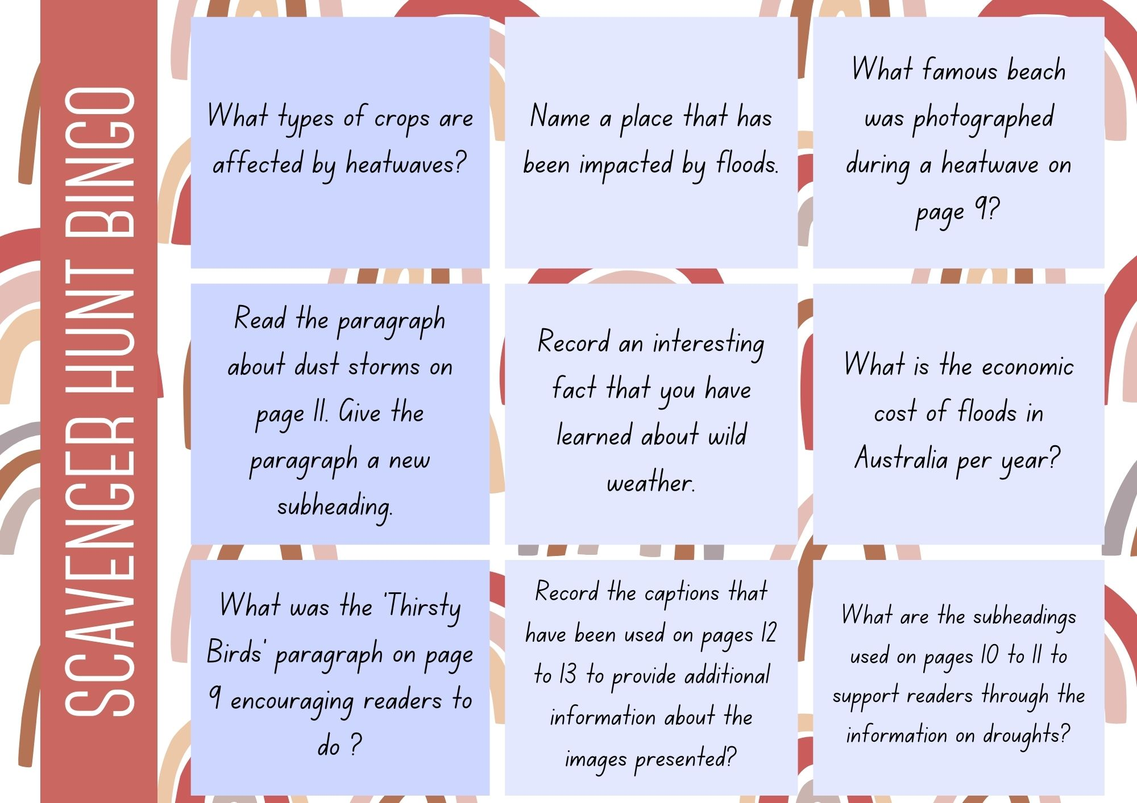

Resource 2 – Nyoongar seasons

Nyoongar seasons jigsaw task
Birak | Bunuru
Djeran | Makuru
Djilba | Kambarang

Resource 3 – vocabulary jamboard
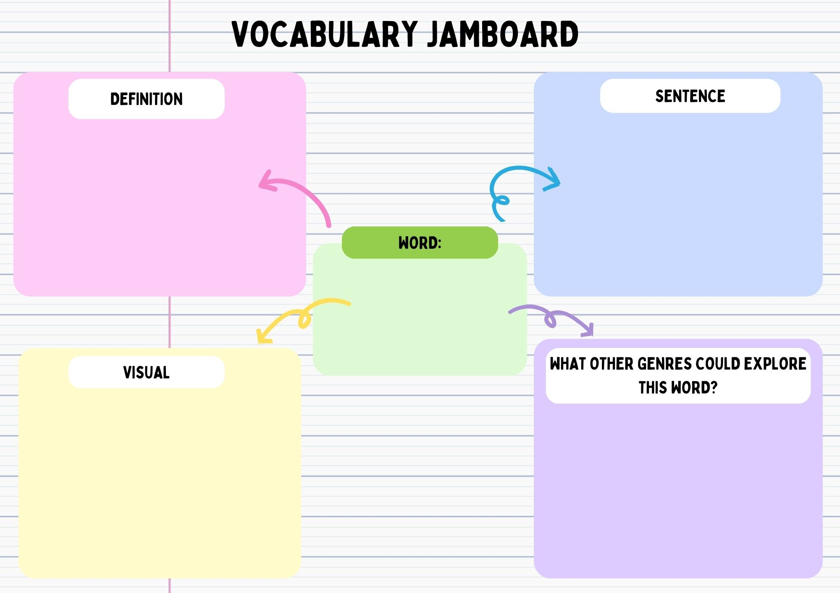

Resource 4 – sentences for meaning grid (Stage 3)
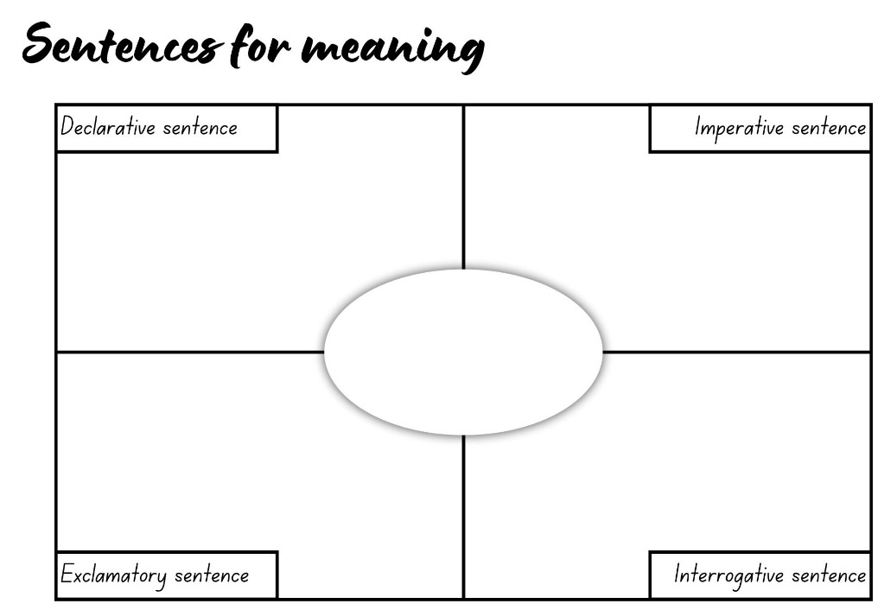

Resource 5 – Book Creator exemplar
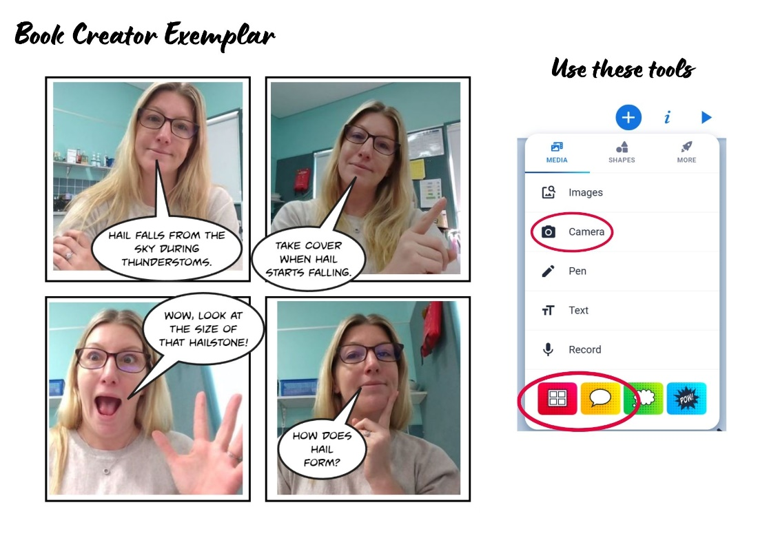

Resource 6 – deadly facts card exemplar
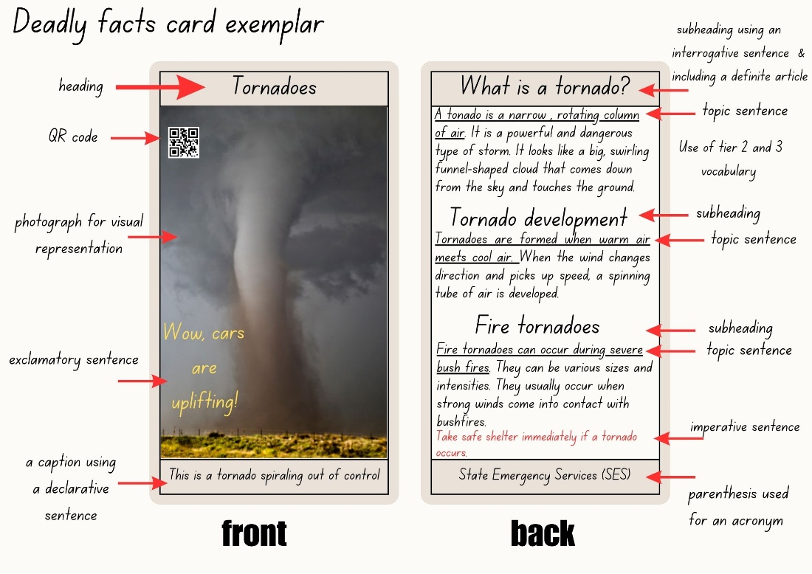

Resource 7 – deadly facts card template
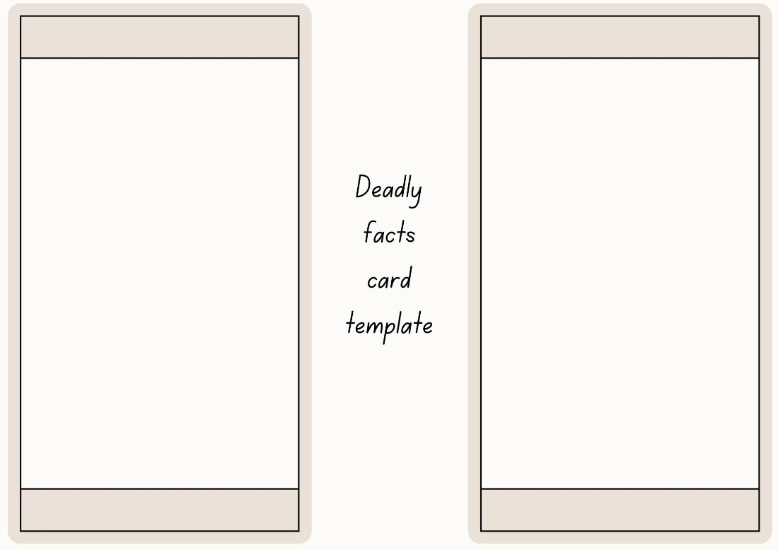

Resource 8 – summarising task board
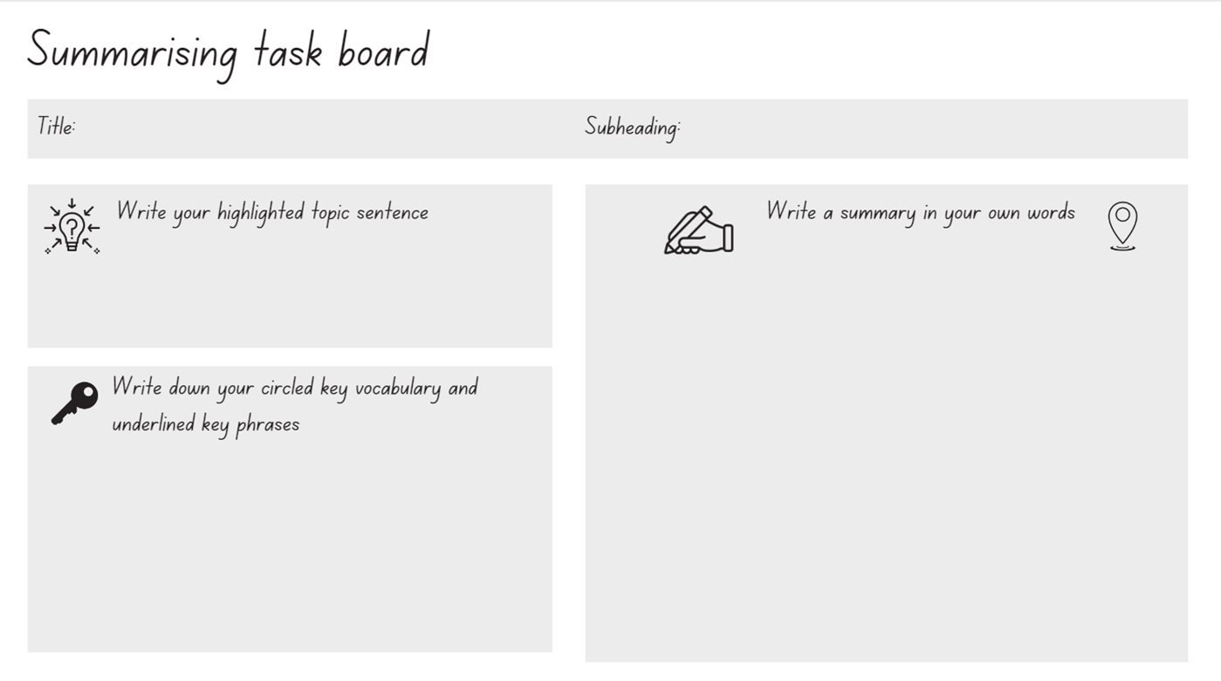

Resource 9 – earthquakes
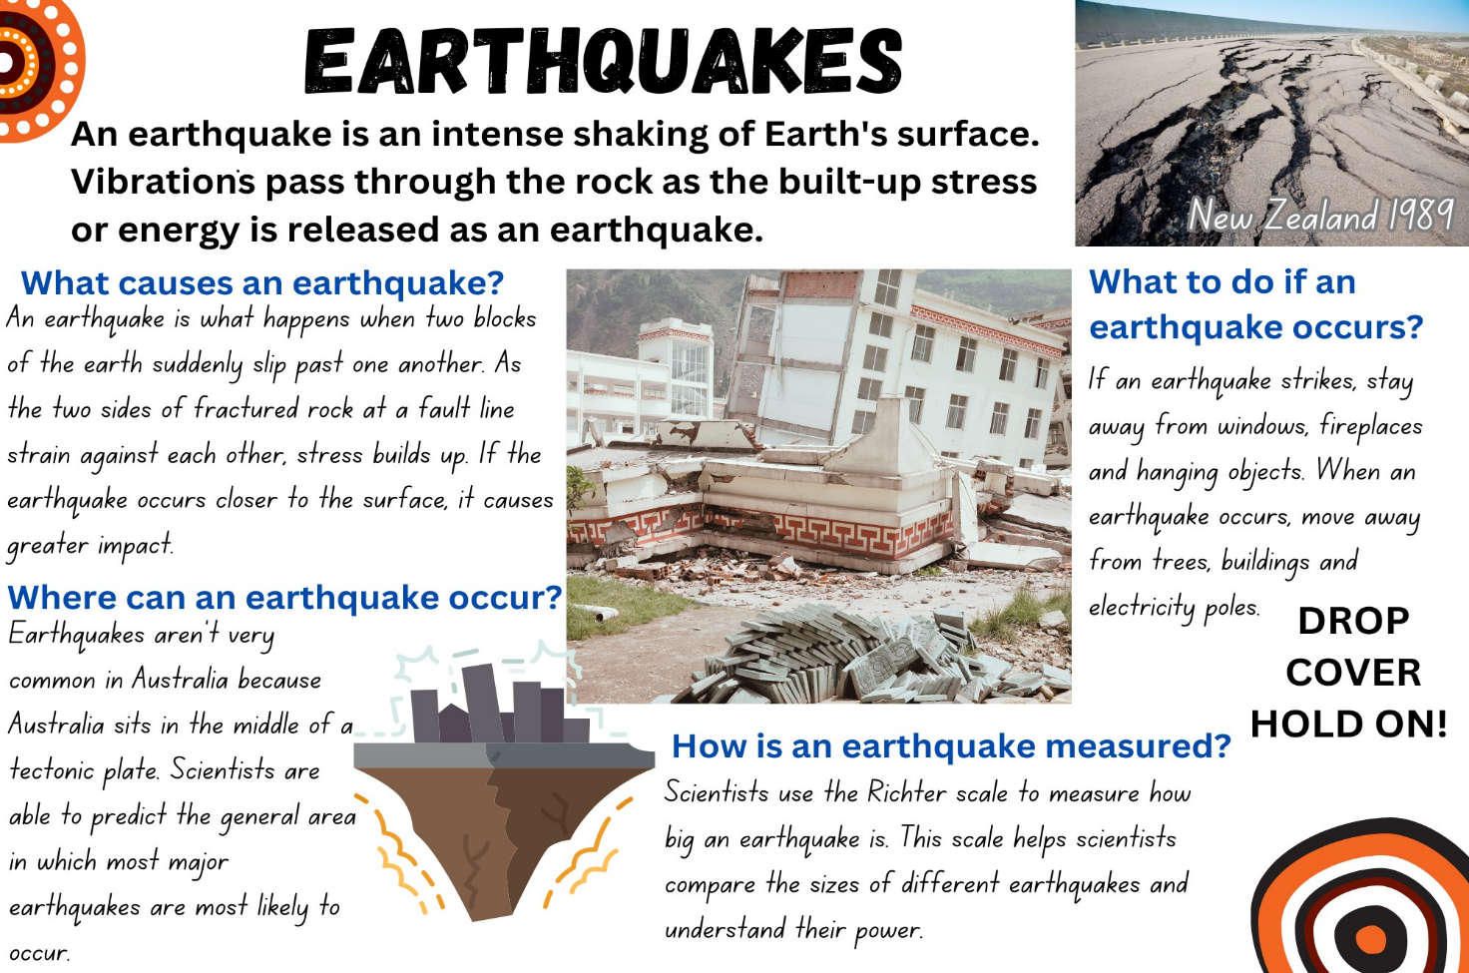

Resource 10 – researching and planning template
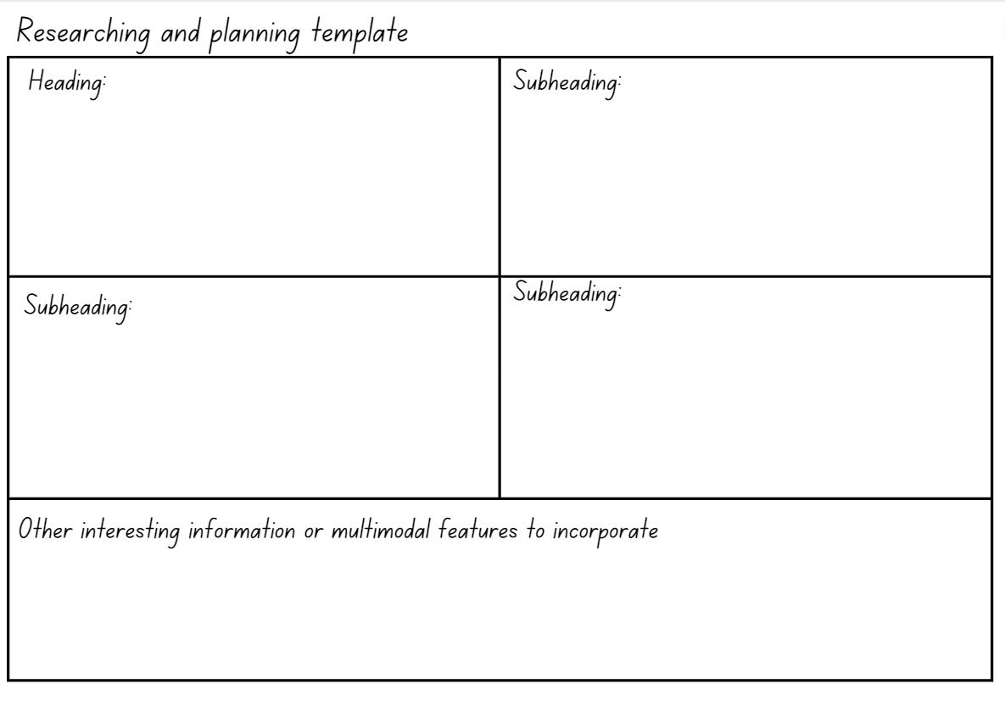

Resource 11 – Newcastle earthquake
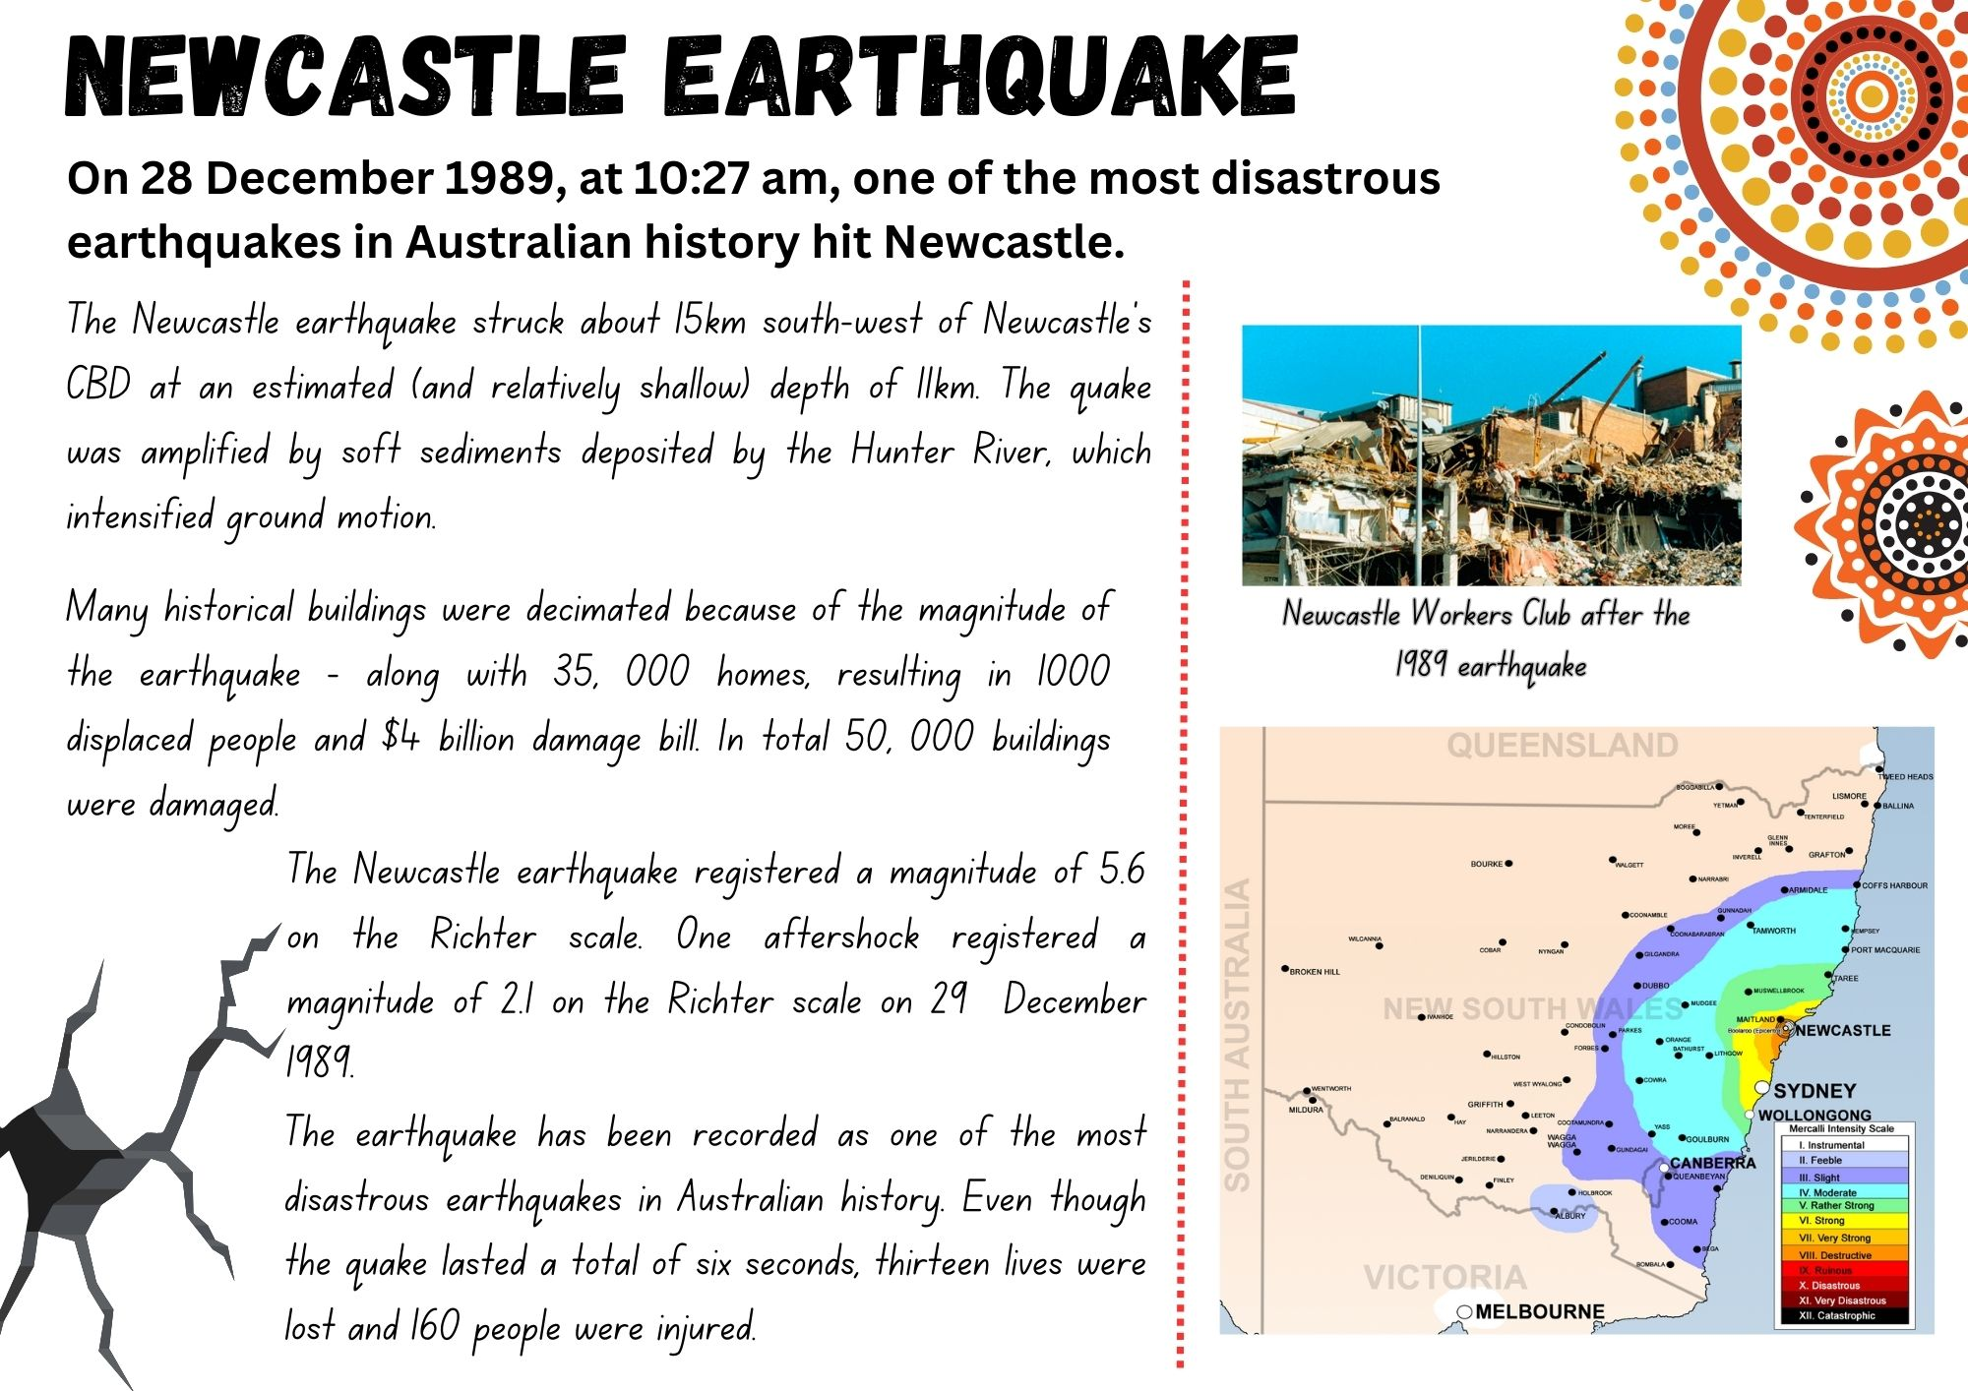

Resource 12 – researching and planning a historical account
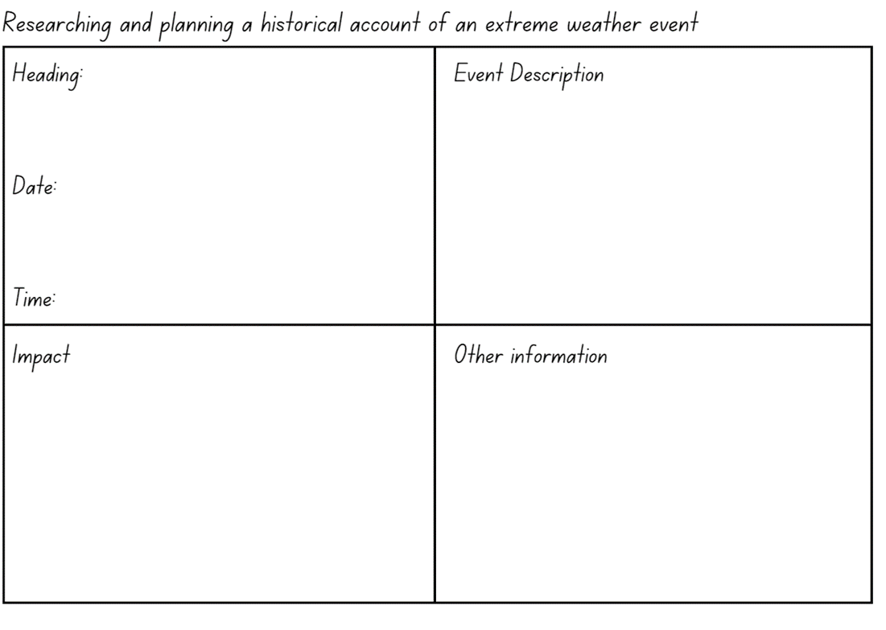

References
This document contains NSW Curriculum and syllabus content. The NSW Curriculum is developed by the NSW Education Standards Authority. This content is prepared by NESA for and on behalf of the Crown in right of the State of New South Wales. The material is protected by Crown copyright.
Please refer to the NESA Copyright Disclaimer for more information. https://educationstandards.nsw.edu.au/wps/portal/nesa/mini-footer/copyright
NESA holds the only official and up-to-date versions of the NSW Curriculum and syllabus documents. Please visit the NSW Education Standards Authority (NESA) website https://educationstandards.nsw.edu.au/ and the NSW Curriculum website https://curriculum.nsw.edu.au/home.
English K–10 Syllabus © NSW Education Standards Authority (NESA) for and on behalf of the Crown in right of the State of New South Wales, 2022.
National Literacy Learning Progression © Australian Curriculum, Assessment and Reporting Authority (ACARA) 2010 to present, unless otherwise indicated. This material was downloaded from the Australian Curriculum website (National Literacy Learning Progression) (accessed 11 August 2023) and was not modified.
Australian Academy of Technological Sciences and Engineering (ATSE) (2021) How Deadly Science is changing the lives of Aboriginal students, ATSE website, accessed 11 August 2023.
Australian Broadcasting Corporation (ABC) (14 November 2017) ‘Indigenous Seasons’ [video], ABC, Behind the News website, accessed 11 August 2023.
Australian Broadcasting Corporation (ABC) (4 February 2020) 'Bushfire Recap’ [video] ABC, Behind the News website, accessed 11 August 2023.
Australian Broadcasting Corporation (ABC) (31 May 2011) ‘Tornado’ [video] ABC, Behind the News website, accessed 11 August 2023.
Australian Geographic (2017) Science Experiment – Tornado, Australian Geographic website, accessed 11 August 2023.
Australian Institute of Aboriginal and Torres Strait Islander Studies (AIATSIS) (2023) Map of Indigenous Australia, AIATSIS website, accessed 11 October 2023.
Australian of the Year Awards (2020) Corey Tutt OAM [video], Australian of the Year Awards, Vimeo, accessed 11 August 2023.
Commonwealth of Australia (Bureau of Meteorology) (2016) Indigenous Weather Knowledge [website], accessed 11 August 2023.
Commonwealth of Australia (Bureau of Meteorology) (2016) Nyoongar calendar, Bureau of Meteorology website, accessed 11 August 2023.
French J (2018) Cyclone (B Whately illus), Scholastic Australia Pty Ltd, Australia. ISBN: 9781743623589
Goertzel L (n.d.) Floods, National Geographic Kids website, accessed 11 August 2023.
Lyons S (n.d.) ‘Tropical Cyclone Tracy: December 25, 1974’, ABC News, accessed 11 August 2023.
NESA (NSW Education Standards Authority) (2023) ‘Glossary’, Resources, NESA website, accessed.
Southwest Aboriginal Land & Sea Council (2023) Kaartdijin Noongar – Noongar Knowledge [website], accessed 11 August 2023.
Tutt C (ed) (2021) Deadly Science Wild Weather, Australian Geographic, Australia. ISBN: 9781922388162

© State of New South Wales (Department of Education), 2023
The copyright material published in this resource is subject to the Copyright Act 1968 (Cth) and is owned by the NSW Department of Education or, where indicated, by a party other than the NSW Department of Education (third-party material).
Copyright material available in this resource and owned by the NSW Department of Education is licensed under a Creative Commons Attribution 4.0 International (CC BY 4.0) license.
This license allows you to share and adapt the material for any purpose, even commercially.
Attribution should be given to © State of New South Wales (Department of Education), 2023.
Material in this resource not available under a Creative Commons license:
- the NSW Department of Education logo, other logos and trademark-protected material
- material owned by a third party that has been reproduced with permission. You will need to obtain permission from the third party to reuse its material.
Links to third-party material and websites
Please note that the provided (reading/viewing material/list/links/texts) are a suggestion only and implies no endorsement, by the New South Wales Department of Education, of any author, publisher, or book title. School principals and teachers are best placed to assess the suitability of resources that would complement the curriculum and reflect the needs and interests of their students.
If you use the links provided in this document to access a third-party's website, you acknowledge that the terms of use, including licence terms set out on the third-party's website apply to the use which may be made of the materials on that third-party website or where permitted by the Copyright Act 1968 (Cth). The department accepts no responsibility for content on third-party websites.

