Music 1 aural skills – sample 2B
The following question is question 3 of the 2022 HSC music 1 aural skills examination.
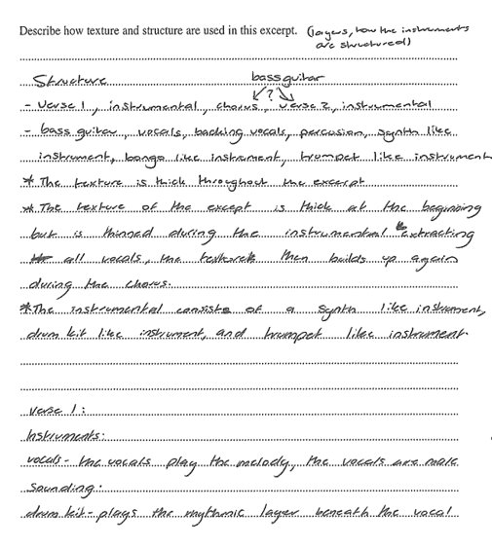
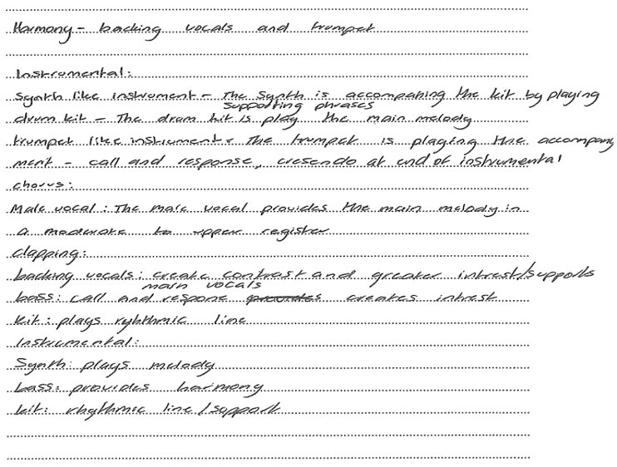
Music 1 2022 HSC exam pack @ NSW Education Standards Authority (NESA) for and on behalf of the Crown in right of the State of New South Wales, 2022.

Transcript of sample
Structure
- Verse 1, instrumental, chorus, bass guitar, verse 2, instrumental.
- Bass guitar, vocals, backing vocals, percussion, synth like instrument, bongo like instrument, trumpet like instrument.
- The texture is thick throughout the excerpt.
- The texture of the excerpt is thick at the beginning but is thinned during the instrumental extracting all vocals, the texture then builds up again during the chorus.
- The instrumental consists of a synth like instrument, drum kit like instrument and trumpet like instrument.
Verse 1
Instruments:
- Vocals – the vocals play the melody, the vocals are male sounding
- Drum kit – plays the rhythmic layer beneath the vocal
- Harmony – backing vocals and trumpet
Instrumental:
- Synth like instrument – the synth is accompanying the kit by playing supporting phrases
- Drum kit – the drum kit is playing the main melody
- Trumpet like instrument – the trumpet is playing the accompanying part – call and response, crescendo at end of instrumental chorus
- Male vocal – the male vocal provides the main melody in a moderate to upper register
- Clapping
- Backing vocals – create contrast and greater interest/supports main vocals
- Bass – call and response creates interest
- Kit – plays rhythmic line
Instrumental:
- Synth – plays melody
- Bass – provides harmony
- Kit – rhythmic line/support

References
This resource contains NSW Curriculum and syllabus content. The NSW Curriculum is developed by the NSW Education Standards Authority. This content is prepared by NESA for and on behalf of the Crown in right of the State of New South Wales. The material is protected by Crown copyright.
Please refer to the NESA Copyright Disclaimer for more information https://educationstandards.nsw.edu.au/wps/portal/nesa/mini-footer/copyright.
NESA holds the only official and up-to-date versions of the NSW Curriculum and syllabus documents. Please visit the NSW Education Standards Authority (NESA) website https://educationstandards.nsw.edu.au/ and the NSW Curriculum website https://curriculum.nsw.edu.au.
Music 1 2022 HSC exam pack @ NSW Education Standards Authority (NESA) for and on behalf of the Crown in right of the State of New South Wales, 2022.

© State of New South Wales (Department of Education), 2024
The copyright material published in this resource is subject to the Copyright Act 1968 (Cth) and is owned by the NSW Department of Education or, where indicated, by a party other than the NSW Department of Education (third-party material).
Copyright material available in this resource and owned by the NSW Department of Education is licensed under a Creative Commons Attribution 4.0 International (CC BY 4.0) license.
This license allows you to share and adapt the material for any purpose, even commercially.
Attribution should be given to © State of New South Wales (Department of Education), 2024.
Material in this resource not available under a Creative Commons license:
- the NSW Department of Education logo, other logos and trademark-protected material
- material owned by a third party that has been reproduced with permission. You will need to obtain permission from the third party to reuse its material.
Links to third-party material and websites
Please note that the provided (reading/viewing material/list/links/texts) are a suggestion only and implies no endorsement, by the New South Wales Department of Education, of any author, publisher, or book title. School principals and teachers are best placed to assess the suitability of resources that would complement the curriculum and reflect the needs and interests of their students.
If you use the links provided in this document to access a third-party's website, you acknowledge that the terms of use, including licence terms set out on the third-party's website apply to the use which may be made of the materials on that third-party website or where permitted by the Copyright Act 1968 (Cth). The department accepts no responsibility for content on third-party websites.

