Music 1 aural skills – sample 1B
The following question is question 3 of the 2022 HSC music 1 aural skills examination.
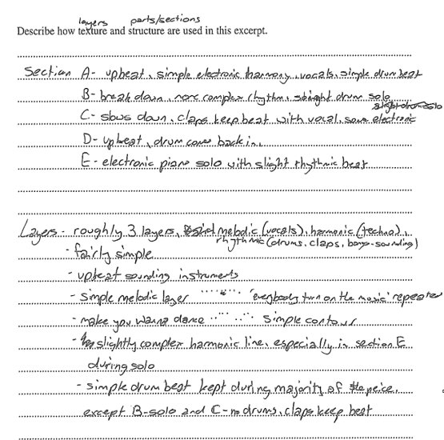
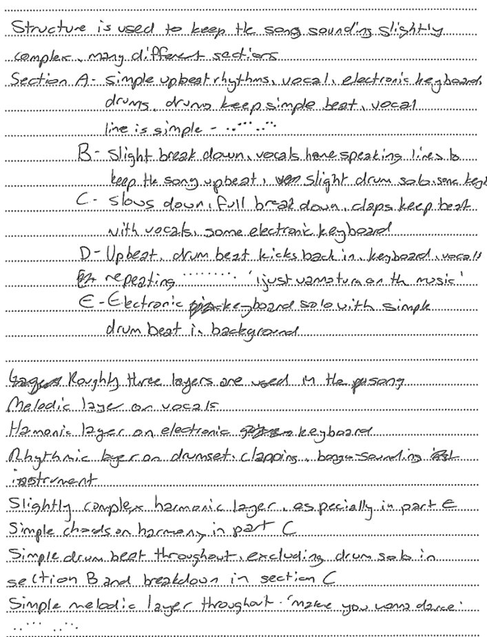
Music 1 2022 HSC exam pack @ NSW Education Standards Authority (NESA) for and on behalf of the Crown in right of the State of New South Wales, 2022.

Transcript of sample
Section:
- A – upbeat, simple electronic harmony, vocals, simple drum beat
- B – breakdown, more complex rhythm, straight drum solo
- C – slows down, claps keep beat with vocal, some electronic
- D – upbeat, drum comes back in
- E – electronic piano solo with slight rhythmic beat
Layers:
- roughly 3 layers, melodic (vocals), harmonic (techno), rhythmic (drums, claps, bongo sounding)
- fairly simple
- upbeat sounding instruments
- simple melodic layer ‘everybody turn on the noise’ (notated) repeated
- ‘make you wanna dance’ (notated) simple contour
- slightly complex harmonic line, especially in section E during solo
- simple drum beat kept during majority of the piece except B solo and C – no drums, claps keep beat
Structure is used to keep the song sounding slightly complex. Many different sections.
Section:
- A – simple upbeat rhythms, vocal, electronic keyboard, drums. Drums keep simple beat, vocal line is simple (notated)
- B – slight breakdown, vocals have speaking lines to keep the song upbeat, slight drum solo, some keys
- C – slows down, full breakdown, clap keep beat with vocals, some electronic keyboard
- D – upbeat, drum beat kicks back in, keyboard, vocals repeating (notated) ‘I just wanna turn on the music’
- E – electronic keyboard solo with simple drum beat in background
Roughly three layers are used in the song. Melodic layer on vocals, harmonic layer on electronic keyboard, rhythmic layer on drum set, clapping, bongo sounding instrument. Slightly complex harmonic layer especially in part E. Simple chords on harmony in part C, simple drum beat throughout excluding drum solo in section B and breakdown in section C. Simple melodic layer throughout ‘make you wanna dance’ (notated).

References
This resource contains NSW Curriculum and syllabus content. The NSW Curriculum is developed by the NSW Education Standards Authority. This content is prepared by NESA for and on behalf of the Crown in right of the State of New South Wales. The material is protected by Crown copyright.
Please refer to the NESA Copyright Disclaimer for more information https://educationstandards.nsw.edu.au/wps/portal/nesa/mini-footer/copyright.
NESA holds the only official and up-to-date versions of the NSW Curriculum and syllabus documents. Please visit the NSW Education Standards Authority (NESA) website https://educationstandards.nsw.edu.au/ and the NSW Curriculum website https://curriculum.nsw.edu.au.
Music 1 2022 HSC exam pack @ NSW Education Standards Authority (NESA) for and on behalf of the Crown in right of the State of New South Wales, 2022.

© State of New South Wales (Department of Education), 2024
The copyright material published in this resource is subject to the Copyright Act 1968 (Cth) and is owned by the NSW Department of Education or, where indicated, by a party other than the NSW Department of Education (third-party material).
Copyright material available in this resource and owned by the NSW Department of Education is licensed under a Creative Commons Attribution 4.0 International (CC BY 4.0) license.
This license allows you to share and adapt the material for any purpose, even commercially.
Attribution should be given to © State of New South Wales (Department of Education), 2024.
Material in this resource not available under a Creative Commons license:
- the NSW Department of Education logo, other logos and trademark-protected material
- material owned by a third party that has been reproduced with permission. You will need to obtain permission from the third party to reuse its material.
Links to third-party material and websites
Please note that the provided (reading/viewing material/list/links/texts) are a suggestion only and implies no endorsement, by the New South Wales Department of Education, of any author, publisher, or book title. School principals and teachers are best placed to assess the suitability of resources that would complement the curriculum and reflect the needs and interests of their students.
If you use the links provided in this document to access a third-party's website, you acknowledge that the terms of use, including licence terms set out on the third-party's website apply to the use which may be made of the materials on that third-party website or where permitted by the Copyright Act 1968 (Cth). The department accepts no responsibility for content on third-party websites.

