Cattle Handling

Animal welfare activity
The Australian animal welfare standards and guidelines for the welfare of cattle [PDF 1.3MB] have been developed to help everyone who works with cattle knows how cattle must be treated and cared for. They apply to everyone across Australia. They have been developed jointly by the government, industry, and the community. The diagram below shows how these standards and guidelines have been developed and who they apply to.
Figure 1 – Development and application of Australian welfare standards for cattle
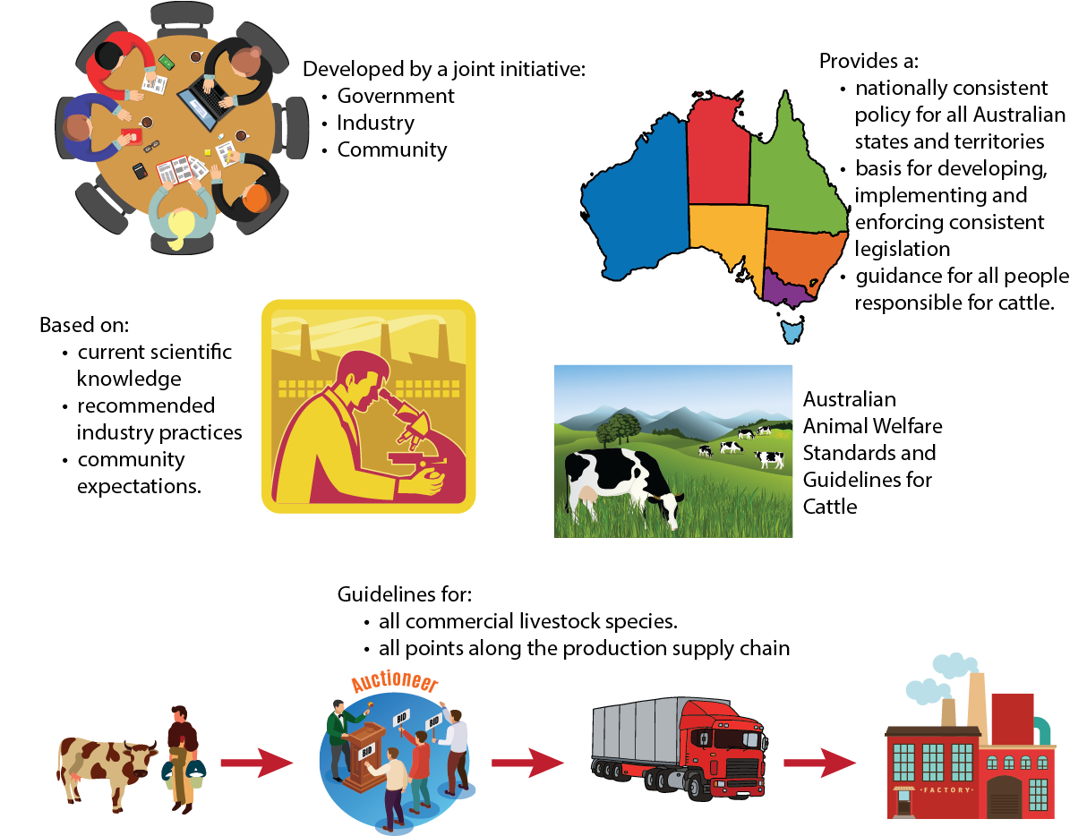
All images sourced from VectorStock and used in accordance with the VectorStock® Membership and Content License Agreement.
These standards and guidelines make it clear that everyone who works with cattle must know and understand the standards and guidelines, and is responsible for the welfare of the cattle they manage or work with.
A sample of the guidelines have been selected and placed into the table below. For each selected guideline, reason for why it is important in relation to animal welfare has been given. You need to complete the third column by providing an example of how the guideline can be put into practice. You may wish to work as a group to complete this task.

Standard 1.1
A person must take reasonable actions to ensure the welfare of cattle under their care.
Table 1 – Responsibilities
Guidelines | Reason | Example
G1.2 Agistment responsibilities should be documented, communicated, and clearly understood by all parties involved. | Expectations of the level of care the cattle will receive while on agistment must be agreed upon, communicated, and understood to ensure that cattle are monitored and handled sufficiently to maintain or reach the necessary body condition and health status. | (Add example)

Standard 2.1
A person in charge must ensure cattle have reasonable access to adequate and appropriate feed and water.
Table 2 – Feed and water
Guidelines | Reason | Example
G2.2 Regular assessment should be made of the needs of the cattle in relation to the quantity and quality of feed and water. | All animals require potable water for drinking. Quantities may vary depending on the species, stage of production, and prevailing weather conditions.  Animals require varying quantities and quality of feed depending on their breed, stage of production, age, size, and prevailing weather conditions. It is important to be able to assess the quantity and quality of feed to ensure animals are getting appropriate feed amounts, as an excess or deficiency of appropriate feed can lead to health issues and decrease in production. The more intensive the production system, the greater the need for monitoring levels of feed and water availability. | (Add example)
G2.3 Stocking rates and/or feed supplementation should be managed to maintain cattle in appropriate body condition. | Pasture available in paddocks is not always sufficient to maintain cattle in appropriate body condition. An appropriate stocking rate is essential to ensure cattle are not getting too much or too little feed. Regular monitoring of paddocks is essential to not only monitor cattle condition, but also pasture availability so that stocking rates can be changed accordingly.  Sometimes supplementary feeding is essential if there is little pasture available. Supplementary feeding should always be introduced slowly and be appropriate for the production stage, condition, and age of the cattle. | (Add example)
G2.8 Self feeders should be checked, cleaned, and maintained regularly. | It is important to ensure that self-feeders are in working order and delivering the expected amount of feed to animals. It is essential that feeders are regularly cleaned thoroughly to remove build-up of old/wasted/spoiled feed and also any build-up of faeces from around feeders, as this can lead to health issues and animals not feeding. | (Add example)
G2.11 Lactating cows, and all cattle in hot weather, should have access to water at least twice daily. | All cattle have much higher water requirements during hot weather, and lactating cows have an even higher need due to milk production. It is essential that cattle have access to clean, cool drinking water at least twice daily; however, a constant supply is always preferred. | (Add example)

Standards 3.1 to 3.3
S3.1 A person in charge must take reasonable actions to ensure the welfare of cattle from threats, including extremes of weather, drought, fires, floods, disease, injury, and predation.
S3.2 A person in charge must ensure the inspection of cattle at intervals, and at a level appropriate to the production system and the risk to the welfare of cattle.
S3.3 A person in charge must ensure appropriate treatment for sick, injured, or diseased cattle at the first reasonable opportunity.
Table 3 – Risk management of extreme weather, natural disasters, disease, injury, and predation
Guidelines | Reason | Example
G3.2 Drought strategies should be prepared in advance and then progressively implemented before paddock feed runs out, and may include:  - relocation  - supplementary feeding  - use of stock containment areas  - sale or agistment  - segregation according to risk  - early weaning  - humane killing. | It is essential that drought plans and strategies are in place and are implemented appropriately to avoid running out of feed for the number of stock on hand. It is important that cattle are only kept if there is a way of meeting their feed requirements. Plans should reflect the available resources, for example, capital to purchase feed and the value of breeding stock. | (Add example)
G3.4 Cattle handling should be minimised during extremely hot weather. | Like any animals, cattle can become very hot, dehydrated, and stressed, leading to sickness and death if handled during extremely hot weather. Where possible, handling should be avoided during hot weather and if handling is required, strategies should be used to minimise the risk of cattle suffering from heat. Calves and lactating cows are particularly susceptible to heat stress. | (Add example)
G3.7 Cattle should be vaccinated to protect against likely infectious diseases if there is a significant risk to the welfare of cattle. | Vaccination can provide protection from many diseases and should be a part of every cattle health program.  It is important to seek advice from a local veterinarian and discuss an appropriate vaccination plan to protect cattle from diseases that could impact of their welfare. Vaccination plans vary depending on the breed of cattle, the location, and the stage of production.  The most commonly used vaccinations are:  - 5-in-1 – protects against five clostridial diseases: pulpy kidney (enterotoxaemia), black disease, tetanus, blackleg, and malignant oedema.  - 7-in-1 – protects against the same diseases as 5-in-1, plus Leptospira harjo and Leptospira pomona. | (Add example)
G3.9 Consideration should be given to selecting cattle that are suitable for and adapted to the production environment, and that are resistant to parasites and specific diseases relevant to the environment. | Different breeds of cattle thrive in different locations. It is important to select a breed that is suitable to the area where production will take place. Selecting cattle that are not appropriate for the area will result in cattle struggling to thrive on unsuitable pastures/forage and being more susceptible to problems like parasites and heat stress. To ensure a high level of cattle welfare, appropriate breeds should be selected for the production location. | (Add example)
G3.12 Predator control programs should be implemented where predation is a significant risk to the welfare of cattle. | It is important to provide cattle with adequate protection from predators if there is a risk present. Calves are the most susceptible to attack from predators and extra care should be taken to control predators around calving time. | (Add example)

Standard 4.1
S4.1 A person in charge must take reasonable actions in the construction, maintenance and operation of facilities and equipment to ensure the welfare of cattle.
Table 4 – Facilities and equipment
Guidelines | Reason | Example
G4.3 The surfaces of yards, pens, tracks, and laneways should be constructed and maintained to minimise the risk of lameness, slips, and falls. | When cattle are under pressure from a handler in a yard or laneway situation, they often move fairly fast and tend to change direction quickly, making slips and falls a risk. To minimise the chance of cattle slipping and falling, it is important that surfaces of yards, pens, laneways, and tracks are constructed using non-slip materials. Good drainage is also essential to reduce slippery areas and the build-up of mud in areas cattle will stand for long periods of time. | (Add example)
G4.4 Facilities should be free of protrusions and obstacles that may cause injury. | Cattle generally move through these areas quickly and can easily injure themselves if there are any protrusions present. Sharp objects can easily cause lacerations that may require veterinary attention, while other protruding objects can cause bruising that is painful and can decrease meat quality. | (Add example)
G4.5 Water sprinklers should be used to reduce dust levels and provide cooling during handling in yards as appropriate. | In hot weather, cattle can easily become very hot from mustering, yarding, and handling. Sprinklers can help cool the cattle and surrounds. The use of sprinklers to dampen the yards also helps reduce dust. Excessive dust can cause respiratory problems for both animals and humans, as well as reducing visibility. | (Add example)
G4.11 Concrete flooring in rest areas should be covered by an appropriate depth of bedding material. | Bedding provides a soft area for cattle to lay that encourages rest and helps to maintain overall health and production. | (Add example)

Standards 5.1 to 5.11
Standards 5.1 to 5.11 can be found on pages 17 and 18 of the Australian animal welfare standards and guidelines for the welfare of cattle [PDF 1.3MB].
Table 5 – Handling management
Guidelines | Reason | Example
G5.4 The degree and duration of restraint for cattle should be the minimum necessary to allow a procedure to be done efficiently and safely. | Restraint of cattle is stressful for animals and can result in injury to both the animal and handlers. For this reason, the duration an animal is restrained must be minimised and tasks requiring restraints completed efficiently. | (Add example)
G5.10 Wounds should be treated as soon as practicable to prevent infection and flystrike. | Untreated wounds can easily become infected and be susceptible to flystrike, which can result in the need for veterinary treatment as well as unnecessary pain, illness, and death. | (Add example)
G5.30 Ear marking and tattooing instruments should be sharp and clean, with relevant hygienic techniques followed. | In order to reduce pain for cattle during ear marking and tattooing, instruments must be sharp and well maintained. Instruments that are not sharp will inflict more pain and cause a larger wound than necessary on animals. A high level of hygiene is also essential in order to reduce the risk of infection.  Sharp and clean instruments give a cleaner wound that heals more quickly. | (Add example)

Standards 6.1 to 6.9
Standards 6.1 to 6.9 can be found on pages 21 and 22 of the Australian animal welfare standards and guidelines for the welfare of cattle.
Table 6 – Castration, dehorning and spaying
Guidelines | Reason | Example
G6.3 Surgical procedures should be planned with consideration of the health and age of cattle, weather, staff availability, and facilities, including the use of temporary or permanent yards. | Surgical procedures can involve a degree of pain, discomfort, and stress to animals. The age and health status of an animal as well as the weather can greatly affect how an animal copes with surgical procedure. For example, hot weather can increase bleeding, and young animals will deteriorate if they need to be walked a long distance to yards and be less able to cope with the stress of the surgical procedure. | (Add example)
G6.7 Calves should be separated from their mothers for the shortest possible time unless they are to be hand-reared or weaned onto a solid diet. | Separating calves from their mothers causes distress to both the cow and calf. However, this is sometimes necessary in order for husbandry procedures to be carried out. Separating calves from cows for an extended period of time can cause calf dehydration, distress to both cow and calf, and problems mothering within the herd. | (Add example)
G6.19 Preference should be given for breeding of naturally polled cattle. | Horned cattle have up to double the amount of bruised trim in a feedlot situation, reducing the quality of meat. Horned cattle are more likely to injure other cattle in the herd, for example eye injuries, are more dangerous and difficult to handle in the yards, and may require particular handling equipment. Dehorned cattle often suffer a production setback for a period of time post dehorning. In addition, it is good practice to breed animals that require less husbandry procedures, as it reduces stress and increases efficiencies. | (Add example)

Standards 7.1 to 7.5
S7.1 A person performing artificial breeding procedures on cattle must have the relevant knowledge, experience, and skills, or be under the direct supervision of a person who has the relevant knowledge, experience, and skills.
S7.2 A person performing artificial breeding procedures on cattle must take reasonable actions to minimise pain, distress, or injury.
S7.3 A person in charge must ensure the inspection of calving cattle at intervals appropriate to the production system and the level of risk to the welfare of cattle.
S7.4 A person in charge must ensure calving induction is done under veterinary advice.
S7.5 A person in charge must ensure that induced calves receive adequate colostrum or be humanely killed at the first reasonable opportunity, and before they are 12 hours old.
Table 7 – Breeding management
Guidelines | Reason | Example
G7.3 Calving should occur in a sheltered and well-drained area where surveillance is possible. Unless birthing assistance is required, disturbance of cows should be avoided. | Shelter is essential to offer protection from the sun, heat, wind, or rain to cows and newborn calves. A well-drained area reduces mud and wet areas that can lead to wet and cold calves. Unless birthing assistance is required, cows are best left undisturbed when calving to reduce stress and promote natural birthing behaviour and good mothering. | (Add example)
G7.5 Cows that receive severe injuries during calving or that are affected by a severe adverse outcome (prolapsed uterus, unable to remove calf) should receive urgent treatment, or be humanely killed without delay. | Calving problems can cause excessive distress and pain to the cow and ultimately lead to the death of the cow and/or calf. Cows due to calf should be monitored, and if signs of distress or calving is prolonged, then assistance by an experienced livestock handler or veterinarian help should be sought. Humane destruction should be considered if a serious injury is sustained or if recovery is unlikely. | (Add example)
G7.7 A cow’s body condition should be considered when deciding when to wean the calf. | More energy is required to feed a lactating cow with a calf at foot than is required to feed a cow and a weaned calf. Lactation requires excessive energy and additional nutrients. The cow’s body condition score provides an objective assessment of the health status of the cow. | (Add example)

Standards 8.1 to 8.4
S8.1 A person in charge must ensure the feeding and inspection of calves in calf rearing systems are performed daily.
S8.2 A person in charge must ensure that calves housed in pens can turn around, lie down and fully stretch their limbs.
S8.3 A person in charge must ensure sufficient iron in the diet to prevent anaemia in calves in veal production systems.
S8.4 A person in charge must not allow the faeces and urine of calves housed in indoor systems to accumulate to the stage that compromises calf health and welfare.
Table 8 – Calf rearing systems
Guidelines | Reason | Example
G8.1 Calves removed from cows should receive adequate colostrum within 12 hours of birth, with the first administration occurring as soon as possible. | It is essential for calves to receive adequate colostrum within 12 hours of birth in order for them to be healthy. Calves are born with little to no immunity and colostrum provides the calf with antibodies to protect it from infectious diseases. Colostrum also contains greater amounts of fat, protein, vitamins, and minerals than milk produced later in the lactation of the cow. | (Add example)
G8.5 Calves should be grouped by size and age to reduce competition and facilitate observation and management. | It is common for calves to grow at varying rates despite their birthdate. It is important to group calves by weight and age so as to group together the most similar sized calves. This will reduce competition and ensure that calves are being fed an appropriate amount of food for their age and size. By grouping small calves together and providing more feed, there is a higher chance that these calves will meet growth targets, rather than grouping calves by age only, which may result in larger calves having access to more feed and smaller calves not getting enough feed. | (Add example)
G8.11 Calves that become sick should be segregated and treated immediately. | Sick animals commonly pass on their illness to other animals if it is contagious. Contagious illness can rapidly spread throughout a herd, particularly when it involves young animals and in an intensive situation. For this reason, it is essential that once an animal is identified as sick, it is separated from the rest of the herd and treated immediately. Calves’ health can deteriorate rapidly if left untreated and it is recommended to seek veterinary advice immediately. If calves are scouring, they can become dehydrated within a short time. | (Add example)

Standards 9.1 to 9.4
S9.1 A person in charge must ensure the daily inspection of lactating dairy cows.
S9.2 A person in charge must implement appropriate actions to minimise heat stress of cattle.
S9.3 A person must tail dock cattle only on veterinary advice and only to treat injury or disease.
S9.4 A person in charge must ensure dairy cattle that are kept on feed pads for extended periods have access to a well-drained area for resting.
Table 9 – Dairy management
Guidelines | Reason | Example
G9.6 During hot weather, access to drinking water should be available at all times. | Cattle can rapidly become dehydrated and suffer from heat stress if not provided with adequate drinking water, especially during hot weather. Dehydration and heat stress can cause serious health implications and death, especially for young animals and lactating cows. | (Add example)

Standards 10.1 to 10.10
Standards 10.1 to 10.10 can be found on page 29 of Australian animal welfare standards and guidelines for the welfare of cattle [PDF 1.3MB].
Table 10 – Beef feedlots
Guidelines | Reason | Example
G10.3 All cattle should be observed standing and moving during daily inspections. | It is essential that cattle are observed both standing and moving during daily inspections to monitor their health and adequately identify any signs of sickness, atypical behaviour, or injury. Cattle can appear to be normal at a glance if they are observed standing still or lying down. However, signs of illness or injury may be present if the animal is moving or standing. | (Add example)
G10.4 Mixing of cattle should be minimised, and bullying behaviour should be managed by segregation. | Cattle that have been in different herds should not be grouped together unless necessary, and in this case, close monitoring should be carried out. Mixing unfamiliar cattle can promote bullying behaviour, aggression, dominance around feed and water, and injury to individuals. It is important to remove problem animals from the herd and identify animals that are being dominated by others. | (Add example)
G10.6 New arrivals to a feedlot should be closely inspected for injury and illness. | It is essential that new arrivals to a feedlot situation are inspected for injury and illness to prevent the spread of infection and to insure that injured animals are not placed into an intensive situation where they could become badly injured. Animals that are sick or injured should be quarantined and treated immediately. | (Add example)
G10.11 Stale or spoiled feed should be removed daily. | Stale and spoiled feed can contain harmful bacteria which can make cattle sick if consumed. Stale and spoiled feed can be unpalatable, with a bad taste and smell. If fresh feed is added to stale and spoiled feed, cattle may not eat the mixed feed as they typically do not like the taste or smell. | (Add example)

