Stage 5 Agricultural technology

Animal welfare – Teacher guide
This unit of work explores the science of animal welfare and what the community considers acceptable practices in using animals for food and fibre production. Community expectations and values are what underpin legislation and hence determine what the different laws, codes, and guidelines say about the use and management of animals. As science provides further knowledge about the anatomy, physiology, and behaviour of animals, and advances in technology become available, changes need to be made to these laws, codes, and guidelines. Everyone who works with animals needs to keep abreast of any changes so that they stay informed and ensure that they maintain high standards of animal welfare.

Outcomes
- AG5-4 investigates and implements responsible production systems for plant and animal enterprises
- AG5-9 evaluates management practices in terms of profitability, technology, sustainability, social issues, and ethics
- AG5-10 implements and justifies the application of animal welfare guidelines to agricultural practices
- AG5-12 collects and analyses agricultural data and communicates results using a range of technologies
Agricultural Technology Years 7-10 Syllabus © 2019 NSW Education Standards Authority (NESA) for and on behalf of the Crown in right of the State of New South Wales.

Delivery strategies
This resource can be used in a variety of ways depending on the teacher, students, and access to resources within the classroom and on the school farm.
Teachers can provide students directly with the background information or may use it to design their own resources and activities.
Student activities accompany this resource and can be completed in pairs or individually, in student workbooks or electronically.

Background Information

What is animal welfare?
Animal welfare refers to the animal’s state of wellbeing and involves providing for the physical and behavioural needs of the particular species.
Good animal welfare exists when the following specific needs of the animal are met:
- nutritional
- environmental
- health
- behavioural
- mental.
These needs align with the five freedoms:
- freedom from thirst, hunger, or malnutrition
- freedom from discomfort
- freedom from pain, injury, or disease
- freedom to express normal behaviours
- freedom from fear and distress.
Good animal welfare should be the standard for every enterprise involving animals and is an essential element for achieving a successful, productive, ethical, and sustainable animal production enterprise.
Best practice animal welfare management requires knowing what the needs of each animal species are and how they can be met. This means that both science and experienced practical skills are important for meeting animal welfare standards.
The science of animal welfare includes having knowledge of animal behaviour, nutrition, physiology, pharmacology, pathology, and veterinary clinical services. Sound practical knowledge needs to come from intelligent, experienced, and reflective practitioners who make observations of animals’ health and welfare status in their day-to-day work.
Each animal species has particular physical and behavioural needs. All of the following should be considered when managing an animals’ welfare:
- social behaviours – solitary or flock/herd animal
- dominance behaviours
- reproductive behaviours
- predator/prey relationships
- anatomy
- ruminant or monogastric
- fur, feathers, or hair covering
- particular adaptations related to origins
- size
- disease prevalence
- stage of production
- fertility/fecundity.
An example of these consideration can be seen in Figure 1, below.
Figure 1 – Characteristics of sheep that should be considered in relation to their welfare
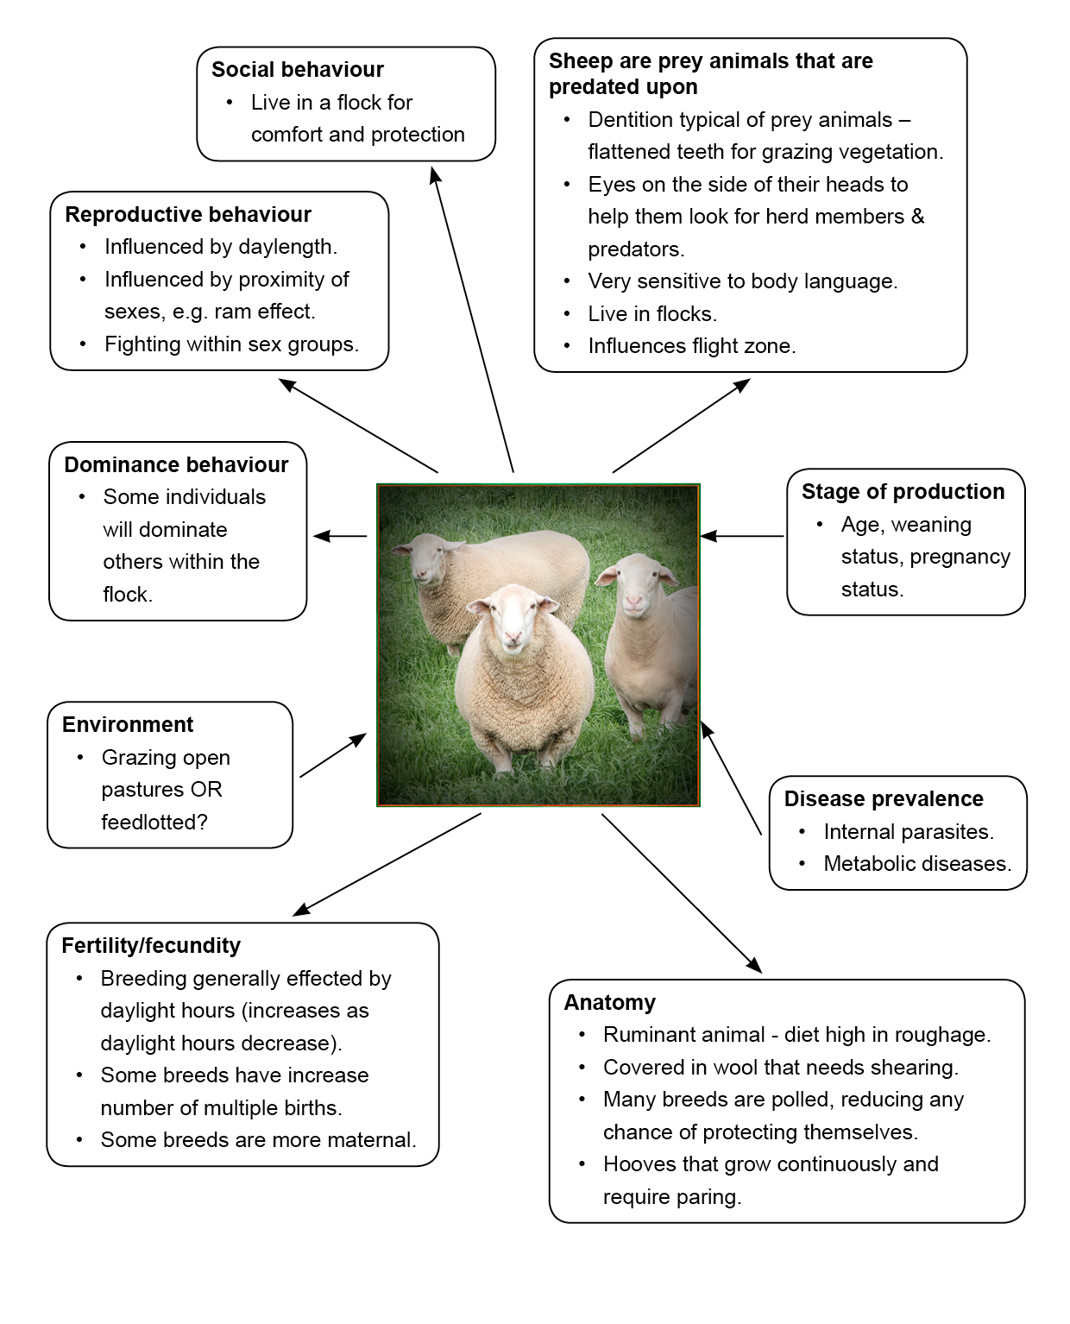

What is the difference between animal welfare and animal rights?
The relationship humans have with animals varies and can be viewed on a continuum with extreme positions on each end and animal welfare in the middle.
Figure 2 – Animal/human relationship continuum
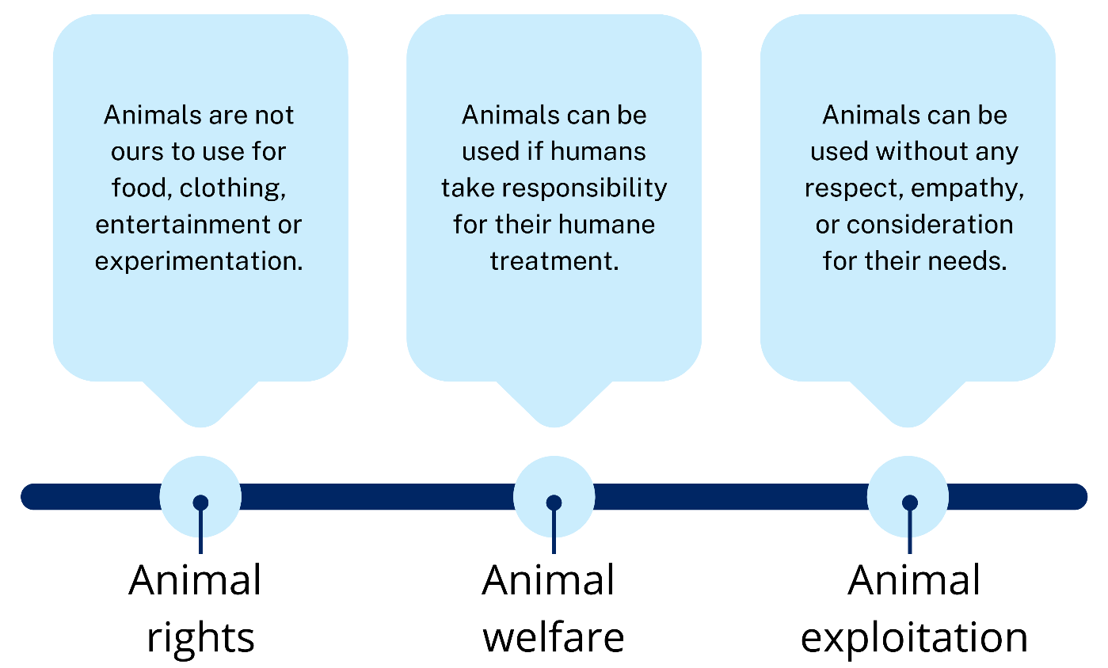
Humans use animals in a number of ways:
- food and fibre production
- companions, for example, pet dogs and cats
- leisure, for example, horse trail riding
- sport, for example, camp drafting and equestrian
- entertainment, for example, zoos, circuses, and horse racing
- work, for example, sheep dogs and guardian dogs
- assistance, for example, guide dogs
- research, for example, laboratory testing.
Some people in our society believe that some or all of these uses are unacceptable. Others believe that if the animals are well cared for, with laws and guidelines to help protect them, the uses are acceptable.
Animal welfare means that humans take responsibility for animals. To do this, we need to have knowledge about the physical and behavioural needs of each species. Having this knowledge means that we can treat them more humanely and make regulations about their use for the whole community.
Having laws and guidelines can help protect animals from the effects of a small percentage of society that may exploit them. Some of this exploitation can result from a lack of respect and empathy for animals, and also from ignorance.

Animal welfare legislation
There are a number of laws, codes, and guidelines that directly affect how animals can be used, housed, fed, and managed by humans, including community members, industry, farmers, transporters, researchers, and educators such as schools, universities, and TAFE.
The purpose of these laws, codes, and guidelines is to provide everyone who owns, manages, or works with animals with clear rules and guidance about how they can and cannot look after animals.
These laws have been written because our community has expectations about how animals should be treated. They reflect what we think is humane treatment of animals.
Here is a summary of the laws, codes, and guidelines have the most impact on the use of animals in schools.

Prevention of Cruelty to Animals Act (1979) (POCTAA)
This Act applies to all citizens in NSW and governs animal welfare in this state. The objectives of POCTAA are:
- to prevent cruelty to animals
- to promote the welfare of animals by requiring a person in charge of an animal to
- provide care for the animal
- treat the animal in a humane manner
- ensure the welfare of the animal.
POCTAA authorises RSPCA inspectors to enter private land to examine animals if there are reasonable grounds to suspect an offence is, has, or is going to be committed with respect to an animal.

Animal Research Act (1985)
The purpose of this Act is to protect the welfare of animals used in connection with research and teaching. It was developed to ensure that whenever animals are used for teaching or research, it is justified, humane, and considerate of the animal’s needs.
The Animal Research Act covers the use of animals in all primary and secondary schools, both government and independent, in NSW.

The Australian code for the care and use of animals for scientific purposes
This code applies to all people in Australia who use animals in any area of science, industry, and teaching. It requires that the use of animals for scientific purposes must:
- have scientific or educational merit
- aim to benefit humans, animals, or the environment
- be conducted with honesty.
When animals are used:
- the number of animals must be minimised
- the wellbeing of the animals must be supported
- harm, including pain and distress, must be avoided or minimised.

Standards and guidelines, codes of practice
Australian animal welfare standards and guidelines for sheep [PDF 1.2MB]
Australian animal welfare standards and guidelines for cattle [PDF 1.3MB]
These standards and guidelines give clear information about the management of sheep and cattle across Australia. They apply to everyone, including farmers, industry, transporters, and schools.
Australian animal welfare standards and guidelines – land transport of livestock [PDF 1.9MB]
The purpose of this document is to describe standards and guidelines that ensure the welfare of livestock during land transport via road and rail. They contain specific requirements relating to the transport of different species and apply to everyone, including farmers, industry, transporters, and schools.
Model code of practice for the care of domestic poultry [PDF 803KB]
This code describes the minimum standards that must be provided in the care and management of poultry.
NSW code of practice – commercial pig production
This code outlines the principles that everyone involved in commercial pig production must use to protect the welfare of the animals in their care.

Animal welfare and school poultry
The Model code of practice for the care of domestic poultry [PDF 803KB] describes minimum standards to help people involved in the care and management of domestic poultry to adopt standards of husbandry that are acceptable. This code recognises that the basic requirement for the welfare of poultry is a husbandry system appropriate to their physiological and behavioural needs. There are standards for each different production system.
Schools are not permitted to keep their egg-producing hens in battery cages. Schools commonly use a barn system or a semi-free-range system, with the hens secured in a shed or barn at night. More information about keeping poultry in schools can be found in the Fowls page of the NSW Animals in Schools website.
Knowledge of the behaviour of particular animal species assists in good design of housing for the animal. Students need to familiarise themselves with the behaviour of their school poultry in terms of movement around their shed, feeding, dust bathing, scratching, huddling, nesting, and perching.
Poultry are social animals and display a pecking order of status. This determines which bird will eat first and where the bird is allowed to sit on the perch. It also means that the dominant individuals in a flock may peck, or in extreme cases, cannibalise other flock members.
If birds are overcrowded, they are more likely to cannibalise. Birds need to be provided with enough perching space and enough feeders and waterers so that they are not crowded when perching and can obtain adequate food and water.
Poultry are not a prey species. Their main mechanism of defence is to flee. This can involve flying short distances or running. Getting on a perch removes them from ground-based predators and helps them to fly short distances should a predator climb up towards them. Perching also allows them to be off the cold ground at night.
Poultry dust bath to help clean themselves. This behaviour is thought to be a natural method of lice and mite control.
In a natural environment, poultry find their own feed by scratching the ground. They also scratch to pick up small rocks and grit to help with digestion as they have no teeth.
Poultry tend to huddle. This may be because they are scared and there may be safety in numbers. If poultry are cold, they may tend to huddle together for warmth.
When hens lay their eggs, they prefer to nest in a quiet area with some protection from being fouled on by other hens and with nesting material to sit on, for example, straw, hay, or rice hulls.

Lesson Sequence
Note: The ‘theme’ areas will vary in length according to the amount of content. There may be one or more lessons of work within each theme. Please use teacher judgement when using this information for lesson planning. Themes can be taught consecutively or independently of each other.

Syllabus content
Core A
- Evaluate intensive and extensive production systems
- Investigate procedures in the management of plants and animals within animal welfare guidelines
- Investigate the social and ethical issues that affect the chosen animal enterprises
- Collect accurate evidence and record relevant data relating to the animal enterprise
Core B
- Compare alternative production techniques for a chosen agricultural system or enterprise
- Investigate Australian animal welfare codes and their effect on the management of intensive and extensive systems
- Examine and analyse data from a range of sources

Theme 1: What is animal welfare?
The aim of this theme is for students to gain an understanding that knowledge and skills underpins good animal welfare. While good animal welfare does encompass respect and empathy for animals, it relies on science and experience to inform it.
It is also important for students to understand that there are varying views in society about how animals should be used, and that there is a difference between animal welfare and animal rights.
Hints and tips
Students will have a range of attitudes and experiences related to the use of animals. It is most important that students are encouraged to learn about the behavioural and physical needs of animals and develop informed views about their use.
Resources
- NSW DPI Egg production systems in Australia
- NSW Animals in Schools

Activities
- Create a diagrammatic representation of characteristics considered in the management and care of layer hens.
- Investigate and articulate acceptable and unacceptable uses of animals.
- Investigate poultry production systems.
- Discuss applying the five needs of animal welfare (nutritional, environmental, health, behavioural, mental).

Theme 2: Animal welfare legislation
Laws, codes, and guidelines about how animals can be treated reflect the values and ethics of our society. They reflect what we think is humane treatment of animals.
There are many different pieces of legislation that indirectly relate to the treatment and use of animals. The summary presented in the Animal welfare legislation section above includes those that have the most impact on the use of animals in schools. The NSW Animals in Schools website interprets these pieces of legislation for schools.
Resources
- Prevention of Cruelty to Animals Act (1979)
- Animal Research Act (1985)
- Australian code for the care and use of animals for scientific purposes
- Australian animal welfare standards and guidelines for sheep [PDF 1.2MB]
- Australian animal welfare standards and guidelines for cattle [PDF 1.3MB]
- Australian animal welfare standards and guidelines – land transport of livestock [PDF 1.9MB]
- Model code of practice for the care of domestic poultry [PDF 803KB]
- NSW code of practice – commercial pig production
Websites and videos:
- NSW Animals in Schools
- NSW DPI Primefacts: small-scale poultry keeping – brooding and rearing chickens [PDF 85KB]
- Animal health Australia: Australian ruminant feed ban
- NSW government department of primary industries: swill feeding

Activities
Complete research questions on relevant animal welfare legislation.

Theme 3: Poultry and animal welfare
The activities included within this theme allow students to put their knowledge and understanding about animal welfare and legislation into practice. Through learning about specific poultry behaviours, students are able to assess the school facilities and enterprise environment to ensure that the five welfare needs of poultry are being accommodated. Students will use observational skills and data collection to evaluate the system and propose recommendations to the teacher to improve animal welfare for poultry at the school.
Hints and tips
The activities outlined within this theme range from classroom theory-based lessons to practical activities involving poultry. Prior to any handling of animals for these activities, teachers should take the time to explicitly teach students correct handling techniques that are safe for both the student and animal being caught and held. Students should also be taught about hygiene procedures prior to and after handling animals.
Resources
- Access to the poultry enclosure(s) at the school
- Poultry feed
- Measuring tools, for example, tape measures, trundle wheels or rulers, weight scales
- Tools to measure temperature, for example, data loggers, minimum maximum thermometers, electronic weather station
Websites and videos:
- NSW Department of Education – Learning Systems: Poultry behaviour.
- NSW Animals in Schools

Activities
- Complete poultry behaviour video and questions.
- Complete animal data collection.
- Conduct observation of a flock.
- Analyse poultry behaviour in the school flock.
- Research the environmental requirements for poultry pens
- Assess the school poultry pen.

