Stage 5 Agricultural technology

Animal welfare
This unit of work explores the science of animal welfare and what the community considers acceptable practices in using animals for food and fibre production.

What is animal welfare?
Each animal species has its own physical and behavioural needs. The following should be considered when managing an animal’s welfare:
- social behaviours
- dominance behaviours
- reproductive behaviours
- predator/prey relationships
- anatomy
- stage of production
- disease prevalence
- fertility/fecundity
- environment.
Figure 1 summarises this for one species, sheep.
Figure 1 – Characteristics of sheep that should be considered in relation to their welfare
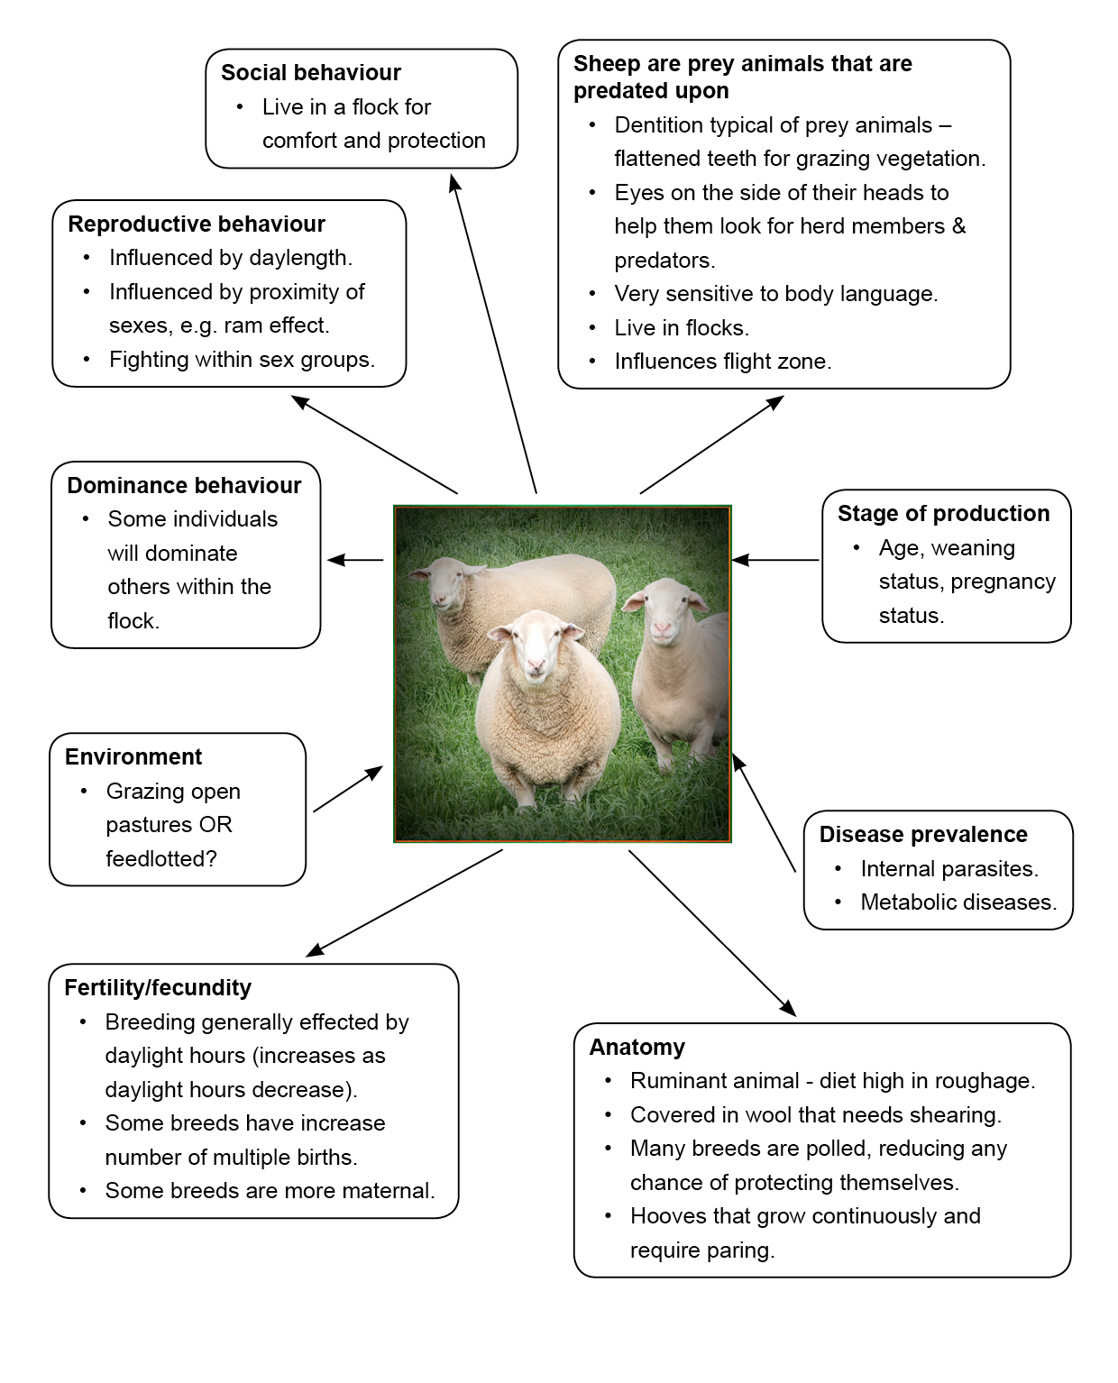

Activity 1
- Working with a partner or as a class, read each of the boxes in Figure 1. Ensure that you understand how the characteristics of sheep impact the type of management and care we provide for them.
- Use Figure 1 as a model to construct your own diagrammatic representation of the characteristics that need to be considered for the management and care of layer hens.

Activity 2
- Working in pairs, brainstorm a range of examples of the different ways animals are used by humans. You should consider their use in the production of food and fibre, leisure activities (for example, horse riding), companion animals, research, education, and entertainment (for example, circus animals).
- Using your examples, decide as a pair if this use of an animal is an acceptable use or not. Construct a table to help you sort the examples into acceptable or unacceptable.
- Compare and discuss your examples and classifications with the rest of the class.

Activity 3
- Visit NSW DPI Egg production systems in Australia and watch the videos about the three different egg production systems.
- Construct a table outlining the advantages and disadvantages of each of the three systems.
- Highlight the advantages and disadvantages that relate to layer hen welfare.
- Select one of the three egg production systems. Using your diagram about characteristics of poultry from Activity 1 and your answer from the previous part of this activity, explain how this production system can impact the welfare of layer hens. Look at both positive and negative impacts.

Activity 4
The table below lists three different enterprises and the five needs of animals that contribute to animal welfare:
- nutritional
- environmental
- health
- behavioural
- mental.
For each of these needs, outline two examples of actions, facilities, or resources that humans can provide for animals to meet them.
Some examples have already been listed to get you started.
Table 1 – Application of good animal welfare to three enterprises
Animal needs | Egg production | Prime lamb production | Pork production
Nutritional | Provision of ad lib good quality layer pellets
Environmental |  | Maintaining wind breaks to protect ewes and lambs in cold, wet, and windy conditions
Health |  |  | Maintaining good biosecurity procedures to reduce disease transmission
Behavioural |  | Moving sheep in flocks or groups
Mental |  |  | Use of good handling procedures by all who work with the pigs

Animal welfare legislation
There are many laws, codes, and guidelines that help protect animals and try to ensure that humans take responsibility for the use and care of animals. These include:
- Prevention of Cruelty to Animals Act (1979)
- Animal Research Act (1985)
- Australian code for the care and use of animals for scientific purposes.

Activity 5
The NSW Animals in schools website has been designed to help teachers and students know what the different laws, codes, and guidelines that govern animal welfare require.
Schools can keep many species of animal, but each species has particular requirements that need to be met if animal welfare is to be maintained. The questions below will give you an idea of how the requirements of these different laws, codes, and guidelines are applied to three different species.
Use Poultry – fowls - Environment to answer questions 1-3 below.
- What is the preferred temperature range for layer hens?
- What is the recommended ratio of birds to nest boxes?
- How much perch space should be provided for birds from 10 weeks of age?
Use Small-scale poultry keeping — brooding and rearing chickens to answer questions 4 and 5 below.
- Why do chickens need to be kept in a brooder when they first hatch?
- Identify the ideal temperatures that should be provided for chickens at 1 day, 1 week, and 4 weeks of age.
Use Sheep- food and water to answer questions 6-8 below.
- Condition scoring is a convenient way to assess how well fed your sheep are. Describe three advantages of condition scoring your sheep.
- Why is it important to introduce new feeds to sheep slowly, particularly when introducing grains to their diet?
- Using Animal Health Australia, define the acronym RAM and explain why RAM must be avoided in diets for ruminant animals.
Use Pigs – food and water to answer questions 9 and 10 below.
- What volume of water do pigs consume daily?
- Read Swill feeding and define what the term ‘swill’ means and explain why it is illegal.

Poultry behaviour
Understanding poultry behaviour assists us to provide an environment for poultry that enhances animal welfare, health, natural behaviours, and production. Becoming familiar with the way that poultry behave, move around their enclosure, and interact with one another is an essential element of understanding their behaviour. An awareness of why poultry behave the way they do can lead to a greater understanding of their needs. It is also important to understand what factors influence behaviour, for example, breed, sex, age, health, type of enclosure, handling, and history.

Activity 6
Watch the NSW Department of Education – Learning Systems video: Poultry behaviour (4:36) to answer the following questions.
Behaviour 1 – dust bathing
- Describe what dust bathing is.
- Explain why it is necessary for fowls to dust bathe.
- What requirements do fowls need to be able to dust bathe?
Behaviour 2 – laying eggs in a secluded area
- Outline the features of a good laying area for hens.
Behaviour 3 – perching
- What makes a good perch?
Behaviour 4 – foraging
- Why is providing areas for foraging necessary in an enclosure?
Behaviour 5 – social hierarchy
- Describe what social hierarchy is in a fowl enterprise.
Enterprise systems
- List the benefits and disadvantages of the two main types of laying systems presented in the video.

Activity 7
Animal data collection
Using the poultry at your school, record some basic information about the chickens kept. This data will be used as background information when observing animal behaviours to better understand why the animals are behaving this way and what factors are influencing them. The information will also be used to evaluate the chickens’ environment and enclosure.
Depending on the number of chickens kept at the school, this activity can be based on the total number of chickens at the school or one enclosure. You may wish to collate this data into a table.
- How many animals?
- Hens
- Roosters
- Chicks.
- How old are the birds? List multiple ages if more than one age group. Are different ages housed together or separated?
- Approximately how many of each age group are there?
- What breeds are in the flock? Include the numbers of each breed.
- Are the birds used for meat or egg production, or both?

Activity 8
Observation of a flock
Quietly observe the school’s flock for a period. Use a table to organise the questions posed below and record your observations from the flock. For each observation recorded, consider why the animal behaves in this way. Record these explanations in the table as well.
- Feeding time: place some feed on the ground and observe behaviour.
- Do any of the birds act differently around the feed on the ground? Identify and record which birds were acting differently.
- Do any of the birds appear to be more bossy or aggressive over the other birds? Identify and describe (age, sex, breed) any birds that display this behaviour.
- Do the birds scratch at the ground while feeding?
- Water: observe the birds drinking.
- How do they drink?
- Is their water clean or dirty?
- In the pen, do any of the birds appear to be pecking at each other, sometimes until they bleed? Identify and describe (age, sex, breed) the birds that display this behaviour and those that receive it.
- Are the birds dust bathing? Describe where and how.
- Do the birds try to hide or crouch when approached by a handler?
- Are the birds using the perch? At what time of day do they display this behaviour?
- Do the birds appear to be huddled together most of the time?
- If your birds are layers, where do they lay their eggs?
- What is the reaction of the birds when a handler walks through the cage? Do any of the birds behave differently towards the handler?

Activity 9
Analysing poultry behaviour in the school flock.
Using the data collected in Activity 3, analyse what factors influence the birds’ behaviours. For example, does sex or age influence the way birds behave? Do older birds dominate the younger ones? Use the following questions to direct your analysis.
- Can you determine the social hierarchy? Who is the ‘top hen’? Describe the differences between this hen and the bird at the bottom of the hierarchy. How do you know which bird plays each role?
- Describe the differences in behaviour of ages, sexes, or breeds when food is added to the pen.
- Describe the differences in behaviour of ages, sexes, and breeds when a handler enters the pen and when they approach the birds. Is there aggressive behaviour displayed by any bird?
- Describe the types of birds that appear broodier than others. Is there a link between ages or breeds?
- Overall, can you see any relationship between the age, sex, or breeds of the birds in the pen and significant poultry behaviours?
Alternative activity to analysing poultry behaviour in the school flock
Use your observations from Activity 3 to answer the following questions about poultry behaviour.
- Why do you think it is important for all birds to perch simultaneously?
- What are some of the reasons why birds tend to peck each other?
- How could you stop the birds pecking each other?
- Why might birds scratch at the ground when feeding?
- Why might birds cover themselves in dirt?
- Do you think birds behave differently if threatened with danger?
- Is it dangerous for the birds to huddle together through fear?
- What conditions are appropriate for hens for nesting?
Predation
Fowl are a prey species and have numerous predators that can sometimes prove problematic to control. Predator control is an essential element in any production system, and enclosures must be constructed with measures taken to protect birds from all types of predators.
- What predators are there?
- How can we control these predators?
- If a plane or larger bird flies overhead, the hens will often hide under trees or other shelter. Why might they do this?
Conclusion
After your observations and answers to the questions, write down 3 examples of specific bird behaviours compared with other animals, for example, cattle.

Assessing the poultry pen
The freedom to express normal behaviour is one of the five freedoms that underpin animal welfare in Australia. This can be upheld by animal owners, managers, and corporations by providing sufficient space, proper facilities, and, where necessary, company of the animal’s own kind. These requirements are different for each species, and in most cases vary with age and stage of production. Facilities appropriate for ducks and geese are not suitable for fowl, and the space requirements for fowl are too limited for larger livestock such as pigs. Knowing, understanding, and providing suitable requirements for stock under your supervision and care is a legislative requirement.
In the case of fowl production in schools, the NSW Animals in Schools website provides the minimum space requirements allowed for different age ranges of fowl, as well as a list of important environmental features, such as nesting boxes and perches.

Activity 10
Research
Use the information found in Environment to answer the following questions about space and facilities required for keeping fowl.
- What are the space requirements per bird for the four age groups listed in this section?
- What temperature range is preferred for layer hens? Outline the minimum and maximum temperatures outside which birds will begin to experience stress.
- Describe the conditions a shelter must adhere to for the protection, light, and ventilation requirements of birds.
- What bedding is required for birds housed indoors and when should it be cleaned?
- Perches and nesting boxes are required for fowl. Summarise the requirements of perches and nesting boxes.

Activity 11
Practical
Using the information from your research and found in Environment, assess the school fowl production system(s). Collate the questions/topics and data into a table to display the results in a simple format.

Space
Use a range of measuring tools (for example, tape measures, trundle wheels, or rulers) to calculate the total size of the fowl enclosure. You will need to use appropriate formulas to calculate the area of the site, not the perimeter.
Divide the total area by the number of fowl housed within it. Does this meet the minimum requirement for the ag/type of bird/system?
Alternatively, calculating the weight of birds per square metre for a shed for broiler chickens is also an effective tool for determining if space requirements have been met. The minimum space requirements are 30kg of birds per square metre, year-round.

Temperature
Develop a system or set up tools to collect temperature data within the housing system for a week or more. Graph the high and low range each day. Does this meet the preferred range of temperatures?

Nesting
Count the available nesting boxes within the layer system. For the total number of hens housed in the system, are there enough boxes available (one box per three hens)? Do the nest boxes have lids or roofs so that nesting hens cannot be fouled on? Is nesting material provided and clean?

Perches
What is the average width of a mature bird of the breed your school keeps? Is there enough perch space to accommodate all the birds simultaneously? Is there 30cm of space between perches that are parallel to one another? Are the perches set up in a way to minimise fouling on the bird below? Do the perches have sharp edges?

Food and water
Is water and food readily accessible to all the birds? Is the water clean? Are the food containers clean?

Shelter
Are the birds protected from the weather? Can they avoid the rain and excessive temperatures? Is the housing well ventilated? (If you can smell ammonia, this means ventilation is poor).

Vermin and predator control
How does the design/construction of the housing attempt to stop the entry of vermin and predators? List any features that help control the entry of these.

Recommendations
Create a simple report for the teacher on areas of the system that meet the animal welfare requirements and areas that could be improved. Provide suitable solutions to the areas of improvement that consider costs, availability of materials, and safety for students and staff.
Question: How do you think poorly designed housing systems can impact the poultry? Use examples to support your answer.

