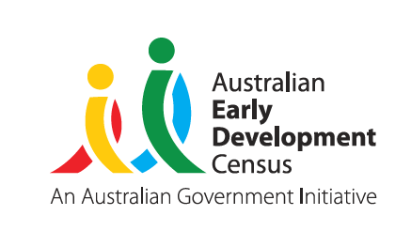
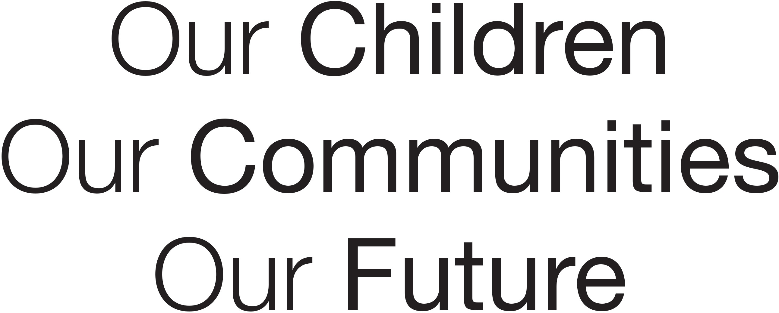
Our Children
Our Communities
Our Future

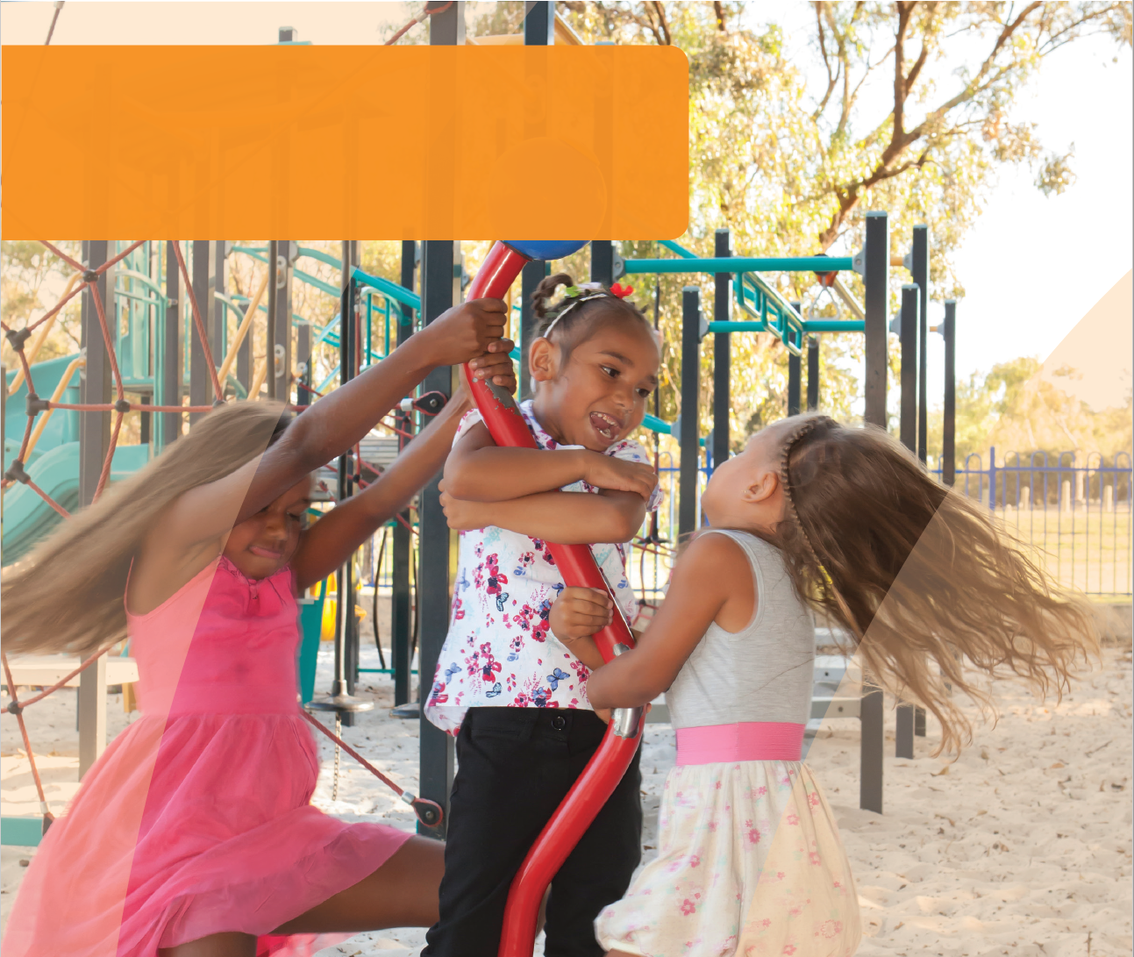
DOMAIN GUIDE:
Physical Health
and Wellbeing
This guide supports early childhood education and care services
and schools to gain a deeper understanding of the AEDC physical health and wellbeing domain. The guide can be used to inform early childhood and curriculum planning, quality improvement and strengthen partnerships with families and the community.
© Western Australian Department of Education 2018

Importance of physical health and wellbeing in educational settings
Reflecting on the way in which physical health and wellbeing enable children to engage in learning and social environments empowers educators and leaders to shape their approach to planning for children.
In reading the section below about the impact of physical health and wellbeing on educational settings:
Consider the challenges children may face in your setting.
How can you promote further development in physical health and wellbeing?
How does your program support children who are facing difficulties with physical health and wellbeing?

Physical health and wellbeing capture a range of developmental and wellbeing indicators. Children’s physical development is generally discussed in terms of motor coordination. Motor coordination, and fine and gross motor enable children to interact with and manipulate their physical environment. Physical health also includes children’s management of their health and hygiene.
Good nourishment, rest and physical comfort are often taken for granted, but without these children are unable to muster the energy and focus they need to engage in learning. When children’s physical and health needs are met, they can use opportunities in their environments to practice emerging skills and learn new skills.
Gross motor skills not only enable children to navigate physical obstacles, they also underpin children’s ability to sit in a classroom. Core muscle strength underpins children’s physical endurance and allows them to focus on the task at hand. Fine motor skills empower children to hold a pencil and cut with scissors. When children come to school with good dexterity they can build on these skills and engage with writing, drawing, and information technology.

The AEDC for considering children’s physical health and wellbeing
The AEDC provides a picture of children’s physical health and wellbeing across the community. It signals factors at a community level that may be impacting on children’s physical development and their health and wellbeing needs. Educators and educational leaders can use this information to connect with their communities, inform their planning, and shed light on issues at a community level that are likely to be impacting children’s ability to engage in learning. AEDC physical health and wellbeing domain questions reflect the types of skills teachers observe in the classroom and playground environments. These should be considered markers of how well children have developed, what might be working well in communities, and where things might be getting in the way of children’s physical health and wellbeing.
Specifically, the AEDC physical health and wellbeing domain
measures:
- Physical readiness for the school day
- Physical independence
- Gross and fine motor skills
Consider who makes up your community.
Your community may include
those who live in the area and the surrounding suburbs. In some cases this may differ from the families that actually attend your educational setting.
Reflect on how other data you collect (e.g home background) can be used alongside the AEDC data to help understand your community and their needs.

© Western Australian Department of Education 2018

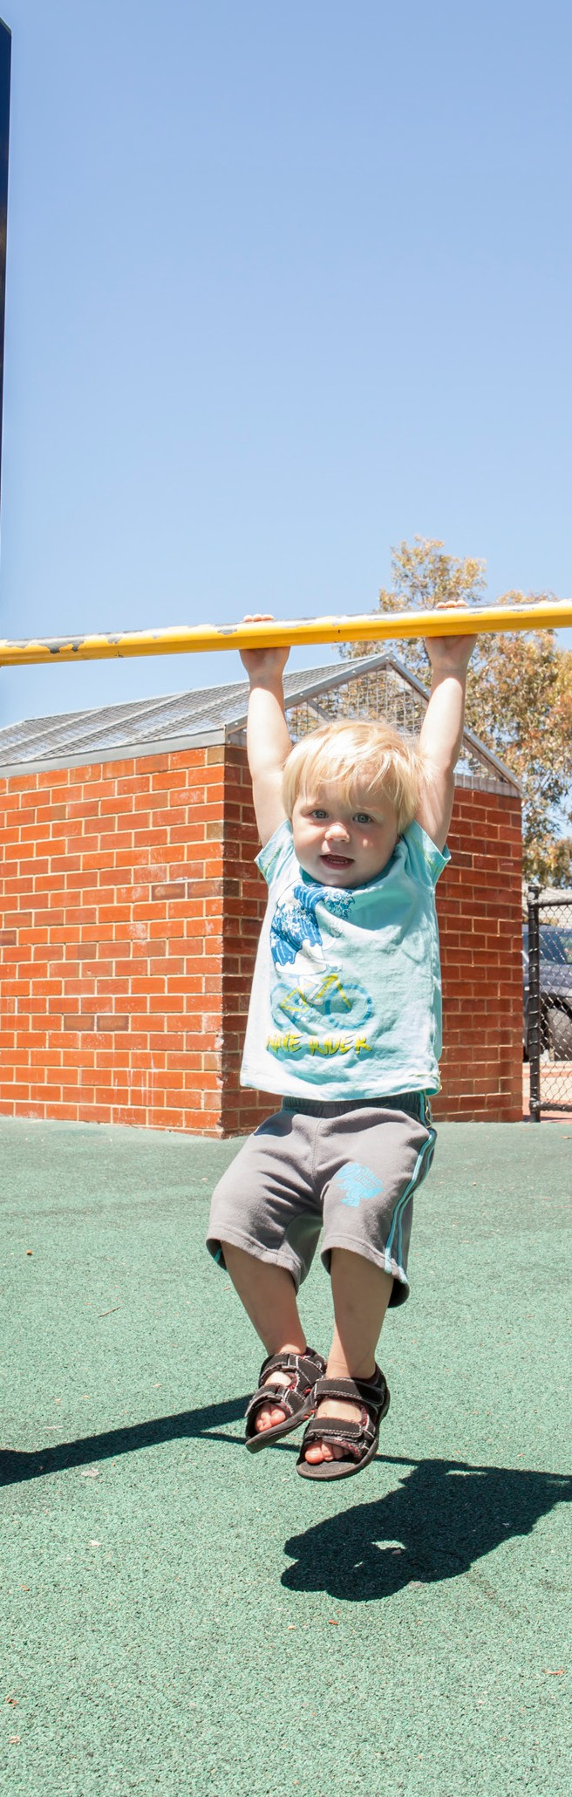
Thinking about how children develop in a domain can help educators and leaders identify what has contributed to the AEDC data in their community.
Consider the domain description below and reflect on what is supporting children’s development of physical health and wellbeing in your community.

About physical health and wellbeing
In the early years, children’s growing physical independence sees them move from wholly dependent on adults to independent agents who are able to clothe, feed, toilet, and clean themselves. Babies who once relied on physical reflexes to feed and grasp caregivers develop into children who can run, jump, climb, and manipulate small objects skilfully. This extraordinary development is often marked and celebrated by families as they witness their children master new skills.
Nevertheless, during childhood children are physically reliant on their caregivers. Children rely on adults to have their basic physical and health needs met – nourishment, warmth, and shelter. Children who are well nourished, well rested, and comfortable, can engage with their environments and make the most of educational opportunities.
The AEDC measures a series of capabilities that are indicators of children’s physical health and wellbeing. Although children can exhibit differing skills in varying contexts (e.g. are less tired at home), the factors measured in the AEDC signal that children have developed physical health and wellbeing and have been able to demonstrate these in the school environment.
These should be considered markers of how well children have developed, what might be working well in communities, and where things might be getting in the way of children developing physical health and wellbeing.
Educators who consider factors impacting on children’s ability to engage with the learning environment are better able to tailor their planning. Ask yourself:
- Do children’s physical health and wellbeing enable their engagement in learning?
- How do I support children’s development of physical independence?
- Is there support for children who are struggling to engage in learning because of poor health/ hunger/comfort/lack of stamina?
© Western Australian Department of Education 2018

Supporting the development of physical health and wellbeing
Research has demonstrated the influence of several family and community level protective factors on
the development of physical health and wellbeing. Consider the protective factors that might exist in
your community and the role you play in promoting these through your partnerships with families and the community. When thinking of development in this domain, educators and education leaders should think about factors that contribute to health, motor skills development, and physical independence.

Family level factors
Children develop the skills they need to become independent agents in the physical world when families provide opportunities for children to practice fine and gross motor skills, and provide a supportive environment that fosters physical independence (Grissmer et al, 2010; Tandon et al., 2016).
Educators who engage families in their children’s learning share insights, listen and learn from parents, and plan together for children’s development. Ask yourself:
- How do I demonstrate respect and cooperation in my approach to working with families?
- What do I learn from parents that supports my work with their child?
- How do I model practices that support children’s development of physical independence?
- Are there health factors, diagnosed or undiagnosed, that may impact children’s development?

Community level factors
Families who face challenges such as lack of employment, food or housing insecurity, poor mental health, or
family violence can find it more challenging to provide for children’s health and wellbeing. Communities that seek
to engage and work in partnership with families facing hardship, can support families to provide for their children’s health and wellbeing and develop healthy eating habits (Dudley, Cotton & Peralta, 2015; Reynolds, Brandt, Hayakawa, Englund & Ou, 2016). In communities where there are high quality early education environments (e.g. early childhood education and care services, playgroups) and mechanisms that assist families to connect with these services, children’s development is supported (Goldfeld, S., O’Connor, E., O’Connor, M., Sayers, M., Moore, T., Kvalsvig, A., & Brinkman, S. (2016).
Successful approaches to working with children to develop healthy eating behaviours have been found to be those that take a multifaceted approach and combine enhanced curricula, cross-curricula, and experiential learning approaches (Dudley, Cotton & Peralta, 2015).
Communities that enable access to services for children who could benefit the most consider and respond to the barriers families may face in accessing these services. Ask yourself:
- Have I considered the areas of physical health and wellbeing in the AEDC and what the different aspects of physical health and wellbeing might tell me about my community?
- What do I know about the community that can help me understand children’s physical health and wellbeing?
- What opportunities do children in my community have to play outdoors?
- Why are children missing out on opportunities to play?
- Do parents facing hardship have access to services and supports and are these sufficient?
© Western Australian Department of Education 2018

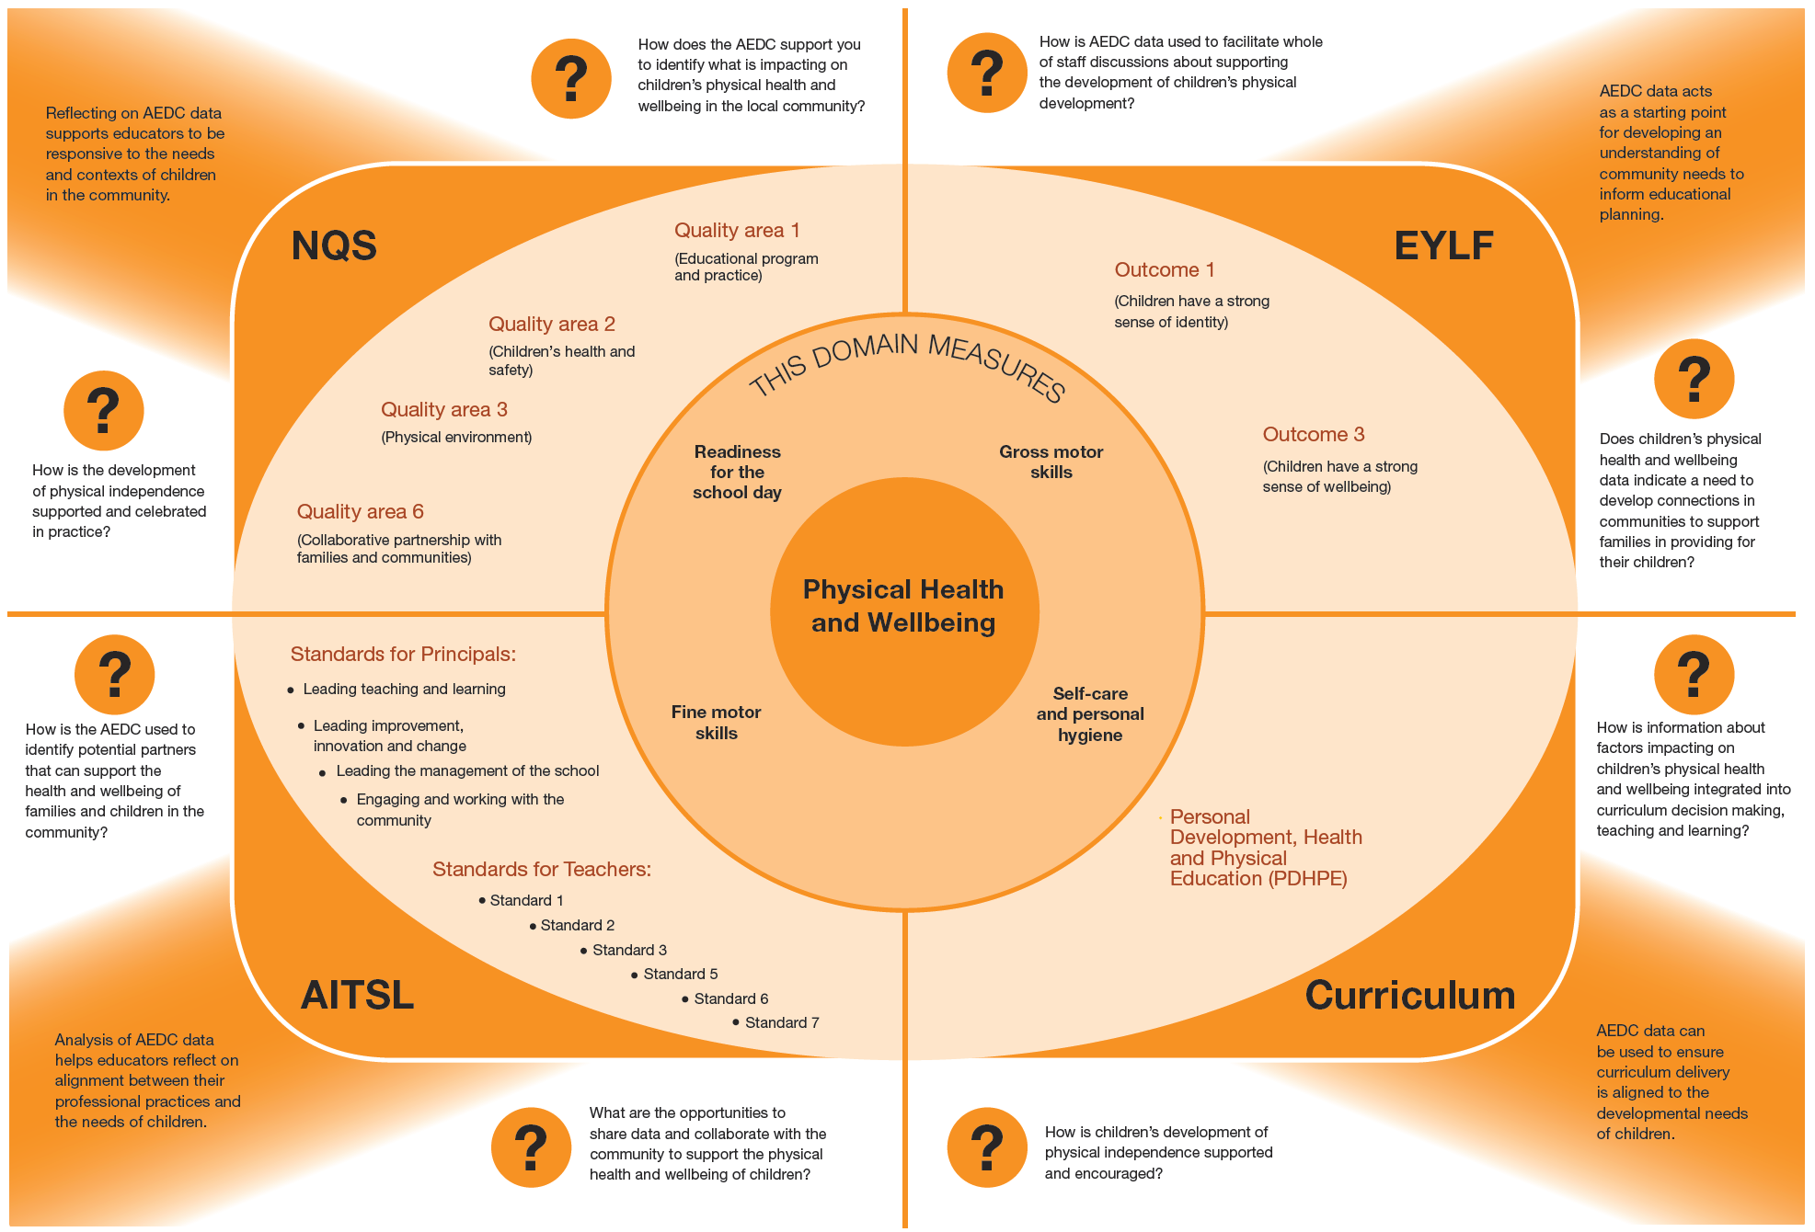

© Western Australian Department of Education 2018

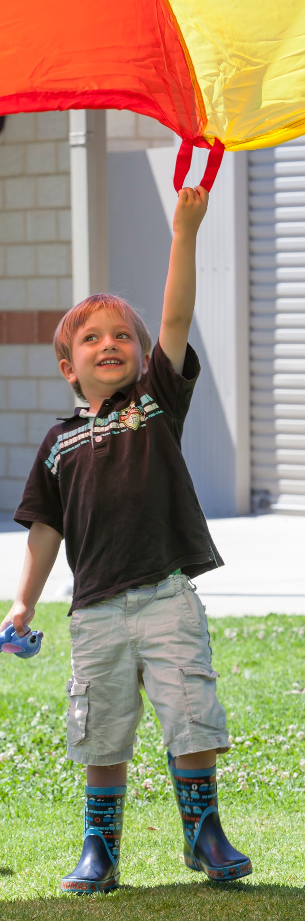
Strategies to support children
and families
Educators and leaders can support the development of children’s physical health and wellbeing in their settings, and they should also work in partnership with families and communities to support children. Consider how you can support children’s physical development:

In the education environment
- Provide opportunities for physical movement/play/ strength building throughout the day
- Provide opportunities for physical practice in relation to early childhood curriculum
- Provide opportunities to develop dexterity
- Consider how you could extend physical learning through connecting with local culture (e.g. dance or engagement with the natural environment)
- Encourage physical independence and encourage and support children’s attempts
- Create opportunities to practice healthy life habits
- Share your data with the whole of staff, school boards and parent leaders
- Partner with Aboriginal Education Officers where appropriate

In partnership with families
- Discuss physical health and independence with families
- Connect families with support services in the community
- Plan in partnership for children’s physical independence

In the community
- Share your data with the community
- Connect with services and supports to talk about what is happening for families
- Invite people into your setting to learn about what you do and to learn about what they do
- Set shared goals for children
© Western Australian Department of Education 2018

Key partners in your community
Consider where you can develop partnerships in your community to support children’s physical development and wellbeing.
- Playgroups
- Early education and care
- Schools
- Local Aboriginal organisations
- Occupational Therapists
- Child health centres / Parent health centres
- Nature Play
- Maternal child health services
- Mental health / Psychological services / Child and adolescent mental health services
- Drug and alcohol services
- Domestic violence services / women’s shelters
- Community Services Sector organisations such as Save the Children, The Smith Family, Anglicare and Mission Australia

Links to more information
To learn more about children’s physical development and wellbeing and how you can foster this in your setting, visit:

Raising Children Network
The Raising Children website offers up-to-date, research-based material on more than 800 topics spanning child development, behaviour, health, nutrition and fitness, play and learning, connecting and communicating, school and education, entertainment and technology, sleep and safety.
Available at www.raisingchildren.net.au

SNAICC
A national non-governmental peak body representing the interests of Aboriginal and Torres Strait Islander children. Resources, news and events, research and policy briefs available from www.snaicc.org.au

Early Childhood Australia
Fact sheets and information on a range of topics including communication skills and general knowledge. Available from www.earlychildhoodaustralia.org.au

What Works for Kids
Australia’s first searchable online database and networking site for researchers, practitioners and policy-makers working to improve the wellbeing of children and youth, aged 0–24 years. Available from www.whatworksforkids.org.au

Risk, protection and resilience in children and families
This Research to Practice Note aims to improve understanding of risk, protection and resilience in working with children and families and provides a brief overview of the relevant literature in this area. Available at: www.community.nsw.gov.au/ data/ assets/pdf_file/0018/321633/researchnotes_ resilience.pdf

Relevant research
Dudley, D.A., Cotton, W.G. & Peralta (2015). Teaching approaches and strategies that promote healthy eating in primary school children: A systematic
review and meta-analysis. International Journal of Behavioural Nutrition, 12(1), 28-61.
Grissmer, D., Grimm, K.J., Aiyer, S.M., Murrah,
W.M. & Steele, J.S. (2010). Fine motor skills and early comprehension of the world: Two new school readiness indicators. Developmental Psychology, 46(5), 1008-1017.
Reynolds, A.J., Brandt, A.R., Hayakawa, M., Englund, M.M. & Ou, S-R. (2016). Multi-site expansion of an early childhood intervention and school readiness. Pediatrics, 138(1)
Tandon, P.S., Trovar, A., Jayasuriya, A.T., Welker, E., Schober, D.J., Copeland, K., Dev, D.A., Murriel,
A.L., Amso, D. & Ward, D.S. (2016). The relationship between physical activity and diet and young children’s cognitive development: A systematic review. Preventive Medicine Reports, 3, 379-390.

The Australian Government is working with State and Territory Governments to implement the Australian Early Development Census (AEDC). Since 2002, the Australian Government has worked in partnership with eminent child health research institutes: the Centre for Community Child Health; Royal Children’s Hospital, Melbourne; and the Telethon Kids Institute, Perth, to deliver the AEDC to communities nationwide.
Find out more at www.aedc.gov.au and https://education.nsw.gov.au/student-wellbeing/whole-school-approach/aedc
© Department of Education Western Australia 2017 (see: https://www.education.wa.edu.au/copyright and https://www.education.wa.edu.au/ disclaimer for full details).
Developed in partnership between the Western Australian Department of Education, the Association of Independent Schools Western Australia, Catholic Education of Western Australia, the New South Wales Department of Education and the South Australian Department for Education and Child Development. The partners acknowledge the assistance and expertise of the Telethon Kids Institute in the development of the resources.
© Western Australian Department of Education 2018
TKI882 - AEDC Domain Guide Physical Health and Wellbeing

