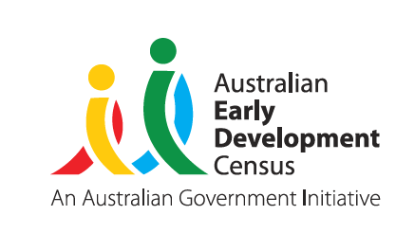
Our Children
Our Communities
Our Future

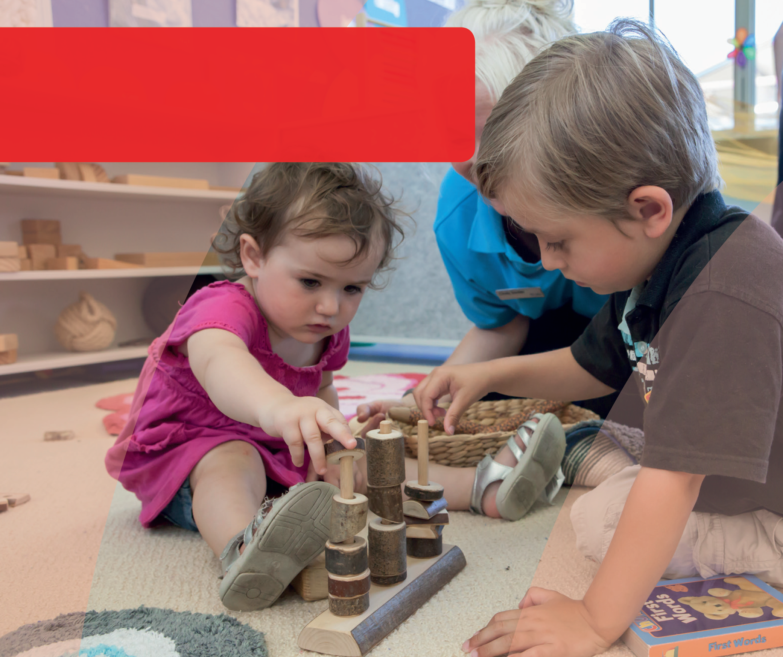
DOMAIN GUIDE:
Language and
Cognitive Skills
This guide supports early childhood education and care
services and schools to gain a deeper understanding of the AEDC language and cognitive skills domain. The guide can be used to inform early childhood and curriculum planning, quality improvement and strengthen partnerships with families and the community.
© Western Australian Department of Education 2018

Importance of language and cognitive skills in educational settings
Reflecting on the way in which language and cognitive skills enable children to engage in learning and social environments empowers educators and leaders to shape their approach to planning for children.
In reading the section below about the impact of language and cognitive skills on educational settings:
Consider the challenges children may face in your setting.
How can you promote further development in language and cognitive skills?
How does your program support children who do not have well developed language and cognitive skills?
While formal reading and writing are not prerequisites for starting school, educators know that children who are curious and interested in stories and books are more easily engaged in reading activities. Children who have developed a foundational understanding of shape, category, time, and number can build on these concepts as they begin formal learning.
Building on and encouraging children’s natural curiosity fosters a life-long love of learning. Children who have their attempts to learn new things encouraged and celebrated develop a sense of themselves as a competent learner. Confidence in their ability to learn new concepts supports children to engage with learning in new environments and sets the foundation for school success. Importantly, children who have come to think of themselves as competent learners who enjoy learning, approach learning with curiosity and enthusiasm.
Consider how you can partner with families from culturally and linguistically diverse backgrounds including Aboriginal and Torres Strait Islander backgrounds to extend the learning children have had in their first language.

The AEDC for considering children’s language and cognitive skills
The AEDC provides a picture of children’s language and communication skills across the community. It signals factors at a community level that may be impacting on children’s language and cognitive skills. By thinking about the skills that children develop before they enter school, educators can ensure they are ready to help them meet their needs. Transitions between home, care, and education settings that set children up for success consider children’s present skills, capabilities, backgrounds and experiences, and
set high expectations for children’s future learning. By being responsive to children’s developmental starting points, educators can trigger the natural curiosity and drive to learn in children and translate this into successful learning in education settings.
Specifically, the AEDC language and cognitive skills domain measures:
- Basic literacy
- Interest in literacy/numeracy and memory
- Advanced literacy
- Basic numeracy
Consider who makes up your community
Your community may include those who live in the area and the surrounding suburbs. In some cases this may differ from the families that actually attend your educational setting.
Reflect on how other data you collect (e.g. language spoken at home) can be used alongside the AEDC data to help understand your community and their needs.
© Western Australian Department of Education 2018

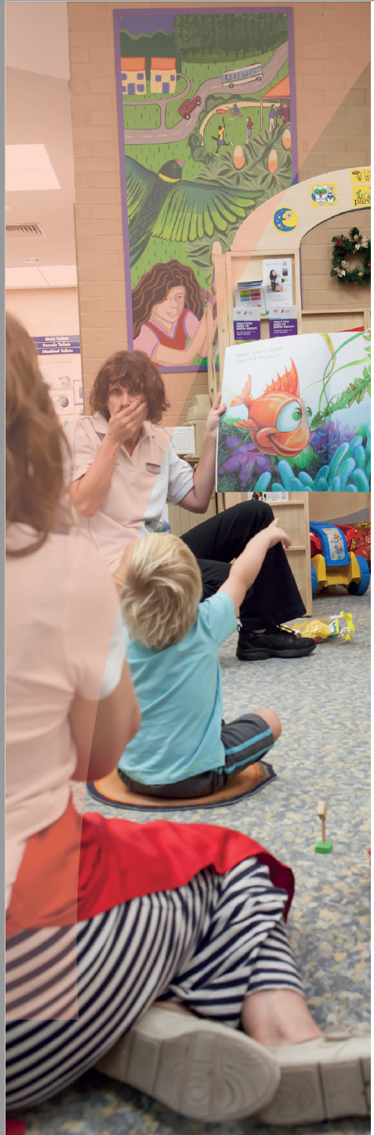
Thinking about how children develop in a domain can help educators and leaders identify what has contributed to the AEDC data in their community. Consider the domain description below and reflect on what is supporting the development of children’s language and cognitive skills in your community.

About language and cognitive
skills
Children’s early language and cognitive skills are precursors to more formal literacy and numeracy. Cognitive skills
that support children’s learning include memory, problem solving and creative thinking. These skills assist children to learn concepts, apply them to new situations and build a rich understanding of the world around them.
Early in life, children are introduced to concepts of shape, number, and sound that scaffold their later school-based learning. An early interest in stories and books can
grow into a love of reading. Early exposure to numerical concepts, such as number and quantity, facilitates later engagement with mathematical concepts. Children are born with a drive to observe, practice, and learn. They take an interest in the adult world and imitate their parents through play. Rich early learning environments stimulate this interest - and these need not be highly structured.
Children learn concepts best when they experience them in routine activities, as part of play, and when they are aligned with their interests and inclinations. Language and cognitive skills in the form of problem solving and creative thinking provide critical platform in preparing the next generation to succeed and meet the demands of contemporary society.
In daily life children are provided with learning opportunities many times over. Intentional exposure may come from parents reading to their children or playing games with them, but much of children’s experience comes by way
of routine interactions. Talking with children, asking them whether they would like more or less, retelling of favourite stories, reflecting on the day’s events – these all build children’s language and cognitive skills. Families who are equipped with knowledge about the simple things they can do to support their children’s learning in the early years find it easier to develop a love of learning in their children.
The AEDC measures a series of capabilities that are indicators of children’s language and cognitive skills. Although children can exhibit differing skills in varying contexts (e.g. being interested in books at home with familiar adults), the factors measured in the AEDC signal that children have developed language and cognitive skills and have been able to demonstrate these in the school environment. These should be considered markers of how well children have developed, what might be working well in communities, and where things might be getting in the way of children developing language and cognitive skills.
© Western Australian Department of Education 2018

Supporting the development of
language and cognitive skills
Research has demonstrated the influence of several family and community level protective factors on the development of
language and cognitive skills. Consider the protective factors that might exist in your community and the role you play in promoting these through your partnerships with families and the community. When thinking of development in this domain, educators and education leaders should think about factors that contribute to reading, writing, counting and recognising numbers and shapes.

Family level factors
Parenting practices in the early years are predictive of children’s cognitive development and school readiness. This has however, been found to be related to parental warmth and consistency, good mental health, and engaging in play with children, rather than any formal teaching activities in the home (Rodriguez 2011).
Educators who engage families in their children’s learning share insights, listen and learn from parents, and plan together for children’s development. Ask yourself:
- What are the characteristics of families in the community?
- What might be influencing their ability to provide rich early learning experiences for their children?
- What is available for families who may need additional support?
- Are there any particular family or cultural characteristics that may impact the child?

Community level factors
Exposure to new experiences and an active involvement in learning helps children develop language and cognitive skills as well as literacy and numeracy (Anderson et al. 2003). Research has demonstrated the benefit of quality early childhood services such as preschool or playgroups for the development of language and cognitive skills (Goldfeld et al. 2016, Gregory et al. 2016). Moreover, early childhood education is particularly advantageous for children from disadvantaged families (Goldfeld et al. 2016).
Educators who consider factors impacting on children’s ability to engage with the learning environment are better able to tailor their planning. Ask yourself:
- Do children’s language and cognitive skills enable their engagement in learning?
- How do I support children’s development of language and cognitive skills?
- Is there support for children who are struggling to engage in learning?
© Western Australian Department of Education 2018

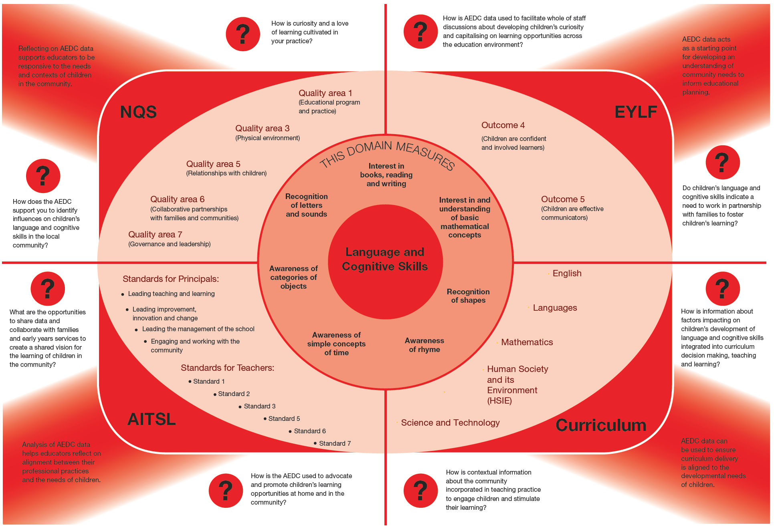
© Western Australian Department of Education 2018

Strategies to support children
and families
Educators and leaders can support the development of children’s language and cognitive skills in their settings, and they should also work in partnership with families and communities to support children. Consider how you can support children’s language and cognitive development:

In the education environment
- Provide visual and physical support for learning including considerations for cultural identity
- Share children’s learning success
- Follow children’s lead
- Use a range of learning and teaching methods to practice and reinforce concepts
- Develop consistent processes for identifying children who may need additional supports including those from culturally and linguistically diverse including Aboriginal and Torres Strait Islander backgrounds
- Set high expectations for children’s learning and development outcomes
- Monitor the effectiveness of your programs in supporting children’s learning and development – if things aren’t working explore what might be getting in the way
- Partner with Aboriginal Education Officers where appropriate
- Welcome and show respect for children from differing backgrounds through the use of inclusive environments and practices

In partnership with families
- Share learning stories
- Develop a range of take home activities that involve and engage parents
- Model supportive practices that develop confident learners
- Invite parents to share their knowledge/skills/culture in the education setting
- Consider literacy and numeracy barriers parents may face in supporting their children’s learning
- Connect families with supports that empower them to share in their children’s learning

In the community
- Share your data with the community
- Connect with services and supports to talk about what is happening for families
- Invite people into your setting to learn about what you do and to learn about what they do
- Set shared goals for children
- Communicate your high expectations for children’s learning and development
© Western Australian Department of Education 2018

Key partners in your
community
Consider where you can develop partnerships in your community to support children’s language and cognitive development.
- Playgroups
- Early education and care
- Local Aboriginal organisations
- Schools
- Speech pathologists
- Occupational Therapists
- Child health centres / Parent health centres
- Library and local council programs for children and families
- Maternal child health services

Links to more information
To learn more about children’s development in communication skills and general knowledge and how you can foster this in your setting, visit:

Early Childhood Australia
Fact sheets and information on a range of topics including language and cognitive skills. Available from www.earlychildhoodaustralia.org.au

SNAICC
A national non-governmental peak body representing the interests of Aboriginal and Torres Strait Islander children. Resources, news and events, research and policy briefs available from www.snaicc.org.au

What Works for Kids
Australia’s first searchable online database and networking site for researchers, practitioners and policy-makers working to improve the wellbeing of children and youth, aged 0–24 years. Available from www.whatworksforkids.org.au

KidsMatter
Frameworks and resources that can assist staff, parents and carers in supporting children’s developmental needs. Available from www.kidsmatter.edu.au

Risk, protection and resilience in children and families
This Research to Practice Note aims to improve understanding of risk, protection and resilience in working with children and families and provides a brief overview of the relevant literature in this area. Available at: www.community.nsw.gov.au/ data/ assets/pdf_file/0018/321633/researchnotes_ resilience.pdf

Relevant research
Anderson, L. M., Shinn, C., Fullilove, M. T., Scrimshaw, S. C., Fielding, J. E., Normand, J., Carande-Kulis, V. G. (2003). The Effectiveness of Early Childhood Development Programs: A
Systematic Review, American Journal of Preventive Medicine.
Goldfeld, S., O’Connor, E., O’Connor, M., Sayers, M., Moore, T., Kvalsvig, A., & Brinkman, S. (2016). The role of preschool in promoting children’s healthy development: Evidence from an Australian population cohort. Early Childhood Research Quarterly.
Gregory, T., Harman-Smith, Y., Sincovich, A., Wilson, A., & Brinkman, S. (2016). It takes a villageto raise a child: The influence and impact of playgroups across Australia. Telethon Kids Institute: South Australia.
Rodriguez, E. T., & Tamis‐LeMonda, C. S. (2011). Trajectories of the home learning environment across the first 5 years: Associations with children’s vocabulary and literacy skills at prekindergarten.
Child Development, 82(4), 1058-1075.

The Australian Government is working with State and Territory Governments to implement the Australian Early Development Census (AEDC). Since 2002, the Australian Government has worked in partnership with eminent child health research institutes: the Centre for Community Child Health; Royal Children’s Hospital, Melbourne; and the Telethon Kids Institute, Perth, to deliver the AEDC to communities nationwide.
Find out more at www.aedc.gov.au and https://education.nsw.gov.au/student-wellbeing/whole-school-approach/aedc
© Department of Education Western Australia 2017 (see: https://www.education.wa.edu.au/copyright and https://www.education.wa.edu.au/ disclaimer for full details).
Developed in partnership between the Western Australian Department of Education, the Association of Independent Schools Western Australia, Catholic Education of Western Australia, the New South Wales Department of Education and the South Australian Department for Education and Child Development. The partners acknowledge the assistance and expertise of the Telethon Kids Institute in the development of the resources.
© Western Australian Department of Education 2018
TKI882 - AEDC Domain Guide Language and Cognitive Skills

