Our Children
Our Communities
Our Future

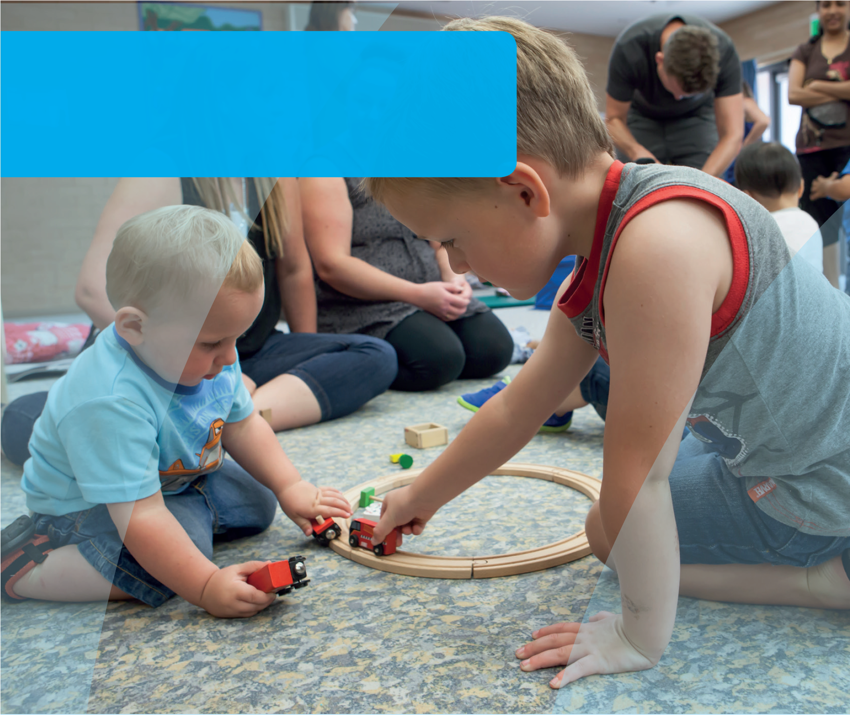
DOMAIN GUIDE:
Emotional maturity
This guide supports early childhood education and care services and schools to gain a deeper understanding of the AEDC emotional maturity domain. The guide can be used to inform
early childhood and curriculum planning, quality improvement and strengthen partnerships with families and the community.
© Western Australian Department of Education 2018

Importance of emotional maturity in educational
settings
Reflecting on the way in which emotional maturity enables children to engage in learning and social environments empowers educators and leaders to shape their approach to planning for children.
In reading the section below about the impact of emotional maturity on educational settings:
Consider the challenges children may face in your setting.
How can you promote further development in emotional maturity?
How does your program support children who are not well developed in emotional maturity?
Emotional maturity refers to a set of abilities that enable children to understand and manage how they respond when faced with situations that elicit an emotional reaction. Emotional reactions are the brain’s way of keeping
us safe from danger and socially connected. Constructive responses are those that seek to resolve the situation that has stimulated the emotion, in order to enable the body to return to a less aroused state. Responses may be counterproductive if the child is unable to move beyond the situation.
Emotional maturity supports children to manage the demands of the social and learning environments. It enables children to form relationships with their peers, recover from disappointment or sadness (building resilience), overcome frustration, and express anger in socially acceptable ways. Difficulties regulating emotions can present in several ways. Children who struggle to regulate and control their anger and frustration may exhibit externalising behaviour including conduct problems, and hyperactive and aggressive behaviours. On the other hand,
children who have feelings of sadness and fear tend to exhibit anxious and depressive symptoms (internalising behaviours), although some may externalise. These early difficulties can translate into later mental health challenges.

The AEDC for considering children’s emotional maturity
The AEDC provides a picture of children’s emotional maturity across the community. It signals factors at a community level that may be impacting on children’s emotional development and their needs. Educators and educational leaders can use this information to connect with their communities, inform their planning, and shed light on issues at a community level that are likely to be impacting children’s ability to engage in learning. AEDC emotional maturity domain questions reflect the types
of skills teachers observe in the classroom and playground environments. These should be considered markers of how well children have developed, what might be working well in communities, and where things might be getting in the way of children’s emotional maturity.
Specifically, the AEDC emotional maturity domain measures:
- Prosocial and helping behaviour
- Anxious and fearful behaviour
- Aggressive behaviour
- Hyperactivity and inattentive behaviour
Consider who makes up your community
Your community may
include those who live in the area and the surrounding suburbs. In some cases this may differ from the families that actually attend your educational setting.
Reflect on how other data you collect (e.g. attendance
& home background) can be used alongside the AEDC data to help understand your community and their needs.
© Western Australian Department of Education 2018

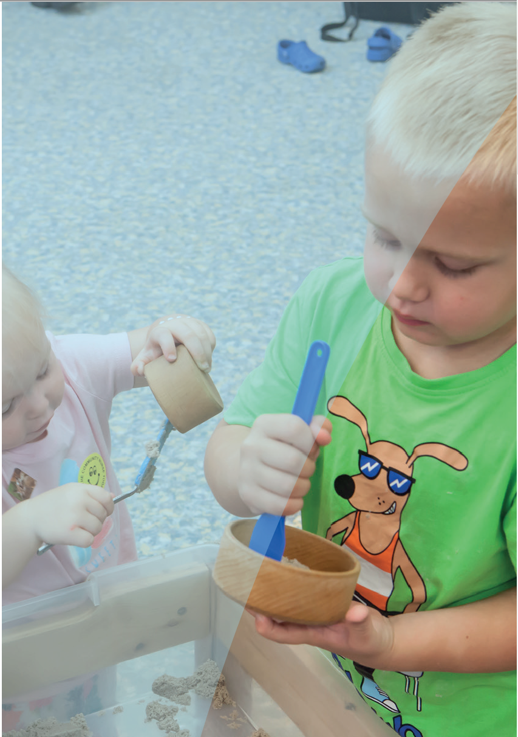

Thinking about how children develop in a domain can help educators and leaders identify what has contributed to the AEDC data in their community. Consider the domain description below and reflect on what is supporting the development of children’s emotional maturity in your community.

About emotional maturity
Before the areas of a child’s brain that enable them to regulate their own emotions develop, children need their emotions to be regulated by their primary caregiver(s) (e.g. a parent soothing a crying baby).
Over time this regulation provided by adults is gradually replaced by co-regulation (e.g. an angry child calming themselves with the support of an adult) and eventually self-regulation (e.g. talking about what has prompted their excitement and then once shared, focusing on the task at hand).
Understanding their own emotions also helps children to empathise with others. Children who are emotionally mature can infer the feelings of others and respond in prosocial ways that demonstrate that they care for other people and value relationships.
These early skills help to develop adults who can form and maintain healthy relationships, get along with their co-workers, and navigate conflict.
Supporting the development of emotional maturity requires a partnership approach with families. On their own, educational settings can support children to cope with education and care environments,
but development of these skills requires practice across a range of settings and situations. In working with families, educators can advocate for children’s development, provide guidance on
parenting approaches, and arm parents with skills that empower them to support their children’s development.
Key skills underlying emotional maturity are predictive of later success, wellbeing, and mental health. Educators know that in the classroom, emotional maturity supports children’s learning by helping them to persevere when challenged and return to tasks when a situation or thought has diverted their focus. Strong communication skills enable children to demonstrate their emotional maturity and help them to express their feelings in socially appropriate ways. Children who struggle to communicate how they feel may need support to

help them manage their emotions in constructive ways.
When children are calm and focused, they can
attend to new information, integrate information and apply it to new contexts. In this way, self-regulation and resilience, the cornerstones of emotional maturity, are at the heart of children’s learning ability.
The AEDC measures a series of capabilities that are indicators of children’s emotional maturity. Although children can exhibit differing skills in varying
contexts (e.g., almost never show anxious behaviour at home), the factors measured in the AEDC signal that children have developed emotional maturity
and have been able to demonstrate these in the school environment. These should be considered markers of how well children have developed,
what might be working well in communities, and where things might be getting in the way of children developing emotional maturity.

Educators who consider factors impacting on children’s ability to engage with the learning
environment are better able to tailor their planning. Ask yourself:
- Are the emotions of children in my setting respected and responded to empathetically?
- Do children have the opportunity to practise emotional regulation?
- Is there support for children who have experienced or are experiencing trauma?
- Are educators trained to support children who have experienced trauma?
© Western Australian Department of Education 2018

Supporting the development of emotional maturity
Research has demonstrated the influence of several family and community level protective factors on the development of emotional maturity. Consider the protective factors that might exist in your community and the role you play in promoting these through your partnerships with families and the community. When thinking of development in this domain, educators and education leaders should think about factors that contribute to self- control, resilience and helping behaviours.

Family level factors
Parents who constructively engage with their children regularly throughout the day support their children’s emotional development (Smart et al. 2008). Play helps support a child’s emotional development, as it provides an opportunity for children to express and cope with feelings. It also allows them to play out situations which may be frightening or exciting to them, assisting them to recognise and regulate a variety of emotions in different situations. These experiences can then be drawn upon in real life situations later in life, providing the child with a sense of control and understanding (Kids Matter 2014). Playgroups also provide children with an opportunity to develop their emotional skills on a regular basis, with those attending a playgroup having stronger emotional skills than their peers (Gregory et al. 2016).
Educators who engage families in their children’s learning share insights, listen and learn from parents, and plan together for children’s emotional development. Ask yourself:
- What do I learn from parents that supports my work with their child?
- How do I work in partnership with families who are facing challenges that I have never experienced myself?
- How do I share my observations with families?
- How do I support parents to engage in play with their children?
- How do I support children who are not developing these skills at home?

Community level factors
Research has found that supporting children’s emotional development in the midst of family complexity requires a
multi-pronged approach that provides positive experiences for children while developing parental capability. Integrated service hubs which include early childhood education and care, parenting support, health, libraries and other community resources can provide these types of wrap around services in communities (Patel 2016).
Communities that enable access to services for children who could benefit the most consider and respond to the barriers families may face in accessing these services. Ask yourself:
- What do I know about the community that can help me understand children’s emotional maturity?
- Who is accessing services and who is missing out?
- Why are children missing out?
- Are there low cost supports such as facilitated playgroups or parenting programs?
© Western Australian Department of Education 2018

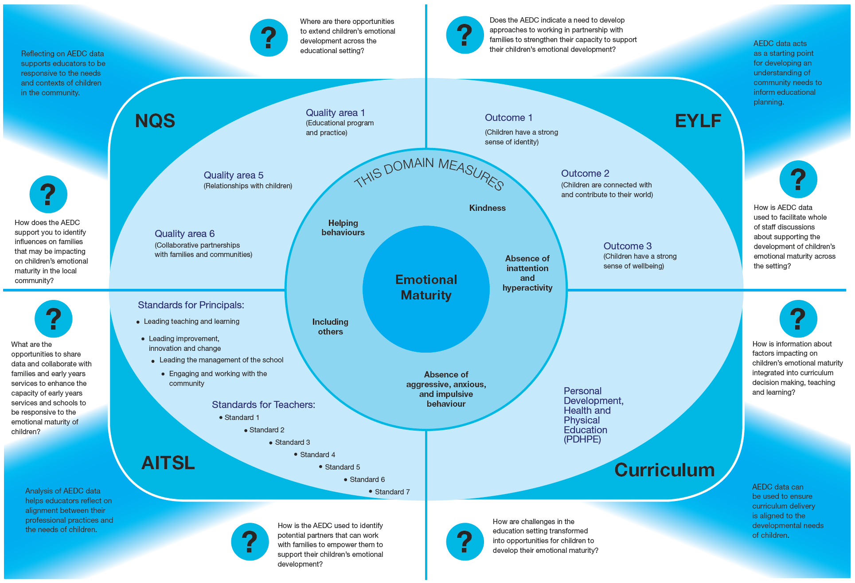
© Western Australian Department of Education 2018

Strategies to support children
and families
Educators and leaders can support the development of
children’s emotional maturity in their settings, and they should
also work in partnership with families and communities to
support children. Consider how you can support children’s
emotional maturity:

In the education environment
- Provide visual cues to help children communicate how they feel
- Create safe, caring and supportive learning environments
- Acknowledge emotions and their validity
- Practice skills to address emotional states through reading stories and play
- Make emotional learning part of everyday lessons
- Monitor the mental health and wellbeing of children
- Provide a physical and social environment that enables children to self-regulate/withdraw when required
- Create opportunities to develop self-control and persistence
- Create opportunities for self-expression
- Partner with Aboriginal Education Officers where appropriate
- Provide activities which will develop a sense of mastery
- Provide opportunities to learn new skills and competencies through role play, modelling and exploration
- Be aware of the signs of potential difficulties
- Share your data with the whole of staff, school boards and parent leaders

In partnership with families
- Adopt a respectful and welcoming approach to engaging with families
- Work in partnership to set shared goals for children
- Model supportive practices that develop emotional maturity
- Provide working with trauma training for educators
- Learn about local cultures and different approaches to child rearing

In the community
- Share your data with the community
- Connect with services and supports to talk about what is happening for families
- Invite people into your setting to learn about what you do and to learn about what they do
- Set shared goals for children
© Western Australian Department of Education 2018

Key partners in your community
Consider where you can develop partnerships in your community to support children’s emotional maturity.
- Playgroups
- Early education and care
- Schools
- Local Aboriginal organisations
- Child health centres / Parent health centres
- Maternal child health services
- Mental health / Psychological services / Child and adolescent mental health services
- Drug and alcohol services
- Domestic violence services / women’s shelters
- Community Services Sector organisations such as Save the Children, The Smith Family, Anglicare, and Mission Australia

Links to more information
To learn more about children’s emotional maturity and how you can foster this in your setting, visit:

Early Childhood Australia
Fact sheets and information on a range of topics including emotional maturity. Available from www.earlychildhoodaustralia.org.au

SNAICC
A national non-governmental peak body representing the interests of Aboriginal and Torres Strait Islander children. Resources, news and events, research and policy briefs available from www.snaicc.org.au

What Works for Kids
Australia’s first searchable online database and networking site for researchers, practitioners and policy-makers working to improve the wellbeing of children and youth, aged 0–24 years. Available from www.whatworksforkids. org.au

KidsMatter
Frameworks and resources that can assist staff, parents
and carers in supporting children’s social and emotional wellbeing needs. Available from www.kidsmatter.edu.au

Calmer Classroom
A guide to working with traumatised children. Available from education.qld.gov.au/schools/healthy/pdfs/calmer- classrooms-guide.pdf

The Collaborative for Academic, Social and Emotional Learning (CASEL)
The CASEL group provides resources, guidance and tools to support integrated academic, social, and emotional learning for all children in preschool through high school. Available from www.casel.org

Raising children’s network
The Australian parenting website: comprehensive, practical, expert child health and parenting information and activities covering children aged 0-15 years. Available at: www. raisingchildren.net.au

Risk, protection and resilience in children and families
This Research to Practice Note aims to improve understanding of risk, protection and resilience in working with children and families and provides a brief overview
of the relevant literature in this area. Available at: www. community.nsw.gov.au/ data/assets/pdf_file/0018/321633/ researchnotes_resilience.pdf

Relevant research
Gregory, T., Harman-Smith, Y., Sincovich, A., Wilson, A., & Brinkman, S. (2016). It takes a village to raise a child:
The influence and impact of playgroups across Australia. Telethon Kids Institute: South Australia.
KidsMatter (2014). Connections with the National Quality Framework Developing children’s social and emotional skills.
Patel, S., Corter, C., Pelletier, J., & Bertrand, J. (2016). ‘Dose-response’ relations between participation in integrated early childhood services and children’s early
development. Early Childhood Research Quarterly, 35, 49- 62.
Smart, D., Sanson, A., Baxter, J., Edwards, B., & Hayes,
A. (2008). Home-to-school transitions for financially disadvantaged children. Sydney: The Smith Family.

The Australian Government is working with State and Territory Governments to implement the Australian Early Development Census (AEDC). Since 2002, the Australian Government has worked in partnership with eminent child health research institutes: the Centre for Community
Child Health; Royal Children’s Hospital, Melbourne; and the Telethon Kids Institute, Perth, to deliver the AEDC to communities nationwide.
Find out more at www.aedc.gov.au and https://education.nsw.gov.au/student-wellbeing/whole-school-approach/aedc
© Department of Education Western Australia 2017 (see: https://www.education.wa.edu.au/copyright and https://www.education.wa.edu.au/ disclaimer for full details).
Developed in partnership between the Western Australian Department of Education, the Association of Independent Schools Western
Australia, Catholic Education of Western Australia, the New South Wales Department of Education and the South Australian Department for Education and Child Development. The partners acknowledge the assistance and expertise of the Telethon Kids Institute in the development of the resources.
© Western Australian Department of Education 2018
TKI882 - AEDC Domain Guide Emotional Maturity

