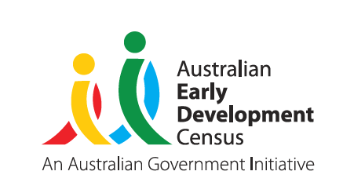
Our Children
Our Communities
Our Future

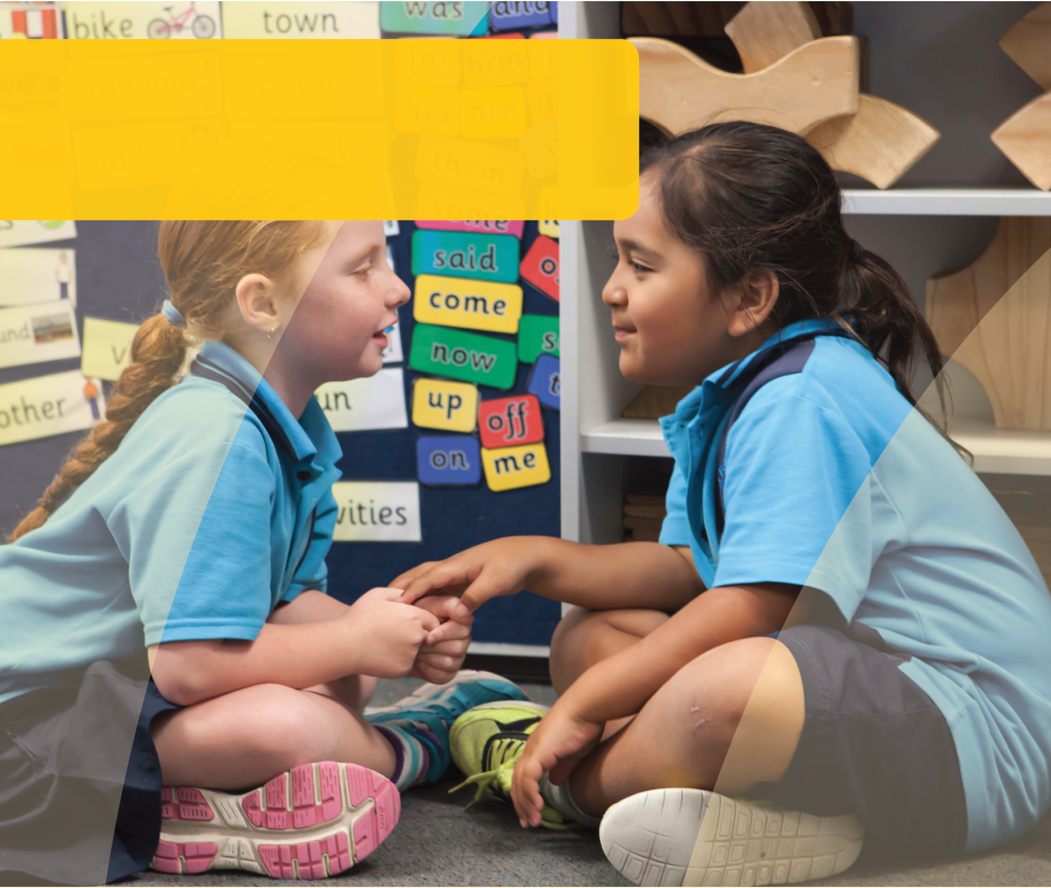
DOMAIN GUIDE:
Communication skills and
general knowledge
This guide supports early childhood education and care services and schools to gain a deeper understanding of the AEDC communication skills and general knowledge domain. The guide can be used to inform early childhood and curriculum planning, quality improvement and strengthen partnerships with families and the community.
© Western Australian Department of Education 2018

The importance of communication skills and general knowledge in educational settings
Reflecting on the way in which communication skills and general knowledge enable
children to engage in learning and social environments empowers educators and leaders
to shape their approach to planning for children.
In reading the section below about the impact of communication and general knowledge on educational settings:
Consider the opportunities and challenges children may face in your setting.
How can you promote further development in communication skills and general knowledge?
How does your program support children who are not well developed in communication skills and general knowledge?
Communication skills enable children to interact with others in their environment to express their needs,
share their thoughts, and demonstrate their knowledge. Communication is about more than words, it is about
interaction and sharing of our inner dialogue. Learning to communicate effectively also means learning to listen and to make sense of the communication attempts of others. In this context general knowledge is where children show knowledge about the world, such as knowing that apple is a fruit and that dogs bark.
Educators know that these skills enable children to form a sense of belonging, develop friendships, engage in learning, and feel understood.
Communication skills support children to follow instructions, understand boundaries and expectations, and seek help from adults. Children who can communicate their thoughts, beliefs and feelings are better able to have their needs met so that they can then make the most of the learning opportunities in their environments. Children who struggle to communicate their needs may demonstrate a range of challenging behaviours, which serve the same purpose of signalling an underlying need.

The AEDC for considering children’s communication skills and general knowledge
Educators who acknowledge children’s communication attempts, and work to understand children, have more success in eliciting cooperation, developing children’s sense of belonging, and engaging children in learning.
The AEDC provides educators and education leaders with a picture of children’s communication skills and general knowledge across the community. It provides a snapshot of vulnerability which can trigger educators and communities to look at contributing or underlying factors that may be impacting on children’s development at the community level. Information is also provided at the school level which can assist education leaders to identify where their incoming cohorts may require additional support.
This approach also helps educators to plan for transitions in a way that is responsive to the needs of children in the community, their culture and language background, and the communication support they may need in the education setting.
Specifically, the AEDC communication skills and general knowledge domain measures:
- Skills to communicate needs and wants in socially appropriate ways
- Symbolic use of language
- Storytelling
- Age-appropriate knowledge about the life and world
Consider who makes up your community.
Your community
may include those who live in the area and the surrounding suburbs. In some cases this may differ from the families that actually attend your educational setting.
Reflect on how other data you collect (e.g. attendance, home background) can be used alongside the AEDC data to help understand your community and their needs.

© Western Australian Department of Education 2018

Thinking about how children develop in a domain can help educators and leaders identify what has contributed to the AEDC data in their community. Consider the domain description below and reflect on what is supporting the development of children’s communication skills and general knowledge in your community.

About communication skills and general knowledge
Educators know that children develop communication
skills and general knowledge through listening and talking. Infants communicate through babbling, facial expressions, and vocalisations. These are the building blocks of later communication. Through exposure to communication children also learn the rules of conversation; waiting for their turn to speak, listening for content, and replying appropriately. By the time children reach school most have developed an impressive vocabulary that enables them
to express ideas and concepts and demonstrate their understanding of and interest in how the world around them works.
The AEDC measures a series of capabilities that are indicators of children’s communication skills and general knowledge. Although children can exhibit differing skills in varying contexts (e.g., speak more at home with familiar adults), the factors measured in the AEDC signal that children have developed communication skills and general knowledge and have been able to demonstrate these in the school environment. These should be considered markers
of how well children have developed, what might be working well in communities, and where things might be getting in
the way of children developing communication skills and general knowledge.
Educators who consider factors impacting on children’s ability to engage with the learning environment are better able to tailor their planning. Ask yourself:
Do children’s communication skills and general knowledge enable their engagement in learning?
How do I support children’s development of communication skills and general knowledge?
Is there support for children who are struggling to engage in learning because of poor communication skills and general knowledge?
How are communication skills and general knowledge considered for children from culturally and linguistically diverse backgrounds including children from Aboriginal and Torres Strait Islander backgrounds?

© Western Australian Department of Education 2018

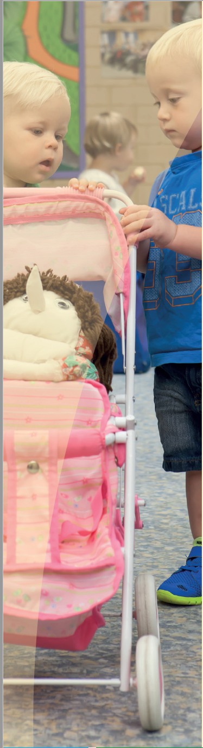
Supporting the development of communication skills and general knowledge
Research has demonstrated the influence of several family
and community level protective factors on the development of
communication skills and general knowledge. Consider the protective factors that might exist in your community and the role you play in promoting these through your partnerships with families and the community. When thinking of development in this domain, educators and education leaders should think about factors that contribute to communication, listening, understanding and being able to take part in imaginative play or tell a story.

Family level factors
Research has clearly demonstrated the importance of language rich environments for children’s development. Children’s communication abilities are linked to how much parents talk with their children – irrespective of education or income (Hart & Risley 1992). Similarly, engaging in play supports children’s development of communication skills and general knowledge. Pretend play strengthens children’s knowledge, communication, and storytelling skills (Burriss & Tsao, 2012; Sutherland, Shelbie, Friedman 2012).
Educators who engage families in their children’s learning share insights, listen and learn from parents, and plan together for children’s development. Ask yourself:
- How do I share my approach to teaching?
- What do I learn from parents that supports my planning?
- What opportunities are there for me to engage in shared planning with families?

Community level factors
Families who face challenges such as lack of employment, food or housing insecurity, poor mental health, or family violence can find it more challenging to provide environments that stimulate their children’s development. In communities where there are high quality early education environments (e.g. child care services, playgroups, library programs and Child and Parent Centres) and mechanisms that support families to connect with these services, children’s development is supported. (Goldfeld et al., 2016; Hansen, Joshi, & Dex, 2014; Patel, Corter, Pelletier, & Bertrand, 2016).
Communities that enable access to services for children who could benefit the most consider and respond to the barriers families may face in accessing these services. Ask yourself:
- Are there quality early learning environments available in this community?
- Who is accessing these services and who is missing out?
- Why are children missing out?
- Are there alternative low cost supports such as facilitated playgroups, library programs and parenting support programs?
© Western Australian Department of Education 2018
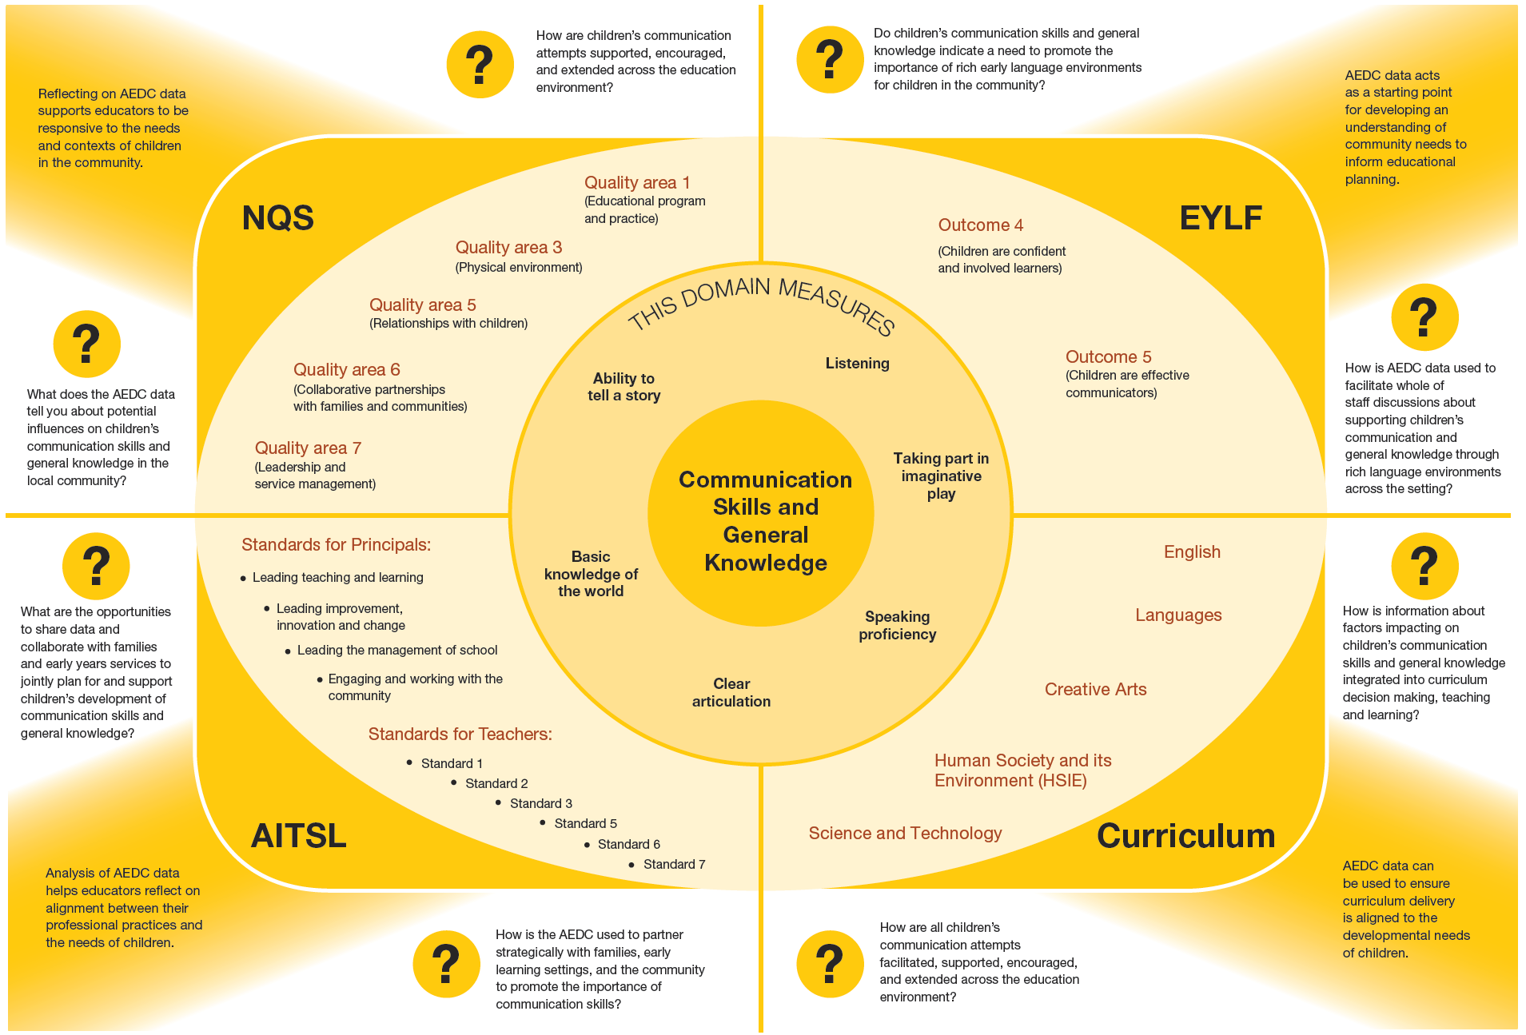
© Western Australian Department of Education 2018

Strategies to support children
and families
Educators and leaders can support the development of children’s communication skills and general knowledge
in their settings, and they should also work in partnership with families and communities to support children.
Consider how you can support children’s development:

In the education environment
- Create language rich environments that stimulate thinking and conversation
- Partner with Aboriginal Education Officers where appropriate
- Encourage and create opportunities for peer communication
- Engage in activities or objects that interest children
- Model language by providing the names of objects or actions
- Model different types of words and grammar
- Listen actively to children
- Engage in conversational turn taking
- Create listening and speaking stations
- Create daily opportunities for children to experiment with, use and practice their communication skills
- Pair verbal instruction with visual aids to support comprehension
- Engage children in sustained shared thinking and conversations
- Share your data with the whole of staff, school boards and parent leaders

In partnership with families
- Children and parents create and share family stories
- Model rich communication
- Value and explicitly celebrate all languages and culture (verbal and non-verbal)
- Share information about strategies to support communication in everyday interactions

In the community
- Share your data with the broader community
- Connect with services and supports to talk about what is happening for families
- Interrogate the quality of children’s early language environments and exposures
- Set shared goals for children
© Western Australian Department of Education 2018

Key partners in your community
Consider where you can develop partnerships in your community to support children’s communication skills and general knowledge.
- Playgroups
- Early education and care
- Schools
- Speech pathologists
- Local Aboriginal organisations
- Occupational Therapists
- Child health centre / Parent health centres
- Library and local council programs for children and families
- Maternal child health services
- School board
- Community based childcare management groups

Links to more information
To learn more about children’s communication skills and general knowledge development and how you can foster this in your setting, visit:

Early Childhood Australia
Fact sheets and information on a range of topics including communication skills and general knowledge. Available from www.earlychildhoodaustralia.org.au

SNAICC
A national non-governmental peak body representing the interests of Aboriginal and Torres Strait Islander children. Resources, news and events, research and policy briefs available from www.snaicc.org.au

What Works for Kids
Australia’s first searchable online database and networking site for researchers, practitioners and policy-makers working to improve the wellbeing of children and youth, aged 0–24 years. Available from www.whatworksforkids.org.au

Abbotsford Early Years
Resources, information and activities for parents to support development for children aged 0 to 5 years.
Available from www.abbyearlyyears.com/child-development

Risk, protection and resilience in children and families
This Research to Practice Note aims to improve understanding of risk, protection and resilience in working with children and families and provides a brief overview of the relevant literature in this area. Available at www.community.nsw.gov.au/ data/ assets/pdf_file/0018/321633/researchnotes_ resilience.pdf

Relevant research
Goldfeld, S., O’Connor, E., O’Connor, M., Sayers, M., Moore, T., Kvalsvig, A., & Brinkman, S. (2016).
The role of preschool in promoting children’s healthy development: evidence from an Australian population cohort. Early Childhood Research Quarterly, 35, 40-48.
Guhn, M., Milbrath, C., & Hertzman, C. (2016). Associations between child home language, gender, bilingualism and school readiness: a population- based study. Early Childhood Research Quarterly, 35, 95-110.
Hart, B., & Risley, T. (1992). American Parenting of Language-Learning Children: Persisting Differences in Family-Child Interactions Observed in Natural Home Environments. Developmental Psychology, 28(6), 1096-1105.
Kinnell, A., Harman-Smith, Y., Engelhardt, D., Luddy,
S. & Brinkman, S. (2013). Boys and Girls in South Australia: A comparison of gender differences from the early years to adulthood. Published by the Fraser Mustard Centre. Department for Education and Child Development and the Telethon Institute for Child Health Research. Adelaide. ISBN 978-0-9876002-2-6.
Sutherland, S. L., & Friedman, O. (2012). Preschoolers acquire general knowledge by sharing in pretense. Child Development, 83(3), 1064-1071.

The Australian Government is working with State and Territory Governments to implement the Australian Early Development Census (AEDC). Since 2002, the Australian Government has worked in partnership with eminent child health research institutes: the Centre for Community Child Health; Royal Children’s Hospital, Melbourne; and the Telethon Kids Institute, Perth, to deliver the AEDC to communities nationwide.
Find out more at www.aedc.gov.au and https://education.nsw.gov.au/student-wellbeing/whole-school-approach/aedc
© Department of Education Western Australia 2017 (see: https://www.education.wa.edu.au/copyright and https://www.education.wa.edu.au/ disclaimer for full details).
Developed in partnership between the Western Australian Department of Education, the Association of Independent Schools Western Australia, Catholic Education of Western Australia, the New South Wales Department of Education and the South Australian Department for Education and Child Development. The partners acknowledge the assistance and expertise of the Telethon Kids Institute in the development of the resources.
© Western Australian Department of Education 2018
TKI882 - AEDC Domain Guide Communication Skills and General Knowledge NSW

