Behaviour continuum
No matter how effectively teachers implement classroom management and behaviour support strategies, there will always be occasions when student behaviour escalates. This may be due to a range of factors, which may or may not be within the control of the teacher.
An understanding of the phases of escalation and knowledge of individual students will assist teachers to recognise the early signs of agitation so they can intervene early to de-escalate or minimise unsafe behaviours. It is helpful for all staff to be aware of these behaviours when they are encountering or working with students. This will help to ensure that students are effectively supported as their behaviour escalates or de-escalates.

There are typical patterns or levels to behaviour escalation
Researchers and practitioners have identified emotional and behavioural patterns or levels that are typical to escalating and de-escalating behaviour.

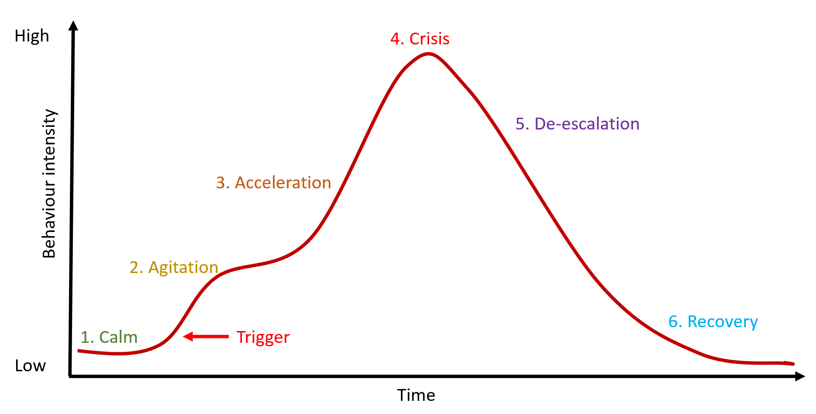
The phases of escalation (Colvin and Sugai, 1989)

Phase 1: Calm
During this phase the emphasis should be on prevention and keeping the student calm:
- Build positive relationships by using eye contact, greeting students and showing interest
- Explicitly teach and prompt expected behaviours and procedures
- Provide high rates of acknowledgement to all students
- Get to know students and their personal signs of distress
- Identify times or situations that may potentially be stressful or difficult
- Provide tasks and activities at the correct level for all students
- Provide opportunities for active engagement
- Actively supervise classroom and non-classroom areas for potential areas of conflict.

Phase 2: Trigger
During this phase something in the environment or inside the student triggers a stress reaction. This is usually signalled by physical changes in the student. Teachers need to be alert to these changes so they can move to modify the environment, provide reassurance or remove triggers. The aim is to return the student to a calm state. Effective strategies include:
- Intervene early at the first signs of stress or agitation
- Remove or minimise triggers
- Demonstrate a supportive approach through facial expression and body language
- Respond flexibly by adapting to the specific situation
- Speak calmly.

Phase 3: Agitation
At this stage there are usually signs that the student is experiencing stress, agitation or other negative emotions. It is critical that teachers get to know students so they can recognise these early signs. The focus at this stage is to reduce anxiety and prevent further escalation. This can be achieved in the following ways:
- Use active listening
- Address issues individually, talking to students aside from others, where possible
- Provide gentle prompt for expected behaviours
- Use distraction or change of activity
- Give reasonable choices and be prepared to compromise
- Be sincere and avoid sarcasm or belittling students
- Provide space
- Reduce or remove demands.

Phase 4: Acceleration
If, despite best efforts, the student’s behaviour continues to escalate, the focus now needs to be on safety. This applies to the safety of the individual student, the safety of other students in the vicinity, and the safety of the adults involved. This is not the time to try to reason with the student or lecture them about consequences. Keep interaction brief, but remain supportive and monitor the situation.
- Brief verbal redirection
- Give processing time
- Provide space
- Move others away

Phase 5: Peak
Once the behaviour reaches its peak, it must be allowed to run its course. Adults should continue to monitor the student and ensure that the immediate environment is as safe as possible by removing objects and keeping a distance from the escalated student. Continue to use the previous strategies, and in addition:
- Allow for silence
- Take evasive action if needed
- Follow school crisis plan.

Phase 6: De-escalation
At this stage, the behaviour will have run its course and the student needs time to return to a calm state. The focus should be on ensuring that the student has the time and space to recover. This may be provided by allowing the student to get a drink, go for a walk, or have a rest. This is not the time to discuss consequences. We need to ensure that the crisis has truly passed because at this stage it is still possible for behaviour to re-escalate. An effective response at this phase is to:
- Speak calmly
- Acknowledge feelings
- Emphasis having a fresh start.

Phase 7: Recovery
The recovery phase is about the re-establishment of routines and activities. During this phase, the focus is on problem-solving and accountability. An opportunity to debrief should happen once the student has returned to a rational and calm state. If possible, debriefing should take place on the same day, but in some cases may need to wait till the day after.
The purpose of debriefing should be on re-establishing communication, rebuilding relationships and problem- solving. A plan should be developed for what everyone could do differently to avoid another similar situation. Logical consequences for behaviours which caused harm or disruption to others should be explained to the student, with an emphasis on teaching rather than punishment. The student should receive positive acknowledgement for taking part in the debriefing process and support should be put in place (for example, additional practice opportunities, direct teaching of calming strategies), and documented.

