Behaviour Response Plan – Behaviour Continuum
Adapted from Autism Spectrum Australia
When planning to address challenging or complex behaviours, it is important to start putting individualised preventative supports and strategies in place based on the knowledge of the student, their strengths, experiences and their interactions with the people around them. If the behaviour continues, targeted strategies and plans should be developed.
These proactive preventative strategies will promote long-term positive changes in behaviour and reduce the likelihood of challenging behaviour occurring.
A behaviour response plan is to be used when a student’s behaviour escalates to crisis point and interferes with the safety of staff, the student themselves and those around them. The response plan will guide the actions of others to respond consistently, to reduce the distress of the individual and to keep everybody safe.
The behaviour response plan should be developed with all people relevant to supporting the student. It is divided into 3 columns and 6 rows, with each colour-coded row representing each stage of an escalation behaviour across a continuum:
- when the student is calm (Green)
- early warning signs of upset (Yellow)
- low level challenging behaviours, when the student is more in control (Orange)
- severe loss of control challenging behaviours (Red)
- de-escalation, when the student is starting to regain some control (Purple)
- recovery (Blue)
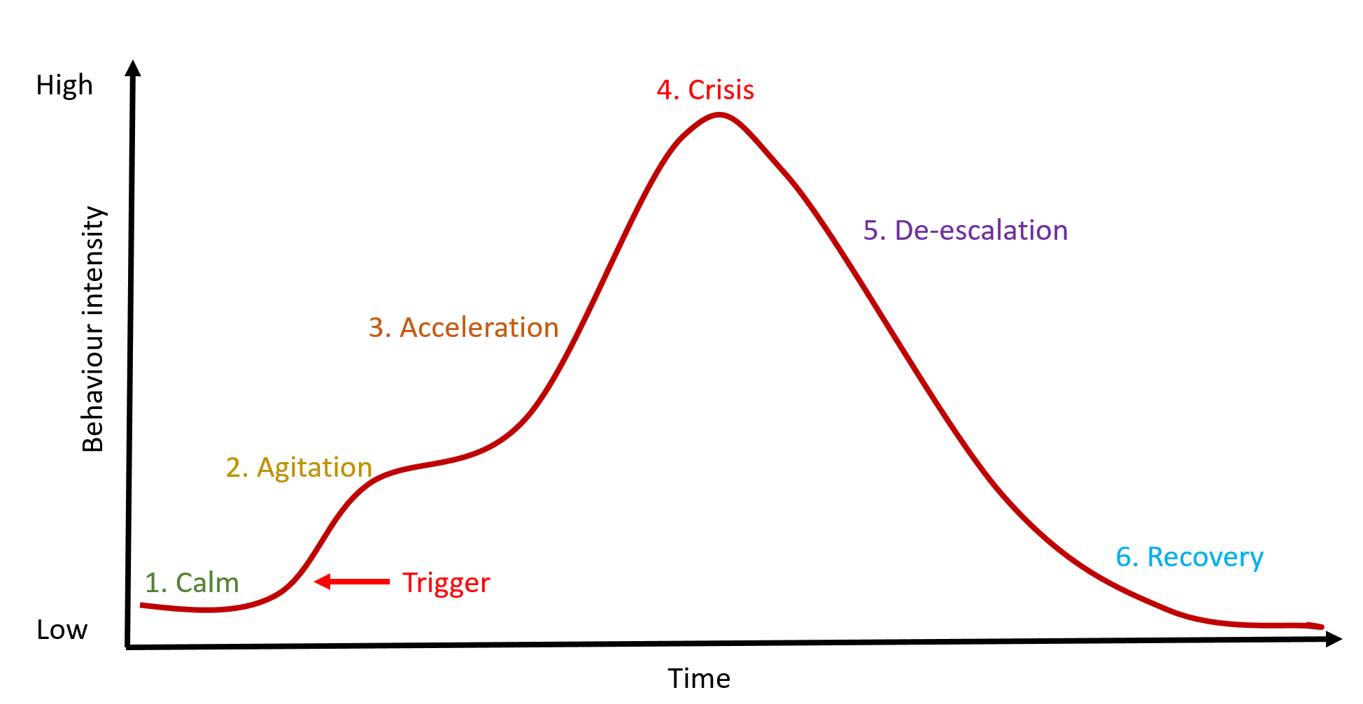
How to complete the Behaviour Response Plan
1. Start with the left column. This outlines the course of a student’s typical pattern of challenging behaviour from beginning to end (even though situations are often quite different).  The Behaviour Response Plan prompt sheet (which is found on the back of the plan) will help you work through each of the boxes to complete the plan.  When filling out the boxes on the left-hand side of the plan, it is important to limit the information only to what people will actually see when the behaviour is at this level (as if you are describing the student to someone who has never met them before) so that the document remains a practical resource.  For example, ‘yells and throws objects around the room’ is better than ‘tantrum’ as a description. | 2. (a) On the near right column, write strategies matched to each level of escalation in the course of challenging behaviour.  Green strategies are the 3 or 4 key strategies that should be put into practice every day to support the student (link implementation)  Yellow strategies look to help the student to problem solve and communicate or otherwise engage in other activities via redirection and distraction.  Orange strategies are similar to yellow and consider the purpose of the behaviour (being careful not to reinforce inappropriate behaviour)  Red strategies are very different and only about keeping everyone as safe as possible by reducing the severity and duration of the incident.  Purple strategies are about trying to de-escalate the situation and helping the student to recover.  Blue strategies are about maintaining calm and rebuilding relationships.  Note: No strategy will work perfectly every time | (b) On the far-right column, write strategies for yourself. When faced with persistent challenges all people naturally experience their own stress and distress. We need to be aware of, and able to manage our own physical and emotional reactions to respond in a calm, planned way.  Emotional strategies are often personal, and each support person may need to develop their own plan for coping with the emotional impact of dealing with the challenging behaviour.
Remember: Long term positive behaviour change only happens using proactive preventative strategies that build happiness, develop environments and teach new behaviours and skills. It is okay to ‘give in’, walk away or ignore behaviour sometimes as long as you have a long-term plan.
Implementing the plan: Once you have developed a behaviour response plan, it is important that everyone who interacts with the student is familiar with the plan and agrees to implement the plan in the same way. The plan can be reviewed and updated as you learn and strategies develop.

Behaviour response plan
Low level challenging behaviours (acceleration)
When ____________ starts

Severe challenging behaviour (crisis)
When ____________ starts

Drop off in behaviour
(de-escalation)
When ____________ starts

Calm
When _____________ is fine
Recovery
Recovery starts when ________

Early Warning Signs (agitation)
When ____________ starts
To de-escalate the situation and prevent challenging behaviours
for __________

Safety strategies
for __________
De-escalation strategies
for __________

Prevention strategies
for __________
To speed the recovery
for __________

To prevent challenging behaviour
for __________

To de-escalate the situation and prevent challenging behaviours
for me

Safety strategies
for me

De-escalation strategies
for me

Prevention strategies
for me

To speed the recovery
for me

To prevent challenging behaviour
for me

Behaviour response plan prompt sheet
Low level challenging behaviours (acceleration)
When ____________ starts
Describe the observable low-level behaviours. At this stage the student is still rational, therefore can still make decisions. These behaviours may look like; swearing, threatening, shoving, etc
Severe challenging behaviour (crisis)
When ____________ starts
Describe the observable severe behaviour. At this stage the student is not rational and has no control over behaviour. There are safety issues. Behaviours include hitting, fighting, etc.

Drop off in behaviour
(de-escalation)
When ____________ starts
Describe the observable drop off in behaviour. At this stage the student may be confused, lack focus, show signs of denial and withdrawal. This could include: blaming others, denial etc.
Calm
When _____________ is fine

Write in what the student is usually like. For example, chatty and interactive.
Recovery
Recovery starts when ________

Describe the observable behaviours you see when the student has calmed down. For example; re-engages in communication, cries, asks for a drink.

Early Warning Signs (agitation)
When ____________ starts
Describe the observable behaviours that show that the student is beginning to feel distressed, anxious or agitated. This could include; withdrawal, talking
louder or faster, red face etc.
To de-escalate the situation and prevent challenging behaviours
Write in strategies you will use to help de-escalate the behaviour. Strategies might include; redirecting, distracting, setting limits, giving simple clear instructions, saying “no” differently.
for __________

Safety strategies
The main goal is to reduce the severity and duration of the episode. Write in safety strategies such as; respecting their space, avoiding verbal interaction, removing other people from area.
for __________
De-escalation strategies
Write in strategies you will help to de-escalate the behaviour and help the student recover. Strategies might include: use concrete directions and simple statements, provide reasonable choices to redirect, use calm voice/tone.
for __________

Prevention strategies

Write in prevention strategies. For example, daily check-in, positive instructions.

for __________
To speed the recovery

Write in strategies to re-establish the relationship and avoid re-
escalation. For example; go on
with the day as planned.

for __________

To prevent challenging behaviour

Write in the strategies you are going to use to help the student calm down and feel more comfortable. Preventative strategies could include; giving them space, distraction and redirecting.
for __________

To de-escalate the situation and prevent challenging behaviours
Write in what strategies you or other staff will use to stay calm. For example, think positively, deep breaths, remind self that student is not doing on purpose, ‘I can do this’
for me

Safety strategies

Write in what strategies you or other staff will use to remain calm. For example; deep breath, take a break, call for help.

for me

De-escalation strategies

Write in what strategies you or other staff will use to remain calm. For example; deep breath, take a break.

for me

Prevention strategies

Write in what you will do when the student is fine. For example, follow plan, praise, reward, have fun.

for me

To speed the recovery

Write in strategies to recover yourself. For example; debrief with someone.

for me

To prevent challenging behaviour

Write in what helpful thoughts you are going to use for yourself or other staff involved. For example; show empathy, look at the situation from their perspective,
for me

