Programming template guide
Contents
Programming template guide 0
Introduction 2
Teaching and learning practices 3
Explicit teaching 3
The teaching and learning cycle 4
Ongoing evidence of learning 5
Inclusion and differentiation 6
Evaluation 8
Digital learning selector 10
Sample programming template 11
Overview 11
Weeks 1–3 13
Weeks 4–6 15
Weeks 7–10 17
Overall program evaluation 19
Capturing student voice when evaluating a program 19
Additional information 21
Support and alignment 21
References 23

Introduction
‘The long-term vision is for a curriculum that supports teachers to nurture wonder, ignite passion and provide every young person with knowledge, skills and attributes that will help prepare them for a lifetime of learning, meaningful adult employment and effective future citizenship’ (NESA 2020:xi).
The development of this programming reference guide aims to respond to the goals articulated in NESA’s curriculum review and provide schools with synthesised research information to inform programming practices.
Our coverage of the processes related to programming in this document is not exhaustive and does not represent the only way to complete or engage in each of them. Curriculum design and implementation is a dynamic and contextually-specific process. While the mandatory components of syllabus implementation must be met by all schools, it is important that the approach taken by teachers is reflective of their needs and faculty or school processes.
NESA defines programming as the process of ‘selecting and sequencing learning experiences which enable students to engage with syllabus outcomes and develop subject specific skills and knowledge’ (NESA 2021). The organisation of the content in a program is flexible and it may vary according to the school, the teacher, the class, and the learning space. They should be working documents that reflect the thoughtful planning and reflection that takes place during the teaching and learning cycle. There are mandatory components of programming and unit development; for more information refer to Curriculum requirements guide - Primary, Curriculum requirements guide - Secondary RoSA, and Curriculum requirements guide - Secondary HSC documents available on the Curriculum and policy monitoring (CPM) webpage.

Teaching and learning practices
The teaching and learning practices described below form a theoretical basis for the design of the sample programming template.

Explicit teaching
‘The evidence shows that students who experience explicit teaching practices perform better than students who do not. Explicit teaching reduces the cognitive burden of learning new and complex concepts and skills, and helps students develop deep understanding.’ (CESE 2020b:11)
Hughes et al. (2017:4) describe explicit instruction as ‘a group of research-supported instructional behaviors used to design and deliver instruction that provides needed supports for successful learning through clarity of language and purpose, and reduction of cognitive load. It promotes active student engagement by requiring frequent and varied responses followed by appropriate affirmative and corrective feedback, and assists long-term retention through use of purposeful practice strategies’.
A well-documented practice of explicit teaching is the use of learning intentions and success criteria, which can assist educators to articulate the purpose of a learning task to make judgements about the quality of student learning. Learning intentions and success criteria also help students focus on the task or activity taking place and what they are learning and provide a framework for reflection and feedback.
The inclusion of learning intentions and suggested success criteria in programming supports teachers and students in having a shared understanding about the learning goals they are working towards (Wisniewski et al. 2020).
Learning intentions and success criteria facilitate opportunities for students to:
- have a common understanding of what they are aiming for and how to get there
- know what they will be judged or evaluated on
- peer and self-assess
- focus on and revisit the skills, knowledge, and understanding they need to be successful in a task.
Another important feature of explicit teaching is scaffolding for student success and gradually building students’ confidence and ability to work independently. Sherrington (2019) expands that ‘the whole point of scaffolding is that, eventually, it has to be taken down’. Modelled, guided and independent practice is an important principle for explicit teaching and can be useful to consider when considering how the programming template can be used to support teaching and learning.
For further reading, advice and professional learning resources, see the explicit instruction practice guide (AERO 2021).

The teaching and learning cycle
Planning learning experiences in a program of learning is complex. Rosenshine (2012:14) indicates that ‘teaching in small steps and then guiding student practice represents an appropriate way of dealing with the limitation of our working memory’. Explicit and targeted lesson sequences that activate prior knowledge provides opportunity for students to experience high rates of success and master difficult concepts with guidance and support. The programming template examples provided should be used in conjunction with the stages of the teaching and learning cycle. It is important to note that this cycle is recursive, and a range of iterations will be present across a program of learning.
Figure 1 – teaching and learning cycle
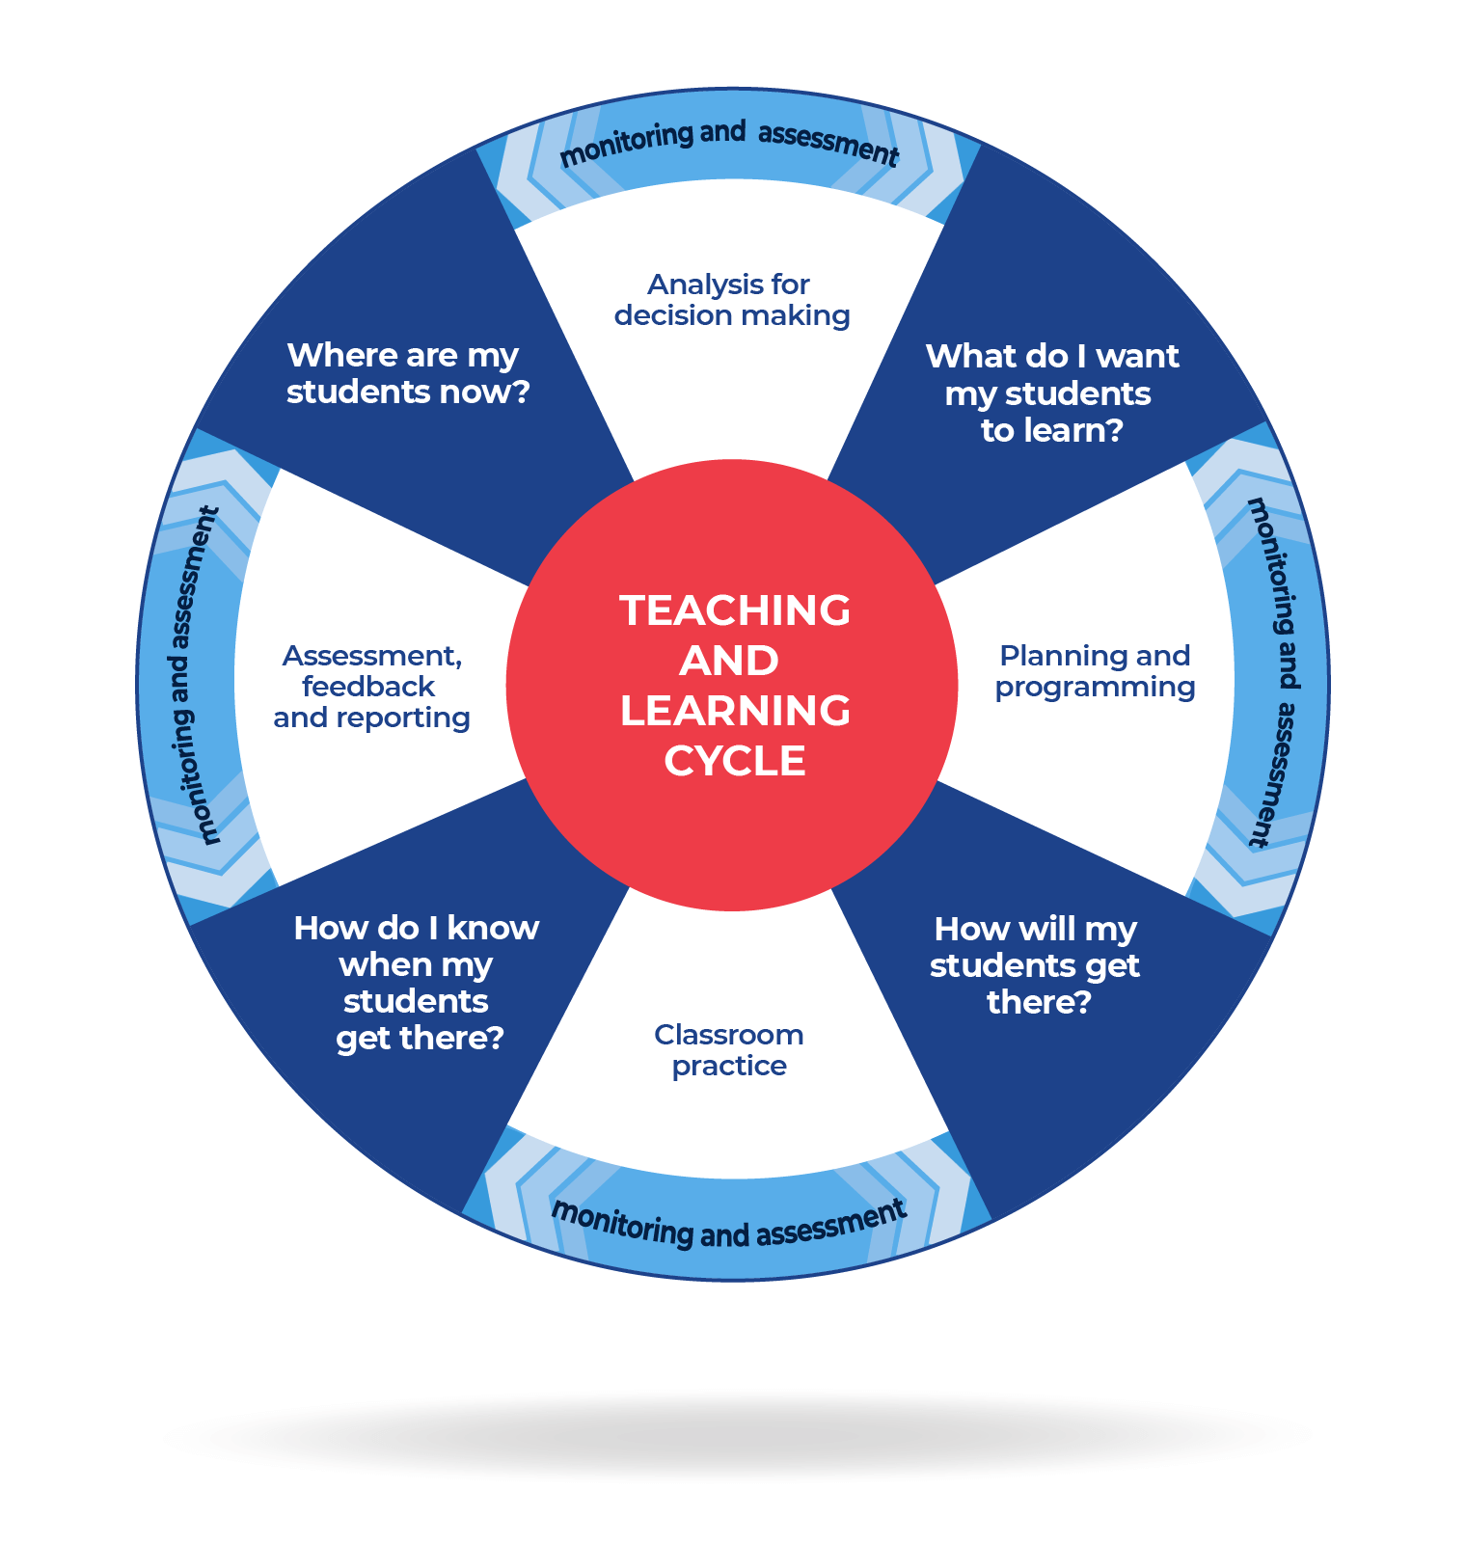

Ongoing evidence of learning
‘The primary role of assessment is to establish where individuals are in their learning so that teaching can be differentiated and further learning progress can be monitored over time.’
(CESE 2020b:24)
Wiliam (2013:15) suggests ‘the term formative should apply not to the assessment but to the function that the evidence generated by the assessment actually serves’. This concept further supports the practice of gathering ongoing evidence of learning and adjusting teaching to support learning. Ongoing formative assessment can be considered ‘checkpoints’ within a learning sequence or unit. Strategies to elicit evidence of learning allow teachers to determine the next steps in learning and assist them in evaluating the impact of teaching and learning activities. Strategies that can be used to elicit evidence include exit tickets, mini whiteboards (actual or digital), Kahoot!, Socrative, or quick quizzes to ensure that individual student progress can be monitored and the lesson sequence adjusted based on formative data collected.
Tracking ongoing evidence of learning through formative assessment provides opportunity for teachers to understand if students have mastered their learning, moving it into long-term memory, or if they have developed misconceptions (Rosenshine 2012).

Inclusion and differentiation
All students need to be challenged and engaged to develop their potential fully. A culture of high expectations needs to be supported by strategies that both challenge and support student learning needs, such as through appropriate curriculum differentiation. (CESE 2020b)
When planning and programming, considering all students is inclusive practice. This allows all students to access and engage with the curriculum. Differentiated learning should be enabled through both planned and contingent adjustments to the teaching approach for content, process, product and the learning environment. For more on inclusive curriculum planning strategies and resources to optimise learning for every student, enrol in Curriculum planning for every student in every classroom (AC00180).
For more information on differentiation go to Differentiating learning and Differentiation.
Planning for all students in the class is important. When planning for every student in your classroom consider:
- Aboriginal and/or Torres Strait Islander students. Targeted strategies can be used to achieve improved outcomes for Aboriginal and/or Torres Strait Islander students and increase knowledge and understanding of Aboriginal and/or Torres Strait Islander histories, knowledge and cultures. Strong strides together can support teachers and school leaders to create high-quality learning environments and meet the educational goals for Aboriginal and/or Torres Strait Islander students. Teachers should use students’ Personalised Learning Pathways to support individual student needs and goals.
- EAL/D learners. EAL/D learners will require explicit English language support and scaffolding, informed by the EAL/D enhanced teaching and learning cycle and the student’s phase on the EAL/D Learning Progression. In addition, these pages provide teachers with information about supporting EAL/D learners, such as Assessing English language proficiency.
- Students with additional learning needs. Learning adjustments enable students with disability and additional learning and support needs to access syllabus outcomes and content on the same basis as their peers. Teachers can use a range of adjustments to ensure a personalised approach to student learning. Additionally, curriculum considerations to support students with disability and additional needs can be found on the Inclusive Practice hub.
- High potential and gifted learners. Assessing and identifying high potential and gifted learners will help teachers decide which students may benefit from extension and additional challenge. Effective strategies and contributors to achievement for high potential and gifted learners helps teachers to identify and target areas for growth and improvement. In addition, the Differentiation Adjustment Tool can be used to support the specific learning needs of high potential and gifted students. The High Potential and Gifted Education Professional Learning and Resource Hub supports school leaders and teachers to effectively implement the High Potential and Gifted Education Policy in their unique contexts.
Implementation of inclusive practices in planning, programming and assessing supports learning for the full range of students and is aligned with the department’s goals and strategic policies, including:
- Aboriginal Education Policy and key documents
- Disability Standards for Education 2005
- Inclusive Education Policy for students with disability
- High Potential and Gifted Education Policy
- Multicultural Education Policy

Evaluation
‘Regularly dedicate time throughout the school year for working with colleagues to plan, develop and refine teaching and learning programs.’
(CESE 2020c)
The Australian Professional Standards for Teachers emphasises the importance of evaluating teaching and learning programs:
Figure 2 – adapted standard descriptors for APST 3.6
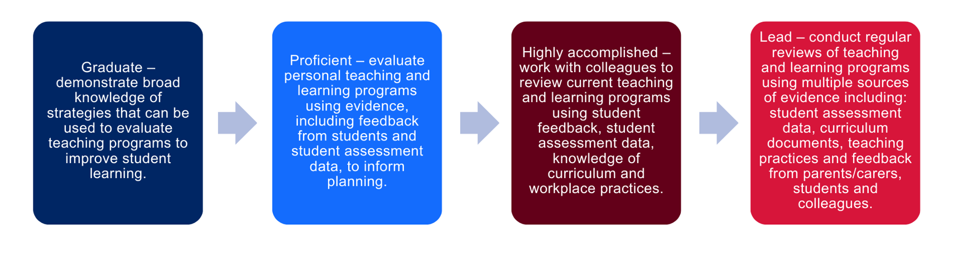
To maintain and refine programming documents, it is beneficial to create routines for ongoing evaluation notes related to:
- assessment data
- curriculum and teaching practices
- student, parent, and collegial feedback
- individual and group reflection.
The sample programming template includes prompts for ongoing evaluation and overall program evaluation. When completing the overall program evaluation, consider Capturing student voice when evaluating a program.

Digital learning selector
The Digital Learning Selector (DLS) provides a wide range of learning activities and learning tools that allows users to search for learning activities and tools. This includes custom-built department templates and standard commercial software which can be utilised in a range of learning environments. The learning activities and tools can be filtered by the level of depth and application required, with further filters available to factor in requirements such as activity time length, level of preparation needed, and learning skill focus.
There are a range of planning templates, graphic organisers, note making and writing scaffolds, visible thinking routines, quiz templates, questioning activities and feedback scaffolds. Each activity is accompanied by an explanation of the task, how to implement it in the classroom, and links to digital tools that support instruction to students.

Sample programming template

Overview
Description: [a description of the unit of work should be included here]
Duration: [the length of the program should be outlined according to the scope and sequence]
Stage or Year: [identify the stage and year this program is designed for]

Outcomes
A student:
- [outcome text] [outcome code]

Focus areas
[This section will be influenced by the priorities of the system, school, faculty, or class.]

Student needs analysis
[Teachers review student learning plans prior to planning and programming to make informed decisions about teaching and learning activities that will support every student.]
Prior to planning for teaching and learning, please consider the following:
Consider engagement
- How will I provide authentic, relevant learning opportunities for students to personally connect with lesson content?
- How will I support every student to grow in independence, confidence and self-regulation?
- How will I facilitate every student to have high expectations for themselves?
Consider representation
- What are some different ways I can present content to enable every student to access and understand it?
- How will I identify and address language and/or cultural considerations that may limit access to content for students?
- How will I make lesson content and learning materials more accessible?
- How will I plan learning experiences that are relevant and challenging for the full range of students in the classroom?
Consider expression
- How will I provide multiple ways for students to respond and express what they know?
- What tools and resources can students use to demonstrate their understanding?
- How will I know every student has understood the concepts and language presented in each lesson?
- How will I monitor if every student has achieved the learning outcomes and learning growth?

Weeks 1–3
Table 1 – weeks 1–3 sequence of program
Outcomes and content | Teaching and learning activities | Evidence of learning | Differentiation or  adjustments | Registration and evaluation
Outcome:  [outcome code], [outcome code]  Content:  - [content point]  - [content point]  - [content point example] | Learning intention  [learning intention]  Success criteria  [success criteria]  Teaching and learning activity  [pre-lesson activity to activate prior knowledge]  [teaching activity]  [resources can be hyperlinked into the teaching and learning activities directly, or a new column could be added to identify the resources needed] |  | [note]

Weeks 4–6
Table 2 – weeks 4–6 sequence of program
Outcomes and content | Teaching and learning activities | Evidence of learning | Differentiation or  adjustments | Registration and evaluation
Outcome:  [outcome code], [outcome code]  Content:  - [content point]  - [content point]  - [content point example] | Learning intention  [learning intention]  Success criteria:  [success criteria]  Teaching and learning activity  [pre-lesson activity to activate prior knowledge]  [teaching activity]  [resources can be hyperlinked into the teaching and learning activities directly, or a new column could be added to identify the resources needed] |  | [note]

Weeks 7–10
Table 3 – weeks 7–10 sequence of program
Outcomes and content | Teaching and learning activities | Evidence of learning | Differentiation or  adjustments | Registration and evaluation
Outcome:  [outcome code], [outcome code]  Content:  - [content point]  - [content point]  - [content point example] | Learning intention  [learning intention]  Success criteria:  [success criteria]  Teaching and learning activity  [pre-lesson activity to activate prior knowledge]  [teaching activity]  [resources can be hyperlinked into the teaching and learning activities directly, or a new column could be added to identify the resources needed] |  | [note]

Overall program evaluation
Collating ongoing evaluations and reflecting on the strengths and areas for development within the program creates opportunities to enhance student outcomes. The following prompts can be used to support your evaluation of the program:
- Did the program assist all students to improve in their learning?
- How could the sequencing of the program be improved?
- What did the student evaluations of the program indicate? How can these be actioned to improve the program?
- The strategies and resources that were most effective for student learning were …
- Teaching strategies and resources that would benefit from review and refinement are …

Capturing student voice when evaluating a program
Student voice is useful in the evaluation process for programs. The statements below could be useful as a starting point when asking students to provide feedback on their learning experiences. These statements are derived from some of the themes from What works best 2020 update (CESE 2020b) and could be useful in teacher reflection on how these themes could be incorporated into a teaching program. The statements could also prompt student reflection on their metacognitive processes while learning.
Please rate how much you agree with these statements:
- My teacher had confidence that I could achieve and improve in my learning. (CESE 2020b Chapter 1: High expectations)
- I had a clear idea of what I was learning and why. (CESE 2020b Chapter 2: Explicit teaching)
- I used the feedback provided to improve my performance. (CESE 2020b Chapter 3: Effective feedback)
- I understood the feedback on the assessment task. (CESE 2020b Chapter 3: Effective feedback)
- I was able to predict the marks I achieved in the assessment tasks. (CESE 2020b Chapter 5: Assessment)
- The activities in the unit prepared me for the assessment task. (CESE 2020b Chapter 5: Assessment)
- I found the activities in the lessons interesting to me. (CESE 2020b Chapter 7: Wellbeing)
- I made valuable contributions to the class during this unit. (CESE 2020b Chapter 7: Wellbeing)
- I ask questions in class when I don’t understand yet. (CESE 2020b Chapter 7: Wellbeing)
Optional open-ended prompts:
- The lessons and/or activities that I most enjoyed were when we … because…
- When the learning was difficult, the strategy I used was …
- If I was giving advice to a student who was starting this unit I would tell them to …
- If I was giving advice to a teacher who was teaching this unit I would tell them to …

Additional information
For additional support and advice or to provide feedback, contact the Teaching and Learning 7-12 curriculum team by emailing secondaryteachingandlearning@det.nsw.edu.au

Support and alignment
All curriculum resources are prepared through a rigorous process. Resources are periodically reviewed as part of our ongoing evaluation plan to ensure currency, relevance and effectiveness.
Alignment to system priorities and/or needs: School Excellence Policy, School Success Model.
Alignment to the School Excellence Framework: this resource supports the School Excellence Framework elements of curriculum (curriculum provision) and effective classroom practice (lesson planning, explicit teaching).
Alignment to Australian Professional Standards for Teachers: this resource supports teachers to address Australian Professional Standards for Teachers 3.2.2, 3.3.2.
Consulted with: Curriculum and Reform, Inclusive Education, Multicultural Education, Aboriginal Outcomes and Partnerships
Author: Curriculum Secondary Learners
Publisher: State of NSW, Department of Education
Resource: Programming template guide
Related resources: further resources to support curriculum planning and programming can be found on the Universal Resources Hub.
Creation date: 15 August 2022
Rights: © State of New South Wales, Department of Education

References
This resource contains NSW Curriculum and syllabus content. The NSW Curriculum is developed by the NSW Education Standards Authority. This content is prepared by NESA for and on behalf of the Crown in right of the State of New South Wales. The material is protected by Crown copyright.
Please refer to the NESA Copyright Disclaimer for more information https://educationstandards.nsw.edu.au/wps/portal/nesa/mini-footer/copyright.
NESA holds the only official and up-to-date versions of the NSW Curriculum and syllabus documents. Please visit the NSW Education Standards Authority (NESA) website https://educationstandards.nsw.edu.au/ and the NSW Curriculum website https://curriculum.nsw.edu.au/home.
AERO (Australian Education Research Organisation) (2021) Explicit instruction practice guide, AERO website, accessed 9 May 2023.
AITSL (Australian Institute for Teaching and School Leadership Limited) (n.d) Learning intentions and success criteria [PDF 251KB], AITSL, accessed 2 June 2022.
Brookhart S (2011) How to Assess Higher-Order Thinking Skills in Your Classroom, Hawker Brownlow Education, Victoria.
CESE (Centre for Education Statistics and Evaluation) (2020a) What works best in practice, NSW Department of Education, accessed 2 June 2022.
CESE (2020b) What works best: 2020 update, NSW Department of Education, accessed 2 June 2022.
CESE (2020c) What works best shareable summary tiles, NSW Department of Education, accessed 9 May 2023.
Hughes C, Morris J, Therrien W and Benson S (2017) 'Explicit Instruction: Historical and Contemporary Contexts: LEARNING DISABILITIES RESEARCH', Learning Disabilities Research and Practice, 32(4):1–9, doi:10.1111/ldrp.12142.
NESA (NSW Education Standards Authority) (2020) Nurturing Wonder and Igniting Passion, designs for a new school curriculum: NSW Curriculum Review [PDF 1.12MB], NESA, accessed 9 May 2023.
NESA (2021) ‘Programming’, Understanding the curriculum, NESA website, accessed 2 February 2023.
Rosenshine B (2012) Principles of Instruction: Research-Based Strategies That All Teachers Should Know, American Educator, 36(1):12–19, 39, accessed 2 June 2022.
Sherrington T (2019) Rosenshine’s Principles in Action, Suffolk, John Catt Educational.
Wiliam D (2013) ‘Assessment: The bridge between teaching and learning’, Voices from the Middle, 21(2):15–20, accessed 10 June 2022.
Wiliam D (2018) Embedded Formative Assessment, 2nd edn, Solution Tree Press, Bloomington, IN.
Wisniewski B, Zierer K and Hattie J (2020) ‘The Power of Feedback Revisited: A Meta-Analysis of Educational Feedback Research’, Frontiers In Psychology, 10:3087, doi:10.3389/fpsyg.2019.03087, accessed 7 June 2022.
© State of New South Wales (Department of Education), 2023
The copyright material published in this resource is subject to the Copyright Act 1968 (Cth) and is owned by the NSW Department of Education or, where indicated, by a party other than the NSW Department of Education (third-party material).
Copyright material available in this resource and owned by the NSW Department of Education is licensed under a Creative Commons Attribution 4.0 International (CC BY 4.0) licence.
This licence allows you to share and adapt the material for any purpose, even commercially.
Attribution should be given to © State of New South Wales (Department of Education), 2023.
Material in this resource not available under a Creative Commons licence:
- the NSW Department of Education logo, other logos and trademark-protected material
- material owned by a third party that has been reproduced with permission. You will need to obtain permission from the third party to reuse its material.
Links to third-party material and websites
Please note that the provided (reading/viewing material/list/links/texts) are a suggestion only and implies no endorsement, by the New South Wales Department of Education, of any author, publisher, or book title. School principals and teachers are best placed to assess the suitability of resources that would complement the curriculum and reflect the needs and interests of their students.
If you use the links provided in this document to access a third-party's website, you acknowledge that the terms of use, including licence terms set out on the third-party's website apply to the use which may be made of the materials on that third-party website or where permitted by the Copyright Act 1968 (Cth). The department accepts no responsibility for content on third-party websites.

