Computing Technology Stage 5 (Year 9) – teacher support resource
Software development – building mechatronic and automated systems

Teacher support resource
Teacher note: this resource has been designed to facilitate the ready conversion into a student workbook by removing the answers within the response windows.
Student name:
Class:
Teacher:

Contents
Teacher support resource 1
Unit overview 5
Assessment task 3 overview 6
Steps to success for Assessment task 3 7
Assessment task 4 overview 9
Steps to success for Assessment task 4 10
Glossary 13
The design and production process 16
Identifying and defining 17
What are mechatronic systems? 17
Real-world mechatronic applications 19
Components of a mechatronic system 25
Functional and non-functional requirements 28
Social impacts and ethical and legal requirements 35
Perspectives of diverse groups 41
Researching and planning 46
Control system 46
Components 47
Microcontroller 47
Arduino UNO R3 board 47
Co-processor 49
Sensors 51
Ultrasonic sensor unpacked 56
Activity – test the ultrasonic sensor with the Serial Monitor 57
Actuators 61
End effectors/manipulators 65
Designing an end effector 65
Using a servo 67
Motion 71
Mechatronic and automated systems evolve in response to need 72
Generate alternative designs 77
Data collection and interpretation 80
Data collection 81
Data ownership 83
Data access 83
Data protection 84
Represent data and code to facilitate computation 86
Selecting appropriate data types 86
Represent algorithms using flowcharts and pseudocode 90
Flowcharts 90
Pseudocode 92
The structures of flowcharts and pseudocode 93
Design a mechatronic or automated system activity 99
Identifying and defining 99
Research and planning 100
Producing and implementing 101
Producing and implementing 102
Design a mechatronic or automated system activity 103
Identifying and defining 103
Researching and planning – sketch 104
Producing and implementing – flowchart 105
Producing and implementing – pseudocode 106
Testing and evaluating – mid process 107
Self-assessment 109
Validate algorithms with desk checking 111
Test data for checking algorithms and code 111
Desk checking 112
Pseudocode example 113
Activity– desk check 115
Producing and implementing 117
Debug a range of errors 120
Interpret and modify existing programs 121
Activity – look at how a H-Bridge can control movement 122
Coding for Arduino cheat sheet 124
Step 1: Declare your variables 124
Step 2: Set up the board 124
Step 3: Write the main program (loop) 125
Record of project development 127
Testing and evaluating 129
Careers 135
Support and alignment 138
Evidence base 140
References 141

Unit overview
In this unit you will develop a fundamental understanding of mechatronic and automated systems. You will investigate different mechatronic and automated systems and choose one to research in depth. You will be guided through the design production process and use an iterative approach in developing a system in a collaborative task.
Teacher note: the focus area of Building mechatronic and automated systems can be delivered using a range of platforms. This guide refers to Arduino as it is open-source software and available on the Software Catalogue.
If students have completed the Stage 4 Technology Mandatory unit, ‘Crack the code’ this prior knowledge will assist in understanding the platform.

Assessment task 3 overview
Type of task: research task and report.
Outcomes being assessed:
A student:
- understands how innovation, enterprise and automation have inspired the evolution of computing technology CT5-EVL-01
- applies computational, design and systems thinking to the development of computing solutions CT5-THI-01
Computing Technology 7–10 Syllabus © NSW Education Standards Authority (NESA) for and on behalf of the Crown in the State of New South Wales, 2022.
Research and examine a mechatronic and/or automated system and create a report showing how it can be developed into a computing solution.
Investigate a real-world problem or need that can be solved by mechatronic and/or automated systems. Your task will include:
- identifying stakeholders and existing solutions
- breaking down the mechatronic and/or automated systems into manageable parts and functional and non-functional requirements
- creating flowcharts and pseudocode to represent how this system will work
- developing test criteria and proposing modifications to increase the effectiveness of the system.

Steps to success for Assessment task 3
Table 1 – steps to success for Assessment task 3
Steps | What I need to do/when I need to do it
Develop a system introduction for the chosen mechatronic and/or automated system | - Write a system introduction that identifies a real-world problem or need that can be solved by mechatronic and/or automated systems that you will research.  - Identify the needs of stakeholders for the chosen mechatronic and/or automated system.  - Evaluate existing solutions to the problem or related problems for the chosen mechatronic and/or automated system.
Develop a table to document the movement of data in the chosen mechatronic and/or automated system | - Describe inputs, storage, transmission, processes, and outputs used in the chosen mechatronic an/or automated system.
Develop a mind map of the system of the chosen mechatronic and/or automated system | - Develop a mind map to break down the chosen mechatronic and/or automated system into manageable parts.
Develop a table to consider the physical components of the chosen mechatronic and/or automated system model | - Identify the control systems, components, microcontrollers, co-processors, sensors, actuators, end effectors and manipulators the model of the system will use.
Specify the functional and non-functional requirements of the chosen mechatronic or automated system | - Specify the functional requirements including stating the purpose of a system, describing user cases and developing test cases of inputs and expected outputs.  - Specify the non-functional requirements of the mechatronic or automated system.
Develop flowcharts and pseudocode of the chosen mechatronic and/or automated system | - Represent algorithms using flowcharts and pseudocode that the model of the mechatronic and/or automated system will use.
Develop test criteria for the chosen mechatronic and/or automated system | - Develop test criteria for components that the model of the system will use.
Propose software and hardware modifications of the chosen mechatronic and/or automated system | - Propose software and hardware modifications to increase the effectiveness of the mechatronic and/or automated system.

What is the teacher looking for?
This task will require students to correctly choose a mechatronic and/or automated system to research. This chosen system will be investigated and examined. Through completing the steps, students begin planning on how to model the system with physical components.
When understanding how innovation, enterprise and automation have inspired the evolution of mechatronic and automated systems, students also build connection to the computational, design and systems thinking required to develop these systems.
Breaking down the system into functional and non-functional components, developing a mind map and understanding how the data moves between components assists in later developing algorithms and testing criteria.
Understanding how the system will computationally work is developed when the student represents the system in algorithms such as flowcharts and pseudocode. Ways to test the model of the system will be examined in developing test criteria and predicting software and hardware modifications.

Assessment task 4 overview
Type of task: mechatronic and/or automated system model and documentation
Outcomes being assessed:
A student:
- applies iterative processes to define problems and plan, design, develop and evaluate computing solutions C5-DPM-01
- manages, documents and explains individual and collaborative work practices CT5-COL-01
- designs, produces and evaluates algorithms and implements them in a general-purpose and/or object-oriented programming language CT5-OPL-01
- applies computational, design and systems thinking to the development of computing solutions CT5-THI-01
Computing Technology 7–10 Syllabus © NSW Education Standards Authority (NESA) for and on behalf of the Crown in the State of New South Wales, 2022.
In pairs or a small group, you are to create, record development and evaluate a mechatronic and/or automated system model.
Build a mechatronic and/or automated system model. Your task will include:
- creating a preferred design through an iterative approach
- coding the model to work, which will also require iteration
- filming the model perform as part of record development
- recording all development of the model and applying test criteria
- evaluating your model using predetermined functional and non-functional requirements.

Steps to success for Assessment task 4
Table 2 – steps to success for Assessment task 4
Steps | What I need to do/when I need to do it
Record all steps of development in creating the model | - Create an extensive record of project development that accurately illustrates the iterative journey of completing the building, coding and problem solving when creating the modelled system.  - The record contains detailed and accurate lesson--by-lesson accounts of work completed which includes discussions, evaluations, images and milestones precisely timestamped and presented in a professional manner.
Build a mechatronic and/or automated system model | - Build a reliable model that demonstrates excellent problem solving and computational, design and systems thinking.  - Ensure the model contains working control systems, components, microcontrollers, co-processors, sensors, effectors and manipulators, and demonstrates motion.
Code the model to complete the chosen function | - Demonstrate an understanding of programming logic and programming language syntax to develop a highly effective, reliable and efficient solution.
Enhance the models function by coding the model to function demonstrating efficiency | - Apply problem-solving skills to code a solution that follows a logical structure, using the correct syntax, contains an accurate and reliable algorithm which is free of syntax and logic errors.  - Ensure the code is highly readable and efficient, and solves all components identified in the mechatronic and/or automated system.
Use video to film the model operating | - Compile and present a well organised and sequenced video that details their iterative approach. The video extensively and accurately illustrates the testing, programming, failures, successes and evaluation of the system.
Evaluate the model using functional and non-functional requirements and test criteria | - Evaluation and test criteria for components of the automated and/or mechatronic system is developed. It details the objective and explains areas of success and improvement based on predetermined functional and non-functional requirements.

What is the teacher looking for?
Students are to manage, document and explain individual and collaborative work practices as they document the development of the system model. The record of development contains detailed and accurate lesson-by-lesson accounts of work completed which includes, discussions, evaluations, images and milestones.
This task will require students to correctly build and code a mechatronic and/or automated system. This chosen system will require problem solving and iteration in computational, design and systems thinking.
Understanding how the system will computationally work is developed in the prior assessment where the student represents the system in algorithms such as flowcharts and pseudocode. This task focuses on coding the model and enhancing the design and function as it is in development.
Evaluation of the final model and code will see students test the model of the system through developing test criteria and analysis using functional and non-functional requirements.

Glossary
Many of the following words will gather more meaning to you as you work through this booklet.
Each time you see a new word in bold throughout this workbook you can add its definition in the table below in case you need to refer to it later.
Table 3 – student glossary
Word | Definition
actuator | An actuator is a mechanism that turns energy into a controlled motion.
algorithm | An algorithm is a procedure used for solving or performing a computation.
automated system | An automation system is an integration of sensors, controls, and actuators designed to perform a function with minimal or no human intervention.
co-processor | A co-processor is a supplementary processor unit or an entirely different circuitry that is designed to complement the central processing unit (CPU) of a computer.
control system | A control system is a set of mechanical or electronic devices that regulates other devices or systems by way of control loops.
cybersecurity | Cybersecurity is the protection of internet-connected systems such as hardware, software and data from cyberthreats.
data type | A data type, in programming, is a classification that specifies which type of value a variable has and what type.
desk checking | Desk checking is the process of manually reviewing the source code of a program. It involves reading through the functions within the code and manually testing them, often with multiple input values.
end effector | In robotics, an end effector is a device or tool that is connected to the end of a robot arm where the hand would be.
flowchart | A graphical representation of the sequence of operations in an information system or program. Different symbols are used to draw each type of flowchart.
functional requirement | Functional requirements define the software's goals, meaning that the software will not work if these requirements are not met.
input | Input is something entered into a machine or other system, the act of entering data or other information.
iterative approach | The iterative approach is a process which looks to continuously improve a concept, design, or product. The practice of refining and improving a product, process, idea or initiative through multiple iterations.
manipulator | In robotics, a manipulator is a robotic arm-like mechanism that is designed to manipulate or move materials, tools, and parts without direct human contact.
microcontroller | A small programmable computer that is able to run code.
motion | Motion is the phenomenon in which an object changes its position with respect to time and can be applied to physical systems.
non-functional requirement | A non-functional requirement is a requirement that specifies criteria that can be used to judge the operation of a system, rather than specific behaviours. They are contrasted with functional requirements that define specific behaviour or functions.
privacy | The degree to which an individual can determine which personal information is to be shared with whom and for what purpose.
pseudocode | Writing in plain English line by line (step by step) what you want the computer program to do.
sensor | A device that can be connected to the microcontroller that detects a change in its environment providing data to the microcontroller.
stakeholders | A stakeholder is either an individual, group or organisation that's impacted by the outcome of a project or a business venture.
test case | A test case is a set of actions performed on a system to determine if it satisfies software requirements and functions correctly.
use case | A use case is a description of the ways in which a user interacts with a system or product.
Teacher note: for students with an EALD background. The glossary can be provided complete so that they have additional time to understand the key terms with bilingual dictionaries. The glossary can be provided to students in their preferred communication mode.

The design and production process
Throughout your study of Computing Technology, you will learn about design processes and how to apply them. You will explore different types of design processes and learn how to apply them in your design project.
The design and production process:
- involves a sequence of organised steps which provide a solution to design needs and opportunities
- may take a few seconds or minutes, such as when you select what clothes to wear, or may take years as in the case with the design of a motor vehicle
- may involve one person or may involve many people
- may be simple or complex, depending on the task
- involves questioning (or evaluating) throughout the iterative process.
Figure 1 – flowchart of design and production process
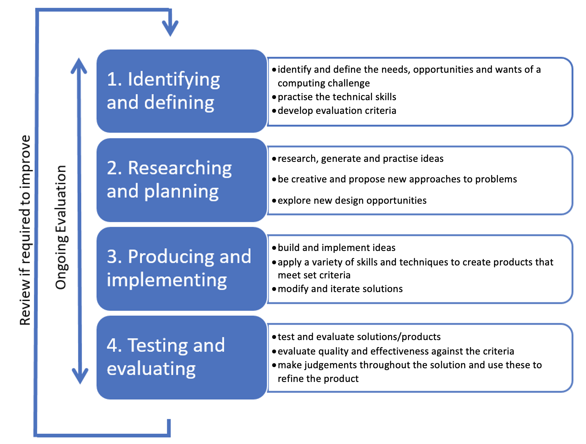

Identifying and defining

What are mechatronic systems?
Discuss and analyse how mechatronics (11:32) acts as an overarching term and look at what areas (mechanical, electrical and computational) are required to understand this concept. Discuss and analyse robotic systems (10:25) and automated systems (6:19).
Define the following concepts in the space below.
What is a mechatronic system?
Sample answer:
A typical mechatronic system picks up signals from the environment, and processes them to generate output signals, transforming them for example into forces, motions and actions.
Mechatronic systems have fewer mechanical parts because of the integration of sensors, circuits, and motion components such as actuators.
A mechatronics engineer unites the principles of mechanics, electronics, and computing to generate a simpler, more economical and reliable system.
What is a robotic system?
Sample answers:
Robotic systems are defined as systems that provide intelligent services and information by interacting with their environment, including human beings, via the use of various sensors, actuators and human interfaces.
Robotic systems can be defined as interconnected, interactive, cognitive and physical tools that are able to perceive their environment using sensors, reason and plans using algorithms implemented in computer programs, and perform actions enabled by actuators.
A robotic system requires a microprocessor, sensors, actuators, power supply and a skeleton.
What is an automated system?
Sample answers:
Automated systems are a combination of both software and hardware that is designed and programmed to work automatically without the need for a human operator to provide inputs and instructions for each operation.
Automation describes a wide range of technologies that reduce human intervention in processes. Human intervention is reduced by predetermining decision criteria, processes, relationships and related actions.

Real-world mechatronic applications
Look at different systems and identify real-world applications.
Present a variety of settings that mechatronics and automated systems are used in, and as a class discuss the following and their role in each scenario:
- systems development and the impact on individuals and society.
- identify human or autonomous control.
- recognise inputs, storage, transmission, processes and outputs as unique in each system.
Sample scenarios
Investigating an example of residential robotic cleaning (6:39) lends to a discussion on the impact on individuals and society.
Investigating an agricultural example of tomato picking, demonstrates machine sight through artificial intelligence.
Investigating a medical example shows human control of a system through robotic surgery (2:15).
Investigating the website from NASA which showcases a range of exploratory robots.
Additional areas and examples could include:
- medical systems such as biomechatronic, exoskeletons, surgical robots, robotic prosthetics
- residential systems such as robotic vacuum cleaner, smart homes
- transport systems such as autonomous driving, anti-lock braking system (ABS)
- manufacturing systems such as assembly lines, warehouse robotics and robotic arms
- exploration systems such as bomb disposal robots and Mars Rover.
In the table below categorise real-world examples into examples of mechatronic, robotic or automated systems.

Table 4 – systems and their applications in the real world
System | Identify real-world applications
Mechatronic System | Sample answers:  Mechatronic systems are used in manufacturing, health care, space exploration, and in tools that make our lives easier on a day-to-day basis.  Autonomous vehicles are an example of a complex mechatronic system.  Robots are a subset or division of mechatronic systems.  Automated systems are not always a mechatronic system as mechatronic systems are normally defined as having movement.
Robotic System | Sample answers:  Many robots are built to do jobs that are hazardous to people, such as defusing bombs, finding survivors in unstable environments, and exploring mines, shipwrecks and Mars.  Robots may also perform repetitive jobs such as on an assembly line producing vehicles.
Automated System | Sample answers:  Automated systems can be seen in the home such as a simple smoke detector, washing machine or automated garage door.  Automated systems can be used in distribution such as a mail sorting centre or a warehouse packing carrots.
Figure 2 – ways to visualise different systems overlapping
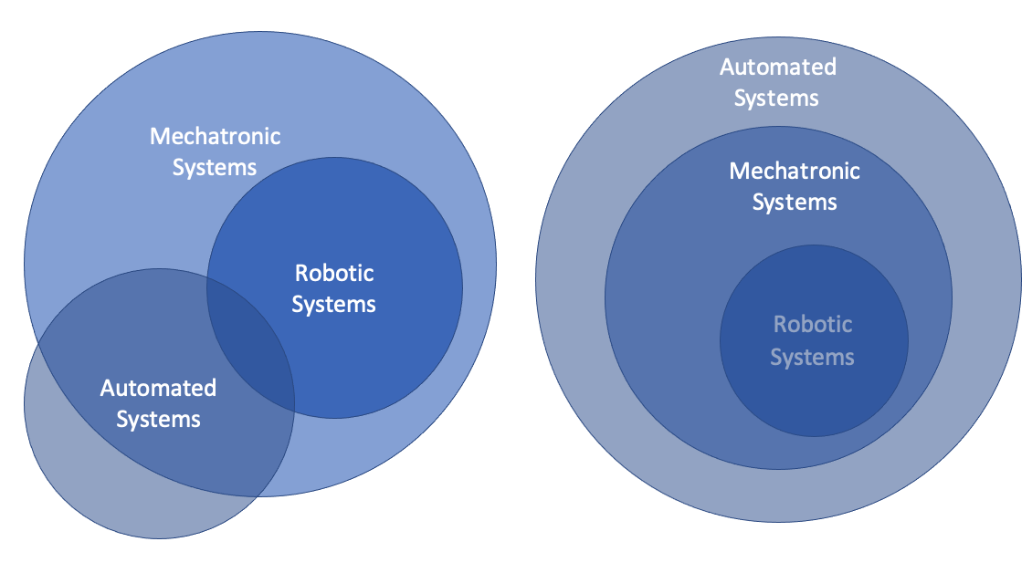
The diagram above shows 2 ways to visualise the different systems overlapping. Discuss which visualisation you see as accurate.
Investigate the development and impact of one chosen real-world application. Look at the Robots IEEE website and investigate how an invention has impacted individuals or society.
Document the development and impact of one chosen real-world application in the space below.
Sample answer: Roomba development
The Roomba is an autonomous vacuum and one of the most popular consumer robots in existence. It navigates around clutter and under furniture cleaning your floors and returns to its charging dock when finished. It was first developed in 2002 and has further advanced. It has been through iteration since first development and improvements have been made in battery life and in development of an app for programming, mapping the house and communicating.
The development of the Roomba has seen change to how individuals keep their home. It includes hands-free cleaning and reduces the allergens in the air. The Roomba can be scheduled to clean when you want it to.
The impact on society is that the Roomba has made it easier to clean floors.
It also helps people with problems like back pain or a broken arm as it vacuums for itself.
Robotic vacuum cleaners are economical and cost-efficient, and they are much cheaper than expensive housekeepers.
The machine can be set to clean exactly as required, while requiring little maintenance. Your only job is to empty the container from time to time.
It can replace a traditional vacuum cleaner or a pan and brush.
Explore mechatronic and automated systems that operate through human or autonomous control.
Investigate TESLA autopilot and autonomous driving.
What does human control of a system involve?
Sample answer:
Human control of a system is a system that relies on a human interaction to operate.
Many automated systems still utilise human control.
What does autonomous control of a system involve?
Sample answer:
Autonomous control of a system is that a system can achieve a given set of goals in a changing environment by gathering information about the environment and working for an extended period of time without human control or intervention.
Describe a mechatronic and/or automated system that operates through human control.
Sample answer:
The Da Vinci robot is used in hospitals for surgery.
The robot has multiple small mechanical instruments on the end effectors including a camera for sight.
The surgeon controls the manipulators/end effectors with precision.
Other medical technology can see a surgeon operate on a patient from a different or remote location.
Describe a mechatronic and/or automated system that operates through autonomous control.
Sample answer:
Autonomous vehicles such as the Tesla can go long lengths of time without human operation.
Autonomous control is also in many manufacturing systems such as gantry gates, assembly lines and conveyor belts.

Components of a mechatronic system
In mechatronic and automated systems, there are components of the system:
- Inputs
- Storage
- Transmission
- Processes
- Outputs
Figure 3 – components of a mechatronic system
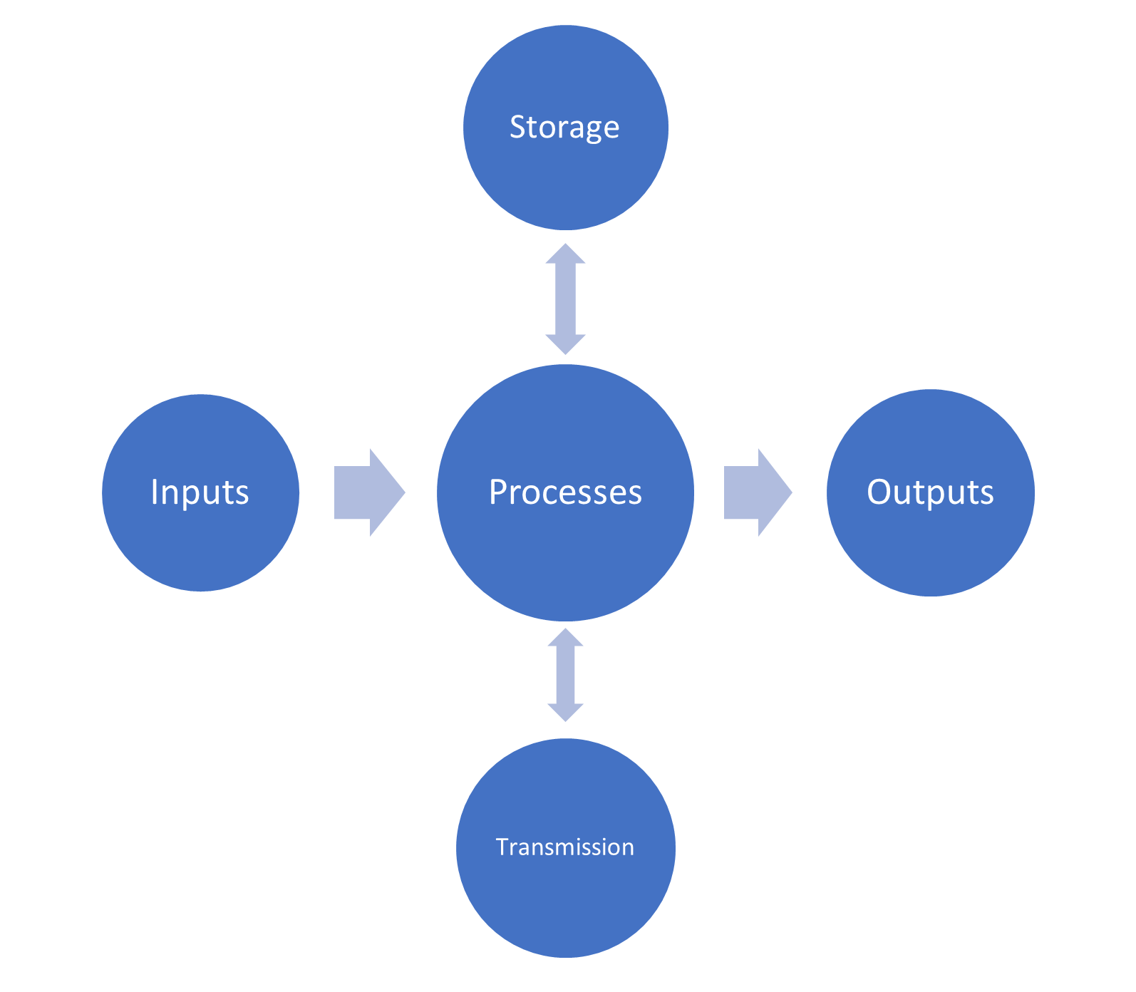
Rewatch the video on robotic cleaning (6:39), and note where the video describes the various technology components. You can classify how these components are examples of inputs, processes, storage, transmission or outputs.
In the space below, describe system inputs.
Sample answer:
Inputs in mechatronic and automated systems are the sensors.
These sensors act to detect and collect data from the environment.
Sensors examples can include lidar, ultrasonic, depth perception.
In the space below, describe storage.
Sample answer:
Storage in mechatronic and automated systems is usually found on the microcontroller.
A microcontroller's memory is used to store the data that the processor receives and uses to respond to instructions that it's been programmed to carry out.
A microcontroller has 2 main memory types: Program memory, which stores long-term information about the instructions that the CPU (Central Processing Unit) carries out.
There are 2 types of memory: RAM (Random Access Memory) which can read and write data, and ROM (Read Only Memory) which mainly stores programs as read-only data.
In the space below, describe transmission.
Sample answer:
Transmission in mechatronic and automated systems is used for communication.
Many mechatronic systems are connected to the internet through Wi-Fi and a router.
Systems can also transmit information and data to an app that is installed on a smart phone.
In the space below, describe processes.
Sample answer:
Processing in mechatronic and automated systems is central to the system operating.
The processing is a computation based on the requirement and performed by the CPU (Central Processing Unit).
In the space below, describe outputs.
Sample answer:
Outputs in mechatronic and automated systems are the actuators.
These actuators allow movement and use force.
Examples of actuators can be the motor driving wheels.

Functional and non-functional requirements
Watch software documentation and planning (10:48).
Investigate learning how software design understands functional and non-functional requirements.
Watch test cases (3:30).
Investigate examples of how industry applies test cases and watch an example of a business analyst discussing use cases vs user stories (6:37).
Look at how use cases can be diagrammatically represented.
Model and discuss how to develop functional and non-functional requirements and how they will need to be evaluated at the end of the iterative process to determine success.
Describe the difference between functional and non-functional requirements of a mechatronic or automated system.
Sample answers:
Functional requirements are the primary way that a customer communicates their requirements to the project team.
Functional requirements help to keep a project team going in the right direction.
Non-functional requirements cover all the remaining requirements which are not covered by the functional requirements.
Even in the case when the non-functional requirements are not met the basic functionality will not be impacted.

Create the functional and non-functional requirements for a prosthetic robotic hand in the table below.
Table 5 – functional requirements of mechatronic or automated systems
Element | Specify the functional requirements of a mechatronic or automated system
The purpose of a system | Sample answer:  When a hand is amputated or lost, a prosthetic robotic hand can play an important role in rehabilitation. For many people, a robotic hand can improve mobility and the ability to manage daily activities, as well as provide the means to stay independent.
Describe use cases | Sample answers:  - Rehabilitation: Prosthetic robotic hands can be used to help individuals who have lost a hand due to injury or illness to regain independence and improve their quality of life. They can help patients to perform everyday tasks such as eating, dressing, and writing.  - Work: Prosthetic robotic hands can be used by individuals who need to perform specific tasks that require fine motor skills, such as typing, assembly line work, or precision craftsmanship.  - Sports: Prosthetic robotic hands can be used by athletes who have lost a hand due to injury or illness to participate in sports such as rock climbing, cycling, or swimming.  - Research: Prosthetic robotic hands can be used in research on human-robot interaction and control to develop new technologies and techniques for prosthetic devices.  - Military: Prosthetic robotic hands can be used by military personnel who have lost a hand in the line of duty to improve their ability to perform their duties.  - Gaming: Some prosthetic robotic hands are designed to be used in gaming, allowing players to interact with the game more intuitively and realistically.
Develop test cases of inputs | Sample answers:  - Basic movement: Test the device's ability to move its fingers and thumb in different positions, such as open, closed, and partially closed.  - Gripping strength: Test the device's ability to grip and hold different objects of varying sizes and shapes, such as a pen, a cup, or a tool.  - Sensors: Test the device's ability to respond to different types of inputs, such as touch, pressure, and temperature.  - Control interface: Test the device's ability to respond to different types of input such as myoelectric signals, muscle signals, or brain-computer interface to ensure that the control interface is working properly.  - Durability: Test the device's ability to withstand different types of stress, such as impact, vibration, and temperature changes.  - Battery life: Test the device's battery life and charging time to ensure that the device can be used for an appropriate amount of time.  - Compatibility: Test the device's compatibility with different types of prosthetic interfaces, such as socket or osseointegration, and different types of clothing and environments.  - User feedback: Test the device's ability to provide appropriate haptic feedback, such as vibrations or force feedback, to the user.  - Safety: Test the device's safety features, such as emergency stop, to ensure that the device can be safely used by the user.  - Real-world scenarios: Test the device's ability to perform a variety of tasks in real-world scenarios such as grasping and manipulating objects, writing, and performing daily living activities.
Develop test cases of expected outputs | Test cases of expected outputs for a robotic prosthetic hand refer to the specific outcomes that should occur when the device is used in response to a given input. These expected outputs are used to validate the functionality and performance of the device.  Sample answers:  - Basic movement: The device should be able to move its fingers and thumb in different positions, such as open, closed, and partially closed, in response to the user's input.  - Gripping strength: The device should be able to grip and hold different objects of varying sizes and shapes, such as a pen, a cup, or a tool, with a specified level of force and stability.  - Sensors: The device should respond to different types of inputs, such as touch, pressure, and temperature, by adjusting its position or grip accordingly.  - Control interface: The device should respond to different types of input such as myoelectric signals, muscle signals, or brain-computer interface in a timely and accurate manner.  - Durability: The device should be able to withstand different types of stress, such as impact, vibration, and temperature changes, without malfunctioning or breaking.  - Battery life: The device should have a specified battery life and charging time, and should be able to be used for an appropriate amount of time.  - Compatibility: The device should be compatible with different types of prosthetic interfaces, such as socket or osseointegration, and different types of clothing and environments.  - User feedback: The device should provide appropriate haptic feedback, such as vibrations or force feedback, to the user, in response to different inputs or actions.  - Safety: The device should have safety features, such as an emergency stop that will allow the user to stop the device’s movement in case of emergency.  - Real-world scenarios: The device should be able to perform a variety of tasks in real-world scenarios such as grasping and manipulating objects, writing, and performing daily living activities with a specified level of accuracy and speed.
Create a diagrammatic drawing of a use case in the space below.

Watch non-functional requirements (9:28) and discuss non-functional requirements including examples of a mechatronic system such as:
- battery disposal
- improved well-being as a result of implementation
- the ease of manufacturing the system
In the space below explain how the examples are non-functional requirements of a mechatronic or automated system.
Table 6 – non-functional requirements of a mechatronic or automated system
Examples | Explain the non-functional requirements of a mechatronic or automated system
Battery disposal | Sample answer:  Batteries are subject to a life span. Their efficiency decreases over time. Materials that create batteries can include rare minerals and it is best for the environment to have a recycling process established for their disposal.
Improved wellbeing as a result of implementation | Sample answer:  Mechatronic and automated systems can increase the user’s wellbeing. In the case of a robotic prosthetic arm the user can have the function of their arm returned and that improves their life.
Ease of manufacturing the system | Sample answer:  Mechatronic and automated systems can be mass produced or customised systems. The ease in which they are manufactured can depend on the complexity of the design. A design can be created with manufacturing ease in mind.

Activity: in the tables, design the functional and non-functional requirements for your chosen model.
Table 7 – functional requirements of chosen mechatronic or automated system
Model | Specify the functional requirements of your chosen mechatronic or automated system
The purpose of a system
Describe use cases
Develop test cases of inputs
Develop test cases of expected outputs
Table 8 – non-functional requirements of chosen mechatronic or automated system
Model | Explain the non-functional requirements of your chosen mechatronic or automated system
Battery disposal
Improved wellbeing as a result of implementation
Ease of manufacturing the system

Social impacts and ethical and legal requirements
Social impacts associated with mechatronic and automated systems are varied. Some social impacts go on to challenge ethical and legal requirements of society.
Investigate why there has been a need for companion robots.
What benefit does a companion robot have?
Sample answer:
Companion robots are designed to enhance well-being, quality of life, and independence by providing service, companionship and assisting daily life.
The benefit for the individual mainly includes cognitive and social support and help reduce depression, loneliness and agitation.
Companion robots may also benefit by providing mobility support, relaxation, health monitoring, and self-care support through human–robot interaction.
Many industries require people to be employed. With technology advancements some positions become redundant. What happens when there is job loss due to automation?
Sample answer:
Automation has displaced many manufacturing and warehouse roles that were performed by humans.
The number of people employed in these roles has decreased due to automation.
These employees may need to complete more education and training to find another industry or job.
Other fields such as maintenance and design of mechatronic systems increase positions.
Watch mechatronic technology (5:36).
Discuss how mechatronic technology can be used in surveillance and affect your privacy.
People change and adjust their behaviour when they are being watched. What is the impact of surveillance?
Sample answer:
The impact of surveillance can be that it creates an environment of suspicion and threat, which can cause people who are not engaged in any wrongdoing to change their behaviour, including the way they act, speak and communicate.
Surveillance can also increase the sense of security. The main benefit of surveillance cameras in public spaces is the increase in public safety. Surveillance can deter crime, reduce theft and vandalism.
Examine Asimov’s laws of robotics.
What are Asimov’s laws of robotics?
Sample answer:
The first law is that a robot shall not harm a human, or by inaction allow a human to come to harm.
The second law is that a robot shall obey any instruction given to it by a human.
The third law is that a robot shall avoid actions or situations that could cause it to come to harm itself.
Investigate how military use the latest technology through their concept for Robotics and Autonomous Systems (1:30). Investigate ethical issues with robots and the military.
What ethical issues are challenged with the development of military robots?

Sample answer:
Military robots can hold advantages as they can save the lives of soldiers, safely defusing roadside bombs or operating in dangerous environment such as caves and underwater.
Military robots can operate without emotions and potentially conduct warfare more ethically and effectively than human soldiers who may experience fatigue, low morale, anger and vengeance.
However military robots using autonomous weapon systems may lead to a dangerous escalation. Armed conflict with military robots could be fought at a scale greater than conflict that has occurred before. The military robots could be used as weapons of terror against civilians or hacked to behave in undesirable ways.
How is society challenged by mechatronic and automated systems that create products that have safety and liability issues?
Sample answer:
A company that produces a product with safety and liability issues may breach law and be subject to legal litigation.
Quality control of products may include humans inspecting and testing products that are assembled by mechatronic and robotic systems.
Vehicles including cars, aeroplanes and trains need to be built to safety standards.
At times there are products that are produced and may need to be recalled if there is a risk of harm to the user.
How does the current federal law regarding privacy apply to mechatronic and automated systems?

Sample answer:
Mechatronic and automated systems can be connected to the internet or feed information back to a database. Personal information is subject to privacy requirements that are detailed and extensive.
At a federal level, the Privacy Act 1988 governs the way in which business entities and federal government agencies must handle personal information, largely through the 13 Australian Privacy Principles (APPs) set out within the Privacy Act. Personal information is defined by the Privacy Act as information or an opinion about an identified individual, or an individual who is reasonably identifiable, whether the information or opinion is true or not and whether the information or opinion is recorded in a material form or not.

Ethics
Ethics is an important topic for engineers of every level and field, as engineers do work that has the potential to affect people’s lives. Whether you’re engineering a bridge, a car, a nuclear reactor, or a computer system, the quality and character of engineered systems are hugely important. Additionally, engineers need ethics because it is very difficult to ensure good behaviour through any other mechanism. Law can never anticipate every possible issue in engineering, and law-enforcement can’t oversee every single detail of every engineer’s job.
In the space below, define ‘ethics’.
Sample answer:
Ethics are moral principles that govern a person's behaviour or the conducting of an activity.
Ethics reflect on human beings and their interaction with nature, with other humans, on freedom, responsibility and justice.
Why is it important that computing engineers work ethically in relation to safety?

Sample answer:
According to engineering codes of ethics, the engineer's most important obligation is to ensure the safety, health, and welfare of the public.
The things engineers help design, build, and maintain could result in a loss of life if engineers put profits, personal advancement, or anything else in front of people.
An important reason to have a code of ethics for professional engineers is it sets a standard for professional behaviour.
Why is it important that computing engineers work ethically in relation to honesty and integrity?
Sample answer:
Mechatronic engineers are trusted and held to high regard by the public, so it is important that they act ethically in regard to honesty and integrity, by only performing services in their areas of expertise, avoiding deception by associates and clients, striving at all times to serve the public interest, not disclosing confidential information without consent.

Legality
What would you consider to be a legal responsibility associated with mechatronic and automated systems?
Sample answer:
Mechatronic engineers work regularly affects the lives of people, either directly or indirectly. Therefore, it is important that engineers act ethically in relation to safety by holding paramount the safety, health and welfare of the public by creating products and performing services only in their areas of competence and only approving developments that conform with applicable standards.
What would you consider to be an illegal use of a mechatronic or automated system?
Sample answer:
An illegal use of a mechatronic or automated system may be one that causes invades a person’s right to privacy or causes a person damage, harm or death.
Inventing mechatronic or automated systems that can be used as a weapon or cause an explosion would be examples of illegal use.
With a partner share your answers and discuss any differences in your ideas around the social impact of mechatronic and automated systems. In the space below, make note of key differences between you and your partner’s ethical views.
Think Pair Share your ideas with the class.

Perspectives of diverse groups
Diverse groups have different perspectives on the use of mechatronic and automated systems. Diverse groups include:
- Aboriginal and/or Torres Strait Islander peoples
- Culturally diverse people
- Linguistically diverse people
- People of different ages
- People of different genders
- People with disability.
Brainstorm as many ways that mechatronic and automated systems can help diverse groups as you can in the space below (for example, assisted driving for people with disability).
Choose some of the examples from the brainstorm and briefly describe how they impact people’s lives in the table below.

Table 9 – impact of mechatronic and automated systems on diverse peoples lives
Example | Impact on diverse peoples lives
There are permissions and protocols for capturing images, voice or video of Aboriginal peoples. What beliefs do Aboriginal peoples hold that underpin this need?
Sample answer:
Aboriginal peoples have a deep spiritual connection to their land, culture, and ancestors. They hold a strong belief in the interconnectedness of all living things and the importance of maintaining balance and harmony within the natural world.
One of the key beliefs that underpin the need for permissions and protocols when capturing images, voice or video of Aboriginal peoples is the belief in the sacredness of their cultural heritage. This includes their stories, songs, dance, art, and ceremonies, which are all considered sacred and integral to their identity and spiritual well-being.
Aboriginal peoples also have a strong belief in the concept of ’cultural ownership’, which holds that their cultural heritage belongs to the community and should be protected and passed down through generations.
This belief is closely tied to the idea of ‘cultural continuity’, which is the belief that their culture and traditions must be preserved in order to ensure that their heritage and identity continue to thrive.
Additionally, many Aboriginal peoples have a strong belief in the importance of maintaining privacy and confidentiality in relation to their cultural heritage, and therefore they may not want their images, voices, or videos to be shared without their consent.
Therefore, capturing images, voice or video of Aboriginal peoples without their permission is seen as a violation of their cultural heritage, privacy, and spiritual beliefs.
It is important to understand and respect the beliefs of Aboriginal peoples and to follow the proper protocols and obtain the necessary permissions before capturing any images, voice or video of them.
Watch and examine what is native title (15:33) and discuss how automated vehicles could be used considering social, ethical and legal responsibilities of indigenous land use.
There is land that is protected by native title. If automated vehicles would like to access this land what considerations would need to be made?
Sample answer:
The company owning the Automatic vehicles (AVs) would need to work closely with the traditional owners and relevant authorities to understand and respect their rights and interests and to ensure that their operations are conducted in a responsible and sustainable manner.
If the company owning the Automatic vehicles (AVs) would like to access native title land, there are several considerations that would need to be made:
Consent: the company owning the AVs would need to obtain the consent of the traditional owners of the native title land before accessing it. This would involve engaging in consultation and negotiation with the traditional owners to understand their concerns and to agree on the terms and conditions of access.
Cultural heritage: the company owning the AVs would need to consider the potential impacts of their operations on the cultural heritage of the traditional owners, including sacred sites, cultural landscapes, and other important cultural assets. They would need to implement measures to protect and respect these cultural heritage values.
Environmental impact: the company owning the AVs would need to consider the potential impacts of their operations on the environment and biodiversity of the native title land. They would need to implement measures to minimise any negative impacts and to ensure that their operations are sustainable.
Economic benefit: the company owning the AVs would need to consider the potential economic benefits of their operations for the traditional owners and the local community. They would need to ensure that they are providing fair compensation and benefits to the traditional owners and the local community.
Data and privacy: the company owning the AVs would need to consider the protection of data and privacy of traditional owners and the local community. They need to comply with the laws and regulations regarding data and privacy protection.
Examine how mechatronics can support people with disabilities. Including watching examples of exoskeleton (6:23), bionics (19:00), prosthetics (4:09) and the ability of autonomous vehicles to provide independence.
An advancement in mechatronic and automated systems has been the ability of engineers to design systems that are helping and supporting independence for people with disability.
Examine autonomous transport or robotic prosthetics and summarise how these systems have been able to assist people.
Sample answer:
Autonomous transport and robotic prosthetics are both technologies that have been developed to assist people with a wide range of abilities and needs.
Autonomous transport, also known as self-driving vehicles, are vehicles that are able to navigate and operate without human input. They are designed to provide safe and efficient transportation to people, and they have been implemented in various forms such as cars, buses, and drones. These systems have been able to assist people by providing them with more efficient and convenient transportation options, and also improving their mobility and access to different places. Autonomous transport systems also have the potential to reduce human error and improve road safety.
Robotic prosthetics are devices that are designed to replace or augment human limbs or body parts that are missing or not functioning properly. Robotic prosthetic limbs are controlled by the user through various methods such as myoelectric signals, muscle signals, or brain-computer interface. These systems have been able to assist people by providing them with increased mobility and independence, and also improving their ability to perform daily tasks. Robotic prosthetics have also been used in rehabilitation to help patients regain independence and improve their quality of life.

Researching and planning

Control system
A control system is a type of computer system that manages, commands and directs other devices or systems. There are open and closed loop control systems. They usually take an input, process it and get an output.
Figure 4 – control system process
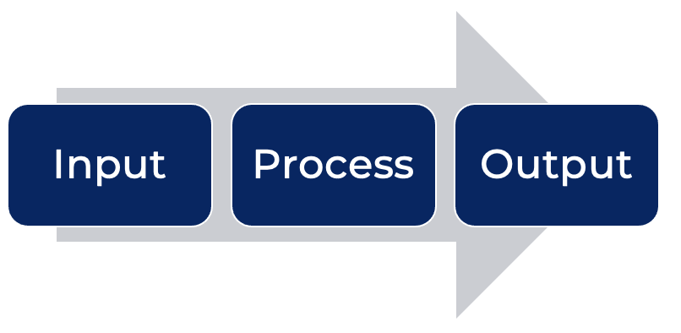
The open-loop configuration does not monitor or measure the condition of its output signal as there is no feedback. The example below shows a clothes dryer that operates on a timer.
Figure 5 – open loop configuration of a control system
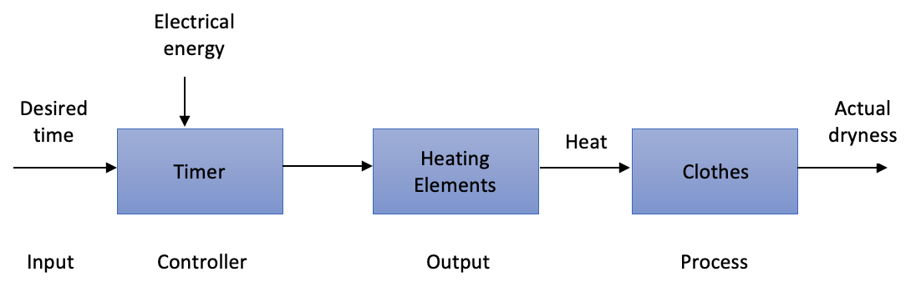
Closed-loop configuration uses feedback where a portion of the output signal is fed back to the input to reduce errors and improve stability. The example below shows a clothes dryer that has a sensor to measure the dryness of clothes.
Figure 6 – closed loop configuration of a control system
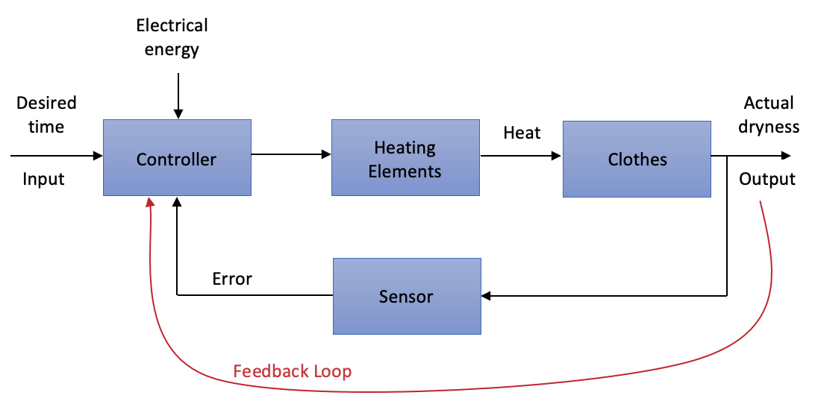

Components
These are the many and various parts of the system. There are defined components such as the microcontroller, co-processor, sensors and actuators. Many elements of a mechatronic or automated system can be described as a component from power supply and batteries to cables.

Microcontroller
A microcontroller is a compact integrated circuit designed to govern a specific operation in an embedded system. A typical microcontroller includes a processor, memory and input/output (I/O) peripherals on a single chip. There are many types of microcontrollers available to work with. A familiar example would be an Arduino UNO R3 board.

Arduino UNO R3 board
The Ardunio UNO R3 board is an example of a microcontroller. In the image below you can see where the microprocessor and various components sit on the Arduino UNO R3 board.
Figure 7 – Arduino UNO R3 diagram
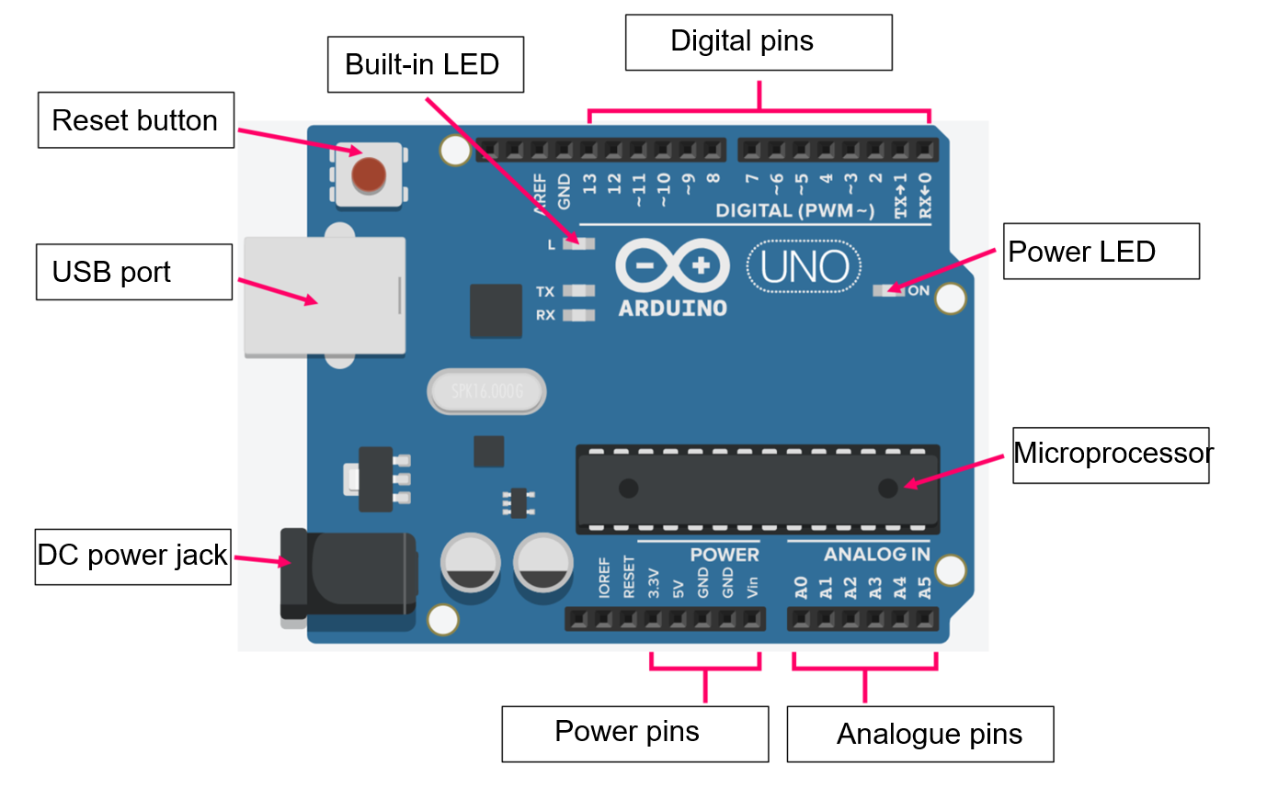

Co-processor
A co-processor is a computer processor used to supplement the functions of the primary processor. Operations performed by the coprocessor may be floating-point arithmetic, graphics, signal processing, string processing, cryptography or I/O interfacing with peripheral devices.
In the table below, identify and justify control systems, components, microcontrollers and co-processors for a mechatronic or automated system.
Table 10 – [insert table caption, please]
Structures | Identify and justify use in a mechatronic or automated system
Control systems | Sample answer:  A control system is a set of mechanical or electronic devices that regulates other devices or systems by way of control loops.  These are used in mechatronic systems for controlling the system.
Components | Sample answer:  Components refer to the individual parts or elements that make up a larger system or structure. They can be physical or logical, and are often modular, meaning they can be easily removed or replaced without disrupting the overall system.
Microcontrollers | Sample answer:  A small programmable computer that is able to run code. These are used in mechatronic systems to operate the system by executing the steps.
Co-processor | Sample answer:  A coprocessor is a supplementary processor unit or an entirely different circuitry that is designed to complement the central processing unit (CPU) of a computer. These are used in mechatronic systems for supporting the microcontroller.

Sensors
Sensors are input devices that detect an event in a system or environment and report those conditions to a user or controller. They work by generating a current that changes in response to a change in the environment.
Investigate how many different kinds of sensors are used in industry.
The following table has many examples of sensors that can be used in mechatronic and automated systems. Complete the table by finding an image of the sensor and a definition or description of what the sensor does.
Table 11 – examples of sensors that can be used in mechatronic and automated systems
Sensor | Image | Description
Accelerometer |  | Sample answer:  An accelerometer sensor is a tool that measures the acceleration of any body or object in its instantaneous rest frame.
Anemometer |  | Sample answer:  An anemometer is a device used for measuring wind speed and is a common weather station instrument.
Gyroscope |  | Sample answer:  A gyroscope sensor is a device that can measure and maintain the orientation and angular velocity of an object. These are more advanced than accelerometers. These can measure the tilt and lateral orientation of the object.
Light dependent resistor |  | Sample answer:  A light dependent resistor is an electronic component that is sensitive to light or luminosity. When light falls upon it, then the resistance changes.
Magnetic transducer |  | Sample answer:  A magnetic transducer emits sound based on the frequency of the electric signals input, and it is the frequency characteristics that determine what degree of sound is caused in relation to input frequency.
Manometer |  | Sample answer:  A manometer is a fluid pressure sensor that provides a relatively simple design structure and an accuracy level greater than that afforded by most aneroid barometers. It takes measurements by recording the effect of pressure on a column of liquid.
Microphone |  | Sample answer:  The microphone sound sensor, as the name says, detects sound. It gives a measurement of how loud a sound is.
Photelectric cell |  | Sample answer:  Photoelectric sensors determine the distance, absence, or presence of physical objects by emitting a field or beam of electromagnetic radiation.
Photo-resistors |  | Sample answer:  Photoresistors are most often used as light sensors. They are often utilised when it is required to detect the presence and absence of light.
Potentiometer |  | Sample answer:  A potentiometer is a three-terminal resistor with a sliding or rotating contact that forms an adjustable voltage divider. A potentiometer sensor measures the distance or displacement of an object in a linear or rotary motion and converts it into an electrical signal.
Strain gauge |  | Sample answer:  A strain gauge is a sensor whose resistance varies with applied force. It converts force, pressure, tension, weight into a change in electrical resistance which can then be measured.
Thermistor |  | Sample answer:  An electrical resistor whose resistance is greatly reduced by heating, used for measurement and control.
Thermocouple |  | Sample answer:  A thermoelectric device for measuring temperature, consisting of 2 wires of different metals connected at 2 points, a voltage being developed between the 2 junctions in proportion to the temperature difference.
Thermostat |  | Sample answer:  A temperature sensor measures the temperature of its environment and converts the input data into electronic data to record.
Ultrasonic |  | Sample answer:  An ultrasonic sensor is an electronic device that measures the distance of a target object by emitting ultrasonic sound waves and converts the reflected sound into an electrical signal.
Venturi |  | Sample answer:  A Venturi flow meter is a type of differential pressure flow meter that generates a flow measurement by measuring the pressure difference at 2 different locations in a pipe.
In the table below, select and justify sensors for a mechatronic or automated system.
Table 12 – justifying the use of sensors in mechatronic or automated systems
Sensors | Identify and justify use in a mechatronic or automated system

Ultrasonic sensor unpacked
Ultrasonic sensors can detect distance. They work by sending out a burst of ultrasound and listening for the echo when it bounces from an object. The Arduino board sends a short pulse to trigger the detection, then listens for a pulse on the same pin using the pulseIn() function.
Figure 8 – how the HC-SR04 ultrasonic sensor works
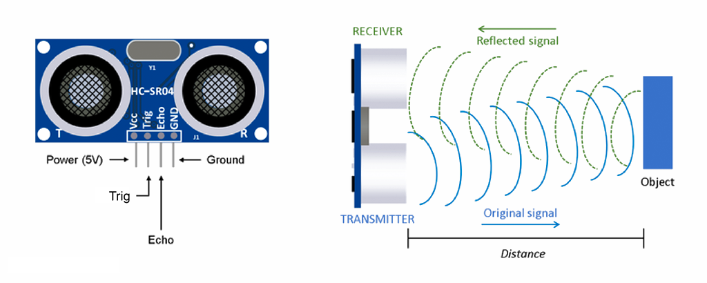
Autodesk screen shots reprinted courtesy of Autodesk, Inc.
When running programs your code may not appear to be working properly. There is a screen in Arduino software known as serial monitor that can indicate what is happening in the program and allow you to check if your program functions properly. This is where to find it (there are 2 places circled):
Figure 9 – how to access the 'Serial Monitor'
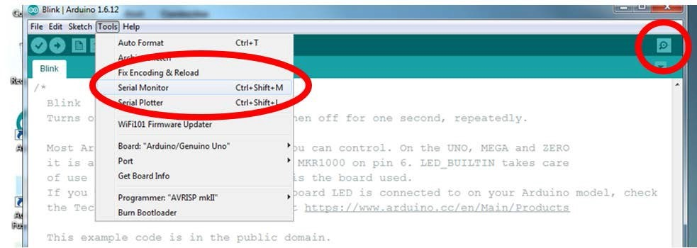
Images taken from Arduino are licensed under CC BY-SA 3.0.

Activity – test the ultrasonic sensor with the Serial Monitor
Keeping track of everything going on in your program can be an uphill battle. The serial monitor is a way to listen to what's going on in your code by reporting back to the computer over the USB cable. You can use the Serial Monitor to ‘talk’ to the computer as a way of checking if the Arduino code is doing what you intended. This can be very useful for solving problems with your code and is called ‘debugging’.
Connect the ultrasonic sensor to your Arduino UNO. See diagram below.

Figure 10 – diagram depicting wiring for the ultrasonic sensor connected to an Arduino UNO
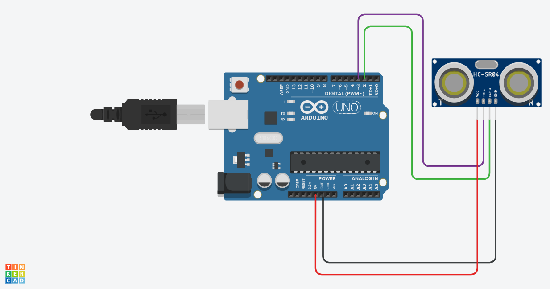
Autodesk screen shots reprinted courtesy of Autodesk, Inc.
Once you have opened serial monitor nothing happens unless you add code into your sketch telling the IDE what data to display on the serial monitor. Run the serial monitor with the sketch on the Arduino to see what happens as you move the ultrasonic sensor.
Serial.begin (9600);
This line is in the Setup. The 9600 refers to the communication speed between the Arduino and the computer. It must match the number in the bottom of the serial monitor window.
Serial.println (distance);
This line prints the value in the brackets () to the computer via the USB cable. In this case it is the value that was read from the variable distance. After printing the value to the screen, it starts a new line.
Create a sketch using the code below to activate the serial monitor.
Figure 11 – coding for the ultrasonic sensor to write to the serial monitor
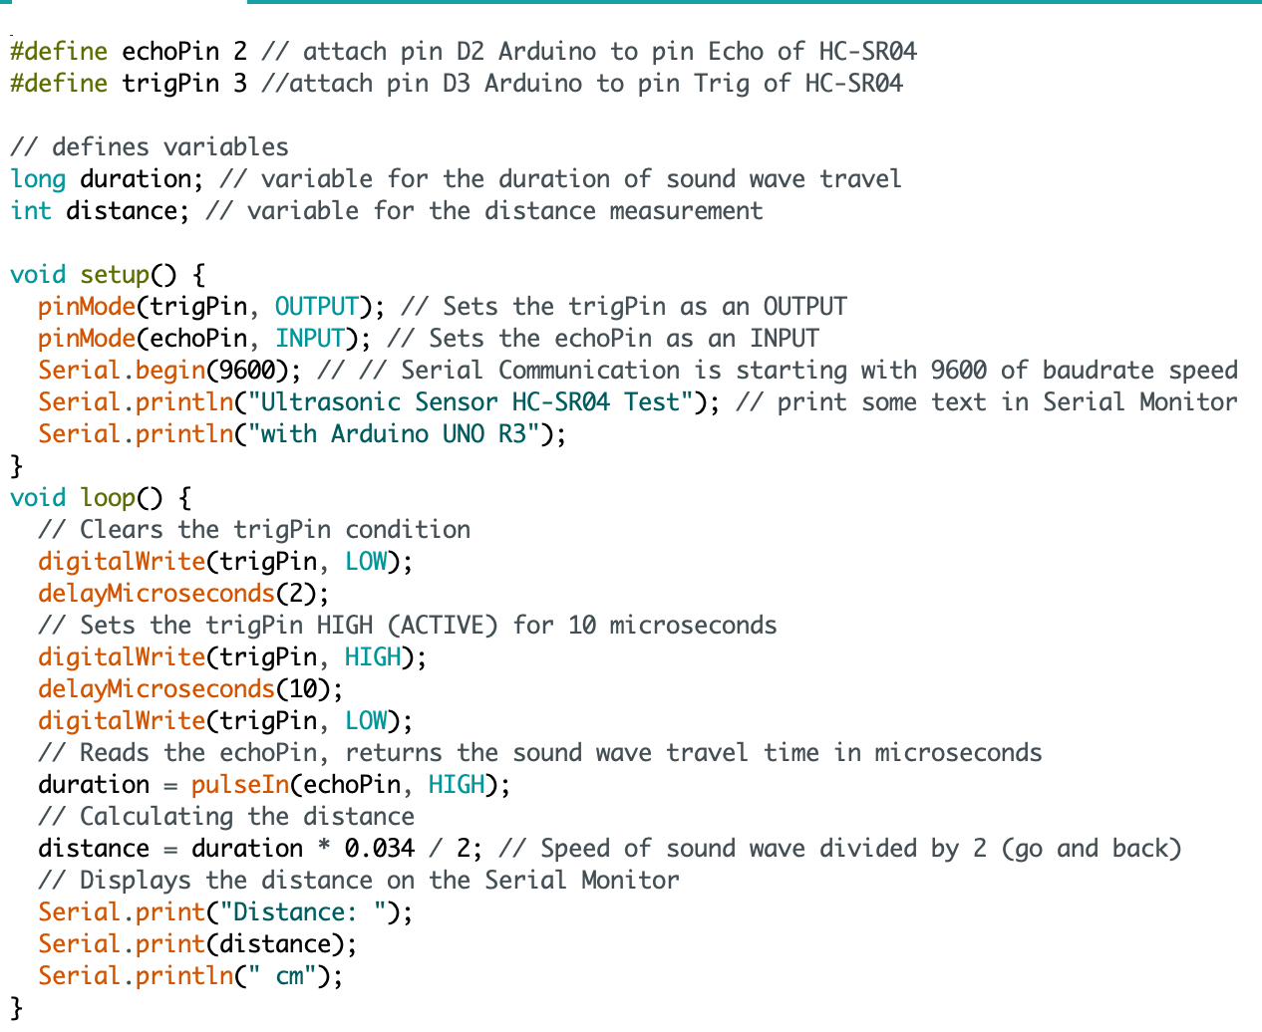
Images taken from Arduino are licensed under CC BY-SA 3.0.

Explain what the Serial Monitor is observing. Document your answer below.
What does the pinMode() function do?
Sample answer:
The pinMode function allows you to declare whether a pin has an input (sensor) or output (actuator) connected to it.
What is the difference between void setup() and void loop()?
Sample answer:
Void setup, will only run once when the Arduino is switched on. Void loop will run repeatedly until the Arduino is reset or power is removed.
What does the digitalWrite() function do?
Sample answer:
The digitalWrite function allows us to send a digital signal (on or off, HIGH or LOW, 1 or 0) to a sensor such as the ultrasonic used in this example.

What does the delay() function do?
Sample answer:
The delay function tells the Arduino to pause for the amount of time specified.
What is pseudocode and how does it help us with coding?
Sample answer:
Pseudo code is a computer algorithm written in plain English. Pseudocode helps us with coding as we can design the logic of the code without using the actual coding language. If we have logic errors with the code once it is created we can refer back to the pseudocode to try and solve the issues.

Actuators
An actuator is a device that causes a machine or other device to operate.
An actuator is a mechanism for turning energy into motion.
Actuators are devices designed to alter things in the real world through performing the mechanical actions required under the direction of the controller. Such as a motor to open a door and are thus output devices performing functions as a result of signals from the controller.
The following table has many examples of actuators that can be used in mechatronic and automated systems. Complete the table by finding an image of the actuator and writing a definition or description of what the actuator does.
Table 13 – examples of actuators and what they do
Actuator | Image | Description
AC motors |  | Sample answer:  An Alternating Current (AC) motor is a motor that converts alternating current into mechanical power.  The stator and the rotor are important parts of AC motors. The stator is the stationary part of the motor, and the rotor is the rotating part of the motor.
DC motors |  | Sample answer:  A Direct Current (DC) motor is a motor that turns energy from a direct current and turns this into mechanical energy.  DC motors can vary in size and power from small motors in toys and appliances to large mechanisms that power vehicles, pull elevators and hoists, and drive steel rolling mills.
Hydraulic actuator |  | Sample answer:  A hydraulic actuator consists of a cylinder or fluid motor that uses hydraulic power to facilitate mechanical operation. The mechanical motion gives an output in terms of linear, rotary or oscillatory motion. Because liquids are nearly impossible to compress, a hydraulic actuator can exert considerable force.
Motors |  | Sample answer:  Meanwhile, a motor is considered as a continuous actuator as it rotates through a full circle.  A motor converts energy into torque which then moves or controls a mechanism or a system into which it has been incorporated. It can introduce motion as well as prevent it. An actuator typically runs on electricity or pressure.
Pneumatic actuator |  | Sample answer:  Pneumatic actuators are devices that convert the energy of compressed air or gas into a mechanical motion that regulates one or more final control elements. Pneumatic actuators are devices that convert the energy of compressed air or gas into a mechanical motion that regulates one or more final control elements.
Relay |  | Sample answer:  A relay is regarded as a binary actuator as it has 2 stable states. Relays are either energised and latched or de-energised and unlatched.
Servo motor |  | Sample answer:  A servo motor is a self-contained electromechanical device that rotates part of a machine with very high precision and great efficiency.
Solenoid |  | Sample answer:  A solenoid converts electrical energy into mechanical work. The coil is made of many turns of tightly wound copper wire. When an electrical current flows through this wire, a strong magnetic field/flux is created.
Stepper motors |  | Sample answer:  A stepper motor, also known as step motor or stepping motor, is a brushless DC electric motor that divides a full rotation into a number of equal steps.

In the table below, select and justify 3 actuators for a mechatronic or automated system.
Table 14 – justifying the use of actuators
Actuators | Identify and justify use in a mechatronic or automated system

End effectors/manipulators
In robotics, an end effector is the device at the end of a robotic arm, designed to interact with the environment. The exact nature of this device depends on the application of the robot.
The term end effector originates from serial robotic manipulators:
‘the end effector means the last link of the robot’.
Examine the definition of end effector and look at emerging technology used to create a manipulator.
In the table below, select and justify end effector and a manipulator for a mechatronic or automated system.
Table 15 – justifying the use of end effectors and manipulators in mechatronic or automated systems
End effector/Manipulator | Identify and justify use in a mechatronic or automated system
End effector | In robotics, an end effector is a device or tool that is connected to the end of a robot arm where the hand would be.
Manipulator | In robotics, a manipulator is a robotic arm-like mechanism that is designed to manipulate or move materials, tools, and parts without direct human contact.

Designing an end effector
Activity: design an end effector or robotic arm that can grab an object or pick up a hot chocolate.
For this activity you will need the following equipment for designing your attachment:
- Micro servo 9g
- Arduino uno
- Potentiometer
- Jumper leads
- Wire
- Cable ties
- Tape
- Cardboard
- Retractable knife
- Cutting mat
Teacher note: the practical lessons may begin earlier than noted in the program and run in synchronicity with learning about components from week 4.
The initial project may depend on students prior learning. As an alternate to designing an end effector, students may be guided to create a boom gate or a garage door. Some example of simple Arduino projects can be found on Damien Kee’s website. Use of the servo can be the focus to ensure they understand the activity before students commence a project for Assessment task 4.

Using a servo
The micro servo is an actuator. Watch how a servo motor (15:44) works.
The micro servo is a system that contains many parts, including:
- Where the cable connects to the microcontroller
- The potentiometer
- The embedded board
- The DC motor
- The gear system that connects to the servo horn.
Figure 12 – a schematic diagram of the servo with labelled parts
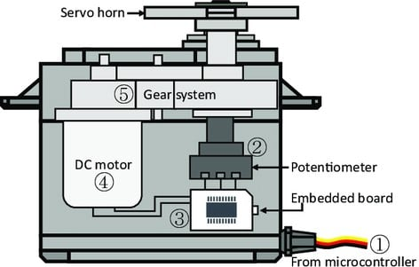
Schematic of an RC servo motor by Hwang et al. (2018) is licensed under CC BY 4.0.

Communication
Servo motors are controlled by sending a PWM (pulse-width modulation) signal to the signal line of the servo. The width of the pulses determines the position of the output shaft.
The angle of the servo motor horn is measured in degrees.
The image below shows how when the PWM signal changes, the angle of the servo changes.
Figure 13 – the space between pulse width modulation and the angle of servo horn
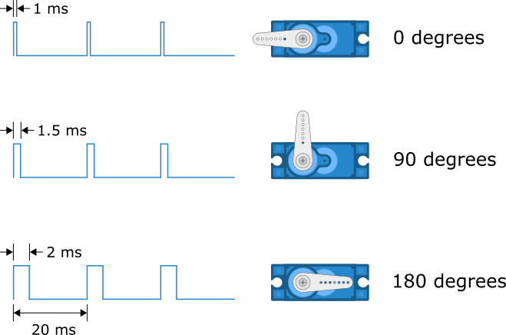
Autodesk screen shots reprinted courtesy of Autodesk, Inc.
The ports on the Arduino that have a ~ symbol next to them can use PWM. The PWM is controlled with a number between 0 and 255. These are pins 3, 5, 6, 9, 10 and 11.
Figure 14 – Arduino PWM pins

Develop a solution
The first step in developing a solution is to build the circuit as shown in schematic image and then code using Arduino IDE.
Servo motors have 3 wires: power, ground, and signal. The power wire is typically red and should be connected to the 5V pin on the Arduino board. The ground wire is typically black or brown and should be connected to a ground pin on the board. The signal pin is typically yellow or orange and should be connected to PWM pin on the board. In these examples, it is pin number 9.
For the knob example, wire the potentiometer so that its 2 outer pins are connected to power (+5V) and ground, and its middle pin is connected to A0 on the board. Then, connect the servo motor to +5V, GND and pin 9.
Use the schematic diagram below and examine the knob sketch to understand coding the Servo Motor Basics with Arduino.

Knob example schematic
Figure 15 – wiring for the potentiometer and 9g servo connected to an Arduino UNO
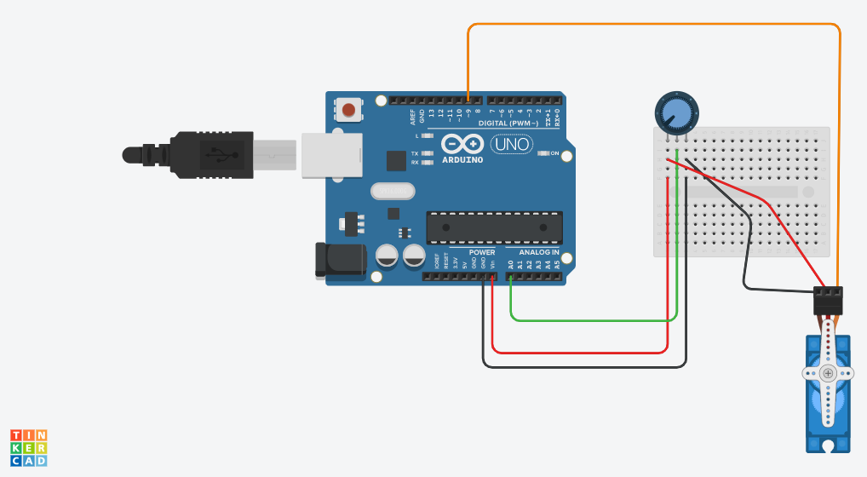
Autodesk screen shots reprinted courtesy of Autodesk, Inc.

Knob example code
Figure 16 – sample knob code
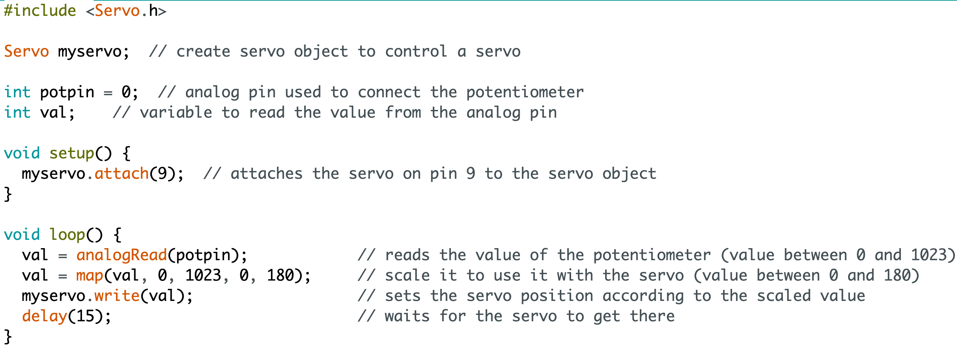
Images taken from Arduino are licensed under CC BY-SA 3.0.

Motion
The ultimate goal of motion control in a mechatronic or automated system is performance and behaviour. This means that the control system will be ultimately decide how the system will operate. But it also means that when control system strategy is developed, an in-depth understanding of the desired behaviour is required. With a better understanding of the mechanical context of mechatronics, better solutions will result.
Describe how motion was required in the creation of your end effector.
Sample answer:
An end effector is a peripheral device that attaches to a robot's wrist, allowing the robot to interact with its task.
Most end effectors are mechanical or electromechanical and serve as grippers, process tools, or sensors.
The required behaviour of the end effector model was to grip a hot chocolate, it had to perform holding an object of weight and needed force to operate with strength.

Mechatronic and automated systems evolve in response to need
Discuss how mechatronic and automated systems have evolved in response to people’s needs and opportunities.
One area of evolution is aged care and this example can lead discussion.
Watch domesticated robots and aged care (14:16).
By 2050, the global population aged 65 or more will be nearly double what it is today. The number of people over the age of 80 will triple, approaching half a billion. Supporting an aging population is a worldwide concern, but this demographic shift is especially pronounced in Japan, where more than a third of Japanese will be 65 or older by midcentury. (Ackerman July 2022)
Describe and discuss how mechatronic and automated systems have evolved in response to people's needs and opportunities.
Sample answers:
Mechatronics and automated systems have been developed to increase the efficiency of various processes and tasks. For example, automated manufacturing systems have been developed to increase production speed and accuracy, while automated transportation systems have been developed to increase the efficiency of transportation and logistics.
Automated systems have been developed to improve safety in various industries, such as construction, mining, and transportation. For example, automated equipment and vehicles can reduce the risk of human error and accidents, while also increasing productivity.
Automated systems have been developed to improve accessibility for people with disabilities or limited mobility. For example, assistive technology, such as robotic prosthetic limbs and exoskeletons, have been developed to improve mobility and independence for people with physical impairments.
Automated systems have been developed to reduce costs in various industries. For example, automated farming equipment can reduce labour costs, while automated manufacturing systems can reduce production costs.
Mechatronics and automated systems have been developed to provide personalisation to the users. For example, in healthcare, personalised prosthetic limbs have been developed that can be controlled through muscle signals or brain-computer interface. In transportation, autonomous vehicles are being developed to cater to the needs of different users, such as elderly or disabled people.
Mechatronic and automated system design needs to ensure safety, device functionality and quality based on predetermined specifications.
Technology advancement and human needs have led to integration among many engineering disciplines. These systems also adapt with emerging technology. Mechatronics engineering is an integrated discipline that focuses on the design and analysis of complete engineering systems. These systems include mechanical, electrical, computer and control subsystems and each have unique design principles.
Mechatronic and automated system design needs to ensure safety, device functionality and quality based on predetermined specifications.
Technology advancement and human needs have led to integration among many engineering disciplines. These systems also adapt with emerging technology. Mechatronics engineering is an integrated discipline that focuses on the design and analysis of complete engineering systems. These systems include mechanical, electrical, computer and control subsystems and each have unique design principles.
List 4 design principles relevant to mechatronic and automated systems and give an example of their impact.
Table 16 – design principles and their impact on mechatronic and automated systems
Design principle | Example of impact on mechatronic and automated systems
Lift | Sample answer:  Lift can be affected by weight. The weight of a component or system may affect the ability to elevate. Lift is often under the control of a DC motor and will need enough power to operate.
Torque | Sample answer:  Torque is a force that causes rotation about an axis. Torque and speed form part of a mechatronic system and are dependent on the actuator. If the torque has not enough speed a systems accuracy will be affected.
Drag | Sample answer:  Drag is a mechanical force. It is generated by the interaction and contact of a solid body with a fluid. Drag can be reduced by designing components with a higher velocity. All mechatronic systems control the processes they are part of, and to achieve this control they need sensors of various sorts.
Power | Sample answer:  Power is defined as the rate at which work is done. In other words, it is a function of work and time. Most machines are designed and built to do work on objects. All machines are typically described by a power rating. The power rating indicates the rate at which that machine can do work upon other objects.

List 4 issues relevant to mechatronic and automated systems and give an example of their impact.
Table 17 – issues and their impact on mechatronic and automated systems
Issue | Example of impact on mechatronic and automated system
Safety | Sample answer:  Automated vehicles, such as self-driving cars, have the potential to greatly improve road safety. These vehicles are equipped with advanced sensors and software that allow them to detect and respond to potential hazards on the road, such as other vehicles, pedestrians, and obstacles.  They also have the ability to communicate with other vehicles and traffic infrastructure, which can help to reduce traffic congestion and improve the flow of traffic.  As a result, the use of automated vehicles could significantly reduce the number of accidents caused by human error, such as distracted driving or driving under the influence. This could lead to a reduction in the number of deaths and injuries caused by car accidents, as well as a reduction in the economic and social costs associated with these accidents.
Cost | Sample answer:  The use of mechatronics and automation systems in the agriculture industry has saved costs. The use of automated farming equipment such as tractors, drones, and robots can significantly reduce labour costs, while increasing productivity and efficiency. Automated systems can also reduce the use of resources such as water, pesticides and fertilisers, which can lower production costs.  In the field of transportation, autonomous vehicles can also have a positive impact on costs. They can reduce the need for human labour, which can lower operating costs for transportation companies. They can also reduce the number of accidents caused by human error, which can lower insurance costs. Additionally, they can optimise their driving routes, reducing fuel consumption and maintenance costs.
Quality | Sample answer:  Automated manufacturing systems, such as robots and automated assembly lines, have been developed to increase production speed, accuracy and improve quality. They have the ability to perform repetitive tasks with high precision and speed, which can greatly increase productivity and efficiency while maintaining consistent high-quality products.  For example, an automated assembly line can increase the precision and accuracy of tasks such as welding, painting or screwing, which can lead to a higher quality final product. Automated systems can also monitor and inspect the products at various stages of production, and quickly identify and correct any defects or errors, which can lead to higher quality final products.
Reliability | Sample answer:  Reliability is an important aspect in the field of transportation as it has a direct impact on the safety, comfort, and cost of transportation services. Automated transportation systems, such as autonomous vehicles, have been developed to increase the reliability of transportation services.  Autonomous vehicles, for example, are equipped with advanced sensors and software that allow them to detect and respond to potential hazards on the road. They can also communicate with other vehicles and traffic infrastructure, which can help to reduce traffic congestion and improve the flow of traffic. These systems are designed to be highly reliable, with built-in redundancies and fail-safes to ensure that they can continue to operate even in the event of a malfunction.

Generate alternative designs
Generate alternative designs and evaluate them against the requirements to select a preferred design.
Students are to work collaboratively in small teams to develop ideas and plan for a mechatronic system they may model.
Produce 3 sketches and annotate drawings of the initial ideas that include microcontrollers and required components such as sensors and actuators.
Teacher note: it may be valuable for students to plan a design knowing the platform and equipment available for completing the model.
A kit may be developed so there are design limitations.
Students can work with a model for a vehicle that has the capacity to have additional sensors attached.
First alternate design for a mechatronic or automated system model.
Draw with annotations a solution below.
Second alternate design for a mechatronic or automated system model.
Draw with annotations a solution below.
Third alternate design for a mechatronic or automated system model.
Draw with annotations a solution below.
Having generated 3 alternative designs, these designs progress to being evaluated against the requirements to select a preferred design. Complete the table below.
Table 18 – evaluation of requirements to select a preferred design
Requirement | Decision on which alternate design is best suited

Data collection and interpretation
Data collection and interpretation needs to adhere to privacy and cybersecurity principles.
Discuss ways in which privacy and cybersecurity is needed and how mechatronic and automated systems could be breached.
Examine common cyber threats that need to be minimised in mechatronic and automated systems including:
- data spill
- denial of service
- hacking
- malicious insiders
Define what a ‘data spill’ is and give an example.
Sample answer:
A data spill is when personal information is released to unauthorised people by accident or as the result of a security breach. For example, an email with personal information can be sent to the wrong person, or a computer system can be hacked into and personal information stolen. These are known as a data breaches or data spills.
Define what ‘denial of service’ is and give an example.
Sample answer:
A distributed denial of service (DDoS) attack is an attempt to make an online service unavailable by overwhelming it with traffic.
DDoS usually uses a network of compromised systems to flood sites with connection requests, causing the website or server to slow down or crash entirely.
A recent trend is for DDoS to be used for extortion, where a business is threatened with an attack against its website unless it makes a payment.
Define what ‘hacking’ is and give an example.
Sample answer:
Hacking refers to unauthorised access of a system or network, often to exploit a system’s data or manipulate its normal behaviour. Once in, a hacker can modify how a network works, steal data, obtain passwords, get credit card information, watch what you are doing or install malicious software (malware) to further the attack.
Define what ‘malicious insiders’ are and give an example.
Sample answer:
Malicious insiders can be employees, former employees, contractors or business associates who have legitimate access to your systems and data, but use that access to destroy data, steal data or sabotage your systems. It does not include well-meaning staff who accidentally put your cyber security at risk or spill data.

Data collection
Investigate data collection and interpretation adhering to privacy and cybersecurity principles. For this activity choose a mechatronic system to examine as a case study.
When looking at the case study, look at specifically what data is collected, who owns it, and how it will be protected. An example of a case study may be emerging technology used to chart the oceans underwater.
Describe the mechatronic system you have chosen for the case study in the space below.
In the table below, outline what data is collected, who owns it and how it will be protected.
Table 19 – case study questions with examples
Question | Case study example
What data is collected?
Who owns it?
How will it be protected?
Watch GPS data (4:50).
Examine and discuss how GPS data is collected and recorded in a smartphone.
In the space below summarise how GPS data works with smartphone.

Data ownership
Examine ownership of data including users and vendors, suspending collection of data, cultural considerations such as Indigenous Cultural and Intellectual Property (ICIP).
Who has ownership of data? Discuss your ideas in the space below.

Data access
Examine who has access to data including on selling of data to a third party and law enforcement’s access to data.
Investigate an example such as Amazon and data collected in homes or data collected in agriculture by John Deere.
Investigate the update to surveillance legislation.
Who has access to data? Discuss your ideas in the space below.

Data protection
Examine data protection including password protection, encryption or legal protection over how data can be used.
Discuss how password protection, encryption or legal protection over how data can be used.
Sample answer:
Password protection, encryption, and legal protection are all methods used to protect data from unauthorised access or use.
Password protection ensures only authorised users can access the data, encryption ensures that the data is difficult to understand or use without the correct decryption key, and legal protection ensures that organisations comply with regulations around data collection, storage and use.
Password protection is a method of protecting data by requiring a user to enter a unique password before accessing it. This prevents unauthorised users from accessing the data, as they would not know the password. Passwords can be stored in a hashed format, which makes it difficult for anyone to decrypt them, even if they manage to access the stored password data.
Encryption is a method of protecting data by converting it into a coded format that can only be read by someone with the correct decryption key. This makes it difficult for unauthorised users to read or understand the data, even if they manage to access it. There are various encryption methods such as symmetric encryption where the same key is used for encryption and decryption, and asymmetric encryption, where different keys are used for encryption and decryption.
Legal protection is a method of protecting data by establishing laws and regulations that govern how data can be used. The law sets rules for how personal data can be collected, stored, and used. These laws also establish penalties for organisations that fail to comply with these regulations.
Take quizzes on multifactor identification, passphrases and learn how to detect a scam to ensure you understand privacy.

Represent data and code to facilitate computation

Selecting appropriate data types
Data types include integer numbers, floating point numbers, boolean, date/time and character. They are described as:
- Integer numbers with no decimal or fractional parts
- Floating point numbers that can contain a decimal or fractional part
- Boolean can take 2 possible values such as true/false or yes/no
- Date/time the number of days or seconds passed since the 'epoch' date
- Character a single text character which can be a letter, number or symbol.
In the table below choose the correct data type for the example:
Table 20 – examples of data types
Example | Data type
Number of people at a rugby match | integer number
Length of the Opera house (183 m) | integer number
$ | character
Are the tickets sold out for a concert? Yes/No | boolean
Your birthday | date/time
@ | character
Distance in kilometers between Sydney and Dubbo (302 km) | integer number
In the table below state the data type and explain the reason behind your choice.
Table 21 – data types with reasons for use
Example | Data type | Reason
Number of ‘likes’ on a Facebook post | integer number | The integer numeric data type stores whole numbers.
Weight of a bag of flour | Floating point number | The floating point data type stores whole numbers with a decimal point.
$ | character | A character data type can be a symbol.
Whether someone voted in an election? Yes/No | boolean | A boolean data type can be yes or no.
Date of a lesson (DD/MM/YYYY) | date/time | A data/time data type can show the date.
& | character | A character data type can be a symbol.
Average depth (1.2 m) of a swimming pool | Floating point number | The floating-point data type stores whole numbers with a decimal point.

Understanding data type limitations
In the space below, describe how data type limitations may impact you when you design an algorithm in a specific programming language.
Sample answers:
Data type limitations can have a significant impact on the design of an algorithm in Arduino, which is a microcontroller platform that uses the C++ programming language.
The limitations of data types in Arduino can affect the memory usage, processing time, and accuracy of the algorithm.
Data type limitations can have a significant impact on the design of an algorithm in Arduino by affecting memory usage, processing time, accuracy, and compatibility. To mitigate these limitations, designers need to be mindful of the data types they are using and consider more efficient or accurate alternatives.
Memory usage: Arduino has limited memory capacity and therefore certain data types such as large arrays or strings may consume a lot of memory and cause the algorithm to run out of memory. This can be mitigated by using more efficient data types like bit fields, or by using dynamic memory allocation.
Processing time: Arduino has limited processing power and certain data types may require more processing time than others. For example, using floating point data types, which are used to represent decimal numbers, can consume more processing power than integer data types. This can be mitigated by using fixed-point arithmetic or by optimising the algorithm to use less processing power.
Accuracy: Some data types may not be able to represent certain values or ranges of values with sufficient accuracy, leading to inaccuracies or rounding errors in the algorithm. This can be mitigated by using more accurate data types or by implementing error correction methods.
Compatibility: Some data types may not be compatible with certain sensors or actuators that are being used in the algorithm, which can result in communication errors or unexpected behaviour. This can be mitigated by using data types that are compatible with the sensors or actuators or by using libraries or functions that provide compatibility.
Additionally, designers can optimise their algorithms to use less memory and processing power and can use libraries or functions that provide compatibility.

Represent algorithms using flowcharts and pseudocode
Watch what is an algorithm (4:57).
An algorithm is a procedure used for solving a problem or performing a computation.
An algorithm is the list of instructions and rules that a computer needs to do to complete a task.
Algorithms act as an exact list of instructions that conduct specified actions step by step in either hardware- or software-based routines.
Algorithms are widely used throughout all areas of computing technology including mechatronics.
An algorithm is made up of 3 basic building blocks or program structures:
- Sequencing
- Selection
- Iteration/loops.
Watch Sequences, selections and loops (2:28).

Flowcharts
A flowchart is a diagram that depicts a process, system or computer algorithm. A flowchart can also be defined as a diagrammatic representation of an algorithm. They are widely used in multiple fields to document, study, plan, improve and communicate often complex processes in clear, easy-to-understand diagrams.
Flowcharts are easier than pseudocode for tracing a sequence of steps and locating errors.
The table below summarises the flowchart symbols.
Table 22 – summary of flowchart symbols
Symbol | Name | Function
 | Start/End | An oval represents a start or end point.
 | Arrows | A line is a connector that shows relationships between the representative shapes.
 | Input/Output | A parallelogram represents input or output.
 | Process | A rectangle represents a process.
 | Decision | A diamond indicates a decision.
 | Delay | A delay symbol indicates a delay in the process.
Teacher note: the focus of flowchart symbols can depend on the choice of text-based coding language used. For example, the use of delay is common when you code in Arduino.

Pseudocode
Pseudocode is an artificial and informal language that helps programmers develop algorithms. It is a step by step written outline of your code that you gradually transcribe into the programming language you are using.
Pseudocode cannot be executed to run as it is intended for human reading.
Pseudocode is useful to:
- describe how an algorithm should work
- explain a computing process to less technical users
- design code in a group setting
Pseudocode can be thought of as a part-English, part-code description of the program you want to develop. It's an easy way to identify every possible step required to solve a given problem. It also helps you plan the logic of your code.
Pseudocode should be precise, concise and language independent.
There are no hard and fast rules for developing pseudocode; there is also a wide variation in pseudocode syntax. The general rule to stick to is that it needs to be easily interpreted and translated into your programming language of choice. If your pseudocode meets this requirement, then its style is appropriate to use.
Make statements simple to understand, use appropriate terms and follow code writing conventions, such as indenting. As long as you pick one style or logic of writing pseudocode and are consistent with it throughout, you shouldn't have any problems.
A good way to write pseudocode is to type it into a text document like Notepad; this can then be used as documentation when you're finished writing your script.
Below are some keywords commonly used in pseudocode to indicate input, output and processing operations.
Table 23 – pseudocode keywords and the code they indicate
Keyword | Indicates
Input | GET, READ, OBTAIN, ACCEPT
Output | PRINT, DISPLAY, SHOW
Initialise | SET, ASSIGN, INIT, INCREMENT
Miscellaneous | FIND, SEARCH, SELECT, SORT

The structures of flowcharts and pseudocode
The control structures, or constructs, of sequence, selection and iteration are used to control the flow of program execution. They provide a means for precisely specifying which instruction will be performed at any given time during the execution of the program. In this section, you'll look at how these constructs are used to create pseudocode and flowcharts.

Sequence
Figure 17 – flowchart symbols showing sequence
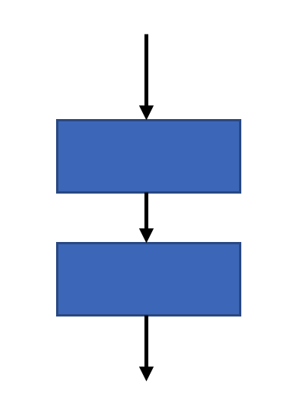
In an algorithm, sequence involves simple steps which are to be executed one after the other. The steps are executed in the same order in which they are written.
In pseudocode, each task is on a separate line and has the same indentation as the other tasks in the sequence. The tasks are executed one after the other, beginning with the task at the top and ending with the task at the bottom.
In a flowchart, tasks are represented by rectangles. The tasks are executed from top to bottom. To ensure the correct order, arrows indicate the flow of tasks through a sequence. An oval is often used to indicate the start and end of the flowchart.
Draw a flowchart and write pseudocode for a smoke detector in the space below.

Selection
Selection is used in an algorithm to determine which particular step or set of steps is to be executed. A selection statement can be used to choose a specific path dependent on a condition.
Selection allows a choice is made between alternative courses of action. A condition is tested (often using a comparison operation) and tasks are performed depending on whether the test is true or false. Selection is also known as branching.
- In pseudocode, selection is represented by the IF-THEN-ELSE construct.
- In flowcharts, selection is represented using the diamond symbol.
There may be times you want something done when a condition is met, but don't want anything done if the condition isn't met, so the ELSE part is optional.
There are 2 types of selection:
- binary (2-way branching) selection
- multi-way (many way branching) selection.

Binary selection
Figure 18 – flowchart symbols showing binary selection
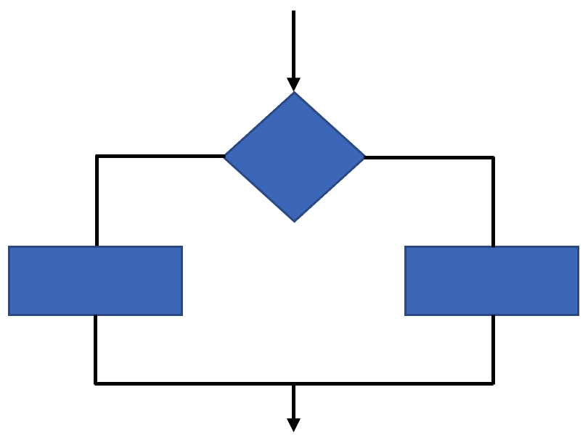
Binary selection allows the choice between 2 possible paths. If the condition is met then one path is taken, otherwise the second possible path is followed.

Multiway selection
Figure 19 – flowchart symbols showing multiway selection
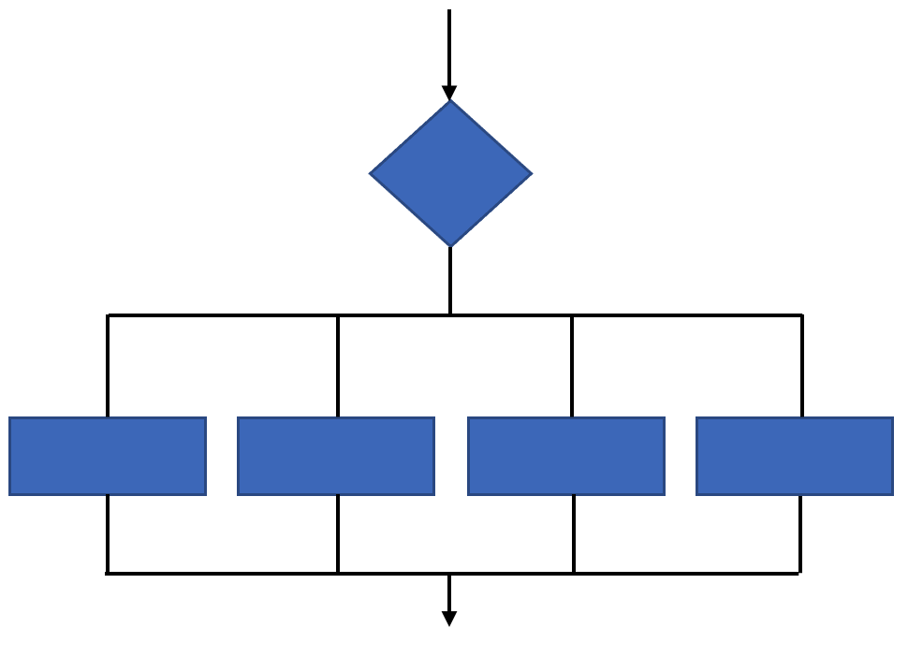
Multi-way selection allows for any number of possible choices, or cases. The path taken is determined by the selection of the choice which is true. Multi-way selection is often referred to as a case structure.

Draw a flowchart and write pseudocode to use an ultrasonic sensor to detect an obstacle in the space below.

Iteration
Repetition allows for a portion of an algorithm to be done any number of times dependent on some condition being met. An occurrence of repetition is usually known as a loop.
An essential feature of repetition is that each loop has a termination condition to stop the repetition, or the obvious outcome is that the loop never completes execution (an infinite loop).
There are several things you need to consider when deciding on the best way to construct loops:
- Conditions of entry: What conditions should exist for entry into a loop?
- Number of loops: Do you want to execute the loop instructions for a particular number of times?
- Conditions of exit: How will you modify the condition, so that it becomes false and the loop can stop?

Pre-test loop
Figure 20 – flowchart symbols showing iteration in a pre-tested loop
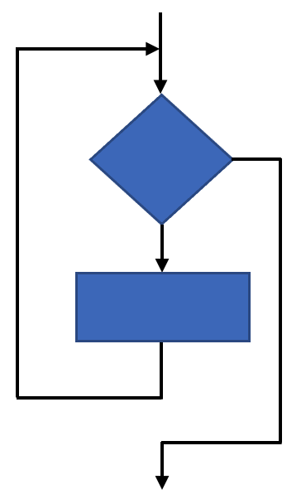
A pre-tested loop is so named because the condition has to be met at the very beginning of the loop or the body of the loop is not executed. The body of the loop is executed.

Post-test loop
Figure 21 – flowchart symbols showing iteration in a post-tested loop
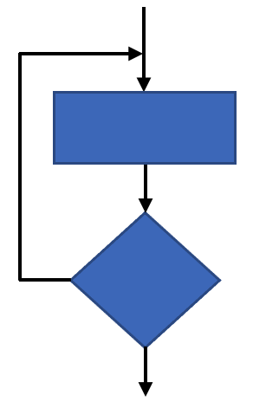
A post-tested loop executes the body of the loop before testing the termination condition. The body of the loop is repeatedly executed until the termination condition is true.
Draw a flowchart and write pseudocode to move a servo when a sensor is activated in the space below.

Design a mechatronic or automated system activity
The sample below is a system designed so that a homeowner does not need to take their bins out to the kerb on rubbish collection day.
Look at the example going through the design and production steps and then imagine a mechatronic or automated system you would like to have at your home.

Identifying and defining
Task: taking rubbish bins to the kerb
Table 24 – sensors and actuators needed for each step
Step | Sensors/actuators
Wait until it is rubbish collection day | Clock
Check that the bin has waste in it to be emptied | Weight sensor or ultrasonic distance sensor
Take the bin to the kerb | GPS, electric motor and camera or ultrasonic distance sensor
Wait until the bin is emptied | Weight sensor or ultrasonic distance sensor
Return the bin to its location on the premises | GPS, electric motor and camera or ultrasonic distance sensor
Repeat (loop) | Arduino or other microcontroller

Research and planning
Figure 22 – labelled wheelie bin
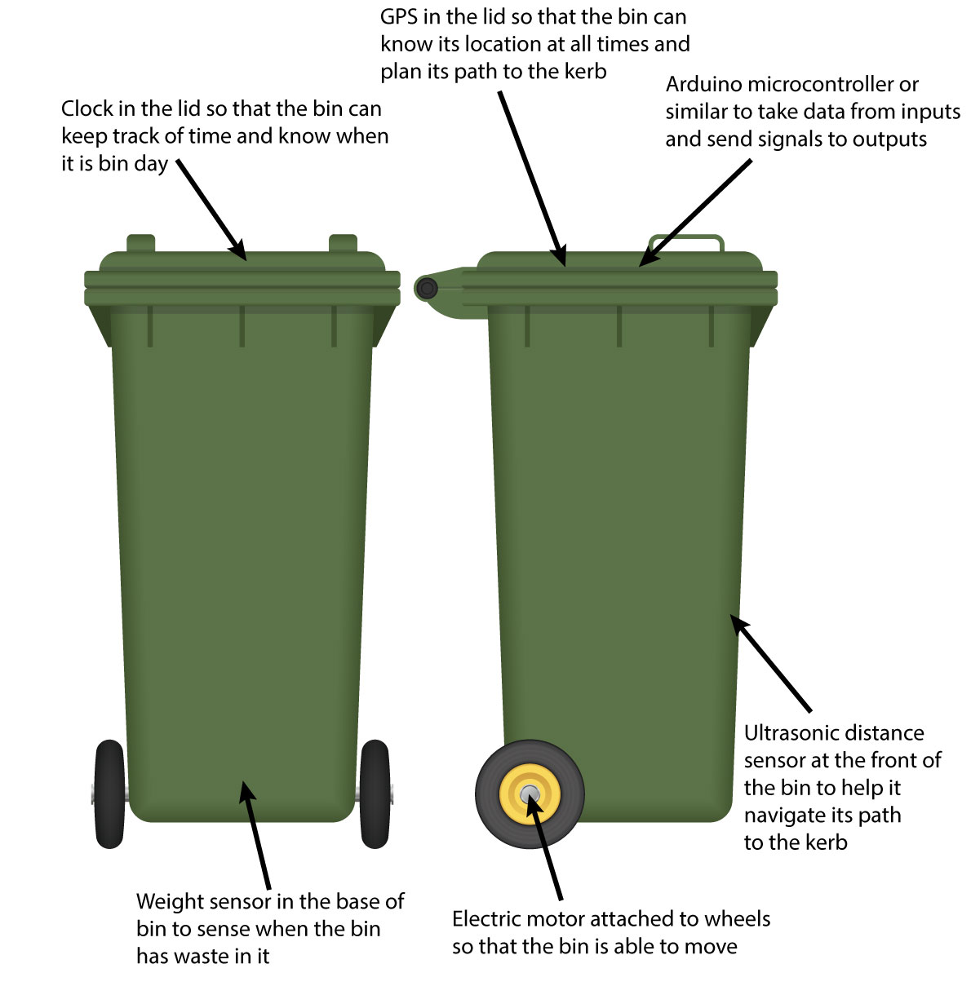
Autodesk screen shots reprinted courtesy of Autodesk, Inc.

Producing and implementing
Below is a sample flowchart for an automated wheely bin.
Figure 23 – flowchart showing a process for creating an automated bin
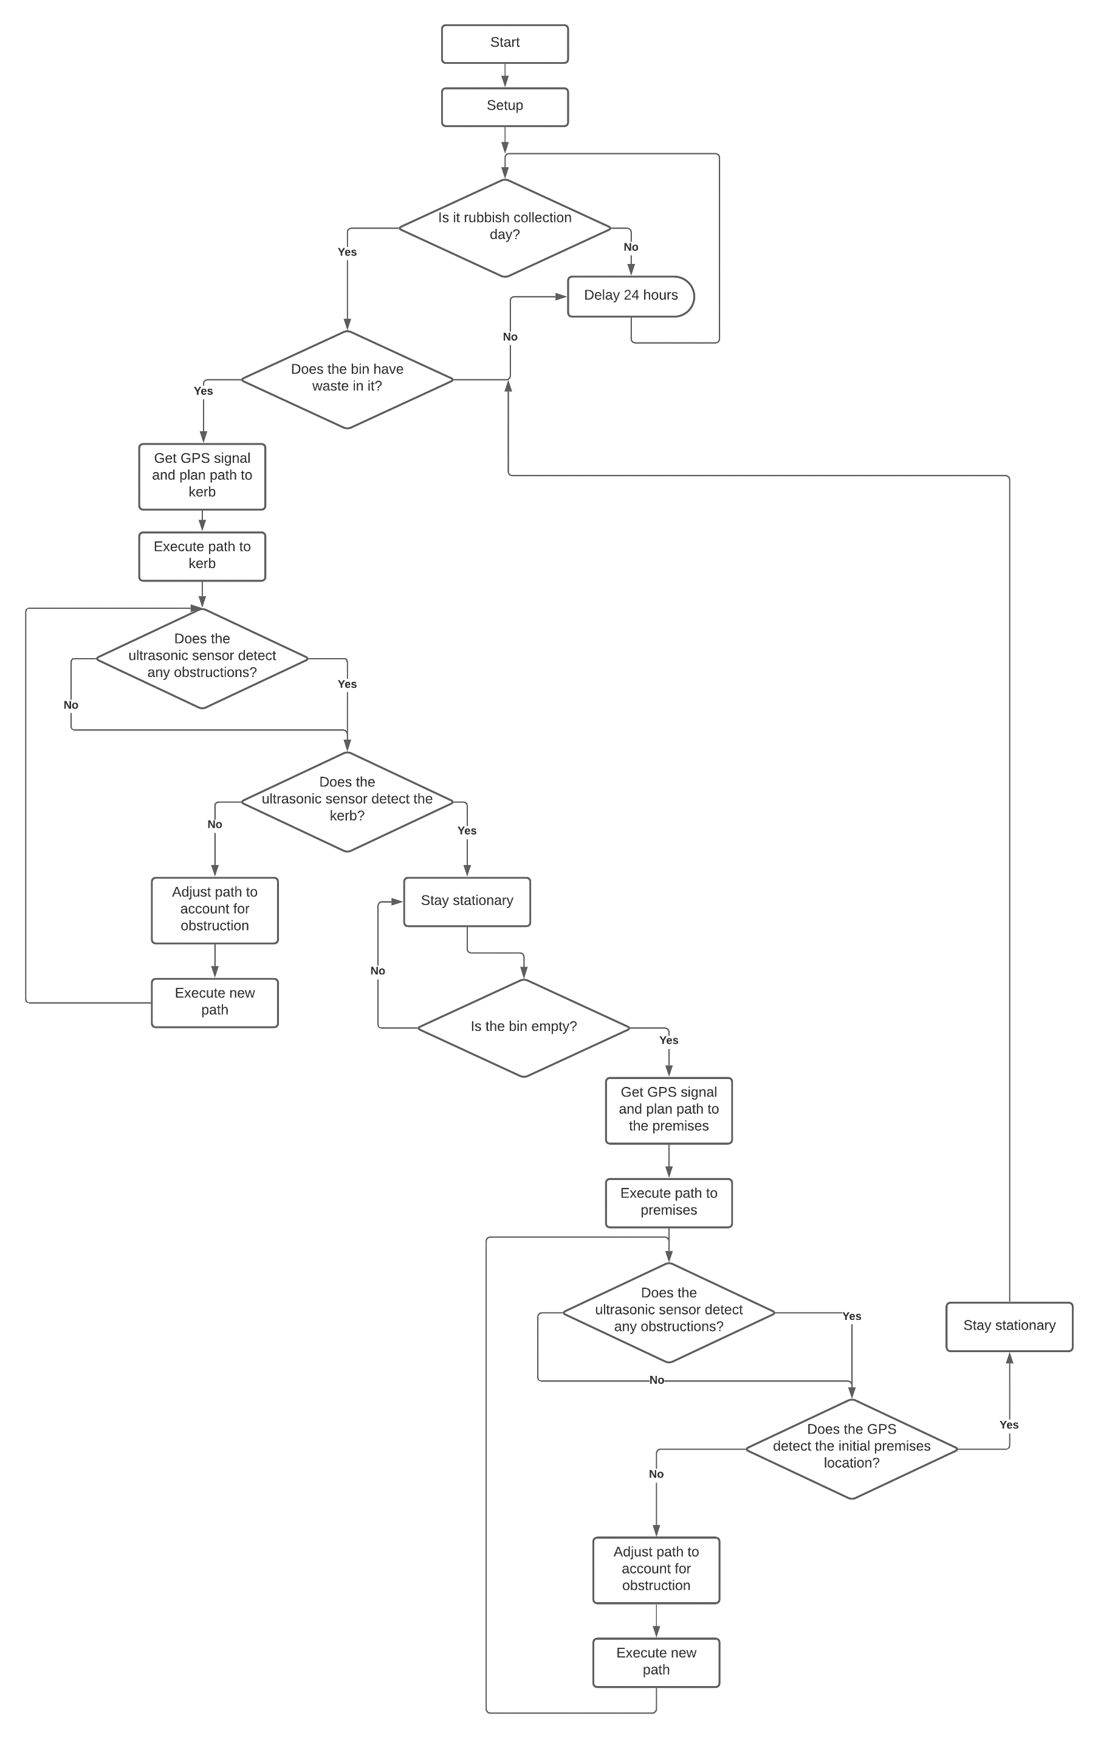

Producing and implementing
Below is a sample pseudocode for an automated rubbish bin.
Initialise the motors as outputs.
Initialise the GPS, weight sensor and ultrasonic distance sensor as inputs.
If it is not rubbish collection day, delay 24 hours.
If it is rubbish collection day, read weight sensor to see if bin has waste in it.
If there is no waste in the bin, delay 24 hours.
If there is waste in the bin, read GPS, plan route to kerb, execute route to kerb.
If there are no obstructions detected, check to see if the kerb is detectable.
If the kerb is not detected, continue route to kerb.
If an obstruction is detected and the kerb is not, adjust route to account for obstruction, execute new route.
If the kerb is detected, stay stationary.
If the bin has not been emptied, stay stationary.
If the bin has been emptied, read GPS, plan route to premises.
If there are no obstructions detected, check GPS to see if initial location is detected.
If an obstruction is detected and the initial location is not detected, continue route to initial location.
If initial location is detected, delay 24 hours.

Design a mechatronic or automated system activity
Choose a task or chore which you do around the house frequently that could be simplified by designing a digital solution.

Identifying and defining
Record the basic steps of the task and consider any sensors or actuators you might need in your digital solution to help complete the task.
Task or chore:
Table 25 – blank table to input steps and sensors or actuators needed
Step | Sensors/actuators

Researching and planning – sketch
Sketch your digital solution below and annotate each of the inputs and outputs that will be required for it to function. Use a pencil so that you can edit your sketch as needed.

Producing and implementing – flowchart
In the space below draw a flowchart to plan how your digital solution will function.
Hint: refer to the ‘Identifying and defining’ exercise, as you have already broken down the task or chore into basic steps. If you need additional space attached a piece of A4 paper. Use pencil so that you can edit your flowchart as needed.

Producing and implementing – pseudocode
In the space below write the pseudocode for your digital solution.
Hint: refer to the ‘Identifying and defining’ exercise, as you have already broken down the task or chore into basic steps. If you need additional space attach an A4 sheet of paper. Use pencil so that you can edit your pseudocode as needed.

Testing and evaluating – mid process
Swap your design with a partner and complete the evaluation below on their digital solution.
What is the common household task or chore the design solution is designed to address?
Are there any products that already exist which make this task or chore easier?
How does this digital solution differ from, or improve upon existing designs?
List the sensors and actuators that have been included in the design.
Are the sensors and actuators appropriate for the function of the digital solution? Are there any alternative/additional sensors that could be included to improve the function?
Analyse the flowchart and pseudocode for the digital solution. Is the algorithm logical and easy to follow? Are there any areas which could be improved? How?
Overall, how effective will the digital solution be at completing its intended task or chore? Why?

Self-assessment
Tick the appropriate box for each of the learning intentions.
1= I need a challenge, I can teach this to others.
2= I can do this confidently.
3= I can do this, but need more practice and revision.
4= I can do this with some assistance.
Table 26 – self-assessment chart
Learning intentions | 1 | 2 | 3 | 4
Break down a common household chore or task into its basic steps so that they can be applied to a digital solution.
Determine the sensors and actuators needed to complete each step of the chore or task.
Plan how each of the inputs and outputs will need to interact with each other so that the solution can complete the chore or task.
Design an algorithm for your digital solution using a flowchart.
Represent the algorithm using pseudocode.
Evaluate a peer’s product based on their choice of sensors and actuators.
Trace a peer’s algorithm.
Evaluate a peer’s algorithm.

Validate algorithms with desk checking

Test data for checking algorithms and code
Test data is made up of sets of inputs. Each test data set is input into either the algorithm or the coded solution and the processing and outputs observed. The creation of test data sets aims to ensure that all processes are thoroughly tested. The logic of algorithms and source code needs to be tested. Therefore, each set of test data will be designed to check some particular processing scenario. To do this effectively requires that we know the expected outputs for each test data set.

Desk checking
Desk checking is a manual process of going through the code or pseudocode to check its logic. It's a good technique to use before your start coding, however, is also used as a debugging method. When using data for desk checking, you should check it against the requirements of the specifications (what the program is supposed to do), not what your algorithm actually does. You should know what the expected outputs are so that you know whether your program is working correctly.
Advantages:
- Catch a bug even before it occurs. An experienced programmer also tends to make mistakes, so desk checking is a way to take precaution in that regard.
- It is an inexpensive and quick technique.
- As the programmer writes the code/algorithm on his own, he can check if there is any issue or not and fix the issue before the project moves on to the later stages.
Disadvantages:
- Although the programmer is able to find out the errors in their own code, it may sometimes be otherwise. He may not be able to track the issue or bug in the code, which may result in erroneous outcomes.
Desk checking enables developers to proceed in a very systematic manner, in terms of coding. This technique eliminates the chances of erroneous code as proper review is done to analyse the problem and therefore offer the best solution for a given problem.
Desk checking is also called a dry run and is where specific aspects of the algorithm are tested. This requires setting up a check table and then systematically working through the algorithm and completing the table. The table generally lists:
- test data
- expected results
- results that are achieved when you precisely follow the algorithm.

Pseudocode example
BEGIN MAINPROGRAM
Initialise values
Get 3 numbers
Average = Sum / Count
Print Average
END MAINPROGRAM
BEGIN SUBPROGRAM
Initialise values
Sum = 0
Average = 0
Number = 0
END SUBPROGRAM
BEGIN SUBPROGRAM Get 3 numbers
Count = 0
WHILE Count < 3
Get a Number
Sum = Sum + Number
Count = Count + 1
ENDWHILE
Count = Count + 1
END SUBPROGRAM
Desk check for algorithm giving incorrect results (Results expected are different to Results achieved).
Table 27 – desk check for algorithm
Numbers entered | Results expected | Results expected | Results achieved | Results achieved
 | Average | Sum | Average | Sum
1, 7, 4 | 4 | 12 | 3 | 12
1, 0, 5 | 2 | 6 | 1.5 | 6
0, 0, 6 | 2 | 6 | 1.5 | 6
The error in the algorithm in the desk check above is the additional Count = Count + 1 (after the ENDWHILE) in the subprogram Get 3 Numbers. Therefore, the value of the Count will be one larger than it should be.
If any faults are discovered the algorithm must be corrected and then tested again. If not re-tested, other errors that may have been introduced while correcting the first error will go undetected.

Activity– desk check
Desk check the following algorithm. Use the test data Y = 2 to complete table below:
Table 28 – algorithm desk check
1 X = 1
2 Get Y
3 REPEAT
4 Z = Y
5 IF X < 7 THEN
6 X = X + 1
7 IF X < 8 THEN
8 Print X * Z
9 END IF
10 END IF
11 X = X + 1
12 UNTIL X > 8
13 Print “Done”

X | Y | Z | Output

Producing and implementing
Investigate a real-world problem or need that can be solved by mechatronic and/or automated systems. Include breaking the system down into manageable parts and interviewing stakeholders to identify their needs.
List the stakeholder needs in the space below.
Create a concept map of the chosen mechatronic or automated system, breaking the system down into manageable parts and insert it in the box below.
Students may use a concept map template.
Students can also use a website that facilitates collaborative mind map building.
Select and evaluate existing solutions to the problem or related problems by completing the table below.
Table 29 – evaluating existing solutions
Existing solution | Evaluate the mechatronic or automated system
Teacher note: platform selection for the project may see various ways to implement the project-based learning required in the focus area. The accompanying assessment removes reference to the platform choice. An example of a base kit that is cost effective and can be modified is the Arbot. This has been produced with instructions on building the components and examples of modifiable code to conquer a range of challenges.
Students can use these activities as stepping stones in their learning to alter and interpret code. Students can then finalise a system that emulates a real-world mechatronic system.
Teacher note: you many need to examine the current equipment and expertise in your school context area. There are many products available, but to meet the needs of the syllabus the platform must use text-based coding.
Depending on the platform chosen you may need to upskill in a range of technology.
There are educational courses from soldering equipment to learning Arduino prototyping available through LinkedIn Learning.
Teacher note: the Arbot is one packaged option available. There are many examples of projects on the Arduino Project Hub. You may also have access to other platforms that use text based programming.
Components for a kit could include:
Laser cut chassis
Arduino Uno with upload cable
Motor Controller (L298N)
Ultrasonic sensor (HC-SR04)
2 motors with wheels
Omni-wheel
Battery Case with four AA batteries
Switch

Teacher note: RoboCup Junior Australia have resources with concepts for further activities. These enriching tasks can deepen the learning of a programming language by completing challenges such as a Rescue Maze. A tutorial is also available for Maze rescue for Ev3 using Micropython.

Debug a range of errors
When making a project there are chances that you encounter errors. The errors can be either related to the code or to the hardware of the project. Issues can be overcome if we keep in mind a few things.
Check that the correct board type and port are selected in the tools menu.
Go back to the pseudocode and flowchart. Are the instructions in the correct order? Computers only do what they are told line by line!
Make sure you use the semi colon (;) at the end of each line.
- Exceptions include:
- void setup () {
- void loop () {
- if (condition) {
For every opening bracket or brace ( {, there must be a closing one. ) }.
- Putting the cursor on a brace will highlight its partner.
- Best practice is to type in a closing brace directly after you type the opening one.
Check that commands change colour when you type them. If a command has not changed colour it may be spelt incorrectly.
Some commands are written in camel case. This is where the words are joined but use a capital for the second word. Examples include:
- pinMode
- digitalWrite.
Check simple things such whether the USB cable is fully plugged in. Sometimes the cable can be faulty. Swap with another cable to check.
Sometimes when you verify your sketch, the error is in the line before the highlighted line.
Do the pin numbers in the code match where devices are plugged in?

Interpret and modify existing programs
Interpret and modify existing programs (code) for mechatronic and/or automated systems
In the diagram below, the vehicle has 3 wheels. One is an omni wheel or rear castor and 2 are motorised wheels. To move the motorised wheels, a microcontroller needs to affect 2 actuators. To control this movement a H-Bridge can receive instructions from a microcontroller to perform. The actuator receives its instructions as power. The H-Bridge communicates to the microcontroller with data and is connected for power supply.
Look at the diagram below to see the rotation of the motor for different movements.
Figure 24 – how 2 motorised wheels move to travel forward, reverse, turn right and turn left
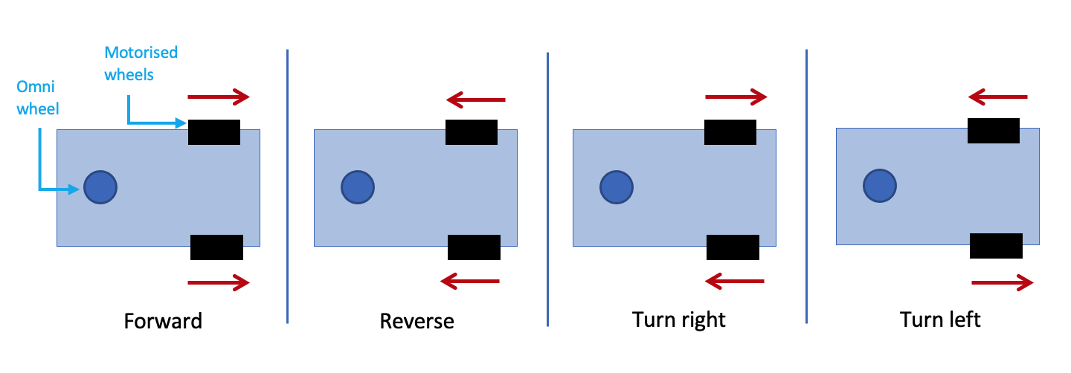

Activity – look at how a H-Bridge can control movement

H-Bridge L298N
The L298N Motor Driver is a controller that uses a H-Bridge to easily control the direction and speed of up to 2 DC motors.
Below is a diagram labelling the connecting pins.
Figure 25 – H-Bridge L298N labelled with pins
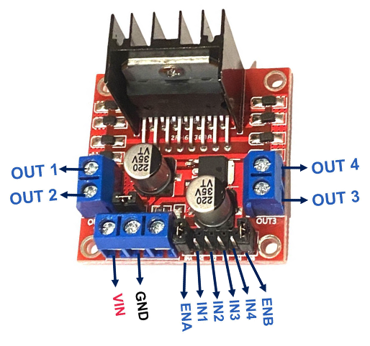
- The Enable A and Enable B pins are used the speed of the motor
- The Input 1 (IN1) and Input 2 (IN2) pins are used for controlling the rotation direction of motor A
- The Input 3 (IN3) and Input 4 (IN4) pins are used for controlling the rotation direction of motor B
- Using these pins we control the switches of the H-Bridge inside the L298N
- If input 1 is LOW and input 2 is HIGH the motor will move forward
- If input 1 is HIGH and input 2 is LOW the motor will move backward
- The same applies for the inputs 3 and 4 and the motor B
- GND stands for ground
- VIN stands for voltage in.
Below is a table and diagram on connecting the pins from the H-Bridge to the Arduino UNO.
Figure 26 – diagram and table of a H-Bridge data and connecting components
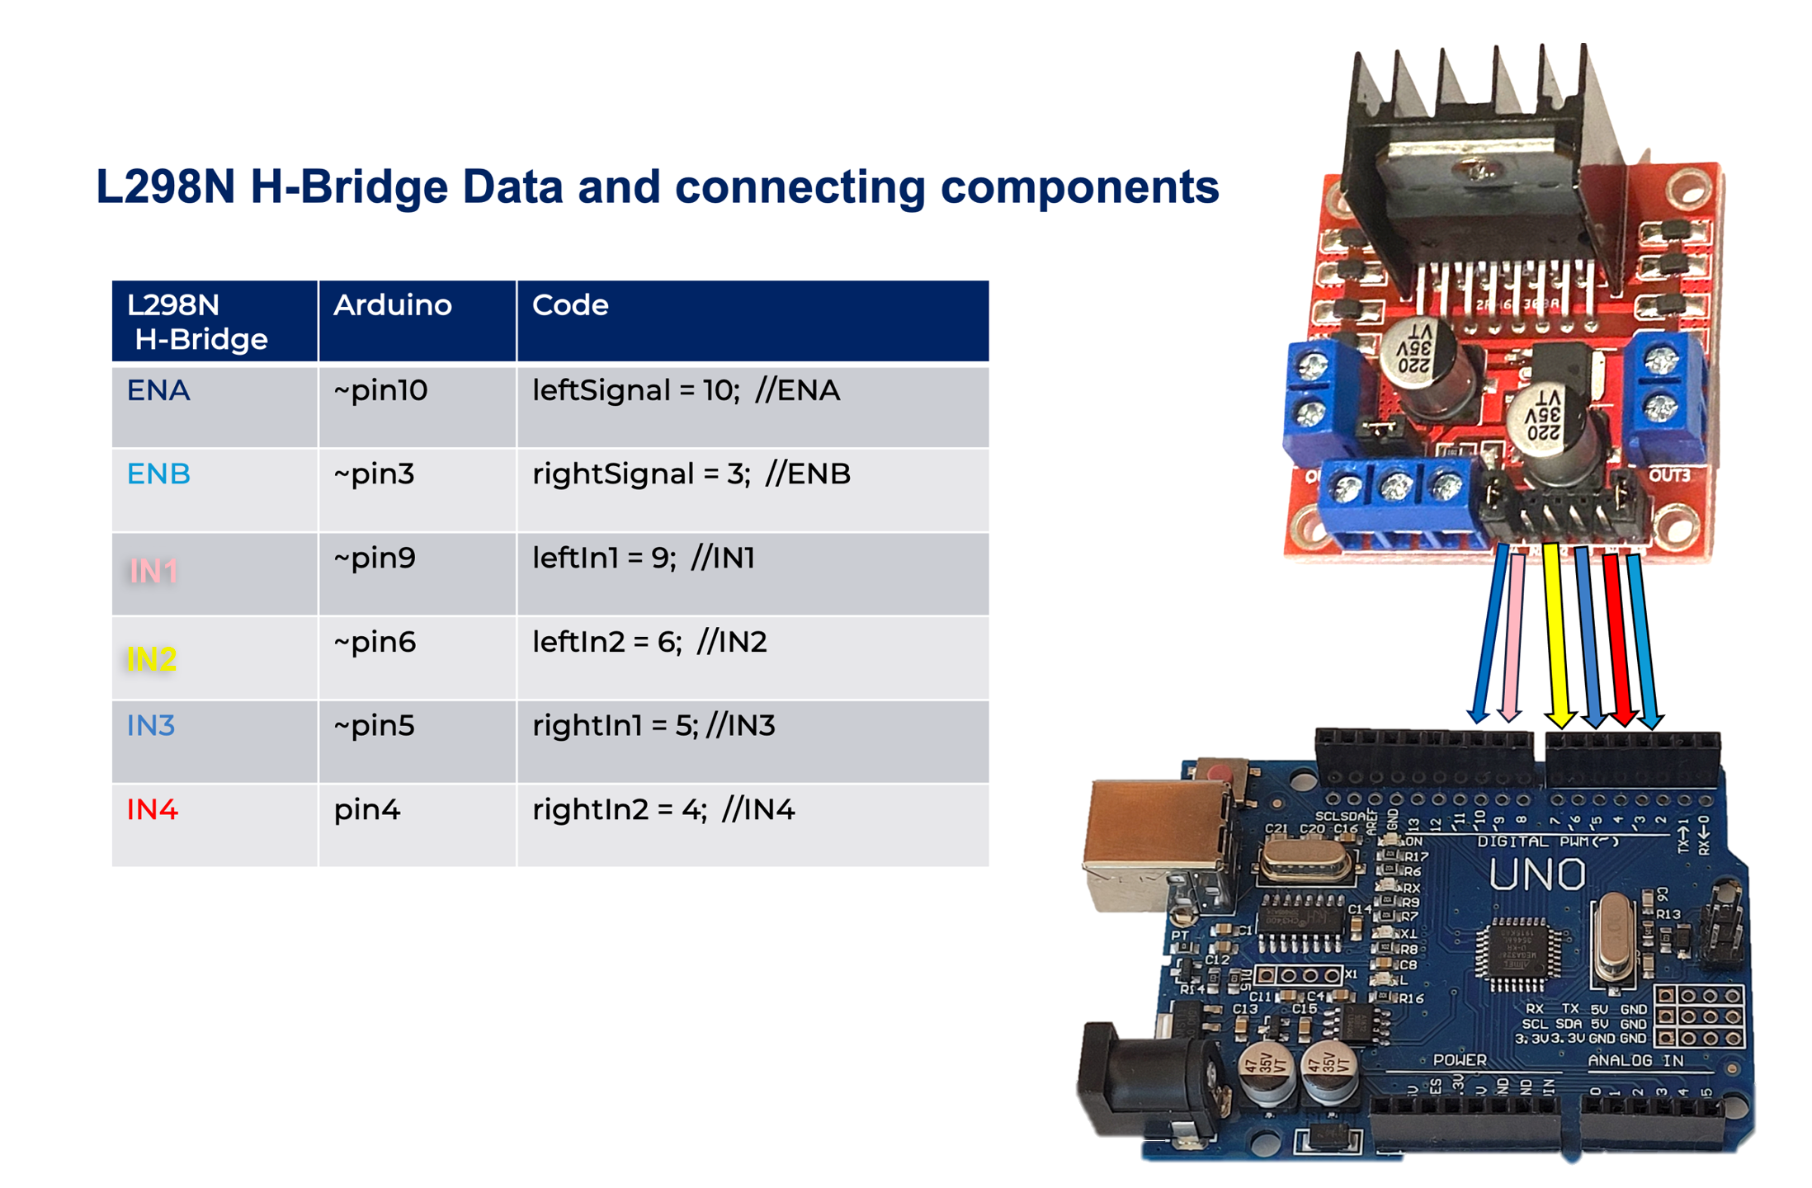
Below is a table and diagram on connecting power to the H-Bridge.
Figure 27 – diagram and table of a H-Bridge and its components that connect to power
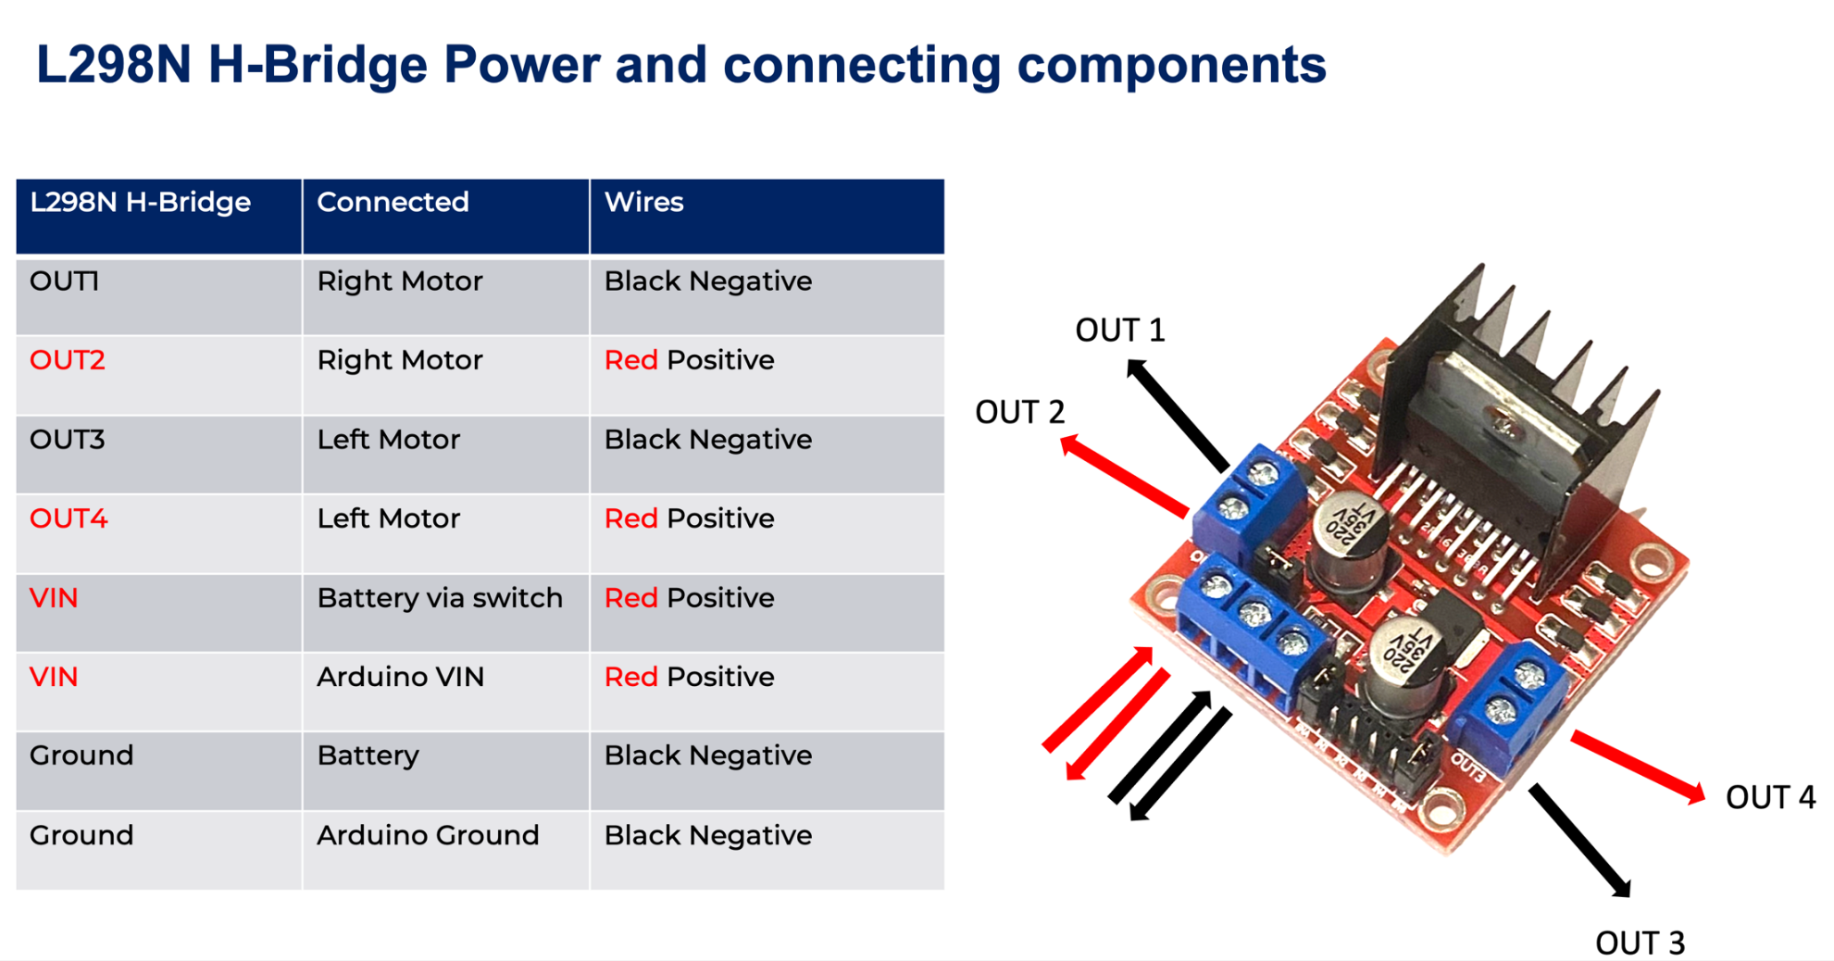

Coding for Arduino cheat sheet
Basic program structure: (students can copy and paste this to start).

Step 1: Declare your variables
A variable is a name given to a value that you change in the program, such as: what is the current temperature?
You need to tell the computer two things. First, what type of data is it? Is it a whole number (integer,) a decimal point number (float) or text (char)?
For example int buzzer = 8; (means the buzzer is connected to pin 8).
Common commands for step 1:
- int buzzer = 8;
- int LED = 13,
- int pushbutton= 12;
This means that the buzzer is connected to pin 8, the LED is connected to pin 13 and a pushbutton is connected to pin 12.

Step 2: Set up the board
In Arduino, we use a command called pinMode to set up the pins as input or output pins. For example, pinMode (8,OUTPUT), tells the Arduino processor to pump electrons out of the board to the pin. Whereas pinMode (8, INPUT); tells the computer to listen to that pin for an electrical signal.
pinMode (Pin#,INPUT_PULLUP) is a special form of INPUT, used when you are listening for a SIGNAL (like a switch or a sensor).
Common commands for step 2:
- pinMode (8,OUTPUT);
- pinMode (A0, INPUT_PULLUP);
- pinMode (10, INPUT);
void setup () {
Write your setup commands inside these curly braces.
}

Step 3: Write the main program (loop)
In this section, we write the main part of the program.
First you write plan out you code using flowcharts and pseudocode so you know what you have to do.
Copy and paste the SIMPLE ENGLISH code across to your board and ‘comment it out’ using two forward slash, like this //.
Write your code in between the curly braces on the left hand side of the two slashes (next to your pseudocode).
Common commands for step 3:
- digitalWrite(#,state)
- delay (in 1/1000s of a second)
- analogRead (pin#)
- digitalRead (pin#)
- tone (pin#, frequency, length in 1/1000s of a second)
- noTone (pin#)
void loop() {
code here // pseudocode in plain English here
}
The ‘if’ and ‘else’ statement:
To write the code for if statements from pseudocode (for example, if (this happens), {do this}, otherwise {do that}), it would look like the code below.
int value = digitalRead (9)
if (value == 1) {digitalWrite(13,HIGH);}
else {digitalWrite(13,LOW);}
if statements - Beware of the ==
1 + 1 = 2 (a single equals sign is maths. Called an assignment)
1 + 1 == 2 (the double equals is asking a question. Does 1 + 1 == 2?

Record of project development
Plan and manage a project using an iterative approach. Keep a record of project development and video record your system model attempting processes as it evolves.
Use the following pages as a diary to document the development of your project. Make note of skills and knowledge gained, challenges faced and successes demonstrating iterative design and evaluation.
Table 30 – diary to document project development
Date | Description
__/__/__
__/__/__
__/__/__
__/__/__
__/__/__
__/__/__
__/__/__
__/__/__
__/__/__

Testing and evaluating
Evaluate your own project using predetermined functional and non-functional requirements in the tables below.
Table 31 – evaluation of project for functional requirements
Requirements | Specify the functional requirements of your mechatronic or automated system | Evaluate the functional requirements of your mechatronic or automated system
The purpose of a system
Describe use cases
Develop test cases of inputs
Develop test cases of expected outputs
Table 32 – evaluation of project for non-functional requirements
Requirements | Explain the non-functional requirements of your mechatronic or automated system | Evaluate the non-functional requirements of your mechatronic or automated system
Battery disposal
Improved wellbeing as a result of implementation
Ease of manufacturing the system
Evaluate your peers using predetermined functional and non-functional requirements in the tables below.
Table 33 – evaluation of project for functional and non-functional requirements
Requirements | Specify the functional requirements of your mechatronic or automated system | Evaluate the functional requirements of your mechatronic or automated system
The purpose of a system
Describe use cases
Develop test cases of inputs
Develop test cases of expected outputs
Table 34 – evaluation of project for functional and non-functional requirements
Requirements | Explain the non-functional requirements of your mechatronic or automated system | Evaluate the non-functional requirements of your mechatronic or automated system
Battery disposal
Improved wellbeing as a result of implementation
Ease of manufacturing the system
Develop and apply test criteria for components of a mechatronic and/or automated system in the table below.
Table 35 – evaluation of test criteria for components of a mechatronic and/or automated system
Components | Test criteria | Evaluate the result of test criteria
microcontroller
ultrasonic sensor
servo
Propose software and hardware modifications to increase the effectiveness of a mechatronic and/or automated system in the table below.
Table 36 – proposed software and/or hardware modifications to increase effectiveness of the project
Software or hardware component | Possible modification to increase effectiveness
Evaluate social, ethical and cybersecurity considerations of mechatronic and automated systems in the table below.
Table 37 – evaluation of social, ethical and cybersecurity considerations for mechatronic and automated systems
Consideration | Evaluation
Social | Sample answers:  - Job loss and economic disruption: As automation becomes more prevalent, it may lead to the displacement of workers, particularly in industries where tasks can be easily automated. This could lead to economic disruption and increased inequality.  - Privacy concerns: Automated systems often collect and process large amounts of personal data, raising concerns about data privacy and security.  - Inclusion and accessibility: Automated systems may not be accessible or inclusive for certain groups of people, such as those with disabilities or those who lack the necessary skills to interact with the technology.  - Social isolation: Some people may feel isolated or lonely due to increased automation and the reduced need for human interaction.  - Societal change and cultural shift: as the technology advances, it is likely to change the way we live and work, which may have an impact on the cultural norms, values and expectations, leading to social issues related to the psychological and social adaptation.  - Distribution of benefits and harms: As the use of mechatronics and automation systems increase, there is a need to ensure that the benefits of these systems are distributed equitably and that their negative impacts are minimised.
Ethical | Sample answers:  - Responsibility: When accidents or errors occur, it can be difficult to determine who is responsible and accountable for the consequences. This is particularly problematic with autonomous systems, which are capable of making decisions and taking actions without human oversight.  - Transparency: Complex algorithms and decision-making processes used in these systems can be difficult for non-experts to understand, making it difficult to assess their performance and trustworthiness.  - Bias and discrimination: Automated systems may perpetuate or even amplify existing biases in society, if the data or algorithms used to train them are biased.  - Data privacy: Automated systems often collect and process large amounts of personal data, raising concerns about data privacy and security.  - Control and autonomy: As autonomous systems become more sophisticated, there are concerns about the degree of control humans will have over them and the potential for these systems to act in ways that are detrimental to humans.  - Human-in-the-loop decision making: As the number of autonomous systems increase, the ethical issues surrounding the decision making process of these systems, like self-driving cars, drones, and robots, become more complex. The ability of these systems to decide whether to harm or spare human lives in certain situations, with or without human supervision, is an ongoing ethical debate.
Cybersecurity | Sample answers:  - Vulnerabilities in hardware and software: Mechatronic and automated systems often use complex hardware and software, which can contain vulnerabilities that can be exploited by cybercriminals.  - Network security: Automated systems often rely on communication networks, which can be vulnerable to cyber-attacks such as denial-of-service attacks and man-in-the-middle attacks.  - Data breaches: Automated systems often collect and process large amounts of personal data, which can be vulnerable to data breaches if the systems are not properly secured.  - Unauthorised access: Mechatronic and automated systems are often controlled remotely, which can leave them vulnerable to unauthorised access by cybercriminals.  - Malicious attacks: Automated systems can be targeted by malicious actors who can use exploits to gain unauthorised access, steal sensitive data, disrupt operations or even cause physical damage.  - Interoperability: As the number of automated systems increase, the integration of these systems with one another and with other networks, increases the risk of cyber-attacks that can spread across different systems and networks.  - Supply chain security: The security of the components and the supply chain of the systems is crucial to the overall security of the system, as it may introduce vulnerabilities if the components or the supply chain are not secure.

Careers
Identify the vast number of pathways into the industry, with a focus on tertiary education. Explain the competitive nature of the industry and prevalence of small start-up companies.
Watch a range of career profile videos including entrepreneurial skills and what it is like to be a mechatronics engineer (2:27).
Explore careers in mechatronic and automated systems design, production, installation or maintenance by completing the table below.
Table 38 – careers in mechatronic and automated systems design
Field | Mechatronic or automated system career example
System design
Production
Installation
Maintenance
Research 3 current existing positions and their criteria from current employment websites such as SEEK, Indeed and CareerOne.
Table 39 – career research task
Criteria | Response
Job title
Training required
Personal requirements
Outline of duties
Average income
Table 40 – career research task
Criteria | Response
Job title
Training required
Personal requirements
Outline of duties
Average income
Table 41 – career research task
Criteria | Response
Job title
Training required
Personal requirements
Outline of duties
Average income

Support and alignment
Resource evaluation and support: all curriculum resources are prepared through a rigorous process. Resources are periodically reviewed as part of our ongoing evaluation plan to ensure currency, relevance, and effectiveness. For additional support or advice contact the TAS curriculum team by emailing TAS@det.nsw.edu.au.
Alignment to system priorities and/or needs: School Excellence Policy, School Success Model.
Alignment to the School Excellence Framework: this resource supports the School Excellence Framework elements of curriculum (curriculum provision) and effective classroom practice (lesson planning, explicit teaching).
Alignment to Australian Professional Teaching Standards: this resource supports teachers to address Australian Professional Teaching Standards 3.2.2, 3.3.2.
Consulted with: Curriculum and Reform and subject matter experts
NSW syllabus: Computing Technology 7–10
Syllabus outcomes: CT5-DPM-01, CT5-COL-01, CT5-EVL-01, CT5-OPL-01, CT5-THI-01.
Author: TAS, Curriculum Secondary Learners, Curriculum Reform
Publisher: State of NSW, Department of Education
Resource: program of learning
Related resources: further resources to support Computing Technology 7–10 can be found on the TAS curriculum page.
Professional learning: relevant professional learning is available through the TAS statewide staffroom.
Creation date: 2022
Rights: © State of New South Wales, Department of Education.

Evidence base
Computing Technology 7–10 Syllabus © NSW Education Standards Authority (NESA) for and on behalf of the Crown in right of the State of New South Wales, 2022.
AITSL (Australian Institute for Teaching and School Leadership Limited) (n.d.) Learning intentions and success criteria [PDF 251KB], AITSL, accessed 29 August 2022.
Brookhart S (2011) How to Assess Higher-Order Thinking Skills in Your Classroom, Hawker Brownlow Education, Victoria.
CESE (Centre for Education Statistics and Evaluation) (2020a) What works best: 2020 update, NSW Department of Education, accessed 29 August 2022.
CESE (Centre for Education Statistics and Evaluation) (2020b) What works best in practice, NSW Department of Education, accessed 29 August 2022.
Rosenshine B (2012) ‘Principles of Instruction: Research-Based Strategies That All Teachers Should Know’, American Educator, 36(1):12-19, 39, accessed 29 August 2022.
Wiliam D (2013) ‘Assessment: The bridge between teaching and learning’, Voices from the Middle, 21(2):15–20, accessed 29 August 2022.
Wiliam D (2018) Embedded Formative Assessment, 2nd edn, Solution Tree Press, Bloomington, IN.
Wisniewski B, Zierer K and Hattie J (2020) ‘The Power of Feedback Revisited: A Meta-Analysis of Educational Feedback Research’, Frontiers In Psychology, 10:3087, doi:10.3389/fpsyg.2019.03087, accessed 29 August 2022.

References
This resource contains NSW Curriculum and syllabus content. The NSW Curriculum is developed by the NSW Education Standards Authority. This content is prepared by NESA for and on behalf of the Crown in right of the State of New South Wales. The material is protected by Crown copyright.
Please refer to the NESA Copyright Disclaimer for more information https://educationstandards.nsw.edu.au/wps/portal/nesa/mini-footer/copyright.
NESA holds the only official and up-to-date versions of the NSW Curriculum and syllabus documents. Please visit the NSW Education Standards Authority (NESA) website https://educationstandards.nsw.edu.au/ and the NSW Curriculum website https://curriculum.nsw.edu.au/home.
Computing Technology 7–10 Syllabus © NSW Education Standards Authority (NESA) for and on behalf of the Crown in right of the State of New South Wales, 2022.
ABC (Australian Broadcasting Corporation) (10 November 2014) 'Talking stick: Native Title’ ABC 2010' [video], Tranby NIAET, YouTube, accessed 9 September 2022.
Ackerman E (23 July 2022) ‘How Robots Can Help Us Act and Feel Younger’, IEEE (Institute of Electrical and Electronics Engineers) Spectrum, accessed 9 September 2022.
Ackerman E (1 September 2022) ‘Aerial Dragon Robot Reconfigures Itself Into a Flying Manipulator’, IEEE Spectrum, accessed 9 September 2022.
ADF (Australian Defence Force) (23 November 2020) 'Concept for Robotics and Autonomous Systems' [video], Digital Media, YouTube, accessed 9 September 2022.
AITSL (Australian Institute for Teaching and School Leadership (2017) ‘Feedback Factsheet’, AITSL, accessed 12 May 2023.
AltexSoft (2 December 2021) 'Software Planning and Technical Documentation' [video], AltexSoft, YouTube, accessed 9 September 2022.
AltexSoft (16 June 2022) 'What are Non-functional Requirements and How Do They Work?' [video], AltexSoft, YouTube, accessed 9 September 2022.
Anderson MR (17 March 2017) ‘After 75 years, Isaac Asimov’s Three Laws of Robotics need updating’, The Conversation, accessed 9 September 2022.
Animagraffs (2022) How Self Driving Cars Work, Animagraffs website, accessed 9 September 2022.
Arduino (2022) ‘Servo Motor Basics with Arduino’, Learn: Electronics, Arduino website, accessed 9 September 2022.
Arts Law Centre of Australia (2022) ‘Indigenous Cultural and Intellectual Property (ICIP)’, Info Sheets, Arts Law website, accessed 9 September 2022.
Beer J (22 May 2012) 'TEDxGeorgiaTech – Jenay Beer – Meet Your Grandparents' Assistant: The Domesticated Robot' [video], TEDx Talks, YouTube, accessed 9 September 2022.
Bender E (25 March 2011) 'Eythor Bender demos human exoskeletons' [video], TED, YouTube, accessed 9 September 2022.
Black E (11 May 2019) 'This tomato-picking robot is more efficient than humans and can work 24/7' [video], CNBC Work, CNBC (Consumer News and Business Channel) website, accessed 9 September 2022.
Brandenburg L (6 June 2018) 'User Stories vs Use Cases' [video], Bridging the Gap – Resources for Business Analysts, YouTube, accessed 9 September 2022.
Camber Foundation and GCF (Goodwill Community Foundation) Inc (4 October 2018) 'Computer Science Basics: Sequences, Selections, and Loops' [video], GCFLearnFree, YouTube, accessed 9 September 2022.
CareerOne Pty Ltd (2022) CareerOne [website], accessed 9 September 2022.
Commonwealth of Australia (2022) Threats, ACSC website, accessed 12 May 2023.
Commonwealth of Australia (2022) ‘Quiz library’, Learn the basics: View resources, ACSC (Australian Cyber Security Centre) website, accessed 12 May 2023.
Curtin University (2 June 2016) 'What’s it like to be a Mechatronic Engineer?' [video], Curtin University, YouTube, accessed 9 September 2022.
Da Silva W (21 August 2017) ‘World’s tech leaders urge UN to ban killer robots’, UNSW (University of New South Wales) Sydney Newsroom, accessed 9 September 2022.
de Vinck M (2020) ‘Soldering for Electronic Products and Manufacturing’, Learning Soldering for Electronics, LinkedIn Learning website, accessed 9 September 2022.
Digital Rights Watch Inc (8 August 2022) Media Release: Amazon’s acquisition of Roomba raises privacy concerns [media release], Digital Rights Watch, accessed 9 September 2022.
Dwivedi N (2019) ‘Functional vs. non-functional’, Software Design: Developing Effective Requirements, LinkedIn Learning website, accessed through the DoE portal, accessed 9 September 2022.
Dwivedi N (2019) Software Design: Developing Effective Requirements, LinkedIn Learning website, accessed through the DoE portal, accessed 9 September 2022.
Fonseca L (15 February 2022) ‘10 Use Case Diagram Examples (and How to Create Them)’, Venngage blog, accessed 9 September 2022.
Freethink Media Inc (9 October 2020) 'Engineering the Impossible: The Future of Military Tech' [video], Freethink, YouTube, accessed 9 September 2022.
Gallup R (2021) Arduino: Prototyping, LinkedIn Learning website, accessed through the DoE portal, accessed 9 September 2022.
Gray N (2020) Rescue Maze EV3 Micropython Tutorial, RoboCup Junior website, accessed 9 September 2022.
Guest A (19 February 2022) ‘Are big ag tech companies harvesting farmers’ confidential data?’, ABC News, accessed 9 September 2022.
Guru99 (3 June 2014) 'How to write a TEST CASE? Software Testing Tutorial' [video], Guru99, YouTube, accessed 9 September 2022.
Hampson M (2 August 2022) ‘Underwater Robots Get a Boost in Mapping the Ocean’, IEEE Spectrum, accessed 9 September 2022.
Hayne Robotics (2022) Hayne Robotics [website], accessed 9 September 2022.
Herr H (29 March 2014) 'New bionics let us run, climb and dance | Hugh Herr' [video], TED, YouTube, accessed 9 September 2022.
Hwang Y, Minami Y and Ishikawa M (2018) ‘Virtual Torque Sensor for Low-Cost RC Servo Motors Based on Dynamic System Identification Utilizing Parametric Constraints’, Sensors, 18(11), doi: 10.3390/s18113856, accessed 18 May 2023.
IEEE (2022) Robots: Your Guide to the World of Robotics [website], accessed 9 September 2022.
Indeed Inc (2022) Indeed [website], accessed 9 September 2022.
Kang JJ and Abu-Khalaf J (7 September 2021) ‘Facebook or Twitter posts can now be quietly modified by the government under new surveillance laws’, The Conversation, accessed 9 September 2022.
Kee D (6 August 2021) ‘4 Starter Arduino Projects for Classrooms’, Damien Kee blog, accessed 9 September 2022.
Lesics Engineers Pvt Ltd (31 January 2022) 'The Amazing Engineering behind the Cleaning Robots!' [video], Lesics, YouTube, accessed 9 September 2022.
LKCollab, LLC (2022) Bubble.us, accessed 9 September 2022.
Malan DJ (21 May 2013) 'What’s an algorithm? – David J. Malan' [video], TED-Ed, YouTube, accessed 9 September 2022.
Microsoft Educator Center (15 April 2022) ‘Build machines that emulate humans’, Microsoft Learn articles, accessed 9 September 2022.
Moghrabi H (28 April 2017) 'Sensors used in industry' [video], Thundertronics, YouTube, accessed 9 September 2022.
NASA (National Aeronautics and Space Administration) (2022) MARS Exploration Rovers, NASA Science: Mars Exploration website, accessed 9 September 2022.
NESA (New South Wales Education Standards Authority) (2021) ‘Programming’, Understanding the curriculum, NESA website, accessed 12 May 2023.
Newsocracy LLC (22 July 2014) ‘'i-Limb Bionic Hand is a Game Changer for Amputees' [video], Newsocracy, YouTube, accessed 9 September 2022.
RealPars BV (22 May 2018) 'What is Process Automation?' [video], RealPars, YouTube, accessed 9 September 2022.
RealPars BV (28 August 2018) 'What is a Servo Motor and How it Works?' [video], RealPars, YouTube, accessed 9 September 2022.
Robocup Junior (Australia) Inc. (2020) Rescue Maze, RoboCup Junior website, accessed 9 September 2022.
Sabik TK (22 January 2020) ‘Cyber Security Breach In Mechatronics System’, LinkedIn Pulse, accessed 9 September 2022.
Samaritan Health Services (3 May 2016) 'da Vinci® Surgery – How It Works' [video], Samaritan Health Services, YouTube, accessed 9 September 2022.
sciBRIGHT (15 September 2016) 'How Does GPS Work?' [video], sciBRIGHT, YouTube, accessed 9 September 2022.
SEEK Limited (n.d.) SEEK [website], accessed 9 September 2022.
Star Z (18 September 2017) 'Robotics | Subfields and Which Majors to Pick' [video], Zach Star, YouTube, accessed 9 September 2022.
State of New South Wales (Department of Planning and Environment) (2022) ‘Indigenous land use agreements’, How Aboriginal joint management works, NSW Department of Planning and Environment website, accessed 9 September 2022.
Terrell Hanna K (2021) ‘robotics’, Computer science: Robotics, TechTarget website, accessed 9 September 2022.
Tesla (2022) Autopilot: Future of Driving, Tesla website, accessed 9 September 2022.
The Medical Futurist (31 July 2018) ‘The Top 12 Social Companion Robots’, The Medical Futurist, accessed 9 September 2022.
The University of Newcastle (n.d.) ‘Mechatronics Engineer’, Careers, My Big Tomorrow website, accessed 9 September 2022.
Voorhees J (12 November 2020) 'What Do Mechatronics Engineers Do? | Can Mechatronics Engineers Build Robots?' [video], Jake Voorhees, YouTube, accessed 9 September 2022.

© State of New South Wales (Department of Education), 2023
The copyright material published in this resource is subject to the Copyright Act 1968 (Cth) and is owned by the NSW Department of Education or, where indicated, by a party other than the NSW Department of Education (third-party material).
Copyright material available in this resource and owned by the NSW Department of Education is licensed under a Creative Commons Attribution 4.0 International (CC BY 4.0) licence.
This licence allows you to share and adapt the material for any purpose, even commercially.
Attribution should be given to © State of New South Wales (Department of Education), 2023.
Material in this resource not available under a Creative Commons licence:
- the NSW Department of Education logo, other logos and trademark-protected material
- material owned by a third party that has been reproduced with permission. You will need to obtain permission from the third party to reuse its material.
Links to third-party material and websites
Please note that the provided (reading/viewing material/list/links/texts) are a suggestion only and implies no endorsement, by the New South Wales Department of Education, of any author, publisher, or book title. School principals and teachers are best placed to assess the suitability of resources that would complement the curriculum and reflect the needs and interests of their students.
If you use the links provided in this document to access a third-party's website, you acknowledge that the terms of use, including licence terms set out on the third-party's website apply to the use which may be made of the materials on that third-party website or where permitted by the Copyright Act 1968 (Cth). The department accepts no responsibility for content on third-party websites.

