Computing Technology Stage 5 (Year 9) – teacher support resource
Enterprise systems – analysing data

Teacher support resource
Teacher note: this resource has been designed to facilitate the ready conversion into a student booklet by removing the answers within the response windows. Teacher notes can be deleted before distributing to students.
Student name:
Class:
Teacher:
Contents
Teacher support resource 1
Unit overview 6
Assessment 1 overview 7
Steps to success for Assessment 1 8
What is the teacher looking for? 9
Assessment 2 overview 10
Steps to success for assessment 2 12
What is the teacher looking for? 14
Glossary 15
The design and production process 18
Identifying and defining 19
Differentiate between data and information 19
Activity 1: M&M Data collection and introduction to spreadsheets 20
Organising and describing data 22
Activity 2: random number exercise 22
Activity 3: data into information table 24
Activity 4: definitions table comparison 25
Activity 5: computational thinking skills 26
Activity 6: introduction to data types 28
Explain simple compression of data and types of compression 31
Activity 7: why compression? 31
Activity 8: data compression 32
Activity 9: image compression 32
Activity 10: lossy and lossless compression 32
Describe the purpose of analysing data 33
Activity 11: data tables 33
Activity 12: data headings 34
Activity 13: collecting data 34
Activity 14: data structures 36
Activity 15: case study 37
Activity 16: what other data is collected over different periods of time? 39
Activity 17: answering questions 39
Activity 18: ‘the right amount of data’ 40
Activity 19: summary describing the purpose of analysing data 40
Activity 20: trends 41
Conversations around data 41
Describe inputs, storage, transmission, processes, and outputs in data analysis 43
Activity 21: jigsaw scenario IPO 43
Activity 22: how fitness trackers work 44
Activity 23: modelling systems 45
Functional vs non-functional requirements 46
Activity 24: specify the functional and non-functional aspects of the fitness tracker data analysis example 47
Describe user cases and develop test cases of inputs and expected outputs 48
Activity 25: data accuracy and validity of fitness trackers 48
Bureau of Meteorology and data analysis 49
Activity 26: weather prediction 49
Activity 27: Aboriginal weather knowledge 49
Activity 28: services the BOM provide 50
Activity 29: MetEye – your eye on the environment 50
Activity 30: MetEye and data accuracy 51
Activity 31: users of other systems 51
Social, ethical and legal responsibilities when analysing data 52
Activity 32: hypothetical scenario 52
Activity 33: research facial recognition software 52
Activity 34: the technology behind facial recognition 53
Activity 35: data is the new oil 53
Activity 36: research and writing 54
Activity 37: Google Trends 55
Activity 38: How does Google use cookies? 55
Activity 39: data fallacies 56
Activity 40: Dear Data project 57
Activity 41: jigsaw model 61
Activity 42: storyboard 62
Activity 43: timeline video 62
What is data visualisation? 63
Activity 44: information is beautiful 64
Activity 45: visualisation principles 64
Activity 46: visualisations of data breaches 64
Activity 47: data trails 64
Activity 48: spurious correlations 65
Activity 49: ownership of data 65
Privacy, cyber security and ethics 67
Activity 50: ethics, morality and the law 67
Activity 51: cyber safety, security, privacy and ethics 67
Activity 52: collecting data issues 68
Activity 53: cybersecurity 68
Activity 54: implications 69
Activity 55: Minecraft 69
Activity 56: examining privacy concerns 69
Spreadsheets 71
Activity 57: appropriate data types 71
Activity 58: data limitations 71
Activity 59: data dictionary 72
Model entities, events and their attributes using structured data 73
Activity 60: library book borrowing 73
Activity 61: role-play 73
Activity 62: database 73
Activity 63: identifying entities 74
Activity 64: cloze passage 74
Activity 65: linking tables 75
Activity 66: entities, attributes and events 77
Activity 67: scenario 77
Compare the usability of data using a spreadsheet or database to analyse the same dataset 79
Activity 68: database 80
Activity 69: Cline 81
Activity 70: queries and reports 82
Activity 71: recommendations 83
Activity 72: generate alternative designs 83
Machine learning 84
Activity 73: what is machine learning? 84
Activity 74: teachable machine 86
Activity 75: machine learning and Artificial Intelligence 87
Activity 76: machine learning and Aboriginal perspectives 88
Activity 77: developing an idea 88
Record of project development 94
Testing and evaluating 96
Activity 78: data validation 96
Activity 79: 3Vs 97
Support and alignment 100
Evidence base 102
References 103

Unit overview
Many complex and wicked problems require evidence and insight to solve. This focus area introduces students to the use of data analysis tools to make meaning that informs data driven decision making.
Students are provided opportunities to complete activities that build skills and understanding to create a project that analyses and visualises datasets to inform or persuade.
These skills include computational thinking, design thinking and systems thinking skills.

Assessment 1 overview
Type of task:
- Part A: conversations about data – interview questions
- Part B: careers research
Outcomes being assessed:
- understands how innovation, enterprise and automation have inspired the evolution of computing technology CT5-EVL-01
- communicates ideas, processes and solutions using appropriate media CT5-COM-01
Computing Technology 7–10 Syllabus © NSW Education Standards Authority (NESA) for and on behalf of the Crown in the State of New South Wales, 2022.
- Explore the growing importance of data analysis in our lives.
- Investigate the careers of a data analyst.
Part A: interview a family member, friend, teacher, coach, manager or employer to complete the questionnaire on conversations about data.
Part B: research the role and career of a data analyst.

Steps to success for Assessment 1
Steps | What I need to do/when I need to do it
Part A:  Identify someone to interview | Create a short list of 3 possible interviewees or participants. In consultation with the teacher choose the most suitable.
Schedule a survey to take place | Contact the interviewees to set a time and determine interviewee accessibility requirements.
Ask the questions | Examine the suggested questions that have been developed.  Clarify any of the questions and rework these samples as required.
Create an online survey | Develop and create an online survey for the participant to use.  Share the link to the prepared online survey form with the teacher.  Share the link to the completed online survey with the teacher.
Part B:  Investigate different data analyst fields and famous analysts. | Research various careers and fields and select an analyst to delve deeply into.
Complete research on one data analyst and organise your report to capture the unique skills and work they complete. | - Who they are  - What they do and what datasets they analyse and visualise  - When and where they work  - Why they analyse the data and who they provide the information to  - How they analyse and visualise the data into information.

What is the teacher looking for?
Students are to manage, document and survey an interviewee about how they use data in their career. Students develop a survey with key questions and use a digital survey to record the participants responses.
This task will require students to find an appropriate person to interview. The interviewee will share their knowledge and understanding of how innovation, enterprise and automation have inspired the evolution of computing technology.
Students will investigate data analysts in a field that captures their interest. Developing a research report on the career and data analyst will assist students in understanding the focus area and learning how to communicate ideas, processes and solutions using appropriate media.

Assessment 2 overview
Type of task: research, create and record the development of a digital solution that requires the collection, analysis and visualisation of data to showcase a real-world problem or opportunity.
Outcomes being assessed:
- applies iterative processes to define problems and plan, design, develop and evaluate computing solutions CT5-DPM-01
- explains how data is stored, transmitted and secured in digital systems and how information is communicated in a range of contexts CT5-DAT-01
- communicates ideas, processes and solutions using appropriate media CT5-COM-01
- applies computational, design and systems thinking to the development of computing solutions CT5-THI-01
- acquires, represents, analyses and visualises simple and structured data CT5-DAT-02
Computing Technology 7–10 Syllabus © NSW Education Standards Authority (NESA) for and on behalf of the Crown in the State of New South Wales, 2022.
Suggested weighting: 35%
Persuade the audience with data transformed into information for a real-world problem or opportunity.
The solution may take any digital form including:
- a social media awareness, education or advocacy campaign
- a prototype proposal for an app
- a webpage or wiki
- an interactive report.
The problem may be personal, school based, local, regional, national or global.
Each team collects and/or sources datasets to analyse and visualise into information used to drive decisions, answer questions and inform the proposed solution.
Datasets are analysed using software tools to create data visualisations.
Teacher note: ensure datasets are compatible with screen reading software for students who are Blind or have low vision. Datasets may need to be presented in digital and print format.

Steps to success for assessment 2
Steps | What I need to do/when I need to do it
Introduction  Define a real-world problem (or question) that can be solved (or answered) using data analysis, visualisation and data driven decision making. | - Select a topic for your presentation and confirm with your teacher its suitability for the task.  - Break down the problem into manageable parts.  - Describe the users of the solution.  - Develop a digital solution using a range of software including a spreadsheet and a database to interpret, represent, analyse and visualise data to create information.
Document the project development of your digital solution | - Document the design and implementation of the solution in a project notebook, learning portfolio or scaffold provided.  - Recording project development can occur in multiple ways including capturing screenshots.  - Demonstrate iterative design and evaluation that occurs throughout the project.
Create your digital solution understanding the importance of data | - Specify what data is collected, who owns it, and how it will be protected.  - Use appropriate methods to collect, store, validate and verify qualitative and quantitative data, considering data integrity.  - Generate alternative designs and evaluate them against the requirements to select a preferred design.
Create your digital solution using data analysis in a spreadsheet and database | - Represent and store data to facilitate computation.  - Select appropriate data types, understanding data type limitations and structuring data systematically.  - Summarise data using formulas, functions and features of a spreadsheet, including complex formulas, aggregate functions and lookup functions.  - Filter, group and sort data using a spreadsheet, including using filters and sorting.  - Using present data, make predictions and decisions using a spreadsheet, including creating a data dashboard or report in a spreadsheet, decision formulas and optimisation.  - Load, insert and update data in a database.  - Model entities, events and their attributes using structured data.  - Model the relationships between entities and events using relational data.
Create your digital solution using data visualisation | - Analyse data to make decisions and generate reports using a database.  - Generate a data visualisation to identify trends and outliers using a range of tools.  - Create interactive solutions for sharing information online with a visualisation library.
Evaluate the analysing data project | - Evaluate your own project and that of your peers using predetermined functional and non-functional requirements.  - Evaluate sourced data processed using the 3Vs: volume, variety and velocity.  - Evaluate whether solutions meet social, ethical and legal responsibilities and cybersecurity principles.  - Evaluate tools and processes used in the analysis of data for validation.

What is the teacher looking for?
Students are to manage, document and explain individual work practices using their preferred communication method, as they document the development of the solution. The record of development contains detailed and accurate lesson by lesson accounts of work completed which includes, discussions, evaluations, images and milestones.
This task will require students to choose a relevant real-world problem or issue they can investigate. Their real-world problem should be researched to ensure there are existing datasets they can utilise to persuade the class with information in the final presentation.
Understanding how they can use software such as spreadsheets and databases is developed in the learning sequence. This task focuses on students forging a journey of collection, analysis and visualisation of data to showcase a real-world problem.
Evaluation of students culminates in a presentation of their findings using their preferred communication method to the class.

Glossary
Many of the following words will gather more meaning to you as you work through this booklet. Each time you see an unfamiliar word in bold throughout this workbook you can add its definition in the table below in case you need to refer later.
Word | Definition
Aggregating | Any process where data is gathered and expressed in a summary form for analytical purposes. For example, finding an average of data from multiple sources.
Attribute | Is a unit of information inside the entity. For example, student’s name.
Classifier | A type of machine learning algorithm used to assign a class label to a data input. For example, to label a car, truck, footpath and so on.
Compression | Data compression is a reduction in the number of bits needed to represent data. Compressing data can save storage.
Cybersecurity | The protection of information technology elements, including hardware and software, data or network services.
Data | Data may include characters (for example alphabetic letters, numbers and symbols), images, sounds and/or instructions that, when represented by number codes, can be manipulated, stored and communicated by digital systems.  For example, characters may be represented using ASCI (American Standard Code for Information Interchange) code or images may be represented by a bitmap of numbers representing each ‘dot’ or pixel.
Data Structure | A method of arranging and organising data, such as a table, or a list.
Data Visualisation | Representing data in a visual manner, using charts, maps, diagrams, or pictures to better allow viewers to quickly gather information from a dataset and to better enable an audience to understand notable trends indicated by analysis.
Database | A collection of data organised by records and fields that can be easily stored, accessed, managed and updated.
Dataset | A collection of data combined for a specific purpose.
Entities | An object or thing in a data model. For example, a student.
Event data | Any data that you want to measure about an event for example logging on, registering, enrolling and borrowing.
Field | A field contains data about one aspect of the table subject, such as first name or e-mail address.
Filter | the process of choosing a smaller part of your dataset and using that subset for viewing or analysis.
Information | Data given meaning through analysis or organisation and the application of context. The presentation of data in a manner that is readily understood.
Outliers | Outliers are the values within a range of data that vary greatly from the data. These significantly larger or smaller numbers can have an impact on your statistical analyses.
Qualitative | Qualitative information is information that cannot be counted, measured, or easily expressed using numbers. It answers questions about the ‘what’, ‘how’ and ‘why’.
Quantitative | Quantitative information is information that measures values or counts that are expressed as numbers. It answers questions about how many or how often.
Query | A question or a request for information expressed in a formal way.
Record | A record is simply a set of data stored in a table, for example, a customer record. A record contains specific data, like information about a particular employee or a product.
Relational | A database structured to recognise relations between stored items of information.
Structured query language (SQL) | Specialist programming language used to manage data and access data in relational database management systems.
Trends | A general direction in which something is developing or changing.
Variety | The diversity of source data, that does not fall into neat relational structures. For example, text from social networks, image data or a raw feed directly from a sensor source.
Velocity | The increasing rate at which data flows into an organisation increased with smartphones, the internet and streaming
Visualisation | The presentation of data or information through pictures or graphics to help the intended audience understand its significance.
Volume | The size of datasets that an organisation has collected to be analysed and processed.
Teacher note: for students with an EALD background. The glossary can be provided complete so that they have additional time to understand the key terms with bilingual dictionaries. The glossary can be provided to students in their preferred communication mode.
These guidelines for using data are useful for this unit as well as for teacher professional development.

The design and production process
Throughout your study of Computing Technology, you will learn about design processes and how to apply them. You will explore different types of design processes and learn how to apply them in your design project.
The design and production process:
- involves a sequence of organised steps which provide a solution to design needs and opportunities
- may take a few seconds or minutes, such as when you select what clothes to wear, or may take years as in the case with the design of a motor vehicle
- may involve one person or may involve many people
- may be simple or complex, depending on the task
- involves questioning (or evaluating) throughout the iterative process.
Figure 1 – flowchart of design and production process
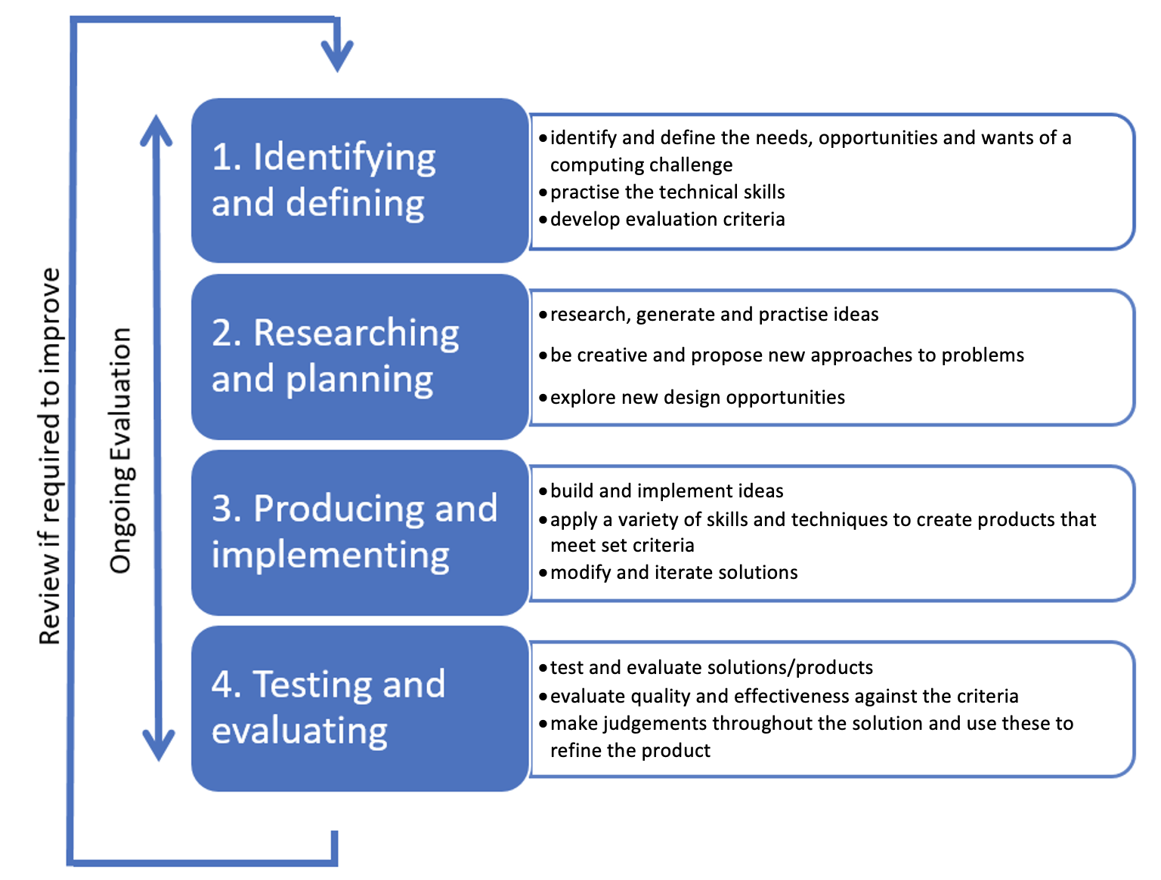

Identifying and defining

Differentiate between data and information
Answer the following questions in the space below.
What is data?
Sample answer:
Data is raw, unorganised collection of facts and figures that represent objects and events.
What is data analysis?
Sample answers:
Analysing data means organising, describing, and exploring data to provide context, create meaning and make it into information.
Once collected data is organised into a data structure such as a table or list.
This data structure is labelled to describe the data and provide meaning.
The organised and described data can be explored using questions.
What is information?
Sample answers:
Information is data which has been properly analysed to give context to the patterns and trends.
Information provides important evidence to inform decisions when problem solving.

Teacher note: analysing data is a powerful way to describe what happened and why it happened. It can also be used to predict what will happen and how it will happen. Analysing data provides opportunities for more questions that lead to deeper understanding. To be a good data analyst means to ask good questions.
Data collection can be done over a few minutes, (like counting the assorted colours of M&Ms in a packet) or across centuries (like Census data).

Activity 1: M&M Data collection and introduction to spreadsheets
The teacher poses the following question to the class, ‘Which colour is the most frequent M&M in an M&Ms packet?’
Students can start with a Think-Pair-Share activity about how to calculate a method for solving which colour is the most frequent M&M in an M&Ms packet.
Each team of students count the colours of M&Ms in their packet and adds the data to a spreadsheet.
Teacher note: adjust the activity to meet student needs, for example vision impairment or anaphylaxis.
Teachers take students through:
Excel Tutorial for Beginners | Excel Made Easy
Excel Training Videos
Be careful this research can be addictive. This scenario has been used for statistical concepts beyond the scope of this course.
Teacher note: a favourite saying of public intellectuals of a certain generation is:
‘Data is not information, information is not knowledge and knowledge is not wisdom.’
Each needs to be investigated, questioned, and reflected upon if it is to inform the next.
Contemporary software, including data analysis and visualisation tools, have removed much of the work required to step up understanding.
Gaining insight is now more like using an elevator than a staircase.
In this unit we will be using spreadsheets and databases to organise data into information for analysis and visualisation that informs data driven decisions and problem solving.
Extension: Data activity resource using lolly snakes.
Teacher note: Engineering teachers may like to use and modify this data activity for modulus of elasticity experiments.

Organising and describing data

Activity 2: random number exercise
Teacher shares a random 8-digit number on a display.
For example: 9 9 8 4 7 3 9 9
Students start with a Think-Pair-Share activity.
Students brainstorm all possibilities of what this number could represent.
For example:
- a value (for example ninety-nine million, eight hundred and forty seven thousand, three hundred and ninety nine)
- a social security number
- a Medicare number
- a student’s ID number
- a password.
Currently these are just 8 digits or data that does not have a context and has no meaning.
In the space below, answer what happens when we put (Ph) in front of it?
Sample answer:
The numbers now have a context and so has meaning.
The data has become information and, in this case, has become a phone number.
Another accessible example from the Digital Technologies hub is the number 1984 especially if students are familiar with its use as the title of a book.

Teacher note: in his report, Building Data Science Teams, D.J. Patil characterises
data scientists as having the following qualities:
- Technical expertise: the best data scientists typically have deep expertise in some scientific discipline.
- Curiosity: a desire to go beneath the surface and discover and distil a problem down into a clear set of hypotheses that can be tested.
- Storytelling: the ability to use data to tell a story and to be able to communicate it effectively.
- Cleverness: the ability to look at a problem in different, creative ways.

Activity 3: data into information table
Student teams complete the table that has data and information side-by-side with other examples of data becoming information.
Complete the table below.
Data | Information
99847399 | Phone number
100, 212, 0, 32 | I freezing and boiling points of water in Fahrenheit and Celsius
9, 92, 7 | Atomic numbers of Fluoride, Uranium and Nitrogen (FUN)

Activity 4: definitions table comparison
Complete the table below.
Teacher note: the content under the ‘Data’ and ‘Information’ headings are sample answers. This can be deleted when distributing to students as a resource.
Basis for comparison | Data | Information
Definition | Data is raw unorganised facts that need to be processed. Data can be something simple, random, and useless until it is organised. | When data is processed, organised, structured, or presented in each context to make it useful it is called information.
Characteristics | Data is an individual unit which contains raw material and does not carry any meaning. | Information is the product and group of data which collectively carry a logical meaning.
Dependence | It does not depend on information. | It relies on data.
Example | Each students test score is one piece of data. | When these are put in a table, labelled, and processed into for example a class average this is information.
Etymology | ‘Data’ comes from the singular Latin word, datum, which originally meant ‘something given’. Its early use dates to the 1600’s. | ‘Information’ is an older word and goes back to the 1300’s where it had Old French and Middle English origins. It has always referred to ‘the act of informing’ usually in education and knowledge communication.
Measuring unit | Measured in bits and bytes. | Measured in meaningful units like time, quantity and so on.
Teacher note: the importance of data driven decisions in all fields has been recognised in subject syllabuses.
In computing syllabuses, the emphasis is on the digital form that the data takes including:
- how digital systems represent text, image, and audio data in binary. For example, how they translate data into binary digital form for efficient moving and processing
- the representation of data
- collecting, managing and analysing data
- analysing and visualising data to create information and address complex problems, and model processes, entities and their relationships using structured data.

Activity 5: computational thinking skills
Activities 6 to 10 will give teachers an indication of the background knowledge and skills of their students.
They may then be able to differentiate between beginner, intermediate, advanced, and expert groups to attempt the CSIRO (Commonwealth Scientific and Industrial Research Organisation) Bebras unplugged resources.
Teachers explicitly teach how to solve the intermediate cards before allocating teams to attempt the advanced levels.
Students share with the class through discussion, the methodology they used to find a solution.
Teacher note: to ensure accessibility, ensure the resource is presented in print and as a digital version. An audio option may be provided as well.

Activity 6: introduction to data types
Teacher note: In the Stage 4 Technology Mandatory syllabus, students explain how data is represented in digital systems and transmitted in networks.
Students should be reminded that all digital data is stored, processed, and transmitted as electrical high and low signals represented by binary digits (zeros and ones).
These zeros and ones are then given meaning by their representation as data types.
This activity introduces students to an understanding that the data represented in digital systems as zeros and ones can be used as distinct types and in different formats.
- Open a spreadsheet.
- Right click on a cell and choose format cells.
- Choose date.
- In the function for that cell type ‘= TODAY()’.
You should see today’s date.
- Now go back into the format by right clicking on the cell and choose the number format.
This is not an error and should give you a number in the 40 thousands.
Can you:
- Determine day zero using the software?
- Calculate how many days old you are?
- Estimate how many hours old you are?
- Determine what this number represents?

Teacher note: students learn more about data types: integers, floats, chars, strings, and Booleans in the Software Development categories. However, spreadsheets provide a quick way to introduce the important concept of data representation.
Figure 2 – categories of data types
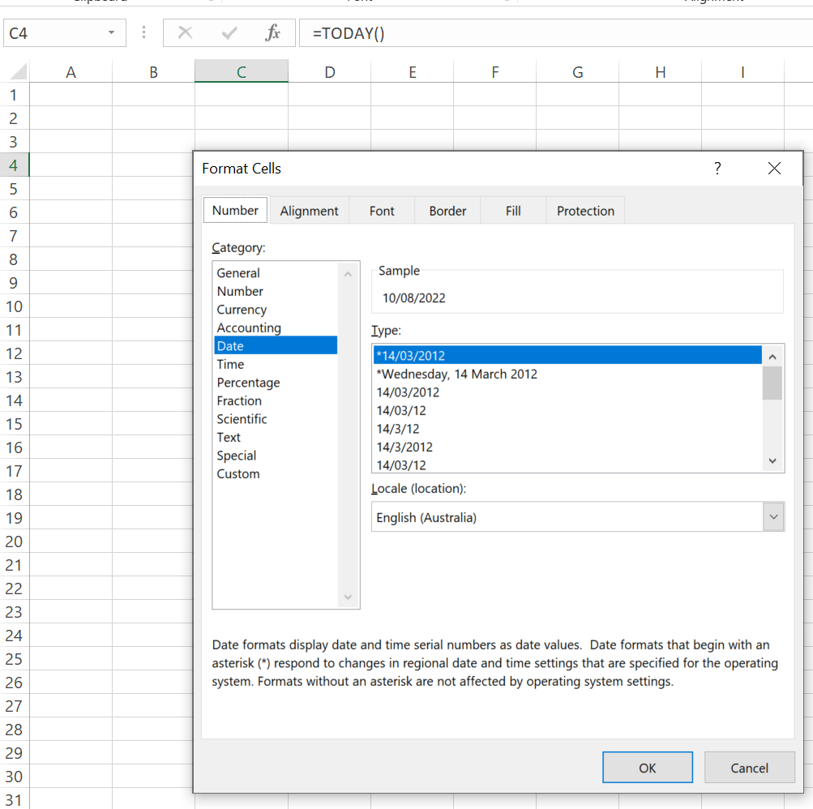
To solve 1:
- Type a zero into the cell and change the format to date.
- For a more detailed explanation of the date systems used, see Differences between the 1900 and the 1904 date system in Excel.
To solve 2:
- Subtract your birthday from the =TODAY() cell and convert to number.
- To prove this works, subtract yesterday’s date from todays and see that you get one day.
To solve 3:
- Multiply the result by 24 (hours in a day: *24).
- Students could use =NOW() function and approximate how many minutes they are old by multiplying the result by 60 (minutes in an hour: * 60).

Explain simple compression of data and types of compression

Activity 7: why compression?
Teacher leads discussion on compression, starting with probing questions on numbers and memory. Examples include:
How many integers (whole numbers) are there?
How many real numbers are there between zero and one?
Do computers have infinite memory?
Sample answers:
Infinite
Infinite
No
How can we represent exceptionally large and exceedingly small numbers?
For example, what solutions are there to the problem of an astronomer wishing to represent exceptionally large numbers or a microbiologist wishing to represent exceedingly small numbers?
Sample answer:
In programming, choosing a data type such as long, double, int or float.
Extension:
Students should research the number of bytes available in each of the datatypes above in a programming language they are familiar with or will be using in this course. For example, how does Python use floats, chars, strings and Booleans?
Students should be familiar with 8 bits = 1 byte = 255 values represented.

Activity 8: data compression
The problem with representing exceptionally large and exceedingly small numbers in a computer of finite memory also occurs when storing exceptionally large files. Big datasets also take more processing time. You can run out of space and patience!
A solution to this is to use data compression.
Students research and define data compression using the following resources:
What is the Purpose of Data Compression?
The need for compression
In the space below, describe why we use data compression.
Sample answer:
Data compression is the process of reducing the amount of data needed to represent a piece of information, typically to reduce file size or to improve transmission speed. The main purpose of data compression is to reduce the amount of storage space or bandwidth required to transmit or store data, making it more efficient and cost-effective.

Activity 9: image compression
Students perform comparisons of various compressions on a variety of images using the engaging resources on compression from the Digital Technologies hub.

Activity 10: lossy and lossless compression
Students collaborate using Clines (a literacy tool to differentiate the meaning of words) to show the differences between lossy and lossless data compression.

Describe the purpose of analysing data
Teacher-led discussion which can include asking the class:
- What questions can and can’t be answered using data?
- How do you know if you are collecting the data you need to answer your question?

Activity 11: data tables
Tables are a way of structuring data to provide information.
The teacher shows students some tables of data and asks them to discuss what information they are being shown.
The data could be anything, but scenarios that are familiar to students work best, such as:
- the weather on different days of the week
- fitness tracker data
- sports data (the class handball tournament in this resource engages active learners: Critical Thinking – Option 4 Strategies and innovations in sports: The path to victory, page 20)
- a student survey
- a school timetable.
Students inspect the tables and discuss which one would be the most appropriate to answer specific questions, such as:
- What was the warmest day last week?
- Where would I find this student during period 4?
The focus of the activity is not on the answer, for example, Wednesday or in room 12, but on encouraging students to recognise that the data has been organised under headings to give it meaning.
Students should be able to dismiss looking for data about the weather in a table about someone’s step count!
Repeat this activity a few times, asking which table the students would use to look for the answer to specific questions.

Activity 12: data headings
The teacher hides the data that is shown in another table so that just the headings are visible.
Can students answer questions about which table they need to use, even without knowing what the data is?
Sample answer:
The answer should be yes.
Table headings should provide a good indication of what can be found out from the table. This is important, as students need to understand the importance of choosing appropriate headings when they begin to organise their own data into tables (Data structures).

Activity 13: collecting data
With a deeper understanding of the importance of table headings and the types of questions they can answer with data, students collect data of their own.
A powerful activity is to require students to collect data about vehicles on a fast-moving road.
This soon reveals how easy it is for people to make errors when they are recording data manually.
Ideally your school looks out on to a main road and students could collect data from there.
If not a video of car traffic (1:00) will suffice.
Each student should be asked to focus on a certain colour of car and keep a tally of how many they see. For example, 3 students may choose red and record their results independently for comparison later.
Some car colours are harder to see than others, so students will need to strategise to record what they think.
After the data has been collected, students can work out the total number of cars that they saw of their colour. It is highly likely that students will have different totals. Using the lanes could also promote some discussion as one of the cars changes lanes in the video.
Answer the following questions in the space below.
Why do different students get different results?
Sample answers:
- Different people saw the colour differently.
- The cars moved quickly, and someone miscounted.
- Someone may have counted the same car twice by accident.
When monitoring traffic, what strategies do agencies use to minimise data counting errors?
Sample answers:
- Having more than one person counting.
- Using averaging to average results.
- Using handheld counters.
- Using tallies.
- Cross referencing the automated monitoring.
These conclusions encourage students to think about the kinds of error that could occur in their data.

What questions can be answered from this data?
Sample answers:
- How many red cars were there?
- Were there more blue cars than black ones?
What questions cannot be answered from this data?
Sample answers:
- How many buses were there?
- How many cars had 2 people in?
Why can’t we answer these questions with the data?
Sample answer:
Because no one was asked to collect data on those questions.
Students answer these questions themselves, so that they can recognise that they need to think carefully about the questions they want to answer before they collect any data.
This will prepare them for later lessons when they are planning their own investigation to answer a question.
Collecting a snapshot like the traffic data can be useful.
Data is often not collected all in the same hour, or even on the same day!

Activity 14: data structures
This series of activities introduces data structures and the categories often called variables.

Activity 15: case study
Teacher note: please note that in the resources provided on the history of collecting census data, there are references to religious and historical means by which data is collected.
Teachers should be mindful of their students’ backgrounds prior to using this material to ensure suitability for the context and maturity level of the class. Suggested resources may have to be substituted if deemed unsuitable.
Care should also be taken to teach this material in a manner that complies with the Controversial Issues in Schools policy. This may include seeking principal approval, or a delegate, prior to delivery.
This case study focuses on the Census and data gathered over time.
From Jesus and Mary in Bethlehem to the Domesday book to the use of the Hollerith machines in Nazi Germany to now, Census data has been collected throughout world history.
As a class, students watch the video Why have a Census? (1:20).
In the space provided below, describe the Census in your own words.
Sample answer:
It is a way for a government to collect data about everyone in a country.
Data is recorded on things like who lives in each house, how old they are, and what they do for work a job.
The data is collected by each household answering questions on a form.
As a class, students watch the video How is the Census data used? (2:01).
In the space provided below, describe how Census data is used in your own words.
Sample answer:
To help plan resources and services for the people.
In the space provided below, research and describe how Census data can be misused.
Sample answers:
In the past it was used
- to identify draft dodgers
- in Nazi Germany to register Jews using racial categories.
Students listen to the dark side of the Census (28:00) and participate in a debate about the value, use and misuse of the census.
Students download and view the Census Infographic: 2021 Census size & scale.
The infographic claims that for every $1 spent $6 is made for the economy.
In the space provided below, explain why this so.
Sample answers:
- More efficient use of and better targeted resources leading to less waste.
- Better planning and time savings in planning.
Students think about the fact that this data is collected over an extended period.
For example, the first census in Australia was conducted in 1911 – over 100 years ago!

Activity 16: what other data is collected over different periods of time?
What other data is collected over different time periods?
Students research and collect pictures of distinct types of data used in different industries. For example, health data could be collected by thermometers, heart rate monitors, or step counters. Each of these can be used to collect data over time.
Using the data example scenarios from Activity 15 students could track for example:
- all the goals that have been scored in a certain tournament since it started
- weather data that might allow us to know if it is the hottest summer on record.
When data is collected regularly over a period and then used to answer questions, such as whether a football team scored more goals this year than last year, it is important to consider how long data has been collected.

Activity 17: answering questions
Is a small amount of data better to answer a question?
Consider the following scenario:
Data shows that it was sunny yesterday and again today.
If our question is: ‘Do we live in a sunny place?’, then using the data we have, the answer would be yes.
However, it might have rained for 50 days before those 2 sunny ones.
Asking and answering questions based on lesser amounts of data helps students see the need for a wider dataset.
In the space provided below, propose questions and model answers based on lesser amounts of data.
Sample answer:
A small amount of data may be sufficient to answer a question if the data is relevant and of high quality.
A larger amount of data can often lead to more accurate and reliable answers, as well as the ability to detect patterns and insights that may not be apparent with a smaller dataset.
The complexity of the question and the scenario described by the data also plays a role in determining the amount needed to answer a question.
The amount of data sufficient to answer a question can vary depending on the context.
Teacher note: This is where a teacher-led discussion on context and data size is valuable.

Activity 18: ‘the right amount of data’
In the space provided below, describe another scenario that requires the ‘right amount of data’ to analyse.
These could include examples from the data tables activity:
- daily step counter versus weekly results
- classes per week versus class per fortnight on a cyclic timetable
- fastest per 100 m heat vs fastest in the 100 m final.

Activity 19: summary describing the purpose of analysing data
Data analysis is the process of collecting, modelling, and studying patterns in data to extract insights that support decision-making.
In the space provided below, use a scenario to describe the purpose of analysing data.
Sample answers:
- The Government using Census data to decide where to build a new high school or the local council using Census data to decide whether there will a need for a skate park in a particular area.
- The council accessing local sports data (number of teams) to plan for more playing fields and which codes need more facilities.

Activity 20: trends
Students explore Google Trends and discuss how this could be used by:
- business
- governments
- start-ups
- influencers.

Conversations around data
Teacher note: a broad definition of data analysis and information could include the daily routines of items on a shopping list to workplaces immersed in data and its analysis.
To increase student awareness of the ubiquity of data have them question family, friends, teachers, clubs, sports coaches, and workplaces with the survey below (data could be qualitative or quantitative). These questions accommodate responses from a diverse range of fields.
Responses to these questions should be kept and shared in the classroom.
The last 5 of these questions could be used to inform the design for a data analysis project for this unit.
- Do you use data at home, in your job, industry or community?
- Where do you see data being collected?
- What data do you source? (Sourced data refers to datasets already collected.)
- What questions do you ask of the data?
- Which data analysis tools do you use? (Interviewers may wish to prompt with: ‘to organise, describe, explore, search, sort and filter the data.’)
- How does visualising the data help?
- What information does the analysis of data give you?
- How does information help you make decisions or solve problems?
Are there other:
- problems you would like to solve?
- questions you would like answered?
- questions that have been raised by analysing the data?
- decisions that data could help you make?
- better visualisations you would like to see?

Describe inputs, storage, transmission, processes, and outputs in data analysis

Activity 21: jigsaw scenario IPO
Jigsaw Activity: student teams are allocated or choose one of the scenarios from the previous activities or an example scenario in the list below. They research and investigate data analysis used in their scenario and describe the inputs, storage, transmission, processes, and outputs of each.
Example scenarios can include:
- the weather on different days of the week
- fitness tracker data
- sports data
- student survey
- a school timetable
- sports team data for the AFL, NRL Super Netball or WNSL
- agriculture
- farmbeats
- environmental research
- social justice
- gapminder.
Teacher note: if you are combining focus areas then the data analysis around mechatronics or social media networks may be preferable to study. For example, analysing the data from a robotic or mechatronic project to improve performance and inform design decisions. Analysing data around social media likes and preferences are a rich source of discussion around privacy, security, and social impacts.

Activity 22: how fitness trackers work
Students find out how fitness trackers work and share their research with the team.
In the table below complete the inputs, storage, transmission, processes and output for the fitness tracker.
Teacher note: the content under the ‘Solutions’ headings are sample answers. This can be deleted when distributing to students as a resource.
Fitness Tracker Example | Solutions
Inputs | Daily step counts, heart rate profiles, and locations visited.  Sensors and manual entry.
Storage | Within device then uploaded activity data to a cloud service/server.
Transmission | Fitbit to mobile phone: Bluetooth  Mobile phone to server/cloud.
Processes | Record, store, and exchange.  Algorithms convert raw data into statistical displays.
Output | Visualised information on a mobile phone screen app.

Activity 23: modelling systems
Students are tasked with illustrating the latest Computing Technology textbook. They are required to draw or illustrate with graphics the: inputs, storage, transmission, processes, and outputs of the data analysis system.
These initial drawings and sketches can be abstracted into diagrammatic models of the system.
This diagram can be achieved using Microsoft Word > Insert shapes > Flowcharts or using Lucidchart (3:34) from the Google Workspace Marketplace.

Functional vs non-functional requirements
Working out the requirements of any software project is a critical part of the process in assessing its success.
There are 2 categories of requirements: Functional and Non-functional.
Functional requirements are those that the end user specifically demands as must haves that the software or system should do.
These include showing:
- the data input to be given to the software
- the operation performed on that input data
- the output expected.
Non-functional requirements are requirements about the quality of how well a software project meets the requirements. These include issues like:
- portability
- security
- maintainability
- reliability
- scalability
- performance
- reusability
- flexibility.

Activity 24: specify the functional and non-functional aspects of the fitness tracker data analysis example
Complete examples of functional and non-functional requirements for a fitness tracker in the table below.
Functional | Non-functional
Accurate step counts | User friendliness
Accurate heart rate | Password protected
Record, store, and exchange algorithms | Battery life
Convert raw data into statistical displays
Correct screen display
Mobile phone screen app

Describe user cases and develop test cases of inputs and expected outputs

Activity 25: data accuracy and validity of fitness trackers
Students design and conduct experiments to determine the data accuracy and validity of fitbits or smart watches and apps.
Students watch How Accurate Is Your Fitness Tracker? (7:20).
This testing process could be integrated into a Step counter project using micro:bit.

Bureau of Meteorology and data analysis
The BOM (Bureau of Meteorology) provides a case study for in-depth research on weather data.

Activity 26: weather prediction
In the space provided below, explain why weather data is collected and analysed.
Sample answers:
- to inform people of predicted rain and that they should carry an umbrella
- to advise farmers on planting and harvesting times
- to monitor changes in climate.

Activity 27: Aboriginal weather knowledge
Students explore the Indigenous Weather Knowledge website and investigate areas of interest including where they live.
As a class, students watch the video Australian Weather Using Traditional Indigenous Calendars (4:15).
In the space provided below, explain how the data used to make information and knowledge about seasonal weather is different from that used by the BOM.
Sample answer:
Aboriginal weather knowledge is informed by close observations of changing seasons indicated by plant growth, flowering, and animal behaviour. Seasonal weather knowledge is also informed by Aboriginal astronomy.

Activity 28: services the BOM provide
Students explore the BOM website.
In the space provided below, list what services the BOM provide.
Sample answers:
- agriculture
- climate and past weather
- water information
- aviation weather services
- marine and ocean
- UV and sun protection
- environmental information
- data services.

Activity 29: MetEye – your eye on the environment
Students watch the video MetEye – your eye on the environment (2:23) as a class. Students investigate the MetEye page of the BOM website.
In the space provided below, answer: ‘What is the purpose of the MetEye solution?
Sample answer:
The BOM's online MetEye tool helps visualise local weather observations and forecasts for any location in Australia.
The forecasts use a blend of model data with the latest science, technology, and expert meteorologist input to best represent expected weather and are routinely updated twice a day.

Activity 30: MetEye and data accuracy
Find your location on MetEye.
Look out the window.
Is the information accurate?

Activity 31: users of other systems
Explore the sites below and investigate who the other users of these systems are:
- About data and observations, Bureau of Meteorology
- agriculture.gov.au/abares/data
- datadrivendance.org/datastorm
- www.nationalmap.gov.au
- data.gov.au.
In the space provided below, describe other users of these systems.

Social, ethical and legal responsibilities when analysing data

Activity 32: hypothetical scenario
Consider the social impacts and ethical and legal responsibilities in analysing data.
Teacher announces that in agreement with the principal, parents, and the school community all students will be microchipped behind the ear.
This will capture attendance data and improve efficiencies in roll marking.
The microchip scanner will be located at the entrance to the school and at every classroom doorway. It will collect student ID as well as time of entry and departure.
Another microchip scanning device is proposed for the local McDonalds restaurant so data can be collected, analysed and cross referenced to ensure no student is out of bounds during the school day.
Students participate in peer discussions around this scenario to either concur or argue against this hypothetical scenario.
Teacher note: a classic TED talk by Glenn Greenwald (the journalist who broke the Edward Snowden story) Why privacy matters (20:29) is worth condensing in response to an important aspect of social and ethical issues.

Activity 33: research facial recognition software
Students are asked to research and consider facial recognition software and databases in preparation for Activity 34 by reading Government building national facial recognition database which describes its use by government and businesses.

Activity 34: the technology behind facial recognition
Students complete tasks on the technology behind Facial Recognition.
Teacher note: a retake on these concepts is provided by Kade Crockford in What you need to know about face surveillance (12:40).
Algorithmic bias in facial recognition software has been a significant issue as explained by
Joy Buolamwini in How I’m fighting bias in algorithms (8:35).

Activity 35: data is the new oil
An analogy used to convey the value of data analysis which was coined in 2006 by British mathematician Clive Humby is that ‘Data is the new oil’.
Student teams use research and use the Six Thinking Hats to:
- Answer the questions:
- What does this analogy mean?
- Is this true?
- Design a more accurate and appropriate metaphor.
- Consider the value of their personal data.
Students read (or are read to) the Futurescot article Why data is the new oil, with a business and sustainability focus.
Students read (or are read to) the Stop Saying 'Data is the New Oil' article, which is a counter argument.
In the space provided below, research and record a justification giving your reasoning.

Activity 36: research and writing
Students use keywords research and collect online articles about current social, ethical and legal issues around data.
Examples include:
- Google fined $60m for collecting location data
- Australian TikTok data can be accessed by China
- Government kills ‘failed’ $21m COVIDSafe app.
In the space provided below, describe what can happen to the data when it is collected.
Sample answers:
- Advertising – data can be used to target ads to individuals based on their browsing history and search queries.
- Analytics – data can be used to track website traffic and user behaviour to improve website design and user experience.
- Personalisation – data can be used to personalise content and recommendations for individuals.
- Research – data can be used for academic and commercial research on topics such as consumer behaviour and market trends.
- Security – data can be used to detect and prevent fraud and other security threats.
- Government surveillance – data can be used by government agencies for surveillance, intelligence gathering, and criminal investigations.
Students read (or are read to) the article and put into their own words what the article is about. Students can use Writing scaffolds, Quick writes and/or explanation text.
Extension:
Students create a meme to encapsulate the story.

Activity 37: Google Trends
Students use Google Trends to compare trends like ‘Tik Tok’ and privacy or big data and open data. Students present their findings to the class and speculate upon why the peaks and troughs appear in the graphs.

Activity 38: How does Google use cookies?
Students watch A look at cookies (4:29)
Research how Google uses location information.
Use Peer discussion and conferencing to discuss as a class whether laws have kept up with privacy and ethical issues.
Teacher note: In this ‘post truth’ world, data literacy has never been more important.
Students are encouraged to utilise critical thinking to identify language, statistical figures, data graphics, and other forms of presentation that are intended to persuade by impressing and overwhelming a reader or listener.
At its worst, data fallacies can occur with a blatant disregard for truth and logical coherence.

Activity 39: data fallacies
Students define fallacy.
In the space below, define the term fallacy.
Sample answers:
- A deceptive, misleading, or false notion or belief. For example, the belief that the world is flat was at one time a popular fallacy.
- A misleading or unsound argument.
- A deceptive or false nature; erroneousness.
In the space below, discuss your ideas about the social impacts, ethical and legal responsibilities of any lie, untruth, deception, or fallacy.
Students’ responses can be entered here and inform a teacher-led discussion on trust and relationships.
Students research examples of the 15 data fallacies from politicians, the media or from history. This site includes cards of each data fallacy which could be printed off for use in class.
In the space below, list some common data fallacies.
Sample answer:
These could include descriptions of confirmation bias, selection bias, survivorship bias, correlation versus causation, overfitting and underfitting.
It is important students are aware of these fallacies and investigate appropriate statistical methods and techniques to avoid them when working with data.
Students are encouraged to become familiar with each and use them during debates or presentations that reference data evidence.

Activity 40: Dear Data project
It is important to explore data analysis considering the perspectives of diverse groups, including Aboriginal and Torres Strait Islander peoples, culturally and linguistically diverse people, people of different ages and gender, and people with disability.
Students complete a Think-Pair-Share Activity 1 to investigate diversity within their community and complete researching and planning. This activity leads to using the How diverse is your community? webpage on the SBS News website.
Data can be collected and analysed in novel, creative and interesting ways.
Visit the Dear Data project and as a class watch the video Big Bang Data: Dear Data (3:18).
As a class discuss the topics Giorgia and Stefanie collected, visualised, and shared personal data about including:
- physical contacts
- how many times do we check the time
- urban animal life
- doors
- our wishes and desires
- our workspaces
- phone addiction
- looking in the mirror
- swearing
- complaints
- compliments
- our boyfriends/husbands
- the sounds of our cities
- what we buy
- how many people in our surroundings
- our thankyous.
Teacher note: Log into your DoE portal to access the Digital Selector and use Learning logs or diaries which could be modified for this activity.
With your partner propose a topic about your life, culture, and perspective.
You and your partner will collect data throughout the week and present this to the class.
Design a symbol to represent the data from your topic:
For example, students might design a symbol that:
- notes the time spent speaking languages other than English
- monitors mobile phone, app or games use
- examines what food they have eaten
- shows how they travelled to and from school; routes or steps taken
- shows friends or family they have spent time with
- examines shopping or spending habits
- shows a mood diary with morning and afternoon ratings and triggers
- represents sports or dance performances.
Data symbols could include emoticons familiar to students or their own designs.
In the space below, describe what you have learnt from your visualised data and how you might use the information to make changes in your life.
Students’ responses can be entered here and inform a teacher-led discussion on visualised data and its use.

Think-Pair-Share Activity 2
In the space below, identify the diverse types of data that were collected and visualised from the personalised topic of the Dear Data project.
Students’ responses should include the collection and visual representation of personal data and sending in the form of postcards.
Think-Pair-Share Activity 3
What type of data did you collect for your topic?
In the space below, explain with reference to the definitions above why your topic fits into this type of data.
Students’ responses could include quantitative and qualitative data.
Students present to the class on their own Dear Data projects.

In the space below, record insights gained from these presentations about the perspectives.
Students’ responses can be entered here and inform a teacher-led discussion.
Students interact with the SBS Australian Census Explorer website to examine How diverse is your community?
Each student reports back to class with statistics about a community with which they identify.
Teacher note: Observations and findings about different perspectives found in this exercise could be used to develop a data analysis-based solution for the unit project. Examples may include developing an advocacy campaign that uses data visualisations and infographics to raise awareness on perspectives of diverse groups.

Researching and planning
In A brief, brief history of Data Analytics, Deryck Brailsford points out that ‘the earliest preserved records of writing are not … poems, great speeches love letters or novels, but rather examples of data analysis. He records that Sumerian scribes:
produced lists of ploughmen employed by the state and preserved this data on clay tablets making the first database in the process.’ These inscriptions also calculated their wages directly from this raw data, so the discipline of data analytics was born too.
Technology moved from storing data on clay tablets to papyrus and then paper. Brailsford identifies ‘the formulation of algebra and the decimal system in the 9th Century CE (again in Iraq), also made both the calculations and the structure of data more efficient’.
Census data (as seen previously) includes biblical references and the Domesday book.
The following activities will assist in describing how data analysis has evolved in response to people's needs and opportunities.

Activity 41: jigsaw model
Working in teams, students will use the Jigsaw model to research one historically significant event from the following list:
- A brief, brief history of Data Analytics
- The development of the binary number system
- Census through the ages
- A Brief History of Social Media
- A Brief History of the Internet
- How VisiCalc’s Spreadsheets Changed the World
- A Brief History of Database Management
- Data.NSW which includes: data policy, sharing data, using data and a description of the work.

Activity 42: storyboard
Each team will research images and text to compile into a storyboard timeline. These may be inspired from research undertaken in Activity 41. The storyboard timeline describes how data analysis has evolved in response to people's needs and opportunities. The storyboard is a proposal for a short montage video that will be created in Activity 43.

Activity 43: timeline video
Teams will then develop a video from the timeline produced in Activity 42.
Each student team will conclude their video presentation with a prediction about the future of data analysis.

What is data visualisation?
Data visualisation is the graphical representation of data to produce easily interpreted information. By using visual elements like charts, graphs, and maps, data visualisation tools provide an accessible way to see and understand trends, outliers, and patterns in data.
In the world of Big Data, data visualisation tools and technologies are essential to analyse massive amounts of information and make data-driven decisions. We will explore design principles and issues relevant to analysing data, including visualisation principles, data trails and ownership of data.
Infographics are everywhere, they allow highly visual representations of, at times, extraordinarily complex datasets.
Figure 3 – graphical user interface
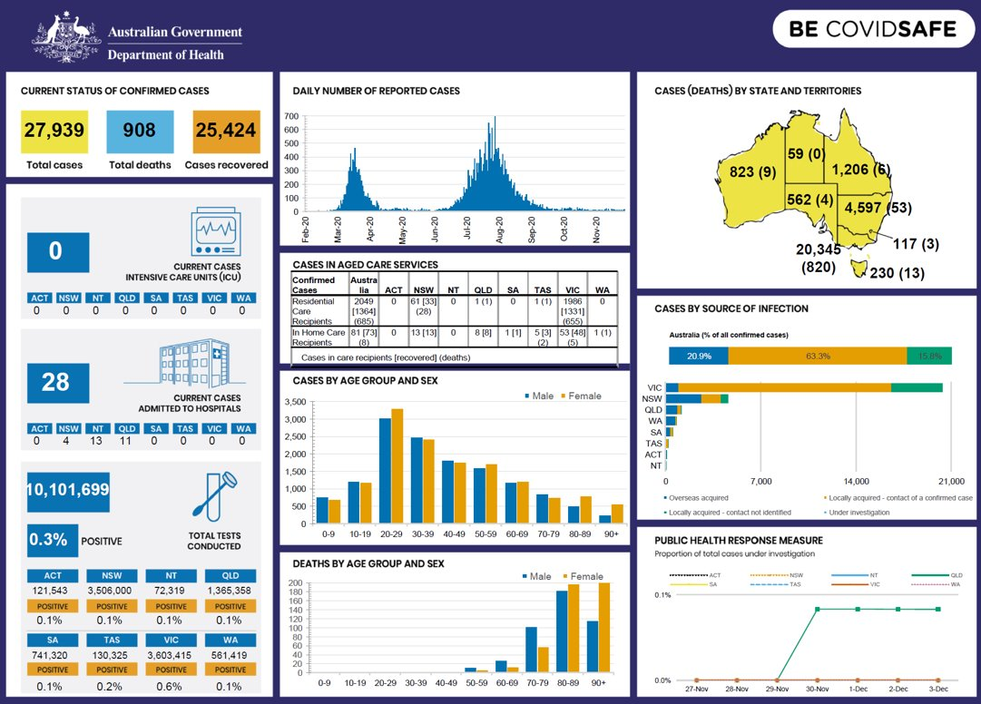
Commonwealth of Australia (2020) Coronavirus at a glance, Department of Health and Aged Care, Australian Government.
Teacher note: many visualisation tools are already used by teachers for student data analysis – SMART, SCOUT, Higher School Certificate (HSC), Results Analysis Package (RAP) and Sentral analysis.

Activity 44: information is beautiful
Students explore the information is beautiful datasets.
Consider and discuss why datasets were chosen in past years and what datasets may make up future visualisations on this site.

Activity 45: visualisation principles
Students watch The value of data visualisation (1:43) and investigate the series of lessons to understand the power of visualising data with a focus on data science and the use of R studio.

Activity 46: visualisations of data breaches
Students navigate to the website showing visualisation of data breaches.
Students use the filter at the bottom left of the page to change dates.
Students explore the results of these datasets by cross referencing with visualised data from Google Trends and discuss anomalies.

Activity 47: data trails
A data trail is the data collected about us as individuals that could be used to see the patterns in our personal lives.
Teacher note: instigate a teacher-led discussion on how we create data trails as we go through life.
Students use the linked series of activities to reflect upon the data trails, we all leave behind us.

Activity 48: spurious correlations
The teacher can choose a graph or series of graphs from the Spurious Correlations website and facilitate a teacher-led discussion on the impact of finding patterns across datasets.

Activity 49: ownership of data
Students are asked to consider and watch Who owns your data? (5:17).
Extension: An extension for more legal detail could include: Who owns the data on the ‘Internet of Things’?
Teacher note: examples of visualised network diagrams could be delivered within the Modelling networks and social connections focus area.
Teachers should be mindful of their students’ backgrounds prior to using this material to ensure suitability for the context and maturity level of the class. Suggested resources may have to be substituted if deemed unsuitable.
Consider keeping a resource repository of interesting articles collected about cyber, social and ethical issues for Google sites which would enable this class collaboration.
The Data.NSW website includes data policy, sharing data, using data and a description of the work.
The Australian Data Strategy supports the Government’s vision to become a modern data-driven society by 2030. The strategy looks to balance ambitions to realise value from data, with trust and protection, while enabling its use.
Students may wish to consider which of these 3 themes currently prevails and represent their views visually.
The CSIRO Data61 site includes latest items which are ideal for case study, including recent data privacy tools.

Privacy, cyber security and ethics
The following activities investigate issues with the use of data, including cyber safety, security, privacy, and ethics.

Activity 50: ethics, morality and the law
Students watch the video What is the difference between Ethics, Morality and the Law? (5:13) and discuss the relationship between ethics, morality, and the law.

Activity 51: cyber safety, security, privacy and ethics
Students record the definitions of cyber safety, security, privacy and ethics and how they relate to any scenario they have previously investigated.
Teacher note: see the linked activities in Activity 52.
In the space below, define cyber safety and explain how it relates to a scenario you have investigated.
Students’ responses can be entered here based on the chosen scenario.
In the space below, define security and explain how it relates to a scenario you have investigated.
Students’ responses can be entered here based on the chosen scenario.
In the space below, define privacy and explain how it relates to a scenario you have investigated.
Students’ responses can be entered here based on the chosen scenario.
In the space below, define ethics and explain how it relates to a scenario you have investigated.
Students’ responses can be entered here based on the chosen scenario.
Teacher leads a student discussion on whether any family or friends have experienced any of these issues.

Activity 52: collecting data issues
Students use Affinity diagrams to categorise facts about the scenarios in Activity 51 and those below, according to whether they represent issues of cyber safety, cyber security, privacy, ethics or morality.
Scenarios could include:
- Google fined $60m for collecting location data
- Australian TikTok data can be accessed by China
- Government kills ‘failed’ $21m COVIDSafe app
- Australian retailers using facial recognition software
- Data trails series of lessons.

Activity 53: cybersecurity
Students watch Cybersecurity (12:29) and match key concepts with the above scenarios.
Extension:
Students may engage in extension work on cybersecurity [DOCX 222KB].
Teacher note: consider keeping a class journal, wiki, or Google site to keep interesting, newsworthy articles.
This content will be revisited during the project for this focus area.

Activity 54: implications
In society we need to collect and interpret data adhering to privacy and cybersecurity principles.
Students explore the data collected about them during the day and discuss the implications.

Activity 55: Minecraft
Students complete an introduction to cybersecurity principles via Minecraft exercises including critical thinking to make responsible and safe decisions on the internet.

Activity 56: examining privacy concerns
Students use a Cline to visualise the difference between the real world on one end and the virtual world on the other.
Dear Data projects are reviewed by students to see which if any aspects of the collection could raise cybersecurity and/or privacy concerns.
Students look at the security.org website and read What is Personally Identifiable Information (PII)?
Students discuss what is:
- direct/indirect PII
- sensitive and non-sensitive PII in the Dear Data project.

Teacher note: this content will be revisited during the project for this focus area.
The use of Minecraft exercises lends itself to the Creating Games and Simulations focus area. Likewise, the use of the Clines to visualise and make clear differences between the real and the virtual world provides for deep and rich class conversations and learning.

Spreadsheets
Students learn to represent and store data to facilitate computation, including selecting appropriate data types.

Activity 57: appropriate data types
Students enter their data (where appropriate) into a spreadsheet.
They label their table headings according to the data they have collected.
They select the appropriate data type by right clicking on the cell, choosing format cell and entering their data.
Students select the data and press Ctrl+T to provide headings and first steps of analysis through computation.
Teachers take students through Excel Training Videos or Get Started with Google Sheets.
Teachers may benefit from viewing 3 Essential Excel skills for the data analyst (18:01).

Activity 58: data limitations
Students learn to identify and describe data type limitations and structure data systematically.
Students ensure their table headings, and the formatting of the cell contents are appropriate to the values contained.
The use of a data dictionary may be of value in describing the data type for each labelled column and the justification for selecting one data type over another.
For example, text can be concatenated though not have calculations applied except simply counts of the number of words.

Activity 59: data dictionary
Students watch Data Dictionary (Database) (2:10) for a driver’s license database and predict which data types will be selected.

Model entities, events and their attributes using structured data

Activity 60: library book borrowing
Students are given an incursion to borrow a book from the library. They make notes or diagrams on all the processes involved and the data required at each step. For example, browse shelves for title or search for a title in the computer, select book, take to counter and scan, provide library card, scan and borrow, exit the library past the scanner.
Teacher note: this may appear tedious at first though it is important to remember that students (like all of us) are so immersed in daily activity and routines that they rarely pause to consider what is happening around them and the systems they are participating in. Other familiar scenarios may include enrolling in school, registering for sport, tapping on to public transport with an opal card, purchasing take away food.

Activity 61: role-play
Students conduct a role-play that re-enacts all steps in the process while referring to the diagrams and notes they have made. They brainstorm and contribute all the data (attributes) they believe was necessary to collect from the book (entity) and the student (entity) and the borrowing (event).

Activity 62: database
Students contribute all this data from all their borrowings into a single file flat database. For example, creating a collaborative spreadsheet in Google Sheets. As they enter their book and student data, they are asked to consider whether this data structure is best to keep both book and borrower data in? Students should begin to understand that this type of flat file database will quickly get enormous as soon as they and their peers borrow another book. It will contain duplicate and redundant data.
Teacher note: an alternate exercise is to have students (entity) contribute a list of every subject (entity) they study (event) at high school. The class will soon see that subjects will often be written several times including subjects like English and Mathematics. This soon creates duplication and redundancy. Students should be given the opportunity to propose a solution to the problem of data redundancy and duplication within a flat file database of multiple entities before the answer is provided.

Activity 63: identifying entities
Students separate out the entities (book and student borrower) into a Venn diagram and fill each circle with the attributes of each entity.
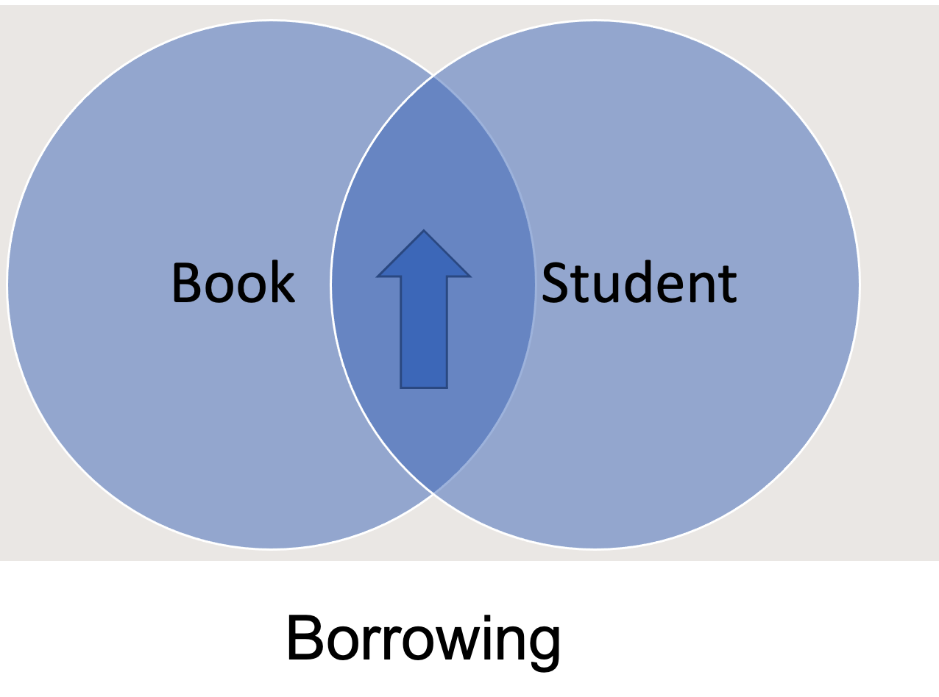
The solution is to separate entities into tables of logically associated data.

Activity 64: cloze passage
Students complete the following using their preferred communication mode.
Some of the words are missing from this description of entities, attributes, and events. Can you use the words in the box below to complete this passage? Once you have filled in the missing words read the passage aloud to make sure it makes sense. Check to make sure you have spelt all the words correctly.
Where the Venn circles _____ would represent the ___: borrowing.
The book and student borrower are both _____.
These entities should each be kept in a separate ____.
Each table has ____headings labelled to describe the characteristics of the entity.
These headings are the ____.
Labelling attributes in a table is _____ the data.
Events are the processes that link entities in a _____.
They also have attributes with labelled headings.
What attributes would each of these entities have?
structuring, event, intersect, entities, table, column, attributes, relationship

Activity 65: linking tables
From the Venn diagram completed earlier, list the key data needed for this library book loan system, including the tables needed and how these tables should be linked.
In the space below, record the key data that will be used in the book table for the library book loan system.
Book (entity as a table):
- Book ID (ISBN)
- Title
- Author
- Publisher
- Category (Attributes).
In the space below, record the key data that will be used in the borrower table for the library book loan system.
Borrower (entity as a table):
- Student ID
- Name
- Address
- Contact
- DOB (date of birth).

In the space below record how these tables should be linked.
Sample answer:
These 2 tables would be linked (made relational) via a Loans Table (Event) that has a Loan ID, Loan Date, and the Primary Key (unique identifier) for the Book ID and the Student ID.
This relationship allows the database to be easily searched and updated.

Activity 66: entities, attributes and events
Identify the entities, attributes and events in the following scenarios by highlighting each an assorted colour.
- Students enrolling in a school to study courses in a subject area.
- Registering for a team or event.
- Footballer playing a game in a team against an opposition team.
- Pokémon trainer catching a Pokémon and adding to her Pokédex.

Activity 67: scenario
Consider and analyse a scenario not listed that has events, entities and attributes that could be modelled.
Other database activities can be found online under the Classic Computer Science Unplugged website.
Teacher note: a powerful learning experience is to have volunteers from class assist with running school carnivals and managing the data collected, processed, stored, and analysed. These students can report back to class with a Q&A activity.

Extension:
An extension of this activity is for students to propose and design an improved carnival system with data analysis and visualisation. This could be developed into a project for this unit.

Compare the usability of data using a spreadsheet or database to analyse the same dataset
At their core, both databases and spreadsheets store collections of information.
The differences come from how that data is stored and how it can be manipulated.
When you open a spreadsheet, you are presented with rows, columns, and cells.
Each cell can independently contain any kind of information, like a piece of text, a date, or a sum function. You can change this around as often as you like.
A quick look at the data arrangement in a database and it looks remarkably like a spreadsheet. But with a database, you cannot change the data types within individual cells.
Each cell instead contains a fixed data type.
In a database table, if the first name column has been defined as a text value only then texts can be stored in it. You cannot change this to a number, or any other type.
The database stores data in many tables, and these tables are made up of columns and rows with each row representing a record within the database.
This makes data access consistent, since you always know what type of data you will get back. Why would you use a database instead of a spreadsheet? (2:41).
Most often this comes down to scale. Most company databases or a database used at a bank, or a supermarket will contain thousands and millions of items of data.
This volume of data is difficult to manage with a spreadsheet.
Because databases can handle enormous amounts of data, they are central to any business, organisation, or institution. They allow thousands of people both inside and outside an organisation to access and query the data. This would be impossible with a spreadsheet.
Both spreadsheets and databases are useful tools, and their functionality overlaps.
If data is stored within a database, SQL is the language to access it.

Activity 68: database
Students:
- import a .csv file of the data from the borrowing scenario into a flat file spreadsheet and change the types of data in individual cells
- analyse the data to determine which category of book is most popular
- visualise this data via a graph
- import the same .csv file of data into a database management system
- This resource is a clear introduction to Access: Access basics for excel users (2:13).
- create your own table and records and source your data
- attempt to change the type of data within the record.

In the space below, explain why the steps above are different between flat file spreadsheets and databases:
Sample answer:
Both spreadsheets and databases can be used to analyse data, but they have different strengths and weaknesses in terms of usability.
Spreadsheets, such as Microsoft Excel or Google Sheets, are generally easier to use and more accessible for non-technical users. They provide a user-friendly interface that allows users to easily input, organise, and visualise data. They also have built-in functions and formulas for common data analysis tasks, such as sorting, filtering, and calculating averages and totals. However, spreadsheets can become unwieldy and difficult to work with as the amount of data grows and becomes more complex.
Databases, on the other hand, are designed to handle large amounts of data and complex data relationships. They provide powerful tools for querying, sorting, and filtering data and can easily handle data from multiple sources. They also provide better security and data integrity than spreadsheets, which can become prone to errors and inconsistencies as data is added, deleted, and edited. However, databases require more technical skills to set up and use and may not be as user-friendly for non-technical users.

Activity 69: Cline
Students complete a Cline that has a database on one end and a spreadsheet on the other.

Activity 70: queries and reports
Students analyse data in both a flat file and relational database using queries and reports.
Students explore the Loans template from Microsoft Access (image below) to determine entities, attributes and relationships used.
Students create a database for their book borrowing scenario.
(Students rename the attributes via the design view and property sheet).
This resource is a clear introduction to Microsoft Access basics for Excel users (2:13). In this example:
- Assets renamed to ‘Books’.
- Transactions renamed to ‘Borrowing’.
- Contacts renamed to ‘Students’.
Figure 4 – database schema
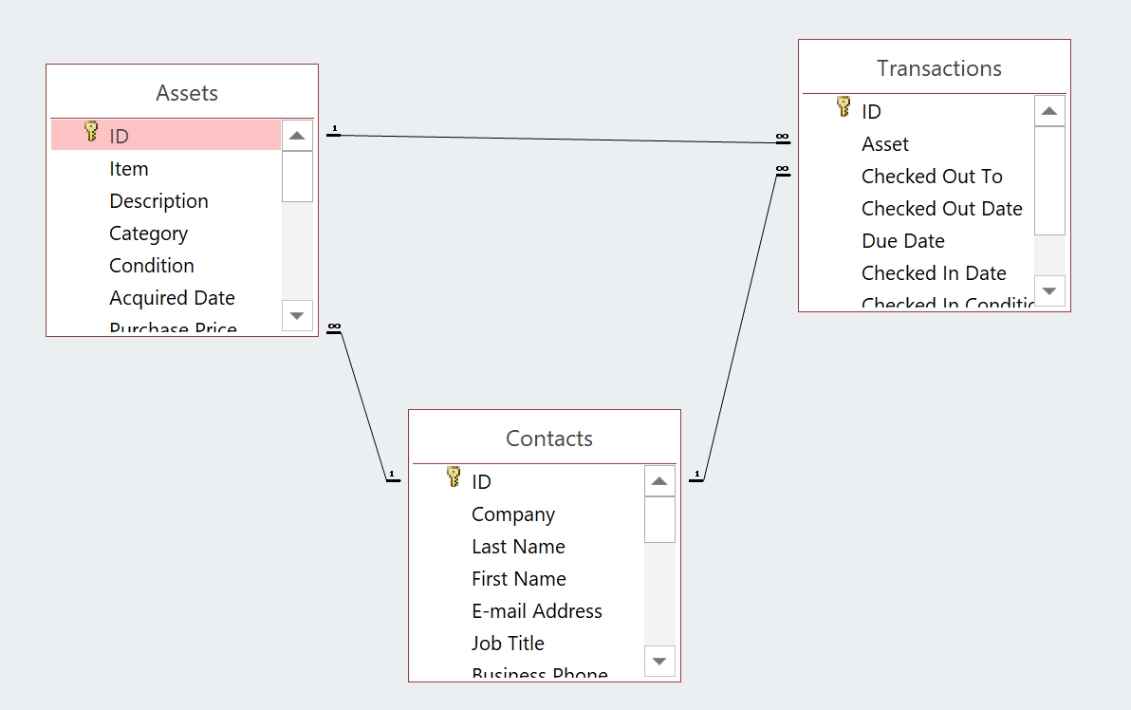
Students use Query by Example (QBE) to determine who may have borrowed their next favourite book.

Activity 71: recommendations
Teacher leads a discussion of how acquiring and manipulating the data through a database (such as Microsoft Access) allows for recommendations of genre for their books.
If a new book of a certain genre came into the school library and student email addresses were collected, students could be instantly made aware it is available for loan.
This discussion links to earlier information in this unit on how preferences and recommendations are made by data streaming companies such as Netflix.
This activity will assist in consolidating student learning.
This is also an opportunity for the teacher to link to how much information students give to companies when registering with websites.
Is it always necessary to give over all their personal information?

Activity 72: generate alternative designs
Students generate alternative designs for a report for the librarian to meet requirements to show the most popular books and which books are overdue.
This resource is a clear introduction to Microsoft Access: Access basics for excel users (2:13).
The Report Wizard section explains the quick generation of a report.
Students should be encouraged to use the design view of the report to generate alternative designs.

Machine learning
Teacher note: the following activities could be delivered at various points in the course depending upon context. Opportunities also exist to deliver these in the Modelling networks and social connections focus area since that focus references both graph theory and shortest path algorithms.
Machine learning (ML) projects involve algorithms that use historical data as input to predict new output values. Machines learn from data and improve.

Activity 73: what is machine learning?
Students watch What is machine learning? (3:27) to answer the questions below:
What is machine learning?
Sample answer:
It is a field of technology that allows machines to learn from data and self-improve.
Why is it becoming increasingly useful?
Sample answers:
- More data than ever before in seconds.
- Computers are more powerful than they used to be.
- Better machine learning algorithms as a result.
What are some of the things that machine learning does?
Sample answers:
- Recommends purchases on the internet.
- Detects credit card fraud.
- Makes movie recommendations.
How does the machine algorithm do it?
Sample answer:
The machine learning algorithm calculates how similar your preferences are to those of the other users in the database.
What is this algorithm called?
Sample answer:
The nearest neighbour algorithm.
What type of machine learning trains the algorithm based on examples?
Sample answer:
Supervised learning.
What type of machine learning is used when the data has not been labelled?
Sample answer:
Unsupervised learning.
Give an example.
Sample answer:
Google’s artificial neural network.
Teacher note: students search for more detail on machine learning including supervised and unsupervised learning.
Extension: Students survey each other’s movie preferences and provide a thumbs up of each other’s choices, then figure out what recommendations to make to their ‘nearest neighbour’ friends.
How Recommender Systems Work (8:17) can be viewed as a class and lead to a class-based discussion on how recommendations work.
Teacher note: this activity could be used in the Modelling networks and social connections focus area since it references graph theory and shortest path algorithms.

Activity 74: teachable machine
Students discuss the social impacts, ethical and legal responsibilities of selecting datasets used to train the machine algorithm. If the datasets used to train machine-learning models contain biased data, it is likely the system could exhibit that same bias when it makes decisions in practice. For instance, if a dataset contains mostly images of white men, then a facial-recognition model trained with these data may be less accurate for women or people with different skin tones.
Teacher note: students consider efforts to overcome dataset bias (5:52). Explore data analysis considering the perspectives of diverse groups, including Aboriginal and/or Torres Strait Islander peoples, culturally and linguistically diverse people, people of different ages and gender, and people with disability.
This activity is designed to broaden definitions of both the nature of data and its potential to describe diverse perspectives.
This video clip on Teachable Machine 1: Image Classification (20:01) may provide background to assist with delivery of this content. Teachers should extract the key concepts:
- What can you train the teachable machine on?
- What are the steps and processes involved?
Students explore these concepts using the teachable machine.
There are more resources on machine learning available on the Digital Technologies Hub and viewing the infographic on what is machine learning?

Activity 75: machine learning and Artificial Intelligence
Students learn to identify and describe how a classifier uses data analysis for machine learning.
As a class, students watch Machine Learning & Artificial Intelligence (11:50) and answer the following questions in the space below.
What is a machine learning classifier?
Sample answer:
A machine learning classifier is a type of algorithm that is trained to predict a class or category for a given input. It is a supervised learning method, meaning it uses labelled data to learn the relationship between input and output. The classifier is trained on a labelled dataset, where the input data is paired with the corresponding output class label. Once the classifier is trained, it can predict the class label for new, unseen input data.
What are the different types of classifiers?
Sample answer:
Some classifiers work well with small datasets, while others are better suited for large datasets. Some classifiers are better at handling categorical data, while others are better at handling numerical data.
How is the choice of a classifier determined?
Sample answer:
Different types of classifiers have their own strengths and weaknesses. The choice of classifier depends on the nature of the data, the complexity of the problem, and the desired performance.
What are some of the applications a classifier is used in?
Sample answer:
A classifier is used in a wide range of applications such as text classification, image classification, speech recognition, and natural language processing.
Students can provide another example of an insect or animal to understand the process of classification.

Activity 76: machine learning and Aboriginal perspectives
Students consider how Aboriginal perspectives on classification may differ from Western methods by focusing upon relationships between things rather than the individual things themselves.
Students investigate the combination of AI (Artificial Intelligence) and Aboriginal knowledge by examining a powerful tool posing critical questions.
In the space below, propose how a classifier may have been used in this scenario:
Student responses consider how they propose a classifier may have been used.
Different types of classifiers have their own strengths and weaknesses.
The choice of classifier depends on the nature of the data, the complexity of the problem, and the desired performance.

Producing and implementing

Activity 77: developing an idea
Students will need to define a real-world problem or question that can be solved by analysing data, including breaking it down into manageable parts and describing the users of the solution.
Teacher note: this content provides opportunities for teachers to introduce real-world problems and questions that engage and motivate through alignment with student interest. Some example scenarios follow. It is important that students consider fields of interest for their own project for this unit.
Student complete a Jigsaw activity and revisit one or more of the scenarios studied including:
- the weather on different days of the week using the Bureau of Meteorology
- fitness tracker data
- sports data (the collection of handball data in this resource engages active learners)
- student surveys
- a school timetable
- census data
- Dear Data
- data conversation interview
Students identify, list, and describe:
- the real-world problems or questions that the data scenarios address
- the essential parts (inputs, processes, and outputs) of the scenario
- the people that use the results of the analysis.
Teacher note: some years ago, Google developed a handy ‘equation’ used to explain the ubiquity of computing: CS (Computer Science) + X.
CS is computing science and the X is anything else in the world you may be into.
The point is that computing everywhere can now be made of data analysis.
Students complete the following:
Read the following article on Data experts are becoming football’s best signings.
He will be heading up a team of data analysts who use millions of stats about players' performance and the upcoming opposition to help the club's chances of winning (Harper 2021).
In the space provided below, explain why big sports clubs are employing data analysts.
Sample answers:
- To measure players' workload and fatigue to manage player fitness.
- To look at specific areas such as the way they build play from the goalkeeper.
- To look at areas on the pitch where they want to press the opposition.
- They also use algorithms to automatically detect patterns in games.
- Signing players who play the style that we want.
Extension:
Students may be encouraged to keep a self-assessment data diary of an activity they most enjoy or wish to improve performance upon. This could open discussions around 10,000 hours to mastery and possibly form the basis of their assignment for this focus area. For example, those interested in the above may keep scores of how many juggles they can do of a ball or how much deliberate practice they have on the violin.
Teacher note: GovHack is an annual Open data hackathon.
This festival of ideas event has teams competing to think of and develop solutions to real-world problems using Open government datasets.
GovHack challenges bring together IT (Information Technology) specialists who attempt to make apps and solutions including the use of the Internet of Things (IoT). Students in high school studying computing and data analysis would benefit from exploring the projects.
Students will be required to propose a digital solution via a video pitch which uses open datasets and data visualisations.
In the project for this unit, teams of 2 or 3 students identify a real-world issue or problem.
This may be personal or social including: local, regional, national or international.
Further data analysis and visualisations resources can be found at:
Australian Data Science Education Institute
CSIRO: Educational Datasets Companion
Teacher note: students should have attained many of the fundamental skills required to complete a data analysis project. This includes providing options to recruit student interest. Students reflect upon the relative success in engagement and motivation from the past activities and scenarios in this guide. This list is not exhaustive. Students may choose to explore one of the past scenarios in more depth or negotiate a project not addressed in this guide.
Type of task: Research, create and record the development of a digital solution that requires the collection, analysis and visualisation of data to showcase a real-world problem or opportunity.
Persuade the audience with data transformed into information for a real-world problem or opportunity.
The solution may take any digital form including:
- a social media awareness, education or advocacy campaign
- a prototype proposal for an app
- a webpage or wiki
- an interactive report.
The problem may be personal, school based, local, regional, national or global.
Each team collects and/or sources datasets to analyse and visualise into information used to drive decisions, answer questions and inform the proposed solution.
Datasets are analysed using software tools to create data visualisations.
The final presentation may take the form of a 3-minute pitch or video to the class to persuade the audience about the problem. The student or team’s solution may include using the data analysis and visualisation to inform a campaign of action.
The presentation should include: The Why, What, Who and How of the digital solution.
Documentation including the associated spreadsheet, database files and final presentation may also be digitally submitted.
Students should be encouraged to combine and explore more than one dataset.
Teacher note: teachers may wish to consider the integration of this task with one or more of the other focus areas.
To gauge the motivation and engagement from previous activities and demonstrate the use of data analysis, teachers should consider surveying students to identify a final list of scenarios to offer as well as determine groups based on interest.
Using Microsoft Forms students could complete a 5-point scale survey on each activity:
- the Bureau of Meteorology used for predicting weather for surfing, sailing, gardening, and so on
- fitness tracker data
- sports data including teams and players performance from school, weekend, or national teams
- s student survey on litter, wellbeing, school uniform or canteen food
- a school timetable for subject selections and demand
- census data for planning, infrastructure, and services
- Dear Data and any of the topics covered
- Data conversation interview and providing the interviewee with a solution
- book, tools or musical instruments borrowing
- the sharing economy
- agricultural including FarmBeats or GPS Cows
- environmental research
- social justice and/or influence
Results of this survey should be graphed and discussed with students.
Students consider the following examples of real-world problems and contribute another of their own.

The need for council to develop infrastructure in your community
Collect and analyse data to show the need for:
- improved car parking
- a new playground
- a skate park
- an off-leash dog park
- other.
The protection of the environment and sustainable living
Collect and analyse data that shows how flora or fauna are adversely affected during natural disasters and extreme weather events. Possible examples include:
- floods
- droughts
- bushfires.
How to improve student health and wellbeing
Collect and analyse data regarding students and their capacity to perform at school, highlighting what type of activities are distracting students from learning. Possible examples include:
- eating habits
- sleeping patterns
- exercise routines.
Solutions may include using the data analysis and visualisation to inform a campaign of action.

Record of project development
Use the following pages as a diary to document the development of your project. Make note of skills and knowledge gained, challenges faced and successes demonstrating iterative design and evaluation. This could also be kept as a Learning Portfolio.
Date | Description
__/__/__
__/__/__
__/__/__
__/__/__
__/__/__
__/__/__
__/__/__
__/__/__
__/__/__

Testing and evaluating
Students evaluate tools and processes used in the analysis of data for validation.
Validation is an automatic computer check to ensure that the data entered is sensible and reasonable. It does not check the accuracy of data.

Activity 78: data validation
Students apply data validation tools to one or more of their spreadsheets.
These validation tools reduce human error by only permitting certain data type entries to be made, and alerting the user with a message if the values they are entering are beyond a logical range.
Student projects will include data validation processes and tools.
Figure 5 – data validation criteria
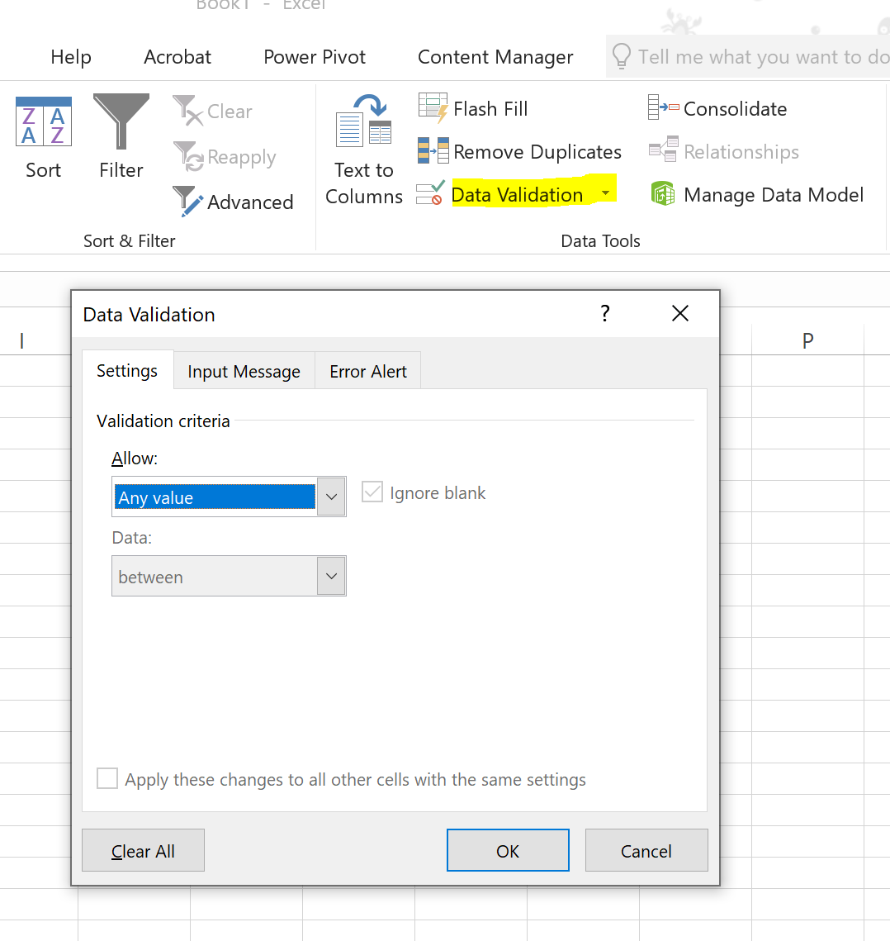

Evaluate sourced data processed using the 3Vs: volume, variety, and velocity
Big Data is different to small datasets because of 3 key principles.
Volume
The volume or size of the data. It is estimated that 2.5 quintillion bytes of data is created each day. This data is stored on devices and on servers.
Variety
Data was once collected from one place and delivered in one format. Once it took the shape of database files, such as Excel, CSV and Access, it is now being presented in non-traditional forms, like video, text, pdf, and graphics on social media, as well as via technology such as wearable devices.
Velocity
Velocity measures how fast this data is collected and processed. Some data is collected in real-time, whereas other will data is collected as a batch.

Activity 79: 3Vs
Students describe one of the big datasets from this unit in terms of the 3Vs. Previous datasets include the:
- Census
- BOM
- IWK
- National Map
- Open Data Hub.
In the space below, describe the volume in your chosen dataset.
Students’ responses can be entered here based on chosen dataset.
In the space below, describe the variety in your chosen dataset.
Students’ responses can be entered here based on chosen dataset.
In the space below, describe the velocity in your chosen dataset.
Students’ responses can be entered here based on chosen dataset.
Students evaluate their own project and that of peers using predetermined functional and non-functional requirements.
During the presentation of their digital solution, students evaluate their own and each other’s project based on the criteria of functional and non-functional requirements they proposed.
These evaluations can be achieved using peer feedback and form part of the summative assessment of this unit.

Evaluate whether solutions meet social, ethical and legal responsibilities and cybersecurity principles
During the presentation of their digital solution students evaluate their own and each other’s project based on whether solutions meet social, ethical and legal responsibilities and cybersecurity principles.
These evaluations can be achieved using peer feedback and form part of the summative assessment of this unit.

Assess a developed solution based on calculations from datasets
During the presentation of their digital solution students indicate calculations from the datasets they have used (including formulas, aggregate and lookup functions, trends, and outliers).
They assess their own and each other’s project based on whether solutions developed adhere to the results of these calculations.
These evaluations can be achieved using peer feedback and form part of the summative assessment of this unit.

Perform verification of datasets, calculations, and outputs
Verification is performed to ensure that the data entered exactly matches the original source. A broader description includes the processes to ensure data is free of errors.
Under the broader definition, verification is a process that occurs from collection, including observer and interviewer bias, to the entry and the analysis of data.
Students consider the importance of data verification, for example, in electoral roles or government databases where without ways of checking the data, letters can be sent to the deceased.
Students will be required to perform verification of the datasets they use for their project.

Support and alignment
Resource evaluation and support: All curriculum resources are prepared through a rigorous process. Resources are periodically reviewed as part of our ongoing evaluation plan to ensure currency, relevance, and effectiveness. For additional support or advice contact the TAS curriculum team by emailing TAS@det.nsw.edu.au.
Alignment to system priorities and/or needs: School Excellence Policy, School Success Model.
Alignment to the School Excellence Framework: This resource supports the School Excellence Framework elements of curriculum (curriculum provision) and effective classroom practice (lesson planning, explicit teaching).
Alignment to Australian Professional Teaching Standards: This resource supports teachers to address Australian Professional Teaching Standards 3.2.2, 3.3.2.
Consulted with: Curriculum and Reform, Inclusive Education, Multicultural Education, Aboriginal Outcomes and Partnerships and subject matter experts.
NSW syllabus: Computing Technology 7–10
Syllabus outcomes: CT5-DPM-01, CT5-EVL-01, CT5-DAT-01, CT5-COM-01, CT5-THI-01, CT5-DAT02.
Author: TAS, Curriculum Secondary Learners, Curriculum Reform
Publisher: State of NSW, Department of Education
Resource: Teacher support resource
Related resources: Further resources to support Computing Technology 7–10 can be found on the TAS curriculum page.
Professional learning: Relevant professional learning is available through the TAS statewide staffroom.
Creation date: 2022
Rights: © State of New South Wales, Department of Education.

Evidence base
Computing Technology 7–10 Syllabus © NSW Education Standards Authority (NESA) for and on behalf of the Crown in right of the State of New South Wales, 2022.
AITSL (Australian Institute for Teaching and School Leadership Limited) (n.d) Learning intentions and success criteria [PDF 251 KB], AITSL, accessed 29 August 2022.
Brookhart S (2011) How to Assess Higher-Order Thinking Skills in Your Classroom, Hawker Brownlow Education, Victoria.
Rosenshine B (2012) ‘Principles of Instruction: Research-Based Strategies That All Teachers Should Know’, American Educator, 36(1):12-19, 39, accessed 29 August 2022.
State of New South Wales (Department of Education) and CESE (Centre for Education Statistics and Evaluation) (2020a) ‘What works best in practice’, CESE, NSW Department of Education, accessed 29 August 2022.
State of New South Wales (Department of Education) and CESE (Centre for Education Statistics and Evaluation) (2020b) ‘What works best: 2020 update’, CESE, NSW Department of Education, accessed 29 August 2022.
Wiliam D (2013) ‘Assessment: The bridge between teaching and learning’, Voices from the Middle, 21(2):15–20, accessed 29 August 2022.
Wisniewski B, Zierer K and Hattie J (2020) ‘The Power of Feedback Revisited: A Meta-Analysis of Educational Feedback Research’, Frontiers In Psychology, 10:3087, doi:10.3389/fpsyg.2019.03087, accessed 29 August 2022.

References
This resource] contains NSW Curriculum and syllabus content. The NSW Curriculum is developed by the NSW Education Standards Authority. This content is prepared by NESA for and on behalf of the Crown in right of the State of New South Wales. The material is protected by Crown copyright.
Please refer to the NESA Copyright Disclaimer for more information https://educationstandards.nsw.edu.au/wps/portal/nesa/mini-footer/copyright.
NESA holds the only official and up-to-date versions of the NSW Curriculum and syllabus documents. Please visit the NSW Education Standards Authority (NESA) website https://educationstandards.nsw.edu.au/ and the NSW Curriculum website https://curriculum.nsw.edu.au/home.
Computing Technology 7–10 Syllabus © NSW Education Standards Authority (NESA) for and on behalf of the Crown in the State of New South Wales, 2022.
ACARA (Australian Curriculum, Assessment and Reporting Authority) and Australian Government Department of Education and Training (n.d.) What do the data really reveal? [DOC 1.71 KB], Digital Technologies in Focus, ACARA and Australian Government Department of Education and Training, accessed 31 August 2022.
ADSEI (Australian Data Science Education Institute) (n.d.) ADSEI [website], accessed 1 September 2022.
American-Israeli Cooperative Enterprise (1998-2023) Hollerith Machine, Jewish Virtual Library: A project of AICE website, accessed 31 August 2022.
AshBox (2022) The Binary Number System: Its History, Applications and Advantages, Binary Translator website, accessed 31 August 2022.
Australian Bureau of Statistics (13 April 2021) 'Ever wonder how Census data is used?' [video], ABSstatistics, YouTube, accessed 31 August 2022.
Australian Bureau of Statistics (13 April 2021) 'Why have a Census?' [video], ABSstatistics, YouTube, accessed 31 August 2022.
Australian Bureau of Statistics (2021) ‘Infographics’, 2021 Census, ABS website, accessed 31 August 2022.
Australian Bureau of Statistics (2022) Census, ABS website, accessed 31 August 2022.
Australian Government Department of Education and Education Services Australia (n.d.) A Visual Introduction to Machine Learning, Digital Technologies Hub website, accessed 31 August 2022.
Australian Government Department of Education and Education Services Australia (n.d.) ‘Seeing the big picture’, Lesson ideas, Digital Technologies Hub website, accessed 31 August 2022.
Bernardone L (11 August 2022) ‘Australian TikTok data can be accessed by China’, ACS (Australian Computer Society): Information Age, accessed 31 August 2022.
Bible Study Tools (24 July 2012) ‘Did a Census Really Bring Joseph and Mary to Bethlehem?’, Bible Study Tools: Topical Studies, accessed 31 August 2022.
Board of Regents of the University System of Georgia (n.d.) ‘A Brief History of the Internet’, Tips for Using the Internet, Online Library Learning Centre website, accessed 31 August 2022.
Brailsford D (15 September 2020) ‘A brief, brief history of Data Analytics’, LinkedIn Pulse, accessed 31 August 2022.
Braue D (11 August 2022) ‘Government kills “failed” $21m COVIDSafe app: But what will happen to the data it collected?’, ACS: Information Age, accessed 31 August 2022.
Braue D (16 August 2022) ‘Google fined $60m for collecting location data’, ACS: Information Age, accessed 31 August 2022.
Buolamwini J (March 2017) 'How I'm fighting bias in algorithms' [video], TEDxBeaconStreet, TED website, accessed 31 August 2022.
Burns E (2021) ‘Machine learning’, Enterprise Artificial Intelligence Definitions, TechTarget website, accessed 31 August 2022.
Cassel D (2 June 2019) ‘How VisiCalc’s Spreadsheets Changed the World’, The New Stack: Tech Life, accessed 31 August 2022.
Central Queensland University (n.d.) GPS Cows [website], accessed 1 September 2022.
Commonwealth of Australia (2016) IWK (Indigenous Weather Knowledge), BoM (Bureau of Meteorology) website, accessed 31 August 2022.
Commonwealth of Australia (10 August 2017) 'MetEye – your eye on the environment' [video], Bureau of Meteorology, YouTube, accessed 31 August 2022.
Commonwealth of Australia (2017) ‘MetEye’, Australia, BoM website, accessed 31 August 2022.
Commonwealth of Australia (2022) ‘Australian Data Strategy’, Publications: Strategy, Department of Finance website, accessed 31 August 2022.
Commonwealth of Australia (2022) BoM [website], accessed 31 August 2022.
Commonwealth of Australia (2022) Data, Data.gov.au, accessed 31 August 2022.
Commonwealth of Australia (2022) ‘Sharing Economy’, Contractors, business.gov.au, accessed 31 August 2022.
Commonwealth of Australia (Geoscience Australia) (2020) National Map [website], accessed 31 August 2022.
Crash Course (16 March 2017) 'Representing Numbers and Letters with Binary: Crash Course Computer Science #4' [video], Crash Course, YouTube, accessed 7 September 2022.
Crash Course (12 October 2017) 'Cybersecurity: Crash Course Computer Science #31' [video], Crash Course, YouTube, accessed 31 August 2022.
Crash Course (2 November 2017) 'Machine Learning & Artificial Intelligence: Crash Course Computer Science #34' [video], Crash Course, YouTube, accessed 31 August 2022.
Crockford K (May 2020) 'What you need to know about face surveillance' [video], TEDxCambridgeSalon, TED website, accessed 31 August 2022.
Cruise B (29 February 2020) ‘How Recommender Systems Work (Netflix/Amazon)’ [video], Art of the Problem, YouTube, accessed 31 August 2022.
CSIRO (Commonwealth Scientific and Industrial Research Organisation) (n.d.) Educational Datasets Companion [PDF 958 KB], CSIRO, accessed 1 September 2022.
CSIRO (27 November 2019) ‘AI + Indigenous Knowledge a powerful tool posing critical questions’, CSIRO Data61: Algorithm blog, accessed 1 September 2022.
CSIRO (28 January 2021) New data privacy tool ensures anonymous COVID-19 data remains secure and private [media release], CSIRO, accessed 31 August 2022.
CSIRO (2022) ‘Bebras unplugged’, Resources, CSIRO website, accessed 31 August 2022.
CSIRO (2022) Computational Thinking in Action, Digital careers, CSIRO website, accessed 31 August 2022.
CSIRO (2022) ‘Computational Thinking in Action: Facial Recognition’, Resources, CSIRO website, accessed 31 August 2022.
De Marco Lawyers (n.d.) ‘Intellectual Property Law – Data: In the "Internet of Things" – Who Owns Data?’, De Marco Thinks: Articles, accessed 31 August 2022.
Dear Data (n.d.) The Project, Dear Data website, accessed 31 August 2022.
Department of Agriculture, Fisheries and Forestry (2022) ‘Data’, ABARES (Australian Bureau of Agricultural and Resource Economics and Sciences), Department of Agriculture, Fisheries and Forestry website, accessed 31 August 2022.
Dorling M (2021) ‘Databases’, Community Activities, Classic Computer Science: Unplugged website, accessed 31 August 2022.
Foote KD (25 October 2021) ‘A Brief History of Database Management’, Dataversity: Information Management Articles, accessed 31 August 2022.
Frost D (2022) Lesson Plan confectionary snakes [DOCX 16.1KB], Google Drive, accessed 31 August 2022.
Gadgets 360 (28 October 2021) ‘How Accurate Is Your Fitness Tracker? We Put This to the Test’ [video], Gadgets 360, YouTube, accessed 31 August 2022.
Ganchev M (3 May 2022) ‘Database vs Spreadsheet: What’s the Difference?’, 365 DataScience, accessed 1 September 2022.
Gapminder (n.d.) Gapminder [website], accessed 31 August 2022.
Geckoboard (2022) ‘Data fallacies’, Best practice, Geckoboard website, accessed 31 August 2022.
Gharani L (4 February 2021) ‘Excel Tutorial for Beginners | Excel Made Easy’ [video], Leila Gharani, YouTube, accessed 31 August 2022.
Google (2022) Teachable Machine [website], accessed 1 September 2022.
Google (2023) ‘Get started with Google Sheets’, Product Guides, Google for Education website, accessed 31 August 2022.
Google (2023) Google Trends [website], accessed 31 August 2022.
Gould R, Machado S, Johnson TA and Molyneux J (n.d.) Lesson 1: Data Trails, Introduction to Data Science Curriculum website, accessed 31 August 2022.
Gould R, Machado S, Johnson TA and Molyneux J (n.d.) Lesson 3: Data Structures, Introduction to Data Science Curriculum website, accessed 31 August 2022.
GOV.UK (n.d.) ‘Domesday: Britain’s finest treasure’, Exhibition, The National Archives website, accessed 31 August 2022.
GovHack (2022) GovHack [website], accessed 1 September 2022.
Greenwald G (2014) ‘Why privacy matters’ [video], TedGlobal 2014, TED website, accessed 31 August 2022.
Harper J (5 March 2021) ‘Data experts are becoming football’s best signings’, BBC News, accessed 1 September 2022.
Herman S (30 October 2020) ‘Should Tech Companies Be Paying Us For Our Data?’, Forbes, accessed 1 September 2022.
Information is beautiful (2022) World’s Biggest Data Beaches & Hacks, information is beautiful website, accessed 31 August 2022.
Jenkins R (16 September 2015) ‘M&M Color Distribution Analysis’ [video], Rose Jenkins, YouTube, accessed 31 August 2022.
Kalodikis C (27 February 2019) ‘Data Dictionary: Student Details’ [video], Christopher Kalodikis, YouTube, accessed 31 August 2022.
Khan Academy (2023) The need for compression, Khan Academy website, accessed 31 August 2022.
Lucid Software (5 November 2021) ‘Learn and Master the Basics in Lucidchart’ [video], Lucid Software, YouTube, accessed 31 August 2022.
Maryville University (2022) ‘The Evolution of Social Media: How Did It Begin, and Where Could It Go Next?’, Maryville University blog, accessed 31 August 2022.
McGahey P and Microsoft Educator Centre (18 February 2023) ‘BBC My World Global Curriculum’, Microsoft Learn, accessed 31 August 2022.
Micro:bit Educational Foundation (2022) ‘Controlling physical systems with sensors (55 mins)’, Courses, micro:bit website, accessed 31 August 2022.
Micro:bit Educational Foundation (2022) ‘Step counter’, Make it: code it, micro:bit website, accessed 31 August 2022.
Microsoft (2022) Differences between the 1900 and the 1904 date system in Excel, Microsoft Learn, accessed 31 August 2022.
Microsoft (2022) Excel video training, Microsoft Support website, accessed 31 August 2022.
Microsoft Educator Centre (11 January 2022) ‘FarmBeats for Students’, Microsoft Learn, accessed 31 August 2022.
Microsoft Educator Centre (20 October 2022) ‘Day of Data: Orcas’, Microsoft Learn, accessed 31 August 2022.
Mikes-Photography (13 January 2016) ‘Cars Motorway Speed’ [video], Mikes-Photography, Pixabay, accessed 31 August 2022.
Minecraft Education (2023) ‘CyberSafe: Home Sweet Hmm’, Lessons, Minecraft Education website, accessed 31 August 2022.
MITCBMM (23 February 2022) ‘When and How CNNs Generalize to Out-of-Distribution Category-Viewpoint Combinations’ [video], MITCBMM, YouTube, accessed 31 August 2022.
Nasrullah Q (17 June 2022) ‘Explainer: Are Australian retailers using facial recognition software on their unknowing customers?’, Cosmos, accessed 31 August 2022.
National Library of Australia (n.d.) ‘Statistics: Population and census reports’, Statistics, National Library of Australia website, accessed 31 August 2022.
Nield D (31 December 2017) ‘How it works: We explain how your fitness tracker measures your daily steps’, Wareable, accessed 31 August 2022.
Parkin J and Madecraft (2021) Spreadsheets vs. databases, LinkedIn Learning website, accessed through the DoE portal, 1 September 2022.
Quince A (host and producer) (18 September 2016) ‘The dark side of the census’ [podcast], Rear Vision – How History Shaped Today, ABC (Australian Broadcasting Corporation): Radio National, accessed 31 August 2022.
Readysaltedcode CIC (2014) [data]storm [website], accessed 31 August 2022.
Rischin J (2019) Report Wizard, LinkedIn Learning website, accessed through the DoE portal, 1 September 2022.
Robson J and Hopkins W (4 July 2021) '3 Essential Excel skills for the data analyst' [video], Access Analytic, YouTube, accessed 1 September 2022.
SBS (2020) SBS Australian Census Explorer, SBS News website, accessed 31 August 2022.
Smolcykr (2016) Introduction to Data Analysis with M&Ms, tableau public website, accessed 31 August 2022.
Somerset House (4 March 2016) ‘Big Bang Data: Dear Data’ [video], Somerset House, YouTube, accessed 31 August 2022.
State of New South Wales (2022) Data.NSW [website], accessed 31 August 2022.
State of New South Wales (Department of Education) (2023) Digital Learning Selector, NSW Department of Education website, accessed 31 August 2022.
State of New South Wales (Department of Education) (2023) ‘Guidelines for using data’, School Excellence Framework evidence guide, NSW Department of Education website, accessed 31 August 2022.
State of New South Wales (Transport for NSW) (n.d.) Open Data – Transport for NSW forum, open data website, accessed 31 August 2022.
Teach Computer Science (2023) Data Compression, Teach Computer Science website, accessed 31 August 2022.
TechTarget (2021) machine learning, TechTarget website, accessed 2 May 2023.
The Australian Institute of Aboriginal and Torres Strait Islander Studies (n.d.) Indigenous languages preservation: Dictionaries project, AIATSIS website, accessed 1 September 2022.
The Coding Train (8 November 2019) ‘Teachable Machine 1: Image Classification’ [video], The Coding Train, YouTube, accessed 1 September 2022.
The Ethics Centre (15 April 2020) ‘What is the difference between Ethics, Morality and the Law?’ [video], The Ethics Centre, YouTube, accessed 31 August 2022.
The Royal Society (2017) What is machine learning?, The Royal Society website, accessed 31 August 2022.
Tonkin C (1 February 2022) ‘Government building national facial recognition database’, ACS: Information Age, accessed 31 August 2022.
University of Canterbury, New Zealand (Computer Science Research Group) (2021) ‘Text Compression’, Activities, Classic Computer Science: Unplugged website, accessed 7 September 2022.
Viernes FA (15 September 2021) ‘Stop Saying ‘Data is the New Oil’, Geek Culture, accessed 31 August 2022.
Vigderman A and Turner G (2 June 2022) ‘What is Personally Identifiable Information (PII)?’, security.org website, accessed 10 June 2022.
Watts M (17 November 2021) ‘Why data is the new oil’, Futurescot website, accessed 31 August 2022.

© State of New South Wales (Department of Education), 2023
The copyright material published in this resource is subject to the Copyright Act 1968 (Cth) and is owned by the NSW Department of Education or, where indicated, by a party other than the NSW Department of Education (third-party material).
Copyright material available in this resource and owned by the NSW Department of Education is licensed under a Creative Commons Attribution 4.0 International (CC BY 4.0) licence.
This licence allows you to share and adapt the material for any purpose, even commercially.
Attribution should be given to © State of New South Wales (Department of Education), 2023.
Material in this resource not available under a Creative Commons licence:
- the NSW Department of Education logo, other logos and trademark-protected material
- material owned by a third party that has been reproduced with permission. You will need to obtain permission from the third party to reuse its material.
Links to third-party material and websites
Please note that the provided (reading/viewing material/list/links/texts) are a suggestion only and implies no endorsement, by the New South Wales Department of Education, of any author, publisher, or book title. School principals and teachers are best placed to assess the suitability of resources that would complement the curriculum and reflect the needs and interests of their students.
If you use the links provided in this document to access a third-party's website, you acknowledge that the terms of use, including licence terms set out on the third-party's website apply to the use which may be made of the materials on that third-party website or where permitted by the Copyright Act 1968 (Cth). The department accepts no responsibility for content on third-party websites.

