Pets in our home
Many Australian households own pets. Dogs, cats, snakes and fish are common pets around Australia. As a class, conduct a survey of all students to collate and analyse data on pet ownership. Using Microsoft Excel, use data to create charts to visually represent results.

Resource information
Resource element | Details
Learning objectives | Students will:  - model and represent unit fractions  - identify multiplicative relationships using bar models.
Curriculum alignment | Mathematics – K-10  - Constructs graphs using many one-to-one scales MA3-DATA-01  - interprets data displays, including timelines and line graphs MA3-DATA-02  Technology mandatory – 7-8  - explains how data is represented in digital systems and transmitted in networks TE4-7DI

Pets owned by our class

Activity 1
Survey the class for the number of pets of and record the results using the table layout below.
Pet type | Tally | Total number | Percentage (%) ownership in class
Dog
Cat
Fish
Bird
Small mammal
Reptiles
Other pets

Activity 2
- Input this data into a spreadsheet.
- Graph this data as a column or bar chart.
See teacher guide ‘creating a chart using survey data’ (page 4).

Pets in Australia

Activity 3
Access the dataset ‘Pet ownership in Australia’ (table on page 9). Recreate this table in Excel.
See teacher notes on page 3.

Activity 4
Examine the number of pets in Australia. Use the data you have just entered into Excel and graph the results.

Reflection Questions
- What is the most popular pet in the class?
- What is the most popular pet in Australia?
- How does pet ownership in our class compare to the survey across Australia?
- Pet ownership in Australia survey shows over 4000 household have a dog. Over 3000 household have a cat. Total households are nearly 7000. Explain why these figures do not add up.

Discussion points
What is a survey sample? The sample size of Australian families used is 2453. Discuss the issues that might occur with the sample size if the population of Australia is over 25 million (2021).
Note: data sample is cross referenced to ABS Census data to reduce bias.
We surveyed the class first and then compared the results to the Australian survey. Would our class results be influenced by the Australian survey if we had reversed the order?

Teacher’s notes
Figure 1 – source data from ‘Animal Medicines Australia’ on pet ownership in Australia (Page 9 of document).
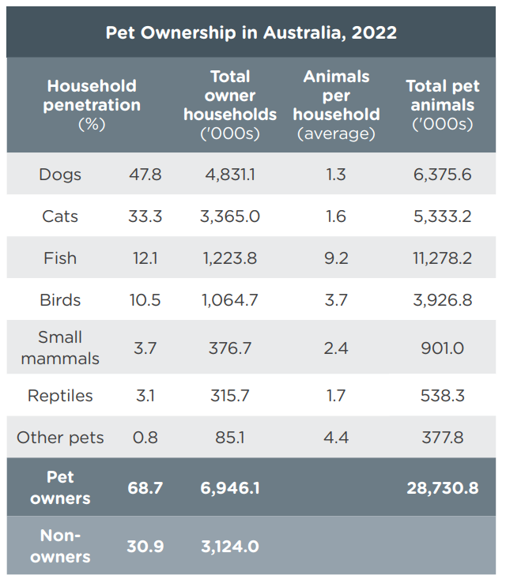
There are 2 ways students get this data into an excel spreadsheet:
- Students can enter the data manually (data entry errors may occur).
- If you wish to extract the data and give the students a prepared excel file watch How to Copy a Table from PDF to Excel - Extract Data to Edit (1:13).

Creating a chart using survey data – teacher guide
Follow the steps below to create a chart using the data for ‘Total pets in Australia by type’.
- Use the mouse to highlight the cells with animal names, then select <ctrl> on the keyboard and use the mouse again to highlight the cells containing total animal numbers.
Figure 2 – selecting cells in Excel
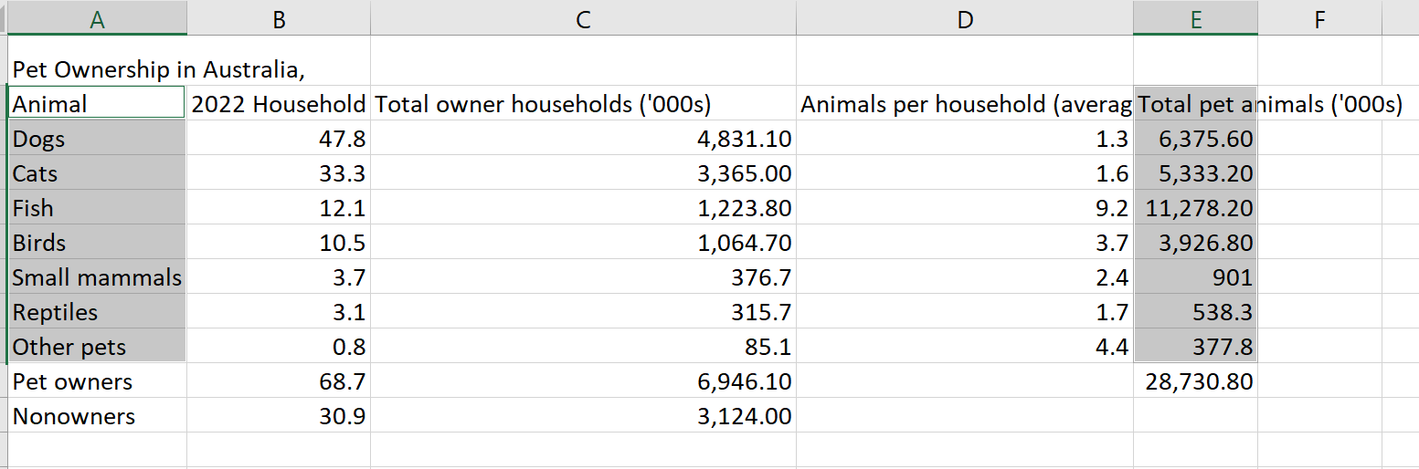
- Select a suitable chart type. There are many variations for each chart type. The example shown is a formatted pie chart.
Figure 3 – visualising data in Excel
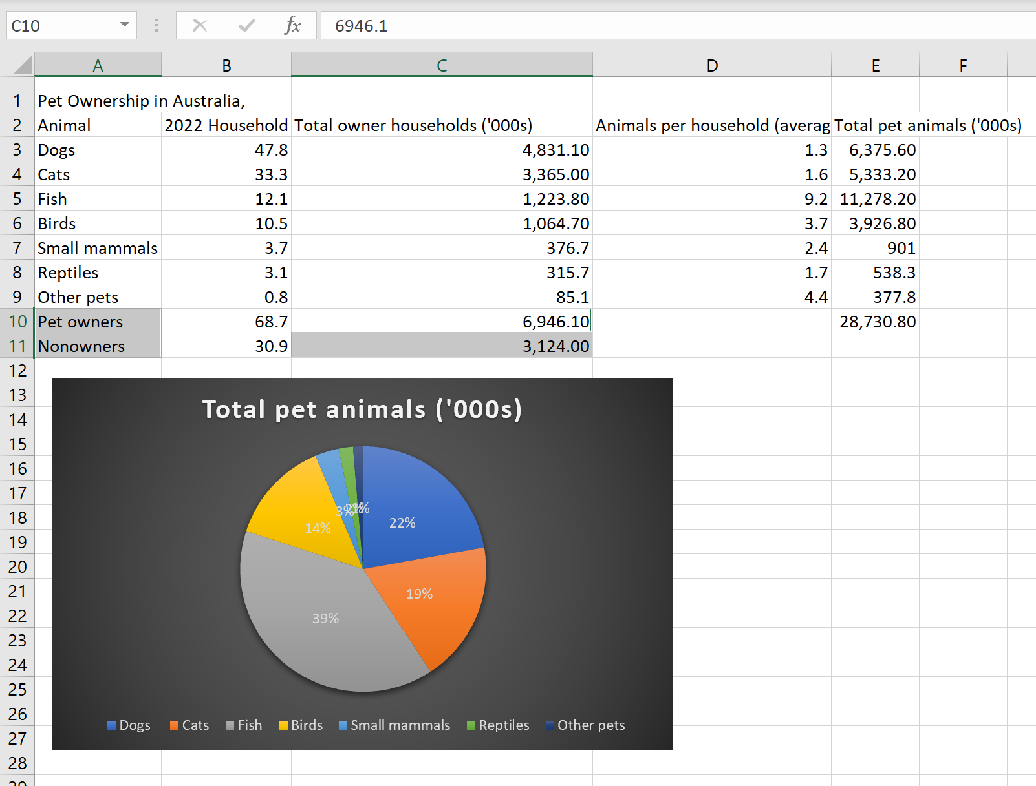
- Chart the data of pet owners to non-pet owners. A bar graph is a suitable chart type.
Figure 4 – pet owners to non-pet owners
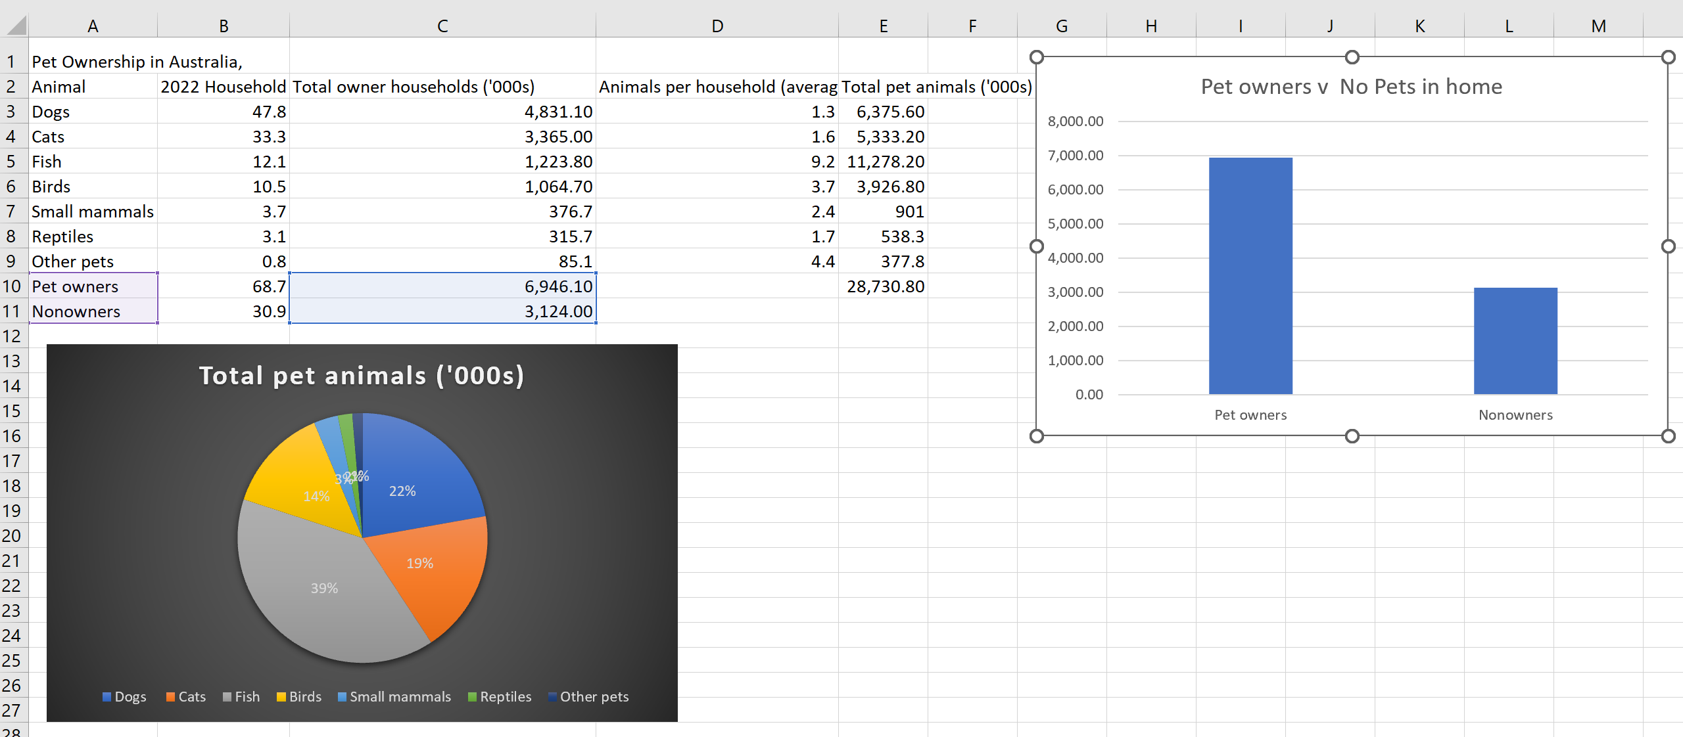
You can change the bar chart into a pictogram by formatting the Data series.
- Select the bars to highlight the data series.
- Right click and navigate to Format Data Series, select Fill, then select Picture or Texture fill and Insert a stock image. For more information on how to do this, see How to Use Pictures in Your Excel Bar Charts
Figure 5 – adding pictures to a bar chart in Excel
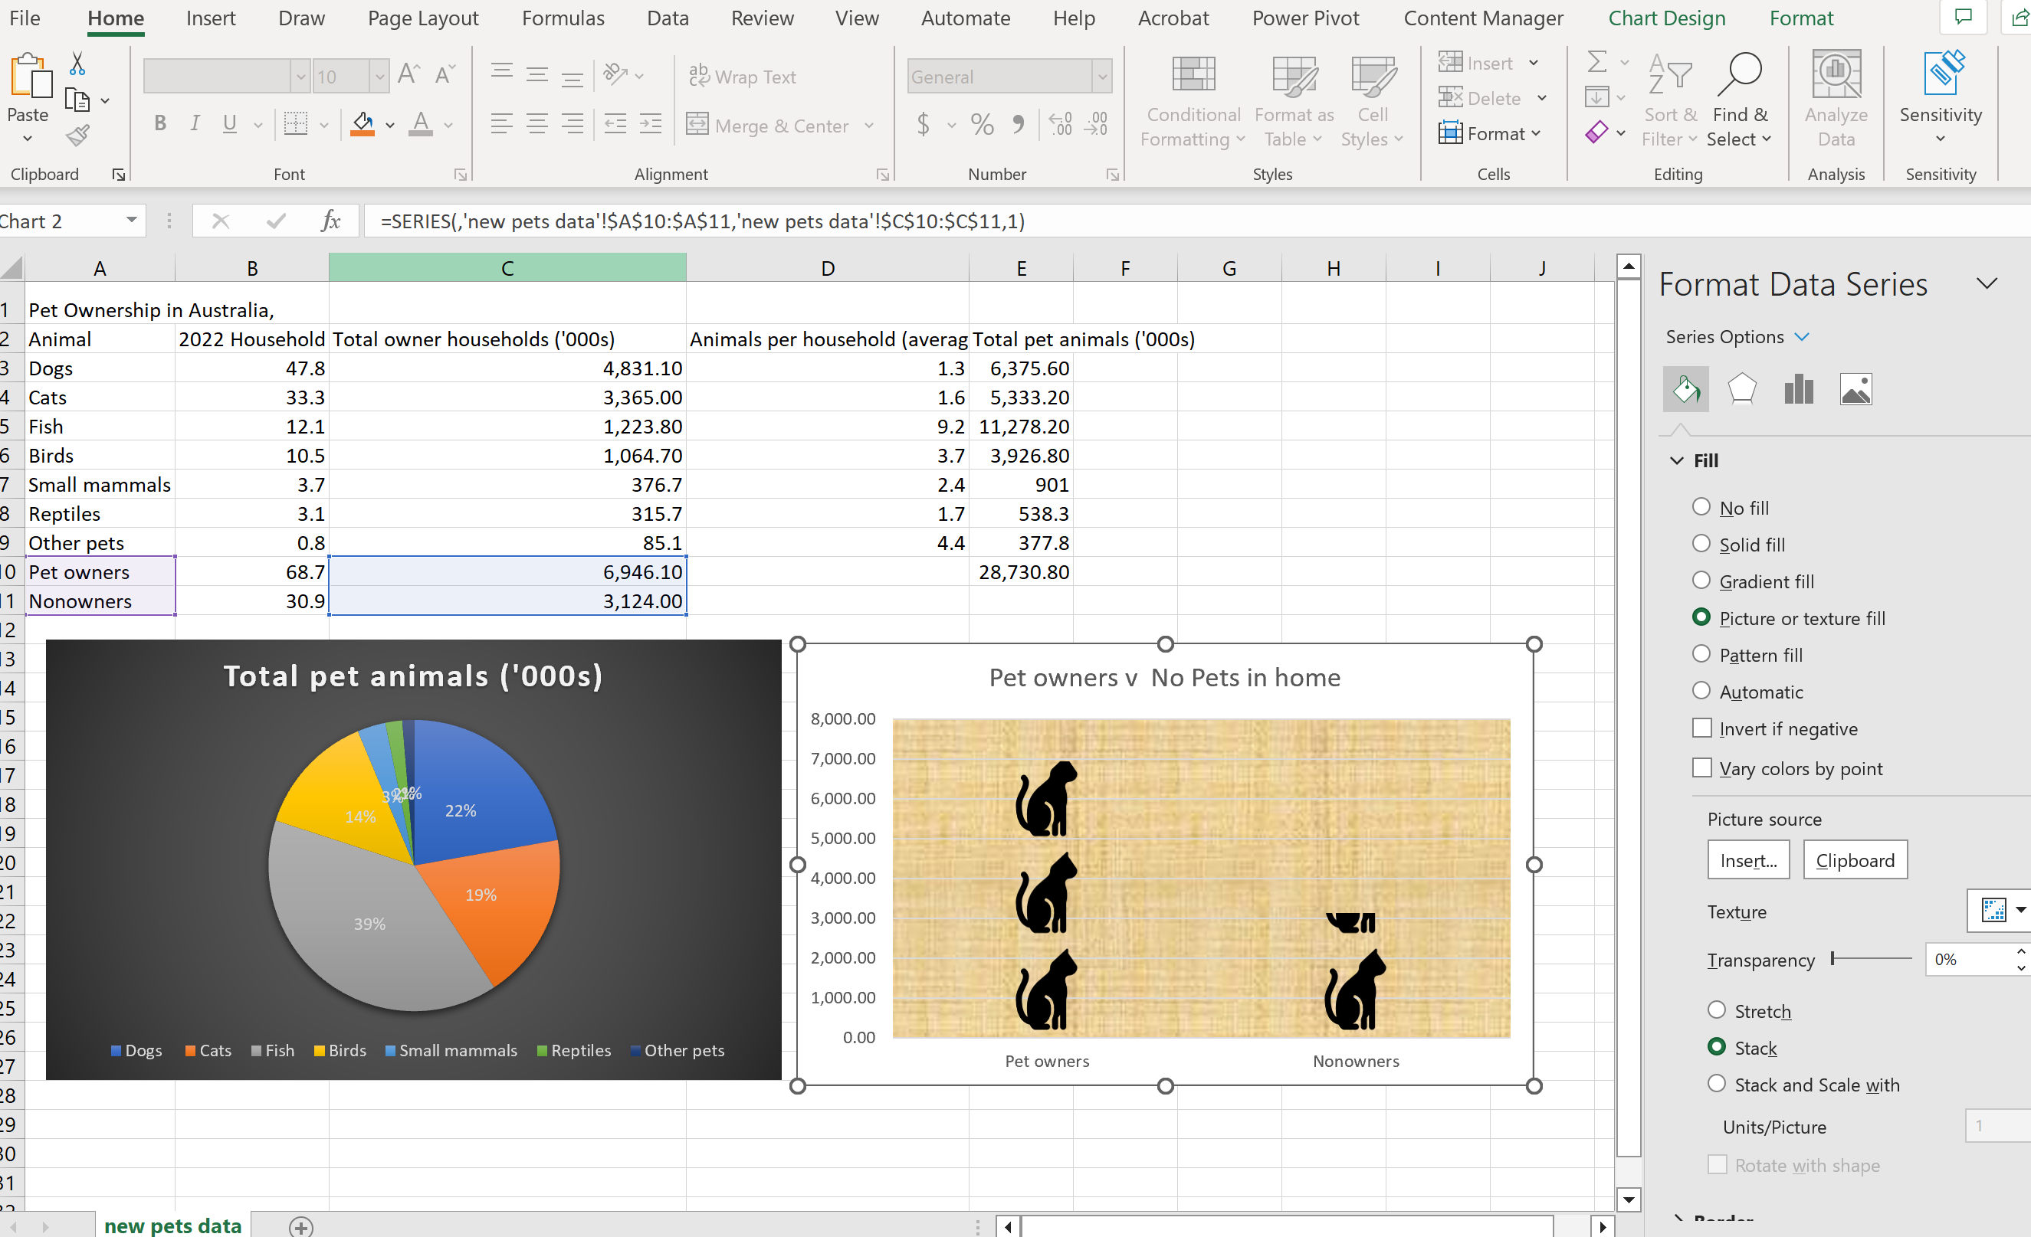

- Using the same method to select discrete columns (<ctrl>+mouse), highlight the animal type and owner households to compare number of animals chart to number of household ownership.
Figure 6 – highlighting cell in Excel
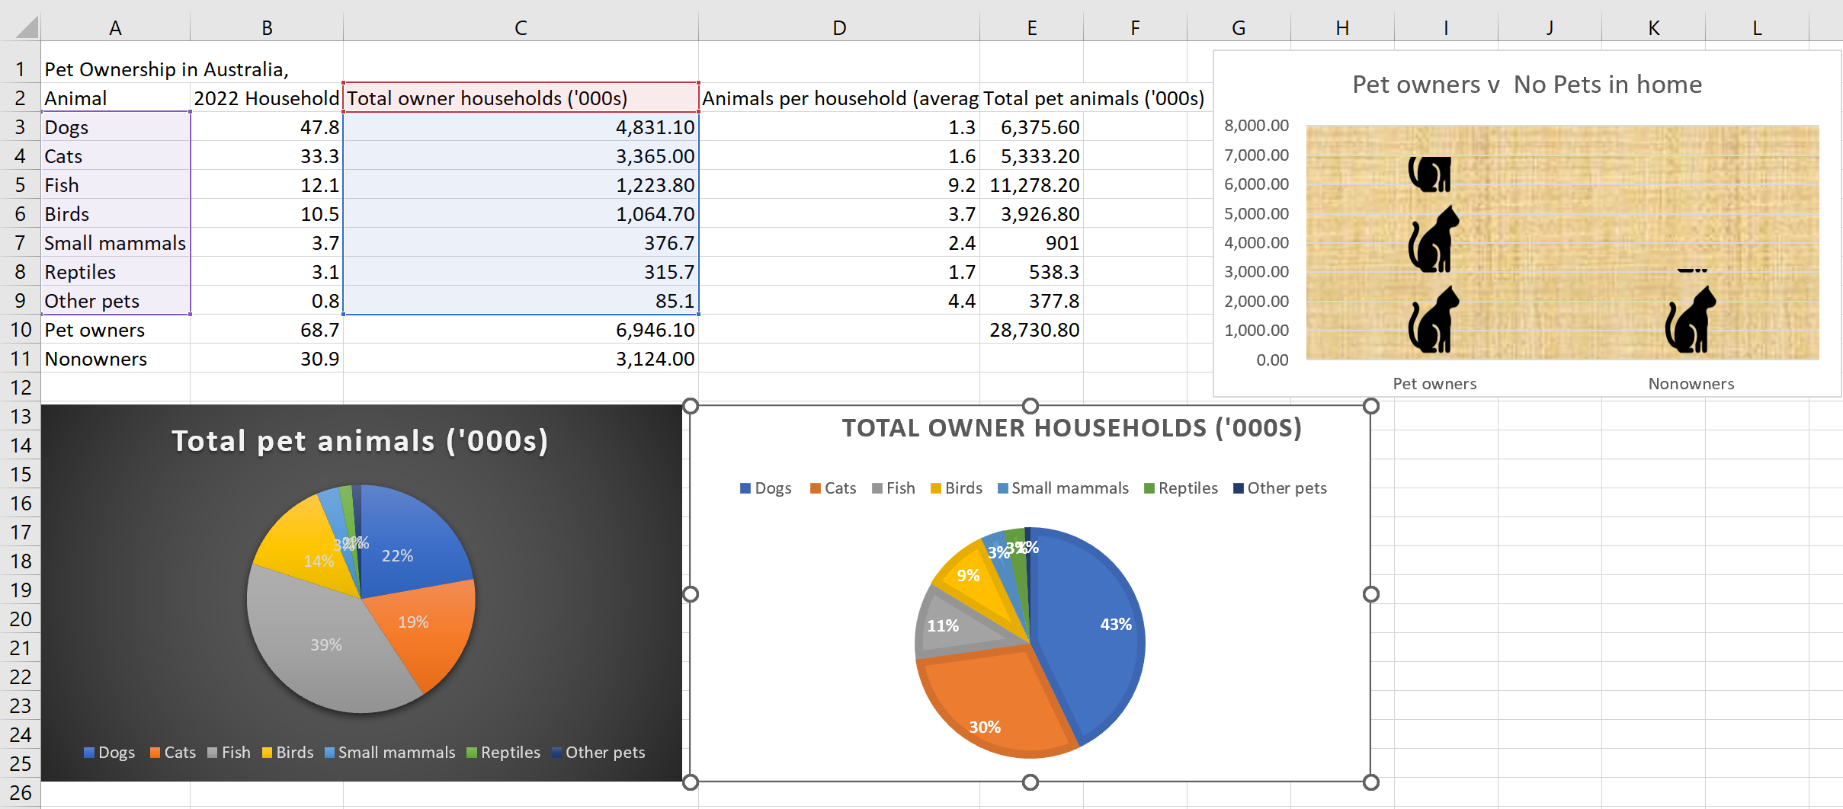

References
This resource contains NSW Curriculum and syllabus content. The NSW Curriculum is developed by the NSW Education Standards Authority. This content is prepared by NESA for and on behalf of the Crown in right of the State of New South Wales. The material is protected by Crown copyright.
Please refer to the NESA Copyright Disclaimer for more information https://educationstandards.nsw.edu.au/wps/portal/nesa/mini-footer/copyright.
NESA holds the only official and up-to-date versions of the NSW Curriculum and syllabus documents. Please visit the NSW Education Standards Authority (NESA) website https://educationstandards.nsw.edu.au/ and the NSW Curriculum website https://curriculum.nsw.edu.au/home.
Mathematics K–10 Syllabus © NSW Education Standards Authority (NESA) for and on behalf of the Crown in right of the State of New South Wales, 2022.

© State of New South Wales (Department of Education), 2023
The copyright material published in this resource is subject to the Copyright Act 1968 (Cth) and is owned by the NSW Department of Education or, where indicated, by a party other than the NSW Department of Education (third-party material).
Copyright material available in this resource and owned by the NSW Department of Education is licensed under a Creative Commons Attribution 4.0 International (CC BY 4.0) licence.
This licence allows you to share and adapt the material for any purpose, even commercially.
Attribution should be given to © State of New South Wales (Department of Education), 2023.
Material in this resource not available under a Creative Commons licence:
- the NSW Department of Education logo, other logos and trademark-protected material
- material owned by a third party that has been reproduced with permission. You will need to obtain permission from the third party to reuse its material.
Links to third-party material and websites
Please note that the provided (reading/viewing material/list/links/texts) are a suggestion only and implies no endorsement, by the New South Wales Department of Education, of any author, publisher, or book title. School principals and teachers are best placed to assess the suitability of resources that would complement the curriculum and reflect the needs and interests of their students.
If you use the links provided in this document to access a third-party's website, you acknowledge that the terms of use, including licence terms set out on the third-party's website apply to the use which may be made of the materials on that third-party website or where permitted by the Copyright Act 1968 (Cth). The department accepts no responsibility for content on third-party websites.

