Where? The mathematics in surveying – participant Booklet
Corrinne Towns, Renee Wells, Colleen Worton and Matthew Fitzsimmons

Agenda
Time | Activity
11:00–11:30 | Introduction
11:30–12:15 | Activity Rotation 1
12:15–1:00 | Activity Rotation 2
1:00–2:00 | Lunch
2:00–2:45 | Activity Rotation 3
2:45–3:30 | Closing  Resources  Feedback and Questions

Activity 1 – How far is it across a river?
How would you tell how far it is across the river?

Equipment list
- 4 tent pegs
- yarn
- measuring tape or ruler

Chain surveying activity with similar triangles (vertically opposite)
- Set out your survey using the following instructions:
Figure 1 – measuring distance over an obstruction
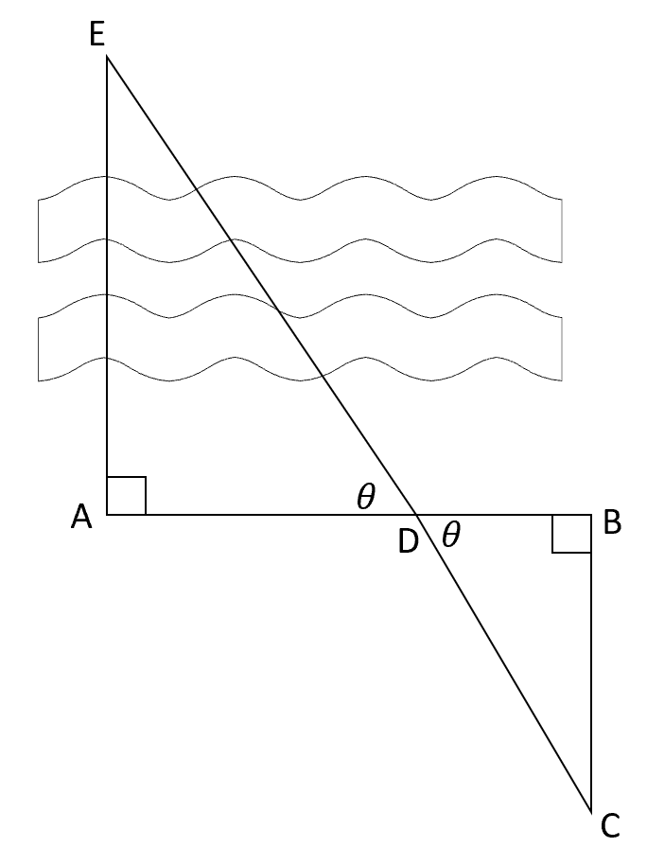
To measure the distance over an obstruction, use the following steps:
- Place a tent peg at your starting point (A). Pick a location on the other side of the obstruction to reference as your end point (E).
- Starting from A, walk in a direction that is perpendicular to AE and place tent peg (B). Thread the yarn from A to B.
- Starting from B, walk a distance away from E, perpendicular to AB and place tent peg (C). You must be able to see (E) from (C). Thread the yarn.
- Walk with the yarn towards E, until you meet somewhere along AB. Mark this as tent peg D and thread the yarn.
- Measure AD, BD and BC. Label these on Figure 1.
- Solve for the unknown distance AE using similar triangles.
- Repeat this for each person in your group. Each individual should have a turn setting out the chain survey.
Further Questions: how accurate are you? Compare your answers with other groups. How similar are they? Why might they be different?
Would you be more accurate with finding a shorter or longer distance? Why?
What is the minimum amount of yarn needed to conduct a chain survey?

Calculate AE

Calculate AE

Calculate AE

Activity 2 – getting my bearings

Task 1 – trilateration
Imagine that there is a person currently lost bushwalking. Fortunately, a signal from their smart watch has been picked up by some mobile phone towers in the area – represented by the cones you see in front of you.
It is known that the person is on a radius of 20 km from each tower. Working in 2 teams using the equipment provided, you must find the person and then radio back the what3words (https://what3words.com or Emergency Plus App) location for the helicopter to be sent out to save them.
You have been given 2 lengths of string each 20 m long representing 20 km.

Task 2 – getting my bearings
You are following your teacher on a bushwalk but you don’t trust their ability to get you home again so decide to take some precautions.
From each checkpoint along the route, you and your friend decide to record the bearing to the next station and the number of steps that you take to travel between those checkpoints. You record this information in the table below.
Path | Bearing | Number of Steps
AB
BC
CD
DE
EF
FG
Unfortunately, you were right! When you reach the destination, your teacher is completely lost. Not only that, but the orienteering team have also packed up the checkpoints!
Can you navigate your way back home?
Planning your way home:

Path | Calculated Bearing | Number of Steps
GF
FE
ED
DC
CB
BA
How close were you?

Activity 3 – finding the maths in Minecraft

Pre-Session Task 1 – downloading and installing Minecraft
To download Minecraft: Education Edition:
- Open the Microsoft Store (you can search for this app in your Start Menu) and ensure you are logged in under your NSW Department of Education credentials.
- In the Microsoft Store app, select the ‘See all’ link towards the top, right-hand corner of the window.
- Navigate through the available apps until you locate Minecraft: Education Edition – select it and follow the prompts to install the application on your device.
Figure 2 – Minecraft: Education Edition
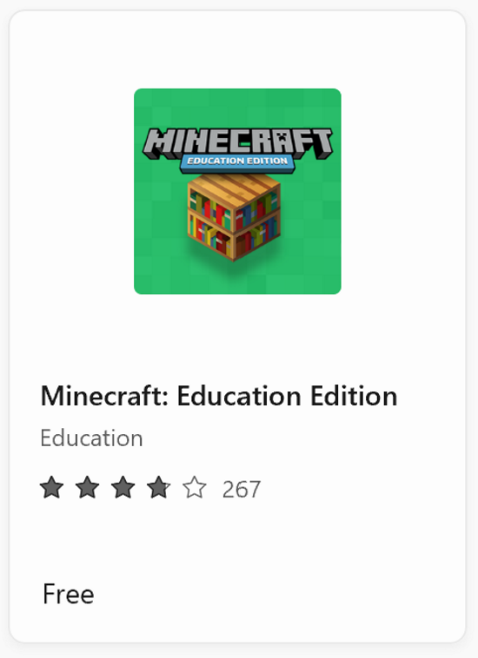
- Once installed, run Minecraft on your device and follow the prompts to log in with your Department of Education credentials.
Changing your settings:
- Select Settings
- Select the ‘Video’ option
- The most important option to change here is the ‘Render Distance’ – slide the bar as far to the right as you can. For Department of Education issued devices, at the time of writing, this should reach a maximum of 16 ‘chunks’.
Figure 3 – render distance 16 chunks
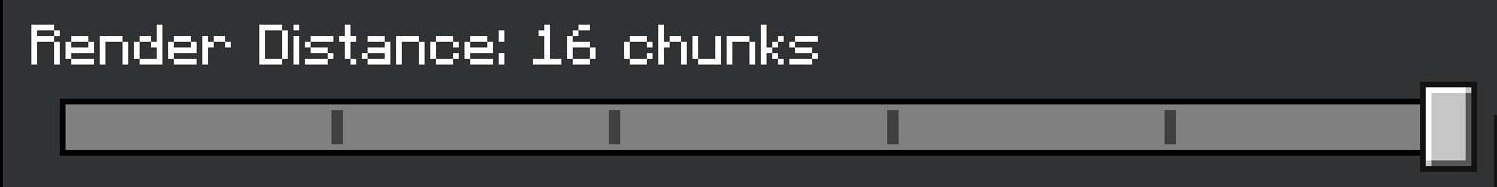

Pre-Session Task 2 – downloading and accessing Mini Melbourne
- Select the following link to be directed to the Mini Melbourne official site.
- To download Mini Melbourne, select the Download button under the Education Edition heading.
- Open your Downloads folder and double-click on the ‘Mini-Melbourne_2.0 (edu)’ file, to launch Mini Melbourne inside Minecraft: Education Edition.
- Save and Exit from this world by pressing the ‘Esc’ key, then select Save and Exit.
Other settings
Changing the name of the worlds you use will be important to better identify them as they are used for different purposes and classes in the future. To be able to do this you need to:
- Select Play
- Select ‘View My Worlds’
- Select ‘Mini-Melbourne 2.0’
- Then select Settings, within World Settings (to the right-hand side of your screen), you can now change the name of this world
- Continue scrolling down and ensure that ‘Show Coordinates’ is set to on
- Select the ‘<’ symbol, next to the word ‘Edit’ in the top, left-hand corner of the window. This will close the settings menu and save your changes.

Session Task – finding the maths in Minecraft
- Open a web browser and search for Flinders Street Station in Melbourne using Google Maps.
- Leaving this browser open, launch Mini Melbourne in Minecraft: Education Edition. Jump into your world by selecting ‘Play’ from the main menu, then ‘View My Worlds’.
The following space has been left blank for you to be able to write any notes, calculations or other information that may be needed throughout this session.

Alternate Activity – approximating distance
How could you tell how far away the building is with only a ruler?

Scenario
We can estimate the distance an object is away from us using just a ruler.
We can create the diagram we explored above using our thumb as the apex of 2 triangles.
Figure 4 – diagram of a viewer and object
In your groups of 3, give each person a role:
Viewer: this person will be the one that stays in the beginning position. They will have their body measured to establish our known information to find the distance from their position to the object. They are to explain where the points go on the object to be measured.
Measurement surveyor: this person will measure the viewer and the object, they are the only person allowed to use the ruler and tape measure.
Field surveryor: this person will write down the measurements and calculations for the group. They will also estimate the length of the object in question.
Given the diagram below, the viewer would try their best to explain to the field surveyor where their thumb sits in relation to the object.
Figure 5 – object with 2 thumbs
In this scenario they might say their thumb began on the edge of the left of the building, when their left eye was closed, and on the right inner edge of the second last window from the right, when their right eye was closed.
These positions should be used by the field surveyor to estimate the length of the object. To assist them, use this list of lengths of common objects:
- small cars are about 4 metres long
- large cars are about 5 metres long
- cars are about 1.8 metres wide
- a normal doorway is around 0.8 metres wide
- the width of a small house is about 8 metres
- the width of a large house is about 12 metres.
The measurement surveyor would take the following measurements:
Description | Length (cm)
Length between eyes
Middle of eyes to outstretched thumb (altitude)
Estimated length of object (from list)
Place the measurements onto the diagram.
Figure 6 – diagram of triangles
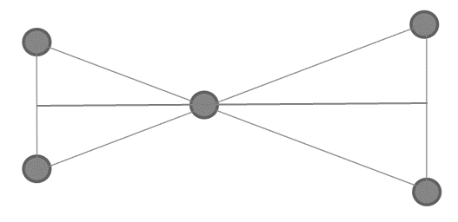
Calculate the distance the viewer was from the object.

Repeat this process and change roles to improve accuracy.
Further Questions: could you generalise this so you don’t need a ruler? What rule could you create to give an estimate for the distance?
Could you estimate when you are 1 km away from an object?

Alternative chain survey
- Set out your survey using the following instructions.
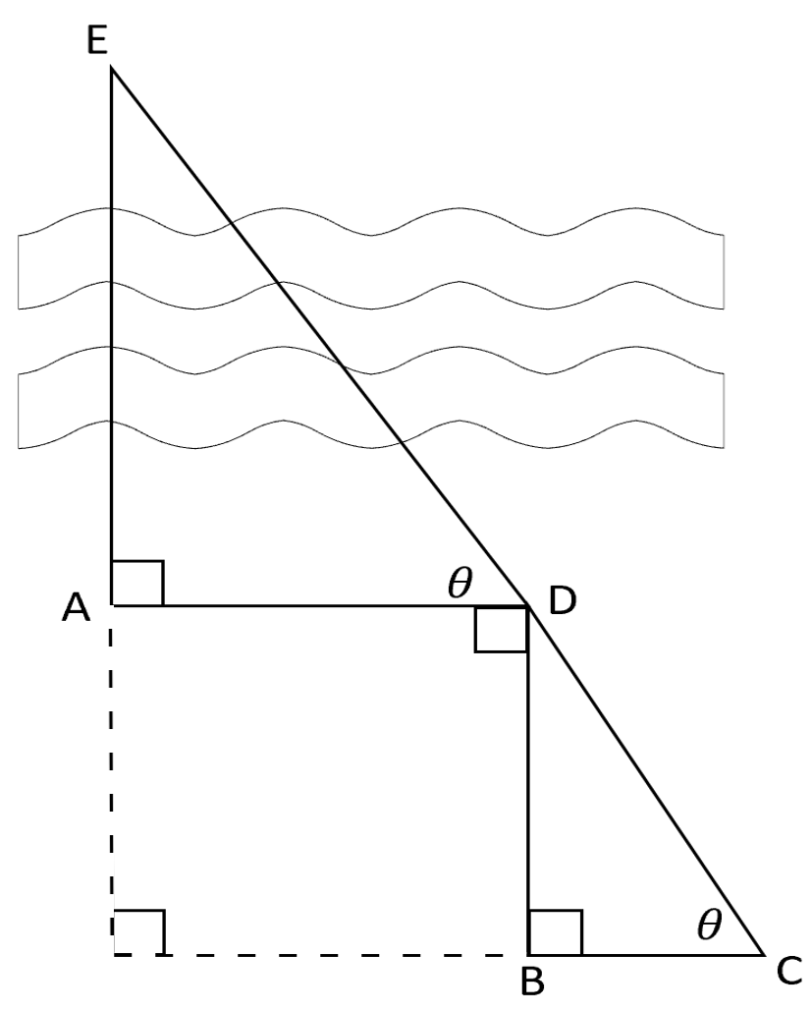 | Working space
To measure the distance over an obstruction, use the following steps:
- Place a tent peg at your starting point (A). Pick a location on the other side of the obstruction to reference as your end point (E).
- Starting from A, walk in a direction that is perpendicular to AE and place tent peg (D). Thread the yarn from A to D.
- Start from D, walk a distance that is perpendicular from AD, further away from E. Place a tent peg (B). Thread the yarn.
- Start from B, walk in the direction that is perpendicular from BD, further away from A, until D is collinear with your location and E. Place a tent peg (C). Thread the yarn.
- Thread the yarn from C to D.
- Measure AD, BD and BC. Label these on the diagram above.
- Solve for the unknown distance AE using similar triangles.

References
This resource contains NSW Curriculum and syllabus content. The NSW Curriculum is developed by the NSW Education Standards Authority. This content is prepared by NESA for and on behalf of the Crown in right of the State of New South Wales. The material is protected by Crown copyright.
Please refer to the NESA Copyright Disclaimer for more information https://educationstandards.nsw.edu.au/wps/portal/nesa/mini-footer/copyright.
NESA holds the only official and up-to-date versions of the NSW Curriculum and syllabus documents. Please visit the NSW Education Standards Authority (NESA) website https://educationstandards.nsw.edu.au/ and the NSW Curriculum website https://curriculum.nsw.edu.au/home.

© State of New South Wales (Department of Education), 2023
The copyright material published in this resource is subject to the Copyright Act 1968 (Cth) and is owned by the NSW Department of Education or, where indicated, by a party other than the NSW Department of Education (third-party material).
Copyright material available in this resource and owned by the NSW Department of Education is licensed under a Creative Commons Attribution 4.0 International (CC BY 4.0) license.
This license allows you to share and adapt the material for any purpose, even commercially.
Attribution should be given to © State of New South Wales (Department of Education), 2023.
Material in this resource not available under a Creative Commons license:
- the NSW Department of Education logo, other logos and trademark-protected material
- material owned by a third party that has been reproduced with permission. You will need to obtain permission from the third party to reuse its material.
Links to third-party material and websites
Please note that the provided (reading/viewing material/list/links/texts) are a suggestion only and implies no endorsement, by the New South Wales Department of Education, of any author, publisher, or book title. School principals and teachers are best placed to assess the suitability of resources that would complement the curriculum and reflect the needs and interests of their students.
If you use the links provided in this document to access a third-party's website, you acknowledge that the terms of use, including licence terms set out on the third-party's website apply to the use which may be made of the materials on that third-party website or where permitted by the Copyright Act 1968 (Cth). The department accepts no responsibility for content on third-party websites.

