Greenhouse effect model
Integrating technology into science lessons – workshop resource

Resource information
Resource element | Details
Learning objectives | Students will:  - follow a procedure to produce a model of the greenhouse effect  - use digital technologies to collect and represent data  - demonstrate their understanding of the greenhouse effect and the enhanced greenhouse effect  - understand the implications of increased greenhouse gases in the atmosphere
Curriculum alignment | Science – Stage 5  - explains how scientific knowledge about global patters of geological activity and interactions involving global systems can be used to inform decisions related to contemporary issues SC5-13ES  - people use scientific knowledge to evaluate claims, explanations or predictions in relation to interactions involving the atmosphere, biosphere, hydrosphere and lithosphere ES3  Investigating science – Stage 6  - solves scientific problems using primary and secondary data, critical thinking skills and scientific processes INS11/12  - develops and engages with modelling as an aid in predicting and simplifying scientific objects and processes INS11-10  Earth and environmental science – Stage 6  - solves scientific problems using primary and secondary data, critical thinking skills and scientific processes EES11/12-6  - analyses the natural processes and human influences on the Earth, including scientific evidence for changes in climate EES12-14
Materials or resources | - Two clear sample bottles (with a neck wide enough for a carbon dioxide probe)  - Rubber stopper with small hole for temperature probes (or plasticine)  - One teaspoon of sodium bicarbonate  - 20 ml white vinegar  - 200 ml beaker  - Heat lamp  - 30 cm ruler  - 2 temperature probes and data logging software  - One carbon dioxide sensor

Introduction
This activity investigates the greenhouse effect by exploring the relationship between atmospheric carbon dioxide and air temperature. The temperature data is collected using temperature sensors and demonstrates how an increase in carbon dioxide concentration in the air enhances the air temperature. This activity can be used to pique interest in climate science and provide tangible evidence of the greenhouse effect that can be observed by students. Sample discussion questions are included, however, they should be adjusted to address the outcomes and stage level of students undertaking the activity.
Students will be able to produce a graph like the one below in this activity.
Figure 1 – sample graph

Background
The greenhouse effect is a natural phenomenon that plays a crucial role in regulating the Earth's temperature. Just as a greenhouse traps heat to create a warm environment for plants, the Earth’s atmosphere acts as a giant blanket, letting sunlight in while keeping some of the heat from escaping back into space. Certain gases, known as greenhouse gases, such as carbon dioxide, water vapour and methane, are responsible for this effect. In this activity, we will delve into the captivating world of the greenhouse effect by crafting a model that demonstrates how varying concentrations of carbon dioxide can influence air temperature.
What is the greenhouse effect, and why is it important for the Earth’s climate?
How do the concentrations of greenhouse gases in the atmosphere contribute to the greenhouse effect?

Hypothesis
Use the ‘If…then…because…’ format to write a hypothesis for the effect of the different gases on the air temperature.

Procedure
- Label the bottles ‘air only’ and ‘added CO2’.
- Set up the data logger with the 2 temperature probes. Set the software to show a graph with temperature on the Y axis and time on the X axis. Set the frequency of measurements to one minute.
- Place the carbon dioxide sensor into the bottle labelled air only. Measure the carbon dioxide level of the air inside (it should be close to 450 ppm). Record the measurement. Remove the sensor and seal the bottle with the stopper and temperature probe.
- Place the bicarbonate soda in the beaker and add the vinegar. Leave it to sit until the gas bubbles settle. Gently pour the CO2 gas into the CO2 labelled bottle. (The CO2 gas will be sitting just above the liquid and, because it is heavier than air, it can be poured.) Seal the bottle with the stopper and temperature probe.
- Place both bottles 30 cm from the heat lamp. DO NOT turn the heat lamp on. Start the data logger and allow it to run for 10 minutes.
- Turn the heat lamp on and continue collecting data for 15 minutes.
Option to add another greenhouse gas: in a third bottle, collect some methane gas from the gas tap. Seal the top with a stopper and temperature probe. Follow instructions from Step 5.

Results
Export the collected data into an Excel spreadsheet. To turn the data into a graph, complete the following steps:
- Adjust the column headings so that they represent the data that is contained in them, for example, air sample temperature (C).
- Highlight the relevant columns (time, temperature air, temperature CO2, temperature CH4, if applicable).
- Select ‘Insert’, and then in the Charts section, select ‘Scatter with Smooth Lines and Markers’.
Figure 2 – Excel instructions
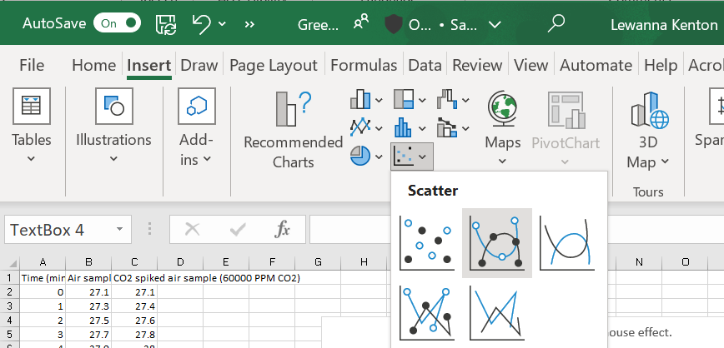
- A graph should appear in the spreadsheet. Click on the graph and select the ‘+’ symbol. Tick ‘Axis titles’. Enter appropriate titles for each axis.
Figure 3 – Excel chart elements
- Give the graph a descriptive title.
- Shade and label the area of the graph where the heat lamp was off. You can insert a rectangle and adjust the transparency to achieve this.
Figure 4 – Excel colour choice
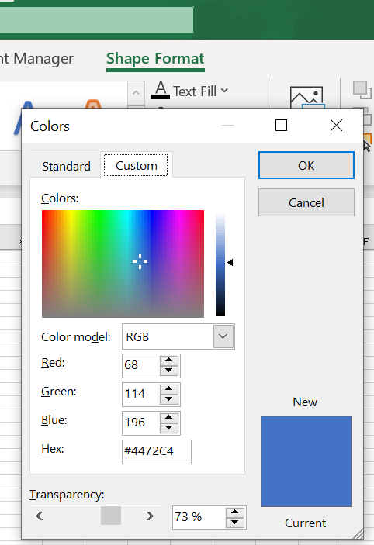
- Shade and label the area of the graph where the heat lamp was on (you can insert a shape and adjust the colour and transparency).

Sample discussion questions
Refer to your data to explain what the results from the investigation show.
Define the enhanced greenhouse effect and outline the factors which are contributing to increased carbon dioxide in the atmosphere.
What are the implications of the results obtained from this investigation? How can these findings be related to real-world climate scenarios?
How can this investigation be expanded or modified to explore other aspects of the greenhouse effect or simulate different scenarios?
Evaluate the effectiveness of this model.
Assess the reliability and validity of this model.

References
This resource contains NSW Curriculum and syllabus content. The NSW Curriculum is developed by the NSW Education Standards Authority. This content is prepared by NESA for and on behalf of the Crown in right of the State of New South Wales. The material is protected by Crown copyright.
Please refer to the NESA Copyright Disclaimer for more information https://educationstandards.nsw.edu.au/wps/portal/nesa/mini-footer/copyright.
NESA holds the only official and up-to-date versions of the NSW Curriculum and syllabus documents. Please visit the NSW Education Standards Authority (NESA) website https://educationstandards.nsw.edu.au/ and the NSW Curriculum website https://curriculum.nsw.edu.au/home.
Science Years 7–10 Syllabus © NSW Education Standards Authority (NESA) for and on behalf of the Crown in right of the State of New South Wales, 2018.

© State of New South Wales (Department of Education), 2023
The copyright material published in this resource is subject to the Copyright Act 1968 (Cth) and is owned by the NSW Department of Education or, where indicated, by a party other than the NSW Department of Education (third-party material).
Copyright material available in this resource and owned by the NSW Department of Education is licensed under a Creative Commons Attribution 4.0 International (CC BY 4.0) licence.
This licence allows you to share and adapt the material for any purpose, even commercially.
Attribution should be given to © State of New South Wales (Department of Education), 2023.
Material in this resource not available under a Creative Commons licence:
- the NSW Department of Education logo, other logos and trademark-protected material
- material owned by a third party that has been reproduced with permission. You will need to obtain permission from the third party to reuse its material.
Links to third-party material and websites
Please note that the provided (reading/viewing material/list/links/texts) are a suggestion only and implies no endorsement, by the New South Wales Department of Education, of any author, publisher, or book title. School principals and teachers are best placed to assess the suitability of resources that would complement the curriculum and reflect the needs and interests of their students.
If you use the links provided in this document to access a third-party's website, you acknowledge that the terms of use, including licence terms set out on the third-party's website apply to the use which may be made of the materials on that third-party website or where permitted by the Copyright Act 1968 (Cth). The department accepts no responsibility for content on third-party websites.

