Crossing the river
Mathematical tools and representations – workshop resource

Resource information
Resource element | Details
Learning objectives | Students will:  - model and represent unit fractions  - identify multiplicative relationships using bar models.
Curriculum alignment | Mathematics – Stage 2  - Working mathematically MAO-WM-01  - represents and uses the structure of multiplicative relations to 10 × 10 to solve problems MA2-MR-01  - represents and compares halves, quarters, thirds and fifths as lengths on a number line and their related fractions formed by halving (eighths, sixths and tenths) MA2-PF-01
Materials or resources | - Strips of paper  - Writing materials

Activity
- Explain to students that they are out on a bushwalk where they need to cross over a creek but there is no bridge. There are planks of wood lying nearby, but the plank will only be stable enough if one third is on the ground on either side of the creek.
- Give each student a strip of paper to fold to make a representation of the plank over the river. Label each part ‘one third’. Draw a representation of the creek and discuss what length the whole plank will be if the creek is one metre wide (see Figure 1). Explain that this way of recording fractions is called a ‘bar model’. It is a visual way to see the part-part-whole of a fraction.
Figure 1 – crossing the river
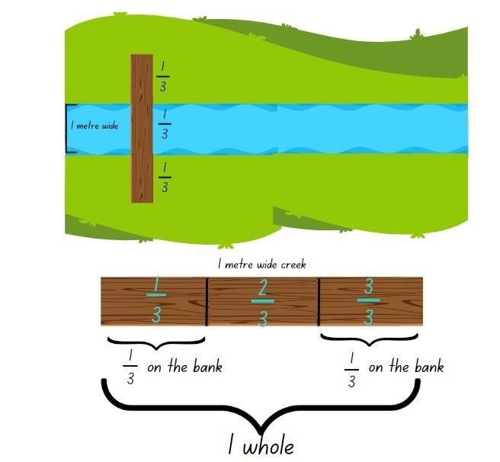
- Discuss the multiplicative relationship in the solution. For example, because 3 metres split into 3 thirds gives one third in each section, one multiplied by 3 is 3.
- Explain to the class that as they move further down the creek, it gets wider at some points where they need to cross over. The same safety rule applies, that one third of the plank must be on either side and one third over the creek to be stable.
- In small groups, students draw bar models to represent bridges where the river is 2 metres wide and 3 metres wide. Move between groups, checking that students understand each section of a plank is one third and for correct bar model representation. Support students to look for number patterns as the river gets wider.
- Students explore different creek widths, including very wide creeks and very narrow creeks.
- Some students may enjoy the challenge of:
- exploring widths smaller than one metre using centimetres
- looking for patterns in rivers that increase multiplicatively in size – for example, 3 m, 6 m, 12 m and 24 m.
Teacher note: some other mathematical contexts where the bar model can be used as a visual tool include addition and subtraction, multiplication and division, and as a pre-skill for ratio tables.

Stage 2 teaching advice
- Bar models and tape diagrams are similar tools.
- The bar model makes visible the part-part-whole thinking that is key to many mathematics concepts.
Figure 2 – bar model to compare parts of the whole
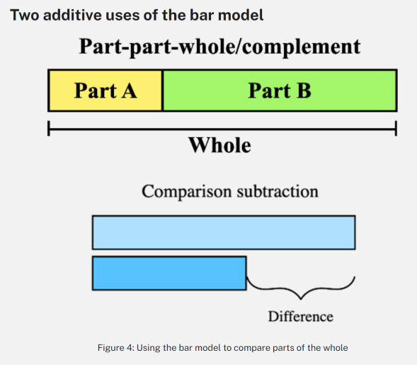
- The bars are proportional to the values they represent. They can be arranged and manipulated to represent different operations, such as addition, subtraction, multiplication, division, percentages and ratios.
- Bar models promote the visualisation of problems by using rectangular bars to represent quantities and relationships between them. This visual representation supports students to see the mathematics in the problem.
- Bar models can assist students to display their mathematical thinking during problem solving, such as in multi-step word problems.
Figure 3 – bar model representing part-part-whole relationship
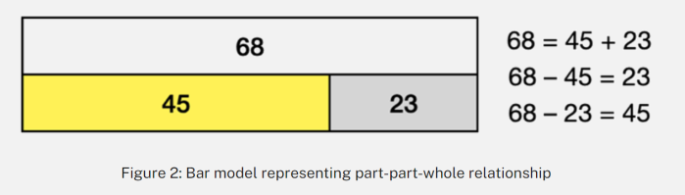
Figure 4 – bar model showing working out for 5 times as many
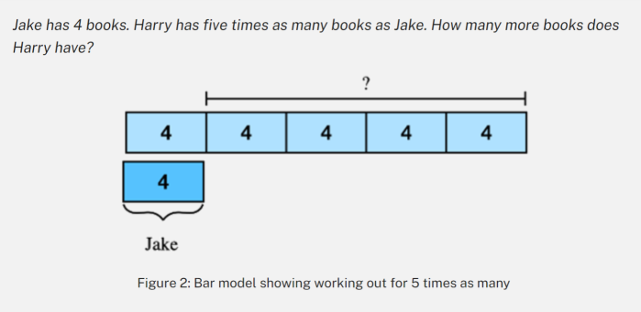

References
This resource contains NSW Curriculum and syllabus content. The NSW Curriculum is developed by the NSW Education Standards Authority. This content is prepared by NESA for and on behalf of the Crown in right of the State of New South Wales. The material is protected by Crown copyright.
Please refer to the NESA Copyright Disclaimer for more information https://educationstandards.nsw.edu.au/wps/portal/nesa/mini-footer/copyright.
NESA holds the only official and up-to-date versions of the NSW Curriculum and syllabus documents. Please visit the NSW Education Standards Authority (NESA) website https://educationstandards.nsw.edu.au/ and the NSW Curriculum website https://curriculum.nsw.edu.au/home.
Mathematics K–10 Syllabus © NSW Education Standards Authority (NESA) for and on behalf of the Crown in right of the State of New South Wales, 2022.

© State of New South Wales (Department of Education), 2023
The copyright material published in this resource is subject to the Copyright Act 1968 (Cth) and is owned by the NSW Department of Education or, where indicated, by a party other than the NSW Department of Education (third-party material).
Copyright material available in this resource and owned by the NSW Department of Education is licensed under a Creative Commons Attribution 4.0 International (CC BY 4.0) licence.
This licence allows you to share and adapt the material for any purpose, even commercially.
Attribution should be given to © State of New South Wales (Department of Education), 2023.
Material in this resource not available under a Creative Commons licence:
- the NSW Department of Education logo, other logos and trademark-protected material
- material owned by a third party that has been reproduced with permission. You will need to obtain permission from the third party to reuse its material.
Links to third-party material and websites
Please note that the provided (reading/viewing material/list/links/texts) are a suggestion only and implies no endorsement, by the New South Wales Department of Education, of any author, publisher, or book title. School principals and teachers are best placed to assess the suitability of resources that would complement the curriculum and reflect the needs and interests of their students.
If you use the links provided in this document to access a third-party's website, you acknowledge that the terms of use, including licence terms set out on the third-party's website apply to the use which may be made of the materials on that third-party website or where permitted by the Copyright Act 1968 (Cth). The department accepts no responsibility for content on third-party websites.

