# Physics Stage 6 – Module 2: Momentum



Contents

Overview 2

Information for teachers 3

Introduction 3

Outcomes 3

Learning intentions and success criteria 4

Teaching and learning activities 6

Big ideas 6

Background 6

Lesson 1 – the impulse-momentum relationship 10

Lesson 2 – conservation of momentum 14

Lesson 3 – more collisions! 22

Student resources 27

Resource 1 – Lesson 1: the impulse-momentum relationship 27

Resource 2 – Lesson 2: exploring elastic and inelastic collisions 27

Resource 1 – Lesson 1: the impulse-momentum relationship 28

Setting the stage – definitions 28

Resource 2 – Lesson 2: exploring elastic and inelastic collisions 31

Example 1 – a ‘sticky’ (completely inelastic) collision 31

Example 2 – an ‘explosion’ 34

Example 3 – an elastic collision of 2 carts of different masses 36

Appendixes 38

Appendix A – suggested simulations 38

Appendix B – problem-solving steps 40

Appendix C – choosing an investigation 43

Support and alignment 45

References 47

Further reading 50

## Overview

**Stage and Learning Area**: Physics Stage 6

**Description**: this resource has been designed to address the Module 2 Inquiry question: How is the motion of objects in a simple system dependent on the interaction between the objects?

This learning sequence builds understanding of momentum. It introduces the concept of impulse to analyse the effects of forces in collisions and other interactions.

**Duration**: while timing will vary based on the mode of delivery, differentiation strategies employed and class or school context, this series of activities should take approximately 3 one-hour sessions.

## Information for teachers

During this lesson sequence, students will:

* explore and analyse a range of simple mechanical systems
* use force-time graphs and vector diagrams to represent and analyse collisions, both qualitatively and quantitatively
* conduct investigations of one-dimensional and 2-dimensional collisions
* solve problems by applying the concepts of momentum, impulse as well as conservation laws.

### Introduction

This learning sequence is designed to build skills gradually throughout the task. Teachers may wish to modify the task or focus on specific sections based on their class context, student ability and current mastery of content.

This content also links with other sections of the Stage 6 course, including:

* Module 1: Inquiry question 1: How is the motion of an object moving in a straight line described and predicted?
* Module 1: Inquiry question 2: How is the motion of an object that changes its direction of movement of a plane described?

### Outcomes

* describes and explains events in terms of Newton’s Laws of Motion, the law of conservation of momentum and the law of conservation of energy **PH11-9**
* selects and processes appropriate qualitative and quantitative data and information using a range of appropriate media **PH11/12-4**
* solves scientific problems using primary and secondary data, critical thinking skills and scientific processes **PH11/12-6**

[Physics Stage 6 Syllabus](https://educationstandards.nsw.edu.au/wps/portal/nesa/11-12/stage-6-learning-areas/stage-6-science/physics-2017) © NSW Education Standards Authority (NESA) for and on behalf of the Crown in right of the State of New South Wales, 2017.

### Learning intentions and success criteria

Students:

* describe and explain events in terms of Newton’s Laws of Motion and momentum
* select and process appropriate qualitative and quantitative data and information
* solve scientific problems using primary and secondary data, critical thinking skills and scientific processes.

Students can:

* Define momentum as a vector quantity with a magnitude equal to the product of an object’s mass and velocity.
* Understand the relationship between impulse and momentum.
* Predict the outcome of collisions between 2 objects using given data.
* Create and analyse graphs representing the motion of objects undergoing changes in momentum.
* Analyse momentum in one and 2-dimensional collisions.
* Apply formulae including $∆\vec{p}={\vec{F}}_{net}∆t$ and ${\vec{F}}_{net}=m\vec{a}$ to solve problems involving impulse and momentum.
* Select qualitative and quantitative data and information and represent them using a range of formats.
* Find the area under the graph showing the force on an object as a function of time (a force-time graph) and use this value to predict changes in its motion.
* Resolve object’s momenta and/or velocities into perpendicular components to solve problems involving collisions in 2-dimensions.

**Differentiation consideration**: learning intentions should not be differentiated. All students need access to the same core content, big ideas and concepts. Differentiation should be evident in the success criteria, or the activities/support needed to achieve the success criteria (Wiliam and Leahy 2015). Teachers may co-construct the success criteria with students or adjust them to suit their class context, for example, using the strategies and resources for curriculum planning on the [Planning, programming and assessing 7-12](https://education.nsw.gov.au/teaching-and-learning/curriculum/planning-programming-and-assessing-k-12/planning-programming-and-assessing-7-12) webpage.

## Teaching and learning activities

### Big ideas

**Observation and measurement**

* The velocity of objects in collisions can be determined from measurements of displacement and time or by using specialised instruments. Examples are listed in the background information section.

**Models and representations**

* Using multiple representations makes a scenario easier to understand and analyse.
* Representations include:
* force-time, velocity-time and momentum-time graphs
* free-body diagrams
* mathematical formulae
* vector diagrams
* [impulse-momentum bar charts (8:36)](https://youtu.be/7CPQu1cGMEs) (Davies 2011).
* Modelling collisions in 3 steps (before, during and after the collision) makes it easier to analyse the forces on objects along with any transfers of momentum.

**Systems and conservation laws**

* Conservation laws describe how interactions change motion.
* Defining a system is a crucial step in analysing momentum and conservation laws.

### Background

This section contains prior knowledge, considerations for the practical activities and an introduction to the impulse-momentum relationship. Prior knowledge could be assessed formally via a pre-test or informally through class discussions or a Kahoot.

#### Prior knowledge

Students developed their ability to describe motion precisely, use multiple representations to support their reasoning, and gain experience using a range of measurement technologies in Module 1. In Module 2, they have developed their understanding of Newton’s laws, forces and vectors.

They should be competent in representing scenarios using a range of scientific formats including:

* graphs of motion (displacement, velocity and acceleration-time graphs)
* free-body diagrams showing the forces acting on an object
* vector diagrams to represent scenarios pictorially and to support problem-solving.

Students will have also developed their ability to:

* resolve a vector into 2 perpendicular components and add vectors together
* determine the relative velocities of objects travelling in 2 dimensions
* analyse graphs of motion to determine and interpret the significance of the gradient and/or the area under the graph.

##### Planning and conducting investigations

Collision investigations can be tricky to manage in a physics classroom. They can be time-consuming and often require specific apparatus. Consider the strengths and limitations of practical investigation and other alternatives when planning your investigation.

Table 1 – strengths and limitations of 3 different approaches to collision investigations

|  |  |  |
| --- | --- | --- |
|  | Strengths | Limitations |
| Collecting primary data | * Develops students’ skills and experience in planning and conducting investigations. * When working with authentic measurement errors, interesting or unexpected results may provoke questioning and deep thinking. * Provides avenues for discussing the accuracy, reliability and validity of the data and investigation. | * Planning and setting up for investigations are time-consuming. * Specialised apparatus often limits active participation to a few students at a time. |
| Using secondary data | * Choice of scenario is not limited by equipment or practicality. For example, space launches or car crashes could be investigated. * When working with authentic measurement errors, interesting or unexpected results may provoke questioning and deep thinking. * All students can do the investigation at the same time. * Provides avenues for discussing the accuracy, reliability and validity of the data and investigation. | * Sourcing appropriate secondary data can be challenging. |
| Using a simulation | * Variables can be set, controlled and measured with high precision. * Data collection is generally fast allowing more data to be collected and analysed. * All students can do the investigation at the same time. | * Many high school simulations produce ‘ideal’ data. |

Further information on choosing an investigation is included in Appendix C – choosing and investigation.

##### Introducing the impulse-momentum relationship

The relationship between impulse and change in momentum is $$Σ\vec{F}Δt=Δ\vec{p}$$

It relates a net force occurring over a finite period to the change in momentum over that period.

Figure 1 – the change in momentum is given by the area under (integral) a net-force versus time graph.

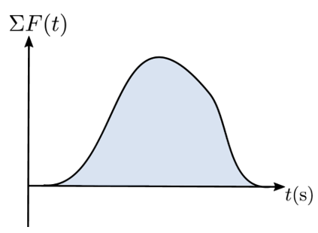

Image from the Physics Module 2 Guide (DoE 2022).

When introducing this relationship, maintain the focus on the physics concepts. For example, Figure 1 shows the net force experienced by an object during a typical collision.

**Differentiation consideration:**

**Extension:** finding the highlighted area underneath the curve in Figure 1 would require integration or the use of computer software. Students with a deep understanding of calculus may appreciate this application of integration. However, calculus is outside the scope of the Physics course.

The forces experienced during collisions can be simplified to be either uniform or uniformly increasing or decreasing. This model will produce force-time graphs shaped like rectangles, triangles or compound shapes with areas that can be easily calculated, as shown in Figure 2. Students can then engage with impulse-momentum relationships using algebra.

Figure 2 – force-time graphs for some simple models of the force experienced during a collision. Note that the area shaded under each graph can be found using basic algebra.

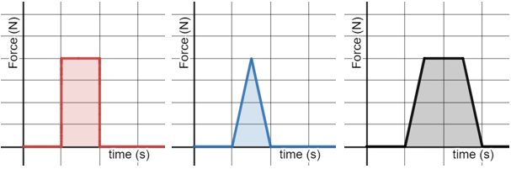

### Lesson 1 – the impulse-momentum relationship

**Teacher notes:** this lesson can be taught from the notes below using student textbooks as a resource. A worksheet is included in the ‘Student resources’ section with links to an online textbook if this platform is preferred. A link to the class Desmos activity will need to be added to the worksheet before printing.

#### Defining momentum and impulse (10 min)

Momentum and impulse are words that have an everyday meaning to many students. Provide clear definitions for your students to encourage the precise use of these scientific terms.

Definitions should be provided in word format and as mathematical expressions that include descriptions of the relevant units and symbols. Some examples are provided below; see [What are momentum and impulse?](https://www.khanacademy.org/science/physics/linear-momentum/momentum-tutorial/a/what-are-momentum-and-impulse) (Khan Academy, n.d.) for further reading and examples.

**Momentum** is a quantity of motion equal to the product of an object’s mass and velocity, that is:

$$momentum=mass×velocity$$

$$\vec{p}=m\vec{v}$$

Momentum is a vector quantity with the same direction as the velocity.

It has no special units but generally $kgms^{-1}$ (or $Ns$) are used where $1 kgms^{-1}=1 Ns$

Together as a class, watch [Hewitt-Drew-it! PHYSICS 24. Momentum (4:17)](https://youtu.be/2FwhjUuzUDg) (Hewitt 2012), which is a short video introduction to momentum and impulse. It uses clear examples and illustrations to show the inverse relationship between time and force when stopping a moving object. The video finishes with a question about catching a baseball which could be discussed in class. Using ‘soft hands’ when catching a cricket ball might be a more relevant example.

**Ranking activities**

Ranking activities are a quick and simple method for assessing student understanding. Ask students to rank the momentum of simple objects and have a quick discussion about any solutions presented by students.

The example below could be made more challenging by either increasing the number of objects, including objects moving in the opposite direction (remembering to define one direction as positive) or using variables instead of numerical values.

Using simple values (or variables like m or 2 m) focuses the activity on the definition of momentum without the need for calculation.

Figure 3 – sample ranking activity to assess students’ conceptual understanding of momentum

**Sample ranking activity to assess students’ conceptual understanding of momentum.**

**Sample answer:**

highest is C: 3 × 2 = 6

D: 5 × 1 = 5

lowest is A: 2 × 2 = 4 and B: 2 × 2 = 4.

#### During a collision – applying Newton’s Second Law (30 minutes)

* Investigate the relationship and analyse information obtained from graphical representations of force as a function of time.

Figure 4 – a screenshot of the Desmos activity screen for Colliding Carts.

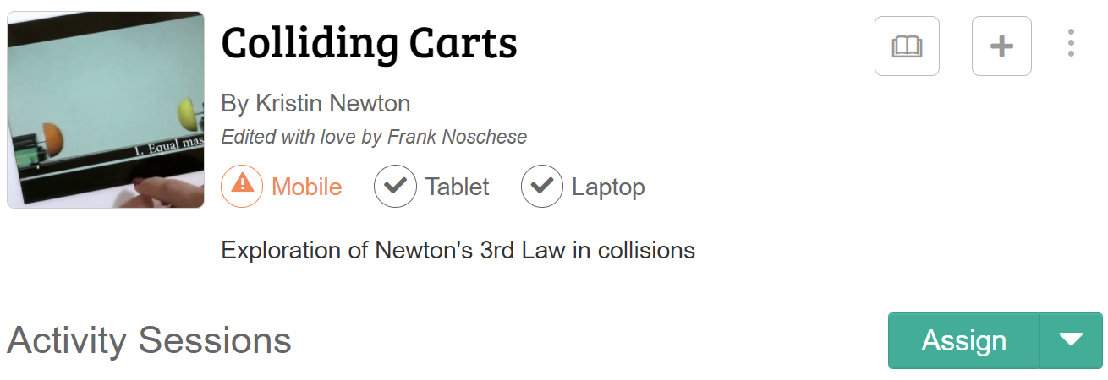

'Colliding Carts' by Kristin Newton is licensed under [CC BY-NC-SA 3.0](https://creativecommons.org/licenses/by-nc-sa/3.0/deed.en_US).

**Teacher notes:** select the ‘Assign’ button on the activity to share the activity with your students. It can be shared directly with a Google Classroom group or directly from Desmos using a Single Session Code. If the worksheet in ‘Teaching resources’ is used, it will need to be updated to include a link to the resource.

Students individually complete the [Colliding Carts](https://teacher.desmos.com/activitybuilder/custom/6024d2e1208f790d355e3807?collections=5f806f2321fa660ca84cf129) (Newton n.d.) activity to analyse a range of collisions. Different scenarios are created by changing each cart’s mass and initial velocity.

For each scenario, students relate the compression of the hoops attached to each trolley to the forces experienced by each cart. The Desmos activity interface allows the teacher to view, share and anonymise student responses to facilitate class discussions and other formative assessments.

**Extension opportunity:** Screen 7 of 11 directs students to complete an [Interactive video vignette](https://www.compadre.org/IVV/vignettes/N3/v/) (2:12) (LivePhoto IVV project, 2013) on Newton’s Third Law. This activity would be a suitable standalone activity.

##### Analysing forces during collisions – Force-Time graphs (20 minutes)

Have a go!

Watch this video on [[Force vs. time graphs (8:13)](https://www.youtube.com/watch?v=8bHPj3ll0vs)](https://youtu.be/8bHPj3ll0vs) (Khan Academy 2016) and then complete the practice questions and [linear momentum review](https://www.khanacademy.org/science/in-in-class11th-physics/in-in-class11th-physics-laws-of-motion/in-in-introduction-to-linear-momentum-and-impulse/a/intro-to-linear-momentum-ap1). Most textbooks contain a suitable set of problems for students to practice problem solving and challenge their understanding.

Other sources of sample problems are listed in the Problem solving practice section.

**Differentiation consideration:** the online textbook could be used to provide students extra practice solving problems to further consolidate their understanding. Targeted support and class discussions may be used to provide extra support students.

### Lesson 2 – conservation of momentum

**Teacher notes:** this lesson addresses the following points from the syllabus:

* conduct an investigation to describe and analyse one-dimensional (collinear) and 2-dimensional interactions of objects in simple closed systems (ACSPH064)
* analyse quantitatively and predict, using the law of conservation of momentum $\sum{m{\vec{v}}_{before}}=\sum{m{\vec{v}}_{after}}$ and, where appropriate, conservation of kinetic energy $\sum{\frac{1}{2}mv_{before}^{2}}=\sum{\frac{1}{2}mv_{after}^{2}}$  
  , the results of interactions in elastic collisions (ACSPH066).

#### Introducing the conservation of momentum (10 minutes)

The following thought experiment is a great class starter. [Think-Pair-Share](https://bit.ly/thinkpairsharestrategy) could be used to guide class discussions.

**A thought experiment:** suppose that there are 3 astronauts outside a spaceship and that they decide to play catch. All the astronauts weigh the same on Earth and are equally strong. The first astronaut throws the second one towards the third astronaut and the game begins. Describe the motion of the astronauts as the game proceeds. How long will the game last?

**Figure 5 – a thought experiment that explores the conservation of momentum**

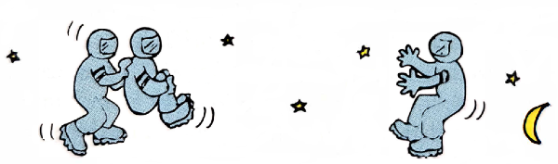

**Sample response:**

Figure – vector diagrams are helpful when analysing the outcome. This thought experiment can also be used to revisit relative velocity. For example, after the second throw, what are the relative velocities of the astronauts? How will each astronaut see the others moving?

Text and images analysing the astronaut thought experiment. 
Text. Our system consists of 3 astronauts with zero velocity relative to space. Therefore, momentum of the system is initially zero. (Let right be positive.)
After the first throw, A and B are moving with equal and opposite velocity, v
When B is caught by C, part of its momentum is transferred or shared and they both travel with half of B’s previous velocity, v/2
After the second throw, the astronauts are moving with the velocities shown below. As C is equally as strong as A, they change the velocity of B by an equal value v in the other direction. This results in a final velocity vB= -v/2

Image and text adapted from Hewitt (2021) and sourced from the Physics Module 2 Guide (DoE 2022).

##### Investigating one-dimensional collisions (50 minutes)

**Teacher notes:** this investigation can be run as a practical investigation, using secondary data or a simulation.

**Option 1: collecting primary data**

Three example collision scenarios are outlined in the student resources section. These examples are chosen to represent a wide range of collision types and to build in complexity. They are:

* a ‘sticky’ collision
* an ‘explosion’
* an elastic collision of 2 carts with different masses.

To conduct this practical investigation, each student group will need the following:

* Two collision carts (some carts have integrated force and motion sensors).
* Light gates or other data logging equipment for velocity and force measurements. (Mobile phone cameras and computers with tracker software installed, if using video analysis.)
* Additional masses to add to carts.

An electronic balance is required to measure the mass of each cart accurately. To save time, weigh each cart before class and label its mass.

If you do not have data logging equipment that can record the force during the collision, the practical investigation can still be completed measuring only the velocities of carts before and after the collision.

**Option 2: using secondary data**

The student resources section provides all the materials required to complete this investigation using secondary data.

All the questions in this worksheet are supported with videos linked to data. Alternatively, students could collect and analyse their data for this sequence using a mobile phone and the free software [Tracker](https://tracker.physlets.org/) (Brown et al. 2022).

Sample responses are included at the end of this section.

**Option 3: using simulated data**

Similar scenarios can be simulated and analysed using either the [Collision Lab](https://phet.colorado.edu/en/simulations/collision-lab) (PhET 2022) or [Collision Carts](https://www.physicsclassroom.com/Physics-Interactives/Momentum-and-Collisions/Collision-Carts/Collision-Carts-Interactive) (TPC nd) simulations.

**Working scientifically – questioning and predicting**

If you are running a practical investigation, there will be deviations from the ideal behaviour predicted by physical laws. This may be due to errors in measurement, an inability to eliminate friction or other issues arising from the method used to collect the data. These differences from the predictions are valuable in provoking student thinking and discussion around data quality and may act as a catalyst for further investigation and depth study.

**Working scientifically – processing data and information**

The guiding questions in the student resource encourage students to use a range of representations to support their problem-solving. For example, free-body and vector diagrams, graphs and other annotations. See Sample responses section for examples.

#### Sample responses for student worksheet – collisions

Figure 7 – sample annotated graph for Option 1 – a 'sticky' collision.

Annotated graph of a 'sticky' collision. Velocity on the position-time graph is represented by the gradient. G has slowed after the collision as it has transferred some of its momentum to Y.
Initial acceleration of green cart (G). Gradient of v-t graph represents acceleration.
The change in velocity for G and Y are equal and opposite.
The accelerations of G and Y are equal and opposite during the collision.

The figure is from the Physics Module 2 Guide (DoE 2022).

Figure 8 – sample annotated graph for Option 2 – an ‘explosion’.

Annotated graphs for an 'explosion'.
Impulse is equal to change in momentum and is represented by the area under the F-t graph. Y and G experience equal and opposite impulses.
The change in velocity for G is significantly smaller than the change for Y. This is due to its larger mass.
Equal and opposite momentum transfers (approximately).The figure is from the Physics Module 2 Guide (DoE 2022).

Figure 9 – sample annotated graph for Option 3 – elastic collision between carts of different masses

Annotated graphs for elastic collision between carts of different masses. 
Graph 1 shows force versus time.  Impulse is equal to change in momentum and is represented by the area under the F-t. The area under the graph for each cart is the same showing equal and opposite momentum transfers.
Graph 2 shows momentum versus time. Y and G experience equal and opposite impulses as demonstrated by the equal and opposite momentum transfers.
Graph 3 shows velocity versus time. Acceleration is represented as the gradient of the function on the graph. Y initially accelerates before collision. The change in velocity for G is significantly smaller than the change for Y due to its larger mass.

Figure sourced from the Physics Module 2 Guide (DoE 2022).

Figure 10 – pictorial representations of carts before (a) and after (b) the collision. Vector diagram (c) showing the conservation of momentum. Mathematical representation (d) of the problem

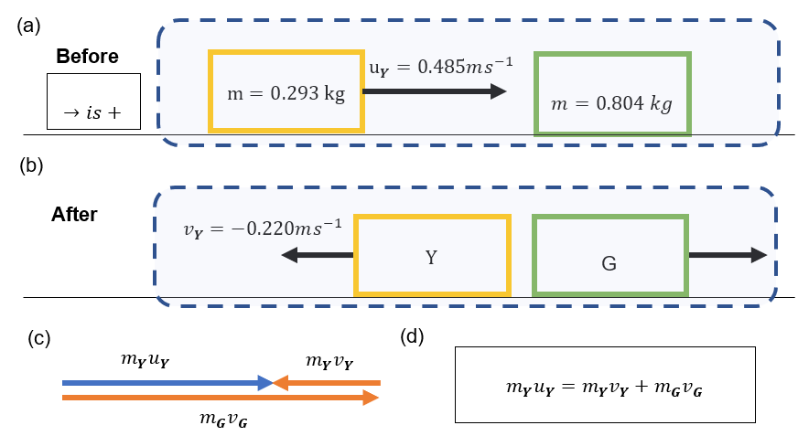

Figure sourced from the Physics Module 2 Guide (DoE 2022).

Table 2 – problem solving steps for the collision between carts of different masses

|  |  |
| --- | --- |
| Step | Description |
| Step 1 – choose the system and the axes | * A system to analyse: the system includes carts Y and G, as shown in (a). It is a closed system. * Axes/coordinate system: all motion is along a single axis, and right is defined as the positive direction. * Crucial instants: two instants are chosen, before and after the collision. |
| Step 2 – represent the problem | * The vector diagram (c) represents the conservation of momentum with the sum of momenta before and after the collision being equal. It also indicates the direction and relative magnitude of the momentum vectors. Figure (d) is an alternative representation of similar information. * The annotated graphs for this example are provided in Figure 10. |
| Step 3 – apply mathematical models | * The law of conservation of energy is selected as the appropriate model as it is a closed system. $\sum{m{\vec{v}}_{before}}=\sum{m{\vec{v}}_{after}}$ $$m_{Y}u_{Y}=m_{Y}v_{Y}+m_{G}v_{G}$$ $$\left(0.293\right)\left(0.485\right)=\left(0.293\right)\left(-0.220\right)+(0.804)v_{G}$$ $$v_{G}=\frac{\left(0.293\right)\left(0.485\right)-\left(0.293\right)\left(-0.220\right)}{\left(0.804\right)}=0.257 ms^{-1}$$* The velocity of G is positive; therefore, it is moving to the right. |

### Lesson 3 – more collisions!

**Option 1: practical investigation**

It is possible to investigate collisions in 2-dimensions using pool or air hockey tables, but for most classes they would be best suited as demonstrations. [Two-dimensional collisions with ball bearings](https://spark.iop.org/two-dimensional-collisions-ball-bearings) (IOP 2022) and variations of this experiment, Collisions in 2-Dimensions (Lab Instruction) (7:48) [(Science’n’me 2017)](https://youtu.be/V20yASOKLcM), only require basic apparatus. Using this apparatus, students can quickly record multiple trials under similar conditions. In addition, the spread of markings for each ball bearing gives students insight into the associated errors and requires them to process their data before analysis. The use of projectile motion to study momentum also reinforces the ability of students to apply the equations of motion from Module 1 and prepares them further for Module 5.

**Option 2: using a simulation**

Simulations are a good option as it allows better control and measurement. The ability to precisely control variables makes this investigation an opportunity for small groups of students to plan and conduct investigations.

Figure 11 – a screenshot of the [Collision Lab](https://phet.colorado.edu/sims/html/collision-lab/latest/collision-lab_en.html) simulation

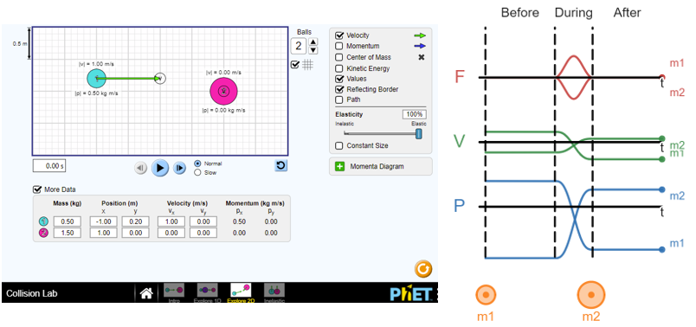

Screenshot of the Collision Lab by PhET Interactive Simulations is licensed under [CC-BY-4.0](https://creativecommons.org/licenses/by/4.0/).

Students can explore the conservation of momentum in one or 2-dimensions by running the simulation multiple times and creating a series of ‘before-and-after’ vector diagrams.

Questions that can be explored using this simulation:

* What does elasticity mean and how does it affect collisions?
* How does the relative mass of objects affect the transfer of momentum?

**Sample response:**

Figure 12 – pictorial representations of carts before (a) and after (b) the collision. Vector diagram (c) showing the conservation of momentum. Mathematical representation (d) of the problem

The figure is from the Physics Module 2 Guide (DoE 2022).

Table 3 – problem solving steps for the collision between carts of different masses

|  |  |
| --- | --- |
| Step | Description |
| Step 1 – choose the system and the axes | * A system to analyse: the system includes carts Y and G, as shown in (a). It is a closed system. * Axes/coordinate system: all motion is along a single axis, and right is defined as the positive direction. * Crucial instants: two instants are chosen, before and after the collision. |
| Step 2 – represent the problem | * The vector diagram (c) represents the conservation of momentum with the sum of momenta before and after the collision being equal. It also indicates the direction and relative magnitude of the momentum vectors. Figure (d) is an alternative representation of similar information. * The annotated graphs for this example are provided above. |
| Step 3 –apply mathematical models | * The law of conservation of energy is selected as the appropriate model as it is a closed system. $\sum{m{\vec{v}}_{before}}=\sum{m{\vec{v}}_{after}}$ $$m_{Y}u_{Y}=m_{Y}v_{Y}+m_{G}v_{G}$$ $$\left(0.293\right)\left(0.485\right)=\left(0.293\right)\left(-0.220\right)+(0.804)v_{G}$$ $$v_{G}=\frac{\left(0.293\right)\left(0.485\right)-\left(0.293\right)\left(-0.220\right)}{\left(0.804\right)}=0.257 ms^{-1}$$* The velocity of G is positive; therefore, it is moving to the right. |

#### Problem-solving practice

Exercises provided in most textbooks provide questions that will challenge a wide range of students. The [OpenStax Physics textbook](https://openstax.org/books/physics/pages/8-1-linear-momentum-force-and-impulse) (Urone and Hinrichs 2020) has a range of problems in the concept builder, Chapter Review and Test Prep sections.

Appendix B outlines general problem-solving steps for momentum and energy problems as well as a more basic problem-solving method.

Figure 13– a challenging question for more capable students.

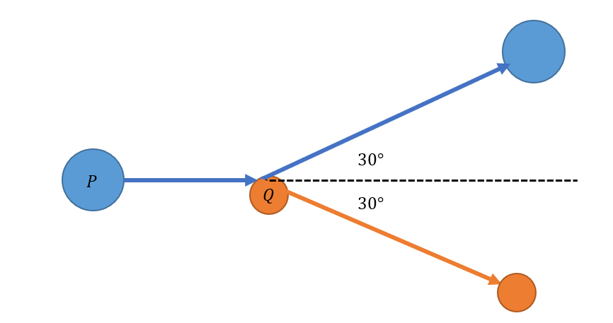

Question: Puck P, with a mass of 10 kg, slides over a frictionless surface at $4.5ms^{-1}$ towards puck Q, mass 5 kg, which is initially at rest. After the collision, both pucks have velocities directed at 30° on either side of the centre line shown in the figure above. What are the final speeds of the 2 objects?

**Sample response:**

Momentum is conserved so total momentum before the collision is equal to total momentum after the collision.

$$p_{Pi}+ p_{Qi}= p_{Pf}+ p_{Qf}$$

$$m_{P}u_{P}+ m_{Q}u_{Q}= m_{P}v_{P}+ m_{P}v_{Q}$$

$$10 ×4.5+ 5 ×0= 45kgms^{-1}$$

So: $m_{P}v_{P}+ m_{P}v_{Q}=0$

This equation can be solved vectorially using the sine rule.

Figure 14 – diagram showing the vector solution for the problem

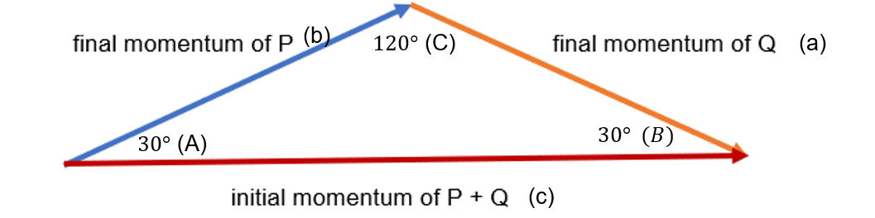

Using the sine rule: $\frac{a}{\sin{A}}=\frac{b}{\sin{B}}=\frac{c}{\sin{C}}$

$$\frac{10v_{Q}}{sin{30}^{o}}= \frac{5v_{P}}{sin{30}^{o}}=\frac{45}{sin{120}^{o}}$$

$$\frac{10v_{Q}}{0.5}= \frac{5v_{P}}{0.5}=\frac{45}{0.866}$$

$$v_{Q}=51.96 ms^{-1 }$$

$v_{P}=25.98 ms^{-1 }$

## Resource 1: Lesson 1 – the impulse-momentum relationship

### Setting the stage – definitions

1. Use the website [What are momentum and impulse?](https://www.khanacademy.org/science/physics/linear-momentum/momentum-tutorial/a/what-are-momentum-and-impulse) and class discussions to write definitions for momentum and impulse. Definitions should include: word descriptions, equations, units and symbols.

Momentum:

|  |
| --- |
|  |
|  |
|  |

Impulse:

|  |
| --- |
|  |
|  |
|  |

1. Watch the video: [Hewitt-Drew-it! PHYSICS 24. Momentum (4:17)](https://youtu.be/2FwhjUuzUDg). Answer the question from the video:

* When you are lucky enough to catch a fly ball with your bare hands, less damage occurs if you begin your catch with your hands extended forward towards the incoming ball so there is space to gradually pull your hands and the ball backwards. In terms of impulse-momentum, explain why this is so.

|  |
| --- |
|  |
|  |
|  |
|  |

Figure 3 – sample ranking activity to assess students’ conceptual understanding of momentum.

2 kg

1 kg

3 kg

5 kg

$$2 ms^{1}$$

$$4 ms^{1}$$

$$2 ms^{1}$$

$$1 ms^{1}$$

**A**

**B**

**C**

**DS**

Rank the momentum of these objects from highest to lowest.

|  |
| --- |
|  |
|  |
|  |
|  |

1. Complete the online activity ‘Colliding carts’ that is assigned to you by your teacher on your online learning platform.
2. Watch the video [‘[Force vs. time graphs’ (8:13)](https://www.youtube.com/watch?v=8bHPj3ll0vs)](https://youtu.be/8bHPj3ll0vs) (SantoPietro 2016).
3. Read the summary on the Khan Academy website: [Linear momentum review](https://www.khanacademy.org/science/in-in-class11th-physics/in-in-class11th-physics-laws-of-motion/in-in-introduction-to-linear-momentum-and-impulse/a/intro-to-linear-momentum-ap1).
4. Complete the practice questions on this webpage: [8.1 Linear Momentum, Force, and Impulse – Physics | OpenStax](https://openstax.org/books/physics/pages/8-1-linear-momentum-force-and-impulse).

## Resource 2: Lesson 2 – exploring elastic and inelastic collisions

**A thought experiment:** suppose that there are 3 astronauts outside a spaceship and that they decide to play catch. All the astronauts weigh the same on Earth and are equally strong. The first astronaut throws the second one towards the third astronaut and the game begins. Describe the motion of the astronauts as the game proceeds. How long will the game last?



All the questions in this section are supported with videos linked to data. Read the information provided, watch the video and answer the questions below.

### Example 1 – a ‘sticky’ (completely inelastic) collision

Figure 15 – the cart labelled G moves at a constant velocity towards the cart labelled Y, which is initially stationary

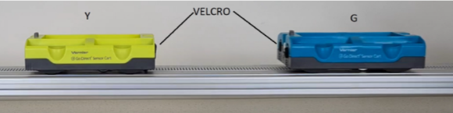

Image from the Physics Module 2 Guide (DoE 2022).

Watch the [example 1 video](https://www.youtube.com/watch?v=nPc5Cnw3v7g) Sticky collision (0:42) (Humphrey 2021a).

Two carts that roll with minimal rolling resistance are on a level track. The cart labelled G moves with a constant velocity towards the cart labelled Y, which is initially stationary. The 2 carts have hook and loop fastener spots so that when they collide, they stick to each other and move off together.

**Other data**

Mass of cart Y: $m=0.281 kg$

Mass of cart G: $m=0.294 kg$ (this cart has magnets installed at one end accounting for the difference in mass). For this example, consider that the masses are equal.

1. Sketch a free body diagram showing the forces acting on each cart during the collision.
2. Label time intervals on the graphs to show before, during and after the interaction.
3. Use the information in Figure 39 and assume that momentum is conserved for the system of 2 carts during the collision to predict:
4. the **acceleration-time graph** for cart Y (only the **acceleration** of cart G is shown)
5. the **position-time** and **velocity-time graphs** during and after the carts collided.

Annotate features of each graph to explain your reasoning.

Figure 7 – partial position-time, velocity-time and acceleration-time graphs for the motion of the carts during a ‘sticky’ collision.

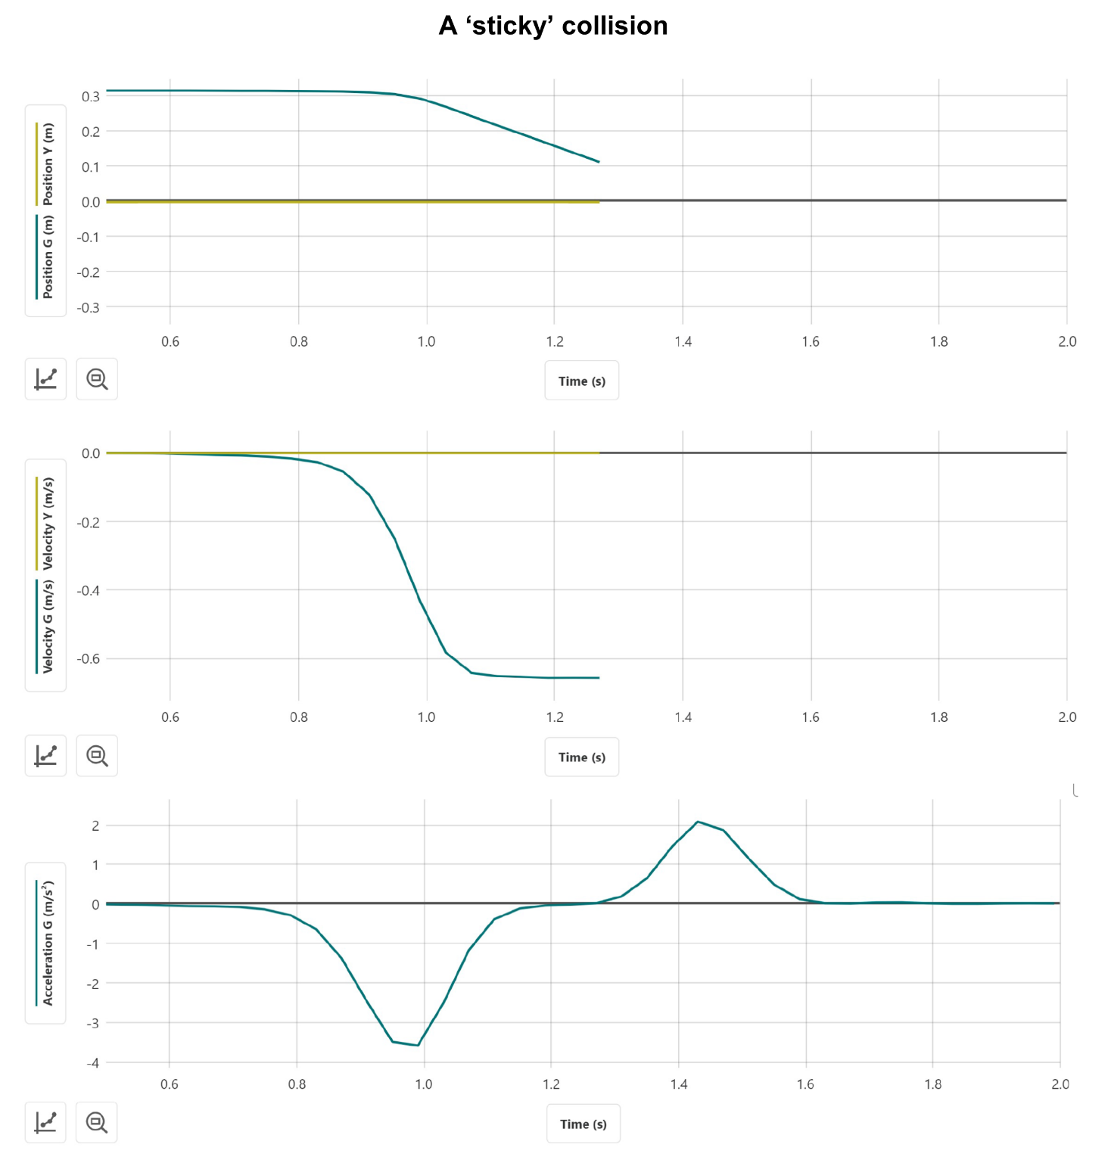 Image from the Physics Module 2 Guide (DoE 2022).

### Example 2 – an ‘explosion’

Figure 8 – before the ‘explosion’ (left) and a firing pin on cart Y is triggered with the base of a screwdriver, so the carts push off each other (right).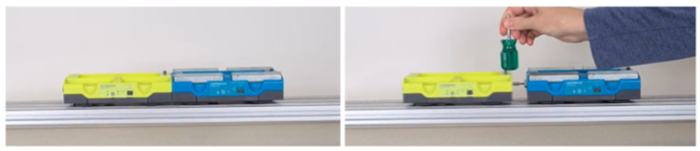

Image from the Physics Module 2 Guide (DoE 2022).

Watch the [example 2 video](https://www.youtube.com/watch?v=ipFxNiNu3rc) Cart ‘Explosion’ (0:25) (Humphrey 2021b).

In this example, 2 carts of unequal mass exert a sudden force on each other due to a spring-loaded ‘firing pin’ in one of the carts.

**Other data**

Mass of cart Y: $m=0.281 kg$

Mass of cart G: $m=0.792 kg$ (the mass of this cart has been increased by adding several small masses).

1. Sketch a free body diagram showing the forces acting on each cart during the ‘explosion’.
2. Label time intervals on the graphs to show before, during and after the interaction.

**Force-time**, **velocity-time** and **momentum-time** graphs for the green cart are shown in Figure 4.

1. Assume that momentum is conserved for the system of 2 carts, and sketch the corresponding force-time, velocity-time and momentum-time graphs for cart Y.
2. Compare the changes in velocity and momentum experienced by carts G and Y.

Annotate features of each graph to explain your reasoning.

Figure 9 – partial force-time, velocity-time and momentum-time graphs for the motion of the carts during an ‘explosion’. The velocity of cart G just after the collision is $v_{G}=0.31ms^{-1}$.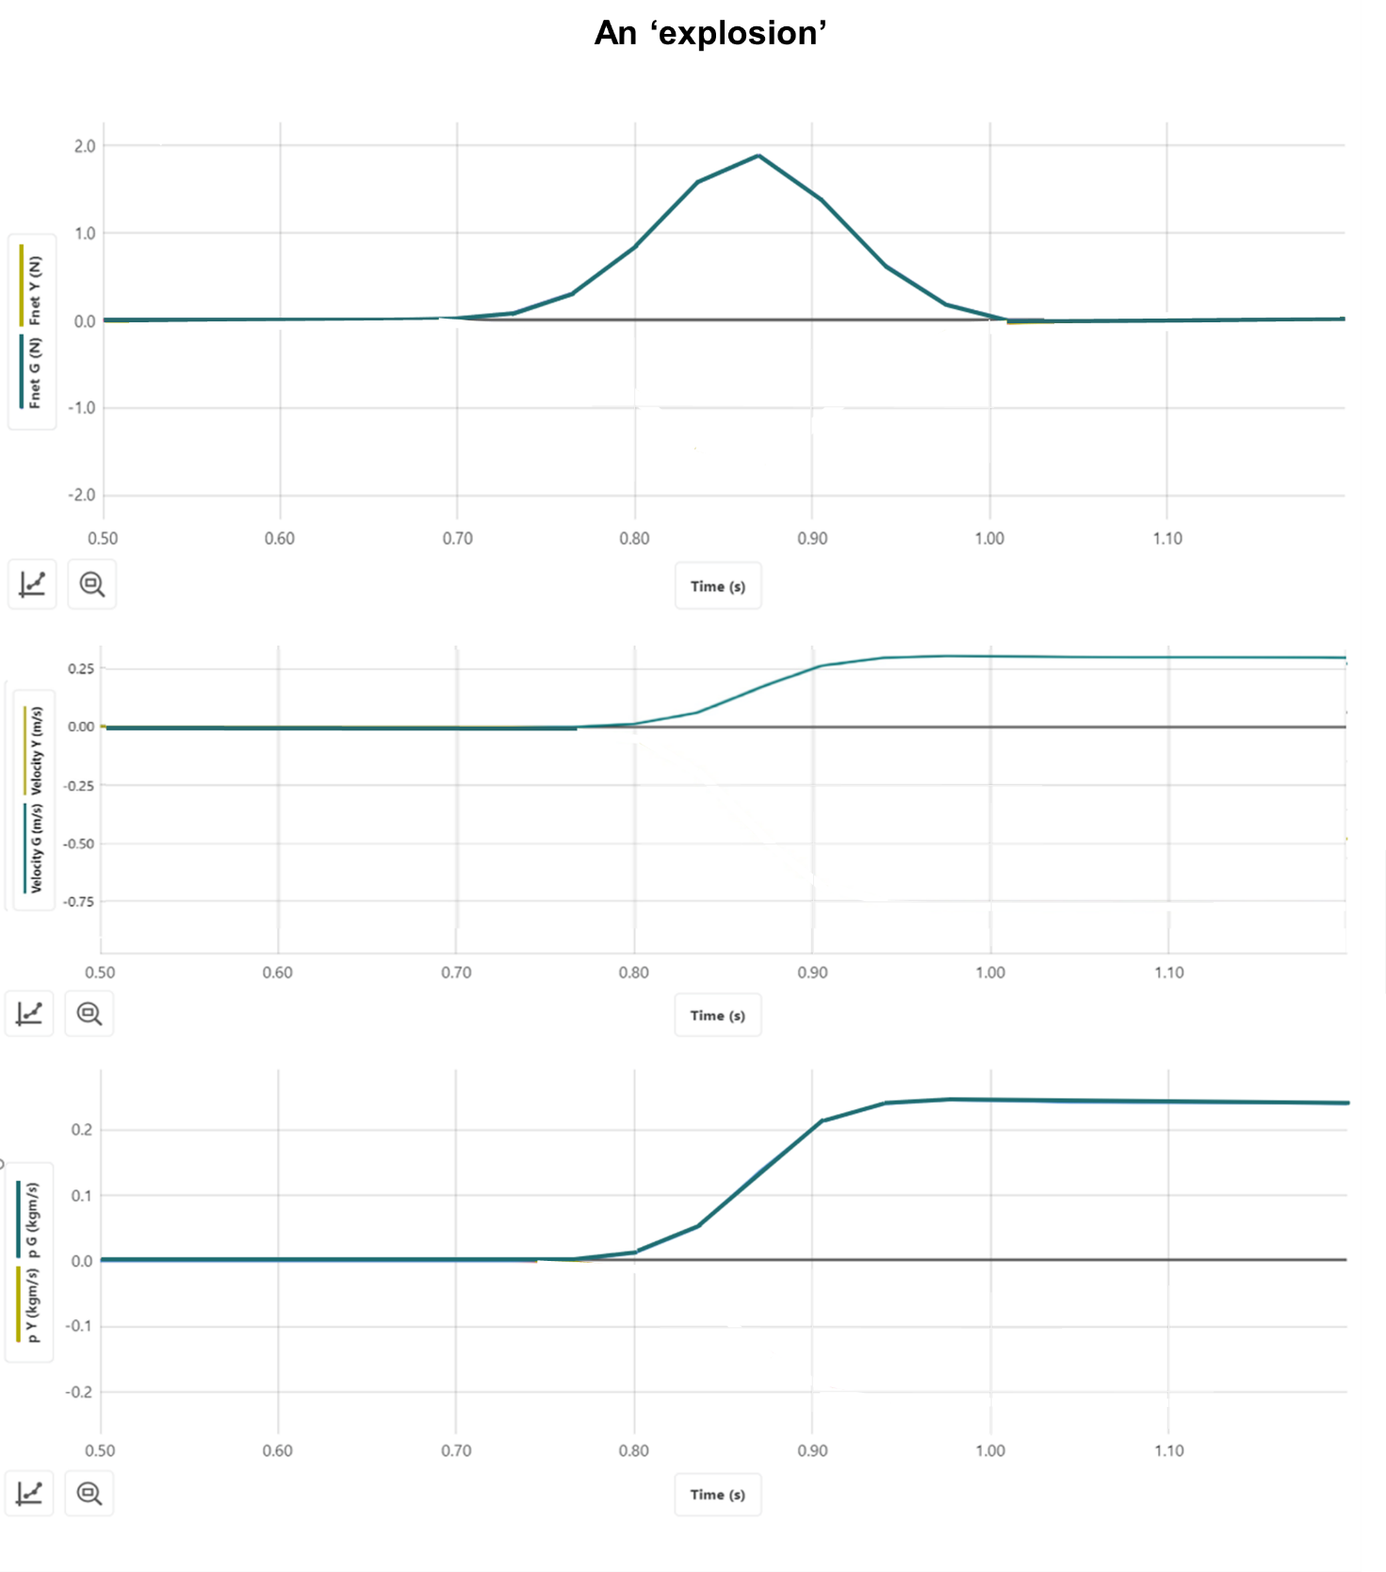

This figure is from the Physics Module 2 Guide (DoE 2022).

### Example 3 – an elastic collision of 2 carts of different masses

Figure 10 – non-contact collision between carts of different masses. Magnets fitted to the ends of each cart provide the repulsive force between carts.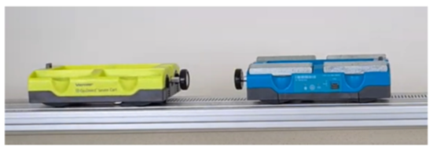

Image from the Physics Module 2 Guide (DoE 2022).

Watch the [example 3 video](https://www.youtube.com/watch?v=995ThX7A_eQ) Elastic bounce between carts of different mass (0:26) (Humphrey 2021c).

Example 3 considers an elastic collision between carts of different masses.

**Other data**

Mass of cart Y: $m=0.293 kg$

Mass of cart G: $m=0.804 kg$ (the mass of this cart has been increased by adding several small masses)

Initial velocity of cart Y: $u_{Y}=0.485 ms^{-1}$

Final velocity of cart Y: $v_{Y}=-0.220 ms^{-1}$

1. Label time intervals on the graphs that correspond to before, during and after the interaction.
2. Assuming the collision is elastic, complete the force-time, velocity-time and momentum time graphs for each cart in Figure 10 (extra writing paper may be required for calculations).

Annotate features of each graph to explain your reasoning.

Figure 11 – partial force-time, velocity-time and momentum-time graphs for the motion of the carts during an elastic collision between carts of different masses

****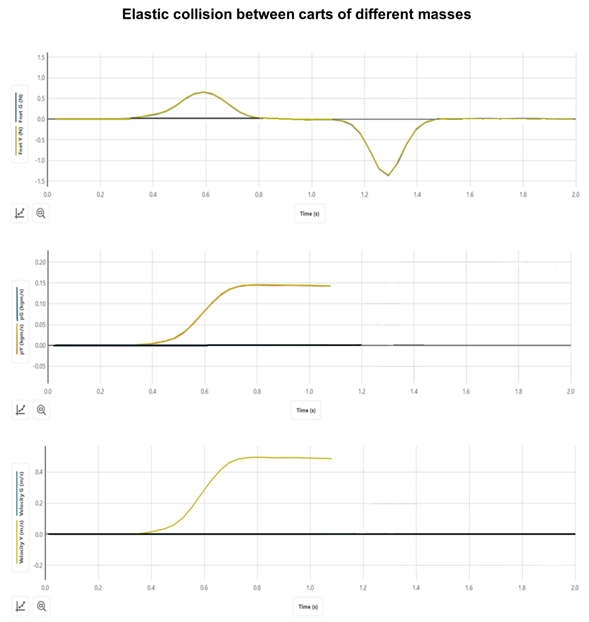****

This figure is from the Physics Module 2 Guide (DoE 2022).

## Appendixes

### Appendix A – suggested simulations

Simulated collisions enable quick collection and analysis of data. In addition, they allow students to carefully control initial conditions to explore the impact of variables on the outcomes of collisions without the need for class sets of equipment.

[Collision carts interactive – the Physics Classroom](https://www.physicsclassroom.com/Physics-Interactives/Momentum-and-Collisions/Collision-Carts/Collision-Carts-Interactive)

This simulation allows students to investigate the conservation of momentum in one-dimensional collisions. In addition, elastic and inelastic collisions can be explored, and the website also includes teacher notes and student worksheets.

[Desmos – a study in the conservation of momentum](https://www.desmos.com/calculator/abkbetlkaj)

This simulation is suitable for introducing students to the behaviour of objects in collinear collisions. It includes graphical representations of motion that are synchronised with the animation. Variables including the mass and initial velocity of each object, along with the time of the collision and whether it is elastic or inelastic can be controlled using the sliders.

[Collision Lab – PhET](https://phet.colorado.edu/sims/html/collision-lab/latest/collision-lab_en.html)

One and 2-dimensional collisions can be investigated using this simulation. Enabling the ‘More Data’ option allows students to systematically investigate the impact of changing variables including the mass and x/y components of the initial velocity of each object.

Figure 12 – a screenshot of the Collision Lab simulation by PhET Interactive Simulations, and graphs of force, velocity and momentum versus time for a simple collision from Desmos



‘[Collision Lab](https://phet.colorado.edu/sims/html/collision-lab/latest/collision-lab_en.html)’ simulation by PhET Interactive Simulations, University of Colorado Boulder licensed under [CC-BY-4.0](https://creativecommons.org/licenses/by/4.0/); ‘[Desmos.– A study in the conservation of momentum](https://www.desmos.com/calculator/abkbetlkaj)’ activity by William Calhoun, licensed under [CC BY-NC-SA 3.0](https://creativecommons.org/licenses/by-nc-sa/3.0/deed.en_US).

### Appendix B – problem-solving steps

A systematic approach to problem-solving can be applied to problems involving impulse and momentum and or work and energy.

Table 4 – systematic problem-solving steps for momentum and energy problems

|  |  |
| --- | --- |
| Step | Description |
| Step 1 – choose the system and the axes | In a ‘pictorial’ representation of the scenario, students explicitly choose:   * A system to analyse. This can be indicated with a dotted line and may indicate whether the system is a closed/isolated system. * Axes/coordinate system, including which direction to set as positive on each axis. The positive direction can be indicated with a ‘+’ symbol. This is particularly important for problems involving changes in direction. * Crucial instants. Define key moments at which to analyse the momentum or energy of the system and label them, $t_{1}$, $t_{2}$ and so on. Separate drawings could be made for each instant. For example, before or after a collision, when a thrown ball leaves the hand or is at the top of its arc. |
| Step 2 – represent the problem | Multiple representations are used to extract, organise and represent the problem in ways that can support problem-solving. Students:   * Analyse impulse and or momentum by drawing vector diagrams or force-time graphs. They resolve any momenta not aligned with one of the axes into components along the axes. * Draw free-body diagrams to analyse the interactions occurring ‘during’ collisions or other events. * Draw work-energy bar charts, energy flow diagrams and force versus distance graphs to support the analysis of energy transfers and transformations in systems and other work-energy problems. |
| Step 3 – apply mathematical models | Apply mathematical models. Students:   * Select the appropriate model for their chosen system and crucial instants. For closed systems, they will apply the laws of conservation of momentum and or energy such that $\sum{m{\vec{v}}_{before}}=\sum{m{\vec{v}}_{after}}$ or $\sum{E_{before}}=\sum{E_{after}}$. For open systems, these would also involve terms for impulse and or work, respectively. * Substitute the relevant masses, velocities, momenta and or energies. * Use any explicit or implicit information given in the question about the system's momentum. For example, it may be clear from the question that the initial momentum of the system in one direction is zero or that the final energy of the system is stored entirely as kinetic energy. |

This approach to problem-solving is demonstrated in the Sample responses section for Example 3 of the elastic and inelastic collision investigation.

#### Basic problem-solving steps

It is expected that most Physics students can extract data presented in graphs, tables, text, diagrams and so on. and apply mathematical formulae to solve familiar problems. The general feedback from HSC Physics exams highlights the importance of showing all working, including full substitution into equations and consideration for SI units. As demonstrated below, the acronym IDEA can be useful as a basic problem-solving routine.

A 46 gm golf ball is hit with a club and launched with an intial velocity of $100 ms^{-1}$. Calculate the average force exerted on the ball by the club if the club and ball were in contact for $0.5 ms$.

Table 5 basic problem-solving steps

|  |  |  |
| --- | --- | --- |
| Step | Description | Example |
| Identify and define | Represent the problem mathematically. That is, state all data provided in a question including correct symbol and units, and identify the quantity you have been asked to calculate. | $$m=46 g = 0.046 kg$$ $$v=100 ms^{-1}$$ $$t= 0.5 ms = 0.0005 s$$ $$F= ?$$ |
| Describe | Write the relevant equation(s) and draw diagrams. | $$∆\vec{p}={\vec{F}}_{net}∆t$$ $$m\vec{v}={\vec{F}}_{net}∆t$$ |
| Evaluate | Do the calculations (substitute, rearrange, and so on). | $$m\vec{v}={\vec{F}}_{net}∆t$$ $$(0.046)(100)={\vec{F}}_{net}(0.0005)$$ $${\vec{F}}_{net}=\frac{(0.046)(100)}{(0.0005)}$$ $${\vec{F}}_{net}=9200 N$$ |
| Answer | Check that you have answered the question that was asked, and not the question you would like to have been asked. | In this case this is the answer. However, some questions may require you to present your solution differently or include other information such as direction. |

### Appendix C – choosing an investigation

**Primary data: measuring the velocity of objects before and or after collisions**

Determining the velocity of an object using data logging equipment or measuring displacements and or times, and then applying equations of motion.

Suggested methods:

* Light gates or video analysis software (including [Tracker](https://tracker.physlets.org/) (Brown et al. 2022)) are versatile tools that make precise speed measurements.
* Launch the object from a known height (for example, off a lab bench) and measure the horizontal distance (and direction if analysing 2-dimensional motion) travelled when it strikes the ground. See [Two-dimensional collisions with ball bearings](https://spark.iop.org/two-dimensional-collisions-ball-bearings) (IOP 2022) for an example of this method.
$v_{x}=\frac{∆x}{t}$

* Where $t= \sqrt{\frac{2∆y}{9.8}}$
* Rolling an object down an inclined plane or smooth curved track. This allows the initial kinetic energy (and momentum) before a collision to be controlled and for several trials to be conducted under similar conditions. For carts and toy cars, it can be assumed that the kinetic energy at the bottom of the ramp is approximately equal to the magnitude of the change in gravitational potential energy.
$E_{k1}≈mg∆h$

* This model does not account for the energy stored in rotational motion and therefore overestimates the energy stored as kinetic energy, particularly if balls or marbles are used.

**Simulations can be a useful alternative to collecting first-hand data.**

Simulated collisions enable quick collection and analysis of data. In addition, they allow students to carefully control initial conditions to explore the impact of variables on the outcome of collisions without the need for class sets of equipment.

Simulations that are suitable for momentum investigations are included in Appendix A – suggested simulations.

**Analysing secondary data**

A comprehensive set of secondary data with graphs and videos for collisions in one-dimension are included with the student resources in the student resources.

## Support and alignment

**Resource evaluation and support:** all curriculum resources are prepared through a rigorous process. Resources are periodically reviewed as part of our ongoing evaluation plan to ensure currency, relevance and effectiveness. For additional support and advice, or to provide feedback, contact the Science Curriculum team by emailing [Science7-12@det.nsw.edu.au](mailto:Science7-12@det.nsw.edu.au).

**Differentiation:** further advice to support Aboriginal and Torres Strait Islander students, EAL/D students, students with a disability and/or additional needs and high potential and gifted students can be found on the [Planning programming and assessing 7-12](https://education.nsw.gov.au/teaching-and-learning/curriculum/planning-programming-and-assessing-k-12/planning-programming-and-assessing-7-12) webpage.

**Assessment**: further advice to support formative assessment is available on the [Planning programming and assessing 7-12](https://education.nsw.gov.au/teaching-and-learning/curriculum/planning-programming-and-assessing-k-12/planning-programming-and-assessing-7-12) webpage.

**Professional learning**: relevant professional learning is available on the [Science statewide staffroom](https://education.nsw.gov.au/teaching-and-learning/curriculum/statewide-staffrooms) and [HSC Professional Learning](https://education.nsw.gov.au/teaching-and-learning/professional-learning/hsc-pl). [Stage 6 Literacy in context](https://education.nsw.gov.au/teaching-and-learning/curriculum/literacy-and-numeracy/teaching-and-learning-resources/literacy/stage-6-literacy-in-context-writing/science) provides further advice to teachers to improve student writing.

**Related resources**: further resources to support Stage 6 Physics can be found on the [HSC hub](https://www.hschub.nsw.edu.au/) and the [Science Curriculum page](https://education.nsw.gov.au/teaching-and-learning/curriculum/science).

**Consulted with**: Literacy and Numeracy, and subject matter experts.

**Alignment to system priorities and/or needs**: [School Excellence Policy](https://education.nsw.gov.au/policy-library/policies/pd-2016-0468), [School Success Model](https://education.nsw.gov.au/public-schools/school-success-model/school-success-model-explained).

**Alignment to the School Excellence Framework**: this resource supports the [School Excellence Framework](https://education.nsw.gov.au/about-us/strategies-and-reports/school-excellence-and-accountability/school-excellence/about-sef) elements of curriculum (curriculum provision) and effective classroom practice (lesson planning, explicit teaching).

**Alignment to Australian Professional Teaching Standards**: this resource supports teachers to address [Australian Professional Teaching Standards](https://educationstandards.nsw.edu.au/wps/portal/nesa/teacher-accreditation/meeting-requirements/the-standards) 2.6.2, 3.2.2, 3.3.2.

**Author**: Science 7–12 Curriculum Team

**Resource**: classroom resource

**Creation date**: updated 10 Jan 2024

## References

This resource contains NSW Curriculum and syllabus content. The NSW Curriculum is developed by the NSW Education Standards Authority. This content is prepared by NESA for and on behalf of the Crown in right of the State of New South Wales. The material is protected by Crown copyright.

Please refer to the NESA Copyright Disclaimer for more information [https://educationstandards.nsw.edu.au/wps/portal/nesa/mini-footer/copyright](https://aus01.safelinks.protection.outlook.com/?url=https%3A%2F%2Feducationstandards.nsw.edu.au%2Fwps%2Fportal%2Fnesa%2Fmini-footer%2Fcopyright&data=05%7C01%7CCaitlin.Pace1%40det.nsw.edu.au%7C9c2c1a9f59c94d2df30708dafa7edb23%7C05a0e69a418a47c19c259387261bf991%7C0%7C0%7C638097720042599463%7CUnknown%7CTWFpbGZsb3d8eyJWIjoiMC4wLjAwMDAiLCJQIjoiV2luMzIiLCJBTiI6Ik1haWwiLCJXVCI6Mn0%3D%7C3000%7C%7C%7C&sdata=BzQh0UsffVZE3eO22b2Xba3p0VMOBZSHfS21FGHXtZM%3D&reserved=0).

NESA holds the only official and up-to-date versions of the NSW Curriculum and syllabus documents. Please visit the NSW Education Standards Authority (NESA) website <https://educationstandards.nsw.edu.au/> and the NSW Curriculum website [https://curriculum.nsw.edu.au/home](https://curriculum.nsw.edu.au/).

[Physics Stage 6 Syllabus](https://educationstandards.nsw.edu.au/wps/portal/nesa/11-12/stage-6-learning-areas/stage-6-science/physics-2017) © NSW Education Standards Authority (NESA) for and on behalf of the Crown in right of the State of New South Wales, 2017.

Briere JF (n.d.) [*Intro to Momentum and Impulse*](https://teacher.desmos.com/activitybuilder/custom/5fbecd888051570d21e3be16?collections=5f63ba070c1d112771f1d439), Desmos website, accessed 9 March 2022.

Brown D, Christian W and Hanson RM (2022) [*Tracker Video Analysis Tool and Modeling Tool*](https://tracker.physlets.org/), comPADRE website, accessed 23 February 2022.

CESE (Centre for Education Statistics and Evaluation) (2020a) [*What works best 2020 update*](https://education.nsw.gov.au/about-us/educational-data/cese/publications/research-reports/what-works-best-2020-update), NSW Department of Education, accessed 23 May 2022.

CESE (2020b) [*What works best in practice*](https://education.nsw.gov.au/about-us/educational-data/cese/publications/practical-guides-for-educators-/what-works-best-in-practice), NSW Department of Education, accessed 23 May 2022.

Davies C (25 October 2011) ‘[Momentum Bar Charts [video]](https://youtu.be/7CPQu1cGMEs)’, *DrCDavies*, YouTube website, accessed 9 March 2022.

DoE (NSW Department of Education) (2022) [*Module 2 guide*](https://education.nsw.gov.au/teaching-and-learning/curriculum/science/planning-programming-and-assessing-science-11-12/Physics), Stage 6 Physics website, accessed 23 February 2022.

Hewitt PG (2010), *Conceptual Physics*, 11th edn, Addison-Wesley, US.

Humphrey T (16 April 2021a) ‘[Cart “Explosion”’ [video]](https://youtu.be/ipFxNiNu3rc), *AUSphysics*, YouTube website, accessed 23 February 2022.

Humphrey T (16 April 2021b) ‘[Elastic bounce between carts of different mass’ [video]](https://youtu.be/995ThX7A_eQ), *AUSphysics*, YouTube website, accessed 23 February 2022.

Humphrey T (16 April 2021c) ‘[Sticky collision’ [video]](https://youtu.be/nPc5Cnw3v7g), *AUSphysics*, YouTube website, accessed 23 February 2022.

IOP (Institute of Physics) (2022) ‘[Two-dimensional collisions with ball bearings](https://spark.iop.org/two-dimensional-collisions-ball-bearings)’, IOP website, accessed 9 March 2022.

IVV (Interactive Video Vignettes) (2013) [*Newton’s Third Law Vignette*](https://www.compadre.org/ivv/vignettes/newtonsThirdLaw.cfm), Compadre website, accessed 8 March 2022.

Jones G (13 May 2020) ‘[Understanding Car Crashes: It’s Basic Physics’ [video]](https://youtu.be/2XKOzibVqJg), *IIHS*, YouTube website, accessed 23 February 2022.

Khan Academy (n.d.) [*What are momentum and impulse?*](https://www.khanacademy.org/science/physics/linear-momentum/momentum-tutorial/a/what-are-momentum-and-impulse), Khan Academy website, accessed 9 March 2022.

NESA (NSW Education Standards Authority) (2022) ‘[Proficient Teacher: Standard descriptors’](https://educationstandards.nsw.edu.au/wps/portal/nesa/teacher-accreditation/meeting-requirements), *The Standards*, NESA website, accessed 23 February 2022.

Newton K (n.d.) [*Colliding Carts – Activity builder by desmos*](https://teacher.desmos.com/activitybuilder/custom/6024d2e1208f790d355e3807?collections=5f806f2321fa660ca84cf129), Desmos website, accessed 8 March 2022.

PhET Interactive Simulations (2022) [Collision Lab](https://phet.colorado.edu/en/simulations/collision-lab/credits), PhET website, accessed 8 March 2022.

Khan Academy (30 July 2016) [‘Force vs. time graphs [video]’](https://youtu.be/8bHPj3ll0vs), *Khan Academy*, YouTube website, accessed 9 March 2022.

Science’n’me (28 March 2017) ‘[Collisions in 2-Dimensions (Lab Instruction) [video]’](https://youtu.be/V20yASOKLcM), *Sceince’n’me*, YouTube website, accessed 9 March 2022.

The Physics Classroom (TPC) (nd) ‘[Collision Carts Interactive’](https://www.physicsclassroom.com/Physics-Interactives/Momentum-and-Collisions/Collision-Carts/Collision-Carts-Interactive), TPCwebsite, accessed 9 March 2022.

Urone PP and Hinrichs R (2020) [*Physics*](https://openstax.org/books/physics/pages/1-introduction), OpenStax website, accessed 9 March 2022.

### Further reading

State of New South Wales (Department of Education) (2022a) [Literacy and numeracy](https://education.nsw.gov.au/teaching-and-learning/curriculum/literacy-and-numeracy), NSW Department of Education, accessed 24 February 2023.

State of New South Wales (Department of Education) (2022b) [Literacy and numeracy priorities](https://education.nsw.gov.au/teaching-and-learning/curriculum/literacy-and-numeracy/priorities), NSW Department of Education, accessed 24 February 2023.

**© State of New South Wales (Department of Education), 2023**

The copyright material published in this resource is subject to the *Copyright Act 1968* (Cth) and is owned by the NSW Department of Education or, where indicated, by a party other than the NSW Department of Education (third-party material).

Copyright material available in this resource and owned by the NSW Department of Education is licensed under a [Creative Commons Attribution 4.0 International (CC BY 4.0) licence](https://creativecommons.org/licenses/by/4.0/).

[](https://creativecommons.org/licenses/by/4.0/)

This licence allows you to share and adapt the material for any purpose, even commercially.

Attribution should be given to © State of New South Wales (Department of Education), 2023.

Material in this resource not available under a Creative Commons licence:

* the NSW Department of Education logo, other logos and trademark-protected material
* material owned by a third party that has been reproduced with permission. You will need to obtain permission from the third party to reuse its material.

**Links to third-party material and websites**

Please note that the provided (reading/viewing material/list/links/texts) are a suggestion only and implies no endorsement, by the New South Wales Department of Education, of any author, publisher, or book title. School principals and teachers are best placed to assess the suitability of resources that would complement the curriculum and reflect the needs and interests of their students.

If you use the links provided in this document to access a third-party's website, you acknowledge that the terms of use, including licence terms set out on the third-party's website apply to the use which may be made of the materials on that third-party website or where permitted by the *Copyright Act 1968* (Cth). The department accepts no responsibility for content on third-party websites.