Chemistry Stage 6 – Module 8: Analysis of organic compounds
Contents
Overview 2
Information for teachers 3
Outcomes 3
Learning intention and success criteria 4
Teaching and learning activities 5
Components of the class activity 5
Student resources 7
Part 1 – proton and carbon-13 NMR 7
Part 2 – the components of a typical 13C NMR spectrum 9
Part 3 – the components of a typical ¹H NMR spectrum 11
Part 4 – infrared spectroscopy – summary and key ideas 14
Part 5 – getting to know the IR spectrum 15
Part 6 – mass spectroscopy – summary and key ideas 18
Part 7 – getting to know the mass spectrum 20
Part 8 – applying your knowledge and understanding 22
Sample responses 27
Part 1 – proton and carbon-13 NMR – summary and key ideas 27
Part 2 – The components of a typical 13C NMR spectrum 27
Part 3 – The components of a typical 1H NMR spectrum 27
Part 4 – Infrared spectroscopy – Summary and key ideas 28
Part 5 – Getting to know the IR spectrum 28
Part 6 – Mass spectroscopy – Summary and key ideas 30
Part 7 – Getting to know the mass spectrum 30
Part 8 – Applying your knowledge and understanding 31
Support and alignment 33
Appendix 35
Spectra templates 35
References 38
Acknowledgements 39
Further reading 39

Overview
Stage and Learning Area: Chemistry Stage 6
Description: this resource has been designed to address the Module 8 inquiry question: How is information about the reactivity and structure of organic compounds obtained?
This learning sequence builds understanding of the processes used to analyse the structure of simple organic compounds addressed in the course, including but not limited to:
- proton and carbon-13 NMR
- mass spectrometry
- infrared spectroscopy.
Duration: while timing will vary based on the mode of delivery, differentiation strategies employed and class or school context, this series of activities should take approximately 2 hours to complete.

Information for teachers
This learning activity revises and consolidates the use and application of the spectroscopic techniques studied in Module 8 to identify organic substances studied in Module 7.
Identifying and analysing chemicals are essential in scientific research, medicine, environmental management, quality control, mining, and many other fields. Students deduce or confirm the structure and identity of organic compounds by interpreting data from:
- qualitative tests of chemical reactivity
- proton ¹H nuclear magnetic resonance (NMR)
- ¹³C nuclear magnetic resonance (NMR) spectroscopy
- infrared spectroscopy (IR)
- mass spectroscopy (MS).
This learning activity is designed to develop students’ understanding of the processes used to analyse simple organic compounds.
This content also links with other sections of the Stage 6 course, including the Module 7 Inquiry question: How do we systematically name organic chemical compounds?

Outcomes
A student:
- CH11/12-4 selects and processes appropriate qualitative and quantitative data and information using a range of appropriate media
- CH11/12-7 communicates scientific understanding using suitable language and terminology for a specific audience or purpose
- CH12-15 describes and evaluates chemical systems used to design and analyse chemical processes
Chemistry Stage 6 Syllabus © NSW Education Standards Authority (NESA) for and on behalf of the Crown in right of the State of New South Wales, 2017.

Learning intention and success criteria
Students:
- understand the processes used to analyse the structure of simple organic compounds.
Students can/will:
- describe the steps in the analysis of organic compounds for the following techniques using specific key terms and characteristics
- ¹H NMR spectroscopy
- ¹³C NMR spectroscopy
- Infrared spectroscopy
- Mass spectroscopy
- use the Infrared absorption and ¹³C NMR chemical shift data to identify functional groups and types of carbons present in an organic compound
- explain features of a specific spectrum used to identify simple organic compounds
- apply knowledge of a variety of spectra to identify an unknown organic compound.
Differentiation consideration: learning intentions should not be differentiated. All students need access to the same core content, big ideas and concepts. Differentiation should be evident in the success criteria, or the activities/support needed to achieve the success criteria (Wiliam and Leahy 2015). Teachers may co-construct the success criteria with students or adjust them to suit their class context, for example using the strategies and resources for curriculum planning on the Planning programming and assessing K-12 webpage.

Teaching and learning activities
Learning activities are sequenced into a series of 8 parts as outlined below. Details of each activity are included in the student resource section.

Components of the class activity
Teacher note: to meet the learning requirements of your students, the activities outlined below can be completed in sequence or as stand-alone components. The summary and key ideas parts (1, 4 and 6) are cloze activities designed to build student vocabulary and use of precise terminology. These parts can be completed as a pre-test to revise the key concepts of each technology studied in class. A word list is provided for the completion of these parts.
Students should be given access to resource materials such as textbooks, course notes and online resources and guided through the completion of part 2, part 3, part 5 and part 7. The teacher should refer to the ¹³C NMR and Infrared data provided in the activities to assist the students in identifying the types of carbons and functional groups present. All diagrams should be drawn in pencil and fully labelled. A word list is provided in part 3. These parts can be completed in a group work setting and students should share their answers in a class discussion.
- Part 1 – proton and carbon-13 NMR – Summary and key ideas
- Part 2 – the components of a typical ¹³C NMR spectrum
- Part 3 – the components of a typical ¹H NMR spectrum
- Part 4 – infrared spectroscopy – Summary and key ideas
- Part 5 – getting to know the IR spectrum
- Part 6 – mass spectroscopy – Summary and key ideas
- Part 7 – getting to know the mass spectrum
- Part 8 – applying your knowledge and understanding
Teacher note: students should complete part 8 individually as an in-class assessment. This part is where students apply their knowledge and understanding by completing an HSC style question. Approximately 20 minutes should be used to complete this part. At the conclusion of part 8 the teacher should collect student work and check their answers. Time should be allocated in the following lesson to go through the answers with the class and reinforce any concepts.

Differentiation consideration: students may work through the activity independently. If students require more guidance, provide targeted support, and use class discussion to consolidate learning. Teachers could consider using the 'Think aloud' technique which is outlined in Using context to infer the meaning of unfamiliar vocabulary.
All students need to be challenged and engaged to develop their potential fully. A culture of high expectations needs to be supported by strategies that both challenge and support student learning needs, such as through appropriate curriculum differentiation.
CESE What works best 2020 update

Student resources

Part 1 – proton and carbon-13 NMR
Table 1 – summary of proton and carbon-13 NMR properties
Spectroscopic techniques | ¹H NMR | ¹³C NMR
Stands for | Proton Nuclear Magnetic Resonance | Carbon Nuclear Magnetic Resonance
Use | ¹H NMR is a spectroscopic technique used to determine the types and number of hydrogen atoms present in a molecule | ¹³C NMR is a spectroscopic method used to determine the types and number of carbon atoms present in a molecule
Detection | Proton nuclei | Carbon nuclei
Chemical shift range  relative position of absorption in the NMR spectrum | 0-14 ppm | 0-240 ppm
Progression | Slow | Fast
Solvent peak | Absent | Present

Table 2 – nuclear and magnetic resonance (NMR) including ¹H and ¹³C NMR
Analysis | Details
Basis of analysis | Nuclei of a compound are bombarded with radio waves.  The way that these nuclei interact with radio waves tells us about the chemical environment of these atoms which allows us to then build information about how these atoms are bonded together and ultimately form the structure of that compound.
Steps in analysis  Word list:  larger  lower  line up  peaks  different  deshielding  radio waves  spin  chemical shifts  dissolved  decrease  environments  higher  absorbed  magnetic field | - The sample is ______________ in a suitable solvent and placed inside the NMR spectrometer.  - A strong ______________ ______________ is applied causing the positively charged nuclei to ______________ and ______________ ________ with the external field (lower energy) or against the external field (higher energy).  - These nuclei are then bombarded with ____________ ____________ of the appropriate frequency that matches that change in energy. This energy is ____________ causing the nuclei to flip to a ____________ energy state (excited state).  - As nuclei return to their ____________ energy state (ground state) energy is released, and an NMR spectrum is produced which shows this absorption.  - Absorptions appear as sharp ____________ or signals on the spectrum at different _______________ ____________ characteristic of their chemical environment.  Electron withdrawing (electronegative) groups can ____________ the electron density at the nucleus, ____________ the nucleus and result in a ____________ chemical shift. This means that H atoms which have ___________ chemical ____________ will have different chemical shifts.

Part 2 – the components of a typical 13C NMR spectrum
¹³C NMR spectrum – ethanal
Solvent CDCl₃
Figure 1 – ¹³C NMR spectrum – ethanal
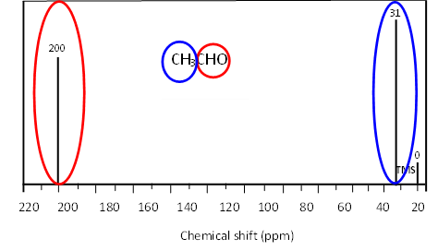
Figure 2 – ¹³C NMR chemical shift data
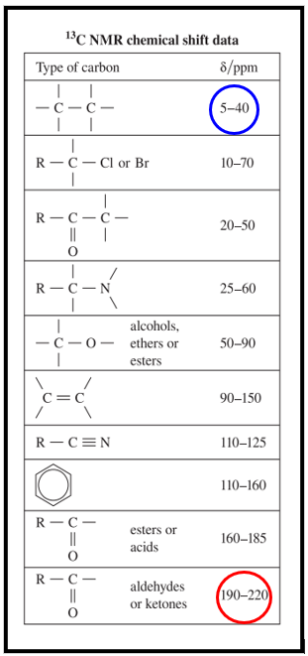
- Why is the CHO group further downfield and the CH₃ group more upfield?
- Analyse the spectrum for pentanoic acid below.
Figure 3 – ¹³C NMR spectrum
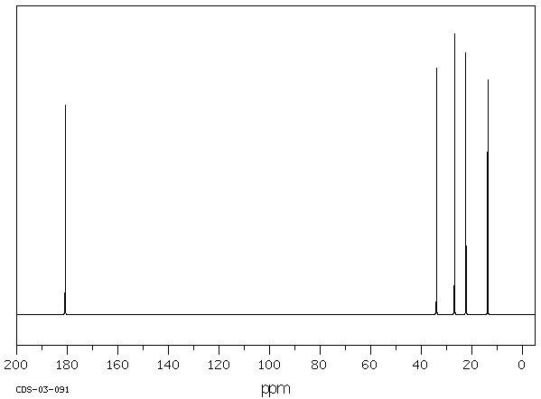
Spectral Database for Organic Compounds image by the National Institute of Advanced Industrial Science and Technology (AIST).
- How many carbon environments are present in the spectrum above?
- What functional group is most likely to be present an approximately 180ppm?

Part 3 – the components of a typical ¹H NMR spectrum
Figure 4 – ¹H NMR spectrum
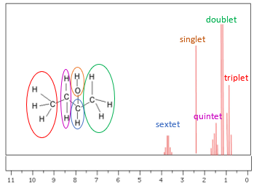
Image adapted from Socratic.
- The explanation for the splitting patterns for triplet and doublet peaks is outlined below. Use this information to complete the explanations for the quintet, singlet and sextet peaks.
The peak at ~ 1ppm is split into a triplet (three peaks), indicating this hydrogen environment is adjacent to a neighbouring carbon with two hydrogens. The terminal CH₃ group, marked in red, is adjacent to the CH₂ group. It produces a triplet peak and is normally a very low shift as it is a terminal hydrogen environment and furthest away from the electron-withdrawing OH group.
The peak at ~ 1.3ppm is split into a doublet (two peaks), indicating this hydrogen environment is adjacent to a neighbouring carbon with one hydrogen, CH group. The spectrum above shows the terminal CH₃ group in green connected to the CH group marked in blue. The doublet has a slightly higher chemical shift than the triplet as it is closer to the electron-withdrawing OH group.
- The peak at ~ 1.5ppm is split into a ________________ (_______ peaks), indicating this hydrogen environment is the CH₂ group marked in purple is adjacent to one neighbouring carbon group _______ attached to ____ H atom and another neighbouring carbon group _______ attached to _______ hydrogen atoms. This gives a total of _______ hydrogen atoms. The quintet has a slightly higher chemical shift than the doublet as it is attached to the electron-withdrawing OH group.
- The peak at ~ 2.5ppm is split into a ______________ (_______ peak), indicating that the hydrogen is attached to a non-carbon. The spectrum above shows the H attached to the ___________ atom (non-carbon). The has a slightly higher chemical shift than the quintet.
- The peak at ~ 3.5ppm is split into a ______________ (_______ peaks), indicating this hydrogen environment is the CH group marked in blue and is attached to one neighbouring carbon group _______ attached to ____ H atoms and another neighbouring carbon group _______ attached to _______ hydrogen atoms. This gives a total of _______ hydrogen atoms. The sextet has the greatest chemical shift, as it is directly attached to the electron-withdrawing OH group.
Word list: quintet, five, CH, CH₃, one, three, four, sextet, six, CH₂, CH₃, two, three, five, singlet, one, oxygen.
- Study the ¹H NMR spectrum and the proton NMR peak data for propanoic acid below
Figure 5 – 1H NMR spectrum
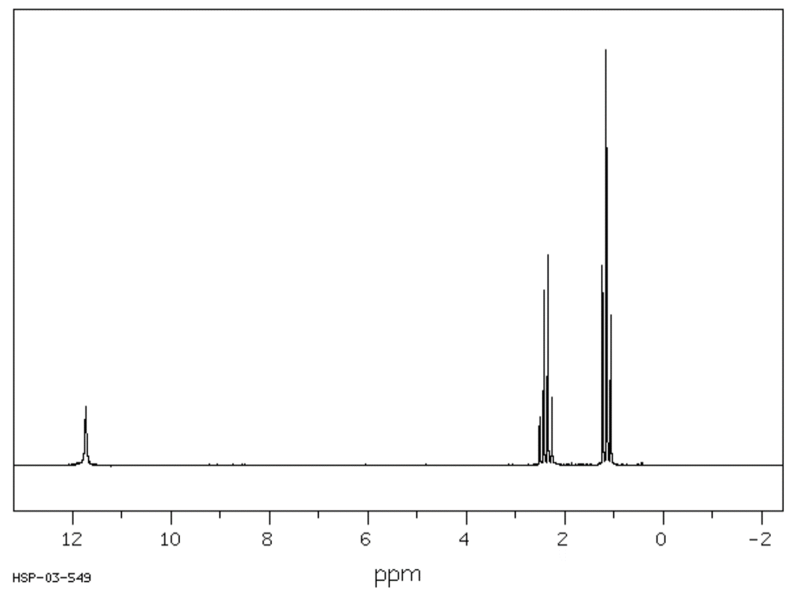
Table 3 – spectral database for organic compounds
Shift (ppm) | Number of peaks | Peak area ratio
11.73 | 1 | 1
2.38 | 4 | 2
1.16 | 3 | 3
Explain how this spectrum is representative of propanoic acid.

Part 4 – infrared spectroscopy – summary and key ideas
Read through the key ideas and complete the steps in the analysis section of the table. A word list has been provided.
Table 4 – Infrared (IR) spectroscopy applications and analysis
Infrared (IR) | spectroscopy
Use | Analytical technique used to determine and identify the structure of organic compounds by utilising electromagnetic radiation in the infrared range.
Basis of analysis | Molecules are identified based on their interaction and absorption of infrared radiation characteristic of their molecular vibration
Steps in analysis  Word list:  absorption data  matches  functional groups  absorption  molecular vibration  irradiated  absorbed | - A sample is ________________ with infrared electromagnetic radiation consisting of a range of wavelengths.  - Energy is either transmitted or ________________.  - Energy is absorbed if the frequency of the radiation _______________ the frequency of the ________________ ________________ causing the molecule in the sample to vibrate in a unique way (stretching/bending).  - An ________________ spectrum is produced and interpreted.  - Patterns are compared to infrared ________________ __________, and the ________________ ________________ of the molecule are determined.
Wavenumber Range | 4000–500.

Part 5 – getting to know the IR spectrum
Draw the peak absorbance (dip in transmittance) for the examples below. The Infrared absorption data table is provided, and the marker is placed below the X axis to guide you.

Hydroxyl group in alcohols
Figure 6 – IR template
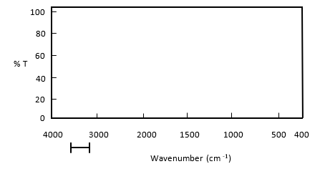

Hydroxyl group in carboxylic acids
Figure 7 – IR template
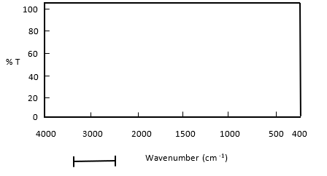

A carbonyl group
Figure 8 – IR template
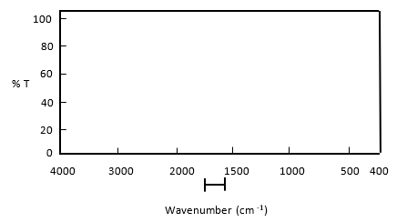
Figure 9 – infrared absorption data
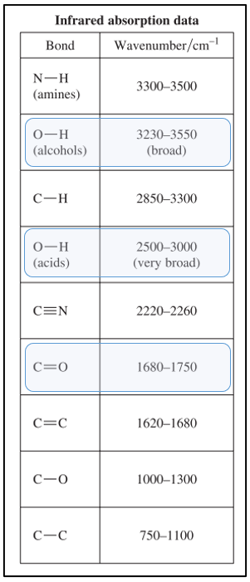
Use Figure 9 to conduct Quick check 1 and 2.
Quick check 1
Consider the classes of organic substances listed in the Chemistry syllabus.
A carbonyl group is found in ketones, ________________ ________________, ________________ _______________ and ________________.
Figure 10 – an amino group
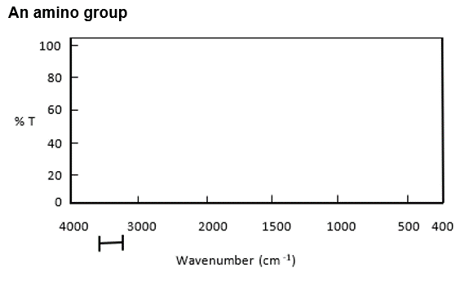
Figure 11 – an amide group
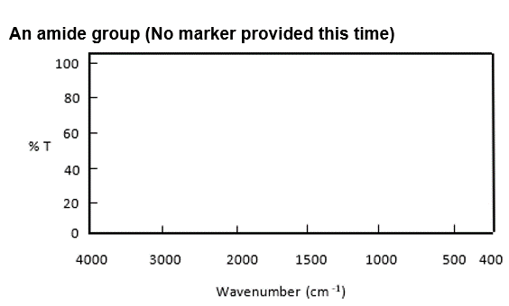
Quick check 2
Consider the classes of organic substances listed in the Chemistry syllabus.
An amino group is found in ________________ and __________________.

Part 6 – mass spectroscopy – summary and key ideas
Read through the key ideas and complete the steps in the analysis section of the table. A word list is provided.
Table 5 – mass spectroscopy applications and analysis
Mass | spectroscopy (MS)
Use | Use to identify the compounds by analysing their molecular weights
Basis of analysis | Molecular fragments are analysed based on charge-to-mass ratio
Steps in analysis  Word list:  database  curved  peaks  detector  charge/mass  fragments  vaporised  peak  Ionised  accelerated  magnetic  abundance | - The sample is ____________ and then ____________ by bombardment with a stream of high energy electrons.  - The positive ions are ____________ by an electric field and then passed through a ____________ field, causing the ions to move in ____________ paths in which the deflection (radius of the path) depends on the ____________ ratio.  - The ions then exit and reach the _______________.  - The mass spectrum is produced consisting of a series of ____________ of varying heights.  - Each peak corresponds to one of the ____________ and the height of the ____________ indicates its ____________. Different chemicals break apart in a distinct way forming a fingerprint spectrum.  - The spectral pattern is used to identify the original molecule by comparison with a computer ____________ of known compounds.
Draw a schematic diagram of a mass spectrometer in the space below. Label the following components: ionisation, acceleration, deflection, detection, electromagnet, vaporised sample, to vacuum pump.

Part 7 – getting to know the mass spectrum
Examine the mass spectrum for ethanoic acid below and answer the questions that follow.

Mass spectrum for ethanoic acid
Figure 12 – mass spectrum of ethanoic acid
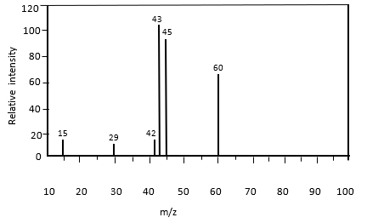
- Draw the structural formula for ethanoic acid in the box below and use the structure to help you to identify the fragmentation pattern for ethanol in the following questions.
- On the mass spectrum above, label the parent molecular ion and the base peak.
- Draw the structural formula for fragment 43 and fragment 60 in the boxes below.
Fragment 43 | Fragment 60

- The table below shows the common fragmentations that occur in ethanoic acid. The first example is done for you. Complete the rest of the table.
Table 6 – relative mass and fragment size
Relative mass | Fragment
15 | CH3⁺
29
43

Part 8 – applying your knowledge and understanding
Question 1
Adapted from 2021 HSC Chemistry Exam.
A chemist obtained spectral data of pentane-1,5-diamine (C₅H₁₄N₂).
- Draw the structural or displayed formula for this compound in the box below and highlight/circle the amine functional groups.

The spectra obtained for pentane-1,5-diamine (C₅H₁₄N₂) are shown below.
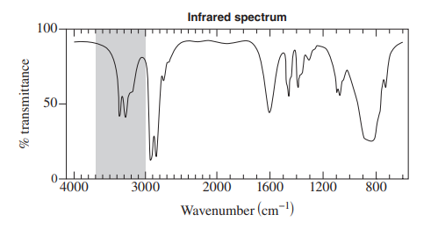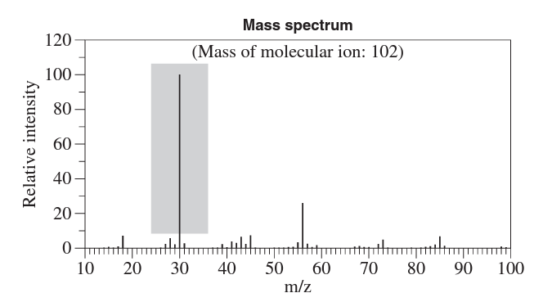
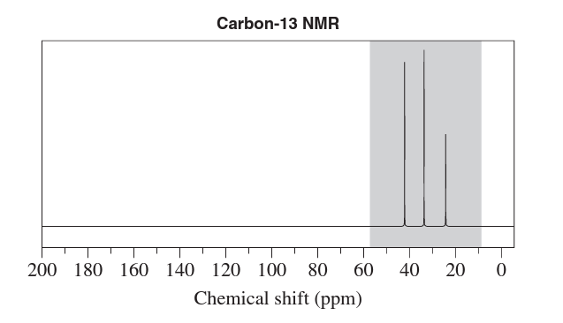
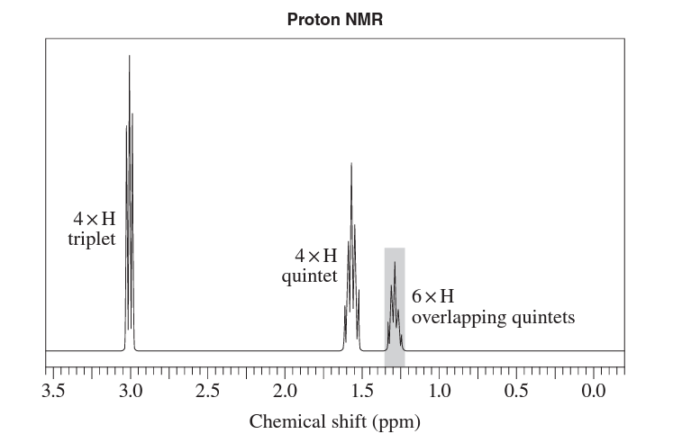
- Relate the highlighted features of the spectra to the structure of pentane-1,5-diamine.

Sample responses

Part 1 – proton and carbon-13 NMR – summary and key ideas
Steps in analysis
- dissolved
- magnetic field, spin, line up
- radio waves, absorbed, higher
- lower
- peaks, chemical shifts
- decrease, deshielding, larger, different environments.

Part 2 – The components of a typical 13C NMR spectrum
- CHO group contains an electronegative oxygen atom. This atom decreases the electron density at the carbon nucleus, deshielding it and resulting in a larger chemical shift (downfield). The CH₃ group does not have any electronegative atoms, and thus the electron density at the carbon nucleus is unaffected/nucleus is shielded. This results in a smaller chemical shift (upfield).

- Five
- COOH

Part 3 – The components of a typical 1H NMR spectrum

- Quintet, five, CH, one, CH₃, three, four
- Singlet, one, oxygen
- Sextet, six, CH₃, three, CH₂, two, five
- Propanoic acid has three different hydrogen environments, as indicated by the three peaks in the spectrum. Peak #1 is a singlet representing the COOH group, as the H atoms are attached to a non-carbon atom. In this case, the electronegative oxygen atom deshields the nucleus causing a larger chemical shift (11.73 from the spectrum). The quartet represents the CH₂.

Part 4 – Infrared spectroscopy – Summary and key ideas
- irradiated
- absorbed
- matches, molecular vibration
- absorption
- absorption data, functional groups

Part 5 – Getting to know the IR spectrum
Table 6 – example spectra
Functional group | Description | Example
Hydroxyl group in alcohol | As referenced in the IR spectrum, a broad peak (beard) is hand-drawn between the 3230–3550 range. | 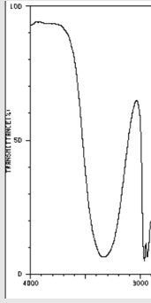
Hydroxyl group in carboxylic acid | A very broad peak (beard) is hand-drawn between the 2500–3000 range as referenced in the IR spectrum | 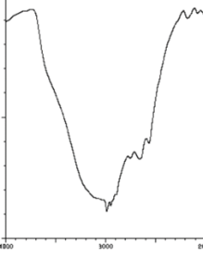
Carbonyl group | A sharp peak (sword) is hand-drawn between the 1680–1750 range as referenced in the IR spectrum | 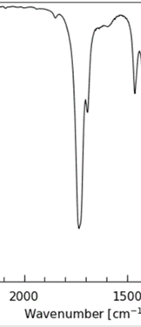
Amino group | A double prong peak is hand-drawn between the 3300–3500 range. | 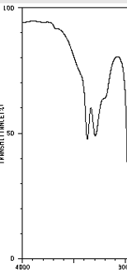
Amide group | A double prong peak is hand-drawn between the 3300–3500 range representative of the amino group and another peak is drawn between the 1680–1750 range representative of the carbonyl group | 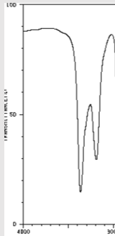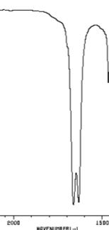
Teacher tip: The analogy of ‘beards’ and ‘swords’ is sometimes used to help students recognise the hydroxyl peaks (beards) and the carbonyl peaks (swords)
Quick check 1 – carboxylic acids, esters, aldehydes, and amides.
Quick check 2 – amines and amides.

Part 6 – Mass spectroscopy – Summary and key ideas
- vaporised, ionised
- accelerated, magnetic, curved, charge/mass
- detector
- peaks
- fragments, peak, abundance
- database
Schematic diagram of MS
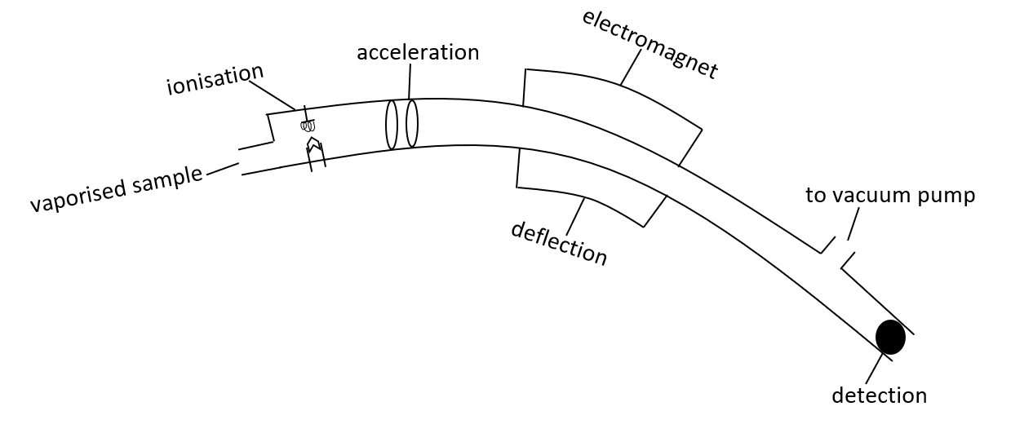

Part 7 – Getting to know the mass spectrum
- 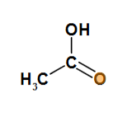
- Students label molecular peak 60 and base peak 43
- Students draw a structural diagram for fragment 43, which is CH₃CO⁺ and for fragment 60, which is CH₃COOH⁺
- Fragment 29 = CH₂CH₃⁺, CHO⁺, Fragment 43 = CH₃CO⁺

Part 8 – Applying your knowledge and understanding
Question 1
- 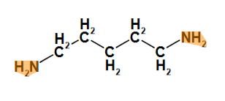

Infrared spectrum
- The peak at the wavenumber range 3300–3400 cm–1 is due to the N-H group (amino group). The spectrum confirms the presence of the amino group.
Mass spectrum
- The highlighted feature is the fragment CH₂NH₂+ (12 x 1 + 1.0 x 4 + 14 x 1 = 30)
Carbon-13 NMR spectrum
- There are 5 carbon atoms in the molecule. However, only 3 peaks (3 signals) are shown in the spectrum.
- Due to symmetry, carbon atoms 1 and 5 are in identical environments. The same is true for carbon atoms 2 and 4. However, carbon atom 3 is in a unique environment.
- The signals at 24 and 33 ppm are consistent with –CH₂–CH₂– carbon atoms (5−40 ppm)
- The signal at 42 ppm is due to the C-N-H groups (25−60 ppm)
Proton NMR
- Quintets arise from H atoms with four H atoms on neighbouring C atoms, for example: the H atoms on C-3 have four neighbouring H atoms on C-2 and C-4.
- The highlighted signal results from similar chemical shifts of protons in two different environments.
- The highlighted signal results from the overlap of a 2H signal and a 4H signal, giving 6H.

Support and alignment
Resource evaluation and support: all curriculum resources are prepared through a rigorous process. Resources are periodically reviewed as part of our ongoing evaluation plan to ensure currency, relevance and effectiveness. For additional support and advice or to provide feedback, contact the Science Curriculum team by emailing Science7-12@det.nsw.edu.au.
Please complete the following feedback form to help us improve our resources and support.
Differentiation: further advice to support Aboriginal and Torres Strait Islander students, EALD students, students with a disability and/or additional needs and High Potential and gifted students can be found on the Planning programming and assessing 7-12 webpage.
Assessment: further advice to support formative assessment is available on the Planning programming and assessing 7-12 webpage.
Professional learning: relevant professional learning is available on the Science statewide staffroom and HSC Professional Learning. Stage 6 Literacy in context provides further advice to teachers to improve student writing.
Related resources: further resources to support Stage 6 Chemistry can be found on the HSC hub and the Science K-12 page.
Consulted with: Literacy and Numeracy and subject matter experts.
Alignment to system priorities and/or needs: School Excellence Policy, School Success Model.
Alignment to the School Excellence Framework: this resource supports the School Excellence Framework elements of curriculum (curriculum provision) and effective classroom practice (lesson planning, explicit teaching).
Alignment to Australian Professional Teaching Standards: this resource supports teachers to address Australian Professional Teaching Standards 3.2.2, 3.3.2.
Author: Science 7-12 Curriculum Team
Resource: Classroom resource
Creation date: updated 26 October 2022

Appendix

Spectra templates
The following templates are to support general teaching and learning activities for spectroscopy. They could be used when designing questions or when demonstrating worked examples to a class.
Teacher tip: the following templates can be used by teachers to create their own spectra when designing learning materials.

Infrared Spectra
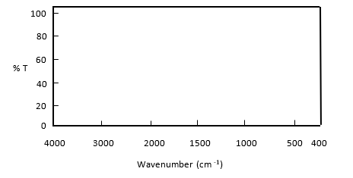

13C NMR Spectra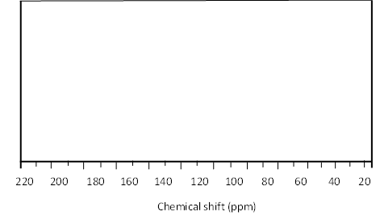

1H NMR Spectra
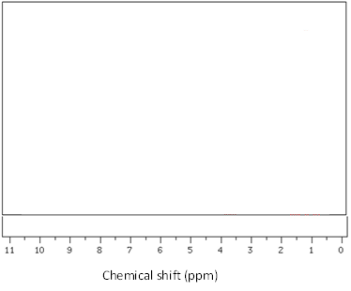

Mass Spectra
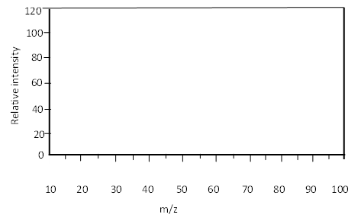

References
This resource contains NSW Curriculum and syllabus content. The NSW Curriculum is developed by the NSW Education Standards Authority. This content is prepared by NESA for and on behalf of the Crown in right of the State of New South Wales. The material is protected by Crown copyright.
Please refer to the NESA Copyright Disclaimer for more information https://educationstandards.nsw.edu.au/wps/portal/nesa/mini-footer/copyright.
NESA holds the only official and up-to-date versions of the NSW Curriculum and syllabus documents. Please visit the NSW Education Standards Authority (NESA) website https://educationstandards.nsw.edu.au/ and the NSW Curriculum website https://curriculum.nsw.edu.au/home.
Chemistry Stage 6 Syllabus © NSW Education Standards Authority (NESA) for and on behalf of the Crown in right of the State of New South Wales, 2017.
AIST (National Institute of Advanced Industrial Science and Technology) (2018) Spectral Database for Organic Compounds [website], accessed 29 June 2020.
CESE (Centre for Education Statistics and Evaluation) (2020) What works best: 2020 update, NSW Department of Education, accessed 23 May 2023.
CESE (Centre for Education Statistics and Evaluation) (2020) What works best in practice, NSW Department of Education, accessed 23 May 2023.
NESA (NSW Education Standards Authority) (2022) ‘Proficient Teacher: Standard descriptors’, The Standards, NESA website, accessed 23 May 2023.
Wiliam D and Leahy S (2015) Embedding Formative Assessment: Practical Techniques for K-12 Classrooms, Learning Sciences International, US.

Acknowledgements
The practice questions in this document are from Chemistry 2021 HSC exam pack © NSW Education Standards Authority (NESA) for and on behalf of the Crown in right of the State of New South Wales, 2021.
Infrared absorption and chemical shift data has been extracted from Chemistry HSC Data Sheet © 2019 NSW Education Standards Authority (NESA) for and on behalf of the Crown in right of the State of New South Wales

Further reading
State of New South Wales (Department of Education) (n.d.) ‘Literacy and numeracy’, Curriculum, NSW Department of Education website, accessed 24 February 2023.
State of New South Wales (Department of Education) (n.d.) ‘Literacy and numeracy priorities’, Literacy and numeracy, NSW Department of Education website, accessed 24 February 2023.
© State of New South Wales (Department of Education), 2023
The copyright material published in this resource is subject to the Copyright Act 1968 (Cth) and is owned by the NSW Department of Education or, where indicated, by a party other than the NSW Department of Education (third-party material).
Copyright material available in this resource and owned by the NSW Department of Education is licensed under a Creative Commons Attribution 4.0 International (CC BY 4.0) licence.
This licence allows you to share and adapt the material for any purpose, even commercially.
Attribution should be given to © State of New South Wales (Department of Education), 2023.
Material in this resource not available under a Creative Commons licence:
- the NSW Department of Education logo, other logos and trademark-protected material
- material owned by a third party that has been reproduced with permission. You will need to obtain permission from the third party to reuse its material.
Links to third-party material and websites
Please note that the provided (reading/viewing material/list/links/texts) are a suggestion only and implies no endorsement, by the New South Wales Department of Education, of any author, publisher, or book title. School principals and teachers are best placed to assess the suitability of resources that would complement the curriculum and reflect the needs and interests of their students.
If you use the links provided in this document to access a third-party's website, you acknowledge that the terms of use, including licence terms set out on the third-party's website apply to the use which may be made of the materials on that third-party website or where permitted by the Copyright Act 1968 (Cth). The department accepts no responsibility for content on third-party websites.

