Chemistry Module 6: Buffers

Contents
Overview 2
Information for teachers 2
Introduction 2
Outcomes 2
Learning intentions and success criteria 3
Teaching and learning activities 4
Common misconceptions about buffers 5
Activity 1: What are buffers? 5
Activity 2: Preparing and testing a buffer solution 16
Activity 3: Investigating the buffer capacity 20
Activity 4: Buffers and titration curves 21
Student resources 27
Glossary table 27
Activity 1: What are buffers? 28
Activity 2: Preparing and testing a buffer solution 34
Activity 3: Investigating the buffer capacity. 36
Activity 4: Buffers and titration curves 37
Appendix 39
How to determine the pH of a buffer solution 39
Scaffold for writing a procedure 40
Sample responses 40
Support and alignment 57
References 59
Further reading 60

Overview
Stage and Learning Area: Stage 6 Chemistry
Description: this resource has been designed to address the concept of equilibrium systems in Module 6: Acid-base reactions. This learning sequence builds an understanding of buffers.
Duration: while timing will vary based on the mode of delivery, differentiation strategies employed and class or school context, this series of activities should take approximately two 60-minute lessons.

Information for teachers
This lesson sequence should be taught after covering the concept of the strength of acids and bases, and the Bronsted-Lowry theory, including conjugate acid-base pairs. A quick diagnostic review may be conducted before teaching this lesson sequence.

Introduction
This learning sequence is designed to build skills gradually throughout the task. Teachers may wish to modify the task or focus on specific sections based on their class context, student ability, and current content mastery. This content also links with other sections of the Stage 6 course, including Module 5: Equilibrium and Acid Reactions.

Outcomes
- CH11/12-3 conducts investigations to collect valid and reliable primary and secondary data and information.
- CH11/12-5 analyses and evaluates primary and secondary data and information.
- CH12-13 describes, explains, and quantitatively analyses acids and bases using contemporary models.
Chemistry Stage 6 Syllabus © NSW Education Standards Authority (NESA) for and on behalf of the Crown in right of the State of New South Wales, 2017.

Learning intentions and success criteria
Students:
- understand how buffers resist changes in pH and the importance of buffers in natural systems.
Students can/will:
- demonstrate skills in preparing a buffer solution
- explain the properties of a prepared buffer
- conduct calculations and problems solving questions related to buffers.
Differentiation consideration: learning intentions should not be differentiated. All students need access to the same core content, big ideas and concepts. Differentiation should be evident in the success criteria, or the activities/support needed to achieve the success criteria (William and Leahy 2015). Teachers may co-construct the success criteria with students or adjust them to suit their class context, for example using the strategies and resources for curriculum planning on the Planning, programming and assessing 7-12 webpage.

Teaching and learning activities
According to science education researchers, if students possess a deep understanding of acid-base reactions in terms of conjugate acid-base pairs, they will be able to analyse, predict, and explain the outcomes of a wide range of related reactions and concepts, such as hydrolysis of salts and buffers.
Teacher note: students find the concept of buffers difficult mainly because they cannot form correct mental models of equilibrium systems at the microscopic level. Simulations like Acid-Base Solutions are helpful for students to explore the concept of equilibrium in weak acids and bases. This simulation enables students to visualise the equilibrium processes at the microscopic level.

Common misconceptions about buffers
The following table examines some common misconceptions regarding buffers. The corresponding scientific conceptions are also indicated.
Table 1 – misconceptions regarding buffers
Misconception | Correct scientific conception
All buffers are neutral and have a pH of 7. | In reality, buffers can be slightly acidic, basic, or neutral. For example, an aqueous solution of equimolar concentration of ethanoic acid/sodium ethanoate buffer has a pH of 4.75, whereas that of ammonium hydroxide/ammonium chloride has a pH of 9.25.
Buffers have unlimited capacity to resist pH changes, maintaining the pH regardless of the amount of acid or base added. | Every buffer has a limiting capacity to resist changes in pH, and if a large amount of acid or base is added, its pH will change.
In these activities, students will explore the concept of buffers and conduct a first-hand investigation or engage in interactive activities using a virtual lab to prepare and test a buffer solution.
This resource will interchangeably use the terms ‘hydrogen ions’ and ‘hydronium ions’. Although hydrogen ions are formed by the ionisation of an acid, however, in aqueous solutions, they bond with water molecules to form hydronium ions, which are more stable than hydrogen ions.

Activity 1 – What are buffers?
Teacher note: analogies and simulations are powerful tools to assist students in deepening their understanding of buffers and chemical systems in equilibrium. This activity will use a water reservoir analogy to explain buffers.
Introduce the concept of buffers by watching the video Buffer Animation (1:49). This allows students to visualise the chemical interactions between conjugate acid-base pairs at the microscopic scale and helps them understand the properties of buffers.
Buffers are solutions that can maintain a relatively stable pH even when small amounts of acids or bases are added to them. To accomplish this, buffer solutions have 2 components, usually in equal concentrations (equimolar):
- A weak acid or base
- A salt of the weak acid or base.
The weak acid or base ionises partially in solution, producing hydronium or hydroxide ions. This ionisation also produces the corresponding conjugate ions. Thus, weak acids will produce conjugate bases upon ionisation, while weak bases produce conjugate acids. These reactions are represented in equations 1 and 2.
${HA}_{\left(aq\right)}+H_{2}O_{\left(l\right)}⇋H_{3}O_{\left(aq\right)}^{+}+A_{\left(aq\right)}^{-}$ equation 1
${B_{\left(aq\right)}+H}_{2}O_{\left(l\right)}⇋{OH}_{\left(aq\right)}^{-}{+ BH}_{\left(aq\right)}^{+}$ equation 2
In equation 1, ${HA}_{\left(aq\right)}$is a weak acid (unionised molecules) and $A_{\left(aq\right)}^{-}$ is its conjugate base. Similarly, in equation 2,$B_{\left(aq\right)}$ is a weak base and ${BH}_{\left(aq\right)}^{+}$ is its conjugate acid.
Weak Acid (acetic acid): ${{CH}_{3}COOH}_{\left(aq\right)}+H_{2}O_{\left(l\right)}⇋H_{3}O_{\left(aq\right)}^{+}+{CH_{3}COO}_{\left(aq\right)}^{-}$
Weak base (ammonium solution): ${{NH_{3}}_{\left(aq\right)}+H}_{2}O_{\left(l\right)}⇋{OH}_{\left(aq\right)}^{-}{+ NH_{4}}_{\left(aq\right)}^{+}$
The second buffer component, the salts of weak acids or bases, dissociates completely in aqueous solutions. After dissociation, the conjugates of the weak acids or bases will be formed.
An example of a buffer solution is the acetate buffer. It consists of acetic acid (weak acid) and sodium acetate (its salt).
${{CH}_{3}COOH}_{\left(aq\right)}+H_{2}O_{\left(l\right)}⇋H_{3}O_{\left(aq\right)}^{+}+{CH_{3}COO}_{\left(aq\right)}^{-}$
$${{CH}_{3}COONa}_{\left(aq\right)}→{Na}_{\left(aq\right)}^{+}+{CH_{3}COO}_{\left(aq\right)}^{-}$$
Another example is the ammonium buffer. Its components are ammonia solution and ammonium chloride.
$${{NH_{3}}_{\left(aq\right)}+H}_{2}O_{\left(l\right)}⇋{OH}_{\left(aq\right)}^{-}{+ NH_{4}}_{\left(aq\right)}^{+}$$
$${NH_{4}Cl}_{\left(aq\right)}→{Cl}_{\left(aq\right)}^{-}{+ NH_{4}}_{\left(aq\right)}^{+}$$
It is important to understand that:
- in buffers, the salt largely contributes to the conjugate acid or base. Weak acids and bases cannot form a buffer solution on their own unless mixed with their corresponding salts. This is because weak acids and bases only dissociate partially in aqueous solutions, producing a very small concentration of conjugate base or acid. In the absence of salt, the equilibrium for equations 1 and 2 essentially lies towards the left, as there is a very small concentration of conjugate base, $A_{\left(aq\right)}^{-}$ or conjugate acid, ${BH}_{\left(aq\right)}^{+}$.
- only the conjugate acid or base component of the salt participates in the buffering reaction. In equation 1, aqueous solution of sodium acetate is mixed with acetic acid solution to form a buffer solution. However, only the acetate ions participate in the reaction, whereas sodium ions are the spectator ions. Similarly, in equation 2, only ammonium ions (from the salt, ammonium chloride) participate in the reaction, chloride ions are the spectator ions. The spectator ions only add to the volume of the solution. The concentration of the weak acid$({HA}_{\left(aq\right)}$) or base ($B_{\left(aq\right)}$) and their conjugate base. ($A_{\left(aq\right)}^{-}$) or acid (${BH}_{\left(aq\right)}^{+}$) varies during the buffering reaction, whereas the concentration of spectator ions stays constant.

A water reservoir analogy for explaining buffers
Imagine a glass water reservoir filled with water up to the fill line. It has a limited capacity equal to the water tank's volume. If excessive water is added, it will overflow. Similarly, a buffer has a limited capacity and cannot resist the pH change indefinitely. The water reservoir analogy in Figure 1 represents this property of buffers, where the fill line represents the total volume occupied by the buffer solution. The space above the fill line represents the maximum capacity of the buffer. The midline is analogous to the equilibrium between acid $HA$(unionised acid molecules) and its conjugate base, $NaA$.
Figure 1 – the water reservoir analogy for buffers showing the equilibrium between weak acid $(HA)$ and its salt (conjugate base$, A^{-}$)
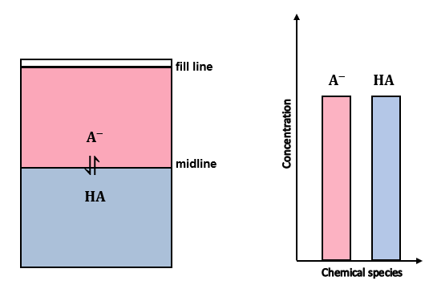
In Figure 1, the blue and pink areas represent the relative concentration of chemical species ($HA$ and $A^{-}$). Since the weak acid and its salt are in equimolar concentrations, the areas representing the acid and its conjugate base are equal. This is represented graphically by the column graph on the right, showing that the initial concentration of both chemical species in a buffer solution is equal. Note that this figure only shows the reactive chemical species (HA and A-) and not the spectator ions.

What happens if a strong acid is added to the buffer solution?
If a strong acid, such as hydrochloric acid ($HCl)$, is added to the buffer solution, the concentration of $H_{3}O^{+}$ ions increase. According to Le Chatelier's principle, the system counteracts the change by removing the added $H_{3}O^{+}$ ions. They react with the salt (conjugate base,$A^{-})$ forming unionised acid molecules $(HA)$, shifting the equilibrium towards the left (in equation 1). Consequently, the concentration of the conjugate base$(A^{-})$ decreases and $\left(HA\right)$increases without significant changes in the concentration of $H_{3}O^{+}$ ions, and the pH of the buffer solution.
Figure 2 – the equilibrium shift that occurs when a strong acid is added to the buffer solution
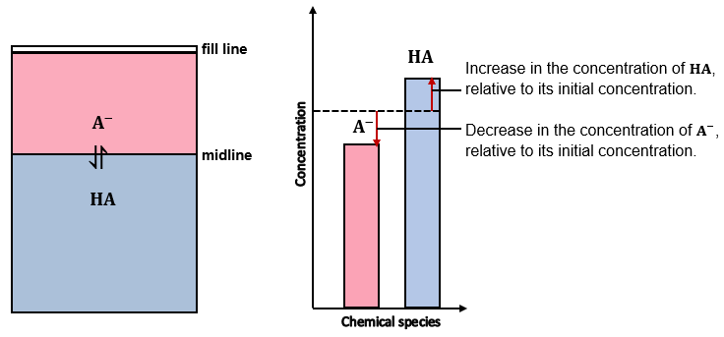
In the Figure 2, the change in blue and pink areas represents the change in the concentration of unionised acid molecules ($HA)$ and the conjugate base$(A^{-}$). It is represented graphically by the column graph on the right, where the dotted line shows the change in concentration of chemical species relative to their initial concentration
The column graph shows the decrease in the concentration of conjugate base,$A^{-}$ equals the increase in the concentration of unionised acid, $HA.$
The fill line has moved up relative to the water reservoir diagram in Figure 1, indicating a slight change in the volume of the buffer solution due to the addition of a strong acid, such as $HCl$. The concentration of $H_{3}O^{+}$ions stay almost constant, but the spectator ions, ${Cl}^{-}$, add to the volume of the solution.
Shifting the midline, relative to the water reservoir diagram in Figure 1, indicates the changes in the concentrations of $HA and A^{-}$.

What happens if a strong base is added to the buffer solution?
If a strong base, such as sodium hydroxide ($NaOH$), is added to the buffer solution, the concentration of $H_{3}O^{+}$ ions decrease due to their reaction with base (${OH}^{-}$ ions). According to Le Chatelier's principle, the system counteracts the change by replenishing the $H_{3}O^{+}$ ions. The unionised acid molecules $(HA)$ react with the water forming $H_{3}O^{+}$ ions and the conjugate base,$A^{-},$ shifting the equilibrium towards the right (in equation 1). Consequently, the concentration of the salt (conjugate base,$A^{-})$ increases and $\left(HA\right)$decreases without significant changes in the concentration of $H_{3}O^{+}$ ions, and the pH of the buffer solution.
Figure 3 – the water reservoir analogy for buffers showing the equilibrium shift when a strong base is added to the buffer solution
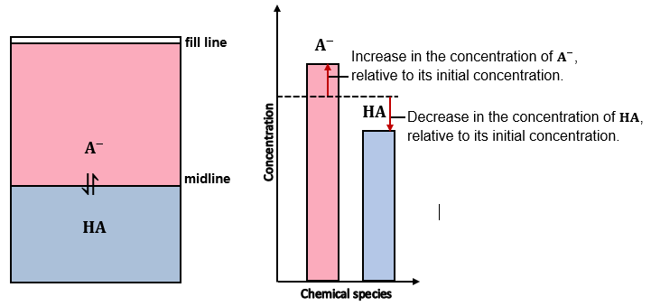
In the figure above, the column graph in the middle shows the increase in the concentration of salt (conjugate base,$A^{-})$ equals the decrease in the concentration of unionised acid, $HA.$
The fill line has moved up relative to the water reservoir diagram in Figure 1, indicating a slight change in the volume of the buffer solution due to the addition of a strong base, such as $NaOH$. The concentration of the $H_{3}O^{+}$ions stay almost constant, but the spectator ions, ${Na}^{+}$, add to the volume of the solution.
Shifting the midline, relative to the water reservoir diagram in Figure 1, indicates the changes in the concentrations of $HA and A^{-}$.
Summary: the addition of a small amount of a strong acid or a base does not change the pH of a buffer significantly, as the increase in the concentration of one chemical species (weak acid/conjugate base) is equal to the decrease in the concentration of the other (conjugate base/weak acid).
Figure 4 – the midline (analogous to equilibrium) shifts when a strong acid or base is added to the buffer solution
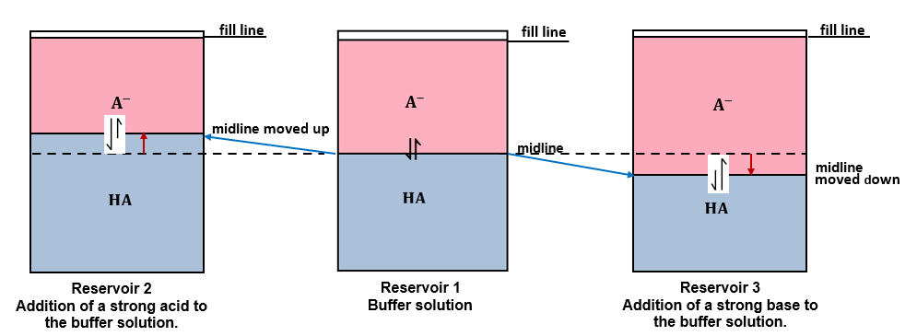
This is shown by the blue arrows. The direction of the equilibrium shift is shown by the unequal reversible arrows, indicating equilibrium shifts towards the unionised acid molecules ($HA$) in Reservoir 2 and towards the conjugate base ($A^{-}$) in Reservoir 3. Reservoir 2 shows the shift that occurs when a strong acid is added to the buffer system in Reservoir 1. The new midline results from the increase in [$HA$], which is shown by the increase in blue area in Reservoir 2 relative to Reservoir 1. The direction of change is indicated by the red arrow. Similarly, Reservoir 3 represents the shifting midline (equilibrium) that occurs when a strong base is added to the buffer system in Reservoir 1 and the increase in [$A^{-}$] is represented by the increase in pink area relative to Reservoir 1.
If a small amount of a strong acid is added to the buffer solution, it will combine with an equivalent amount of the conjugate base, converting it to the unionised weak acid molecules. Similarly, when adding a strong base, the concentration of salt (conjugate base) increases as the concentration of unionised acid molecules decreases accordingly. However, the logarithm of the overall ratio of salt concentrations (conjugate base) to weak acid (unionised acid molecules) does not change significantly.
Formative assessment
After every concept, there are checkpoints to assess learning. These should help the teacher identify common student misconceptions, check for learning retention, and assist in planning future instruction. Refer to the Appendix for teaching notes and sample answers.
Checkpoint 1
Question 1: Draw a diagram of the water reservoir analogy showing the changes in the concentration of acid and its conjugate base on adding a small amount of distilled water.
Question 2: Justify the changes you have identified in question 1.
Question 3: Three different solutions contain equal concentrations of the following ions:
- Solution A: bromide ion and hydrobromic acid.
- Solution B: fluoride ion and hydrofluoric acid.
- Solution C: carbonate ion and hydrogen carbonate ion.
Which of these solutions is not a buffer? Refer to the table of acid and base strength for $K_{a}$ values. Justify your choice.

How to determine the pH of a buffer solution
The equation for the dissociation constant ($K_{a}$) of a weak acid can be rearranged to derive an equation for determining the pH of buffers. This is the Henderson-Hasselbalch equation.
Note: the derivation of this equation is not required for the Stage 6 HSC Chemistry syllabus. However, linking the dissociation constant with the ratio of $\frac{{[A}_{\left(aq\right)}^{-}]}{{[HA}_{\left(aq\right)}]}$ helps students to understand the relationship between the strength of acid-base and the pH of the buffer formed. Refer to the Appendix for the derivation of the Henderson-Hasselbalch equation.
The pH of a buffer solution depends on the dissociation constant of the weak acid or base forming the buffer. The stronger the acid, the lower the pH of the resulting buffer.
$pH={pK}_{a }+log\frac{{[A}_{\left(aq\right)}^{-}]}{{[HA}_{\left(aq\right)}]}$ equation 3
Similarly, if the buffer consists of a weak base and its conjugate acid, the equation is:
$pOH={pK}_{b }+log\frac{{[BH}_{\left(aq\right)}^{+}]}{{[B}_{\left(aq\right)}]}$ equation 4
where $K_{b}$ is the dissociation constant of a weak base.

Buffer capacity
Buffer capacity is a measure of the buffer’s ability to resist a significant change in $pH$ (usually by one unit). It may be defined as the amount of strong acid or base that can be added to one litre of a buffer solution before its $pH$ changes significantly (usually by one unit).
The buffer capacity depends on the combined number of moles of acid-base and its conjugate base/acid. A concentrated buffer solution has more moles of acid and its conjugate base than the dilute solution. Therefore, it can take in more acid or base without a significant change in its $pH$.
For example, a buffer solution formed by mixing equal volumes (say 50 $mL$ each) of 1M acetic acid and 1M sodium acetate will have a greater buffer capacity than a buffer solution made up by mixing the same volume of 0.1M acetic acid and 0.1M sodium acetate.
Figure 5 – a sponge and water reservoir analogy for buffer capacity
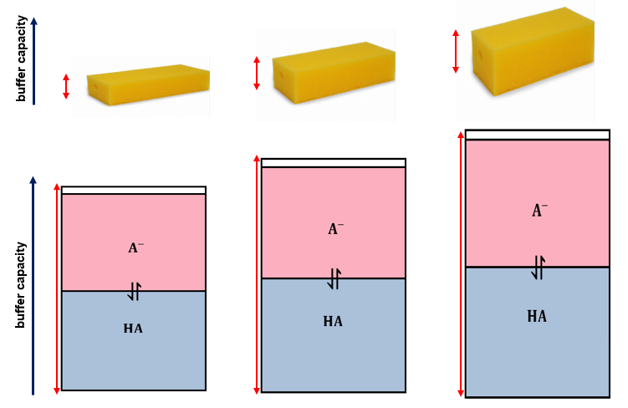
This image was created by the author using DALL–E 2 – OpenAI.
Figure 5 displays a two-headed red arrow to indicate buffer capacity. It increases with the increase in the sponge's depth or the water reservoir's size. This represents the increase in the number of moles of the weak acid or base and its conjugate base or acid (salt). The blue and pink areas in the 3 reservoirs represent the relative concentrations of the weak acid and its salt (conjugate base).
As shown in the analogy above, as the buffer capacity increases (shown by the depth of the sponge), it can ‘soak up’ more moles of strong acid and base without a significant change in$pH$.
Similarly, the water reservoir analogy could also explain the buffer capacity. The bigger the reservoir, the higher the buffer capacity, as it can take in more moles of strong acid and base without a significant change in the $pH.$ In the figure above, the pink and blue area is analogous to the concentration of chemical species ($HA and A^{-})$. The larger area indicates a greater number of moles of $HA and A^{-}$, hence the greater buffer capacity.

How does the ratio of an acid or base to its salt affect the buffer capacity?
A buffer is most effective when there are an equal number of moles of acid or base and its conjugate base or acid(salt). However, this ratio may vary.
If the concentration of $HA =A^{-},$ then substituting in equation 3.
$$log\frac{{[A}_{\left(aq\right)}^{-}]}{{[HA}_{\left(aq\right)}]}=0$$
$$pH={pK}_{a }$$
- If the buffer solution has more moles of conjugate base (salt) than the weak acid, it has the capacity to take in more moles of a strong acid than a base without undergoing significant changes in the $pH.$
If the ratio of $\frac{{[A}_{\left(aq\right)}^{-}]}{{[HA}_{\left(aq\right)}]}$ =10; then substituting in equation 3
$$log\frac{{[A}_{\left(aq\right)}^{-}]}{{[HA}_{\left(aq\right)}]}=1,$$
$$pH={pK}_{a }+1$$
- Similarly, if the buffer solution has more moles of weak acid than the conjugate base (salt), it has the capacity to take in more moles of a strong base than acid without significant changes in the $pH.$
If the ratio of $\frac{{[A}_{\left(aq\right)}^{-}]}{{[HA}_{\left(aq\right)}]}$ =1/10; then substituting in equation 3
$$log\frac{{[A}_{\left(aq\right)}^{-}]}{{[HA}_{\left(aq\right)}]}=-1,$$
$$pH={pK}_{a }-1$$
Checkpoint 2
Question 4:
Which of the following equimolar solutions would be the best choice for preparing a buffer with a pH = 9.2? Show all working.
- P: a solution of acetic acid and sodium acetate, $K_{a}=1.8 x 10^{-5}$
- Q: a solution of hypochlorous acid and sodium hypochlorite, $K_{a}=3.5 x 10^{-8}$
- R: a solution of boric acid and sodium borate, $K_{a}=5.8 x 10^{-10}$
How can you increase the pH of your chosen buffer? Will it have any impact on its buffer capacity? Explain why or why not?
Question 5: Consider a solution formed by mixing 500 mL of 1M ammonia solution and 300 mL of 1M ammonium chloride solution. Calculate the number of moles of ammonium ions present after adding 40 mL of 0.800M NaOH to this solution. $K_{a}=5.8 x 10^{-10}$

Activity 2 – preparing and testing a buffer solution
This activity can be carried out either as a first-hand investigation using a solution of 0.1M acetic acid and 0.1M sodium acetate or as interactive activities using a virtual lab.
Differentiation: teachers can either provide the procedure for the investigation or challenge the students to develop their own procedure for preparing and testing the buffer using the chemicals provided by the teacher. The acetic acid/sodium acetate buffer is one example of a buffer solution. Other solutions, such as 0.1M ammonia and 0.1M ammonium chloride or 0.1M sodium dihydrogen phosphate and 0.1M sodium dihydrogen phosphate, can also be used to conduct this investigation.
Planning: the following solutions are required for conducting this activity:
- 0.1M sodium acetate (sodium ethanoate)
- 0.1M acetic acid (ethanoic acid)
- 1M HCl
- 1MNaOH
- A pH meter
- 6 x 50 ml beakers
- 2 x 50 ml measuring cylinder
- Pasteur pipettes
- A wash bottle containing distilled water.
The Universal Indicator can be used if a pH probe is unavailable. However, it only provides qualitative data, like colour change, with the addition of a strong acid or base and does not show small changes in pH that are measurable with the pH probe.
Before planning this activity, the teacher must conduct a risk assessment, and all the safety measures must be implemented for safely conducting this investigation in class.
- Collect 4 clean and dry 50 mL glass beakers.
- Label them A, B, C and D.
- Measure 20 mL of 0.1 M sodium acetate solution using a clean measuring cylinder and add it to beaker A. Repeat step 3 for other beakers.
- Measure 20 ml of 0.1 M acetic acid solution using a measuring cylinder and add it to beaker A. Stir gently using a stirring rod to mix the 2 solutions. Repeat step 4 for other beakers. Beaker D is the control.
- Clean the $pH$ meter with distilled water and dry it using a paper towel. Then, calibrate it using standard buffer solutions with $pH$ 4 and 7. Finally, rinse the pH meter probe with distilled water and dry it using a paper towel before recording the pH in each beaker to avoid contamination of solutions.
- Add 20 drops of $1M HCl$ solution drop by drop to beaker A using a clean Pasteur pipette. Swirl gently to mix. Record the $pH$ after each addition of 2 drops using the pH meter.
- Repeat step 6 for beaker B adding $1M NaOH$ instead of the $HCl,$ and for beaker C adding distilled water instead of the $HCl$.
- Collect 2 clean and dry beakers and label them E and F.
- Add 100 ml of distilled water to each beaker and repeat steps 8 and 9, adding $1M HCl$ to beaker E and $1M NaOH$ to beaker F.
- Record your results in a table.

Table 2 – number of drops of acid/base/distilled water versus $pH$
Number of drops | Beaker A pH  $$(0.1MHCl)$$ | Beaker B  pH  $$(0.1M NaOH)$$ | Beaker C  pH  (distilled water) | Beaker D  pH  (control) | Beaker E  pH  $$(1M HCl)$$ | Beaker F  pH  $$(1M NaOH)$$
0
2
4
6
8
10
12
14
16
18
20

Teaching notes:
- Rinse the pH meter probe with distilled water and dry it using a paper towel before recording pH in each beaker to avoid contamination of solutions.
- If students conduct this investigation using the virtual lab, a pH probe is not required as the pH data is automatically generated. Once the buffer solution is prepared, it can be duplicated by clicking on the picture, unlike first-hand investigations, where multiple sets of buffer solutions are prepared for repeated trials. Use a dilution method to prepare a 0.1M acetic acid and sodium acetate solution, as the available solutions are 1M. Dilutions can be performed by adding 10 mL of each solution (using a 10mL pipette) to a 100 mL volumetric flask and adding distilled water to the graduated mark.
The teacher can modify this procedure by:
- changing the concentration or volume of the buffer solution
- adding 10 drops of strong acid-base and distilled water instead of 20 drops.
- using universal indicator instead of pH meter. It will not yield any quantitative data; however, it is ideal for visual comparison of colour changes in the buffer solution and in distilled water with the addition of a strong acid or base.
Students can discuss their conclusion in groups and then as a class to clarify any alternate conceptions.
Differentiation: refer to the teaching notes above for modifying the first-hand investigation. Teachers are recommended to use a scaffold for writing a procedure for EAL/D students. Generally, students in stage 6 have developed skills in writing a procedure for an investigation. However, a reminder to include the following in structuring a method is helpful for all students.
- Divide the method into logical steps, starting each step with an action verb.
- Use clear and simple language.
- Include a control in the experiment.
Extension: students prepare their own buffer solutions by varying the amount of acid: salt ratios. For example, instead of using a 1:1 ratio of acetic acid and sodium acetate, they can use 1:3 and 2:3 ratios to observe and analyse how the ratio of acid: salt affects the pH of the buffer and its buffering capacity (tendency to resist change in pH). This investigation could also include discussions on the reliability and accuracy of first-hand investigations. For example, students can repeat activity 2 using the universal indicator instead of a $pH$ meter and compare the accuracy of data obtained in each investigation.

Activity 3 – investigating the buffer capacity
Teaching notes: in this activity, students will apply their conceptual understanding to predict a prepared buffer solution's pH changes upon adding a strong acid and a base and test them using a virtual lab.
PEOE (Predict-Explain-Observe-Explain) is a modified version of the POE strategy, effectively probing students’ understanding and exploring their alternate conceptions/misconceptions. In this strategy, students are required to predict their investigation's outcome and explain using their prior or acquired knowledge, then to make observations, and finally to explain their observations. Explaining is especially important when the observations contradict the students’ predictions. This may assist teachers in reflecting on the teaching strategies and determining if their students can transfer their knowledge to unfamiliar situations. It would also prompt classroom discussions and provide opportunities for constructive feedback.
Use the virtual lab to prepare a buffer solution using 1M sodium acetate and 1M acetic acid in the ratio of 3:1. For example, mix 60 mL of 1M sodium acetate with 20 mL of 1M acetic acid to prepare 80 mL of the buffer solution. Use the following scaffold to check your conceptual understanding.
Table 3 – Predict-Explain-Observe-Explain (PEOE) framework
Element | Predict-Explain-Observe-Explain (PEOE) framework
Predict | Predict the following:  - the pH of the buffer solution  - effect of adding $1M HCl$, $1M NaOH$, distilled water, $10M HCl$ and 1$0M NaOH$, drop by drop, on the $pH$ of buffer solution.
Explain | Write the reasons why you think it will happen this way.
Observe | Describe what you did see.
Explain | Add to or change your ideas about why it happened.

Activity 4: Buffers and titration curves
Figure 6 – the titration curve for the neutralisation reaction of acetic acid (ethanoic acid) with sodium hydroxide. The green rectangle shows the buffering region. The $pK_{a}$ for acetic acid corresponds to the midpoint of the titration
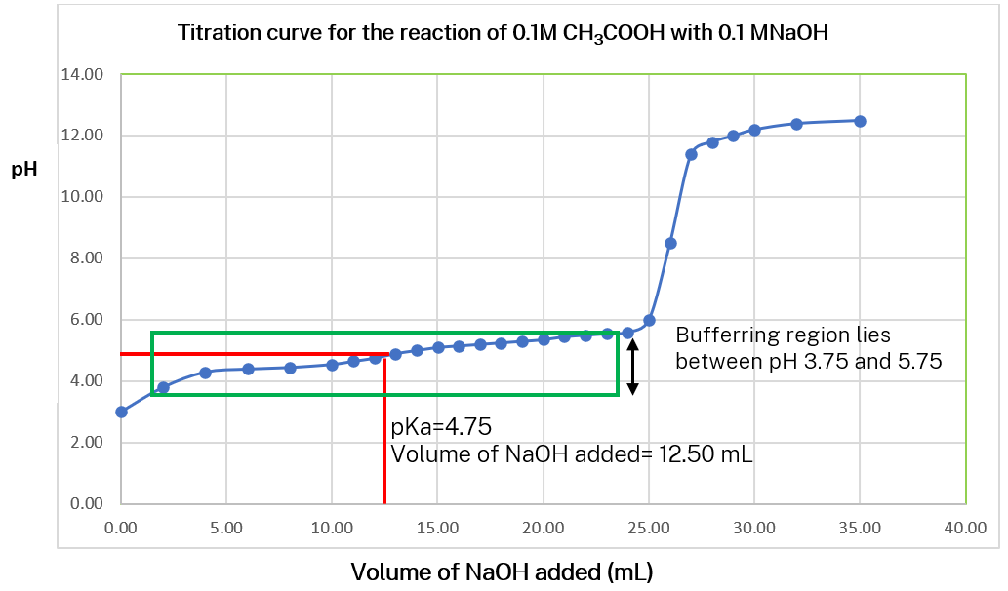
When a strong acid or base is titrated with a weak base or acid, a buffer solution is formed due to the resulting salt, a conjugate base/acid of a weak acid/base. For example, as shown in Figure 6 above, in the titration of 25 mL of 0.1M acetic acid with 0.1M sodium hydroxide, a buffer mixture is formed between acetic acid and the salt sodium acetate. At pH=4.75, the midpoint of titration, when half the volume of acetic acid is titrated (12.50 mL), there are equal numbers of moles of acetic acid and the salt sodium acetate.
$${CH}_{3}COOH_{\left(aq\right)}+H_{2}O_{\left(l\right)}⇋{CH}_{3}COO{Na}_{\left(aq\right)}+ H_{3}O_{\left(aq\right)}^{+}$$
The buffering region is the portion of the titration curve between pH 3.75 to 4.75. As seen in the titration curve, there is a small change in $pH$during this region. This correlates with the buffer capacity, which lies within ±1$pH$ units of the ${pK}_{a}$.

The importance of buffers in natural systems
Watch the video pH and Buffers (5:56) to introduce the importance of buffers in natural systems.
The human body must maintain its pH between 7.37 and 7.42 for normal cellular reactions. Carbonic acid/hydrogen carbonate and dihydrogen phosphate/hydrogen phosphate are some examples of buffers that maintain the pH in natural systems.
$$H_{2}C{O_{3}}_{\left(aq\right)}+H_{2}O_{\left(l\right)}⇆HCO_{3\left(aq\right)}^{-}+ H_{3}O_{\left(aq\right)}^{+}$$
An important buffer in the human body is the weak acid, carbonic acid, and its conjugate base, bicarbonate ion. Carbonic acid forms when carbon dioxide gas (formed by cellular respiration) combines with water with the help of the enzyme carbonic anhydrase.
When the hydronium ion concentration decreases, it donates its hydrogen ion to water and the equilibrium shifts to the right, producing more $HCO_{3}^{-}$and $H_{3}O^{+}$ions. On the other hand, when there are excess hydronium ions, the hydrogen carbonate ions react with hydronium ions to form carbonic acid, shifting the equilibrium towards the left. Carbonic acid can dissociate to form water and carbon dioxide, which can be breathed out through the lungs. If there are excess hydrogen carbonate ions, they are eliminated by the kidneys.
Figure 7 – a table and a line graph for pH versus hydrogen ion concentration. The $pH$ between two red lines on the graph shows the optimal $pH$ range for the normal cellular functions in a human body
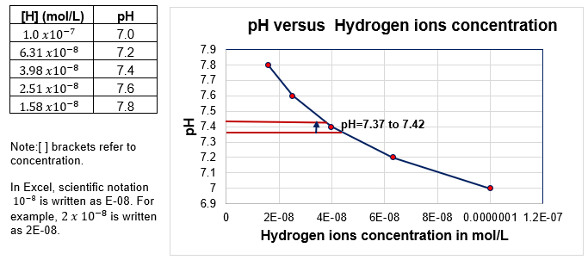
The figure above shows:
- as the hydrogen ion concentration increases, the pH decreases because of the negative sign in front of the log ($pH=-\log\left[H_{3}O_{\left(aq\right)}^{+}\right]$.
- Since it is a logarithmic function, pH and hydrogen ion concentration do not have a linear relationship. Therefore, as seen in Figure 7, the graph is a curve rather than a straight line.
Checkpoint 3: answer the following question.
Question 6: Research an example of a buffer (other than that covered in class) essential for the normal functioning of natural systems, such as the human body or maintaining the pH of water bodies, such as rivers.
Teacher notes: complex multistep problems require more than one operation and linking multiple concepts. Deconstructing the question and providing a scaffold for steps allows students to develop problem-solving skills and understand the logical sequence to tackle such questions. In addition, students must apply their conceptual understanding to calculation problems rather than the ‘plug and chug method’, which may result in missing a step-in calculation or making errors.
Step 1: What do you already know?
Write down/highlight the data provided in the question.
Step 2: What do you need to calculate?
Write down/highlight the item(s) you need to calculate.
Step 3: How will you solve the problem?
Write down the relevant formulae (rearrange the formula(s) if required)
Work out a logical sequence of steps to solve the problem, from simple to complex.
Step 4: Check if the calculated answer is reasonable (if possible). For example, if the calculated pH = 50, it shows errors in one or more calculation steps.
Step 5: Use the correct units (where relevant) and significant figures.

Checkpoint 4: answer the following question.
Question 7: Sodium hypochlorite$\left(NaOCl\right)$ is the active ingredient in pool chlorine. It completely dissolves in water to produce the hypochlorite ion ($O{Cl}^{-}$), which undergoes hydrolysis according to the following equilibrium:
$${OCl}_{\left(aq\right)}^{-}+H_{2}O_{\left(l\right)}⇆ {HOCl}_{\left(aq\right)}+ OH_{\left(aq\right)}^{-}$$
The equilibrium constant for this reaction at $25°C$ is $3.33 x {10}^{-7}$. Another buffer is used to maintain the pool $pH$ at $7.5$ and hypochlorous acid ($HOCl$) concentration at $1.33 x {10}^{-4} molL^{-1}$. Calculate the volume of 2.0 $molL^{-1}$ sodium hypochlorite solution$\left(NaOCl\right)$ that needs to be added to a $1.00 × 10^{4} L$ pool to meet these required conditions.
CER scaffold is helpful for students with structuring scientific arguments and explanations. Watch CER - Claim Evidence Reasoning (7:24).
Claim: answer the question (usually a statement).
Evidence: that supports your claim (it may include observations/data from an experiment, data from a graph or flow chart, information from the stimulus material, facts, or any other relevant information).
Reasoning: logic that links evidence to the claim (it may include an explanation using scientific principle or chemical concept).
Teachers may use the CER scaffold to develop skills in structuring responses.
Checkpoint 5: answer the following question:
Question 8: A student added concentrated hydrochloric acid into 3 unknown liquids, X, Y and Z. Solutions X and Y contained the same type of ions. The pH of each was monitored over time and recorded in the graph shown. The student concluded that solutions X and Y are buffers and Z is distilled water.
Figure 8 – pH versus time graph for solutions X, Y and Z
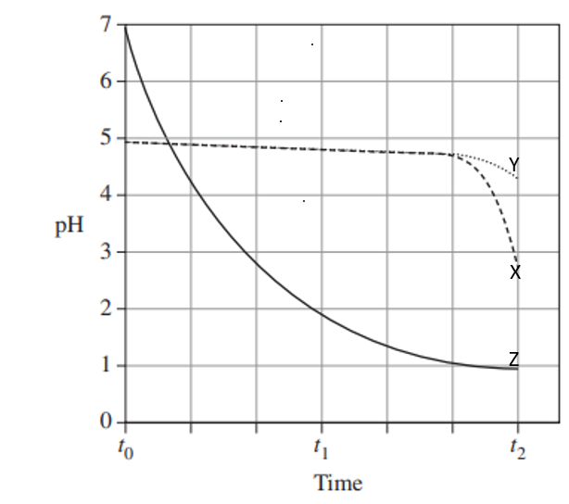
Source: HSC Chemistry Examination 2021
Do you agree with the student’s conclusion? Explain with reason(s) why or why not?
Why do solutions X and Y solutions have a different pH at $t_{2}$?

Student resources

Glossary table
Word | Meaning
Buffer | A solution that can maintain a relatively stable pH even when small amounts of acids or bases are added to it. The buffer solution consists of a weak acid or base and its salt, generally in equimolar concentration.
Buffer capacity | The amount of acid or base that can be added to one litre of a buffer solution before its pH changes significantly (usually by one unit).
Conjugate acid-base pairs | An acid and a base pair that differs only by a proton. For example, HCl and ${Cl}^{-}$are conjugate acid-base pairs, where HCl is the acid and ${Cl}^{-}$is its conjugate base.
Dissociation | A chemical process in which a chemical compound breaks up into smaller components such as ions, atoms, or radicals.
Ionisation (of acid/base) | The process in which a molecular compound (acid/base) reacts with water to form an aqueous solution of its ions. For example, HCl undergoes an ionisation reaction with water to form $H_{3}O^{+}$ (hydronium) and ${Cl}^{-}$ ions in solution.
pH | The quantitative measure of acidity/basicity of a substance based on the hydronium ion concentration. pH= -log ${[H}_{3}O^{+}]$
Strong acid/base | An acid/base that completely ionises in its aqueous solution. Its solution has only ions, and no molecular species remain. These solutions have a very low pH (for acids) or very high pH (for bases).
Weak acid/base | A weak acid/base partially ionises in its aqueous solution. Its solution is an equilibrium mixture of its molecular species and ions. These solutions have a moderate pH within a few units of neutral (pH 7).

Activity 1 – What are buffers?
A Buffer is a solution of weak acid and its salt (conjugate base) or weak base and its salt (conjugate acid), which resist changes in pH when small quantities of a strong acid or base are added. The 2 components, acid or base, and their salt is nearly equimolar. It means the buffer solution has nearly the same number of moles of acid or base and its salt.
The buffer solution can be represented by the equations below:
${HA}_{\left(aq\right)}+H_{2}O_{\left(l\right)}⇋H_{3}O_{\left(aq\right)}^{+}+A_{\left(aq\right)}^{-}$ equation 1
${B_{\left(aq\right)}+H}_{2}O_{\left(l\right)}⇋{OH}_{\left(aq\right)}^{-}{+ BH}_{\left(aq\right)}^{+}$ equation 2
In equation 1 above, ${HA}_{\left(aq\right)}$is a weak acid (unionised molecules) and $A_{\left(aq\right)}^{-}$ is its conjugate base. Similarly, in equation 2 above,$B_{\left(aq\right)}$ is a weak base and ${BH}_{\left(aq\right)}^{+}$ is its conjugate acid. These 2 chemical species are in equilibrium and generally present in equimolar quantities for buffers to work effectively.
An example of a buffer is a solution of acetic acid (weak acid) and sodium acetate (its salt, which provides the conjugate base, acetate ions). Similarly, a solution of ammonia (a weak base) and ammonium chloride (its salt, which provides the conjugate acid, ammonium ions) is also a buffer.

A water reservoir analogy for explaining buffers
Imagine a glass water reservoir filled with water up to the fill line. It has a limited capacity equal to the water tank's volume. If excessive water is added, it will overflow. Similarly, a buffer has a limited capacity and cannot resist the pH change indefinitely. The water reservoir analogy in Figure 1 represents this property of buffers, where the fill line represents the total volume occupied by the buffer solution. The space above the fill line represents the maximum capacity of the buffer. The midline is analogous to the equilibrium between acid $HA$(unionised acid molecules) and its conjugate base, $NaA$.
Figure 1 – the midline (analogous to equilibrium) shifts when a strong acid or base is added to the buffer solution shown by the blue arrows
In Figure 1, the direction of the equilibrium shift is shown by the unequal reversible arrows, indicating equilibrium shifts towards the unionised acid molecules (HA) in Reservoir 2 and towards the conjugate base (A^-) in Reservoir 3. Reservoir 2 shows the shift that occurs when a strong acid is added to the buffer system in Reservoir 1. The new midline results from the increase in [HA], which is shown by the increase in blue area in Reservoir 2 relative to Reservoir 1. The direction of change is indicated by the red arrow. Similarly, Reservoir 3 represents the shifting midline (equilibrium) that occurs when a strong base is added to the buffer system in Reservoir 1 and the increase in [A^-] is represented by the increase in pink area relative to Reservoir 1.
If a small amount of a strong acid is added to the buffer solution, it will combine with an equivalent amount of the conjugate base, converting it to the unionised weak acid molecules. Similarly, when adding a strong base, the concentration of salt (conjugate base) increases as the concentration of unionised acid molecules decreases accordingly. However, the logarithm of the overall ratio of salt concentrations (conjugate base) to weak acid (unionised acid molecules) does not change significantly.
Checkpoint 1: Answer the following questions.
Question 1: Draw a diagram of the water reservoir analogy showing the changes in the concentration of acid and its conjugate base on adding a small amount of distilled water.
Question 2: Justify the changes you have identified in question 1.
Question 3: Three different solutions contain equal concentrations of the following ions:
- Solution A: bromide ion and hydrobromic acid.
- Solution B: fluoride ion and hydrofluoric acid.
- Solution C: carbonate ion and hydrogen carbonate ion.
Which of these solutions is not a buffer? Refer to the table of acid and base strength for $K_{a}$ values. Justify your choice.

How to determine the pH of a buffer solution
The pH of a buffer solution depends on the dissociation constant of the weak acid or base forming the buffer – the stronger the acid, the lower the pH of the resulting buffer.
$pH={pK}_{a }+log\frac{{[A}_{\left(aq\right)}^{-}]}{{[HA}_{\left(aq\right)}]}$ equation 3
$K_{a}$ is the dissociation constant of a weak acid.
Similarly, if the buffer consists of a weak base and its conjugate acid, the equation is:
$pOH={pK}_{b }+log\frac{{[BH}_{\left(aq\right)}^{+}]}{{[B}_{\left(aq\right)}]}$ equation 4
where $K_{b}$ is the dissociation constant of a weak base.
Note: equimolar means solutions that contain the same number of moles.

Buffer capacity
Buffer capacity is a measure of the buffer’s ability to resist a significant change in $pH$ (usually by one unit). It may be defined as the amount of strong acid or base that can be added to one litre of a buffer solution before its $pH$ changes significantly (usually by one unit).
The buffer capacity depends on the combined number of moles of acid-base and its conjugate base/acid. A concentrated buffer solution has more moles of acid and its conjugate base than the dilute solution. Therefore, it can take in more acid or base without a significant change in its $pH$(usually by one unit).
For example, a buffer solution formed by mixing equal volumes (say 50$mL$ each) of 1M acetic acid and 1M sodium acetate will have a greater buffer capacity than a buffer solution made up by mixing the same volumes of 0.1M acetic acid and 0.1M sodium acetate.
Figure 2 – a sponge and water reservoir analogy for buffer capacity
Image was created by the author using DALL·E 2 - Open AI
In Figure 2, a two-headed red arrow in the picture indicates buffer capacity. It increases with the increase in the sponge's depth or the water reservoir's size. This represents the increase in the number of moles of the weak acid or base and its conjugate base or acid (salt). The blue and pink areas in the 3 reservoirs represent the relative concentrations of the weak acid and its salt (conjugate base).
As shown in the analogy above, as the buffer capacity increases (shown by the depth of the sponge), it can ‘soak up’ more moles of strong acid and base without a significant change in$pH$.
Similarly, the water reservoir analogy could also explain the buffer capacity. The bigger the reservoir, the higher the buffer capacity, as it can take in more moles of strong acid and base without a significant change in the $pH.$ In the figure above, the pink and blue area is analogous to the concentration of chemical species ($HA and A^{-})$. The larger area indicates a greater number of moles of $HA and A^{-}$, hence the greater buffer capacity.
Checkpoint 2: answer the following questions:
Question 4: Which of the following equimolar solutions would be the best choice for preparing a buffer with a pH = 9.2? Show all working.
- P: a solution of acetic acid and sodium acetate, $K_{a}=1.8 x 10^{-5}$
- Q: a solution of hypochlorous acid and sodium hypochlorite, $K_{a}=3.5 x 10^{-8}$
- R: a solution of boric acid and sodium borate, $K_{a}=5.8 x 10^{-10}$
How can you increase the pH of your chosen buffer? Will it have any impact on its buffer capacity? Explain why or why not?
Question 5: Consider a solution formed by mixing 500 mL of 1M ammonia solution and 300 mL of 1M ammonium chloride solution. Calculate the number of moles of ammonium ions present after adding 40 mL of 0.800M NaOH to this solution. $K_{a}=5.8 x 10^{-10}$

Activity 2 – preparing and testing a buffer solution
Aim: to prepare a buffer solution and investigate the effect of adding a strong acid, base, and distilled water on its $pH.$
Equipment:
- 0.1M sodium acetate (sodium ethanoate)
- 0.1M acetic acid (ethanoic acid)
- 1M HCl
- 1MNaOH
- A pH meter
- 6 x 50 mL beakers
- 2 x 50 mL measuring cylinder
- Pasteur pipettes
- A wash bottle containing distilled water.
Procedure
- Collect 4 clean and dry 50 mL glass beakers.
- Label them A, B, C and D.
- Measure 20 mL of 0.1 M sodium acetate solution using a clean measuring cylinder and add it to beaker A. Repeat step 3 for other beakers.
- Measure 20 mL of 0.1 M acetic acid solution using a measuring cylinder and add it to beaker A. Stir gently using a stirring rod to mix the 2 solutions. Repeat step 4 for other beakers. Beaker D is the control.
- Clean the $pH$ meter with distilled water and dry it using a paper towel. Then, calibrate it using standard buffer solutions with $pH$ 4 and 7. Finally, rinse the pH meter probe with distilled water and dry it using a paper towel before recording the pH in each beaker to avoid contamination of solutions.
- Add 20 drops of $1M HCl$ solution drop by drop to beaker A using a clean Pasteur pipette. Swirl gently to mix. Record the $pH$ after each addition of 2 drops using the pH meter.
- Repeat step 6 for beaker B adding $1M NaOH$ instead of the $HCl,$ and for beaker C adding distilled water instead of the $HCl$.
- Collect 2 clean and dry beakers and label them E and F.
- Add 100 mL of distilled water to each beaker and repeat steps 8 and 9, adding $1M HCl$ to beaker E and $1M NaOH$ to beaker F.
- Record your results in a table.
Table 1 – number of drops of acid/base/distilled water versus $pH$.
Number of drops | Beaker A pH  $$(0.1MHCl)$$ | Beaker B  pH  $$(0.1M NaOH)$$ | Beaker C  pH  (distilled water) | Beaker D  pH  (control) | Beaker E  pH  $$(1M HCl)$$ | Beaker F  pH  $$(1M NaOH)$$
0
2
4
6
8
10
12
14
16
18
20
Conclusion: write a conclusion based on your results.
You must include the answer to the flowing questions in your conclusion.
Which solutions did you use to prepare a buffer solution and why?
What is the effect of adding a strong acid, base, and distilled water on the pH of buffers and why?

Activity 3 – investigating the buffer capacity
Use the virtual lab to prepare a buffer solution using 1M sodium acetate and 1M acetic acid in a ratio of 3:1. For example, mix 60 mL of 1M sodium acetate with 20 mL of 1M acetic acid to prepare 80 mL of the buffer solution. Use the following scaffold to check your conceptual understanding.
Table 2: Predict-Explain-Observe-Explain (PEOE) framework.
Predict-Explain-Observe-Explain (PEOE) framework
Predict | Predict the following:  - the pH of your buffer solution  - effect of adding 1M HCl, 1M NaOH, distilled water, 10M HCl and 10M NaOH on the pH of the buffer solution
Explain | Write the reasons why you think it will happen this way. You must explain the reasons for all your predictions.
Observe | Describe what you did see. Complete this for all the activities you have conducted.
Explain | Add to or change your ideas about why it happened.
Note: you may use the same table or complete a separate PEOE table for each activity.

Activity 4 – buffers and titration curves
Analyse the titration curve given below and answer the following questions.
Figure 3 – the titration curve for the neutralisation reaction of acetic acid (ethanoic acid) with sodium hydroxide
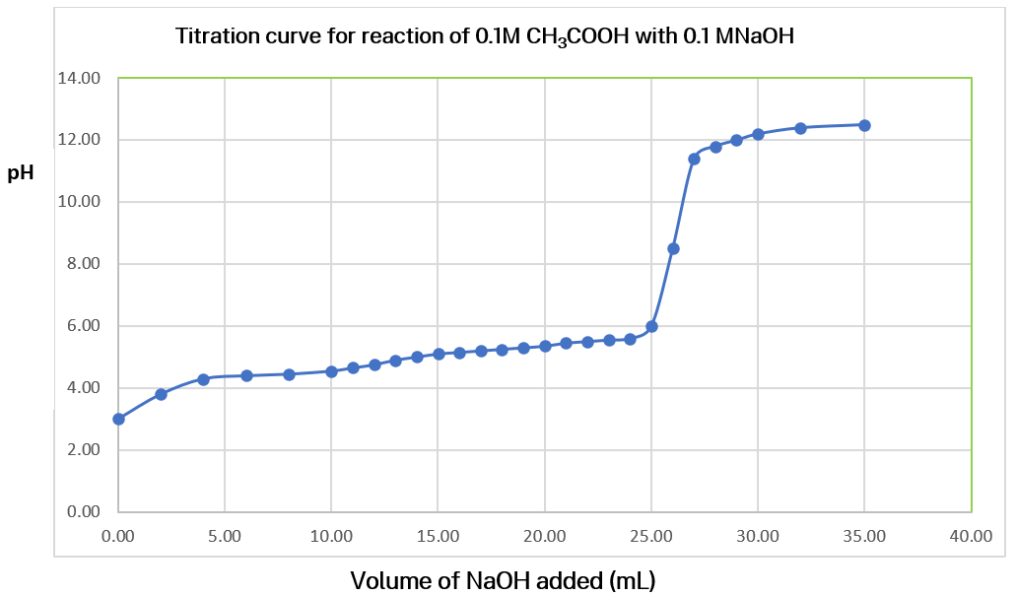
- Identify the buffer solution formed by the reaction of 0.1M ${CH}_{3}COOH$ with 0.1M $NaOH$
- Annotate the following on the titration curve above:
- Buffering region
- ${pK}_{a}$ of the buffer
Checkpoint 3: answer the following question:
Question 6: Research an example of a buffer (other than that covered in class) essential for the normal functioning of natural systems, such as the human body or maintaining the pH of water bodies such as rivers.

Checkpoint 4: answer the following question:
Question 7: Sodium hypochlorite$\left(NaOCl\right)$ is the active ingredient in pool chlorine. It completely dissolves in water to produce the hypochlorite ion ($O{Cl}^{-}$), which undergoes hydrolysis according to the following equilibrium.
$${OCl}_{\left(aq\right)}^{-}+H_{2}O_{\left(l\right)}⇆ {HOCl}_{\left(aq\right)}+ OH_{\left(aq\right)}^{-}$$
The equilibrium constant for this reaction at $25°C$ is $3.33 x {10}^{-7}$. Another buffer is used to maintain the pool pH at 7.5 and hypochlorous acid ($HOCl$) concentration at $1.33 x {10}^{-4} molL^{-1}$. Calculate the volume of 2.0 $molL^{-1}$sodium hypochlorite solution$\left(NaOCl\right)$ that needs to be added to a $1.00 × 10^{4} L$ pool to meet these required conditions.
Checkpoint 5: answer the following question:
Question 8: A student added concentrated hydrochloric acid into three unknown liquids, X, Y and Z. Solutions X and Y contained the same type of ions. The pH of each was monitored over time and recorded in the graph shown. The student concluded that solutions X and Y are buffers and Z is distilled water.
Figure 4 – pH versus time graph for solutions $X, Y$ and$Z$.
Source: HSC Chemistry Examination 2021
- Do you agree with the student’s conclusion? Explain with reason(s) why or why not?
- Why do solutions X and Y solutions have different pH values at $t_{2}$?

Appendix

How to determine the pH of a buffer solution
The equation for the dissociation constant ($K_{a}$) of a weak acid can be rearranged to derive an equation for determining the pH of buffers. This is the Henderson-Hasselbalch equation.
The equation for the ionisation of a weak acid HA is below:
$${HA}_{\left(aq\right)}+H_{2}O_{\left(l\right)}⇆H_{3}O_{\left(aq\right)}^{+}+A_{\left(aq\right)}^{-}$$
weak acid conjugate base
$$K_{a}= \frac{\left[H_{3}O_{\left(aq\right)}^{+}\right]×\left[A_{\left(aq\right)}^{-}\right]}{\left[{HA}_{\left(aq\right)}\right]}$$
Rearranging the above equation gives the following equation:
$$\left[H_{3}O_{\left(aq\right)}^{+}\right]= \frac{{K_{a}}_{\left(aq\right)}×\left[{HA}_{\left(aq\right)}\right]}{\left[A_{\left(aq\right)}^{-}\right]}$$
If we take the negative log of both sides:
$$-log\left[H_{3}O_{\left(aq\right)}^{+}\right]=-\log{K_{a}}-log\frac{{[HA}_{\left(aq\right)}]}{\left[A_{\left(aq\right)}^{-}\right]}$$
However, $-\log\left[H_{3}O_{\left(aq\right)}^{+}\right]=pH$ and ${-logK}_{a }= {pK}_{a }$
$$pH={pK}_{a }-log\frac{{[HA}_{\left(aq\right)}^{-}]}{\left[A_{\left(aq\right)}^{-}\right]}$$
By inverting $\frac{{[HA}_{\left(aq\right)}^{-}]}{\left[A_{\left(aq\right)}^{-}\right]}$ the log term becomes positive.
$pH={pK}_{a }+log\frac{{[A}_{\left(aq\right)}^{-}]}{{[HA}_{\left(aq\right)}]}$ Equation 3
Similarly, if the buffer consists of a weak base and its conjugate acid, the equation is:
$pOH={pK}_{b }+log\frac{{[BH}_{\left(aq\right)}^{+}]}{{[B}_{\left(aq\right)}]}$ Equation 4
where $K_{b}$ is the dissociation constant of a weak base.
Note: equimolar means solutions that contain the same number of moles.

Scaffold for writing a procedure
- Write in the past tense if the experiments have already been conducted. Write in the present tense if these are instructions. For example, collect 4 clean and dry 50mL glass beakers.
- Write a list of steps in a logical sequence, preferably each sentence starting with an actionable verb. Step 1: Collect 4 clean and dry 50 mL glass beakers. Step 2: Label them A, B, C and D.
- State what quantities are to be measured exactly and how to make the measurement(s). For example, measure 20 mL of 0.1M sodium acetate solution using a clean measuring cylinder and add it to beaker A.
- Identify the control setup (the same setup minus the tested variable). For example, beaker D is the control (only buffer solution).
- Specify what data is to be recorded, how it is measured and where it is recorded. For example, use a calibrated pH meter to record the pH reading in a table.
- Must include trials and repetition (as relevant). For example, repeat step 3 for all the beakers except the control (beaker D).
- Include instructions on how to calculate the average (where relevant).

Sample responses
Checkpoint 1
Question 1
Draw a diagram of the water reservoir analogy showing the changes in the concentration of acid and its conjugate base when a small amount of distilled water is added.
Sample response
The following figure shows the water reservoir analogy to illustrate the effect of adding distilled water to a buffer consisting of a weak acid (HA) and its conjugate base (A⁻.)
Figure 7 – the water reservoir analogy for buffers, showing the equilibrium between acid and its conjugate base when distilled water is added to the buffer solution. Both species $(HA and A-)$ have the same concentration
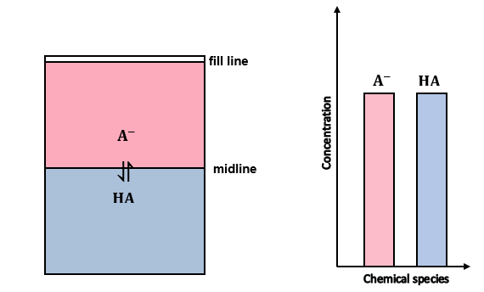
Question 2
Justify the changes you have identified in question 1.
Sample response
Water is partially ionised and has equal concentrations of hydronium and hydroxide ions.
$H_{2}O_{\left(l\right)}+H_{2}O_{\left(l\right)}⇋H_{3}O_{\left(aq\right)}^{+}+{OH}_{\left(aq\right)}^{-}$ $K_{a}=1 x 10^{-14}$
When a small amount of distilled water is added, the concentration of weak acid/base and its conjugate base/acid does not change significantly, so the pH stays the same.
Question 3
Three different solutions contain equal concentrations of the following ions:
- Solution A: bromide ion and hydrobromic acid.
- Solution B: fluoride ion and hydrofluoric acid.
- Solution C: carbonate ion and hydrogen carbonate ion.
Which of these solutions is not a buffer? Refer to the table of acid and base strength for K_{a} values. Justify your choice.
Sample response
Solution A is NOT a buffer.
Both solutions B and C consist of weak acids, HF with $K_{a}=6.6 x {10}^{-4}$ and hydrogen carbonate ion with $K_{a}=4.7 x {10}^{-11}$
Solution B: ${HF}_{\left(aq\right)}+H_{2}O_{\left(l\right)}⇋ F_{\left(aq\right)}^{-}+ H_{3}O_{\left(aq\right)}^{+}$
Solution C: ${H{CO}_{3}^{-}}_{\left(aq\right)}+H_{2}O_{\left(l\right)}⇋ {CO}_{3\left(aq\right)}^{2-}+ H_{3}O_{\left(aq\right)}^{+}$
They form an equilibrium mixture with their conjugate bases, whereas solution A consists of strong acid, HBr, with $K_{a}=1.0 x {10}^{9}$. Its conjugate base ${Br}^{-}$ is extremely weak and unlike $F^{-}$ and ${CO}_{3}^{2-}$ ions, it does not react with hydronium ions to form ionised acid HBr. Consequently, it does not form an equilibrium mixture and hence cannot resist the change in $pH$. The addition of strong acid will result in a significant drop in pH, and the addition of base will significantly increase pH as the available hydrogen ions are neutralised.
Checkpoint 2
Answer the following question.
Question 4
- Which of the following solutions would be the best choice for preparing a buffer with a pH = 9.2? Show all working.
- P: a solution of acetic acid and sodium acetate, $K_{a}=1.8 x 10^{-5}$
- Q: a solution of hypochlorous acid and sodium hypochlorite, $K_{a}=3.5 x 10^{-8}$
- R: a solution of boric acid and sodium borate, $K_{a}=5.8 x 10^{-10}$
- How can you increase the pH of your chosen buffer? Will it have any impact on its buffer capacity? Explain why or why not?
Sample response
- Solution R with equimolar concentration of boric acid and sodium borate. Out of the 3 buffer solutions, solution R has the weakest acid, as it has the lowest $K_{a}$. Therefore, according to the Bronsted-Lowry theory, its conjugate base will be the strongest of the three, and hence it will have the highest $pH.$ You can calculate the pH by calculating ${pK}_{a }$for each acid and substituting the values in Equation 1.
$$pH={pK}_{a }+log\frac{{[A}_{\left(aq\right)}^{-}]}{{[HA}_{\left(aq\right)}]}$$
If the weak acid and its conjugate base have equimolar concentration, then $log\frac{{[A}_{\left(aq\right)}^{-}]}{{[HA}_{\left(aq\right)}]}=0$.
That means, $pH={pK}_{a }$
For solutions
P, ${pK}_{a }= -\log{ (1.8 x 10^{-5}}$) = 4.75
Q, ${pK}_{a }= -\log{ (3.5 x 10^{-8}})$ = 7.46
R, ${pK}_{a }= -\log{ 5.8 x 10^{-10}})$ = 9.24
- The pH can be increased by increasing the number of moles of conjugate base sodium borate. The buffer capacity depends on the number of moles of the weak acid and its conjugate base. If the number of moles of the base is greater than the acid, the resulting buffer will take in more moles of strong acid than the base before it runs out of its buffer capacity.
Question 5
Consider a solution formed by mixing 500 mL of 1M ammonia solution and 300 mL of 1M ammonium chloride solution.
- Calculate the number of moles of ammonium ions present after adding 40 mL of 0.800M NaOH to this solution. $K_{a}=5.8 x 10^{-10}$.
- Will the pH of the buffer solution increase after the addition of NaOH? Justify your choice.
Sample response
- Step 1: write a balanced chemical equation for the reaction between NaOH and ammonium ion(acid).
$${NH_{4}^{+}}_{\left(aq\right)}+{OH^{-}}_{\left(aq\right)}⇋ {NH}_{3\left(aq\right)}+ H_{2}O_{\left(l\right)}$$
Step 2: use the ICE table to calculate the number of moles of ions.
ICE | $$NH_{4}^{+}$$ | $$OH^{-}$$ | $${NH}_{3}$$
Initial (moles) | $$\left(0.3 x 1\right)=0.3$$ | $$0.04x0.8=0.032$$ | $$0.5 x 1=0.5$$
Change (moles) | $$-\left(0.04x0.8\right)=0.032$$ | $$-0.032$$ | $$+0.032$$
Equilibrium (moles) | $$0.268$$ | $$0$$ | $$0.532$$
The number of moles of ammonium ions =$0.268.$
- As a strong base (NaOH) is added, acid ($NH_{4}^{+}$) will neutralise it, hence the concentration of $H_{3}O^{+}$ will decrease, increasing the $pH$. Since this is a buffer solution, it will resist the change in pH so the change will be very small. The buffer solution will try to resist large changes in pH until it runs out of its buffer capacity.
Teachers note: some students might use the following equation:
$${{NH}_{3\left(aq\right)} + H_{2}O_{\left(l\right)} ⇋NH_{4}^{+}}_{\left(aq\right)}+ H_{3}O_{\left(aq\right)}^{+}$$
The incorrect interpretation could be as $H_{3}O_{\left(aq\right)}^{+}$ ions are neutralised by the addition of $NaOH$, according to LCP (Le Chatelier’s principle), the system will counteract the change by shifting towards the right-hand side, producing more $H_{3}O^{+},$so the pH will not change.
Actually, the pH will increase slightly, but not significantly.
Using the logic that there will be an increase in the concentration of $H_{3}O^{+}$ and $NH_{4}^{+}$, students may make errors in calculations by adding rather than subtracting the change in moles of ${NH}_{4}^{+}$.
Incorrect calculation of the number of moles of ammonium ions = $0.3 +0.032=0.332$.
Question 7
Sodium hypochlorite$\left(NaOCl\right)$ is the active ingredient in pool chlorine. It completely dissolves in water to produce the hypochlorite ion ($O{Cl}^{-}$), which undergoes hydrolysis according to the following equilibrium.
$${OCl}_{\left(aq\right)}^{-}+H_{2}O_{\left(l\right)}⇋ {HOCl}_{\left(aq\right)}+ OH_{\left(aq\right)}^{-}$$
The equilibrium constant for this reaction at $25°C$ is $3.33 x {10}^{-7}$. Another buffer is used to maintain the pool pH at 7.5 and hypochlorous acid ($HOCl$) concentration at $1.33 x {10}^{-4} molL^{-1}$.
Calculate the volume of $2.0 molL^{-1}$sodium hypochlorite solution$\left(NaOCl\right)$ that needs to be added to a $1.00 × 10^{4} L$ pool to meet these required conditions.
Sample response
Step 1: What do you already know?
$$K=3.33 x {10}^{-7}$$
$$\left[HOCl\right]=1.33 x {10}^{-4} molL^{-1}$$
$$pH=7.5$$
Volume of the pool = $1.00 × 10^{4} L$
$$\left[NaOCl\right]=2.0 molL^{-1}$$
Step 2: What do you need to calculate?
$$Volume of NaOCl=?$$
Step 3: How will you solve the problem?
The sequence of logical steps:
- Calculate the concentration of $\left.{OH}^{-}\right.$ ions at pH 7.5.
Calculate the $pOH$ using$pH$.
$$pOH= 14 - pH$$
$$14-7.5 = 6.5$$
Calculate ${[OH}^{-}]$ from $pOH.$
$${[OH}^{-}]=10^{-6.5}$$
$${[OH}^{-}]=3.16 x {10}^{-7}molL^{-1}$$
- Calculate the required concentration of ${OCl}^{-}$ ions by rearranging the equation for the equilibrium constant and substituting the values.
$$K= \frac{\left[HOCl\right]×\left[{OH}^{-}\right]}{\left[{OCl}^{-}\right]}$$
$$\left[{OCl}^{-}\right]= \frac{\left[HOCl\right]×\left[{OH}^{-}\right]}{K}$$
$$\left[{OCl}^{-}\right]= \frac{1.33 x {10}^{-4} x 3.16 x {10}^{-7}}{3.33 x {10}^{-7}}$$
$$\left[{OCl}^{-}\right]= 1.26 x {10}^{-4}molL^{-1}$$
- The $\left[{OCl}^{-}\right]$ calculated above is the required equilibrium${[OCl}^{-}]$ achieved after the addition of $NaOCl$, which dissociates as shown by the equation:
$${NaOCl}_{\left(aq\right)}→ {Na}_{\left(aq\right)}^{+}+ O{Cl}_{\left(aq\right) }^{-}$$
Use the ICE table below to calculate the initial ${[OCl}^{-}]$ before the addition of $NaOCl.$
Concentration $\left(molL^{-1}\right)$ | $${OCl}^{-}$$ | $$HOCl$$ | $$OH^{-}$$
Initial | $$2.59 x {10}^{-4}$$ | $$0$$ | NA
Change | $$-1.33 x {10}^{-4}$$ | $$+1.33 x {10}^{-4}$$ | NA
Equilibrium | $$1.26 x {10}^{-4}$$ | $$1.33 x {10}^{-4}$$ | $$3.16 x {10}^{-7}$$
$$Initial \left[{OCl}^{-}\right]= 2.59 x {10}^{-4}molL^{-1}$$
- Use the dilution equation to calculate the volume of $NaOCl$ added to the pool to achieve the required ${[OCl}^{-}].$
$c_{1}V_{1}=c_{2}V_{2}$,
$c_{1}$ is the concentration of $NaOCl$
$V_{1}$ is the volume of $NaOCl$
$c_{2}$ is the initial concentration of ${OCl}^{-}$
$V_{2}$ is the volume of the pool.
Rearrange the dilution equation and substitute the values.
$$V_{1}=\frac{c_{2}V_{2}}{c_{1}}$$
$$V_{1}=\frac{2.59 x {10}^{-4} x 1.00 × 10^{4} }{2.0}$$
$$V_{1}=1.295L$$
Step 4: Use the correct units (where relevant) and significant figures.
The volume of $NaOCl$ added to the pool = $1.3L$
Teacher notes: using the scaffold assists students with developing skills to tackle problem-solving questions that involve linking concepts and applying their conceptual knowledge to unfamiliar situations.
For question 6, students will generally complete the simpler steps such as:
  - Calculate the concentration of $\left.{OH}^{-}\right..$
  - Calculate the required concentration of ${OCl}^{-}$ ions.
They will need assistance with the following step (c), as the majority of students will use the required concentration of ${OCl}^{-}(1.26 x {10}^{-4}molL^{-1})$ to calculate the volume of $NaOCl.$The dissociation equation for $NaOCl$ and the ICE table help students to understand the change in concentrations of various chemical species.
  - Calculate the initial ${[OCl}^{-}]$ before the addition of $NaOCl$.
Students will need prior knowledge of all these concepts, relevant formulae, and an in-depth understanding of buffers before attempting these types of complex problems.
All the formulae used in this problem are not provided in the datasheet. However, some can be derived from the ones given on the datasheet, and the others, such as dilutions, are the fundamental concepts of stoichiometric calculations.
Question 8
A student added concentrated hydrochloric acid into 3 unknown liquids, X, Y and Z. Solutions X and Y contained the same type of ions. The pH of each was monitored over time and recorded in the graph shown. The student concluded that solutions X and Y are buffers and Z is distilled water.
- Do you agree with the student’s conclusion? Explain with reason(s) why or why not?
- Why do solutions X and Y solutions have different pH values at $t_{2}$.
Sample response
CER scaffold is helpful with structuring scientific arguments and explanations.
Claim: answer the question (usually a statement).
Evidence: that supports your claim (it may include observations/data from an experiment, data from a graph or flow chart, information from the stimulus material, facts, or any other relevant information).
Reasoning: logic that links evidence to the claim (it may include an explanation using scientific principle or chemical concept).
Teachers may use the CER scaffold to develop skills in structuring responses.
- The student’s conclusion is correct:
$Z$is distilled water. At$t_{0}$ the $pH$of Z is $7,$ and it drops to $1$ at $t_{2}$. The pH of water is dropping rapidly due to increasing concentrations of $H_{3}O^{+}$ with the addition of strong acid, $HC$l. ($pH=-\log\left[H_{3}O_{\left(aq\right)}^{+}\right])$.
Since $X$ and $Y$have a $pH of 4.9, they$ are acidic buffers. As evident from the graph, the pH of $X$ and $Y$ have only dropped slightly because they resist change in pH. The equilibrium in the buffer solutions $X/Y$ is shown below:
$${HA}_{\left(aq\right)}+H_{2}O_{\left(l\right)}⇋H_{3}O_{\left(aq\right)}^{+}+A_{\left(aq\right)}^{-}$$
Where $HA$ is a weak acid and $A^{-}$ is its conjugate base
When $HCl$ is added, it donates a proton to the base, $A^{-}$ to produce $HA$, shifting the equilibrium towards the left. This keeps the concentration of $H_{3}O^{+}$ ions constant, hence the $pH$.
$${HCl}_{\left(aq\right)}+{A_{\left(aq\right)}^{-}⇋ HA}_{(aq)}+ {Cl}_{\left(aq\right)}^{-}$$
- Although solutions $X$ and $Y$ have the same ions, they are at different concentrations (number of moles of acid and its conjugate base). $X$, the dilute solution, has a lower buffer capacity than solution $Y$. At $t_{2}$ it runs out of the base, $A^{-}$ such an addition of $HCl$ results in a rapid increase in the concentration of $H_{3}O^{+}$ ions, hence the pH drops drastically as compared to $Y.$

Pictures of Activity 2: first-hand investigation on preparing and testing a buffer solution
Figure 1 – experiment set up showing all the required chemicals and equipment for the investigation
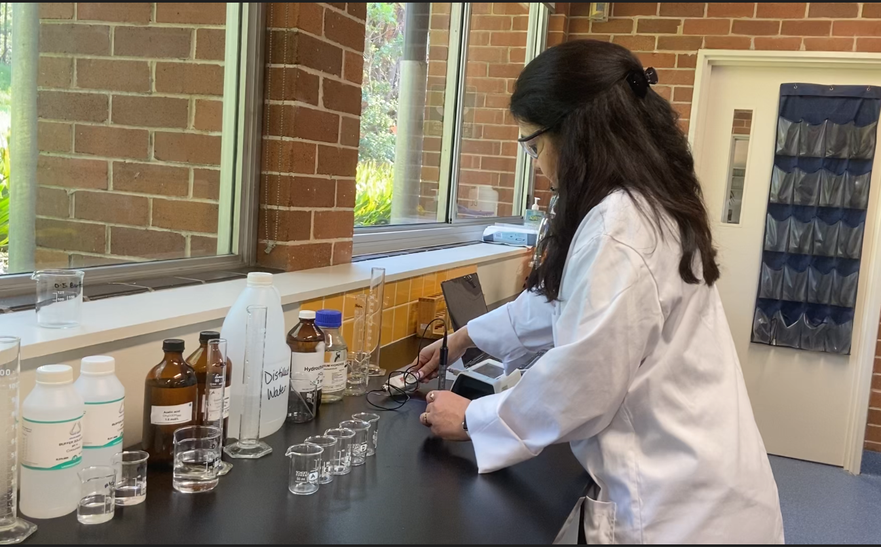
Figure 2 – screenshot of a data logger showing the variation of pH with time. The initial pH of the buffer solution (1:1 ratio of 0.1M acetic acid and 0.1M sodium acetate solutions) was 4.78. It changed slightly after adding 20 drops of 0.1M HCl (in the range of 4.65 - 4.70)
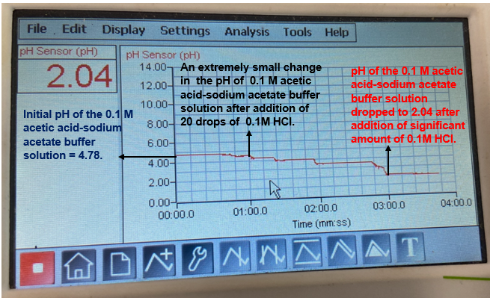
Figure 3 – screenshot of a data logger showing the variation of pH with time. The initial pH of the buffer solution (1:1 ratio of 0.1M acetic acid and 0.1M sodium acetate solutions) was 4.78. It changed slightly after adding 20 drops of 0.1M NaOH (in the range of 4.8-4.9)
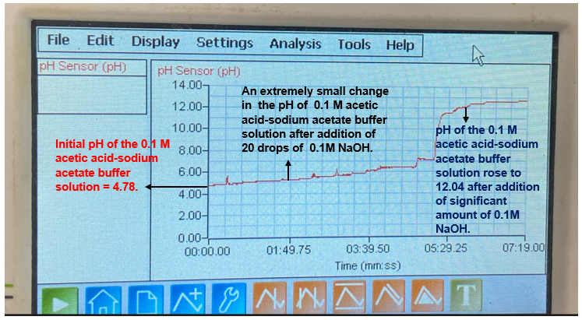
Figure 4 – the image showing equal volumes of 0.1M acetic acid-sodium acetate buffer solutions (with universal indicator) after adding 20 drops of: 0.1M HCl to beaker A, 0.1M NaOH to beaker B, and distilled water to beaker C. Beaker D was the control. The initial colour of the buffer solution was red (weakly acidic, pH = 4.78). There was no visible difference in the colour of solutions in each beaker after adding a strong acid, strong base or distilled water
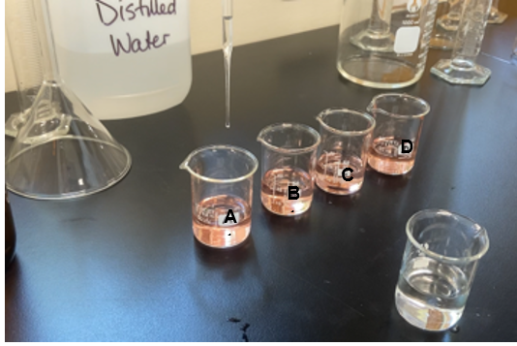
Figure 5 – the image showing equal volumes of distilled water (with universal indicator) after adding 20 drops of: 0.1M HCl to beaker A, 0.1M NaOH to beaker B, and distilled water to beaker C. The initial colour of the solution in each beaker was green. Beaker C had no colour change, but the solution in beaker A turned red and beaker B turned purple. The universal indicator colour chart shows the estimated pH
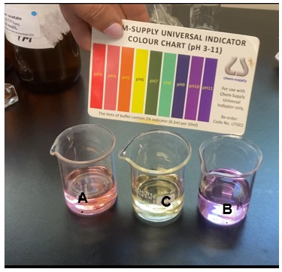

Pictures of Activity 3: investigating the buffer capacity
Figure 6 – screenshot of a virtual lab showing the initial pH (4.76) of the buffer solution (1:1 ratio of 0.1M acetic acid and 0.1M sodium acetate solutions), 0.1M HCl, 0.1M NaOH,1M NaOH and 1M HCl solutions
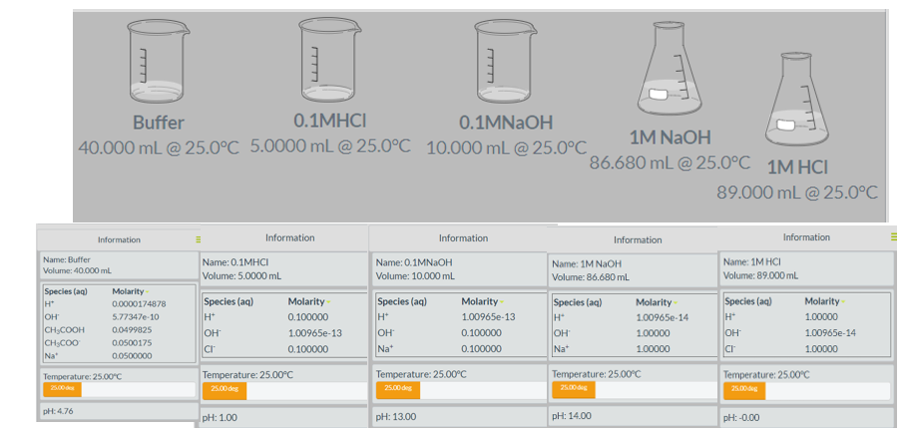
Figure 7 – screenshot of a virtual lab showing the variation of pH with time. The initial pH of the buffer solution (1:1 ratio of 0.1M acetic acid and 0.1M sodium acetate solutions) was 4.76. It changed slightly after adding 20 drops of 1M NaOH (from 4.76 to 5.23) and 1MHCl (4.76 to 4.28)
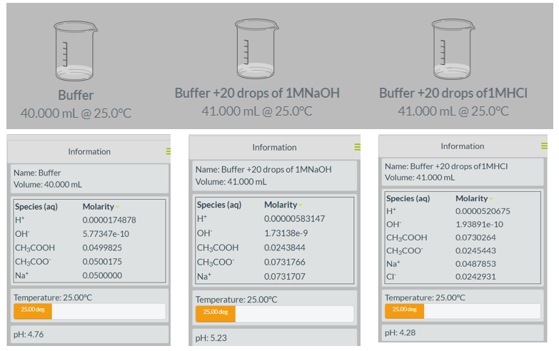
Figure 8 – screenshot of a virtual lab showing the variation of pH with time. The initial pH of the buffer solution (1:3 ratio of 1M acetic acid and 1M sodium acetate solutions) was 5.23. It changed slightly after the addition of 20 drops of 1M HCl (from 5.23 to 4.98), 1M NaOH (from 5.23 to 5.60), 10M HCl (from 5.23 to 1.31), 10M NaOH (from 5.23 to 12.99)
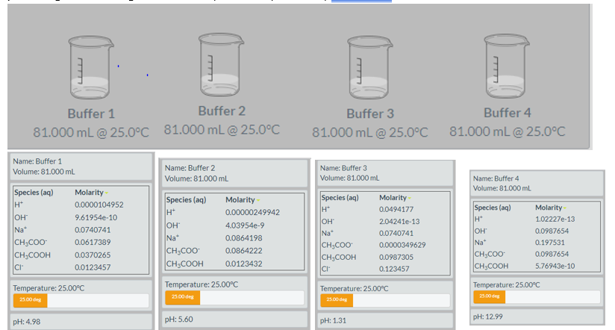

Support and alignment
Resource evaluation and support: all curriculum resources are prepared through a rigorous process. Resources are periodically reviewed as part of our ongoing evaluation plan to ensure currency, relevance, and effectiveness. For additional support or advice, or to provide feedback, contact the Science Curriculum team by emailing Science7-12@det.nsw.edu.au.
Differentiation: further advice to support Aboriginal and Torres Strait Islander students, EALD students, students with a disability and/or additional needs and High Potential and gifted students can be found on the Planning programming and assessing 7-12 webpage.
Assessment: further advice to support formative assessment is available on the Planning programming and assessing 7-12 webpage.
Professional learning: relevant professional learning is available on the Science statewide staffroom and HSC Professional Learning. Stage 6 Literacy in context provides further advice to teachers to improve student writing.
Related resources: further resources to support Stage 6 Chemistry can be found on the HSC hub and the Science K-12 webpage.
Consulted with: Multicultrual Education and Subject matter experts.
Alignment to system priorities and/or needs: School Excellence Policy, School Success Model.
Alignment to the School Excellence Framework: this resource supports the School Excellence Framework elements of curriculum (curriculum provision) and effective classroom practice (lesson planning, explicit teaching).
Alignment to Australian Professional Teaching Standards: this resource supports teachers to address Australian Professional Teaching Standards 3.2.2, 3.3.2.
Author: Science 7-12 Curriculum Team
Acknowledgements: thanks to Normanhurst Boys High School Science faculty for providing facilities and resources to conduct the first-hand investigations included in this resource.
Resource: Classroom resource
Creation date: 28 April 2023

References
This resource contains NSW Curriculum and syllabus content. The NSW Curriculum is developed by the NSW Education Standards Authority. This content is prepared by NESA for and on behalf of the Crown in right of the State of New South Wales. The material is protected by Crown copyright.
Please refer to the NESA Copyright Disclaimer for more information https://educationstandards.nsw.edu.au/wps/portal/nesa/mini-footer/copyright.
NESA holds the only official and up-to-date versions of the NSW Curriculum and syllabus documents. Please visit the NSW Education Standards Authority (NESA) website https://educationstandards.nsw.edu.au/ and the NSW Curriculum website https://curriculum.nsw.edu.au/home.
Chemistry Stage 6 Syllabus © NSW Education Standards Authority (NESA) for and on behalf of the Crown in right of the State of New South Wales, 2017.
Ball D, Hill J and Scott R (n.d.) ‘10: Acids and Bases: 10.5: Buffers’, in Basics of General, Organic and Biological Chemistry, LibreTexts Chemistry, accessed 28 April 2023.
Bozeman Science (22 February 2014), 'pH and Buffers' [video], AP Chemistry Video Essentials, YouTube, accessed 28 April 2023.
CESE (Centre for Education Statistics and Evaluation) (2020a) What works best in practice, NSW Department of Education20 February 2023.
CESE (Centre for Education Statistics and Evaluation) (2020b) What works best: 2020 update, NSW Department of Education, accessed 20 February 2023.
ChemCollective (2021) VIRTUAL LAB: Creating a Buffer Solution, ChemCollective website, accessed 28 April 2023.
Lomax J (5 January 2021) ‘Water Tower Reservoir Analogy of a Buffer’, James Lomax’s blog: ChemED Xchange, accessed 28 April 2023.
Merck & Co., Inc (n.d.) Overview of Physiologic pH and Buffers, MSD Manual: Professional Version website, accessed 28 April 2023.
Meyers D (6 December 2018), ‘Demonstrating the Effect of a Strong Acid or Base on a Buffer System’, Dan Meyers’s blog: ChemED Xchange, accessed 28 April 2023.
Moverman M (8 March 2015) ‘Buffers animation’ [video], Mark Moverman, YouTube, accessed 28 April 2023.
NESA (NSW Education Standards Authority) (2022) ‘Proficient teacher: standard descriptors’, The Standards, NESA website, accessed 20 February 2023.
Romklao A; Thasaneeya R; Richard KC; Tienthong T (2010) ‘Thai Grade 11 students’ alternative conceptions for acid–base chemistry’, Research in Science and Technological Education, 28 (2):167–183, doi:10.1080/02635141003748382, accessed 28 April 2023.
Salame I, Ramirez L, Nikolic D, Krauss D (2022) ‘Investigating Students’ Difficulties and Approaches to Solving Buffer Related Problems’, International Journal of Instruction, 15(1):911–926, doi: https://doi.org/10.29333/iji.2022.15152a, accessed 28 April 2023.
University of Colorado (n.d.) ‘Acid-Base Solutions’, Simulations, PhET Interactive Simulations website, accessed 28 April 2023.
University of Oregon (Chemistry Department) and UO Libraries Interactive Media Group (n.d.) ‘Buffer Solution Demonstration: Acetic Acid/Acetate vs Water Compare pH’, Demos, ChemDemos website, accessed 28 April 2023.
Western Australian Department of Education and Training (DET) and The University of Western Australia (2022) Buffering systems in the human body [PDF 465 KB], SPICE, accessed 28 April 2023.

Further reading
State of New South Wales (Department of Education) (n.d.) ‘Literacy and numeracy’, Curriculum, NSW Department of Education website, accessed 24 February 2023.
State of New South Wales (Department of Education) (n.d.) ‘Literacy and numeracy priorities’, Literacy and numeracy, NSW Department of Education website, accessed 24 February 2023.

© State of New South Wales (Department of Education), 2023
The copyright material published in this resource is subject to the Copyright Act 1968 (Cth) and is owned by the NSW Department of Education or, where indicated, by a party other than the NSW Department of Education (third-party material).
Copyright material available in this resource and owned by the NSW Department of Education is licensed under a Creative Commons Attribution 4.0 International (CC BY 4.0) license.
This license allows you to share and adapt the material for any purpose, even commercially.
Attribution should be given to © State of New South Wales (Department of Education), 2023.
Material in this resource not available under a Creative Commons license:
- the NSW Department of Education logo, other logos and trademark-protected material
- material owned by a third party that has been reproduced with permission. You will need to obtain permission from the third party to reuse its material.
Links to third-party material and websites
Please note that the provided (reading/viewing material/list/links/texts) are a suggestion only and implies no endorsement, by the New South Wales Department of Education, of any author, publisher, or book title. School principals and teachers are best placed to assess the suitability of resources that would complement the curriculum and reflect the needs and interests of their students.
If you use the links provided in this document to access a third-party's website, you acknowledge that the terms of use, including licence terms set out on the third-party's website apply to the use which may be made of the materials on that third-party website or where permitted by the Copyright Act 1968 (Cth). The department accepts no responsibility for content on third-party websites.

