Biology Module 8: Obesity: a non-infectious disease and an example of the failure of homeostasis
Contents
Overview 2
Information for teachers 3
Outcomes 3
Learning Intentions and Success Criteria 3
Teaching and learning activities 5
Notes for teachers 5
Activity 1: What is obesity? 5
Activity 2: How widespread is obesity? 6
Activity 4: Why is obesity a problem? 9
Activity 5: Obesity and homeostasis 11
Student resources 17
How widespread is obesity? 17
Why is obesity a problem? 17
Obesity and homeostasis 17
Support and alignment 20
References 22
Further reading 23

Overview
Stage and Learning Area: Biology Stage 6
Description: this sequence of learning activities is designed for Year 12 Biology. It ties together the concepts of homeostasis, causes of non-infectious diseases and epidemiology from Module 8 and links to Module 5 (interaction of genes and environment) through the study of obesity. Obesity is a complex disease, and not all causative factors have been identified. This task looks at obesity through the lens of homeostasis and explores the role of the endocrine system in the control of body weight.
The sequence embeds student development of working scientifically skills.
Duration: while timing will vary based on the mode of delivery, differentiation strategies employed and class or school context, this series of activities should take approximately 2 hours to complete.

Information for teachers

Outcomes
This resource addresses the following outcomes:
- selects and processes appropriate qualitative and quantitative data and information using a range of appropriate media BIO 11/12-4
- analyses and evaluates primary and secondary data and information BIO 11/12-5
- communicates scientific understanding using suitable language and terminology for a specific audience or purpose BIO 11/12-7
- explains non-infectious disease and disorders and a range of technologies and methods used to assist, control, prevent and treat non-infectious diseases BIO12-15
Biology Stage 6 Syllabus © NSW Education Standards Authority (NESA) for and on behalf of the Crown in right of the State of New South Wales, 2017.

Learning Intentions and Success Criteria
Students:
- identify that many non-infectious diseases are caused by a combination of factors
- describe the features of a valid epidemiological study
- determine correlation between different data sets
- apply understanding of negative feedback loops to new information about hormones.
Students can:
- interpret data to describe trends in the prevalence of obesity around the world
- select quantitative data and represent it using digital technologies
- identify the relationship between obesity and non-infectious diseases
- draw a feed-back loop for the secretion of leptin
- explain the relationship between leptin resistance and obesity.
Differentiation consideration: learning intentions should not be differentiated. All students need access to the same core content, big ideas and concepts. Differentiation should be evident in the success criteria, or the activities/support needed to achieve the success criteria (Wiliam and Leahy, 2015). Teachers may co-construct the success criteria with students or adjust them to suit their class context, for example using the strategies and resources for curriculum planning on the Planning programming and assessing 7-12 webpage.

Teaching and learning activities

Notes for teachers
By undertaking this sequence of activities students will develop skills in:
- interpreting maps, graphs and tables to derive trends, patterns and relationships in data
- applying their knowledge to interpreting new and unfamiliar information to propose explanations for scientific issues.
They will understand that many non-infectious diseases are caused by a range of interacting predisposing factors.
Some of the questions listed are for group and class discussion. Students are to record answers to the numbered questions. A worksheet with these is provided.
Blue call-out boxes include strategies for differentiation.

Activity 1: What is obesity?
Ask students ‘How is obesity measured?’ Those students who have studied PDHPE will probably know that it is body mass index (BMI).
$$BMI=\frac{body mass \left(kg\right)}{{body height \left(m\right)}^{2}}$$
The BMI scale then defines categories based on the following thresholds:
- Underweight: a BMI equal to or less than 18.5
- Healthy: a BMI between 18.5 and 24.9
- Overweight: a BMI between 25 and 29.9
- Obese: a BMI equal to or greater than 30
It is not necessary for biology students to know the BMI equation and scale, but it will allow students to understand the stimulus material that follows.

Activity 2: How widespread is obesity?
Display the map below.
Figure 1 – World map showing location and percentage of obese adults
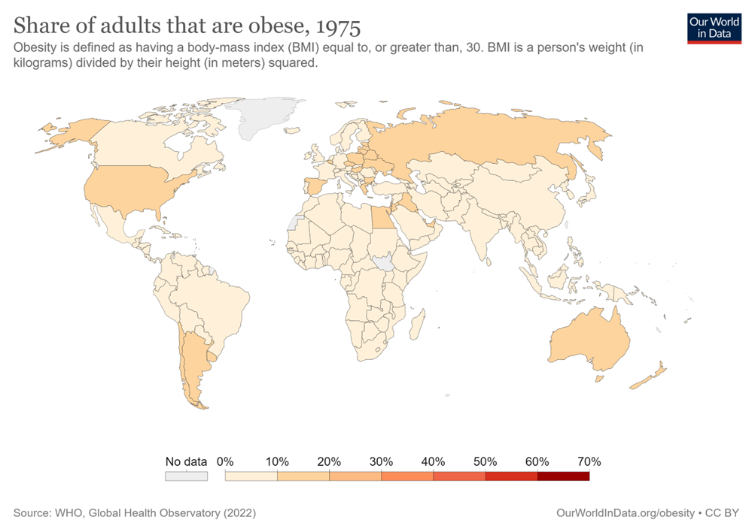
‘Share of adults that are obese, 1975’ by Our World in Data is licensed under CC BY 4.0
Ask students to discuss what this map displays.
Suggested answer: The map shows that in 1975, 10–20% of the population in Australia, New Zealand, Eastern Europe, USA, Iraq, Egypt, Argentina and Chile were obese.
Differentiation consideration:
The Identify and Interpret (I² Strategy [PDF 1.6KB] can be used to support students to interpret maps, as well as graphs, data tables and diagrams.
Ask the students: ‘What do you see?’ (What I see – WIS)
Suggested answer: A map of the world with some countries – Australia, New Zealand, Eastern Europe, USA, Iraq, Egypt, Argentina and Chile coloured mid tan. The remaining countries are coloured a light tan.
Ask the students: ‘What does this mean?’ (What it means – WIM)
Suggested answer: 10%–20% of the population in the mid tan countries were obese in 1975. In the light tan countries less than 10% of the population were obese.
Direct the students to: ‘Put it all together to write a caption’.
Suggested answer: 10–20% of the population of Australia, New Zealand, Eastern Europe, USA, Iraq, Egypt, Argentina and Chile were obese in 1975. In the remaining countries less than 10% of the population were obese.
Direct students to interact with the charts and map online, under the heading ‘What share of adults are obese?’ By hovering over a country on the map, the name of the country and the level of obesity will be displayed. Students complete questions 1–3.
- Use the chart tab to make a graph showing 6 countries with the highest levels of obesity. Copy your map here.
Suggested answer:
Figure 2 – sample answer of graph showing 6 countries with the highest levels of obesity
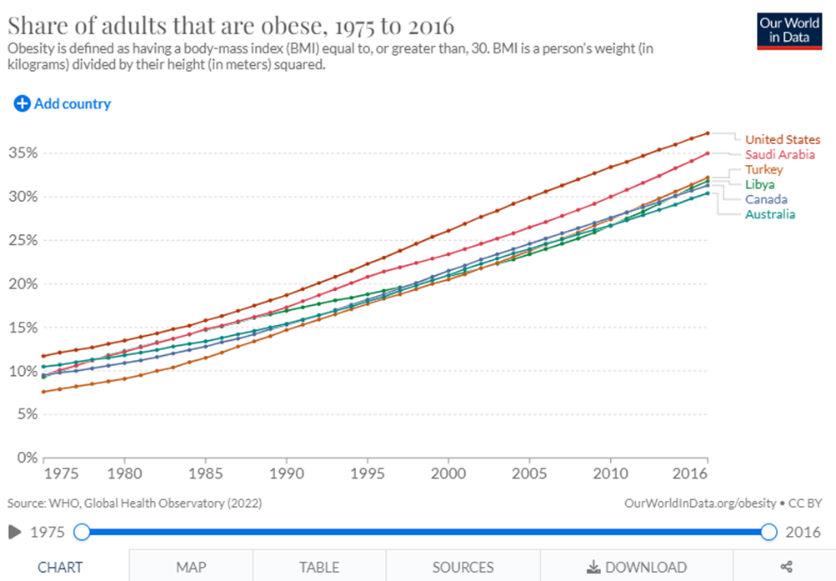
Share of adults that are obese, 1975 to 2016 by Our World in Data is licensed under CC BY 4.0
- Describe the trends observed on the world map from 1975 to 2016.
Suggested answer: in 1975, most countries in the world had less than 10% of their population being obese. Australia, NZ, USA, eastern Europe, Egypt, Iraq and the south of South America had 10-20% of their population obese.
Between 1975 and 2016 there was a steady increase in levels of obesity in most countries. The USA, Saudi Arabi, Turkey, Libya, Canada and Australia had levels of obesity above 30%. All of Europe, the Americas and north Africa are shown as being above 20%.
Open this GDP per capita, 2018 map. Explain to the students that gross domestic product (GDP) per capita is a measure of a country’s wealth. The higher the GDP, the wealthier the country. (GDP is the sum of gross value added by all resident producers in the economy divided by mid-year population).
- What correlation (relationship) can you see between the share of adults that are obese, 2016 (from activity 2) and the GDP per capita, 2018?
Suggested answer: the prevalence of obesity tends to be higher in wealthier countries across Europe, North America, and Oceania. Obesity rates are much lower across South Asia and Sub-Saharan Africa which have lower income levels.
Differentiation consideration for HPGE
No GDP data is provided on the map for the South Pacific nations such as the Solomon Islands, Tonga, Vanuatu and Samoa. The World Bank reports that these nations have a GDP per capita in the $2,000–$5,000 range. Look at the map showing the share of adults that are obese from question 1 above. Hover over the Pacific Islands on the map or access the table to identify the prevalence of obesity in these countries.
Is there a similar correlation between wealth and prevalence of obesity in these countries as there is in the rest of the world? What else do you think could be influencing the level of obesity?
Suggested answer: Tonga and Samoa both have obesity rates above 70% and the Solomon Islands and Vanuatu above 50%. This does not correlate with the low level of wealth in these countries.
Possible reasons for the very high levels of obesity could include:
- a possible genetic predisposition to obesity
- The influence of neighbouring wealthy countries, such as Australia and New Zealand on diet and lifestyle
- plentiful supply of food, despite these countries not being wealthy
- people being less involved in traditional manual labour than in other low GDP countries.

Activity 3: Why is obesity a problem?
Display the Share of deaths by cause, World, 2019 graph below.
Figure 3 – share of deaths by cause, World, 2019
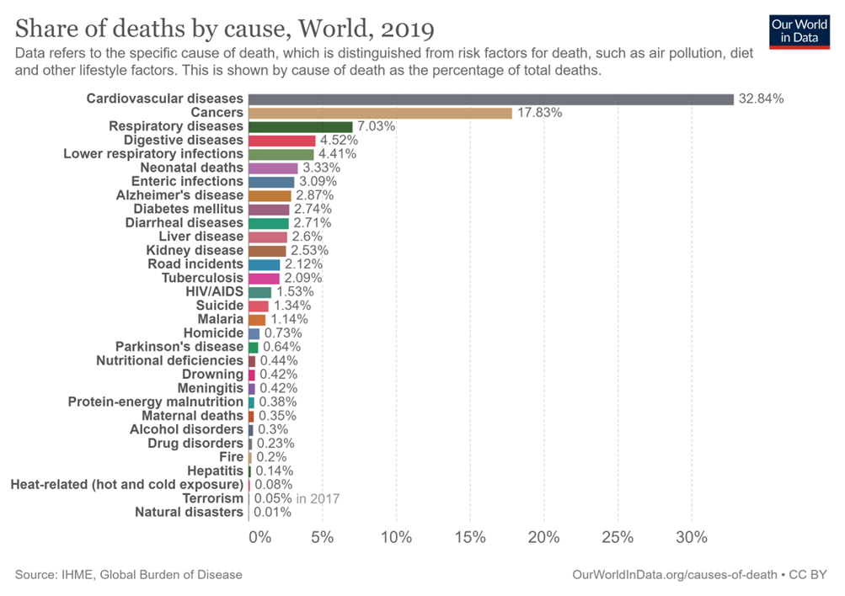
Share of deaths by cause, World, 2019 by Our World in Data is licensed under CC BY 4.0
Ask the students to discuss in groups which of these diseases could be a health consequence of obesity. Groups contribute their suggestions to a class list. Draw the students’ answers together with the following list.
Obesity is a major risk factor for non-infectious diseases such as:
- cardiovascular diseases (mainly heart disease and stroke), which were the leading cause of death in 2019
- diabetes
- some cancers (including endometrial, breast, ovarian, prostate, liver, gallbladder, kidney, and colon).
Additionally, obesity is a major risk factor for musculoskeletal disorders (especially osteoarthritis – a highly disabling degenerative disease of the joints).
Students read Obesity is one of the leading risk factors for early death and interact with the chart to answer question 4 (and HPGE question).
- How many premature deaths in 2019 were attributed to obesity in:
- the world?
- Australia?
Suggested answers:
- 5.02 million
- 18,713
For HPGE: the data in the table below was extracted from the website.
Propose a hypothesis to account for the differing death rates shown in the table. (Hint: refer to your GDP data from Activity 2).
Suggested answer: even though obesity levels are similar in Australia and Egypt, there are twice the levels of death attributed to obesity in Egypt than in Australia. This could be because Egypt has a lower level of income (GDP), so could have poorer overall health and healthcare systems compared to Australia, which has a higher level of income (GDP).
Country | Percentage of population obese | Percentage of deaths attributed to obesity
Australia | 31 | 10.7
Egypt | 30.4 | 21.2

Activity 4: obesity and homeostasis
Ask the students, ‘What are considered to be the 2 major causes of obesity?’ Students should be able to identify high intake of high energy food and low levels of exercise as being major causes. Propose to the students that there may be another factor. Students read the articles, Who’s really in charge of your weight? and Leptin and leptin resistance and answer the following questions.
Note: the article, ‘Who’s really in charge of your weight?’ includes several colloquial expressions (for example, ‘lack of executive control’, ‘our sluggish bulk runs the gauntlet of predation’ and ‘the onward march or girths’) and other terms (inexorably, ubiquitous, etcetera) that will make reading and understanding the text challenging for EAL/D learners in particular. These expressions can be pre-taught or their meaning provided before students engage with the text.
- In terms of evolution, why is homeostasis considered to be important in the regulation of body weight?
Suggested answer: homeostasis means to maintain a relatively constant internal state, in this case body weight, regardless of external changes in the environment, in this case diet and activity. As humans evolved, being of a moderate body weight was favourable to survival. If the human was overweight, they would be not sufficiently mobile and would be easy prey. If underweight, they would not have sufficient energy stores and risk starvation.
- Complete the negative feedback loop showing how leptin regulates our food intake and hence maintains homeostasis. (Student worksheet has lower 3 circles blank).

Suggested answer:
Figure 4 – cycle showing leptin feedback
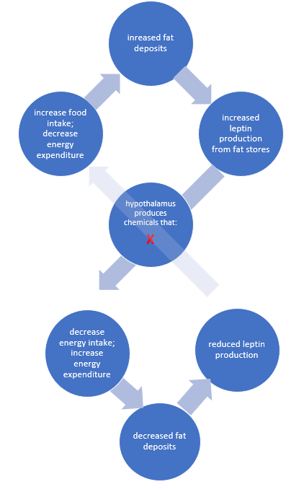
- Explain why high levels of leptin in an obese person may not trigger the hypothalamus to signal to the body to reduce energy intake. Place a red cross on the feedback loop to show where the loop is not functioning properly.
Suggested answer: people who are obese have high numbers of fat cells, therefore produce high levels of leptin. When the hypothalamus is exposed to high levels of leptin for a long time it can become leptin resistant and therefore not stimulate the body to reduce energy intake and increase energy expenditure (cross shown on diagram above). The obese person continues to eat excessively and gains more weight.
- What is the evidence that suggests that specific foods may increase leptin resistance?
Suggested answer: rats fed lard, beef tallow, coconut oil and corn syrup developed leptin resistance within days.
- Propose how the information about the rat experiments could be relevant to the data about levels of human obesity investigated in Activity 2.
Suggested answer: as income rises people eat more energy rich, processed and fast food. These foods often are cooked in fats and oils (similar to lard, tallow and corn oil) and contain corn syrup as a sweetener. It could be hypothesised that an increased intake of these substances is causing leptin resistance, and hence increasing levels of obesity, in the human population in wealthier countries.
Hormones often work to oppose each other to carefully maintain homeostasis. These hormones are called antagonists. Some hormones that are antagonists are:
- insulin and glucagon – maintain glucose homeostasis
- calcitonin and parathyroid hormone – maintain calcium homeostasis.
- Explain why ghrelin could be considered an antagonist to leptin.
Suggested answer: ghrelin is called the hunger hormone and is produced by the stomach when it is empty. It stimulates the hypothalamus to produce chemicals to increase appetite. This is the opposite to leptin, which suppresses appetite.
- What experimental evidence is there that suggests that both over-eating and under-eating by women during pregnancy may put their babies at risk of obesity later in life?
Suggested answer: when young rats had ghrelin blocked (the equivalent of overeating), their hypothalamus had added nerve growth. Rats that were given ghrelin (the equivalent of under-eating) had stunted nerve growth in the same area. However, the same result occurred in both groups of rats – they got fat.
- Why do children with a mutation to the ob gene become morbidly obese?
Suggested answer: the ob gene codes for the production of leptin. A mutated ob gene will not produce leptin. Consequently, without leptin, the hypothalamus continually stimulates the body to eat and slows down energy metabolism with the result that the child becomes morbidly obese.
Rarely is obesity due to changes in a single gene. Since 2006, genome-wide association studies have found more than 50 genes associated with obesity, most with very small effects.

Assessment question
Our modern lifestyle is testing the human body’s capacity to maintain homeostasis. Consequently, humans are becoming more vulnerable to a range of non-infectious disease.
Evaluate the statement with reference to the data and information provided.
Suggested answer: homeostasis means to maintain a relatively constant internal state, regardless of external changes in the environment. One of the ways which the human body maintains a healthy weight is through the action of the hormone leptin. Leptin is produced by fat stores in the body. As the fat stores increase, with increased food intake and lower levels of exercise, the level of leptin secreted increases. Leptin acts to decrease energy intake and increase energy expenditure, thereby reducing fat stores and returning the body to a stable state.
If a person consistently eats an excessive amount of fats, oils and simple carbohydrates, common in the processed and fast food that make up modern diets, they will produce large amounts of leptin which can make the hypothalamus resistant to it. As result the person continues to overeat and become obese.
The data shows that the prevalence of obesity tends to be higher in wealthier countries across Europe, North America, and Oceania. Obesity rates are much lower across South Asia and Sub-Saharan Africa which have lower income levels.
The data also shows that the prevalence of obesity has risen from 1975 to 2016 in countries with increasing or already high GDP (a measure of wealth of a nation).
While the data does not examine this, it could be hypothesised that as a country’s wealth increases the population’s lifestyle shifts to a more modern diet of highly processed, energy rich foods and people are involved in less manual labour and undertake lower levels of exercise.
Finally, the data shows that cardiovascular disease is the major cause of death in the world, rising from 25.8% of deaths in 1990 to 32.8% in 2019. Obesity is a major cause of heart disease. Additionally, obesity is a major risk factor for diabetes and several types of cancers which are also significant non-infectious diseases and causes of death.
Therefore, it can be concluded that as a country’s population becomes wealthier and adopts a more modern lifestyle, individuals may struggle to maintain homeostasis with respect to fat levels. The level of obesity in the population increases which causes an increase in the deaths from non-infectious diseases such as cardiovascular disease. However, not all obesity can be accounted for by excessive food intake, lack of exercise and the consequent disruption to homeostatic mechanisms. There is a genetic component that contributes, mostly in a small way, to a person’s predisposition to obesity.
Criteria | Marks
- Provides a comprehensive analysis and interpretation of scientific data and information in reference to the statement.  - Provides arguments for and against the statement. | 6-7
- Interprets scientific data to support arguments for and/or against the statement. | 4-5
- Demonstrates some understanding of the information provided and/or the role of homeostasis in the management of body weight. | 2-3
- Provides some relevant information. | 1

Student resources

How widespread is obesity?
Explore the charts and map online, under the heading ‘What share of adults are obese?’ By hovering over a country on the map, the name of the country and the level of obesity will be displayed. Complete the questions 1–3.
- Use the chart tab to make a graph showing 6 countries with the highest levels of obesity. Copy your map here.
- Describe the trends observed on the world map from 1975 to 2016.
Open the GDP per capita, 2018 map. Gross domestic product (GDP) per capita is a measure of a country’s wealth. The higher the GDP, the wealthier the country. (GDP is the sum of gross value added by all resident producers in the economy divided by mid-year population).
- What correlation (relationship) can you see between the share of adults that are obese, 2016 (from activity 2) and the GDP per capita, 2018?

Why is obesity a problem?
Read Obesity is one of the leading risk factors for early death and interact with the chart to answer question 4.
- How many premature deaths in 2019 were attributed to obesity in:
- the world?
- Australia?

Obesity and homeostasis
Read the articles, Who’s really in charge of your weight? and Leptin and leptin resistance and answer the following questions.
- In terms of evolution, why is homeostasis considered to be important in the regulation of body weight?
- Complete the negative feedback loop showing how leptin regulates our food intake and hence maintains homeostasis.
Figure 5 – negative feedback loop for leptin
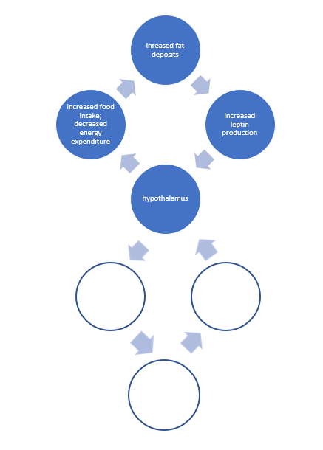
- Explain why high levels of leptin in an obese person may not trigger the hypothalamus to signal to the body to reduce energy intake. Place a red cross on the feedback loop to show where the loop is not functioning properly.
- What is the evidence that suggests that specific foods may increase leptin resistance?
- Propose how the information about the rat experiments could be relevant to the data about levels of human obesity investigated in Activity 2.
Hormones often work to oppose each other to carefully maintain homeostasis. These hormones are called antagonists. Some hormones that are antagonists are:
- Insulin and glucagon – maintain glucose homeostasis
- Calcitonin and parathyroid hormone – maintain calcium homeostasis
- Explain why ghrelin could be considered an antagonist to leptin.
- What experimental evidence is there that suggests that over or under-eating by women during pregnancy may put their babies at risk of obesity later in life?
- Why do children with a mutation to the ob gene become morbidly obese?
Rarely is obesity due to changes in a single gene. Since 2006, genome-wide association studies have found more than 50 genes associated with obesity, most with very small effects.

Assessment question
Our modern lifestyle is testing the human body’s capacity to maintain homeostasis. Consequently, humans are becoming more vulnerable to a range of non-infectious disease.
Evaluate the statement with reference to the data and information provided in these activities.

Support and alignment
Resource evaluation and support: all curriculum resources are prepared through a rigorous process. Resources are periodically reviewed as part of our ongoing evaluation plan to ensure currency, relevance and effectiveness. For additional support or advice, or to provide feedback, contact the Science Curriculum team by emailing Science7-12@det.nsw.edu.au.
Differentiation: further advice to support Aboriginal and Torres Strait Islander students, EALD students, students with a disability and/or additional needs and High Potential and gifted students can be found on the Planning programming and assessing 7-12 webpage.
Assessment: further advice to support formative assessment is available on the Planning programming and assessing 7-12 webpage.
Professional learning: relevant professional learning is available on the Science statewide staffroom and HSC Professional Learning. Stage 6 Literacy in context provides further advice to teachers to improve student writing.
Related resources: further resources to support Stage 6 Earth and Environmental Science can be found on the HSC hub and the Science Curriculum page.
Consulted with: Literacy and Numeracy, Inclusive Education, Multicultural Education, and subject matter experts.
Alignment to system priorities and/or needs: School Excellence Policy, School Success Model.
Alignment to the School Excellence Framework: This resource supports the School Excellence Framework elements of curriculum (curriculum provision) and effective classroom practice (lesson planning, explicit teaching).
Alignment to Australian Professional Teaching Standards: This resource supports teachers to address Australian Professional Teaching Standards 3.2.2, 3.3.2.
Author: Science 7-12 Curriculum Team
Resource: Sequence of classroom activities
Creation date: updated on 24 April, 2023

References
This document contains NSW Curriculum and syllabus content. The NSW Curriculum is developed by the NSW Education Standards Authority. This content is prepared by NESA for and on behalf of the Crown in right of the State of New South Wales. The material is protected by Crown copyright.
Please refer to the NESA Copyright Disclaimer for more information https://educationstandards.nsw.edu.au/wps/portal/nesa/mini-footer/copyright.
NESA holds the only official and up-to-date versions of the NSW Curriculum and syllabus documents. Please visit the NSW Education Standards Authority (NESA) website https://educationstandards.nsw.edu.au/ and the NSW Curriculum website https://curriculum.nsw.edu.au/home.
NSW Biology Syllabus © NSW Education Standards Authority (NESA) for and on behalf of the Crown in right of the State of New South Wales, 2017.
Biegler P (2016) ‘Who’s really in charge of your weight?’, Cosmos Magazine, accessed 14 June 2023.
Bolt and van Zanden (2020) GDP per capita, 2018, Our World In Data website, accessed 28 September 2022.
BSCS Science Learning (2010) I Can Use the Identify and Interpret (I2) Strategy [PDF 1.6KB], BCSC, accessed 28 September 2022.
CESE (Centre for Education Statistics and Evaluation) (2020a) ‘What works best: 2020 update’, NSW Department of Education, accessed 23 May 2022.
CESE (Centre for Education Statistics and Evaluation) (2020b) ‘What works best in practice’, NSW Department of Education, accessed 23 May 2022.
Gunnars K (2018) ‘Leptin and Leptin Resistance: Everything You Need to Know’, Healthline, accessed 28 September 2022.
Loos R and Yeo G (2021) ‘The genetics of obesity: from discovery to biology’.Nature Reviews: Genetics, 23:120–133 accessed 28 September 2022.
NESA (NSW Education Standards Authority) (2022) ‘Proficient teacher: standard descriptors’, The Standards, NESA website, accessed 14 June 2023.
Ritchie H and Roser M (2017) Obesity, Our World In Data website, accessed 28 September 2022.
Ritchie H and Roser M (2017) Obesity is one of the leading risk factors for early death, Our World in Data website, accessed 14 June 2023.
Wiliam D and Leahy S (2015) Embedding formative assessment: practical techniques for K-12 classrooms, Learning Sciences International, US.
The World Bank Group (2022) GDP per capita (current US$) – Pacific island small states, The World Bank Data website, accessed 28 September 2022.

Further reading
State of New South Wales (Department of Education) (2022) Literacy and numeracy, NSW Department of Education, accessed 24 February 2023.
State of New South Wales (Department of Education) (2022) Literacy and numeracy priorities, NSW Department of Education, accessed 24 February 2023.
State of New South Wales (Department of Education) (2022) Strategies for differentiation, NSW Department of Education, accessed 10 Jan 2023.

© State of New South Wales (Department of Education), 2023
The copyright material published in this resource is subject to the Copyright Act 1968 (Cth) and is owned by the NSW Department of Education or, where indicated, by a party other than the NSW Department of Education (third-party material).
Copyright material available in this resource and owned by the NSW Department of Education is licensed under a Creative Commons Attribution 4.0 International (CC BY 4.0) licence.
This licence allows you to share and adapt the material for any purpose, even commercially.
Attribution should be given to © State of New South Wales (Department of Education), 2023.
Material in this resource not available under a Creative Commons licence:
- the NSW Department of Education logo, other logos and trademark-protected material
- material owned by a third party that has been reproduced with permission. You will need to obtain permission from the third party to reuse its material.
Links to third-party material and websites
Please note that the provided (reading/viewing material/list/links/texts) are a suggestion only and implies no endorsement, by the New South Wales Department of Education, of any author, publisher, or book title. School principals and teachers are best placed to assess the suitability of resources that would complement the curriculum and reflect the needs and interests of their students.
If you use the links provided in this document to access a third-party's website, you acknowledge that the terms of use, including licence terms set out on the third-party's website apply to the use which may be made of the materials on that third-party website or where permitted by the Copyright Act 1968 (Cth). The department accepts no responsibility for content on third-party websites.

