Science Stage 5
Rainbow challenge

Contents
Overview 3
Information for teachers 4
Outcomes 4
Learning intentions and success criteria 5
Teaching and learning activities 6
Activity 1 – rainbow challenge 6
Sample response 8
Student resources 11
Resource 1 – rainbow challenge – the task 11
Resource 2 – peer assessment sheet 13
Questions for consideration 14
Resource 2 – peer assessment sheet with emojis 15
Questions for consideration 16
Resource 2 – student questions 17
Marking rubric 19
Support and alignment 24
References 25
Further reading 25

Overview
Stage and Learning Area: Science Stage 5
Description: this resource has been designed to address the outcome PW1 Energy transfers through different mediums can be explained using wave and particle models.
The students will work in small teams to apply critical thinking skills and use problem-solving strategies to create a rainbow in a dark corner of a room using lenses and mirrors.
Duration: while timing will vary based on the mode of delivery, differentiation strategies employed and class or school context, this series of activities should take approximately one hour. The timing may be extended if the activity is to be used as an assessment task to allow time for the students to develop a high-quality presentation.

Information for teachers
The students should have learned about reflection and refraction of light before they undertake this learning activity. The students should also be familiar with different types of mirrors and lenses, although they do not need a comprehensive understanding of these as they can learn their properties through experimentation as they complete the task.
This learning activity can be used as formative assessment or easily adjusted to become a summative assessment task.
This learning activity is designed to investigate how students work together as a team to apply the scientific knowledge and skills they have learned during class to a new or novel situation. This requires a particular focus in teaching the students explicit teamwork, leadership and communication skills. The students should be familiar with these skills before the lesson. The skills should be reinforced at the beginning of, and throughout the lesson.
This is a template task. This means the format of this task can be applied to any Problem Based Learning challenge or approach. Any challenge can be substituted and subsequently only require minor changes to the marking rubric and syllabus links, for example the rainbow can be substituted for a radiometer and the outcome being investigated is their knowledge of how waves transfer energy. Additionally, another idea could be to create a model that moves under wind power to explore Newton’s Laws of Motion. This task can even be expanded to a larger Rube Goldberg machine that incorporates a range of scientific knowledge and skills.

Outcomes
- PW1 Energy transfer through different mediums can be explained using wave and particle models.
- SC5-WS5 produces a plan to investigate identified questions, hypotheses or problems, individually and collaboratively
- SC5-WS6 undertakes first-hand investigations to collect valid and reliable data and information, individually and collaboratively
- SC5-WS8 applies scientific understanding and critical thinking skills to suggest possible solutions to identified problems
- SC4-9WS presents science ideas, findings and information to a given audience using appropriate scientific language, text types and representations
Science Years 7–10 Syllabus © NSW Education Standards Authority (NESA) for and on behalf of the Crown in right of the State of New South Wales, 2018.

Learning intentions and success criteria
The learning intentions and success criteria below are a guide and may be adapted to meet your students’ needs.
Students:
- understand applications of reflection and refraction.
Students can/will:
- use mirrors and lenses to create a rainbow on a small target
- work together as an effective team
- reflect on how effectively their team worked together
- apply the principles of reflection and refraction to real-world situations.
Differentiation consideration: learning intentions should not be differentiated. All students need access to the same core content, big ideas and concepts. Differentiation should be evident in the success criteria, or the activities or support needed to achieve the success criteria (Wiliam and Leahy 2015). Teachers may co-construct the success criteria with students or adjust them to suit their class context, for example, using the strategies and resources for curriculum planning on the Planning, programming and assessing 7–12 webpage.

Teaching and learning activities

Activity 1 – rainbow challenge
Introduce this activity by showing a picture of a rainbow and discussing observations. This should be a short introductory discussion only.
Figure 1 – double Alaskan rainbow
‘Double rainbow’ by Eric Rolph is licensed under CC BY-SA 2.5.
Part A
The class will then be divided into small groups and given the task to complete. They should take about 30 minutes to complete the task. The teacher should see the rainbow hit the target before the students pack up their equipment. This allows for immediate feedback to students on the success of their design.
This challenge has been tested using the sun outside in the garden being reflected into the classroom off a variety of mirrors into a dark corner. Along its path, the light is focused using the lenses and refracted using the prism.
The ‘target’ should be small enough to present a significant challenge to overcome but not too small. A ‘target’ area of between 10 cm x 10 cm should suffice. It should be in a dark location where the rainbow will be clearly visible. The target could be inside an enclosed box.
Teacher notes: in part 3, the students will be creating a class presentation. They may wish to take photographs or video steps in the process to include in the presentation.
Differentiation: the target location and size can be adjusted to suit student capabilities. This activity can be further differentiated by describing and/or explaining the purpose and use of the mirrors and lenses available for use.
Extension opportunity: this activity can be adjusted to focus on the mathematics and engineering components such as identifying the required distances and angle of refraction of each wavelength of light and predetermining the position of each component in the design phase using the calculated angles required. This helps students explore the maths within science and engineering in a practical hands-on way.
Part B – peer assessment
The peer assessment component is an avenue for students to critically examine their role and the role of others in group work. It can be used in post activity debriefs to help facilitate future teamwork and leadership opportunities. Each student should be encouraged to identify areas of strength and areas for improvement when working collaboratively.
The peer assessment sheet can be edited to suit the needs of your class. They could be asked to rate themselves and their peers based on a scale, give a description of collaboration or a combination of both.
Teacher notes: the expectations of honesty without being hurtful need to be emphasised in this activity. It may be helpful to explain each point to the students at the start of the activity so that they understand the team-work qualities that they should display and are assessing.
Differentiation: two versions of the peer assessment worksheet are available for use. One uses more simple language and emojis. Further adjustments may be made to support the needs of your class.
Part C
The students will complete a short questionnaire. They will use the responses to the questionnaire to prepare a class presentation justifying their design. The presentation can take any appropriate form such as a scientific poster with discussion, PowerPoint presentation or a vodcast.
Differentiation: we suggest that students can select their preferred mode of communication for this part of the task. If students are not confident presenting in front of the class, they may be able to present to a small group of students or other alternatives may be presented to them.
The marking rubric only assigns a small portion of marks to whether the teams succeed in generating a rainbow. This is done for 2 reasons: to reward those who do succeed in the challenge, and; place an emphasis on working collaboratively and apply scientific knowledge. Students should be encouraged to learn from mistakes and use trial and error. The task is designed to assess how students accomplish the task.

Sample response
The text and image below show a snapshot of a sample student response for Part C. It is not a complete response. Students are to be encouraged to use their creativity to complete this activity so responses may vary greatly. There is no single correct response to Part C.
Table 1 – sample student questions
Question | Response | Explanation
Did you use convex lenses?  If yes how and why did you use them? If no, why not? | ☒ Yes  ☐ No | We used a biconvex lens to focus the light onto a mirror. We did this because the light from the torch was spread over a large area and we wanted to focus it on a smaller area
Did you use concave lenses?  If yes how and why did you use them? If no, why not? | ☐ Yes  ☒ No | We did not use concave lenses because they spread the light out too much. We wanted to keep it focused.
Did you use a prism?  If yes how and why did you use it? If no, why not? | ☒ Yes  ☐ No | We used a prism to disperse the light onto the card at the target. We used a prism because it disperses light into all the colours well.
Did you use mirrors?  If yes how and why did you use them? If no, why not? | ☐ Yes  ☐ No
Where is refraction and reflection of EM waves used in everyday life? | ☐ Yes  ☐ No
Describe an application of your solution. Where could it be used in everyday life? | ☐ Yes  ☐ No
What would you change or improve for next time and why? | ☐ Yes  ☐ No

Figure 2 – snapshot of a sample response poster
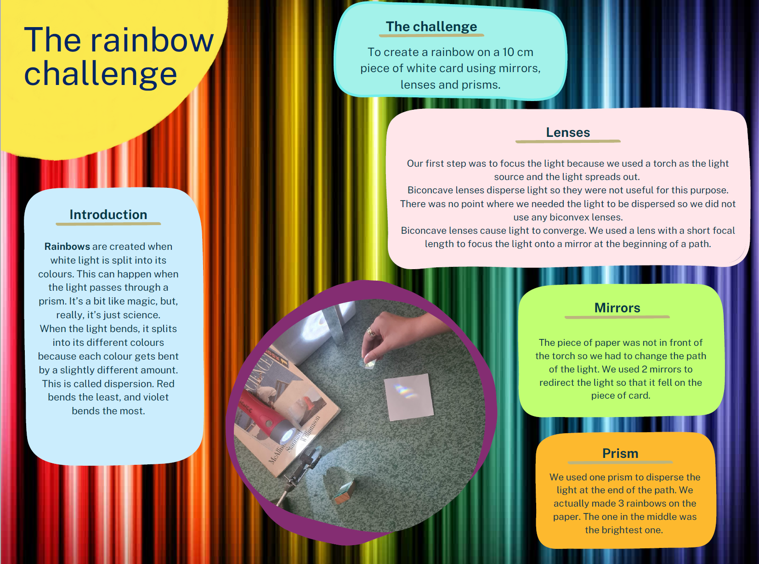

Student resources

Resource 1 – rainbow challenge – the task
Background
Sometimes the greatest innovation comes from looking at an issue from different perspectives. A solution to one problem in a classroom can inspire solutions to other problems out in the real world. In class you have learned about refraction and reflection as well as how different lenses and mirrors can help you manipulate light.
The task
In this task you will be asked to put your creative thinking skills to the test and apply what you have learned in class. You will also need to use teamwork, leadership and communication skills to accomplish this challenge.
Your team is charged with casting a rainbow onto a 10 cm x 10 cm target placed on a wall in a dark corner of your classroom. You may only use the equipment provided to you and you must be able to explain why you have chosen to solve the problem the way you have. You will need to work in groups of 3–4 students and you will have 30 minutes to complete your task. You will have another 15 minutes to complete a short questionnaire relating to your solution.
You will be provided with the following items:
- 1 piece of grid paper to plan out your solution
- 1 glass convex lens
- 1 glass concave lens
- 1 glass triangular prism
- 4 small hand mirrors
- 2 retort stands with boss heads and clamps
- 1 source of bright non-directional white light (for example, the sun outside or a portable bright lamp)
- 1 stopwatch.
You will be marked on:
- your understanding of refraction and reflection
- your understanding of the different lenses, prisms and mirrors and how they can be used in this situation
- real-world applications of your solution
- teamwork, leadership and communication skills
- your overall contribution to the group.

Resource 2 – peer assessment sheet
Use the following table to describe the contributions of yourself and your team member. Give each member a number from 1–3 and justify your decision.
Key: 3 – excellent, 2 – satisfactory, 1 – low
Table 2 – peer assessment
Task | Myself | Team member 1 | Team member 2 | Team member 3
Ability to listen to suggestions from other team members
Ability to communicate their ideas to the group
Demonstrated leadership of the group
Ability to work as an effective team member
Role in group work
Overall contribution to the group task

Questions for consideration
- Identify 3 strengths you displayed in this activity.
- Identify an area you could improve from this task and how you would do this.

Resource 2 – peer assessment sheet with emojis
Use the following table to describe the contributions of yourself and your team members. Colour the emoji that fits each person and how they worked together. Give a reason why.
Table 3 – peer assessment
Task | Myself | Team member 1 | Team member 2 | Team member 3
Did they listen to others in the team?
Did they communicate their ideas well?
Did they lead the group?
Did they work as a good group member?
What was their role in group work?
How much did they help the group?

Questions for consideration
- Identify 3 things that you did well in this activity.
- Identify an area you could improve from this task and how you would do this.

Resource 2 – student questions
Answer the questions in the table below. When you have finished, create a class presentation explaining what you did and why. Your class presentation may take the form of a poster presentation with a discussion, a PowerPoint presentation or a vodcast.
The target audience is your teacher and classmates. This should guide your language choices and the mode of presentation.
Table 4 – student questions
Question | Response | Explanation
Did you use convex lenses?  If yes how and why did you use them? If no, why not? | ☐ Yes  ☐ No
Did you use concave lenses?  If yes how and why did you use them? If no, why not? | ☐ Yes  ☐ No
Did you use a prism?  If yes how and why did you use it? If no, why not? | ☐ Yes  ☐ No
Did you use mirrors?  If yes how and why did you use them? If no, why not? | ☐ Yes  ☐ No
Where is refraction and reflection of EM waves used in everyday life? | ☐ Yes  ☐ No
Describe an application of your solution. Where could it be used in everyday life? | ☐ Yes  ☐ No
What would you change or improve for next time and why? | ☐ Yes  ☐ No

Marking rubric
The rubric below could be adapted and used if this activity is to be used as a formal assessment task.
The following achievement levels are referenced in the rubric
- Elementary – understanding and working with support
- Developing – understanding – developing skills and knowledge
- Competent – understanding and achieving all outcomes
- Highly developed – confident understanding demonstrating secure skills and knowledge
- Outstanding – perceptive and sophisticated understanding demonstrating outstanding skills and knowledge
Outcomes | Non-submission | Elementary | Developing | Competent | Highly developed | Outstanding
PW 1  Explanation: Lenses, prisms and mirrors | Could not explain the function of a lens, prism or mirror. | Basic information on lenses, prisms and mirrors is presented in a way not appropriate for the task. | Limited information on lenses, prisms and mirrors is explained with language not suitable for the target audience. | Sufficient information on lenses, prisms and mirrors is explained using appropriate language for the target audience. | Information on lenses, prisms and mirrors is well explained using appropriate language for the target audience. | In-depth information on lenses, prisms and mirrors is clearly explained using appropriate scientific language for the target audience.
Connection to Real world | No possible adaptations or suggestions for the outside world. | Basic information is presented in a way not appropriate for the task. | Limited information is presented using. | Sufficient information on applications in the real world is explained. | Relevant information on applications in the real world is well-explained. | Relevant and innovative applications are clearly explained.
SC5-WS5 Challenge success | Did not get a rainbow at all. | Got a faint small rainbow not near the target area. | Got an obvious rainbow but not near the target areas. | Got a faint rainbow near the target area. | Got an obvious rainbow near the target area. | Got an obvious rainbow in the target area.
SC5-WS6 Teamwork | Did not work in a group. | Worked towards group goals only when prompted by team members or teachers. | Worked towards group goals with frequent prompting from team members or teachers. | Worked towards group goals with occasional prompting from team members or teachers. | Worked towards group goals and accepted responsibility for a role within the group. | Consistently and actively worked towards the group goals and fulfilled individual roles within the group.
Leadership | Did not demonstrate any leadership. | Struggled to communicate goals to the group. | Took some initiative and attempted to set goals for the group. | Helped set and work towards clear goals that were well communicated to other team members. | Helped set and work towards clear goals well communicated to other team members. Attempted to use an appropriate leadership style to guide and direct the group. | Helped set and work towards clear goals well communicated to other team members. Used an appropriate leadership style to strategically guide and direct the group.
Communication | Did not communicate with team members. | Needed constant teacher intervention to listen to each other and speak to each other appropriately. | Needed some teacher intervention to listen to each other and speak to each other appropriately. | Each member listened to each other and spoke respectfully most of the time. | Listened to each other and spoke to each other in equal amounts. Each member spoke with respect. | Listened well to other members. Each member spoke in respectful and encouraging ways.
Participation | Did not participate. | Took over contribution and did all the work and did not let others do anything. | Did not contribute a fair share of the workload. | Did a fair share of the workload with prompts and reminders from team member or teachers. | Contributed equally without prompts or reminders. | Contributed equally and supported equal participation from others.
SC5-WS8: Problem solving and critical thinking | No problem-solving or critical thinking was demonstrated. | Problem-solving and critical thinking were heavily scaffolded. | Problem-solving and critical thinking were attempted with teacher support. | Some problem-solving and critical thinking were attempted. | Problem-solving and critical-thinking skills were used at times. | High-level problem-solving skills and critical-thinking skills were evident.
SC4-9WS: Communication | No presentation of the challenge was demonstrated. | A basic presentation was delivered using language not appropriate to the audience. | A basic presentation was delivered with little care or preparation. Language not suitable for the target audience was used. | A satisfactory presentation was delivered with some errors. Language appropriate for the target audience was used. | The complete presentation was delivered with confidence. It was presented clearly with few errors. Scientific language appropriate for the target audience was used. | A comprehensive presentation was delivered with high level communication skills. Information was clear with no errors. Scientific language appropriate for the target audience was used.
Self-reflection | Demonstrates no awareness of own strengths and weaknesses and gives no consideration to the learning experience. | Demonstrates a basic awareness of either own strengths or weaknesses with little consideration to the learning experience. | Demonstrates a limited awareness of own strengths and weaknesses and gives some consideration to the learning experience. | Demonstrates a sufficient awareness of own strengths and weaknesses and gives structured consideration to the learning experience. | Demonstrates a thorough awareness of own strengths and weaknesses and gives thoughtful consideration to the learning experience. | Demonstrates an in-depth awareness of own strengths and weaknesses and gives insightful consideration to the learning experience.

Support and alignment
Resource evaluation and support: all curriculum resources are prepared through a rigorous process. Resources are periodically reviewed as part of our ongoing evaluation plan to ensure currency, relevance and effectiveness. For additional support or advice, or to provide feedback, contact the Science Curriculum team by emailing Science7-12@det.nsw.edu.au.
Differentiation: further advice to support Aboriginal and Torres Strait Islander students, EALD students, students with a disability and/or additional needs and High Potential and gifted students can be found on the Planning, programming and assessing 7-12 webpage.
Assessment: further advice to support formative assessment is available on the Planning, programming and assessing 7-12 webpage.
Professional learning: relevant professional learning is available on the Science statewide staffroom.
Related resources: further resources to support Stage 5 Science can be found on the Science K-12 page.
Consulted with: Literacy and numeracy and subject matter experts.
Alignment to system priorities and/or needs: School Excellence Policy, School Success Model.
Alignment to the School Excellence Framework: this resource supports the School Excellence Framework elements of curriculum (curriculum provision) and effective classroom practice (lesson planning, explicit teaching).
Alignment to Australian Professional Teaching Standards: this resource supports teachers to address Australian Professional Teaching Standards 2.1.2, 3.1.2, 3.3.2, 5.2.2.
Author: Science 7-12 Curriculum Team
Resource: Classroom resource
Creation date: updated on 10 October 23

References
This resource contains NSW Curriculum and syllabus content. The NSW Curriculum is developed by the NSW Education Standards Authority. This content is prepared by NESA for and on behalf of the Crown in right of the State of New South Wales. The material is protected by Crown copyright.
Please refer to the NESA Copyright Disclaimer for more information https://educationstandards.nsw.edu.au/wps/portal/nesa/mini-footer/copyright.
NESA holds the only official and up-to-date versions of the NSW Curriculum and syllabus documents. Please visit the NSW Education Standards Authority (NESA) website https://educationstandards.nsw.edu.au/ and the NSW Curriculum website https://curriculum.nsw.edu.au/home.
Science Years 7–10 Syllabus © NSW Education Standards Authority (NESA) for and on behalf of the Crown in right of the State of New South Wales, 2018.
CESE (Centre for Education Statistics and Evaluation) (2020) What works best: 2020 update, NSW Department of Education, accessed 2 June 23.
CESE (Centre for Education Statistics and Evaluation) (2020) What works best in practice, NSW Department of Education, accessed 2 June 23.
NESA (NSW Education Standards Authority) (2022) ‘Proficient teacher: Standard descriptors’, The Standards, NESA website, accessed 2 June 23.
Wiliam D and Leahy S (2015) Embedding formative assessment: practical techniques for K-12 classrooms, Learning Sciences International, US.

Further reading
State of New South Wales (Department of Education) (2022) Literacy and numeracy, NSW Department of Education, accessed 2 June 23.
State of New South Wales (Department of Education) (2022) Literacy and numeracy priorities, NSW Department of Education, accessed 2 June 23.

© State of New South Wales (Department of Education), 2023
The copyright material published in this resource is subject to the Copyright Act 1968 (Cth) and is owned by the NSW Department of Education or, where indicated, by a party other than the NSW Department of Education (third-party material).
Copyright material available in this resource and owned by the NSW Department of Education is licensed under a Creative Commons Attribution 4.0 International (CC BY 4.0) license.
This license allows you to share and adapt the material for any purpose, even commercially.
Attribution should be given to © State of New South Wales (Department of Education), 2023.
Material in this resource not available under a Creative Commons license:
- the NSW Department of Education logo, other logos and trademark-protected material
- material owned by a third party that has been reproduced with permission. You will need to obtain permission from the third party to reuse its material.
Links to third-party material and websites
Please note that the provided (reading/viewing material/list/links/texts) are a suggestion only and implies no endorsement, by the New South Wales Department of Education, of any author, publisher, or book title. School principals and teachers are best placed to assess the suitability of resources that would complement the curriculum and reflect the needs and interests of their students.
If you use the links provided in this document to access a third-party's website, you acknowledge that the terms of use, including licence terms set out on the third-party's website apply to the use which may be made of the materials on that third-party website or where permitted by the Copyright Act 1968 (Cth). The department accepts no responsibility for content on third-party websites.

