Science Stage 4 – introduction to biomechanics, vertical jump
Contents
Overview 2
Introduction 2
Outcomes 4
Learning intentions and success criteria 4
Teaching and Learning activities 5
Notes for teachers 5
Activity 1: A basic analysis of jumping 9
Notes for teachers 13
Activity 2: Introduction to the human musculoskeletal system 14
Notes for teachers 15
Activity 3 (Extension): Sport Science in action 16
Student Resources 18
Support and Alignment 19
References 21
Further reading 23

Overview
Stage and Learning Area: Science Stage 4
Description: this resource has been designed to address the outcomes, describe the action of unbalanced forces in everyday situations and explain how new biological evidence changes people's understanding of the world.
Duration: while timing will vary based on the mode of delivery, differentiation strategies employed and class or school context, this series of activities should take approximately 3 lessons.

Introduction
This learning sequence is designed to develop a student’s critical thinking skills in designing and evaluating first-hand investigations in the field of biomechanics.
This resource begins with a basic analysis of forces in the human body. The context is the movement involved in making a standing vertical jump and how scientific understanding transfers to performance in the sporting arena.
The sequence of lessons has the Working Scientifically skills at its core while covering aspects of Stage 4 Physical and Living Worlds. The following student descriptors are addressed in this resource.
PW1 Change to an object's motion is caused by unbalanced forces acting on the object (ACSSU117).
- Students:
- identify changes that take place when particular forces are acting
- predict the effect of unbalanced forces acting in everyday situations
- describe some examples of technological developments that have contributed to finding solutions to reduce the impact of forces in everyday life, eg car safety equipment and footwear design.
Additional content
- Students:
- investigate characteristics of specific forces in terms of size and direction
- investigate some simple machines, eg levers, pulleys, gears or inclined planes
LW3 Multicellular organisms contain systems of organs that carry out specialised functions that enable them to survive and reproduce (ACSSU150)
- Students
e. describe the role of the digestive, circulatory, excretory, skeletal/muscular and respiratory systems in maintaining a human as a functioning multicellular organism
Additional content
- Students:
- describe how people in occupations that involve the biological sciences use understanding and skills from across the disciplines of science
The sequence of lessons will take approximately 2 hours to complete. Extension activities have been supplied to extend students' understanding of quantifying data to build mathematical models to measure performance in sports.

Outcomes
A student:
- describes the action of unbalanced forces in everyday situations SC4-10PW
- explains how new biological evidence changes people's understanding of the world SC4-15LW
- identifies questions and problems that can be tested or researched and makes predictions based on scientific knowledge SC4-4WS
- collaboratively and individually produces a plan to investigate questions and problems SC4-5WS
- follows a sequence of instructions to safely undertake a range of investigation types, collaboratively and individually SC4-6WS
- processes and analyses data from a first-hand investigation and secondary sources to identify trends, patterns and relationships, and draw conclusions SC4-7WS
Science Year 7-10 Syllabus © NSW Education Standards Authority (NESA) for and on behalf of the Crown in right of the State of New South Wales, 2018.

Learning intentions and success criteria
Students:
- describe the action of unbalanced forces through examination of movement of the human body.
Students can:
- analyse the forces involved in jumping
- construct a model of a skeleton that represents the jumping movement
- calculate the lower body power of a vertical jump.

Teaching and learning activities

Notes for teachers
In activity 1, students describe the forces involved in human movement, specifically jumping. Students initially describe forces that generate jumps in a range of sports. After this, they will analyse the standing vertical jump.
The movement will be needed to be broken into its various stages. Students can do this individually, or it can be completed as a class activity.
Table 1 provides some examples for students to use, or they could find their own examples. At this stage, students can use everyday language to describe the motion. This activity's purpose is for students to look more closely at the jumping motion and document their observations.
Discussions for ‘Derek’s 3 incorrect laws of motion’ could be presented in a table format below (sample answers are included for teacher reference).
Table 1 – laws of motion
Newton's Laws of motion | Derek’s 3 incorrect laws of motion | Why it is incorrect
An object at rest remains at rest, and an object in motion remains in motion at a constant speed and in a straight line unless acted on by an unbalanced force. | An object with no unbalanced forces acting on it will naturally come to rest. | The object initially had a force to start its motion. The examples of objects coming to rest on the clip had frictional forces acting on the object in the opposite direction to its motion, causing them to come to rest. The external unbalanced force in those cases is the frictional force, resulting in it coming to rest.
The acceleration of an object depends on the mass of the object and the amount of force applied.  F = ma | An unbalanced force causes an object to move with a constant velocity.  F = mv | The unbalanced force causes a change in acceleration, not velocity. For example, if the object is at rest and an unbalanced force is applied, it will begin to move. This unbalanced force has resulted in a change in its velocity (an acceleration). On the other hand, the forces would be balanced in objects moving at a constant velocity (no acceleration).
Whenever one object exerts a force on another object, the second object exerts an equal and opposite on the first. | Larger objects apply larger forces to smaller objects | Consider yourself standing still on the Earth. Your weight force is acting down towards the centre. The reaction force acts in the opposite direction and is the same magnitude (Weight force = Reaction Force). The Earth is much bigger than you, but the forces are of the same magnitude.
When assessing students' answers for the vertical jump force diagram, look for details such as:
- in the free body diagram provided
- the arrows (vector arrows) drawn from the centre of mass
- the relative size of each arrow (showing magnitude or size of force)
- the direction of arrows
- the size of the unbalanced force plus direction.

Table 2 – force diagram for vertical jump (sample response)
Standing still on the ground before jumping | Your feet have just left the ground | At the peak of your jump | Just before your feet touch the ground | Standing still after you have finished your jump
The forces are balanced.  Blue arrow: reaction force  Green arrow: weight force | The thrust force upwards is greater than the weight forces down.  Red: thrust force upwards | Your object is not producing any thrust, and at the peak, only the weight force is acting down. | The weight force continues to act downwards. Note: at the peak of the jump, the velocity was zero, and you have accelerated downwards back to the ground (change in velocity). | The forces are balanced.

Activity 1: a basic analysis of jumping
Table 3 contains links to videos of jumps in various sports. First, break down the movement involved in the motion of jumping for one of the videos. Then, describe how the body is propelled upwards and how the human body supports this movement during each stage of the jumping motion.
A jump can be broken down into the following stages:
- Approach
- Take-off
- Flight
- Landing
For example: (Canada's Drouin, at the 30-second mark in the video). The high jumpers use a curved approach as they run towards the bar. Their steps are quite large, and the upper body is straight. Also, their running style, which is initially bouncy, turns into a more traditional running approach. The speed of the athlete increases as they approach the bar. The jump is incorporated into a bouncy run-up. They use the run-up and their arms to propel up. During their flight, the jumper twists with their back facing the ground and their body curving over the bar. The head curves over first, the back arches, and the legs are lifted over the bar. The flight is like a squashed ‘n’ shape, which morphs into a ‘u’ as the athlete moves the lower limbs over the bar and lands on their back on the mat. This motion is also referred to as the ‘Fosbury flop’. Canada's Drouin wins gold in Men's High Jump (1:26).
Table 3 – jumping in sports
Sport | YouTube link | Analysis of ‘jumping movement’ (description)
Basketball | Top 10 Highest Vertical Jumps In NBA History (7:48)
Volleyball | Crazy Volleyball Spikes by Yuji Nishida (10:17)
Football | Ronaldo Scores Insane Goal With Giant Leap! | Sampdoria 1-2 Juventus | Top Moment | Serie A TIM (1:44)
AFL | Best of 2021: High-flying marks from the AFL season (9:42)
Student questions:
- Is it fair to use these or similar examples to compare an athlete's ability to jump? Explain your answer, supported by the reasoning you used.
47.1-inch vertical jump.
- The vertical jump is sometimes used to measure an athlete’s power. Analyse the movement in the clip below and describe how they achieve the goal of ‘leaping into the air’.
Watch Josh Imatorbhebhe's 47.1-inch vertical jump (0:33).
- Can a fair comparison be made between all the jumps by the athletes in the videos you have viewed? Support your answer with the reasoning you used.
Sports scientists endeavour to measure an athlete’s performance and quantify the results.
- Watch ONE of the videos in the table below and identify ONE piece of the scientific language they use to describe jumping (you may wish to include more).
Table 4 – basketball sports science examples
Sport/Athlete | Link | An example of scientific language used and its meaning
Basketball/Dwight Howard | Dwight Howard: Superman | Sport Science | ESPN Archives (3:11)
Basketball/Ja Morant | The science behind Ja Morant's explosiveness | NBA Today (4:08)
- Watch the 2 videos on forces in the table below and summarise the main ideas.
Table 5– understanding forces
Video links | Main ideas
What is a Force? (3:39)
What Forces Are Acting On You? (2:24)
- The following video describes Newton’s 3 laws of motion incorrectly. How do you think they are incorrect, and can you correct them? Discuss this as a class.
Video: Three Incorrect Laws of Motion (2:28)
Complete the table below by drawing annotated force diagrams on a body completing a vertical jump (Simplified diagram). Table 6 shows an example of a force diagram for a car.
Table 6 – example of a force diagram
Parked car | Car travelling at a constant velocity | An accelerating car
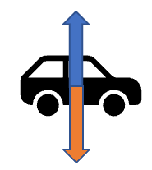 | 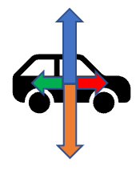 | 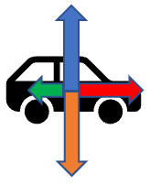
Arrow key:
- Orange arrow: weight force
- Blue arrow: reaction force
- Red arrow: thrust
- Green: frictional forces
Think about the following question: What information does the arrow size and direction give?
Table 7 – force diagram for the vertical jump
Standing still on the ground before jumping | Feet have just left the ground | At the peak of the jump | Just before the feet touch the ground | Standing still after the jump has finished

Notes for teachers
The human skeletal system is introduced in this modelling activity. First, students will need to watch the YouTube videos demonstrating how to make some basic joints in the human body and examine the printout of the skeletal system. From this, students create a working model of the skeletal system to analyse the vertical jump.
This would also be a good opportunity to discuss the benefits and limitations of models for building our understanding processes, such as the vertical jump.
Alternatively, if a model skeletal system is available, the vertical jumping motion can be demonstrated to the class and analysed together.
Student responses to the questions may include the following points.
- Every person has a different structure and size to their skeletal system. To make an accurate model of a specific person, you need measurements of each bone. A generic model created would just show approximate sizes as an average.
- By using a model, we see how the skeletal systems move and the type of joint that supports the movement. However, the model does not show which muscles are involved in the movement and how they move the joints.
- The vertical jump can be improved by either working on the technical aspects of your jump and/or building your muscles in the core areas. The type of muscles and other genetic factors will limit on how much you can improve.

Activity 2: introduction to the human musculoskeletal system
The musculoskeletal system includes bones, muscles, tendons, ligaments and soft tissues. They work together to support your body’s weight and help you move.
Using the supplied printout (found on page 18) of the human skeletal system and/or the information on building joints in the human body, construct:
- a complete skeleton that can perform the movements of the vertical jump
- the lower limbs only (hip down) that can perform the movements of the vertical jump
Table 8 – modelling human joints
Type of joint | Link
Hinge | Body Joints – Hinge | ThinkTac | DIY Science (5:56)
Ball – socket | Body Joints – Ball –– Socket Joint version 2 | ThinkTac (3:55)
Ball – socket | Body Joints – Ball-Socket Joint | ThinkTac | Science Experiment (3:11)
Gliding | Body Joints – Gliding | ThinkTac (2:13)
Student questions:
- What aspects of jumping does your model reflect clearly?
- What aspects of jumping cannot be observed in your model?
Watch the video ‘Chicken Wing Dissection for Skeletal & Muscular Systems’ (6:00).
- Explain how the human muscular system supports the movement needed in a vertical jump.
- Do you think it is possible to improve your vertical jump?

Notes for teachers
This next activity could be done in conjunction with the PDHPE faculty and promote cross-curriculum learning for students.
For this activity, students design and conduct an investigation to assess mathematical models to calculate the power required for a vertical jump. If students are conducting the vertical jump, it is important for them to wear appropriate clothing, warm up, choose a suitable venue, and undertake a risk assessment.
Students will choose an equation to work with and design an investigation to measure the power output of a vertical jump.
This activity can be extended into a student research project in which they can investigate the impact of a single variable on jump height. These could include:
- use of counter-movement of arms
- the depth of squat before jumping
- the width of stance (between feet).
Students may want to use Microsoft Excel to enter their data and use Excel’ s functions to calculate the power. This could also allow students to record multiple trails, calculate averages and select appropriate visual representations (Graphing).

Activity 3 (extension): sport Science in action
The vertical jump is sometimes used to determine an athlete's lower body power. Watch the following clip: Why It's Almost Impossible to Jump Higher Than 50 Inches | WIRED (11:46).
Many mathematical models attempt to calculate power from a vertical jump indirectly. The equations below are 3 examples.
Choose ONE mathematical model shown below and design an experiment to calculate the power of a vertical jump using this model (equation).
- Lewis Formula: $Average Power \left(Watts\right)= \sqrt{4.9 ×body mass (kg)}×\sqrt{jump reach score (m)}×9.81$
- Sayers Formula: $PAPw \left(Anaerobic Power output\right)=60.7 ×jump height \left(cm\right)+45.3 ×body mass \left(kg\right)-2055$
- Bosco Formula: $Average power generated (W) = \frac{(Total flight time × Test duration ×gravity ×2 )}{4×number of jumps ( test duration-total flight time) }$
*Test duration from 15 to 60 seconds
Discussion points:
- How will you fairly measure the variables to test the relationship shown in the equation?
- How many trials will you complete for each equation, and how will you use the data?
- Can you fairly compare results from different equations? Support your answer with an explanation.
- What further questions do you have regarding using formulae to calculate power required for a vertical jump?
Students who experience explicit teaching practices make greater learning gains than students who do not experience these practices. Explicit teaching recognises that learning is a cumulative and systematic process. Explicit teaching helps students develop sophisticated and well-organised ways of thinking, understanding and doing.
CESE What works best: 2020 update

Student resources

Activity 1: skeletal system printout
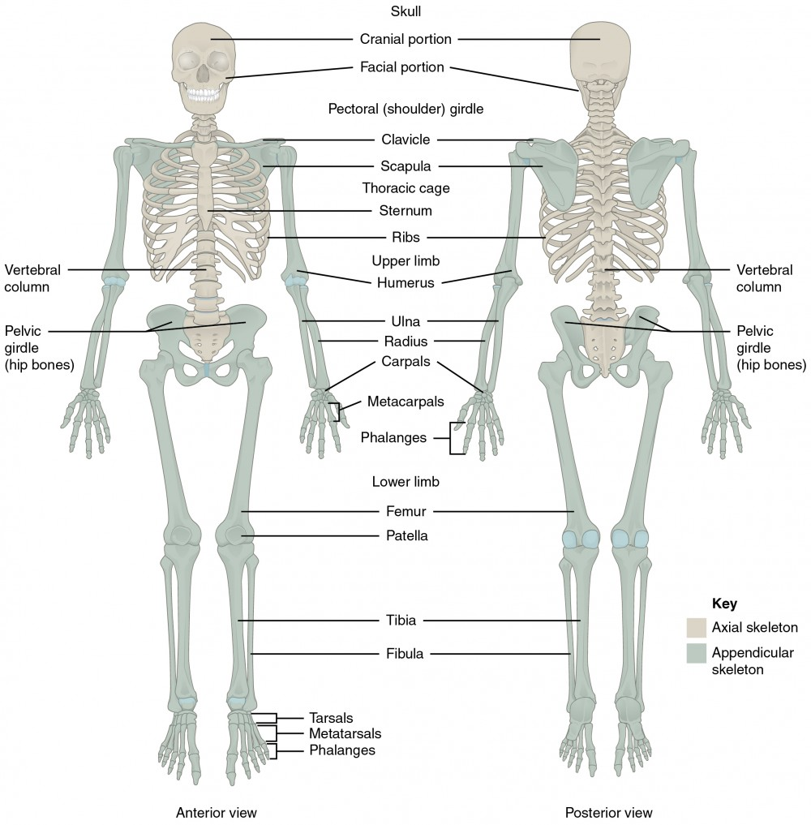
‘Axial Skeleton’ by OpenStax College is licensed under CC BY 4.0.

Support and alignment
Resource evaluation and support: All curriculum resources are prepared through a rigorous process. Resources are periodically reviewed as part of our ongoing evaluation plan to ensure currency, relevance and effectiveness. For additional support or advice, or to provide feedback, contact the Science Curriculum team by emailing Science7-12@det.nsw.edu.au.
Differentiation: Further advice to support Aboriginal and Torres Strait Islander students, EALD students, students with a disability and/or additional needs and High Potential and gifted students can be found on the Planning, programming and assessing 7-12 webpage.
Assessment: Further advice to support formative assessment is available on the Planning, programming and assessing 7-12 webpage.
Professional learning: Relevant professional learning is available on the Science statewide staffroom.
Related resources: Further resources to support Stage 4 Science can be found on the Science Curriculum page.
Consulted with: Curriculum and Reform, Inclusive Education, Multicultural Education,
Aboriginal Outcomes and Partnerships and subject matter experts.
Alignment to system priorities and/or needs: School Excellence Policy, School Success Model.
Alignment to the School Excellence Framework: This resource supports the School Excellence Framework elements of curriculum (curriculum provision) and effective classroom practice (lesson planning, explicit teaching).
Alignment to Australian Professional Teaching Standards: This resource supports teachers to address Australian Professional Teaching Standards 3.2.2, 3.3.2.
Author: Science 7-12 Curriculum Team
Resource: Classroom resource
Creation date: 1 September 2022

References
This resource contains NSW Curriculum and syllabus content. The NSW Curriculum is developed by the NSW Education Standards Authority. This content is prepared by NESA for and on behalf of the Crown in right of the State of New South Wales. The material is protected by Crown copyright.
Please refer to the NESA Copyright Disclaimer for more information https://educationstandards.nsw.edu.au/wps/portal/nesa/mini-footer/copyright.
NESA holds the only official and up-to-date versions of the NSW Curriculum and syllabus documents. Please visit the NSW Education Standards Authority (NESA) website https://educationstandards.nsw.edu.au/ and the NSW Curriculum website https://curriculum.nsw.edu.au/home.
NSW Science Year 7-10 Syllabus © NSW Education Standards Authority (NESA) for and on behalf of the Crown in right of the State of New South Wales, 2018.
AFL (Australian Football League) (7 December 2021) 'Best of 2021: High-flying marks from the AFL season | AFL' [video], AFL, YouTube, accessed 1 September 2022.
CESE (Centre for Education Statistics and Evaluation) (2020a) What works best: 2020 update, NSW Department of Education, accessed 22 Aug 2022.
CESE (Centre for Education Statistics and Evaluation) (2020b) What works best in practice, NSW Department of Education, accessed 22 Aug 2022.
Epic Volleyball (18 December 2020) 'Crazy Volleyball Spikes by Yuji Nishida' [video], Epic Volleyball, YouTube, accessed 1 September 2022.
ESPN (26 November 2017) 'Dwight Howard: Superman | Sport Science | ESPN Archives' [video], ESPN, YouTube, accessed 1 September 2022.
ESPN (29 January 2022) 'The science behind Ja Morant's explosiveness | NBA Today' [video], ESPN, YouTube, accessed 1 September 2022.
Gonzalez R (25 September 2018) 'Why It's Almost Impossible to Jump Higher Than 50 Inches | WIRED' [video], WIRED, YouTube, accessed 1 September 2022.
Hall N (30 June 2022) ‘Newton’s Laws of Motion', NASA Glenn Research Center, accessed 1 September 2022.
Morgan A (13 March 2020) 'Chicken Wing Dissection for Skeletal & Muscular Systems' [video], Suburban Science, YouTube, accessed 1 September 2022.
Muller D (11 March 2011) 'Three Incorrect Laws of Motion' [video], Veritasium, YouTube, accessed 1 September 2022.
Muller D (18 February 2011) 'What is a Force?' [video], Veritasium, YouTube, accessed 1 September 2022.
Muller D (19 February 2011) 'What Forces Are Acting On You?' [video], Veritasium, YouTube, accessed 1 September 2022.
NESA (NSW Education Standards Authority) (2022) ‘Proficient teacher: standard descriptors’, The Standards, NESA website, accessed 22 August 2022.
Nonstop Sports (22 May 2020) 'Top 10 Highest Vertical Jumps In NBA History' [video], Nonstop Sports, YouTube, accessed 1 September 2022.
Olympics (22 August 2016) 'Canada's Drouin wins gold in Men's High Jump' [video], Olympics, YouTube, accessed 1 September 2022.
Parry A (5 February 2022) ‘Vertical Jump Test Explained: Normative Data & Considerations’, Sport Science Insider, accessed 1 September 2022.
Serie A (19 December 2019) 'Ronaldo Scores Insane Goal With Giant Leap! | Sampdoria 1-2 Juventus | Top Moment | Serie A TIM' [video], Serie A, YouTube, accessed 1 September 2022.
The Oregonian (10 July 2015) 'Watch Josh Imatorbhebhe's 47.1 inch vertical jump' [video], The Oregonian, YouTube, accessed 1 September 2022.
ThinkTac (11 September 2021) 'Body Joints – Hinge | ThinkTac | DIY Science' [video], ThinkTac, YouTube, accessed 1 September 2022.
ThinkTac (16 April 2019) 'Body Joints – Ball-Socket Joint | ThinkTac | Science Experiment' [video], ThinkTac, YouTube, accessed 1 September 2022.
ThinkTac (29 July 2020) 'Body Joints – Gliding | ThinkTac' [video], ThinkTac, YouTube, accessed 1 September 2022.
ThinkTac (9 January 2019) 'Body Joints – Ball -- Socket Joint version 2 | ThinkTac' [video], ThinkTac, YouTube, accessed 1 September 2022.
Wood R (13 July 2022) ‘Bosco Repeat Vertical Jump’, Bosco, Topend Sports website, accessed 1 September 2022.
Wood R (13 July 2022) ‘Vertical Jump Power Calculators’, Vertical Jump, Topend Sports website, accessed 1 September 2022.

Further reading
State of New South Wales (Department of Education)(2022) Literacy and numeracy priorities, NSW Department of Education, accessed 24 February 2023.
State of New South Wales (Department of Education)(2022) Literacy and numeracy, NSW Department of Education, accessed 24 February 2023.
State of New South Wales (Department of Education) Strategies for differentiation (nsw.gov.au), NSW Department of Education, accessed 10 January 2023.

© State of New South Wales (Department of Education), 2023
The copyright material published in this resource is subject to the Copyright Act 1968 (Cth) and is owned by the NSW Department of Education or, where indicated, by a party other than the NSW Department of Education (third-party material).
Copyright material available in this resource and owned by the NSW Department of Education is licensed under a Creative Commons Attribution 4.0 International (CC BY 4.0) licence.
This licence allows you to share and adapt the material for any purpose, even commercially.
Attribution should be given to © State of New South Wales (Department of Education), 2023.
Material in this resource not available under a Creative Commons licence:
- the NSW Department of Education logo, other logos and trademark-protected material
- material owned by a third party that has been reproduced with permission. You will need to obtain permission from the third party to reuse its material.
Links to third-party material and websites
Please note that the provided (reading/viewing material/list/links/texts) are a suggestion only and implies no endorsement, by the New South Wales Department of Education, of any author, publisher, or book title. School principals and teachers are best placed to assess the suitability of resources that would complement the curriculum and reflect the needs and interests of their students.
If you use the links provided in this document to access a third-party's website, you acknowledge that the terms of use, including licence terms set out on the third-party's website apply to the use which may be made of the materials on that third-party website or where permitted by the Copyright Act 1968 (Cth). The department accepts no responsibility for content on third-party websites.

