Health and movement science Stage 6 (Year 11)
The collaborative investigation process
Contents
Overview 3
Purpose 4
Step 1 – forming a group 5
Research or investigation activities 5
Collaboration strategies or activities 5
Step 2 – identifying areas of interest 7
Research or investigation activities 7
Collaboration strategies or activities 7
Step 3 – collecting, analysing and recording secondary data 9
Research or investigation activities 9
Collaboration strategies or activities 9
Step 4 – developing a research question 11
Research or investigation activities 11
Collaboration strategies or activities 11
Step 5 – selecting research methods 13
Research or investigation activities 13
Collaboration strategies or activities 14
Step 6 – creating methodologies to collect data 15
Research or investigation activities 15
Collaboration strategies or activities 15
Step 7 – applying research methods to collect data 17
Research or investigation activities 17
Collaboration strategies or activities 17
Step 8 – interpreting and analysing research to determine findings 19
Research or investigation activities 19
Collaboration strategies or activities 19
Step 9 – drawing conclusions from the research 21
Research or investigation activities 21
Collaboration strategies or activities 21
Step 10 – presenting findings to class or panel of experts 22
Research or investigation activities 22
Collaboration strategies or activities 22
Additional information 23
Support and alignment 23
References 25
This resource has been developed to assist teachers in NSW Department of Education schools to create learning that is contextualised to their classroom. It can be used as a basis for the teacher’s own program, assessment, or scope and sequence, or be used as an example of how the new curriculum could be implemented. The resource has suggested timeframes that may need to be adjusted by the teacher to meet the needs of their students.

Overview
In Health and movement science Year 11, students engage in a Collaborative Investigation. Students work collaboratively to investigate an agreed topic aligned with content and concepts explored throughout coursework. Completion of the investigation forms a component of the mandatory coursework for Health and movement science Year 11. Teachers can decide when and how a Collaborative Investigation is undertaken.
Participation in the investigation allows students to build and extend their subject knowledge and develop a range of skills to apply their knowledge and understanding. The focus of the investigation is on the knowledge and understanding, skills and processes involved, and the findings of the investigation.

Purpose
This document outlines the 10-step process which could be undertaken to complete a Collaborative Investigation within groups. For each step, the processes for research or investigation have been outlined.
Accompanying collaboration strategies, which may be important or observable at each step, are also suggested. These may not be the only processes or strategies for each step. Teachers and students can make judgements based on their context.
Figure 1 – collaborative investigation 10-step process
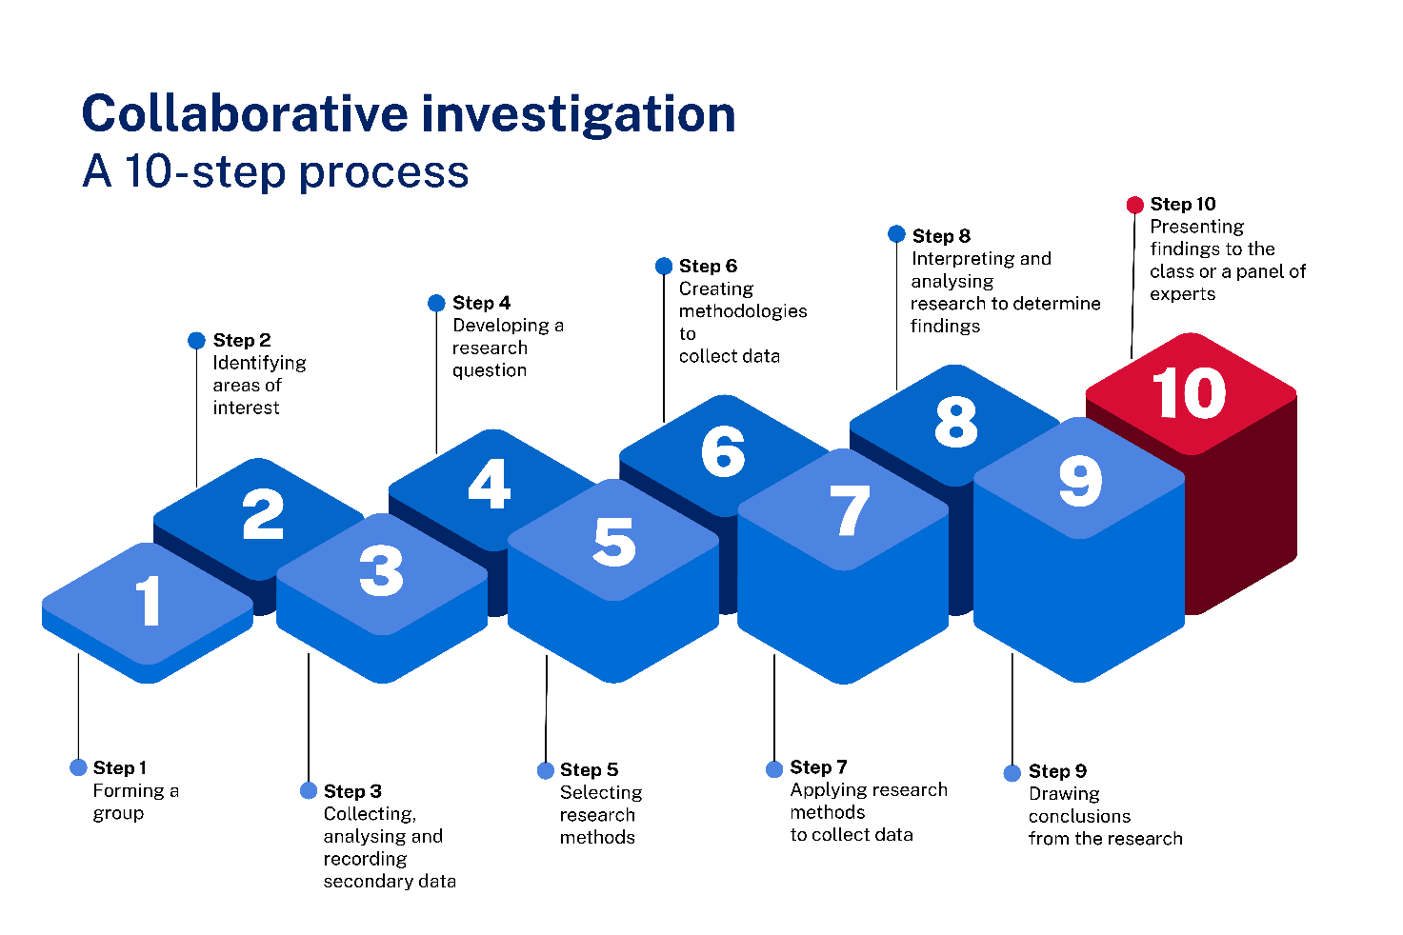

Step 1 – forming a group
The purpose of this step is for group members to become oriented with each other and to establish group norms, boundaries, processes and expectations.
Groups can be formed:
- at the beginning of the process to allow for collaborative discussion of expectations, areas of interest, and roles and responsibilities
- after students have individually identified their areas of interests, so that groups are formed based on area of interest
- after collecting and analysing secondary data.

Research or investigation activities
- Establish groupings – teacher or student directed
- Discuss and establish norms, expectations, processes, boundaries and standards
- Create a contract to promote on-task behaviours and accountability for individual actions and responsibilities
- Discuss roles required for the investigation process and characteristics of each role
- Identify strengths of group members
- Allocate roles and responsibilities based on the strengths of group members

Collaboration strategies or activities
- Communicate needs and how they can be met
- Identify and apply own strengths to participate in the group
- Assess own ability and contribute to the group
- Establish clear boundaries and expectations, for example, group contract or agreement
- Assess the ability, needs and strengths of others for group success
- Discuss individual and group responsibilities
- Share responsibility for the tasks to reach a common goal
- Match responsibilities with expertise where possible
- Set goals based on individual responsibility and group progress

Step 2 – identifying areas of interest
The purpose of this step is for group members to review the syllabus content and identify areas of interest across the core content which they would be interested in investigating further. Collectively, the group shares ideas and narrows down to a group-based area of interest.

Research or investigation activities
- Brainstorm areas with a direct link to the Health and Movement Science 11–12 Syllabus content that sparks interest for members of the group
- Narrow areas of interest to opportunities for investigation which promote collaboration and are accessible
- Discuss population or target groups
- Brainstorm existing sources of primary and secondary data
- Predict the resources required to investigate the areas of interest, issues or focuses
- Discuss links and connections between ideas to include the contribution of others
- Negotiate interests, issues and focuses
- Finalise the interest, issue and focus for the investigation

Collaboration strategies or activities
- Make quality and relevant contributions
- Actively listen to understand others
- Modify communication style where necessary
- Tailor explanations for different group members
- Acknowledge others’ perspectives
- Discuss difference of opinion or perspective
- Come to an agreement where opinions differ or conflict arises
- Negotiate the most effective approach to completing the task for the greater good of the group
- Assess the ability, needs and strengths of others for group success
- Support others to understand the task or perform their role

Step 3 – collecting, analysing and recording secondary data
The purpose of this step is for group members to identify and review secondary sources to further refine their area of interest for investigation. Collaboratively reviewing, recording and discussing information from secondary sources will build a shared understanding of the existing findings and gaps, before moving into creating a group research question or selecting methods for collecting primary data.

Research or investigation activities
- Create a document that stores all sources of secondary data and credit them to ensure integrity
- Identify reliable and credible sources of primary and secondary data relevant to the group’s investigation issue or focus
- Allocate roles and responsibilities to access appropriate secondary sources, for example, healthcare data, newspaper articles and images, or information in a published report and collect secondary data
- Review and communicate the focus of previous research collected and findings from each secondary source such as sample group and size, and types and sources of data, for example, individuals and groups, print and digital
- Report back to the group, identifying common themes, findings or gaps across the sources
- Discuss the relevant variables for the interest, issue and focus
- Review and refine the relevant variables based on the secondary data
- Create a reference list

Collaboration strategies or activities
- Pool resources and information, including:
- tangible resources such as equipment, space, technology
- primary and secondary knowledge and understanding, skills, expertise.
- Take personal responsibility for tasks
- Share responsibility for the tasks to reach a common goal
- Perform responsibilities assigned by the collective group
- Review the group contract and make any required changes:
- discuss individual and group responsibilities
- share roles between group members
- match responsibilities with expertise where possible.
- Enhance own understanding as a result of the perspectives, understanding or contributions of others
- Support others to understand the task or perform their role
- Monitor own and others’ contribution to the group and overall progress

Step 4 – developing a research question
The purpose of this step is for group members to negotiate their final topic or issues based on the review of secondary sources. They then develop a research question for investigation. Using an evaluative process, they interrogate their question to ensure it meets their investigation needs.

Research or investigation activities
- Negotiate the final topic, content, issue, and population or target group based on secondary source reviews, findings and gaps
- Create potential research questions individually related to the final agreed topic, content or issue for the investigation
- Present questions to the group
- Use a guide, such as the Relevant, Answerable, Focused, Timed, Ethical and Resourced (RAFTER) model, to make judgements on the suitability of each question
- Discuss each question and resolve differences in opinion
- Establish a consensus and agree on the final research question

Collaboration strategies or activities
- Initiate communication with others suitable to the purpose of the task:
- actively listen to understand others
- modify communication style where necessary
- tailor explanations for different group members.
- Perform responsibilities assigned by the collective group
- Identify and evaluate different options and pathways towards a common goal
- Provide constructive feedback on others’ participation or communication in the group
- Discuss difference of opinion or perspectives
- Come to an agreement where opinions differ or conflict arises
- Negotiate the most effective approach to completing the task for the greater good of the group
- Share responsibility for the tasks to reach a common goal
- Make quality and relevant contributions
- Take personal responsibility
- Discuss individual and group responsibilities
- Share roles between group members
- Adapt roles or group composition if necessary
- Access assistance or feedback where required

Step 5 – selecting research methods
The purpose of this step is for group members to identify and select the most suitable research methods for their investigation and their question.
Data collection (5:16) involves 2 methods, primary and secondary.
Primary data collection is firsthand data that the researcher gathers themselves. Secondary data collection involves accessing data that has been collected by someone else.
Decisions and discussions focus on ethical and safety considerations when managing the investigation and the participants. Access the Investigation and research support booklet for more details. This will be published on the Planning, programming and assessing PDHPE 11-12 curriculum webpage.

Research or investigation activities
- Identify the most suitable research methods for the research question or problem
- Discuss whether the group has the training, skills and knowledge of sensitivities to apply this research method to the research question or problem. Where the group does not possess what is required, discuss the use of secondary research methods
- Discuss ethical considerations for each research method and record how the group will apply each throughout the investigation, for example. informed consent, integrity, privacy and respect
- Discuss any safety considerations or risks to be managed in conducting the research
- Discuss and record how the group will ensure reliability, validity and credibility of their research and data
- Evaluate the suitability of each research method based on the research question, data or evidence required, ethical considerations and access to resources (for example, people, time, equipment, technology):
- decide if a chosen data method is suitable for the question
- determine if suitable data can be collected to help answer it
- consider whether the data and methods of collecting, recording and using the data are ethical
- consider group access to resources to conduct this research method and collect the data.

Collaboration strategies or activities
- Identify and apply own strengths to participate in the group
- Actively listen to understand others
- Identify and evaluate different options and pathways towards a common goal
- Tailor explanations for different group members
- Discuss difference of opinion or perspective
- Come to an agreement where opinions differ or conflict arises
- Negotiate the most effective approach to completing the task for the greater good of the group
- Make quality and relevant contributions
- Acknowledge others’ perspectives
- Comprehend others’ understanding
- Enhance own understanding as a result of the perspectives, understanding or contributions of others
- Perform responsibilities assigned by the collective group
- Match responsibilities with expertise where possible
- Discuss individual and group responsibilities
- Access assistance or feedback where required

Step 6 – creating methodologies to collect data
The purpose of this step is for group members to develop their plan for conducting the investigation. Groups will establish, create and/or test the processes, tools and methods to ensure reliability, validity and credibility.

Research or investigation activities
- Create the plan for conducting the research, including how ethical considerations, safety considerations and risk will be managed
- Develop each research method, instruction and protocols for primary data collection, for example, questionnaire, practical application or lab protocol and recording sheet, observation sheet, interview questions, environment, instructions, equipment
- Discuss processes for secondary data collection, for example, storage, coding, credibility of sources
- Test, review and evaluate each research method using group members or other members of the class to check reliability and validity

Collaboration strategies or activities
- Assess own ability and contribution back to the group
- Identify and evaluate different options and pathways towards a common goal
- Negotiate the most effective approach to completing the task for the greater good of the group
- Discuss difference of opinion or perspective
- Discuss individual and group responsibilities
- Share responsibility for the tasks to reach a common goal
- Share roles between group members
- Match responsibilities with expertise where possible
- Perform responsibilities assigned by the collective group
- Comprehend others’ understanding
- Access assistance or feedback where required

Step 7 – applying research methods to collect data
The purpose of this step is for group members to apply their processes, tools and methods to collect data, and ensure reliability, validity and credibility.

Research or investigation activities
- Allocate roles and responsibilities to access and collect data
- Identify, source and test resources for testing and recording
- Organise access to the target or population group or secondary sources
- Seek informed consent from research participants
- Implement the research methods to collect and record data
- Use an established process and system to record and share results and data between group members

Collaboration strategies or activities
- Identify and apply own strengths to participate in the group
- Identify and evaluate different options and pathways towards a common goal
- Negotiate the most effective approach to completing the task for the greater good of the group
- Monitor own and others’ contributions to the group and overall progress
- Discuss individual and group responsibilities
- Share responsibility for the tasks to reach a common goal
- Perform responsibilities assigned by the collective group
- Persist with tasks when challenged
- Acknowledge others’ perspectives
- Comprehend others’ understanding
- Enhance own understanding as a result of the perspectives, understanding or contributions of others
- Access assistance or feedback where required

Step 8 – interpreting and analysing research to determine findings
The purpose of this step is for group members to simplify, decode and extract meaning from the data they have collected. This involves presenting data in a variety of ways to enable group members to interpret the data, identify trends and construct meanings to draw conclusions. As students share findings as a group, they should analyse and discuss any primary data findings in relation to their research question and secondary data findings. Access the Investigation and research support booklet for more information on analysing data and presenting findings. This will be published on the Planning, programming and assessing PDHPE 11-12 curriculum webpage.

Research or investigation activities
- De-identify the results by use of a coding system for each individual to ensure privacy
- Organise data into graphs, tables and organised transcripts to assist in identifying trends
- Look at results individually to determine some key themes and findings
- Share findings as a group and discuss primary data in relation to the research question and secondary data findings
- Identify what information is important and what is not needed
- Evaluate the depth and quality of information in relation to the research question
- Determine if the data and information is enough or whether secondary sources or more primary data is required

Collaboration strategies or activities
- Initiate communication with others suitable to the purpose of the task
- Actively listen to understand others
- Modify communication style where necessary
- Tailor explanations for different group members
- Provide constructive feedback on others’ participation or communication in the group
- Pool resources and information
- Discuss difference of opinion or perspective
- Share responsibility for the tasks to reach a common goal
- Make quality and relevant contributions
- Acknowledge others’ perspectives
- Enhance own understanding as a result of the perspectives, understanding or contributions of others
- Access assistance or feedback where required
- Monitor own and others’ contributions to the group and overall progress

Step 9 – drawing conclusions from the research
The purpose of this step is for group members to answer their research questions by drawing conclusions from the research findings.

Research or investigation activities
- Draw conclusions from the findings to answer the research question, prove or disprove a hypothesis
- Ask relevant questions to deepen individual and group understanding of the content, issue or findings
- Identify relationships across the findings and compare to secondary data
- Discuss links and connections between ideas to include the contribution of others
- Develop arguments and justifications for the data and findings and discuss as a group

Collaboration strategies or activities
- Make quality and relevant contributions
- Actively listen to understand others
- Acknowledge others’ perspectives
- Discuss difference of opinion or perspective
- Come to an agreement where opinions differ or conflict arises
- Enhance own understanding as a result of the perspectives, understanding or contributions of others
- Support others to understand the task or perform their role

Step 10 – presenting findings to the class or a panel of experts
The purpose of this step is for students to present what they have concluded and found through their investigation. This could be presented individually or as a group.

Research or investigation activities
- Determine the best way to present the findings, for example, verbal explanation, infographic, report, presentation, video
- Present findings
- Credit sources of data in a reference list

Collaboration strategies or activities
- Assess own ability and contributions back to the group
- Modify communication style where necessary
- Make quality and relevant contributions
- Negotiate the most effective approach to completing the task for the greater good of the group
- Evaluate own strengths and weaknesses in relation to the group
- Share responsibility for the tasks to reach a common goal
- Perform responsibilities assigned by the collective group
- Share roles between group members
- Pool resources and information
- Support others to understand the task or perform their role

Additional information
The information below can be used to support teachers when using this teaching resource for Health and movement science.

Support and alignment
Resource evaluation and support: all curriculum resources are prepared through a rigorous process. Resources are periodically reviewed as part of our ongoing evaluation plan to ensure currency, relevance and effectiveness. For additional support or advice, contact the PDHPE Curriculum team by emailing PDHPEcurriculum@det.nsw.edu.au.
Alignment to system priorities and/or needs: School Excellence Policy, School Success Model
Alignment to the School Excellence Framework: this resource supports the School Excellence Framework elements of curriculum (curriculum provision) and effective classroom practice (lesson planning, explicit teaching).
Alignment to Australian Professional Teaching Standards: this resource supports teachers to address Australian Professional Teaching Standards 3.2.2, 3.3.2.
Consulted with: Curriculum and Reform and subject matter experts
NSW syllabus: Health and Movement Science 11–12 Syllabus
Syllabus outcomes: HM-11-05
Author: PDHPE Curriculum Team
Publisher: State of NSW, Department of Education
Resource: Learning program
Related resources: further resources to support Health and movement science Stage 6 can be found on the Planning, programming and assessing PDHPE 11-12 curriculum webpage and the HSC hub.
Professional learning: relevant professional learning is available through the PDHPE statewide staffroom.
Universal Design for Learning: Curriculum planning for every student in every classroom. Support the diverse learning needs of students using inclusive teaching and learning strategies.
Creation date: 5 October 2023
Rights: © State of New South Wales, Department of Education.

References
This resource contains NSW Curriculum and syllabus content. The NSW Curriculum is developed by the NSW Education Standards Authority. This content is prepared by NESA for and on behalf of the Crown in right of the State of New South Wales. The material is protected by Crown copyright.
Please refer to the NESA Copyright Disclaimer for more information https://educationstandards.nsw.edu.au/wps/portal/nesa/mini-footer/copyright.
NESA holds the only official and up-to-date versions of the NSW Curriculum and syllabus documents. Please visit the NSW Education Standards Authority (NESA) website https://educationstandards.nsw.edu.au/ and the NSW Curriculum website https://curriculum.nsw.edu.au/home.
Health and Movement Science 11–12 Syllabus © NSW Education Standards Authority (NESA) for and on behalf of the Crown in right of the State of New South Wales, 2023.

© State of New South Wales (Department of Education), 2023
The copyright material published in this resource is subject to the Copyright Act 1968 (Cth) and is owned by the NSW Department of Education or, where indicated, by a party other than the NSW Department of Education (third-party material).
Copyright material available in this resource and owned by the NSW Department of Education is licensed under a Creative Commons Attribution 4.0 International (CC BY 4.0) license.
This license allows you to share and adapt the material for any purpose, even commercially.
Attribution should be given to © State of New South Wales (Department of Education), 2023.
Material in this resource not available under a Creative Commons license:
- the NSW Department of Education logo, other logos and trademark-protected material
- material owned by a third party that has been reproduced with permission. You will need to obtain permission from the third party to reuse its material.
Links to third-party material and websites
Please note that the provided (reading/viewing material/list/links/texts) are a suggestion only and implies no endorsement, by the New South Wales Department of Education, of any author, publisher, or book title. School principals and teachers are best placed to assess the suitability of resources that would complement the curriculum and reflect the needs and interests of their students.
If you use the links provided in this document to access a third-party's website, you acknowledge that the terms of use, including licence terms set out on the third-party's website apply to the use which may be made of the materials on that third-party website or where permitted by the Copyright Act 1968 (Cth). The department accepts no responsibility for content on third-party websites.

