Health and movement science Stage 6 (Year 11) – depth study – energy systems

Contents
Overview 2
Purpose 3
Syllabus 4
Outcomes 4
Content 4
Depth study instruction 5
Practical experience 1 – phosphate recovery test (ATP-PCr) 6
Practical experience 2 – 400-metre sprint (Glycolytic or Lactic Acid System) 8
Practical experience 3 – 1.6-kilometre run or walk (Aerobic System) 13
Practical experience 4 – touch football or netball (interplay of energy systems) 15
Biathlon 18
Final product and submission 21
The task 21
Case study 21
The submission 21
Marking guidelines 23
Support and alignment 25
References 27
This resource has been developed to assist teachers in NSW Department of Education schools to create learning that is contextualised to their classroom. It can be used as a basis for the teacher’s own program, assessment, or scope and sequence, or be used as an example of how the new curriculum could be implemented. The resource has suggested timeframes that may need to be adjusted by the teacher to meet the needs of their students.

Overview
The following depth study is provided as a guide. External resources embedded throughout should not be considered endorsed.
Preview, evaluate and adjust all strategies, resources and teaching and learning approaches in full before use with students to determine suitability for student learning needs, stage of development and local school context.
This depth study is intended to be completed in Year 11 as part of Core 2 – The body and mind in motion. The depth study is designed to be assessable.
Ten hours have been allocated to this depth study.
Before undertaking this depth study, students should have:
- demonstrated sound understanding of the energy systems including fuel source and efficiency of ATP production, duration, intensity, rate of recovery, causes of fatigue and interplay of the energy systems
- previously completed a depth study or collaborative investigation.
This depth study is designed to be implemented at the time the identified syllabus content is being delivered.
The Year 11 Core 2 – sample assessment task accompanies this depth study to formally assess application of energy systems learning. This sample assessment task program can be accessed on the Planning, programming and assessing PDHPE 11–12 curriculum webpages.
Opportunities for reflection and adjustments can be made depending on student interest.

Purpose
This depth study provides students with opportunities to consolidate their knowledge and understanding of the ATP-PCr, Glycolytic (Lactic Acid) and Aerobic energy systems of the body through participation in a series of practical activities.
Questions are provided to support students to analyse fuel source and efficiency of ATP production, duration, intensity and rate of recovery, causes of fatigue and interplay of the energy systems in relation to each practical activity.
Students will participate in a range of practical activities and observe and record the body’s reactions and responses. Participation in the practical activities provide opportunities for students to apply concepts through movement and physical experience. It brings the learning to life through creating memories and experiences to call on.
Students will have the opportunity to consolidate their learning on the relationships between the respiratory and circulatory systems including pulmonary and systemic blood circulation, gaseous exchange and factors that impact on the efficiency of the cardiovascular system. The depth study will also develop student knowledge and understanding of the immediate physiological responses to training, types of training and the FITT principle.
The use of a biathlon promotes application of the learning to an unfamiliar sport. When students move into Year 12 content, they are expected to examine the relationships between principles of training, physiological adaptations and improved performance. The memories and experiences from this depth study can be called on to build on concepts related to training energy systems for physiological adaptations and promotes application of learning to a variety of sports.

Syllabus
The following syllabus outcomes and content are addressed if all the teaching activities are completed. Teachers are to use their professional judgement to ensure suggested syllabus content is addressed.

Outcomes
A student:
- analyses the systems of the body in relation to movement HM-11-03
- Analysis: analyses the relationships and implications of health and movement concepts HM-11-06
- Communication: communicates health and movement concepts to audiences and contexts, using a variety of modes HM-11-07

Content
What factors influence movement and performance?
- Analyse the ATP-PCr, Glycolytic (Lactic Acid) and Aerobic energy systems of the body including fuel source and efficiency of ATP production, duration, intensity and rate of recovery, causes of fatigue and interplay of the energy systems

Depth study instruction
Inquiry question – What is the interrelationship between the energy, respiratory and circulatory systems in response to movement?
Task: students participate in a series of practical experiences. It is recommended that each practical experience occurs in a separate lesson.
Note: students should complete a thorough warm up before undertaking any of the practical experiences in each lesson. On conclusion of the practical, students should participate in a cool down to restore their body to pre-exercise state.
Evidence of learning:
Use a whole class debrief or check-in after each practical experience to discuss results, answer the related questions and consolidate the content and its application.
Formative assessment opportunity:
Gather evidence of learning from the questions at the completion of each practical experience.
Use a whole class guided activity to apply knowledge gained through the practical experiences to a hypothetical biathlon event where the interplay of energy systems are essential for success.
A final assessment submission involves students applying their learning to a case study of an athlete in a sporting situation. This task can be used as formative assessment.
For teachers who choose to use this task as a formal summative assessment, access the Year 11 Core 2 – sample assessment task. This assessment task can be accessed on the Planning, programming and assessing PDHPE 11–12 curriculum webpages.

Practical experience 1 – phosphate recovery test (ATP-PCr)
The phosphate recovery test is an anaerobic capacity fitness test, designed to assess the ability of an individual to recover between sprints and produce the same level of power repeatedly.
The test involves 6 maximal sprints over 35 metres with 30 seconds recovery time between each sprint.

Equipment
- Measured distance of 35 metres – tape measure, markers
- Whistle
- Recording sheets or devices
- Stopwatches
- Heart rate (HR) monitor (phone or tracking device can be used)

Procedure
- Students work in pairs. One student adopts the role of runner and the other adopts the role of timekeeper and recorder.
- Record resting heart rate (RHR) and breathing rate (rate and depth) prior to any physical activity taking place including warm up.
- Record thoughts, emotions and physical feelings about completing this activity such as motivation levels, feelings in legs and overall body.
- Make predictions about how your body may feel at the end of the 6 sprints and record.
- Timekeepers and recorders stand at the 35-metre line.
- Runners begin at the zero metre or start line and prepares to run towards the 35-metre line.
- On the whistle, they sprint towards and across the 35-metre line, then do a slow jog or walk to the zero metre or start line.
- The sprint is then repeated until 6 sprints have been completed.
- Six sprints are performed in total with 30 seconds between each sprint.
- A 5 second warning is given before each sprint.
- Each sprint is timed to the nearest 0.01 seconds and recorded.
- On a false start, the sprint continues but the timing doesn’t. The false starter completes an extra sprint at the end.
- At the end of each sprint heart rate is recorded.
- Measure and record heart rate each minute thereafter, to establish the time it takes to return to RHR.
- Runners describe their physical response after each sprint to be recorded, such as breathing rate and depth, feelings in legs and overall body response.
- Runners and recorders then reverse roles.

Results
- Sprint time one is recorded and set aside as an original base line time.
- Sprint times 2 through 6 are totalled, averaged and recorded as an average time.
- The performance decrement is then calculated by subtracting the average time from the first time.
- This difference is then expressed as a percentage. This is the performance percentage.
- Record time taken to return to RHR.

Questions
- What was the predominant energy system being used for this activity? Give reasons for your answer.
- What happened to your times from sprint one to sprint 6?
- Describe how your body responded from sprint one to sprint 6. What do you notice? Compare that with others in the class.
- Explain what the body’s response tells you about the energy system being used.
- Outline any factors that may have impacted positively on your performance, such as motivation levels, previous training, rest.
- Outline any factors that may have impacted negatively on your performance such as motivation levels, illness or injury.
- For those that may have false started, what impact did this have? For those that didn’t false start, predict what ways this could make a difference to performance.
- If you trained for this test, what would you expect your percentage score to do and why?
- An average score for an elite athlete is less than 10%. What does your score indicate?
- Suggest ways you could train to improve your performance for this test.

Practical experience 2 – 400-metre sprint (Glycolytic or Lactic Acid System)
The 400-metre sprint is a long sprint test, and a test of anaerobic capacity which is an important fitness attribute for performing short intense bursts of effort.

Equipment
- Measured distance of 400 metres – tape measure, markers
- Whistle
- Recording sheets or devices
- Stopwatches
- Heart rate (HR) monitor (phone or tracking device can be used)

Procedure
- Students work in pairs. One student adopts the role of runner and the other adopts the role of timekeeper and recorder.
- Record resting heart rate (RHR) and breathing rate (rate and depth) prior to any physical activity taking place.
- Record heart rate every minute for 5 minutes prior to sprinting.
- Record thoughts, emotions and physical feelings about completing this activity such as motivation levels, feelings in legs and overall body.
- Make predictions about how your body may feel at the end of the 400-metre sprint and record.
- Timekeepers and recorders stand at the 400 metre or finish line but must be able to observe their partner at all times.
- Runners begin at the zero metre or start line.
- Runners sprint or run at maximal effort for 400 metres. Encourage participants to complete the 400 metres even if they have to jog or walk. The recorded time is necessary data for the task.
- Recorders should record their observations as their partner runs. For example, do they stop, where do they speed up, where do they slow down, what is their body language or posture?
- At the immediate end of the 400-metre sprint, record heart rate (HR). Then continue to record HR every minute after completing the sprint for a total of 7 minutes.
- Record personal observations about breathing rate and depth, feelings in legs and overall body after completing the run.
- Runners and recorders then reverse roles.

Results
- Recorded time at the conclusion of the sprint.
- Recorded HR at the immediate end of the 400-metre sprint.
- Recorded HR for each minute after the sprint up to 7 minutes.
- Graph the heart rate response for pre, during and post 400 metre sprint.

Questions
- What was the predominant energy system being used for this activity? Give reasons for your answer.
- What other energy system(s) contributed to this activity? Provide a brief explanation of their role in the 400-metre sprint.
- Describe how your body responded from the start line to finish line during the 400-metre sprint. What did your partner notice about your sprint and body response? Compare that with others in the class.
- When performing the 400-metre sprint, did you experience muscle fatigue? How do you know this?
- Explain what the body’s response tells you about the energy system(s) being used.
- Outline any factors that may have positively impacted on your performance such as motivation levels, previous training, rest.
- Outline any factors that may have had a negative impact on your performance such as fatigue, dehydration, training the previous day, illness, injury, lack of motivation.
- Graph your own heart rate responses on Figure 1 and breathing ventilation rates on Figure 2.
- Using your knowledge of maximum heart rate, calculate your upper and lower target heart rate (THR) zones and mark this on Figure 1. For this activity, we are assuming all participants are the same age and therefore have the same maximum and target heart rate zones.
Note: maximum heart rate (MHR) can be calculated by using the following formula: MHR = 220 − age. Target heart rate (THR) zone can be calculated by 0.60 × MHR equals the lower end of the target heart rate zone. The upper end of the target heart rate zone is equal to 0.80 × MHR. For example, Sam is 18 years old. His MHR is 202 bpm. His THR zone is between 121–161 bpm. Monitoring heart rate provides an objective measure of exercise intensity. In general, the higher your heart rate during physical activity, the higher the exercise intensity.
- Review Figure 1 and Figure 2 to answer the questions that follow each.
Figure 1 – heart rate response to 400-metre sprint
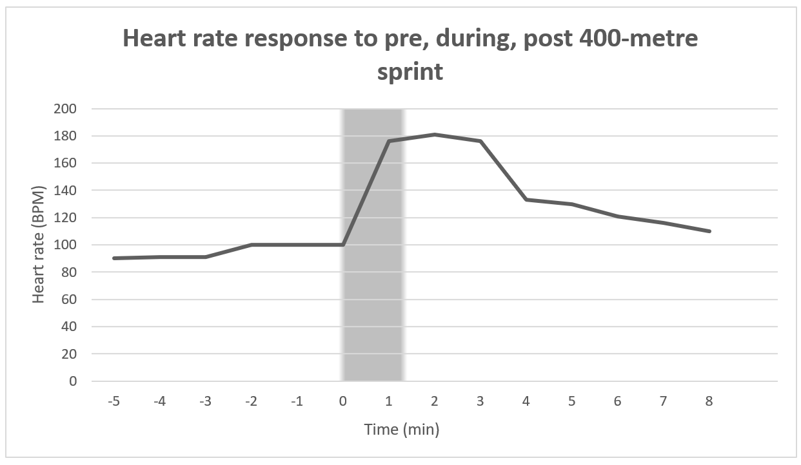
Note: students will need to have graphed their own heart rate responses for the 400-metre sprint to complete the following task.
Figure 1 represents the heart rate of a 17-year-old trained female athlete. This data was collected from a recent 400-metre sprint she completed mid-way through her normal 2-hour training session. Her resting heart rate is 60 beats per minute. Using the results on the graph and your own results that you have added, answer the following questions.
- Look at the graph. What are 3 things you notice?
- At the start of the 400-metre sprint, why are your results similar to that of the trained athlete?
- What similarities and differences do you see between the 2 sets of data?
- Identify possible reasons for the similarities and differences paying attention to pre, during and post 400-metre sprint.
- Imagine that at the 375-metre mark of the 400-metre sprint, you and the other runner represented in Figure 1 are tied. You both give a maximal effort to win the race. Predict which participant would win the race and why?
- Consider the energy system used for this activity. How do you know this?
- How long would each participant need to wait before they could replicate the activity to the same intensity?
- If you were asked to complete another 400-metre sprint within 5 minutes of completing the first, how might your body and mind be feeling?
- How would you know you could replicate this? Give examples.
- Would you expect your time to be quicker or slower? Give reasons for your answer.
- Explain at what point during the 400-metre sprint you would anticipate each participant to start to experience muscle fatigue?
- During the 400-metre sprint did you exhaust any of your energy systems? How do you know this? What did you experience? How did this impact your performance in the 400-metre sprint?
Figure 2 – breathing ventilation rate response to 400-metre sprint
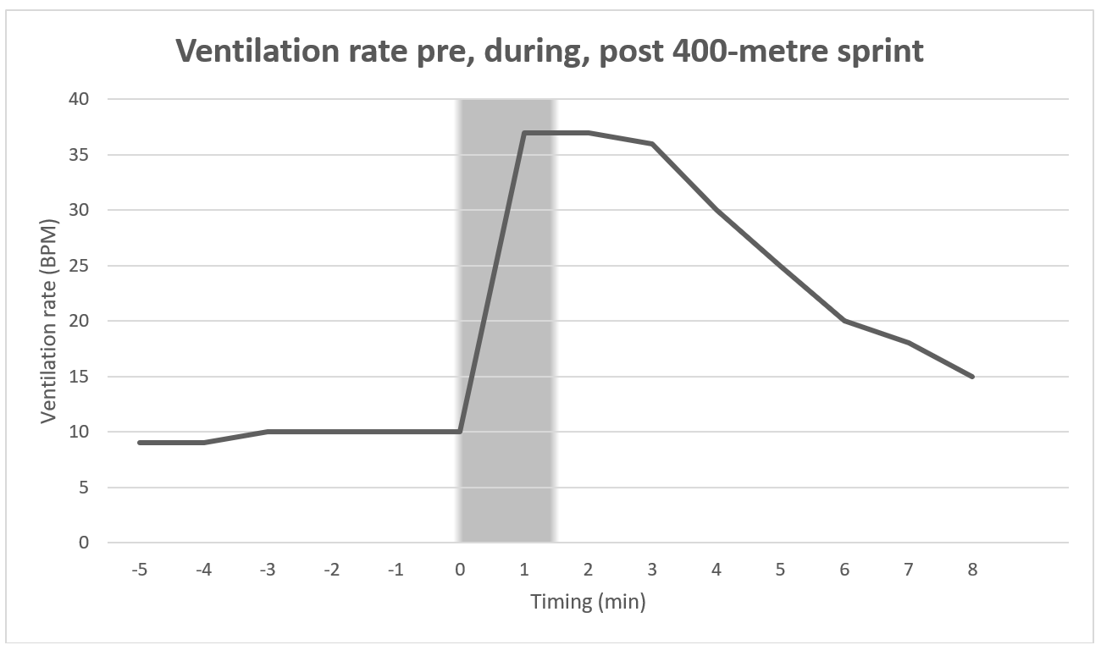
Note: students will need to have graphed their own ventilation or breathing rate responses for the 400-metre sprint to complete the following task.
Figure 2 represents the ventilation rate of a 17-year-old trained female athlete. This data was collected from a recent 400-metre sprint she completed mid-way through her normal 2-hour training session. Using the results on the graph and your own results that you have added, answer the following questions.
- Look at the graph. What are 3 things you notice?
- Compare your own results to the runner. Describe the difference between ventilation rates.
- What assumptions can be made about the fitness level of the runner that was initially on the graph based on ventilation rates?
- Examine both the heart rate and ventilation graphs provided in Figures 1 and 2.
- What correlations can be seen between heart rate and ventilation rate for each participant? What are the possible reasons for this?
- Account for these correlations in regard to the energy system used, including fuel source, intensity of exercise, duration of exercise, by products, causes of fatigue.
- If you trained for this test, what would you expect your time to do and why?
- Suggest ways you could train to improve your performance for this test.

Practical experience 3 – 1.6-kilometre run or walk (Aerobic System)
This is a test of aerobic fitness, an important component of endurance-based and team sports.

Equipment
- Measured distance of 1.6 kilometres – trundle wheel, markers
- Whistle
- Recording sheets or devices
- Stopwatches
- Heart rate (HR) monitor (phone or tracking device can be used)

Procedure
- Students work in pairs. One student adopts the role of runner and the other adopts the role of timekeeper and recorder.
- Record resting heart rate (RHR) and breathing rate (rate and depth) prior to any physical activity taking place including warm up.
- Record thoughts, emotions and physical feelings about completing this activity such as motivation levels, feelings in legs and overall body.
- Make predictions about how your body may feel at the end of the 1.6-kilometre run and record.
- Timekeepers and recorders stand in a position to observe their partner at all times.
- Runners begin at the zero metre or start line.
- Runners run or walk continuously for 1.6 kilometres. Encourage participants to complete the 1.6 kilometres even if they must jog or walk. The recorded time is necessary data for the task.
- Recorders should record their observations as their partner runs. For example, do they stop, where do they speed up, where do they slow down, what is their body language or posture?
- Record HR at the 800-metre mark of the run or jog if possible.
- At the immediate end of the 1.6-kilometre run, record heart rate (HR).
- Take heart rate each minute to record the time it takes to return to RHR.
- Record personal observations about breathing rate and depth, feelings in legs and overall body after completing the run.
- Runners and recorders then reverse roles.

Results
- Record HR at the beginning, 800-metre mark and immediate end of the 1.6-kilometre run.
- Record time taken to complete the 1.6 kilometres.
- Record heart rate each minute to record the time it takes to return to RHR.

Questions
- What was the predominant energy system being used for this activity? Give reasons for your answer.
- What other energy system(s) contributed to this activity? Provide a brief explanation of their role in the 1.6-kilometre run. Include at what time of the run the energy system contributed and the evidence of this occurring.
- Describe how your body responded from the start line to finish line during the 1.6-kilometre run. What did your partner notice about your run and body response? Compare that with others in the class.
- Explain what the body’s response tells you about the energy system(s) being used.
- Did you reach a steady state at any time during this activity? How did you recognise this?
Note: steady state can be defined as activity that achieves a balance between the energy required by working muscles and the rate of oxygen and delivery for aerobic ATP production. During steady state exercise, the exercise is performed at an intensity such that energy expenditure is balanced with the energy required to perform exercise.
- Outline any factors that may have positively impacted your performance such as motivation levels, previous training, rest.
- Outline any factors that may have had a negative impact on your performance such as fatigue, dehydration, training the previous day, illness, injury, lack of motivation.
- If you were asked to complete another 1.6-kilometre run within 5 minutes of completing the first, how might your mind and body feel? Would you expect your time to be quicker or slower? Give reasons for your answer.
- How long do you think you would need to physically recover before running 1.6 kilometres again to get a similar time to what you just recorded? Give reasons for your answer.
- If you trained for this test, what would you expect your time to do and why?
- Suggest ways you could train to improve your performance for this test.
- If you had to sprint the final 100 metres of the run how would your body have responded? Give reasons for your answer that include references to energy systems.

Practical experience 4 – touch football or netball (interplay of energy systems)
To gain an understanding of how energy systems interact and impact performance during participation in a team sport.

Equipment
- Space and equipment for chosen sport
- HR monitor (phone or tracking device can be used)

Procedure
- Students work in pairs. One student adopts the role of player or participant and the other adopts the role of recorder.
- Record resting heart rate (RHR) and breathing rate (rate and depth) before any physical activity takes place including warm up.
- Record thoughts, emotions and physical feelings about completing this activity such as motivation levels, feelings in legs and overall body.
- Make predictions about how your body may feel at the end of the game and record.
- As a playing group, choose regular intervals throughout the game to record HR and breathing rate and depth. Record the physical response, including feeling in legs and overall body, if possible.
- At the conclusion of the game, record HR and breathing rate and depth. Record the physical response, including feeling in legs and overall body.
- Take heart rate each minute to record the time it takes to return to RHR.
- Player or participant and recorder then reverse roles.

Results
- Record HR variations and physical responses, including breathing rate and depth, legs and overall body.
- Record HR at regular intervals throughout the game along with type of activity that preceded the recording such as did a drive, quick dump and then was dummy half for the next play HR = 125 bpm.

Questions
- What is the predominant energy system being used for this activity? Give reasons for your answer.
- In what parts of the game did you use your ATP-PCr energy system? How did you know you were using that energy system? How did your body respond or feel when doing this?
- In what parts of the game did you use your Glycolytic or Lactic Acid energy system? How did you know you were using that energy system? How did your body respond or feel when doing this?
- In what parts of the game did you use your Aerobic energy system? How did you know you were using that energy system? How did your body respond or feel when doing this?
- Would you expect your use of energy systems to differ if you were playing a different position? Give reasons for your answer and support with specific examples.
- Suggest ways a player in this sport could train to maximise their ability to move between energy systems. Apply the FITT principle to this training.

Biathlon
As a class, watch the video Biathlon in Beijing 2022: How it works (3:23). Focus particular attention to the structure of the 10-kilometre sprint biathlon (0:59–3:23). As a class, discuss the structure of the event.
The biathlon combines cross country skiing with target shooting. The sprint biathlon for men is a 10-kilometre time trial event. At 2 designated points in the race, athletes fire 5 rounds at a target from their rifle. The first set of shots must be done lying down and occur at the 3.3-kilometre race mark. The second set of shots occur at the 6.7-kilometre mark from a standing position. For every target an athlete misses, a 150-metre penalty lap is added and must be completed at the end of the race before crossing the finish line. The sprint event normally takes 23 minutes for elite athletes to complete.
The cross-country skiing is a demanding endurance element of biathlon that involves continuous changes in speed, external power and energy system contributions while skiing across varying terrain. Added to the high aerobic metabolic power required to excel in cross-country (XC) skiing, sufficient anaerobic power and well-developed efficiency with associated technical and tactical skills are of high importance.
In small groups:
- discuss how the sport of biathlon and the 10-kilometre sprint event uses all 3 energy systems
- identify the specific movements that occur when using each energy system
- record these in a table (some responses have already been added)
- then share as a class.
Table – how the energy systems are used in the biathlon and 10-kilometre sprint event
Specific movements for each system | ATP-PCr | Glycolytic (Lactic Acid) | Aerobic
Specific movements | - Laying down to shoot  - Standing up from the laying down position | - Penalty lap | - 10 km skiing
In small groups, discuss the interplay of energy systems. Use the questions as a guide for the discussion and share as a class.
- What energy systems are used at different times in the event?
- Identify when and where in the event each energy system is used. Why was this energy system used at this moment and was it the best energy system to be used to enhance performance? Explain your answer.
- What implications would variations in terrain have on the intensity of the performance?
- Predict how performance may be impacted if an athlete missed 3 targets and had to complete 3 penalty laps immediately before they sprinted to the finish line.
- During the shooting phases, what happens to the athlete’s heart and ventilation rates?
Work in small groups to complete the following activity.
Based on your knowledge of energy systems, use Figure 3 to draw a hypothetical line graph for the 10-kilometre sprint biathlon by plotting the following race stages. The x axis of Figure 3 represents the following 12 stages.
Race stages
- A standing still race start.
- The athlete sprints the first 100 metres to get the best start possible.
- The first kilometre of the race is a gradual uphill climb, and the athlete has a strong head wind to ski into.
- From the 2-kilometre to 2.5-kilometre mark the terrain creates a very steep incline.
- There is a gradual downhill run from the 2.5-kilometre mark to the 3-kilometre mark as the athlete heads towards the rifle range.
- At the 3.3-kilometre mark, the athlete must lie down to shoot 5 rounds at a target that is 45 millimetres in diameter. They miss one target and will incur a penalty lap.
- The course is flat for the next kilometre and the athlete knows they must take this opportunity to improve their time, as they have a penalty lap to complete.
- At the 6.7-kilometre mark, the athlete remains standing to shoot 5 rounds at a target that is 115 mm in diameter. They are successful in completing all shots.
- The athlete falls over at the 7.5-kilometre mark. They are slow to their feet and have sustained a minor injury that slows them down for the next 500 metres.
- The athlete needs to increase their speed to make up for lost time from their fall and recovery.
- Complete penalty lap of 150 metres because a shot was missed at 3.3 kilometres.
- Sprint to the finish line.
Figure 3 – level of effort by an athlete, expressed as a percentage, for selected stages of a biathlon 10-kilometre sprint race
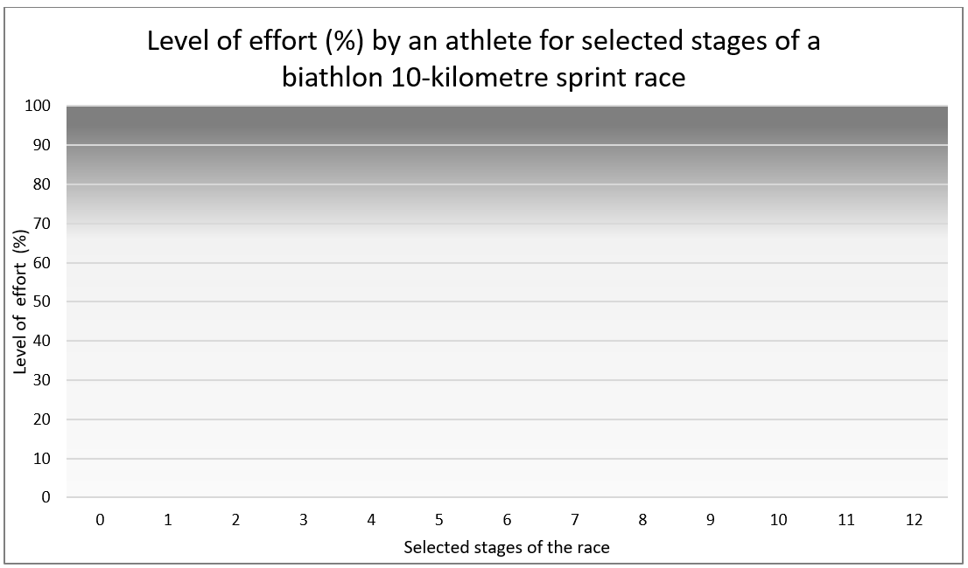
- On the Y axis, identify where the energy systems change from one to another.
- As a class, discuss the interplay of energy systems in this event.

Final product and submission
Note: this final product and submission can be completed as a part of class based formative assessment or can be completed as an assessable summative task.
For teachers who choose to use this task as a formal summative assessment, access the Year 11 Core 2 – sample assessment task. This assessment task can be accessed on the Planning, programming and assessing PDHPE 11-12 curriculum webpages.

The task
Students will assume the role of a head sports coach reviewing an athlete’s performance after an event. The case study below provides an overview of the athlete’s reflection on their performance in a sport, event, match or race they competed in. Using the information in the case study, students are to complete a written or verbal submission.

Case study
The athlete felt like they didn’t perform as well as they could have. The athlete has reported that they felt tired and fatigued towards the end of the sport, event, match or race and that their body could not sustain the level of intensity needed, despite how hard they tried.

The submission
As the role of head sports coach, students use the information provided in the case study to create the following:
- A short profile of the athlete, including the level (recreational or elite) and the sport, event, match or race they competed in. Where students select an athlete playing a team sport, they should specify the athlete’s specific position.
- A hypothetical energy graph for the athlete, demonstrating the interplay of energy systems during their performance.
- A recording or transcript of the conversation between the head sports coach and the athlete analysing the interplay of the energy systems for the sport, event, match or race they competed in. The conversation could include
- reference to fuel sources
- efficiency of ATP production
- duration of event
- recruitment or use of the energy systems at different points in the sport, event, match or race they competed in
- intensity of performance at different points in the sport, event, match or race they competed in and the relationship to interplay of the energy systems
- rate of recovery
- causes of fatigue.
- A justification of why the athlete was not able to sustain the intensity they desired in the final stage of the sport, event, match or race they competed in. Specific examples must be used to support the justification.
- Suggestions for what the athlete could have done both prior to, and during the sport, event, match or race they competed in to ensure they were able to sustain the desired intensity in the final stages.

Marking guidelines
Table 2 – assessment marking guidelines
Mark | Marking guideline descriptors
10–9 | - Demonstrates a comprehensive understanding of the interplay between the ATP-PCr, Glycolytic (Lactic Acid) and Aerobic energy systems  - Shows a clear relationship between the profile of the athlete (the position, the situation of the sport, event, match or race they competed in) and the interplay of the energy systems  - Draws out a variety of implications this relationship has on movement and performance in the final stages of the sport, event, match or race they competed in  - Provides substantiated justifications of why the athlete was fatigued in the final stages of the sport, event, match or race they competed in highlighting the features of each energy system and the interrelationships between energy systems  - Provides a variety of valid suggestions for what the athlete could have done prior and during the sport, event, match or race they competed in to sustain the desired intensity  - Communicates with the athlete in a clear and logical manner  - Supports the response with relevant examples that are specific to the sport, event, match or race they competed in and position chosen
8–7 | - Demonstrates a thorough understanding of the interplay between the ATP-PCr, Glycolytic (Lactic Acid) and Aerobic energy systems  - Shows a relationship between the profile of the athlete (the position, the situation of the sport, event, match or race they competed in) and the interplay of the energy systems  - Draws out implication(s) of this relationship on movement and performance in the final stages of the sport, event, match or race they competed in  - Provides a justification of why the athlete was fatigued in the final stages of the sport, event, match or race they competed in highlighting the features of energy systems and the interrelationship between energy systems  - Provides a valid suggestion regarding what the athlete could have done prior and during the sport, event, match or race they competed in and correctly links these to post sport, event, match or race recovery  - Communicates with the athlete in a clear and logical manner  - Supports the response with examples that relate to the sport, event, match or race they competed in and/or the position chosen
6–5 | - Demonstrates a sound understanding of the interplay between the ATP-PCr, Glycolytic (Lactic Acid) and Aerobic energy systems  - Makes evident some relationships between the energy systems, the athlete and/or participation and performance in the final stages of the sport, event, match or race they competed in  - Provides some relevant examples  - Attempts to give reasoning or vague reasoning on why the athlete was fatigued in the final stages of the sport, event, match or race they competed in making some links to the interrelationship between energy systems
4–3 | - Provides characteristics and features of the use of energy system(s) in the practical activity  - Attempts to show the relationships between the energy systems and/or the athlete and/or participation and performance in the final stages of the sport, event, match or race they competed in  - Provides some examples
2–1 | - Sketches energy systems in general terms  - Provides an example(s) of energy systems

Support and alignment
Resource evaluation and support: all curriculum resources are prepared through a rigorous process. Resources are periodically reviewed as part of our ongoing evaluation plan to ensure currency, relevance and effectiveness. For additional support or advice contact the PDHPE curriculum team by emailing PDHPEcurriculum@det.nsw.edu.au.
Alignment to system priorities and/or needs: School Excellence Policy, School Success Model
Alignment to the School Excellence Framework: this resource supports the School Excellence Framework element of assessment (formative assessment, summative assessment, student engagement).
Alignment to Australian Professional Teaching Standards: this resource supports teachers to address Australian Professional Teaching Standards 5.1.2, 5.4.2.
Consulted with: PDHPE Community of Learners
NSW Syllabus: Health and Movement Science 11–12 Syllabus
Syllabus outcomes: HM-11-03, HM-11-06, HM-11-07
Author: PDHPE Curriculum Team
Publisher: State of NSW, Department of Education
Resource: Depth study
Related resources: further resources to support Health and movement science Stage 6 can be found on the Planning, programming and assessing PDHPE 11-12 curriculum webpage and the HSC hub.
Professional learning: relevant professional learning is available on the PDHPE statewide staffroom.
Universal Design for Learning: Curriculum planning for every student in every classroom. Support the diverse learning needs of students using inclusive teaching and learning strategies.
Creation date: 14 September 2023
Rights: © State of New South Wales, Department of Education.

References
This resource contains NSW Curriculum and syllabus content. The NSW Curriculum is developed by the NSW Education Standards Authority. This content is prepared by NESA for and on behalf of the Crown in right of the State of New South Wales. The material is protected by Crown copyright.
Please refer to the NESA Copyright Disclaimer for more information https://educationstandards.nsw.edu.au/wps/portal/nesa/mini-footer/copyright.
NESA holds the only official and up-to-date versions of the NSW Curriculum and syllabus documents. Please visit the NSW Education Standards Authority (NESA) website https://educationstandards.nsw.edu.au/ and the NSW Curriculum website https://curriculum.nsw.edu.au/home.
Health and Movement Science 11–12 Syllabus © NSW Education Standards Authority (NESA) for and on behalf of the Crown in right of the State of New South Wales, 2023.
Biathlonworld (1 February 2022) ‘Biathlon in Beijing 2022: How it works’ [video], Biathlonworld, YouTube, accessed 22 September 2023.
Laaksonen MS, Finkenzeller T, Holmberg H and Sattlecker G (2018) ‘The influence of physiobiomechanical parameters, technical aspects of shooting, and psychophysiological factors on biathlon performance: A review’, Journal of Sport and Health Science, 7(4):394–404, doi: 10.1016/j.jshs.2018.09.003, accessed 13 September 2023.
Luchsinger H, Talsnes RK, Kocbach J and Sandbakk Ø (2019) Analysis of a Biathlon Sprint Competition and Associated Laboratory Determinants of Performance, Frontiers in Sports and Active Living website, accessed 13 September 2023.
Wood R (2008) Anaerobic Capacity Fitness Tests, Topend Sports website, accessed 22 September 2023.
© State of New South Wales (Department of Education), 2023
The copyright material published in this resource is subject to the Copyright Act 1968 (Cth) and is owned by the NSW Department of Education or, where indicated, by a party other than the NSW Department of Education (third-party material).
Copyright material available in this resource and owned by the NSW Department of Education is licensed under a Creative Commons Attribution 4.0 International (CC BY 4.0) license.
This license allows you to share and adapt the material for any purpose, even commercially.
Attribution should be given to © State of New South Wales (Department of Education), 2023.
Material in this resource not available under a Creative Commons license:
- the NSW Department of Education logo, other logos and trademark-protected material
- material owned by a third party that has been reproduced with permission. You will need to obtain permission from the third party to reuse its material.
Links to third-party material and websites
Please note that the provided (reading/viewing material/list/links/texts) are a suggestion only and implies no endorsement, by the New South Wales Department of Education, of any author, publisher, or book title. School principals and teachers are best placed to assess the suitability of resources that would complement the curriculum and reflect the needs and interests of their students.
If you use the links provided in this document to access a third-party's website, you acknowledge that the terms of use, including licence terms set out on the third-party's website apply to the use which may be made of the materials on that third-party website or where permitted by the Copyright Act 1968 (Cth). The department accepts no responsibility for content on third-party websites.

