Sums and differences
Students continue to use bar models to assist them in solving simultaneous linear equations. In this lesson, they extend their bar models to include differences in the equations as well as sums.
Students will need at least one digital device per pair to interact with Desmos during this lesson.

Visible learning
This lesson incorporates Path content.

Learning intention
- To be able to solve simultaneous equations.

Success criteria
- I can draw a bar model to represent 2 unknown variables.
- I can combine 2 bar models to eliminate an unknown variable.
- I can apply my knowledge of bar models and simultaneous equations to solve problems.

Syllabus outcomes
A student:
- develops understanding and fluency in mathematics through exploring and connecting mathematical concepts, choosing and applying mathematical techniques to solve problems, and communicating their thinking and reasoning coherently and clearly MAO-WM-01
- solves linear equations of more than 3 steps, monic and non-monic quadratic equations, and linear simultaneous equations MA5-EQU-P-02
Mathematics K–10 Syllabus © NSW Education Standards Authority (NESA) for and on behalf of the Crown in right of the State of New South Wales, 2022.

Activity structure

Launch
- Assign students the Desmos classroom activity ‘Systems of Two Linear Equations’ (bit.ly/SumsDifferences).
These instructions will help teachers set up a Desmos classroom and assign this activity to a class (bit.ly/desmosclassroomstrategy).
Alternatively, teachers can choose to lead their class through a similar activity by using the instructions in Appendix A ‘Sums and differences’.
- Students will work through the activity in pairs. During the activity, they will be able to see responses from other students.
This activity is designed to introduce students to solving equations involving differences by graphing equations and finding the point of intersection. Students will investigate how to solve these scenarios using a bar model in the Explore section of the lesson.

Explore
- In the Launch, students have been revising how to solve simultaneous linear equations, graphically. Using visibly random groups of 3 (bit.ly/visiblegroups) at a vertical non-permanent surface (bit.ly/VNPSstrategy), challenge students to represent the following 2 equations using a bar model.
$$x+y=6$$
$$x-y=6$$
- Give groups time to do a gallery walk (bit.ly/DLSgallerywalk) to look at other group’s representations. Allow students the opportunity to provide constructive peer feedback.
- Choose 3 or 4 groups to explain their representations.

Summarise
- Use slides 2–5 of the Sums and differences PowerPoint to explicitly teach students how to represent and solve these equations using a bar model.
The explicit teaching technique used in the associated PowerPoint is ‘Your turn.’ The first slide is a worked example which should be displayed for the students and then use the following steps.
- Reveal the question to students and its solution.
- Students read in silence.
- Students individually think and explain to themselves what is happening in each step.
- Students hold a thumbs up to the teacher when they have finished reading and have some sort of understanding.
- Think-Pair-Share. Students explain the solution to their partner.
- In pairs, students then answer the self-explanation questions.
- Finally, randomly select students to share their answers with the whole class.
Review the notes section of the PowerPoint slides to find important considerations for teachers when engaging in class discussions.
- In the same groups of 3 from earlier, students complete the ‘Sums and differences with bar models’ worksheet from Appendix B. They would benefit from completing these at a vertical non-permanent surface if possible.
These questions progress into negative solutions and students will need to discuss how to represent this using their bar model. For example, $2x+y= -18$. Sample solutions are provided.

Apply
- In visibly random groups of 3 at vertical non-permanent surfaces, if possible, have students complete the ‘Old, older, oldest’ activity from Appendix C.
This activity involves writing equations from worded statements before solving. Low readiness students should be provided with the equations and/or bar model cards. Their first task will be to match the cards, before they attempt to solve the problems.
High readiness students could just be presented with the worded statements and write their own equations.
- Encourage groups as they finish, to compare their answers with another group. If their answers differ, they should be encouraged to justify and prove why their answers are correct.

Assessment and differentiation

Suggested opportunities for differentiation
Explore
- Students may need support drawing bar models. This is a great opportunity for peer teaching.
Summarise
- Students could be challenged to construct 2 bar models that have no solution and reason why this occurs.
Apply
- When using the ‘Old, Older, Oldest’ activity, teachers can choose whether to give groups of students, just the worded description cards or whether they give them the equations and/or the bar model. High readiness students should be challenged by just providing the worded description. Low readiness students will benefit from matching the worded descriptions to the bar models and equations before solving.

Suggested opportunities for assessment
Launch
- Student responses can be monitored through the Desmos teacher dashboard and used as both formative and summative assessment.
Summarise
- The worksheet in Appendix B could be collected and used as a source of evidence.
Apply
- Appendix C could be collected and used as a source of evidence.

Appendix A

Sums and differences
- Ask students to silently think of 2 numbers that have a difference of 8 and a sum of 1.
- Use a Pose-Pause-Pounce-Bounce question strategy [PDF 200KB] (bit.ly/pausepouncebouncestrategy) to randomly ask 3 or 4 students for the larger of their 2 numbers that have a difference of 8.
- Use their numbers to tell them what their second number is.
- Write each pair of numbers on the board as a coordinate.
- Either using a graphing program, or manually, plot each of the coordinates on a number plane.
- Ask students what they notice and what they wonder.
Students should notice that all the coordinates form a straight line.
- Ask students to read other points that would be on the straight line, and test whether they have a difference of 8.
- Repeat the process by collecting coordinates that have a sum of 1.
- Which point satisfies both criteria and is thus on both lines?
- Ask students to write an equation for the line passing through all the coordinates that have a difference of 8.
- Ask students to write an equation for the line passing through all the coordinates that have a sum of 1.
- Is it possible for a pair of numbers to have a sum of 6 and a difference of 6?
- Write equations for these lines and graph on a cartesian plane.
- What is the point of intersection?

- What about the following criteria:
- Sum of 12 and a difference of 5
- Sum of 6 and a sum of 7.

Appendix B

Sums and differences with bar models
Draw a bar model for each equation before solving to find the value of $x \text{and }y.$
Equations | Bar models | Solutions
$$2x+3y=18$$
$$6x+3y= 30$$
$$2x+3y=18$$
$$6x-3y= 30$$
$$2x+y=18$$
$$6x-y= 30$$
$$2x-y=18$$
$$6x-y= 30$$
$$y+2x=18$$
$$y+6x= 30$$
$$y+2x=-18$$
$$y+6x= 30$$
$$2x+y=-18$$
$$6x-y= -30$$
$$2x+4y=-18$$
$$2x-4y= -30$$
$$x+4y=-18$$
$$2x-4y= -30$$
$$x+y=-18$$
$$x-y= -30$$

Appendix C

Old, Older, Oldest
Your task is to discover the ages of all the people mentioned on the cards below and put them into a list starting with the oldest and finishing with the youngest. There are 2 sets of twins.
- Write an equation and draw a bar model for each statement.
- Solve the equations to discover each person’s age.
- List each person from oldest to youngest.
18 is the sum of the ages of Adam and Ben.  Adam’s age minus Ben’s age is 8. | Twice Carol’s age minus Dawn’s age is 20.  Carol’s age plus Dawn’s age is 73.
Twice Fred’s age minus Eric’s age is 78.  Fred is 13 years older than Eric. | Three times Gemma’s age plus twice Hayley’s age is 38.  Twice Gemma’s age plus three times Hayley’s age is 42.
Three times Ian’s age plus four times John’s age is 147.  Seven times Ian’s age minus three times John’s age is 10. | Four times Kay’s age plus three times Laura’s age is 40.  Five times Kay’s age plus twice Laura’s age is 43.
Twice Mike’s age plus Nayha’s age is 91.  Mike is 8 years older than Nayha. | Three times Oliver’s age plus Parveen’s age is 27.  Twice Oliver’s age plus Parveen’s age is 25.
47 is the sum of the ages of Roger and Satomi.  Twice Roger’s age plus Satomi’s age is 76. | Three times Wendy’s age minus four times Teela’s age is 33.  Twice Wendy’s age plus three times Teela’s age is 107.

$$2A-B=20$$  $$A+B=73$$ | $$2A-B=78$$  $$A-B=13$$
$$A+B=18$$  $$A-B=8$$ | $$5A+2B=43$$  $$4A+3B=40$$
$$2A+B=91$$  $$A-B=8$$ | $$7A-3B=10$$  $$3A+4B=147$$
$$2A+B=76$$  $$A+B=47$$ | $$3A-4B=33$$  $$2A+3B=107$$
$$3A+B=27$$  $$2A+B=25$$ | $$3A+2B=38$$  $$2A+3B=42$$
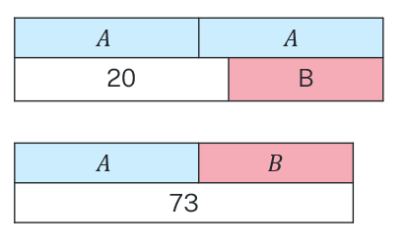 | 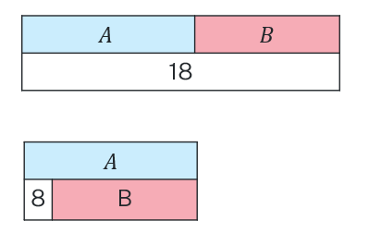
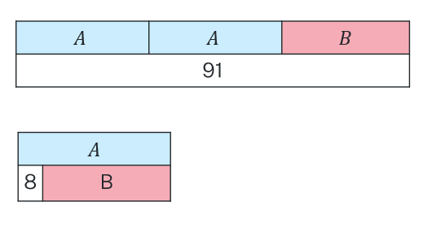 | 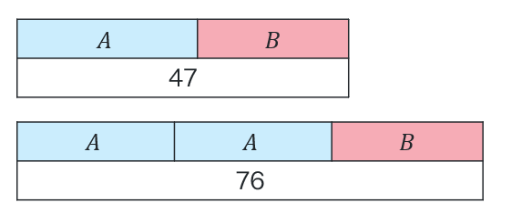
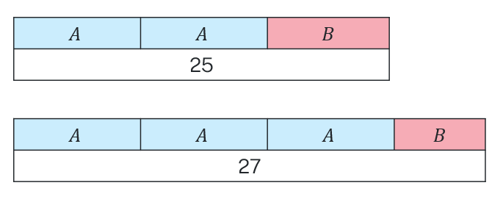 | 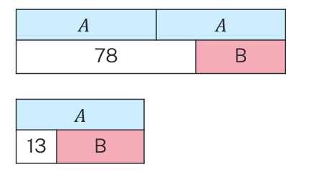
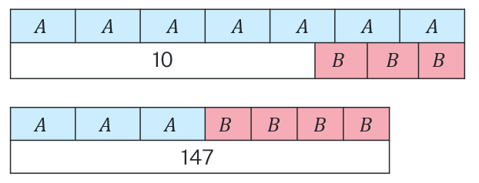 | 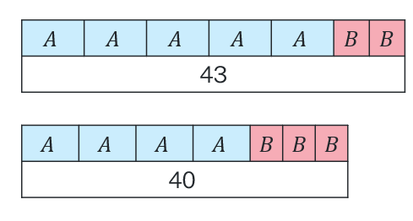
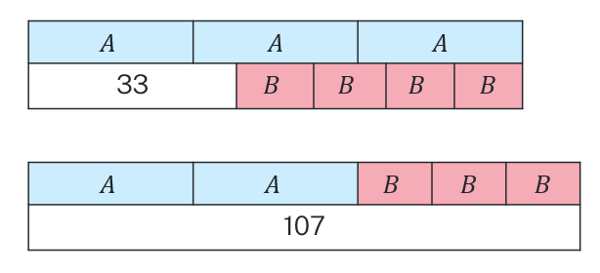 | 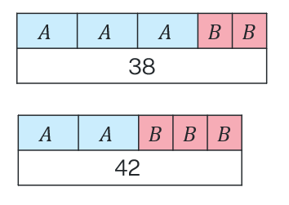

Sample solutions

Appendix B – Sums and differences with bar models
Equations | Bar models | Solutions
$$2x+3y=18$$  $$6x+3y= 30$$ | Step 1  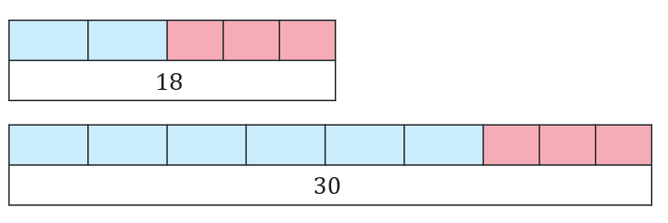  Step 2  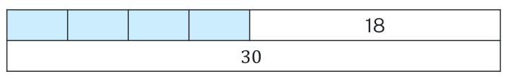  Step 3  $$4x+18=30$$  Step 4  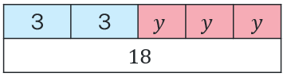  $$6+3y=18$$  $$y=4$$ | $$x=3, y=4$$
$$2x+3y=18$$  $$6x-3y= 30$$ | Step 1  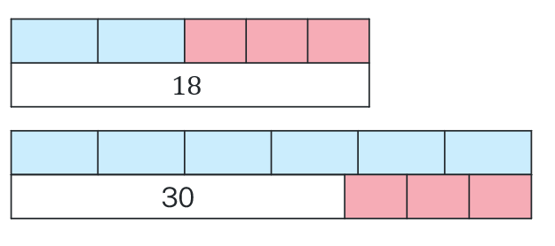  Step 2  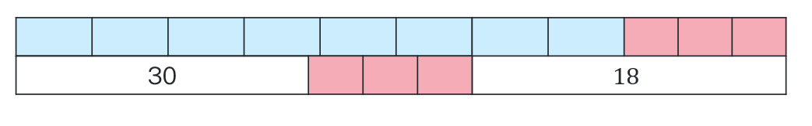  Step 3  $$8x=48$$  $$x=6$$  Step 4  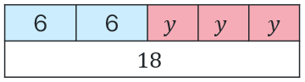  $$12+3y=18$$  $$y=2$$ | $$x=6, y=2$$
$$2x+y=18$$  $$6x-y= 30$$ | Step 1  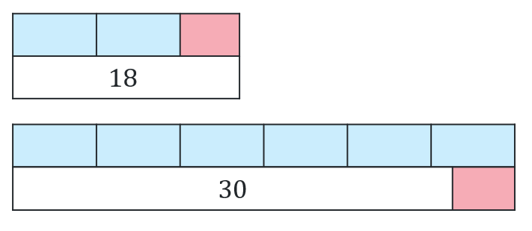  Step 2  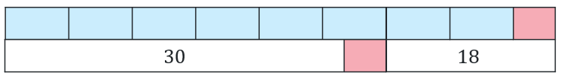  Step 3  $$8x=48$$  $$x=6$$  Step 4  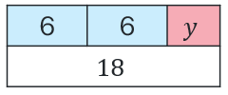  $$12+y=18$$  $$y=6$$ | $$x=6, y=6$$
$$2x-y=18$$  $$6x-y= 30$$ | Step 1  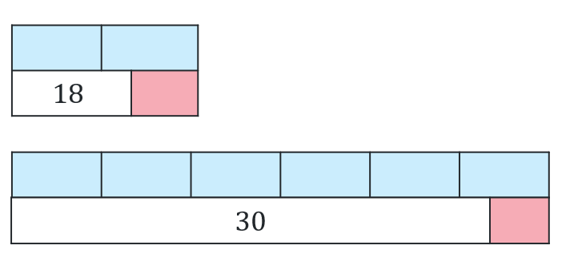  Step 2  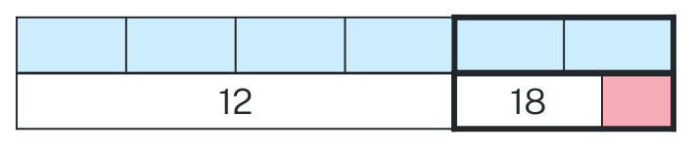  Step 3  $$4x=12 \\ x=3$$  Step 4  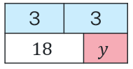  $$6=18+y$$  $$y=-12$$ | $$x=3, y=-12$$
$$y+2x=18$$  $$y+6x= 30$$ | Step 1  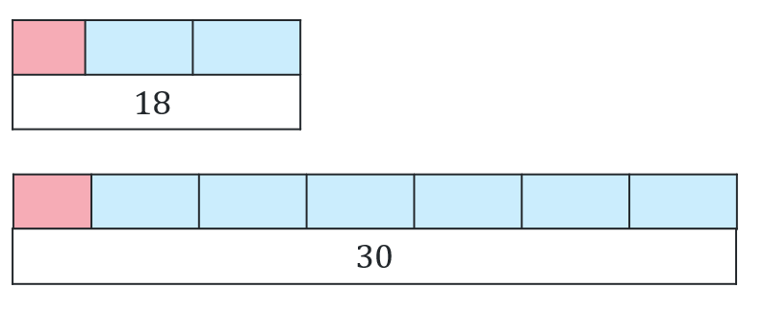  Step 2  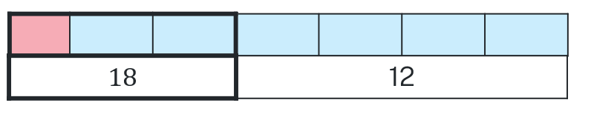  Step 3  $$4x=12 \\ x=3$$  Step 4  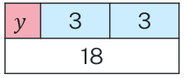  $$y+6=18$$  $$y=12$$ | $$x=3, y=12$$
$$y+2x=-18$$  $$y+6x= 30$$ | Step 1  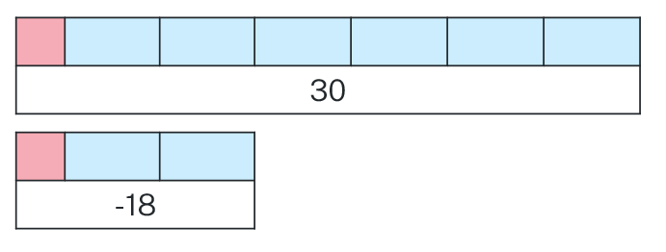  Step 2  Step 3  $$48=4x$$  $$x=12$$  Step 4  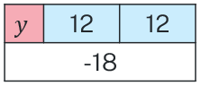  $$y+24=-18$$  $$y=-42$$ | $$x=12, y=-42$$
$$2x+y=-18$$  $$6x-y= -30$$ | Step 1  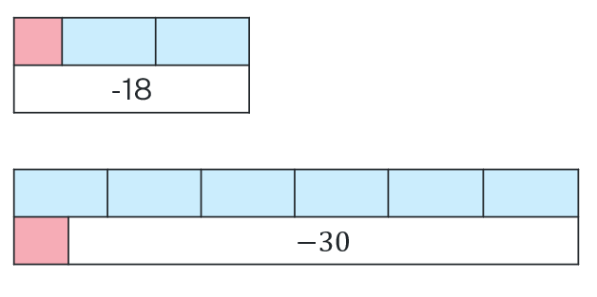  Step 2  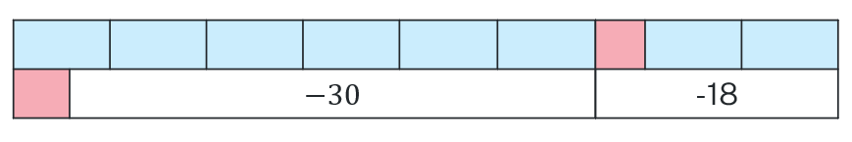  Step 3  $$8x=-48$$  $$x=-6$$  Step 4 | $$x=-6, y=-6$$
$$2x+4y=-18$$  $$2x-4y= -30$$ | Step 1  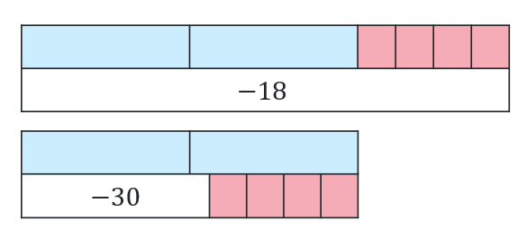  Step 2  Step 3  $$4x=-48$$  $$x=-12$$  Step 4  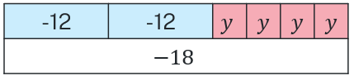  $$-24+4y=-18$$  $$y=2$$ | $$x=-12 y=2$$
$$x+4y=-18$$  $$2x-4y= -30$$ | Step 1  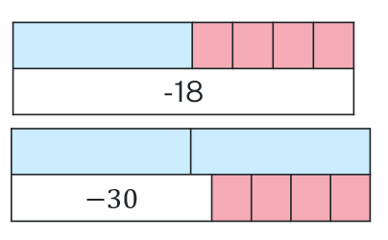  Step 2  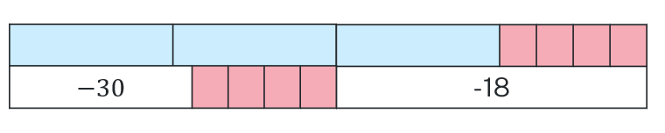  Step 3  $$3x=-48$$  $$x=-16$$  Step 4  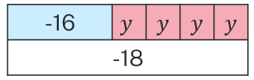  $$-16+4y=-18$$  $$y=-0.5$$ | $$x=-16, \\ y=-0.5$$
$$x+y=-18$$  $$x-y= -30$$ | Step 1  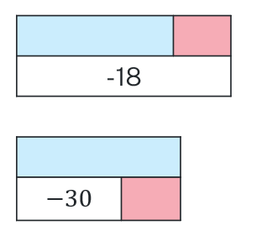  Step 2  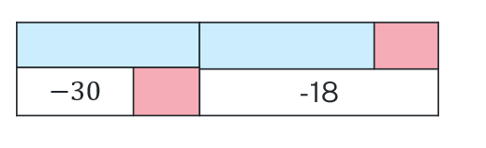  Step 3  $$2x=-48$$  $$x=-24$$  Step 4  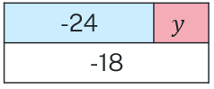  $$-24+y=-18$$  $$y=6$$ | $$x=-24, y=6$$

Appendix C – Old, older, oldest
- Fred 65
- Eric 52
- Dawn 42
- Mike 33
- Wendy 31
- Carol 31
- Roger 29
- John 27
- Nayha 25
- Parveen 21
- Satomi 18
- Teela 15
- Ian 13
- Adam 13
- Hayley 10
- Kay 7
- Gemma 6
- Ben 5
- Laura 4
- Oliver 2

References
This resource contains NSW Curriculum and syllabus content. The NSW Curriculum is developed by the NSW Education Standards Authority. This content is prepared by NESA for and on behalf of the Crown in right of the State of New South Wales. The material is protected by Crown copyright.
Please refer to the NESA Copyright Disclaimer for more information https://educationstandards.nsw.edu.au/wps/portal/nesa/mini-footer/copyright.
NESA holds the only official and up-to-date versions of the NSW Curriculum and syllabus documents. Please visit the NSW Education Standards Authority (NESA) website https://educationstandards.nsw.edu.au/ and the NSW Curriculum website https://curriculum.nsw.edu.au/home.
Mathematics K–10 Syllabus © NSW Education Standards Authority (NESA) for and on behalf of the Crown in right of the State of New South Wales, 2022.

© State of New South Wales (Department of Education), 2023
The copyright material published in this resource is subject to the Copyright Act 1968 (Cth) and is owned by the NSW Department of Education or, where indicated, by a party other than the NSW Department of Education (third-party material).
Copyright material available in this resource and owned by the NSW Department of Education is licensed under a Creative Commons Attribution 4.0 International (CC BY 4.0) license.
This license allows you to share and adapt the material for any purpose, even commercially.
Attribution should be given to © State of New South Wales (Department of Education), 2023.
Material in this resource not available under a Creative Commons license:
- the NSW Department of Education logo, other logos and trademark-protected material
- material owned by a third party that has been reproduced with permission. You will need to obtain permission from the third party to reuse its material.
Links to third-party material and websites
Please note that the provided (reading/viewing material/list/links/texts) are a suggestion only and implies no endorsement, by the New South Wales Department of Education, of any author, publisher, or book title. School principals and teachers are best placed to assess the suitability of resources that would complement the curriculum and reflect the needs and interests of their students.
If you use the links provided in this document to access a third-party's website, you acknowledge that the terms of use, including licence terms set out on the third-party's website apply to the use which may be made of the materials on that third-party website or where permitted by the Copyright Act 1968 (Cth). The department accepts no responsibility for content on third-party websites.

