Simultaneous shopping
Students explore solving simultaneous equations through shopping scenarios. In this lesson they are introduced to bar models as a method to solve simultaneous equations.

Visible learning
This lesson incorporates Path content.

Learning intentions
- To be able to solve simultaneous linear equations using substitution.

Success criteria
- I can draw a bar model to represent an equation.
- I can substitute a value into an equation.
- I can determine the solution to linear simultaneous equations by using a bar model.

Syllabus outcomes
A student:
- develops understanding and fluency in mathematics through exploring and connecting mathematical concepts, choosing and applying mathematical techniques to solve problems, and communicating their thinking and reasoning coherently and clearly MAO-WM-01
- solves linear equations of more than 3 steps, monic and non-monic quadratic equations, and linear simultaneous equations MA5-EQU-P-02
Mathematics K–10 Syllabus © NSW Education Standards Authority (NESA) for and on behalf of the Crown in right of the State of New South Wales, 2022.

Activity structure

Launch
- Display slide 2 of the Simultaneous shopping PowerPoint.
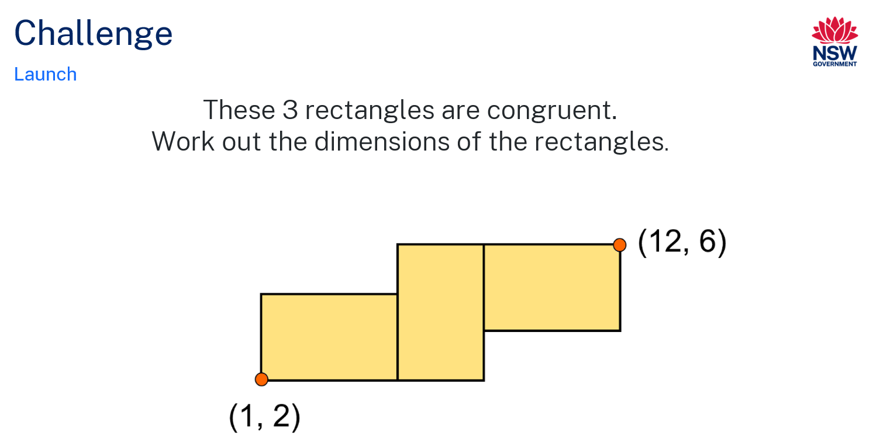
- Students are to work in pairs to find the dimensions of the rectangles.
- Use a Pose-Pause-Pounce-Bounce question strategy [PDF 200KB] (bit.ly/pausepouncebouncestrategy) to get students to share their strategies for solving the problem without acknowledging the correct solution or correct or incorrect strategies.
Highlight the similarities and differences between the strategies that have been shared. The solution will be revealed in the Summarise section of the lesson.

Explore
- Navigate to the website (https://bit.ly/simultaneousshop). If devices are not available, there is an alternate activity in Appendix A ‘Simultaneous shopping’.
- Students are to work in pairs to solve each of the puzzles. They can move on to the next level when they are ready.
There is an option below the activity to change the units to dollars. 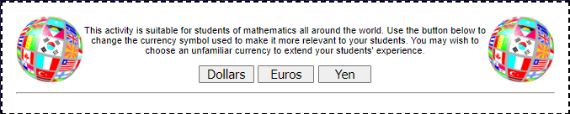
- Combine each pair of students with another pair of students so that they can explain the strategies they used to solve the puzzles to each other. If they used similar strategies, could they together come up with a different strategy? If they used different strategies, get them to play again using the other pair’s strategy.
- Allow students time to discuss whether the new strategy was more or less efficient than their original approach.

Summarise
- Use a Think-Pair-Share (bit.ly/thinkpairsharestrategy) for students to consider if they could draw a diagram, similar to the ‘Simultaneous Shopping’ game, to represent the information they know from the challenge question in the Launch.
For instance, = 11 and = 4.
- Use a Pose-Pause-Pounce-Bounce question strategy to get students to share their representations and reasoning.
- Show slide 3 from the Simultaneous shopping PowerPoint. Discuss with students how this representation can help us to determine the length and width of the rectangles.
- Show slides 4–11 from the Simultaneous shopping PowerPoint to explicitly teach how to use a bar model to solve simultaneous linear equations.
The explicit teaching technique used in the associated PowerPoint is ‘Your turn.’ The first slide is a worked example which should be displayed for the students and then use the following steps.
- Reveal the question to students and its solution.
- Students read in silence.
- Students individually think and explain to themselves what is happening in each step.
- Students give a thumbs up to the teacher when they have finished reading and have some sort of understanding.
- Think-Pair-Share. Students explain the solution to their partner.
- In pairs students then answer the self-explanation questions.
- Finally, randomly select students to share their answers with the whole class.
Review the notes section of the PowerPoint slides to find important considerations for teachers when engaging in class discussions.
- Students are to complete Appendix B ‘Simultaneous equations – bar model’ either individually or in pairs.

Apply
- Students are to complete Appendix C ‘Making connections’. The first table has been completed as an example.
- Students need to fill as many cells as possible using the given information.

Assessment and differentiation

Suggested opportunities for differentiation
Explore
- The website activity has different levels which allow for differentiation.
Summarise
- Students could be given manipulatives to assist in forming bar graphs.
Apply
- Students could be given the gradient intercept form of the equation rather than the general form of the equation.
- Students could find 2 equations that intersect at a given point.

Suggested opportunities for assessment
Summarise
- The teacher could gauge understanding by listening to students’ responses during discussion as well as during the questioning.
- The teacher could check students’ equations and answers for Appendix B ‘Simultaneous equations – bar model’.
Apply
- The teacher could collect Appendix C as formative assessment for many of the concepts learnt previously in this topic as well as simultaneous equations.

Appendix A

Simultaneous shopping
Find the cost of each item in the baskets. The total cost of the items in each basket is shown.

Set 1
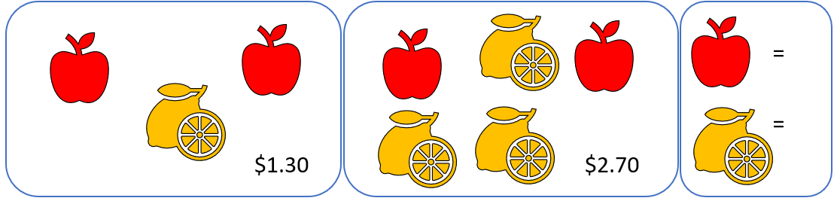

Set 2
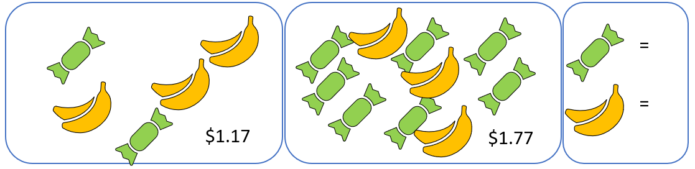

Set 3
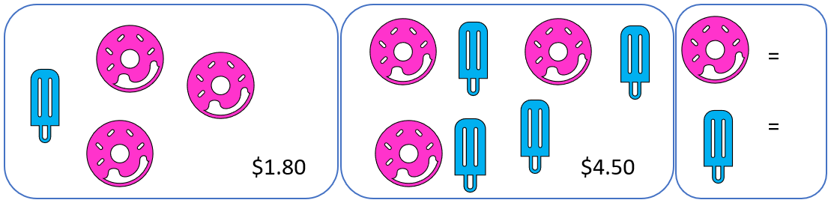

Set 4
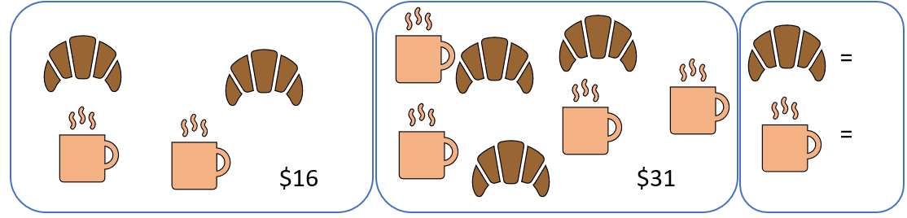

Set 5
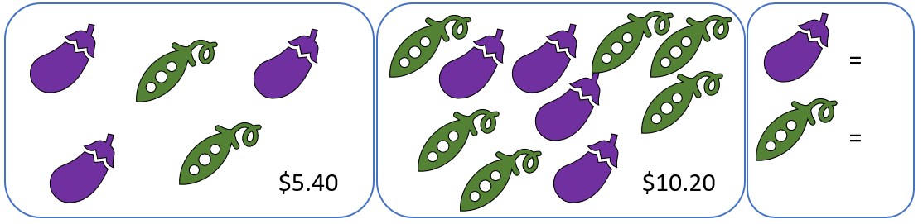

Set 6
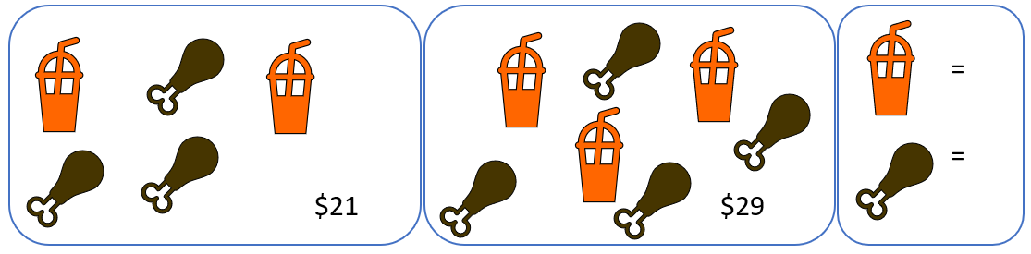

Set 7
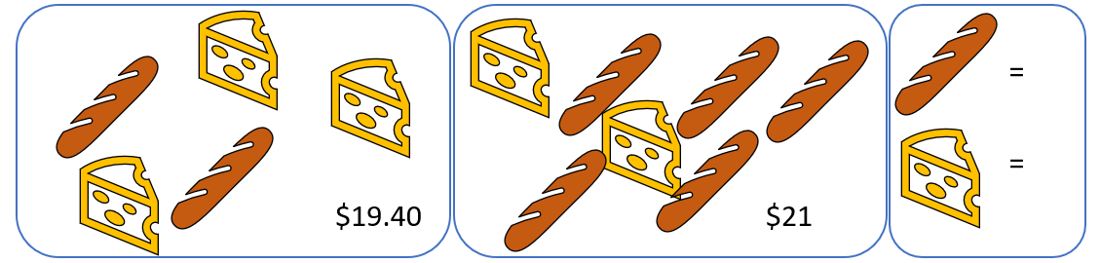

Set 8
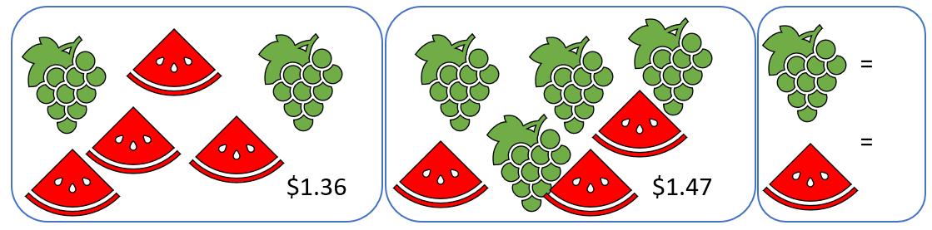

Set 9
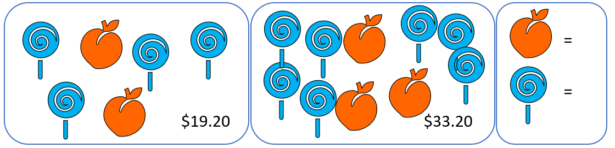

Set 10
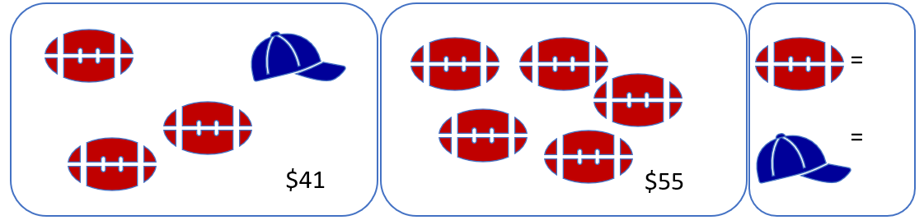

Set 11

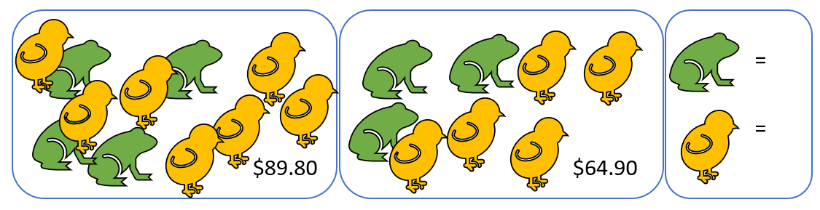

Appendix B

Simultaneous equations – bar model
Bar model | Equations | Solution
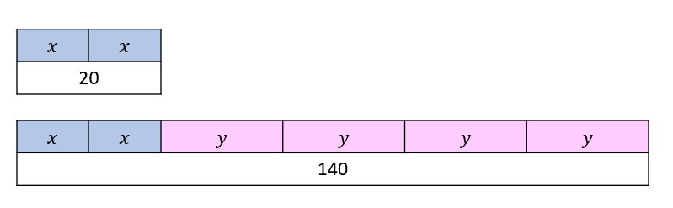 | $$2x=20$$  $$2x+4y=140$$ | $$x=10$$  $$y=30$$
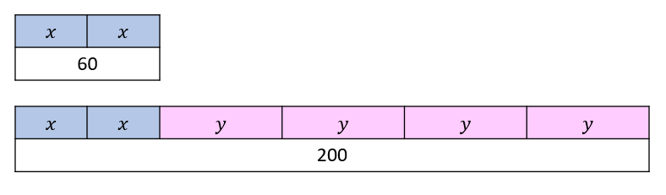
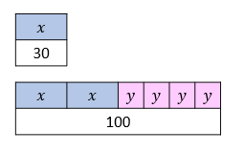
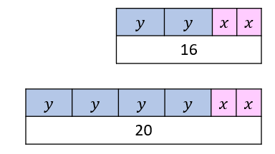
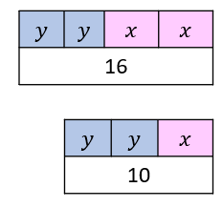
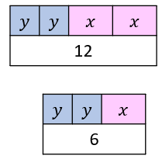
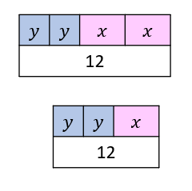
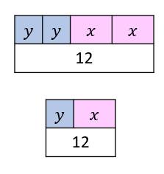
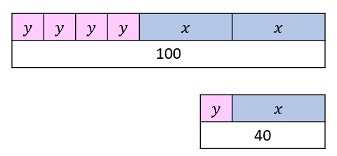
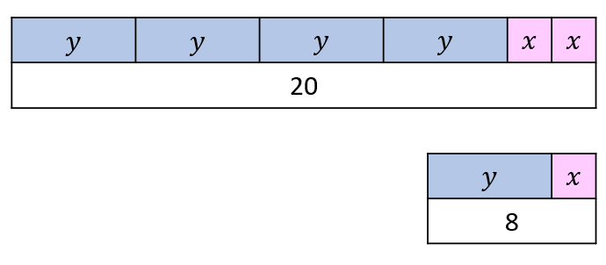

Appendix C

Making connections
For each table, fill in as much information as possible. The first one has been completed for you as an example.
Equations  Line 1: $2x+2y=16$ or $y=8-x$  Line 2: $2x+4y=20$ or $y=5-\frac{1}{2}x$ | Solutions/Point of intersection  $x=$ 6  $y=$ 2  ($6 , 2 )$
Bar model 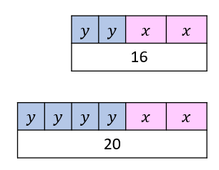 | Graph 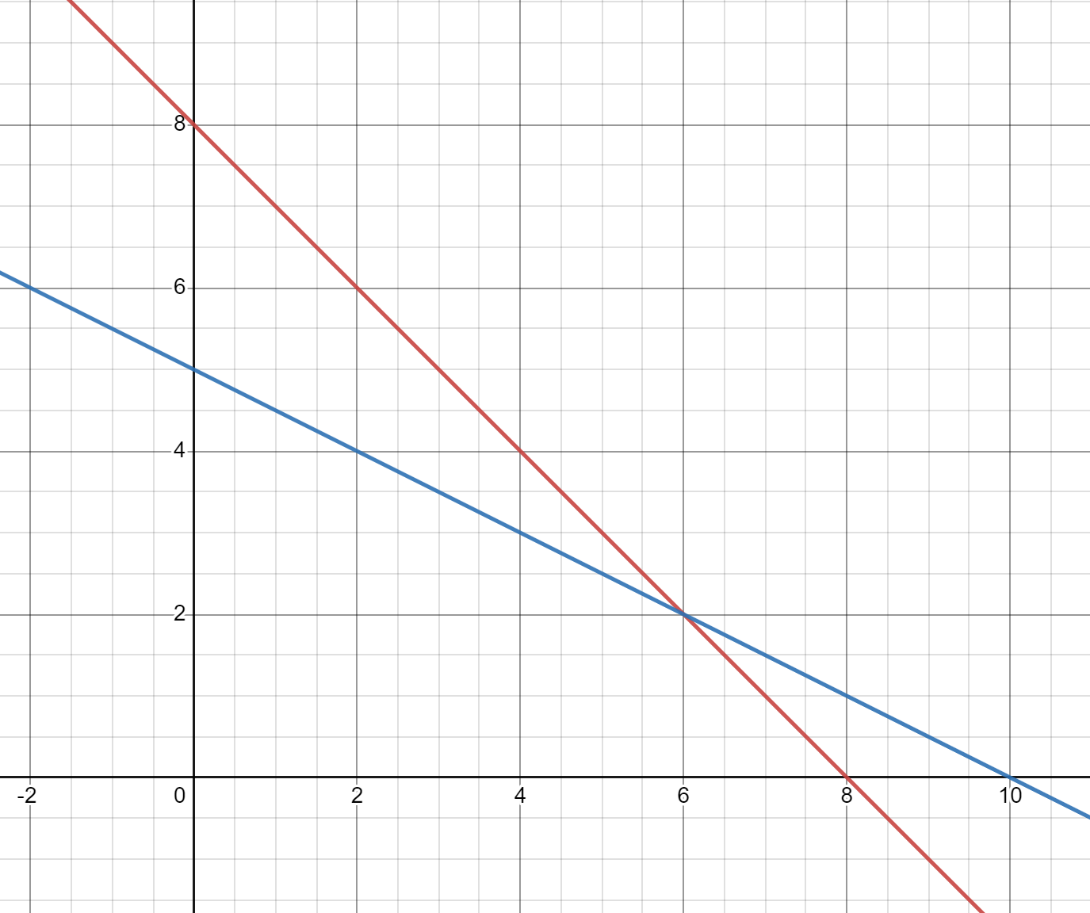
Intercepts  Line 1: $x-intercept$(8$,0)$  Line 1: y$-intercept$(0,8$)$  Line 2: $x-intercept$(10$,0)$  Line 2: y$-intercept$(0$,5)$ | Gradients  Line 1: $m=\frac{8}{8}=1$  Line 2: $m=\frac{5}{10}=\frac{1}{2}$

Table of Values
Line 1
Line 2
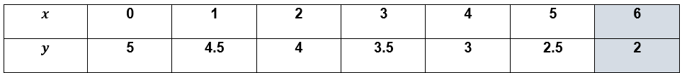

Equations  Line 1: $x+y=14$ or  Line 2: $x+2y=16$ or | Solution/Point of intersection  $$x=$$  $$y=$$  ( $, )$
Bar model | Graph
Intercepts  Line 1: $x-intercept$( $, )$  Line 1: y$-intercept$( $, )$  Line 2: $x-intercept$( $, )$  Line 2: y$-intercept$( $, )$ | Gradients  Line 1: $m=\frac{}{}=$  Line 2: $m=\frac{}{}=$

Table of values
Line 1
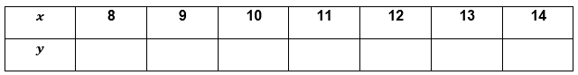

Line 2
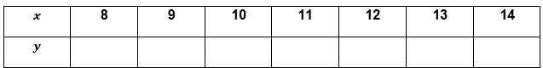

Equations  Line 1:  Line 2: | Solution/Point of intersection  $$x=$$  $$y=$$  ( $, )$
Bar model | Graph  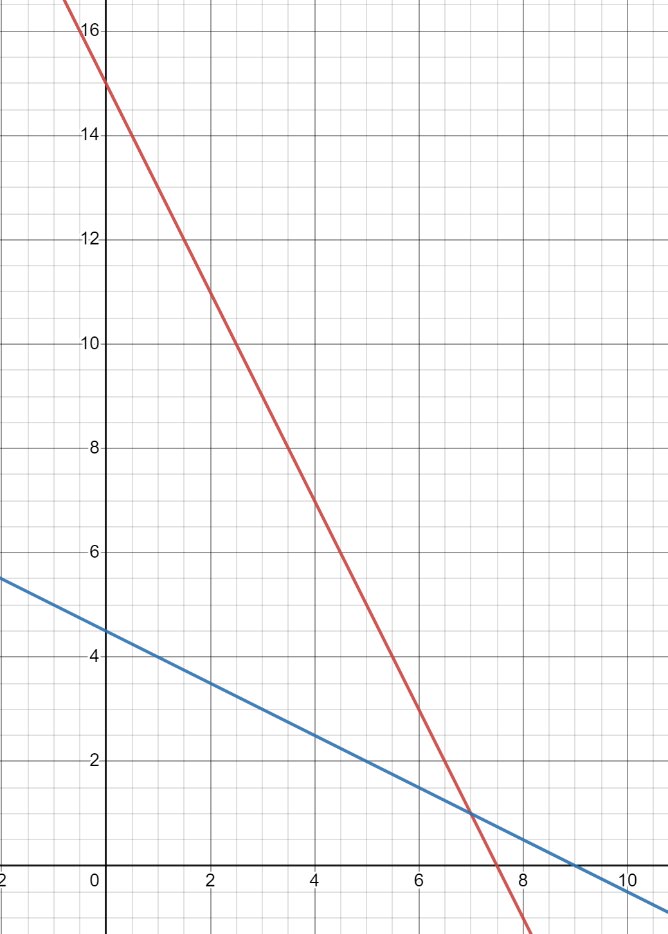
Intercepts  Line 1: $x-intercept$( $, )$  Line 1: y$-intercept$( $, )$  Line 2: $x-intercept$( $, )$  Line 2: y$-intercept$( $, )$ | Gradients  Line 1: $m=\frac{}{}=$  Line 2: $m=\frac{}{}=$

Table of values
Line 1
Line 2

Equations  Line 1:  Line 2: | Solution/Point of intersection  $$x=$$  $$y=$$  ( $, )$
Bar model | Graph
Intercepts  Line 1: $x-intercept (3,0)$  Line 1: y$-intercept (0,18)$  Line 2: $x-intercept (3.5,0)$  Line 2: y$-intercept (0,14)$ | Gradients  Line 1: $m=\frac{}{}=$  Line 2: $m=\frac{}{}=$

Table of values
Line 1
Line 2

Sample solutions

Appendix A – simultaneous shopping

Set 1
2 apples + 1 lemon = $1.30
2 apples + 3 lemons = $2.70
2 lemons = $1.40
1 lemon = $0.70
1 apple = $0.30

Set 2
2 lollies + 3 bananas = $1.17
7 lollies + 3 bananas = $1.77
5 lollies = $0.60
1 lolly = $0.12
1 banana = $0.31

Set 3
1 ice block + 3 donuts = $1.80
4 ice block + 3 donuts = $4.50
3 ice blocks = $2.70
1 ice block = $0.90
1 donut = $0.30

Set 4
2 croissants + 2 coffees = $16
3 croissants + 4 coffees = $31
4 croissants + 4 coffees = $32
1 croissant = $1
1 coffee = $7

Set 5
3 eggplants + 2 pea pods = $5.40
4 eggplants + 6 pea pods = $10.20
9 eggplants + 6 pea pods = $5.40 x 3 = $16.20
5 eggplants = $6.00
1 eggplant = $1.20
1 pea pod = $0.90

Set 6
3 drumsticks + 2 drinks =$21
4 drumsticks + 3 drinks =$29
12 drumsticks + 8 drinks = 21 x 4 = $84
12 drumsticks + 9 drinks = 29 x 3 = $87
1 drink = $3
1 drumstick = $5

Set 7
2 breadsticks + 3 cheese = $19.40
5 breadsticks + 2 cheese = $21
10 breadsticks + 15 cheese = 19.40 x 5 = $97
10 breadsticks + 4 cheese = 21 x 2 = $42
11 cheese = $55
1 cheese = $5
1 breadstick = $2.20

Set 8
2 grapes + 4 watermelon = $1.36
4 grapes + 3 watermelon = $1.47
4 grapes + 8 watermelon = 1.36 x 2 = $2.72
5 watermelon = $1.25
1 watermelon = $0.25
1 grape = $0.18

Set 9
4 lollypops + 2 peaches = $19.20
7 lollypops + 3 peaches = $33.20
12 lollypops + 6 peaches = 19.20 x 3 = $57.60
14 lollypops + 6 peaches = 33.20 x 2 = $66.40
2 lollypops = $8.80
1 lollypop = $4.40
1 peaches = $0.80

Set 10
3 footballs + 1 cap = $41
5 footballs = $55
1 football = $11
1 cap = $8

Set 11
4 frogs + 7 chicks = $89.80
3 frogs + 5 chicks = $64.90
12 frogs + 21 chicks = 89.80 x 3 = $269.40
12 frogs + 20 chicks = 64.90 x 4 = $259.60
1 chick = $9.80
1 frog = $5.30

Appendix B – simultaneous equations – bar model
Bar model | Equations | Solution
 | $$2x=20$$  $$2x+4y=140$$ | $$x=10$$  $$y=30$$
 | $$2x=60$$  $$2x+4y=200$$ | $$x=30$$  $$y=35$$
 | $$x=30$$  $$2x+4y=100$$ | $$y=10$$
 | $$2y+2x=16$$  $$4y+2x=20$$ | $$y=2$$  $$x=6$$
 | $$2y+2x=16$$  $$2y+x=10$$ | $$x=6$$  $$y=2$$
 | $$2y+2x=12$$  $$2y+x=6$$ | $$x=6$$  $$y=0$$
 | $$2y+2x=12$$  $$2y+x=12$$ | $$x=0$$  $$y=6$$
 | $$2y+2x=12$$  $$y+x=12$$ | No solution  Parallel lines
 | $$4y+2x=100$$  $$y+x=40$$ | $$x=30$$  $$y=10$$
 | $$4y+2x=20$$  $$y+x=8$$ | $x=$6  $$y=2$$

Appendix C – making connections
Equations  Line 1: $x+y=14$ $y=-x+14$  Line 2: $x+2y=16$ or $y=-\frac{x}{2}+8$ | Solution/Point of intersection  $$x=12$$  $$y=2$$  $$(12,2)$$
Bar model  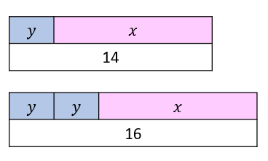 | Graph  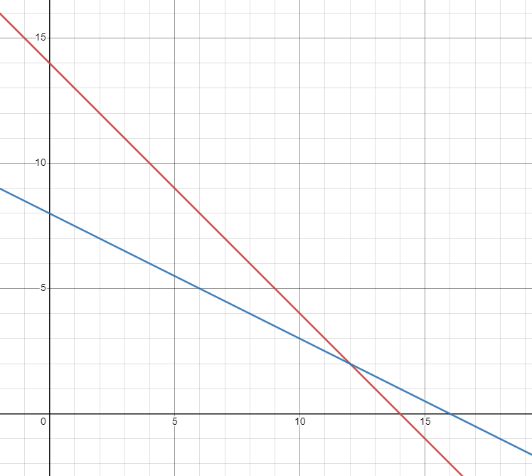
Intercepts  Line 1: $x-intercept (14,0)$  Line 1: y$-intercept (0,14)$  Line 2: $x-intercept (16,0)$  Line 2: y$-intercept (0,8)$ | Gradients  Line 1: $m=-1$  Line 2: $m=-\frac{1}{2}$

Table of values
Line 1
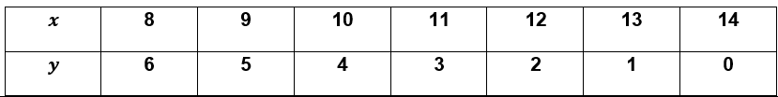
Line 2
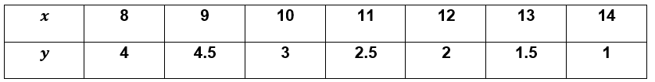

Equations  Line 1: $2y+x=9$ $y=-\frac{x}{2}+\frac{9}{2}$  Line 2: $y+2x=15$ or $y=-2x+15$ | Solution/Point of intersection  $$x=7$$  $$y=1$$  $$(7,1)$$
Bar model  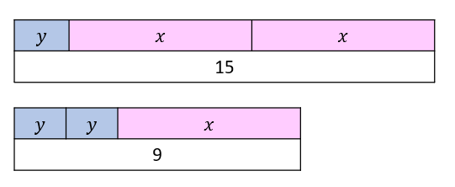 | Graph
Intercepts  Line 1: $x-intercept (9,0)$  Line 1: y$-intercept (0, 4\frac{1}{2})$  Line 2: $x-intercept (7\frac{1}{2},0)$  Line 2: y$-intercept (0,15)$ | Gradients  Line 1: $m=\frac{-4.5}{9}=\frac{-1}{2}$  Line 2: $m=\frac{-15}{7.5}=-2$

Table of values
Line 1
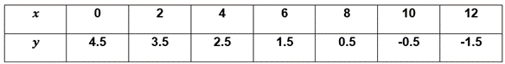
Line 2
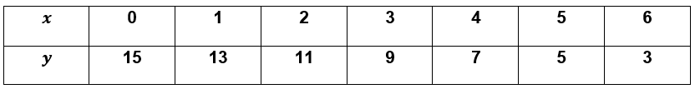

Equations  Line 1: $y=-6x+18$  Line 2: $y=-4x+14$ | Solution/Point of intersection  $$x=2$$  $$y=6$$  $$(2,6)$$
Bar model  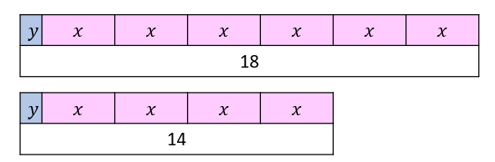 | Graph  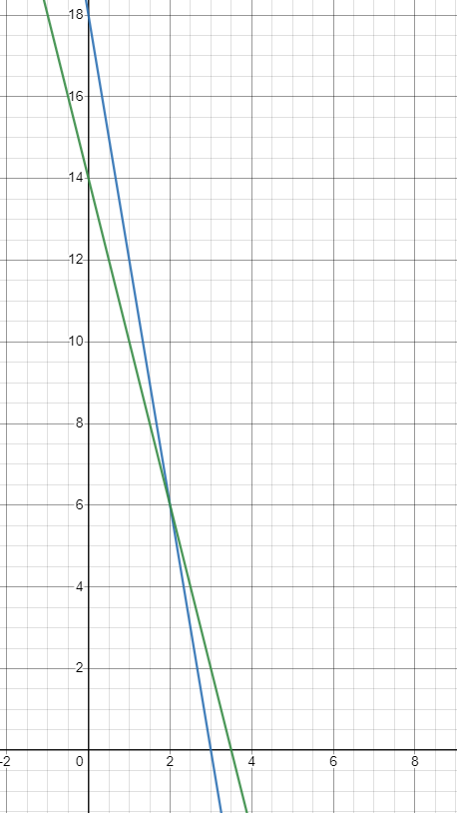
Intercepts  Line 1: $x-intercept (3,0)$  Line 1: y$-intercept (0,18)$  Line 2: $x-intercept (3.5,0)$  Line 2: y$-intercept (0,14)$ | Gradients  Line 1: $m=\frac{-18}{3}=-6$  Line 2: $m=\frac{-14}{3.5}=-4$

Table of values
Line 1
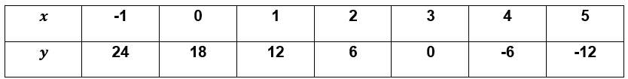
Line 2
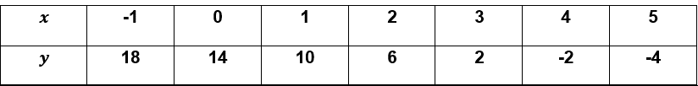

References
This resource contains NSW Curriculum and syllabus content. The NSW Curriculum is developed by the NSW Education Standards Authority. This content is prepared by NESA for and on behalf of the Crown in right of the State of New South Wales. The material is protected by Crown copyright.
Please refer to the NESA Copyright Disclaimer for more information https://educationstandards.nsw.edu.au/wps/portal/nesa/mini-footer/copyright.
NESA holds the only official and up-to-date versions of the NSW Curriculum and syllabus documents. Please visit the NSW Education Standards Authority (NESA) website https://educationstandards.nsw.edu.au/ and the NSW Curriculum website https://curriculum.nsw.edu.au/home.
Mathematics K–10 Syllabus © NSW Education Standards Authority (NESA) for and on behalf of the Crown in right of the State of New South Wales, 2022.

© State of New South Wales (Department of Education), 2023
The copyright material published in this resource is subject to the Copyright Act 1968 (Cth) and is owned by the NSW Department of Education or, where indicated, by a party other than the NSW Department of Education (third-party material).
Copyright material available in this resource and owned by the NSW Department of Education is licensed under a Creative Commons Attribution 4.0 International (CC BY 4.0) license.
This license allows you to share and adapt the material for any purpose, even commercially.
Attribution should be given to © State of New South Wales (Department of Education), 2023.
Material in this resource not available under a Creative Commons license:
- the NSW Department of Education logo, other logos and trademark-protected material
- material owned by a third party that has been reproduced with permission. You will need to obtain permission from the third party to reuse its material.
Links to third-party material and websites
Please note that the provided (reading/viewing material/list/links/texts) are a suggestion only and implies no endorsement, by the New South Wales Department of Education, of any author, publisher, or book title. School principals and teachers are best placed to assess the suitability of resources that would complement the curriculum and reflect the needs and interests of their students.
If you use the links provided in this document to access a third-party's website, you acknowledge that the terms of use, including licence terms set out on the third-party's website apply to the use which may be made of the materials on that third-party website or where permitted by the Copyright Act 1968 (Cth). The department accepts no responsibility for content on third-party websites.

