Tortoise and the Hare
Students explore solving simultaneous linear equations, graphically through the story of the Tortoise and the Hare.

Visible learning
This lesson incorporates Path content.

Learning intentions
- To graphically find the point of intersection of simultaneous linear equations.

Success criteria
- I can read and write the coordinate of a point on the Cartesian plane.
- I can interpret the meaning of the gradient and intercepts of a linear graph.
- I can interpret the meaning of the point of intersection of 2 linear graphs.

Syllabus outcomes
A student:
- develops understanding and fluency in mathematics through exploring and connecting mathematical concepts, choosing and applying mathematical techniques to solve problems, and communicating their thinking and reasoning coherently and clearly MAO-WM-01
- solves linear equations of more than 3 steps, monic and non-monic quadratic equations, and linear simultaneous equations MA5-EQU-P-02
- determines the midpoint, gradient and length of an interval, and graphs linear relationships, with and without digital tools MA5-LIN-C-01
- graphs and interprets linear relationships using the gradient/slope intercept form
MA5-LIN-C-02
Mathematics K–10 Syllabus © NSW Education Standards Authority (NESA) for and on behalf of the Crown in right of the State of New South Wales, 2022.

Activity structure

Launch
- Tell students the modified story of the Tortoise and the Hare as outlined below. This is based on a very old fable by Aesop to teach children that ’The race is not always to the swift.’
A Hare was making fun of the Tortoise one day for being so slow.
“Do you ever get anywhere?” he asked with a mocking laugh.
“Yes,” replied the Tortoise, “and I get there sooner than you think. I’ll run you a race and prove it.”
The Hare was much amused at the idea of running a race with the Tortoise, but for the fun of the thing he agreed. So, the Fox, who had consented to act as judge, marked the distance and the race began.
The Hare, thinking he had all the time in the world, lay down beside the course and decided to take a nap.
The Tortoise, meanwhile, started down the racetrack going slowly but steadily.
The Hare woke with a start, having slept longer than he intended. He ran his swiftest, but he could not overtake the Tortoise in time.
- Use a Think-Pair-Share (bit.ly/thinkpairsharestrategy) for students to discuss what they notice and what they wonder about the story. Challenge them to draw a diagram to represent the story.
- Randomly select students to share their diagrams and their wonderings. Questions may include:
- How long was the racetrack?
- How fast were the Tortoise and the Hare travelling?
- How long did the Hare sleep?
- How much faster would the Hare have to have travelled to catch the Tortoise?
- How much sooner would the Hare have to have woken, to catch the Tortoise?
- If the racetrack was 100 metres longer, could the Hare have caught the Tortoise?

Explore
- Brainstorm with students how we could answer some of our questions?
Students will hopefully suggest creating tables of values and graphs.
- Assign students the Desmos classroom activity ‘The Tortoise and the Hare’. (bit.ly/Tortoise_Hare). An alternative activity, if devices are not available, can be found in Appendix A ‘The Tortoise and the Hare’.
Teachers who have not used Desmos classroom activities before can seek help from the website (bit.ly/desmosclassroomstrategy).
- Students work through the activity, analysing the meaning of the gradient of the graphs, the intercepts, and the point of intersection.

Summarise
- Introduce the terminology ‘point of intersection’.
- Students will write notes to their future forgetful selves (bit.ly/notesstrategy) describing what they have learnt during the activity but paying particular attention to the ‘point of intersection’ and what it means.
- Assign students the Desmos activity ‘Polygraph: Linear systems’ (bit.ly/LinearPolygraph) so they can practice using the new terminology.
Information on how to play the Polygraph game, can be found at bit.ly/HowToUsePolygraphs.

Apply
Students complete the worksheet in Appendix B ‘Putting it all together’. In this activity they identify the point of intersection, intercepts of graphs, gradient and equations from given graphs.
In the last question, it is difficult to read the point of intersection accurately. This could lead into a discussion of how to check an answer by substituting the point of intersection back into both equations. This discussion could also lead into a lesson on algebraic methods of finding the point of intersection.

Assessment and differentiation

Suggested opportunities for differentiation
Launch
- There are no correct or incorrect answers at this point, so all students should be encouraged to share their thoughts.
- Students can represent the story using any visual representations they choose. Teachers can highlight the advantages of the different methods.
Explore
- The use of the Desmos classroom activity will allow students to ‘play’ with the features of the graphs without having to draw graphs by hand. They can observe how the graph changes as they adjust different variables.
- Teachers can use the pacing feature of Desmos classroom to restrict students to particular slides, or to pause the activity to draw attention to or discuss questions.
Summarise
- Teachers should monitor student language during the Polygraph activity. Students could be challenged to use the terms quadrants and the quadrant numbers rather than just ‘top right corner’.
- Some students may benefit from scaffolding to help them write their notes to their future forgetful self.
Apply
- All students should be able to read the point of intersection and intercepts from the graphs.
- Students could be challenged to write their equations in both general form and the form $y=mx+c$. They could also be challenged to prove the point of intersection by substituting the values into both equations.
- Students could be challenged to consider if there will always be a point of intersection.

Suggested opportunities for assessment
Explore and summarise
- Student responses can be monitored through the Desmos teacher dashboard and used as both formative and summative assessment.
Apply
- The worksheet in Appendix B could be collected and used as a source of evidence.

Appendix A

The Tortoise and the Hare
- If the Tortoise is represented by the green line and the Hare is represented by the purple line, which graph represents the Hare winning the race?
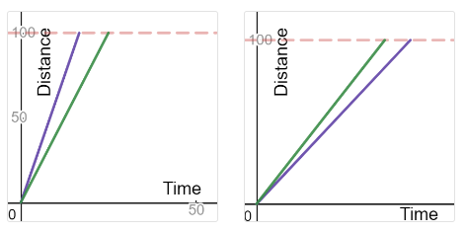
- How long did it take the Hare to win the 100 m race?
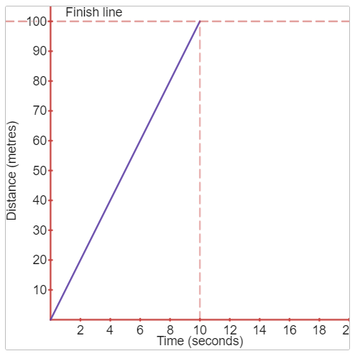
- Calculate the speed of the Hare.
- Calculate the gradient of the Hare’s graph. How does this relate to the speed of the Hare?
- On the same set of axes as the Hare’s graph, draw an approximate graph of your choice, for the Tortoise, that shows he lost the race.
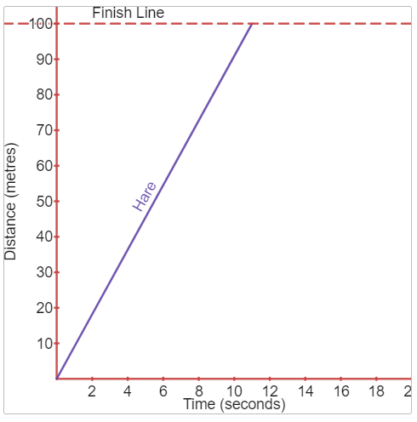
- Calculate the speed of the Tortoise based on your graph.
- The Tortoise took 16 seconds to finish the race. Add a third line to your graph above to demonstrate this.
- What happens to the graph as the animals run faster or slower?
- Write an equation for the graph of the Hare.
- Write an equation for the graph of the Tortoise where he took 16 seconds to finish the race.
- The Hare decides to give the Tortoise a 20-metre head start. Draw a graph for the Tortoise to show what this looks like (assume the Tortoise still travels at the same speed).
- Pretend you are commentating the race. Use the information in the graphs below to describe the race. What does it mean when the 2 lines cross?
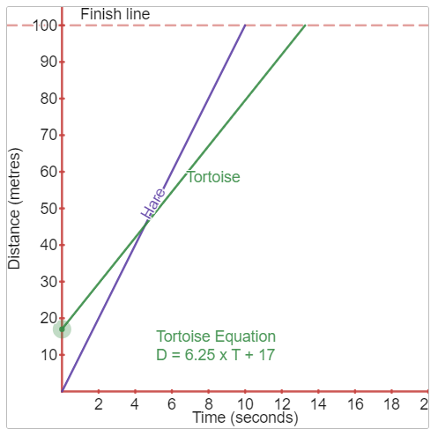
- What if the Hare decided to take a nap at the start of the race and didn’t start running until 5 seconds had passed. What would this look like on his graph?
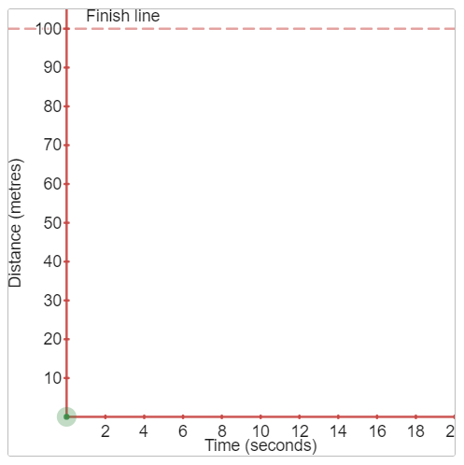
- How fast would the Hare need to run to be able to win the race?
- Once again pretend you are commentating the race. Use the information in the graphs below to describe the race. Who wins this time?
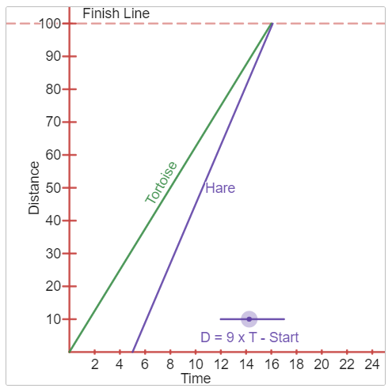

Appendix B

Putting it all together
Complete the table for each pair of graphs. The first one has been done for you.
Graph | Point of Intersection | Intercepts | Gradient | Equations
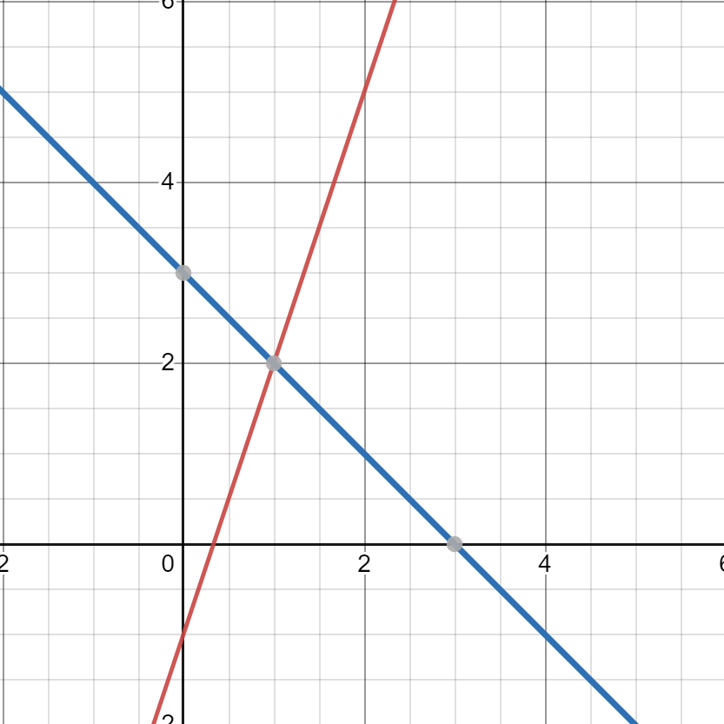 | (1, 2) | $x$-intercept 1: (3, 0)  $y$-intercept 1: (0, 3)  $x$-intercept 2: ($\frac{1}{3}, 0)$  $y$-intercept 2: (0, -1) | Gradient 1:$\frac{-3}{3}=-1$  Gradient 2: $\frac{1}{3}$ | Equation 1: $y=-x+3$  Equation 2: $y=\frac{1}{3}x-1$
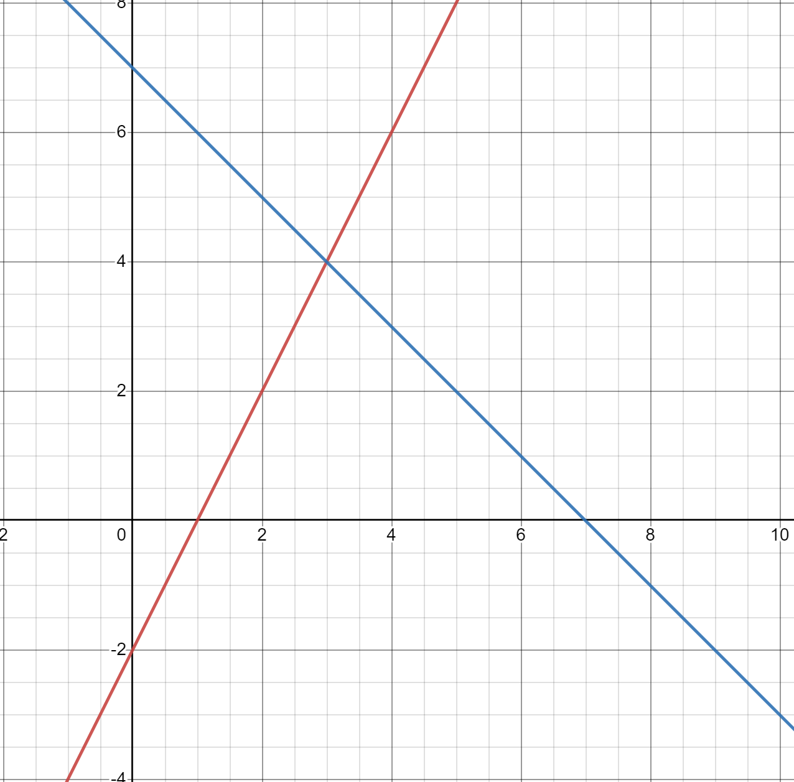 |  | $x$-intercept 1:  $y$-intercept 1:  $x$-intercept 2:  $y$-intercept 2: | Gradient 1:  Gradient 2: | Equation 1:  Equation 2:
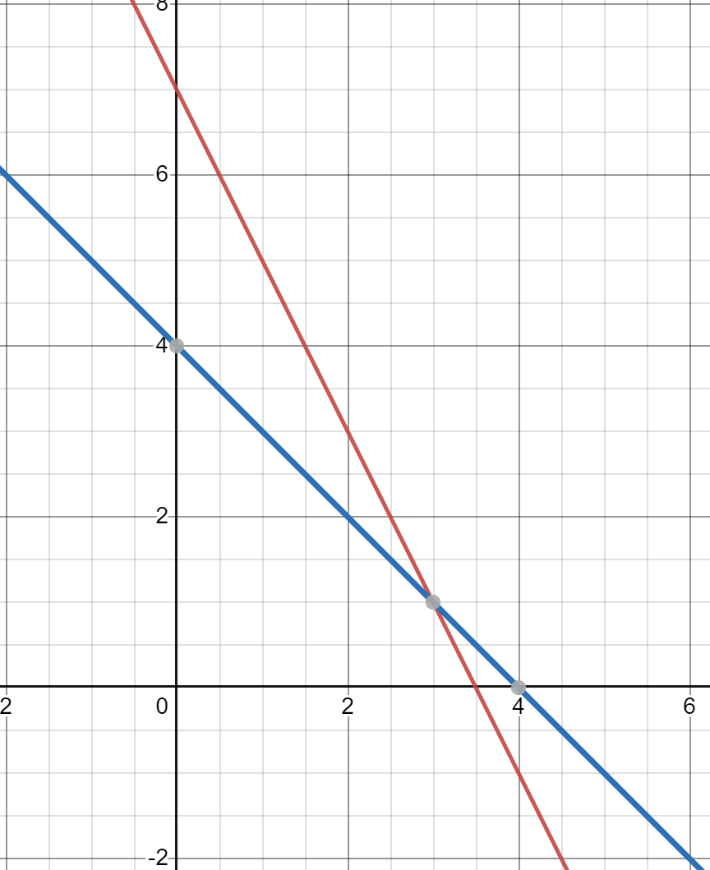 |  | $x$-intercept 1:  $y$-intercept 1:  $x$-intercept 2:  $y$-intercept 2: | Gradient 1:  Gradient 2: | Equation 1:  Equation 2:
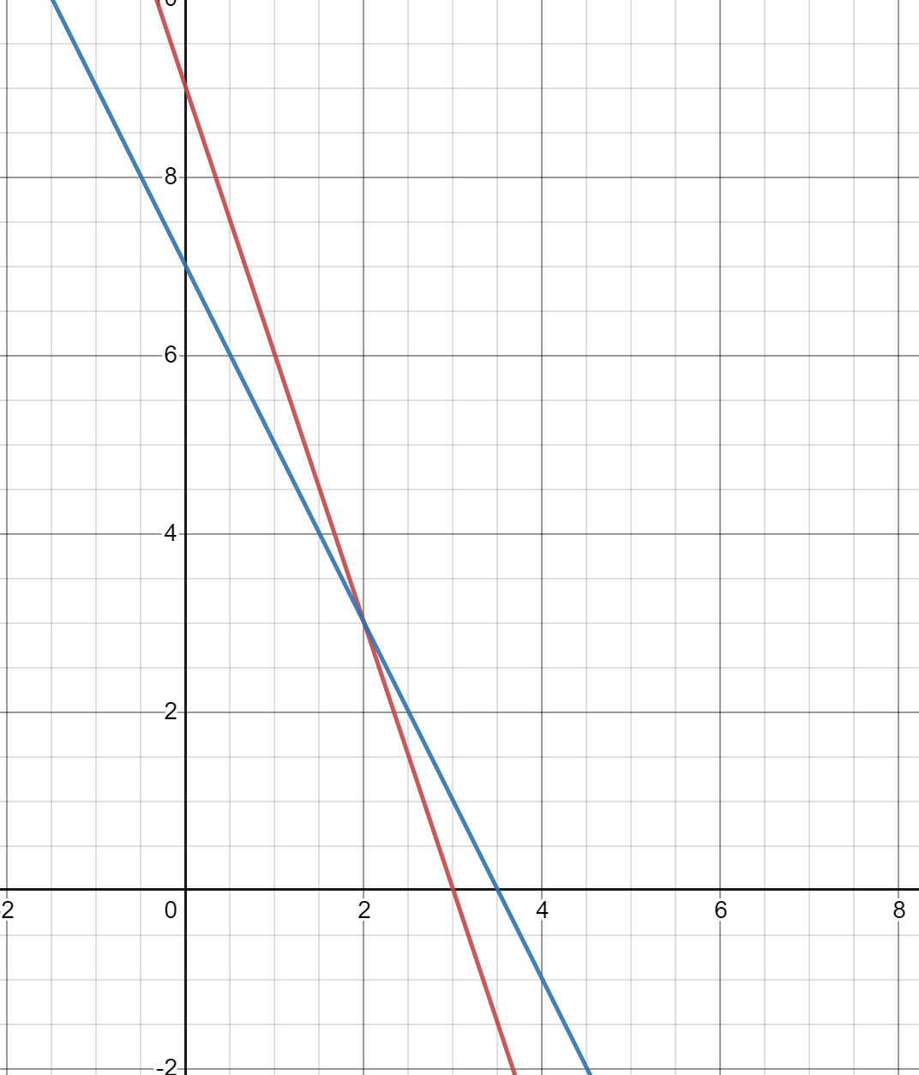 |  | $x$-intercept 1:  $y$-intercept 1:  $x$-intercept 2:  $y$-intercept 2: | Gradient 1:  Gradient 2: | Equation 1:  Equation 2:
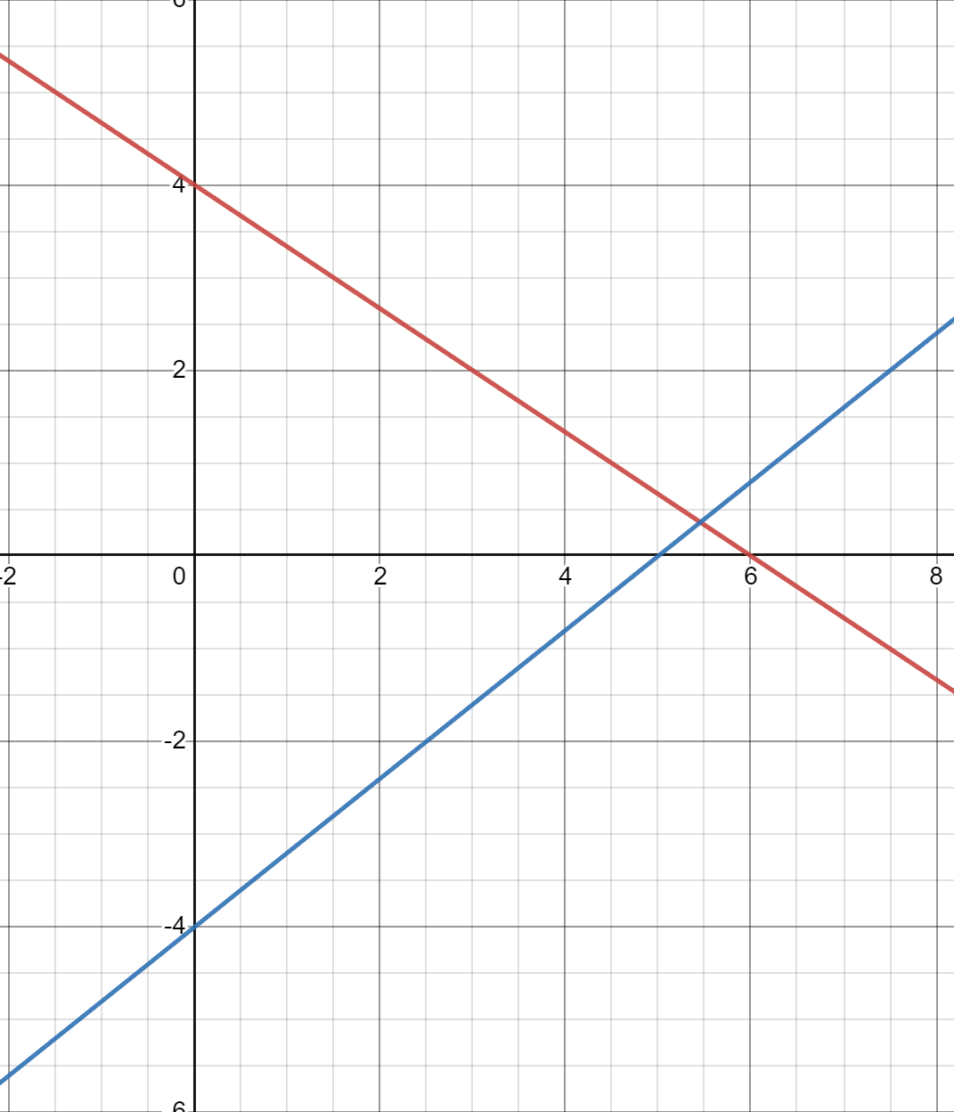 |  | $x$-intercept 1:  $y$-intercept 1:  $x$-intercept 2:  $y$-intercept 2: | Gradient 1:  Gradient 2: | Equation 1:  Equation 2:

Sample solutions

Appendix A – the Tortoise and the Hare
- The first graph
- 10 seconds
- $S=\frac{D}{T}$
$$=\frac{100}{10}$$
$$=10m/s$$
- $m=\frac{rise}{run}$
$$=\frac{100}{10}$$
$$=10$$
The speed and gradient are the same value.
- Answers will vary.
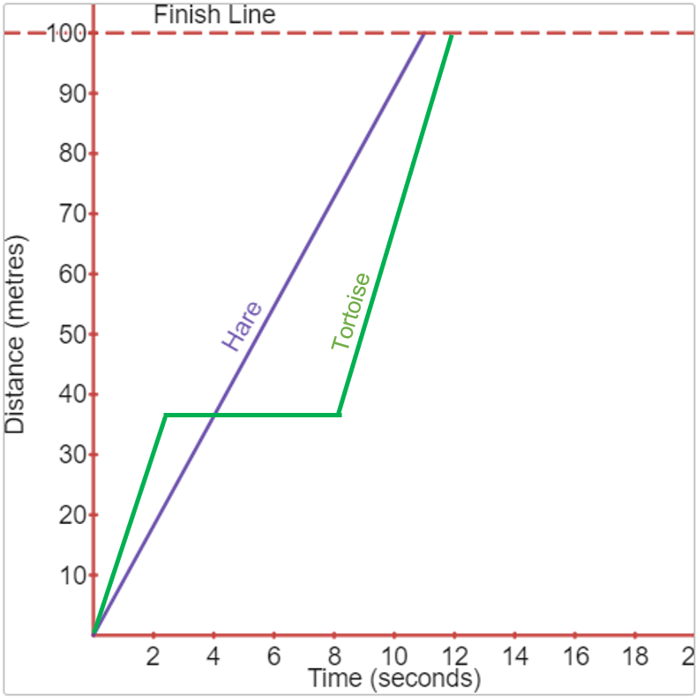
- Answers will vary.
- Answers will vary.
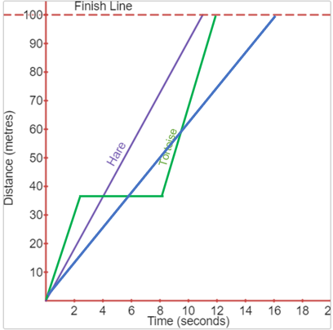
- The line becomes steeper as the animal runs faster and flatter as it slows down.
- $y=10x$
- $y=\frac{100}{16}x$ or $y=6.25x$

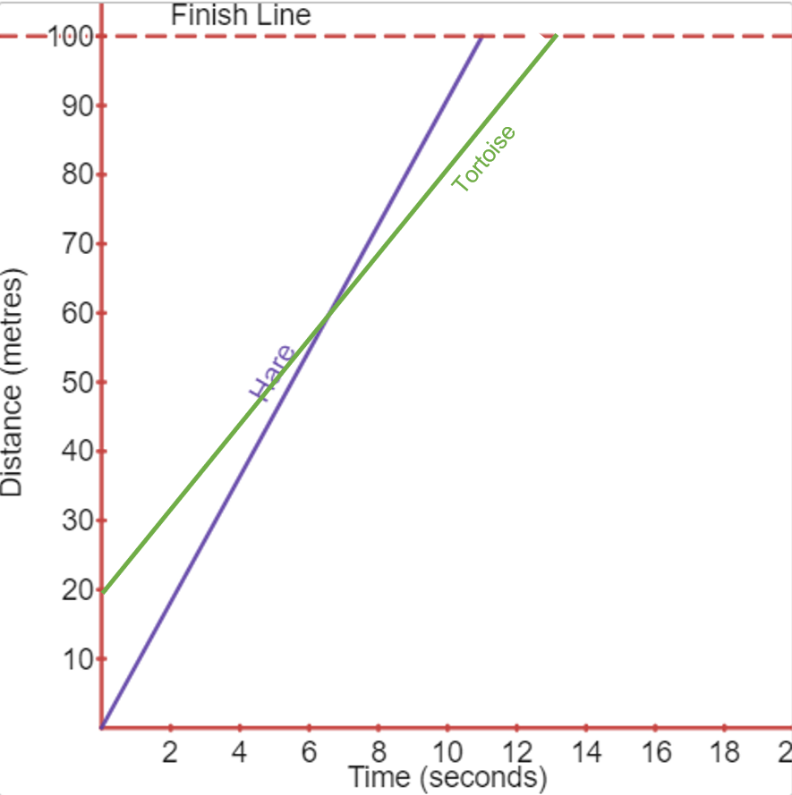
- The Hare and Tortoise are at the same position where the lines cross.

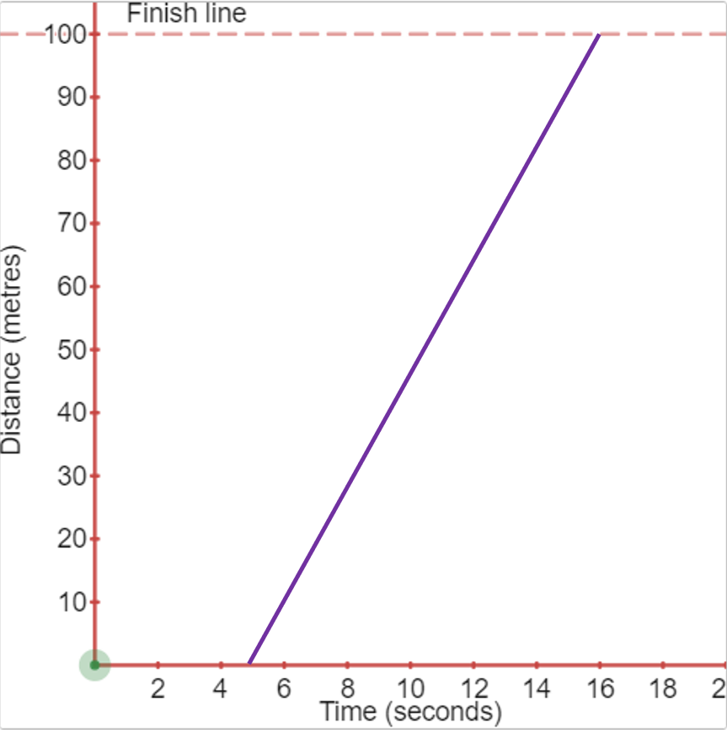
- The Hare would need to go10m/s or more to win the race.
- The race is a tie.

Appendix B – putting it all together
Point of intersection | Intercepts | Gradient | Equation
(3,4) | $x$-intercept 1: (7,0)  $y$-intercept 1: (0,7)  $x$-intercept 2: $(1,0)$  $y$-intercept 2: (0,-2) | Gradient 1: -1  Gradient 2: $\frac{1}{2}$ | Equation 1:  $$y=-x+7$$  Equation 2:  $$y=\frac{1}{2}x-2$$
(3,1) | $x$-intercept 1: (4,0)  $y$-intercept 1: (0,4)  $x$-intercept 2: $(3\frac{1}{2},0)$  $y$-intercept 2: (0,7) | Gradient 1: -1  Gradient 2: -2 | Equation 1:  $$y=-x+4$$  Equation 2:  $$y=-2x+7$$
(2,3) | $x$-intercept 1: $(3\frac{1}{2},0)$  $y$-intercept 1: (0,7)  $x$-intercept 2: $(3,0)$  $y$-intercept 2: (0,9) | Gradient 1: -2  Gradient 2: -3 | Equation 1:  $$y=-2x+7$$  Equation 2:  $$y=-3x+9$$
(3,1) | $x$-intercept 1: (4,0)  $y$-intercept 1: (0,4)  $x$-intercept 2: $(3\frac{1}{2},0)$  $y$-intercept 2: (0,7) | Gradient 1: -1  Gradient 2: -2 | Equation 1:  $$y=-x+4$$  Equation 2:  $$y=-2x+7$$

References
This resource contains NSW Curriculum and syllabus content. The NSW Curriculum is developed by the NSW Education Standards Authority. This content is prepared by NESA for and on behalf of the Crown in right of the State of New South Wales. The material is protected by Crown copyright.
Please refer to the NESA Copyright Disclaimer for more information https://educationstandards.nsw.edu.au/wps/portal/nesa/mini-footer/copyright.
NESA holds the only official and up-to-date versions of the NSW Curriculum and syllabus documents. Please visit the NSW Education Standards Authority (NESA) website https://educationstandards.nsw.edu.au/ and the NSW Curriculum website https://curriculum.nsw.edu.au/home.
Mathematics K–10 Syllabus © NSW Education Standards Authority (NESA) for and on behalf of the Crown in right of the State of New South Wales, 2022.

© State of New South Wales (Department of Education), 2023
The copyright material published in this resource is subject to the Copyright Act 1968 (Cth) and is owned by the NSW Department of Education or, where indicated, by a party other than the NSW Department of Education (third-party material).
Copyright material available in this resource and owned by the NSW Department of Education is licensed under a Creative Commons Attribution 4.0 International (CC BY 4.0) license.
This license allows you to share and adapt the material for any purpose, even commercially.
Attribution should be given to © State of New South Wales (Department of Education), 2023.
Material in this resource not available under a Creative Commons license:
- the NSW Department of Education logo, other logos and trademark-protected material
- material owned by a third party that has been reproduced with permission. You will need to obtain permission from the third party to reuse its material.
Links to third-party material and websites
Please note that the provided (reading/viewing material/list/links/texts) are a suggestion only and implies no endorsement, by the New South Wales Department of Education, of any author, publisher, or book title. School principals and teachers are best placed to assess the suitability of resources that would complement the curriculum and reflect the needs and interests of their students.
If you use the links provided in this document to access a third-party's website, you acknowledge that the terms of use, including licence terms set out on the third-party's website apply to the use which may be made of the materials on that third-party website or where permitted by the Copyright Act 1968 (Cth). The department accepts no responsibility for content on third-party websites.

