Cutting through lines
Students find intercepts of equations and use them to graph linear relationships, including horizontal and vertical lines.

Visible learning
This lesson incorporates optional Path content.

Learning intention
- To know how to graph linear relationships.

Success criteria
- I can identify intercepts from a linear graph.
- I can find intercepts from equations.
- I can use intercepts to graph linear equations.
- I can graph horizontal and vertical lines.

Syllabus outcomes
A student:
- develops understanding and fluency in mathematics through exploring and connecting mathematical concepts, choosing and applying mathematical techniques to solve problems, and communicating their thinking and reasoning coherently and clearly MAO-WM-01
- determines the midpoint, gradient and length of an interval, and graphs linear relationships, with and without digital tools MA5-LIN-C-01
- describes and applies transformations, the midpoint, gradient/slope and distance formulas, and equations of lines to solve problems MA5-LIN-P-01
Mathematics K–10 Syllabus © NSW Education Standards Authority (NESA) for and on behalf of the Crown in right of the State of New South Wales, 2022.

Activity structure
Please use the associated PowerPoint Cutting through lines to display images in this lesson.

Launch
- Display slide 2 from the PowerPoint Cutting through lines, which shows an image of 3 people making statements about graphing straight lines.
Figure 1 – graphing statements
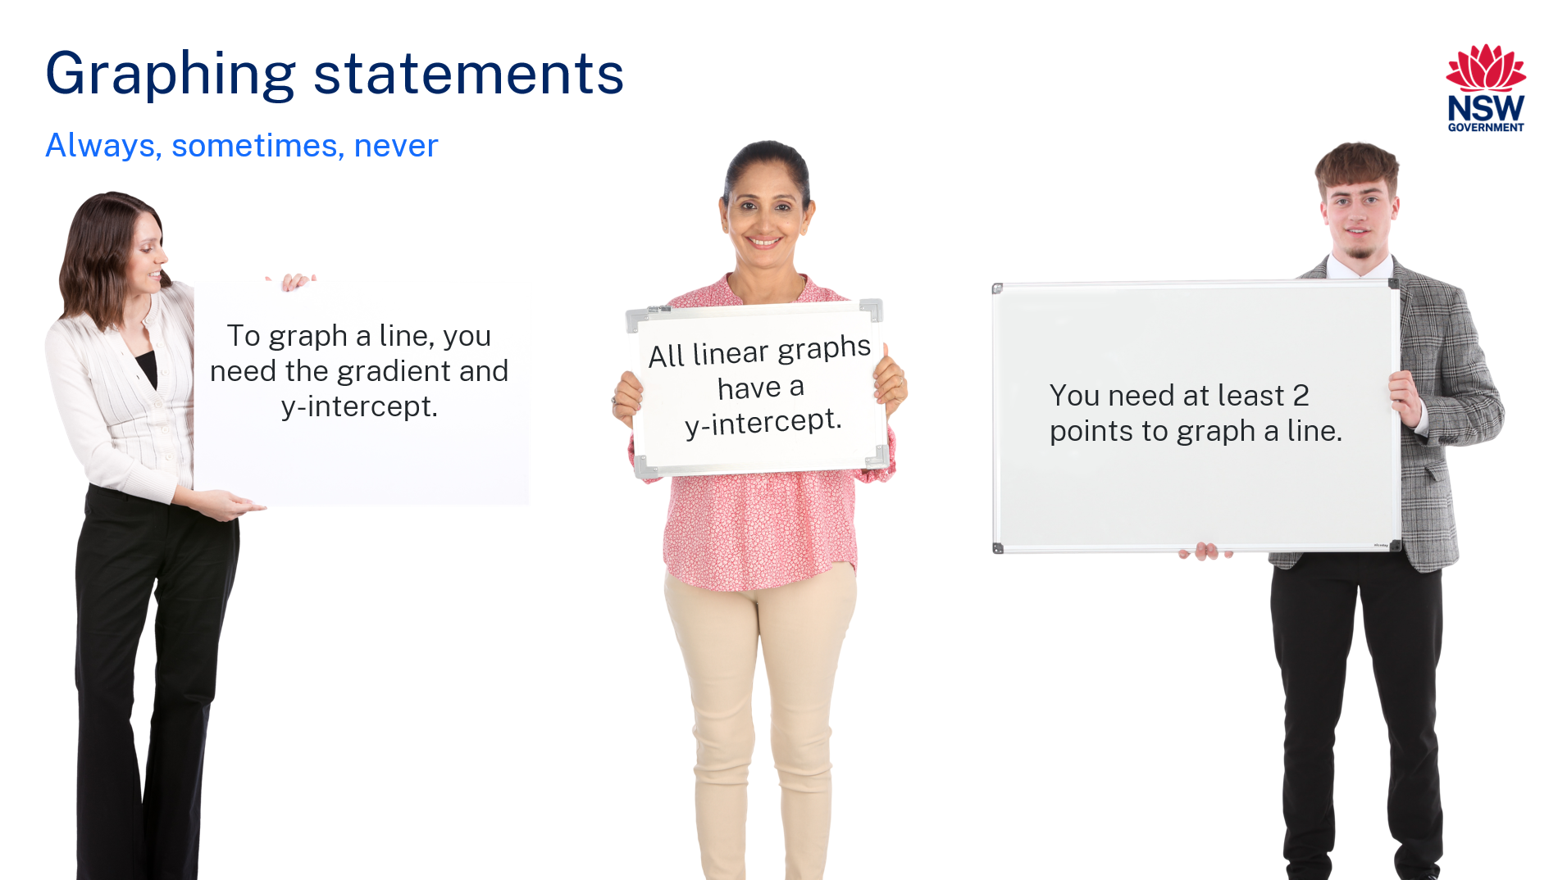
- In a Think-Pair-Share, (bit.ly/thinkpairsharestrategy) students are to decide if the statements are always, sometimes, or never true. Have them justify their answers.
- Initiate a sharing of solutions and reasoning using the Pose-Pause-Pounce-Bounce question strategy [PDF 200KB] (bit.ly/pausepouncebounce).

Explore
- Assign the Desmos activity ‘Cutting through lines’ (https://bit.ly/cuttingthroughlines) to the class. Students are to complete slides 1 to 29 at their own pace. These slides explore horizontal and vertical lines.
Students should conclude that all lines that are horizontal are parallel to each other. They should also be able to state that the$x$-axis has an equation of $y=0$.
Students should conclude that all vertical lines are parallel to each other. They should also be able to state that the $y$-axis has an equation of $x=0$.
Alternatively, if you do not have access to technology, students can complete questions 1 to 3 of the Appendix A ‘Lines and intercepts’.
- Students are to complete slides 30 to 33 in the Desmos activity. These slides explore intercepts of linear relationships by studying their graphs and coordinates.
Alternatively, if you do not have access to technology, students can complete questions 4 and 5 of Appendix A ‘Lines and intercepts’.
Both activities should highlight that for an x-intercept, the $y$-value of the coordinate will always be zero. For a $y$-intercept, the$x$-value of the coordinate will always be zero.
- Display slide 3 in the PowerPoint Cutting through lines. This displays the equation of a line.
- Using a Think-Pair-Share, ask students to discuss how they would find the $x$- and $y$-intercepts from the equation. Prompt students to try to find the intercepts of the line on the slide.
- Initiate a sharing of solutions and reasoning using the Pose-Pause-Pounce-Bounce question strategy [PDF 200 KB] (bit.ly/pausepouncebounce).

Summarise
- Use slides 4 to 7 in the PowerPoint Cutting through lines for the explicit teaching of graphing using intercepts.
The explicit teaching technique used in the associated PowerPoint is ‘Your turn.’ The first slide is a worked example which should be displayed for the students and then use the following steps.
- Reveal the question to students and its solution.
- Students read in silence.
- Students individually think and explain to themselves what is happening in each step.
- Students hold up a thumbs up to the teacher when they have finished reading and have some sort of understanding.
- Think, pair, share. Students explain the solution to their partner.
- In pairs students then answer the self-explanation questions.
- Finally, randomly select students to share their answers with the whole class.
- Students are to create notes to their future forgetful self (bit.ly/notesstrategy) on how to find intercepts of lines graphically and algebraically and how to use intercepts to graph linear relationships.

Apply

Around the room
In this activity, students find the answers to questions around the room. Each answer has a new question at the bottom of the page. Students must note the order in which they solve the questions. When students have solved all the questions, they should end up back where they started and the letters should spell out a word related to the lesson.
- Hang up each game card from Appendix B ‘Around the room’ in different locations around your classroom or specified space.
- In pairs, students are to start at any game card. Get them to note down the letter on the game card they have started with. Explain to students that each question has an answer that matches on another sheet. They are to find the answer, write down the letter and complete the next question. They are to continue to do so until they have reached their beginning point again. Once completed, they should spell a word relating to the lesson.

Lots of lines
- Distribute Appendix C ‘Lots of lines’ so that each pair of students has a copy.
- In pairs, students are to complete the activity by dividing 12 straight lines into 6 pairs, each pair matching a description.
Set A is aimed at students who have prior knowledge of general form, or rearranging equations, as it has lines in varying forms. Set B has the same lines in gradient intercept form.

SWOT analysis
- Ask students to recall the different ways we have graphed in this topic. Have them compare 2 ways we can graph, with intercepts or the gradient and intercept, by completing a SWOT analysis (bit.ly/dlsSWOTanalysis).
- Students are to write a paragraph of what method of graphing they believe is the best for them and why.

Assessment and differentiation

Suggested opportunities for differentiation
Explore
- Students can explore how the intercepts influence the graph. For example, if both intercepts are positive, does that imply the gradient is positive or negative?
- Students who are confident in algebra can be extended into Path content by being given lines in different forms to find the intercepts.
Apply
- Appendix A can be modified so that equations are all in gradient intercept form.
- Students can also be asked to graph the line or find the equation of the line in the ‘Around the room activity’.
- In Appendix B ‘Lots of lines’, Set A is aimed at students who have knowledge of rearranging equations, as it has lines in varying forms. Set B has the same lines in gradient intercept form.

Suggested opportunities for assessment
Explore
- The use of mini whiteboards allows for the direct application of student knowledge and as a point for teachers to identify students with misconceptions.
- Self-feedback is given when students are writing coordinates for intercepts to see if they have the $x$-values and the $y$-values in the correct order.
Apply
- Self-feedback is available for students when completing the ‘Around the room’ activity. This is seen if they cannot find their solution on another sheet or if they don’t correctly spell the missing word.
- Students’ algebra skills are assessed when completing the ‘Lots of lines’ activity as they can pair up incorrect equations if they make common misconceptions.

Appendix A

Lines and intercepts
- Here is a graph of an equation.
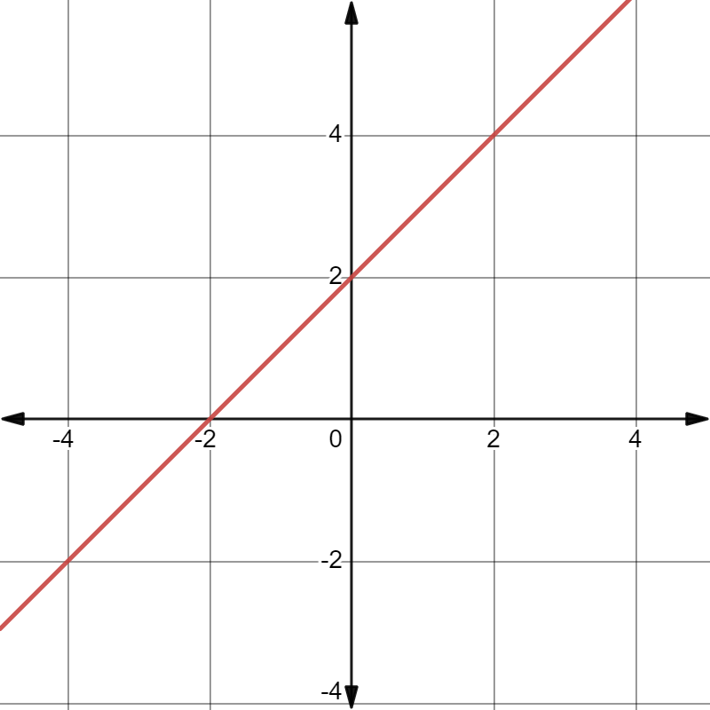
- Explain what an intercept is.
- State the coordinates of the $x$-intercept and $y$-intercept.
- Explain how you found the coordinates of the $x$-intercept and $y$-intercept.

- Consider the graph.
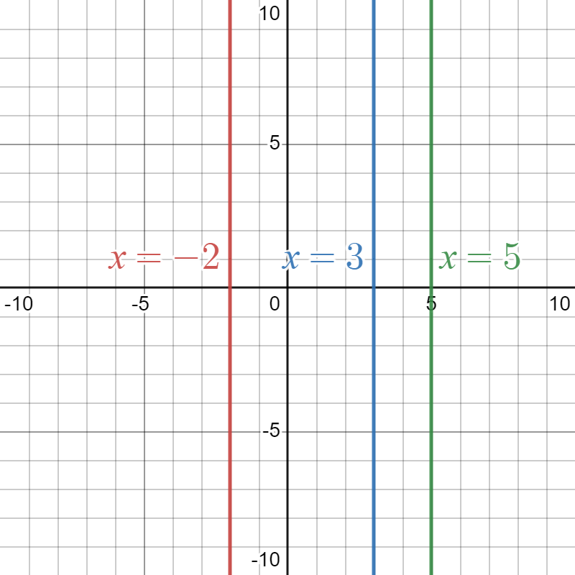
- State the coordinates of the $x$-intercepts.
- What do you notice about the equations and the coordinates of the $x$-intercepts?
- Draw the line $x = 1$ on the graph above.
- State the equation for the $y$-axis.

- Consider the graph.
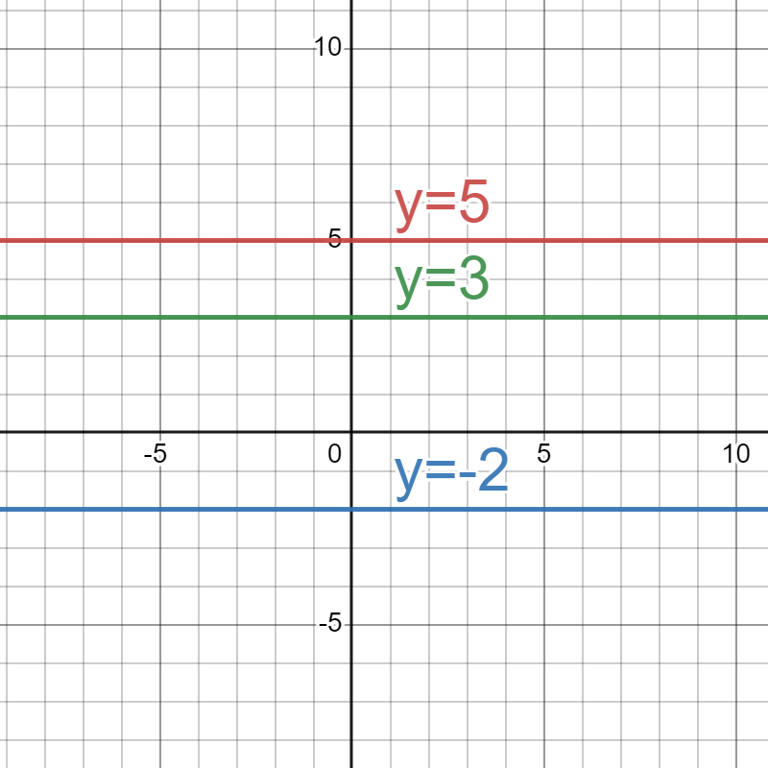
- State the coordinates of the$y$-intercepts.
- What do you notice about the equations and the coordinates of the $y$-intercepts?
- Draw the line $y=-5$ on the graph above.
- State the equation for the$x$-axis.

- Consider the graph below.
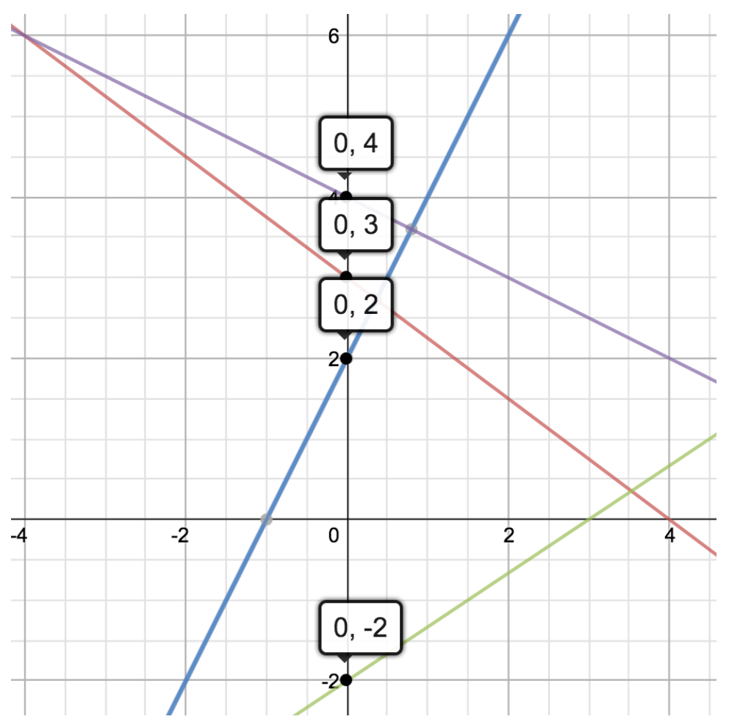
- What do you notice about all the $y$-intercepts?
- Can you identify which ordered pairs are $y$-intercepts from the list below.
(0,7), (4, −5), (6,0), (2,5) and (0,2).
- Explain how you would find a y-intercept given a graph or table of values.

- Consider the graph below.
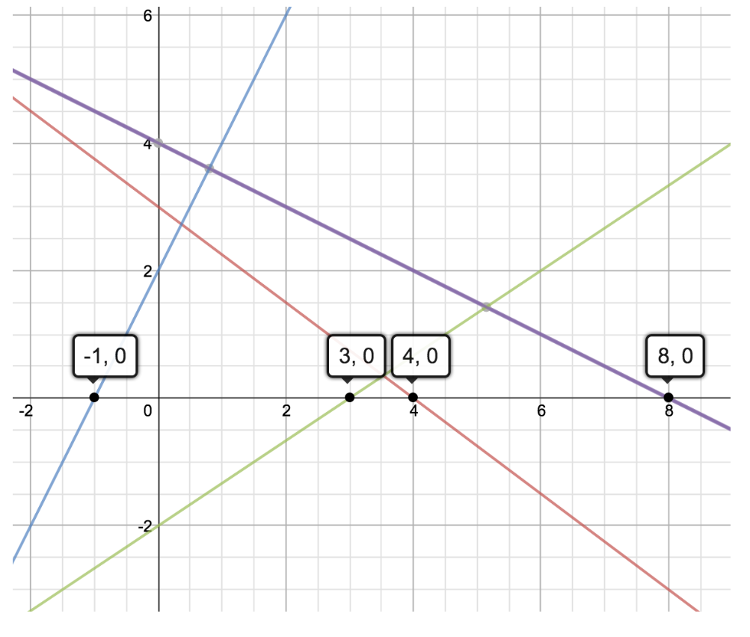
- What do you notice about all the$x$-intercepts?
- Can you identify which ordered pairs are $x$-intercepts from the list below.
(0,7), (4,−5), (6,0), (2,5) and (0,2).
- Explain how you would find an $x$-intercept given a graph or table of values.

Appendix B

Around the room

Card I
$x$-intercept: (−5,0)
$y$-intercept: (0,7)
Find the intercepts of the equation $4x-8y=24$.

Card N
$x$-intercept: (6,0)
$y$-intercept: (0,−3)
Identify the intercepts on the graph.
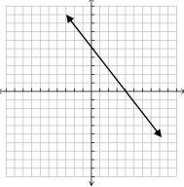

Card T
$x$-intercept: (4,0)
$y$-intercept: (0,5)
Find the intercepts of the equation $y=15-5x$

Card E
$x$-intercept: (3,0)
$y$-intercept: (0,15)
Identify the intercepts on the graph.
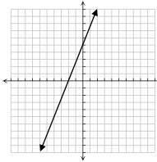

Card R
$x$-intercept: (−2,0)
$y$-intercept: (0,5)
Find the intercepts of the equation $-5x+3y=15$

Card C
$x$-intercept: (−3,0)
$y$-intercept: (0,5)
Identify the intercepts on the graph.
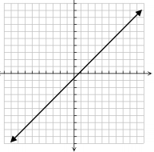

Card E
$x$-intercept: (1,0)
$y$-intercept: (0,−1)
Find the intercepts of the equation $y=\frac{5}{2}x+10$.

Card P
$x$-intercept: (−4,0)
$y$-intercept: (0,10)
Find the intercepts of the equation $y=5x-2$

Card T
$x$-intercept: ($\frac{5}{2}$,0)
$y$-intercept: (0,−2)
Identify the intercepts on the graph.
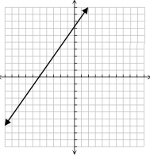

Appendix C

Lots of lines
These 12 straight lines can be divided up into the 6 categories below:
- These lines are parallel.
- These lines are perpendicular.
- These lines have the same$y$-intercept.
- These lines have the same $x$-intercept.
- These lines both go through the point (1, 5)
- Add your own description.
Can you sort them into the correct categories and complete the description of the final category?

Set A
$$y=4x+4$$ | $$4y=x+3$$
$$y=8x-3$$ | $$y+4x+6=0$$
$$3y=2x-8$$ | $$y+6x=11$$
$$y+8x=6$$ | $$2y+8=3x$$
$$2y+x=4$$ | $$2y=8x+3$$
$$y=6x-4$$ | $$y+x+8=0$$

Set B
$$y=4x+4$$ | $$y=\frac{x}{4}+\frac{3}{4}$$
$$y=8x-3$$ | $$y=-4x-6$$
$$y=\frac{2}{3}x-\frac{8}{3}$$ | $$y=-6x+11$$
$$y=-8x+6$$ | $$y=\frac{3}{2}x-4$$
$$y=-\frac{1}{2}x+2$$ | $$y=4x+\frac{3}{2}$$
$$y=6x-4$$ | $$y=-x-8$$
This activity is an adaptation of 'Lots of Lines' (https://undergroundmathematics.org/geometry-of-equations/lots-of-lines) from Underground Mathematics (https://undergroundmathematics.org/) by The University of Cambridge.

Sample solutions

PowerPoint – always, sometimes, never
Statement | Solution
To graph a line, you need a gradient and  $y$-intercept. | Sometimes. Vertical and horizontal lines do not require a gradient. It can be easier to draw diagonal lines when you have these characteristics.
All linear graphs have a $y$-intercept. | Sometimes. Vertical lines have no y-intercept (unless you count $x = 0$).
You need at least 2 points to graph a line. | Sometimes. Even when graphing with a gradient and $y$-intercept, we are using the gradient to find another point on the line.

Appendix B – lots of lines

Set A
Description | Line 1 | Line 2
These lines are parallel. | $$y=4x+4$$ | $$2y=8x+3$$
These lines are perpendicular. | $$4y=x+3$$ | $$y+4x+6=0$$
These lines have the same $y$-intercept. | $$2y+8=3x$$ | $$y=6x-4$$
These lines have the same $x$-intercept. | $$3y=2x-8$$ | $$2y+x=4$$
These lines both go through the point (1,5). | $$y=8x-3$$ | $$y+6x=11$$
Add your own description  The gradient on one line is the same as the $y$-intercept of the other.  Or  Both go through the point $\left(\frac{5}{7},\frac{2}{7}\right)$. | $$y+8x=6$$ | $$y+x+8=0$$

Set B
Description | Line 1 | Line 2
These lines are parallel. | $$y=4x+4$$ | $$y=4x+\frac{3}{2}$$
These lines are perpendicular. | $$y=\frac{x}{4}+\frac{3}{4}$$ | $$y=-4x-6$$
These lines have the same $y$-intercept. | $$y=\frac{3}{2}x-4$$ | $$y=6x-4$$
These lines have the same $x$-intercept. | $$y=\frac{2}{3}x-\frac{8}{3}$$ | $$y=\frac{1}{2}x+2$$
These lines both go through the point $(1,5)$. | $$y=8x-3$$ | $$y=-6x+11$$
Add your own description  The gradient on one line is the same as the y-intercept of the other.  Or  Both go through the point $(2, -10).$ | $$y=-8x+6$$ | $$y=-x-8$$

References
This resource contains NSW Curriculum and syllabus content. The NSW Curriculum is developed by the NSW Education Standards Authority. This content is prepared by NESA for and on behalf of the Crown in right of the State of New South Wales. The material is protected by Crown copyright.
Please refer to the NESA Copyright Disclaimer for more information https://educationstandards.nsw.edu.au/wps/portal/nesa/mini-footer/copyright.
NESA holds the only official and up-to-date versions of the NSW Curriculum and syllabus documents. Please visit the NSW Education Standards Authority (NESA) website https://educationstandards.nsw.edu.au/ and the NSW Curriculum website https://curriculum.nsw.edu.au/home.
Mathematics K–10 Syllabus © NSW Education Standards Authority (NESA) for and on behalf of the Crown in right of the State of New South Wales, 2022.
University of Cambridge (2017) ‘Lots of lines!’ (https://undergroundmathematics.org/geometry-of-equations/lots-of-lines), Geometry of Equations, Underground Mathematics website, accessed 3 October 2023.

© State of New South Wales (Department of Education), 2023
The copyright material published in this resource is subject to the Copyright Act 1968 (Cth) and is owned by the NSW Department of Education or, where indicated, by a party other than the NSW Department of Education (third-party material).
Copyright material available in this resource and owned by the NSW Department of Education is licensed under a Creative Commons Attribution 4.0 International (CC BY 4.0) license.
This license allows you to share and adapt the material for any purpose, even commercially.
Attribution should be given to © State of New South Wales (Department of Education), 2023.
Material in this resource not available under a Creative Commons license:
- the NSW Department of Education logo, other logos and trademark-protected material
- material owned by a third party that has been reproduced with permission. You will need to obtain permission from the third party to reuse its material.
Links to third-party material and websites
Please note that the provided (reading/viewing material/list/links/texts) are a suggestion only and implies no endorsement, by the New South Wales Department of Education, of any author, publisher, or book title. School principals and teachers are best placed to assess the suitability of resources that would complement the curriculum and reflect the needs and interests of their students.
If you use the links provided in this document to access a third-party's website, you acknowledge that the terms of use, including licence terms set out on the third-party's website apply to the use which may be made of the materials on that third-party website or where permitted by the Copyright Act 1968 (Cth). The department accepts no responsibility for content on third-party websites.

